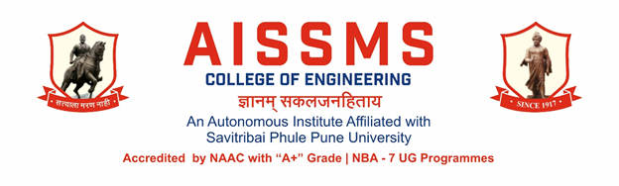
Internal Quality Assurance Cell

DEPARTMENT OF MECHANICAL ENGINEERING
ANNUAL REPORT
(01 JULY 2025 to 30 June 2026)
TERM ONE: 01 July to 31 December
TERM TWO: 01 January to 30 June

Academic Year 2025 – 26
Guidelines:
Fill up this sheet for all the contributions /activities conducted at Department level only.
- In case data does not exist please mention it as ‘No Data’.
- Please add rows to the table below to suit your requirements
- Ensure that data does not differ from other official records and all the supporting documents are available.
- Use: Font Type: Times New Roman, Font Size: 12, Sentence case, Spacing: 1.15
- Use separate row for every details.
- For any queries, you may contact: Dr V R Patil, Coordinator, IQAC
- email: iqac@aissmscoe.com

CONTENTS
Sr No | Activity/ Item | Page No
- PROFILE OF DEPARTMENT
1.1 | Introduction | 05
1.2 | Laboratories in the Department | 07
1.3 | Software Available in the Department | 07
1.4 | Faculty in the Department | 08
1.5 | Details of Supporting Staff | 09
1.6 | Students’ Enrollment | 09
1.7 | Students–Faculty Feedback Details | 10
1.8 | Result Analysis | 36
1.9 | Class Result Analysis | 39
 | - FACULTY CONTRIBUTION
2.1 | Achievements of Faculty | 43
2.2 | Contribution of Faculty (Interaction With Outside World) | 44
2.3 | e content developed by faculty and available online | 47
2.4 | FDP/STTP attended by the department faculty | 49
2.5 | Seminars/ workshops/ webinars attended by the department faculty | 57
2.6 | Conferences/ symposiums attended by the department faculty | 60
2.7 | Online courses / certificate courses completed by department faculty | 61
2.8 | Extension lectures / webinars organized | 64
2.9 | Faculty served as resource person, expert, chairperson | 67
- ACTIVITIES ORGANISED
3.1 | FDP/STTP organized by the department | 71
3.2 | Seminars/ workshops/ webinars organized by the department (for faculty) | 72
3.3 | Conferences/ symposiums organized by the department | 73
3.4 | Extension activities conducted by the department | 74
3.5 | MOU signed with academic and professional organizations | 74
3.6 | Students’ chapters /clubs | 75
3.7 | Social activities organized | 75
3.8 | Parent meeting | 76
3.9 | Alumni meet | 77
3.10 | Support from Alumni | 77
3.11 | Interaction with Alumni | 78
3.12 | Student counseling and career guidance at the department level | 79
3.13 | SDG Initiatives | 84
- RESEARCH CONTRIBUTION
4.1 | Funded research project | 89
4.2 | Testing and consultancy | 90
4.3 | Patents, copyright, trademark and other (IPR) | 91
4.4 | Papers published/ presented in proceedings of conferences | 97
4.5 | Papers published in journals | 100
4.6 | Book/ article publications | 111
4.7 | Total Research citations | 111
4.8 | ME awarded | 112
4.9 | PhD guide details | 112
4.10 | PhD AWARDED | 112
4.11 | Student Publication in Conference | 114
4.12 | Student Publication in Journal | 115
4.13 | Students IPR | 127
 | - INTERACTION WITH INDUSTRY
5.1 | Industrial visits organised | 129
5.2 | Expert lectures delivered by industry experts | 130
5.3 | Industry –sponsored projects (UG/PG) | 134
5.4 | MOU signed with industry | 135
5.5 | Faculty members undergone industrial training | 137
5.6 | Students undergone in-plant training and (or) internship programme | 154
5.7 | Support from Industry | 154
5.8 | Training to Industry personnel/ Activity Supporting industry | 158
5.9 | Any other activities to Promote Interaction With Industry | 159
5.10 | Students Undergone Sandwich Training | 160
- STUDENTS’ ACHIEVMENT
6.1 | Students’ Achievement (Professional) (Individual Level) | 169
6.2 | Students’ Achievement (Other than Professional) (Individual Level) | 177
6.3 | Certificate / Online Courses Completed by Students | 179
6.4 | Number of Students Placed | 180
6.5 | Number of Students qualified in the competitive examinations | 181
6.6 | Sports / Cultural Achievements of Students (Individual Level) | 182
6.7 | Students’ Achievements (Team Level) | 184
 | - SUMMARY AND SWOC ANALYSIS
7.1 | Any other noteworthy achievement of the department | 193
7.2 | Miscellaneous (Syllabus Implementation, Major Addition In Infrastructure And Facility, Innovations Introduced, etc.) | 193
7.3 | Feedback from Stakeholders | 193
7.4 | Two Best Practices Followed in the Department | 193
7.5 | Major Grievances of Students (If Any) Redressed | 194
7.6 | SWOC Analysis | 194
7.7 | Future Plans of the Department | 195
7.8 | Initiatives Taken By The Department At Department And Institute Level To Improve And Assure Quality | 195
7.9 | Summary Sheet (Annual) | 196

- PROFILE
OF
DEPARTMENT

VISION OF DEPARTMENT

To be recognized as a premier center in the field of Mechanical Engineering Education

MISSION STATEMENTS OF DEPARTMENT

- To strive continuously for an advancement of academics and lifelong learning through an effective teaching learning process.
- To strengthen industry-institute interface, association with professional societies to develop leadership, team work and industry oriented attributes through internship.
- To develop skill based mechanical engineering professionals for sustainable development through project based learning and active research.

1.1 INTRODUCTION
Year of Establishment | 1992 Mechanical, 1996 Mechanical (Sandwich Pattern)
UG Programmes | Mechanical & Mechanical SW
PG Programmes | Design Engineering
Number of Teaching Staff | 32
Number of Non-Teaching Staff | 06 + 06 = 12

1.2 LABORATORIES IN THE DEPARTMENT
Name of Laboratory
Heat Engine Lab | Metallurgy Lab
Fluid Machinery Lab | Mechatronics
Fluid Power Lab | Computer Graphics Lab
Refrigeration & Air conditioning Lab | Computer Center
Metrology Lab | Heat Transfer Lab
Computer Aided Design Lab | Computer Aided Engineering Lab
Research Lab | Drawing Hall
Theory of Machine | Dynamics of Machinery

1.3 SOFTWARES AVAILABLE IN THE DEPARTMENT
Software Available
1.AutoCAD 2009 & 2022 | 4. Master CAM X9
2.Creo 12.0 | 5. ANSYS 23 & 25 R2
3.Altair Hyper works R11 | 6. MSC Adams

1.4 FACULTY IN THE DEPARTMENT
Name of faculty | Designation
Dr M R Phate | Professor & Head
Dr D Y Dhande | Professor
Dr S H Wankhade | Professor
Dr M S Deshmukh | Professor
Dr A V Waghmare | Associate Professor
Dr C S Choudhari | Associate Professor
Dr S V Chitanya | Associate Professor
Dr M. R. Dahake | Associate Professor
Dr S.R.Patil | Assistant Professor
Dr V R Patil | Assistant Professor
Mr P V Deshmukh | Assistant Professor
Mr A P Desale | Assistant Professor
Mr R A Marne | Assistant Professor
Dr C S Dharankar | Assistant Professor
Dr S J Navale | Assistant Professor
Mr M U Gan | Assistant Professor
Mr O A More | Assistant Professor
Mr P S Aglawe | Assistant Professor
Mr S K Bidgar | Assistant Professor
Ms Y K Funde | Assistant Professor
Mr M S Swami | Assistant Professor
Mrs A T Thombare | Assistant Professor
Mrs M P Shah | Assistant Professor
Mr G P Lohar | Assistant Professor
Mr Y B Karandikar | Assistant Professor
Mr N N Gotkhindikar | Assistant Professor
Dr M M Sayyad | Assistant Professor
Dr. D S Malwad | Assistant Professor
Mr S A Ansari | Assistant Professor
Mr Y P Patil | Assistant Professor
Mr J S Supekar | Assistant Professor
Mrs S S Chougule | Assistant Professor

1.5 DETAILS OF SUPPORTING STAFF
Name of non-teaching staff | Designation
Mr. J. N. Khiratkar | Technical Assistant
Mr. A .A. Jachak | Technical Assistant
Mr. S. K. Jogdand | Lab Assistant
Mr. O. R. Chavan | Lab Assistant
Mr. A. D. Raut | Lab Assistant
Mr. T. J. Patil | Lab Assistant
Mr. G. B. Mate | Lab Attendant
Mr.P.R.Phrande | Lab Attendant
Mr.R.D.Nalwade | Lab Attendant
Mr.P.D.Mahajan | Lab Attendant
Mr.N.A.Kale | Lab Attendant
Mr.S.N.Mane | Lab Attendant
1.6 STUDENTS’ ENROLLMENT
Program | GEN |  | SC |  | ST |  | OBC |  | PWD |  | Others |  | Total
 | M | F | M | F | M | F | M | F | M | F | M | F | M | F
UG (Mech) Division I | 79 | 17 | 25 | 7 | 0 | 1 | 64 | 22 |  |  | 56 | 9 | 224 | 56
UG (Mech) Division II | 86 | 16 | 25 | 4 |  |  | 64 | 18 |  |  | 55 | 12 | 230 | 50
UG (Mech SW) | 84 | 9 | 20 | 4 |  |  | 71 | 13 |  |  | 57 | 12 | 232 | 38
PG (Design) | 4 |  | 1 |  |  |  | 1 |  |  |  |  |  | 6 | 0

1.7 STUDENTS–FACULTY FEEDBACK DETAILS
 | Term One
Sr. No. | Name of faculty | Class and Subject taught | Feedback (I) (%) | Feedback (II) (%) | Average  Feedback (%)
1 | Dr M R Phate | TE B Design of Machine Elements | 78.73 | 95.25 | 86.99
1 | Dr M R Phate | TE B Design of Machine Elements | 80.79 | 96.94 | 88.86
2 | Dr D Y Dhande | TE SW Fundamentals of Computer Aided Engineering | 85.87 | 90.46 | 88.16
2 | Dr D Y Dhande | TE SW Fundamentals of Computer Aided Engineering | 95.06 | 98.06 | 96.56
2 | Dr D Y Dhande | TE SW Fundamentals of Computer Aided Engineering | 83.41 | 81.48 | 82.44
2 | Dr D Y Dhande | TE SW Fundamentals of Computer Aided Engineering | 85.92 | 94.86 | 90.39
2 | Dr D Y Dhande | TE SW Fundamentals of Computer Aided Engineering | 88.61 | 81.39 | 85
3 | Dr S H Wankhade | TE SW Mechatronics | 83.54 | 88.89 | 86.21
3 | Dr S H Wankhade | BE A Product Design and Development | 88.41 | 82.64 | 85.52
3 | Dr S H Wankhade | BE B Product Design and Development | 77.56 | 93.9 | 85.73
3 | Dr S H Wankhade | TE SW Mechatronics | 94.56 | 95 | 94.78
3 | Dr S H Wankhade | TE SW Mechatronics | 80.34 | 78.27 | 79.30
3 | Dr S H Wankhade | TE SW Mechatronics | 83.70 | 95.56 | 89.63
4 | Dr M S Deshmukh | BE B HVAC | 84.28 | 93.15 | 88.71
4 | Dr M S Deshmukh | BE B HVAC & R | 74.70 | 91.11
4 | Dr M S Deshmukh | BE B HVAC & R | 87.18 | 88.24 | 87.71
4 | Dr M S Deshmukh | BE B HVAC & R | 89.20 | 97.91 | 93.55
4 | Dr M S Deshmukh | BE B HVAC & R | 89.49 | 92.31 | 90.9
5 | Dr A V Waghmare | BE A HVAC & R | 91.16 | 89.68 | 90.42
5 | Dr A V Waghmare | BE A HVAC & R | 93.33 | 98.52 | 95.92
5 | Dr A V Waghmare | BE A HVAC & R | 82.89 | 80.85 | 81.87
5 | Dr A V Waghmare | BE A HVAC & R | 99.36 | 94.58 | 96.97
5 | Dr A V Waghmare | BE A HVAC & R | 90.00 | 83.17 | 86.59
6 | Dr C S Choudhari | TE SW Heat & Mass Transfer | 83.91 | 87.15 | 85.53
6 | Dr C S Choudhari | TE SW Heat & Mass Transfer | 94.81 | 95.56 | 95.18
6 | Dr C S Choudhari | TE SW Heat & Mass Transfer | 81.02 | 75.56 | 78.29
6 | Dr C S Choudhari | TE SW Heat & Mass Transfer | 82.78 | 96.11 | 89.44
6 | Dr C S Choudhari | TE SW Heat & Mass Transfer | 86.11 | 80.56 | 83.34
7 | Dr S V Chaitanya | SE A Entrepreneurship Development and Innovation | 80.37 | 90.48 | 85.42
7 | Dr S V Chaitanya | SE B Entrepreneurship Development and Innovation | 68.24 | 96.36 | 82.30
7 | Dr S V Chaitanya | BE A Operations Research | 92.56 | 93.06 | 92.81
7 | Dr S V Chaitanya | BE B Operations Research | 87.16 | 93.9 | 90.53
7 | Dr S V Chaitanya | TE A Digital Manufacturing Laboratory | 90.44 | 99.61 | 95.03
7 | Dr S V Chaitanya | TE SW Digital Manufacturing Laboratory | 86.94 | 78.61 | 82.78
8 | Dr M R Dahake | TE B Heat & Mass Transfer | 81.90 | 96.38 | 89.14
8 | Dr M R Dahake | TE B Heat & Mass Transfer | 76.00 | 97.39 | 86.69
8 | Dr M R Dahake | TE B Heat & Mass Transfer | 83.65 | 96.81 | 90.23
8 | Dr M R Dahake | TE B Heat & Mass Transfer | 87.52 | 95.38 | 91.45
8 | Dr M R Dahake | TE B Heat & Mass Transfer | 77.28 | 97.3 | 87.29
9 | Dr S R Patil | TE A Design of Machine Elements | 89.66 | 99.14 | 94.40
9 | Dr S R Patil | TE A Design of Machine Elements | 89.09 | 99.37 | 94.23
9 | Dr S R Patil | TE A Design of Machine Elements | 85.55 | 99.89 | 92.72
9 | Dr S R Patil | TE A Design of Machine Elements | 95.71 | 99.44 | 97.58
9 | Dr S R Patil | TE A Design of Machine Elements | 90.00 | 99.08 | 94.54
10 | Mr V R Patil | SE SW Thermal Engineering | 78.51 | 84.26 | 81.39
10 | Mr V R Patil | SE SW Community Engagement Project | 84.97 | 87.43 | 86.20
11 | Mr P V Deshmukh | SE B Digital Business and Technology | 69.19 | 94.46 | 81.82
11 | Mr P V Deshmukh | BE A Industrial Engineering | 91.11 | 89.77 | 90.44
11 | Mr P V Deshmukh | TE B Design of Machine Elements | 73.48 | 95.82 | 84.65
11 | Mr P V Deshmukh | TE B Design of Machine Elements | 85.92 | 95.04 | 90.48
11 | Mr P V Deshmukh | TE B Design of Machine Elements | 78.51 | 96.98 | 87.75
12 | Mr R A Marne | TE SW Design of Machine Elements | 84.23 | 89.76 | 86.99
12 | Mr R A Marne | TE SW Design of Machine Elements | 95.06 | 97.22 | 96.14
12 | Mr R A Marne | TE SW Design of Machine Elements | 82.56 | 81.48 | 82.02
12 | Mr R A Marne | TE SW Design of Machine Elements | 85.00 | 93.61 | 89.30
12 | Mr R A Marne | TE SW Design of Machine Elements | 88.33 | 81.11 | 84.72
13 | Dr C S Dharankar | BE A Dynamics of Machinery | 90.85 | 90.32 | 90.58
13 | Dr C S Dharankar | BE A Dynamics of Machinery | 94.14 | 97.22 | 95.68
13 | Dr C S Dharankar | BE A Dynamics of Machinery | 82.22 | 80.68 | 81.45
13 | Dr C S Dharankar | BE A Dynamics of Machinery | 97.46 | 91.81 | 94.63
13 | Dr C S Dharankar | BE A Dynamics of Machinery | 90.00 | 89.52 | 89.76
14 | Dr S J Navale | TE A Heat & Mass Transfer | 87.83 | 99.02 | 93.43
14 | Dr S J Navale | TE A Heat & Mass Transfer | 90.15 | 99.37 | 94.76
14 | Dr S J Navale | TE A Heat & Mass Transfer | 85.37 | 98.62 | 91.99
14 | Dr S J Navale | TE A Heat & Mass Transfer | 93.01 | 99.17 | 96.09
14 | Dr S J Navale | TE A Heat & Mass Transfer | 89.11 | 98.56 | 93.84
14 | Dr S J Navale | TE B Numerical & Statistical Methods | 75.25 | 97.25 | 86.25
14 | Dr S J Navale | TE B Numerical & Statistical Methods | 77.28 | 98.25 | 87.76
15 | Mr M U Gan | BE A Turbomachinery | 89.40 | 90.19 | 89.80
15 | Mr M U Gan | BE B Turbomachinery | 84.68 | 93.24 | 88.96
15 | Mr M U Gan | BE A Turbomachinery | 82.44 | 80.85 | 81.65
15 | Mr M U Gan | BE A Turbomachinery | 99.36 | 93.47 | 96.42
15 | Mr M U Gan | BE B Turbomachinery | 87.18 | 88.24 | 87.71
15 | Mr M U Gan | BE B Turbomachinery | 88.28 | 92.31 | 90.30
16 | Mr O A More | TE A Mechatronics | 86.78 | 98.96 | 92.87
16 | Mr O A More | SE SW Workshop Practices | 75.68 | 84.13 | 79.90
16 | Mr O A More | TE A Mechatronics | 89.52 | 99.37 | 94.44
16 | Mr O A More | TE A Mechatronics | 86.11 | 99.05 | 92.58
16 | Mr O A More | TE A Mechatronics | 90.63 | 99.31 | 94.97
16 | Mr O A More | TE SW Mechatronics | 88.44 | 98.43 | 93.44
16 | Mr O A More | TE SW Mechatronics | 87.50 | 80.56 | 84.03
17 | Mr P S Aglawe | TE SW Numerical & Statistical Methods | 82.75 | 88.89 | 85.82
17 | Mr P S Aglawe | SE B Community Engagement Project | 63.49 | 93.43 | 78.46
17 | Mr P S Aglawe | SE B Community Engagement Project | 68.69 | 100 | 84.35
17 | Mr P S Aglawe | TE B Numerical & Statistical Methods | 87.03 | 95.73 | 91.38
17 | Mr P S Aglawe | TE SW Numerical & Statistical Methods | 86.17 | 97.5 | 91.83
17 | Mr P S Aglawe | TE SW Numerical & Statistical Methods TE SW | 81.02 | 81.23 | 81.13
17 | Mr P S Aglawe | TE SW Numerical & Statistical Methods TE SW | 84.07 | 94.86 | 89.47
17 | Mr P S Aglawe | TE SW Numerical & Statistical Methods TE SW | 87.22 | 79.72 | 83.47
18 | Mr S K Bidgar | TE A Machining Science& Technology | 88.69 | 99.23 | 93.96
18 | Mr S K Bidgar | TE B Machining Science& Technology | 80.91 | 96.01 | 88.46
18 | Mr S K Bidgar | BE A Data Analytics Laboratory | 90.00 | 86.98 | 88.49
18 | Mr S K Bidgar | BE B Data Analytics Laboratory | 74.35 | 91.11 | 82.73
18 | Mr S K Bidgar | BE B Data Analytics Laboratory | 89.04 | 97.52 | 93.28
18 | Mr S K Bidgar | BE B Data Analytics Laboratory | 89.89 | 92.31 | 91.10
19 | Ms Y K Funde | TE B Mechatronics | 81.14 | 95.74 | 88.44
19 | Ms Y K Funde | TE B Mechatronics | 77.92 | 97.52 | 87.72
19 | Ms Y K Funde | TE B Mechatronics | 83.17 | 96.67 | 89.92
19 | Ms Y K Funde | TE B Mechatronics | 85.43 | 94.1 | 89.76
19 | Ms Y K Funde | TE B Mechatronics | 78.51 | 96.35 | 87.43
19 | Ms Y K Funde | TE SW Mechanical Measurement Laborator | 88.88 | 98.06 | 93.47
19 | Ms Y K Funde | TE SW Mechanical Measurement Laborator | 82.05 | 78.77 | 80.41
20 | Mr M S Swami | SE B Engineering Materials and Metallurgy | 67.64 | 96.8 | 82.22
20 | Mr M S Swami | SE SW Universal Human Values | 73.82 | 83.28 | 78.55
20 | Mr M S Swami | SE B Material Testing and characterization Lab | 60.21 | 93.72 | 76.96
20 | Mr M S Swami | SE B Material Testing and characterization Lab | 66.76 | 99.93 | 83.34
20 | Mr M S Swami | SE B Material Testing and characterization Lab | 82.07 | 92.73 | 87.40
20 | Mr M S Swami | SE SW Workshop Practices | 70.74 | 77.53 | 74.14
21 | Mrs A T Thombare | BE B Dynamics of Machinery | 84.93 | 92.73 | 88.83
21 | Mrs A T Thombare | SE SW Workshop Practices | 83.81 | 86.59 | 85.20
21 | Mrs A T Thombare | BE B Dynamics of Machinery | 74.01 | 91.11 | 82.56
21 | Mrs A T Thombare | BE B Dynamics of Machinery | 85.61 | 88.24 | 86.93
21 | Mrs A T Thombare | BE B Dynamics of Machinery | 90.47 | 97.52 | 94.00
21 | Mrs A T Thombare | BE B Dynamics of Machinery | 89.89 | 92.31 | 91.10
22 | Mrs M P Shah | SE B Solid Mechanics | 69.49 | 96.33 | 82.91
22 | Mrs M P Shah | SE B Universal Human Values | 67.19 | 96.65 | 81.92
22 | Mrs M P Shah | SE B Workshop Practices | 77.48 | 94.75 | 86.11
22 | Mrs M P Shah | SE B Community Engagement Project | 80.29 | 94.55 | 87.42
22 | Mrs M P Shah | TE SW Digital Manufacturing Laboratory | 77.95 | 77.28 | 77.61
23 | Mr G P Lohar | SE A Engineering Thermodynamics | 79.73 | 90.16 | 84.94
23 | Mr G P Lohar | SE SW Entrepreneurship Development and Innovation | 75.09 | 83.2 | 79.15
23 | Mr G P Lohar | SE SW Community Engagement Project | 71.48 | 79.51 | 75.50
23 | Mr G P Lohar | BE A Turbomachinery | 92.92 | 96.85 | 94.89
23 | Mr G P Lohar | BE A Turbomachinery | 90.00 | 87.62 | 88.81
23 | Mr G P Lohar | BE B Turbomachinery | 74.52 | 91.11 | 82.82
23 | Mr G P Lohar | BE B Turbomachinery | 89.52 | 97.65 | 93.58
24 | Mr Y B Karandikar | BE B Industrial Engineering | 85.21 | 93.01 | 89.11
24 | Mr Y B Karandikar | TE A Digital Manufacturing Laboratory | 89.62 | 99.58 | 94.60
24 | Mr Y B Karandikar | TE B Digital Manufacturing Laboratory | 76.89 | 97.25 | 87.07
24 | Mr Y B Karandikar | TE B Digital Manufacturing Laboratory | 83.80 | 96.53 | 90.17
24 | Mr Y B Karandikar | TE B Digital Manufacturing Laboratory | 85.67 | 95.47 | 90.57
24 | Mr Y B Karandikar | TE B Digital Manufacturing Laboratory | 77.28 | 99.21 | 88.24
25 | Dr N N Gotkhindikar | SE A Engineering Materials and Metallurgy | 82.42 | 93.62 | 88.02
25 | Dr N N Gotkhindikar | SE A Material Testing and characterization Lab | 90.58 | 95.74 | 93.16
25 | Dr N N Gotkhindikar | SE A Material Testing and characterization Lab | 72.06 | 94.57 | 83.31
25 | Dr N N Gotkhindikar | SE A Material Testing and characterization Lab | 85.11 | 94.44 | 89.78
25 | Dr N N Gotkhindikar | TE SW Mechanical Measurement Laborator | 86.11 | 95.14 | 90.62
25 | Dr N N Gotkhindikar | TE SW Mechanical Measurement Laborator | 87.50 | 81.94 | 84.72
26 | Dr M M Sayyad | SE A Solid Mechanics | 80.70 | 91.4 | 86.05
26 | Dr M M Sayyad | SE SW Solid Mechanics | 75.80 | 81.9 | 78.85
26 | Dr M M Sayyad | SE ACommunity Engagement Project | 89.33 | 96.11 | 92.72
26 | Dr M M Sayyad | SE A Community Engagement Project | 70.15 | 91.03 | 80.59
26 | Dr M M Sayyad | SE A Community Engagement Project | 83.56 | 94.02 | 88.79
26 | Dr M M Sayyad | SE SW Community Engagement Project | 75.18 | 84.92 | 80.05
27 | Dr. D S Malwad | TE A Numerical & Statistical Methods | 90.52 | 99.35 | 94.94
27 | Dr. D S Malwad | TE B Numerical & Statistical Methods | 82.22 | 96.68 | 89.45
27 | Dr. D S Malwad | TE A Numerical & Statistical Methods | 90.68 | 99.37 | 95.03
27 | Dr. D S Malwad | TE A Numerical & Statistical Methods | 87.59 | 99.79 | 93.69
27 | Dr. D S Malwad | TE A Numerical & Statistical Methods | 95.23 | 99.58 | 97.41
27 | Dr. D S Malwad | TE A Numerical & Statistical Methods | 91.33 | 99.48 | 95.41
27 | Dr. D S Malwad | TE B Numerical & Statistical Methods | 83.33 | 96.67 | 90.00
27 | Dr. D S Malwad | BE B Data Analytics Laboratory | 86.14 | 87.58 | 86.86
28 | Mr S A Ansari | SE A Universal Human Values | 79.93 | 88.51 | 84.22
28 | Mr S A Ansari | SE B Engineering Thermodynamics | 69.03 | 96.59 | 82.81
28 | Mr S A Ansari | TE A Digital Manufacturing Laboratory | 86.85 | 99.79 | 93.32
28 | Mr S A Ansari | TE A Digital Manufacturing Laboratory | 90.00 | 99.03 | 94.51
28 | Mr S A Ansari | TE SW Digital Manufacturing Laboratory | 95.30 | 97.5 | 96.40
28 | Mr S A Ansari | TE SW Digital Manufacturing Laboratory | 84.63 | 95.56 | 90.09
29 | Mr Y P Patil | SE SW Engineering Materials and Metallurgy | 76.61 | 84.18 | 80.40
29 | Mr Y P Patil | SE SW Material Testing and characterization Lab | 73.79 | 79.18 | 76.49
29 | Mr Y P Patil | SE SW Material Testing and characterization Lab | 85.61 | 88.43 | 87.02
29 | Mr Y P Patil | SE SW Material Testing and characterization Lab | 76.05 | 86.35 | 81.20
29 | Mr Y P Patil | BE A Data Analytics Laboratory | 92.52 | 95.74 | 94.13
29 | Mr Y P Patil | BE A Data Analytics Laboratory | 76.44 | 80.51 | 78.48
29 | Mr Y P Patil | BE A Data Analytics Laboratory | 96.50 | 91.67 | 94.09
30 | Mr J S Supekar | SE A Electrical/ Electronics and computer Interfacing Technology Lab | 90.31 | 97.22 | 93.77
30 | Mr J S Supekar | SE A Electrical/ Electronics and computer Interfacing Technology Lab | 72.06 | 92.43 | 82.25
30 | Mr J S Supekar | SE A Electrical/ Electronics and computer Interfacing Technology Lab | 85.44 | 93.93 | 89.69
30 | Mr J S Supekar | SE B Electrical/ Electronics and computer Interfacing Technology Lab | 63.59 | 93.72 | 78.66
30 | Mr J S Supekar | SE B Electrical/ Electronics and computer Interfacing Technology Lab | 70.14 | 99.86 | 85.00
30 | Mr J S Supekar | SE B Electrical/ Electronics and computer Interfacing Technology Lab | 82.66 | 96.67 | 89.67
30 | Mr J S Supekar | SE SW Electrical/ Electronics and computer Interfacing Technology Lab | 73.89 | 79.75 | 76.82
30 | Mr J S Supekar | SE SW Electrical/ Electronics and computer Interfacing Technology Lab | 86.66 | 90.27 | 88.47
30 | Mr J S Supekar | SE SW Electrical/ Electronics and computer Interfacing Technology Lab | 77.90 | 87.62 | 82.76
31 | Mrs S S Chougule | SE A Digital Business and Technology | 78.38 | 88.31 | 83.34
31 | Mrs S S Chougule | SE SW Digital Business and Technology | 71.32 | 80.98 | 76.15
31 | Mrs S S Chougule | SE A Workshop Practices | 88.80 | 93.24 | 91.02
31 | Mrs S S Chougule | SE A Workshop Practices | 69.41 | 89.3 | 79.36
31 | Mrs S S Chougule | SE A Workshop Practices | 83.56 | 92.91 | 88.23
31 | Mrs S S Chougule | SE B Workshop Practices | 61.90 | 93.62 | 77.76
31 | Mrs S S Chougule | SE B Workshop Practices | 64.92 | 99.93 | 82.43
32 | Mr K B Kshirsagar | SE A Engineering Mathematics-III | 80.53 | 90.33 | 85.43
32 | Mr K B Kshirsagar | SE B Engineering Mathematics-III | 68.85 | 96.62 | 82.73
33 | DR M Gauratra | SE SW Engineering Mathematics-III | 77.88 | 82.86 | 80.37

 | Term II
Sr. no | Faculty Name | Subject | Mid Term | End Term | Average
1 | Dr M R Phate | DTE ( TH ) - BE-MS-A | 89.28% | 93.29% | 91.29%
2 | Dr D Y Dhande | CAE ( TH ) - TE-ME-A | 91.11% | 91.25% | 91.18%
2 | Dr D Y Dhande | CAE ( PR ) - TE-ME-A | 93.89% | 91.37% | 92.63%
2 | Dr D Y Dhande | CAE ( PR ) - TE-ME-A | 90.37% | 91.37% | 90.87%
2 | Dr D Y Dhande | CAE ( PR ) - TE-ME-A | 92.84% | 91.37% | 92.11%
3 | Dr S H Wankhade | CIM ( TH ) - BE-ME-A | 91.82% | 92.25% | 92.04%
3 | Dr S H Wankhade | CIM ( PR ) - BE-ME-A | 93.56% | 89.49% | 91.53%
3 | Dr S H Wankhade | CIM ( PR ) - BE-ME-A | 87.78% | 89.49% | 88.64%
3 | Dr S H Wankhade | CIM ( PR ) - BE-ME-A | 94.63% | 89.49% | 92.06%
4 | Dr M S Deshmukh | EE ( TH ) - BE-ME-B | 90.37% | 90.44% | 90.41%
4 | Dr M S Deshmukh | EE ( PR ) - BE-ME-B | 92.38% | 95.08% | 93.73%
4 | Dr M S Deshmukh | EE ( PR ) - BE-ME-B | 89.33% | 95.08% | 92.21%
5 | Dr A V Waghmare | FPCL (PR)-TE-ME-B | 94.44% | 99.03% | 96.74%
5 | Dr A V Waghmare | FPCL (PR)-TE-ME-B | 97.22% | 99.03% | 98.13%
5 | Dr A V Waghmare | FPCL (PR)-TE-ME-B | 74.81% | 99.03% | 86.92%
5 | Dr A V Waghmare | FM (TH) - SE-ME-B | 89.04% | 87.36% | 88.20%
6 | Dr C S Choudhari | EE ( TH ) - BE-ME-A | 90.10% | 89.95% | 90.03%
6 | Dr C S Choudhari | EE ( PR ) - BE-ME-A | 93.70% | 94.63% | 94.17%
6 | Dr C S Choudhari | EE ( PR ) - BE-ME-A | 88.89% | 94.63% | 91.76%
7 | Dr S V Chitanya | CIM ( PR ) - BE-ME-A | 91.52% | 95.56% | 93.54%
7 | Dr S V Chitanya | CIM ( PR ) - BE-ME-B | 85.00% | 84.85% | 84.93%
7 | Dr S V Chitanya | EE ( TH ) - SE-ME-B | 91.42% | 90.34% | 90.88%
8 | Dr M. R. Dahake | AT ( TH ) - SE-ME-B | 91.53% | 90.61% | 91.07%
8 | Dr M. R. Dahake | TFEL ( PR ) - SE-ME-B | 96.67% | 94.57% | 95.62%
9 | Dr S.R.Patil | DTS ( TH ) - TE-ME-A | 91.68% | 92.99% | 92.34%
9 | Dr S.R.Patil | DTS ( PR ) - TE-ME-A | 94.26% | 97.59% | 95.93%
9 | Dr S.R.Patil | DTS ( PR ) - TE-ME-A | 92.72% | 97.59% | 95.16%
9 | Dr S.R.Patil | DTS ( PR ) - TE-ME-A | 92.29% | 97.59% | 94.94%
9 | Dr S.R.Patil | DTS ( PR ) - TE-ME-A | 88.44% | 97.59% | 93.02%
9 | Dr S.R.Patil | DTE ( PR ) - BE-MS-A | 81.39% | 89.21% | 85.30%
10 | Dr V R Patil | TEII ( TH ) - SE-MS-A | 95.66% | 94.13% | 94.90%
11 | Mr A P Desale | FPCL ( PR ) - TE-ME-B | 91.67% | 84.94% | 88.31%
11 | Mr A P Desale | EE ( PR ) - BE-ME-A | 89.33% | 84.72% | 87.03%
11 | Mr A P Desale | EE ( PR ) - BE-ME-B | 92.22% | 90.67% | 91.45%
11 | Mr A P Desale | EE ( PR ) - BE-ME-B | 80.00% | 90.67% | 85.34%
11 | Mr A P Desale | SE OEPM ( TH ) - SE-MS-A | 90.69% | 92.57% | 91.63%
12 | Mr R A Marne | DTS ( TH ) - TE-ME-B | 93.33% | 95.47% | 94.40%
12 | Mr R A Marne | DTS ( PR ) - TE-ME-B | 82.54% | 97.19% | 89.87%
12 | Mr R A Marne | DTS ( PR ) - TE-ME-B | 80.25% | 97.19% | 88.72%
12 | Mr R A Marne | DTS ( PR ) - TE-ME-B | 97.22% | 97.19% | 97.21%
12 | Mr R A Marne | DTS ( PR ) - TE-ME-B | 95.38% | 97.19% | 96.29%
12 | Mr R A Marne | DTE ( PR ) - BE-MS-A | 87.78% | 90.43% | 89.11%
13 | Dr C S Dharankar | MDV ( TH ) - BE-MS-A | 86.78% | 92.32% | 89.55%
13 | Dr C S Dharankar | MDV ( PR ) - BE-MS-A | 91.11% | 89.40% | 90.26%
13 | Dr C S Dharankar | MDV ( PR ) - BE-MS-A | 93.97% | 89.40% | 91.69%
13 | Dr C S Dharankar | MDV ( PR ) - BE-MS-A | 82.22% | 89.40% | 85.81%
13 | Dr C S Dharankar | MDV ( PR ) - BE-MS-A | 83.33% | 89.40% | 86.37%
14 | Dr S J Navale | AT ( TH ) - SE-ME-A | 92.60% | 93.11% | 92.86%
14 | Dr S J Navale | TFEL ( PR ) - SE-ME-A | 92.22% | 95.36% | 93.79%
14 | Dr S J Navale | TFEL ( PR ) - SE-ME-A | 94.22% | 95.36% | 94.79%
14 | Dr S J Navale | TFEL ( PR ) - SE-ME-A | 92.59% | 95.36% | 93.98%
15 | Mr M U Gan | FM ( TH ) - SE-ME-A | 90.72% | 93.27% | 92.00%
15 | Mr M U Gan | ESSD ( TH ) - SE-ME-A | 90.75% | 92.97% | 91.86%
15 | Mr M U Gan | TFEL ( PR ) - SE-ME-B | 90.61% | 92.05% | 91.33%
15 | Mr M U Gan | TFEL ( PR ) - SE-MS-A | 90.91% | 96.91% | 93.91%
15 | Mr M U Gan | TFEL ( PR ) - SE-MS-A | 91.22% | 96.91% | 94.07%
15 | Mr M U Gan | TFEL ( PR ) - SE-MS-A | 87.78% | 96.91% | 92.35%
16 | Mr O A More | AIML ( TH ) - TE-ME-B | 85.76% | 93.13% | 89.45%
16 | Mr O A More | AIML ( PR ) - TE-ME-B | 96.67% | 87.30% | 91.99%
16 | Mr O A More | AIML ( PR ) - TE-ME-B | 74.67% | 87.30% | 80.99%
16 | Mr O A More | AIML ( PR ) - TE-ME-B | 91.43% | 87.30% | 89.37%
16 | Mr O A More | AIML ( PR ) - TE-ME-B | 90.07% | 87.30% | 88.69%
16 | Mr O A More | QRE ( TH ) - BE-ME-A | 92.32% | 92.37% | 92.35%
16 | Mr O A More | QRE ( TH ) - BE-ME-B | 87.28% | 90.96% | 89.12%
16 | Mr O A More | DSAIML ( PR ) - SE-ME-B | 90.99% | 92.35% | 91.67%
17 | Mr P S Aglawe | AIML ( TH ) - TE-ME-A | 87.49% | 85.72% | 86.61%
17 | Mr P S Aglawe | AIML ( PR ) - TE-ME-A | 91.23% | 89.12% | 90.18%
17 | Mr P S Aglawe | AIML ( PR ) - TE-ME-A | 79.56% | 89.12% | 84.34%
17 | Mr P S Aglawe | AIML ( PR ) - TE-ME-A | 85.62% | 89.12% | 87.37%
17 | Mr P S Aglawe | AIML ( PR ) - TE-ME-A | 88.33% | 89.12% | 88.73%
17 | Mr P S Aglawe | DSAIML ( PR ) - SE-ME-A | 88.80% | 93.43% | 91.12%
17 | Mr P S Aglawe | DSAIML ( PR ) - SE-ME-B | 85.43% | 84.44% | 84.94%
18 | Mr S K Bidgar | ML ( PR ) - TE-ME-B | 76.30% | 98.37% | 87.34%
18 | Mr S K Bidgar | ML ( PR ) - TE-ME-B | 95.56% | 98.37% | 96.97%
18 | Mr S K Bidgar | ML ( PR ) - TE-ME-B | 96.19% | 98.37% | 97.28%
18 | Mr S K Bidgar | ML ( PR ) - TE-ME-B | 92.84% | 98.37% | 95.61%
18 | Mr S K Bidgar | EIVPDD ( TH ) - BE-MS-A | 81.94% | 88.36% | 85.15%
18 | Mr S K Bidgar | ME ( TH ) - SE-MS-A | 92.90% | 92.69% | 92.80%
19 | Ms Y K Funde | ML ( PR ) - TE-ME-A | 90.46% | 90.14% | 90.30%
19 | Ms Y K Funde | ML ( PR ) - TE-ME-A | 93.70% | 90.14% | 91.92%
19 | Ms Y K Funde | ML ( PR ) - TE-ME-A | 90.86% | 90.14% | 90.50%
19 | Ms Y K Funde | ML ( PR ) - TE-ME-A | 85.93% | 90.14% | 88.04%
19 | Ms Y K Funde | MPI ( TH ) - SE-ME-A | 91.44% | 92.27% | 91.86%
19 | Ms Y K Funde | ESSD ( TH ) - SE-ME-B | 87.55% | 88.61% | 88.08%
20 | Mr M S Swami | EIISE ( TH ) - TE-ME-A | 89.09% | 89.93% | 89.51%
20 | Mr M S Swami | EIISE ( TH ) - TE-ME-B | 84.44% | 94.44% | 89.44%
20 | Mr M S Swami | SMD ( PR ) - SE-ME-A | 96.44% | 97.54% | 96.99%
20 | Mr M S Swami | MPI ( TH ) - SE-ME-B | 93.60% | 92.22% | 92.91%
20 | Mr M S Swami | SMD ( PR ) - SE-ME-B | 98.64% | 95.80% | 97.22%
20 | Mr M S Swami | SMD ( PR ) - SE-ME-B | 93.13% | 95.80% | 94.47%
20 | Mr M S Swami | SMD ( PR ) - SE-ME-B | 89.88% | 95.80% | 92.84%
21 | Mrs A T Thombare | EEFM ( TH ) - BE-ME-A | 85.96% | 90.05% | 88.01%
21 | Mrs A T Thombare | EEFM ( TH ) - BE-ME-B | 89.86% | 86.67% | 88.27%
21 | Mrs A T Thombare | DTE ( PR ) - BE-MS-A | 89.33% | 95.56% | 92.45%
21 | Mrs A T Thombare | DTE ( PR ) - BE-MS-A | 95.40% | 95.56% | 95.48%
21 | Mrs A T Thombare | SMD ( PR ) - SE-ME-A | 92.59% | 87.65% | 90.12%
22 | Mrs M P Shah | CAE ( TH ) - TE-ME-B | 88.44% | 94.73% | 91.59%
22 | Mrs M P Shah | CAE ( PR ) - TE-ME-B | 76.00% | 90.79% | 83.40%
22 | Mrs M P Shah | CAE ( PR ) - TE-ME-B | 93.33% | 90.79% | 92.06%
22 | Mrs M P Shah | CAE ( PR ) - TE-ME-B | 90.37% | 90.79% | 90.58%
22 | Mrs M P Shah | CAE ( PR ) - TE-ME-B | 92.14% | 90.79% | 91.47%
22 | Mrs M P Shah | AIML ( TH ) - SE-ME-B | 88.47% | 89.17% | 88.82%
23 | Mr G P Lohar | AE ( TH ) - BE-MS-A | 86.11% | 93.41% | 89.76%
23 | Mr G P Lohar | SMD ( PR ) - SE-ME-A | 86.75% | 93.89% | 90.32%
23 | Mr G P Lohar | TFEL ( PR ) - SE-ME-B | 83.46% | 85.43% | 84.45%
23 | Mr G P Lohar | SMD ( PR ) - SE-MS-A | 90.71% | 94.57% | 92.64%
23 | Mr G P Lohar | SMD ( PR ) - SE-MS-A | 89.74% | 94.57% | 92.16%
23 | Mr G P Lohar | SMD ( PR ) - SE-MS-A | 90.09% | 94.57% | 92.33%
24 | Mr Y B Karandikar | MSAL ( PR ) - BE-ME-A | 90.30% | 88.33% | 89.32%
24 | Mr Y B Karandikar | MSAL ( PR ) - BE-ME-A | 94.00% | 88.33% | 91.17%
24 | Mr Y B Karandikar | MSAL ( PR ) - BE-ME-A | 92.04% | 88.33% | 90.19%
24 | Mr Y B Karandikar | MSAL ( PR ) - BE-ME-A | 86.89% | 88.33% | 87.61%
24 | Mr Y B Karandikar | EE ( TH ) - SE-ME-A | 91.14% | 91.44% | 91.29%
24 | Mr Y B Karandikar | EE ( TH ) - SE-MS-A | 92.47% | 91.80% | 92.14%
25 | Mr N N Gotkhindikar | EIICM ( TH ) - TE-ME-A | 94.64% | 92.81% | 93.73%
25 | Mr N N Gotkhindikar | EIICM ( TH ) - TE-ME-B | 91.54% | 96.43% | 93.99%
25 | Mr N N Gotkhindikar | CIM ( TH ) - BE-ME-B | 91.02% | 90.32% | 90.67%
25 | Mr N N Gotkhindikar | CIM ( PR ) - BE-ME-B | 89.05% | 90.52% | 89.79%
25 | Mr N N Gotkhindikar | CIM ( PR ) - BE-ME-B | 89.33% | 90.52% | 89.93%
25 | Mr N N Gotkhindikar | CIM ( PR ) - BE-ME-B | 95.87% | 90.52% | 93.20%
26 | Dr. D S Malwad | AIME ( TH ) - BE-MS-A | 85.56% | 92.44% | 89.00%
26 | Dr. D S Malwad | AIME ( PR ) - BE-MS-A | 92.38% | 95.24% | 93.81%
26 | Dr. D S Malwad | AIME ( PR ) - BE-MS-A | 90.22% | 95.24% | 92.73%
26 | Dr. D S Malwad | DSAIML ( PR ) - SE-ME-B | 85.15% | 85.73% | 85.44%
26 | Dr. D S Malwad | AIME ( PR ) - BE-MS-A | 78.89% | 95.24% | 87.07%
26 | Dr. D S Malwad | AIME ( PR ) - BE-MS-A | 85.00% | 95.24% | 90.12%
27 | Mr S A Ansari | FPCL ( PR ) - TE-ME-A | 83.11% | 82.61% | 82.86%
27 | Mr S A Ansari | FPCL ( PR ) - TE-ME-A | 93.70% | 82.61% | 88.16%
27 | Mr S A Ansari | FPCL ( PR ) - TE-ME-A | 84.44% | 82.61% | 83.53%
27 | Mr S A Ansari | FPCL ( PR ) - TE-ME-A | 91.73% | 82.61% | 87.17%
27 | Mr S A Ansari | FM ( TH ) - SE-MS-A | 90.55% | 88.73% | 89.64%
27 | Mr S A Ansari | ESSD ( TH ) - SE-MS-A | 90.61% | 88.57% | 89.59%
28 | Mr Y P Patil | EVIAR ( TH ) - BE-ME-A | 92.89% | 94.31% | 93.60%
28 | Mr Y P Patil | MSAL ( PR ) - BE-ME-B | 83.61% | 90.22% | 86.92%
28 | Mr Y P Patil | EVIAR ( TH ) - BE-ME-B | 91.36% | 90.44% | 90.90%
28 | Mr Y P Patil | AR ( TH ) - BE-MS-A | 89.17% | 93.61% | 91.39%
28 | Mr Y P Patil | SAL ( PR ) - BE-MS-A | 88.89% | 98.22% | 93.56%
28 | Mr Y P Patil | SAL ( PR ) - BE-MS-A | 86.67% | 98.22% | 92.45%
28 | Mr Y P Patil | SAL ( PR ) - BE-MS-A | 88.06% | 98.22% | 93.14%
28 | Mr Y P Patil | SAL ( PR ) - BE-MS-A | 94.13% | 98.22% | 96.18%
29 | Mr J S Supekar | CAE ( PR ) - TE-ME-A | 87.71% | 89.17% | 88.44%
29 | Mr J S Supekar | EVIEHV ( TH ) - BE-ME-A | 93.70% | 93.18% | 93.44%
29 | Mr J S Supekar | MSAL ( PR ) - BE-ME-B | 92.00% | 95.24% | 93.62%
29 | Mr J S Supekar | MSAL ( PR ) - BE-ME-B | 93.02% | 95.24% | 94.13%
29 | Mr J S Supekar | MSAL ( PR ) - BE-ME-B | 94.92% | 95.24% | 95.08%
29 | Mr J S Supekar | EVIEHV ( TH ) - BE-ME-B | 91.11% | 93.86% | 92.49%
29 | Mr J S Supekar | EVIEHV ( TH ) - BE-MS-A | 98.70% | 98.67% | 98.69%
30 | Mrs S S Chougule | AIML ( TH ) - SE-ME-A | 89.32% | 92.09% | 90.71%
30 | Mrs S S Chougule | DSAIML ( PR ) - SE-ME-A | 90.90% | 87.53% | 89.22%
30 | Mrs S S Chougule | DSAIML ( PR ) - SE-ME-A | 89.56% | 87.53% | 88.55%
30 | Mrs S S Chougule | AIML ( TH ) - SE-MS-A | 88.89% | 88.45% | 88.67%
30 | Mrs S S Chougule | DSAIML ( PR ) - SE-MS-A | 93.23% | 87.19% | 90.21%
30 | Mrs S S Chougule | DSAIML ( PR ) - SE-MS-A | 89.54% | 87.19% | 88.37%
30 | Mrs S S Chougule | DSAIML ( PR ) - SE-MS-A | 89.70% | 87.19% | 88.45%
31 | Mr. P S Gholap | MIL ( TH ) - SE-ME-A | 91.28% | 92.68% | 91.98%
31 | Mr. P S Gholap | MIL ( TH ) - SE-ME-B | 92.87% | 92.40% | 92.64%
31 | Mr. P S Gholap | MIL ( TH ) - SE-MS-A | 94.13% | 93.37% | 93.75%

1.8 RESULT ANALYSIS
Term One
Name of faculty | Class and Subject Taught | % passing | Name of faculty | Class and Subject Taught | % passing
Dr M M Sayyad | SE M-A, SM | 38.15 | Mrs. M P Shah | SE M-B, SM | 30.66
Mr. G P Lohar | SE M-A, ET | 38.66 | Dr S A Ansari | SE M-B, ET | 52.70
Dr N N Gotkhindikar | SE M-A, EMM | 78.66 | Mr. M S Swami | SE M-B, EMM | 74.64
Mrs. S S Chougule | SE M-A OE | 96.05 | Mr. P V Deshmukh | SE M-B OE | 100
Mr. K B Khrirsagar | SE M-A, EM III | 73.68 | Mr. K B Khrirsagar | SE M-B, EM III | 66.21
Mrs. S S Chougule | SE M-A UHV | 94.73 | Mrs. M P Shah | SE M-B, UHV | 90.66
Dr D S Malwad | TE M -A, NSM | 74.65 | Dr D S Malwad | TE M -B, NSM | 79.41
Dr S J Navale | TE M -A, HMT | 66.20 | Dr M R Dahake | TE M -B, HMT | 80.88
Dr S R Patil | TE M -A, DME | 43.66 | Dr M R Phate | TE M -B, DME | 72.06
Mr O A More | TE M -A, MTX | 71.43 | Ms. Y K Funde | TE M -B, MTX | 85.29
Mr S K Bidgar | TE M -A, MST | 84.51 | Mr S K Bidgar | TE M -B, MST | 92.65
Dr A V Waghmare | BE M -A, HVAR | 92.98 | Dr M S Deshmukh | BE M -B, HVAR | 98.25
Dr C S Dharankar | BE M -A, DOM | 66.67 | A T Thombare | BE M -B, DOM | 61.15
Mr M U Gan | BE M -A, TM | 82.46 | Mr M U Gan | BE M -B, TM | 87.72
Dr S V Chaitanya | BE M -A, OR | 97.50 | Dr S V Chaitanya | BE M -B, OR | 95.56
Dr S H Wankhade | BE M -A, PDD | 100 | Dr S H Wankhade | BE M -B, PDD | 100
Mr P V Deshmukh | BE M -A, IE | 100 | Mr Y B Karandikar | BE M -B, IE | 98.25
Dr P S Gajjal | BE M - (Hon) EHV | 100 | Mr P S Aglawe | TE M/S, NSM | 80.36
Dr M M Sayyad | SE M/S, SM | 29.00 | Dr C S Choudhari | TE M/S, HMT | 53.45
Dr V R Patil | SE M/S, TE I | 72.00 | Mr R A Marne | TE M/S, DME | 53.57
Prof Y P Patil | SE M/S, EMM | 69.00 | Dr S H Wankhade | TE M/S, MTX | 91.23
Mrs. S S Chougule | SE M/S, OE | 99.00 | Dr D Y Dhande | TE M/S, FCAE | 94.74
Dr M Gauratra | SE M/S, EM III | 33.75 | Dr P S Gajjal | TE M/S, EHV (Hon) | 100.00
Mr M S Swami | SE M/S, UHV | 94.94
Self Study | BE M/S EEM | 97.44
Self Study | BE M/S IEOM | 89.74
Dr S H Wankhade | BE M/S HR MINR-IND. ROBO. & AUTO. | 100.00

Term Two
Name of faculty | Class and Subject Taught | % passing | Name of faculty | Class and Subject Taught | % passing
Mr M U Gan | SE A  FM |  | Dr A V Waghmare | SE B  FM
Ms Y K Funde | SE A  MP-I |  | Mr M S Swami | SE B  MP-I
Dr S J Navale | SE A  AT |  | Dr M R Dahake | SE B  AT
Dr S V Chaitanya | SE  PM (OE II) |  | Dr V R Patil | SE  PM (OE II)
Mr A P Desale | SE  PM (OE II) |  | Dr V N Patil | SE  FM (OE II)
Dr N G Shekapure | SE  BERD (OE II) |  | Dr M Y Naniwadekar | SE  N&N (OE II)
Mr P S Aglawe | TE A  AIML |  | Mr O A More | TE B  AIML
Dr D Y Dhande | TE A  CAE |  | Mrs M P Shah | TE B  CAE
Mr R A Marne | TE A  DTS |  | Mrs S S Chougule | TE B  DTS
Mr O A More | TE A  CM |  |  | TE B  CM
Dr S H Wankhade | TE A  HON. RP&S |  | Dr S H Wankhade | BE A HON-AIR | 100
Dr S H Wankhade | BE A  CIM | 100 | Dr N N Gotkhindikar | BE B  CIM | 100
Dr C S Choudhari | BE A  EE | 95 | Dr M S Deshmukh | BE B  EE | 98
Mr O A More | BE A  QRE | 97 | Mr O A More | BE B  QRE | 100
Mrs A A Tonde | BE A  EEFM | 100 | Mrs A A Tonde | BE B  EEFM | 92
Mr J S Supekar | BE A  EHV | 97 | Mr J S Supekar | BE B  EHV | 100
Mr Y P Patil | BE A  AR | 100 | Mr Y P Patil | BE B  AR | 89
Dr S A Ansari | SE M/S  FMM |  | Dr C S Dharankar | BE M/S  MDAV | 100
Mr S K Bidgar | SE M/S  ME |  | Dr D S Malwad | BE M/S  AIME | 94.59
Dr V R Patil | SE M/S  TE |  | Mr Y P Patil | BE M/S AR | 100
Mr A P Desale | SE M/S  SE  PM (OE II) |  | Mr G P Lohar | BE M/S AE | 100
Mr S K Bidgar | TE M/S  PPTS |  | Mr S K Bidgar | BE M/S  PDD | 100
Dr N.N.Gotkhindikar | TE M/S  AMM |  | Mr J S Supekar | BE M/S  EHV | 100
Dr M R Phate | BE M/S  DTE | 100 | Dr S H Wankhade | BE M/S HON. AIR | 100

1.9 CLASS RESULT ANALYSIS (All Classes FE to BE) (Sunil Jogdand & Amit)
Term One
SN | Class | Number of Students |  |  |  |  |  |  |  |  | Percentage of Passing
SN | Class | Appeared | Clear Passed | Outstanding  (O)  (9.1 -10) | Excellent  (A+)  (8.1 – 9) | Very Good (A)  (7.1 – 8) | Good (B+)  (6.1 – 7) | Above Average (B)  (5.1 – 6) | Average / pass class  (4.1 – 5 ) | Fail  (F)  0 – 3.99 | All Clear | With ATKT
1 | SE Mech A | 77 | 16 | 0 | 4 | 12 | 0 | 0 | 0 | 10 | 20.78 | 87.01
2 | SE Mech B | 76 | 15 | 1 | 5 | 6 | 3 | 0 | 0 | 12 | 19.74 | 84.21
3 | TE Mech A | 71 | 23 | 1 | 5 | 6 | 11 | 0 | 0 | 7 | 32.39 | 90.14
4 | TE Mech B | 68 | 39 | 4 | 14 | 14 | 6 | 1 | 0 | 6 | 57.35 | 91.18
5 | BE Mech A | 57 | 33 | 4 | 18 | 7 | 4 | 0 | 0 | 0 | 57.89 | 100
6 | BE Mech B | 58 | 31 | 4 | 16 | 7 | 4 | 0 | 0 | 1 | 53.45 | 98.28
7 | SE Mech Sand | 82 | 13 | 0 | 3 | 3 | 4 | 0 | 0 | 19 | 15.85 | 76.83
8 | TE Mech Sand | 58 | 21 | 0 | 3 | 6 | 9 | 3 | 0 | 4 | 36.21 | 93.10
9 | BE Mech Sand | 39 | 35 | 26 | 9 | 0 | 0 | 0 | 0 | 1 | 89.74 | 97.44

Term Two
SN | Class | Number of Students |  |  |  |  |  |  |  |  |  | Percentage of Passing
SN | Class | Appeared | Clear Passed | Outstanding  (O)  (9.1 -10) | Excellent  (A+)  (8.1 – 9) | Very Good (A)  (7.1 – 8) | Good (B+)  (6.1 – 7) | Above Average (B)  (5.1 – 6) | Average / pass class  (4 – 5 ) |  | Fail  (F)  0 – 3.99 | All Clear | With ATKT
1 | SE Mech A
2 | SE Mech B
3 | TE Mech A
4 | TE Mech B
5 | BE Mech A | 57 | 51 | 5 | 25 | 17 | 4 | 0 | 0 | 0 | 6 | 89.47% | -
6 | BE Mech B | 58 | 53 | 8 | 26 | 17 | 2 | 0 | 0 | 0 | 5 | 91.38% | -
7 | SE Mech Sand
8 | TE Mech Sand
9 | BE Mech Sand | 38 | 35 | 13 | 18 | 4 | 0 | 0 | 0 | 0 | 3 | 92.11

Term Two Final Result for BE Classes (Based on CGPA)
SN | Class | Number of Students |  |  |  |  |  |  |  |  | Percentage of Passing
SN | Class | Appeared | Clear Passed | Outstanding  (O)  (9.1 -10) | Excellent  (A+)  (8.1 – 9) | Very Good (A)  (7.1 – 8) | Good (B+)  (6.1 – 7) | Above Average (B)  (5.1 – 6) | Average / pass class  (4 – 5 ) | Fail  (F)  0 – 3.99 | All Clear | With ATKT
 | BE Mech A | 57 | 51 | 5 | 25 | 17 | 4 | 0 | 57 | 6 | 89.47% | -
 | BE Mech B | 58 | 53 | 8 | 26 | 17 | 2 | 0 | 58 | 5 | 91.38% | -
 | BE Mech Sand | 38 | 35 | 13 | 18 | 4 | 0 | 0 | 0 | 3 | 92.11

  - UNIVERSITY RANKERS (Consider last five academic years) (Sunil Jogdand)
Academic Year 2023 - 24
Sr No | Name of the Ranker | Class | Rank
1 | Pawar Vinit Nitin | BE (Mechanical) | 6th
2 | Khalate Puja Chandrakant | BE (Mechanical) | 9th
3 | Niranjan Jitendra Urkude | BE (Mechanical Sandwich) | 1st
4 | Chaudhari Mohan Dattatray | BE (Mechanical Sandwich) | 2nd
5 | Asawari Dinkar Ingale | BE (Mechanical Sandwich) | 3rd
6 | Bhosale Jayesh Dattatray | BE (Mechanical Sandwich) | 4th
7 | Patel Yash Jayant | BE (Mechanical Sandwich) | 5th
8 | Jadhav Shashwat Shivaji | BE (Mechanical Sandwich) | 6th
9 | Abhishek Prashant Kulkarni | BE (Mechanical Sandwich) | 7th
10 | Late Prathamesh Girish | BE (Mechanical Sandwich) | 8th
11 | Uttekar Aryesh Dhiraj | BE (Mechanical Sandwich) | 9th
12 | Sonawani Parth Sanjay | BE (Mechanical Sandwich) | 10th
13 | Prerna Dinesh Bundele | BE (Mechanical Sandwich) | 10th

- FACULTY CONTRIBUTION

2.1 ACHIEVEMENTS OF FACULTY (AWARDS, RECOGNITION, PHD COMPLETION, ETC.)
Term One
SN | Name of Faculty | Awards & Recognitions
01 | Dr N N Gotkhindikar | NPTEL exam Topper 5% aspirant with Gold Medal Nov 25
02 | DYD (All 8 NITTR Module) | Module 1 : Orientation towards Technical Education and Curriculum Aspects  Module 2 : Professional Ethics and Sustainability  Module 3 : Communication Skills, Modes and Knowledge Dissemination  Module 4 : Instructional Planning and Delivery  Module 5 : Technology Enabled Learning and Life-Long Self Learning  Module 6 : Student Assessment and Evaluation  Module 7 : Creative problem Solving, innovation and Meaningful R & D  Module 8 : Institutional Management and Administrative Procedures
04 | Dr. S H Wankhade  (Completed all 8 NITTR Module) | Module 1 : Orientation towards Technical Education and Curriculum Aspects  Module 2 : Professional Ethics and Sustainability  Module 3 : Communication Skills, Modes and Knowledge Dissemination  Module 4 : Instructional Planning and Delivery  Module 5 : Technology Enabled Learning and Life-Long Self Learning  Module 6 : Student Assessment and Evaluation  Module 7 : Creative problem Solving, innovation and Meaningful R & D  Module 8 : Institutional Management and Administrative Procedures
05 | Dr A V Waghmare | Completed Six-Month PG QIP Course from IIT Guwahati.

Term Two
SN | Name of Faculty | Awards & Recognition
01 | Dr. S H Wankhade | ICTIEE, 8 to 10 Jan 2026 GITAM University, Student Chapter Recognition by Indo Universal Collaboration for Engineering Education Foundation
02 | Dr. S H Wankhade | Engineering Advances 2025, Second International Conference, 29 - 30 December 2025, Paper titled ‘Automatic Liquid Purification Methods: Review’ was awarded as a BEST PAPER presented at the conference topic ‘Intelligent Systems, Optimization, Maintenance & Industry 4.0 Applications’
03 | Dr M R Dahake | Best Paper Award at IETE and ISF Congress by Adani University, Ahmadabad.
04 | Dr S.J.Navale | NITTT-Module 1-Orientation Towards Technical Education and Curriculum Aspect .  NITTT-Module 3  Communication Skills, Modes and Knowledge Dissemination  NITTT-Module 5-Technology Enabled Learning and Life Long Self Learning  NITTT-Module 7-Creative Problem Solving, Innovation and Meaningful R&D
05 | Dr A V Waghmare | Module 1 : Orientation towards Technical Education and Curriculum Aspects  Module 2 : Professional Ethics and Sustainability  Module 3 : Communication Skills, Modes and Knowledge Dissemination  Module 4 : Instructional Planning and Delivery  Module 5 : Technology Enabled Learning and Life-Long Self Learning  Module 6 : Student Assessment and Evaluation  Module 8 : Institutional Management and Administrative Procedures
06 | Mrs. S S Chougule | Completed Teachers training at IIT Bombay (May 2025), Received fellowship from INAE CEEE

2.2 CONTRIBUTION OF FACULTY (Interaction with outside world)
Term One
SN | Name of Faculty | Nature and details of contribution (Representation at University, State, National , International level, corporate world, Social Platforms, etc)
1 | Dr A V Waghmare | Chairman, Project Stage 1 and Stage 2, For Mechanical / Automobile / Automation & Robotics Engineering
2. | Dr D Y Dhande | Chairman for PR/OR examination of Fundamentals of Computer Aided Engineering (TE Mech SW) Nov.2025 Examination
3 | Dr M M Sayyad | appointed as Chairman for the course Kinematics of Machinery for SE MS SPPU university.
4 | M P SHAH | Faculty mentor for “Artificial Intelligence for All”  Organized by IUCEE, June to Aug 2025
5 | Dr. N N Gotkhindikar | Chairman Mechanical Measurement Laboratory TE Mechanical Sandwich programme
6 | DrV R Patil | Appointed as Chairman for the courseThermal Engineering for SE MS SPPU university.
7 | Dr S A Ansari | Appointed as Chairman for the courseFluid Mechanics and Machinery for SE MS SPPU university.
8 | Dr N N Gotkhindikar | Appointed as Chairman for the course Manufacturing Engineering for SE MS SPPU university.
9 | Mr. Y. P. Patil | Appointed as Chairman for the course Material Testing & Characterisation Lab for SE MS SPPU university.
10 | Mr S K Bidgar | Two Week Industrial Training at Speciality Sintered India Pvt. Ltd. Shirwal
11 | P.S.Aglawe | Appointed as Chairman for the course Artificial Intelligence in Mechanical Engineering for BE MS SPPU university.

Term Two
SN | Name of Faculty | Nature and details of contribution (Representation at University, State, National , International level, corporate world, Social Platforms, etc)
01 | Dr A V Waghmare | 1. ISHRAE-CWC Member  2. SAE's Student Convention-Convener  3. FPSI-Council Member of Pune Chapter
02 | Dr A V Waghmare | BOS Member at Adarsh Institute of Technology and Research Centre, Vita
03 | Dr A V Waghmare | Chairman, Project Stage 1 and Stage 2, For Mechanical / Automobile / Automation & Robotics Engineering
04 | Dr S J Navale | Industrial training
05 | Dr M R Phate | Industrial training
06 | Dr. S H Wankhade | T & L Certificate, Indo Universal Collaboration for Engineering Education Foundation
07 | Mr S K Bidgar | One Week Industrial Training at Speciality Sintered India Pvt. Ltd. Shirwal
08 | Dr. S H Wankhade | ICTIEE, 8 to 10 Jan 2026 GITAM University, Student Chapter Recognition by Indo Universal Collaboration for Engineering Education Foundation.
09 | Dr M R Phate | Expert session @ ISBM 30/12/2025 “OBE based NBA Accederation GAPC V4.0 ”
10 | Dr. S H Wankhade | Expert session at Professional Development Course ABSTC, Taloja, Mumbai
11 | Dr. S H Wankhade | Expert session one Week online ISTE SF STTP/FDP on OBE and NEP-2020" under the aegis of The Indian Society for Technical  Education (1STE), New Delhi.
12 | Dr. S H Wankhade | Expert talk dated 27/03/2026
13 | Mr. Y. P. Patil | Appointed as Chairman for the course Automation & Robotics for BE MS SPPU In-Sem Examination.
14 | Dr. S H Wankhade | Expert talk dated 27/03/2026
15 | Dr.S.R.Patil | Paper Setter for MIT WPU, Pune.
16 | Dr D S Malwad | Session chair for of the conference on Modern Developments in Mechanical Engineering (MDME) 2026 21st and 22nd April 2026
17 | Dr D Y Dhande | Expert session on ““Mathematical Modelling and ANN based simulation for performance prediction and optimization of Engineering Systems: A Biofuel Engine Case Study” in ISTE-sponsored Faculty Development Programme on “Modelling, Simulation and  Optimization in Engineering Applications with Emphasis on AI,” conducted from 9th March 2026 to 14th March 2026 organized by Electrical Engineering Department, AISSMS COE, Pune.
18 | Dr. N N Gotkhindikar | Appointed as Chairman for the course Advanced materials and manufacturing engineering for TE MS SPPU .
19 | Dr. N N Gotkhindikar | Appointed as Chairman for the course Engineering materials and metallurgy for SE Mechanical SPPU Examination.
20 | Ms Y K Funde | "Green Hydrogen Technologies: Production, Storage and Applications For a Sustainable Future" 23/03/2026 to 28/03/2026
21 | Ms Y K Funde | Two Week Industrial Training at
22 | M P Shah | External senior supervisor at ZCOER, Pune
23 | M P Shah | NPTEL course (July-oct 2025) 12 week
24 | Dr M R Phate | Member of University Selection Committee
25 | Mr S K Bidgar | Appointed as Chairman for the Course Manufacturing Engineering - I for SE MS SPPU .

2.3 e CONTENT DEVELOPED BY FACULTY AND AVAILABLE ONLINE
Term One
Sr No. | Name of Faculty | Title of e-content | e-content development facility/platform | link of the content
01 | Dr D S Malwad | Numerical and Statistical Methods: Statistics | YouTube | https://www.youtube.com/playlist?list=PLZWhtVLgEiTnJ6cuDYS9Ie3--sc0QhUHs
02 | Dr N N Gotkhindikar | Website | GATE exam awareness, Mechatronics and Manufacturing e- handouts | nngk77engg – GATE Exam ME & Mechatronics
03 | Mr S K Bidgar | Content of Jigs and Fixtures | Slide Share Jigs and Fixtures | https://www.slideshare.net/slideshow/jigs-and-fixtures-technology-in-engineering/285442010

Term Two
Sr No. | Name of Faculty | Title of e-content | e-content development facility/platform | link of the content
1 | Dr D S Malwad | AIME | Term paper writing | https://drive.google.com/drive/folders/1TvlRXgV96S0IxwnN7g4k2IfcGjuz5s_6?usp=drive_link
2 | Ms Y K Funde | Soil Conservation and Sustainable Management | Uploaded presentation on slide share | https://www.slideshare.net/slideshow/comprehensive-soil-conservation-and-sustainable-management-practices-for-agriculture/288219961
3 | Ms Y K Funde | Comprehensive Guide to Finite Element Analysis: Elements, Coordinates, and Stiffness Matrix | Uploaded presentation on slide share | https://www.slideshare.net/slideshow/comprehensive-guide-to-finite-element-analysis-elements-coordinates-and-stiffness-matrix/288237292
4 | Ms Y K Funde | Comprehensive Introduction to Artificial Intelligence and Machine Learning Concepts | Uploaded presentation on slide share | https://www.slideshare.net/slideshow/comprehensive-introduction-to-artificial-intelligence-and-machine-learning-concepts/288197497
5 | Mr S K Bidgar | Content of Mechanics of Metal Cutting | SlideShare | https://www.slideshare.net/slideshow/theoty-of-metal-cutting-merchant-force-circle-pdf/288317702

2.4 FDP/STTP ATTENDED BY THE DEPARTMENT FACULTY
Term One
S N | Name of Faculty | Title of the FDP/STTP | Organized by | Duration/ Dates
1 | Dr M R Phate | One week FDP on Advance Manufacturing Process | Sandip Inst. of Tech. and Research Centre,  Nashik | 23/09/2025  to  27/09/2025
2 | Dr M R Phate | One week National Level FDP on "Intelligent Healthcare & Medical System ” | ATAL Anjuman COE Nagpur | 25/08/2025 to 30/08/2025
3 | Dr S H Wankhade | AICTE Training And Learning (ATAL) Academy Faculty Development Program on "Intelligent Healthcare & Medical System" | Anjuman College of Engineering & Technology | 25/08/2025 to 30/08/2025
4 | Dr S H Wankhade | Automation in Manufacturing | NPTEL AICTE | 12 week  (09/12/2024 to  13/09/2024)
5 | Dr. M. S. Deshmukh | FDP on Intelligent Healthcare & Medical System. | Anjuman College Of Engineering & Technology | 25/08/2025 to 30/08/2025.
6 | Dr. M. S. Deshmukh | National Level FDP on Advancements in HVAC&R | Department of Mechanical Engineering, Jaihind College of Engineering, Kuran, in association with ISHRAE Pune Chapter. | 16/12/2025 to 20/12/2025.
7 | Dr A V Waghmare | Stress Management | NPTEL IIT Kharagpur | July-Aug 2025
8 | Dr A V Waghmare | Grants, Funding, and Project Proposal Writing | D Y Patil International  University | 07/07/2025 to 11/07/2025
9 | Dr A V Waghmare | Mental Health and Wellbeing | NPTEL  IIT Kanpur | 21/07/2025 to 10/10/2025
10 | Dr A V Waghmare | Six-Month QIP-PG Certificate Programme On Sustainable Energy Systems: A Data-Driven Approach | Indian Institute of Technology Guwahati | Six months
11 | Dr A V Waghmare | The Joy of Computing using Python | NPTEL | 12 Weeks
12 | Dr C S Choudhari | Outcome Based Education and curriculum | NITTR Ext Center Pune | 22/09/2025 to 26/09/2025
13 | Dr M R Dahake | Robotic Vision using ROS and Machine Learning | MITADT University Pune | 03/10/2025 to 11/10/2025
14 | Dr M R Dahake | Attended AICTE ATAL FDP on Hydrogen Energy Transformation: Sustainable Production, AIML Integration and Policy Alignment | Shri Ramdeobaba College of Engineering and Management Nagpur | 08/12/2025 to 13/12/2025
15 | Dr S R Patil | One week FDP on Advance Manufacturing Process | Sandip Inst. of Tech. and Research Centre,  Nashik | 23/09/2025  to  27/09/2025
16 | Dr V R Patil | Attended AICTE ATAL FDP on Hydrogen Energy Transformation: Sustainable Production, AIML Integration and Policy Alignment | Shri Ramdeobaba College of Engineering and Management Nagpur | 08/12/2025 to 13/12/2025
17 | Dr S J Navale | Outcome Based Education and Curriculum | NITTR Ext Center Pune | 22/09/2025 to 26/09/2025
18 | Mr O A More | Making Learning Engaging through Interactive Games | NPTEL, IIT Madras | 04 Weeks
19 | Mr S K Bidgar | Two weeks Faculty Development Program on “Soft Computing Applications in Manufacturing and Automation” | National Institute of Technology Patna | 14-07-2025  to  25-07-2025
20 | Mr S K Bidgar | Online One-Week ATAL Faculty Development Program (FDP) on “Intelligent Healthcare & Medical System” | Anjuman College Of Engineering & Technology, Nagpur | 22-07-2025  to  26-07-2025
21 | Mr S K Bidgar | Online One-Week ATAL Faculty Development Program (FDP) on “Hydrogen Energy Transformation: Sustainable  Production, AI/ML Integration, and Policy Alignment” | Shri Ramdeobaba College Of Engineering And Management, Nagpur | 08-12-2025  to  13-12-2025
22 | Ms Y K Funde | Future Prospects of Green Technologies with AI and ML Applications | Electronics and ICT Academy, NIT  Patna | 14/07/2025 to 25/07/2025
23 | Ms Y K Funde | Attended two-week Faculty Development Program on “Future Prospects of Green Technologies with AI and ML Applications." | Electronics and ICT Academy, NIT  Patna | 10/07/2025 to 12/07/2025
24 | Ms Y K Funde | Robotic Vision using ROS and Machine Learning | MITADT University, Pune | 03/10/2025 to 15/10/2025
25 | A T Thombare | STTP ON “Research Methodology and Quality Research Work” | Department of Mechanical  Engineering, K J College of Engineering and Management Research, Pune | 08/09/2025 to 12/09/2025
26 | Ms A T Thombare | AICTE Training And Learning (ATAL) Academy Faculty Development Program on “Next Generation Engineering Practices: Materials, Design and Manufacturing” | Marathwada Mitra Mandal’s COE Pune | 22-12-2025 to 27-12-2025
27 | Ms A T Thombare | Mental Health and Wellbeing | NPTEL, IIT Madras | 12 Weeks
28 | Ms M P Shah | STTP ON “Research Methodology and Quality Research Work” | Department of Mechanical  Engineering, K J College of Engineering and Management Research, Pune | 08/09/2025 to 12/09/2025
29 | Dr M M Sayyad | ATAL Faculty Development Program on Intelligent Healthcare & Medical Sytem | ANJUMAN  COLLEGE OF ENGINEERING & TECHNOLOGY | 25/08/2025 to 30/08/2025
30 | Dr N N Gothindikar | Laser Based Manufacturing | NPTEL  IIT Guwahati | Aug-Oct 2025
31 | Dr D S Malwad | AICTE Training And Learning (ATAL) Academy Faculty Development Program on "Intelligent Healthcare & Medical System" | Anjuman College of Engineering & Technology | 25-08-2025 to 30-08-2025
32 | Dr D S Malwad | two weeks Faculty Development Program on “Future Prospects of Green Technologies with AI and ML Applications” | Electronics and ICT Academy, NIT Patna | 14-07-2025 to  25-07-2025
33 | Dr. SA Ansari | ATAL Faculty Development on Empowering Smart Manufacturing through  Advanced Human-Robot Collaboration and Digital Technologies: A Step Towards Viksit Bharat | LENDI INSTITUTE OF ENGINEERING AND  TECHNOLOGY | 15/09/2025 to 20/09/2025.
34 | Dr. SA Ansari | ATAL Faculty Development on Smart Energy Systems for Climate Resilient and  Sustainable Development | SRI CHANDRA SEKHARENDRA SARASWATHI VISWAMAHA VIDYALAYA | 22/09/2025 to 27/09/2025.
35 | Dr. SA Ansari | UGC - SPONSORED Short Term Course One -Week Online Short Term Course on "Energy Storage Solutions for Sustainable | JAWAHARLAL NEHRU TECHNOLOGICAL UNIVERSITY HYDERABAD | 22/09/2025 to 29/09/2025
36 | Mr J S Supekar | One week FDP on Robot operating System | MIT-WPU | 23/09/2025 to 29/09/2025
37 | Mr J S Supekar | One week FDP on Outcome Based Education (OBE) | College of Engineering Pandharpure | 05/10/2025 to 12/10/2025
38 | Mr Y P Patil | Five days Faculty Development Programme on "Interdisciplinary Manufacturing Process Advances and Characterization Techniques" | Jain College of Engineering and Rersearch, Udyambag, Belagavi | 22-07-2025 to 26-07-2025
39 | Mr Y P Patil | AICTE Training And Learning (ATAL) Academy Faculty Development Program on "Intelligent Healthcare & Medical System" | Anjuman College Of Engineering & Technology, Nagpur | 25-08-2025 to 30-08-2025
40 | Ms S S Chougule | Emerging Frontiers in Energy, Climate and Sustainability | Government Engineering College Samastipur | 8/9/2025 to 13/9/2025

Term Two
S N | Name of Faculty | Title of the FDP/STTP | Organized by | Duration/ Dates
01 | Dr M R Phate | Leadership Development Program | AISSMS | 16 /03/2026 to  17/03/2026
02 | Dr D Y Dhande | Leadership Development Program | AISSMS | 16 /03/2026 to  17/03/2026
03 | Dr D Y Dhande | One Week FDP on “ OBE and NEP 2020” | AISSMSCOE, Pune | 3/02/2026 To 07/02/2026
04 | Dr S H Wankhade | Automation, Robotics & Mechatronics for Modern Manufacturing In Mechanical Engineering | Dattakala Group of Institutions University of Science and Technology of Southern Philippines (USTP), and approved by (ISTE) | 19/01/2026 to 23/01/2026
05 | Dr. M. S. Deshmukh | Green Hydrogen Technologies : Production, Storage and Applications for Sustainable Futur | AISSMS COE Pune | 23/03/2026 to 28/03/2026
06 | Dr A V Waghmare | One Week FDP on Transformative Engineering Pedagogy: Outcome-Based Education, AI-Enabled Teaching, and Assessment Excellence under NEP-2020 | AISSMS COE | 02-02-26  07-02-26
07 | Dr A V Waghmare | One Week FDP on Techno-Socio Impact of Artificial Intelligence | AISSMS COE | 09-02-26  14-02-26
08 | Dr A V Waghmare | One Week FDP on Green Hydrogen Technologies : Production, Storage and Applications For Sustainable Future | AISSMS COE | 23-03-26  28-03-26
09 | Dr. S V Chaitanya | ne Week FDP on Transformative Engineering Pedagogy: Outcome-Based Education, AI-Enabled Teaching, and Assessment Excellence under NEP-2020 | AISSMS COE | 02-02-26  07-02-26
10 | Dr. S V Chaitanya | One Week FDP on Green Hydrogen Technologies : Production, Storage and Applications For Sustainable Future | AISSMS COE | 23-03-26  28-03-26
11 | Dr M R Dahake | ISTE Approved One Week FDP on Smart Manufacturing With Industry 4.0: Robotics, AI and IoT | AISSMSCOE Pune | 16/02/2026 to 21/02/2026
12 | Dr.S.R.Patil | ISTE approved FDP on Automation, Robotics & Mechatronics for Modern Manufacturing in Mechanical Engineering | Dattakala Shikshan Sansthas Dattakala Group of Institutions,  Tal.Daund, Dist.Pune | 19 /01/2026 to 23/01/2026
13 | Dr V R Patil | Leadership Development Program | AISSMS | 16 /03/2026 to  17/03/2026
14 | Mr O.A.More | One Week ISTE SFFDP on Techno- Socio impact of Artificial Intelligence | AIML Department  AISSMS  COE Pune. | 9/02/2026  To 14/02/2026
15 | Mr O.A.More | ISTE Approved One Week FDP on Smart Manufacturing With Industry 4.0: Robotics, AI and IoT | AISSMS  COE Pune. | 16/02/2026 to 21/02/2026
16 | Mr O.A.More | One Week Online ISTE Self Finance STTP/FDP on “Green Hydrogen Technologies” | AISSMS  COE Pune. | 23/03/2026 to 28/03/2026
17 | Mr P.S.Aglawe | One Week Online ISTE Self Finance STTP/FDP on “Green Hydrogen Technologies” | AISSMS COE Pune | 23/2026 to 28/03/2026
18 | Mr S K Bidgar | 5 Day’s International e-Faculty Development Program on “Automation, Robotics & Mechatronics for Modern  Manufacturing In Mechanical Engineering” | Dattakala Group of Institutions Department 0f Mechanical Engineering,  Swami-Chincholi. Maharashtra | 19-01-2026  to  23-01-2026
19 | Mr S K Bidgar | One Week  Faculty Development Program (FDP) on “Tribology and Advanced  Characterization Techniques” | Kirloskar Corrocoat Private Limited, Kirloskarwadi and Rajarambapu Institute of Technology, Rajaramnagar, Sangli | 19-01-2026  to  23-01-2026
20 | Mr S K Bidgar | Online One Weeks ISTE approved Self-Financing Faculty Development Program on ““Smart  Manufacturing with Industry 4.0: Robotics, AI and IoT” | AISSMS College of  Engineering, Pune, Maharashtra. | 16-02-2026  to  21-02-2026
21 | Mr S K Bidgar | Online One Weeks ISTE approved Self-Financing Faculty Development Program on “Green  Hydrogen Technologies: Production, Storage and Applications For Sustainable  Future” | AISSMS College of  Engineering, Pune, Maharashtra. | 23-03-2026  to  28-03-2026
22 | Ms Y K Funde | One Week Online ISTE Self Finance STTP/FDP on “Green Hydrogen Technologies : Production, Storage and Applications for Sustainable Future” | AISSMS COE Pune | 23/03/2026 to 28/03/2026
23 | Ms A T Thombare | ISTE Approved One Week FDP on Smart Manufacturing With Industry 4.0: Robotics, AI and IoT | AISSMS COE Pune | 16/02/2026 to 21/02/2026
24 | Ms A T Thombare | One Week Online ISTE Self Finance STTP/FDP on “Green Hydrogen Technologies” | AISSMS COE Pune | 23/03/2026 to 28/03/2026
25 | Ms M P Shah | ISTE Approved One Week FDP on Smart Manufacturing With Industry 4.0: Robotics, AI and IoT | AISSMS COE Pune | 16/02/2026 to 21/02/2026
26 | Ms M P Shah | One Week Online ISTE Self Finance STTP/FDP on “Green Hydrogen Technologies” | AISSMS COE Pune | 23/03/2026 to 28/03/2026
27 | Mr G P Lohar | One Week Online ISTE Self Finance STTP/FDP on “Green Hydrogen Technologies” | AISSMS COE Pune | 23/03/2026 to 28/03/2026
28 | Mr G P Lohar | ISTE Approved One Week FDP on Smart Manufacturing With Industry 4.0: Robotics, AI and IoT | AISSMS COE Pune | 16/02/2026 to 21/02/2026
29 | Mr G P Lohar | “Transformative  Engineering Pedagogy: Outcome-Based Education, AI-Enabled Teaching, and  Assessment Excellence under NEP-2020” | AISSMS COE Pune | 02/02/26 to 07/02/26
30 | Mr Yogesh B Karandikar | One Week Online ISTE Self Finance STTP/FDP on “Green Hydrogen Technologies” | AISSMS COE Pune | 23/03/2026 to 28/03/2026
31 | Dr N N Gotkhindikar | Theory and Practice of Non Destructive Testing | IIT Madras | Jan- March 26
32 | Dr N N Gotkhindikar | Next generation engineering practices | ATAL | 22/12/2025 to 27/12/2025
33 | Dr D S Malwad | One week ATAL FDP on Recent Trends in Solar Energy Conversion: From Silicon to Perovskite Photovoltaics | JAWAHAR EDUCATION SOCIETY'S A. C. PATIL COLLEGE OF ENGINEERING | 05/01 2026 to 10/01/2026.
34 | Dr S A Ansari | COEP 1 Week FDP on Application of Beam in HVAC System Design | COEP | 20-01-26 to 26-01-2026
35 | Mr Y P Patil | One week Faculty Development Program on “Design Principles in Drone and Robotics” | Dr D Y Parik Institute of Technology, Pune | 05-01-2026 to 09-01-2026
36. | Mr J S Supekar | Two Day FDP on Laws for Engineers | IEI Pune local chapter | 07/03/2026 to 08/03/2025
37 | Mr J S Supekar | One week FDP on Student Centric approaches and faculty excellence | Trinity Academy of Engineering, Pune | 06/02/2026 to 12/02/2026
38 | Mr J S Supekar | One week FDP on Advances in Automation, Robotics and Control Engineering with AILM for research | Pravara Rural Engineering College Loni | 02/02/2026 to 07/02/2026
39 | Mr J S Supekar | One week FDP on Smart Manufacturing with Industry 4.0 Robotics AI and IOT | AISSMS COE Pune | 16/02/2026 to 21/02/2026
40 | Mr J S Supekar | One week FDP on Industry 5.0 powered by Agentic AI, IoT & Robotic Automation for Digital Transformation | DYP, DPU, Pune | 12/12/2025 to 18/12/2025
41 | Ms S S Chougule | One Week Online ISTE Self Finance STTP/FDP on “Green Hydrogen Technologies” | AISSMS COE Pune | 23/03/2026 to 28/03/2026
42 | Ms S S Chougule | One Week Online ISTE Self Finance FDP On Techno-Socio Impact Of Artificial Intelligence | AISSMS COE Pune | 9/02/2026 to 14/02/2026.

2.5 SEMINARS/WORKSHOPS/WEBINARS ATTENDED BY THE DEPARTMENT FACULTY
Term One
S N | Name of Faculty | Title of the Seminar/Webinar | Organized By | Duration/ Dates
1 | Dr. N N Gotkhindikar | SE Syllabus detailing workshop EMM | JSPM, Pune | 05/06/2025
2 | Dr. N N Gotkhindikar | SE Syllabus detailing workshop MTCL | JSPM, Pune | 05/06/2025
3 | Dr. N N Gotkhindikar | SE Syllabus detailing workshop MP | JSPM, Pune | 05/06/2025
4 | Dr A V Waghmare | Optimizing Semiconductor Manufacturing with Minitab and Simul8 | Minitab | 15/07/ 2025
5 | Dr A V Waghmare | Research Paper Writing and Publication | University of Malaysia Pahang Al-Sultan Abdullah | 29/08/ 2025
6 | Dr. S.A Ansari | SE Syllabus detailing workshop ET | JSPM, Pune | 05/06/2025
7 | Dr. S.A Ansari | SE Syllabus detailing workshop Fluid Mechanics | JSPM, Pune | 05/06/2025
8 | Dr. S A Ansari | SE Syllabus detailing workshop FMM | JSPM, Pune | 05/06/2025
9. | Dr D Y Dhande | From skills to stories- A lifelong Learning and Teaching Journey for Teachers. | DIDAC Academy, New Delhi | 19 /11/  2025
10. | Dr D Y Dhande | Innovative Teaching Learning Methodologies and Assessments for Outcome based Education | DIDAC Academy, New Delhi | 19 /11/  2025
11. | Dr V R Patil | From skills to stories- A lifelong Learning and Teaching Journey for Teachers. | DIDAC Academy, New Delhi | 19 /11/  2025
12 | Dr V R Patil | Innovative Teaching Learning Methodologies and Assessments for Outcome based Education | DIDAC Academy, New Delhi | 19 /11/  2025
13 | Dr M M Sayyad | SE Syllabus detailing workshop Solid Mechanics | Dr. VVP College of Engineering, Ahilyanagar | 18/07/2025
14 | Mr. Y. P .Patil | Syllabus Implementation -2024 Pattern for MTCL | MES Wadia college of Engg | 21/07/2025
15 | Dr. S H Wankhade | From skills to stories- A lifelong Learning and Teaching Journey for Teachers. | DIDAC Academy, New Delhi | 19 /07/  2025
16 | Dr. S H Wankhade | Innovative Teaching Learning Methodologies and Assessments for Outcome based Education | DIDAC Academy, New Delhi | 19 /07/  2025

Term Two
S N | Name of Faculty | Title of the Seminar/Webinar | Organized By | Duration/ Dates
01 | Dr. D S Malwad | FEA & CFD Simulation using ANSYS | AISSMSCOE | 12-01-2026 to 14-01-2026
02 | M P Shah | Training on FEA & CFD Simulation using ANSYS | AISSMSCOE | 12-01-2026 to 14-01-2026
03 | S S Chougule | FEA & CFD Simulation using ANSYS | AISSMSCOE | 12-01-2026 to 14-01-2026
04 | Y P Patil | FEA & CFD Simulation using ANSYS | AISSMSCOE | 12-01-2026 to 14-01-2026
05 | A A Jachak | FEA & CFD Simulation using ANSYS | AISSMSCOE | 12-01-2026 to 14-01-2026
06 | S K Jogdand | FEA & CFD Simulation using ANSYS | AISSMSCOEAISSMSCOE | 12-01-2026 to 14-01-2026
07 | O R Chavan | FEA & CFD Simulation using ANSYS | AISSMSCOE | 12-01-2026 to 14-01-2026
08 | J Supekar | Laws of Engineers | AISSMSCOE | 7-03-26 & 08-03-26
09 | Dr. D S Malwad | AIML department workshop | AISSMSCOE | 11-03-26 to 16-03-2026
10 | Mr S K Bidgar | Syllabus Implementation Workshop -2024 Pattern for Manufacturing Processes - I (PCC212MEC) Online Mode | MES Wadia College of Engineering, Pune | 01-01-2026

2.6 CONFERENCES/ SYMPOSIUMS ATTENDED BY THE DEPARTMENT FACULTY
Term One
S N | Name of Faculty | Title of the Conference / Symposium | Organized By | Duration/ Dates
1 | MS S S Chougale | Confluence 2025 | G M University Davanagere | 07/11/2025
2 | Dr S H Wankhade | IFAT India, Bombay Exhibition Centre , Mumbai | Bombay Exhibition Centre , Mumbai | 15/10/2025
3 | Dr M R Phate | IFAT India, Bombay Exhibition Centre , Mumbai | Bombay Exhibition Centre , Mumbai | 15/10/2025
4 | Dr S H Wankhade | AICTE Meet- The Human Factor:Teachers,Leaders & Lifelong Learning | AICTE,Delhi | 18/11/2025 to 20/11/2025
5 | Dr D Y Dhande | AICTE Meet- The Human Factor:Teachers,Leaders & Lifelong Learning | AICTE ,Delhi | 18/11/2025 to 20/11/2025
6 | Dr V R Patil | AICTE Meet- The Human Factor:Teachers,Leaders & Lifelong Learning | AICTE,Delhi | 18/11/2025 to 20/11/2025
7 | Dr C S Choudhari | IUCEE’s Annual Leadership Summit | International Centre Goa | 11/07/2025 and 12/07/2025.
8 | Dr S H Wankhade | IUCEE’s Annual Leadership Summit | International Centre Goa | 11/07/2025 and 12/07/2025.
9 | Dr M R Dahake | ICAER 2025 IIT Bombay | IIT Bombay | 17 /12/2025 to 19/12/2025

Term Two
S N | Name of Faculty | Title of the Conference / Symposium | Organized By | Duration/ Dates
01 | Dr M R Dahake | IETE West Zone Seminar and ISF Congress 2026 | Adani University Ahmadabad | 07/02/2026 to 08/02/2026
02 | Mr S K Bidgar | International Conference (ICAMMS-2026) on Advancement Materials and Manufacturing for Sustainability -2026 | Department of Mechanical Engineering, VNIT, Nagpur. Maharashtra, India | 12/03/2026 to 14/03/2026
03 | Dr M R Phate | International Conference (ICAMMS-2026) on Advancement Materials and Manufacturing for Sustainability -2026 | Department of Mechanical Engineering, VNIT, Nagpur. Maharashtra, India | 12/03/2026 to 14/03/2026
04 | Dr M R Dahake | International Conference on Emerging Markets (ICEM 2026) | NSB Bangalore | 19/02/2026 to 20/02/2026
05 | Dr. S H Wankhade | 13th International Conference on Transformations in Engineering Education (ICITIEE 2026) | GITAM (Deemed to be) University, Bengaluru | 08/10/2026 to 10/10/2026
06 | Dr M R Phate | Emerging Trends & Technologies -2026 | Department of Electronics & Telecommunication Engineering, ISBM, College of Engineering, Pune. Maharashtra, India | 26/02/2026 to 28/02/2026
7 | Dr D Y Dhande | Recent Advances in Engineering - 2025 (ICARE 2025) | Poornima College of Engineering, Jaipur | 21/02/2026 to 21/02/2026

2.7 ONLINE COURSES / CERTIFICATE COURSES COMPLETED BY DEPARTMENT FACULTY
Term One
S N | Name of Faculty | Title of the Course | Conducted By | Duration/ Dates
01 | Dr Mangesh R Phate | MOOC Module 1 : Orientation towards technical education and curriculum Aspects | NITTR | 2025
02 | Dr Mangesh R Phate | MOOC Module 3 : Communication skill , modes and knowledge dissemination | NITTR | 2025
03 | Dr. N N Gotkhindikar | Laser based manufacturing | NPTEL | Aug-Oct 2025
04 | Dr D S Malwad | NITTT - Module 1 - Orientation Towards Technical Education and Curriculum Aspects | NITTR | 2025
05 | Dr D S Malwad | NITTT - Module 2 - Professional Ethics & Sustainability | NITTR | 2025
06 | Dr A V Waghmare | Lean SIx Sigma Yellow Belt | Binghamton University | 3-5 Nov 2025
7 | Dr D Y Dhande | NITTT - Module 1 - Orientation Towards Technical Education and Curriculum Aspects | NITTR | 2025
8. | Dr D Y Dhande | NITTT - Module 2 - Professional Ethics & Sustainability | NITTR | 2025
9. | Dr D Y Dhande | NITTT-Module 3- Communication Skills, Modes and Knowledge Dissemination | NITTR | 2025
10. | Dr D Y Dhande | NITTT-Module 4 - Instructional Planning and Delivery | NITTR | 2025
11 | Dr D Y Dhande | NITTT-Module 5- Technology Enabled Learning and Life long self learning | NITTR | 2025
12 | Dr D Y Dhande | NITTT-Module 6- Student Assessment and Evaluation | NITTR | 2025
13 | Dr D Y Dhande | NITTT-Module 7- Creative Problem Solving, Innovation and Meaningful R & D | NITTR | 2025
14 | Dr D Y Dhande | NITTT-Module 8- Institutional Management and Administrative Procedures | NITTR | 2025
15 | Dr M M Sayyad | NITTT - Module 2 - Professional Ethics & Sustainability | NITTTR | 2025
16 | Dr S H Wankhade | NITTT - Module 1 - Orientation Towards Technical Education and Curriculum Aspects | NITTR | 2025
17 | Dr S H Wankhade | NITTT - Module 2 - Professional Ethics & Sustainability | NITTR | 2025
18 | Dr S H Wankhade | NITTT-Module 3- Communication Skills, Modes and Knowledge Dissemination | NITTR | 2025
19 | Dr S H Wankhade | NITTT-Module 4 - Instructional Planning and Delivery | NITTR | 2025
20 | Dr S H Wankhade | NITTT-Module 5- Technology Enabled Learning and Life long self learning | NITTR | 2025
21 | Dr S H Wankhade | NITTT-Module 6- Student Assessment and Evaluation | NITTR | 2025
22 | Dr S H Wankhade | NITTT-Module 7- Creative Problem Solving, Innovation and Meaningful R & D | NITTR | 2025
23 | Dr S H Wankhade | NITTT-Module 8- Institutional Management and Administrative Procedures | NITTR | 2025
24 | M P Shah | Mental Health and Wellbeing | NPTEL | 2025
25 | A T Thombare | Mental Health and Wellbeing | NPTEL | 2025

Term Two
S N | Name of Faculty | Title of the Course | Conducted By | Duration/ Dates
01 | Dr A V Waghmare | Module 1: Orientation towards Technical Education and Curriculum Aspects  Module 2: Professional Ethics and Sustainability  Module 3: Communication Skills, Modes and Knowledge Dissemination  Module 4: Instructional Planning and Delivery  Module 5: Technology-Enabled Learning and Lifelong Self-Learning  Module 6: Student Assessment and Evaluation  Module 8: Institutional Management and Administrative Procedures and Curriculum Aspect | NITTT | Oct 2026 to Feb 2026
02 | Dr S.J.Navale | NITTT-Module 1-Orientation Towards Technical Education | NITTT | 2026
03 | Dr S.J.Navale | NITTT-Module 3  Communication Skills, Modes and Knowledge Dissemination | NITTT | 2026
04 | Dr S.J.Navale | NITTT-Module 5-Technology Enabled Learning and Life Long Self Learning | NITTT | 2026
05 | Dr S.J.Navale | NITTT-Module 7-Creative Problem Solving, Innovation and Meaningful R&D | NITTT | 2026
06 | Dr D S Malwad | Module 3-Communication Skills, Modes and Knowledge Dissemination | NITTT | Oct 2026 to Feb 2026
07 | Dr D S Malwad | Module 5 -Technology Enabled Learning and Life Long Self Learning | NITTT | Oct 2026 to Feb 2026
08 | Dr D S Malwad | Module 7- Creative Problem Solving, Innovation and Meaningful R&D | NITTT | Oct 2026 to Feb 2026
09 | Mr.Y.P.Patil | NPTEL- “Business Development : From Start to Scale | NPTEL | Jan-Apr 2026
10 | Dr. N N Gotkhindikar | Theory and Practice of Non Destructive Testing | NPTEL | Jan-March 2026

2.8 EXTENSION LECTURES / WEBINARS (Lectures organized on other than technical topics))
Term One
S N | Name of faculty coordinator | Topic | Name and contact details of guest | Date | Number of beneficiaries
1 | Dr M R Phate  Dr D S Malwad | From data to decisions : Industrial applications of data science & Gen AI | Mr Kaustubj Kumbhar , Technical Lead, Wipro Technology, Pune | 25/09/2025 | TE & BE
2 | Dr M R Phate | Unlocking Potential (Leadership Skill) | Dr.Amruta Chimote, University of Technology and applied Sciences , Oman | 19/08/2025 | SE
3 | Dr M R Phate | Effective Communication & Speech Crafting Ideas | Dr.Amruta Chimote, University of Technology and applied Sciences , Oman | 20/08/2025 | SE
4 | Dr N N Gotkhindikar | Powder metallurgy in manufacturing advances | Mr. Sudarshan Palve | 26/09/2025 | SE
5 | Dr N N Gotkhindikar | Geometric dimensioning and modelling | Mr Darshan Narayanpure | 14/10/2025 | SE
6 | Dr N N Gotkhindikar  Dr,SA Ansari | Unlocking Potential (Leadership Skill) | Dr.Amruta Chimote, University of Technology and applied Sciences , Oman | 19/08/2025 | SE
7 | Dr D S Malwad | Driving Digital Transformation Through Product Lifecycle Management | Mr. Surajkumar Tekale, Senior Software Engineer  Intelizign Lifecycle Services Pvt Ltd, Pune | 11/09/2025 | 97
8 | Dr A V Waghmare | Introduction to Railway HVAC Systems + Heat Load Calculations for HVAC Sizing | Mr Ketan Gayawal | 9/10/2025 | 24
9 | Dr D Y Dhande, Dr C S Dharankar | Porosity reduction in Aluminium casting using Topology optimization | Mr Nitin K Choudhari, Research & Development  Hero MotorCorp, Jaipur | 27/07/ 2025 | 65
10 | Dr D Y Dhande | Crash Analysis Overview | Mr. Nilesh Rhataval, Adient India Pvt.Ltd, Pune | 01 /11/ 2025 | 45
11 | Dr M R Dahake | Monetizing Innovation - The Strategic Edge of IPR Careers | Dr Mahesh Jadhav  IP Intellect Services Pune | 13/10/ 2025 | 58
12 | M P Shah | Careers in PLM Automotive Design - Explore Real Industry Opportunities | Mr. Alok Sasane Certified Trainer in Ansys Workbench, Hypermesh and Creo software | 9/9/2025 | 89
13 | Ms Y K Funde | Industrial Automation | Mr Vijay Umbre ,  Director, CEO ONXY Industry Pune | 14/10/2025 | 45
14 | Dr D S Malwad | An Expert Session on Innovation/Prototype Validation – Converting Innovation into a Startup | Dr. Amarnath Gupta, an international trainer and consultant | 28/08/2025 | 66

Term Two
S N | Name of faculty coordinator | Topic | Name and contact details of guest | Date | Number of beneficiaries
1 | Dr S V Chaitanya | Value added course on Placement Preparations for Mechanical Engineering Challenges | Industry  Speakers | 30 Hrs Course from Feb to April 2026 | 117
2 | Ms. Y K Funde | Manufacturing Processes | Mr Balaji Dapke | 12 Feb 2026 | 65
3 | Dr D S Malwad | Understanding Entrepreneurship | Manisha Tapasvi | 15 April 2026 | 35
4 | Dr D S Malwad | Current Trends in Electric Vehicle | Deepak Bhatia | 9 January 2026 | 89
5 | Dr S A Ansari | Green Building Movement in India | Mr Bhavesh Mehta | 11/02/2026 | 30
2.9 FACULTY SERVED AS RESOURCE PERSON, EXPERT, CHAIRPERSON
Term One
S N | Name of Faculty | Title of Activity | Organizing body | Date
1 | Dr A V Waghmare | Expert, Avishkar Project Competition. (Zonal Level) | D Y Patil College, Akurdi Pune | 3/10/2025
2 | Dr A V Waghmare | Expert, Avishkar Project Competition. (University Level) | Savitribai Phule Pune University | 12/11/2025
3 | Mr M S Swami | Expert for District level project exhibition Inspire organised by Flora Institute, Khopi, Pune | Flora Institute, Khopi, Pune | 13/11/2025 to 15/11/2025
4 | Dr M R Phate | PhD Thesis review | Rashtra Sant Tukdogi Maharaj , Nagpur university | 10/09/2025
5 | Dr D Y Dhande | PhD Thesis review | Sinhgad College of Engineering, Pune | 29/12/2025

Term Two
S N | Name of Faculty | Title of Activity | Organizing body | Date
01 | Dr M R Phate | Outcome based Education in ISTE approved FDP ( Methodology of Teaching ) | ISBM COE , Pune | 30/12/2025
02 | Dr M R Phate | Effective Implementation of Outcomes Based Education (OBE) In Engineering Institute  Integrate with New Educational Policy 2020 & New NBA Accreditation GPAC V4.0 | AISSMSCOE COE Pune | 05/02/2026
03 | Dr M R Dahake | Session in FDP on Financial Analysis of Green Hydrogen Production | AISSMSCOE Pune | 28/03/2026
04 | Dr S.J.Navale | Session in FDP on Overview of Hydrogen Fueled Internal Combustion Engines and Future Challenges | AISSMSCOE, Pune | 26/03/2026
05 | Dr D Y Dhande | Session in ISTE FDP on Mathematical Modelling and ANN based simulation for performance prediction and optimization of Engineering Systems: A Biofuel Engine Case Study | AISSMSCOE, Pune | 11/03/2026
06 | Dr D S Malwad | Solar Energy: Technology Applications and Future Opportunities | AISSMSCOE, Pune | 17/03/2026
07 | Dr D S Malwad | Technochill 2026 | ISHARE Pune | 04/04/2026
08 | Ms Y K Funde | Session in FDP on Financial Analysis of Green Hydrogen Production | AISSMSCOE Pune | 28/03/2026

Few photographs of related to faculty contribution (felicitation of faculty, photos of award function etc.
Size of photo 5 cm x 7 cm with captions
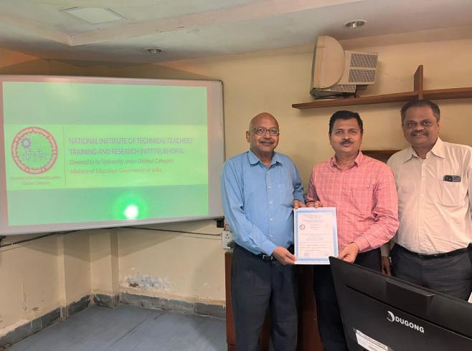 | 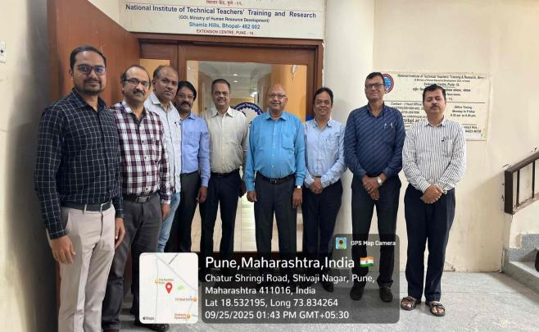
FDP on OBE and Curriculum at NITTR Pune | FDP on OBE and Curriculum at NITTR PUNE
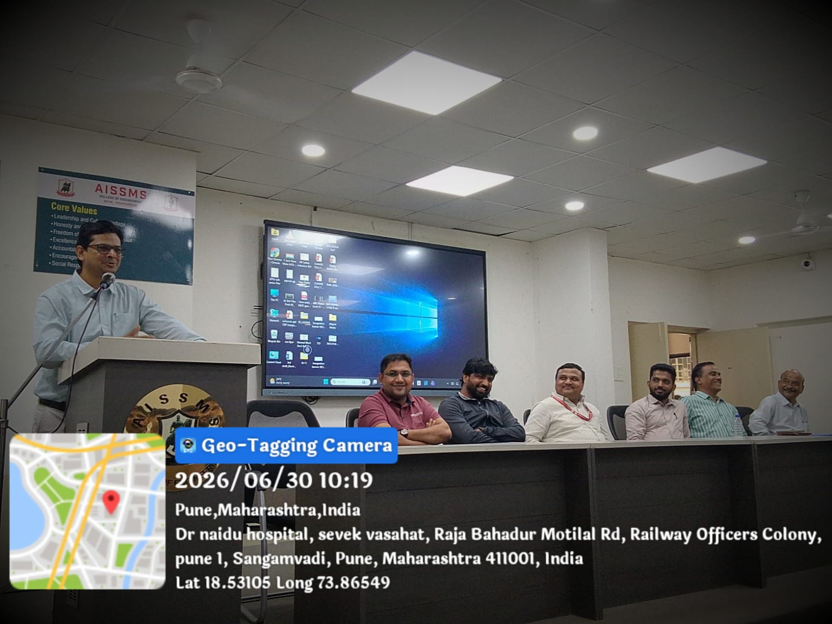 | 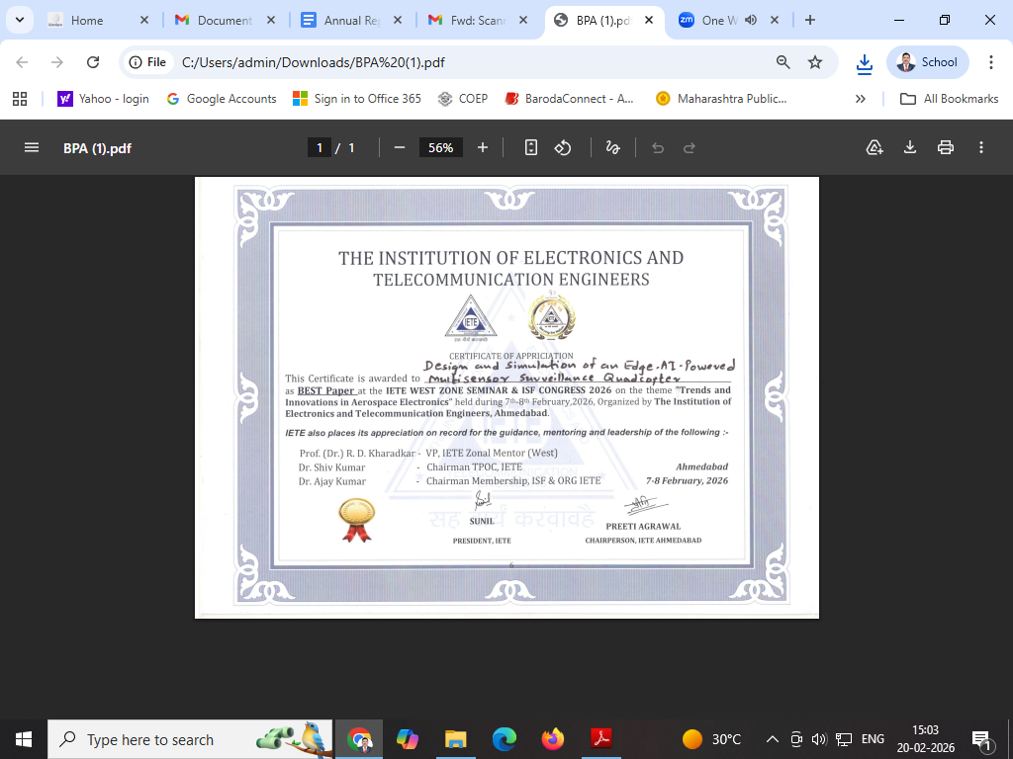

- ACTIVITIES ORGANIZED

3.1 FDP/STTP ORGANIZED BY THE DEPARTMENT
Term One
S N | Name of faculty coordinator | Title of the FDP/STTP/WS/Seminar/Symposium | Duration/ Dates | No. of Participants | Funding Agency  (If any) and Amount (Rs.)
1 | Dr A V Waghmare & Dr S H Wankhade | Lean Six Sigma Yellow Belt | 3 Days | 78 | Binghamton University, USA
2 | Dr S V Chaitanya & | Two days Workshop on Career Opportunity as Entrepreneur in | 21/08/2025 to 22/08/2025 | 167 | Association with Velocity Xcelerator Pvt Ltd pune

Term Two
S N | Name of faculty coordinator | Title of the FDP/STTP/WS/Seminar/Symposium | Duration/ Dates | No. of Participants | Funding Agency  (If any) and Amount (Rs.)
01 | Dr.C S Choudhari | Three Day Training Workshop on “Ansys and CFD” | 12-01-2026 to 14-01-2026 | 42 | Industry
02 | Dr. S V Chaitanya | Value added course Value added course On Preplacement Preparations for Mechanical Engineering Challenges | 11.02.2026 to 30 March 2026 | 117 | AISSMS COE
03 | Dr M R Dahake | ISTE Approved Online Faculty Development Programme on “Green Hydrogen Technologies: Production, Storage, and Applications for a Sustainable Future” | 23/03/2026 to 28/03/2026 | 122 | Rs. 23050/-
04 | Dr A V Waghmare | Techochill 2026 | 04/04/2026 | 160 | ISHRAE Pune Chapter
05 | Dr A V Waghmare | Student Convention 2026 | 11/04/2026 | 143 | SAE WIG
06 | Dr S H Wankhade  Mr S K Bidgar | IEI Project Idea Competition | 11 & 12 /04/2026 | 26 | IEI and AISSMS
07 | Dr C S Choudhari  Dr C S Dharankar | IE(I) Paper presentation | 11/04/2026 | 42 | AISSMS COE
08 | Dr S H Wankhade & Mr S K Bidgar | IE(I) Project Competition | 10/04/2026 & 11/04/2026 | 41 | IE(I)

3.2 SEMINARS/ WORKSHOPS/ WEBINARS ORGANIZED BY THE DEPARTMENT
Term One
S N | Name of Coordinator/s | Title of the Seminar/Webinar | Duration/ Dates | No. of Participants | Funding Agency  (If any) and Amount (Rs.)
1 | Dr, N N Gothindikar | SE Syllabus implementation workshop (2024 Pattern) | 22/07/2025 | 95 | NA
2 | Dr, S H Wankhade | SE Syllabus implementation workshop (2024 Pattern) | 22/07/2025 | 95 | NA
3 | Dr S V Chaitanya  Mr G P Lohar  Dr S A Ansari | Career as Entrepreneur | 21 - 22 August 2025 | 167 | AISSMS
4 | Dr S V Chaitanya  Dr S H Wankhade | Concept to Creation: A Practical Guide to Product Design | 12 /09/2025 | 25 | AISSMS

Term Two
S N | Name of Coordinator/s | Title of the Seminar/Webinar | Duration/ Dates | No. of Participants | Funding Agency  (If any) and Amount (Rs.)
01 | Mrs S S Chougule | The blueprint for success for Engineeris | 10/02/2026 | 73 | Mr. Ragawan Koli
02 | Dr. D S Malwad | Yukti Innovation Challenge 2026 | 28 April 2026 | 64 | AISSMS COE

3.3 CONFERENCES/ SYMPOSIUMS ORGANIZED BY THE DEPARTMENT
Term One
S N | Name of Coordinator/s | Title of the Conference / Symposium | Duration/ Dates | No. of Participants | Funding Agency  (If any) and Amount (Rs.)
 |  | NIL

Term Two
S N | Name of Coordinator/s | Title of the Conference / Symposium | Duration/ Dates | No. of Participants | Funding Agency  (If any) and Amount (Rs.)
 |  | NIL

3.4 EXTENSION ACTIVITIES CONDUCTED BY THE DEPARTMENT (Social activities / any other activity)
Term One
S N | Name of Faculty Coordinator | Details of activity conducted | Date | Number of beneficiaries
01 | Dr M R Dahake & Dr M R Phate | Visit and donating groceries to old age home (Swaminiwas Vruddhashram) | 08/10/2025 | 18
02 | P S Aglawe | Blood Donation | 24/09/2025 | 226
03 | Dr C S Choudhari Dr S A Ansari | Technical paper Presentation | 17/09/2025 | 19

Term Two
S N | Name of Faculty Coordinator | Details of activity conducted | Date | Number of beneficiaries
1 | P S Aglawe | NSS Special Residential camp at Kalyan VillageTal. Haveli Dist:.Pune | 29/01/2026-30/01/2026 | 4
2 | Dr C S Choudhari  Dr A V Waghmare | Drone and UAV Demonstrations at Vishwabharti English Medium School, Dhayari, Pune | 25/03/2026 | School students: 500
3 | Dr A V Waghmare | National level Convention 2025 (SAE India, Westen Section ) | 11/04/2026 | 143
4 | Dr M R Dahake | Sponsored lunch and donated Rs 15000/- to The Poona School for Blind Girls Kothrud Pune | 23/04/2026 | 120
5 | Dr. M. S. Deshmukh | A visit to AISSMS CoE solar roof top power plant | 22/04/2026 | 40
6 | Dr D S Malwad | Orientation program for YUKTI Innovation Challenge 2026 | 27/04/2026 | 22

3.5 MOU SIGNED WITH ACADEMIC AND PROFESSIONAL ORGANISATIONS
Term One
Sr. No. | Faculty Coordinator | Name of Organisation | Date  of MoU Signed | Valid upto  00/00/0000
NIL

Term Two
Sr. No. | Faculty Coordinator | Name of Organisation | Date  of MoU Signed | Valid upto  00/00/0000
 | NIL

Total Functional / Live MoU initiated by Department
Sr. No. | Faculty Coordinator | Name of Organisation | Date  of MoU Signed | Valid upto  00/00/0000

3.6 STUDENTS’ CHAPTERS /CLUBS
Sr. No | Name of Students’ Chapter | Number of Student Members
1 | IEI (I) Mechanical Engineering (CSC) | 39
2 | ISHRAE (SAA) | 30
3 | IMechE (NNG) | 46
4 | SAE (REEV, Aero-Design (Garudshwa), BAJA) (AVW) | 85
5 | FPSI (GPL) | 10

3.7 SOCIAL ACTIVITIES ORGANISED (NSS, Women empowerment, Awareness Programms, etc.)
Term One
Faculty coordinator | Name of Activity | Date, Duration | Number of students involved
Dr M R Dahake & Dr M R Phate | Visit and donating groceries to old age home (Swaminiwas Vruddhashram) | 08/10/2025 | 18
P S Aglawe | Blood Donation Camp | 24/09/2025 | 15

Term Two
Faculty coordinator | Name of Activity | Date, Duration | Number of students involved
P.SAglawe | NSS Special Residential camp at Kalyan VillageTal. Haveli Dist:.Pune | 23/01/2026-30/01/2026 | 23
Dr C S Choudhari  Dr A V Waghmare | Drone and UAV Demonstrations at Vishwabharti English Medium School, Dhayari, Pune | 25/03/2026 | 64
Dr M R Dahake | Sponsored lunch and donated Rs 15000/- to The Poona School for Blind Girls Kothrud Pune | 23/04/2026 | 15
Dr. M. S. Deshmukh | A visit to AISSMSCoE solar roof top power plant- A Climate Change Awareness Programm | 22/04/2026 | 40
Dr D Y Dhande  Dr V R Patil | E-waste awareness program as a part of earth week celebration | 22/04/2026 to 29/04/2026 | 35

3.8 PARENT MEETING
Faculty Coordinator | Day and Date | Details of Parent meetings organized | Number of Parents attended
A T Thombare | 19th September 2025 | Parents meet for Mechanical Engineering department was scheduled on 19th September 2025.The meet was arranged on Google meet platform. Number of points related to department, technical events , academics, training and placement, sandwich training ,examination etc. were discussed by HOD, Academic Coordinator ,Sandwich Coordinator, respective class GFM, and Examination coordinator. | 45
A T Thombare | Term 2 | Parents meet for Mechanical Engineering department was scheduled on 16th March 2026.The venue for the meet was department conference hall. Number of points discussed were students attendance, academics, training and placement, sandwich training ,examination etc. HOD, Academic Coordinator ,Sandwich Coordinator, respective class GFM, and Examination coordinator were present during the meeting. | 28

3.9 ALUMNI MEET
Faculty Coordinator | Day and Date | Details of Alumni meetings organized | Number of Alumni attended

3.10 SUPPORT FROM ALUMNI
Term One
Sr No | Name of Alumni | Position and Organisation | Batch of Alumni  (e.g. 2020 – 2024) | Details of Support | Date
01 | Aditya Wadhokar | MD, Fligen Systems | 2016-2017 | Placed 6 students

Term Two
Sr No | Name of Alumni | Position and Organisation | Batch of Alumni  (e.g. 2020 – 2024) | Details of Support | Date
01 | Mr Deepak Bhatia | Lead: E Drive Software Integration at Mercedes- Benz, Germany | 2002-2003 | Expert session on “EV Technology" for UG students in Jan 2026 | 09 / 01 / 2026
02 | Oshan Kothadiya | Supplier Quality Engineer at ASML Eindhoven, North Brabant, Netherlands | 2010-2011 | Interacted with BAJA Team | 03 / 02 / 2026
03 | Surjeet Real | Senior Manager (PQ-CV Engineering) Tata Motors, Pimpri | 2004-2005 | Project Guidance | 30 / 06 / 2026
04 | Mr Ganesh Inamdar (Praj Industries, Head of Distribution, 1 G Business | BOS Member | One postgraduate meritorious alumnus to be nominated by the principal | BOS member | 25/08/2025

3.11 INTERACTION WITH ALUMNI
Term One
S N | Name of Alumni and Activity coordinator | Details of Activity conducted | Date and duration | Total Number of beneficiaries
01 | Dr D Y Dhande | Discussion on Industry trends and demands in the view of Autonomy Syllabus Planning | 30/12/2025 | 35
02 | Mr Ganesh Inamdar (Praj Industries, Head of Distribution, 1 G Business) | Autonomy syllabus discussion | 21/07/2025 | Autonomy students
03 | Oshan Kothadiya | Interacted with BAJA Team | 03/02/2026 | BAJA team
04 | Surjeet Real | Project Guidance | 30/06/2026 | BAJA team

Term Two
S N | Name of Alumni and Activity coordinator | Details of Activity conducted | Date and duration | Total Number of beneficiaries
01 | Dr M M Sayyad & Dr D S Malwad ( Mr Deepak Bhatia) | Expert talk on “The current technologies in the latest Electric Vehicles” | 09 January 2026, 10:00 am to 12:00 pm | 62 students
02 | Mr Ganesh Inamdar-Praj Industries Ltd  Dr S V Chaitanya, Mrs Y K Funde | BOS meeting for SY B.Tech Syllabus finalization and approval | 10 March 2026  At 1:00 PM | Board Members and Department Faculties.

3.12 DETAILS OF STUDENT COUNSELING AND CAREER GUIDANCE AT THE DEPARTMENT LEVEL
Number of students referred for counseling | 01
Number of Faculty referred for counseling

Faculty coordinator | CAREER GUIDANCE ACTIVITY DETAILS
Dr. S A Ansari | BE MECH A & B GD & PI Session  11/08/2025-13/08/2025 (18 Hrs Total Students =70
Dr. S A Ansari | TE MECH A/B & SW APTITUTE TRAINING Session 29/10/2025-31/10/2025 18 Hrs Total Students =98
Dr. S A Ansari | SE MECH A/B & SW Soft Skill Training Session  21/04/2026-23/04/2026 18 Hrs Total Students =120

(Start on new page) Few good photographs related to different activities organized
Size of photo 5 cm x 7 cm with captions
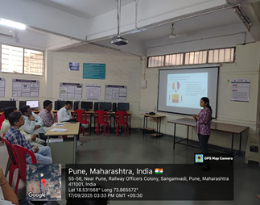 | 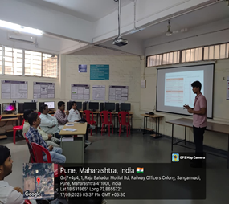
Students Presenting Technical Paper in the Paper presentation Competition
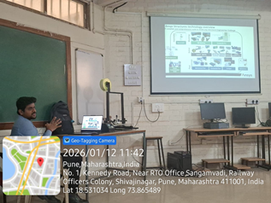 | 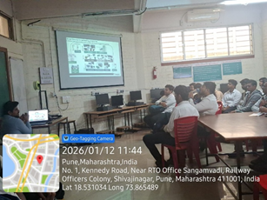
Three-day Certified workshop on “ANSYS and CFD”
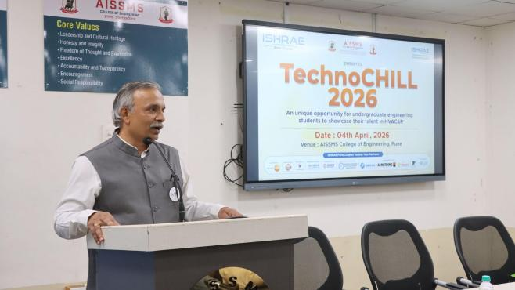 | 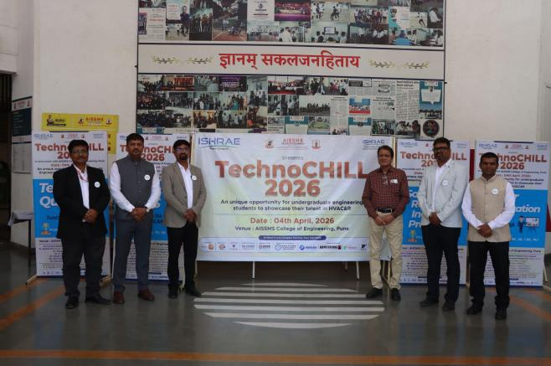
TechnoChill 2026 | TechnoChill 2026
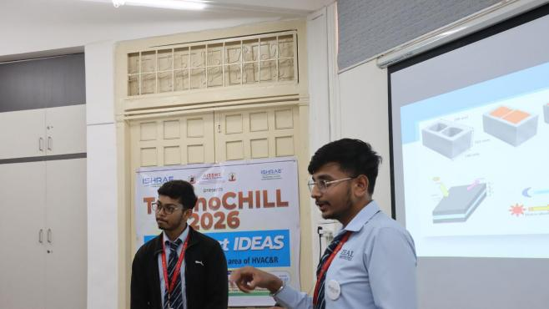 | 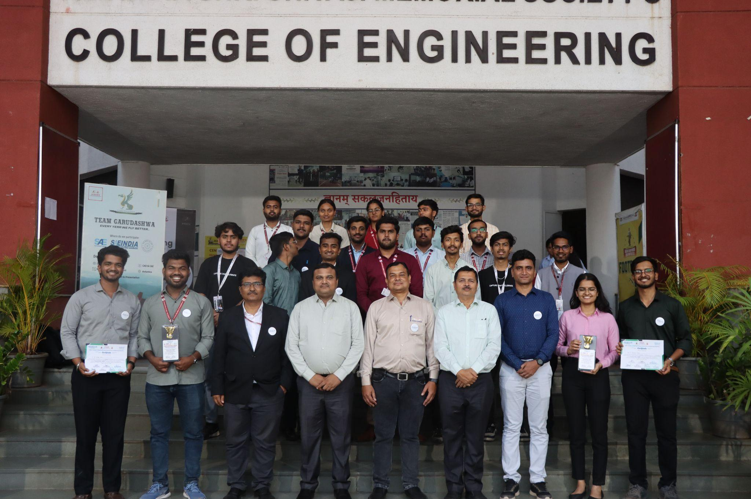
TechnoChill 2026 | TechnoChill 2026
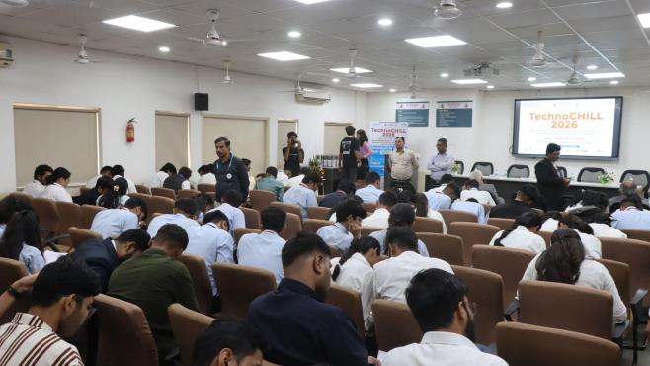 | 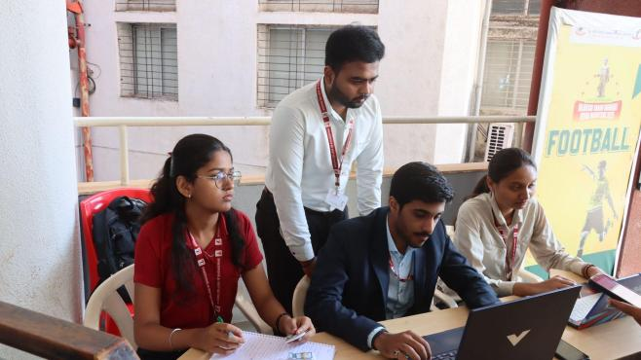
TechnoChill 2026 | TechnoChill 2026
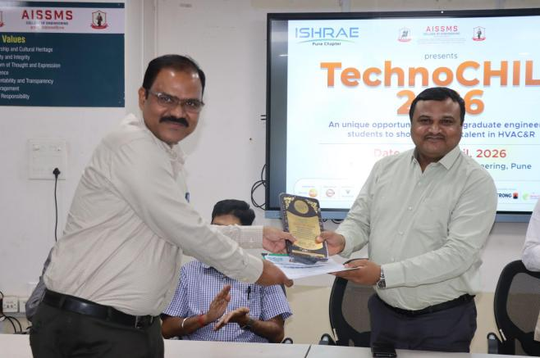
TechnoChill 2026 | TechnoChill 2026
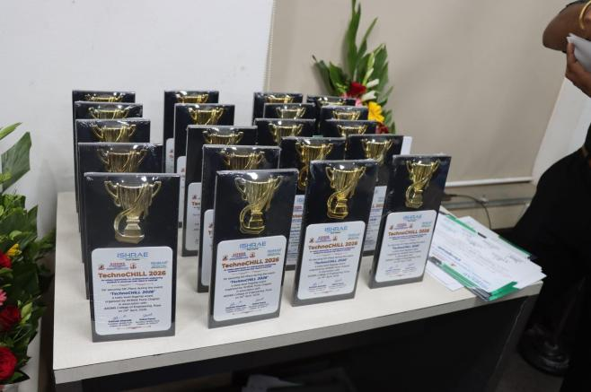 | 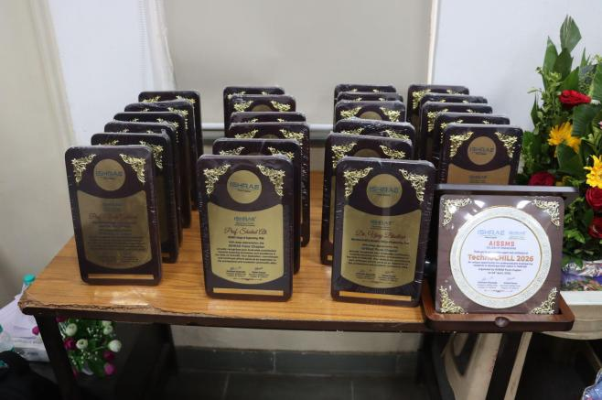
TechnoChill 2026 | TechnoChill 2026
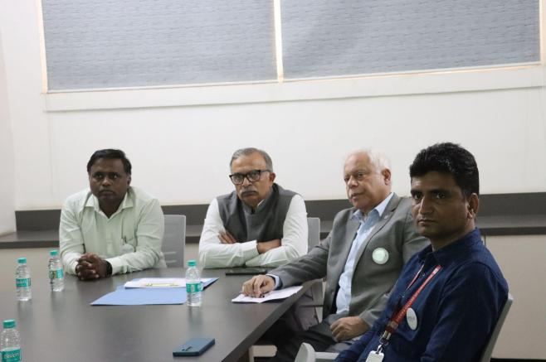 | 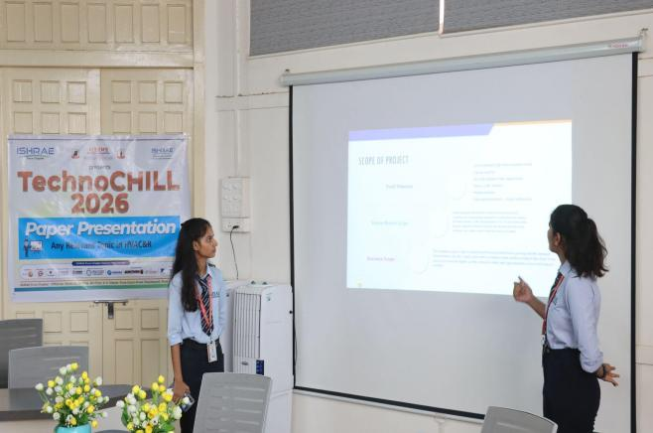
 | 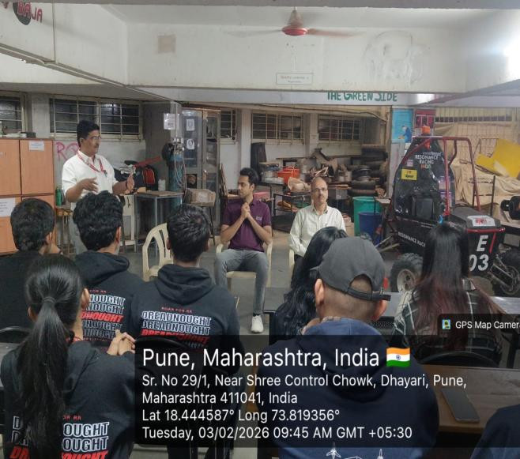
Industry experts interacting with Students before Project Evaluation | Interaction with Alumni
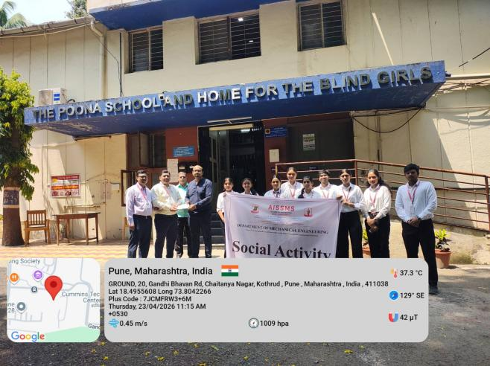 | 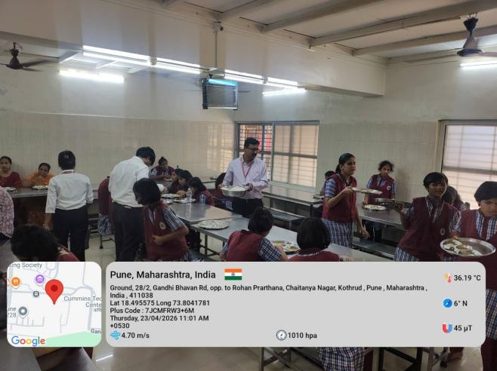
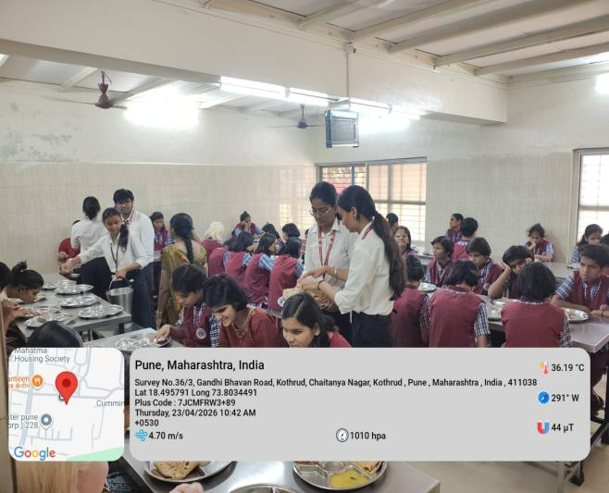 | 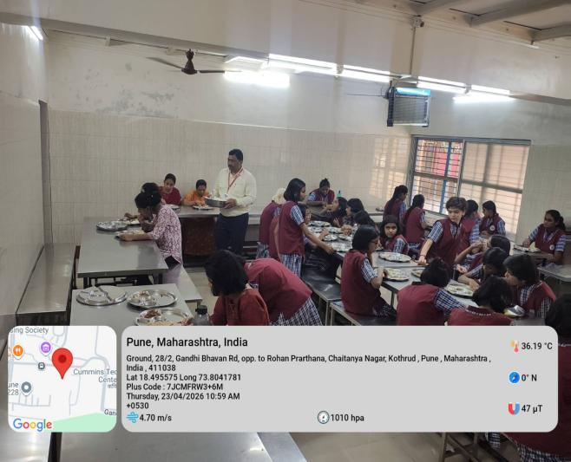
Social Activity of Sponsoring Lunch and Serving Them at The Poona School For Blind Girls
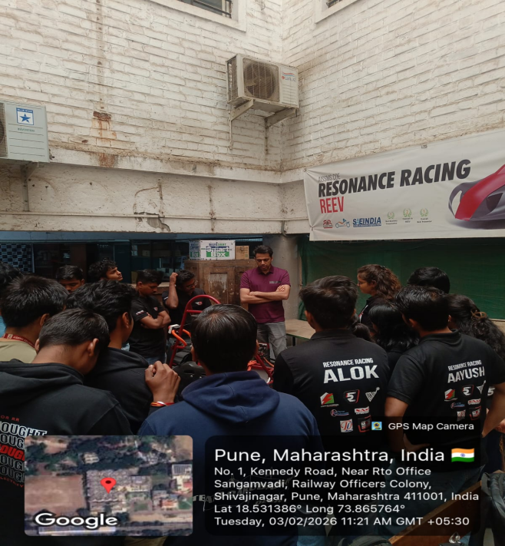
Alumni interacting with BAJA Students

3.13 SUSTAINABLE DEVELOPMENT GOALS (SDG) - INITIATIVES

Term I
S N | Name of Activity | Name of Coordinator | Date of Activity | No. of Participants | Resource person/Collaborating organization | SDG Goal(No and title)
1 | Visit and donating groceries to old age home (Swaminiwas Vruddhashram) | Dr M R Dahake & Dr M R Phate | 08/10/2025 | 18 | Swaminiwas Vruddhashram | SD1,SD2,SD4,SD7
2 | Blood Donation camp | P.S. Aglawe  (Blood Donation) | 24/09/2025 | 15 |  | SD1,SD2

Term II
S N | Name of Activity | Name of Coordinator | Date of Activity | No. of Participants | Resource person/Collaborating organization | SDG Goal(No and title)
01 | AISSMSCoE Solar Power plant visit | Dr. M. S. Deshmukh and Prof. S. M. Choudhari | 22/04/2026 | 40 | Prof. S. M. Choudhari , Electrical ENgineering Department | SD1,SD2
2. | Sponsored lunch and donated Rs 15000/- to The Poona School for Blind Girls Kothrud Pune | Dr. M. R. Dahake | 24/04/2026 | 14 | Poona School For Blind Girls Kothrud Pune | SD1,SD2,SD4,SD7
3. | Demonstration and Awareness program on Drones and Unmanned Vehicle | Dr. C. S. Choudhari and Dr. A. V. Waghmare | 24/03/2025 | School students @ 500 | Team Members from Garudashwa | SD1,SD2
4 | E-waste Awareness | Dr. V R Patil | 22/4/2026 | 60 | SE students | SDG 4,SDG12,SDG13,SDG3
5 | E- waste collection drive | Dr. V R Patil | 23/4/2026 and 13 May 2026 | 52 | Department faculties,students | SDG 4,SDG12,SDG13,SDG3
6 | Zero Plastic Drive | Dr. V R Patil | 28/4/2026 | 45 |  | SDG 13,SDG11,SDG15

Few good photographs related to different activities organized
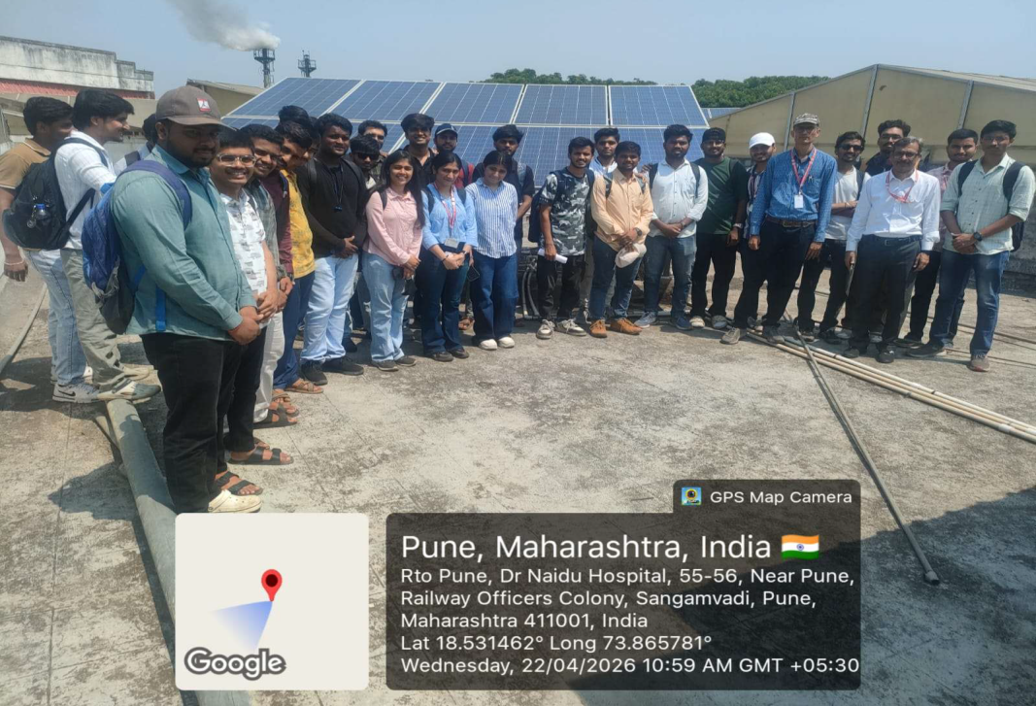
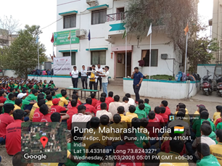
Demonstration and Awareness program on Drones and Unmanned Vehicle
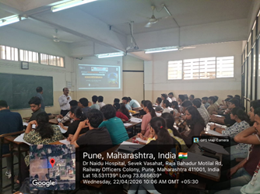
E-Waste Awareness Session
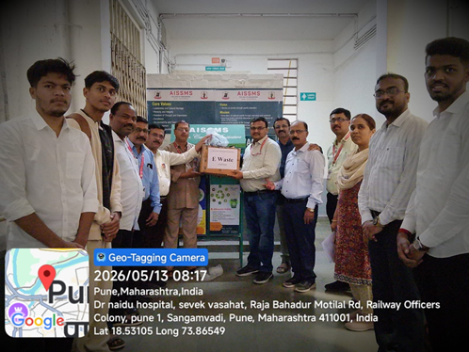
E-waste collection Drive

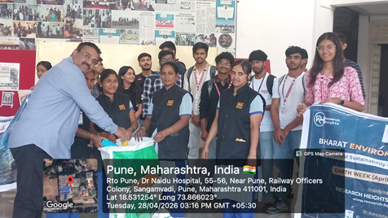

Zero Plastic Drive

- RESEARCH CONTRIBUTION

4.1 FUNDED RESEARCH PROJECT
Term One
S N | Principal Investigator | Title of the Project | Amount Received (Rs) | Funding Agency
1 | Dr M M Sayyad and Dr M S Deshmukh | Assessment of feasibility of EPDM material used as a sealant in discharge door of ploughshare mixer | 59000 | Redimix construction machinery limited pune

Term Two
S N | Principal Investigator | Title of the Project | Amount Received (Rs) | Funding Agency
1 | NIL

FUNDING RECEIVED FOR ANY OTHER ACTIVITY
Term One
S N | Faculty Coordinator | Title of the activity | Amount Received (Rs) | Funding Agency
1 | Dr M M Sayyad and Dr M S Deshmukh | Assessment of feasibility of EPDM material used as a sealant in discharge door of ploughshare mixer | 54000 | Redimix construction machinery limited pune

Term Two
S N | Faculty Coordinator | Title of the activity | Amount Received (Rs) | Funding Agency
1

4.2 TESTING AND CONSULTANCY
Term One
Sr. No. | Faculty Coordinator | Details of Testing & Consultancy Conducted | Total Revenue Generated (Rs.)
01 | Dr M M Sayyad and Dr M S Deshmukh | Assessment of Feasibility of EPDM Material Used as a Sealant in Discharge Door of Ploughshare Mixer | 54000

Term Two
Sr. No. | Faculty Coordinator | Details of Testing & Consultancy Conducted | Total Revenue Generated (Rs.)
01 | Dr D Y Dhande | Anit-wear test and Extreme Pressure Test as per ASTM D5183,ASTM D4172, ASTM D2266 for TWO lubricants | 29,600/-
02 | Dr D Y Dhande | Anit-wear test and Extreme Pressure Test as per ASTM D5183,ASTM D4172, ASTM D2266 for FOUR Lubricants | 59,661/-
03 | Dr. B D Bachchhav | Anti-wear Test as per ASTM D5183,ASTM D4172,ASTM D2265 (QTY. 1) | 7,500/-
04 | Dr D Y Dhande | Anit-wear test and Extreme Pressure Test as per ASTM D5183,ASTM D4172, ASTM D2266 for Three Lubricants | 42,480/-
05 | Dr D Y Dhande | Anit-wear test and Extreme Pressure Test as per ASTM D5183,ASTM D4172, ASTM D2266 for Two Lubricants | 28,320/-

4.3 PATENTS, COPYRIGHT, TRADEMARK AND OTHER (IPR)
Term One
Sr No. | Name of Faculty | Name of the Patent | Patent Number and Date | Type (National/  International/Commercialized)
1 | Dr M R Dahake  Mr M S Swami | Onion and Garlic Harvesting Machine | 459117-001 dated 29/09/2025 | National
2 | Dr C S Choudhari  Onkar Dhumal | Design and Performance Assessment of a  composite based desiccant wheel | LD-39360/2025-CO dated 29/09/2025 | National
3 | Dr S.J.Navale | Blockchain device for network security | 474221-001 dated 19/9/2025 | National

Term Two
Sr No. | Name of Faculty | Name of the Patent | Patent Number and Date | Type (National/  International/Commercialized)
1 | Dr M R Dahake | Arduino Based Fire Fighting Device | 480544-001 dated 06/02/2026 | National
2 | Dr M R Dahake | Autonomous UltravioletSterilization Device | 480545-001 dated 12/02/2026 | National
3 | Dr S V Chaitanya  Mr Ajinkya Patil | User defined function for ANSYS fluent developed to simulate hydrogen absorption in a metal hybrid reactor | SW-2026022302  Dt 29/01/2026  (Copy right) | National
4 | Dr M R Phate | LD-37575/2025-CO | Assessment of OBE based Engineering Psychomotor Skill Sets ) | National

TOTAL PATENTS DETAILS OF THE DEPARTMENT
Sr. No. | Faculty Coordinator | Title of patent | Status
 |  |  | Date of Filing | Date of Publication / Grant | National / International
01 | Dr M R Phate | Mechanical Chronometer with Plastic Gear And Pin Pallet Arrangement for 60 min time delay | 24/11/2022 | 24/04/ 2023 | National
02 | Dr M R Phate | Chronometer with variable time delay | 06/01/2023 | 15/03/2024 | National
03 | Dr M R Dahake  Mr M S Swami | Onion and Garlic Harvesting Machine | 16/05/2025 | 459117-001 dated 29/09/2025 | National
04 | Dr M R Dahake | Arduino Based Fire Fighting Device | 17/11/2025 | 480544-001 dated 06/02/2026 | National
05 | Dr M R Dahake | Autonomous Ultraviolet Sterilization Device | 17/11/2025 | 480545-001 dated 12/02/2026 | National
06 | Dr M S Deshmukh | Innovation Patent Australia-  Kitchen Items Cleaning Device: Kitchen Items Cleaning and  Disinfecting Device Using Water and UV-Light.  Australian Government, Innovation | Granted on 16th  September 2020 | Patent (Patent number: 2020101948) | International
07 | Dr M S Deshmukh | Innovation Patent Indian-  Pesticide Sprayer & COVID Sanitization Intelligent Drone | Innovation Patent,  202121062301 (03/2022) | DOP-21/01/2022 | Indian

TOTAL COPYRIGHT DETAILS OF THE DEPARTMENT
Sr. No. | Faculty Coordinator | Title of copyright | Status
 |  |  | Date of Filing | Date of Publication / Grant
1 | Dr Mangesh R Phate | Formulation of Experimental Data Based Model for the Machining Process using Dimensional Analysis Approach. | 07/02/2019 | Registered
2 | Dr Mangesh R Phate | Critical Analysis of novel fabricated Al/SiC/B4C Metal Matrix Composites Machining Performance. | 24/04/2019 | Registered
3 | Dr Mangesh R Phate | Analysis of 6-DOF Human Biodynamic Model for Seated Human Posture  Using Artificial Neural Network. | 14/05/2019 | Registered
4 | Dr Mangesh R Phate | Models for EDM of Novel Composition of Al/Cu/Ni MMC. | 11/02/2019 | Registered
5 | Dr Mangesh R Phate | Formulation Of Experimental Data Based Model For The Machining Process Using Artificial Neural Networks. | 10/09/2019 | Registered
6 | Dr Mangesh R Phate | Formulation Of Experimental Data Based Model For The Machining Process Using Higher Degree Response Surface Method. | 18/12/2019 | Registered
7 | Dr Mangesh R Phate | Easy and Efficient CO-PO/PSO Mapping Process for University Affiliated Engineering Institutes. | 15/02/2021 | Registered
8 | Dr Mangesh R Phate | Effective and Efficient design process based Algorithm for design of Gear Train use in Mechanical Chronometer. | 11/03/2024 | Registered
9 | Dr Mangesh R Phate | Research Methodology to investigate and formulate the performance model of Aluminum based MMC with Coconut and bagasse Ash Al/SiC/A. | 28/03/2024 | Registered
10 | Dr Mangesh R Phate | Framework for Outcomes Based Education (OBE) in Higher Educational Institute (HEI) | 09/07/2024 | Registered
11 | Dr Mangesh R Phate | Process To Formulate The Experimental Databased  Model For Mechanical Chronometer  Performance Evaluation | 04/12/2024 | Registered
12 | Dr Mangesh R Phate | Research Process To Formulate Machining  Performance Model For Aluminum Based MMC  With Coconut And Bagasse Ash Al/Sic/A.. | 22/11/2024 | Registered
13 | Dr N N Gotkhindikar | Analysis Of Fdm Based Additive Manufacturing Process Through Optimized Deep Learning Strategy. | 01/08/2023 | Registered
14 | Dr Mangesh R Phate | "Outcome Based Education  (OBE) Based Rubrics for Psychomotor Skillset Assessment | 17/09/2025 | LD-37575/2025-CO Registered
15 | Dr C S Choudhari  Omkar Dhumal | Design and Performance Assessment of a  composite based desiccant wheel | 29/09/2025 | LD-39360/2025-CO
16 | Dr S V Chaitanya  Mr Ajinkya Patil | User defined fuction for ANSYS fluent devloped to simulate hydrogen absorption in a metal hybrid reactor | SW-2026022302  Dt 29/01/2026  (Copy right) | National
17 | Dr.S A Ansari  Mr. Aryan Waware | Miniature Steam Power Plant | 20/09/2025 | LD-38034/2025-CO
18 | Dr. M. S. Deshmukh | New Mathematical model  for the Diesel Exhaust  Particulate Filter Efficiency | 17762/2018-  CO/L | 17762/2018-  CO/L

PUBLICATIONS
4.4 PAPERS PUBLISHED/ PRESENTED IN PROCEEDINGS OF CONFERENCES
Term One
S. No | Authors | Document Details | Year | Conference Details | ISBN | Organized  by
1 | S S Chougule | Solar-Powered Car: Prototype for Eco-Friendly Transportation | 2025 | Confluence 2025 | - | GM University Davanagere
2 | Dr M R Dahake | Analysis of Financial Viability of Green Hydrogen Production Plant In India | 2025 | 10th International Conference on Advances in Energy Research(ICAER 2025) |  | IIT Bombay

Term Two
S. No | Authors | Document Details | Year | Conference Details | ISBN | Organized  by
1 | Dr S H Wankhade | Automatic Liquid Purification Methods: Review | 2025 | Engineering Advances 2025 Second International Conference |  | pa
2 | Dr M R Dahake  Mr. Aaryan Patil | Design and Simulation of an Edge AI Powered Multisensor Surveillance Quadcopter | 2026 | IETE Seminar and ISF Congress |  | Adani University Ahmedabad
3 | Dr S H Wankhade | Systematic Product Innovation through the Integration of VAVE & TRIZ :A Proposed Synergistic Methodology | 2026 | 2nd International Conference on Innovative Engineering Design |  | NIT Uttarakhand & IIT Roorkee
4 | Dr M R Dahake | Metal Hydride Hydrogen Compressors for Industrial Scale Green Hydrogen: A Techno Economic Analysis and Market Readiness Assessment | 2026 | International Conference on Emerging Markets |  | National School of Banking Bangalore
5 | Dr M R Phate | Design and Performance Optimization of a 60-Minutes Mechanical Chronometer using Advanced Computational Techniques | 2026 | International Conference |  | Jindal College of Engineering
6 | Dr M R Phate | Manufacturing and testing of Al/SiC/Coconut & Bagasse Ash Metal Matrix Composite for Under water Application  API Journal | 2026 | International Conference |  | Jindal College of Engineering
7 | Dr D Y Dhande | Topology Optimization of Aluminium CastingStructure | 2026 | Recent Advances in Engineering -2025 |  | Poornima College of Engineering, Jaipur
8 | Mr S K Bidgar | Comparative Analysis of Nontreated and Cryotreated Inserts for Machinability of DTM Materials Using MADM Techniques: A Review | 12 to 14 March 2026 | International Conference (ICAMMS-2026) on Advancement Materials and Manufacturing for Sustainability -2026 | ICAMMS-2026 | Department of Mechanical Engineering, VNIT, Nagpur. Maharashtra, India
9 | Dr. M. S. Deshmukh | Design and fabrication of smart motorcycle helmet attachment | 2026 | IEEE Conference International | IEEE Conference 2026 | AISSMS CoE, Pune
10 | Ms Y K Funde | Design and  Mathematical  Modelling of  Payload in Lifting Mechanism of  Overhead Crane |  | 2 nd International  Conference on  Sustainable  Industry 4.0:  Innovations for a  Greener Future  (ICSI 2026) |  | Department  of Mechanical  Engineering and  Department of Automation and  Robotics

4.5 PAPERS PUBLISHED IN JOURNALS

Term One
S. No | Authors | Document Details | Year | Source Details | ISBN/  ISSN | Publisher
01 | Dr M R Phate | Manufacturing and Critical Analysis of Al/SiC/Coconut and Bagasse Ash MMC using Dimensional Analysis and Feed Forward Back –Propagation Neural Network. | 2025 | https://informaticsjournals.co.in/index.php/jmmf/article/view/49524 | 0022-2755 | Journal of Mines, Metals and Fuels
02 | Dr M R Phate | Design and Performance Evaluation of Mechanical Chronometer with Variable Time Delay Arrangement for Safe Evacuation of Mining Workers Using Soft Computing. | 2025 | https://informaticsjournals.co.in/index.php/jmmf/article/view/49556 | 0022-2755 | Journal of Mines, Metals and Fuels
03 | Choudhari, N., Dhande, D.Y. | Bimetallic Insert Casting Approach to Minimize Porosity and Improve Reliability of Aluminium Swing Arm | 2025 | International Journal of Metalcasting, 2025 | 2163-3193 | Springer
04 | Choudhari, N., Dhande, D.Y. | A Study on Steel Insert Integration for Porosity Reduction in Aluminium High-Pressure Die Castings | 2025 | J. Inst. Eng. India Ser. D | 2250-2130 | Springer
05 | Dr M R Phate | Formulation of Image Based Mass Model of Indian Potato (Solanum Tuberosum) with Selected Dimensional Attributes using Artificial Neural Network and Response Surface Method. | 2025 | Potato research | 0014-3065 | Springer
06 | Onkar A. Dhumal, C S Choudhari | Comprehensive characterization and analysis of superabsorbent polymers for dehumidication systems: insights from polynomial regression, BET analysis, and FTIR | 2025 | Analytical Science and Technology | ISSN/eISSN: 1225-0163/2288-8985 | WoS
07 | Ganesh Gamane, C S Choudhari | Topology Optimised Design for Additive Manufacturing | 2025 | International Journal of Advanced Research in Science, Communication and Technology | ISSN: 2581-9429 | IJARSCT
08 | Omkar Dhumal, C S Choudhari | Evaluation of R290 and R600a as sustainable substitute for R22 in refrigeration systems: Performance, Safety and environmental impacts | 2025 | International Journal of Advanced Research in Science, Communication and Technology | ISSN: 2581-9429 | IJARSCT
09 | V R Patil | Influence of Lower Blends of Algae Biodiesel on Diesel Engine Performance and Emissions | 2025 | The Archives of Automotive Engineering-Archiwum Motoryzacji |  | Archiwum Motoryzacji
10 | Dr S H Wankhade | Evaluating the Efficiency of Micro End Mill Tools and Performance Metrics in Micro Milling | 2025 | Advances in Science and Technology Research Journal | 2253–2265 | Politechnika Lubelska (Lublin University of Technology)
11 | Dr. S A Ansari | Performance Evaluation of Paraffin Wax as Phase Change Material in a Horizontal Cylindrical Thermal Energy Storage Unit | 2025 | Journal of Advanced Research in Fluid Mechanics and Thermal Sciences | 2289-7879 | SCI/ WOS
12 | Dr S H Wankhade | Center drill geometry mapping in friction drilling of Aluminium 6063 using artificial neural network approach | 2025 | Advances in Science and Technology Research Journal | 2253–2265 | Politechnika Lubelska (Lublin University of Technology)
135 | Dr M S Deshmukh | Investigation of Femur Head Implant Wear and Fatigue Properties for Climbing Upstairs and Climbing Down Stairs Without Rail Support | 2025 | Biointerface Research in Applied Chemistry | 2069-5837 | Biointerface Research in Applied Chemistry
14 | Mr. Nikhil S Pisal & Dr C. M Sedani | Crowdsourcing- Driven Product design and Development : A Mathematical and Empirical Framework for Enhancing Product Quality in SMES |  |  | International Journal of Applied Mathematics | Wos /Scopus
15 | Dr M R Dahake | Optimizing regenerative braking performance  in EVs through advanced deep learning models | 2025 | World Journal of Engineering | ISSN 1708-5284] | Emerald Publishing
16 | Ms Y K Funde | Failure Analysis of Wire Ropes in Lifting Systems | April-2026 | International Research Journal of Innovations in Engineering and Technology (IRJIET) | 2581-3048 | IRJIET
17 | Mr P.S.Aglawe | Modification and Implementation of a Dual-Variant  Compatible Sheet Metal Welding Fixture for  Flexible Manufacturing in a Live Production Line | April-2026 | International Research Journal of Innovations in Engineering and Technology  (IRJIET)  ISSN (online): 2581-3048  Volume 9, Issue 12, pp 1-20, December-2025  https://doi.org/10.47001/IRJIET/2025.912008 | 2581-3048  Volume 9, | IRJIET
18 | Dr S A Ansari | Verification Of Forming Force,Major And Minor Strain For  UHMWPE For Single Point Incremental Formingby Using  Experimental And Analytical Approach | 2025 | International Journal of Environmental Sciences | Vol. 11 No. 18s, 2025 | IJES

Term Two
S. No | Authors | Document Details | Year | Source Details | ISBN/  ISSN | Publisher
01 | Dr M R Phate | Integrated Grey Relational Analysis and Adaptive Neuro-Fuzzy Inference Based Approach for Mechanical Evacuation Timer Performance Analysis : Application in Mining Worker Safety Evacuation | 2026 | https://link.springer.com/article/10.1007/s40032-026-01323-y | 2250-0553 | Institution of Engg Series C
02 | Dr M R Phate | Precision Engineering of Mine Safety Timers: Multi-Objective Optimization of Pin Pallet Escapements Using Neuro-Fuzzy Systems | 2026 | Springer | 0256-2499 | SADHNA
03 | Dr M R Phate | Design, Development, and Performance Evaluation of Mechanical Time Delay Mechanism Integrated with Material Handling System for Effective Potato Quality Testing and Sorting | 2026 | Springer |  | Potato research
04 | Dr M R Dahake | An Adaptive Energy Efficient Regenerative Braking Control Systems in Electric Vehicle | 2026 | International Journal of System Assurance Engineering and Management  https://doi.org/10.1007/s13198-025-03119-2 | ISSN 0975-6809 | Springer
05 | Yogesh B Karandikar | International Research Journal of Innovations in Engineering and Technology - IRJIET | 2026 | https://irjiet.com/Volume-10/Issue-3-March-2026/Design-and-Manufacturing-of-Device-for-Industrial-Pipe-Cleaning-Internal-Cleaning-of-Circular-Pipes-/3121 | DOI Prefix: 10.47001/IRJIET
06 | Dr S V Chaitanya | HHO cell for Two Wheeler | April 2026 | International Research Journal of Innovations in Engineering and Technology (IRJIET) ISSN (online): 2581-3048 Volume 10, Issue 4, pp 262-269, April-2026 https://doi.org/10.47001/IRJIET/2026.104038 | ISSN (online): 2581-3048
07 | Dr S V Chaitanya | Performance Analysis of Load Cell–Based Carbon and Oil Weighing System | 2026 | INTERNATIONAL JOURNAL OF INNOVATIVE RESEARCH IN TECHNOLOGY | Volume 12 Issue 11 | ISSN: 2349-6002
08 | Dr S V Chaitanya | Quality Assurance and Manufacturing Processes related to Steering Column Components | Mar 2026 | International Research Journal of Engineering and Technology (IRJET) | e-ISSN: 2395-0056
09 | Dr S.J.Navale | Experimental investigation on banana root-derived bioethanol for spark-ignition engine applications: Performance and emission characteristics | Jan 2026 | Institution of Mechanical Engineers Part C | ISSN: 0954-4062 | SAGE
10 | Dr S.J.Navale | Simulation and virtual reality applications in medical training for tuberculosis diagnosis | Feb 2026 | Indian Journal of Tuberculosis | ISSN: 0019-5707 | Elsevier
11 | Dr S.J.Navale | Efficient solving of partial differential equations with new numerical methods | Feb 2026 | Journal of Interdisciplinary Mathematics | ISSN: 0972-0502 | Taru Publications
12 | Dr S.J.Navale | Mathematical models to optimize pandemic spread and control strategies in public health management | Mar 2026 | Journal of Interdisciplinary Mathematics | ISSN: 0972-0502 | Taru Publications
13 | Dr. N N Gotkhindikar | Machine Learning Model for Friction Prediction on Textured Surface | 2026 | IJRASET | ISSN:2321-9653 | IJRASET
13 | Dr D S Malwad | Experimental analysis of milled groove conformal cooling in injection molding | 2026 | AUT Journal of Mechanical Engineering | 2588-2937 | Amirkabir University of Technology
14 | Dr D S Malwad | A Comparative Study of Traditional and Sustainable Materials in Automotive for Noise, Vibration and Harshness | 2026 | International Journal of Engineering and Techniques | 2395-1303 | International Research Group
15 | Dr. M. S. Deshmukh | Design and Development of a Battery Thermal Management  System (BTMS) for an Electric Two-Wheeler Volume 10, Issue 5, pp 603-609, May-2026 | 2026 | International Research Journal of Innovations in Engineering and Technology (IRJIET) | ISSN (online): 2581-3048 | International Research Journal of Innovations in Engineering and Technology (IRJIET)
16 | Dr. M. S. Deshmukh | Thermal Audit of Ice Plant Using Ammonia (NH3) as Refrigerant | 2026 | International Journal for Research in Applied Science & Engineering Technology (IJRASET)  ; IC Value: 45.98;  Volume 14 Issue V May 2026 | ISSN: 2321-9653 | International Journal for Research in Applied Science & Engineering Technology (IJRASET)  ; IC Value: 45.98;  Volume 14 Issue V May 2026
17 | Dr. M. S. Deshmukh | Green Synthesis of MnFe₂O₄ Spinel Nanoparticles  Using Camellia sinensis Extract: Optical Bandgap  Engineering and Sunlight-driven Photocatalytic  Wastewater Remediation | 2026 | Journal of Environmental Nanotechnology  ( article in press) | ISSN 2279-0748 | Journal of Environmental Nanotechnology  ( article in press)
18 | Mr.P.S.Aglawe |  | April-2026 | International Research Journal of Innovations in Engineering and echnology  (IRJIET)  ISSN (online): 2581-3048  Volume 9, Issue 12, pp 1-20, December-2025  https://doi.org/10.47001/IRJIET/2025.912008 | 2581-3048  Volume  9, | TIRJIET
20 | Dr.S.R.Patil | Numerical Analysis of Forward Curved Impeller of Centrifugal Blower | June 2026 |  | ISSN;  2582-  3930 | International Journal of Scientific Research in Engineering and Management.
21 | Dr.S.R.Patil | Design Methodology of a Dual- Medium Propeller Using BET | June 2026 |  | ISSN:  2581-  3048 | International Research Journal of Innovations in Engineering and Technology.

4.6 BOOK / ARTICLE PUBLICATIONS
Term One
Author | Title of the Book | Published by | ISBN | Year
Nil | Nil | Nil | NIL | Nil

Term Two
Author | Title of the Book | Published by | ISBN | Year

4.7 RESEARCH CITATIONS (Source of Data: Google scholar) (As on 30th May)
Name of faculty | Citations, h-index, i10 index | Name of faculty | Citations, h-index, i10 index
Dr D S Malwad | 199,7,5 | Dr N N Gotkhindikar | 24,2,1
Dr M R Dahake | 125, 05, 05 | Dr.S.R.Patil | 93,05,03
Dr C S Choudhari | 344,8,6 | Dr.S.A Ansari | 72.01.01
Dr M R Phate | 679,15,20 | Dr A V Waghmare | 215, 4, 2
Dr D Y Dhande | 669,14,17 | Dr V R Patil | 38,4,2
Dr S J Navale | 106,04,02 | Dr M S Deshmukh | 131,6,1
Dr C S Dharankar |  | Dr M M Sayyad | 150,3,3
Total Citations of Department:

4.8 ME AWARDED
Sr No | Name of Supervisor | Title of Thesis | Name of Candidate
01 | Dr D Y Dhande | Propeller Shaft Emergency Braking System (19/06/2026) | Mr Baviskar Rahul N.

4.9 Ph.D. GUIDE DETAILS
Name of Faculty who are PhD Supervisor | Number of Scholars Registered
Dr M R Dahake | 01
Dr C S Choudhari | 03
Dr A V Waghmare | 04
Dr D Y Dhande | 04
Dr S V Chaitanya | 02
Dr C S Dharankar | 02
Dr S H Wankhede | 03
Dr. B D Bachchhav | 01
4.10 PhD AWARDED (For departments having Ph.D. research centers)

Sr No | Name of Supervisor | Title of Thesis | Name of Candidate

Few good photographs related to different activities organized under research, innovation
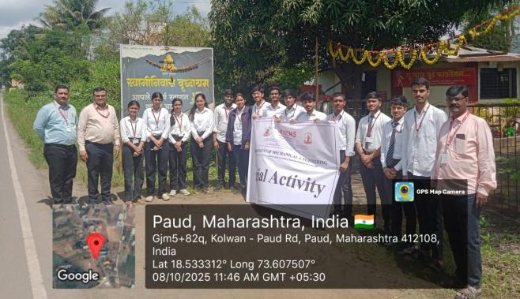 | 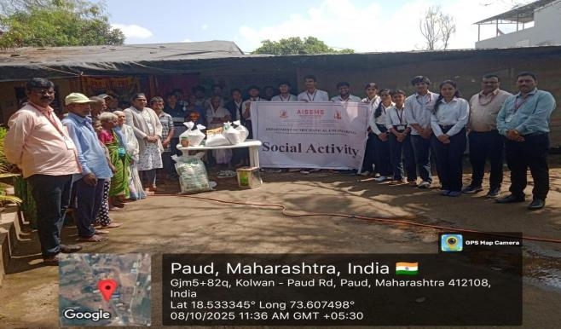
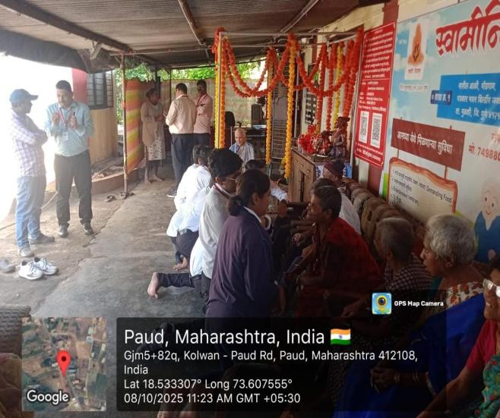 | 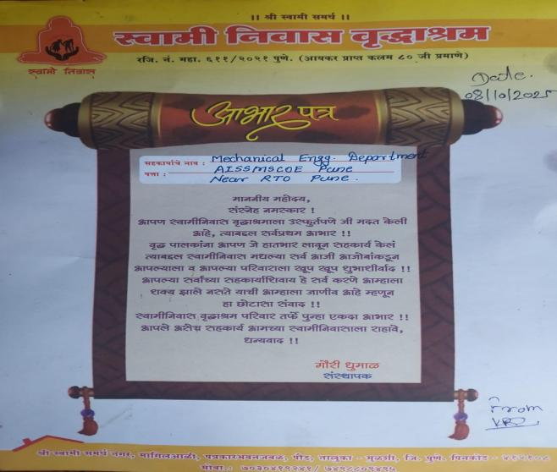
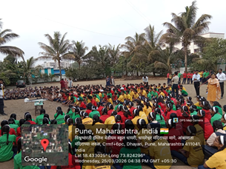 | 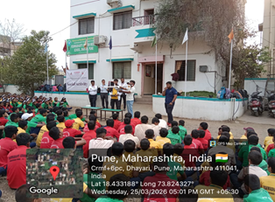
Social Activity at Vishwabharti English Medium School, Dhayari, Pune
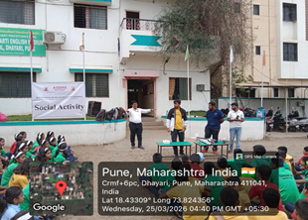
DEMONSTRATION OF AIRCRAFT MODEL AND DRONE

STUDENT PUBLICATIONS
4.11 PAPERS PUBLISHED/ PRESENTED IN CONFERENCES
Term One
S. No | Authors | Document Details | Year | Conference Details | ISBN | Organized  by
01 | MS S S Chougale | Confluence 2025 | 2026 | Confluence 2025 |  | G M University Davanagere
02 | Dr M R Dahake | ICAER 2025 IIT Bombay | 2025 | ICAER 2025 |  | IIT Bombay

Term Two
S. No | Authors | Document Details | Year | Conference Details | ISBN | Organized  by
01 | Mr S K Bidgar | International Conference (ICAMMS-2026) on Advancement Materials and Manufacturing for Sustainability -2026 | 2026 | International Conference (ICAMMS-2026) on Advancement Materials and Manufacturing for Sustainability -2026 |  | VNIT Nagpur
02 | Dr M R Phate | International Conference (ICAMMS-2026) on Advancement Materials and Manufacturing for Sustainability -2026 | 2026 | International Conference (ICAMMS-2026) on Advancement Materials and Manufacturing for Sustainability -2026 |  | VNIT Nagpur
03 | Dr M R Dahake | International Conference on Emerging Markets (ICEM 2026) |  | International Conference on Emerging Markets (ICEM 2026) |  | NSB Bangalore
04 | Dr M R Phate | Emerging Trends & Technologies -2026 |  | Emerging Trends & Technologies -2026 |  | ISBE Pune
05 | Dr S H Wankhede | 13th International Conference on Transformations in Engineering Education (ICITIEE 2026) |  | 13th International Conference on Transformations in Engineering Education (ICITIEE 2026) |  | GITAM (Deemed to be) University, Bengaluru
06 | Dr D Y Dhande | Recent Advances in Engineering - 2025 (ICARE 2025) |  | Recent Advances in Engineering - 2025 (ICARE 2025) |  | Poornima College of Engineering, Jaipur

4.12 PAPERS PUBLISHED IN JOURNALS
Term One
S. No | Authors | Document Details | Year | Source Details | ISBN/  ISSN | Publisher
1 | Ganesh Gamane1 and Dr. C. S. Choudhari | Topology Optimized Design for Additive  Manufacturing | 2025 | Volume 5, Issue 1, November 2025 | ISSN: 2581-9429 | International Journal of Advanced Research in Science, Communication and Technology

Term Two
S. No | Authors | Document Details | Year | Source Details | ISBN/  ISSN | Publisher
1 | Y. B. Karandikar, Mihir D. Salunkhe,  Jatin V. Shitole,  Shivraj S. Kadam, Mayur B. Sonkamble | Design and Manufacturing of Device for Industrial Pipe  Cleaning (Internal Cleaning of Circular Pipes) | 2025-2026 | Volume 10, Issue 3, pp 175-178, | 2581-3048 | International Research Journal of Innovations in Engineering and Technology (IRJIET)
2 | Amey Yadav,  Abhishek Ghatge, Aaditya Thorve,  Dr. Dnyaneshwar Malwad,  Dr. Chandrashekhar Dharankar | A Comparative Study of Traditional and Sustainable Materials in Automotive for Noise, Vibration and Harshness | 2025-2026 | Volume 12 Issue 3, | ISSN: 2395-1303 | International Journal of Engineering and Techniques
3 | Anuja Baredar,  Pratiksha Borate,  Vaishnavi Doke,  Mr.Y. P. Patil | Design of Cold Storage with Process Layout | 2025-2026 | Volume 10, Issue 5, pp 366-370 | ISSN (online): 2581-3048 | International Research Journal of Innovations in Engineering and Technology (IRJIET)
4 | Dr. Manoj Dahake,  Dr. Priya Gajjal,  Aaryan Patil,  Samar Patil,  Akhilesh Kulkarni,  Vinay Shedge | Design and Simulation of an Edge AI-Powered Multi-Sensor Surveillance Quadcopter for Disaster Response and Autonomous Victim Detection | 2025-2026 |  |  | THE INSTITUTION OF ELECTRONICS AND TELECOMMUNICATION ENGINEERS (Recognized as SIRO by DSIR, Govt. of India)
5 | Tanishq Katkar,  Harshwardhan Atpadkar,  Yash Bodade | DESIGN AND DEVELOPMENT OF UNIVERSAL RIG FOR BACKLASH MEASUREMENT AND OPTIMIZATION | 2025-2026 | Volume: 13 Issue | e-ISSN: 2395-0056,  p-ISSN: 2395-0072 | International Research Journal of Engineering and Technology (IRJET)
6 | Dr. M.R Phate,  Prof. R.A. Marne,  Jatin A. Nirgude,  Sarang P. Pimparkar,  Abhay S. Patil,  Ajit S. Shinde | Formulation of Experimental Database Model of Indian Plantain Banana | 2025-2026 | Volume 10, Issue 6, pp 167-173 | ISSN (online): 2581-3048 | International Research Journal of Innovations in Engineering and Technology (IRJIET)
7 | Dr. C. S. Dharankar,  Manav Matwankar,  Om Pardeshi,  Ankit Lande,  Om Abnave | Development of a MATLAB/Simulink Model with Graphical User Interface for Prediction of Engine Forces in a Single-Cylinder Four- Stroke Engine | 2025-2026 | Vol. 15 Issue 06 | ISSN: 2278-0181 | International Journal of Engineering Research & Technology (IJERT)
8 | Dr. Manish S Deshmukh,  Pawar Chaitanaya Sanjay,  Jadhav Rohit Kishor | Design and fabrication of smart motorcycle helmet attachment | 2025-2026 | Volume 4, Issue 6 | ISSN: 2984-8903 | INTERNATIONAL JOURNAL OF VERSATILE RESEARCH AND ANALYSIS (IJVRA)
9 | Prof. S.S.Chaughule,  Avishkar Varpe,  Swapnil Soultale,  Harshit Tirpude,  Vaishnavi Ghode | Development and Performance Evaluation of an Automated Dual-Axis Tracking Scheffler Reflector | 2025-2026 | Volume 9, Issue 12, pp 1-20 | ISSN (online): 2581-3048 | International Research Journal of Innovations in Engineering and Technology (IRJIET)
10 | Dr.Mangesh Phate,  Shraddha Gore,  Harsha Deshmukh,  Vedant Harkare,  Sumedh Joshi | Formulation of Experimental Data-Based Artificial Neural Network Model for Performance Evaluation of Lubricating Oil Blends | 2025-2026 | Vol. 15 Issue 05 | ISSN: 2278-0181 | International Journal of Engineering Research & Technology (IJERT)
11 | Atharva Kulkarni,  Vaishnavi Mate,  Anushka Nalawade,  Avanti Nanote,  Dr. Mangesh Phate5 | Seagull-Inspired Centrifugal Fan: Design, Numerical Analysis, and CFD Validation. | 2025-2026 | Volume 13, Issue 6 | ISSN-2349-5162 | Journal of Emerging Technology and Innovative Research [JETIR)
12 | Dr. Dinesh Dhande,  Vaishnavi Kapase,  Devashish Joshi,  Sahil Adagale,  Nupoor Holkar | Camber Morphing Wing Design and Aerodynamic Analysis for Fixed Wing UAV | 2025-2026 | Volume 14 Issue V | ISSN: 2321-9653 | International Journal for Research in Applied Science & Engineering Technology (IJRASET)
13 | Vinay Dhende,  Abhishek Avhad,  Rushikesh Jadhav,  Aditya Amin,  C. S. Choudhari | Performance Analysis of Refrigerants R22 and R290 in Vapour Compression Refrigeration Systems Under Different Operating Conditions | 2025-2026 | Volume: 10 Issue | ISSN: 2582-3930 | International Journal of Scientific Research in Engineering and Management (IJSREM)
14 | Karan Kankate,  Omkar Dhaybar,  Atharva Patil,  Abhishek Abhale,  Prof. M.P. Shah | STRUCTURAL OPTIMIZATION OF ENGINE MOUNT FOR MARUTI SUZUKI WAGON R: WEIGHT REDUCTION AND VIBRATION ATTENUATION STUDY | 2025-2026 | Volume: 13 Issue: 06 | e-ISSN:2395-0056,  p-ISSN:2395-0072 | International Research Journal of Engineering and Technology (IRJET)
15 | Prof. G. P. Lohar,  Dr. A. V. Waghmare,  Parth Machewar,  Atharva Jambhulkar,  Jay Kasar,  Shlok Chaudhari | DESIGN AND DEVELOPMENT OF AN AUTOMATED WIRE CUTTING AND END-CHAMFERING MACHINE FOR DKO HYDRAULIC FITTING ASSEMBLY | 2025-2026 | Volume: 13 Issue: 06 | e-ISSN: 2395-0056,  p-ISSN: 2395-0072 | International Research Journal of Engineering and Technology (IRJET)
16 | Vasudha Shinde,  Mehak Shaikh,  Ruchi Yadav,  M. U. Gan | Design and Analysis of Centrifugal Fan Blade Inspired By Teal Bird Wings | 2025-2026 | Volume 10, Issue 5, pp 200-203, | ISSN (online): 2581-3048 | International Research Journal of Innovations in Engineering and Technology (IRJIET)
17 | Atharv Jamdade,  Atharva Jagtap,  Aditya Gogawale,  Harsh Dhumal,  S. J. Navale | Design and Development of Regenerative Suspension System Using Rack and Pinion Mechanism | 2025-2026 | Volume 10, Issue 5, pp 433-440, | ISSN (online): 2581-3048 | International Research Journal of Innovations in Engineering and Technology (IRJIET)
18 | Pratik Ghuge,  Sushant Ghongade,  Shashank Govekar,  Shreeya Jadhav,  Dr M.S.Deshamukh | Design and Development of a Battery Thermal Management System (BTMS) for an Electric Two-Wheeler | 2025-2026 | Volume 10, Issue 5, pp 603-609, | ISSN (online): 2581-3048 | International Research Journal of Innovations in Engineering and Technology (IRJIET)
19 | Atharva G. Khaire,  Tejas K. Ghodake,  Mujjamil A. Jamadar,  Mitanshu R. Hire,  J.S.Supekar | Drill Indexing Jig for Industrial Applications | 2025-2026 | Volume 10, Issue 5, pp 713-719, | ISSN (online): 2581-3048 | International Research Journal of Innovations in Engineering and Technology (IRJIET)
20 | Suraj Ghuge,  Sakshi Daphal,  Aishwarya Dhumal,  Mayur Gaul,  V. R. Patil | Design & Development of Solar Peltier Plate Refrigerator | 2025-2026 | Volume 10, Issue 6, pp 140-149 | ISSN (online): 2581-3048 | International Research Journal of Innovations in Engineering and Technology (IRJIET)
21 | Aditya Vinod Makade,  Manish Rajeshrao Swan,  Tejas Ashok Shendge,  Shreyas Ramakant Chaudhari,  Prof. O.A.More | Automatic Seed Sowing Machine for Agriculture Sector | 2025-2026 | Volume 10, Issue 3, pp 20-23 | ISSN (online): 2581-3048 | International Research Journal of Innovations in Engineering and Technology (IRJIET)
22 | Avishkar Patil,  Samarth Mane,  Varad Ghule,  Yogita Funde,  Chandrashekar Dharankar | Failure Analysis of Wire Ropes in Lifting Systems | 2025-2026 | Volume 10, Issue 4, pp 242-246 | ISSN (online): 2581-3048 | International Research Journal of Innovations in Engineering and Technology (IRJIET)
23 | Sahil P. Badgujar,  S.V. Chaitanya,  Om Bhatjire,  Sarthak Bhogil,  Pushpak Chadorikar | HHO Cell for Two Wheeler | 2025-2026 | Volume 10, Issue 4, pp 262-269 | ISSN (online): 2581-3048 | International Research Journal of Innovations in Engineering and Technology (IRJIET)
24 | Prof. A.T. Thombare,  Ruturaj Wagh,  Sanket Rahatikar,  Yash Sanware | Optimization of Passive Suspension | 2025-2026
25 | Ms. Hritika Chafekar,  Mr. Prasad Gonewar,  Mr. Karan Kunte,  Mr. Dheeraj Kamble,  Dr. Sunil Patil | Design Methodology of a Dual-Medium Propeller using BET | 2025-2026 | Volume 10, Issue 6, pp 266-276 | ISSN (online): | International Research Journal of Innovations in Engineering and Technology (IRJIET)
26 | Omkar Chavan,  Prathamesh Dangmali,  Deep Dhande,  Rohan Godbole,  Prof. S. K. Bidgar | Electricity Generation from Speed Breakers Using Rack-and-Pinion Mechanism with DC Generator | 2025-2026 |  |  | International Journal of Mechanical and Energy Engineering
27 | P. S. Aglawe,  Shivaji M. Mane,  Manas N. Kulkarni,  Arihant S. Upadhye | Modification and Implementation of a Dual-Variant Compatible Sheet Metal Welding Fixture for Flexible Manufacturing in a Live Production Line | 2025-2026 | Volume 9, Issue 12, pp 1-20 | ISSN (online): 2581-3048 | International Research Journal of Innovations in Engineering and Technology  (IRJIET)
28 | Prof. M.S. Swami,  Mr. Sawailal Savlaram Suthar,  Miss. Vaishnavi Sunil Sonawane,  Mr. Satyam Vinod Chaudhari,  Miss. Vaishnavi Raosaheb Sangle | Design and Development of Solar-Assisted, Dual Charging Electric Scooter | 2025-2026 | Volume: 13 Issue: 03 | e-ISSN:2395-0056  p-ISSN:2395-0072 | International Research Journal of Engineering and Technology (IRJET)
29 | Manish Deshmukh,  Vaishnavi Pasalkar, Arish Patel,  Abubakar Sayed | Thermal Audit of Ice Plant Using Ammonia (NH3) as Refrigerant | 2025-2026 | Volume 14 Issue V | ISSN: 2321-9653 | International Journal for Research in Applied Science & Engineering Technology (IJRASET)
31 | Dr. N. N. Gotkhindikar,  Atharva Dhanegave,  Janhavi Nikam,  Prathamesh Karwa | Machine Learning Model for Friction Prediction on Textured Surface | 2025-2026 | Volume 14 Issue V | ISSN: 2321-9653 | International Journal for Research in Applied Science & Engineering Technology (IJRASET)
32 | Dr. S.H. Wankhade,  Mr. Ganesh Nikumbh,  Mr. SynyaanTarkash,  Mr. Yashraj Patil,  Mr. Pankaj Waghmare | Design and Development of Smart Aquaculture System for Automatic Fish Feeding and Real-Time Water Quality Analysis | 2025-2026 | Volume 6 Issue 12 | ISSN: 2349-6002 | IJIRT
33 | Rahul Baviskar, Dr D Y Dhande | Propeller Shaft Emergency Braking System | 2025-2026 | Volume 13, Issue 2 | 2348-1269 | International Journal of Research and Analytical Reviews (IJRAR)
34 | Vinay Dhende, C S Choudhari | Performance analysis of refrigerants R22 and R290 in vapour compression refrigeration systems under different operating conditions | 2025-2026 | Vol. 10 Issue. 06 June 26 | ISSN: 2582 3930 | International Journal of Scientific research in Engineering and Management (IJSREM)
35 | Ms Y K Funde | Failure Analysis of Wire Ropes in Lifting Systems | 2025-2026 | Vol 10,Issue 6 | 2581-3048 | IRJIET
36 | Mr.Suraj Ghuge,Sakshi Daphal,Aishwarya Dhumal,Mayur Gaul,Dr. V R Patil | Design and Development of Solar Peltier Plate Refrigerator | 2025-2026 | Vol 10,Issue 6 | ISSN (online)2581-3048 | IRJIET
37 | Sushant Shivshankar Ghongade  Pratik Gajanan Ghuge  Shashank Somnath Govekar  Shreeya Makarand Jadhav  Dr. M. S. Deshmukh | Design and Development of a Battery Thermal Management  System (BTMS) for an Electric Two-Wheeler | 2025-2026 | Volume 10, Issue 5, pp 603-609, May-2026 | ISSN (online): 2581-3048 | International Research Journal of Innovations in Engineering and Technology (IRJIET)

4.13 IPR (PATENTS, COPYRIGHT, AND OTHER )
Term One
Sr No. | Name of Student | Name of the Patent | Patent Number and Date | Type (National/  International/Com  mercialized)

Term Two
Sr No. | Name of Student | Name of the Patent | Patent Number and Date | Type (National/  International/Com  mercialized)
1 | Rahul Baviskar, Dr. D Y Dhande (Copyright) | PROPELLER SHAFT EMERGENCY BRAKING SYSTEM | LD-22037/2026-CO | National
2 | Rahul Baviskar, Dr. D Y Dhande (Patent) | PROPELLER SHAFT EMERGENCY BRAKING SYSTEM | 202621043276 | National

- INTERACTION WITH INDUSTRY

5.1 INDUSTRY VISITS ORGANISED
Term One
Sr. No. | Faculty Coordinator | Class and Number of students attended | Industry Name and Address | Date of visit
1 | Dr. S V Chaitanya | TE M A&B, TE MS (130) | Sachin Forge Sanaswadi pune | 16, 17 & 23/09/2025
2 | Dr. M S Deshmukh | BE M B Div. (50) | Balgandharv Rangmandir, Shivajinagar Pune | 19/09/2025
3 | Mr. M U Gan | BE M A&B Div (69) | Koyna Dam and Power Station, Koynanagar, Dist Satara. | 08/10/2025
4 | Ms S S Chougule  Mr S K Bidgaar | SE M A&B (100) | Siddheshwar Industries Pvt Ltd. Talwade Pune | 15/10/2025
5 | Dr A V Waghmare | BE M A  (48) | Central Air-Conditioning System at Balgandharv Rangmandir, Pune | 18/09/2025

Term Two
Sr. No. | Faculty Coordinator | Class and Number of students attended | Industry Name and Address | Date of visit
1 | Ms Y K Funde & Mr O A More | TE M A (42) | Specialty Sintered Products Pvt Ltd Pune | 15/04/2026
2 | Dr. M R Dahake | SE M A&B (127) | CWMSRTC Dapodi Pune | 16&17/04/2026
3 | Dr V R Patil | SE MS (48) | Katraj Dairy Pune | 16/04/2026
4 | Dr S A Ansari | TE M A&B (57) | Stauff India Pvt Ltd. Samaswadi Pune | 22/04/2026
5 | Mr S K Bidgaar  Ms Y K Funde | SE M A and MS (110) | Siddheshwar Industries Pvt Ltd Pune | 24/04/2026
6 | Dr. A V Waghmare | TE M B (43) | Unitread Sanaswadi Pune | 24/04/2026
7 | Mr S K Bidgar | TE M B (50) | Specially Sintered Products Pvt Ltd Shirwal Pune | 28/04/2026

5.2 EXPERT LECTURES / WEBINARS DELIVERED BY INDUSTRY EXPERTS (Dr M R Dahake)
Term One
Sr. No. | Faculty Coordinator | Class  (Number of students attended) | Name, Industry, designation and contact details of Expert | Topic | Date
1 | Dr. C S Choudhari | TE MS (47) | Mr Aaryan Jagushte Robotics Engineer ROBOTRY Pune | Unlocking Robotics with ROS2 | 15/07/2025
2 | Dr. S V Chaitanya | TE M (30) | Mr Ajinkya Patil  RIT Sangli | Skill development domain- Heat Transfer | 18/07/2025
3 | Dr. C S Chaoudhari | TE MS (47) | Mrs. Dipali Babhulkar Sr. Manager TATA Motors Pune | Fundamentals of Vehicle Dynamics | 27/07/2025
4 | Dr. D Y Dhande | TE MS/ BE M (70) | Mr Nitin Choudhari Hero Motocorp Jaipur | Porosity Reduction in Aluminium Castings using Topology Optimization | 28/07/2025
5 | Dr. M R Phate | SE M A&B, MS (161) | Dr Amruta Chimote Sr. Lecturer UTAS Oman | Unlocking Potential (Leadership Skill) | 19/08/2025
6 | Dr. M R Phate | SE M A&B, MS (158) | Dr Amruta Chimote Sr. Lecturer UTAS Oman | Effective Communication and Speech Crafting Ideas | 20/08/2025
7 | Dr D S Malwad | TE Mech (61) | Dr Amarnath Gupta International Trainer and Consultant | Converting Innovation into Startup | 28/08/2025
8 | Ms M P Shah | TE M A&B, MS (89) | Mr. Alok Sasane Certified Trainer | Careers in PLM Automotive Design- Explore Real Industry Opportunities | 09/09/2025
9 | Ms M P Shah | BE M A&B(48) | Mr. Tukaram Varak Technical Director. Cad Cambridge Solutions Pvt Ltd Pune | Application of FEA and CFD in mechanical engineering | 10/09/2025
10 | Dr. D S Malwad | TE/BE M (97) | Mr Surajkumar Tekale Sr Software Engineer Intelizign Lifecycle Services Pvt Ltd Pune | Driving digital transformation through product lifecycle management | 11/09/2025
11 | Dr S R Patil | TE M A& MS (81) | Mr Shailesh Patil Dy Gen Manager Tata Technologies Pune | CAE Tools, applications in automotive industry and job opportunities | 17/09/2025
12 | Dr. M R Phate | TE/BE M (61) | Mr. Kaustubh Kumbhar Technical Lead Wipro Technology Pune | From data to decisions: Industrial applications of data science and Gen AI | 25/09/2025
13 | Dr. N N Gothkhindikar | SE M A&B (117) | Mr Sudarshan Palve Speciality Sintered Products Pvt Ltd Pune | Powder metallurgy advances in manufacturing | 26/09/2025
14 | Ms. S S Chougule | TE M A&B (63) | Ms. Sonam Pawar Design Consultant Elte Electro Engineers Pvt Ltd Pune | Designing for safety: Insights into fire fighting systems | 08/10/2025
15 | Ms. A T Thombare | SE M A&B (55) | Mr Rajkumar LalProcess Head Cad Enfield Technologies Pune | Battery design with Simulink for electric vehicle | 09/10/2025
16 | Mr S K Bidgar | TE/BE M B(110) | Mr Vivek Deshpande Director AI Adventure Pune | Role of AI and Python in modern mechanical systems | 09/10/2025
17 | Mr. S K Bidgar | TE M A&B(87) | Mr Balasaheb Dahifale Dy. Gen. Manager Cummins India Ltd Pune | Manufacturing simulation | 10/10/2025
18 | Dr. M R Dahake | TE/BE M B(67) | Dr Mahesh Jadhav IP Intellect Solutions Pune | Monetizing Innovation: The strategic edge of IPR careers | 13/10/2025
19 | Dr. N N Gothkhindikar | SE M A&B(78) | Mr Darshan Narayanpure CadInfield Technologies Pune | Geometric diamensioning and tolerancing | 14/10/2025
20 | Ms. Y K Funde | TE M B(44) | Mr Vijay Umbre | Industrial Automation | 14/10/2025
21 | DR D Y Dhande | SE/TE/BE Mech (45) | Mr Nilesh Rhatwal Lead CAE Engineer Adient India Pvt Ltd Pune | Finite element and computer aided engineering | 30/10/2025

Term Two
Sr. No. | Faculty Coordinator | Class  (Number of students attended) | Name, Industry, designation and contact details of Expert | Topic | Date
1 | Dr D S Malwad | SE/BE M (89) | Mr. Deepak Bhatia Lead E drive software integration | Current trends in electric vehicles | 09/01/2026
2 | Ms S S Chougule | SE A/B/SW (73) | Mr. Raghuvan Koli  Int. Motivational Spaker, Fourshlag Overseas Services Germany | The blueprint of success for engineers | 10/02/2026
3 | Ms Y K Funde | SE M A (54) | Mr Balaji Dapke Dr GM Sales & Marketing GROZ NET Industries Pune | Manufacturing processes | 12/02/2026
4 | Dr M R Dahake | SE M B (52) | Dr Dadasaheb Shendage H2e Power Systems Pvt Ltd Pune | Role of hydrogen fuel cells | 28/03/2026
5 | Dr C S Choudhari | TE M A BE M A/B (68) | Mr Arvind Paranjape Retd. AGM TATA Power Mumbai | Power plant engineering | 07/04/2026
6 | Dr M R Phate | BE SW (20) | Dr Mayuri Ardak Rode Director Pratyag Technocart Pvt Ltd Pune | Application of design in mining industry | 13/04/2026
7 | Mr S K Bidgar | SE SW (67) | Mr Santosh Khawale | New product design and development | 30/04/2026

5.3 INDUSTRY – SPONSORED PROJECTS (UG/PG) ((Excluding Sandwich Projects)
Sr. No. | Name of Project guide | Title of Industry Sponsored Project | Name of Sponsoring Industry
1 | Mr.Y.P.Patil | Design of Cold Storage with Process Layout | Ashapuri Ref Solutions Pvt.Ltd
2 | Mr.Y.B.Karandikar | Design and Development of Pipe Cleaning Device | Kalaban Foods Pvt.Ltd.
3 | Dr. M.M.Sayyad | Thermodynamic analysis and MATLAB Simulation of R22 and NH3 Vapour Compression Cycle in Ice Factory | Refcool solutions
4 | Dr A V Waghmare  Mr G P Lohar | Design and development of an automated wire cutting and end chamfering machine for DKO hydraulic machine assembly | Stauff India, Lonikand

5.4 MOU SIGNED WITH INDUSTRY
Term One
Sr. No. | Name of Industry | Name of Coordinator | Date of MoU Signed | Valid  upto
1 | Avinya Technologies Pune | Dr S H Wankhade | 18/07/2025 | 17/07/2026
2 | Pratyag Technocart Pvt Ltd. Pune | Dr M R Phate | 04/08/2025 | 03/08/2028
3 | Setco Spindles India Pvt Ltd Pune | Dr S V Chaitanya | 19/08/2025 | 18/08/2028
4 | Stead Solve Design & Manufacturing Solutions LLP Pune | Dr S V Chaitanya | 20/08/2025 | 19/08/2028
5 | MCAD Solutions Pune | Dr M R Phate | 17/09/2025 | 16/09/2028
6 | Pritomatic Technologies India Pvt Ltd Pune | Dr S A Ansari | 17/11/2025 | 16/11/2028

Term Two
Sr. No. | Name of Industry | Name of Coordinator | Date of MoU Signed | Valid  upto
1 | TPM HTEC India Pvt Ltd Pune | Dr M R Dahake Mr S K Bidgar | 30/01/2026 | 29/01/2029
2 | Zenith Dfabex Pune | Ms Y K Funde | 13/02/2026 | 12/02/2031
3 | TECHLUSTER Pune | Dr M R Dahake | 07/04/2026 | 06/04/2029

TOTAL FUNCTIONAL / LIVE MOU INITIATED BY THE DEPARTMENT
Sr. No. | Faculty Coordinator | Name of Industry | Date  of MoU Signed | Valid upto  (dd/mm/yyyy)
01 | Dr M R Dahake | TECHLUSTER Pune | 07/04/2026 | 06/04/2029
02 | Dr S V Chaitanya | Setco Spindles India Pvt Ltd Pune | 19/08/2025 | 18/08/2028
03 | Dr M R Dahake Mr S K Bidgar | TPM HTEC India Pvt Ltd Pune | 30/01/2026 | 29/01/2029
04 | Dr S A Ansari | Pritomatic Technologies India Pvt Ltd Pune | 17/11/2025 | 16/11/2028
05 | Dr S H Wankhade | Avinya Technologies Pune | 18/07/2025 | 17/07/2026
06 | Dr M R Phate | MCAD Solutions Pune | 17/09/2025 | 16/09/2028
07 | Dr M R Phate | Pratyag Technocart Pvt Ltd. Pune | 04/08/2025 | 03/08/2028
08 | Dr S V Chaitanya | Stead Solve Design & Manufacturing Solutions LLP Pune | 20/08/2025 | 19/08/2028
09 | Dr M R Dahake | Motorman Lubricants LLP Pune | 29/07/2024 | 28/07/2027
10 | Dr C S Chaudhari | ASKpro Solutions Pune | 14/08/2024 | 13/08/2027
11 | Dr B D Bachchhav | Pooja Castings Pvt Ltd Pune | 18/03/2025 | 17/03/2026
12 | Dr A V Waghmare | Ameya Industries Pune | 31/08/2021 | Until it is discontinued by both parties.
13 | Mr P S Aglawe | E-Addict Mobility Solutions Pvt Ltd OPC Pune | 05/08/2022 | 04/08/2025
14 | Dr S H Wankhede | Twin Engineers Pvt Ltd Pune | 10/04/2023 | 09/04/2028
15 | Ms Y K Funde | Zenith Dfabex Pune | 13/02/2026 | 12/02/2031

5.5 FACULTY MEMBERS UNDERGONE INDUSTRIAL TRAINING
Term One
Sr. No. | Name of Faculty | Name of Industry | Dates and Duration
01 | Dr M R Phate | Pratyag PVt Ltd narhe | 17/06/2025 to 19/06/2025
2 | Dr N N Gotkhindikar | MThread Pvt Ltd | 17/05/2025 to 08/06/2025
3 | Mr S K Bidgar | Speciality Sintered Product Pvt. Ltd., Shirwal, Satara | 09/06/2025 to 20/06/2025
4 | Dr S.J.Navale | Indotech Industries Pvt Ltd | 8/12/2025 to 26/12/2026

Term Two
Sr. No. | Name of Faculty | Name of Industry | Dates and Duration
01 | Dr M R Phate | Pratyag PVt Ltd narhe | 17/06/2025 to 19/06/2025
02 | Mr S K Bidgar | Speciality Sintered Product Pvt. Ltd., Shirwal, Satara | 08/12/2025 to 12/12/2025
03 | Dr D S Malwad | Simusoft Technologies Pvt Ltd Pune | 11/03/2026 to 18/03/2026
04 | Ms Y K Funde | VRMMETAZINE PVT.Ltd  Ambethan, Khed, Pune - | 15/05/2026 to 30/05/2026

5.6 STUDENTS UNDERGONE IN-PLANT TRAINING AND (OR) INTERNSHIP PROGRAMME (Excluding Sandwich Training) Dr M R Dahake
Term One
Sr. No. | Name of the Student | Name of the Industry | Class | Training duration
 |  |  |  | Start date | Last date | Duration (days)
01 | NIL

Term Two
Sr. No. | Name of the Student | Name of the Industry | Class | Training duration
 |  |  |  | Start date | Last date | Duration (days)
1 | Anarase Yadnyesh Dnyaneshwar | Diesel Loco Shed , Ghorpadi , Pune | TE M A | 05-01-2026 | 05-02-2026 | 25
2 | Apurv Mahesh Pednekar | System Engineering Plot No.112 Tiny Industrial Estate, Kondhwa Pisoli Road, Kondhwa Pisoli Roadpisoli Road, Kondhwa Budruk-411048 | TE M A | 22-12-2025 | 21-01-2026 | 31
3 | Atharva Ram Gore | Pinnacle Polymers, Ambethan Rd, Chalan MIDC | TE M A | 02-01-2026 | 31-01-2026 | 30
4 | Auti Himanshu Shivkiran | Kalyani Technoforge, Mundhwa Industrial Area, Mundhwa | TE M A | 05-01-2026 | 31-01-2026 | 23
5 | Avhad Akash Adinath | Kalyani technoforge Ltd,Mundhwa, Pune | TE M A | 05-01-2026 | 31-01-2026 | 23
6 | Bade Rushikesh Devidas | Diesel Loco Shed Ghorpadi Pune | TE M A | 02-01-2026 | 02-02-2026 | 30
7 | Bagwan Abuzar Ayyub | Diesel loco shed, Ghopadi pune | TE M A | 05-01-2026 | 05-02-2026 | 25
8 | BARMUKH SUMEET VAIBHAV (Carry On) | Pinnacle Polymers, Ambethan Rd, Chalan MIDC | TE M A | 02-01-2026 | 31-01-2026 | 21
9 | Belagade Aditi Sachin | Vardhan Agro Processing Limited, Tal Khatav, Dist Satara | TE M A | 01-01-2026 | 30-04-2026 | 24
10 | Benadikar Arnav Ashwin | Trio Enterprises, B-4 Shiroli MIDC kolhapur | TE M A | 06-01-2026 | 07-02-2026 | 31
11 | Bhandaru Siddharth | RINL Vizag SteelPlant, Vishakhpatnam | TE M A | 05-01-2026 | 30-01-2026 | 26
12 | Bhondve Tejas Dnyandev | DIESEL LOCO SHED GHORPADI PUNE. | TE M A | 02-01-2026 | 02-02-2026 | 31
13 | Bhopale Vaishnav Laxman | Jay shri ram engineering Chinchwad Pune | TE M A | 01-01-2026 | 31-01-2026 | 30
14 | Bhor Akshay Bharat | Cametech Technology Bhosari sector 10 | TE M A | 22-12-2025 | 31-01-2026 | 28
15 | Bhor Shantanu Bharat | Kalyani technoforge Ltd,Mundhwa, Pune | TE M A | 05-01-2026 | 31-01-2026 | 25
16 | Bhosale Kunal Kundlik | Pinnacle Polymers. Plot No. E65/2 MIDC, Ranjangaon, Tal- Shirur Dist. Pune- 412220 | TE M A | 02-01-2026 | 31-01-2026 | 30
17 | Bhujbal Aishwarya Sachin | Greenflame Private Limited Parner, Ahmednagar | TE M A | 13-01-2026 | 13-02-2026 | 30
18 | Bodkhe Anirudha Vijay | Pinnacle Polymers, Ambethan Rd, Chalan MIDC | TE M A | 01-01-2026 | 31-01-2026 | 28
19 | Chaudhari Puja Rajesh | Dhiraj Engineering Works, Jalgaon; PLOT NO . V = 126, MIDC, Jalgaon, Maharashtra 425003 | TE M A | 05-01-2026 | 31-01-2026 | 30
20 | CHAVAN SAHIL PRAKASH (Carry On) | Mahindra pune motors narhe | TE M A | 01-01-2026 | 31-01-2026 | 31
21 | Chinmay Kulkarni | Phillips Machine tools, Chakan, Pune | TE M A | 01-01-2026 | 31-01-2026 | 31
22 | Chousalkar Vaishnavi Prasad | ICON Precision Engineering, Chikhali ,Pune | TE M A | 31-12-2025 | 31-01-2026 | 24
23 | Dahikamble Deepak Bandeappa | Pune Motors, 6/5/1, Narhe - Ambegaon Road, pune 411041 | TE M A | 01-01-2026 | 31-01-2026 | 24
24 | Dangi Mayur Yogesh | Bharat forge limited,mundhawa ,pune -36 | TE M A | 25-12-2025 | 31-01-2026 | 31
25 | Desale Sahil Pratap | Pinnacle Polymers, Ambethan Rd, Chalan MIDC | TE M A | 02-01-2026 | 31-01-2026 | 28
26 | Deshmukh Anish Nilesh | SPARKOTECH s. No. 25/7, Dedge Industrial Estate, Near Savali Dhaba, Nanded phata, Sinhagad Road, Pune-411041. | TE M A | 01-01-2026 | 31-01-2026 | 26
27 | Deshpande Atharvaa Saleel | Manimarkh Urja pvt ltd, kothrud , Pune | TE M A | 27-12-2025 | 04-02-2026 | 30
28 | Devdikar Soham Makarand | Pinnacle Polymers, Ambethan Rd, Chalan MIDC | TE M A | 02-01-2026 | 31-01-2026 | 29
29 | Dhage Sandhya Anil | Vanaz Engineers limited Kothrud | TE M A | 01-01-2026 | 22-01-2026 | 22
30 | Dhamdhere Yuvraj Uday | TATA MOTORS Passenger Vehicle plant Ltd, Chikhali, Pune | TE M A | 05-01-2026 | 06-03-2026 | 60
31 | Dhebe Sunil Dhondiba | SPARKOTECH s. No. 25/7, Dedge Industrial Estate, Near Savali Dhaba, Nanded phata, Sinhagad Road, Pune-411041. | TE M A | 01-01-2026 | 31-01-2026 | 31
32 | Dhekle Siddhesh Milind | Intensify Technology/ Shelkewadi ,Ghotawade Pune | TE M A | 01-01-2026 | 01-02-2026 | 31
33 | Dhruv Pravin Patil | Intensify Technology/ Shelkewadi ,Pune | TE M A | 01-01-2026 | 01-02-2026 | 30
34 | Dikshant Kadu | Spiral Tools Pvt. Ltd. Address:- Gat no.6, B1 Village- kasurdi, Khedshivapur Taluka Bhor District Pune- 412205 | TE M A | 02-01-2026 | 31-01-2026 | 30
35 | Durgude Ruturaj Mahesh | Marelli Motherson Automotive Lighting India (MMLI). Atpost:Ambethan,Tal: Khed, Dist:Pune | TE M A | 12-01-2026 | 12-02-2026 | 30
36 | Dusane Pooja Ashok | Dhiraj Engineering Works, Jalgaon; PLOT NO . V = 126, MIDC, Jalgaon, Maharashtra 425003 | TE M A | 05-01-2026 | 31-01-2026 | 30
37 | Dusunge Shrikant Dnyaneshwar | Eka mobility,chakan. | TE M A | 07-01-2026 | 06-02-2026 | 30
38 | Ekanksh Deepak Ghavalkar | Bhagyashree Accessories Pvt. Ltd. Narhe Industrial Area, Narhe 411041 | TE M A | 01-01-2026 | 31-01-2026 | 31
39 | GADE ATHARVA DADA (Carry On) | Unity Technologies, Walunj, Aurangabad | TE M A | 02-01-2026 | 02-02-2026 | 25
40 | Gaikwad Mrudula Dilip | Crystalline Buildcon Pvt.ltd. Fortune square by pritam group, Dharmaveer Nagar Opposite sunrise business park Balewadi High Street , Baner Pune | TE M A | 22-12-2025 | 22-01-2026 | 28
41 | Garud Atharva Mukund | Infinity Technology, J-446, M.I.D.C, Bhosari, Pune- 411026 | TE M A | 05-01-2026 | 05-02-2026 | 31
42 | Gavali Sneha Vishal | Anant Engineering & Company, 270, mangalwar peth, pune 411011 | TE M A | 23-12-2025 | 23-01-2026 | 31
43 | Gawade Sarthak Dadasaheb | Pinnacle Polymers, Ambethan Rd, Chalan MIDC | TE M A | 01-01-2026 | 06-02-2026 | 28
44 | Gawande Mayur Vijay | CAD-MECH ENGINEERING PVT.LTD.Abhinav Pharmacy College, Narhe, Pune 411041 | TE M A | 22-12-2025 | 22-01-2026 | 30
45 | Ghodichor Piyush Mahadeo | MSC Enterprises S4/1, T-Block, Near Post Office, MIDC, Bhosari, Pune-411026. | TE M A | 21-12-2025 | 31-01-2026 | 30
46 | Ghodke Siddhesh Anil | Pinnacle Polymers, Ambethan Rd, Chalan MIDC | TE M A | 02-01-2026 | 31-01-2026 | 24
47 | Ghule Hariom Vitthal | HITECHGURU LASER INDUSTRIES PVT. LTD. Address:-Sector no.: 10, Plot no. 103, MIDC, Bhosari, Pune | TE M A | 22-12-2025 | 22-01-2026 | 31
48 | Gorlewar Shraddha Mahadeo | KGC engineering project pvt.ltd.,S BLOCK,bhosari MIDC | TE M A | 22-12-2025 | 22-01-2026 | 24
49 | Gulmar Sahil Santosh | Crest precision industries | TE M A | 05-01-2026 | 05-02-2026 | 30
50 | Gumphekar Soham Avinash | Aaba Engineering. Jaihind colony, Akbar, Nashik - 422010 | TE M A | 02-01-2026 | 31-01-2026 | 30
51 | Gutte Ramkrishna Manik | KSB Pumps Private limited . Vambori Dist. Ahilyanagar | TE M A | 05-01-2026 | 05-02-2026 | 24
52 | Halde Abhishek Santosh | Crest Precision Screws Pvt.ltd , Pune , khed | TE M A | 05-01-2026 | 05-02-2026 | 30
53 | Hande Chaitanya Kaviraj | Bharat forge limited,mundhawa ,pune -36 | TE M A | 22-12-2025 | 31-01-2026 | 30
54 | Ingawale Sanika Balasaheb | Vinayak Roofing Services Wakad, Pune | TE M A | 23-12-2025 | 23-01-2026 | 28
55 | Ingawale Shlok Santosh | MCAU Automation Technology, Saswad, Pune | TE M A | 01-01-2026 | 31-01-2026 | 24
56 | Jadhav Ganraj Bajirao | BALAJI ENGINEERING WORKS,MOSHI,PUNE-412105 | TE M A | 02-01-2026 | 02-02-2026 | 25
57 | JADHAV VAIBHAV KAMLESH (Carry On) | Soneshwar Industries, BlockNo, 185, 5+185/4, Soneshwar Industries, ch ShahuCo-Op.ind.Estate, PlotNo.36-37, Shirol Bypass Rd, Agar Bhag, Agar, Maharashtra 416144 | TE M A | 02-01-2026 | 31-01-2026 | 26
58 | Joshi Sanskar Krupasagar | HITECHGURU LASER INDUSTRIES PVT LTD Sector No.:-10, Plot No. 103, PCNTDA, Bhosari, Pune - 411026 | TE M A | 22-12-2025 | 22-01-2026 | 24
59 | Jumde Akshat Atul | Bhagyashree Accessories Private Limited, Narhe, Pune | TE M A | 01-01-2026 | 31-01-2026 | 30
60 | Kale Atharv Santosh | Diesel Loco Shed Ghorpadi Pune | TE M A | 02-01-2026 | 02-02-2026 | 31
61 | Kale Sumit Sambhaji | Premium transmission Ltd (kalbhor nagar pcmc) | TE M A | 01-01-2026 | 30-01-2026 | 30
62 | Kalkeri Yash Anand | Micro India engineering, Katraj near jambhulwadi lake | TE M A | 22-12-2025 | 30-01-2026 | 30
63 | Kamble Nilesh Satish | Bhagyashree Accessories Pvt. Ltd. Narhe Industrial Area, Narhe 411041 | TE M A | 01-01-2026 | 31-01-2026 | 31
64 | Karve Shreyas Vaijanath | Uluka Systems pvt ltd VJ Indilife, 1523, Pashan - Sus Rd, Vardayani Society, Pashan, Pune, Maharashtra 411021 | TE M A | 04-01-2026 | 04-02-2026 | 22
65 | Katakdhond Yash Dattkumar | Trust Tooling Kondhwa, Pune | TE M A | 01-01-2026 | 30-01-2026 | 30
66 | Kavyadeep Dipak Khilare | Trust Tooling Kondhwa, Pune | TE M A | 01-01-2026 | 30-01-2026 | 30
67 | Kekan Akash Sugriv | HITECHGURU LASER INDUSTRIES PVT LTD Sector No.:-10, Plot No. 103, PCNTDA, Bhosari, Pune - 411026 | TE M A | 22-12-2025 | 22-01-2026 | 22
68 | Khairnar Rohan Pankaj | MSC Enterprises Plot S4, 1, T Block, MIDC, Bhosari, Pimpri-Chinchwad, Maharashtra 411026 | TE M A | 22-12-2025 | 31-01-2026 | 30
69 | Kharmate Omkar Vinayak | CAMTECH Technology, Bhosari, Pune -411026 | TE M A | 22-12-2025 | 31-01-2026 | 41
70 | Khilare Piyush Prashant | Droneacharya innovations LMD Chowk, Bavdhan, Pune | TE M A | 23-12-2025 | 06-02-2026 | 24
71 | Kholgade Makrand Vishnu | MSC ENTERPRISES, Plot S4, T block, MIDC, Bhosari, Pune | TE M A | 22-12-2025 | 31-01-2026 | 30
72 | Kulathe Atharv Deepak | MSC Enterprises Plot S4, 1, T Block, MIDC, Bhosari, Pimpri-Chinchwad, Maharashtra 411026 | TE M A | 22-12-2025 | 31-01-2026 | 30
73 | Kulkarni Gaurang Rajesh | KROHNE Marshall Pvt.Ltd. Pimpri MIDC | TE M A | 09-01-2026 | 06-02-2026 | 21
74 | Kumawat Nitesh Suresh | Edgelink Technology Pvt. Ltd. - Sanskriti Arcade Building, 103, Hinjawadi Rd, near Mankar Chowk Road, Kaspate Wasti, Wakad, Pimpri-Chinchwad, Pune, Maharashtra 411057 | TE M A | 22-12-2025 | 31-01-2026 | 41
75 | Lohar Suyash Baban | Kirloskar Oil Engines Ltd , Kolhapur | TE M A | 05-01-2026 | 05-02-2026 | 31
76 | KHINVASARA CHETAN SHEETALKUMAR (Carry On) | Aakar Engineers, MIDC Akurdi | TE M B | 12-12-2025 | 01-02-2026 | 44
77 | Khursale Aditya Jayant | Evolvente technologies pvt ltd Gat No 170, Plot No 4/5, Alandi-Markal Rd, Dhanore, Maharashtra 412105 | TE M B | 22-01-2026 | 22-02-2026 | 28
78 | Kulkarni Aaryan Sushant | EVOLVENT PVT TECHNOLOGIES LTD alandi - dhanore road,dhanore | TE M B | 22-12-2025 | 22-01-2026 | 30
79 | Kulkarni Atharva Gajanan | Ratna Gears Pvt. Ltd. , Handewadi Hadapsar Pune | TE M B | 22-12-2025 | 31-01-2026 | 29
80 | KUSPE RAJESH AVINASH (Carry On) | Bharat gears , A/p lonand ,taluka -khandala, Dist-satara | TE M B | 01-01-2026 | 31-01-2026 | 31
81 | Lembhe Aryan Mohan | MICROCUT TECHNOLOGY Office: - Gat No.63, Chimbali village road, Near Shamraj Enercon Technologies,Chimbali Pune-412105. | TE M B | 21-12-2025 | 30-01-2026 | 30
82 | Lole Ayush Rajesh | JEEVAN ENGINEERS ( URULI KANCHAN PUNE-412202) | TE M B | 30-12-2025 | 31-01-2026 | 28
83 | Maindre Yash Satish | Premium Transmission Private Limited. 5, Old Mumbai Rd, Kalbhor Nagar, MIDC, Chinchwad, Pimpri-Chinchwad, Maharashtra 411019 | TE M B | 01-01-2026 | 30-01-2026 | 30
84 | Mali Tejas Anil | Sheetal dies and tools PVT. LTD. Bhosari, Pune | TE M B | 28-12-2025 | 30-01-2026 | 34
85 | Mane Atharva Arun | Tulja-Hitech Automations Pvt.Ltd, Tal.Bhor, Gat no.622, Near Hotel Maratha, Pune- Banglore Highway,At.Post.Velu, Dist, Khed Shivapur, Pune, Maharashtra 412205 | TE M B | 25-12-2025 | 25-01-2026 | 24
86 | Mane Makarand Pradeep | Automatix robotics solutions | TE M B | 01-04-2026 | 30-04-2026 | 26
87 | Mane Vivek Anil | MAULI REALITY, Tal Khandal Dist Satara | TE M B | 22-12-2025 | 22-01-2026 | 30
88 | Marathe Varun Rajiv | Suhas Enterprises, Nanded fata, Sinhgad road, pune | TE M B | 01-01-2026 | 30-01-2026 | 30
89 | Mate Prasad Nitin | SPARKOTECH, S. No. 25/7, Dedge Industrial Estate, Near Savali Dhaba, Nanded Phata, Sinhagad Road, Pune â€“ 411041., City, State, Pin: Pune, Maharashtra, 411068 | TE M B | 01-01-2026 | 31-01-2026 | 24
90 | Modak Atharv Ashok | Droneacharya Aerial Innovations, Bavdhan, Pune | TE M B | 23-12-2025 | 06-02-2025 | 30
91 | Moharle Teena Sudhir | Twin Engineers Pvt.Ltd, J-524,MIDC, Bhosari, Pune | TE M B | 24-12-2025 | 24-01-2026 | 32
92 | More Ravi Rajendra | KSB Pumps Private limited . Vambori Dist. Ahilyanagar | TE M B | 01-01-2026 | 30-01-2026 | 24
93 | Mothe Omkar Laxman | Premium Transmission Chichwad, Pune | TE M B | 01-01-2026 | 30-01-2026 | 30
94 | MUSALE HARSH DHIRAJ (Carry On) | Tata Motors Ltd, Pimpri, PCMC | TE M B | 05-01-2026 | 15-02-2026 | 42
95 | Nadaf Sufiyan Husen | Premium Transmission pvt Ltd., Kalbhor Nagar, Pimpri-Chinchwad | TE M B | 01-01-2026 | 30-01-2026 | 30
96 | Nawale Dnyaneshwari Balasaheb | Twin Engineers Pvt Ltd Bhosari Pune | TE M B | 24-12-2025 | 24-01-2026 | 31
97 | Neve Sadhika Yogesh | Zeal Tech Automation 19/4, Telco Bhosari Rd, Block F-2, MIDC, Pimpri Colony, Pimpri-Chinchwad, Maharashtra 411018 | TE M B | 22-12-2025 | 22-01-2026 | 30
98 | Nikhil Pratibha Jain | V. S. Industries, S No. 247, Plot No. 2, Hinjewadi, Pune 411057 | TE M B | 22-12-2025 | 24-01-2026 | 28
99 | Ovhal Pranjal Sachin | Diesel Loco Shed Ghorpadi Pune | TE M B | 01-01-2026 | 31-01-2026 | 27
100 | Padekar Tanmay Vilas | Saiprasad Enterprises House of automation products,Narhe | TE M B | 01-01-2026 | 29-04-2026 | 29
101 | Parakh Aman Swapnil | Srujan Solutions Private Limited, Kothrud, Pune | TE M B | 01-01-2026 | 31-01-2026 | 30
102 | PARDESHI HEMANT SANJAY (Carry On) | Trimurti engineers Hadapsar Pune | TE M B | 01-01-2026 | 29-01-2026 | 29
103 | Parte Vedanti Rakesh | Diesel Loco Shed, Ghorpadi, Pune | TE M B | 01-01-2026 | 31-01-2026 | 27
104 | Parth Vinit Chinchankar | Shirodkar Preci Comp Pvt Ltd, Kinetic Industry, Plot no 18/1, HK Firodia Road, D-1 Block, MIDC, Chinchwad, Pimpri-Chinchwad | TE M B | 02-01-2026 | 04-02-2026 | 27
105 | Pathak Shardul Suhas | Inatoz Robotics & Automation, Mhetrewasti, PCMC | TE M B | 05-01-2026 | 05-02-2026 | 22
106 | Patil Prem Satish | Vighnahar Sahakari Sakhar Karkhana,Junnar, Narayangaon | TE M B | 05-01-2026 | 05-02-2026 | 32
107 | Patil Sagar Shamkant | Hero motor corp. At post kajgaon.dist.jalgaon. | TE M B | 01-01-2026 | 28-01-2026 | 24
108 | Patil Varad Ravindra | Shreedip Industries Ahmednagar | TE M B | 31-12-2025 | 01-02-2026 | 33
109 | Pawar Divya Ganesh | Vohra auto distributors Pvt Ltd. Hadapsar Pune | TE M B | 01-01-2026 | 31-01-2026 | 26
110 | Pawar Sarthak Vijay | Ratna Gears Pvt. Ltd. , Handewadi Hadapsar Pune | TE M B | 31-01-2026 | 31-01-2026 | 45
111 | Pawar Suyash Prashant | Sandvik Mining and Rock Technology Dapodi, Pune | TE M B | 02-01-2026 | 31-01-2026 | 30
112 | Poddar Rohit Shrikant | ELITE MEGATOOLING LLP , BHOSARI MIDC | TE M B | 19-12-2025 | 20-01-2026 | 30
113 | Pranav Nilesh Nyati | Eletrographic pvt. Ltd. Umala road nashirabad, Jalgaon. | TE M B | 23-12-2025 | 23-01-2026 | 26
114 | Rakshe Kunal Dattatray | DIESEL LOCO SHED GHORPADI PUNE. | TE M B | 01-01-2026 | 31-01-2026 | 26
115 | Ranmale Vaishnavi Laxman | HEMRL, Sutarwadi, Pashan | TE M B | 01-01-2026 | 30-01-2026 | 30
116 | Ransing Vishwajeet Vinod | Modern Engineers Walchandnagar, Pune | TE M B | 21-12-2025 | 31-01-2026 | 45
117 | Ratnakar Aarya Manoj | Patson Machines Pvt LTD, S. No 78/1 ,Near Chaudhary veet bhatti ,Shivane ,Pune - 411023 | TE M B | 31-12-2025 | 01-02-2026 | 33
118 | Raut Vedant Avinash | Camtech Technology, Telco road, Bhosari MIDC, Pune | TE M B | 22-12-2025 | 31-01-2026 | 40
119 | Rokade Sahil Ravindra | Shivam Engineering,Bhosari,Pune | TE M B | 01-01-2026 | 31-01-2026 | 27
120 | Sangale Suyash Santosh | CADMech Engineering Pvt Ltd, Narhe, Pune | TE M B | 22-12-2025 | 22-01-2026 | 31
121 | SATHE OMKAR RAVINDRA (Carry On) | ELITE MEGATOOLING LLP , BHOSARI MIDC | TE M B | 19-12-2025 | 20-01-2026 | 30
122 | Sawant Rohit Ranjeet | CADMECH ENGINEERING PVT LTD. and S.N. 8/11, Plot No. 30, Near Abhinav Pharmacy College, Narhe, Pune - 411041. | TE M B | 22-12-2025 | 22-01-2026 | 31
123 | Senghani Madhav Kantilal | Paranjpe Engineers Dhayari, Pune | TE M B | 23-12-2025 | 22-01-2026 | 30
124 | Shaha Deep Pritam | Prerna Engineering sector 10 bhosri midc pimpri chinchwad | TE M B | 31-12-2025 | 31-01-2026 | 25
125 | Shahid Shah Shabbir Shah | VS Industries, SR NO.247/2, PHASE 2 Hinjewadi, PUNE â€“411057 | TE M B | 22-12-2025 | 24-01-2026 | 28
126 | Shaikh Tawqeer Zamir | CadMech Engineering Pvt.Ltd., Narhe, Pune | TE M B | 22-12-2025 | 22-01-2026 | 22
127 | Shinde Diya Kailas (Tfws) | Sai Viraj Engineering Corporation P-10, MIDC, MIDC Area, Malegaon, Maharashtra | TE M B | 01-01-2026 | 27-01-2026 | 22
128 | SHINDE KUNAL KAMLAKAR (Carry On) | BALAJI ENGINEERING WORKS,MOSHI,PUNE-412105 | TE M B | 24-12-2025 | 02-02-2026 | 30
129 | Shinde Yash Umesh | S V Engineers & Tools , Plot No. X-2 Block, MIDC, Bhosari, pune-411026 | TE M B | 29-12-2025 | 31-01-2026 | 24
130 | Shitole Akanksha Satish | HEMRL, Sutarwadi, Pashan | TE M B | 01-01-2026 | 30-01-2026 | 30
131 | Sodhi Krishna Jagjitsingh | CAMTECH Technology, Bhosari, Pune -411026 | TE M B | 22-12-2025 | 31-01-2026 | 40
132 | Sonawane Vaibhavi Dnyandev | Paranjpe Engineers Dhayari, Pune | TE M B | 23-12-2025 | 22-01-2026 | 30
133 | Surve Jijai Harshal | MAI Hyundai, old Pune Bangalore Road Kolhapur-416012 | TE M B | 01-01-2026 | 30-01-2026 | 30
134 | Tambe Om Chandrakant | Terana Shetkari SSK Ltd, Dhoki, dharashiv | TE M B | 21-12-2025 | 21-01-2026 | 27
135 | Teli Devang Chandrashekhar | Prerna Engineering sector 10 bhosri midc pimpri chinchwad | TE M B | 31-12-2025 | 31-01-2026 | 26
136 | Thakare Kaustubh Prashant | AMISON Engineering New Sangvi, Pune | TE M B | 01-01-2026 | 31-01-2026 | 30
137 | Thorat Sarvesh Pritish | Globtech MetalCrafts Pvt. Ltd. Address:D1/18, MIDC Ambad, Nashik, Maharashtra 422010 | TE M B | 22-12-2025 | 22-01-2026 | 26
138 | Thorave Shivang Vinod | S V Engineers & Tools , Plot No. X-2 Block, MIDC, Bhosari, pune-411026 | TE M B | 29-12-2025 | 31-01-2026 | 24
139 | Tiwade Piyush Namdeo | AMISON Engineering New Sangvi, Pune | TE M B | 01-01-2026 | 30-01-2026 | 30
140 | Vadavkar Aditya Pramod | Thermax Babcock Wilcox Energy Solutions Limited, R.D Aga Road, Chinchwad | TE M B | 10-01-2026 | 07-02-2026 | 25
141 | Varpe Omkar Ashok | Teconnex India, S-1, Industrial Area, Phase 2, Sawardari, Maharashtra 410501 | TE M B | 22-12-2025 | 22-01-2026 | 26
142 | Vibhute Aditya Nitin | Bharat Forge, Mundhwa, Pune | TE M B | 25-12-2025 | 30-01-2026 | 37
143 | Viraj Sachin Patil | Tech Luster Bhosari Pune | TE M B | 01-01-2026 | 31-01-2026 | 31
144 | Vt Adithyan Mangesh | K Drive Mobility Solutions Pvt Ltd. Pune | TE M B | 12-01-2026 | 11-02-2026 | 22
145 | Waghmode Avdhut Shrinivas | Intervalve Poonawala Private Limited, Hadapsar, Pune | TE M B | 02-01-2026 | 31-01-2026 | 30
146 | Wandile Rushikesh Vinod | Tech Lushter, Bhosari, Pune | TE M B | 01-01-2026 | 31-01-2026 | 31
147 | Wasake Bhavika Sudhir | Maharashtra State Road Transport, Tadoba, Chandrapur | TE M B | 06-01-2026 | 06-02-2026 | 30

5.7 LIST OF INDUSTRIES SUPPORTED IN THE ORGANISATION OF WORKSHOPS/SEMINARS/WEBINARS/CONFERENCES/COURSES AND ANY OTHER CONTRIBUTION OF INDUSTRY
Term One
Sr.  No. | Faculty Coordinators | Industry Representative and Name of Industry | Nature of Contribution (Title/Date)
1 | Dr D S Malwad | Ms Manisha Tapasvi, De Asra Foundation, Pune | Understanding Entrepreneurship  15 April 2026

Term Two
Sr.  No. | Faculty Coordinators | Industry Representative and Name of Industry | Nature of Contribution
1 | Dr.S V Chaitanya | Mr Anjeev George-Danfoss Systems Pvt Ltd | Session on -Oil and Hydraulic dt 11.02.2026
2 | Dr.S V Chaitanya | Mr Ravi Patil-Moherson Automotive Technologies, Pune | Product Design and Development 18.02.2026
3 | Dr.S V Chaitanya | Mr Nagraj Hamilpure-Indian Machine Tool Manufacture’s Association, Pune | Design Of Special Purpose Machine.5.3.2026
4 | Dr.S V Chaitanya | Mr D K Mohan-Industry Consultant and Professor of Practice | CNC Machining and Programming Basics 16.3.2026
5 | Dr.S V Chaitanya | Miss.Jayashree Sawant-Zenithdfx, Shriram Industrial Estate,Khed Shivapur,Pune | Startup Basics and Engineering Fundamentals for new graduates. 18.3.2026
6 | Dr.S V Chaitanya | Mr D K Mohan-Industry Consultant and Professor of Practice | Smart Materials MEMS Fundamentals 23.3.2026
7 | Dr.S V Chaitanya | Mr Ravindra Babhulkar-TATA Motors | Career Readiness and Innovation in engineering. 24.3.2026
8 | Dr.S V Chaitanya | Mrs Yogita Todkar-Director-Manolaya Consultants | Corporate life Psychology and Behaviour for Freshers 25.3.2026
9 | Dr.S V Chaitanya | Mr Dayanand Yadav-CI Manager-APAC, Hoerbiger India Pvt Ltd,Pune | Compression Technology 30.3.2026
10 | Dr.S V Chaitanya | Mr Aravind Paranjape-AGM(Retd) TATA Power Company. | Power Plant Engineering. 7.4.2026
11 | Dr. S H Wankhade  &  Mr S K Bidgar | Mr Harsha Gangan Director - A2H Associates, Pune | One Day Workshop on Business Model Canvas: The Role of Finance in Starting and Managing a Business on 11/02/2026
5.8 TRAINING TO INDUSTRY PERSONNEL/ ACTIVITY SUPPORTING TO INDUSTRY
Term One
Sr. No. | Faculty Coordinator | Technical Area in which Training Provided / Type of Support | Industry Name
01 | Dr Mangesh Phate | Training related to design | Pratyag Pvt Ltd, Narhe Pune

Term Two
Sr. No. | Faculty Coordinator | Technical Area in which Training Provided / Type of Support | Industry Name

5.9 ANY OTHER ACTIVITIES TO PROMOTE INTERACTION WITH INDUSTRY
Term One
Sr. No. | Faculty coordinator | Name of Activity | Remark

Term Two
Sr. No. | Faculty coordinator | Name of Activity | Remark
01 | Dr A V Waghmare | Interaction of industry experts with students before project examination | This interaction provided exposure to students about the requirements of industry.

5.10 STUDENTS UNDERGONE SANDWICH TRAINING (For Sandwich Programs)
Dr S H Wankhede & Mr S K Bidgar)
Term One
Sr No | Name of student | Industry | Sr No | Name of student | Industry
1 | Pansare Anas Sikandar | MENAR AUTO COMPONENTS PVT.LTD - Address:BG-118,General Block, MIDC,Near Landewadi Chowk,Bhosari, Pune-411026 | 21 | Jadhav Atharva Vibhas | Penta Designers Pvt. Ltd. - 5- B, Nina Society, above Nike Showroom, Opposite Vanaz Company, Paud Rd, Lokmanya Colony, Kothrud, Pune, Maharashtra 411038
2 | Deshpande Aryan Mahesh | Bharat Forge,Ltd. - Mundhwa,BT Kawade Road,Pune-411036 | 22 | Vasave Durwankur Ganesh | 4D Infotech Pvd Ltd - Above Kanhaiya Sweet, 1st Floor, Vetalbuva Chowk, Zeal & Jspm College Road, Narhe, Pune
3 | Pawar Shreyash Shrikant | Pune Maha Metro - GQ5X+QRW, Hill View Park Car Depot, Pune Metro, Paud Rd, Indira Nagar, Kothrud, Pune, Maharashtra 411038 | 23 | Kakade Revan Dadasaheb | KIRLOSKAR PNEUMATIC - Plot No.1, Hadapsar Industrial Estate, Hadapsar, Pune, Maharashtra 411013
4 | Nikam Apurv Rajendra | Hitachi Astemo FIE Pvt. Ltd. - B-3, M I D C Chakan, Village-mahalunge, Talegaon-Chakan Rd, Talkhed, Pune, Maharashtra 410501 | 24 | Deshpande Atharv Vijaykumar | Bharat Forge Limited - State Highway 5, Mundhwa Industrial Area, Mundhwa, Pune, Maharashtra 411036
5 | Hake Rahul Dnyaneshwar | Bharat forge - Bharat forge mundwa, pune | 25 | Bodhane Yogesh Datta | METTECHINK - 138/8, Mahadev Nagar, Landge industrial Estate, Chakrapani Vasahat Rd, Bhosari, Pune, Maharashtra 411039
6 | Chopade Sharvil Vijay | Bharat Forge Ltd. - Mundwa, Pune | 26 | Aditya Vishal Ovhal | L&T Talegaon - QMMX+723 L&T Defence Talegoan, Umbare Navalakh, Maharashtra 410507
7 | Wani Sumit Sudhir | Mahindra defence - Alandi phata, pune | 27 | Lad Tanvi Rupesh | SKF India Ltd - Chinchwad, near Chapekar Chowk, Pune, Maharashtra 411033
8 | Patil Ketan Anil | Mahendra defence system limited - Alandi phata pune | 28 | Suryawanshi Govind Rajesh | METTECHNIK PVT.LTD. Pune - 138/8, Mahadev Nagar, Landge industrial Estate, Chakrapani Vasahat Rd, Bhosari, Pune, Maharashtra 411039
9 | Dhadge Priya Gahininath | SKF India Ltd pimpri chinchvad Pune - Chafekar chauk pimpri chinchvad Pune | 29 | Padale Prajwal Ravsaheb | Pune Metro - vanaz metro station
10 | Gamane Ganesh Balasaheb | Okay Fern Precision Castings Pvt.Ltd - Near MIDC Malegaon, Behind Cci Ltd, Sinnar-422103 | 30 | Gagade Varun Ravindra | Sankalp industries - Sr.no.378/3,Chakan-Talegaon Road, Kharabwadi, Chakan
11 | Hamza Warunkar | Bharat Forge - Mundhwa Industrial Area, Mundhwa, Pune, Maharashtra 411036 | 31 | Oswal Kartish Raju | Atlas Copco chakan - Biradvadi, Maharashtra 410501
12 | Ashtekar Shrihari Madhav | ARAI - ARAI- homologation and technology center Chakan, PRVM+387, Chakan, Maharashtra 410501 | 32 | Mohite Pritam Prasannakumar | Growus Auto India Pvt. Ltd Pune (Tata Toyo Radiator) - A/P Akurdi, Pune, Maharashtra-411035
13 | Vanarse Parth Prashant | Dran Engineers Pvt. Ltd. - S.No, 30 / 6, Dhayari-Narhe Rd, Dhayari, Pune, Maharashtra 411041 | 33 | Ansari Aashif Kamran | Ecomak systems pvt ltd - 2nd Floor, Mantri Alpine, Off, Pune Banglore Highway Pashan Exit, Bavdhan, Pune, Maharashtra 411021
14 | Khatode Yash Pandurang | Porite india pvt.ltd. - Plot No. A-1/2/1 & A-1/2/2, MIDC Chakan, Phase II, Shinde, Maharashtra 410501 | 34 | Dalvi Anjali Dattatray | TATA Motors - TATA Motors H3, H Block, MIDC, Pimpri Colony, Pimpri-Chinchwad, Pune, Maharashtra 411018
15 | Vinchurkar Atharva Shirish | Jai laxmi Castings & Alloy pvt. Ltd. - Chittegaon , Aurangabad , Maharashtra | 35 | Pardeshi Shubhamsing N | PUNE METRO - GQ5X+QRW, Hill View Park Car Depot, Pune Metro, Paud Rd, Indira Nagar, Kothrud, Pune, Maharashtra 411038
16 | Kore Saurabh Devendra | Forbes Marshall Pvt. Ltd. - B 85, Phase-II, Chakan, Pandurang Industrial Area, Sawardari, Maharashtra 410501 | 36 | Deshmukh Aditya Pravin (Ews) | Maha metro (Pune metro) - Maha metro Hill view Vanaz
17 | Barve Madhav Dayaram | Saideep Precision Pvt. Ltd. - Saideep Precision Pvt. Ltd., Shirur, Maharashtra 412210. | 37 | Prathamesh Bhagwat Dhavane | Sandvik coromant pune - Sai Service Station Rd, Phugewadi, Dapodi, Pimpri-Chinchwad, Maharashtra 411012
18 | Lohar Jay Bhikan | Burckhardt Compression - Gat No. 304 Village Kondhapuri, Taluka, Shirur, Maharashtra 412209 | 38 | Amrale Rutvik Shashikant | ASHWINI ELECTROMECH ENGINEERING SERVISES - Office K-77 Megacentre magrpatta pune
19 | Fahad Kamran Khan Nazakat Khan | Siddhivinayak gensets pvt ltd - Gat no 219, Waki Budruk, Pune Nashik Highway,  Tal. Khed, Dist Pune- 410501 | 39 | Yadav Mayur Rajendra | Endurance Technologies Ltd., Alloy wheels B-22 plant - Endurance Technologies Ltd., Alloy wheels B-22 plant
20 | Baviskar Suraj Anil | Mettechnik - 138/8, Mahadev Nagar, Landge industrial Estate, Chakrapani Vasahat Rd, Bhosari, Pune, Maharashtra 411039

Term Two
Sr No | Name of student | Industry | Sr No | Name of student | Industry
1 | Joshi Tanmay Yashodhar | ACME Process System Pvt. Ltd. Bhosari | 32 | Siddhant Balkrushana Poman | Yashdeep Industries, Dhankwadi Pune
2 | Nalawade Atharva Ramchandra | ACME Process System Pvt. Ltd. Bhosari | 33 | Nelwade Om Dattu | Reliable Mechatronics, Bhosari, Pune
3 | Wagh Deepraj Prakash | ACME Process System Pvt. Ltd. Bhosari | 34 | Nimgade Prashik Chandu (C) | Reliable Mechatronics, Bhosari, Pune.
4 | Bhamare Tushar Vijay | TPM HTEC India Private Limited. Sanaswadi. | 35 | Chavan Kaustubh Pratap | Shapers India PVT LTD , Sanaswadi , Pune
5 | Gajare Atharva Machindra | TPM HTEC India Private Limited. Sanaswadi. | 36 | Kadam Vinay Vilas | Shapers India Pvt. Ltd. ,Sanaswadi
6 | Kejkar Varad Ganesh | TPM HTEC India Private Limited. Sanaswadi. | 37 | Sayyad Samad Salim | Atharva Foundries, Wai, Satara
7 | Vagga Pranav M (C) | ASKpro Solutions Magarpatta, Hadapsar, Pune | 38 | Shinde Aryan Vijay | T E Connectivity India Pvt Ltd Shirwal
8 | Dhumal Aditya Rajendra | Dhumal group of industries, Indo image & technology Latur | 39 | Chavan Yash Deepak | Simusoft technologies private limited, Phursungi, Pune.
9 | Tale Mahesh Maroti | Radiance Dies and Moulds, Bhosari | 40 | Satpute Asmit Dattatraya | Simusoft technologies privateu limited, Phursungi, Pune
10 | Varun Mandade | Radiance Dies and Moulds, Bhosari | 41 | Raje Yash Ajay | Simusoft Technologies pvt Ltd, Phursungi, Pune
11 | Chavan Omkar Pratap | Yazaki, Kesnand, Pune | 42 | Warade Vedant Milind | Avinya Technologies, Bhosari
12 | Narwade Vikram Gajanan | Yazaki, Kesnand, Pune | 43 | Raskar Karan Anant | Twin Engineers Pvt. Ltd, Bhosari
13 | Velani Prem Prabhu | Knorr Bremse, Phase-2, Hinjewadi, Pune | 44 | Kakade Jyotiraditya Pratap | Twin Engineers Pvt. Ltd, Bhosari
14 | Desai Daksh Sandeep | Sparkonix India Private Limited, Pimpri Chinchwad, Pune | 45 | Abir Harish Hatti | Msquare Nexus Pvt. Ltd., Kothrud, Pune
15 | Lad Mihir Rajendra (Tfws) | TPM HTEC India Private Limited. Sanaswadi. | 46 | Shimple Vaishnavkumar D (C) | JBM Auto Ltd, Chakan, Pune
16 | Ladhe Pranav Gajanan | TPM HTEC India Private Limited. Sanaswadi. | 47 | Atharv Rajesh Kondhalkar | Sai Prasad Traders, Dhayari, Pune
17 | Shreeniket Dhande | Esmech Equipments Pvt Ltd. Thane, Mumbai. | 48 | Rahul Ravindra Jekate (C) | Sandvik Coromant India Pvt. Ltd
18 | Pradhan Tushita | Tinita engineering pvt. Ltd. Rabale, Navi Mumbai | 49 | Shaikh Mohmmad Riyan S | Eloquent engineering limited, Hadapsar, Pune
19 | Auti Pranav Santosh | ACME Process System Pvt. Ltd. Bhosari | 50 | Thadake Amit Chandrakant | Renu electronics pvt Ltd,Baner,Pune .
20 | Gaikwad Yash Subhash | ACME Process System Pvt. Ltd. Bhosari | 51 | Tekawade Shantanu Shashikant | Accurate metrology and automation. Khalad, Jejuri Road
21 | Hingane Parthsarthi Pundlik | ACME Process System Pvt. Ltd. Bhosari | 52 | Abhay Sharad Cheulwar | TATA MOTORS LTD, Pune
22 | Kambale Aditya Shahaji | Mettechnik Industry, Bhosari | 53 | Ameya Shekhar Palkhe | TATA MOTORS LTD, Pune
23 | Mangalvedhekar Mahesh J | Mettechnik Industry, Bhosari | 54 | Joglekar Srushti Girish | Tata Motors, Pimpri- Chinchwad, Pune
24 | Bang Vedant Nitin | Pratyag Technokart Pvt. Ltd. Narhe,Pune | 55 | More Veer Vijay | Walchandnagar Industries Limited Walchandnagar
25 | Prachi Gajanan Jogale | Pratyag Technokart Pvt. Ltd. Narhe,Pune | 56 | Bhambure Vinay Sadanand | Walchandnagar Industries Limited Walchandnagar.
26 | Patil Priyanka Sandeep | Forbes Marshall Kasarwadi, Pune | 57 | Dhayde Atul Samadhan | Patil Automation ltd. , Chakan
27 | Arya Sanjay Kawade | Indstamp industries, Bhosari | 58 | Yashwantrao N Deshmukh | Patil Automation ltd. , Chakan
28 | Kadam Atharva Ravi | CHDK India technology centre Ltd and Ecosaras Dehu | 59 | Kadam Rushikesh Dnyandev | SV Engineers and Tools, Bhosari Pune
29 | Gondkar Atharva P (C) | CHDK India technology centre Ltd and Ecosaras Dehu | 60 | More Swami Ganesh | SV Engineers and Tools, Bhosari Pune
30 | Dalwi Dhananjay Sanjay | KNI ( KARENEST INNOVATIONS PVT LTD ) Nagpur. | 61 | Swapnil Shailesh Karandikar | PJ Valves Manufacturing Pvt. Ltd. Bhosari Pune
31 | Bhushan Ganesh Pangam | AB Square Hydraulics, MIDC Bhosari, Pune | 62 | Patil Pruthviraj Shital | Royal Group Private Limited, Jaysingpur , Kolhapur

Few good photographs related to different activities organized under Industry Institute Interaction
Size of photo 5 cm x 7 cm with captions
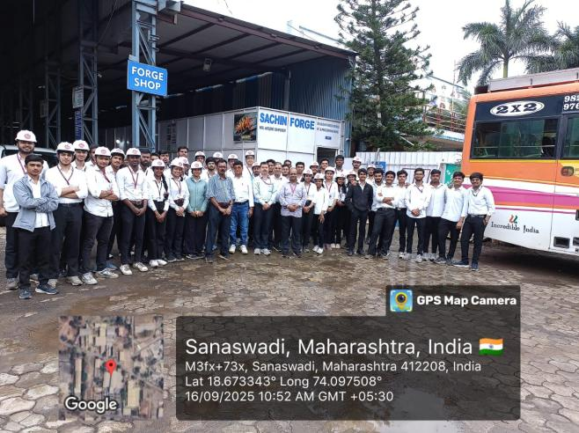 | 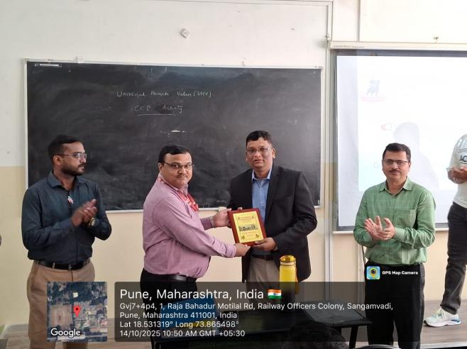
Visit to Sachin Forge Sanaswadi Pune | Felicitation of guest for expert talk on GD and T
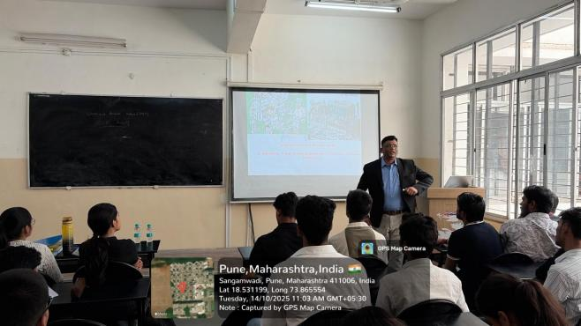 | 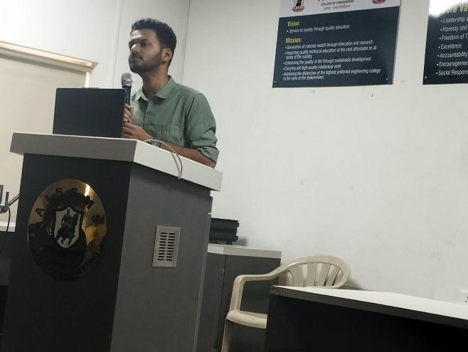
Expert delivering talk on GD and T | Expert delivering talk on “Unlocking Robotics with ROS2”
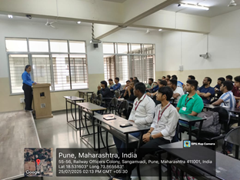 | 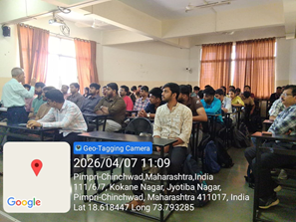
Expert delivering talk on “ Fundamental of Vehicle Dynamics” | Expert talk on “Power Plant Engineering”

Industrial Visit
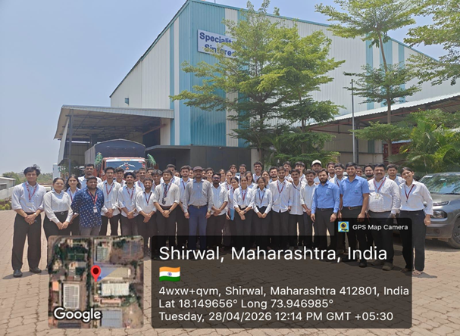
Industrial Visit at “ Speciality Sintered Product Pvt Ltd Shirwal, Satara”

Industrial Visit
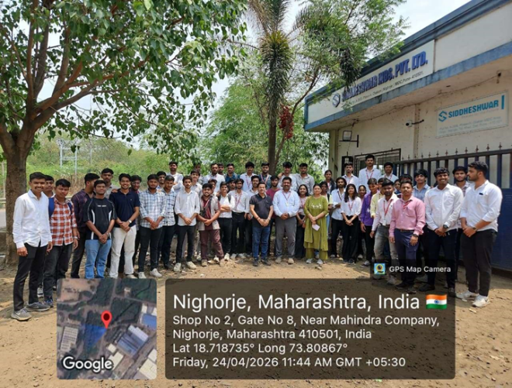
Industrial Visit at “ Siddeshwar Industries Pvt Ltd Chakan, Pune

6.STUDENTS’ ACHIEVEMENT

6.1 EVENTS ORGANISED (By Students’ Chapters / Clubs and others)
Name of Students’ Chapter: Institution Of Engineers Mechanical Engineering
Faculty Advisor: Dr C S Choudhari
Term One
SN | Event name and details of event | Name of chief guest, judges etc. | Duration and Dates | Number of beneficiaries
1 | Expert Talk  on  “Unlocking Robotics with ROS2” | Mr Aryan Jagushte , Founder and Robotics Engineer, ROBOTRY, Pune | 15 July 2025 | 80
2 | Expert Talk on  “Fundamentals of Vehicle Dynamics” | Mrs.Dipali Babhulkar, Sr. Manager, Design Department, TATA MOTORS, Pune | 27th July, 2025 | 55
3 | “Certified Program on Geometric Dimensioning and Modelling” | Mr. Mr. Darshan Narayanpure  MD Candifield Technologies, Pune | 14th October, 2025 | 87
4 | Paper Presentation Competition | Dr A V Waghmare, Dr D Y Dhande, Dr C S Choudhari  Dr S A Ansari | 17 September 2025 | 47
5 | Student Conclave IEI Paper Presentation Competition | Dr C S Choudhari  Dr C S Dharankar | 10 and 11 April 2026 | 36
6 | Student Conclave IEI Paper Presentation Competition | Dr S H Wankhade  Mr S K Bidgar | 10 and 11 April 2026 | 26

Name of Students’ Chapter: ISHRAE Chapter
Faculty Advisor: Dr S A Ansari
Term One
SN | Event name and details of event | Name of chief guest, judges etc. | Duration and Dates | Number of beneficiaries
1 | Tree Plantation Derive at Sanjivan Vanodyan Pune ” | Cargo NGO  Mr .Chetan Thakur | 12 July 2025 | 15
2 | Interdepartmental Technical Paper Presentation Competition | Dr. C S Choudhari  Dr. SA Ansari | 17 September 2025 | 47
3 | Expert Talk on Introduction to Railway HVAC system + Heat Load Calculation for HVAC Sizing | Mr. Ketan Gayawal  Technical Specialist R&D Knorr Bremse Technology Pvt Ltd. | 9th October, 2025 | 30
4 | TechnoCHILL-2026 | Mr.Subhas khanade  Mr. Chetan Thakur | 04/04/2026 | 142
5 | Technical talk on Green Building Movement in India | Mr Bhavesh Mehta | 11/02/2026 | 30
Name of Students’ Chapter: SESI
Faculty Advisor: Dr D S Malwad
Term One
SN | Event name and details of event | Name of chief guest, judges etc. | Duration and Dates | Number of beneficiaries
1 | From data to decisions: Industrial applications of data science & Gen AI | Mr Kaustubj Kumbhar, Technical Lead, Wipro Technology, Pune | 25/09/2025 | 61
2 | Driving Digital Transformation Through Product Lifecycle Management | Mr. Surajkumar Tekale, Senior Software Engineer Intelizign Lifecycle Services Pvt Ltd, Pune | 11/09/2025 | 97
3 | An Expert Session on Innovation/Prototype Validation – Converting Innovation into a Startup | Dr. Amarnath Gupta, an international trainer and consultant | 28/08/2025 | 66

Term Two
SN | Event name and details of event | Name of chief guest, judges etc. | Duration and Dates | Number of beneficiaries
01 | 1. Vinodottam karandak  2.Dajikaka Gadgil karandak  3.Bharat Karandak | 1.Ganesh Nikumbh  2.Anish Jagdale  3.Atharva Deshpande  4.Om Desale  5.Kunal Shinde  6.Pranavi Jarande | State Level competitions | 6
02 | NSS | Geetanjali Anjali | 02/01/2026 | 1
03 | NSS | Mr. Gajanan Patil Mr. Bhausaheb Shinde  Mr. Gaurav Borkar Dr. Ganesh Bhame Dr. Savita Kulkarni | 23/01/26 To 30/01/26 | 10
8 | NSS | Justice B.G Kolse Patil | 09-04-2026 | 02

Name of Students’ Chapter: SAE
Faculty Advisor: Dr A V Waghmare

Term One
SN | Event name and details of event | Name of chief guest, judges etc. | Duration and Dates | Number of beneficiaries
1 | Participation in REEV Competition | Event at Benguluru | Year-round activity | Team
2 | Participation in BAJA Competition | Event at Pithampur | Year-round activity | Team
3 | Participation in the SAE INDIA Aero-Design Competition | Event at Chennai | Year-round activity | Team
4 | Participation in the SAE International Aero-Design Competition | An event in Texas, America | Year-round activity | Team

Term Two
SN | Event name and details of event | Name of chief guest, judges etc. | Duration and Dates | Number of beneficiaries
1 | Organized Quiz Competition | Online event at national level | 15-16 Jan 2026 | 64 teams
2 | Organized Student Convention: A Regional Event | Dr Abhay Jere  Dr Reji Mathai | 11/04/2026 | 143
3 | Interaction with Alumni | Oshan Kothadia | Jan 2026 | SAE Members
Name of Students’ Chapter: IMechE
Faculty Advisor: DR N N Gotkhindikar
Term One
SN | Event name and details of event | Name of chief guest, judges etc. | Duration and Dates | Number of beneficiaries
1 | Expert talk on “ Powder metallurgy advances in manufacturing” | Mr. Sudarshan Palve , Manager SSPL ltd, Pune. | 26th September 2025 | 106
2 | “Certified Program on Geometric Dimensioning and Modelling” | Mr. Mr. Darshan Narayanpure  MD Candifield Technologies, Pune | 14th October, 2025 | 87

Term Two
SN | Event name and details of event | Name of chief guest, judges etc. | Duration and Dates | Number of beneficiaries
1 | Expert talk on Power plant engineering | Mr Arvind Paranjape | 07.04.2026 | 56
2 | Workshop on ANSYS & CFD | Mr, Chetankumar Patil | 12-14th Jan 20226 | 44
Name of Students’ Chapter: FPSI
Faculty Advisor: Mr G P Lohar
Term One
SN | Event name and details of event | Name of chief guest, judges etc. | Duration and Dates | Number of beneficiaries
1  2. | Driving Digital Transformation Through Product Lifecycle Management  Entrepreneurship as a career | Mr. Kaustubh Kumbhar  Mr. Virendra Ingale | 25th Sept 2025  21 & 22 August 2025 | 60  110

Term Two
SN | Event name and details of event | Name of chief guest, judges etc. | Duration and Dates | Number of beneficiaries
1 | A session on Oil Hydraulics in a Value-added course | Mr Anjeev George – Danfoss Systems Pvt Ltd | 11.02.2026 | 42
Name of Students’ Chapter: SESI
Faculty Advisor: Dr D S Malwad
Term Two
SN | Event name and details of event | Name of chief guest, judges etc. | Duration and Dates | Number of beneficiaries
1 | Understanding Entrepreneurship | Ms Manisha Tapasvi, De Asra Foundation, Pune | 15 April 2026
2 | Current Trends in Electric Vehicle | Mr Deepak Bhatia, Mercedes-Benz, Germany | 9 January 2026

6.2 SOCIAL ACTIVITIES ORGANISED (NSS, Women empowerment, Awareness Programms, etc.)
Term One
Faculty coordinator | Name of Activity | Date, Duration | Number of students involved
P.S.Aglawe | Community Engagement Program – Educate Children in Shelters | 30/07/2025 | 136  (Male:82  Female:48  Staff:7  Others: 1)
Dr M R Dahake | Visit to Swaminiwas old age home Akole Pune | 10/10/25 | 15
Mr P S A | Eye Checkup and Dental Checkup Camp | Monday, 15/09/2025  Wednesday 24/09/2025 | 20
Mr.Gopal Lohar | Bhakti Yog | Saturday / 21-06-2025. | 3
Mr.Gopal Lohar | Constitution @ 75 | Wednesday 24/09/2025 | 12
Mr.Gopal Lohar | Blood Donation Camp | 24/09/2025 | 15

Term Two
Faculty coordinator | Name of Activity | Date, Duration | Number of students involved
PSA NSS camp activities | NSS Special Residential camp at Kalyan VillageTal. Haveli Dist:.Pune | 23/01/2026-30/01/2026 | 23
Dr C S Choudhari  Dr A V Waghmare | Orientation and demo session (Techno-Social Activity) for school students on “Design of Unmanned Vehicle (Aircraft)" | Wednesday, 25/03/2026 | 560 school students
Dr M R Dahake | Donated Rs 15000/- and sponsored lunch to Poona School for Blind Girls Kothrud Pune | 26/04/2026 | 10
6.3 STUDENTS’ ACHIEVEMENT (Professional) (Individual Level) (Technical activities such as design competitions, paper presentation, technical quiz, Product development, innovation, etc.)
Term One
Name of Student | Details of Achievement (State/University/ National/International Level) | Remark  (Domain)
TE & BE Mechanical | Lean Six Sigma Yellow belt certification from Binghamton University – 23 Students successfully completed | School of Science and IE
 | (NPTEL certificates in Robotic, Product design and development, Basics of finite element analysis)
Rane Mohit Umesh (BE Mechanical Student) | The Late Mahadeo Ramchandra Bhise Prize, SPPU Pune | Amount 700/-
Rane Mohit Umesh (BE Mechanical Student ) | The Shri Vasant Vinayak Deodhar memorial Prize | Amount 600/-
Rane Mohit Umesh (BE Mechanical Student ) | The Principal G. K. Ogale memorial Prize | Amount 6400/-
Rane Mohit Umesh (BE Mechanical Student ) | The Late Smt Radhabai Vishnu Joglekar memorial Prize | Amount 1500/-
Rane Mohit Umesh (BE Mechanical Student ) | The BANCO Foundation BARODA prize | Amount 4900/-

Term Two
Name of Student | Details of Achievement (State/University/National/International Level) | Remark  (Domain)
Team of 18 students | Team Resonance Racing participated in the SAE India REEV 2026 National Competition. The team secured AIR 1 in the virtuals. | Technical - Range Extended Electric Vehicle Design, Manufacturing and Race
Team of 18 students | Best Aerodynamic Analysis (CFD): 2nd Rank  In SAEISS MICRO CLASS 2026 | Technical Competition of Microclass aeroplanes
Team of 18 students | Overall Result: 14th RANK  Technical Design Report: 5th RANK  In the SAE Aero Design International competition. | Technical Competition of advance class aeroplanes
GSA Mechanical | Overall bestBDepartment 2025 SHIVANJALI | Overall Performance
1.Ganesh Nikumbh  2. Anish Jagdale | State Level competitions (2025) | Cultural
- Aaryan Patil | Best Paper Award in Paper Presentation in IETE Congress organized by Adani University Ahmedabad | TechnicaL
7 Rohan Khairnar (TE Mech) | Got shortlisted for prototype funding of Rs 5000 in YUKI Innovation Challenge 2026  (Mentor: Dr D S Malwad) | YUKTI 2026

6.4 STUDENTS’ ACHIEVEMENT (other than Professional) (Individual Level) (Social activities, etc.)
Term One
Name of Student | Details of Achievement (State/University/ National/International Level) | Remark  ((Domain)
Mr Mane | Best Outgoing NSS Volunteer 2025 | NSS

Term Two
Name of Student | Details of Achievement (State/University/ National/International Level) | Remark  ((Domain)
1 Aaryan Patil | Best Paper Award at IETE conference and ISF congress by Adani University Ahmedabad | Momento and Certificate
2 | First Prize in Product and Prototype Competition IE(I)  Dated 11/04/2026 (Arayan Waware and group, Guide : Dr S A Ansari) | 10000/-
3 | Vaishaniwi Mate Best paper Presentation ISHRE Technochill dated 04/04/2026 | 5000/-
4 | Manav Matwankar Second prize in Quiz Competition | 5000/-
Ruturja Wagh | YUKTI Innovation Challenge 2026Second

6.5 CERTIFICATE / ONLINE COURSES COMPLETED BY STUDENTS (Certificate courses, value added courses, MOOC, etc

Term One
S N | Name of Student | Title of the Course | Conducted By | Duration/ Dates
1 | Atharva Pravin Pakhode | Data Structures and Algorithms Design | NPTEL | July-Oct 25
2 | Suryawanshi Govind Rajesh | Automation in Manufacturing | NPTEL | July-Oct 25
3 | Shreya Sandip Patil | Automation in Manufacturing | NPTEL | July-Oct 25
4 | Atharva Pravin Pakhode | Data Structure and Algorithms using Java | NPTEL | July-Oct 25
5 | SE Mech- 55 Students | Geometric dimensioning and tolerancing | Cad Infield technologies | 1 day
6 | TE Mech- 33 Students | Geometric dimensioning and tolerancing | Cad Infield technologies | 1 day

Term Two
S N | Name of Student | Title of the Course | Conducted By | Duration/ Dates
01 | Mayur Sonkamble | Operation management | IIT Roorkee | Jan-April 26
2 | Mayur Sonkamble | Computer Integrated manufacturing | IIT Kanpur | Jan-April 26
3 | Mayur Sonkamble | Product engineering and design thinking | IIT Kharagpur | Jan-March 26

6.6 NUMBER OF STUDENTS PLACED
MECHANICAL (Dr S A Ansari & for Sw Mr J S Supekar)
MECHANICAL PLACED STUDENTS
Term One
Sr No | Name of Student Placed | Name of Organization | Package
1 | Tanaya Rahul Otari | Atlas Copco | 5.50 LPA
2 | Samar Dhanraj patil | Atlas Copco | 5.50 LPA
3 | Arish Patel | Thermax | 5.00 LPA
4 | Yash Bodade | Thermax | 5.00 LPA
5 | pushpak chandorikar | Thermax | 5.00 LPA
6 | shreeya jadhav | Thermax | 5.00 LPA
7 | Mugdha Kirve | Thermax | 5.00 LPA
8 | Hritika Chafekar | Bristlecone | 5.00 LPA
9 | Shrihari Madhav Ashtekar | Bristlecone | 5.00 LPA
10 | Manav Dasharth Matwankar | Bristlecone | 5.00 LPA
11 | Samarth Yogesh Mane | Bristlecone | 5.00 LPA
12 | Aaryan Vidyadhar Patil | Vanderlande | 8.50 LPA
13 | Amey Yadav | Vanderlande | 8.50 LPA
14 | Varad ghule | Reliance Industries | 5.50 LPA
15 | Sawailal Suthar | Reliance Industries | 5.50 LPA
16 | omkar Tigote | Reliance Industries | 5.50 LPA
17 | Om Bhatjire | Reliance Industries | 5.50 LPA
18 | Sarthak Bhogil | Reliance Industries | 5.50 LPA
19 | Kartik Satav | Bosch | 4.50 LPA
20 | Varad Ghule | Bosch | 4.50 LPA
21 | Abhishek Ghatge | Bosch | 4.50 LPA
22 | Avishkar patil | Bosch | 4.50 LPA
23 | Shraddha Gore | NY Engineers India Services Pvt. Ltd. | 6.00 LPA
24 | Harsh Dhumal | NY Engineers India Services Pvt. Ltd. | 6.00 LPA
25 | Nupoor Holkar | NY Engineers India Services Pvt. Ltd. | 6.00 LPA
26 | Atharva Jamdade | Vanderlande | 8.50 LPA
27 | Pratiksha Borate | Sulzer | 8.05 LPA
28 | Aishwarya Dhumal | Nova Sintech | 3.00 LPA
29 | Shreyas Chaudhari | Nova Sintech | 3.00 LPA
30 | Ajit Shinde | Nova Sintech | 3.00 LPA
31 | Sakshi Daphal | Nova Sintech | 3.00 LPA
32 | Tejas Ghodake | godrej enterprises | 7-8 LPA
33 | Vaishnavi Sangle | PrestinePeck Technologies | 3.00 LPA
34 | Sarang Pimparkar | PrestinePeck Technologies | 3.00 LPA
35 | Jatin Nirgude | PrestinePeck Technologies | 3.00 LPA
36 | Vaishnavi Ghode | PrestinePeck Technologies | 3.00 LPA
37 | Ajit Shinde | Bonfiglioli | 3.00 LPA
38 | Vinay Vivek Shedge | ASSA Abloy Opening Solutions India | 4.50 LPA
39 | Atharva Ganesh Khaire | ASSA Abloy Opening Solutions India | 4.50 LPA
40 | Harshwardhan Atpadkar | ASSA Abloy Opening Solutions India | 4.50 LPA
41 | Harsha Jitendra Deshmukh | ASSA Abloy Opening Solutions India | 4.50 LPA
42 | Sahil Prakash Badgujar | Trans engineers | 3-4 LPA
43 | Abhay Sahebrao Patil | Trans engineers | 3-4 LPA

Lower Package Offered:5.00 LPA
Higher package Offered:8.50 LPA
Average Package Offered:5.50 LPA
6.7 NUMBER OF STUDENTS QUALIFIED IN THE EXAMINATIONS (GATE, GRE, UPSC, MPSC, CAT, TOEFL, any other examination)
Sr. No. | Name of Student | Examination | Examination / registration number
 |  |  | Nil

6.8 SPORTS / CULTURAL ACHIEVEMENTS OF STUDENTS (Individual Level) (Team level achievements to be mentioned in institute level sports/Cultural committee report)
Term One
Name of Student | Details of Achievement (State/University/ National/International Level) | Remark  (Domain)
Shrushti Kshirsagar | Boxing Inter Collegiate Boxing (W) organized by MMCOE Medal | Silver
Vinayak Raut | Kabaddi Gold Medal in Kabaddi (M) at Peace Organised by-AIT University  Runner up in Rajarshi Shahu Maharaj Krida Mahotsav 2026 A State Level competition | Gold
Abhisheck Avhad | Kabaddi Gold Medal in Kabaddi (M) at Peace Organised by-AIT University  Runner up in Rajarshi Shahu Maharaj Krida Mahotsav 2026 A State Level competition | Gold
Niranjan Choudhary | Kabaddi Medal in Kabaddi (M) at Peace Organised by-AIT University  Runner up in Rajarshi Shahu Maharaj Krida Mahotsav 2026 A State Level competition | Gold
Tanmay Padekar | Cricket (M) at Zest 26 Organized by-COEP | Gold
Deep Shaha | Cricket (M) at Zest 26 Organized by-COEP | Gold
Ayush Lunavat | Football, Runner up in Rajarshi shhu maharaj krida mahotsav 2026, State level competition | Silver
Daksh Desai | Football, Runner up in Rajarshi shhu maharaj krida mahotsav 2026, State level competition | Silver
Anuj Mane | Football, Runner up in Rajarshi shhu maharaj krida mahotsav 2026, State level competition | Silver
Nishad Chinchkar | Football, Runner up in Rajarshi shhu maharaj krida mahotsav 2026, State level competition | Silver
Tejas Ghorpade | Football, Runner up in Rajarshi shhu maharaj krida mahotsav 2026, State level competition | Silver
Aryen Shitole | Football, Runner up in Rajarshi shhu maharaj krida mahotsav 2026, State level competition | Silver
Aryen Shitole | Football, Runner up in Rajarshi shhu maharaj krida mahotsav 2026, State level competition | Silver
Aryen Shitole | Football, Runner up in Rajarshi shhu maharaj krida mahotsav 2026, State level competition | Silver
Tanishq Katkar | Basketball Runner Up Medal in Elevate organized by APCOER | Silver
Shardul Pathak | Basketball Runner Up Medal in Elevate organized by APCOER | Silver
Arish Patel | Basketball Runner Up Medal in Elevate organized by APCOER | Silver
 | Cultural
Aryan Munde | 3rd Rank in Singing | Talent Hunt
Kewal Deshpande | Monologue 1st, Improvisation 1st,  Skit- 2nd | Talent Hunt
Tanmay Tambat | Group Dance 3rd | Talent Hunt
Tanvi Desale | Skit 2nd, 1st group dance, | Talent Hunt
Kunal shinde (TE mech)  Pranavi Jarande(SE mech) | Debate Competition organized by COEP  5th prize | Debate Competition
Go-Kart Team | Resonance Racing Go-Kart Team  at Morphine's Motorsport Season 1  Overall Rank – AIR 1  Endurance – AIR 1  Driver Ergonomics – AIR 1  Design – AIR 2  Skid Pad – AIR 2  Time Trials – AIR 2  Competition Location – Pune, Maharashtra  Year – 2025 | Manufacturing and Racing

Term Two
Name of Student | Details of Achievement (State/University/ National/International Level) | Remark  (Domain)
NSS Club | 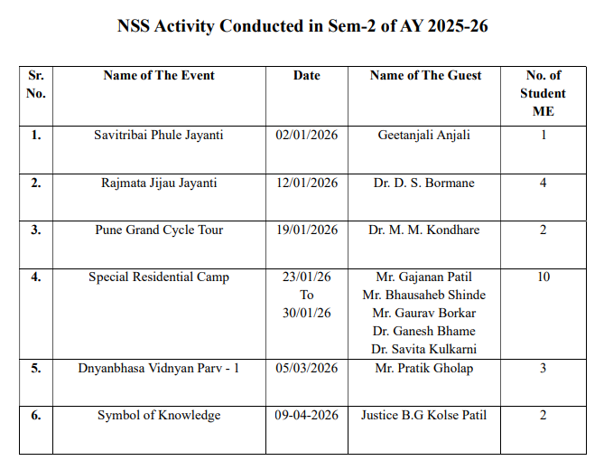

6.9 STUDENTS’ ACHIEVEMENTS (Team Level)
Term One
Name of Event | Name of Faculty Advisor | Details of Achievement (State/University/ National/International Level) | Remark  (Domain)
GoKART | Dr A V Waghmare | Resonance Racing Go-Kart Team  at Morphine's Motorsport Season 1  Overall Rank – AIR 1  Endurance – AIR 1  Driver Ergonomics – AIR 1  Design – AIR 2  Skid Pad – AIR 2  Time Trials – AIR 2  Competition Location – Pune, Maharashtra  Year – 2025 | Manufacturing and Participation in Racing competition

Term Two
Name of Event | Name of Faculty Advisor | Details of Achievement (State/University/ National/International Level) | Remark  (Domain)

Few good photographs related to students’ achievements
Size of photo 5 cm x 7 cm with captions
Social Activity at Vishwabharti English Medium School, Dhayari, Pune
DEMONSTRATION OF AIRCRAFT MODEL AND DRONE
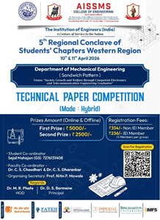 | 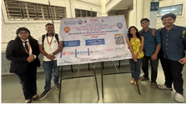  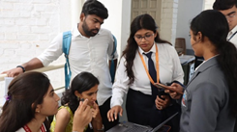
Paper Presentation Competition
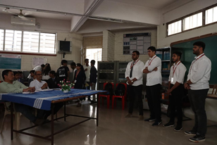 | 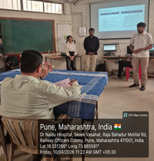
Paper Presentation Competition
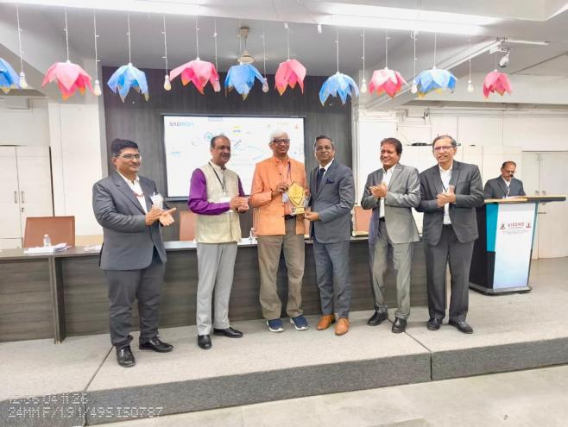 | 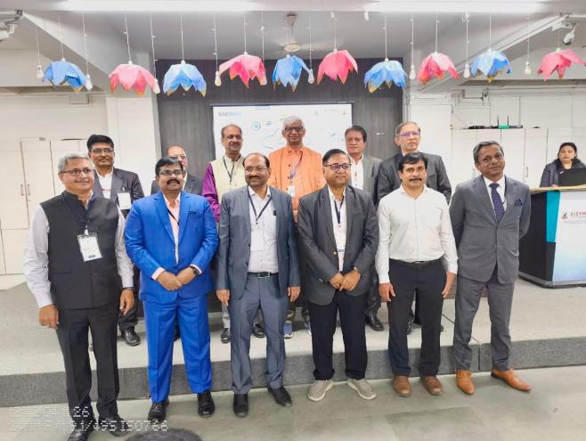
SAE Student Conclave 2026 | SAE Student Conclave 2026
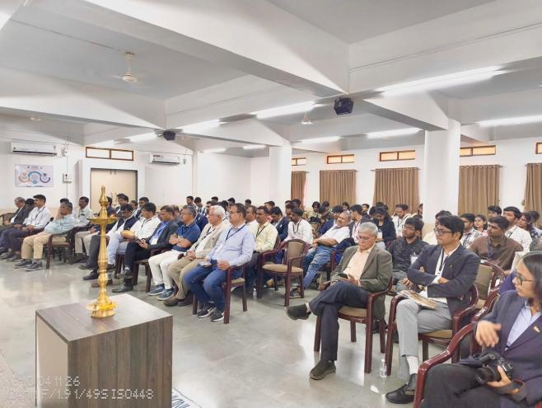 | 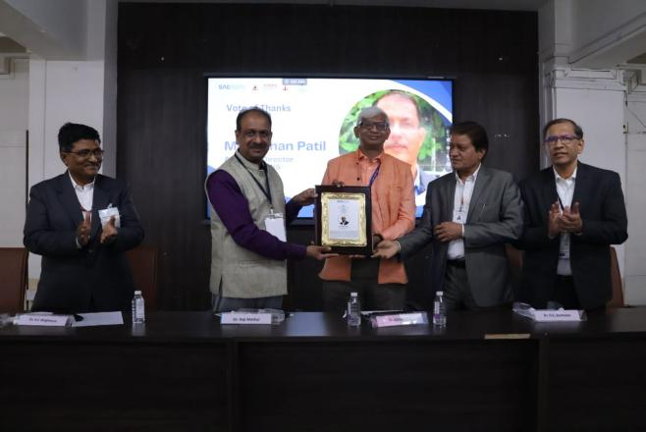
SAE Student Conclave 2026 | SAE Student Conclave 2026
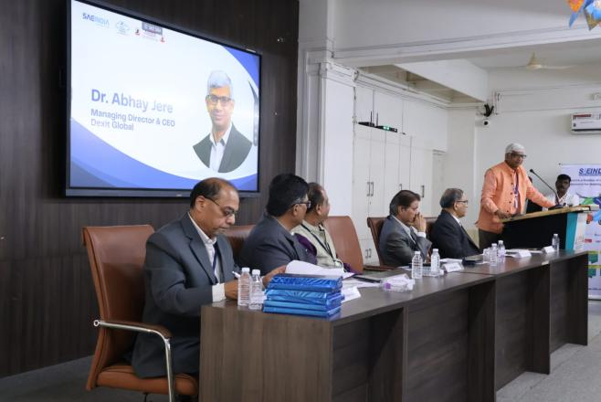
SAE Student Conclave 2026

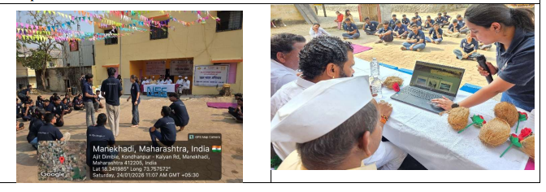
Special Residential Camp Inauguration

6.10 Participation and achievements in International Level Interaction (Students and faculty)

Term One
Nature of Interaction | Details of Participation / Achievement | Remark  (Domain)
The International Certificate Course on Lean Six Sigma Yellow Belt Aug 2024 | The International  Certificate Course on Lean  Six Sigma Yellow Belt Aug 2024 was conducted  During 05/08/2024 to 08/08/ 2024 as  Collaboration between AISSMS, India  and Binghamton University, USA

Term Two
Nature of Interaction | Details of Participation / Achievement | Remark  (Domain)
 | NIL

- SUMMARY
AND
SWOC ANALYSIS

7.1 ANY OTHER NOTEWORTHY ACHIEVEMENT OF THE DEPARTMENT (Not mentioned above)
Sr. No. | Details
01 | Best Department award for year 2025-2026 at Institute Level

7.2 MISCELLANEOUS (SYLLABUS IMPLEMENTATION, MAJOR ADDITION IN INFRASTRUCTURE AND FACILITY, INNOVATIONS INTRODUCED, ETC.)
FACULTY | ACTIVITY
Dr D Y Dhande ,  & Dr M R Phate | Additional facility in the department Viscometer
Dr D Y Dhande ,  & Dr M R Phate | Additional facility in the department Stress Analyzer
Dr D Y Dhande ,  & Dr M R Phate | Four Ball tester machine for oil testing

7.3 FEEDBACK FROM STAKEHOLDERS

Sr No | Stake holder | Number of Feedbacks Received | Overall Feedback
1 | Alumni | 25 | Curriculum alignment to be ensured with professional world.  Good improvement in infrastructure and facilities.
2 | Parents | 26 | Appreciated conduction of parent meeting.
3 | Employers | 28 | Suggested to motivate students for more and more skill enhancement courses and to focus on basic engineering knowledge.
4 | Students | 135 | Engoys activity based learning, especially as per NEP and autonomy syllabus.

7.4 TWO BEST PRACTICES FOLLOWED IN THE DEPARTMENT
- Rubrics based assessment using affective domains activity i.e. club, sport, culture and NSS activities along with its impact analysis.
- Rubrics based assessment for testing quality test papers
- Rubrics based assessment of impact and feedback of various industrial activities
- Social connect of department
- Initiated Sustainable Development Goals in academics .

7.5 MAJOR GRIEVANCES OF STUDENTS (IF ANY) REDRESSED
Nil

7.6 SWOC ANALYSIS
Five major strengths, weaknesses, opportunities, and challenges (SWOC) of the department and future plans of the Department.
Strengths:
1 | Highly qualified faculty with PhD qualification
2 | Good retention ratio
3 | Experience staff
4 | Strong industry connect
5 | Effective and efficient students clubs

Weaknesses:
1 | Involvement of all faculty in research and development
2 | Placement quality is not satisfactory
3 | Consultancy and testing is not strong
4 | Industry supported labs is not in the department.

Opportunities:
1 | Industry involvement in curriculum and teaching and learning
2 | Preparation for Tier 1 institute and related accreditation
3 | Analysis of department strength and weakness and try to overcome the weakness to lead in the field of Mechanical Engineering

Challenges
1 | Challenges arise due to AI based courses and cope up with this for upgradation.
2 | Adopting new NEP2020 guidelines in the regular academics.

7.7 FUTURE PLANS OF THE DEPARTMENT (For Next Academic Year)
1 | NBA for six years
2 | Enhancement in Quality placement and higher study
3 | Enhancement in Quality of internship and Entrepreneurship
4 | Developing Industry sponsored labs
5 | Funded project
6 | ISO certification in the department

7.8 INITIATIVES TAKEN BY THE DEPARTMENT AT DEPARTMENT AND INSTITUTE LEVEL TO IMPROVE AND ASSURE QUALITY IN THE FOLLOWING AREAS

Area | Initiatives
Academics and overall profile of Department | Outcome based Education in the overall department policies.  Strong Academic monitoring
Organization of different activities | Social connect of the department  Organising FDP  Various activity to enhance industry involvement
Research and Innovation | Good Publication in Quality Journal, Testing and consultancy , good numbers of copyrights and patents
Industry institute Interaction | Rubrics based Evaluation and impact analysis  Functional MoUs  Internship  Expert talk from various industry experts
Students’ Achievements | Achievement in Clubs event an national and international level.  Best performance in social and cultural events.  University rankers

7.9 NBA / NAAC / AAA work progress

Key points | Status
NBA | Prequalifier ready and 75 % work completed
NAAC | Update as per institute NAAC coordinator instruction
AAA | Completed as per guideline. Annual report for 2025-2026 is updated

SUMMARY SHEET (Annual)
Sr No | Activity/ Item | Numbers
PROFILE OF DEPARTMENT
01 | Students in the department | 636
 | FACULTY CONTRIBUTION
02 | e content developed by faculty and available online | 08
03 | Number of FDP/STTP attended by the department faculty | 84
04 | Number of Seminars/ workshops/ webinars attended by the department faculty | 29
05 | Number of Conferences/ symposiums attended by the department faculty | 16
06 | Number of Online courses / certificate courses completed by department faculty | 35
07 | Number of extension lectures / webinars (Lectures delivered on other than technical topics)) | 19
08 | Number of Faculty served as resource person, expert, chairperson | 13
 | ACTIVITIES ORGANISED
09 | Number of FDP/STTP organized by the department | 01
10 | Number of Seminars/ workshops/ webinars organized by the department (for faculty) | 10
11 | Number of Conferences/ symposiums organized by the department (for faculty) | 00
12 | Number of Extension activities conducted by the department (Social/ Quizzes at national/international level/any other activity) | 09
13 | MOU signed with academic and professional organizations | 00
14 | Number of Students’ chapters /clubs | 05
15 | Number of Social activities organized | 07
16 | Number of Parent meeting | 02
17 | Number of Alumni meet | 00
18 | Number of student counseling and career guidance at the department level | 308
 | RESEARCH CONTRIBUTION
19 | Number of Funded research project | 01
20 | Number of Testing and consultancy | 06
21 | Number of Patents, copyright, trademark and other (IPR) | 07
22 | Number of Papers published/ presented in proceedings of conferences | 12
23 | Number of Papers published in journals | 39
24 | Number of Book/ article publications | 00
25 | Total Research citations | 2577
26 | Number of ME awarded | 01
27 | Number of PhD AWARDED | 00
 | INTERACTION WITH INDUSTRY
28 | Number of Industrial visits organised | 12
29 | Number of Expert lectures delivered by industry experts | 28
30 | Number of Industry –sponsored projects (UG/PG) | 04
31 | Number of MOU signed with industry | 09
32 | Number of Faculty members undergone industrial training | 08
33 | Number of Students undergone in-plant training and (or) internship programme | 147
34 | Number of students placed | 51
35 | Number of students qualified in the examinations | 00

Declaration by the Head of the Department

I am aware that the above information provided by the Department will be validated by the AAA committee during the visit.

Dr. Mangesh R. Phate

Head of Mechanical Engg Department

