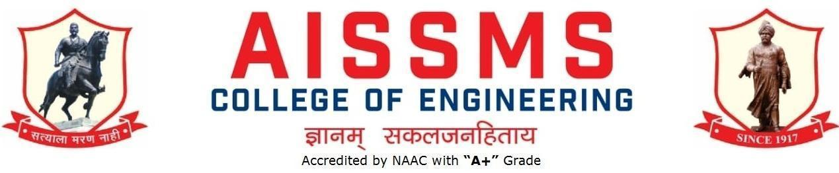
Internal Quality Assurance Cell

DEPARTMENT OF ELECTRONICS and TELECOMMUNICATION ENGINEERING
ANNUAL REPORT
(15 June 2024 to 14 June 2025)
TERM ONE: 01July to 31 December
TERM TWO: 01 January to 30 June

Academic Year 2024 – 25
Guidelines:
Fill up this sheet for all the contributions /activities conducted at Department level only.
- In case data does not exist please mention it as ‘No Data’.
- Please add rows to the table below to suit your requirements
- Ensure that data does not differ from other official records and all the supporting documents are available.
- Use: Font Type: Times New Roman, Font Size: 12, Sentence case, Spacing: 1.15
- Use separate row for every details.
- For any queries, you may contact:Coordinator, IQAC
- email: iqac@aissmscoe.com

CONTENTS
Sr No | Activity/ Item | Page No
- PROFILE OF DEPARTMENT
1.1 | Introduction | 6
1.2 | Laboratories in the Department | 6
1.3 | Software Available in the Department | 6
1.4 | Faculty in the Department | 6
1.5 | Details of Supporting Staff | 7
1.6 | Students’ Enrollment | 7
1.8 | Result Analysis | 7
1.9 | Class Result Analysis | 9
1.10 | University Ranker | 9
 | - FACULTY CONTRIBUTION
2.1 | Achievements of Faculty | 11
2.2 | Contribution of Faculty (Interaction With Outside World) | 11
2.3 | e content developed by faculty and available online | 11
2.4 | FDP/STTP attended by the department faculty | 16
2.5 | Seminars/ workshops/ webinars attended by the department faculty | 19
2.6 | Conferences/ symposiums attended by the department faculty | 20
2.7 | Online courses / certificate courses completed by department faculty | 20
2.8 | Extension lectures / webinars organized | 21
2.9 | Faculty served as resource person, expert, chairperson | 22
- ACTIVITIES ORGANISED
3.1 | FDP/STTP organized by the department | 24
3.2 | Seminars/ workshops/ webinars organized by the department | 25
3.3 | Conferences/ symposiums organized by the department | 30
3.4 | Extension activities conducted by the department | 31
3.5 | MOU signed with academic and professional organizations | 32
3.6 | Students’ chapters /clubs | 32
3.7 | Social activities organized | 37
3.8 | Parent meeting | 38
3.9 | Alumni meet | 38
3.10 | Support from Alumni | 38
3.11 | Interaction with Alumni | 38
3.12 | Student counseling and career guidance at the department level | 39
- RESEARCH CONTRIBUTION
4.1 | Funded research project | 47
4.2 | Testing and consultancy | 47
4.3 | Patents, copyright, trademark and other (IPR) | 48
4.4 | Papers published/ presented in proceedings of conferences | 48
4.5 | Papers published in journals | 52
4.6 | Book/ article publications | 53
4.7 | Total Research citations | 54
4.8 | ME awarded | 54
4.9 | PhD guide details | 54
4.10 | PhD AWARDED | 54
 | - INTERACTION WITH INDUSTRY
5.1 | Industrial visits organized | 56
5.2 | Expert lectures delivered by industry experts | 56
5.3 | Industry –sponsored projects (UG/PG) | 58
5.4 | MOU signed with industry | 58
5.5 | Faculty members undergone industrial training | 59
5.6 | Students undergone in-plant training and (or) internship programme | 60
5.7 | Support from Industry | 65
5.8 | Training to Industry personnel/ Activity Supporting industry | 66
5.9 | Any other activities to Promote Interaction With Industry | 67
5.10 | Students Undergone Sandwich Training | 67
- STUDENTS’ ACHIEVMENT
6.1 | Students’ Achievement (Professional) (Individual Level) | 69
6.2 | Students’ Achievement (Other than Professional) (Individual Level) | 69
6.3 | Certificate / Online Courses Completed by Students | 70
6.4 | Number of Students Placed | 70
6.5 | Number of Students qualified in the competitive examinations | 70
6.6 | Sports / Cultural Achievements of Students (Individual Level) | 71
6.7 | Students’ Achievements (Team Level) | 72
 | - SUMMARY AND SWOC ANALYSIS
7.1 | Any other noteworthy achievement of the department | 77
7.2 | Miscellaneous (Syllabus Implementation, Major Addition In Infrastructure And Facility, Innovations Introduced, etc.) | 77
7.3 | Feedback from Stakeholders | 77
7.4 | Two Best Practices Followed in the Department | 77
7.5 | Major Grievances of Students (If Any) Redressed | 77
7.6 | SWOC Analysis | 77
7.7 | Future Plans of the Department | 78
7.8 | Initiatives Taken By The Department At Department And Institute Level To Improve And Assure Quality | 78
 | Summary Sheet (Annual) | 79

- PROFILE
OF
DEPARTMENT

1.1 INTRODUCTION
Year of Establishment | 1992
UG Programme | 1992
UG Programme(VLSI and DT) | 2023
Number of Teaching Staff | 15
Number of Non-Teaching Staff | 8

1.2 LABORATORIES IN THE DEPARTMENT
Name of Laboratory
Data Analytics Laboratory | Communication Engineering Laboratory
Basic Electronics Laboratory | VLSI Laboratory
Project and Skill Development Laboratory | Signal Processing & Embedded Laboratory
Circuit & Simulation Laboratory | AI & ML Integrated IoT laboratory
Power Electronics and Digital Circuit Laboratory

1.3 SOFTWARES AVAILABLE IN THE DEPARTMENT
Software Available
1. Xilinx | 2.Multisim
3.Microwind | 4.Matlab
5.Proteus | 6.Dev C++
7.eClipse | 8.Side 51, Side Arm, Side Terminal
9.Code Composer Studio

1.4 FACULTY IN THE DEPARTMENT
Name of faculty | Designation
Dr. D S Bormane | Principal
Dr. S B Dhonde | Professor – HOD
Dr. K.B.Chaudhari | Assistant Professor
Mr. S.B.Dhekale | Assistant Professor
Mr. N.P.Mawale | Assistant Professor
Dr. P.P.Vast | Assistant Professor
Ms. V.D.Nagrale | Assistant Professor
Dr. V.V.Deshmukh | Assistant Professor
Mrs. V.S.Navale | Assistant Professor
Mrs. Y.P.Lad | Assistant Professor
Mrs. A A Randive | Assistant Professor
Mr. V.B.Gawai | Assistant Professor
Dr. R.R.Itkarkar | Assistant Professor
Dr. G D Salunke | Assistant Professor
Mrs. C.D.Rananaware | Assistant Professor

1.5 DETAILS OF SUPPORTING STAFF
Name of non-teaching staff | Designation
1.Mr. S.M.Dhiwar | Technical Assistant
2.Mr. S.T.Gajar | Laboratory Assistant
3.Mrs. K Zhambare | Laboratory Assistant
4.Mrs. S S Bodke | Laboratory Assistant
5.Mrs. P Dighe | Laboratory Assistant
6.Mr. S.P.Gaikwad | Attendant
7.Mr. S.S.Kale | Attendant
8.Mr. R S Amoli | Attendant

1.6 STUDENTS’ ENROLLMENT
Program
 | M | F | Total
SE E &TC | 45 | 31 | 76
SE VLSI and DT | 46 | 24 | 70
TE E&TC | 46 | 23 | 69
BE E&TC | 35 | 27 | 62

1.8 RESULT ANALYSIS
Term One
Name of faculty | Class and Subject Taught | % passing | Name of faculty | Class and Subject Taught | % passing
SE(E&TC)
Dr. P.P.Vast | Electronic Circuits | 89.19 | Dr. K.B.Chaudhari | Data Structures | 89.04
Dr. V.V.Deshmukh | Digital Circuits | 89.19 | Mr. K.B.Kshirsagar | Eng. Mathematics III | 84.93
Ms. G.D.Salunke | Electrical Circuits | 82.19
SE(VLSI and DT)
Mr. V B Gawai | Electronic Circuits | 74.29 | Mrs. V S Navale | Data Structures | 70
Mrs. A A Randive | Digital Circuits | 78.57 | Mr. K.B.Kshirsagar | Eng. Mathematics III | 70
Ms. V D Nagrale | Principles of Programming Language | 80
TE(E&TC)
Mrs.Y.P.Lad | Digital communication | 85.29 | Dr.V,V.Deshmukh | Elctromagnetic Field | 89.71
Ms. V.D.Nagrale | Data base management | 92.65 | Mr.V.B.Gawai | Microcontroller | 88.24
Mr.S.B.Dhekale | fun.Java programming | 94.12 | Dr.S.B.Dhonde | Computer Network | 94.12
BE(E&TC)
Mrs Y P Lad | Radiation & Microwave Theory | 95.08 | Mr S B Dhekale | JAVA SCRIPT | 100
Mr N P Mawale | VLSI Design & Technology | 98.36 | Mrs A A Randive | Modernised IOT | 100
Dr R R Itkarkar | Cloud Computing | 100 | Dr K B Chaudhari | Deep Learning | 98.36

Term Two
Name of faculty | Class and Subject Taught | % passing | Name of faculty | Class and Subject Taught | % passing
SE(E&TC)
Dr. V V Deshmukh | Signal & Systems | 88.57% | Mrs.V S Navale | Principales of Comm. systems | 95.71%
Mr.V B Gawai | Control Systems | 90% | Mr.S B Dhekale | Object Oriented programming | 91.42%
SE(VLSI and DT)
Mrs. C.D.Rananaware | Signal & Systems | 72.46% | Mr. S.B.Dhekale | Object Oriented Programming | 81.15%
Dr. P.P. Vast | Control Systems | 68.11%
Mrs. V.S.Navale | Principles of Comm. Systems | 82.6%
TE(E&TC)
Dr. P.P.Vast | Cellular networks | 88.41 | Dr.S.B.Dhonde | Project management | 100
Mr.N.P.Mawale | Power devices & circuits | 86.96 | Mrs.A.A.Randive | Network security | 84.06
BE (E&TC)
Mrs. Y P Lad | Fiber Optic Comm. | 98.38% | Ms V D Nagrale | Android Devlopment | 93.33%
Dr R R Itkarkar | Mobile Computing | 100% | Dr K B Chaudhari | Digital Marketing | 98.38%

1.9 CLASS RESULT ANALYSIS (Classes SE to BE)
Term One
SN | Class | Number of Students |  |  |  |  |  |  |  |  |  | Percentage of Passing
SN | Class | Appeared | Clear Passed | Outstanding  (O)  (9.1 -10) | Excellent  (A+)  (8.1 – 9) | Very Good (A)  (7.1 – 8) | Good (B+)  (6.1 – 7) | Above Average (B)  (5.1 – 6) | Average / pass class  (4 – 5 ) |  | Fail  (F)  0 – 3.99 | All Clear | With ATKT
1 | SE  (E&TC) Term-I | 74 | 49 | 5 | 14 | 21 | 6 | 3 |  |  |  | 66.22
2 | SE(VLSI and DT)  Term-I | 71 | 35 | 4 | 6 | 14 | 10 | 1 |  |  |  | 49.30%
3 | TE  (E&Tc )  Term-I | 68 | 45 | 3 | 17 | 16 | 9 |  |  |  |  | 66.18
4 | BE  (E&Tc) Term-I | 61 | 58 | 9 | 23 | 19 | 5 | 2 |  |  | 3 | 95.08

1.10 UNIVERSITY RANKERS (Consider last five academic years)
Academic Year 2022 – 23
Sr No | Name of the Ranker | Class | Rank
1 | Kshirsagar Prachi Rajabhau | BE | 2

- FACULTY CONTRIBUTION

2.1 ACHIEVEMENTS OF FACULTY (AWARDS, RECOGNITION, PHD COMPLETION ETC.)
Term One
SN | Name of Faculty | Awards & Recognitions
1 | Mr. N P Mawale | Best Sponsorship Award (Faculty) for AISSMSET-2024
2 | Mr. N P Mawale | Best Sponsorship Award (Department) for AISSMSET-2024
3 | Dr. G D Salunke | Awarded Ph.D
4 | Mrs. A A Randive | Best Department ET-Coordinator 2024

2.2 CONTRIBUTION OF FACULTY (Interaction with outside world)
Term One
SN | Name of Faculty | Nature and details of contribution (Representation at University, State, National , International level, corporate world, Social Platforms, etc)
1 | Dr. D S Bormane | Co-opted member IETE Pune Center for 2024-26
1 | Dr. D S Bormane | Elected Member on IEI Maharashtra State Center for 2023-2025
2 | Dr R R Itkarkar | Executive Council Member IETE Pune center for 2024-26
3 | Mr. N P Mawale | Elected Member on IEI, Pune Local Center for 2023-2025

Term Two
SN | Name of Faculty | Nature and details of contribution (Representation at University, State, National , International level, corporate world, Social Platforms, etc)
1 | Dr R R Itkarkar | Vice Chairman & EC Member IETE Pune Centre 24-26

2.3 e CONTENT DEVELOPED BY FACULTY AND AVAILABLE ONLINE
Term One
Sr No. | Name of Faculty | Title of e-content | e-content development facility/platform | link of the content
1 | Dr S B Dhonde | CN | Google Classroom | https://classroom.google.com/c/NzAyNzU2MTU5Mjgx
2 | Dr K B Chaudhari | Data Structures | Google classroom | https://classroom.google.com/w/Njk3NTYzMDk5ODk0/t/all
2 | Dr K B Chaudhari | Deep Learning | Google classroom | https://classroom.google.com/c/NzA0ODgzMTY3MzA0
3 | Mr.S B Dhekale | Fundamentals of JAVA | Google Classroom | https://classroom.google.com/c/NzM3NDc2MzU2NzQ2
4 | Mr. N P Mawale | VLSI and Design Technology | Google classroom | https://classroom.google.com/u/0/c/Njk3NTYwMjY1NDQ4
5 | Dr. P. P. Vast | Electronic Circuits | Google classroom | https://classroom.google.com/c/NjkxNzA1NjU1NTAz?cjc=zcnrwuo
6 | Dr V V Deshmukh | Digital Circuits | Google Classroom | https://classroom.google.com/c/NzAzMzAxNTM1MDk5?cjc=bvkk5f3
6 | Dr V V Deshmukh | Electromagnetic Field Effect Theory | Google Classroom | https://classroom.google.com/c/NzA3OTQ5NTEwMTIz?cjc=sg2ajmz
7 | Mrs. V S Navale | Data Structure  SE VLSI | Google Classroom | https://classroom.google.com/w/NjkxNjEwMzY1Mzcx/t/all
8 | Mrs. Y. P. Lad | Digital Communication | Google Classroom | https://classroom.google.com/c/NjkxNTc4MDk1MTM1
8 | Mrs. Y. P. Lad | Radiation & Microwave Theory | Google Classroom | https://classroom.google.com/c/Njk3NjYxMDczNzM2
9 | Mrs.A.A.Randive | Digital Circuits SE VLSI | Google Classroom | https://classroom.google.com/c/NjkxNTIwMjE1NTkw
9 | Mrs.A.A.Randive | Modernized Internet of Things BE E & TC | Google classroom | https://classroom.google.com/c/NzAxMTM5NTMyNzI2
10 | Mr.V.B.Gawai | Electronic Circuits | Google classroom | https://classroom.google.com/c/NzAyODkzMzc2MDc0
11 | Dr R R Itkarkar | Cloud Computing | Google classroom | https://classroom.google.com/c/NjE2NDA2MDAyODEy?cjc=26vbix4
12 | Dr. G D Salunke | Electrical Circuits | Google classroom | https://classroom.google.com/c/Njk3NDU5ODk2MDg4

Term Two
Sr No. | Name of Faculty | Title of e-content | e-content development facility/platform | link of the content
1 | Dr. S B Dhonde | Project MAnagement | Google Classroom | https://classroom.google.com/c/NzAyNzU2MTU5Mjgx
2 | Dr K B Chaudhari | Digital Marketing | Google Classroom | https://classroom.google.com/w/NzQ4MzMwNjE5Mjg0/t/all
 | Dr K B Chaudhari | Data Analytics Laboratory | Google Classroom | https://classroom.google.com/w/NzM2ODg3OTkxODIz/t/all
3 | Mr. S B Dhekale | OOPS | Google Classroom | https://classroom.google.com/c/NzM3NDc2MzU2NzQ2
4 | Mr., N P Mawale | PDC  (TE E&TC) | Google ClassRoom | https://classroom.google.com/u/0/c/NzUxNzI1NjcxMjAy
5 | Dr. P. P. Vast | Control Systems | Google classroom | https://classroom.google.com/c/NzMzODY5NzI3ODMz?cjc=kd53bxk
 |  | Cellular Networks |  | https://classroom.google.com/c/NzQ3NjA1OTQwMjIx?cjc=fml5ylz
6 | Dr V V Deshmukh | Signals & Systems | Google Classroom | https://classroom.google.com/c/NjY5NzQ4Nzg2MTQ3?cjc=wvbemp7
7 | Mrs. V S Navale | Principles of Communication Systems | Google Classroom | https://classroom.google.com/c/NzM3NDc2MzU2NzQ2
8 | Mrs. Y. P. Lad | Fiber Optics Communication |  | https://classroom.google.com/c/NzM2ODgwNjU0Mjgx
9 | Mr.V.B.Gawai | Control System | Google Classroom | https://classroom.google.com/c/NzQ1NjE3MzYyOTkz
10 | Dr R R Itkarkar | Mobile computing | Google Classroom | https://classroom.google.com/c/NTk5MDY1MzM3NzM4
 | Dr R R Itkarkar | Principles of communication system | Youtube videos | https://www.youtube.com/watch?v=Zu6ufru14Cg&t=760s  https://www.youtube.com/watch?v=H96j3T606lo&t=2s  https://www.youtube.com/watch?v=JTOgZH8rXiY&t=1s  https://www.youtube.com/watch?v=wxzhLSSo_Nk&t=2s  https://www.youtube.com/watch?v=JTOgZH8rXiY&t=1s&pp=0gcJCYsJAYcqIYzv
11 | Dr. G. D. Salunke | Electrical Circuits | Google Classroom | https://classroom.google.com/c/Njk3NDU5ODk2MDg4
12 | Mrs. C.D.Rananaware | Signals and Systems | Google Classroom | https://classroom.google.com/c/NzU1NTg3MTQ3MTgy

2.4 FDP/STTP ATTENDED BY THE DEPARTMENT FACULTY
Term One
S N | Name of Faculty | Title of the FDP/STTP | Organized by | Duration/ Dates
1 | Dr S B Dhonde | Leveraging Cutting Edge Technologies for Sustainable Agriculture Practices | Atal FDP Organized by  CSMSS CHH. SHAHU COLLEGE OF ENGINEERING | 02/12/2024 –07/12/2024
2 | Dr K B Chaudhari | International 1 week FDP on “AI for sustainable Development’ | VIIT Pune & IEEE Pune Section | 5/8/2024 to 9/8/2024
2 | Dr K B Chaudhari | International 1 week FDP on “AI Innovations & MATLAB Solutions’ | PCCOER & IEEE Pune Section | 23/9/2024 to 28/9/2024
3 | Mr. N P Mawale | VLSI Design: IC to Silicon | Sandip Foundations Sandip Institute of Engineering and Management, Nashik | 22/07/2024 to 26/07/2024
3 | Mr. N P Mawale | Exploring IoT & 5G using AI, ML | Ajinkya D Y Patil School of Engineering, Lohgaon, Pune | 02/09/2024 to 06/09/2024
4 | Mr. N P Mawale | Advances in 5G and 6G Communication Technology and Applications | VIT, Pune | 22/10/2024 to 26/10/2024
5 | Mr. N P Mawale | 39th Indian Engineering Congress at Kolkata  (Theme: Irresistible India, A Global Engineering PowerHouse) | The Institution of Engineers (India), Kolkata,  (At Hotel Novotel, Kolkata, WB) | 20/12/2024 to 22/12/2024
6 | Ms V D Nagrale | International 1 week FDP on “AI for sustainable Development’ | VIIT Pune & IEEE Pune Section | 5/8/2024 to 9/8/2024
6 | Ms V D Nagrale | International 1 week FDP on “AI Innovations & MATLAB Solutions’ | PCCOER & IEEE Pune Section | 23/9/2024 to 28/9/2024
7 | Dr V V Deshmukh | International 1 week FDP on “AI for sustainable Development’ | VIIT Pune & IEEE Pune Section | 5/8/2024 to 9/8/2024
7 | Dr V V Deshmukh | International 1 week FDP on “AI Innovations & MATLAB Solutions’ | PCCOER & IEEE Pune Section | 23/9/2024 to 28/9/2024
8 | Ms Y P Lad | International 1 week FDP on “AI for sustainable Development’ | VIIT Pune & IEEE Pune Section | 5/8/2024 to 9/8/2024
 |  | International 1 week FDP on “AI Innovations & MATLAB Solutions’ | PCCOER & IEEE Pune Section | 23/9/2024 to 28/9/2024
9 | Ms A A Randive | One week Online FDP on “ Transformative Pathways: AI and Emerging Trends in Teaching and Research” | School of Management , Avantika University in association with Research Foundation of India & RFI-CARE | 24/06/24 to 30/06/24
10 | Mr V B Gawai | 1 Week FDP on Employability skills | NITTTR Chennai | 30/9/2024 to 6/10/2024
11 | Dr R R Itkarkar | 1 week FDP on AI Innovation and Matlab Solutions | PCCOE, Pune & Mathwork | 23/9/2024 to 28/9/2024
12 | Dr. G. D Salunke | - Recent Trends in Electronic Communication & Semiconductors | ABMSP’s Anantrao Pawar College of Engineering, Pune in association with ISTE | 10/06/2024 to  14/06/2024
13 | Dr. G. D Salunke | - AI Innovations & MATLAB Solutions | PCET’s Pimpri Chinchwad College of Engineering & Research, Ravet | 23/09/2024 to  28/09/2024

Term Two
S N | Name of Faculty | Title of the FDP/STTP | Organized by | Duration/ Dates
1 | Dr K B Chaudhari | 1 Week FDP on “Emerging Technologies for Research scholars and Faculties” | Ayya Nadar Janaki Ammal College | 03/03/2025 to 07/03/2025
2 | Dr. P. P. Vast | Innovative Tools for  Educators: Generative AI and Advanced Excel Mastery | Basic Engineering Science  department of GCOERC, Nashik | 13/1/2025 to 18/1/2025
3 | Dr V V Deshmukh | 1 week FDP on “Innovative Tools for  Educators: Generative AI and Advanced Excel Mastery” | Guru Gobind Singh College of Engineering & Research, | 13/1/2025 to 18/1/2025
4 | Mrs. V S Navale | Innovative Tools for Educators: Generative AI amd Advanced Excel Mastery. | Basic Engineering Science  department of GCOERC, Nashik | 13/1/2025 to 18/1/2025
5 | Mrs. Y. P. Lad | 1 week FDP on “Innovative Tools for  Educators: Generative AI and Advanced Excel Mastery” | Guru Gobind Singh College of Engineering & Research, | 13/1/2025 to 18/1/2025
6 | Mr.V.B.Gawai | One week FDP on “warehouse Management” | NITTTR bhopal | 6/1/2025 to 10/1/2025
7 | Mr.V.B.Gawai | One Week FDP on “Next-Gen Digital Marketing: Tools, Techniques and Trends” | JSPM Narhe Campus | 7/4/2025 to  11/4/2025
8 | Dr R R Itkarkar | Innovative Tools for  Educators: Generative AI and Advanced Excel Mastery” | GCOERC, Nashik | 13/1/205 to 18/1/2025
9 | Mrs.C.D.Rananaware | One week FDP on “Leveraging AI in academic writing and research “ | Indian institute of industrial and social research | 13/1/2025 to 17/1/2025
10 | Dr. G. D. Salunke | Recent Trends & ‘Techniques in cyber security & digital framework’ | D Y Patil COEI Varale Pune in Association with ISTE | 06/01/2025 to  10/01/2025

2.5 SEMINARS/ WORKSHOPS/ WEBINARS ATTENDED BY THE DEPARTMENT FACULTY
Term One
S N | Name of Faculty | Title of the Seminar/Webinar | Organized By | Duration/ Dates
1 | Dr K B Chaudhari | E-Workshop on  “Intelligent Device Computing, Communication and Signal Processing 2.0” | Electronics and Communication Engineering Department, National Institute of Technology, Hamirpur | Five days  June 03 – 07, 2024

Term Two
S N | Name of Faculty | Title of the Seminar/Webinar | Organized By | Duration/ Dates
1 | Dr R R Itkarkar | Annual IIC E-Summit 2025 | Bahrati vidyapeeth’s COE, Lavale in association with IIC, Ministry of Education Innovation cell (Western region) | 11/3/2025
2 | Mr. N P Mawale | Unleashing the Power of Engineers to Advance the Sustainable Development Goals | IEI Pune Local Center | 04/03/2025
3 | Mr. N P Mawale | World Telecommunication & Information Society Day  Panel Discussion on Gender Equality in Digital Transformation | IEI, IEEE, IETE & IET | 17/05/2025

2.6 CONFERENCES/ SYMPOSIUMS ATTENDED BY THE DEPARTMENT FACULTY
Term One
S N | Name of Faculty | Title of the Conference / Symposium | Organized By | Duration/ Dates
1 | Dr K B Chaudhari | National Conference on Internet Of Things (NCIOT - 24) | - | 23/11/ 2024
2 | Mr. N P Mawale | 39th Indian Engineering Congress at Kolkata  (Theme: Irresistible India, A Global Engineering PowerHouse) | The Institution of Engineers (India), Kolkata,  (At Hotel Novotel, Kolkata, WB) | 03 Days  20/12/2024 to 22/12/2024

Term Two
S N | Name of Faculty | Title of the Conference / Symposium | Organized By | Duration/ Dates
1 | Dr R R R Itkarkar | InternationalConferenceon ClimateChange. | SNDTWomen’s University,Mumbai. | 17/1/2025
2 | Dr R R R Itkarkar | International Conference Gender Equality and Women Empowerment 2025 | PVGCOE,Pune. | 8/3/2025
3 | Dr R R R Itkarkar | 10th National Conference on  “Advancements in Communication, Computing and  Electronics Technology | Modern Education Society’s  Wadia College of Engineering, Pune | 4/4/2025.

2.7 ONLINE COURSES / CERTIFICATE COURSES COMPLETED BY DEPARTMENT FACULTY
Term Two
S N | Name of Faculty | Title of the Course | Conducted By | Duration/ Dates
1 | Mr.V.B.Gawai | Introduction To Internet Of Things | NPTEL | 12 Week
2 | Mrs. V S Navale | Educational ICT | NPTEL | 12 week  (Jan-April 2025)
3 | Mrs. A A Randive | Educational ICT | NPTEL | 12 week  (Jan-April 2025)
4 | Mrs.C.D.Rananaware | Communication Network | NPTEL | 12 weeks  (Jan-April 2025)
5 | Dr. G. D. Salunke | Soft skill & Personality development | NPTEL | Feb-April 2025 (8 Week)

2.8 EXTENSION LECTURES / WEBINARS (Lectures organized on other than technical topics)

Term Two
S N | Name of faculty coordinator | Topic | Name and contact details of guest | Date | Number of beneficiaries
1 | Dr. G. D. Salunke & Mrs. C.D.Rananaware | ‘Leadership Skills and Group Dynamics’  For SE (E & TC) & SE (VLSI & DT) | Mrs. Deepmala Maurya,  Councellor, Hefshine Software Pvt. Ltd. Pune | 28/02/2025 | 40
2 | Dr R R Itkarkar & N P Mawale | Seminar on Management as Career Option- Organized under AISSMSCOE IE(I) and IETE student forum | T. Rammohan,  T.I.M.E, Shivaji nagar, Pune | 3rd March 2025 | 65

2.9 FACULTY SERVED AS RESOURCE PERSON, EXPERT, CHAIRPERSON
Term One
S N | Name of Faculty | Title of Activity | Organizing body | Date
1 | Dr R R Itkarkar | Judge at Poster presentation (Project Based) | MES’s Wadia College of Engineering, Pune | 19/10/2024
2 | Mr. S B Dhekale | Judge at Poster presentation (Project Based) | MES’s Wadia College of Engineering, Pune | 19/10/2024
3 | Mr. S B Dhekale | Project competition on OOP Campion | AISSMSIOIT Pune | 16/10/2024
4 | Mr. N P Mawale | NAAC SSR Submission and Documentation required and Dos and Don’ts at the time of actual NAAC Peer Team Visit | CSMSS College of Engineering, Chh. Sambhaji Nagar | 12/09/2024
5 | Mr N P Mawale | Benefits and Opportunities of IEI Students’ Chapter | Dr. D Y Patil Institute of Technology, Pimpri, Pune. | Date: 20.09.2024
6 | Dr K B Chaudhari | Session Chair for RKET 24 | PES Modern College of Engineering | 14/06/2024

Term Two
S N | Name of Faculty | Title of Activity | Organizing body | Date
1 | Dr. K B Chaudhari | Judge for Project Competition | Institute of Information Technology | 16/04/2025
2 | Mr. N P Mawale | Session Chair for All India Seminar | IEI Pune Local Center | 19/03/2025 to 20/03/2025
3 | Dr. P P Vast | An Expert Talk on Cellular Network | Modern College of Engineering, Pune | 06/05/2025
4 | Dr V V Deshmukh | Session Chair for Synergy 2025 National Level Conference on 202510th National Conference on“Advancements in Communication, Computing andElectronics Technology” | Wadia College of Engineering Pune | 04/04/2025

3. ACTIVITIES ORGANIZED

3.1 FDP/STTP ORGANIZED BY THE DEPARTMENT
Term One
S N | Name of faculty coordinator | Title of the FDP/STTP/WS/Seminar/Symposium | Duration/ Dates | No. of Participants | Funding Agency  (If any) and Amount (Rs.)
1 | Mr. N P Mawale | 30 Hours Value Added Course on “Trends and Challenges in VLSI Design using EDA Tools” | 03 Days  21/10/2024 to 23/10/2024 | Faculty and BE E&TC Students | IEI Students’ Chapter (E&TC Engineering)  Rs. 20,000/-
2 | Mr. N P Mawale | MOCK Placement | 02 Days  18/07/2024 to 19/07/2024 | Faculty and BE, TE and SE E&TC Students | SEED Infotech Ltd. Pune
3 | Mr. N P Mawale | Multi Tasking Robot Workshop | 02 Days  21/09/2024 to 22/09/2024 | BE, TE and SE E&TC &VLSIDT Students | Avit-O-Virtue  Drone and Robotics Club
4 | Mr. N P Mawale | Webinar on CADENCE | 01 Day  19/09/2024 | faculties & BE, TE and SE E&TC &VLSIDT Students | IEI MSC, Mumbai

Term Two
S N | Name of faculty coordinator | Title of the FDP/STTP/WS/Seminar/Symposium | Duration/ Dates | No. of Participants | Funding Agency  (If any) and Amount (Rs.)
1 | Mr. S B Dhekale  Mr. N P Mawale | Syllabus framing Faculty Orientation Workshop | 1 day  28/4/2025 | 100 | SPPU

3.2 SEMINARS/ WORKSHOPS/ WEBINARS ORGANIZED BY THE DEPARTMENT
Term One
S N | Name of Coordinator/s | Title of the Seminar/Workshop/Webinar | Duration/ Dates | No. of Participants | Funding Agency  (If any) and Amount (Rs.)
1 | Dr.K B Chaudhari | Inaugural Ceremony of UNIVERSO Club  Speaker: Shri Deepak Joshi, Vice President, Jyotirvidya Parisanstha | 23/08/2024 | 80 | –
2 | Mr. N P Mawale | Mock Placement Activity  BE Students | 10/07/2024 | 100 | SEED Infotech Ltd. Pune
3 | Dr. R R Itkarkar | 4th NCEIT-2024 National Conference | 13/08/2024 | 138 | AISSMS COE, Pune
4 | Dr. R R Itkarkar | Seminar on “Cloud Computing: A Practical Approach  Speaker: Mr. Sushil Taskar, Team Leader, Siemens, Pune | 05/08/2024 | 50 | AISSMS COE, Pune
5 | Mrs. A A Randive | 19th AISSMS ET-2024  SILICON FUSION | 26/09/2024  27/09/2024 | 363 | AISSMS COE , Pune & sponsors
6 | Mr. N P Mawale | Preparation of Campus Interviews  Speaker: Ms. Saumya Thakur | 18/07/2024 | 55
7 | Mr. N P Mawale  Dr. R R Itkarkar | Seminar : Build Your own Brand: Interview Preparation and Personality Development  conducted under Gender Equality and Women Empowerment | 16/07/2024 |  | Self funded
8 | Dr. R R Itkarkar | Webinar on : Full Stack Development  by Sachin Duhan, Yours that senior. | 02/08/2024 | online- 56 and offline 43 | Technically supported by IETE Pune and AISSMS COE, ISF
9 | Dr K B Chaudhari | Guest lecture on “Campus to Corporate”,by Gauri Talegaonkar, Security Delivery Manager, Accenture, Pune | 05/09/2024 | 89
10 | Mr. N P Mawale | Induction Program regarding Avit-o-Virtue Roboticsand Drone Club |  | 100
11 | Dr. R R Itkarkar | Seminar: Mastering GitHub  Speaker: Sunayna Gaikwad  BE E&TC Student | 24/9/2024 | 63 | Technically under AISSMS COE ISF
12 | Ms. V D Nagrale | Seminar:Red Hat Linux | 24/9/2024
13 | Mr. N P Mawale | Multitasking Robotics Workshop  Conducted by Avit-o-Virtue Robotics and Drone Club | 22/9/2024 | 35 Participants | IEI Students’ Chapter
14 | Dr. R R Itkarkar | Seminar: Advanced Placement Preparation.  Speaker:Mr. Mohit Kadayan  CEO and Founder, Yoursthatsenior | 19/9/2024 | 54
15 | Mr. N P Mawale | Webinar : CADENCE  Recent Trends and Industry Requirements and Opportunities in Coming Future for Semiconductor Chip Manufacturing | 19/09/2024 | 200+ | IEI Students’ Chapter
16 | Dr. R R Itkarkar | Webinar : Leveraging Technology for a better tomorrow  Speaker:Mr. Mr. Piyush Chaudhari (MBA-DTM) | 2/10/2024
17 | Mr. S B Dhekale | Semicon India Prime Minister's Event | 11/09/2024 | 157
18 | Mr. S B Dhekale | GD PI two days session for BE E&TC Students | 03/09/2024  04/09/2024 | 60
19 | Mrs. G D Salunke & Mrs. A A Randive | Expert Session on Improving Analytical Skills | 22/07/2024 | 51 | SE (ETC and  VLSI)

Term Two
S N | Name of Coordinator/s | Title of the Seminar/Webinar | Duration/ Dates | No. of Participants | Funding Agency  (If any) and Amount (Rs.)
1 | Dr. G D Salunke | Presentation Competition on : “An overview of Bureau of Indian Standards and Types of Standards” organised by Standards Club of E&TC Department  Judge:Manojkumar Sinha ( Scientist B/ Assistant Director BIS Pune)  Mr. Vishwanath Pachling  (Managing Partner Vishwadeep Enterprises, Pune) | 23/1/2025  1 day | 36 | Funding from BIS- 41,288/-
2 | Dr. R R Itkarkar &  Mr. N P Mawale | Overseas Opportunities and Process  Speaker:  Dr. Shrivastava Vaidya | 29/1/2025 | 98 | IEI & IETE Students Chapter
3 | Dr. P P Vast | “Entrepreneurship Awareness” | 11/2/2025
4 | Mrs. A A Randive & Mr. N P Mawale | Expert Talk on “Network Security” | 10/02/2025 | 55 | IEI Students’ Chapter
5 | Dr. R R Itkarkar & Mr. N P Mawale | Seminar on “ Management as Career Option”  Speaker: T Rammohan | 03/03/2025 | 100 | IEI and IETE Students’ Chapter
6 | Dr. G D Salunke | Expert talk on “Leadership Skills and Group Dynamics” | 28/2/2025 | 69 | IEEE Students chapter
7 | Dr. R R Itkarkar  Mrs. Y P Lad | Visit to Research and training centre wireless police headquarters, Pashan.  Total 35 students | 5/2/2025
8 | Mr. N P Mawale | Online Energy Literacy Training (ELT) 3 Hours | 01.01.2025 to 31.03.2025 | 1000+ | IEI Students’ Chapter
9 | Dr. R R Itkarkar | National Technical Paper Contest 2025  IETE Pune, Center  Theme: Futuristic Technology Transformation | 27/3/2025 |  | IETE Funded
10 | Dr. R R Itkarkar | NCIET 2025  ISTE Funded  Theme: Futuristic Technology Transformation | 8/4/2025 |  | ISTE Funded
11 | Dr V V Deshmukh | Expert Talk on Recent Trends, Technologies & Threats in Cyber Security | 3/3/2025 | 53
12 | Dr V V Deshmukh | 30 Hours Value added course on “Cyber Security’ | 4/4/2025,  11/4/2025,  25/4/2025,  26/4/2025 | 21 | SPPU Approved
13 | Mrs.C.D.rananaware | Expert talk on “Leadership Skills and Group Dynamics” | 28/2/2025 | 60

3.3 CONFERENCES/ SYMPOSIUMS ORGANIZED BY THE DEPARTMENT
Term One
S N | Name of Coordinator/s | Title of the Conference / Symposium | Duration/ Dates | No. of Participants | Funding Agency  (If any) and Amount (Rs.)
1 | Dr R R Itkarkar | National conference on Innovation in Engineering and technology 2024- NCIET 2024 | 13/8/2024 | 46 papers presented | Full funding by AISSMS COE

Term Two
S N | Name of Coordinator/s | Title of the Conference / Symposium | Duration/ Dates | No. of Participants | Funding Agency  (If any) and Amount (Rs.)
1 | Dr R R Itkarkar | National Technical Paper Contest | 28/3/2025 | 63 papers presented | IETE , Pune local Center
2 | Dr R R Itkarkar and Mr. N P Mawale | National conference on Innovation in Engineering and technology 2025- NCIET 2025 | 8/4/2025 to 9/4/2025 | 86 papers presented | ISTE, New Delhi  Rs. 1 Lakh

3.4 EXTENSION ACTIVITIES CONDUCTED BY THE DEPARTMENT (Social activities / Quizzes at national/international level/any other activity)
Term One
S N | Name of Faculty Coordinator | Details of activity conducted | Date | Number of beneficiaries
1 | Mr.N P Mawale | Global Education fair-2024 at hotel Blue Diamond and Edwise Expo at Hotel Westin | 31/08/2024 | 107
2 | Mr.N P Mawale | Organised “IDP Edufest-2024” at Hotel Sheraton Grand” | Date: 22/09/2024 | 155
3 | Mr.N P Mawale | Organised “Fateh Education Fair-2024 at Hyatt Residency, Pune” | Date: 30/09/2024 | 51
4 | Mr.N P Mawale | Organised “Fateh Education Fair-2024 at Hyatt Residency, Pune” | Date: 16/11/2024 | 28
5 | Mr.N P Mawale | Organised “Foreign University Fair: University of Alabama at Birmingham (UAB) Edufest-2024 at IMFS, FC Road, Pune | Date: 04/09/2024 | 28
6 | Mr.N P Mawale | Organised “New Zealand Foreign Universities Edufest-2024 at IMFS, FC Road, Pune | Date: 14/09/2024 | 27
7 | Mr.N P Mawale | Organised Blogathon Competition on the Occasion of Teachers Day | 05/09/2024 to 25/09/2024 | 39
8 | Dr R R Itkarkar | Techno social visit under Eureka 24 at Zilha Parishad School Hinjewadi | 16/10/2024 | 260
9 | Mrs.A.A.Randive | Techno-Social Visit to Balkalyan Sansthan, Pune | 31/07/2025 | 104

3.5 MOU SIGNED WITH ACADEMIC AND PROFESSIONAL ORGANIZATIONS
Term One
Sr. No. | Faculty Coordinator | Name of Organisation | Date  of MoU Signed | Valid upto  00/00/0000
1 | Dr R R Itkarkar | Yoursthatsenior | 20/9/ 2024 | valid till terminated by anyone party
2 | Dr K B Chaudhari | NoSpaceLimit | 8/10/2024 | 3 Years
3 | Mr. N P Mawale | IMFS, Pune | 22/11/2024 | 3 Years
4 | Mr. N P Mawale | Imperial Overseas Education, Pune | 2024 | 1 Year
5 | Mr. N P Mawale | T.I.M.E. Pune | 2024 | 1 Year

Term Two
Sr. No. | Faculty Coordinator | Name of Organisation | Date  of MoU Signed | Valid upto  00/00/0000
1 | Mrs. C D Rananaware | KIMAYA Automation Pvt.Ltd.Pune | 29/4/2025 | 29/5/2030

3.6 STUDENTS’ CHAPTERS /CLUBS
Sr. No | Name of Students’ Chapter | Number of Student Members
1 | Daexus Data Science Club | 35
2 | IETE Students Forum | 63
3 | The Institution of Engineers (India), Students’ Chapter | 278
4 | IEEE Student Branch | 35
5 | Bureau of Indian Standards club | 213
6 | ISTE Student Chapter | Nil
7 | Electronics for You Skill Center | 30
8 | Avit-O-Virtue: Drone and Robo Club | 56
9 | Universo Space Club | 55
EVENTS ORGANISED (By Students’ Chapters / Clubs and others)
Name of Students’ Chapter: Institution of Engineers (India), Students’ Chapter ____
Faculty Advisor: Mr. N P Mawale

Term One
SN | Event name and details of event | Name of chief guest, judges etc. | Duration and Dates | Number of beneficiaries
1 | Organised Seminar under Gender Equality and Women Empowerment on “ Build Your own Brand: Interview Preparation and Personality development” | Faculty Co-ordinator: Mr. N P Mawale | Date: 16/07/2024 | Girls Students
2 | Organised Seminar on “Preparation of Campus Interviews” | Faculty Co-ordinator: Mr. N P Mawale | 18/07/2024 | E&TC Students
3 | Organise “Imperial Edufest-2024” at Hotel Blue Diamond” | Faculty Co-ordinator: Mr. N P Mawale | Date: 31/08/2024
4 | Organise “IDP Edufest-2024” at Hotel Sheraton Grand” | Faculty Co-ordinator: Mr. N P Mawale | Date: 22/09/2024
5 | Organised “Fateh Education Fair-2024 at Hyatt Residency, Pune” | Faculty Co-ordinator: Mr. N P Mawale | Date: 30/09/2024
6 | Organised “Fateh Education Fair-2024 at Hyatt Residency, Pune” | Faculty Co-ordinator: Mr. N P Mawale | Date: 16/11/2024
7 | Organised “Foreign University Fair: University of Alabama at Birmingham (UAB) Edufest-2024 at IMFS, FC Road, Pune | Faculty Co-ordinator: Mr. N P Mawale | Date: 04/09/2024
8 | Organised “New Zealand Foreign Universities Edufest-2024 at IMFS, FC Road, Pune | Faculty Co-ordinator: Mr. N P Mawale | Date: 14/09/2024
9 | Organised Blogathon Competition on the Occasion of Teachers Day | Faculty Co-ordinator: Mr. N P Mawale | 05/09/2024 to 25/09/2024 | Teachers
10 | 4th NCIET-2024 National Conference | Dr. Milind Pande, Pro-VC, MIT World Peace University, Pune | 12/08/2024 | Teachers and Students

Name of Students’ Chapter: __ IETE
Faculty Advisor: Dr R R Itkarkar

Term One
SN | Event name and details of event | Name of chief guest, judges etc. | Duration and Dates | Number of beneficiaries
1 | Webinar on : Full Stack Development | Mr. Sachin Duhan | 2/8/2024 | online- 56 and  offline 43
2 | Techno social visit to Narsinh Vidayla tathwade pune | Faculty Co-ordinator: Dr. R R Itkarkar | 04/10/2024 | 360
3 | Peer learning session | Sunayana Gaikwad | 24/09/2024 | 63

Name of Students’ Chapter: __ ISTE
Faculty Advisor: Mrs. V S Navale

Term Two
SN | Event name and details of event | Name of chief guest, judges etc. | Duration and Dates | Number of beneficiaries
1 | Poster Competition | Dr. S Nalamwar, Dr. L Godse, Mrs. V Waykule, Mrs. V Tarange, Mr. S Gunjal | 11/4/2025 | 74
2 | Mini Project Exhibition | Dr. S B Dhonde, Dr. K B Chaudhari, Mr. V B Gawai, Dr. V V Deshmukh, Mr. S B Dhekale, Mrs. Y P Lad and Mrs. V S Navale | 22/4/2025 | 69

Name of Students’ Chapter: __ IEEE
Faculty Advisor: Dr. R R Itkarkar
Term One
SN | Event name and details of event | Name of chief guest, judges etc. | Duration and Dates | Number of beneficiaries
1 | Expert demonstration Session on Cloud Computing – A Practical Approach | Sushil Taskar - Team leader at Siemens Pune | 05/08/2024 | 49 BE (E & Tc)
2 | Seminar on ‘‘Interview preparation and Personality Development” | Mrs. Sonali Bhagwat | 16/07/2024 | 85
3 | Seminar Advanced Placement Preparation –(Under MoU with Yoursthatsenior) | Mohit Kandan | 20/09/2024 | 54
4 | online session on IEEE day- Leveraging technology with IEEE for better tomorrow | Mr Piyus Chaudhari- Alumni | 2/10/24 | 34
5 | Visit to Narsinh Vidayla Tathawade, Pune, under Eureka 2024 flag ship event under IEEE Pune section and AISSMS COE IEEE | Faculty Co-ordinator: Dr. R R Itkarkar | 04/10/2024 | 360
6 | Visit to Zilha Parished School Hinjewadi, under Eureka 2024 flag ship event under IEEE Pune section and AISSMS COE IEEE | Faculty Co-ordinator: Dr. R R Itkarkar | 16/10/2024 | 240

Name of Students’ Chapter: Universo Space
Faculty Advisor: Dr. Mrs. K B Chaudhari and Dr V V Deshmukh

Term One
SN | Event name and details of event | Name of chief guest, judges etc. | Duration and Dates | Number of beneficiaries
1 | Inauguration of Club | Mr Deepak Joshi, Jyotirvidya Sanstha | 23 August 2024 | 45
2 | 5 days NCRA-TIFR Summer school Program at GMRT | GMRT | 23-27 September 2024 | 04
3 | Space Exhibition | Mr Tejas Kale, NoSpaceLimit | 26-27 September 2024 | 68

Term Two
SN | Event name and details of event | Name of chief guest, judges etc. | Duration and Dates | Number of beneficiaries
1 | Visit of newly inducted members to IUUCA on Science day | IUCCA | 28 February 2025 | 38

Name of Students’ Chapter: Bureau of Indian Standards Club
Faculty Advisor: Dr. G D Salunke

Term Two
SN | Event name and details of event | Name of chief guest, judges etc. | Duration and Dates | Number of beneficiaries
1 | Presentation Competition on ‘An overview on Bureau of Indian Standards and types of standards’ | 1. Manojkumar Sinha  Scientist B/ Assistant Director Bis Pune.  2. Vishwanath Pachling  Managing Partner Vishwadeep Enterprises,Pune. | 23/01/2025 | 113

3.7 SOCIAL ACTIVITIES ORGANISED (NSS, Women empowerment, Awareness Programs, etc.)
Term One
Faculty coordinator | Name of Activity | Date, Duration | Number of students involved
Dr. G D Salunke | Techno Social Visit to Balkalyan Sanstha, Pune | 31/7/2025 | 30

Term Two
Faculty coordinator | Name of Activity | Date, Duration | Number of students involved
NSS | NSS Camp at  Kalyan Village | 1 week | 16

3.8 PARENT MEETING
Faculty Coordinator | Day and Date | Details of Parent meetings organized | Number of Parents attended
Mr V B Gawai | 4 Oct 2024 | SE TE BE class parent meet | 16
Mr.V.B.Gawai | 28 Feb 2025 | SE TE BE class parent meet | 21

3.9 ALUMNI MEET
Faculty Coordinator | Day and Date | Details of Alumni meetings organized | Number of Alumni attended
 | -

3.10 SUPPORT FROM ALUMNI
Term Two
Sr No | Name of Alumni | Position and Organisation | Batch  (e.g. 2014 – 2018) | Details of Support | Date
1 | Mr. Pradeep Yuvraj | CEO, Story telling, Presentism | 1999 | Panel Discussion Moderator in Industrial Conclave | 2/1/2025
2 | Mr. Manish Ratnakar | Capgemini | 2006 | 30 hours Value Added Course  SPPU Approved  21 Students | 4/4/2025,  11/4/2025,  25/4/2025,  26/4/2025

3.11 INTERACTION WITH ALUMNI
Term One
S N | Name of Alumni and Activity coordinator | Details of Activity conducted | Date and duration | Total Number of beneficiaries
01 | Ms. Saumya | Interview Dos and Donts | 1 Hour | 55

3.12 DETAILS OF STUDENT COUNSELING AND CAREER GUIDANCE AT THE DEPARTMENT LEVEL
Number of students referred for counseling | Nil
Number of Faculty referred for counseling | Nil

Photographs related to different activities organized
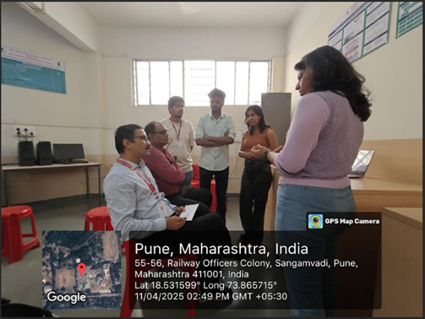  PBL Poster Competition, 11/5/2025 | 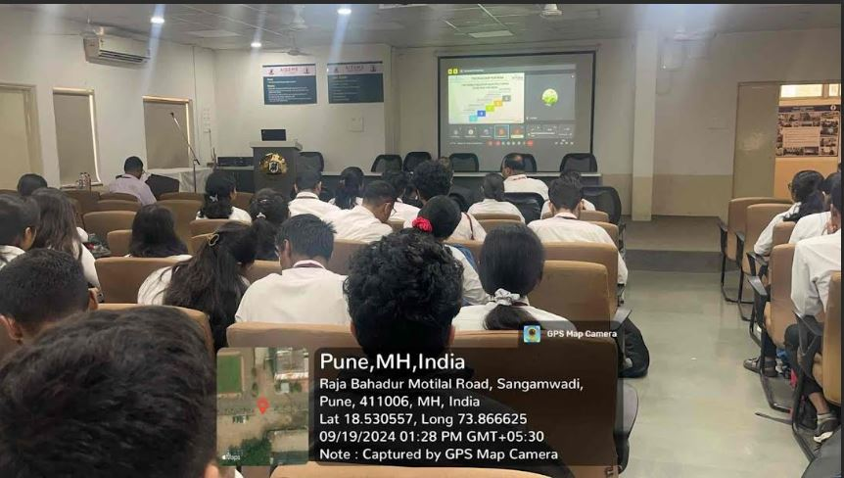  Seminar on Advance Placement Preparation
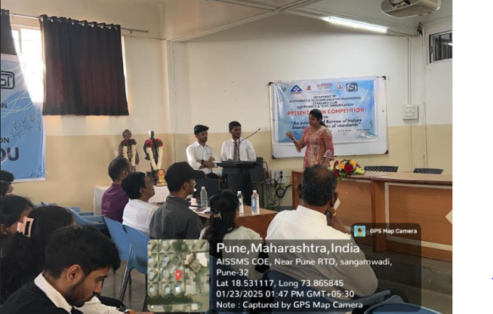  BIS Presentation Competition | Seminar on Campus preparation By Ms. Soumya
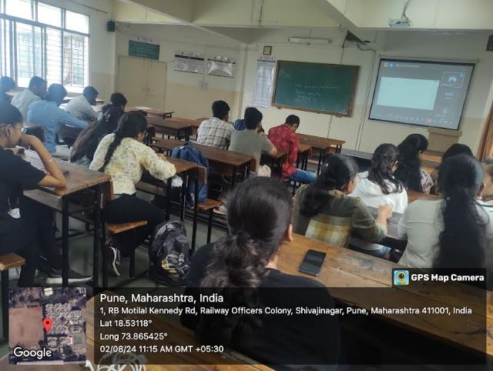  Webinar on Full Stack Development | 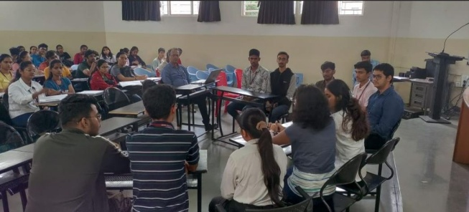Mock Placement Activity for BE students
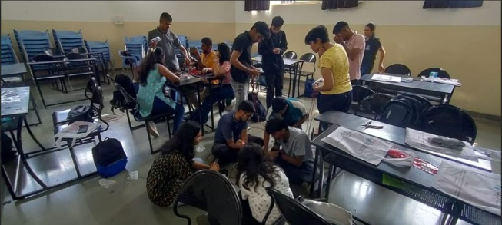  Multitasking Robotics workshop for students | 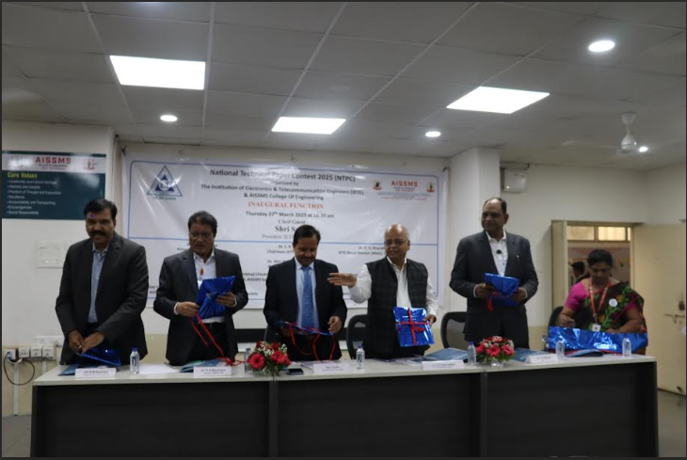  National Technical Paper Contest 2025 Inauguration.
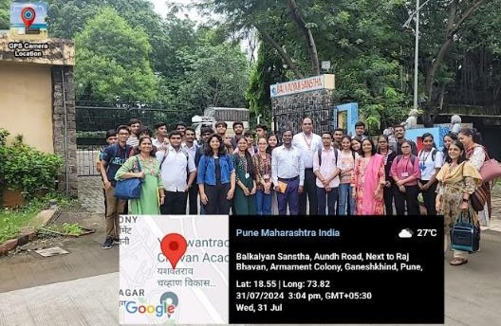  Visit to BalkalyanSanstha by Students and faculty | 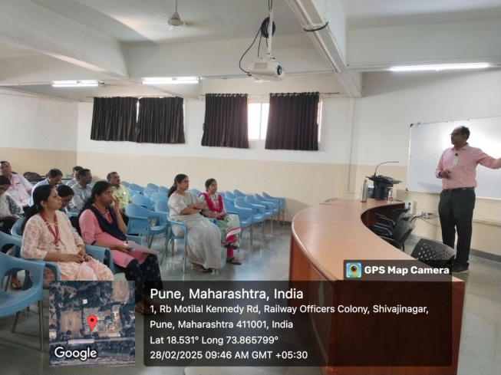  Parent Meet 28 Feb 2025
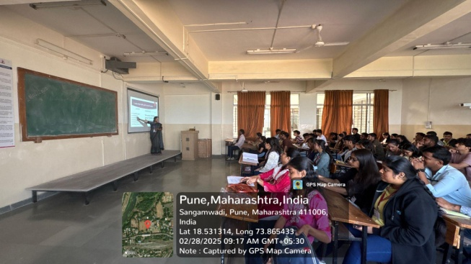  Expert Talk “ Leadership Quality and Group Dynamic” | 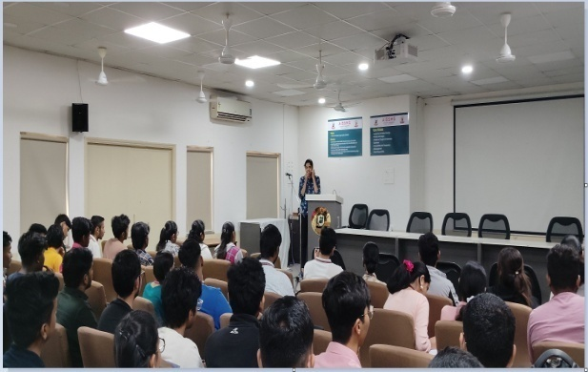  Expert Talk on “Campus to Corporate” by Ms. GauriTalegaonkar, Security Delivery Manager, Accenture, Pune.
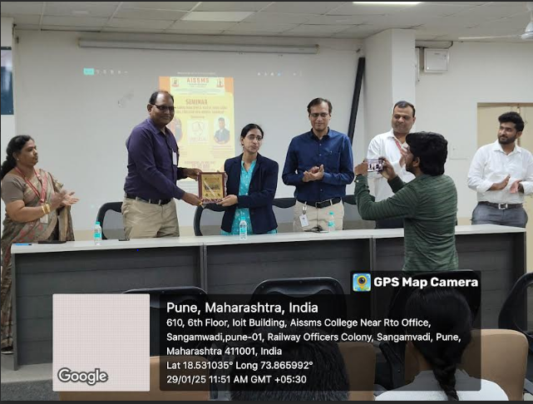  Seminar on “Overseas Opportunities and Process”Speaker: Dr. Shrivastava Vaidya on 29/1/2025 | 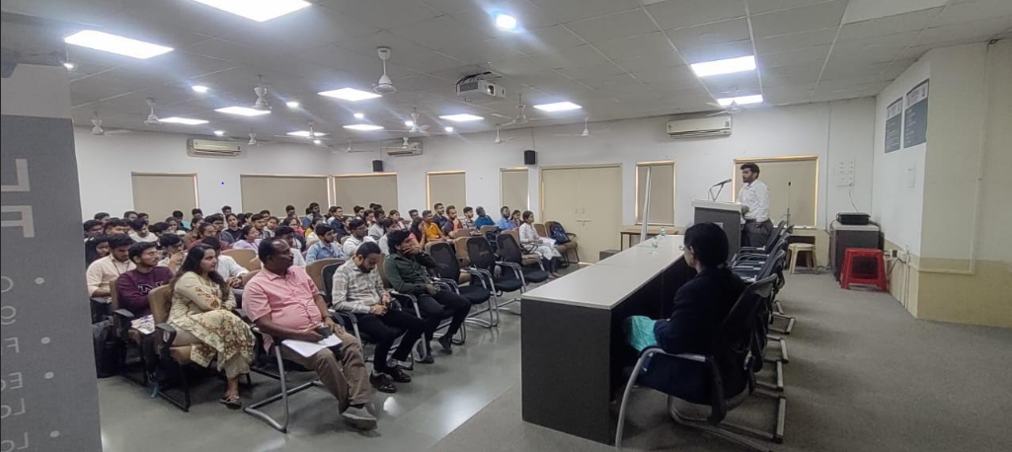  Overseas Opportunities and Process  Speaker: Dr. Shrivastava Vaidya on 29/1/2025
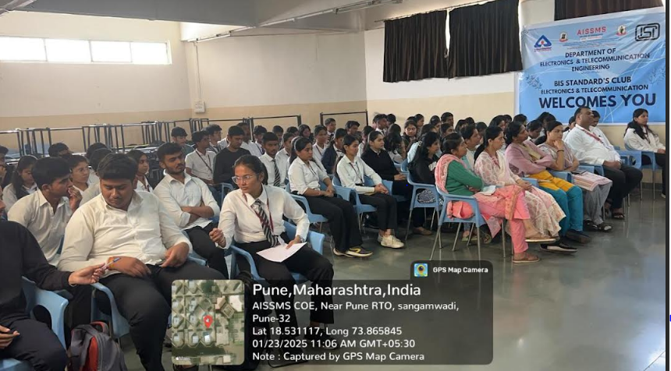  BIS Presentation Competition Inauguration Speaker: Manojkumar Sinha  Scientist B/ Assistant Director Bis Pune.  VishwanathPachling  Managing Partner VishwadeepEnterprises,Pune, 23/1/2025 | 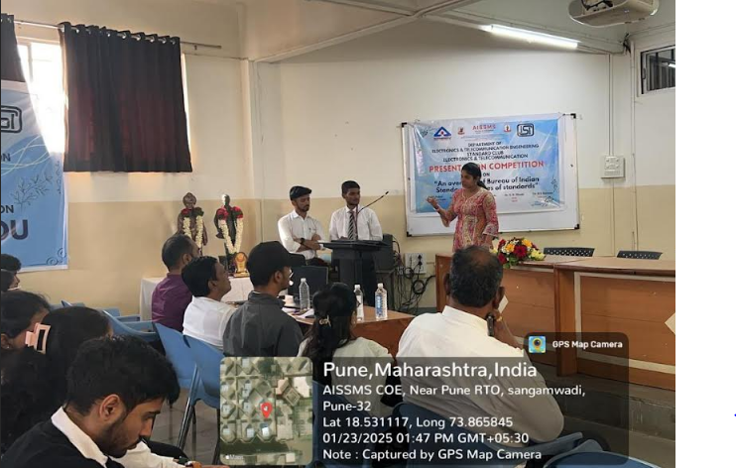  BIS Presentation Competition on  23/1/2025
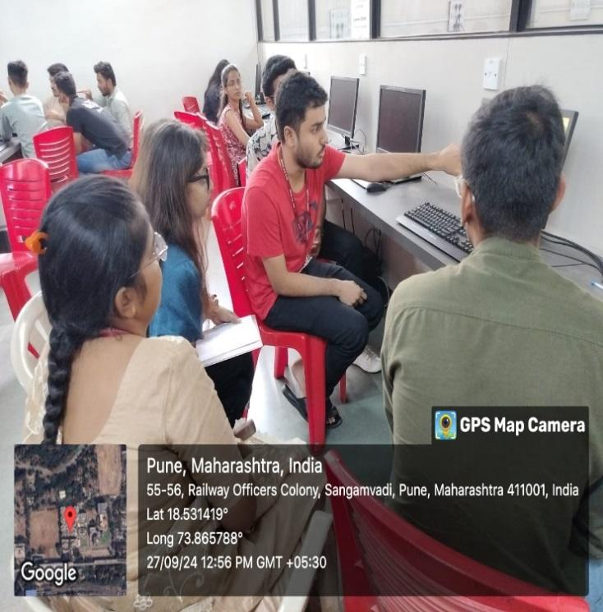  Ms. Siddhi Sadavarte evaluating the participants in Hackathon Competition( ET 2025) | 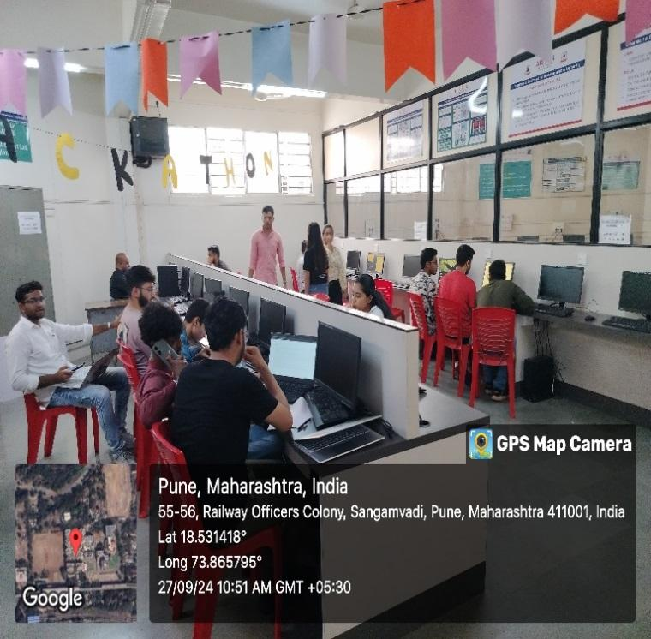  During the offline round in Hackathon Competition( ET 2025)
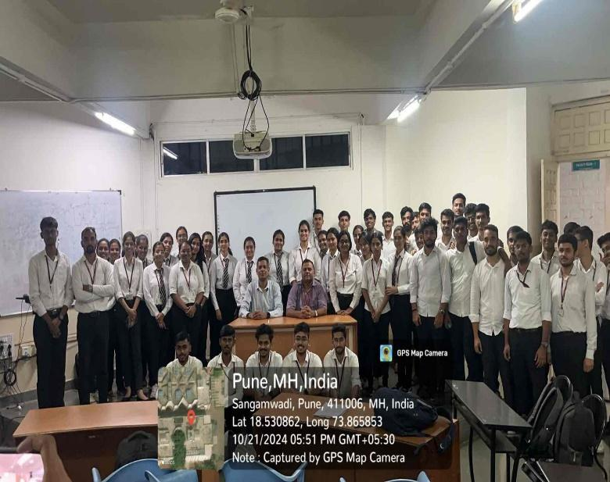  3-Day Hands-On Training Program: “Trends and Challenges in VLSI Design using EDA Tools” Participants with speaker(Mr. ShrikantAtkarne) and faculty coordinator. | 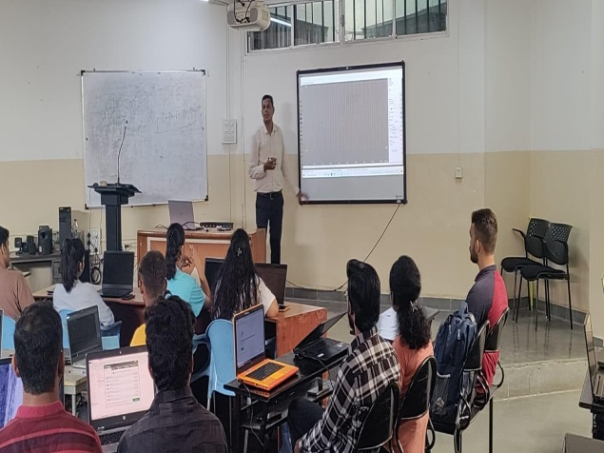  3-Day Hands-On Training Program: “Trends and Challenges in VLSI Design using EDA Tools”
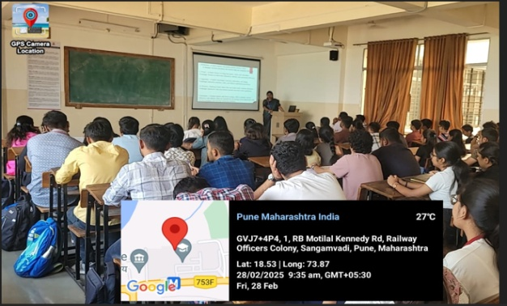  Expert Talk on “Leadership Skill” 28/2/2025 | 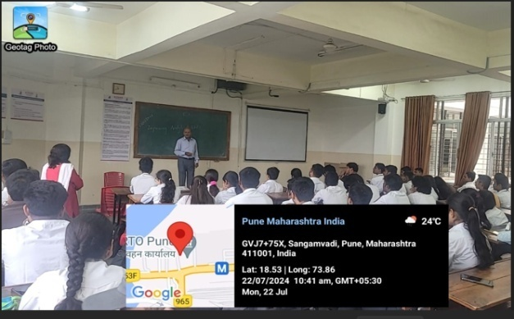  Expert Talk on “Improving Analytical Skills” 22/7/2024
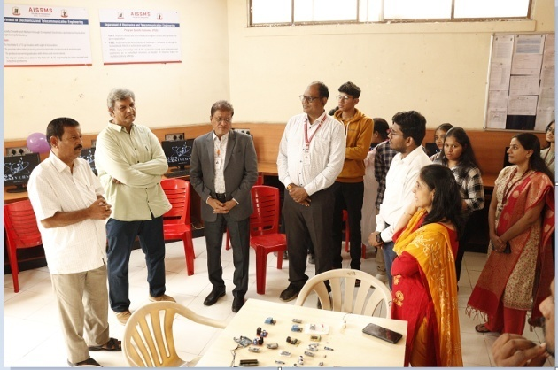  Universo club inauguration by Mr. Deepak Joshi, JyotirvidyaSanstha, Pune | 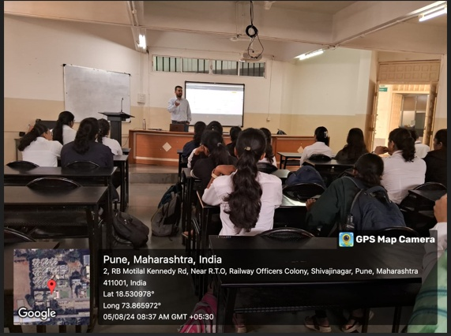  Expert Talk on “Cloud Computing” 5/8/2024
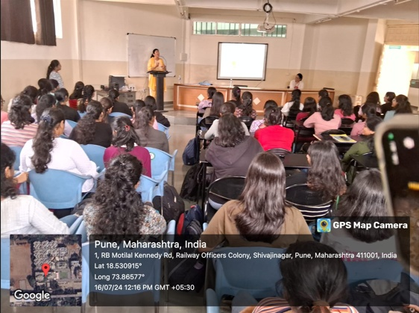  Seminar on “Gender Equality” 15/7/2024 | 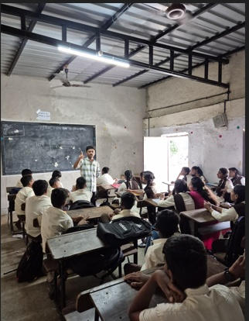  Student Visit to NarsinhVidyalay, Tathawade, Technical Interaction ,4/10/2024
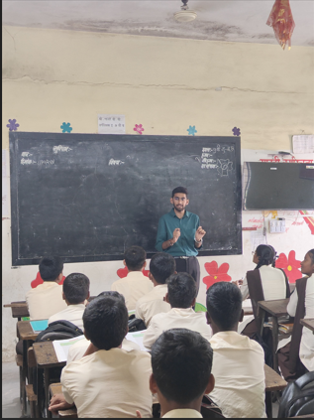  Student Visit to NarsinhVidyalay, Tathawade, Technical Interaction ,4/10/2024 | 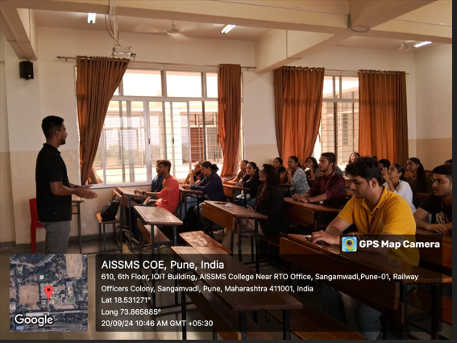  Seminar on “Advanced Placement Preparation” by Mr. MohitKadayan, CEO and Founder, YourthatseniorMMR.
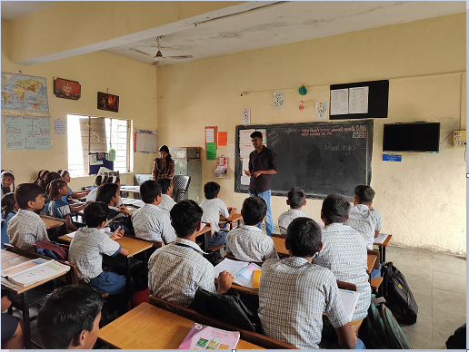  Visit to Zillah Parishad School for Carrier Counseling | 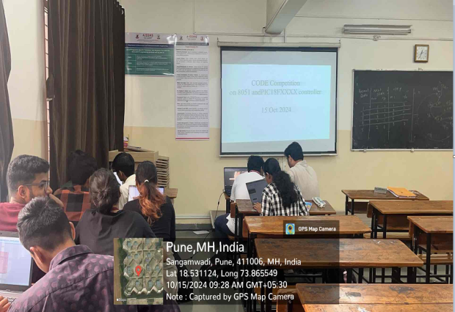  Code Competition conducted for TE Students based on 8051 and PIC Microcontroller 15/10/2024
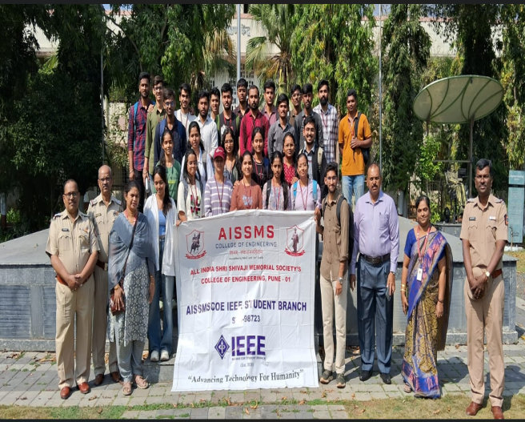 | 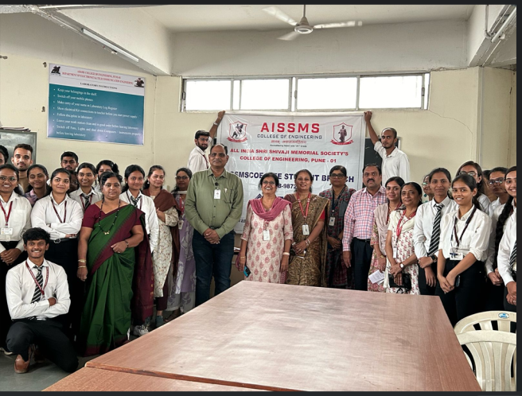
Visit to Research and training centre wireless police headquarters, Pashan.  05/02/2025 | Department level Project Exhibition on 4th April 2025
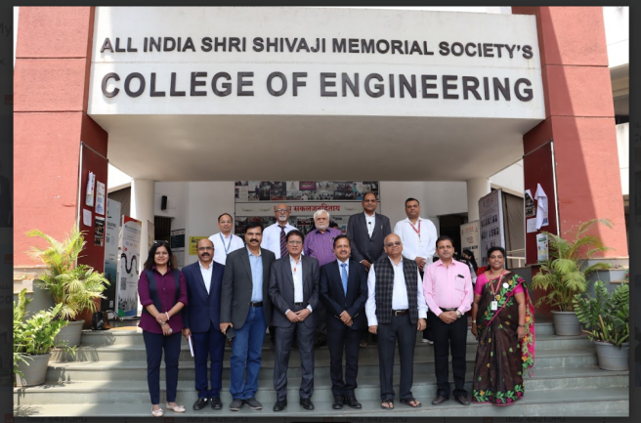 | 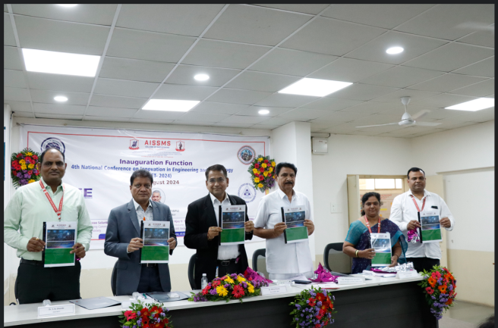
NTPC 2025, Chief Guest Shri Sunil President IETE, New Delhi, 27/03/2025 | NCIET 2025 National Conference August 2024
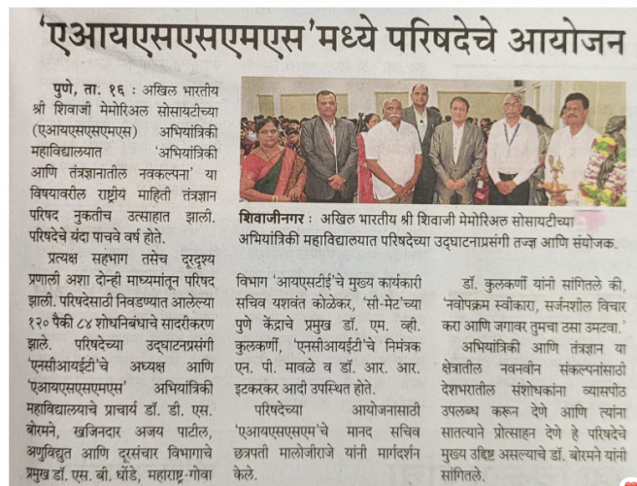 | 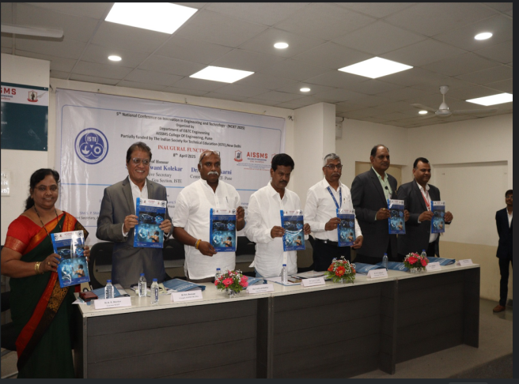
Sakal News NCIET 2025 | NCIET 2025 -8th April 2025

- RESEARCH CONTRIBUTION

4.1 FUNDED RESEARCH PROJECT
Term One
S N | Principal Investigator | Title of the Project | Amount Received (Rs) | Funding Agency
1 | -----

Term Two
S N | Principal Investigator | Title of the Project | Amount Received (Rs) | Funding Agency
1 | -------

FUNDING RECEIVED FOR ANY OTHER ACTIVITY
Term One
S N | Faculty Coordinator | Title of the activity | Amount Received (Rs) | Funding Agency
1 | ------

Term Two
S N | Faculty Coordinator | Title of the activity | Amount Received (Rs) | Funding Agency
1 | Mr. N P Mawale & Dr. R R Itkarkar | 5th NCIET-2025  8-9 April-2025 | 1,00,000/- | ISTE, New Delhi

4.2 TESTING AND CONSULTANCY
Term One
Sr. No. | Faculty Coordinator | Details of Testing & Consultancy Conducted | Total Revenue Generated (Rs.)
1 | -----

Term Two
Sr. No. | Faculty Coordinator | Details of Testing & Consultancy Conducted | Total Revenue Generated (Rs.)
 | ----

4.3 PATENTS, COPYRIGHT, TRADEMARK AND OTHER (IPR)
Term One
Sr No. | Name of Faculty | Name of the Patent | Patent Number and Date | Type (National/  International/Com  mercialized)
1

Term Two
Sr No. | Name of Faculty | Name of the Patent | Patent Number and Date | Type (National/  International/  Commercialized)
1 | Mrs.C.D.Rananaware | Controlling Device for Industrial Electrical Appliances | Design number - 6425901  Date - 7/3/2025 | International

PUBLICATIONS
4.4 PAPERS PUBLISHED/ PRESENTED IN PROCEEDINGS OF CONFERENCES
Term Two
S. No | Authors | Document Details | Year | Conference Details | ISBN | Organized  By
1 | Dr. D S Bormane | “Formulating an Integrated Chest Radiograph Dataset to Alleviate Data Scarcity in Respiratory Disease Detection”. | 2025 | 2025 6th International Conference For Emerging Technology (INCET) | Electronic ISSN: 2996-4490 Print on Demand(PoD) ISSN: 2996-4482 | IEEE International Scopus Indexed Conference
2 | Dr. S B Dhonde | Dysarthric Speech Data Augmentation Using Generative Adversarial Networks | 2025 | 2025 Fifth International Conference on Advances in Electrical, Computing, Communication and Sustainable Technologies (ICAECT) | Electronic ISBN:979-8-3503-5623-6  Print on Demand(PoD) ISBN:979-8-3503-5624-3 | IEEE International Scopus Indexed Conference
3 | Dr. S B Dhonde | Beam Space Hybrid Precoding for Rayleigh Fading MIMO-OFDM Systems Using Compressive Sensing and SVD | 2025 | 2025 IEEE International Conference on Interdisciplinary Approaches in Technology and Management for Social Innovation (IATMSI) | Date of Conference: 06-08 March 2025  Date Added to IEEE Xplore: 09 May 2025 | IEEE International Scopus Indexed Conference
4 | Dr. S B Dhonde | Dysarthric Speech Recognition using Deep Convolution Neural Network | 2024 | IEEE International Conference on Information Technology Electronics & Intelligent Communication System (ICITEICS) | D ate of Conference: 28-29 June 2024  Date Added to IEEE Xplore: 22 August 2024 | IEEE International Scopus Indexed Conference
5 | Mr. N P Mawale | Automated Student Result Analysis and Career Guidance System using Robotic Process Automation and Decision Tree Classification | NCIET-2024 | 4th National Conference  on  Innovation in Engineering  and  Technology  (NCIET-  2024)  Date:  13.08.2024 | ISSN:2319-6386 (Online)  https://www.ijisme.org/portfolio-item/b809513020724/ | AISSMSCOE
6 | Mr. V B Gawai | IoT based Thermal Management System Using Liquid Coolant for Electric Two Wheelers | 2025 | NTPC  202527/3/2024 |  | IETE and AISSMS COE
7 | Mrs. V S Navale | Heart Disease Detection using Deep Learning | 2025 | NCIET 2025  8/4/2025 and 9/4/2025 |  | IETE and AISSMS COE
8 | Dr. Mrs. K B Chaudhari | Sign Language to Text Converter | 2025 | NTPC 2025  27 March 2025 |  | IETE and AISSMS COE
9 | Dr R RItkarkar | EmpoweringVoices:WomeninDecision-MakinginIndia–FromHistoricalLegacytoFutureLeadership | 8- 9 March2025. | InternationalConferenceonGenderEquality&WomenEmpowerment2025 | International Conference presentation | DepartmentofElectronics&TelecommunicationEngineering,PVG’sCOET&GKPIOMinassociationwithDepartmentofEducation&Extension, SPPU
10 | Dr R RItkarkar | Innovative Frameworks for Sustainable Smart Cities: Leveraging Technology for A Better Tomorrow | 16-18 Jan 2025 | International Conference on Climate Change | International Conference presentation | SNDT women’s University Mumbai

4.5 PAPERS PUBLISHED IN JOURNALS
Term One
S. No | Authors | Document Details | Year | Source Details | ISBN/  ISSN | Publisher
1 | Dr. P. P. Vast | Seed Germination Prediction using Machine Learning | July 2023 | Volume 46 | 0971-  3034 | INDIAN SOCIETY FOR TECHNICAL EDUCATION
2 | Dr. P. P. Vast | Semantic Segmentation of Retinal Arteries and Veins | July 2023 | Volume 46 | 0971-  3034 | INDIAN SOCIETY FOR TECHNICAL EDUCATION
3 | Mr. N P Mawale | Solar Based Water Purification System  pg. 1-4 | Sept. 2024 | International Journal of Innovative Science and Modern Engineering  (IJISME)  Volume:12, Issue-9, Sept.2024  DOI:10.35940//ijisme.B8095.12090924  www.ijisme.org | (IJISME)  Volume:12, Issue-9, Sept.2024 | Modern College of Engineering
4 | Mr. N P Mawale | Automated Student Result Analysis and Career Guidance System using Robotic Process Automation and Decision Tree Classification | International Journal of Scientific Research in Engineering & Management (IJSREM) | ISSN:2582-3930 | UGC Care  Peer Reviewed  Impact Factor: 8.448
5 | Dr. G. D. Salunke | Deep Learning-Based Face Mask Recognition in Real-Time Photos and Videos | African Journal of Biomedical Research | 1119-5096  Pages  1302-1308 | Scopus  DOI: https://doi.org/10.53555/AJBR.v27i1S.1603  https://www.africanjournalofbiomedicalresearch.com/index.php/AJBR/article/view/1603/1366
6 | Dr. G. D. Salunke | Iot Based Health Monitoring System for Human | African Journal of Biomedical Research | 1119-5096  Pages  1309-1315 | Scopus  DOI:10.53555/AJBR.v27i1S.1606  https://www.researchgate.net/publication/384159566_Iot_Based_Health_Monitoring_System_for_Human

Term Two
S. No | Authors | Document Details | Year | Source Details | ISBN/  ISSN | Publisher
1 | DeepaliUjlambkar, Chaitanya Kulkarni, RajeshriItkarkar | AI powered Solutions for Deepfake Identification | Advances in Nonlinear variational Inequalities | Vol 28,No 4s(2025) | ISSN 1092-910X | Scopus
2 | Dr. UmakantDinkar Butkar1, Dr. Deepali Ujalambkar2, Rajeshri Rahul Itkarkar3,Vidya Nitin Patil | AI-Human Co-Evolution: Feedback Loop Design, Organizational Innovation, Ethical Considerations, and Workforce Dynamics | Nanotechnology Perceptions | Nanotechnology Perceptions 20No.5(2024) 1709–1721 | ISSN 1660-6795 | Scopus
3 | Deepali M. Ujalambkar1, Rajeshri R. Itkarkar 2,Vidya N. Patil3, Swagat M. Karve4 | Automated Detection of Lower-Grade Gliomas Using Deep Learning with UNet and EfficientNet-B7 | Journal of Information Systems Engineering and Management 2025, 10(33s) | Journal of Information Systems Engineering and Management 2025, 10(33s) | e-ISSN: 2468-4376 | Scopus

4.6 BOOK / ARTICLE PUBLICATIONS
Term One
Author | Title of the Book | Published by | ISBN | Year

Term Two
Author | Title of the Book | Published by | ISBN | Year
Rajeshri Rahul Itkarkar  Petkar  Roshani More | Cloud- Based Professional  Development | IGI Global | www.igi-global.com/chapter/cloud-based-professionaldevelopment  DOI: 10.4018/979-8-3693-6705-6.ch002 | 2025

4.7 RESEARCH CITATIONS (Source of Data: Google scholar) (As on 30th May)
Name of faculty | Citations, h-index, i10 index | Name of faculty | Citations, h-index, i10 index
Dr. S B Dhonde | Citations : 157  h index: 7  i10 index: 6 | Dr R R Itkarkar | Citations : 68  h index: 5  i10 index:3
Mr. N P Mawale | Citations : 9  h index: 1  i10 index:0 | Dr. G. D. Salunke | Citations : 110  h index: 6  i10 index:3
Dr V V Deshmukh | Citations : 177  h index: 9  i10 index:9
Ms V D Nagrale | Citations : 13  h index: 2  i10 index:0
Mr.V.B.Gawai | Citations : 5  h index: 1  i10 index:0
Total Citations of Department: 457
4.8 ME AWARDED
Sr No | Name of Supervisor | Title of Thesis | Name of Candidate
 | ----

4.9 PhD GUIDE DETAILS
Name of Faculty who are PhD Supervisor | Number of Scholars Registered
Dr. S B Dhonde | 4
Dr. P P Vast | 3

4.10 PhD AWARDED (For departments having Ph.D research centers)
Sr No | Name of Supervisor | Title of Thesis | Name of Candidate
 | NA

- INTERACTION WITH INDUSTRY

5.1 INDUSTRY VISITS ORGANISED
Term One
Sr. No. | Faculty Coordinator | Class and Number of students attended | Industry Name and Address | Date of visit
1 | Mr.N P Mawale | SE(E&TC) VLSI | Automation Expo 2024, Mumbai | 24/8/2024
2 | Dr.P P Vast  Dr K B Chaudhari | TE(E&TC) | Auto Cluster Exhibition Center,Pimpri Chinchwad, Pune | 5/8/2024

Term Two
Sr. No. | Faculty Coordinator | Class and Number of students attended | Industry Name and Address | Date of visit
1 | Mr.N P Mawale | TE E&TC and BE E&TC | DIPEX-2025 | 04.04.2025

5.2 EXPERT LECTURES / WEBINARS DELIVERED BY INDUSTRY EXPERTS
Term One
Sr. No. | Faculty Coordinator | Class  (Number of students attended) | Name, Industry, designation and contact details of Expert | Topic | Date
1 | Dr K B Chaudhari | SE E and TC  SE VLSI  87 | Ms Gauri Talegaonkar, Security Delivery Manager, Accenture | Campus to Corporate | 05/09/2024
2 | Dr. R R Itkarkar | Seminar on “Cloud Computing: A Practical Approach | Speaker: Mr. Sushil Taskar, Team Leader, Siemens, Pune | Seminar on “Cloud Computing: A Practical Approach | 5/8/2024

Term Two
Sr. No. | Faculty Coordinator | Class  (Number of students attended) | Name, Industry, designation and contact details of Expert | Topic | Date
1 | Mrs.A.A.Randive & Mr. N P Mawale | TE (E &TC) 55 | Mr.Pranit Malave, Consultant, IT Companies | Expert Talk on “Current Trends and Career Opportunities in Cyber Security” | 10/02/2025
2 | Dr V V Deshmukh | 53 TE (E &TC) | Mr. Manish Ratnakar  Capgemini | Expert Talk on Recent Trends, Technologies & Threats in Cyber Security | 3/3/2025
3 | Mrs.C.D.rananaware | 60 SE(E&TC) | Mrs. Deepmala Maurya, Counsellor, Hefshine Software Pvt. Ltd. | Expert talk on “Leadership Skills and Group Dynamics” | 28/2/2025
4 | Mr. N P Mawale | 65 TE E&TC | Dr. M V Kulkarni, Center Head, C-MET, Pune  (Scientist-F) | Expert Talk on Batteries Technology | 08/04/2025

5.3 INDUSTRY – SPONSORED PROJECTS (UG/PG) ((Excluding Sandwich Projects)
Sr. No. | Name of Project guide | Title of Industry Sponsored Project | Name of Sponsoring Industry
1

5.4 MOU SIGNED WITH INDUSTRY
Term One
Sr. No. | Faculty Coordinator | Name of Industry | Date  of MoU Signed | Valid upto  (00/00/0000)
1 | Dr K B Chaudhari | NoSpaceLimit | 08/10/2024 | 07/10/2027

Term Two
Sr. No. | Faculty Coordinator | Name of Industry | Date  of MoU Signed | Valid upto  (00/00/0000)
1 | Mrs. C D Rananaware | KIMAYA Automation Pvt.Ltd.Pune | 29/4/2025 | May 2030

TOTAL FUNCTIONAL / LIVE MOU INITIATED BY THE DEPARTMENT
Sr. No. | Faculty Coordinator | Name of Industry | Date  of MoU Signed | Valid upto  (00/00/0000)
1 | Dr.D.G.Bhalke | Firenest Reality Pvt Ltd | 2021-22 | 2027
2 | Ms.P.P.Tayade | Startech Engineers, Mumbai | 2021-22 | 2025
3 | Mr.V.B.Gawai | Elon Power | 2021-22 | 2027
4 | Dr.P.P.Vast | PMP Automation Pvt Ltd | 2021-22 | 2025
5 | Ms.P.P.Tayade | CMS Digital Automation Pune | 2021-22 | 2025
6 | Mr.S.B.Dhekale | Wish Energy | 2021-22 | 2025
7 | Mr.N.P.Mawale | Softcon Pvt Ltd | 2021-22 | 2027
8 | Mr.V.B.Gawai | MICROCON Power Electronics Pune | 2021-22 | 2025
9 | Dr.K.B.Chaudhari | IndEyes Infotech Pvt | 2019-20 | 2025
10 | Dr. V V Deshmukh | Sunshine Powertronics, Pune | 2021-22 | 2026
11. | Mr. N P Mawale | IMFS, Pune | 2024-25 | 2028
12 | Dr R R Itkarkar | Yoursthatsenior | 20/9/ 2024 | valid till terminated by anyone party
13 | Dr K B Chaudhari | NoSpaceLimit | 8/10/2024 | 2027
14 | Mr. N P Mawale | IMFS, Pune | 22/11/2024 | 2027
15 | Mr. N P Mawale | Imperial Overseas Education, Pune | 2024 | 2025
16 | Mr. N P Mawale | T.I.M.E. Pune | 2024 | 2025
17 | Mrs. C D Rananaware | KIMAYA Automation Pvt. Ltd. Pune | 29/4/2025 | May 2030

5.5 FACULTY MEMBERS UNDERGONE INDUSTRIAL TRAINING
Term One
Sr. No. | Name of Faculty | Name of Industry | Dates and Duration
1 | Dr. K B Chaudhari | TCS | 21 June 2024
2 | Mr. N P Mawale | TCS | 21 June 2024

5.6 STUDENTS UNDERGONE IN-PLANT TRAINING AND (OR) INTERNSHIP PROGRAMME

Term Two
Sr. No. | Name of the Student | Name of the Industry | Class | Training duration
 |  |  |  | Start date (MM/DD/YYYY) | Last date  (MM/DD/YYYY) | Duration (days)
1 | Manasvi Arjun Pandilwar | CyberArt Solutions Pvt ltd Pune | TE ENTC | 12/20/2024 | 1/20/2025 | 30 Days
2 | Bhavesh khushu | Emerson Measurement system and solutions | TE ENTC | 12/20/2024 | 1/21/2025 | 30 Days
3 | Gunjal Sakshi Shivaji | CyberArt Solution Pvt lmt | TE ENTC | 12/20/2024 | 1/20/2025 | 30 Days
4 | Vaibhav Jaybhay | Sunshine powertronics pvt ltd . | TE ENTC | 11/14/2024 | 1/17/2025 | 30 Days
5 | Tanmay Jagtap | Sunshine Powertronics Pvt. Ltd. | TE ENTC | 11/14/2024 | 1/17/2025 | 30 Days
6 | Somya Verma | Bharat Forge | TE ENTC | 12/20/2024 | 1/21/2025 | 30 Days
7 | Tushar Patil | Sunshine Powertronics Pvt. Ltd. | TE ENTC | 12/2/2024 | 1/14/2025 | 30 Days
8 | Yogesh Vijay Kadlag | Shricap Electronics | TE ENTC | 12/20/2024 | 1/20/2025 | 30 Days
9 | Saniasnine Patel | Sunshine Powertronics private limited | TE ENTC | 11/14/2024 | 1/17/2025 | 30 Days
10 | Rujal Patil | Sunshine Powertronics Pvt Ltd | TE ENTC | 12/2/2024 | 1/14/2025 | 30 Days
11 | Ujjwal Deshmukh | 3S Analytical Technologies Pvt. Ltd | TE ENTC | 12/13/2024 | 1/13/2025 | 30 Days
12 | Deshmukh Aditya Nilesh | Farmtrac,Borundia Motors | TE ENTC | 12/24/2024 | 1/24/2025 | 30 Days
13 | Lalit Vijay Shirsale | Anilata AB Pvt.Ltd | TE ENTC | 12/22/2024 | 1/22/2025 | 30 Days
14 | Shreyas Kadam | CSM Digital Technologies | TE ENTC | 12/24/2024 | 1/20/2025 | 30 Days
15 | Rohit Dnyaneshwar Sakhale | Sunshine Powertronics Pvt. Ltd. | TE ENTC | 12/24/2024 | 1/23/2025 | 30 Days
16 | Abhishek Singh | CSM Digital Technologies | TE ENTC | 12/24/2024 | 2/20/2025 | 30 Days
17 | Gaikwad Ashish | CSM Digital Technologies | TE ENTC | 12/24/2024 | 1/20/2025 | 30 Days
18 | Agarwal Krishna Pravin | CSM Digital Technologies | TE ENTC | 12/24/2024 | 1/24/2025 | 30 Days
19 | Siddhi Darwatkar | DCC infotech | TE ENTC | 1/3/2025 | 2/3/2025 | 30 Days
20 | Vaibhav Dattatray Samgir | PRO Electronics | TE ENTC | 12/27/2024 | 1/27/2025 | 30 Days
21 | Aditya Sonawane | ANUERA Technologies pvt. Ltd. | TE ENTC | 12/26/2024 | 1/25/2025 | 30 Days
22 | Atharv Patil | ANUERA Technologies Pvt. Ltd. | TE ENTC | 12/26/2024 | 1/25/2025 | 30 Days
23 | Shravani Khanvilkar | SunBeam institute | TE ENTC | 1/6/2025 | 2/1/2025 | 30 Days
24 | Dhawal Phalak | Sunshine powertronics pvt ltd | TE ENTC | 12/2/2024 | 1/14/2025 | 30 Days
25 | Patil Samradnyi Sharad | Kimaya Automation Pvt LTD | TE ENTC | 1/1/2025 | 2/1/2025 | 30 Days
26 | Digvijay Kadolkar | Sunshine Powertronics | TE ENTC | 12/24/2024 | 1/27/2025 | 30 Days
27 | Krishi Hanumant Varada | Sunshine Powertronics Pvt. Ltd | TE ENTC | 12/23/2024 | 1/23/2025 | 30 Days
28 | Yash Ayachit | CSM Digital Technology | TE ENTC | 12/24/2024 | 1/20/2025 | 30 Days
29 | Arwa Master | Sunshine Powertronics Pvt.Ltd. | TE ENTC | 11/14/2024 | 1/17/2025 | 30 Days
30 | Prathamesh Devadiga | Pro_Electronics | TE ENTC | 12/27/2024 | 1/27/2025 | 30 Days
31 | Anushka Kangutkar | Laconqic Infotech Pvt Ltd | TE ENTC | 1/2/2025 | 2/2/2025 | 30 Days
32 | Ganesh Chandrakant Dhangond | SNR Electronics | TE ENTC | 12/20/2024 | 1/20/2025 | 30 Days
33 | Nidhi Bhurke | TOX PRESSOTECHNIK India Pvt Ltd. | TE ENTC | 1/2/2025 | 1/31/2025 | 30 Days
34 | Veer Akshada Santosh | Kimaya Automation Pvt.Ltd | TE ENTC | 1/1/2025 | 1/30/2025 | 30 Days
35 | Begampalli Tahareen Sadiqhusain | Kimaya Automation PVT.Ltd | TE ENTC | 1/1/2025 | 1/30/2025 | 30 Days
36 | Ajinkya Kiran Ransubhe | PRO ELECTRONICS | TE ENTC | 12/27/2024 | 2/27/2025 | 30 Days
37 | Vaibhav Yuvraj Ingle | Bhagyashree IT Solutions. | TE ENTC | 12/23/2024 | 1/25/2025 | 30 Days
38 | Shruti Shah | Twintech control systems pvt.ltd | TE ENTC | 12/30/2024 | 1/30/2025 | 30 Days
39 | Reuben Anthony | Techroid Solutions Pvt Ltd | TE ENTC | 1/3/2025 | 2/6/2025 | 30 Days
40 | Prajwal Raju Khunkar | Diligence Tech | TE ENTC | 1/2/2025 | 1/30/2025 | 30 Days
41 | Raviraj Dattatray Disale | Sunshine Powertronics | TE ENTC | 12/24/2024 | 1/24/2025 | 30 Days
42 | Amruta Ohal | Diligence tech | TE ENTC | 1/2/2025 | 1/29/2025 | 30 Days
43 | Harish Choudhary | Sunshine powertronics PVT LTD | TE ENTC | 12/24/2024 | 1/24/2025 | 30 Days
44 | Hitesh Hirve | BITS, Pune | TE ENTC | 1/23/2025 | 2/25/2025 | 30 Days
45 | Prajwal D. Kashiwar | Bhagyashree IT Solution (BITs) Pune | TE ENTC | 12/23/2024 | 1/25/2025 | 30 Days
46 | Karan Prashant Mane | ANUERA technologies Pvt.Ltd. | TE ENTC | 12/26/2024 | 1/25/2025 | 30 Days
47 | Saurabh Murlidhar Dalvi | Sunshine electronics | TE ENTC | 12/23/2024 | 1/24/2025 | 30 Days
48 | Chavan Satyam Santosh | Sunshine Powertronics Pvt.Ltd. | TE ENTC | 12/23/2024 | 1/23/2025 | 30 Days
49 | Jayesh Suresh Roman | Diligence Tech | TE ENTC | 1/2/2025 | 2/2/2025 | 30 Days
50 | Abhishek santosh Bhosale | Bhagyashree it solutions | TE ENTC | 12/20/2024 | 1/25/2025 | 30 Days
51 | Aditya Kashinath Shelar | Diligence Tech | TE ENTC | 1/2/2025 | 2/14/2025 | 30 Days
52 | Halnor Sahil Nareshkumar | Diligence Tech | TE ENTC | 1/2/2025 | 1/29/2025 | 30 Days
53 | Chavan Supriya Ganpat | Diligence Tech | TE ENTC | 1/2/2025 | 1/29/2025 | 30 Days
54 | Singh Prajjawalkumar Arun | Pro Electronics | TE ENTC | 12/27/2024 | 1/27/2025 | 30 Days
55 | Sayli H I | World Wide Oilfield (I) Pvt. Ltd. | TE ENTC | 12/22/2024 | 1/22/2025 | 30 Days
56 | Jayada Tarhalkar | Itorix Infotech LLP | TE ENTC | 1/2/2025 | 2/5/2025 | 30 Days
57 | Ishwari Ravindra Pilkhane | Cyber Art solutions Pvt. Ltd. | TE ENTC | 12/30/2024 | 1/30/2025 | 30 Days
58 | Sravani Pande | Earth LogicWare Technologies | TE ENTC | 12/20/2024 | 1/29/2025 | 30 Days
59 | Viraj Vidhale | Twintech Control Systems Pvt.Ltd | TE ENTC | 12/26/2024 | 1/26/2025 | 30 Days
60 | Shravani Thorat | Zogato Tech. Pvt . Ldt | TE ENTC | 12/20/2024 | 1/20/2025 | 30 Days
61 | Saloni Rupeja | IMD Aws lab ,pasan pune | TE ENTC | 12/23/2024 | 2/15/2025 | 30 Days
62 | Keyur Sanjay Pawar | India meteorological department IMD pashan | TE ENTC | 12/22/2024 | 2/18/2025 | 30 Days
63 | Sujal Wadekar | IMD | TE ENTC | 12/23/2024 | 2/18/2025 | 30 Days
64 | Shantanu Ghorpade | IMD pune | TE ENTC | 12/23/2024 | 2/15/2025 | 30 Days
65 | Gayatri Raykar | Itorix infotech LLP | TE ENTC | 1/2/2025 | 2/5/2025 | 30 Days
66 | Ruchita Anil Magar | Indian Meterological Department | TE ENTC | 12/23/2024 | 2/15/2025 | 30 Days
67 | Pravin kumbhar | India metrological department | TE ENTC | 12/22/2024 | 2/15/2025 | 30 Days

5.7 LIST OF INDUSTRIES SUPPORTED IN THE ORGANISATION OF WORKSHOPS/SEMINARS/WEBINARS/CONFERENCES/COURSES AND ANY OTHER CONTRIBUTION OF INDUSTRY
Term One
Sr.  No. | Faculty Coordinators | Industry Representative and Name of Industry | Nature of Contribution
1 | Mr. N P Mawale | Mr. Shrikant Atkire,  Consultant-Techno Commercial (Pan India)  SPAARTA SOFT Technology Solutions | 30 Hours Value Added certification Program

Term Two
Sr.  No. | Faculty Coordinators | Industry Representative and Name of Industry | Nature of Contribution
1 | Mrs. A A Randive & Mr. N P Mawale | SEED Infotech Ltd. | Seminar
2 | Dr. R R Itkarkar and Mr. N P Mawale | T.I.M.E | Seminar
3 | Dr. R R Itkarkar and Mr. N P Mawale | Imperial Overseas Consultant | Seminar
4 | Dr. V V Deshmukh | Mr. Manish Ratnakar Capgemini | 30 Hours Value Added Course on Cyber Security

5.8 TRAINING TO INDUSTRY PERSONNEL/ ACTIVITY SUPPORTING TO INDUSTRY
Term One
Sr. No. | Faculty Coordinator | Technical Area in which Training Provided / Type of Support | Industry Name
1 | ----

Term Two
Sr. No. | Faculty Coordinator | Technical Area in which Training Provided / Type of Support | Industry Name
1 | ----

5.9 ANY OTHER ACTIVITIES TO PROMOTE INTERACTION WITH INDUSTRY
Term One
Sr. No. | Faculty coordinator | Name of Activity | Remark
01 | Mr. N P Mawale | Energy Literacy Training Certification Program in Association with Energy Swaraj Foundation, Mumbai | 1000+ Certification done

Term Two
Sr. No. | Faculty coordinator | Name of Activity | Remark
01 | Mr. N P Mawale | Energy Literacy Training Certification Program in Association with Energy Swaraj Foundation, Mumbai | 1000+ Certification done

5.10 STUDENTS UNDERGONE SANDWICH TRAINING (For Mechanical & Production departments)
Term One
Sr No | Name of student | Industry | Sr No | Name of student | Industry
 | NA

Term Two
Sr No | Name of student | Industry | Sr No | Name of student | Industry
 | NA

- STUDENTS’ ACHIEVEMENTS

6.1 STUDENTS’ ACHIEVEMENT (Professional) (Individual Level) (Technical activities such as design competitions, paper presentation, technical quiz, Product development, innovation, etc.)
Term One
Name of Student | Details of Achievement (State/University/ National/International Level) | Remark  (Domain)
Supriya Chavan | Republic Day Parade  district Level selection round.SPPUPune. 14/9/2024 | Selectedfor university
Supriya Chavan | ET2025mockplacement AISSMSCOE,  Pune, 27/9/2024 | 3rdrank
Supriya Chavan | Triz international conference and presentationTrizAssociation, Russia.10/10/2024 | 1strank
Supriya Chavan | Hackathon, MMCOE, Pune Nov. 2024 | 3rdrank
Supriya Chavan | Spot talk AISSMSCOE,  Pune. 27/3/2025 | 1strank
Supriya Chavan | Battle of wits national debate 2025, TrinityAOE, Pune. 7/4/2025 | 1strank

Term Two
Name of Student | Details of Achievement (State/University/ National/International Level) | Remark  (Domain)
Supriya Chavan | Spot talk AISSMSCOE,  Pune. 27/3/2025 | 1strank
Supriya Chavan | Battle of wits national debate 2025, TrinityAOE, Pune. 7/4/2025 | 1strank

6.2 STUDENTS’ ACHIEVEMENTS (other than Professional) (Individual Level) (Social activities, etc.)
Term One
Name of Student | Details of Achievement (State/University/ National/International Level) | Remark  ((Domain)

Term Two
Name of Student | Details of Achievement (State/University/ National/International Level) | Remark  ((Domain)

6.3 CERTIFICATE / ONLINE COURSES COMPLETED BY STUDENTS (Certificate courses, value added courses, MOOC, etc.)

Term One
S N | Name of Student | Title of the Course | Conducted By | Duration/ Dates
1 | Sarthak Ambhore | German -I Nptel Online Certification Course – 73% | Funded by MoE, Govt. of India | Jul-Oct 2024  (12 week)

Term Two
S N | Name of Student | Title of the Course | Conducted By | Duration/ Dates
1 | Nuraj Dhamale | CMOS Digital VLSI Design Nptel Online Certification Course– 73% | Funded by MoE, Govt. of India | Jan-March 2025  (8 week)
2. | Macchindra Kapse | CMOS Digital VLSI Design Nptel Online Certification Course– 63% | Funded by MoE, Govt. of India | Jan-March 2025  (8 week)

6.4 NUMBER OF STUDENTS PLACED

Term Two
Sr No | Name of Organization visited | Number of students Participated | Number of students Placed
1 | Mahindra and Mahindra, Cognizant  3)Bosch  L&T Infotech  TCS  Infosys  Godrej Enterprises | 50 | 40

6.5 NUMBER OF STUDENTS QUALIFIED IN THE EXAMINATIONS (GATE, GRE, UPSC, MPSC, CAT, TOEFL, any other examination)
Sr.No | Name of Student | Examination | Examination / registration number
4 | Dewanshi Agarkar | MSc. Cyber Security | Cardiff University, UK
5 | Saee Murkute | MSc. Microelectronics | New Castle University, UK
6 | Omkar Vartak | MSc. Management of Information Systems and Digital Innovation | Leeds University, UK

6.6 SPORTS / CULTURAL ACHIEVEMENTS OF STUDENTS (Individual Level) (Team level achievements to be mentioned in institute level sports/Cultural committee report)

Term Two
Name of Student | Details of Achievement (State/University/ National/International Level) | Remark  (Domain)
Deewanshi Agarkar  Siddhi Darwatkar | Flame Kurukshetra 2025, Flame University | 1st Runner Up
Deewanshi Agarkar  Siddhi Darwatkar | Zest 2025, COEP, Pune | Winner
Ashutosh Waghavkar | Maharashtra Open State Taekwondo Championship 2025 ( under 63 weight category)  Selected for West Zone Championship Gujarat2025 (will represent Maharashtra  Selected forIndia Taekwondo Federation Cup  Qualified for Maharashtra State Olympics 2025 | Silver Medal
Ashutosh Waghavkar | Bank of Baroda Achiever Award - Sports Category | 21000/-
Mr. Vishwaraj Patil | National Level The Institution of Engineers (India), Kolkata Scholarship | 14,000/-
Mr. Manthan P. Angeer | National Level The Institution of Engineers (India), Kolkata Scholarship | 6000/-
Ms. Samruddhi Nikam | National Level The Institution of Engineers (India), Kolkata Scholarship | 6000/-
Ms. Likhita Bujade | National Level The Institution of Engineers (India), Kolkata Scholarship | 14,000/-
Ms. Arya Dombe | National Level The Institution of Engineers (India), Kolkata Scholarship | 14,000/-
Mr. Mandar Kulkarni | National Level The Institution of Engineers (India), Kolkata Scholarship | 6000/-
Ms. Janvi Mahapadi | National Level The Institution of Engineers (India), Kolkata Scholarship | 6000-

6.7 STUDENTS’ ACHIEVEMENTS (Team Level)
One
Name of Event | Name of Faculty Advisor | Details of Achievement (State/University/ National/International Level) | Remark  (Domain)
Aviot-O-Virtue team  Aditya Sonawane  Atharva Patil  Aditya Shelar  Krishna Agarwal  Pranav Birade  Pandurang Jawale  Swaraj Malusare  Ajinkya Darekar  Paras Pingle | Mr. N P Mawale | TECHNOVANZA 2024 at VJTI Mumbai  Robo Race | 1st Prize
Aviot-O-Virtue team  Aditya Sonawane  Atharva Patil  Aditya Shelar  Krishna Agarwal  Pranav Birade  Pandurang Jawale  Swaraj Malusare  Ajinkya Darekar  Paras Pingle | Mr. N P Mawale | TECHNOVANZA 2024 at VJTI Mumbai  Robo Soccer in overall teams of 78 | 3rd Prize
Aviot-O-Virtue team  Aditya Sonawane  Atharva Patil  Aditya Shelar  Krishna Agarwal  Pranav Birade  Pandurang Jawale  Swaraj Malusare  Ajinkya Darekar  Paras Pingle | Mr. N P Mawale | TECHNOVANZA 2024 at VJTI Mumbai  Robo Striker in overall teams of 68 teams | 3rd Prize
Aviot-O-Virtue team  Aditya Sonawane  Atharva Patil  Aditya Shelar  Krishna Agarwal  Pranav Birade  Pandurang Jawale  Swaraj Malusare  Ajinkya Darekar  Paras Pingle | Mr. N P Mawale | TECHNOVANZA 2024 at VJTI Mumbai  Robo Sumo in 15 Kg category in overall teams of 39 teams | 3rd Prize
Aviot-O-Virtue team  Aditya Sonawane  Atharva Patil  Aditya Shelar  Krishna Agarwal  Pranav Birade  Pandurang Jawale  Swaraj Malusare  Ajinkya Darekar  Paras Pingle | Mr. N P Mawale | Robo Veda Competition 2024 at Shrinidhi Institute of Science and Technology | Runner Up
Supriya Chavan  Sahil Halnor |  | Presentation Competition Organized by BIS, Pune on the occasion of 78th foundation day of BIS | 2nd Prize
Supriya Chavan  Sahil Halnor  Jayesh Roman |  | BIS carnival presentation  Competition, AISSMSCOE, 16/1/2025 | 2nd Rank
Supriya Chavan  Sahil Halnor  Jayesh Roman |  | BIS presentation  Competition, AISSMSCOE, 23/1/2025 | 2nd Rank
Supriya Chavan  Sahil Halnor  Jayesh Roman |  | NTPC-2025 | Best Paper Award
Supriya Chavan  Sahil Halnor  Jayesh Roman |  | Sig Poster Presentation Competition, SAE Kondhwa, Pune, 10/9/2024 | 2nd Rank
Supriya Chavan  Sahil Halnor  Jayesh Roman |  | ETHON Presentation Competition 2025, AITDighi,Pune, 3/4/2025 | 3rd Rank

Photographs related to students’ Achievements
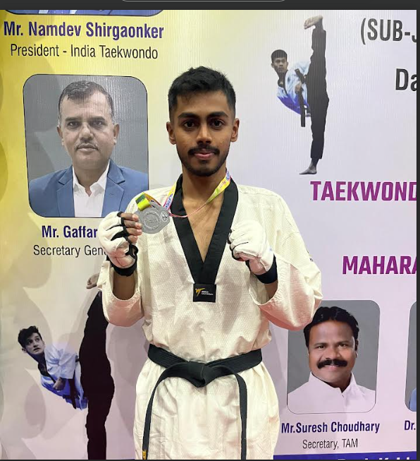  Mr. AshutoshWaghavkar won Silver  medal in Maharashtra Open State Taekwondo Championship 2025 ( under 63 weight category). | 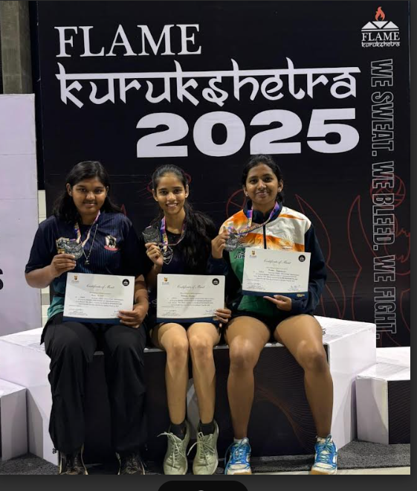  Ms. DeewanshiAgarkar won 1st prize in Table Tennis Competition in FLAME Kurukshetra 2025.
BIS Presentation Competition  Inauguration on 23/1/2025 | BIS Presentation Competition on  23/1/2025
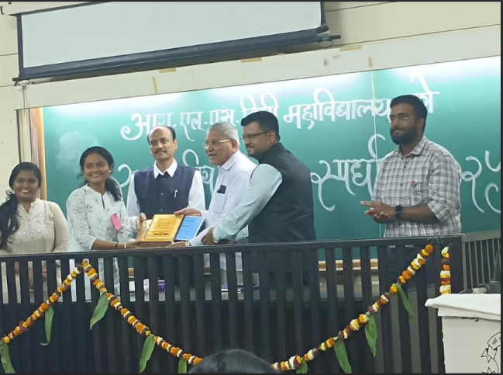  Ms. VaishnaviPatil won first prize in Elocution Competition at State Level. | 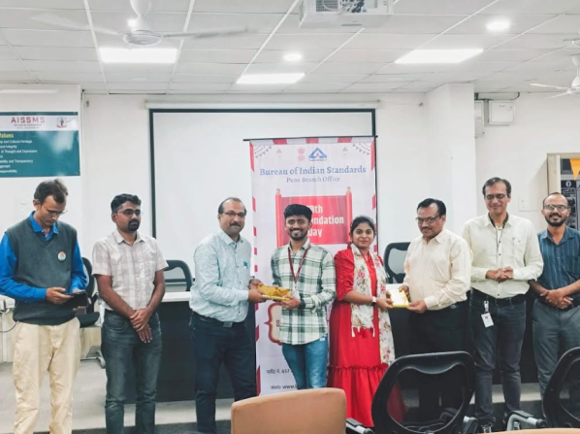  Ms.SupriyaChavan and SahilHalnor won 2nd prize in Presentation Competition Organized by BIS, Pune on the occasion of 78th foundation day of BIS
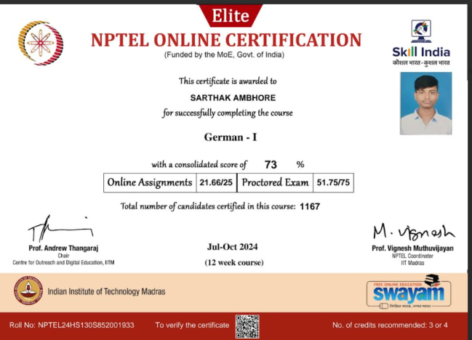
German I Nptel Certification with 72.% marks

- SUMMARY
AND
SWOC ANALYSIS

7.1 ANY OTHER NOTEWORTHY ACHIEVEMENT OF THE DEPARTMENT(Not mentioned above)
Sr. No. | Details
1 | Dr.Amitabh Bhattacharya Memorial Trophy, Best Engineering College Student Chapter, The Institute of Engineers India.

7.2 MISCELLANEOUS (SYLLABUS IMPLEMENTATION, MAJOR ADDITION IN INFRASTRUCTURE AND FACILITY, INNOVATIONS INTRODUCED, ETC.)
FACULTY | ACTIVITY

7.3 FEEDBACK FROM STAKEHOLDERS

Sr No | Stake holder | Number of Feedbacks Received | Overall Feedback
1 | Parents | 34 | -

7.4 TWO BEST PRACTICES FOLLOWED IN THE DEPARTMENT
One faculty One Industry

Active Student Chapter/Clubs

7.5 MAJOR GRIEVANCES OF STUDENTS (IF ANY) REDRESSED
---

7.6 SWOC ANALYSIS
Five major strengths, weaknesses, opportunities, and challenges (SWOC) of the department and future plans of the Department.
Strengths:
1 | Experienced Faculty
2 | Effective Teaching Learning Process
3 | Industry Institute Interaction
4 | Center of Excellence
5 | Active Student Chapter/Clubs

Weaknesses:
1 | Consultancy
2 | Research Grants
3 | Less number of Industry sponsored laboratories

Opportunities:
1 | To Increase Research and Development.
2 | To increase the number of Training Programs
3 | To increase the number of Consultancies and funded Projects.
4 | To increase number of Ph.D. faculties
5 | To increase Research publications of faculties and Students

Challenges
1 | To cope up with Dynamic changes in technology
2 | To improve number of Patents and Copyrights
3 | To increase Placement in core Industries

7.7 FUTURE PLANS OF THE DEPARTMENT (For Next Academic Year)
1 | To increase Industry Sponsored Projects
2 | To increase Industry sponsored Laboratories
3 | To Launch certificate courses
4 | To Strengthen Industry Institute Interaction

7.8 INITIATIVES TAKEN BY THE DEPARTMENT AT DEPARTMENT AND INSTITUTE LEVEL TO IMPROVE AND ASSURE QUALITY IN THE FOLLOWING AREAS

Area | Initiatives
Academics and overall profile of Department | Conducted Webinars and Expert Talk organized on Technical Topic and Project Competition.
Organization of different activities | Organized Industrial Visit, National Conference and Workshop
Research and Innovation | Organized National Conference and Journal Publication by Students
Industry institute Interaction | Organized Industrial Visit and MoU with different Industry
Students’ Achievements | Technical Paper presentation, Robotics Competition and Project Competition

SUMMARY SHEET (Annual)
Sr No | Activity/ Item | Numbers
PROFILE OF DEPARTMENT
01 | Students in the department | 277
 | FACULTY CONTRIBUTION
02 | Achievements of Faculty | 4
03 | Contribution of Faculty (Interaction With Outside World) | 4
04 | e content developed by faculty and available online | 30
05 | FDP/STTP attended by the department faculty | 28
06 | Seminars/ workshops/ webinars attended by the department faculty | 4
07 | Conferences/ symposiums attended by the department faculty | 5
08 | Online courses / certificate courses completed by department faculty | 5
09 | Extension lectures / webinars organized | 2
 | ACTIVITIES ORGANISED
09 | Number of FDP/STTP organized by the department | 5
10 | Number of Seminars/ workshops/ webinars organized by the department (for faculty) | 32
11 | Number of Conferences/ symposiums organized by the department (for faculty) | 3
12 | Number of Extension activities conducted by the department (Social/ Quizzes at national/international level/any other activity) | 9
13 | MOU signed with academic and professional organizations | 6
14 | Number of Students’ chapters /clubs | 9
15 | Number of Social activities organized | 2
16 | Number of Parent meeting | 2
17 | Number of Alumni meet | -
18 | Number of student counseling and career guidance at the department level | -
 | RESEARCH CONTRIBUTION
19 | Number of Funded research project | -
20 | Number of Testing and consultancy | -
21 | Number of Patents, copyright, trademark and other (IPR) | 1
22 | Number of Papers published/ presented in proceedings of conferences | 10
23 | Number of Papers published in journals | 9
24 | Number of Book/ article publications | 1 chapter
25 | Total Research citations | 457
26 | Number of ME awarded | NA
27 | Number of PhD AWARDED | -
 | INTERACTION WITH INDUSTRY
28 | Number of Industrial visits organised | 3
29 | Number of Expert lectures delivered by industry experts | 6
30 | Number of Industry –sponsored projects (UG/PG) | -
31 | Number of MOU signed with industry | 2
32 | Number of Faculty members underg  one industrial training | 2
33 | Number of Students undergone in-plant training and (or) internship programme | 67
34 | Number of students placed | 15
35 | Number of students qualified in the examinations | 3

Declaration by the Head of the Department

I am aware that the above information provided by the Department will be validated by the AAA committee during the visit.

Dr. S B Dhonde
Name and Signature
Head of Department

