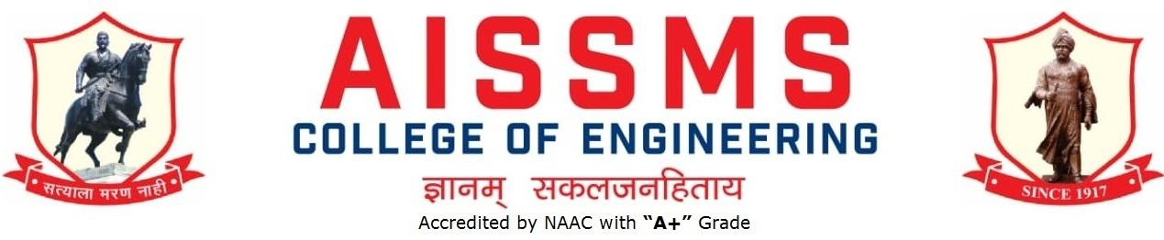
Internal Quality Assurance Cell

DEPARTMENT OF CHEMICAL ENGINEERING
ANNUAL REPORT
(15 JUNE 2024 to 14 June 2025)
TERM ONE: 15 June to 30 November
TERM TWO: 01 December to 14 June

Academic Year 2024 – 25
Guidelines:
Fill up this sheet for all the contributions /activities conducted at Department level only.
- In case data does not exist please mention it as ‘No Data’.
- Please add rows to the table below to suit your requirements
- Ensure that data does not differ from other official records and all the supporting documents are available.
- Use: Font Type: Times New Roman, Font Size: 12, Sentence case, Spacing: 1.15
- Use separate row for every details.
- For any queries, you may contact: Dr V R Patili, Coordinator, IQAC
- email: iqac@aissmscoe.com

CONTENTS
Sr No | Activity/ Item | Page No
- PROFILE OF DEPARTMENT
1.1 | Introduction
1.2 | Laboratories in the Department
1.3 | Software Available in the Department
1.4 | Faculty in the Department
1.5 | Details of Supporting Staff
1.6 | Students’ Enrollment
1.7 | Students–Faculty Feedback Details
1.8 | Result Analysis
1.9 | Class Result Analysis
 | - FACULTY CONTRIBUTION
2.1 | Achievements of Faculty
2.2 | Contribution of Faculty (Interaction With Outside World)
2.3 | e content developed by faculty and available online
2.4 | FDP/STTP attended by the department faculty
2.5 | Seminars/ workshops/ webinars attended by the department faculty
2.6 | Conferences/ symposiums attended by the department faculty
2.7 | Online courses / certificate courses completed by department faculty
2.8 | Extension lectures / webinars organized
2.9 | Faculty served as resource person, expert, chairperson
- ACTIVITIES ORGANISED
3.1 | FDP/STTP organized by the department
3.2 | Seminars/ workshops/ webinars organized by the department (for faculty)
3.3 | Conferences/ symposiums organized by the department
3.4 | Extension activities conducted by the department
3.5 | MOU signed with academic and professional organizations
3.6 | Students’ chapters /clubs
3.7 | Social activities organized
3.8 | Parent meeting
3.9 | Alumni meet
3.10 | Support from Alumni
3.11 | Interaction with Alumni
3.12 | Student counseling and career guidance at the department level
- RESEARCH CONTRIBUTION
4.1 | Funded research project
4.2 | Testing and consultancy
4.3 | Patents, copyright, trademark and other (IPR)
4.4 | Papers published/ presented in proceedings of conferences
4.5 | Papers published in journals
4.6 | Book/ article publications
4.7 | Total Research citations
4.8 | ME awarded
4.9 | PhD guide details
4.10 | PhD AWARDED
 | - INTERACTION WITH INDUSTRY
5.1 | Industrial visits organised
5.2 | Expert lectures delivered by industry experts
5.3 | Industry –sponsored projects (UG/PG)
5.4 | MOU signed with industry
5.5 | Faculty members undergone industrial training
5.6 | Students undergone in-plant training and (or) internship programme
5.7 | Support from Industry
5.8 | Training to Industry personnel/ Activity Supporting industry
5.9 | Any other activities to Promote Interaction With Industry
5.10 | Students Undergone Sandwich Training
- STUDENTS’ ACHIEVMENT
6.1 | Students’ Achievement (Professional) (Individual Level)
6.2 | Students’ Achievement (Other than Professional) (Individual Level)
6.3 | Certificate / Online Courses Completed by Students
6.4 | Number of Students Placed
6.5 | Number of Students qualified in the competitive examinations
6.6 | Sports / Cultural Achievements of Students (Individual Level)
6.7 | Students’ Achievements (Team Level)
 | - SUMMARY AND SWOC ANALYSIS
7.1 | Any other noteworthy achievement of the department
7.2 | Miscellaneous (Syllabus Implementation, Major Addition In Infrastructure And Facility, Innovations Introduced, etc.)
7.3 | Feedback from Stakeholders
7.4 | Two Best Practices Followed in the Department
7.5 | Major Grievances of Students (If Any) Redressed
7.6 | SWOC Analysis
7.8 | Future Plans of the Department
7.9 | Initiatives Taken By The Department At Department And Institute Level To Improve And Assure Quality
7.10 | Summary Sheet (Annual)

PROFILE OF DEPARTMENT

- Vision

- To be a leader in Chemical Engineering education providing service to society

- Mission

- To prepare graduates for responsible positions in chemical industry, academia and research.
- To prepare graduates to analyse and solve problems of chemical industry, academia and research.
- To strengthen industry-institute interaction to develop industry-oriented attributes like attitude, soft skills, team work and leadership.

- PEOs

- Competency: To prepare competent graduates in Chemical Engineering so that they are successful in their professional career in industry, academia or research.
- Problem Solving Skills: To prepare graduates who can identify, analyse, research and solve Chemical Engineering problems of practical importance to industry, academia or research.
- Leadership Skills: To prepare graduates with effective communication, teamwork and leadership skills so that they can play effective role in industry, academia and research institutes.

- DEPARTMENTAL HIGHLIGHTS

- Well-equipped laboratories with advanced analytical instruments
- Highly Qualified & Dedicated faculty members with experience from Industry and Research
- Department has PG and PhD centre
- Students ranked in University Results
- Value added course on Water and waste water management supported by industries
- Research by students on funded research projects
- Every year students excel in GATE, GRE and CAT /CET with many students pursuing post- graduate programs in Engineering/Management in India and abroad
- Guest faculty is invited to impart Soft Skills training to students
- Every student undergoes in-plant training in industries
- Industry visits are organized every semester.
- Organization & Participation in sports, technical & cultural events
- Department has signed 30 MOUs with reputed companies under Industry Institute interaction cell

- STUDENT CHAPTERS AND CLUB
- American Institute of Chemical Engineering (AIChE)
- Indian Institute of Chemical Engineering (IIChE)
- Institution of Engineers (IEI)
- Bureo of Indian Standards Club (BIS)

PLACEMENT, HIGHER STUDIES & ENTREPRENEURS

RECRUITERS  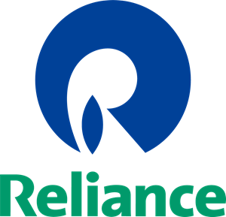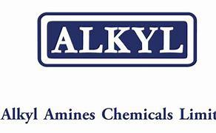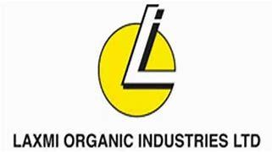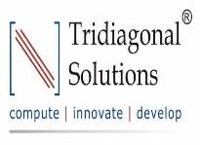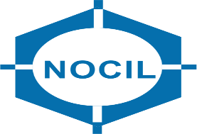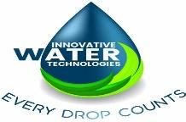 | 

1.1 INTRODUCTION
Year of Establishment | 1996
UG Programmes | 01
PG Programmes | 01
Number of Teaching Staff | 13
Number of Non-Teaching Staff | 06

1.2 LABORATORIES IN THE DEPARTMENT
Name of Laboratory
1. Heat Transfer | 2. Fluid Mechanics
3. Software A and B | 4. Mechanical Operations
5 Chemical Reaction Engineering | 6. Applied Chemistry Lab
- Project and Analytical Labs | 8.Mass Transfer I and II
9. Process Dynamics & Control | 10. Water Management Lab

1.3 SOFTWARES AVAILABLE IN THE DEPARTMENT
Software Available
1. MATLAB 7 (26 Users) | 2. AutoCAD (Autodesk Inventor 11) 13 User
3. UNISIM R430 (100 Users) | 4. CHEMCAD 5.3.8 (Perpetual License) 10 Users

1.4 FACULTY IN THE DEPARTMENT
Sr No | Name of faculty | Designation
1 | Dr A V Mohod | Head & Associate Professor
2 | Dr A S Jadhav | Associate Professor
3 | Dr M Y Naniwadekar | Associate Professor
4 | Dr P N Dange | Assistant Professor
5 | Mrs H L Kamble | Assistant Professor
6 | Mr P M Warke | Assistant Professor
7 | Mr K B Gandhi | Assistant Professor
8 | Dr S B Ghugare | Assistant Professor
9 | Mrs K N Bawankar | Assistant Professor
10 | Mr P S Tadkar | Assistant Professor
11 | Dr S R Varade | Assistant Professor
12 | Dr S Sharma | Assistant Professor
13 | Dr M B Mane | Assistant Professor

1.5 DETAILS OF SUPPORTING STAFF
Sr No | Name of non-teaching staff | Designation
1 | Mr N B Jagtap | Sr Lab Assistant
2 | Mr R S Mane | Lab Assistant
3 | Ms S A Vyas | Lab Assistant
4 | Mr A S Despande | Lab Assistant
5 | Mr N D Ughade | Lab Attendant
6 | Mr D S Rajiwade | Lab Attendant
7 | Mr P D Nalawade | Lab Attendant

1.6 STUDENTS’ ENROLLMENT -24-25
Program | GEN |  | SC |  | ST |  | OBC |  | PWD |  | Others |  | Total
 | M | F | M | F | M | F | M | F | M | F | M | F | M | F
UG (Chem) SE | 15 | 8 | 5 | 1 | 0 | 0 | 13 | 6 | 0 | 0 | 8 | 3 | 41 | 18
UG (Chem) TE | 12 | 8 | 2 | 2 | 0 | 0 | 4 | 2 | 0 | 0 | 7 | 1 | 25 | 13
UG (Chem) BE | 23 | 3 | 1 | 2 | 0 | 1 | 21 | 2 | 0 | 0 | 11 | 3 | 56 | 11
ME(Chem) FY | 0 | 0 | 0 | 0 | 0 | 0 | 0 | 1 | 0 | 0 | 1 | 0 | 1 | 1
ME (Chem) SY | 0 | 1 | 0 | 0 | 0 | 0 | 0 | 0 | 0 | 0 | 0 | 0 | 0 | 1
PG (Chem) | 1 | 2 | 0 | 0 | 0 | 0 | 0 | 0 | 0 | 0 | 0 | 0 | 1 | 2

1.7 STUDENTS–FACULTY FEEDBACK DETAILS

SE Chemical

 | Term -I
Sr. No. | Name of faculty | Class and Subject taught | Feedback (I) (%) | Feedback (II) (%) | Average  Feedback (%)
1 | Dr. P. N. Dange | Fluid Mechanics | 78 | 79.25 | 78.62
2 | Mr. K. B. Gandhi | Engineering Materials | 89 | 88.06 | 88.53
3 | Dr. S. R. Varade | Process Calculations | - | 79.92 | 79.92
4 | Dr. P. D. Baviskar | Industrial Chemistry - I | 81 | 83.35 | 82.17
5 | Mr. P. S. Gore | Engineering Mathematics -III | 79 | 67.04 | 73.02

SE Chemical
 | Term -II
Sr. No. | Name of faculty | Class and Subject taught | Feedback (I) (%) | Feedback (II) (%) | Average  Feedback (%)
1 | Dr. M.Y. Naniwadekar | Chemical Technology-I | 82.32 | 85.03 | 83.67
2 | Mr. P.S. Tadkar | Heat Transfer | 87.64 | 90.60 | 89.12
3 | Dr. S.R. Varade | Mechanical Operations | 77.54 | 75.15 | 76.34
4 | Dr. M.B. Mane | Principles of Design | 83.33 | 84.62 | 83.97
5 | Dr. P.D. Baviskar | Industrial Chemistry-II | 78.76 | 85.78 | 82.27

TE Chemical
 | Term I
Sr. No. | Name of faculty | Class and Subject taught | Feedback (I) (%) | Feedback (II) (%) | Average  Feedback (%)
1 | Dr. M.Y. Naniwadekar | Chemical Technology- II | 81 | 82.28 | 81.64
2 | Dr. A. S. Jadhav | Chemical Engg Thermodynamics | 73 | 85.71 | 79.35
3 | Dr. A. S. Jadhav | Chemical Engg Management (Elective-I) | 74 | 87.61 | 80.80
4 | Mrs. H. L. Kamble | Chemical Engg Mathematics | 87 | 88.89 | 87.94
6 | Mrs. K. N. Bawankar | Mass Transfer-I | 81 | 80.90 | 80.95
7 | Dr. S. Sharma | Food Technology  ( Elective-I) | 92 | 90.14 | 91.07

TE Chemical
 | Term II
Sr. No. | Name of faculty | Class and Subject taught | Feedback (I) (%) | Feedback (II) (%) | Average  Feedback (%)
1 | Dr. A.S. Jadhav | Elective-II | 74.7 | 81.13 | 77.91
2 | Mrs H.L. Kamble | Mass Transfer-II | 75.8 | 80.61 | 78.20
3 | Mr. K. B. Gandhi | Elective-II | 72.2 | 80.15 | 76.17
4 | Dr. A. V. Mohod | Chemical Reaction Engg-I | 74 | 79.06 | 76.53
5 | Dr. S. R. Varade | Transport Phenomena | 64 | 72.24 | 68.12

BE Chemical
 | Term I
Sr. No. | Name of faculty | Class and Subject taught | Feedback (I) (%) | Feedback (II) (%) | Average  Feedback (%)
1 | Dr. P. N. Dange | Petroleum Refining (Elective-III) | 100
2 | Mrs. H. L. Kamble | Environmental Engineering  ( Elective-III) | 58
3 | Mr. P. M. Warke | Chemical Engg Design | 85 | 90.79 | 87.89
4 | Dr. S. B. Ghugare | Process Dynamics & Control | 78 | 85.95 | 81.97
5 | Mr. P. S. Tadkar | Chemical Reaction Engg-II | 91 | 91.50 | 91.25
6 | Dr. S. Sharma | Industrial Management & Entrepreneurship (Elective-IV) | 81 | 90.95 | 85.97

BE Chemical
 | Term II
Sr. No. | Name of faculty | Class and Subject taught | Feedback (I) (%) | Feedback (II) (%) | Average  Feedback (%)
1 | Dr. P. N. Dange | Process Modelling & Simulation | 86.50 | 88.55 | 87.52
2 | Dr. A.S. Jadhav | Advanced Materials Elective -V | 86.23 | 82.90 | 84.56
3 | Mr. P. M. Warke | Process Engg Costing & Plant Design | 90.04 | 87.71 | 88.87
4 | Dr. S. B. Ghugare | Petrochemical Engg ( Elective-V) | 84.37 | 87.38 | 85.87
5 | Dr. S. B. Ghugare | Chemical Process Safety ( Elective-V) | 82.93 | 85.86 | 84.39
6 | Dr. S. Sharma | Nanotechnology  (Elective-VI) | 92.29 | 88.88 | 90.58

Result Analysis - Pro-forma B
Class: SE Chemical
University Examination: NOV. 2024 TERM -I Result Date :- 17 /02/ 2024

Sr No | Subject | Number of Students |  |  |  | Highest Marks | %Passing | Name of the Faculty
Sr No | Subject | Appeared | Passed | Securing >=60 |  | Highest Marks | %Passing | Name of the Faculty
1 | Engg. Maths. | 71 | 50 | 19 | 90 |  | 70.42 | Prof P S Gore
2 | Chemistry-II | 71 | 44 | 16 | 89 |  | 61.97 | Dr. P D Baviskar
3 | Fluid Mechanics | 71 | 46 | 22 | 89 |  | 64.79 | Dr. Dange P. N.
4 | Eng. Material | 71 | 65 | 36 | 88 |  | 91.55 | Prof.Gandhi K. B.
5 | Process Calculation | 71 | 54 | 26 | 92 |  | 76.06 | Dr. A V Mohod

Result Analysis - Pro-forma B

Class: SE Chemical

University Examination: MAY 2025 TERM -II Result Date:- 05 /07/ 2025
Sr No | Subject | Number of Students |  |  | Highest Marks | %Passing | Name of the Faculty
 |  | Appeared | Passed | Securing >=60
1 | Industrial Chemistry-II | 71 | 65 | 25 | 85 | 91.54 | Dr P D Baviskar
2 | Heat Transfer | 71 | 60 | 27 | 88 | 84.50 | Prof P S Tadkar
3 | Principle of Design | 71 | 41 | 6 | 74 | 57.74 | Dr M B Mane
4 | Chemical Technology-I | 71 | 60 | 24 | 85 | 84.50 | Dr M Y Naniwadekar
5 | Mechanical Operations | 71 | 65 | 20 | 91 | 91.54 | Dr S R Varade

Result Analysis/Pro-forma B

Class: TE Chemical

University Examination: November-2024 Result Date: - 31 January 2025

Sr No | Subject | Number of Students |  |  | Highest Marks | %Passing | Name of the Faculty
 |  | Appeared | Passed | Securing >=60
1 | Mass Transfer-I | 45 | 42 | 22 | 89 | 93.93 | Prof K N Bawankar
2 | Chemical Technology -II | 45 | 43 | 35 | 90 | 95.56 | Dr M Y Naniwadekar
3 | Chemical Engineering Math. | 43 | 37 | 13 | 89 | 86.05 | Prof H L Kamble
4 | Chemical Engineering Thermodynamics | 45 | 41 | 25 | 80 | 91.11 | Dr A S Jadhav
5 | Chemical Industry Mgmt | 30 | 30 | 29 | 77 | 100 | Dr A S Jadhav
6 | Food Technology | 15 | 15 | 11 | 79 | 100 | Dr S S Sharma

Result Analysis/Pro-forma B

Class: TE Chemical

University Examination: May-2025 Result Date: - 30 June 2025

Sr No | Subject | Number of Students |  |  | Highest Marks | %Passing | Name of the Faculty
Sr No | Subject | Appeared | Passed | Securing >=60 | Highest Marks | %Passing | Name of the Faculty
1 | Chemical Reaction Engg -I | 49 | 38 | 18 | 76 | 93.33 | Dr A V Mohod
2 | Mass Transfer -II | 50 | 43 | 26 | 86 | 95.56 | Prof H L Kamble
3 | Transport Phenomenon | 51 | 38 | 13 | 71 | 86.05 | Dr S R Varade
4 | Energy Cons.in Chem Pro. Ind | 19 | 18 | 6 | 74 | 91.11 | Dr A S Jadhav
5 | Procee Inst. And Control | 33 | 32 | 18 | 84 | 100 | Prof K B Gandhi

Result Analysis/Pro-forma B

Class: BE Chemical

University Examination: OCT/NOV 2024 Term –I Result Date :-12 Jan 2025

Sr No | Subject | Number of Students |  |  | Highest Marks | %Passing | Name of the Faculty
 |  | Appeared | Passed | Securing >=60
1 | Process Dynamics and Control | 33 | 30 | 22 | 81 | 90.90 | Dr. S B Ghugare
2 | Chemical Reaction Engineering II | 33 | 33 | 23 | 82 | 100 | Prof P S Tadkar
3 | Chemical Engineering Design | 33 | 30 | 18 | 81 | 90.90 | Prof. P. M Warke
4 | Elective -I Environmental Engineering | 33 | 31 | 24 | 81 | 93.94 | Dr. M B Mane
5 | Elective II Industrial Management & Entrepreneurship | 33 | 33 | 27 | 77 | 100 | Dr S S Sharma
6 | CACHE-II | 33 | 33 | 32 | 46 | 100 | Dr P N Dange
7 | Project Phase I | 33 | 33 | 33 | 46 | 100 | All Eligible Guides

Result Analysis/Pro-forma B
Class: BE Chemical

University Examination: MAY 2025 Term II Result Date:- 28 JUNE 2025

Sr No | Subject | Number of Students |  |  | Highest Marks | %Passing | Name of the Faculty
 |  | Appeared | Passed | Securing >=60
1 | Process Model. & Simulation | 37 | 35 | 17 | 79 | 94.59% | Dr P N Dange
2 | Process Engineering Costing & Plant Design | 37 | 36 | 29 | 86 | 97.30% | Prof. P. M. Warke
3 | Advanced Materials | 16 | 15 | 10 | 74 | 93.75% | Dr A S Jadhav
4 | Chemical Process Safety | 21 | 21 | 20 | 78 | 100% | Dr S B Ghugare
5 | Nanotechnology | 6 | 6 | 5 | 77 | 100% | Dr Shushmita Sharma
6 | Petrochemical Engineering | 31 | 31 | 27 | 84 | 100% | Dr S B Ghugare

1.7 CLASS RESULT ANALYSIS (All Classes SE to BE)

Result Analysis SE Chemical -Proforma A

University Examination: NOV. 2024 TERM I Result Date:- 03 Feb 2025

TERM ONE
SN | Class |  | No. of Students - 57 |  |  |  |  |  |  |  |  |  |  | Percentage of Passing
SN | Class | Appeared |  | Clear Passed | Outstanding  (O)  (9.1 -10) | Excellent  (A+)  (8.1 – 9) | Very Good (A)  (7.1 – 8) | Good (B+)  (6.1 – 7) | Above Average (B)  (5.1 – 6) | Average /  (4.1 – 5 ) | Pass Class  4 | ATKT  (F)  0 – 3.99 | All Clear |  | With ATKT
1 | SE | 72 |  | 36 | 8 | 6 | 14 | 8 | Nil | Nil | Nil | 36 | 50 % |  | 100%
- FE/SE/TE/ BE (First Term) results based on SGPA and BE (Second Term) based on CGPA

University Examination: MAY 2025 TERM II Result Date:-05/07/2025

SN | Class |  | No. of Students - 71 |  |  |  |  |  |  |  |  |  | Percentage of Passing
SN | Class | Appeared |  | Clear Passed | Outstanding  (O)  (9.1 -10) | Excellent  (A+)  (8.1 – 9) | Very Good (A)  (7.1 – 8) | Good (B+)  (6.1 – 7) | Above Average (B)  (5.1 – 6) | Average /  (4.1 – 5 ) | Pass Class  4 | ATKT  (F)  0 – 3.99 | All Clear | With ATKT
1 | SE | 71 |  | 38 | 3 | 10 | 19 | 6 | 0 | 0 | 0 | 33 | 53.5 | 100

- FE/SE/TE/ BE (First Term) results based on SGPA and BE (Second Term) based on CGPA

Result Analysis TE Chemical

University Examination: November - 2024 TERM I Result Date: - 31/01/ 2025

TERM ONE
SN | Class |  | No. of Students–67 ( Two Students Result are Reserved for Eligibility) |  |  |  |  |  |  |  |  | Percentage of Passing
SN | Class | Appeared | Clear Passed | Outstanding  (O)  (9.1 -10) | Excellent  (A+)  (8.1 – 9) | Very Good (A)  (7.1 – 8) | Good (B+)  (6.1 – 7) | Above Average (B)  (5.1 – 6) | Average /  (4.1 – 5 ) | Pass Class  4 | ATKT  (F)  0 – 3.99 | All Clear | With ATKT
1 | TE | 45 | 35 | 8 | 14 | 9 | 2 | 2 | Nil | Nil | Nil | 77.78 | 100
- FE/SE/TE/ BE (First Term) results based on SGPA and BE (Second Term) based on CGPA

University Examination: MAY 2025 TERM II Result Date:- 30/6/2025

 |  |  | TERM TWO
SN | Class |  | No. of Students–38 [ 07 Students Result are reserved for Backlog] |  |  |  |  |  |  |  |  |  | Percentage of Passing
SN | Class | Appeared |  | Clear Passed | Outstanding  (O)  (9.1 -10) | Excellent  (A+)  (8.1 – 9) | Very Good (A)  (7.1 – 8) | Good (B+)  (6.1 – 7) | Above Average (B)  (5.1 – 6) | Average /  (4.1 – 5 ) | Pass Class  4 | ATKT  (F)  0 – 3.99 | All Clear | With ATKT
1 | TE | 52 |  | 33 | 6 | 16 | 8 | 3 | Nil | Nil | Nil | Nil | 63.46 | 100
- FE/SE/TE/ BE (First Term) results based on SGPA and BE (Second Term) based on CGPA

Result Analysis/Pro-forma A

University Examination: OCT/NOV 2024 Term -I Result Date:-23 /01/ 2025

TERM ONE
SN | Class |  | No. of Students–65 |  |  |  |  |  |  |  |  |  | Percentage of Passing
SN | Class | Appeared |  | Clear Passed | Outstanding  (O)  (9.1 -10) | Excellent  (A+)  (8.1 – 9) | Very Good (A)  (7.1 – 8) | Good (B+)  (6.1 – 7) | Above Average (B)  (5.1 – 6) | Average /  (4.1 – 5 ) | Pass Class  4 | ATKT  (F)  0 – 3.99 | All Clear | With ATKT
1 | BE | 33 |  | 30 | 3 | 19 | 6 | 2 | 0 | 0 | 0 | 3 | 90.90 | 100
- FE/SE/TE/ BE (First Term) results based on SGPA and BE (Second Term) based on CGPA

University Examination: MAY 2024 Term -II Result Date:- 21/06/ 2024

TERM TWO
SN | Class |  | No. of Students–67 (06 Students results are reserved for Backlogs) (RRB) |  |  |  |  |  |  |  |  |  | Percentage of Passing
SN | Class | Appeared |  | Clear Passed | Outstanding  (O)  (9.1 -10) | Excellent  (A+)  (8.1 – 9) | Very Good (A)  (7.1 – 8) | Good (B+)  (6.1 – 7) | Above Average (B)  (5.1 – 6) | Average /  (4.1 – 5 ) | Pass Class  4 | ATKT  (F)  0 – 3.99 | All Clear | With ATKT
1 | BE | 37 |  | 31 | 4 | 23 | 4 | 0 | 0 | 0 | 0 | 6 | 83.78% | 100
- FE/SE/TE/ BE (First Term) results based on SGPA and BE (Second Term) based on CGPA

1.10 UNIVERSITY RANKERS (Consider last five academic years)
Academic Year 2024-25 -NA

Sr.  No. | Exam Year  & Month | Year & Branch | Name of The Student | Rank

Group Photo - Final Year 2024-25
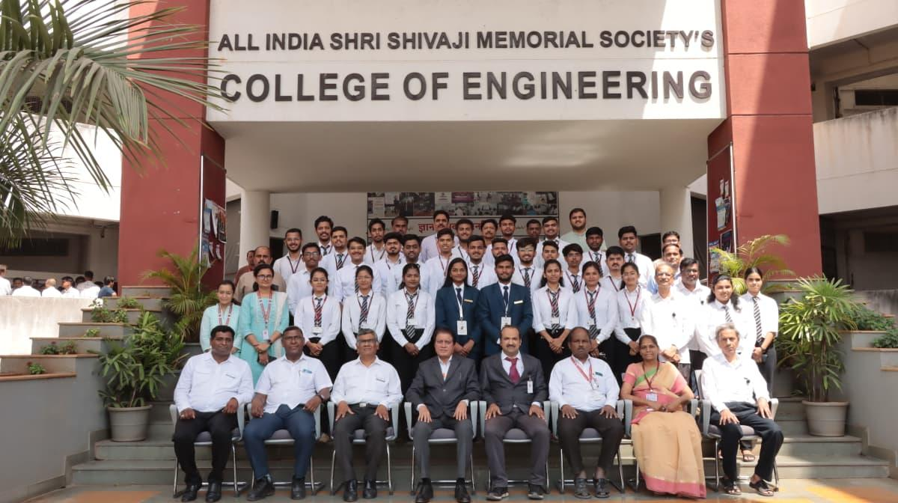
MECHANICAL OPERATION LABORATORY | PROCESS DYNAMICS AND CONTROL  LABORATORY
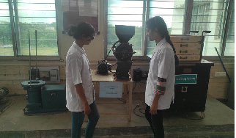 | 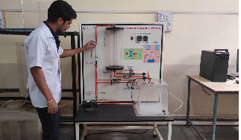
Equipment  - Blake Jaw Crusher  - Ball Mill  - Sigma Mixer  - Sieve Shaker  - Vibrating Screen  - Brustone Mill  - Conveyors  - Gyratory Sieve Shaker | Equipment  - PID Controller,  - I/P Converter,  - Two tank interacting & non interacting  - Temp loop control trainer  - Level loop control trainer  - Pressure Transmitter  - On-Off Controller  - Flow loop control trainer
PROJECT LABORATORY  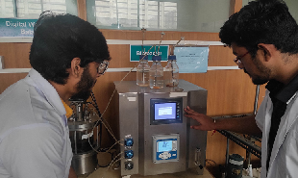  Equipment  - Chemito UV/Vis Spectrophotometer  - Autoclavable Bioreactor Setup 3. Water Bath with Heater and Stirrer  - Simple Distillation Unit  - Digital COD digester  - High Speed Centrifuge 7. Air Compressor  - IR Oven  - Ultrasonic Bath 10. Microwave Oven  - Heating Mantles  - Temperature Controlled Bath Circulator  - Digital COD digester with accessories  - Iodine Value Mete  - Autoclave | CENTRAL RESEARCH LABORATORY  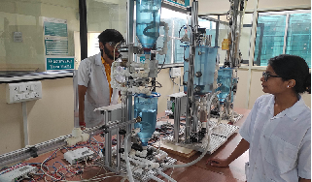  Equipment  - Environmental Discovery System (EDS)  - Biodiesel Manufacturing Prototype Model  - Hydrodynamic cavitation  - Air-marble cavitation column
PG Chemical Laboratory:

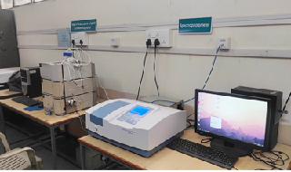
Equipment
- Microwave Oven LG
- Centrifuge
- Vinyl Anaerobic Chamber
- Ultrasonic Cleaner
- Multistation Heating Mantles
- Digital Weighing Balance
- UV Chamber
- Microwave Synthesizer

Water Central Research Laboratory:

Equipment
Environmental Discovery System (EDS)
Biodiesel Manufacturing Prototype Model
Hydrodynamic cavitation
Air-marble cavitation column

FACULTY CONTRIBUTION

2.1 ACHIEVEMENTS OF FACULTY (AWARDS, RECOGNITION, PHD COMPLETION ETC.)
Term One
SN | Name of Faculty | Awards & Recognitions
1 | Dr. A V Mohod | Reviewer in Ultrasonic Sonochemistry
2 | Dr. A V Mohod | Reviewer in Chemical Engineering Research and Design
3 | Dr M Y Naniwadekar | BOS Member Chemical SPPU
4 | Mr. P. M. Warke | Best Mentor ‘Standards’ Clubs in Engineering Institutes (Period: 2023-24). Award received on World Standards Day (14th October 2024). Level: Among 12 Districts BIS Pune branch/zone
5 | Mr. P. M. Warke | 39+ Students from various streams are selected/ placed in Companies due to Interaction with Industries.
6 | Mr. P. M. Warke | 26 Number of Students from TE Chemical have undergone In-Plant Training of 04 weeks due to Interaction with Industries.
7 | Mr. P. M. Warke | ‘Quality Walk’ event in the College with the support of BIS, Pune branch on 10th October 2024. News published in Newspapers ‘Sakal’ and ‘Dainik Prabhat’ Pune
8 | Mr. P. M. Warke | Revenue Generation: Rs. 40652/- by BIS for Activity I conducted on 02/08/2024 by ‘Standards’ Club- Chemical alongwith initiative via guidance to the Mentors to obtain advance of Rs. 1, 31,960/- for the 1st Activity of five Standards Clubs discipline on 09/10/2024.
9 | Mr. P. M. Warke | Examiner and Paper Setter for subjects in B.Tech. & M. Tech. Chemical at BVDU BVCOE, Pune
8 | P S Tadkar | Examiner and Paper Setter for subjects in B.Tech. Chemical at BVDU BVCOE, Pune

Term Two
SN | Name of Faculty | Awards & Recognition
1 | Dr. A V Mohod | Awarded Second Post-Doctorate at CNR-STIIMA, Biella, Italy
2 | Dr. A V Mohod | Reviewer in Chemical Engineering Journal
3 | Dr. A V Mohod | Reviewer in Results in Chemistry
4 | Dr. A V Mohod | Reviewer in Chemical Engineering and Processing - Process Intensification
5 | Dr A S Jadhav | शिवाजी विद्यापीठ महाविद्यालयीन नियतकलिक स्पर्धेसाठी तज्ज्ञ परीक्षक म्हणून नियुक्ती
6 | Dr M Y Naniwadekar | Elected BOS Member Chemical SPPU
7 | Dr M Y Naniwadekar | Elected Member -IEI PLC Pune Local Chapter
8 | Mr. P. M. Warke | A.T.E. HUBER Envirotech Pvt. Ltd., Mumbai offered two R&D Consultancy Projects for Textile Effluent Treatment
9 | Mr. P. M. Warke | Azeocryst Organics Pvt. Ltd., MIDC Taloja, Navi Mumbai offered two Consultancies: COD / BOD Demonstration and Cavitation trial set up of capacity 1000 lit/day effluent treatment
10 | Mr. P. M. Warke | Revenue Generation: Rs. 40000/- as a rent to the College by BIS regarding ‘Standards Carnival’ in the Campus on 10/01/2025. News published in a Newspapers ‘Sakal’ Pune
11 | Mr. P. M. Warke | Revenue Generation: Rs. 51116/- by BIS for Activity II conducted on 12/02/2025 by ‘Standards’ Club- Chemical
12 | Mr. P. M. Warke | Appointment as a Subject Chairman by SPPU, Pune for preparation of the Syllabus Mechanical Operations subject. The draft is published in the SE Chemical syllabus NEP 2024
13 | Mr. P. M. Warke | Examiner and Paper Setter for subjects in B.Tech. & M. Tech. Chemical at BVDU BVCOE, Pune
14 | Mr. P. M. Warke | 20+ Students from various streams are selected/ placed in Companies due to Interaction with Industries.
9 | P S Tadkar | Examiner and Paper Setter for subjects in B.Tech. Chemical at BVDU BVCOE, Pune

2.2 CONTRIBUTION OF FACULTY (Interaction with outside world)
Term One
SN | Name of Faculty | Nature and details of contribution (Representation at University, State, National , International level, corporate world, Social Platforms, etc)
1. | Dr. A V Mohod | Research fellow at CNR STIIMA, Biella, Italy
2. | Dr. A V Mohod | Research publication in The Canadian J of Chemical Engg
3 | Dr. A V Mohod | Research publication in Advances in Environmental Technology
4. | Dr. A V Mohod | Research publication in Brazilian Journal of Chemical Engineering
5 | Dr A S Jadhav | Expert Examiner for Shivaji University College Magazine Competition
6 | Mr. P. M. Warke | BIS for Standard based programs and Interaction with Industry Personnel during Celebration Ceremony by BIS ‘World Standards Day’ on 14/10/2025
7 | Mr. P. M. Warke | Invited Companies for Campus Recruitment Drives for Students from Chemical along with other branches. List: 1) Reliance Industries Ltd., Mumbai 2) Ultra Tech Cement Ltd., Pune 3) P- Mech Consultant, Mumbai  4) Marcuras Water Treatment (India) Pvt. Ltd. for Fresher 2024  5) NM Jalmaitreya LLP, Pune  6) Deepak Nitrite Ltd., Roha & Taloja plants  7) Corizo Edu-Tech., Bangalore  8) Vijay Chemical Industries, Lote Parshuram MIDC  9) Reinwelle Projects LLP, Pune  10) Vinati Organics Ltd., Mahad  11) Worley India, Mumbai & Pune for BE Computer  12) Tranworld Furtichem Pvt. Ltd., Roha  13) Urja Disha Boiler Technologies, Pimpri  14) Thermax Ltd., Pune  15) FluiDimensions, Baner  16) Nagpur based API Manuf. Company  17) For Client Comnpany of Worley India, Navi Mumbai  18) GreEnviro Systems Pvt. Ltd., Pune  19) Neologic Engineers Pvt. Ltd., Balewadi  20) Innomatics Research Lab., Pune  21) Mesotech Engineering Systems, Pune  22) Intellipaat, Bangalore  23) Worley Consulting, Navi Mumbai for 2025 batch  24) Marcuras Water Treatment (India) Pvt. Ltd. 2025  25) Clean Science & Technology, Pune & Kurkumbh  26) Meta Engitech, Sanaswadi  27) Equinox Software Services, Pune  28) RayChem. RPG Ltd, Chakan  29) SAR Chem.Tech. Solutions  30) Amalgam Biotech, Pune  31) Samruddhi Water Works, Pune  32) Liqsure Systems, Solapur  33) Proburgeon Pvt Ltd., Pune
8 | Mr. P. M. Warke | Interaction with Industries for In-Plant Training of TE Chemical (26) Students. List: List of Companies:  1) Ross Boilers, Kindhwa (03 students)  2) Thermax Ltd., Chinchwad (03 students)  3) Hypro Engineers, Pirangut (02 students)  4) Victory Polychem, Pirangut (02 students)  5) Urja Disha Boilers Technologies, Pimpri (03 students)  6) Mesotech Engineering Systems, Bhosari (02 students)  7) Techpert Process Industries, Wakad (02 students)  8) Elantas Beck India Ltd., Pimpri (01 student)  9) Mega Engineering Ltd., Balewadi (02 students)  10) Shravani Chemicals, Dhayari (03 students)  11) Marcuras Water Treatment, Bhosari (03 students)  12) Techniche Engineering Pvt. Ltd., Dhayari (03 students could not cleared interview to seek internship)

Term Two
SN | Name of Faculty | Nature and details of contribution (Representation at University, State, National , International level, corporate world, Social Platforms, etc)
1 | Dr. A V Mohod | Research publication in Polymers
2 | Dr. A V Mohod | Research publication in Environmental quality management
3 | Dr. A V Mohod | International Seminar at University of Turin, Italy with a title Hermetia illucens biofactory: from waste to high value technological products
4 | Dr. A V Mohod | 4th International Conference at CNR-STIIMA, Biella, Italy on title Advances in wastewater treatment for the textile industry
5 | Dr P N Dange | PhD Guide, Research Centre, AISSMS COE, Pune
6 | Dr A V Mohod | Reviewer of Separation and Purification Technology Elsevier Journal
7 | Mr. P. M. Warke | BIS for Standard based programs and Interaction with Industry Personnel during the Exhibition and Teachers from School and Colleges regarding the program ‘Standards Carnival’ on 10/01/2025
8 | Mr. P. M. Warke | Invited Companies for Campus Recruitment Drives for Students from Chemical along with other branches. List: Arya Engineers and Contractors Pvt. Ltd., Pune  2. Engie India, Pune  3. CH Four Energy Solutions, Pune  4. EngiTech Metamorphosis, Pune  5. Suresh Indu Lasers Pvt. Ltd., Pune  6. Technotreon Intellectual Ventures,  7. Synergy Process Systems, Pune  8. Parker Hannifin, Mumbai  9. ATE Group of Companies, Mumbai  10. P-Mech Engineering, Mumbai  11. Essar Oil UK Services, Mumbai  12. NM Jalmaitreya, Pune  13. Hayo Engineering and Service LLP, Pune  14. Mega Engineering, Pune  15. Praj Industries Ltd., Pune  16. Osmoflo Engineering Services, Pune  17. Techniche Engineering, Pune  18. Privi Specialty Chemicals Ltd., Mahad  19. Prismane Consulting, Pune  20. Alkyl Amines Chemicals Ltd., Mumbai and Pune  21. Envicare, Pune  22. Tata Autocomp Ltd., Pune

2.3 e CONTENT DEVELOPED BY FACULTY AND AVAILABLE ONLINE

Term One
Sr No. | Name of Faculty | Title of e-content | e-content development facility/platform | link of the content
1 | Dr S B Ghugare | Principles of Design | Google Classrrom | https://youtu.be/4VCB4EoART
2 | Prof K B Gandhi | Engg Materials. | Google Classrrom | https://youtu.be/4VCB4EoART
3 | Dr P N Dange | Fluid  Mechanics (T) | Microsoft Teams | FM-Fluid Mechanics -  Google Drive
4 | Dr M Y Naniwadekar | CT- II | Google Drive | https://drive.google.com/drive/folders/  17KWmmMxxcvCvvpb5bAcASug-IZPCNxHs
5 | P N Dange | PPTs, VDOs  for CACHE-II  (P) | Microsoft Teams | CACHE II – Google Drive
6 | H L Kamble | Chemical Engineering Mathematics | Google Drive | https://drive.google.com/drive/folders/1Fp4
7 | P M Warke | CED II & ASP  Subjects - RO,  Adsorption,  Ion Exchange, Plant Utilities & Hazards. | NPTEL notes,  PPT | https://drive.google.com/file/d/1bE0ylwbZNRryx3off8j_7_gaRnMOud0x/view?usp=sharing
8 | K B Gandhi | Brinell  hardness  number | You Tube | https://youtu.be/nfRZorp40pM
9 | K B Gandhi | Atomic weight  to Molecular  weight | You Tube | https://youtu.be/4VCB4EoARTo
10 | Dr. S B Ghugare | PDC Google Classroom | Google Class Room | https://classroom.google.com/c/M  zE5MjA5MjMwOTky?cjc=kzxgi45
11 | K N Bawankar | Mass Transfer-I | Google Drive | https://drive.google.com/drive  /u/0/folders/1zsrQybrD  _j_n33wOyfy6UwtrEGqoSS87
12 | P S Tadkar | CRE II | Google Classroom | https://drive.google.com/drive/folders/1aEQ2-UmJ2eAg3A6RXqGP1ajQPTVoZ4GZKW-LvHHFY5lfXbyuFhtbv1WIyIyNt7upue-Gdl5k
133 | Dr. M. Baingne | Process Calculations | Google Drive | https://drive.google.com/drive/u/0/folders/  1trHklXuV1XkwqsDgFMeF66ufFoA0TxLc

Term Two
Sr No. | Name of Faculty | Title of e-content | e-content development facility/platform | link of the content
1 | Miss H L Kamble | Process Dynamics & Control | Google Classrrom | https://classroom.google.com/c/MzE5MjA5MjMwOTky?cjc=kzxgi45
2 | Prof M Y Naniwadekar | Petroleum Refining | Google Classrrom | https://classroom.google.com/c/  MzE5MjA5MjMxMTAz?cjc=qx3n4n6
5 | P N Dange | PPTs, VDOs  for PMS (P) | Microsoft Teams | PMS Theory and  Practicals - Google  Drive
6 | H L Kamble | Mass Transfer-II | Google drive | https://drive.google.com/drive/u/ 1/folders/1H7DWuRQN2rRAA9WZJIk2s XJj_4vBsBCD
7 | Dr. S B Ghugare | POD Google Classroom | Google Class Room | https://classroom.google.com/c/N  DY5NTMzOTkyNzA4
8 | Dr. S B Ghugare | APC e-Contents | Google Drive | https://drive.google.com/drive/fo  lders/12KtioLSZnDylEOJc1cFQ  bky0yg96dHtv?usp=sharing
9 | K N Bawankar | Mechanical Operations | Google Drive | https://drive.google.com/drive  /u/0/folders/1nMxiZDOVfO  Q8TkExGl8THAMPuQ_x6fS1
10 | P S Tadkar | Heat Transfer | Google Class Room | https://drive.google.com/drive/folders/1t5XwY4l4pYGiHuelcADjLjnnsW57zkV-k3TU2PCx4mZtKDXDP2-KCI9c_ULe1vizkbzPG305
11 | Dr. M. Baingne | Transport Phenomena | Google Drive | https://drive.google.com/drive/u/0/folders/  15zYVv28M7pRl4X6wHuKi6cdRA52OhzA6

2.4 FDP/STTP ATTENDED BY THE DEPARTMENT FACULTY -
Term One
S N | Name of Faculty | Title of the FDP/STTP | Organized by | Duration/ Dates
1 | Dr Maya Mane | Emerging Technologies and Innovations “Pioneering Environmental Sustainability | K K Wagh Education Society Nasik | 30..09.2024-04.10.2024
2 | Dr Maya Mane | Role of Nanotechnology and Sustainable Development | Gharada COE Chiplun | 18.10.2024-22.10.2024
3 | Dr A S Jadhav, | Chemical Process Simulation using DWSIM | Gayatri Vidya Prathisthan, Vishakhapatanam | 11.11.2024-15.11.2024
4 | Dr S S Sharma | Chemical Process Simulation using DWSIM | Gayatri Vidya Prathisthan, Vishakhapatanam | 11.11.2024-15.11.2024
5 | Dr S Sharma | Advanced Design Thinking & Innovation | AISSMS COE | 02/12/2024- 14/12/2024.
6 | Dr A S Jadhav | Emerging Trends in Block Chain Technology | PCCOE Pimpri Pune | 15.07.2025- 20.07.2025
7 | Dr S R Varade | The New Era of Bio Engg Innovations and Applications | MIT WPU | 01.07.2024-05.07.2024
8 | Dr S R Varade | Python for Chemical Engg | Gayatri Vidya Prathisthan, Vishakhapatanam | 09.12.2024-14.12.2024
9 | Dr S R Varade | Empowering Education Advanced Design Thinking and Innovation | AISSMS COE Pune | 02.12.2024-14.12.2024
10 | Dr S R Varade | Block Chain Governanace structure and Trust: from Theory to Practice | AICTE New Delhi | 23.12.2024-23.12.2024
11 | Dr MAYA Mane | Emergining Technlogies and Innovations | AISSMS COE | 30.12.2024-  04.12.202
12 | Dr A S Jadhav | Emerging Trends in Block Chain Technology | CUMMINS COE Pune | 5th july to 20 th july 2024
13 | Dr S Sharma | Emerging Technologies and Innovations , Pioneering Environmental sustainability | K K Wagh COE Nashik | 30 Sept. 2024-4 Oct. 2024
14 | Dr S Sharma | Advancing  Environmental Sustainability: Integrated approaches to Decarbonization and  Wastewater Treatment (AES IADWT-2024) | Department of  Chemical Engineering, HIT Haldia, West Bengal | (9 Sep – 13 Sep 2024
15 | Dr A S Jadhav | Emerging Trends in Block Chain Technology | CUMMINS COE Pune | 5th july to 20 th july 2024
16 | Dr Maya Mane | Empowering Educators: Advanced Design Thinking &  Innovation | AICTE Training and Learning (ATAL) Academy | 02/12/2024 to 14/12/2024.
17 | Mr P S Tadkar | Process Optimisation | UPL University of Sustainable Technology, Vataria, Ankleshwar | 14/10/2024 to 18/10/2024
18 | Mr P S Tadkar | Optimisation Techniques in Engineering | Dr D Y Patil Institute of Engineering and Research Akurdi Pune | 24/06/2024 to 28/06/2024
19 | Mr P S Tadkar | Chemical Process Safety | SCOE Pune | 16/12/2024 to 20/12/2024
20 | Mr. P. M. Warke | “Emerging Technologies and Innovations: Pioneering Environmental Sustainability (ETIPES- 2024)” | K. K. Wagh Institute of Engineering Education and Research, Nashik | 30/09/2024- 04/10/2024
21 | Mr. P. M. Warke | “Chemical Process Safety” | SCOE, Pune | 16/12/2024- 20/12/2024

FDP/STTP Attended by the Department Faculty

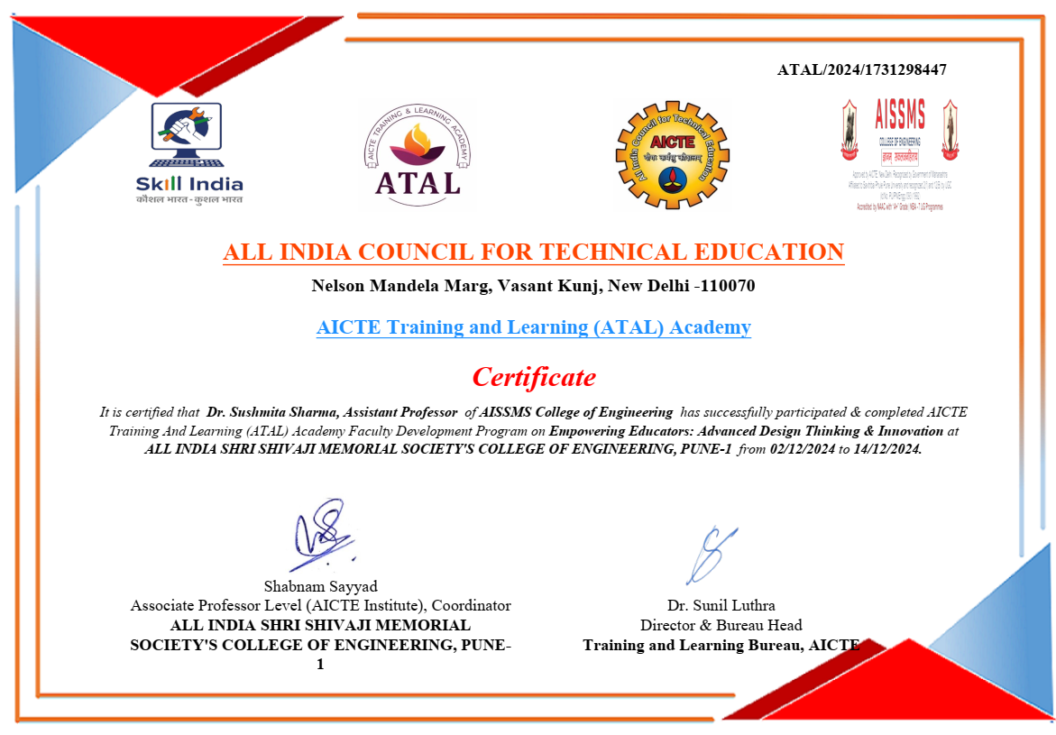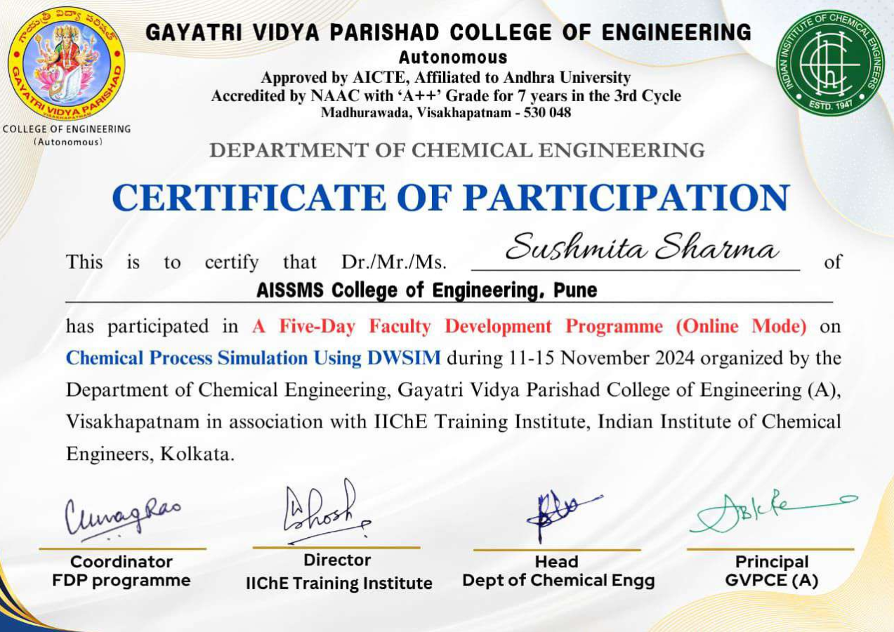

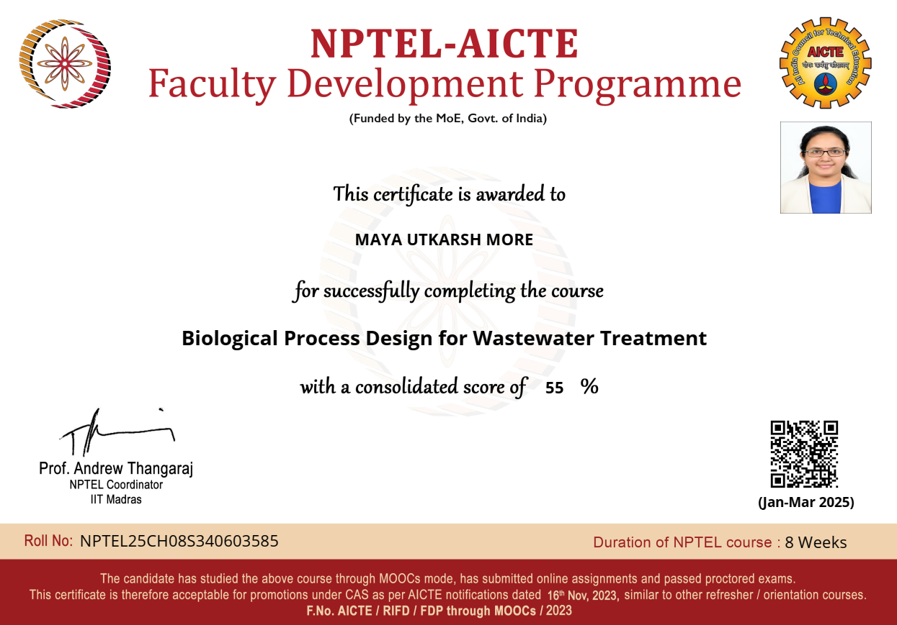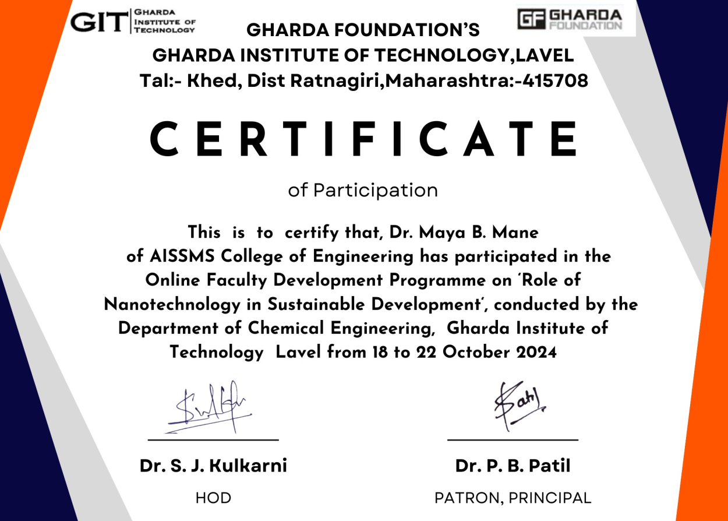

Term Two
S N | Name of Faculty | Title of the FDP/STTP | Organized by | Duration/ Dates
1 | Dr S S Sharma | Process Intensification through Heat Transfer Augmentation | Gharda Institute of Technology, , Ratnagiri, Maharashtra | 18.02.2025  22.02.2025
2 | Prof H L Kamble | Process intensification: Sustainability in Chemical Engineering | Datta Meghe COE , Mumbai | 07.04.2025 11.04.2025
3 | Prof H L Kamble | The Science of Happiness and Wellbeing” | NPTEL | Feb-April 2025-8 Weeks
4 | Prof H L Kamble | Human Behavior | NPTEL | Feb-April 2025-8 weeks
5 | Dr M B Mane | Biological Process Design for Wastewater Treatment | NPTEL | An-Mar 2025
6 | Mr P S Tadkar | Process Intensification through Heat Transfer Augmentation | GIT Ratnagiri | 18/02/2025 to 22/02/2025
7 | Mr P S Tadka | Cyber Security | Excel R | 14/02/2025 to 20/02/2025
8 | Mr P S Tadka | Integrating Synergism among Chemical Processes and Technologies for Sustainable Development | AICTE Training and Learning (ATAL) Academy SVNIT Surat | 10/02/2025 to 18/02/2025
9 | Mr. P. M. Warke | “Research Paper Writing and Publishing in High-Impact Journal” | SCOE, Pune | 24/02/2025- 28/02/2025

FDP/STTP Attended by the Department Faculty

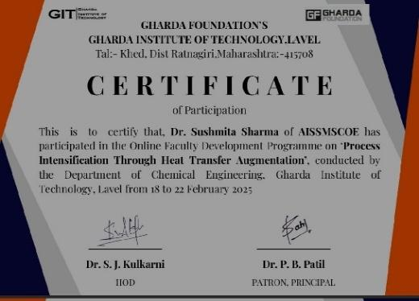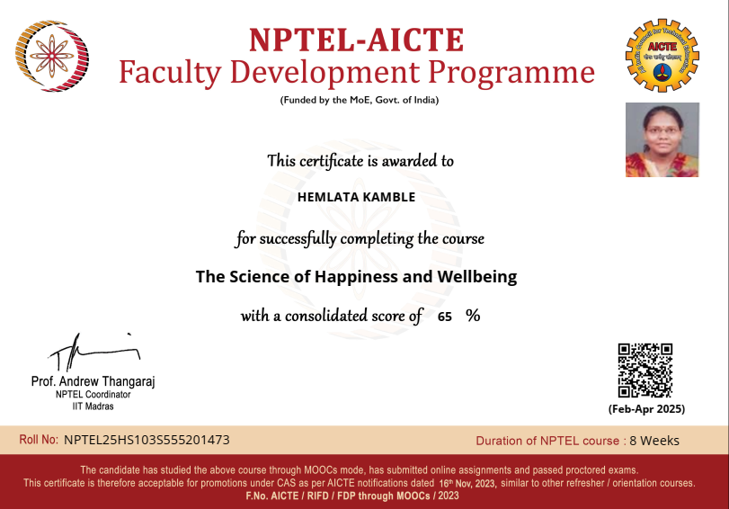
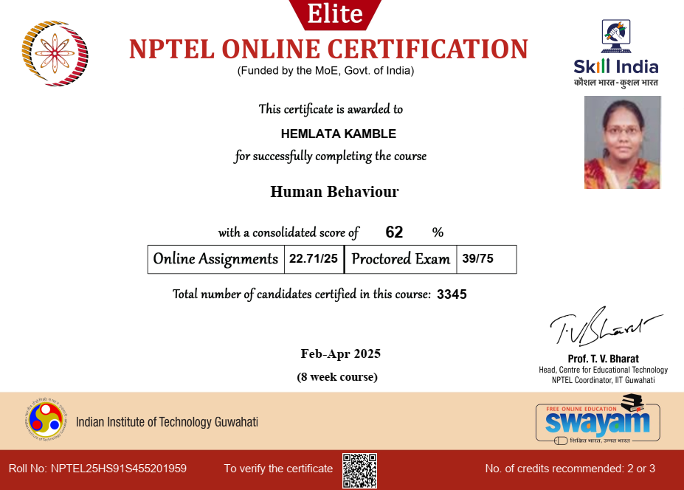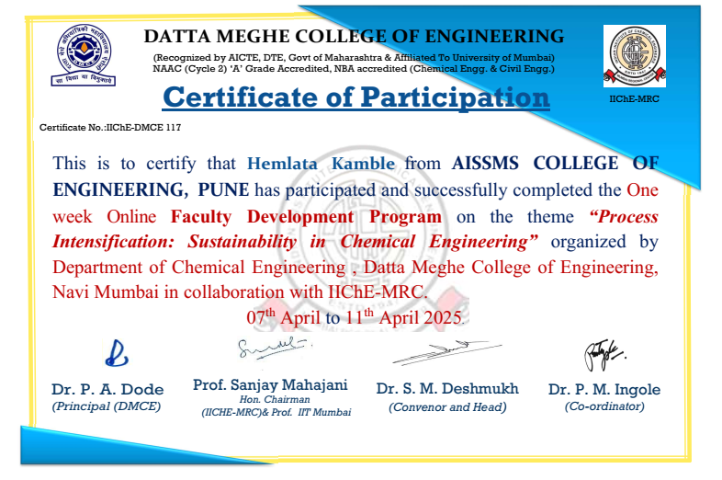

2.5 SEMINARS/ WORKSHOPS/ WEBINARS ATTENDED BY THE DEPARTMENT FACULTY
Term One
S N | Name of Faculty | Title of the Seminar/Webinar | Organized By | Duration/ Dates
1 | Dr A S Jadhav | Industrial Waste Water Treatment-Webinar | Department of Chemical Engg-AISSMS COE | One hour -20.10.2024
2 | Dr M Y Naniwadekar | Industrial Waste Water Treatment-Webinar | Department of Chemical Engg-AISSMS COE | One hour -20.10.2024
3 | Dr S Sharma | Industrial Waste Water Treatment-Webinar | Department of Chemical Engg-AISSMS COE | One hour -20.10.2024
4 | Mr. P. M. Warke | Seminar on ‘Overview of BIS’ Expert from BIS: Mr. Gautam Chand Soni, Scientist | ‘Standards’ Club- Chemical, AISSMS COE, Pune | One hr. 12/08/2024
5 | Mr. P. M. Warke | Chemical Engineering Design | ‘Standards’ Club- Chemical, AISSMS COE, Pune | 2 hrs 02/10/2024

Term Two
S N | Name of Faculty | Title of the Seminar/Webinar/Workshop | Organized By | Duration/ Dates
1 | Dr A S Jadhav  Dr P D Baviskar , Prof P S Tadkar | One-day workshop on Awareness of Entrepreneurship Development-Workshop | AISSMS - De Asra Foundation, Pune | 6th February 2024 at CITP Hall from 10:00 AM onwards
2 | Mr. P. M. Warke | Seminar on ‘Standards in Detergents Manufacturing’ Expert from Industry: Mr.Ranjit Thorat, Director, Darshan Detergent Industries | ‘Standards’ Club- Chemical, AISSMS COE, Pune | 1 hr. 12/02/2025

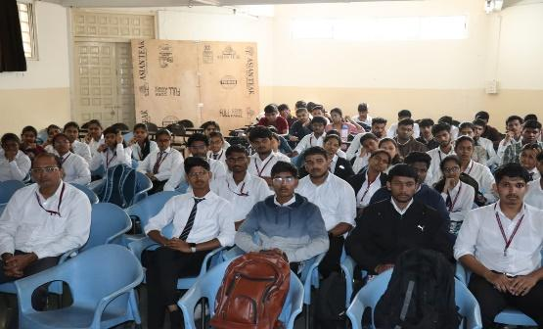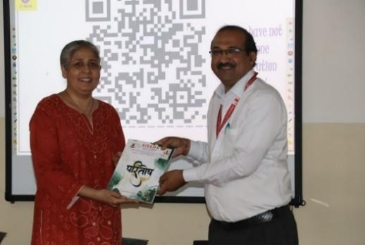

2.6 CONFERENCES/ SYMPOSIUMS ATTENDED BY THE DEPARTMENT FACULTY

Term One
S N | Name of Faculty | Title of the Conference / Symposium | Organized By | Duration/ Dates
1 | Mr P S Tadkar | Chemcon 2024 | NIT Jalandhar | 27/12/2024 to 30/12/2024

Term Two
S N | Name of Faculty | Title of the Conference / Symposium | Organized By | Duration/ Dates
1 | Mr P M Warke | International Exhibition regarding Innovations in Plastic and Polymer Industries on 11th January 2025 | World Trade Centre, Moshi, Pune | 11th January 2025

Term One
S N | Name of Faculty | Title of the Conference / Symposium | Organized By | Duration/ Dates
1 | Prof S B Ghugare | Engineering Today 2024 (Symposium) | AISSMS COE | 06 .09.2024  07.09.2024  2days
2 | All Staff | Engineering Today 2024 (Symposium) | AISSMS COE | 06 .09.2024  07.09.2024  2days
3 | Mr. P. M. Warke | Organized a One Day Competition ‘Dolphin Tank” in CHEMIXIR an Event in AISSMS Engineering Today 2024-25 | Dept. of Chemical Engineering , AISSMS COE, Pune | 06 .09.2024

2.7 ONLINE COURSES / CERTIFICATE COURSES COMPLETED BY DEPARTMENT FACULTY -
Term Two
S N | Name of Faculty | Title of the Course | Conducted By | Duration/ Dates
2 | Prof P S Tadkar | Matlab Based Programming in Chemical Engineering | NPTEL | 12 Weeks
2 | Prof P S Tadkar | Process/Chemical Engineering | UDEMY | December 2024

Term Two
S N | Name of Faculty | Title of the Course | Conducted By | Duration/ Dates
1 | Prof P S Tadkar | Research Methodology in Natural Sciences | NPTEL | 12 Weeks  Jan-Apr 2025
3 | Dr S B Ghigare | Materials Data Science and Informatics | MOOC-Coursera | Feb 6 2024
3 | Dr S S Sharma | Chemical Reaction Engineering II. | NPTEL | 12 Weeks  Jan-Apr 2025
4 | Prof H L Kamble | Human Behaviour | NPTEL | 8 Weeks
5 | Prof H L Kamble | The Science of Happiness and Wellbeing | NPTEL | 8 Weeks

Certificates of Faculty attended FDP
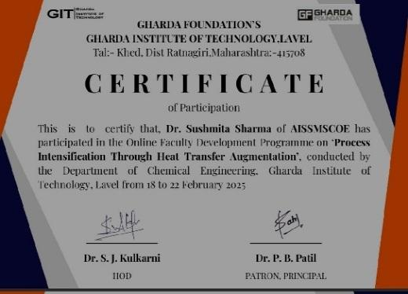

2.8 EXTENSION LECTURES / WEBINARS (Lectures organized on other than technical topics))
Sr. No. | Name of Speaker | Name of Industry | Date of  Lecture | Topic | Number of beneficiaries

2.9 FACULTY SERVED AS RESOURCE PERSON, EXPERT, CHAIRPERSON
Term One
S N | Name of Faculty | Title of Activity | Organizing body | Date

Term Two
S N | Name of Faculty | Title of Activity | Organizing body | Date
01 | Dr A S Jadhav | Expert Examiner for Shivaji University College Magazine Competition | Shivaji University | 2 Feb 2025

ACTIVITIES ORGANIZED

3.1 FDP/STTP ORGANIZED BY THE DEPARTMENT
Term One
S N | Name of faculty coordinator | Title of the FDP/STTP/WS/Seminar/Symposium | Duration/ Dates | No. of Participants | Funding Agency  (If any) and Amount (Rs.)
1 | Dr S B Gughare | ET 2024-25 | 3 Days | 55 | Sponsorship worth Rs 10000
2 | Mr. P M Warke | competition’ Standards of Centrifugal Pumps’ among the student members of the ‘standards’ Club- Chemical | 2 Days | 67 | Financial Support Rs. 40652/- by BIS
3 | Mr. P M Warke | ‘Quality Walk’ | 1 Day | 600 | All expenses by BIS Pune branch

Term Two
S N | Name of faculty coordinator | Title of the FDP/STTP/WS/Seminar/Symposium | Duration/ Dates | No. of Participants | Funding Agency  (If any) and Amount (Rs.)
1 | Mr. P M Warke | ‘Standards Carnival’ | 2 Days | 500 | Rs. 40000/- by BIS and other expenses by BIS Pune branch
2 | Mr. P M Warke | Activity II on Indian Standards Detergents | 2 Days | 71 | Rs. 51116/- by BIS

3.2 SEMINARS/ WORKSHOPS/ WEBINARS ORGANIZED BY THE DEPARTMENT
Term One
S N | Name of Coordinator/s | Title of the Seminar/Webinar | Duration/ Dates | No. of Participants | Funding Agency  (If any) and Amount (Rs.)
1 | Prof P S Tadkar | Industrial Waste Water Treatment-Webinar  Resource Person -  Dr Pankaj N Patil  Senior Manager, Praj Industries Ltd., Pune | One Hour  20/10/2024 | 55 | Online
2 | Mr. P M Warke | Chemical Engineering Design | 1 hr on 02/10/2024 | 57 | Offline

Glimpses of Event
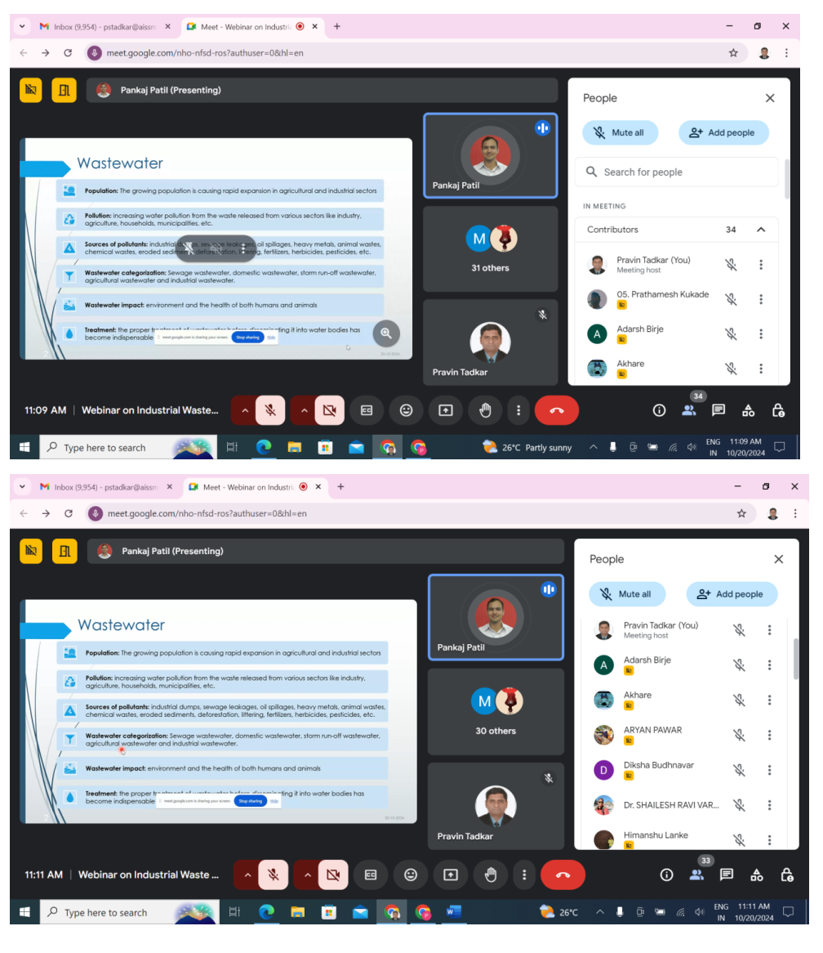

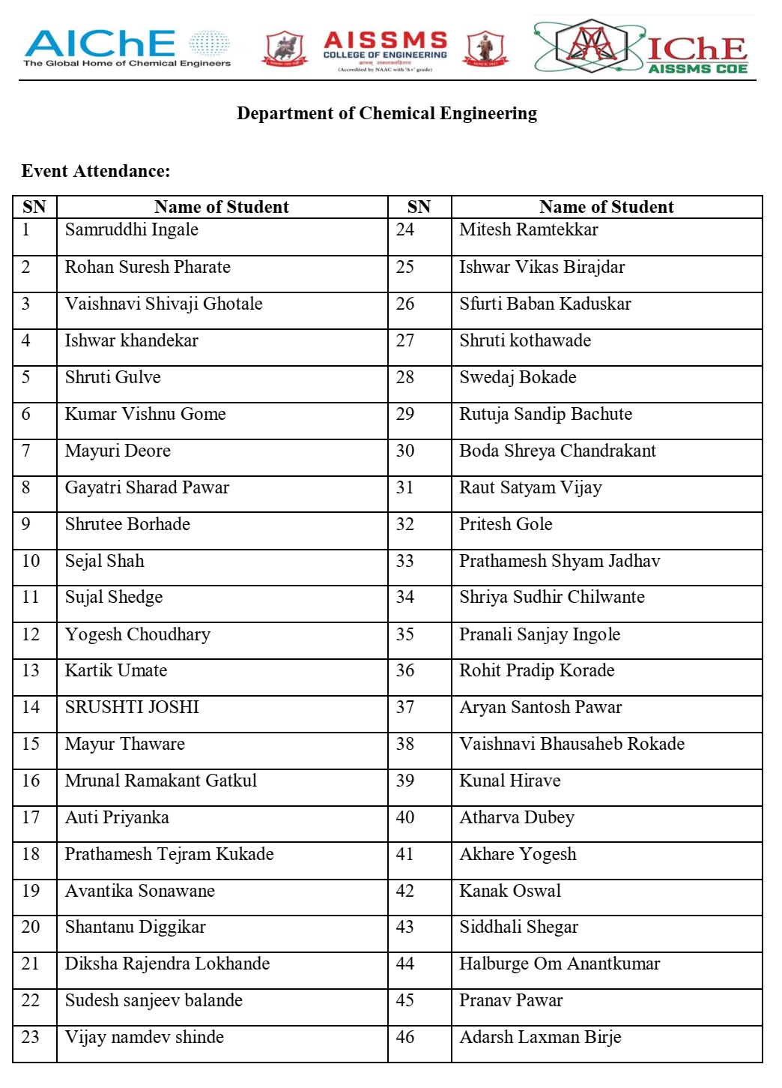

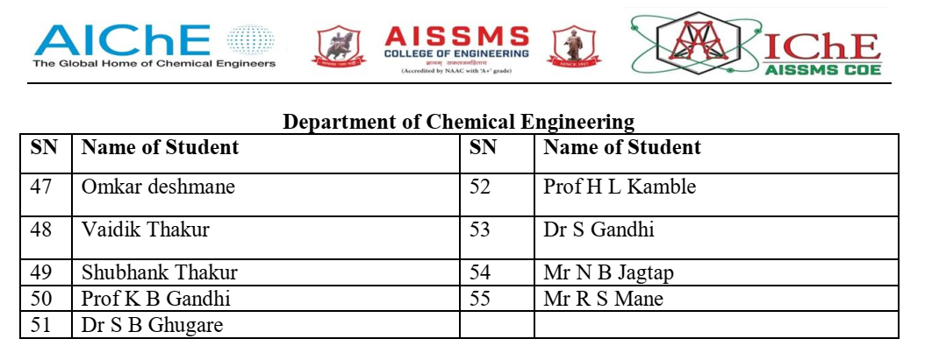
Term Two
S N | Name of Coordinator/s | Title of the Seminar/Webinar | Duration/ Dates | No. of Participants | Funding Agency  (If any) and Amount (Rs.)
1 | Prof P S Tadkar | Heat Exchanger Design-Webinar  Resource Person -  Dr Pankaj N Patil  Senior Manager, Praj Industries Ltd., Pune | One Hour  26.04.2025 | 95 | Online
Glimpses of Event
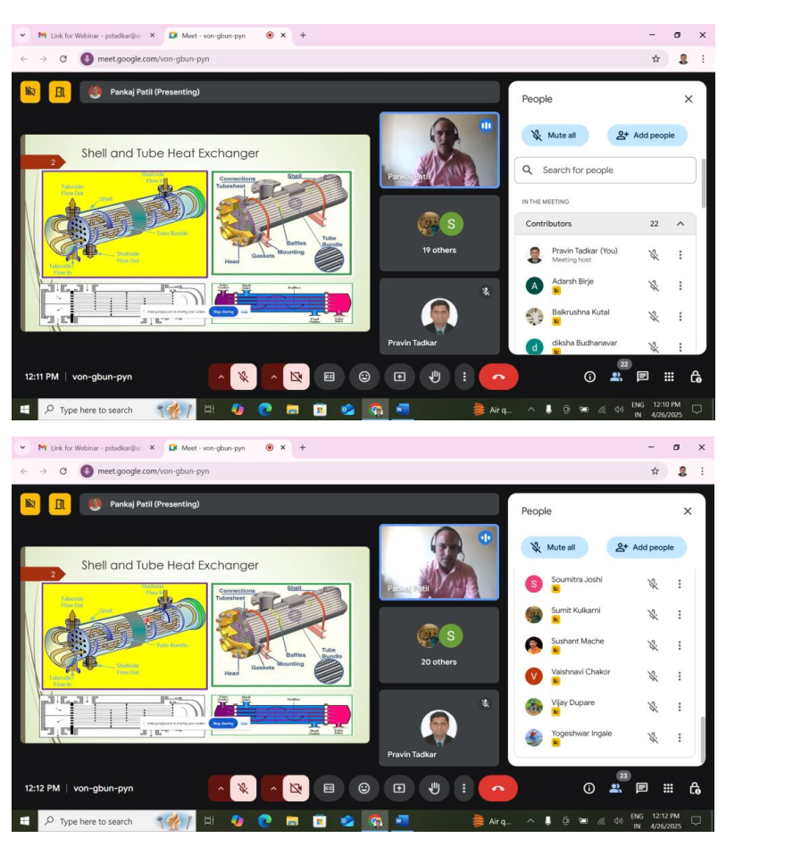
Attendance of Student
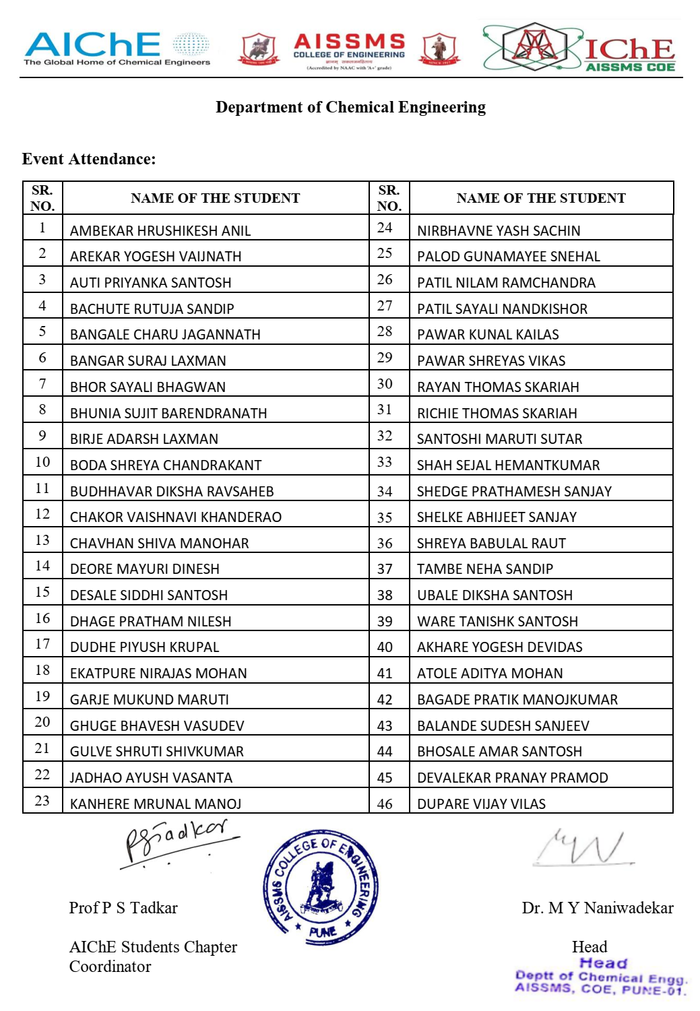
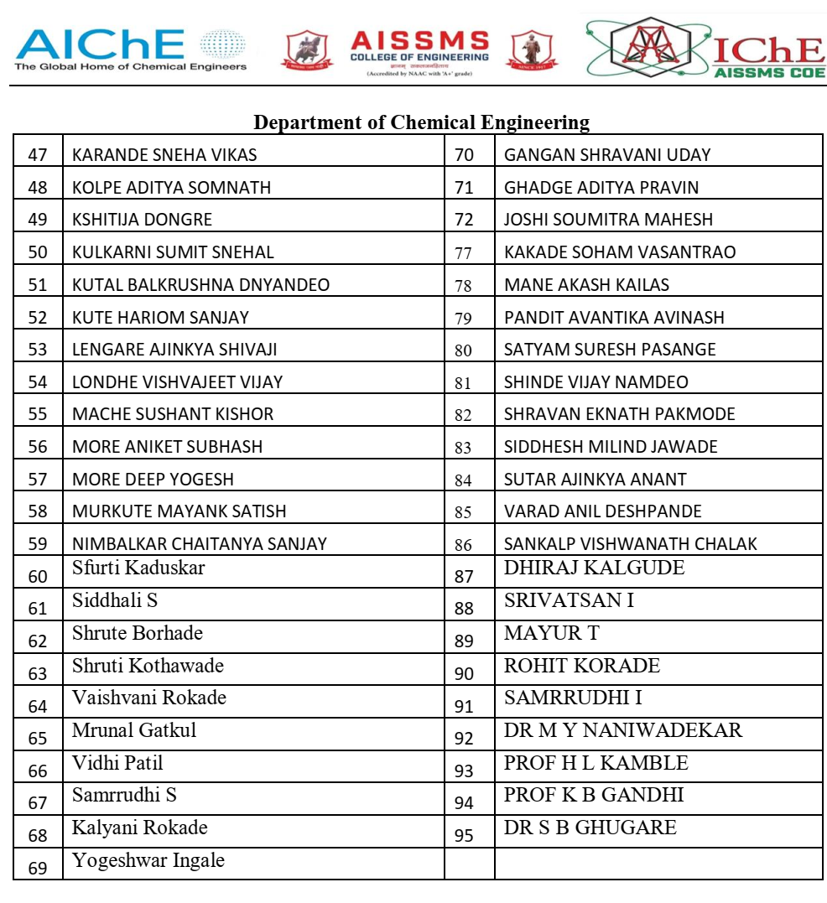

3.3 CONFERENCES/ SYMPOSIUMS ORGANIZED BY THE DEPARTMENT
Term One
S N | Name of Coordinator/s | Title of the Conference / Symposium | Duration/ Dates | No. of Participants | Funding Agency  (If any) and Amount (Rs.)
1 | Dr S B Ghugare | ET-Chemical 2024-25 | Two days | 124 | AISSMS COE
2 | Mr. P M Warke | Competition ‘Dolphin Tank” in CHEMIXIR an Event in AISSMS Engineering Today 2024-25 | One Day | 21 | AISSMS COE

Participant Information 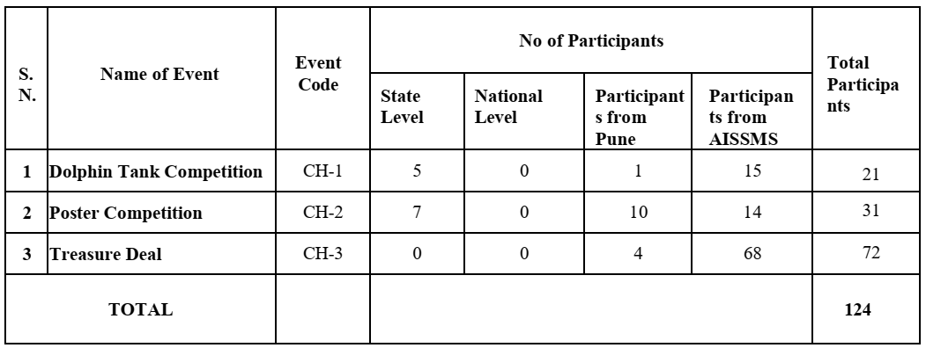
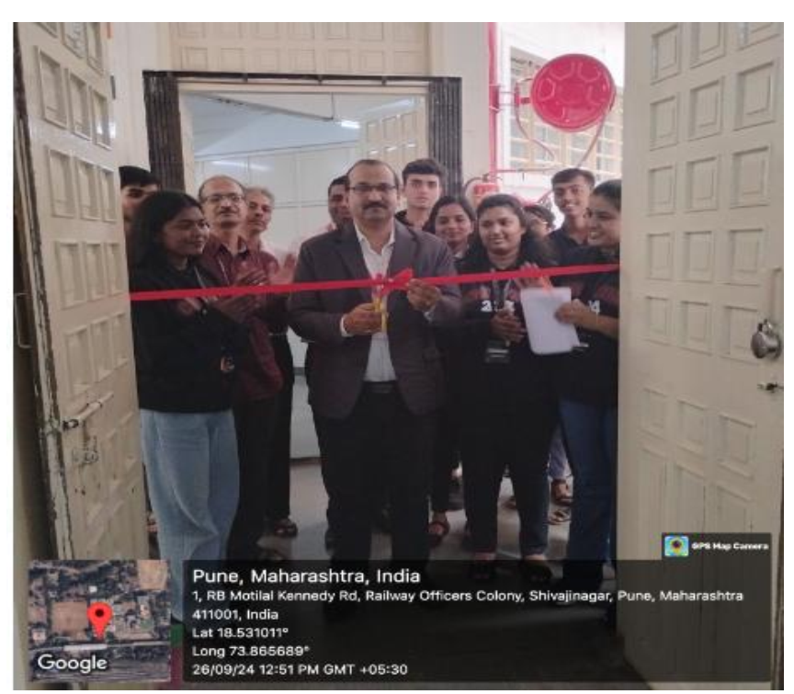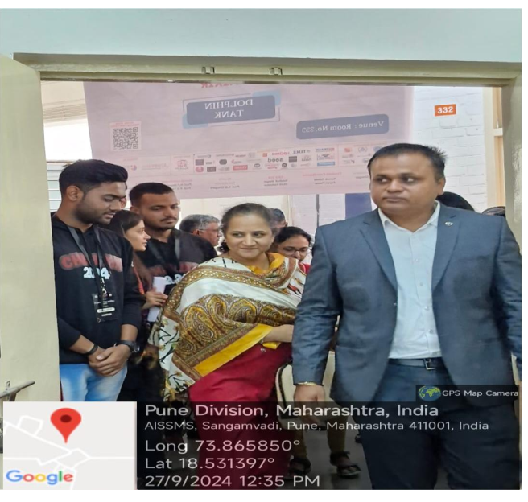
Event -Dolphin Tank Competition (CH-1)
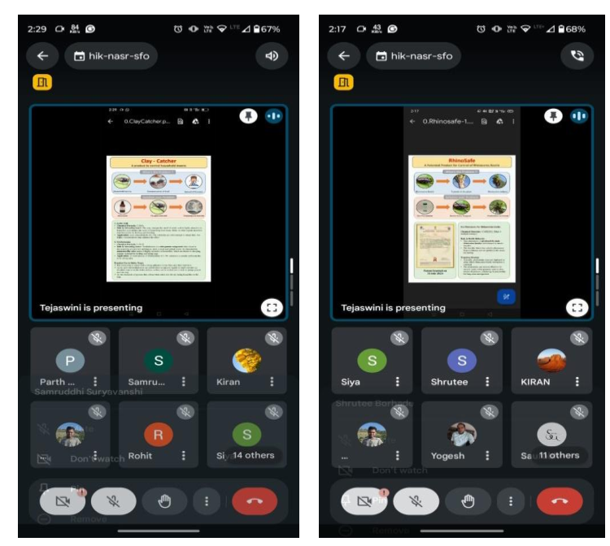

Event- Poster Competition (CH-2

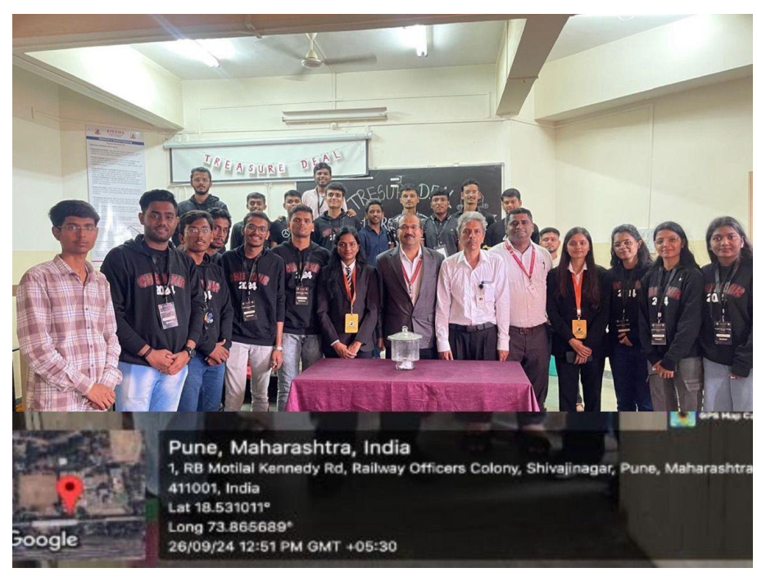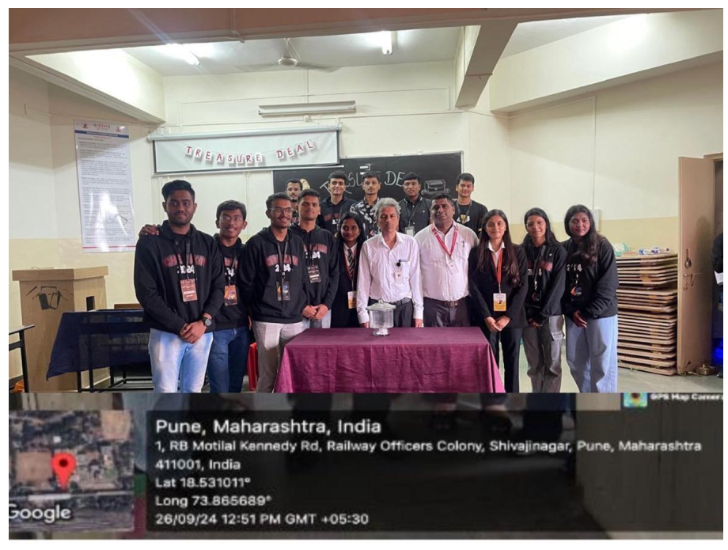

Treasure Deal (CH-3)

Term Two
S N | Name of Coordinator/s | Title of the Conference / Symposium | Duration/ Dates | No. of Participants | Funding Agency  (If any) and Amount (Rs.)

3.4 EXTENSION ACTIVITIES CONDUCTED BY THE DEPARTMENT (Social activities / Quizzes at national/international level/any other activity)
Term One
S N | Name of Faculty Coordinator | Details of activity conducted | Date | Number of beneficiaries
1 | Prof H L Kamble | Social Visit to Old age home | 19.10.2024 | 28
2 | Prof. P M Warke | Quality Walk for social awareness to use BIS- certified products for Hygiene, Safety & Environment. | 10.10.2024 | 600+

Glimpses of Social Visit at OLD AGE HOME
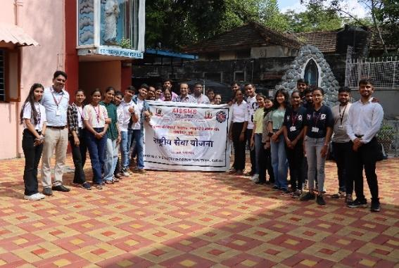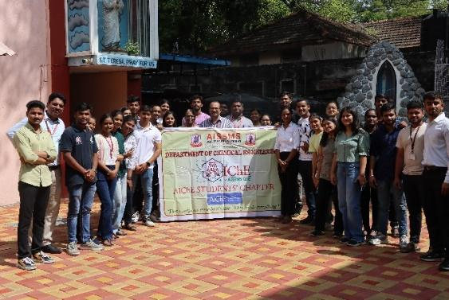
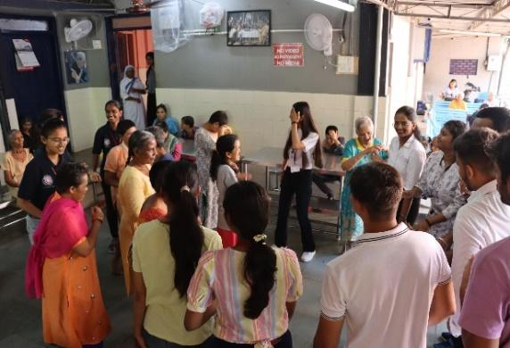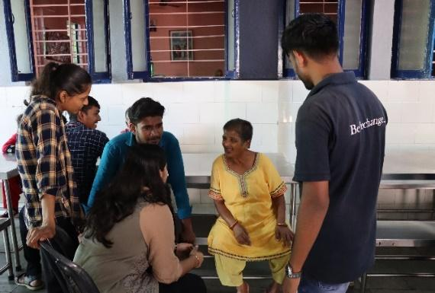
Attendance of Participant
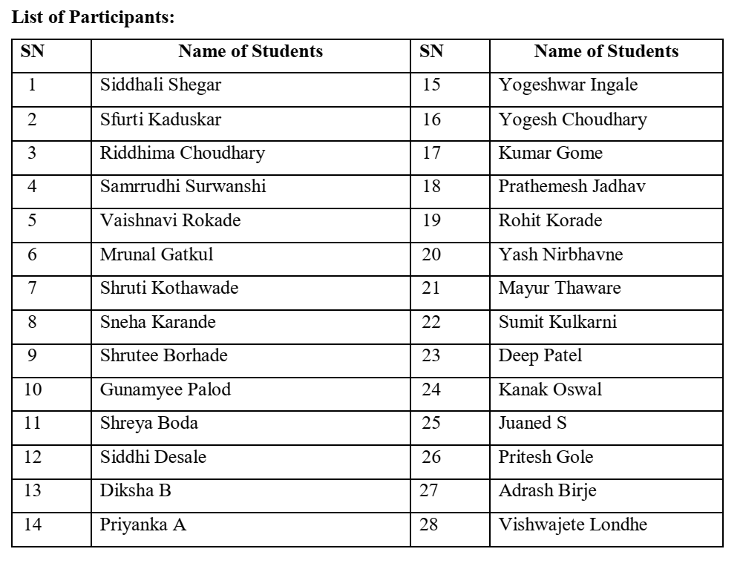

Term Two
S N | Name of Faculty Coordinator | Details of activity conducted | Date | Number of beneficiaries
1 | Dr S Sharma | NSS special residential camp | 02..02.2025 | 100
2 | Prof P S Tadkar | Project Based Learning Exhibition | 11/04/2025 | 72
3 | Dr. A V Mohod | Soap manufacturing Process at rural area | 27.03.2025 | 30
4 | Mr. P. M. Warke | ‘Standards Carnival’ to use BIS Care App and BIS certified products for Hygiene, Safety & Environment. | 10/01/2025 | 500+

Glimpses of NSS special residential camp
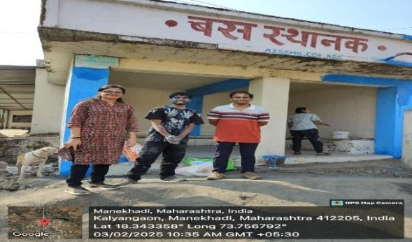
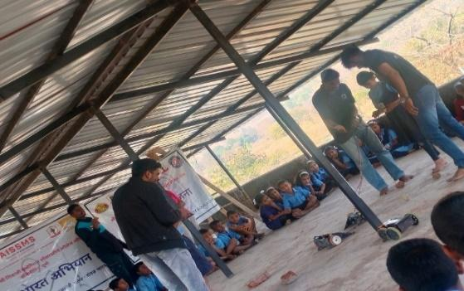

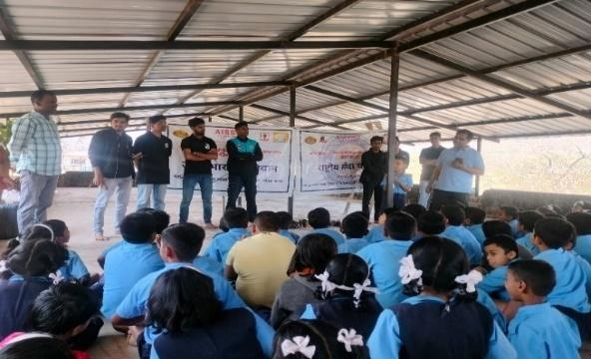
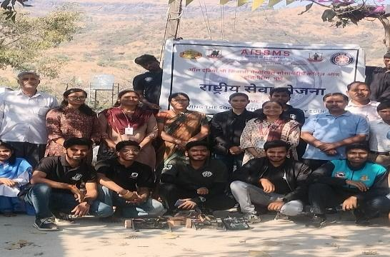

Glimpses of Project Based Learning Exhibition

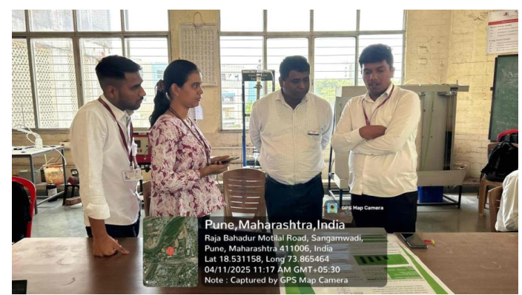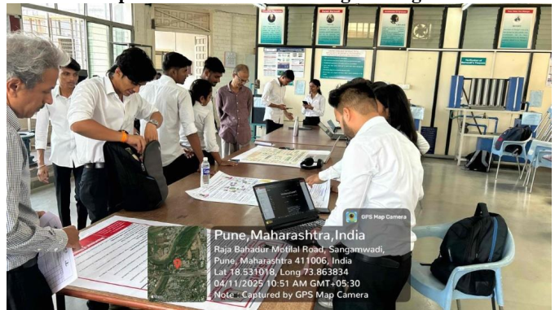

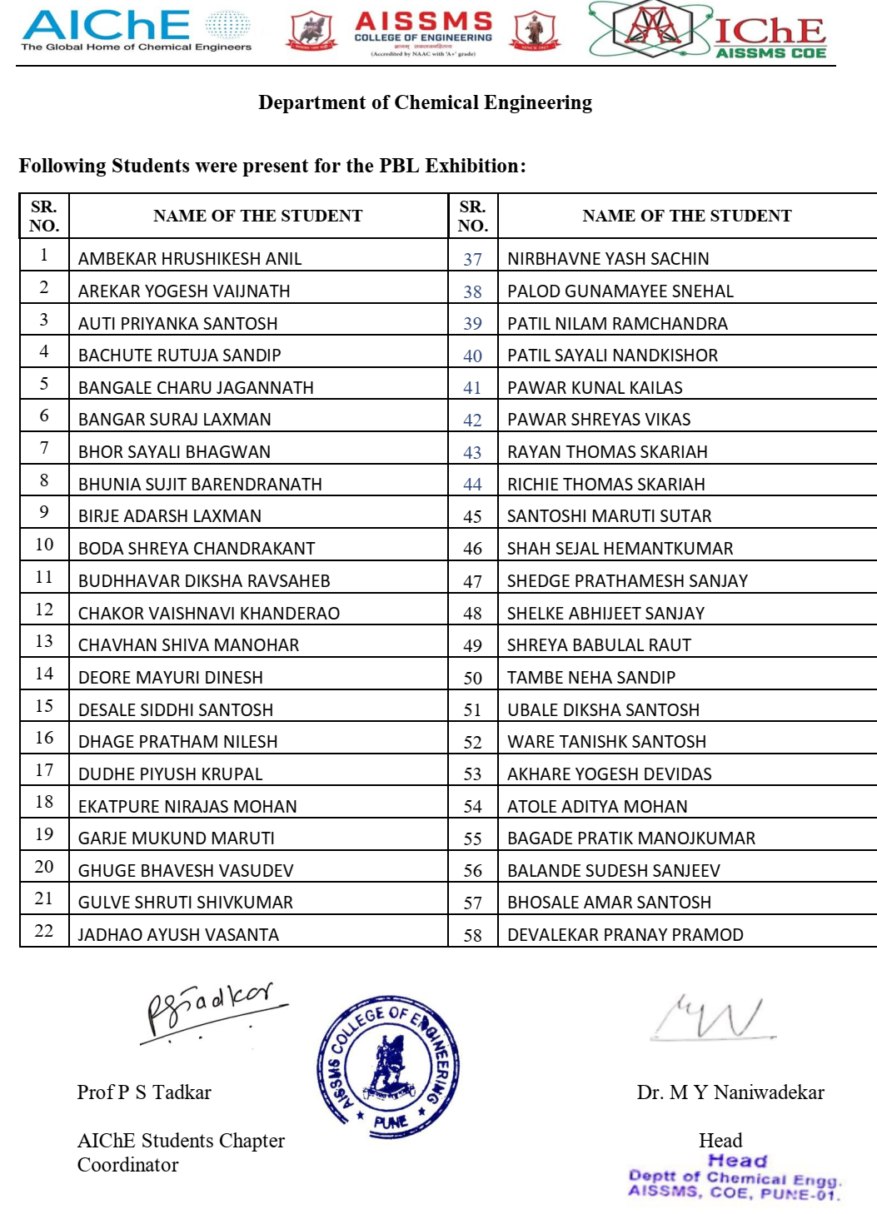

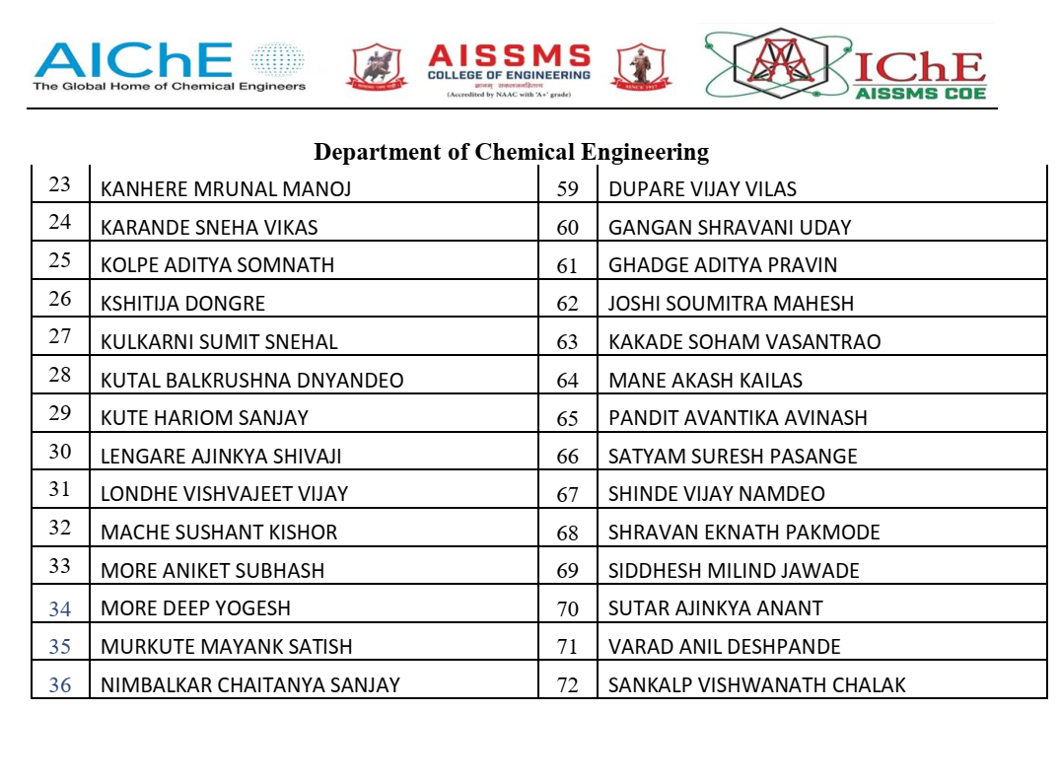
3.5 MOU SIGNED WITH ACADEMIC AND PROFESSIONAL ORGANISATIONS
Term One
Sr. No. | Faculty Coordinator | Name of Organisation | Date  of MoU Signed | Valid upto  00/00/0000
1 | Dr M Y Naaniwadekar | Reva Process Technologies, Pune | 2021 | 2031
2 | Dr A S Jadhav | Concept Development Centre, Pune | 2023 | 2033
3 | Mr. P C Walke | SERVEINDIA, Pune | 2023 | 2026
4 | Mr. P C Walke | Ethix Water Conditioner, Pune | 2023 | 2028

MOU Signed with REVA Process
-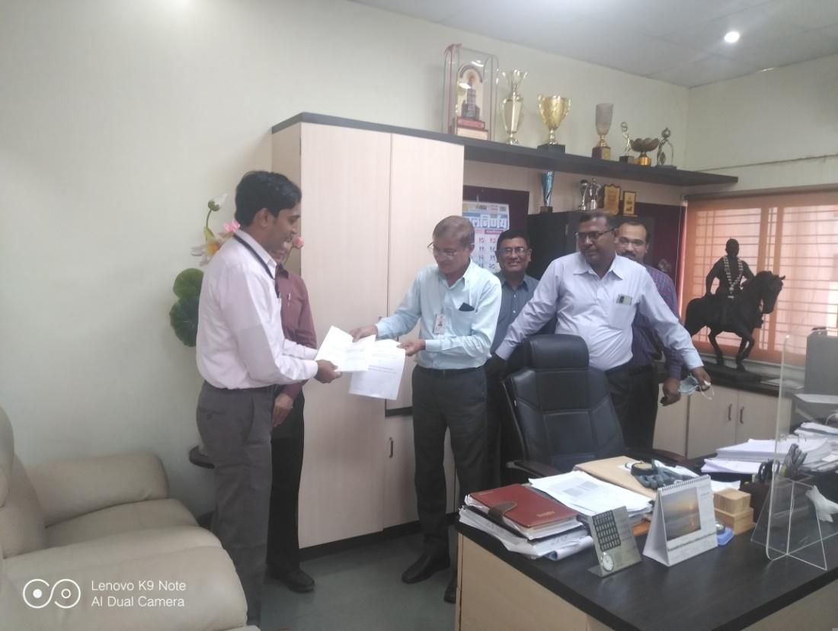 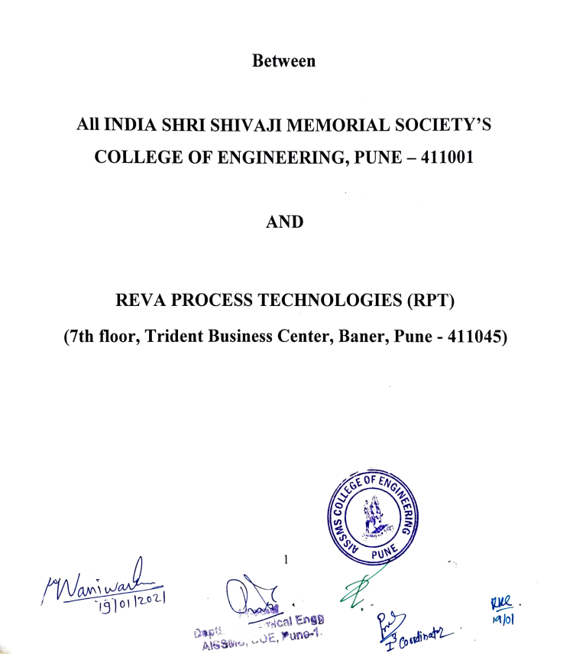

Term Two
Sr. No. | Faculty Coordinator | Name of Organisation | Date  of MoU Signed | Valid upto  00/00/0000
1 | Mr. P C Walke | Shreeji Aquatreatment Pvt Ltd., Pune | 2024 | 2027
2 | Dr. A V Mohod | LiqSure Systems Pvt. Ltd., IIT Hyderabad campus | 2024 | 2026
3 | Mr. P C Walke | Super Aqua Services, Pune | 2023 | 2026

Total Functional / Live MoU initiated by Department
Sr. No. | Faculty Coordinator | Name of Organisation | Date  of MoU Signed | Valid upto  00/00/0000
 | Prof P M Warke | BIS, Pune | 04/05/2022 | Till the BIS continue the Collaboration
1 | Mr. P C Walke | Super Aqua Services, Pune | 2023 | 2026
2 | Dr M Y Naaniwadekar | Reva Process Technologies, Pune | 2021 | 2031
3 | Mr. P C Walke | Ethix Water Conditioner, Pune | 2023 | 2028

Glimpses of MOU Signed with Industry
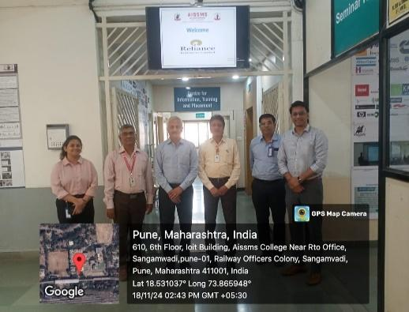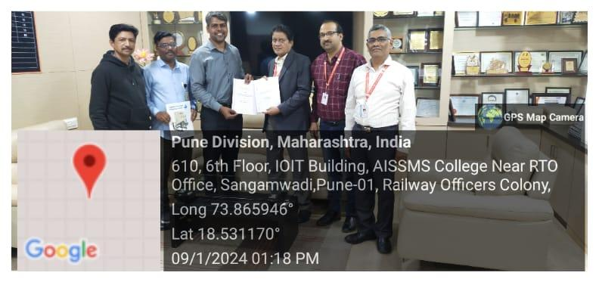
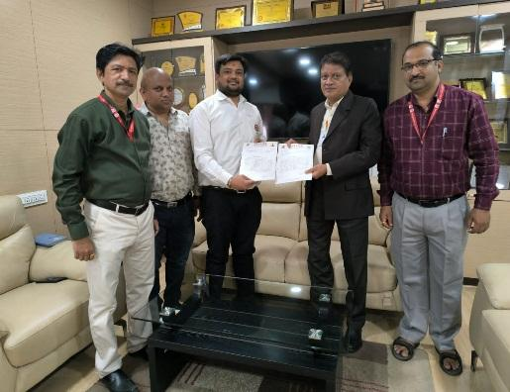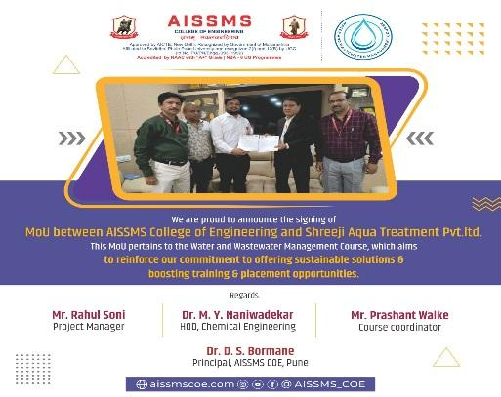

3.6 STUDENTS’ CHAPTERS /CLUBS
Sr. No | Name of Students’ Chapter | Number of Student Members
01 | IEI Students Chapter Chemical Engg | 35
02 | IIChE Students Chapter Chemical Engg | 49
03 | AIChE Students Chapter Chemical Engg | 44
04 | Standards Club- Chemical with Bureau of Indian Standards | 148

3.7 SOCIAL ACTIVITIES ORGANISED (NSS, Women empowerment, Awareness Programms, etc.)
Term One
Faculty coordinator | Name of Activity | Date, Duration | Number of students involved
Prof H L Kamble | Social Visit to Old age home | 19.10.2024 | 28
Prof. P M Warke | Quality Walk for social awareness to use BIS- certified products for Hygiene, Safety & Environment. | 10.10.2024 | 600+

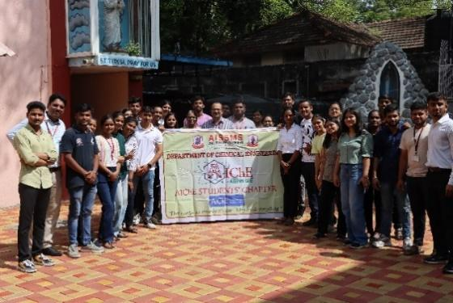
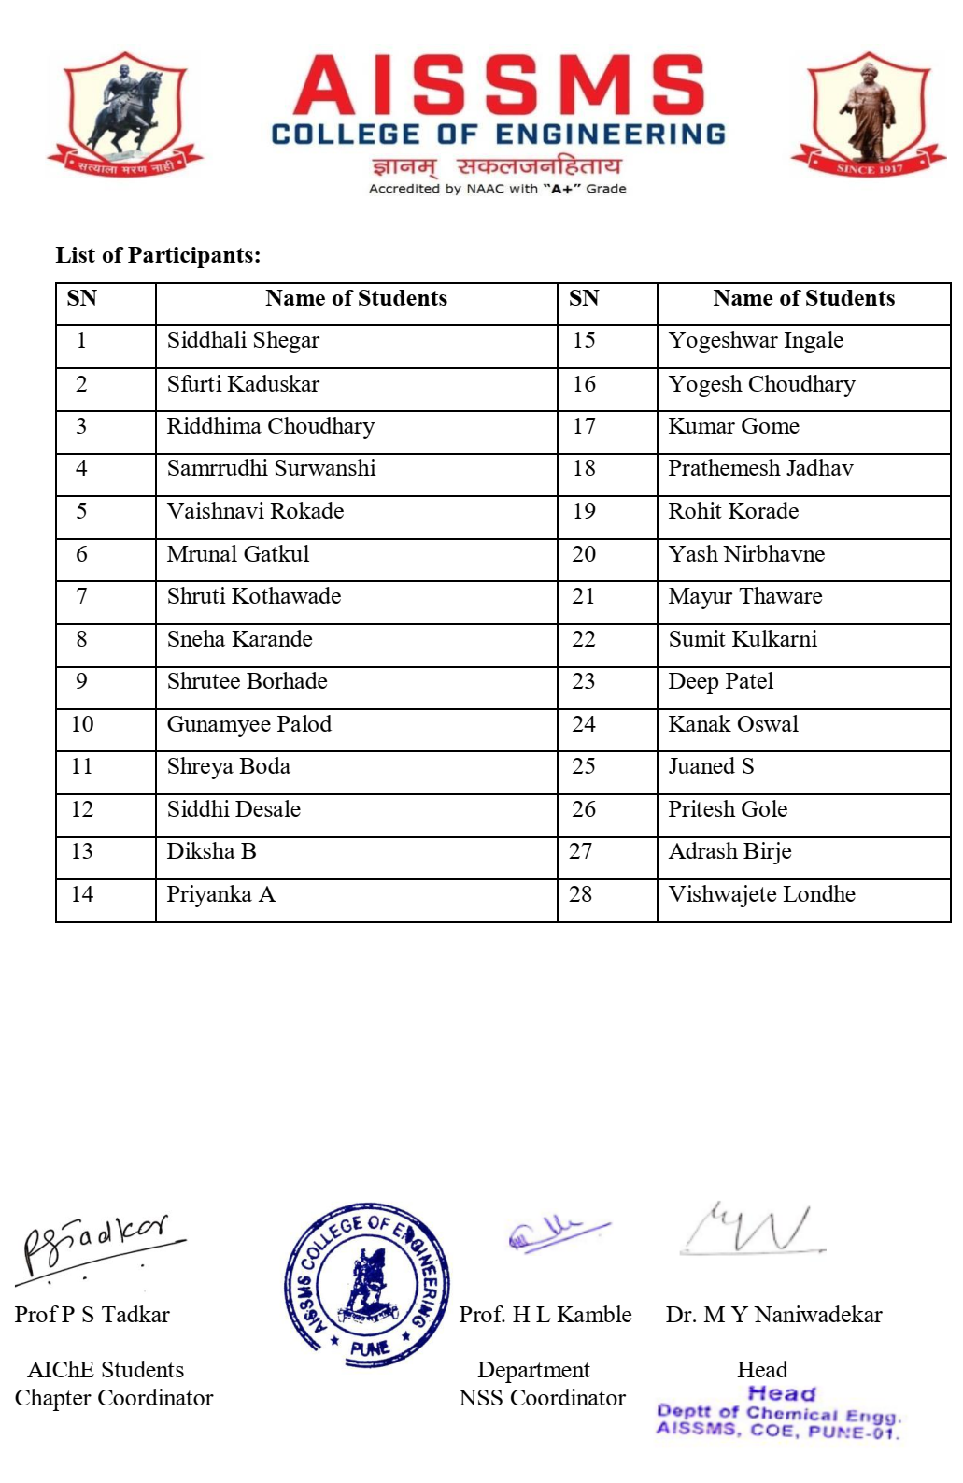

Term Two
Faculty coordinator | Name of Activity | Date, Duration | Number of students involved
Mr. P. M. Warke | ‘Standards Carnival’ to use BIS Care App and BIS certified products for Hygiene, Safety & Environment. | 10/01/2025 | 500+
Prof P C Walke | STP course for the Social Development Department of Pune Municipal Corporation staff | 16th March to 23rd March 2025 | 13
Dr S Sharma | NSS special residential camp | 02..02.2025 | 100

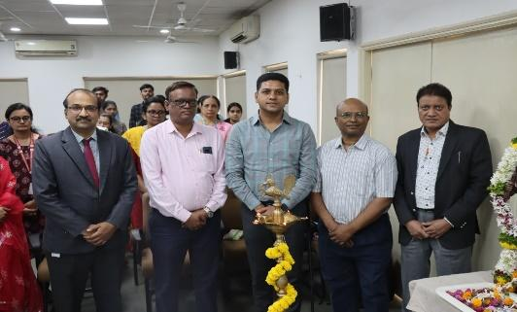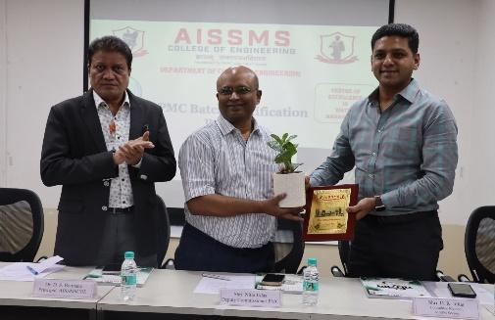
Glimpses of Social Training Programme Sewage Treatment

3.8 PARENT MEETING
Faculty Coordinator | Day and Date | Details of Parent meetings organized | Number of Parents attended
Prof P S Tadkar | 12/04/2025 | The AIChE Student Chapter, Department of Chemical Engineering, AISSMS COE Pune, organized an online “Parents Meet” on 12th April 2025. The objective of the meeting was to foster a healthy Parent-Teacher interaction and to create a smooth, transparent, and efficient communication channel for the academic and overall development of students. | 21

Following Parents attended meet
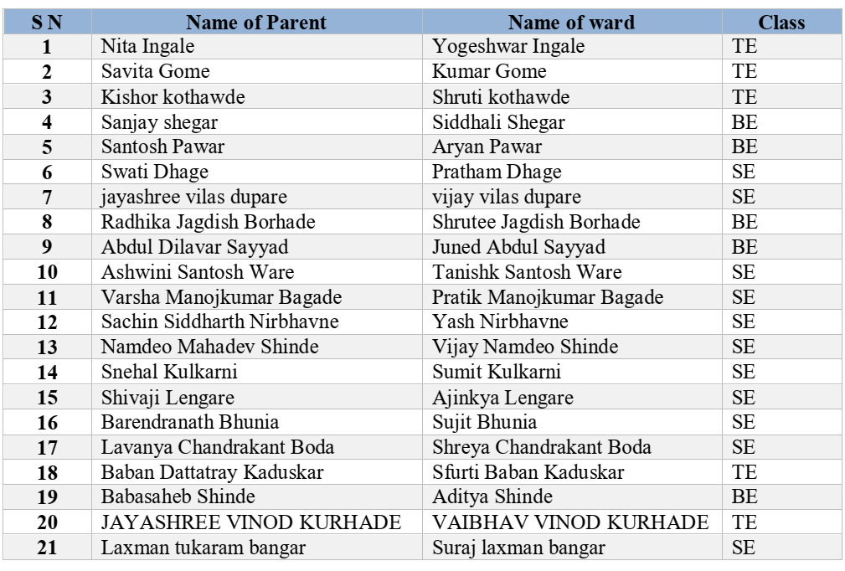
Glimpses of the Event –Parents Meet
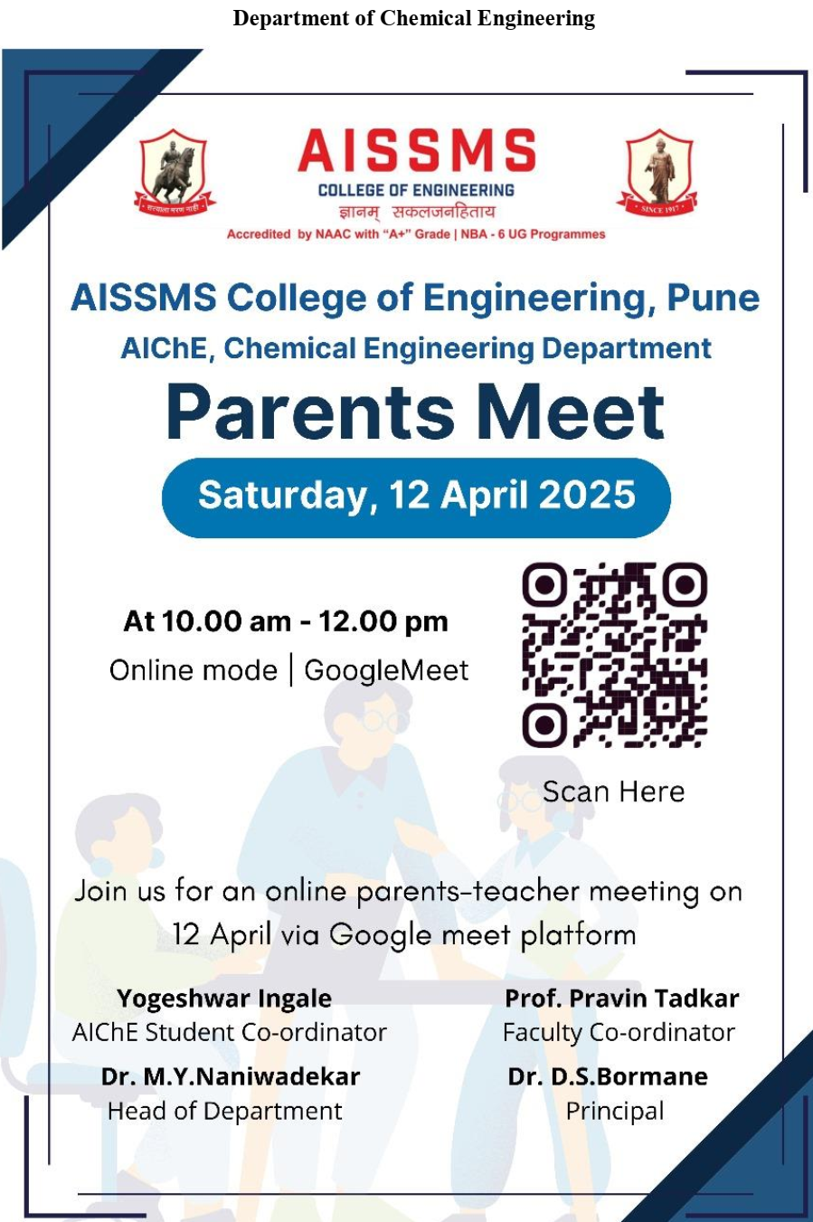

Glimpses of the Event –Parents Meet
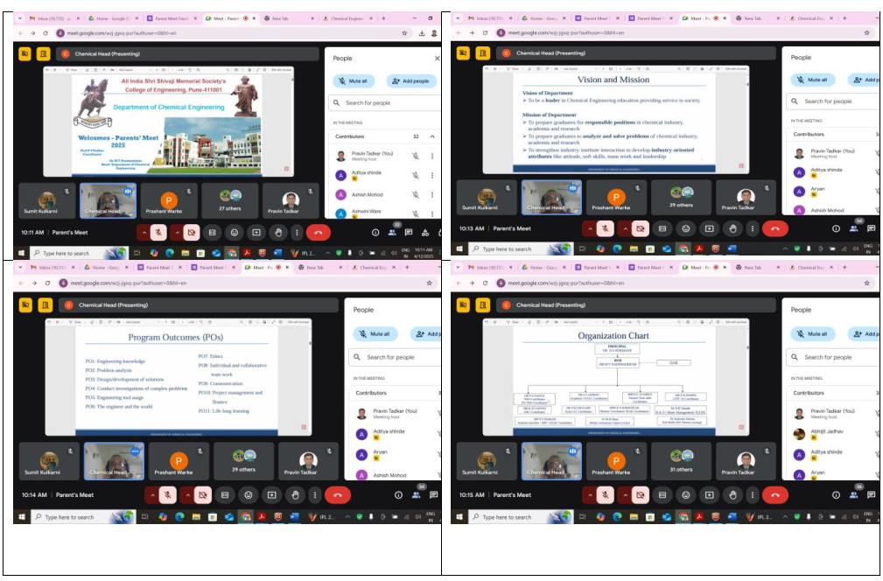
3.9 ALUMNI MEET
Faculty Coordinator | Day and Date | Details of Alumni meetings organized | Number of Alumni attended
Prof P C Walke | 9th May 2025 at AISSMS COE Pune. | Alumni meet held for Completion of Sewage Treatment course completed by PMC Staff | 13
Prof H L Kamble | 22 June 2025 online | Online Alumni meet of Department of Chemical Engineering was held on June 22, 2025 at Department seminar hall. Seventeen alumni participated in the meet. Head of the Department, Dr. M Y Naniwadekar introduced himself and shared department vision mission and PEO and various activities done in the department.  Alumni shared their experience and then interacted with the current students. The points discussed were about internship, job, higher study, career opportunities and social responsibilities. | 07

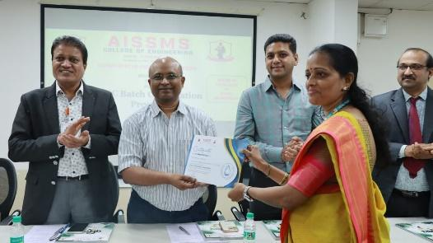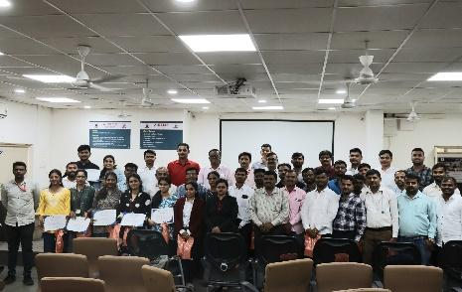
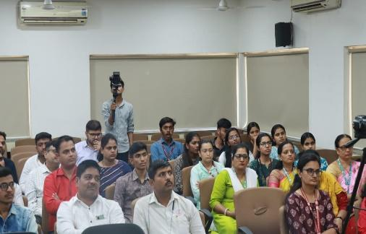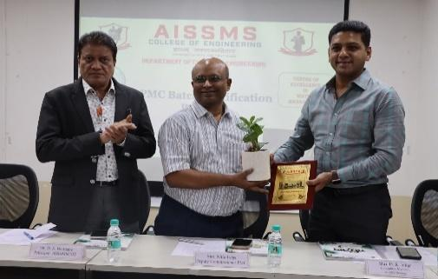

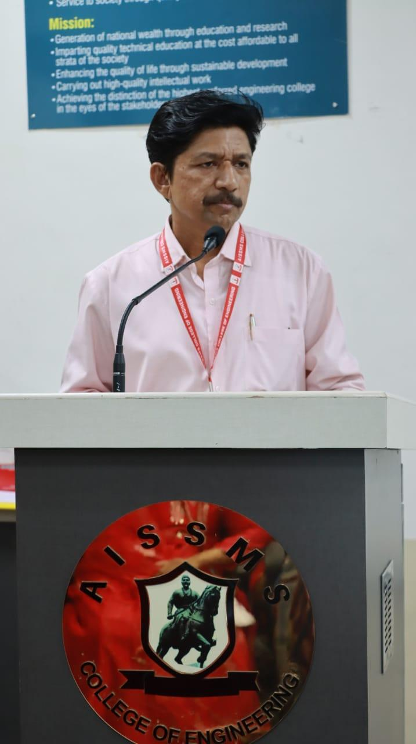
Glimpsed of Alumni meet held for Completion of Sewage Treatment course completed
by PMC Staff
2.0 Glimpses of Alumini Meet –Chemical Engg

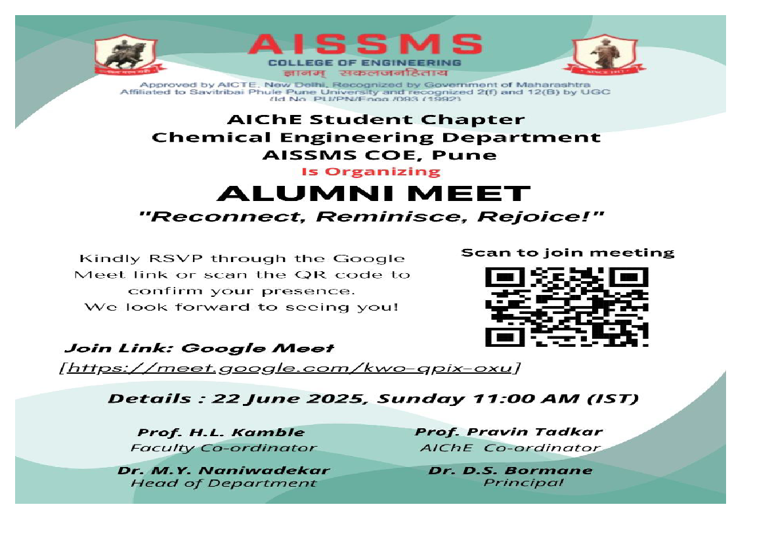

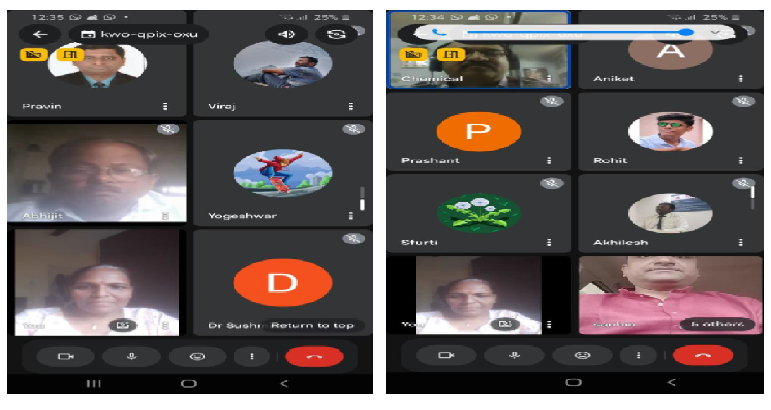
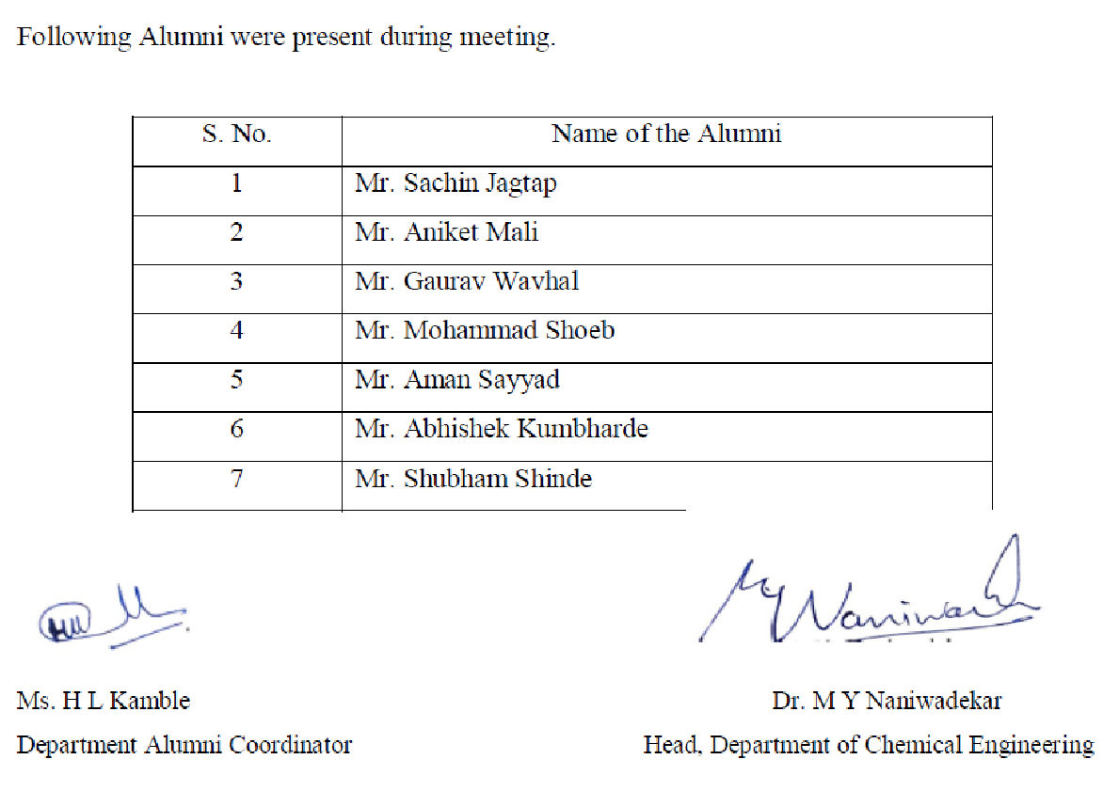

3.10 SUPPORT FROM ALUMNI
Term One
Sr No | Name of Alumni | Position and Organisation | Batch  (e.g. 2014 – 2018) | Details of Support | Date

Term Two
Sr No | Name of Alumni | Position and Organisation | Batch  (e.g. 2014 – 2018) | Details of Support | Date

3.11 INTERACTION WITH ALUMNI
Term One
S N | Name of Alumni and Activity coordinator | Details of Activity conducted | Date and duration | Total Number of beneficiaries

Term Two
S N | Name of Alumni and Activity coordinator | Details of Activity conducted | Date and duration | Total Number of beneficiaries
1 | Prof P C Walke | Interaction with Alumni who successfully completed Sewage Treatment Course 9th May 2025 at AISSMS COE Pune. | 9th May 2025 at AISSMS COE Pune.  4 hours | 13

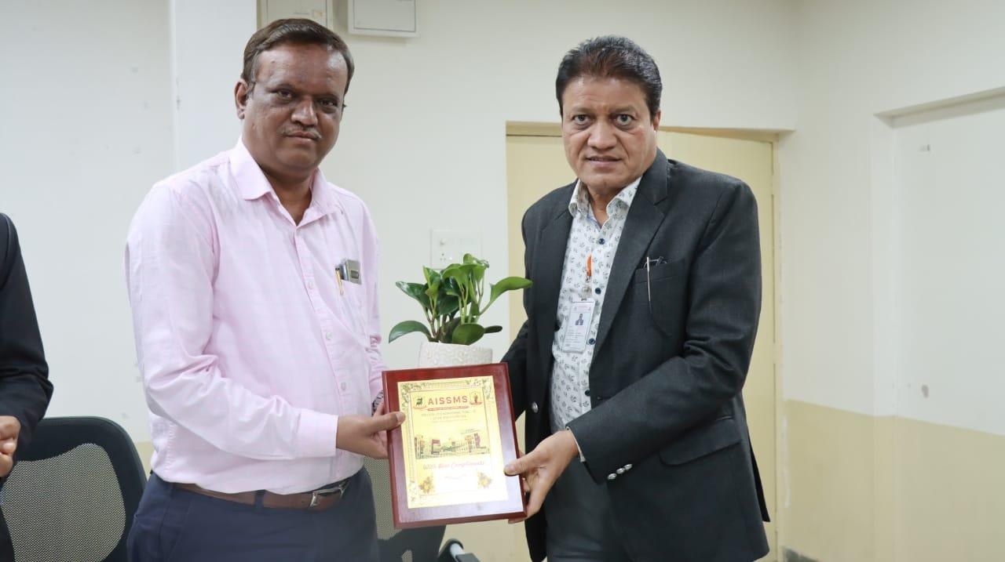

3.12 DETAILS OF STUDENT COUNSELING AND CAREER GUIDANCE AT THE DEPARTMENT LEVEL
Number of students referred for counseling
Number of Faculty referred for counseling

Faculty coordinator | CAREER GUIDANCE ACTIVITY DETAILS
 | Soft Skill
Dr S Sharma | Soft skill classes on Group Discussion (GD) and Personal Interview (PI) were conducted for the Final Year students from 10th October to 11th October 2024.  The sessions were aimed at preparing students for campus recruitment by enhancing their communication skills, teamwork, critical thinking, and confidence required for GD and PI rounds.

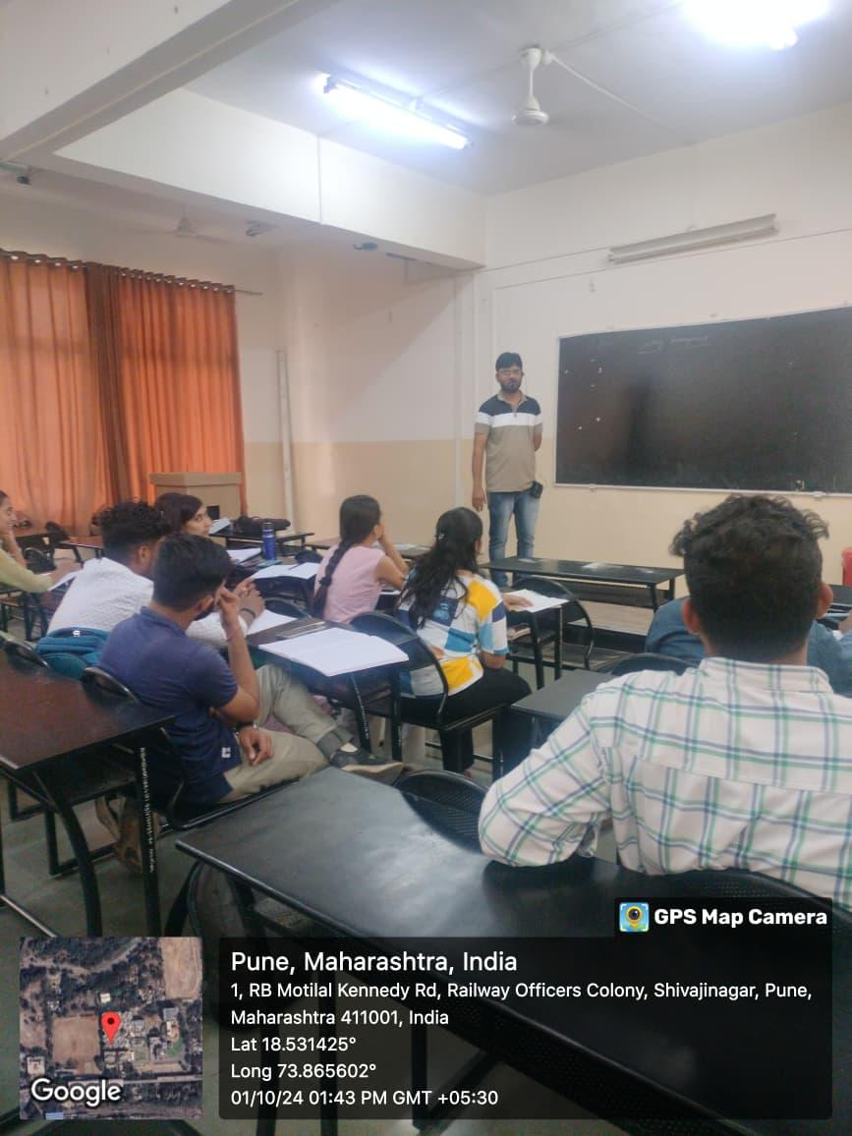
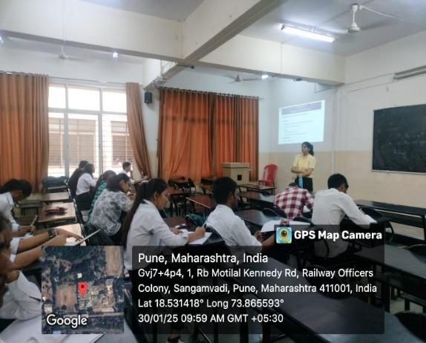
Glimpses of Soft Skills
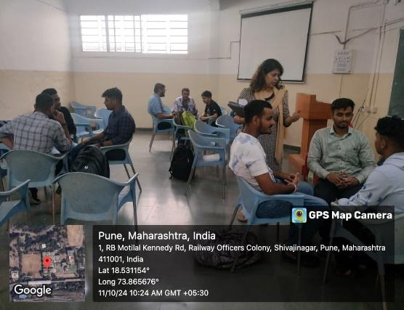
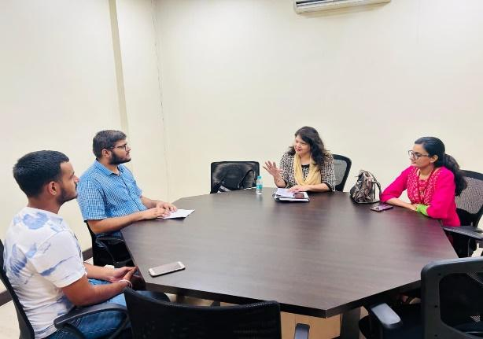

RESEARCH CONTRIBUTION

4.1 FUNDED RESEARCH PROJECT -
Term One
S N | Principal Investigator | Title of the Project | Amount Received (Rs) | Funding Agency
1 | Dr. A V Mohod | Eco-friendly Detergent synthesis at Rural Area based Natural Resources | Rs 50000 | Unnat Bharat Abhiyan (UBA), Ministry of Finance Department of Expenditure

Term Two
S N | Principal Investigator | Title of the Project | Amount Received (Rs) | Funding Agency
1 | Dr. A V Mohod  Dr. S R Varade  Mrs. K N Bawankar | Sustainable green product development from Hermitia illucens Black Soldier | 1.52 Crore  Proposed | DST SUNIL
2 | Dr. M B Mane | Sustainable Development for removal of pathogenic bacteria by integrating advanced technologies with Indian Knowledgebase | 25 Lakh  Proposed | Indian Council of Social Science Research
3 | Dr. S Sharma  Dr. M Y Naniwadekar | Selective recovery of Lithium metal ion from spent lithium ion batteries | 10 Lakh Proposed | National Science and Technology Management Information System

FUNDING RECEIVED FOR ANY OTHER ACTIVITY
Term One
S N | Faculty Coordinator | Title of the activity | Amount Received (Rs) | Funding Agency
1 | Mr. P M Warke | Competition on Indian Standards on Centrifugal Pump | Rs. 40652/- | BIS
2 | Mr. P M Warke | Quality Walk event | All expenses of kits and snacks along with program organized 600 + participants | BIS Pune branch

Term Two
S N | Faculty Coordinator | Title of the activity | Amount Received (Rs) | Funding Agency
1 | Mr. P M Warke | ‘Standards Carnival’ | Rs. 40000/- | BIS Pune branch
2 | Mr. P M Warke | Competition on Indian Standards on Detergents | Rs. 51116 | BIS

4.2 TESTING AND CONSULTANCY NIL
Term One
Sr. No. | Faculty Coordinator | Details of Testing & Consultancy Conducted | Total Revenue Generated (Rs.)

Term Two
Sr. No. | Faculty Coordinator | Details of Testing & Consultancy Conducted | Total Revenue Generated (Rs.)

4.3 PATENTS, COPYRIGHT, TRADEMARK AND OTHER (IPR)
Term One
Sr No. | Name of Faculty | Name of the Patent | Patent Number and Date | Type (National/  International/Com  mercialized)
01 | Dr. A V Mohod | Shell and tube photocatalytic reactor for efficient rhodamine B degradation in wastewater treatment | 202421080882 A | National

Term Two
Sr No. | Name of Faculty | Name of the Patent | Patent Number and Date | Type (National/  International/  Commercialized)
01 | Dr M Y Naniwadekar | Smart Plastic Waste Management Device | 395856-001  23/09/2023 | National
TOTAL PATENTS DETAILS OF THE DEPARTMENT
Sr. No. | Faculty Coordinator | Title of patent | Status
 |  |  | Date of Filing | Date of Publication / Grant | National / International
01 | Dr M Y Naniwadekar | Smart Plastic Waste Management Device | 01.03.2023 | 23.09.  2023 | International
02 | Dr. A V Mohod | Shell and tube photocatalytic reactor for efficient rhodamine B degradation in wastewater treatment |  |  | International

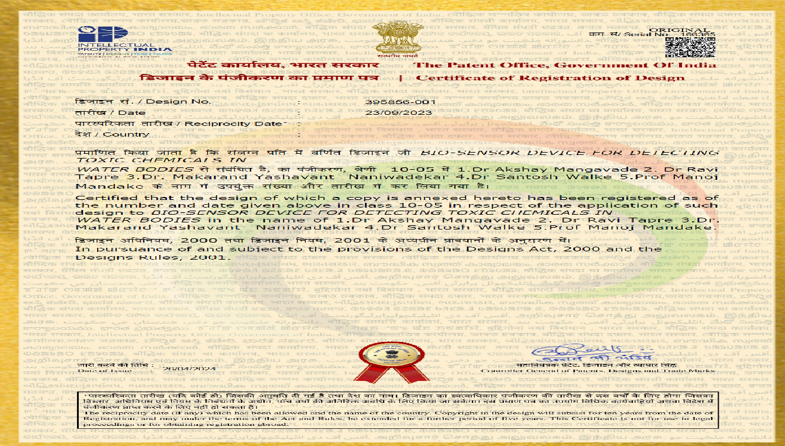
TOTAL COPYRIGHT DETAILS OF THE DEPARTMENT
Sr. No. | Faculty Coordinator | Title of copyright | Status
 |  |  | Date of Filing | Date of Publication / Grant

PUBLICATIONS
4.4 PAPERS PUBLISHED/ PRESENTED IN PROCEEDINGS OF CONFERENCES
Term One
S. No | Authors | Document Details | Year | Conference Details | ISBN | Organized  by
1 | A S Jadhav ,  S Sharma | Evaluating the impact of UV treatment on water quality: A focus on TDS, Hardness, Chlorine content and COD | 9th April 2025 | National Conference on Innovation in Engineering and Technology (NCIET) |  | AISSMSCOE, Pune

Term Two
S. No | Authors | Document Details | Year | Conference Details | ISBN | Organized  by
1 | Dr. A V Mohod | Hermetia  illucens biofactory: from waste to high value technological products | 31.01.2025 | Progetto HI-Tech: “Hermetia illucens biofactory: from waste to high value technological products | NA | University  Of Turin,  Italy
2 | Dr. A V Mohod | Advances in wastewater treatment for the textile industry | 16.01.2025 | 4th International Conference CNR-STIIMA | NA | Biella, Italy

4.5 PAPERS PUBLISHED IN JOURNALS
Term One
S. No | Authors | Document Details | Year | Source Details | ISBN/  ISSN | Publisher
01 | AS Jadhav,  R Nalawade | Tests for Evaluating the Efficacy of Phosphoric Acid Activated Charcoals from Two Biomasses, | Jan 2024 | Nature Environment and Pollution Technology | 2395-3454 (Online). | Technoscience Publication
02 | M V Bagal, B A Nandgawle, R V Thosar, A V Mohod, P R Gogate | Degradation of pesticides using hybrid processes based on cavitation and photo catalysis: A Review | Jan 2025 | Environmental Quality Management | ISSN 1520-6483 | Elesvier
03 | A Mohod, D Clemente, N Klanovicz, P Moreira, M Bagal, A Teixeira, R Giudici | Doehlert matrix-based optimization of degradation of Rhodamine B in a swirling flow photocatalytic reactor operated in circulation mode | Oct 2025 | Brazilian Journal of Chemical Engineering | ISSN 0104-6632 | Elesvier
04 | MV Bagal, V Rajan, S Shinde, BV Banerjee, V Gole, AV Mohod | Degradation of azo dyes using hydrodynamic cavitation and external oxidants |  | Advances in Environmental Technology, | ISSN 17443563 | Elesvier
05 | M Bagal, V Mane, H Ambulkar, B Gawande, M Naniwadekar, K Bawankar, P Dange, A V Mohod, P Gogate | Degradation of rhodamine dye using a modified flow photocatalytic reactor in the presence of external oxidants | 30.10.2024 | The Canadian J of Chemical Engg | ISSN 1939-019X | Wiley Online Librrary
06 | Alessia Di Pasquale, Marina Zoccola, Ashish Mohod, Giulia Dalla Fontana, Anastasia Anceschi, Sara Dalle Vacche | Bioplastics Production from Proteins Extracted from the Black Soldier Fly, | Dec 2024 | Waste to Technological Products | ISSN 2073-4360 | Elesvier
07 | S. Chougule, S. Sharma, H. Bhave, R. Kundiya, and J. Bhat | Development of cashew nutshell based composite material and heat absorber panel: a comprehensive review | Nov 2024 | Bulgarian Chemical Communications |  | Elesvier
08 | T Pessanha, S Varade, A Salonen, D Langevin |  |  | Langmuir |  | Elesvier
09 | Requier A, Varade S, Galvani N, Pasquet M, Cohen Addad S, Gehin Delval C, Höhler R, Pitois O, Rio E, Salonen A, Langevin D | Wet foam coarsening: More than film permeability |  | J Colloid Interface Sci. |  | Elesvier

Term Two
S. No | Authors | Document Details | Year | Source Details | ISBN/  ISSN | Publisher
01 | HB Chaitanya S Kulkarni, Makarand Y Naniwadekar, Yuldasheva M Mirzaxmatovna | Enhanced Ubiquitous system architecture for securing healthcare IoT using efficient authentication and encryption | March 2024 | International Journal of avitation and Data Science and Analytics, (2024) 11 | ISSN 2319-7064 | Springer
02 | Requier A, Varade S, Galvani N, Pasquet M, Cohen Addad S, Gehin Delval C, Höhler R, Pitois O, Rio E, Salonen A, Langevin | Wet foam coarsening: More than film permeability. | Feb 2025 | Colloid Interface Sci. | ISSN: 1095-7103. | Elesvier
03 | Makarand Naniwadekar, Santosh Walke, Manoj Madake, Ravi Tapre | A comprehensive study of performance metrices and potato dehydration at various slice  thickness using an IoT–based indirect solar dryer: An experimental approach, Solar Energy | 09.01.2025 | Solar Energy | ISSN: 0038–092X | International Solar Energy Society®
04 | Santosh Walke, Manoj Mandake, Makarand Naniwadekar, Ravi Tapre | Dehydration of Onion Slices for Food Processing Application Using Internet of Things–Based Smart Solar Drying System | Feb. 2025 | ASME Journal of Solar Engineering | ISSN 1528–8986 | Elsevier
05 | Tejas Velapure, Makarand Naniwadekar, Prashant Warke | Pharmaceutical Waste Water Treatment by Advanced Oxidation Processes | June 2025 | Journal of Technology | ISSN 1012–3407 | University of Taiwan
06 | Santosh Walke, Manoj Mandake, Makarand Naniwadekar | Review study of e–waste management and resource recovery system for controlling environmental pollution, | 04.06.2025 | International Journal of Environment and Waste Management | ISSN 1478–9868 | Inderscience
07 | A S Jadhav, R D Nalwade, A Kadam | Study of Influence of Carbonized Temperature on Surface Morphology of Grape Stalk, | Oct 2024 | ALOCHANA JOURNAL | ISSN:2231-6329 | Rajkamal Prakashan (P) LTD
08 | A S Jadhav, R D Nalwade, D P Gaikwad | Microbial production of green polymer xanthan gum from xanthomonas campestris | Jan 2025 | Biochemical and cellular archives | ISSN: 0972-5075 | Chief Editor: PROF. (DR.) P. R. YADAV.
09 | A S Jadhav, R D Nalwade, D P Gaikwad | Effective Teaching and Learning Practices: Strategies for Academic Success and Student Engagement | Feb 2025 | Meerayan | ISSN:2455-6033 | Meera Smriti Sansthan.
10 | A S Jadhav, R D Nalwade, D P Gaikwad | Modification in Strength Parameter (CBR) of Sub-Grade Soil with Addition of Fly Ash, | Jan 2025 | International Journal of Advanced Science  Computing and Engineering | SSN / E-ISSN, 2714-7533. | Society of Visual Informatics (SOTVI)  Indonesia
11 | A S Jadhav, R D Nalwade, D P Gaikwad | Adsorption Study of Rhodium B on activated Carbon derived from coconut leaves | Jan 2025 | International Research Journal of Biotechnology | ISSN 2141-5153 | Interes Journals

4.6 BOOK / ARTICLE PUBLICATIONS -NIL
Term One
Author | Title of the Book | Published by | ISBN | Year

Term Two
Author | Title of the Book | Published by | ISBN | Year

4.7 RESEARCH CITATIONS (Source of Data: Google scholar) (As on 30th May)
Name of faculty | Citations, h-index, i10 index | Name of faculty | Citations, h-index, i10 index
Dr. A V Mohod | 1093 | Dr S Sharma | 37
Dr MY Naniwadekar | 80 | Dr S R Varade | 248
Dr S B Ghugare | 235 | Dr MB Mane | 157
Dr P N Dange | 106 | Prof K N Bawankar | 106
Total Citations of Department: 2062

4.8 ME AWARDED
Sr No | Name of Supervisor | Title of Thesis | Name of Candidate
01 | Dr M Y Naniwadekar | Epoxidation of Jatropa Oil | Ms Twinkle Zade
02 | Dr S B Gughare | Claasification of Regional COALS Using Unsupervised Cluterig Methods | Rehan Sheikh
 |  | Claasification of Regional COALS Using Unsupervised Cluterig Methods | Mohammed Raihan
03 | Dr S B Gughare | Computational Study of Dynamics of Droplets | Suraj Divekar

4.9 Ph.D. GUIDE DETAILS -
Name of Faculty who are PhD Supervisor | Number of Scholars Registered
Dr P N Dange | 03

4.10 PhD AWARDED (For departments having Ph.D. research centers)

Sr No | Name of Supervisor | Title of Thesis | Name of Candidate

INTERACTION WITH INDUSTRY

5.1 INDUSTRY VISITS ORGANISED
TERM -I

Sr. No. | Name of the Industry | Faculty Coordinator | Class (No. of Students) | Date
1 | Katraj Dairy Ltd, Katraj, Pune | Dr. A S Jadhav | TE and BE Chemical (29) | 22/08/2024
2 | Arista Chemicals Ltd, Lonand, Satara | Dr. A S Jadhav | TE Chemical (41) | 28/08/2024
3 | Magnesia Chemicals Ltd, Lonand, Satara | Dr. A S Jadhav | TE Chemical (41) | 28/08/2024
4 | Attaquant Enterprises Pvt Ltd, Alandi Bypass Road, Ghat No 138, Near Grow Well Company, Post Dhanore, Tal Khed, Pune, MH – 412105 | Dr. A S Jadhav | SE Chemical (47) | 04/09/2024
5 | Kani Overseas Corporation, Satara | Dr. A S Jadhav | SE and TE Chemical (58) | 28/09/2024
6 | Sewage Treatment Plant, Baner, Pune | Mrs. Kanchan Bawankar | TE and BE Chemical (25) | 15/10/2024
7 | Baner Pune Municipal Corporation Water Treatment Plant, Baner, Pune | Dr. M B Mane | BE Chemical (21) | 21/10/2024

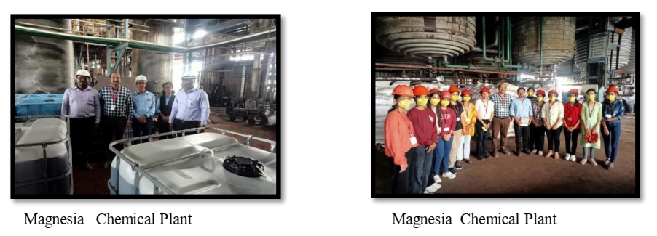
ARISTA Chemical Ltd Lonand , Satara

Term Two
Sr. No. | Faculty Coordinator | Class and Number of students attended | Industry Name and Address | Date of visit
1 | Dr A S Jadhav  Dr S Sharma | 30 | Clean Earth Energy Solution India Pvt. Ltd. | 14/02/2025
2 | Dr A S Jadhav  Dr S Sharma | 35 | Online Industrial Visit of Sudarshan Chemical | 04/04/2025
3 | Dr A S Jadhav  Dr S Sharma | 40 | Vikson Glory Chemicals Pvt. Ltd., Taswade, Karad | 01/02/ 2025
4 | Mr. P M Warke | (30) Standards Club members only | Garware Technical Fibres Ltd., Wai | 05/03/2025

Glimpses of Visit Conducted
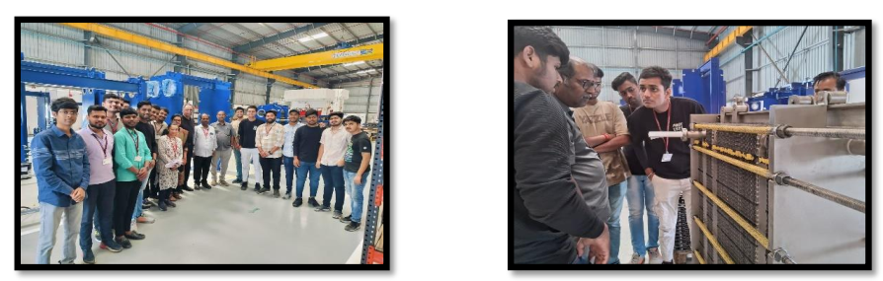
Clean Earth Energy Solution India Pvt. Ltd.
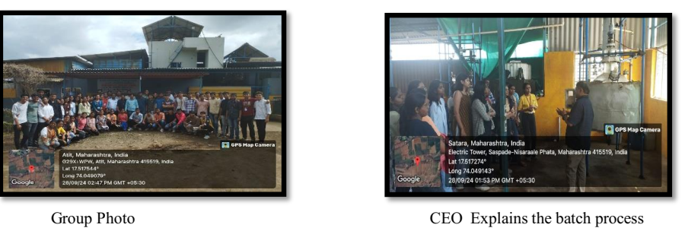
KANI OVERSEAS corporation, SATARA
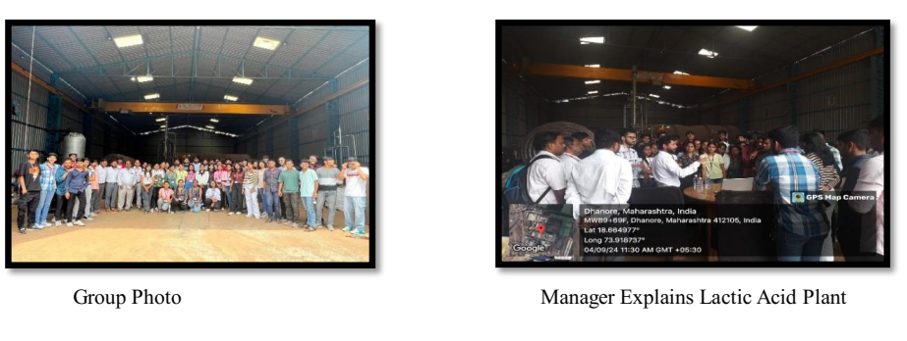
ATTAQUANT Enterprises Pvt Ltd, Alandi ,Pune
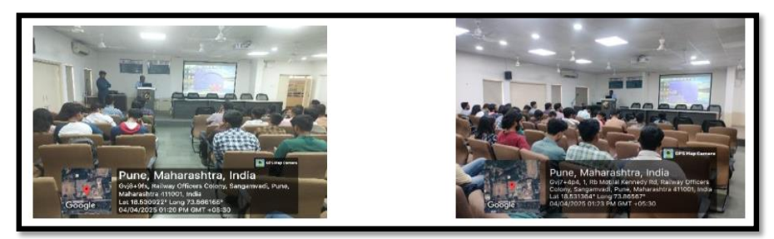
Online Industrial Visit of Sudarshan Chemical Ltd
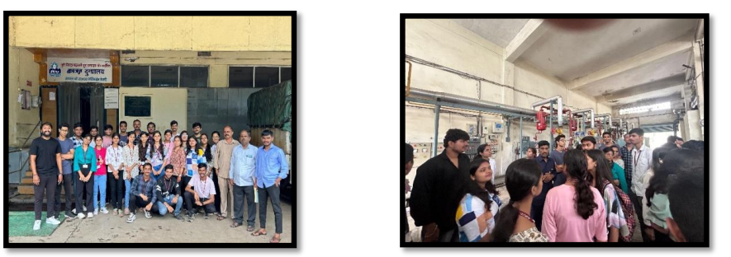
Katraj Diary Ltd Pune

5.2 EXPERT LECTURES / WEBINARS DELIVERED BY INDUSTRY EXPERTS

Expert Lectures Organized: AY 2024-25
TERM –I

Sr No | Name of Speaker | Name of Company | Date of Lecture | Topic
1 | Chandrakant Mohikar | Independent Consultant for Oil, Gas and Energy Industry | 14-08-2024 | Fluid Moving Machinery for Oil and Gas Industry
2 | Dr. Vinay M. Bhandari | CSIR-National Chemical Laboratory, Pune-411008 | 30-09-2024 | Integrating Science and Engineering for Sustainable Developments in Water and Wastewater Treatment
3 | Mr. Pramod Deshmukh | Asian Professional Training Centre, Pune | 02-10-2024 | Chemical Engineering Design
4 | Mr. Pramod Deshmukh | Asian Professional Training Centre, Pune | 02-10-2024 | Importance of Engineering Material
5 | Mr. Kailash Tarde | Sai Energy Services | 19-10-2024 | Energy Management in Chemical Industries
6 | Mr. Kailash Tarde | Sai Energy Services | 19-10-2024 | Energy Efficiency Study in Industrial Utilities
7 | Dr. Pankaj Nandlal Patil | Praj Industries Ltd Pune | 20-10-2024 | Industrial Wastewater Treatment
8 | Mr. Bhushan Thakare | Cyient Engineering Services & Design, Mumbai | 21-10-2024 | Process Control in Oil and Gas Industries

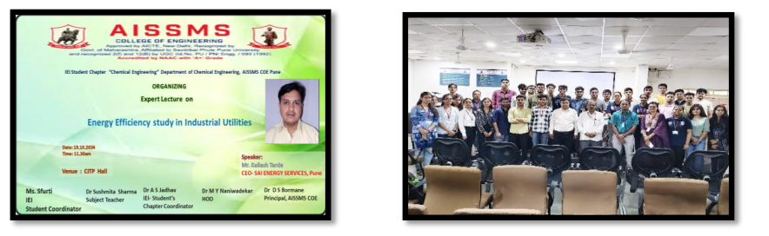

Guest lecture on topic “Energy efficiency study in Industrial utilities” ”On 19.10.2024 .Mr
Kailash Tarde CEO Sai Energy Services, Pune,
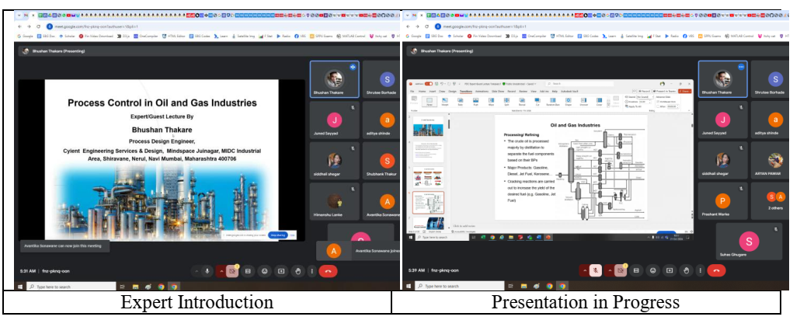
Expert lecture on topic “Process Control in Oil and Gas Industries” ”On October 21, 2024.Mr Bhushan Thakare Cyient Technology Navi Mumbai

Expert Lectures Organized: AY 2024-25
TERM -II

Sr No | Name of Speaker | Name of Company | Date of Lecture | Topic
1 | Dr. Pankaj Nandlal Patil | Praj Industries Ltd. Pune | 26-04-2025 | Heat Exchanger Design
2 | Mr. Piyush P. Kshirsagar | Inotek Technologies Pvt. Ltd., Thane | 26-04-2025 | Process Safety in Pharmaceutical Industries
3 | R. Banerjee | IMS Learning Resources Pvt. Ltd | 21-01-2025 | Study Abroad Seminar

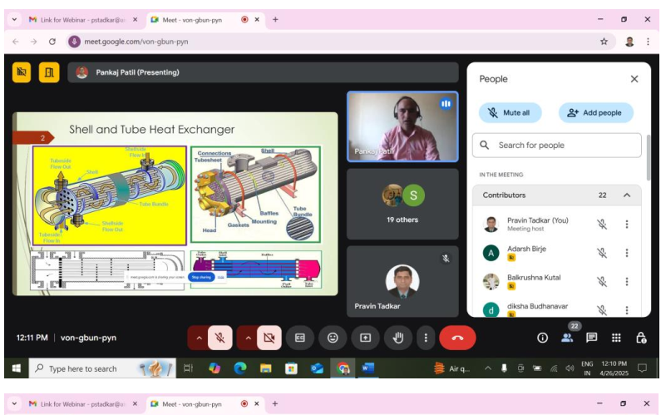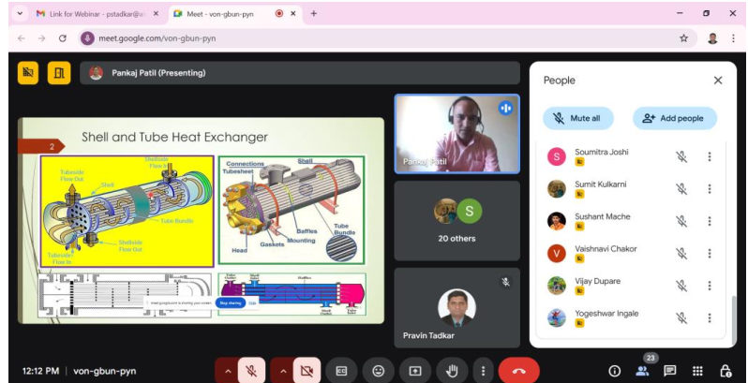
Expert lecture on topic “Heat Exchanger Design” conducted on 26-04-2025 by
Dr Pankaj N Patil Praj Industries Ltd. Pune
5.3 INDUSTRY – SPONSORED PROJECTS (UG/PG) ((Excluding Sandwich Projects)
Sr. No. | Name of Project guide | Title of Industry Sponsored Project | Name of Sponsoring Industry

5.4 MOU SIGNED WITH INDUSTRY
Term One
Sr. No. | Faculty Coordinator | Name of Industry | Date  of MoU Signed | Valid upto  (00/00/0000)
1 | Dr M Y Naaniwadekar | Reva Process Technologies, Pune | 2021 | 2031
2 | Dr A S Jadhav | Concept Development Centre, Pune | 2023 | 2033
3 | Mr. P C Walke | SERVEINDIA, Pune | 2023 | 2026
4 | Mr. P C Walke | Ethix Water Conditioner, Pune | 2023 | 2028

Term Two
Sr. No. | Faculty Coordinator | Name of Industry | Date  of MoU Signed | Valid upto  (00/00/0000)
1 | Mr. P C Walke | Shreeji Aquatreatment Pvt Ltd., Pune | 2024 | 2027
2 | Dr. A V Mohod | LiqSure Systems Pvt. Ltd., IIT Hyderabad campus | 2024 | 2026
3 | Mr. P C Walke | Super Aqua Services, Pune | 2023 | 2026

TOTAL FUNCTIONAL / LIVE MOU INITIATED BY THE DEPARTMENT
Sr. No. | Faculty Coordinator | Name of Industry | Date  of MoU Signed | Valid upto  (00/00/0000)
1 | Prof. P. M. Warke | BIS | 04/05/2022 | Continued till with collaboration with BIS
1 | Mr. P C Walke | Super Aqua Services, Pune | 2023 | 2026
2 | Dr M Y Naaniwadekar | Reva Process Technologies, Pune | 2021 | 2031
3 | Mr. P C Walke | Ethix Water Conditioner, Pune | 2023 | 2028

5.5 FACULTY MEMBERS UNDERGONE INDUSTRIAL TRAINING
Term One
Sr. No. | Name of Faculty | Name of Industry | Dates and Duration
1 | Mr P S Tadkar | Naidu Sewage Treatment Plant | 05/12/2024 to 19/12/2024 (15 Days)

Term Two
Sr. No. | Name of Faculty | Name of Industry | Dates and Duration

5.6 STUDENTS UNDERGONE IN-PLANT TRAINING AND (OR) INTERNSHIP PROGRAMME (Excluding Sandwich Training)

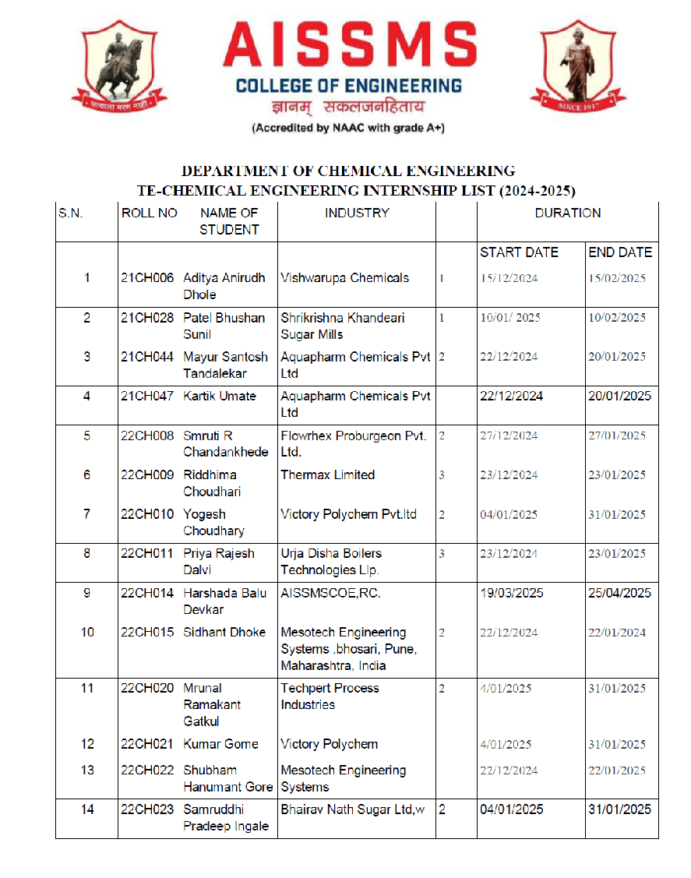

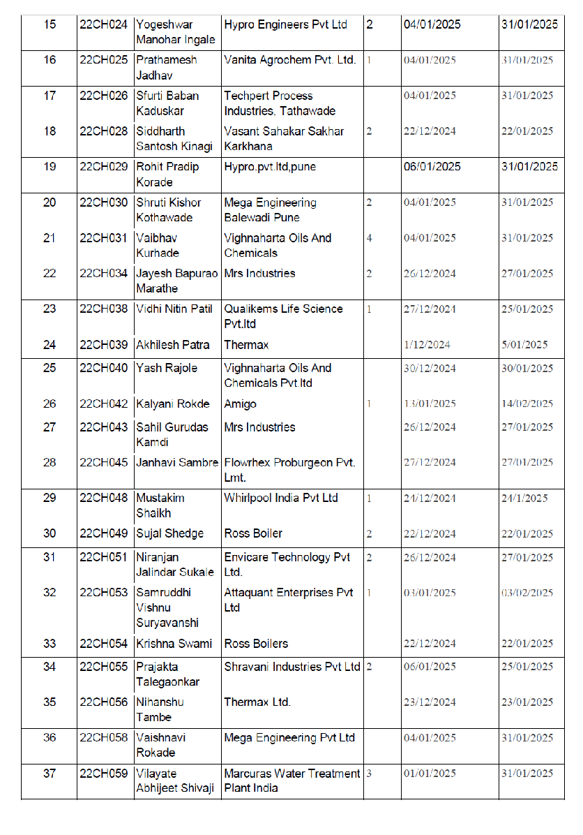

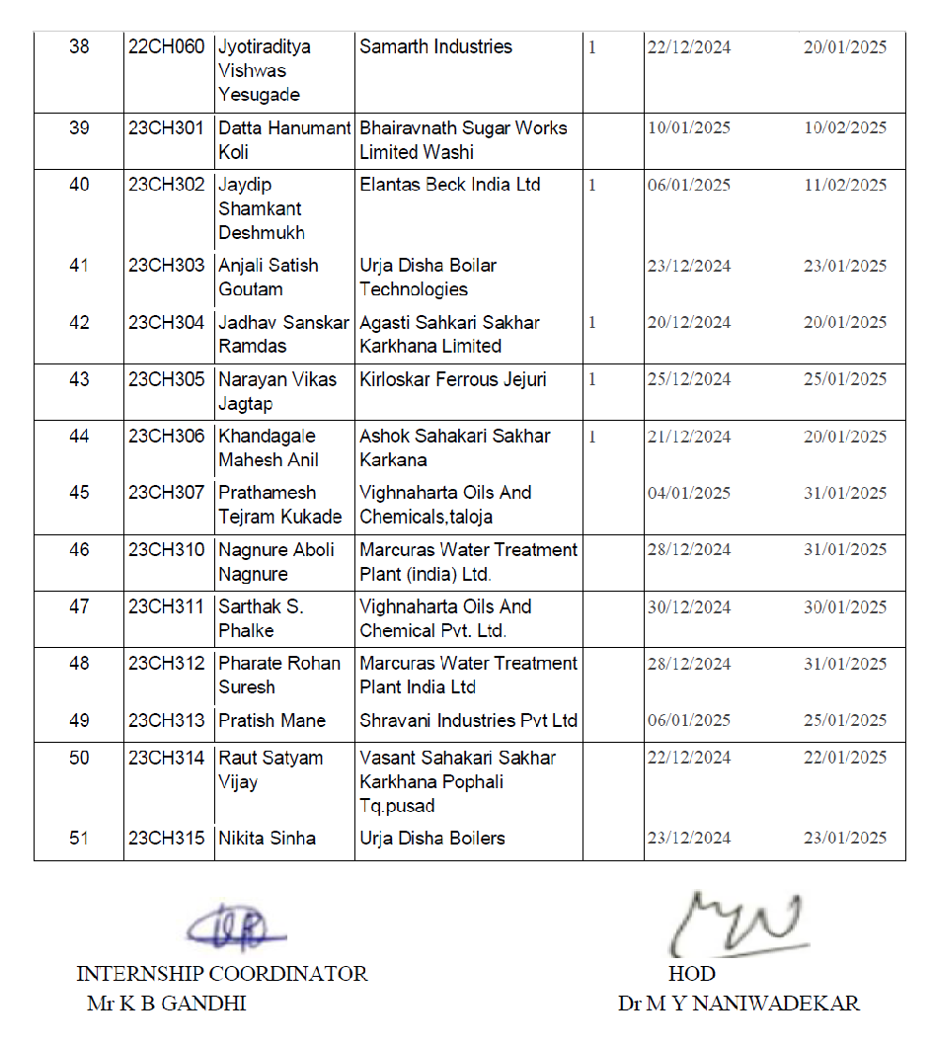

5.7 LIST OF INDUSTRIES SUPPORTED IN THE ORGANISATION OF WORKSHOPS/SEMINARS/WEBINARS/CONFERENCES/COURSES AND ANY OTHER CONTRIBUTION OF INDUSTRY
Term One
Sr.  No. | Faculty Coordinators | Industry Representative and Name of Industry | Nature of Contribution
1 | Mr. P M Warke | 1) Reliance Industries Ltd., Mumbai 2) Ultra Tech Cement Ltd., Pune 3) Worley India, Mumbai & Pune for BE Computer  4) Thermax Ltd., Pune  5) FluiDimensions, Baner 6) Neologic Engineers Pvt. Ltd., Balewadi  7) Innomatics Research Lab., Pune  8) Worley Consulting, Navi Mumbai for 2025 batch  9) Meta Engitech, Sanaswadi  10) RayChem. RPG Ltd, Chakan  11) SAR Chem.Tech. Solutions  12) Liqsure Systems, Solapur | Placement of Students & relocation of Alumni from various streams
 | Mr. P M Warke | 1) Ross Boilers, Kindhwa (03 students)  2) Thermax Ltd., Chinchwad (03 students)  3) Hypro Engineers, Pirangut (02 students)  4) Victory Polychem, Pirangut (02 students)  5) Urja Disha Boilers Technologies, Pimpri (03 students)  6) Mesotech Engineering Systems, Bhosari (02 students)  7) Techpert Process Industries, Wakad (02 students)  8) Elantas Beck India Ltd., Pimpri (01 student)  9) Mega Engineering Ltd., Balewadi (02 students)  10) Shravani Chemicals, Dhayari (03 students)  11) Marcuras Water Treatment, Bhosari (03 students)  12) Techniche Engineering Pvt. Ltd., Dhayari (03 students could not cleared interview to seek internship) | In- Plant Training for 26 number of TE Chemical students

Term Two
Sr.  No. | Faculty Coordinators | Industry Representative and Name of Industry | Nature of Contribution
1 | Mr. P M Warke | - Arya Engineers and Contractors Pvt. Ltd., Pune  2. Engie India, Pune  3. CH Four Energy Solutions, Pune  4. EngiTech Metamorphosis, Pune  5. Synergy Process Systems, Pune  6. Mega Engineering, Pune 7. Techniche Engineering, Pune  8. Privi Specialty Chemicals Ltd., Mahad  9. Prismane Consulting, Pune  10 Envicare, Pune  11. Tata Autocomp Ltd., Pune | Placement of Students & relocation of Alumni from various streams

5.8 TRAINING TO INDUSTRY PERSONNEL/ ACTIVITY SUPPORTING TO INDUSTRY
Term One
Sr. No. | Faculty Coordinator | Technical Area in which Training Provided / Type of Support | Industry Name

Term Two
Sr. No. | Faculty Coordinator | Technical Area in which Training Provided / Type of Support | Industry Name

5.9 ANY OTHER ACTIVITIES TO PROMOTE INTERACTION WITH INDUSTRY
Term One
Sr. No. | Faculty coordinator | Name of Activity | Remark

Term Two
Sr. No. | Faculty coordinator | Name of Activity | Remark

5.10 STUDENTS UNDERGONE SANDWICH TRAINING (For Mechanical & Production departments) NA
Term One
Sr No | Name of student | Industry | Sr No | Name of student | Industry

Term Two
Sr No | Name of student | Industry | Sr No | Name of student | Industry

STUDENTS’ ACHIEVEMENTS

6.1 STUDENTS’ ACHIEVMENT (Professional) (Individual Level) (Technical activities such as design competitions, paper presentation, technical quiz, Product development, innovation, etc.)
Students' achievement (AY 2024-25)

Sr.  No. | Name of Student/  Students | Event Name | Event Organised by | Prize/Rank  /Achievement
1 | Shrutee Borhade | Circular  Economy for  Sustainable  Development | IEI | Best Paper
2 | Siddhali Shegar | Publication of Patent
3 | Siddhali Shegar | Publication of Patent
4 | Siddhali Shegar | Publication of Paper
5 | Shrutee Borhade | Standard Based TvS Hunt  Indian  Standards for  Centrifugal  Pump | Standards Club  AISSMS COE and BIS | First
6 | Kanak Oswal | Standard Based TvS Hunt  Indian  Standards for  Centrifugal  Pump | Standards Club  AISSMS COE and BIS | First
7 | Siddhali Shegar | Standard Based TvS Hunt  Indian  Standards for  Centrifugal  Pump | Standards Club  AISSMS COE and BIS | First
8 | Pritesh Gole | Standard Based TvS Hunt | Standards Club  AISSMS COE and | First

 |  | Indian  Standards for  Centrifugal  Pump | BIS
9 | Om Surana | Standard Based TvS Hunt  Indian  Standards for  Centrifugal  Pump | Standards Club  AISSMS COE and BIS | Second
10 | Kunal Hirave | Standard Based TvS Hunt  Indian  Standards for  Centrifugal  Pump | Standards Club  AISSMS COE and BIS | Second
11 | Shruti Kothawade | Standard Based TvS Hunt  Indian  Standards for  Centrifugal  Pump | Standards Club  AISSMS COE and BIS | Third
12 | Vaishnavi Rokade | Standard Based TvS Hunt  Indian  Standards for  Centrifugal  Pump | Standards Club  AISSMS COE and BIS | Third
13 | Yogeshwar Ingale | Standard Based TvS Hunt  Indian  Standards for  Centrifugal  Pump | Standards Club  AISSMS COE and BIS | Third
14 | Rohit Korade | Standard Based TvS Hunt  Indian  Standards for  Centrifugal Pump | Standards Club  AISSMS COE and BIS | Third

15 | Samruddhi Suryawanshi | Chemcon 2024 | IIChE | Participated
16 | SfurtiKaduskar | Chemcon 2024 | IIChE | Participated
17 | Shruti Kothwade | Chemcon 2024 | IIChE | Participated
18 | Vaishnavi Rokade | Chemcon 2024 | IIChE | Participated
19 | Mrunal Gatkul | Chemcon 2024 | IIChE | Participated
20 | Kalyani Rokade | Chemcon 2024 | IIChE | Participated
21 | Kumar Gome | Chemcon 2024 | IIChE | Participated
22 | Prathamesh Jadhav | Chemcon 2024 | IIChE | Participated
23 | Yogesh Choudhary | Chemcon 2024 | IIChE | Participated
24 | Rohit Korade | Chemcon 2024 | IIChE | Participated
25 | Vaibhav Kurhade | Chemcon 2024 | IIChE | Participated
26 | Prathamesh Kukade | Chemcon 2024 | IIChE | Participated
27 | Datta Koli | Chemcon 2024 | IIChE | Participated
28 | Yogeshwar Ingale | Chemcon 2024 | IIChE | Participated
29 | Siddhali Shegar | Circular  Economy for  Sustainable  Development | IEI | Participated
30 | Adarsh Birje | Circular  Economy for  Sustainable  Development | IEI | Participated

6.2 STUDENTS’ ACHIEVMENTS (other than Professional) (Individual Level) (Social activities, etc.)
Term One
Name of Student | Details of Achievement (State/University/ National/International Level) | Remark  ((Domain)
Shubham Gore | Participated in Natioal Integration camp By government of India at Jalgoan. | Social Activity
Sfurti Kadhuskar | Second Prize in Essay Writing by State level competition at pune(Organized by NSS) | Social Activity

Term Two
Name of Student | Details of Achievement (State/University/ National/International Level) | Remark  ((Domain)

  - CERTIFICATE / ONLINE COURSES COMPLETED BY STUDENTS (Certificate courses, value added courses, MOOC, etc.)

TERM I
S N | Name of Student | Title of the Course | Conducted By | Duration/ Dates
1 | BIRADAR POONAM PRASHANT | MS-CIT | Other | Jul-Dec-2024
2 | PAWAR ARYAN SANTOSH | Career Essentials in System Administration by Microsoft and LinkedIn,Introduction to Artificial Intelligence,Build Your Own GPTs | LinkedIn Learning | Jul-Dec-2024
3 | SHINDE ADITYA BABASAHEB | Heat exchanger: Design, operation and maintenancenancenance | UDEMY | Jul-Dec-2024
4 | VANZARE SHIYA RAJU | Excel Bootcamp | Let's upgrade | Jul-Dec-2024
5 | https://drive.google.com/open?id=1r5YE1DCTzDNOc1DBgvahoDzD_VxZSMCt | Aspen Plus V 11 Masterclass :From begineer to advanced user | UDEMY | Jul-Dec-2024
6 | HALBURGE OM ANANTKUMAR | Aspen Plus V 11 Masterclass: From begineer to advanced user | UDEMY | Jul-Dec-2024
7 | SHRUTEE JAGDISH BORHADE | Process engineering | UDEMY | Jul-Dec-2024
8 | GOLE PRITESH VIJAY | Aspen Plus V11 Masterclass: From Beginner to advanced user | UDEMY | Jul-Dec-2024
9 | LANKE HIMANSHU RAJESH | SOLIDWORKS Beginner to Intermediate course | UDEMY | Jul-Dec-2024
10 | ATTIKERI ASMI SHANKAR | An Easy Introduction with applications with Ansys Workbench | UDEMY | Jul-Dec-2024
11 | IYENGAR SRIVATSAN ARAVAMUDAN | Aspen plus V11 Masterclass | UDEMY | Jul-Dec-2024
12 | DUMBRE SHRADDHA BHANUDAS | Aspen plus V11 masterclass : from beginner to advanced user | UDEMY | Jul-Dec-2024
13 | OSWAL KANAK RAKESH | Process/Chemical Engineering BOOTCAMP 2021 | Udemy | Jul-Dec-2024
14 | BIRADAR POONAM PRASHANT | AutoCAD for beginners CAD CAM tutorials | Cursa | Jul-Dec-2024
15 | SHEGAR SIDDHALI SANJAY | AutoCAD for beginners | Other | Jul-Dec-2024
16 | DAWARE RAJASHREE DHANANJAY | Aspen plus v11 masterclass | Udemy | Jul-Dec-2024
17 | THAKUR SHUBHANK KISHOR | Chemical process simulation | Udemy | Jul-Dec-2024
18 | KALGUDE DHIRAJ BAJIRAO | DWSIM Process Simulation: Mastering the Fundamentals | UDEMY | Jul-Dec-2024
19 | VANZARE SHIYA RAJU | Excel for beginners | Great learning | Jul-Dec-2024
20 | KHALADKAR AADESH SANJAY | Process/Chemical Engineering -Bootcamp 2011 | UDEMY | Jul-Dec-2024
21 | SURANA OM SANJAY | Process/Chemical engineering Bootcamp 2021 | Udemy | Jul-Dec-2024
22 | KARAD ADITYA HANUMANT | CHEMICAL SEFETY | Other ( ALISON) | Jul-Dec-2024
23 | RATHOD SANDESH RAJESH | Chemical Safety ; Process Safety Management | Other ( ALISON) | Jul-Dec-2024
24 | PANSARE ISHWARI KISHORKUMAR | Process/Chemical Engineering - Bootcamp | UDEMY | Jul-Dec-2024
25 | PAWAR PRANAV UMESH | Petroleum Refining - Complete Guide to Products & Processess | UDEMY | Jul-Dec-2024
26 | THAKUR VAIDIK YESHENDRA | HEAT EXCHANGERS : DESIGN, OPERATION AND MAINTENANCE | UDEMY | Jul-Dec-2024
27 | HIRAVE KUNAL PRABHAKAR | Process/Chemical Engineering- Bootcamp 2021 | UDEMY | Jul-Dec-2024
28 | SHELAR APURVA VISHNU | Process/chemical Engineering - Bootcamp 2021 | UDEMY | Jul-Dec-2024
29 | DESHMANE OMKAR PARMESHWAR | Process/Chemical Engineering - BOOTCAMP 2021 | UDEMY | Jul-Dec-2024
30 | SAYYAD JUNED ABDUL | Aspen Plus V11 Masterclass : From beginner to advanced user | UDEMY | Jul-Dec-2024
31 | THAWARE MAYUR PRAVIN | Aspen Plus V11 Masterclass : From beginner to advanced user | UDEMY | Jul-Dec-2024
32 | SALUNKE SANGRAM SUNIL | Aspen plus V11 | UDEMY | Jul-Dec-2024
33 | SONAWANE AVANTIKA GAUTAM | AutoCAD | Other | Jul-Dec-2024
34 | DALVI PRIYA RAJESH | Effective speaking: Master public speaking and presentation skills | UpGrad | Jul-Dec-2024
35 | GOME KUMAR VISHNU | Waste management and environmentalism in China | Open University | Jul-Dec-2024
36 | INGALE YOGESHWAR MANOHAR | Waste management and environmentalism inChina | The Open university | Jul-Dec-2024
37 | GOME KUMAR VISHNU | Food Waste Prevention | Swedish Environmental Protection Agency | Jul-Dec-2024
38 | INGALE YOGESHWAR MANOHAR | Food waste Prevention | Swedish Environmental Protection Agency | Jul-Dec-2024
39 | SWAMI KRISHNA DEVENDRA | Self Placed Traning Course | MATLAB Onramp | Jul-Dec-2024
40 | KINAGI SIDDHARTH SANTOSH | ASPEN PLUS | UDEMY | Jul-Dec-2024
41 | SWAMI KRISHNA DEVENDRA | Waste Management | The Open University | Jul-Dec-2024
42 | KORADE ROHIT PRADIP | waste management and environmentalism in china | open university | Jul-Dec-2024
43 | KORADE ROHIT PRADIP | Food Waste Prevention | Swedish Environmental Protection Agency | Jul-Dec-2024
44 | KOTHAWADE SHRUTI KISHOR | Master class of aspen plus | Udemy | Jul-Dec-2024
45 | CHOUDHARY YOGESH DUNGARAM | living with climate change and water management | unicef | Jul-Dec-2024
46 | VAISHNAVI ROKADE | Food waste prevention | Unitar | Jul-Dec-2024
47 | KADUSKAR SFURTI BABAN | Food Waste Prevention | Swedish Environmental Protection Agency | Jul-Dec-2024
48 | SURYAVANSHI SAMRUDDHI VISHNU | Matlab On Ramp | MathWorks Training Services | Jul-Dec-2024
49 | NAGNURE ABOLI RAJESH | Chemical Engineering Overview | Alison (Certificate was paid, Here is it's sample copy) | Jul-Dec-2024
50 | GATKUL MRUNAL RAMAKANT | Food Waste Prevention | Other | Jul-Dec-2024
51 | JADHAV SANSKAR RAMDAS | Model Deployment Using Heroku | Other | Jul-Dec-2024
52 | KHANDAGALE MAHESH ANIL | Introduction to machine learnings | Other | Jul-Dec-2024
53 | JADHAV SANSKAR RAMDAS | Heat exchanger types and applications | Alison | Jul-Dec-2024
54 | VILAYATE ABHIJEET SHIVAJI | Chemical Engineering Overview | ALISON EMPOWER YOURSELF | Jul-Dec-2024
55 | SRUSHTI JOSHI | Energy literacy training | Energy Swaraj Foundation | Jul-Dec-2024
56 | PHARATE ROHAN SURESH | Chemical engineering overview | Alison University | Jul-Dec-2024
57 | PRATISH MANE | Chemical Engineering Overview | Alison | Jul-Dec-2024
58 | TALEGAONKAR PRAJAKTA | Chemical Engineering Overview | Alison | Jul-Dec-2024
59 | RAUT SATYAM VIJAY | Waste Water treatment in PETROLEUM REFINERY ENGINEERING | IIChE | Jul-Dec-2024
60 | PATRA AKHILESH ARUN | FOSSE OpenFoam Cfd training | IITB-FOSSE | Jul-Dec-2024
61 | JAGTAP NARAYAN VIKAS | Introduction of machine learning | Great learning | Jul-Dec-2024
62 | RAJOLE YASH KAILASH | Fundamentals of auditing | Great Learning Academy | Jul-Dec-2024
63 | PHALKE SARTHAK SAINATH | Solar power conservation | Luminious | Jul-Dec-2024
64 | PATIL VIDHI NITIN | Fundamentals of auditing | Great learning academy | Jul-Dec-2024
65 | KURHADE VAIBHAV VINOD | Fundamentals in auditing | Great learning | Jul-Dec-2024
66 | KUKADE PRATHAMESH TEJRAM | Waste water treatment | Alison | Jul-Dec-2024
67 | UMATE KARTIK BHAURAO | Energy Swara Foundation | Online course | Jul-Dec-2024
68 | JADHAV PRATHAMESH SHYAM | Food Waste Prevention | Other | Jul-Dec-2024
69 | YESUGADE JYOTIRADITYA VISHWAS | Waste management and environmentalism in china | Open learn | Jul-Dec-2024
70 | YESUGADE JYOTIRADITYA VISHWAS | Waste management and environmentalasim in china | Open learn | Jul-Dec-2024
71 | SHEDGE SUJAL TUSHAR | Waste management and environmentalism in China | Open Learn | Jul-Dec-2024
72 | SHAIKH MUSTAKIM FARUK | Waste Management and environmentalism in China | Open Learn | Jul-Dec-2024
73 | TAMBE NIHANSHU YOGENDRA | Waste management | Other | Jul-Dec-2024
74 | CHOUDHARI RIDDHIMA NARESH | Waste management | Openlearn | Jul-Dec-2024
75 | KUKADE PRATHAMESH TEJRAM | Waste water treatment approach | EPCE | Jul-Dec-2024
76 | KUKADE PRATHAMESH TEJRAM | Waste water treatment | Asce | Jul-Dec-2024
77 | JADHAV SANSKAR RAMDAS | Waste Water Treatment | Other | Jul-Dec-2024
78 | JADHAO AYUSH VASANTA | Chemical Engineering Overview | Other | Jul-Dec-2024
79 | MACHE SUSHANT KISHOR | Chemical engineering overview | Alison | Jul-Dec-2024
80 | BODA SHREYA CHANDRAKANT | Process/Chemical Engineering-BOOTCAMP 2021 | UDEMY | Jul-Dec-2024
81 | BUDHNAVAR DIKSHA RAVSAHEB | Process or chemical engineering Boot camp | UDEMY | Jul-Dec-2024
82 | BHUNIA SUJIT BARENDRANATH | Principles of Chemical Processes-Mass and Energy Balance | UDEMY | Jul-Dec-2024
83 | BHOR SAYALI BHAGWAN | Water treatment and purification | Alison | Jul-Dec-2024
84 | PATIL NILAM RAMCHANDRA | Process Calculation/Chemical Engineering-BOOTCAMP | UDEMY | Jul-Dec-2024
85 | KULKARNI SUMIT SNEHAL | Energy Literacy | Energy Swaraj Foundation | Jul-Dec-2024
86 | KULKARNI SUMIT SNEHAL | Energy Literacy Training | Energy Swaraj Foundation | Jul-Dec-2024
87 | PAWAR KUNAL KAILAS | Chemical Engineering overview | Alison | Jul-Dec-2024
88 | PAWAR KUNAL KAILAS | Chemical Engineering Overview | Alison | Jul-Dec-2024
89 | WARE TANISHK SANTOSH | Chemistry AS Cambridge | UDEMY | Jul-Dec-2024
90 | LENGARE AJINKYA SHIVAJI | Group leadership skills for leaders | Mind Luster | Jul-Dec-2024
91 | PATIL SAYALI NANDKISHOR | PRINCIPALS OF CHEMICAL PROCESS | UDEMY | Jul-Dec-2024
92 | TAMBE NEHA SANDIP | Intro to fluid Mechanics | UDEMY | Jul-Dec-2024
93 | KUTAL BALKRUSHNA DNYANDEO | Chemical engineering overview | Alison | Jul-Dec-2024
94 | JAWADE SIDDHESH MILIND | The Coshh of risk assessor | Knights Safety Academy | Jul-Dec-2024
95 | KAKADE SOHAM VASANTRAO | THE COSHH RISK ASSESSOR | THE KNIGHTS OF SAFETY | Jul-Dec-2024
96 | SATYAM SURESH PASANGE | The COSHH Risk Assesso | THE KNIGHTS OF SAFETY | Jul-Dec-2024
97 | KUTAL BALKRUSHNA DNYANDEO | The COSHH Risk Assessor Certificate | Other | Jul-Dec-2024
98 | JADHAO AYUSH VASANTA | The COSHH Risk Assessor Certification™ | Other | Jul-Dec-2024
99 | GHUGE BHAVESH VASUDEV | The COSHH Risk Assessor | The knights of safety | Jul-Dec-2024
100 | DUPARE VIJAY VILAS | The coshh risk assessor certificate | UDEMY | Jul-Dec-2024
101 | JOSHI SOUMITRA MAHESH | The COSHH Risk Assessor | The KNIGHTS of SAFETY Academy | Jul-Dec-2024
102 | DEORE MAYURI DINESH | Chemical engineering | Other | Jul-Dec-2024
103 | GHADGE ADITYA PRAVIN | The COSHH Risk Assessor Certification | The Knights Of Safety | Jul-Dec-2024
104 | BHOSALE AMAR SANTOSH | COSHH Risk Assessor | THE KNIGHT OF SAFETY | Jul-Dec-2024
105 | BAGADE PRATIK MANOJKUMAR | The COSHH risk Assessor certification | THE KNIGHT OF SAFETY | Jul-Dec-2024
106 | MANE AKASH KAILAS | The COSHH Risk Assessor Certification | THE KNIGHTS OF SAFETY | Jul-Dec-2024
107 | AKHARE YOGESH DEVIDAS | Sustainability: Industry and Business Processes | Infosys Springboard | Jul-Dec-2024
108 | BODA SHREYA CHANDRAKANT | PROCESS/CHEMICAL ENGINEERING - BOOTCAMP 2021 | UDEMY | Jul-Dec-2024
109 | SHINDE VIJAY NAMDEO | Sustainability: industry and business process | Infosys springboard | Jul-Dec-2024
110 | DESHPANDE VARAD ANIL | COSHH Risk Assistor | Other | Jul-Dec-2024
111 | SHAH SEJAL HEMANTKUMAR | Overview of Industrial Chemical Reactors | Udemy | Jul-Dec-2024
112 | KARANDE SNEHA VIKAS | Water treatment and purification | Other - Alison | Jul-Dec-2024
113 | LONDHE VISHVAJEET VIJAY | Public Relations: Crisis Communications Oil and Gas Industry | UDEMY | Jul-Dec-2024
114 | AUTI PRIYANKA SANTOSH | Public Relations: Crisis Communications Oil and Gas Industry | UDEMY | Jul-Dec-2024
115 | AREKAR YOGESH VAIJNATH | Chemical Engineering Overview | Alison | Jul-Dec-2024
116 | KUTE HARIOM SANJAY | Chemical Engineering overview | Alison | Jul-Dec-2024
117 | CHAKOR VAISHNAVI KHANDERAO | Chemical engineering overview | Alison | Jul-Dec-2024
118 | KUTE HARIOM SANJAY | Chemical Engineering overview | Alison | Jul-Dec-2024
119 | NIMBALKAR CHAITANYA SANJAY | Chemical engineering | Alison | Jul-Dec-2024
120 | CHAVHAN SHIVA MANOHAR | Fundamental of Chemical Engineering | Alison | Jul-Dec-2024
121 | KOLPE ADITYA SOMNATH | Fundamental of chemical engineering | Alison | Jul-Dec-2024
122 | MURKUTE MAYANK SATISH | Fundamental Of Chemical Engineering | Alison | Jul-Dec-2024
123 | DESALE SIDDHI SANTOSH | Water treatment and purification | Others | Jul-Dec-2024
124 | GULVE SHRUTI SHIVKUMAR | Introduction to chemical engineering | UDEMY | Jul-Dec-2024
125 | DUDHE PIYUSH KRUPAL | Chemical engineering overview | Alison | Jul-Dec-2024
126 | SHRAVAN EKNATH PAKMODE | The COSHH Risk Assessor | The Knights of Safety | Jul-Dec-2024
127 | TAMBE NEHA SANDIP | Intro to fluid mechanics | UDEMY | Jul-Dec-2024
128 | BANGALE CHARU JAGANNATH | The coshh risk Assesor certification | Other | Jul-Dec-2024
129 | SHEDGE PRATHAMESH SANJAY | Chemical engg overview | Alison | Jul-Dec-2024
130 | DEVALEKAR PRANAY PRAMOD | The COSHH Risk Assessor Certification | THE KNIGHTS OF SAFETY | Jul-Dec-2024
131 | SHELKE ABHIJEET SANJAY | Chemical overview | Alison | Jul-Dec-2024
132 | ATOLE ADITYA MOHAN | The coshh risk accessor certification | The Knights of safety | Jul-Dec-2024
133 | GANGAN SHRAVANI UDAY | Emotional Intelligence in leadership for beginners | Mind Luster | Jul-Dec-2024
134 | SHEDGE PRATHAMESH SANJAY | Aspen plus | Udemy | Jul-Dec-2024
135 | SHELKE ABHIJEET SANJAY | COSHH Risk Assessor certificate | Knight saftey | Jul-Dec-2024
136 | KUTE HARIOM SANJAY | The COSHH Risk Assessor Certiícation™ | Other | Jul-Dec-2024
137 | DEORE MAYURI DINESH | Great learning | Other | Jul-Dec-2024
138 | AREKAR YOGESH VAIJNATH | COSHH Risk Assessor certificate | Knights safety | Jul-Dec-2024
139 | KSHITIJA DONGRE | Petroleum Refining | UDEMY | Jul-Dec-2024
140 | AMBEKAR HRUSHIKESH ANIL | COSHH Risk assessor | KNIGHTS OF SAFETY | Jul-Dec-2024
141 | MACHE SUSHANT KISHOR | COSHH Risk Assessor | Knight Saftey | Jul-Dec-2024
142 | BANGAR SURAJ LAXMAN | Leadership skills for leaders | Mind luster | Jul-Dec-2024
143 | MURKUTE MAYANK SATISH | Coshh | Knights safety | Jul-Dec-2024
144 | KOLPE ADITYA SOMNATH | COSHH RISK ASSESSOR | The Knight Of Safety | Jul-Dec-2024
145 | CHAVHAN SHIVA MANOHAR | COshh | Knight safety | Jul-Dec-2024
146 | DUDHE PIYUSH KRUPAL | COSHH Risk Assessor Certificate | Knight Safty | Jul-Dec-2024
147 | CHAKOR VAISHNAVI KHANDERAO | The COSHH Risk Assessor Certification | Other | Jul-Dec-2024
148 | NIMBALKAR CHAITANYA SANJAY | The coshh risk assessor | Knight safety | Jul-Dec-2024
149 | KANHERE MRUNAL MANOJ | THE COSH RISK ASSESSOR | Other | Jul-Dec-2024
150 | PANDIT AVANTIKA AVINASH | The COSHH Risk Assessor | Other | Jul-Dec-2024
151 | PAWAR KUNAL KAILAS | The COSHH Risk Assessor | KNIGHTS OF SAFETY™ | Jul-Dec-2024
152 | BHOR SAYALI BHAGWAN | Start modeling your first Chemical process with Aspen HYSYS | UDEMY | Jul-Dec-2024
153 | GARJE MUKUND MARUTI | Overview of Industrial chemical reactors | UDEMY | Jul-Dec-2024
154 | PAWAR SHREYAS VIKAS | Introduction to chemical engineering | Udemy | Jul-Dec-2024
155 | DESALE SIDDHI SANTOSH | Crisis communications oil and gas industry | Udemy | Jul-Dec-2024
156 | MORE DEEP YOGESH | Public relations: crisis communication oil and gas industry | UDEMY | Jul-Dec-2024
157 | KARANDE SNEHA VIKAS | The COSHH assessor certification | Other | Jul-Dec-2024
158 | NIRBHAVNE YASH SACHIN | Petroleum refining | Udemy | Jul-Dec-2024
159 | MORE ANIKET SUBHASH | Overview of Industrial chemical reactors | Udemy | Jul-Dec-2024
160 | SANTOSHI MARUTI SUTAR | Audit course | COSHH | Jul-Dec-2024
161 | UBALE DIKSHA SANTOSH | The COSHH risk assessor | COSHH | Jul-Dec-2024

TERM II
S N | Name of Student | Title of the Course | Conducted By | Duration/ Dates
1 | LANKE HIMANSHU RAJESH | Chemical Process Simulation using DWSIM, SCILAB & ChemSep. | Udemy | Jan-Jun-2025
2 | GOLE PRITESH VIJAY | Mastering ANSYS CFD from zero to expert | Sijal Ahmed | Jan-Jun-2025
3 | HALBURGE OM ANANTKUMAR | Petroleum Refining - complete guide to products and processes | Udemy | Jan-Jun-2025
4 | PAWAR PRANAV UMESH | PowerBI workshop Holder | OfficeMaster | Jan-Jun-2025
5 | KHALADKAR AADESH SANJAY | Aspen plus v11 Masterclass | Udemy | Jan-Jun-2025
6 | OSWAL KANAK RAKESH | Mastering Ansys Simulation | Udemy | Jan-Jun-2025
7 | HIRAVE KUNAL PRABHAKAR | Chemical Process Hazards Analysis with OSHA Safety Standards | Udemy | Jan-Jun-2025
8 | PANSARE ISHWARI KISHORKUMAR | Aspen v11 | Udemy | Jan-Jun-2025
9 | SURANA OM SANJAY | Aspen Plus V11 Masterclass : From beginner to advanced user | Udemy | Jan-Jun-2025
10 | SHELAR APURVA VISHNU | Petroleum Refining | Udemy | Jan-Jun-2025
11 | SHEGAR SIDDHALI SANJAY | Renewable energy | Cursa | Jan-Jun-2025
12 | NIMBARTE ANJALI MANOJ | Aspen plus b11 | Udemy | Jan-Jun-2025
13 | ATTIKERI ASMI SHANKAR | SAP Oil & Gas HPM Hydrocarbon Product | Udemy | Jan-Jun-2025
14 | IYENGAR SRIVATSAN ARAVAMUDAN | Matlab Onramp | Mathworks | Jan-Jun-2025
15 | SHRUTEE JAGDISH BORHADE | Tissue engineering | Alison | Jan-Jun-2025
16 | SAYYAD JUNED ABDUL | Engineering: environmental fluids | The Open University | Jan-Jun-2025
17 | SHRUTEE JAGDISH BORHADE | Tissue engineering | Alison | Jan-Jun-2025
18 | KALGUDE DHIRAJ BAJIRAO | MathWorks training service | matlab online | Jan-Jun-2025
19 | THAKUR VAIDIK YESHENDRA | Petroleum refining - Complete guide to products and processes | Chemical Engineering GUY | Jan-Jun-2025
20 | DESHMANE OMKAR PARMESHWAR | Non conventional source of energy, aspen plus v11 Master Plus: from beginner to advance | Tutorial points, udemy | Jan-Jun-2025
21 | DUMBRE SHRADDHA BHANUDAS | Water and wastewater | Mr. Prashant walke | Jan-Jun-2025
22 | THAKUR SHUBHANK KISHOR | Chemical process simulation using DWsim | Udemy | Jan-Jun-2025
23 | PAWAR ARYAN SANTOSH | Career Essentials in System Administration by Microsoft and LinkedIn | Microsoft and LinkedIn Learning | Jan-Jun-2025
24 | BIRADAR POONAM PRASHANT | AutoCAD | Alison | Jan-Jun-2025
25 | SALVE KAVERI SURESH | AutoCAD | Alison | Jan-Jun-2025
26 | SALVE KAVERI SURESH | AutoCAD | UDEMY | Jan-Jun-2025
27 | VANZARE SHIYA RAJU | Autocad | Allison | Jan-Jun-2025
28 | SHINDE ADITYA BABASAHEB | PROCESS DESIGN ENGINEERING | SB TECHNOLOGIES, MUMBAI | Jan-Jun-2025
29 | THAWARE MAYUR PRAVIN | Aspen | Udemy | Jan-Jun-2025
30 | PAWAR ARYAN SANTOSH | Career Essentials in Cybersecurity by Microsoft and LinkedIn | Microsoft and LinkedIn | Jan-Jun-2025
31 | THAKUR SHUBHANK KISHOR | MATHWORKS | udemy | Jan-Jun-2025
32 | DAWARE RAJASHREE DHANANJAY | AutoCAD | Alison | Jan-Jun-2025
33 | SONAWANE AVANTIKA GAUTAM | Autocad | Alison | Jan-Jun-2025
34 | SHIRBHAIYE KRRISHH SURYAKANT | E-Drive | My Equation | Jan-Jun-2025
35 | SAYYAD AKBAR ABDUL | RENEWABLE ENERGY | Open learn | Jan-Jun-2025
36 | SAYYAD AKBAR ABDUL | QUALITATIVE INTERVIEW PRACTICE | Open learn | Jan-Jun-2025
37 | THAWARE MAYUR PRAVIN | Autocad | Cursa | Jan-Jun-2025
38 | SALUNKE SANGRAM SUNIL | Simulation of chemical engineering | Udemy | Jan-Jun-2025
39 | INGALE YOGESHWAR MANOHAR | Non conventional source of energy | Tutorials point | Jan-Jun-2025
40 | KOTHAWADE SHRUTI KISHOR | Non conventional source of energy | . | Jan-Jun-2025
41 | CHOUDHARI RIDDHIMA NARESH | Waste to energy conversion | Nptel | Jan-Jun-2025
42 | TANDALEKAR MAYUR SANTOSH | Excelr | Excelr | Jan-Jun-2025
43 | INGALE YOGESHWAR MANOHAR | RE100: Introduction to Renewable Energy | SOLAR ENERGY INTERNATIONAL | Jan-Jun-2025
44 | JADHAV PRATHAMESH SHYAM | Non conventional sources of energy | Tutorialspoint | Jan-Jun-2025
45 | GOME KUMAR VISHNU | Business Intelligence Using Advanced Excel & Power BI | Excelr Rising Excellence | Jan-Jun-2025
46 | KADUSKAR SFURTI BABAN | Non Conventional Sources of Energy | TutorialsPoint | Jan-Jun-2025
47 | UMATE KARTIK BHAURAO | Oil and Gas Management - Health and Safety | Alison | Jan-Jun-2025
48 | KORADE ROHIT PRADIP | Business Intelligence Using Advanced Excel & Power BI | EXCELR | Jan-Jun-2025
49 | DHOKE SIDHANT PARBHAKAR | postman api fundamental student expert | postman | Jan-Jun-2025
50 | DALVI PRIYA RAJESH | Non conventional sources of energy | Tutorialspoint | Jan-Jun-2025
51 | GATKUL MRUNAL RAMAKANT | Non conventional sources of energy | Tutorialspoint | Jan-Jun-2025
52 | SAHIL GURUDAS KAMDI | Batteries as Alternative Energy Sources | Alison | Jan-Jun-2025
53 | JADHAV SANSKAR RAMDAS | Heat exchanger types and applications | Alison | Jan-Jun-2025
54 | DEVKAR HARSHADA BAU | Audit Course | Tadkar sir | Jan-Jun-2025
55 | SRUSHTI JOSHI | NANOSCIENCE | EDIGLOBE | Jan-Jun-2025
56 | KINAGI SIDDHARTH SANTOSH | energy balance | udemy | Jan-Jun-2025
57 | VAISHNAVI ROKADE | Non conventional source of energy | Tutorialspoint | Jan-Jun-2025
58 | CHOUDHARY YOGESH DUNGARAM | Non conventional source of energy | Tutorialspoint | Jan-Jun-2025
59 | PHALKE SARTHAK SAINATH | Conventional energy resources | Udemy | Jan-Jun-2025
60 | KURHADE VAIBHAV VINOD | Aspen plus | Udemy | Jan-Jun-2025
61 | RAJOLE YASH KAILASH | Conventional Energy Resources | UDEMY | Jan-Jun-2025
62 | JAGTAP NARAYAN VIKAS | Non conventional Energy sources | Tutorial point | Jan-Jun-2025
63 | KUKADE PRATHAMESH TEJRAM | Non convential energy | Udemy | Jan-Jun-2025
64 | PATIL VIDHI NITIN | Conventional Energy Resources | Udemy | Jan-Jun-2025
65 | KUKADE PRATHAMESH TEJRAM | Aspen and Matlab | IICHE -CBIT HYDERABAD | Jan-Jun-2025
66 | KUKADE PRATHAMESH TEJRAM | Asepen plus | UDEMY | Jan-Jun-2025
67 | INGALE SAMRUDDHI PRADEEP | Aspen | - | Jan-Jun-2025
68 | TALEGAONKAR PRAJAKTA | NON CONVENTIONAL SOURCES OF ENERGY | Tutorialspoint | Jan-Jun-2025
69 | INGALE SAMRUDDHI PRADEEP | Aspen plus | - | Jan-Jun-2025
70 | PRATISH MANE | Non conventional sources of energy | B S Racheti | Jan-Jun-2025
71 | SRUSHTI JOSHI | Waste water treatment | DR PRASHANT WALKE | Jan-Jun-2025
72 | TAMBE NIHANSHU YOGENDRA | Process safety | AICHE | Jan-Jun-2025
73 | TAMBE NIHANSHU YOGENDRA | Managing Process Safety Hazards | AlChE ACADEMY | Jan-Jun-2025
74 | DHOKE SIDHANT PARBHAKAR | MATLAB Onramp | MATLAB | Jan-Jun-2025
75 | KINAGI SIDDHARTH SANTOSH | Energy swaraj | Energy swaraj | Jan-Jun-2025
76 | KHANDAGALE MAHESH ANIL | Heat exchanger types and application | Alison | Jan-Jun-2025
77 | SHEDGE SUJAL TUSHAR | Heat exchanger | Alison | Jan-Jun-2025
78 | SHAIKH MUSTAKIM FARUK | Heat Exchanger | Alison | Jan-Jun-2025
79 | SURYAVANSHI SAMRUDDHI VISHNU | Matlab On Ramp | Math works | Jan-Jun-2025
80 | SHEDGE SUJAL TUSHAR | Heat exchanger | Alison | Jan-Jun-2025
81 | SRUSHTI JOSHI | WATER AND WASTEWATER MANAGEMENT | DR PRASHANT WALKE | Jan-Jun-2025
82 | DESHMUKH JAYDIP SHAMKANT | Substantial Energy Development | NPTL | Jan-Jun-2025
83 | SINHA NIKITA VINAYSINHA | Energy literacy training | Energy swaraj foundation | Jan-Jun-2025
84 | YESUGADE JYOTIRADITYA VISHWAS | Heat exchanger types and applications | Alison | Jan-Jun-2025
85 | YESUGADE JYOTIRADITYA VISHWAS | Heat Exchanger Types and Applications | Alison | Jan-Jun-2025
86 | BIRJE ADARSH LAXMAN | MICROSOFT EXCEL COMPREHENSIVE GUIDE | Udemy | Jan-Jun-2025
87 | BHOR SAYALI BHAGWAN | Water and westwater treatment | Udemy | Jan-Jun-2025
88 | PALOD GUNAMAYEE SNEHAL | Business Intelligence Using Advanced Excel & Power BI | EXCELR Raising Excellence | Jan-Jun-2025
89 | WARE TANISHK SANTOSH | Basic Process Modeling and Simulation with DWSIM (New UI) | Udemy | Jan-Jun-2025
90 | MACHE SUSHANT KISHOR | Aspen Plus V11 Masterclass : From beginner to advanced user | Udemy | Jan-Jun-2025
91 | JADHAO AYUSH VASANTA | Mechanical Unit Operation | NPTEL | Jan-Jun-2025
92 | KULKARNI SUMIT SNEHAL | Business Intelligence Using Advanced Excel & Power BI | ExcelR | Jan-Jun-2025
93 | KARANDE SNEHA VIKAS | Water and wastewater treatment | Udemy | Jan-Jun-2025
94 | BHUNIA SUJIT BARENDRANATH | Microsoft Excel Comprehensive Guide | UDEMY | Jan-Jun-2025
95 | GHUGE BHAVESH VASUDEV | aspen plus v11 mastercalss | Udemy | Jan-Jun-2025
96 | SHINDE VIJAY NAMDEO | Power BI for beginers | Simple learn | Jan-Jun-2025
97 | SATYAM SURESH PASANGE | Power BI for Beginners | Simpli Learn | Jan-Jun-2025
98 | SHRAVAN EKNATH PAKMODE | Power BI for Beginner | Microsoft , Simplilearn | Jan-Jun-2025
99 | KAKADE SOHAM VASANTRAO | Power BI For Beginner | Microsoft, Simplilearn | Jan-Jun-2025
100 | CHAKOR VAISHNAVI KHANDERAO | Introduction to drinking water treatment | Udemy | Jan-Jun-2025
101 | KUTE HARIOM SANJAY | COSHH Hazard Communication Awareness | The Knights of Safety Academy | Jan-Jun-2025
102 | KUTAL BALKRUSHNA DNYANDEO | COSHH Hazard Communication Awareness | The knights of safety academy | Jan-Jun-2025
103 | GANGAN SHRAVANI UDAY | Hazardous Substances Routes-to-Entry | Knights of Safety Academy | Jan-Jun-2025
104 | SHEDGE PRATHAMESH SANJAY | Hazardous Substances Routes-to-Entry | Knights of Safety Academy | Jan-Jun-2025
105 | AREKAR YOGESH VAIJNATH | Introduction to drinking water treatment | Udemy | Jan-Jun-2025
106 | SHELKE ABHIJEET SANJAY | Drinking water treatment | Udemy | Jan-Jun-2025
107 | PAWAR KUNAL KAILAS | Personal Protective Equipment (PPE) | THE KNIGHTS OF SAFETY | Jan-Jun-2025
108 | JOSHI SOUMITRA MAHESH | Power BI for Beginners | Simplilearn | Jan-Jun-2025
109 | BANGAR SURAJ LAXMAN | Basic process modeling and simulation with dwsim | Udemy | Jan-Jun-2025
110 | DUDHE PIYUSH KRUPAL | Unit Operations in Chemical Engineering | Udemy | Jan-Jun-2025
111 | SIDDHESH MILIND JAWADE | The COSHH Manager | The Knights of Safety Academy | Jan-Jun-2025
112 | DHAGE PRATHAM NILESH | AI for Beginners | HP LIFE | Jan-Jun-2025
113 | DEVALEKAR PRANAY PRAMOD | Power BI for Beginners | Simpli learn | Jan-Jun-2025
114 | DEORE MAYURI DINESH | Hydrogen fuel for the future | 30days | Jan-Jun-2025
115 | PATIL SAYALI NANDKISHOR | Aspen Plus Basic | Mindcluster | Jan-Jun-2025
116 | BODA SHREYA CHANDRAKANT | Industrial Design Problem | AZeotropy'25 , IIT BOMBAY | Jan-Jun-2025
117 | DUPARE VIJAY VILAS | Power Bi | Simplylearn | Jan-Jun-2025
118 | ATOLE ADITYA MOHAN | POWER BI FOR BEGINNERS | MICROSOFT | Jan-Jun-2025
119 | TAMBE NEHA SANDIP | Aspen plus basics | Mind Luster | Jan-Jun-2025
120 | AKHARE YOGESH DEVIDAS | Aspen plus V11 master class | Udemy | Jan-Jun-2025
121 | MANE AKASH KAILAS | Power BI | Simplilearn | Jan-Jun-2025
122 | LENGARE AJINKYA SHIVAJI | Basic process modeling and simulation with DwSim | Udemy | Jan-Jun-2025
123 | SHINDE VIJAY NAMDEO | Power BI for beginners | Simply learn | Jan-Jun-2025
124 | VARAD ANIL DESHPANDE | Power BI for beginners | Simply learn | Jan-Jun-2025
125 | SHREYA BABULAL RAUT | Business Intelligence Using Advanced Excel & Power BI | Excel R | Jan-Jun-2025
126 | BODA SHREYA CHANDRAKANT | Data Visualization : Empowering Business with effective insights | Tata : Forage , Empowering and Inspiring Future Professionals | Jan-Jun-2025
127 | BHOSALE AMAR SANTOSH | Introduction to industrial engineering | Alison | Jan-Jun-2025
128 | BAGADE PRATIK MANOJKUMAR | COSHH awareness | The knight of safety academy | Jan-Jun-2025
129 | BUDHHAVAR DIKSHA RAVSAHEB | Microsoft office mastery learn world excel and power point | Udemy | Jan-Jun-2025
130 | PATIL NILAM RAMCHANDRA | Introduction to industrial Engineering | Alison | Jan-Jun-2025
131 | GHADGE ADITYA PRAVIN | COSHH Awareness | Night of safety | Jan-Jun-2025
132 | GHADGE ADITYA PRAVIN | COSHH Awareness | Knight Of Safety | Jan-Jun-2025
133 | GHUGE BHAVESH VASUDEV | Introduction of ITIL V4 | Simplilearn certificate | Jan-Jun-2025
134 | KANHERE MRUNAL MANOJ | Aspen plus V11 masterclass | Udemy | Jan-Jun-2025
135 | GULVE SHRUTI SHIVKUMAR | Aspen Plus V11 Masterclass | Udemy | Jan-Jun-2025
136 | AUTI PRIYANKA SANTOSH | Microsoft Excel comprehensive Guide | Udemy | Jan-Jun-2025
137 | BACHUTE RUTUJA SANDIP | Microsoft Excel Comprehensive Guide | Udemy | Jan-Jun-2025
138 | DESALE SIDDHI SANTOSH | Microsoft excel | Udemy | Jan-Jun-2025
139 | SHAH SEJAL HEMANTKUMAR | Industrial Energy Management | Udemy | Jan-Jun-2025
140 | RICHIE THOMAS SKARIAH | Audit Course | Ps Tadkar | Jan-Jun-2025
141 | MORE DEEP YOGESH | Microsoft Excel Comprehensive Guide | Udemy | Jan-Jun-2025
142 | NIMBALKAR CHAITANYA SANJAY | Basic of chemical engineering aspen | Mind luster | Jan-Jun-2025
143 | RAYAN THOMAS SKARIAH | Allison | Empower Yourself | Jan-Jun-2025
144 | KOLPE ADITYA SOMNATH | Aspen plus Basic | Tadakar sir | Jan-Jun-2025
145 | LENGARE AJINKYA SHIVAJI | DwSim | Udemy | Jan-Jun-2025
146 | BANGAR SURAJ LAXMAN | DWSIM | Udemy | Jan-Jun-2025
147 | MURKUTE MAYANK SATISH | Aspen plus basic | Tadkar sir | Jan-Jun-2025
148 | PANDIT AVANTIKA AVINASH | DWSIM | Udemy | Jan-Jun-2025
149 | AMBEKAR HRUSHIKESH ANIL | Industry energy mangement | Udemy | Jan-Jun-2025
150 | KSHITIJA DONGRE | Waste management and environmentalism in China | The Open University | Jan-Jun-2025
151 | NIRBHAVNE YASH SACHIN | Petrol Refining | Udemy | Jan-Jun-2025
152 | LONDHE VISHVAJEET VIJAY | MS Excel Masterclass for Job Seekers Accounting Success | UDEMY | Jan-Jun-2025
153 | MORE DEEP YOGESH | MS Excel Masterclass for Job Seekers Accounting Success | UDEMY | Jan-Jun-2025
154 | SANKALP VISHWANATH CHALAK | Introduction to wastewater treatment | Udemy | Jan-Jun-2025
155 | PAWAR SHREYAS VIKAS | Aspen plus v11 master class | Udemy | Jan-Jun-2025
156 | UBALE DIKSHA SANTOSH | Aspen plus basics | Min lus | Jan-Jun-2025
157 | MORE ANIKET SUBHASH | OVERVIEW OF INDUSTRIAL CHEMICAL REACTORS | UDEMY | Jan-Jun-2025
158 | BANGALE CHARU JAGANNATH | Power BI | . | Jan-Jun-2025
159 | SANTOSHI MARUTI SUTAR | Introduction to drinking water treatment | Green courses | Jan-Jun-2025
160 | JADHAO AYUSH VASANTA | Energy Literacy | Energy Swaraj Foundation | Jan-Jun-2025

  - NUMBER OF STUDENTS PLACED
Placement/Higher Studies of BE Chemical Appearing (2024-25)
Sr. No. | Name of the student | Position | Name of the Company
1 | Aadesh Sanjay Khaladkar | Graduate Engineer Trainee | Techniche
2 | Aditya Babasaheb Shinde | Graduate Engineer Trainee | Sopan
3 | Aditya Hanumant Karad | Graduate Engineer Trainee | Sopan
4 | Apurva Vishnu Shelar | Graduate Engineer Trainee | Sulzer India
5 | Himanshu Rajesh Lanke | Graduate Engineer Trainee | Thermax
6 | Juned Abdul Sayyad | Graduate Engineer Trainee | Reliance
7 | Rajshree Daware | Graduate Engineer Trainee | Worley
8 | Shrutee Jagdish Borhade | Graduate Engineer Trainee | Reliance
9 | Siddhali Shegar | Graduate Engineer Trainee | Thermax
10 | Mayur Thaware | Graduate Engineer Trainee | Tata Autocomp Systems Ltd
11 | Rushikesh Navale | Graduate Engineer Trainee | Flowrhex, Proburgeon Pvt Ltd
12 | Kunal Hirave | Graduate Engineer Trainee | Privi Specialty Chemicals Ltd.
13 | Shraddha Dumbre | Graduate Engineer Trainee | Enversys Greentek Solution
14 | Siya Vanzare | Graduate Engineer Trainee | Enversys Greentek Solution

6.5 NUMBER OF STUDENTS QUALIFIED IN THE EXAMINATIONS (GATE, GRE, UPSC, MPSC, CAT, TOEFL, any other examination) - NIL
Sr. No. | Name of Student | Examination | Examination / registration number

6.6 SPORTS / CULTURAL ACHIEVEMENTS OF STUDENTS (Individual Level) (Team level achievements to be mentioned in institute level sports/Cultural committee report)
Term One
Name of Student | Details of Achievement (State/University/ National/International Level) | Remark  (Domain)
Kartik Umate  Omkar Potsure | Second Prize at  Kabaddi event at AIT, pune | Sports
Kaveri Salve | Runner up at Volleyball (Shahu KridaMohatsv)by AISSMS COE Pune | Sport

Term Two
Name of Student | Details of Achievement (State/University/ National/International Level) | Remark  (Domain)

6.7 STUDENTS’ ACHIEVEMENTS (Team Level)
Term One
Name of Event | Name of Faculty Advisor | Details of Achievement (State/University/ National/International Level) | Remark  (Domain)
Paper Presentation | Prof.P.M.Warke | Third prize at paper presentation by Jadhavar Science Festival by LUTJF’s and Jadhavar Group of Institutes.  Team member are as follows-  1.Siddharth Kingi  2. Prathmesh Jadhav | Technical Competition

Term Two
Name of Event | Name of Faculty Advisor | Details of Achievement (State/University/ National/International Level) | Remark  (Domain)
Research Paper | Prof P M Warke | Patent on TRAP FOR BANANA RHIZOBIUM INSECTS by  1 Siddhal Shegar  2 Yash Kamble | Granted

SUMMARY AND SWOC ANALYSIS

7.1 ANY OTHER NOTEWORTHY ACHIEVEMENT OF THE DEPARTMENT (Not mentioned above)
Sr. No. | Details
1 | Report on Centre for Engineering Education Excellence (CEEE) Program at IIT Bombay.
The Centre for Engineering Education Excellence (CEEE) is an initiative by the Indian National Academy of Engineering (INAE) and the Infosys Foundation under the Corporate Social Responsibility (CSR) framework. In collaboration with AICTE, a two-week in-person mentorship program was organized from 16th June to 27th June 2025 at IIT Bombay, specifically focused on the field of Chemical Engineering. The program covered the following key subdomains:
- Mass and Energy Balance
- Thermodynamics
- Fluid Mechanics
- Chemical Reaction Engineering
- Mass Transfer

We Dr. S. Sharma, Dr. M. B. Mane and Dr. S. R. Varade from the Department of Chemical Engineering, participated in the program at IIT Bombay. The program started with an overview session delivered by Prof. Sanjay Mahajani, Convener of the program, followed by a 1-hour test conducted by the faculty of the Chemical Engineering department at IIT Bombay. On the last day of program, we have also given a presentation based on the learning of subjects that were taught.

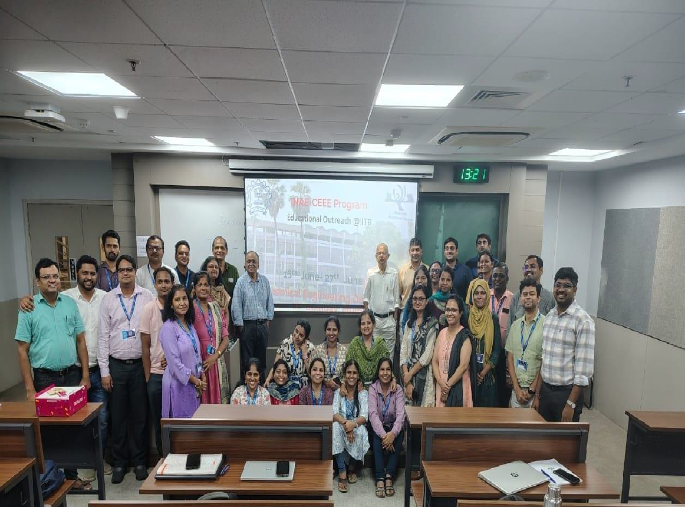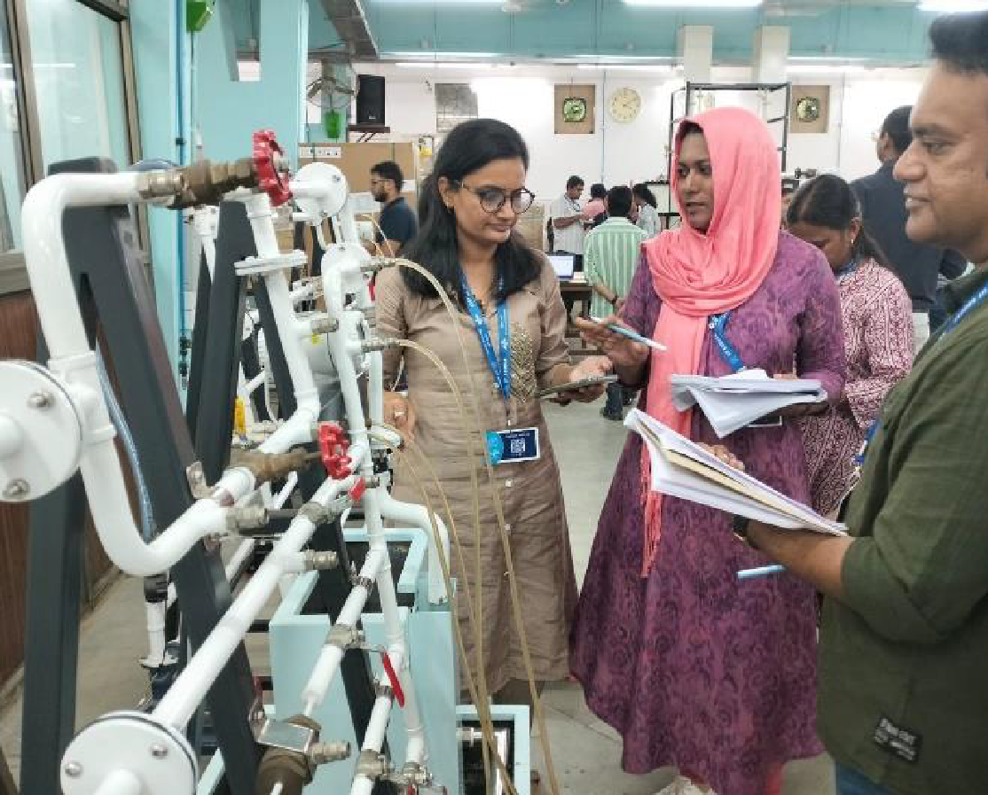

7.2 MISCELLANEOUS (SYLLABUS IMPLEMENTATION, MAJOR ADDITION IN INFRASTRUCTURE AND FACILITY, INNOVATIONS INTRODUCED, ETC.)
FACULTY | ACTIVITY

7.3 FEEDBACK FROM STAKEHOLDERS

Sr No | Stake holder | Number of Feedbacks Received | Overall Feedback
1 | Alumni
2 | Parents
3 | Employers
4 | Students

7.4 TWO BEST PRACTICES FOLLOWED IN THE DEPARTMENT
1. Virtual labs: In certain labs like the dynamics of machinery lab, some relevant experiments are conducted online on web browsers with the help of simulators. Such online facilities are called as virtual labs (http://www.vlab.co.in/), and are a part of an excellent innovative initiative taken by the MHRD of India. Virtual Experiment of IIT vlabs on Response of Stirred Tank Heater was conducted online for the practical subject, PDC of B.E. Chemical

2. Project based Learning and working models: In many relevant subjects, faculty encourage the students to make miniature working models of mechanisms and machine components. The faculty members also make use of cut sections as well as working models to enhance interest and level of learning. The final year undergraduate curriculum includes completion of a one year project with comprehensive viva voce. Hence, the final year students are divided in 2 to 4 member teams for executing the project tasks allotted by their project adviser(s). Also, the students are given chances for pursuing their final year projects in prestigious institutions like ICT, National laboratories (NCL Pune) and in the institutions in abroad. As a result many undergraduate project teams have published their project works in prestigious international journals and conference proceedings

7.5 MAJOR GRIEVANCES OF STUDENTS (IF ANY) REDRESSED
NIL

7.6 SWOC ANALYSIS
Five major strengths, weaknesses, opportunities, and challenges (SWOC) of the department and future plans of the Department.
Strengths:
1
2
3
4
5
Weaknesses:
1
2
3
4
5
Opportunities:
1
2
3
4
5
Challenges
1
2
3
4
5

7.7 FUTURE PLANS OF THE DEPARTMENT (For Next Academic Year)
1 | Conducting Mini Projects
2 | Conducting in house workshops and symposium with software interface
3 | Conducting Industrial Visit
4 | Students promoted to participate in various competitions
5 | Improvement in Placement

7.8 INITIATIVES TAKEN BY THE DEPARTMENT AT DEPARTMENT AND INSTITUTE LEVEL TO IMPROVE AND ASSURE QUALITY IN THE FOLLOWING AREAS

Area | Initiatives
Academics and overall profile of Department | Overall academics is maintained by keeping constant watch on attendance
Organization of different activities | Students are promoted to participate in house workshops and symposium with software interface
Research and Innovation | Mini Projects are allotted to students in SE and TE to improve the basic in Chemical Engg
Industry institute Interaction | Industrial Visit are arranged for SE , TE and BE Chemical Engg Students
Students’ Achievements | Students promoted to participate in various competitions

SUMMARY SHEET (Annual)
Sr No | Activity/ Item | Numbers
PROFILE OF DEPARTMENT
01 | Students in the department | 191
 | FACULTY CONTRIBUTION
02 | e content developed by faculty and available online | Yes
03 | Number of FDP/STTP attended by the department faculty | 21
04 | Number of Seminars/ workshops/ webinars attended by the department faculty | 04
05 | Number of Conferences/ symposiums attended by the department faculty | 01
06 | Number of Online courses / certificate courses completed by department faculty | 08
07 | Number of extension lectures / webinars (Lectures delivered on other than technical topics)) | Nil
08 | Number of Faculty served as resource person, expert, chairperson | Nil
 | ACTIVITIES ORGANISED
09 | Number of FDP/STTP organized by the department | Nil
10 | Number of Seminars/ workshops/ webinars organized by the department (for faculty) | 03
11 | Number of Conferences/ symposiums organized by the department (for faculty) | 01
12 | Number of Extension activities conducted by the department (Social/ Quizzes at national/international level/any other activity) | 10
13 | MOU signed with academic and professional organizations | 08
14 | Number of Students’ chapters /clubs | 03
15 | Number of Social activities organized | 02
16 | Number of Parent meeting | 01
17 | Number of Alumni meet | 02
18 | Number of student counseling and career guidance at the department level | 01
 | RESEARCH CONTRIBUTION
19 | Number of Funded research project | Nil
20 | Number of Testing and consultancy | Nil
21 | Number of Patents, copyright, trademark and other (IPR) | 02
22 | Number of Papers published/ presented in proceedings of conferences | Nil
23 | Number of Papers published in journals | 18
24 | Number of Book/ article publications | Nil
25 | Total Research citations | 969
26 | Number of ME awarded | 02
27 | Number of PhD AWARDED | In Progress
 | INTERACTION WITH INDUSTRY
28 | Number of Industrial visits organised | 10
29 | Number of Expert lectures delivered by industry experts | 04
30 | Number of Industry –sponsored projects (UG/PG) | NIL
31 | Number of MOU signed with industry | 08
32 | Number of Faculty members undergone industrial training | 03
33 | Number of Students undergone in-plant training and (or) internship programme | 51
34 | Number of students placed | 14
35 | Number of students qualified in the examinations | NIL

Declaration by the Head of the Department

I am aware that the above information provided by the Department will be validated by the AAA committee during the visit.

Name and Signature
Head of Department

