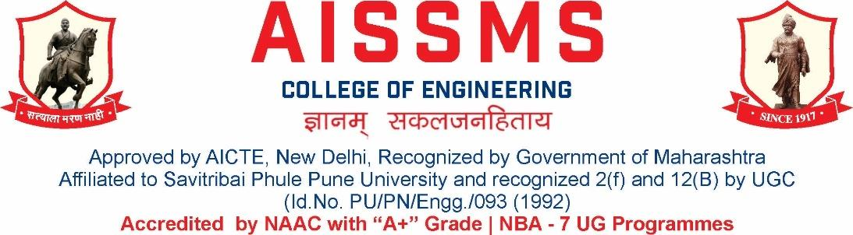
Internal Quality Assurance Cell
DEPARTMENT OF ROBOTICS & AUTOMATION / PRODUCTION ENGINEERING
ANNUAL REPORT
(15 JUNE 2024 to 14 June 2025)
TERM ONE: 15 June 2024 to 30 November 2024
TERM TWO: 01 December 2024 to 14 June 2025

Academic Year 2024 – 25
Guidelines:
Fill up this sheet for all the contributions /activities conducted at Department level only.
- In case data does not exist please mention it as ‘No Data’.
- Please add rows to the table below to suit your requirements
- Ensure that data does not differ from other official records and all the supporting documents are available.
- Use: Font Type: Times New Roman, Font Size: 12, Sentence case, Spacing: 1.15
- Use separate row for every details.
- For any queries, you may contact: Dr C S Choudhari, Coordinator, IQAC
- email: iqac@aissmscoe.com

CONTENTS
Sr No | Activity/ Item | Page No
- PROFILE OF DEPARTMENT
1.1 | Introduction | 6
1.2 | Laboratories in the Department | 6
1.3 | Software Available in the Department | 6
1.4 | Faculty in the Department | 7
1.5 | Details of Supporting Staff | 7
1.6 | Students’ Enrollment | 8
1.7 | Students–Faculty Feedback Details | 10
1.8 | Result Analysis | 10
1.9 | Class Result Analysis | 12
- FACULTY CONTRIBUTION
2.1 | Achievements of Faculty | 17
2.2 | Contribution of Faculty (Interaction With Outside World) | 17
2.3 | e content developed by faculty and available online | 17
2.4 | FDP/STTP attended by the department faculty | 18
2.5 | Seminars/ workshops/ webinars attended by the department faculty | 19
2.6 | Conferences/ symposiums attended by the department faculty | 20
2.7 | Online courses / certificate courses completed by department faculty | 20
2.8 | Extension lectures / webinars organized | 21
2.9 | Faculty served as resource person, expert, chairperson | 21
- ACTIVITIES ORGANISED
3.1 | FDP/STTP organized by the department | 24
3.2 | Seminars/ workshops/ webinars organized by the department (for faculty) | 24
3.3 | Conferences/ symposiums organized by the department | 25
3.4 | Extension activities conducted by the department | 25
3.5 | MOU signed with academic and professional organizations | 25
3.6 | Students’ chapters /clubs | 27
3.7 | Social activities organized | 27
3.8 | Parent meeting | 27
3.9 | Alumni meet | 27
3.10 | Support from Alumni | 27
3.11 | Interaction with Alumni | 28
3.12 | Student counseling and career guidance at the department level | 28
- RESEARCH CONTRIBUTION
4.1 | Funded research project | 32
4.2 | Testing and consultancy | 32
4.3 | Patents, copyright, trademark and other (IPR) | 33
4.4 | Papers published/ presented in proceedings of conferences | 34
4.5 | Papers published in journals | 34
4.6 | Book/ article publications | 34
4.7 | Total Research citations | 35
4.8 | ME awarded | 35
4.9 | PhD guide details | 35
4.10 | PhD AWARDED | 35
- INTERACTION WITH INDUSTRY
5.1 | Industrial visits organised | 38
5.2 | Expert lectures delivered by industry experts | 38
5.3 | Industry –sponsored projects (UG/PG) | 39
5.4 | MOU signed with industry | 39
5.5 | Faculty members undergone industrial training | 39
5.6 | Students undergone in-plant training and (or) internship programme | 41
5.7 | Support from Industry | 41
5.8 | Training to Industry personnel/ Activity Supporting industry | 42
5.9 | Any other activities to Promote Interaction with Industry | 42
5.10 | Students Undergone Sandwich Training | 43
- STUDENTS’ ACHIEVEMENT
6.1 | Students’ Achievement (Professional) (Individual Level) | 46
6.2 | Students’ Achievement (Other than Professional) (Individual Level) | 46
6.3 | Certificate / Online Courses Completed by Students | 46
6.4 | Number of Students Placed | 48
6.5 | Number of Students qualified in the competitive examinations | 48
6.6 | Sports / Cultural Achievements of Students (Individual Level) | 48
6.7 | Students’ Achievements (Team Level) | 48
 | - SUMMARY AND SWOC ANALYSIS
7.1 | Any other noteworthy achievement of the department | 51
7.2 | Miscellaneous (Syllabus Implementation, Major Addition In Infrastructure And Facility, Innovations Introduced, etc.) | 51
7.3 | Feedback from Stakeholders | 51
7.4 | Two Best Practices Followed in the Department | 51
7.5 | Major Grievances of Students (If Any) Redressed | 52
7.6 | SWOC Analysis | 52
7.8 | Future Plans of the Department | 53
7.9 | Initiatives Taken by The Department At Department And Institute Level To Improve And Assure Quality | 54
7.10 | Summary Sheet (Annual) | 55

- PROFILE
OF
DEPARTMENT

VISION OF DEPARTMENT
To produce responsible professionals in the field of Robotics & Automation Engineering.

MISSION STATEMENTS OF DEPARTMENT
- Impart state of art technical education in Robotics & Automation Engineering.
- Inculcate sustainable skills in automation technologies, research, and learning attitudes.
- Committed to fulfilling the needs of society in the manufacturing and service sector.
- Prepare individuals with the ability to fulfill social responsibilities.

1.1 INTRODUCTION
Year of Establishment | 1994 / 2022-23
UG Programmes | Production Engineering (Sandwich)/  Robotics and Automation Engineering
PG Programmes | NA
Number of Teaching Staff | 10
Number of Non-Teaching Staff | 13 (Production + Workshop)

1.2 LABORATORIES IN THE DEPARTMENT
Production SW

Name of Laboratory |  | Name of Laboratory
1 | CAD/CAM Laboratory | 4 | Tool Engineering Laboratory
2 | Robot & Automation Laboratory | 5 | NonTraditional Machine Laboratory
3 | Production Management Laboratory | 6 | Advanced Production Technology

Robotics & Automation

Name of Laboratory |  | Name of Laboratory
1 | Robotics Laboratory | 3 | Software Laboratory
2 | PL and SCADA Programming Laboratory | 4 | Sensor Technology Laboratory

1.3 SOFTWARES AVAILABLE IN THE DEPARTMENT

Software Available |  | Software Available
1 | Unigraphics Mfg. Bundle 10 nos. and (FEMAP +NASTRAN) 5 nos. and FACTORY CAD-2 nos. and  FACTORY FLOW-02 Nos.and eMplant- 02 Nos. | 6 | JASP- Version 2 (Janatics Animation Software & Pneumatics) (01)
2 | Computer Software Autodesk Inventor Professional Edu. License (03) | 7 | Systat Statistical Software -Version 12 ( 01)
3 | Solid Edge Bundle (Drafting Solid Modeling and Sheet Metal) for 25 user | 8 | RoboAnalyzer - 30 Licenses
4 | Unigrahics 8.0 Cam Express  (Simulation, Modeling, Tool Path Generation) 20 user | 9 | RT Toolbox Software – 30 Licenses
5 | ANSYS Academic Teaching + CFD Version 16.2 for (25 user)

1.4 FACULTY IN THE DEPARTMENT

Name of faculty | Designation
Mr V D Dholle | Head & Workshop Superintendent
Dr N G Shekapure | Assistant Professor
Mr M A Kelkar | Asst Workshop Superintendent
Mr S S Kallurkar | Assistant Professor
Mr S N Chiwande | Assistant Professor
Mr S K Bidgar | Assistant Professor
Mr M L Chanpur | Assistant Professor
Mr Y R Chandwade | Assistant Professor
Dr (Ms) A S Ubale | Assistant Professor
Mr M P Bauskar | Assistant Professor

1.5 DETAILS OF SUPPORTING STAFF
Name of non-teaching staff | Designation
Mr Rahul S Gangawane | Technical Assistant
Mr Pratik B Alhat | Lab Assistant
Mr A Chopane | Store Keeper
Mr N V Walke | Instructor
Mr V N Hire | Instructor
Mr Sanjay M K | Instructor
Mr R M Khedekar | Instructor
Mr P D Pawar | Electrician
Mr A G Mate | Electrician
Mr B H Gade | Attendant
Mr Y G Patil | Attendant
Mr N V Adhav | Attendant
Mr A U Dhame | Attendant

1.6 STUDENTS’ ENROLLMENT (2024-25)
Program | GEN |  | SC |  | ST |  | OBC |  | PWD |  | Others |  | Total
 | M | F | M | F | M | F | M | F | M | F | M | F | M | F
UG( R & A) | 17 | 7 | 2 | 2 | – | – | 11 | 5 | – | – | 11 | 5 | 41 | 19
Over and Above Admission (2024-25) (OPEN EWS and TFWS)
Program | Over and Above |  | Total
 | M | F | M | F
UG (R & A) | 6 | 2 | 6 | 2

1.7 STUDENTS–FACULTY FEEDBACK DETAILS
 | Term One
Sr. No. | Name of faculty | Class and Subject taught | Feedback (I) (%) | Feedback (II) (%) | Average  Feedback (%)
1 | Mr V Dholle | Operation Research (BE PSW) | 87 | 95.87 | 91.43
2 | Dr N G Shekapure | Creative Product Design (BE Prod) | 96 | 99.37 | 98
3 | Dr N G Shekapure | Industrial & Technology Management (TE Electrical) | 92 | 94 | 93
4
5 | Mr M A Kelkar | Manufacturing Technology  SE (R & A) | 88 | 88 | 88
6 | Mr S S Kallurkar | Sensors Technology TE (R&A) | 81 | 80.48 | 80.74
7 | Mr S S Kallurkar | CPL SE (R&A) | 79 | 81.48 | 80.24
10 | Mr S N Chiwande | Industrial Robotics (BE Prod)
11 | Mr M L Chanpur | Strength of Materials (SE R&A) | 88 | 90.12 | 89.06
12 | Mr M L Chanpur | Strength of Materials Lab (SE R&A) | 79 | 88.64 | 83.82
15 | Mr S K Bidgar | Material Science & Engineering Metallurgy (SE R&A) | 79 | 84 | 81.5
17 | Mr Y R Chandwade | Industrial Robotics & Material Handling System (TE R&A) | 92 | 93.33 | 92.66
18 | Mr Y R Chandwade | Mini Project (BE Prod) | 96 | 98.89 | 97.44
19 | Dr (Ms) A S Ubale | Embedded System in Robotics (TE R&A) | 89 | 82.91 | 8.5
20 | Mr M P Bauskar | Manufacturing Automation/ BE Prod sw | 88 | 97 | 92.5
21 | Mr M P Bauskar | Hydraulics & Pneumatics/ TE Robotics & Automation | 82 | 82.71 | 82.36
22 | Mr S N Chiwande | Industrial Robotics (BE Prod) | 95 | 99 | 97
23 | Mr S N Chiwande | Robot Kimatic & Dynamics (TE R&A) | 82 | 78 | 80

 | Term Two
Sr No | Name of faculty | Class and Subject taught | Feedback (I) (%) | Feedback (II) (%) | Average  Feedback (%)
1 | Mr V Dholle | Kinematics & Design of Machines
2 | Dr N G Shekapure | Artificial Intelligence for Robotics  TE (R&A) | 93.70 | 98.60 | 96.15
3 | Dr N G Shekapure | Artificial Intelligence for Robotics  TE (R&A) | 93.70 | 98.19 | 95.89
4 | Dr N G Shekapure | Industrial Engineering Management SE (R&A) | 88.31 | 92.59 | 90.45
 | Mr S S Kallurkar | Computer Graphics for Robotics (SE R&A) | 77.20 | 85.32 | 81.26
 | Mr S S Kallurkar | Statistics and Numerical Optimization (TE PSW) | 84.76 | 92.22 | 88.49
5 | Mr S N Chiwande | Theory of Machine (SE Prod) | 100 | 100 | 100
7 | Mr M L Chanpur | SE/Design of Machine Elements/ (SE R&A) | 87.90 | 92.46 | 90.18
8
9 | Dr A S Ubale | Control System Engineering (SE R&A) | 85.43 | 91.52 | 88.4
10
11 | Dr A S Ubale | SE/Project Based Learning | 85.60 | 93.20 | 89.4
12 | Mr S S Kallurkar | SE/ Computer Graphics for Robotics | 77.20 | 80.48 | 78.84
13 | Mr S S Kallurkar | TE Prod SW/ Statistics and Numerical Optimization Methods | 84.76 | 92.22 | 88.49
14 | Mr S N Chiwande | World Class Manufacturing (TE Prod) | 92 | 94.44 | 93.22
15 | Mr Y R Chandwade | Material forming and mould design (  TE Prod) | 93.33 | 97.28 | 95.30
16 | Mr Y R Chandwade | Modelling and Simulation (TE R&A) | 95.93 | 95.56 | 95.75
17 | Mr S K Bidgar | Flexible Manufacturing System (TE R&A) | 88.37 | 90.78 | 89.58
18 | Mr M P Bauskar | Robot Programming (TE R&A) | 89.04 | 92.59 | 90.08

1.8 RESULT ANALYSIS (OCT 24) PRODUCTION SW
Term One
Name of faculty | Class and Subject Taught | % passing | Name of faculty | Class and Subject Taught | % passing
Mr M P Bauskar | BE(MA-TH) | 100 | Mr S N Chiwande | BE(IR-TH) | 100
Mr V D Dholle | BE(OR-TH) | 85.71 | Dr N G Shekapure | BE(CPD-TH) | 100
All Faculty Members | TE(IIT-TW) | 100 | All Faculty Members | TE(Seminar-OR) | 100
All Faculty Members | TE(IIT-OR) | 100 | All Faculty Members | TE(MT-TH) | 87.5
All Faculty Members | TE(Seminar-TW) | 100 | All Faculty Members | TE(MT-TW) | 100
Dr M Gauratra | SE (EM III-TH) | 100 | Mr M A Kelkar | SE (MP I-TH) | 100
Mr S S Kallurkar | SE(H&FE-TH) | 100 | Mr S K Bidgar | SE(MS&M-TH) | 100
Mr M L Chanpur | SE(SOM-TH) | —

(OCT 24) ROBOTIC AND AUTOMATION
Term One
Name of faculty | Class and Subject Taught | % passing | Name of faculty | Class and Subject Taught | % passing
Dr A S Ubale | TE (ESR-TH) | 100 | Mr S S Kallurkar | TE (ST-TH) | 100
Mr M P  Bauskar | TE (H&P-TH) | 100 | Mr Y R Chandwade | TE (IR&MHS-TH) | 100
Mr S N Chiwande | TE(RK& D- TH) | 100 | Mr M A Kelkar | SE (MT-TH) | 97.14
Dr M Gauratra | SE (EM III-TH) | 91.5 | Mr S K Bidgar | SE (MSME-TH) | 94.3
Mr M L Chanpur | SE (SOM-TH) | 80
Mr Rajesh Wani | SE (IEE-TH) | 88.57

MAY 25 (PRODUCTION SW)
Term Two
Name of faculty | Class and Subject Taught | % passing | Name of faculty | Class and Subject Taught | % passing
All Faculty Members | BE IIT (TW) |  | All Faculty Members | BE Project (OR)
All Faculty Members | BE IIT (OR) |  | Mr S S Kallurkar | BE SCM (PP)
All Faculty Members | BE Project (TW)
Mr V D Dholle | TE KDM (TH) |  | Mr M A Kelkar | TE MQC (TH) | 75
Mr S S Kallurkar | TE S&NOM (TH) |  | Mr S S Kallurkar | TE WCM (TH)
Mr Y R Chandwade | TE MFMD (TH) |  | Mr S N Chiwande | TE WCM(TH)
Mr S M Chaudhari | SE EEE (TH) |  | Mr S K Bidgar | SE MP II (TH)
Mr S N Chiwande | SE TOM (TH) |  | Mr M P Bauskar | SE IEM (TH)
Mr M L Chanpur | SE DME (TH)

(MAY 25) ROBOTIC AND AUTOMATION
Term Two
Name of faculty | Class and Subject Taught | % passing | Name of faculty | Class and Subject Taught | % passing
Dr N G Shekapure | SE IEM (TH) | 91.4 | Mr M A Kelkar | SE MQA (TH) | 91.4
Dr.A S Ubale | SE CSE (TH) | 94.3 | Mr S S Kallurkar | SE CGR (TH) | 91.42
Mr M L Chanpur | SE DME (TH) | 83
Mr M P Bauskar | TE RP(TH) | 100 | Mr S K Bidgar | TE FMS (TH) | 100
Dr N G Shekapure | TE AIFR(TH) | 100 | Mr Y R Chandwade | TE M&S(TH) | 100

1.9 CLASS RESULT ANALYSIS (All Classes FE to BE)
Term One (OCT 24)
SN | Class | Number of Students = 74 |  |  |  |  |  |  |  |  | Percentage of Passing
SN | Class | Appeared | Clear Passed | Outstanding  (O)  (91 -10) | Excellent  (A+)  (81 – 9) | Very Good (A)  (71 – 8) | Good (B+)  (61 – 7) | Above Average (B)  (51 – 6) | Average / pass class  (4 – 5) | Fail (F)  0 – 399 | All Clear | With ATKT
1 | SE(PSW) | 1 | — | — | — | — | — | — | — | — | — | 100
1 | SE(R&A) | 35 | 28 | 3 | 11 | 12 | 2 | — | — | — | 80 | 100
2 | TE(PSW) | 8 | 7 | 7 | — | — | — | — | — | — | 87.5 | 100
3 | TE(R&A) | 32 | 28 | 11 | 16 | 1 | — | — | — | — | 87.5 | 100
3 | BE(PSW) | 7 | 6 | — | 1 | 4 | 1 | — | — | — | 85.71 | 100

Term Two (MAY 25)
SN | Class | Number of Students = |  |  |  |  |  |  |  |  |  | Percentage of Passing
SN | Class | Appeared | Clear Passed | Outstanding  (O)  (91 -10) | Excellent  (A+)  (81 – 9) | Very Good (A)  (71 – 8) | Good (B+)  (61 – 7) | Above Average (B)  (51 – 6) | Average / pass class  (4 – 5 ) |  | Fail  (F)  0 – 399 | All Clear | With ATKT
1 | SE(PSW)
1 | SE(R&A) | 35 | 27 | 1 | 17 | 9 | – | – | – |  | 1 | 77.14 | 97.14
2 | TE(PSW)
3 | TE(R&A | 33 | 33 | 17 | 12 | 3 | 1 | – | – | – | – | 100 | –
4 | BE(R&A)

Term Two Final Result for BE Classes (Based on CGPA) (MAY 25)
SN | Class | Number of Students |  |  |  |  |  |  |  |  | Percentage of Passing
SN | Class | Appeared | Clear Passed | Outstanding  (O)  (91 -10) | Excellent  (A+)  (81 – 9) | Very Good (A)  (71 – 8) | Good (B+)  (61 – 7) | Above Average (B)  (51 – 6) | Average / pass class  (4 – 5) | Fail (F)  0 – 399 | All Clear | With ATKT
1

1.10 UNIVERSITY RANKERS (Consider last five academic years)
Academic Year 2024 - 25 (Oct 24) Academic Term I (R&A)
Sr No | Name of the Ranker | Class | Rank
1 | BARGE ARYA UDAY | SE | 1
2 | AYUSH PRAKASH JAGADALE | SE | 2
3 | NEWALE BHARGAVI VIKAS | SE | 3
4 | CHAVHAN SHRUTI KAILASH | SE | 4
5 | GADEWAR KRISHNA DHANANJAY | SE | 4
1 | DONGARE SANIKA SANJAY | TE | 1
2 | ALURKAR AVANI ANAND | TE | 2
3 | CHOUDHARI SWAYAM POPAT | TE | 3
3 | KANATE PARTH WASUDEO | TE | 4

Academic Year 2024 - 25 (Oct 24) Academic Term I (Production SW)
Sr No | Name of the Ranker | Class | Rank
1 | ____ | SE | NIL
1 | MANE YUVRAJ RAJKUMAR | TE | 1
2 | MITALI PARAMANAND HURDALE | TE | 1
3 | BHISE SULAKSHAN PRAKASH | TE | 2
4 | DHUMAL BHUVAN SHEKHAR | TE | 2
1 | ATIWADKAR PARTH PANDIT | BE | 1
2 | GADAKH ABHISHEK ASHOKRAO | BE | 2
3 | NAVSUPE TEJAS POPAT | BE | 2
4 | UMESH BALASAHEB KHADKE | BE | 3
5 | HANDE VAISHNAVI GANESH | BE | 4

Academic Year 2024 - 25 (MAY 25) Academic Term II (R&A)
Sr No | Name of the Ranker | Class | Rank
1 | BARGE ARYA UDAY | SE | 1
2 | THORAT ANJALI DATTATRA | SE | 2
3 | AYUSH PRAKASH JAGADALE | SE | 3
4 | BHOITE SHRINIVAS GAJANAN | SE | 3
5 | MEHTA AKSHAT AVINASH | SE | 3
6 | NEWALE BHARGAVI VIKAS | SE | 3
1 | DONGARE SANIKA SANJAY DONGARE | TE | 1
2 | ALURKAR AVANI ANAND | TE | 1
3 | KANATE PARTH WASUDEO | TE | 2
4 | GHODKE SAKSHI SIDDHESHWAR | TE | 3
5 | KALSHETTI CHAITANYA SANTOSH | TE | 4

Academic Year 2024 - 25 (MAY 25) Academic Term II (PSW)
Sr No | Name of the Ranker | Class | Rank
1 |  | SE | NIL
1 |  | TE | 1
2 |  | TE | 2
3 |  | TE | 3
4 |  | TE | 4
1 |  | BE | 1
2 |  | BE | 2
3 |  | BE | 3
4 |  | BE | 4
5 |  | BE | 5

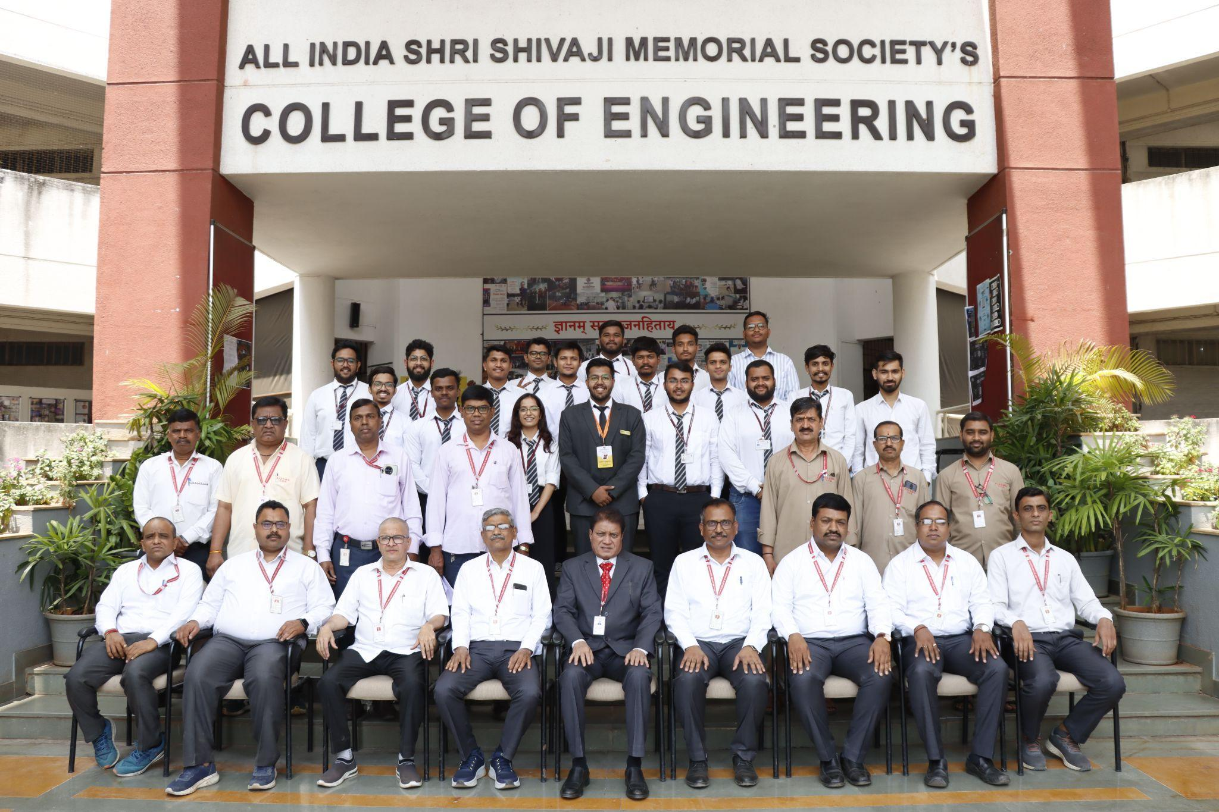 | 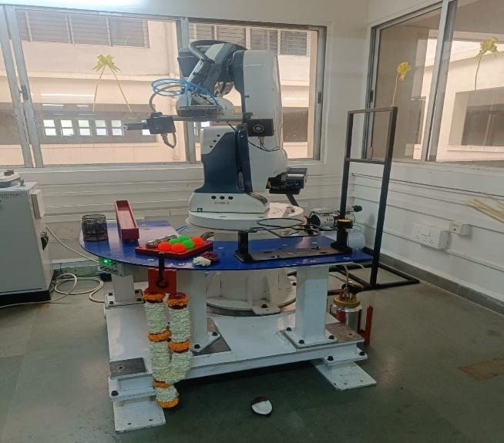
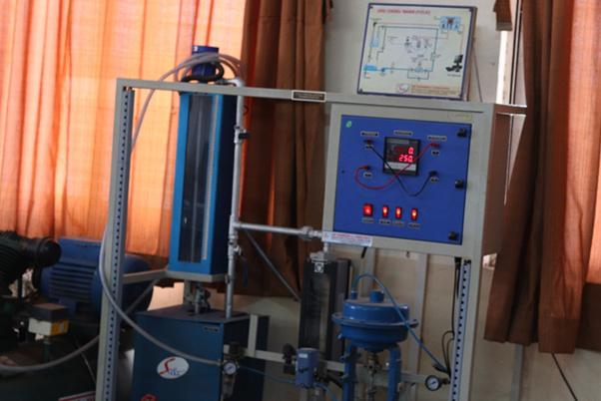 | 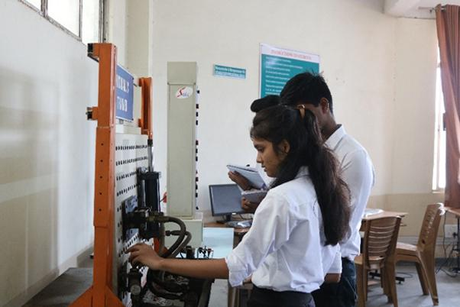

- FACULTY CONTRIBUTION

2.1 ACHIEVEMENTS OF FACULTY (AWARDS, RECOGNITION, PHD COMPLETION ETC)
Term One
SN | Name of Faculty | Awards & Recognitions
01 | Dr N G Shekapure | Received 2nd Prize in Blogathon Competition on the Occasion of Teachers Day-2024
02

Term Two
SN | Name of Faculty | Awards & Recognition
01
02

2.2 CONTRIBUTION OF FACULTY (Interaction with the outside world)
Term One
SN | Name of Faculty | Nature and details of contribution (Representation at University, State, National, International level, corporate world, Social Platforms, etc)
01 | Dr N G Shekapure | BOS Member, Production and Industrial Engineering at SPPU, Pune
02 | Dr N G Shekapure | BOS Member, Engineering Sciences & Humanities, PVG COET and GKPIOM, Pune

Term Two
SN | Name of Faculty | Nature and details of contribution (Representation at University, State, National, International level, corporate world, Social Platforms, etc)
01 | Dr N G Shekapure | BOS Member, Production and Industrial Engineering at SPPU, Pune
02 | Dr N G Shekapure | BOS Member, Engineering Sciences & Humanities, PVG COET and GKPIOM, Pune

2.3 e CONTENT DEVELOPED BY FACULTY AND AVAILABLE ONLINE
Term One
Sr No | Name of Faculty | Title of e-content | e-content development facility/platform | link of the content
 | Dr N G Shekapure | Artificial Intelligence and Robotics | Videos and Notes | https://a.impartus.com/ilc/#/course/3088883/1453
1 | M P Bauskar | Find the Efficiency of the Pump | You Tube | https://youtu.be/iDEIt  s332ZM?si=zw0b6KeFoSUmLkQM
2 | Mr M P Bauskar | Sequencing Ckt by using Hydraulic Trainer | You tube | https://youtu.be/CDuLW0FZfc0?si=F0yhCtrZaWoL2MMv
3 | Mr M P Bauskar | Meter out Ckt by using Hydraulic Trainer | You Tube | https://youtu.be/KKtf1sIYe3o?si=5TKoVkQiPIixoky1
4 | Dr A S Ubale | Understanding GPIO Registers in LPC 2148 | You Tube | https://www.youtube.com/watch?v=8VKCuigx2Zo&t=89s
5 | Dr A S Ubale | ARM embedded C programming | You Tube | https://www.youtube.com/watch?v=MawtPFbiMB4
6 | Dr N G Shekapure | Creative Product Design | Impartus | https://a.impartus.com/ilc/#/course/3022043/1412

Term Two
Sr No | Name of Faculty | Title of e-content | e-content development facility/platform | link of the content
1 | Dr N G Shekapure | Artificial Intelligence and Robotics | Videos and Notes | https://a.impartus.com/ilc/#/course/3088883/1453

2.4 FDP/STTP ATTENDED BY THE DEPARTMENT FACULTY
Term One
S N | Name of Faculty | Title of the FDP/STTP | Organized by | Duration/ Dates
1 | M P Bauskar | Transformative Education: Integrating AI Tools with Outcome-Based Learning | Radha Krishna Institute of Technology (RITE), Odisha | 05/08/2024 to 11/08/2024  (One Week)
2 | Dr A S Ubale | Ethical Issues in Writing | Regional College for Education Research and Technology, Jaipur | 11/09/2024 to 16/09/2024  (One Week)
3 | Dr A S Ubale | Applications of AI &amp; ML in Emerging Fields Using  MATLAB | PRMCEAM Badnera | 23/09/2024 to 27/09/2024  (One Week)
4 | Dr A S Ubale | VLSI Design Flow: RTL to GDS | NPTEL | Jul-Oct 2024 (12 Weeks)
5 | Dr A S Ubale | NITTTR FDP on PLC and SCADA | NITTTR | 25/11/2024 to 29/11/2024  (One Week)
6 | Mr M A Kelkar | NITTTR FDP on NEP | NITTTR | 12/08/2024 to 14/08/2024
7 | Dr N G Shekapure | EMPLOYABILITY SKILLS | NITTTR, Chennai | 30/09/2024 to 05/09/2024  (One Week)
8 | Dr N G Shekapure | Transformative Education: Integrating AI Tools with Outcome-Based Learning | Radha Krishna Institute of Technology (RITE), Odisha | 05/08/2024 to 11/08/2024  (One Week)
9 | Dr N G Shekapure | Innovative AI Tools for Research Excellence: Effective Writing and Data Visualization | Guru Gobind Singh College of Engineering and Research Center, Nashik | 26/08/2024 to 31/08/2024  (One Week)
10 | Mr M L Chanpur | HR Analytics | NPTEL - AICTE | Jul – Oct 2024 12 Weeks
11 | Mr M L Chanpur | Niche Areas of Sustainable Development | PVG COE | 02/09/2024 to 06/09/2024
12 | Mr M L Chanpur | EMPLOYABILITY SKILLS | NITTTR, Chennai | 30/09/2024 to 05/09/2024  (One Week)
13 | Mr V D Dholle | Work System Design | NPTEL | July-Oct 2024  (12 Week)
14 | Mr Y R Chandwade | STTP on Question paper design for outcome based-Based curriculum design | NITTR | one week

Term Two
S N | Name of Faculty | Title of the FDP/STTP | Organized by | Duration/ Dates
1 | Dr A S Ubale | Recent Trends  and Techniques in Cyber Security & Digital Forensic | Dr. D. Y. Patil College of Engineering and Innovation,  Varale, Dist. Pune. | 06/01/2025 to  10/01/2025  (One Week)
2 | Dr A S Ubale | NITTTR FDP on Simulations in Electronics | NITTTR | 03/02/2025 07/02/2025
3 | Dr A S Ubale | Introduction to Embedded System Design | NPTEL-AICTE | Jan-Apr 2025 (12 week course)
4 | Mr M L Chanpur | Advance Materials for Defence and Aerospace Applications | BITM, Ballari | 27/01/2025 to 01/02/2025  (One Week)
5 | Mr Y R Chandwade | Advance Materials for Defence and Aerospace Applications | BITM, Ballari | 27/01/2025 to 01/02/2025  (One Week)
6 | Dr N G Shekapure | Warehouse Management | NITTTR, Bhopal | 06/01/2025 to 10/01/2025 (One Week)
7 | Dr N G Shekapure | Next Generation: Digital Marketing: Tools, Techniques and Trends | JSPM, Nahre | 07/04/2025 to 11/04/2025
8 | Mr M P Bauskar | Innovative teaching Learning Practises for Engg Education | SND COE Yeola | 20/01/2025 to 24/01/2025
9 | Mr S N Chiwande | Wadhwani Foundation Ignite India Faculty Development Program on Entrepreneurship | Wadhwani Foundation | 24/02/2025 to 28/03/2025
10 | Dr N G Shekapure | Wadhwani Foundation Ignite India Faculty Development Program on Entrepreneurship | Wadhwani Foundation | 24/02/2025 to 28/03/2025

2.5 SEMINARS/ WORKSHOPS/ WEBINARS ATTENDED BY THE DEPARTMENT FACULTY
Term One
S N | Name of Faculty | Title of the Seminar/Webinar | Organized By | Duration/ Dates
1 | Dr A S Ubale | Significance of Wind Energy in Indian Energy Sector | HIEE EMPOWERING ENGINEERS PVT. LTD. | 11/08/2024  (One Day)
2 | Dr N G Shekapure | AWSOME DAY, Cloud Services | AWS | 11/07/2024  (One Day)
3 | Mr M L Chanpur | Participated in NEP 2020 Faculty Orientation Workshop on ‘Design Thinking And Idea Lab (FE Pattern) | SSPU and PVG College of Engineering | 20/08/2024  (One Day)
4 | Mr Y R Chandwade | Participated in NEP 2020 Faculty Orientation Workshop on ‘Design Thinking And Idea Lab (FE Pattern) | SSPU and PVG College of Engineering | 20/08/2024  (One Day)
5
6

Term Two
S N | Name of Faculty | Title of the Seminar/Webinar | Organized By | Duration/ Dates
1 | Mr S K Bidgar | Workshop on Advances in Non Traditional Machining | COEP Tech University | 10/01/2025
2 | Mr Y R Chandwade | Workshop on Advances in Non Traditional Machining | COEP Tech University | 10/01/2025
3 | Mr Y R Chandwade | Webinar on Visual Components simulation software | SimuSoft Technologies | 17/3/2025
4 | Mr M P Bauskar | Robodk Simulation Training | Simusoft Technologies Pune | 13/03/2025 1 Day

2.6 CONFERENCES/ SYMPOSIUMS ATTENDED BY THE DEPARTMENT FACULTY
Term One
S N | Name of Faculty | Title of the Conference / Symposium | Organized By | Duration/ Dates
1 | M P Bauskar | 4th National Conference on Innovation in Engineering and Technology  (NCIET 2024) | AISSMS COE Pune | 13 August 2024
2 | Dr N G Shekapure | 4th National Conference on Innovation in Engineering and Technology  (NCIET 2024) | AISSMS COE Pune | 13 August 2024

Term Two
S N | Name of Faculty | Title of the Conference / Symposium | Organized By | Duration/ Dates
1 | Mr S K Bidgar | 2nd National Conference on  Recent Advancements in Manufacturing  Technology & Management  RAMTM–II 2025 | Department of Production Engineering, Jadavpur University | 16 - 17th January, 2025
2 | Mr M L Chanpur | 2nd National Conference on  Recent Advancements in Manufacturing  Technology & Management  RAMTM–II 2025 | Department of Production Engineering, Jadavpur University | 16 - 17th January, 2025
3 | Mr M P Bauskar | First International Conferenc ICRCESM 2025 | Ramchardra COE Andra Pradesh & RSP research Hub | 30-31 May 2025

2.7 ONLINE COURSES / CERTIFICATE COURSES COMPLETED BY DEPARTMENT FACULTY
Term One
S N | Name of Faculty | Title of the Course | Conducted By | Duration/ Dates
1 | Mr M L Chanpur | HR Analytics | NPTEL - AICTE | Jul – Oct 2024 12 Weeks
2 | Dr N G Shekapure | EMPLOYABILITY SKILLS | NITTTR, Chennai | 30/09/2024 to 05/10/2024
3 | Dr N G Shekapure | Transformative Education: Integrating AI Tools with Outcome-Based Learning | Radha Krishna Institute of Technology (RITE), Odisha | 05/08/2024 to 11/08/2024  (One Week)
4 | Dr N G Shekapure | Innovative AI Tools for Research Excellence: Effective Writing and Data Visualization | Guru Gobind Singh College of Engineering and Research Center, Nashik | 26/08/2024 to 31/08/2024  (One Week)
5 | Mr V D Dholle | Work System Design | NPTEL | July-Oct 2024  (12 Week)
6 | Mr M P Bauskar | Transformative Education: Integrating AI Tools with Outcome-Based Learning | Radha Krishna Institute of Technology (RITE), Odisha | 05/08/2024 to 11/08/2024  (One Week)

Term Two
S N | Name of Faculty | Title of the Course | Conducted By | Duration/ Dates
1 | Dr A S Ubale | Introduction to Embedded System Design | NPTEL | Jan-Apr 2025  (12 week)
2 | Mr M L Chanpur | Research and Publication Ethics | SPPU | 16/05/2025 – 18/06/2025  (4 Weeks)
3
4

2.8 EXTENSION LECTURES / WEBINARS
(Lectures organized on other than technical topics))
Term One
S N | Name of faculty coordinator | Topic | Name and contact details of guest | Date | Number of beneficiaries
1

Term Two
S N | Name of faculty coordinator | Topic | Name and contact details of guest | Date | Number of beneficiaries
1 | Mr S K Bidgar | Career Opportunities after Engineering | Mr Arjun Chabra  Ace Academy Hyderabad | 23/01/2025 | 55
2 | Mr M L Chanpur | Career Guidance for Abroad Studies | Mr Ashwin Ayinipully, Project and Process Engineer, Fleetguard Filters Pvt. Ltd., Pune | 23/01/2025 | 55
3 | Dr N G Shekapure | Future-Ready Engineers: Market Trends & Essential Skills for Success | Mr. Sanket Ashok Chaskar | 31/01/2025 | 47

2.9 FACULTY SERVED AS RESOURCE PERSON, EXPERT, CHAIRPERSON
Term One
S N | Name of Faculty | Title of Activity | Organizing body | Date
1 | Dr N G Shekapure | Workshop on "Design Thinking & Idea Lab". | PVG's COET & GKPI , Pune | 20/08/2024
2 | Dr N G Shekapure | Design Thinking and Innovation | Pravara Rural Engineering College, Loni | 21/11/2024
3 | Dr N G Shekapure | Design Thinking and Product Development | PVPIT, Pune | 27/12/2024

Term Two
S N | Name of Faculty | Title of Activity | Organizing body | Date
1 | Dr N G Shekapure | Design Thinking | MIT Alandi | 03/01/2025 & 04/01/2025
2 | Dr N G Shekapure | Design thinking, Critical Thinking and Innovative Design | MMIT, Lohagaon, Pune | 25/01/2025

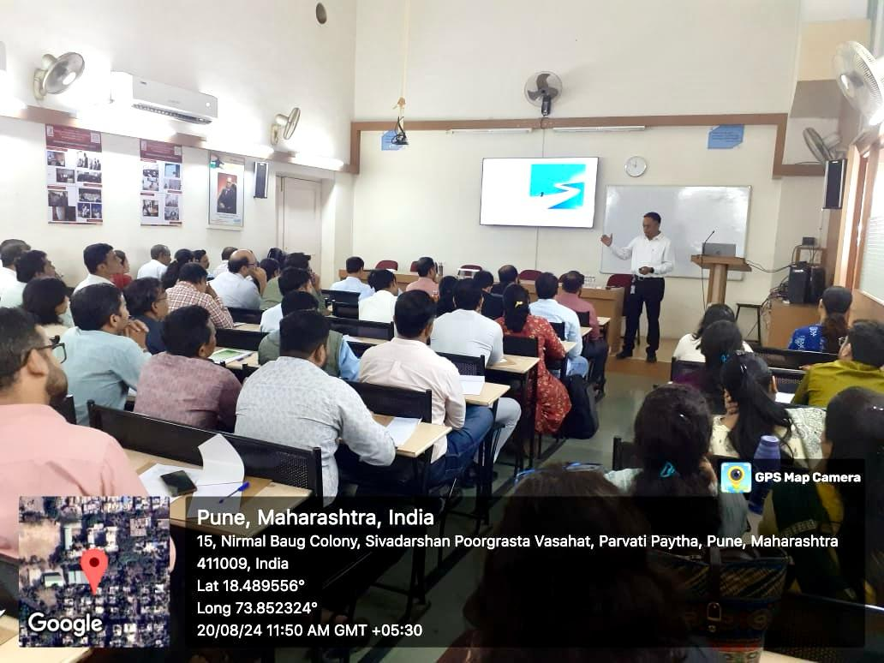
Expert Lecture on Design Thinking and Idea for Faculties at PVG COE, Pune

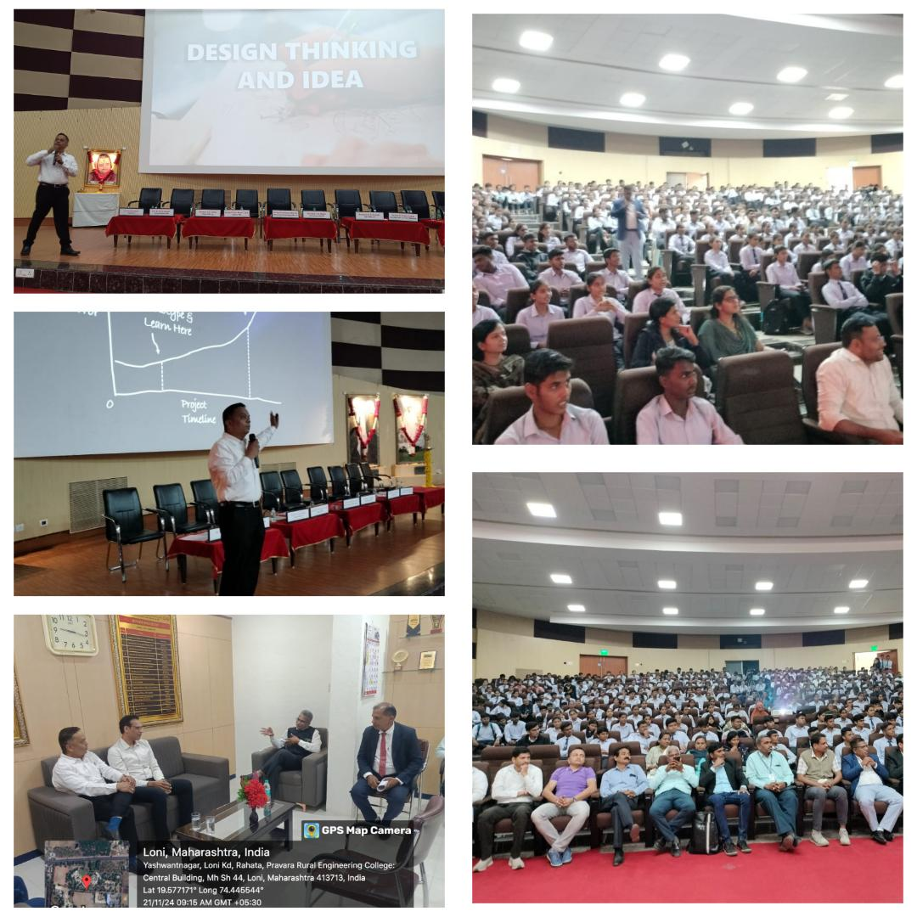
Expert Lecture on Design Thinking and Innovation for Students & Faculties of Engineering and Medical College at Pravara Rural Engineering College, Lon
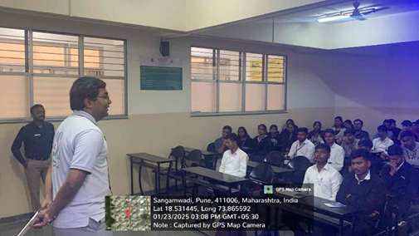
Mr Ashwin Ayinipully delivering talk to student

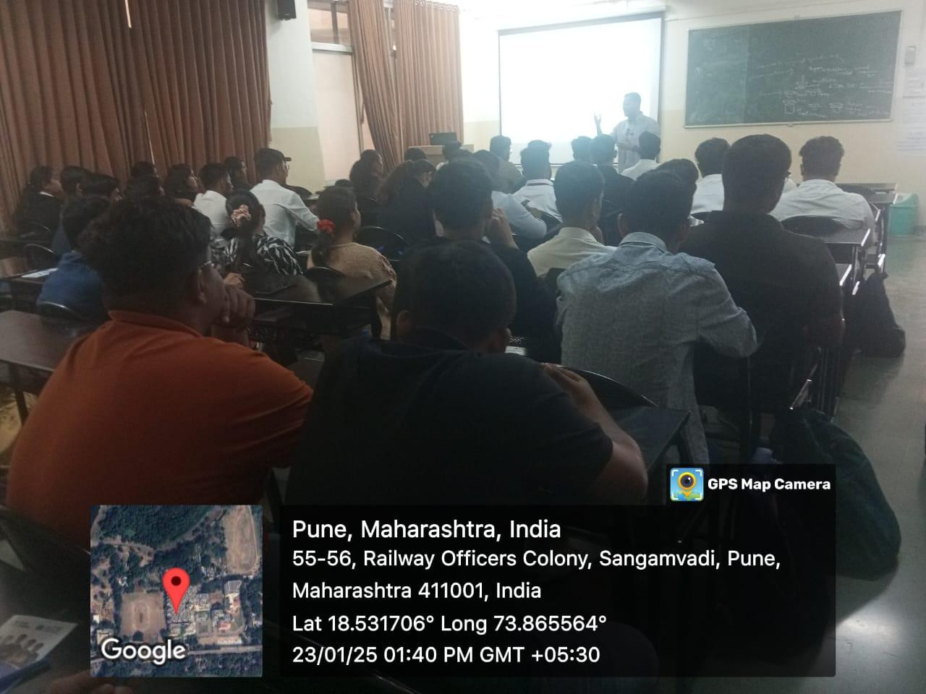
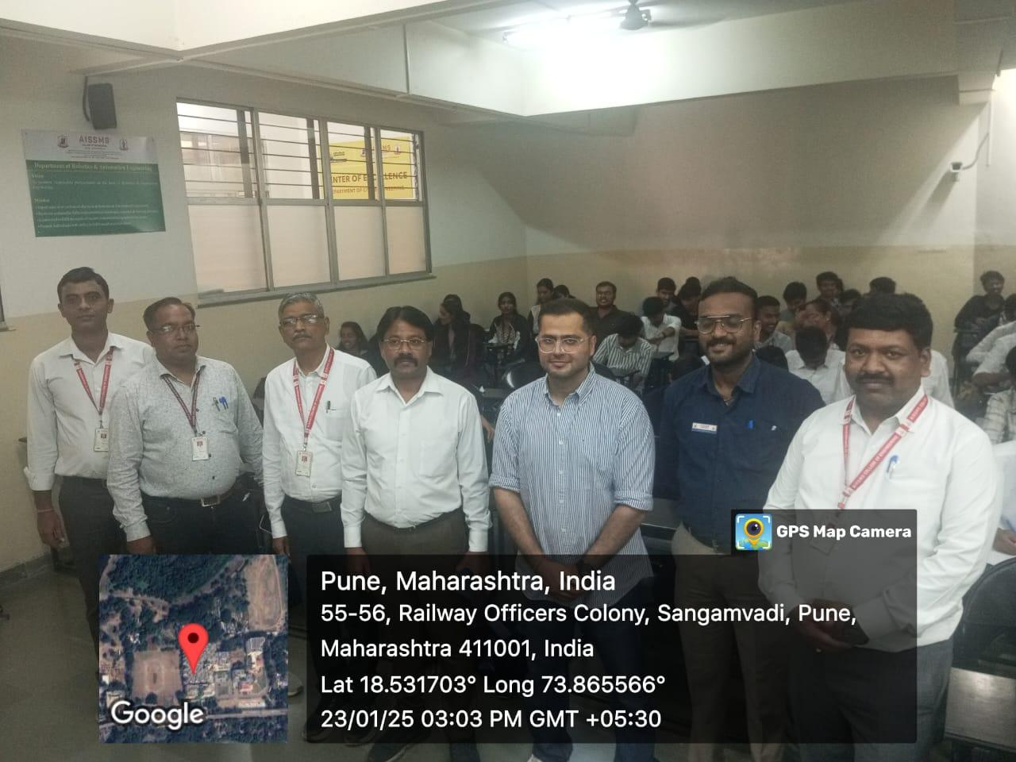

Expert Lecture on Career Opportunities after Engineering by Mr Arjun Chabra,
Ace Academy Hyderabad.
3. ACTIVITIES ORGANIZED

3.1 FDP/STTP ORGANIZED BY THE DEPARTMENT
Term One
S N | Name of faculty coordinator | Title of the FDP/STTP/WS/Seminar/Symposium | Duration/ Dates | No of Participants | Funding Agency  (If any) and Amount (Rs)

Term Two
S N | Name of faculty coordinator | Title of the FDP/STTP/WS/Seminar/Symposium | Duration/ Dates | No of Participants | Funding Agency  (If any) and Amount (Rs)

3.2 SEMINARS/ WORKSHOPS/ WEBINARS ORGANIZED BY THE DEPARTMENT
Term One
S N | Name of Coordinator/s | Title of the Seminar/Webinar | Duration/ Dates | No of Participants | Funding Agency  (If any) and Amount (Rs)
1 | Mr M P Bauskar | One-day Workshop Organized on Introduction to RoboDk | 22/10/2024 | 42 | AISSSMS COE
2

Term Two
S N | Name of Coordinator/s | Title of the Seminar/Webinar | Duration/ Dates | No of Participants | Funding Agency  (If any) and Amount (Rs)
1 | Mr Veejhay Dholle, Dr.A.S.Ubale | Expert Lecture on Role of Automation in Industry | 13/02/2025 | 40 | -
2 | Dr N G Shekapure | Optimizing Supply Chains with AI and Robotics: Trends and Innovations | 13/02/2025 | 55

3.3 CONFERENCES/ SYMPOSIUMS ORGANIZED BY THE DEPARTMENT
Term One
S N | Name of Coordinator/s | Title of the Conference / Symposium | Duration/ Dates | No of Participants | Funding Agency  (If any) and Amount (Rs)

Term Two
S N | Name of Coordinator/s | Title of the Conference / Symposium | Duration/ Dates | No of Participants | Funding Agency  (If any) and Amount (Rs)

3.4 EXTENSION ACTIVITIES CONDUCTED BY THE DEPARTMENT
(Social activities / Quizzes at national/international level/any other activity)
Term One
S N | Name of Faculty Coordinator | Details of activity conducted | Date | Number of beneficiaries
01 | Mr S N Chiwande  Dr A S Ubale | Presentation competition  on “Insight into Indian Standards and Its Benefits” | 18/10/2024 | 36
02 | Mr M A Kelkar | Engineering Today 2024 - F1 Simulation | 26/09/2024 to 27/09/2024 | 218
 | Mr Y R Chandwade | Engineering Today 2024 - RoboMaze | 26/09/2024 to 27/09/2024 | 31
03 | Dr N G Shekapure | Engineering Today 2024 - Mock Placement | 26/09/2024 to 27/09/2024 | 38
04 | Mr M L Chanpur | FORT CLEANLINESS DRIVE | 23/10/2024 | 33

Term Two
S N | Name of Faculty Coordinator | Details of activity conducted | Date | Number of beneficiaries
01 | Dr. A S Ubale | PBL Project Competition | 15/04/2025 | 38

3.5 MOU SIGNED WITH ACADEMIC AND PROFESSIONAL ORGANISATIONS
Term One
Sr No | Faculty Coordinator | Name of Organisation | Date  of MoU Signed | Valid upto  00/00/0000
1 | Dr N G Shekapure | HorizonFX, PCSIC, Auto Cluster, ‘H’ Block, Plot – C-181, M.I.D.C., Chinchwad – Pune-411018,  Maharashtra, India. | 16/10/2024 | 15/10/2029
2
3
4

Term Two
Sr No | Faculty Coordinator | Name of Organisation | Date  of MoU Signed | Valid upto  00/00/0000
1

Total Functional / Live MoU initiated by Department
Sr No | Faculty Coordinator | Name of Organisation | Date  of MoU Signed | Valid upto  00/00/0000
1 | Mr V D Dholle | Pune Heat, Bhosari, Pune | 16/04/2024 | 16/4/2029
2 | Mr M A Kelkar | TOPSONN ELECTROTEK & MACHINERY PUNE | 22/11/2023 | 22/11/2028
3 | Mr M P Bauskar | METTECHNIK Pune | 02/11/2023 | 2/11/2028
4 | Mr Y R Chandwade | VISHWA CNC Technologies Pvt Ltd Pune | 02/11/2023 | 2/11/2028
5 | Mr S S Kallurkar | Yash Plastic & Engineering Works Pune | 01/11/2023 | 1/11/2028
6 | Dr N G Shekapure | Autofina Robotics Automation Pvt Ltd Pune | 30/10/2023 | 30/10/2028
7 | Mr S N Chiwande | B & R Industrial Automation Pune | 01/03/2023 | 1/3/2028
8 | Mr N G Shekapure | ELON POWER PVT LTD Pune | 22/02/2022 | 22/2/2027
9 | Mr S K Bidgar | UB Cryogenic Solution LPP Pune | 04/03/2022 | 4/3/2027
10 | Mr S N Chiwande | PMA, Pune | 20/09/2021 | 20/9/2026
11 | Mr M L Chanpur | Aarohi Industries, Pune | 18/01/2021 | 18/1/2026
12 | Ms Y K Funde | Univision Automation, Pune | 08/01/2021 | 8/1/2026
13 | Mr S N Chiwande | BYST, Pune | 04/12/2020 | 4/12/2025
14 | Dr N G Shekapure | HorizonFX, Pune | 16/10/2024 | 15/10/2029

3.6 STUDENTS’ CHAPTERS /CLUBS
Sr No | Name of Students’ Chapter | Number of Student Members
1 | Standards Club (BIS) | 65
2 | The Robotic Society of India, Pune Chapter | 17

3.7 SOCIAL ACTIVITIES ORGANISED (NSS, Women empowerment, Awareness Programme, etc)
Term One
Faculty coordinator | Name of Activity | Date, Duration | Number of students involved
Mr M L Chanpur | FORT CLEANLINESS DRIVE | 23/10/2024 | 33

Term Two
Faculty coordinator | Name of Activity | Date, Duration | Number of students involved

3.10 SUPPORT FROM ALUMNI
Term One
Sr No | Name of Alumni | Position and Organisation | Batch  (eg 2014 – 2018) | Details of Support | Date
1 | Mr Ashwin Ayinipully | Project and Process Engineer, Fleetguard Filters Pvt. Ltd., Pune | 2020-2023 | Expert talk on Career Guidance for Abroad Studies | 23/01/2025
2

Term Two
Sr No | Name of Alumni | Position and Organisation | Batch  (eg 2014 – 2018) | Details of Support | Date
02 | Mr. Tapan Chitnis | Engineering Manager – Supply Chain Solutions, NFI Industries, Toronto, Canada | 2009-2013 | Expert Talk on "Optimizing Supply Chains with AI and Robotics: Trends and Innovations" | 13/02/205
02 | Mr. Sanket Ashok Chaskar | Management Consultant, Holcon Services Pvt. Ltd | 2013-2017 | Expert Talk on "Future-Ready Engineers: Market Trends & Essential Skills for Success" | 31/01/2025

3.11 INTERACTION WITH ALUMNI
Term One
S N | Name of Alumni and Activity Coordinator | Details of Activity conducted | Date and duration | Total Number of beneficiaries
1

Term Two
S N | Name of Alumni and Activity coordinator | Details of Activity conducted | Date and duration | Total Number of beneficiaries
1

3.12 DETAILS OF STUDENT COUNSELING AND CAREER GUIDANCE AT THE DEPARTMENT LEVEL
Number of students referred for counseling
Number of Faculty referred for counseling

Faculty coordinator | CAREER GUIDANCE ACTIVITY DETAILS
Mr M P Bauskar | Soft skill Training for TE R& A SE R & A conducted In Jan 2025
Mr M L Chanpur | Expert talk on Career Guidance for Abroad Studies by Mr Ashwin Ayinipully, Project and Process Engineer, Fleetguard Filters Pvt. Ltd., Pune on 23/01/2025.

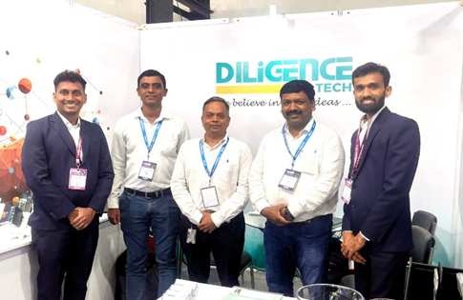Alumni Interaction - Founders, Diligence Tech Pvt Ltd | 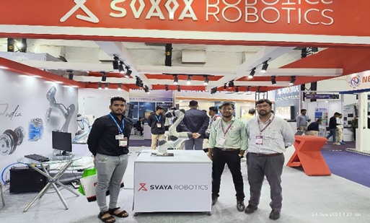Students interacting with Delegates during Automation 2024, Mumbai
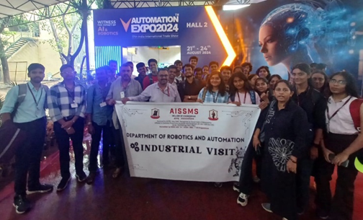
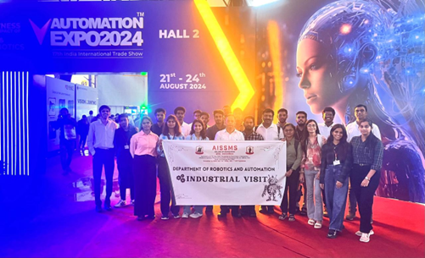
Students of SE (Robotics and Automation Engineering), TE (Robotics and Automation Engineering), and BE (Production SW Engineering) at Automation Expo 2024, Mumbai
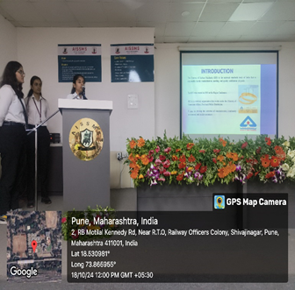 | 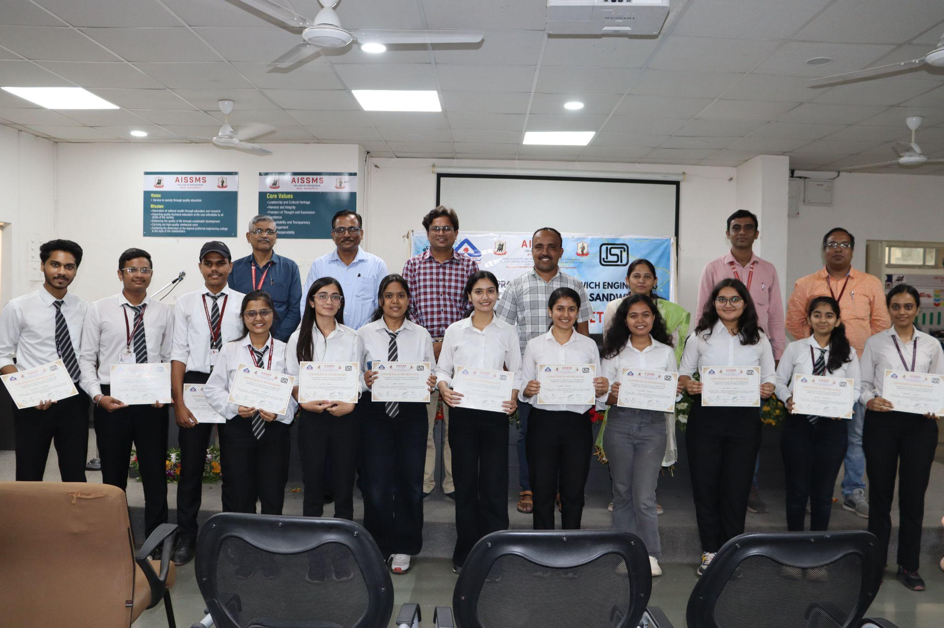
Presentation Competition on “Insight into Indian Standards and Its Benefits” organized under Standard Club on 18/10/2024.
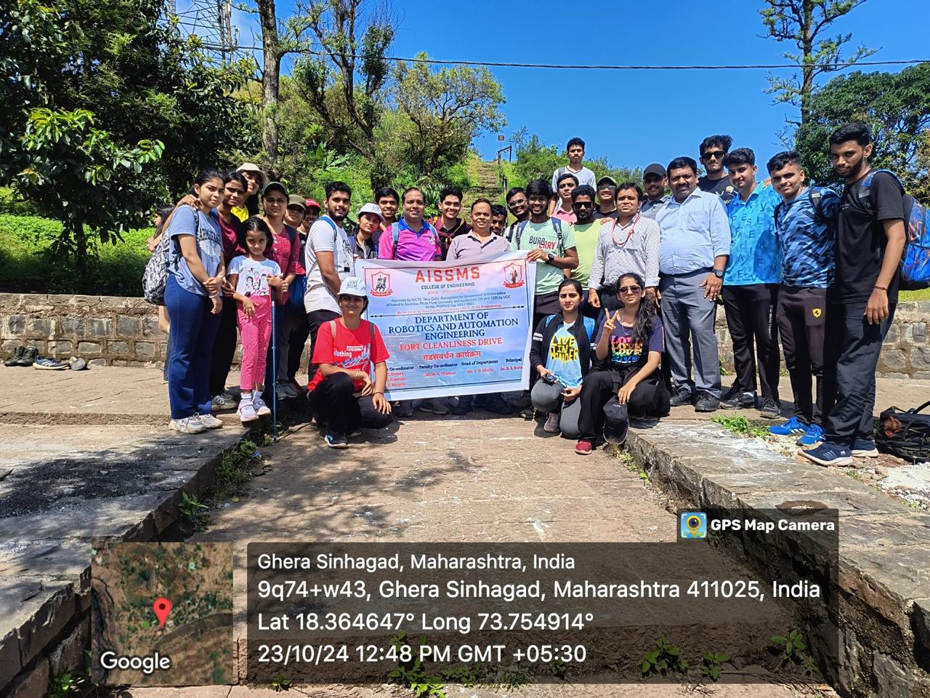 | 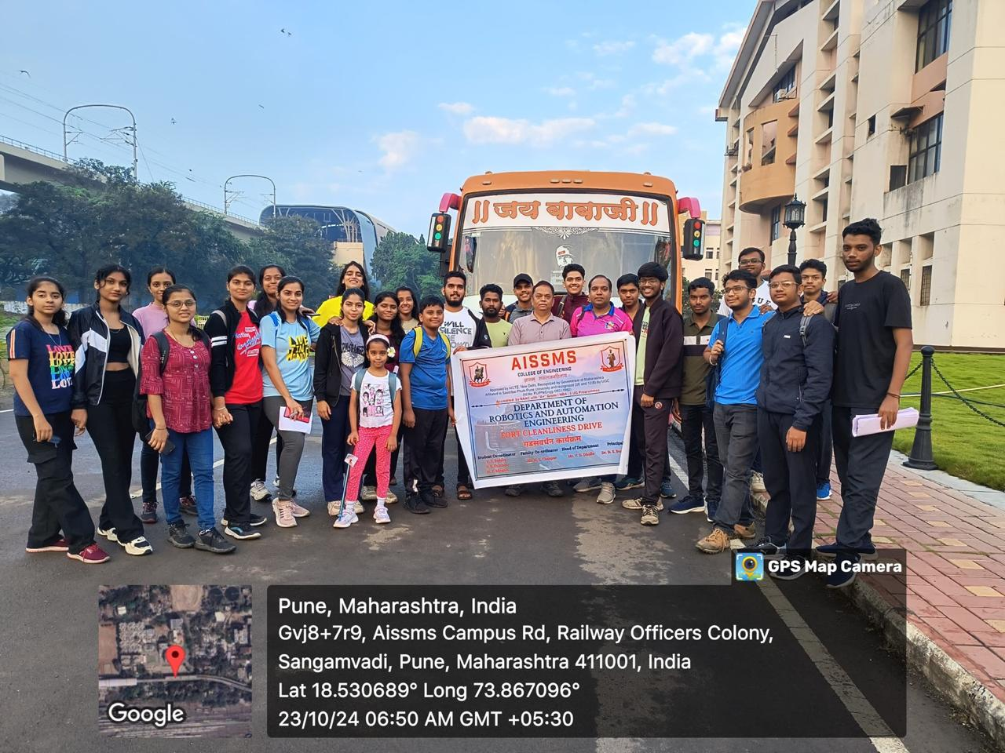
Fort Cleanliness Drive at Sinhagad
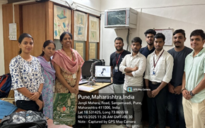 | 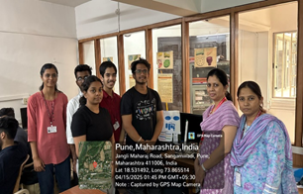
PBL Project Competition conducted on 15/04/2025

- RESEARCH CONTRIBUTION
4.1 FUNDED RESEARCH PROJECT
Term One
S N | Principal Investigator | Title of the Project | Amount Received (Rs) | Funding Agency
1

Term Two
S N | Principal Investigator | Title of the Project | Amount Received (Rs) | Funding Agency
1

FUNDING RECEIVED FOR ANY OTHER ACTIVITY
Term One
S N | Faculty Coordinator | Title of the activity | Amount Received (Rs) | Funding Agency
1

Term Two
S N | Faculty Coordinator | Title of the activity | Amount Received (Rs) | Funding Agency
1

4.2 TESTING AND CONSULTANCY
Term One
Sr No | Faculty Coordinator | Details of Testing & Consultancy Conducted | Total Revenue Generated (Rs)

Term Two
Sr No | Faculty Coordinator | Details of Testing & Consultancy Conducted | Total Revenue Generated (Rs)

4.3 PATENTS, COPYRIGHT, TRADEMARK AND OTHER (IPR)
Term One
Sr No | Name of Faculty | Name of the Patent | Patent Number and Date | Type (National/  International/Com  mercialized)
1

Term Two
Sr No | Name of Faculty | Name of the Patent | Patent Number and Date | Type (National/  International/Com  mercialized)

TOTAL PATENTS DETAILS OF THE DEPARTMENT
Sr No | Faculty Coordinator | Title of patent | Status
 |  |  | Date of Filing | Date of Publication / Grant | National / International
01 | Dr N G Shekapure | IOT Based/ Solar Empowered Agriculture Robot | 14/03/2023 | 24/05/2023 | National

TOTAL COPYRIGHT DETAILS OF THE DEPARTMENT
Sr No | Faculty Coordinator | Title of copyright | Status
 |  |  | Date of Filing | Date of Publication / Grant
1 | Dr N G Shekapure | EXCEL SHEET TO COMPILE AND EXTRACT ATTENDANCE  FROM MICROSOFT TEAMS ATTENDEE | 07/10/2021 | 29/12/2021
2 | Mr M L Chanpur | A Study of Technical and Economical Feasibility on Cryogenic Treated Plug Gauge Made of OHNS Material | 16/09/2022 | 20/10/2023

PUBLICATIONS
4.4 PAPERS PUBLISHED/ PRESENTED IN PROCEEDINGS OF CONFERENCES
Term One
S No | Authors | Document Details | Year | Conference Details | ISBN | Organized  by
01 | Dr N G Shekapure, Mr M P Bauskar | High Availability in Cloud Computing for Supply Chain Management: A Case Study on AWS | 2024 | NICET 2024 |  | AISSMSCOE
02 | M P Bauskar,  Dr N G Shekapure,  Mr V D Dholle | Experimental Investigation of Mechanical Properties of Polypropylene on adding Additive | 2024 | NICET 2024 |  | AISSMSCOE

Term Two
S No | Authors | Document Details | Year | Conference Details | ISBN | Organized  by
01 | Mr S K Bidgar | ISBN: 978-81-986567-9-7 | 2025 | 2nd National Conference on  Recent Advancements in Manufacturing  Technology & Management  RAMTM–II 2025 | 978-81-986567-9-7 | Department of Production Engineering, Jadavpur University
02 | Mr M L Chanpur | ISBN: 978-81-986567-9-7 | 2025 | 2nd National Conference on  Recent Advancements in Manufacturing  Technology & Management  RAMTM–II 2025 | 978-81-986567-9-7 | Department of Production Engineering, Jadavpur University
03 | Mr M P Bauskar | e-ISSN 2584-2137 | 2025 | First International Conference (ICRCESM-2025) | Paper presented 30 May2025

4.5 PAPERS PUBLISHED IN JOURNALS
Term One
S No | Authors | Document Details | Year | Source Details | ISBN/  ISSN | Publisher
1

Term Two
S No | Authors | Document Details | Year | Source Details | ISBN/  ISSN | Publisher
1 | M P Bauskar, | IRJEAH Vol-3 ^June 2025 | 2025 |  | e ISSN2584-2137

4.6 BOOK / ARTICLE PUBLICATIONS
Term One
Author | Title of the Book | Published by | ISBN | Year
Dr N G Shekapure | Design Thinking and Idea | Study Max Publications | 978-81-977409-1-6 | 2024

Term Two
Author | Title of the Book | Published by | ISBN | Year
Dr A S Ubale | Architecture and Protocols for Data Transmission in VANET-17(Book Chapter) | Springer Nature | eBook ISBN 978-981-96-5190-0
Dr A S Ubale | Case Studies and Real-World Deployment Examples of VANETs  (Vehicular Ad-Hoc Networks)(Book Chapter) | Springer Nature | eBook ISBN 978-981-96-5190-0

4.7 RESEARCH CITATIONS (Source of Data: Google scholar) (As on 30th May)
Name of faculty | Citations, h-index, i10 index | Name of faculty | Citations, h-index, i10 index
Dr N G Shekapure | 13, 2, 1
Mr M P Bauskar | 20,2,1
Dr A S Ubale | 4, 1, 0
Total Citations of Department:

4.8 ME AWARDED
Sr No | Name of Supervisor | Title of Thesis | Name of Candidate

4.9 PhD GUIDE DETAILS
Name of Faculty who are PhD Supervisor | Number of Scholars Registered

4.10 PhD AWARDED (For departments having PhD research centers)

Sr No | Name of Supervisor | Title of Thesis | Name of Candidate

- INTERACTION WITH INDUSTRY

5.1 INDUSTRY VISITS ORGANISED
Term One
Sr No | Faculty Coordinator | Class and Number of students attended | Industry Name and Address | Date of visit
01 | Dr N G Shekapure | BE Prod SW | Automation Expo 2024, Mumbai | 24/08/2024
02 | Mr Y R Chandwade | TE R&A | Automation Expo 2024, Mumbai | 24/08/2024
03 | Mr S S Kallurkar | SE R&A | Automation Expo 2024, Mumbai | 24/08/2024
04 | Mr S N Chiwande | TE R& A | Automation Expo 2024, Mumbai | 24/08/2024
05 | Mr S K Bidgar | SE R&A  TE R&A  BE Prod SW | Speciality Sintered Products Pvt. Ltd. Shirwal Pune | 19/10/2024

Term Two
Sr No | Faculty Coordinator | Class and Number of students attended | Industry Name and Address | Date of visit
1 | Mr Y R Chandwade | SE R&A, TE R&A, TE Prod, BE Prod | Dipex 2025 | 5/4/2025
2 | Mr S K Bidgar, M P Bauskar | TE R&A | Just Engineering, Pune | 16/4/2025
3
4
5

5.2 EXPERT LECTURES / WEBINARS DELIVERED BY INDUSTRY EXPERTS
Term One
Sr No | Faculty Coordinator | Class  (Number of students attended) | Name, Industry, designation and contact details of Expert | Topic | Date
1

Term Two
Sr No | Faculty Coordinator | Class  (Number of students attended) | Name, Industry, designation and contact details of Expert | Topic | Date
1 | Mr M L Chanpur | SE, TE Robotics and Automation and BE Mechanical | Mr Ashwin Ayinipully, Project and Process Engineer, Fleetguard Filters Pvt. Ltd., Pune | Expert talk on Career Guidance for Abroad Studies | 23/01/2025

5.3 INDUSTRY – SPONSORED PROJECTS (UG/PG) ((Excluding Sandwich Projects)
Sr No | Name of Project Guide | Title of Industry-Sponsored Project | Name of Sponsoring Industry
1

5.4 MOU SIGNED WITH INDUSTRY
Term One
Sr No | Faculty Coordinator | Name of Industry | Date  of MoU Signed | Valid upto  (00/00/0000)
1 | Dr N G Shekapure | HorizonFX, PCSIC, Auto Cluster, ‘H’ Block, Plot – C-181, M.I.D.C., Chinchwad – Pune-411018,  Maharashtra, India. | 16/10/2024 | 15/10/2029
2
3
4

Term Two
Sr No | Faculty Coordinator | Name of Industry | Date  of MoU Signed | Valid upto  (00/00/0000)
1

TOTAL FUNCTIONAL / LIVE MOU INITIATED BY THE DEPARTMENT
Sr No | Faculty Coordinator | Name of Industry | Date  of MoU Signed | Valid Upto
1 | Mr V D Dholle | Pune Heat, Bhosari, Pune | 16/04/2024 | 16/04/2029
2 | Mr M A Kelkar | TOPSONN ELECTROTEK & MACHINERY PUNE | 22/11/2023 | 22/11/2028
3 | Mr M P Bauskar | METTECHNIK Pune | 02/11/2023 | 02/11/2028
4 | Mr Y R Chandwade | VISHWA CNC Technologies Pvt Ltd Pune | 02/11/2023 | 02/11/2028
5 | Mr S S Kallurkar | Yash Plastic & Engineering Works Pune | 01/11/2023 | 01/11/2028
6 | Dr N G Shekapure | Autofina Robotics Automation Pvt Ltd Pune | 30/10/2023 | 30/10/2028
7 | Mr S N Chiwande | B & R Industrial Automation Pune | 01/03/2023 | 01/03/2028
8 | Mr N G Shekapure | ELON POWER PVT LTD Pune | 22/02/2022 | 22/02/2027
9 | Mr S K Bidgar | UB Cryogenic Solution LPP Pune | 04/03/2022 | 04/03/2027
10 | Mr S N Chiwande | PMA, Pune | 20/09/2021 | 20/09/2026
11 | Mr M L Chanpur | Aarohi Industries, Pune | 18/01/2021 | 18/01/2026
12 | Ms Y K Funde | Univision Automation, Pune | 08/01/2021 | 08/01/2026
13 | Mr S N Chiwande | BYST, Pune | 04/12/2020 | 04/12/2025
14 | Dr N G Shekapure | HorizonFX, Pune | 16/10/2024 | 15/10/2029

5.5 FACULTY MEMBERS UNDERGONE INDUSTRIAL TRAINING
Term One
Sr No | Name of Faculty | Name of Industry | Dates and Duration
1
2
3
4
5
6

Term Two
Sr No | Name of Faculty | Name of Industry | Dates and Duration
1 | Mr Mohan L Chanpur | Speciality Sintered Products Pvt Ltd, Shirwal | 09/06/2025 – 20/06/2025  (2 Weeks)
2 | Mr Sandip K Bidgar | Speciality Sintered Products Pvt Ltd, Shirwal | 09/06/2025 – 20/06/2025  (2 Weeks)

5.6 STUDENTS UNDERGONE IN-PLANT TRAINING AND (OR) INTERNSHIP PROGRAMME (Excluding Sandwich Training)
Term One
Sr No | Name of the Student | Name of the Industry | Class | Training duration
 |  |  |  | Start date | Last date | Duration (days)

2024-25 Term Two
Sr. No. | Name of the Student | Name of the Industry | Class | Training duration
 |  |  |  | Start date | Last date | Duration (days)
1 | Avani Anand Alurkar | SYNCAXIS Engineering And Integration | TE R&A | 25-12-2024 | 25-01-2025 | 31
2 | Siddhi Bahirat | Svr Robotics | TE R&A | 23-12-2024 | 17-01-2025 | 25
3 | Prathamesh Yuvraj Bodake | Automax Robotics | TE R&A | 23-12-2024 | 23-01-2025 | 31
4 | Swayam Chaudhari | Automax Robotics Pvt. Ltd. | TE R&A | 08-11-2024 | 27-01-2025 | 80
5 | Harshada Uday Daddikar | SVR ROBOTICS | TE R&A | 23-12-2024 | 17-01-2025 | 25
6 | Vaibhavi Darda | Syncaxis | TE R&A | 25-12-2024 | 25-01-2025 | 31
7 | Rohit Divekar | Syncaxis | TE R&A | 25-12-2024 | 25-01-2025 | 31
8 | Ragul Gaunder | SVR Robotics | TE R&A | 23-12-2024 | 17-01-2025 | 25
9 | Sakshi Siddheshwar Ghodke | SVR Robotics Pvt. Ltd. | TE R&A | 23-12-2024 | 23-01-2025 | 31
10 | PARTH KANATE | FOODVEZ PVT.LTD | TE R&A | 25-12-2024 | 25-01-2025 | 31
11 | Khushi Karde | Haosen automation company | TE R&A | 24-12-24 | 25-01-25 | 32
12 | Ayush Khonde | AUTOMAX ROBOTICS | TE R&A | 11-12-2024 | 27-01-2025 | 47
13 | Anjali Rahul Konde | PHN Technology | TE R&A | 30-12-2024 | 30-01-2025 | 31
14 | Diyan Kothari | Automax Robotics | TE R&A | 23-12-2024 | 23-01-2025 | 31
15 | Sumit Shivappa Kumbhar | Automax robotics pvt ltd | TE R&A | 23-12-2024 | 23-01-2025 | 31
16 | Mitesha Dange | Podium System Pvt Ltd | TE R&A | 18-11-2024 | 24-01-2025 | 67
17 | Sushrut Munje | Foodvez pvt ltd | TE R&A | 25-12-2024 | 25-01-2025 | 31
18 | Sarthak Pande | Foodvez pvt ltd | TE R&A | 25-12-2024 | 25-01-2025 | 31
19 | Falguni Pawar | PHN Technology | TE R&A | 30-12-2024 | 30-01-2025 | 31
20 | Pritish Mudaliar | Automax Robotics | TE R&A | 23-12-2024 | 23-01-2025 | 31
21 | sunidhi sakpal | SVR Robotics | TE R&A | 23-12-2024 | 17-01-2025 | 25
22 | VAISHNAVI SHARMA | BOLT IOT | TE R&A | 27-12-2024 | 27-01-2025 | 31
23 | Aryen Shitole | Matrix Robotics Pvt.Ltd | TE R&A | 01-02-2025 | 28-02-2025 | 27
24 | Vyankatesh Pandharpurkar | AUTOMAX ROBOTICS PVT LTD | TE R&A | 08-11-2024 | 27-01-2025 | 80
25 | Sarvesh Waghode | AUTOMAX PVT.LTD | TE R&A | 08-11-2024 | 27-01-2025 | 80
26 | Srushti Dipak Deshmukh | Cybernetik Technologies pvt ltd | TE R&A | 23-12-2024 | 23-01-2025 | 31
27 | Sanika Sanjay Dongare | Cybernetik technologies Pvt Ltd | TE R&A | 23-12-2024 | 23-01-2025 | 31
28 | Gaurav Kale | Robonist tech solutions Pvt Ltd | TE R&A | 23-12-2024 | 23-12-2025 | 31
29 | Chaitanya Santosh Kalshetti | Cybernetik Technologies Pvt.Ltd. | TE R&A | 23-12-2024 | 23-01-2025 | 31
30 | Masira Azim Kazi | Cybernetik Technologies Pvt Ltd | TE R&A | 28-12-2024 | 28-01-2025 | 31
31 | Aditya Ramnaresh Yadav | SVR ROBOTICS | TE R&A | 23-12-2024 | 17-01-2025 | 25
32 | Aarya Salunkhe | PHN Technologies | TE R&A | 30-12-2024 | 30-01-2025 | 31
33 | Sujay Subhash Ankalgi | Pune Heat | TE R&A | 23-12-2024 | 17-1-20225 | 25

5.7 LIST OF INDUSTRIES SUPPORTED IN THE ORGANISATION OF WORKSHOPS/SEMINARS/WEBINARS/CONFERENCES/COURSES AND ANY OTHER CONTRIBUTION OF INDUSTRY
Term One
Sr  No | Faculty Coordinators | Industry Representative and Name of Industry | Nature of Contribution
1 | Mr M P Bauskar | Mr Sagar Mangrulkar Automax Robotics | Expert talk for One day

Term Two
Sr  No | Faculty Coordinators | Industry Representative and Name of Industry | Nature of Contribution
01 | Mr M L Chanpur | Mr Praskash Salukhe, CadMech Engineering Pvt Ltd, Pune | Six months training to student

5.8 TRAINING TO INDUSTRY PERSONNEL/ ACTIVITY SUPPORTING TO INDUSTRY
Term One
Sr No | Faculty Coordinator | Technical Area in which Training Provided / Type of Support | Industry Name

Term Two
Sr No | Faculty Coordinator | Technical Area in which Training Provided / Type of Support | Industry Name

5.9 ANY OTHER ACTIVITIES TO PROMOTE INTERACTION WITH INDUSTRY
Term One
Sr No | Faculty coordinator | Name of Activity | Remark
1 | Dr N G Shekapure | Industry Institute Interaction Visit to Horizon Graphics | MOU signing, securing internships for students, knowledge and experience sharing.

Term Two
Sr No | Faculty coordinator | Name of Activity | Remark
1 | Dr.A.S.Ubale | Industry Institute Interaction Visit to PHN Technology | MOU Enquiry ,securing internships for students,
5.10 STUDENTS UNDERGONE SANDWICH TRAINING (For Mechanical & Production departments)
Term One
Sr No | Name of student | Industry | Sr No | Name of student | Industry
01 | ANUP SURESH MANE | Thermax Ltd, Bhosari | 06 | MANE YUVRAJ RAJKUMAR | Bekaert, Ranjangaon
02 | BHISE SULAKSHAN PRAKASH | Mettechnik, Bhosari | 07 | MITALI PARAMANAND HURDALE | Vanaz, Kothrud
03 | BHOSALE SHRADDHA SUNIL | Mettechnik, Bhosari | 08 | RIYANSHU DEEPAK RAWAL | Vanaz, Kothrud
04 | DHUMAL BHUVAN SHEKHAR | Twin Engineers, Bhosari | 09
05 | HINGE TEJAS SANJAY | Mettechnik, Bhosari | 10

Term Two
Sr No | Name of student | Industry | Sr No | Name of student | Industry
01 | ATIWADKAR PARTH PANDIT | Sadhana NDT Services LPP | 14
02 | BHAGAT HARSHADA HARI | Cummins India Ltd, Kothrud | 15
03 | GADAKH ABHISHEK ASHOKRAO | Twin Engineers, Bhosari | 16
04 | HANDE VAISHNAVI GANESH | L&T, Ahilyanagar | 17
05 | KACHI ADITYA GIRISH | Vanaz Engineers Ltd, Kothrud | 18
06 | KHADKE UMESH BALASAHEB | CADMECH Engineering Pvt Ltd, Narhe | 19
07 | NAVSUPE TEJAS POPAT | Twin Engineers, Bhosari | 20
08 | KADAM ADITYA UDAY | Star Engineers (I) Pvt. Ltd., Chinchwad | 21

Industrial Visit at Specially Sintered Pvt Ltd Shirwal on 01 December 2023 for SE Production SW and Robotics & Automation Students

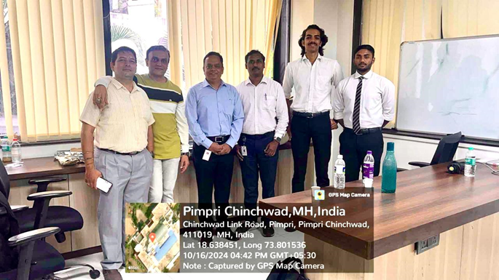
Industry Institute Interaction Visit to Horizon Graphics

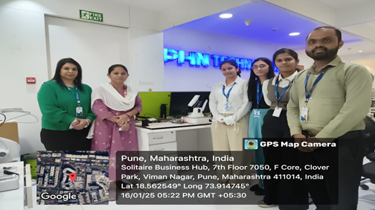
Industry Institute Interaction Visit to PHN Technology

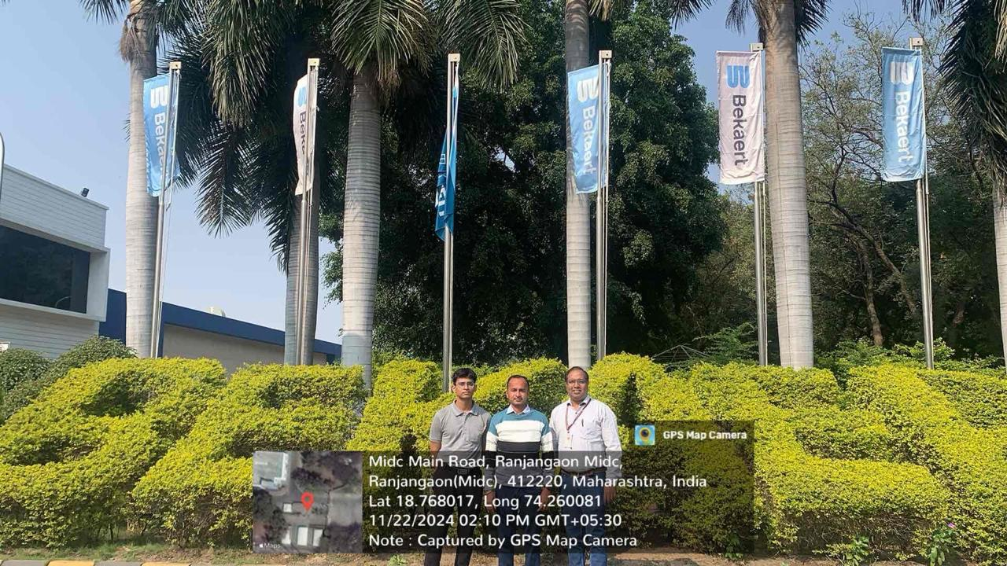
Visit to Bekaert Industries, Ranjangaon for IIT student activity.
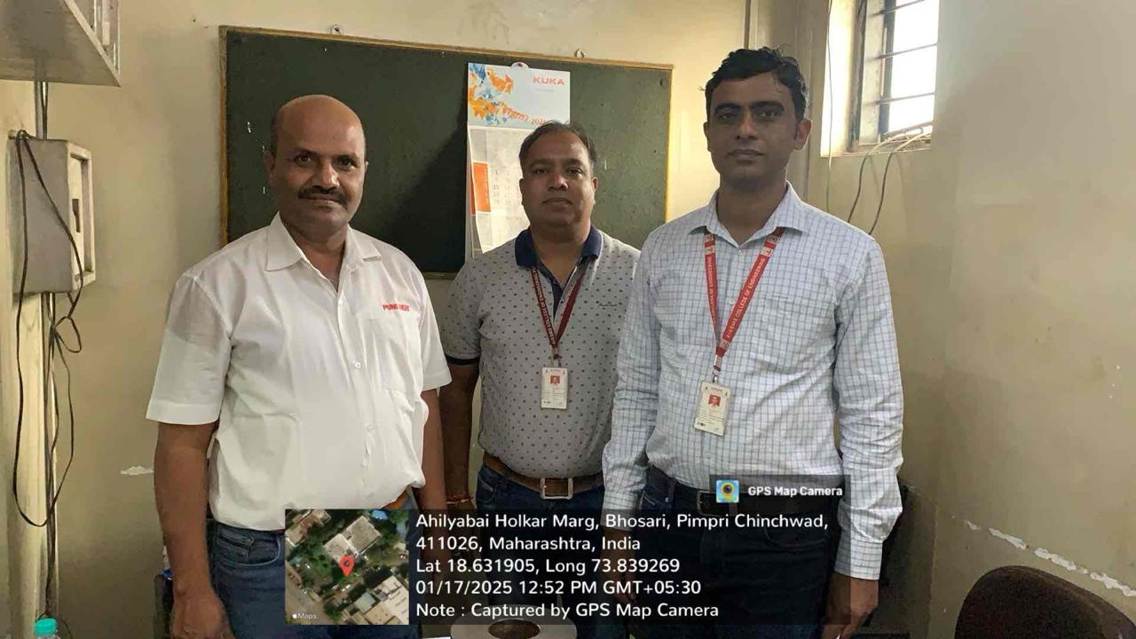
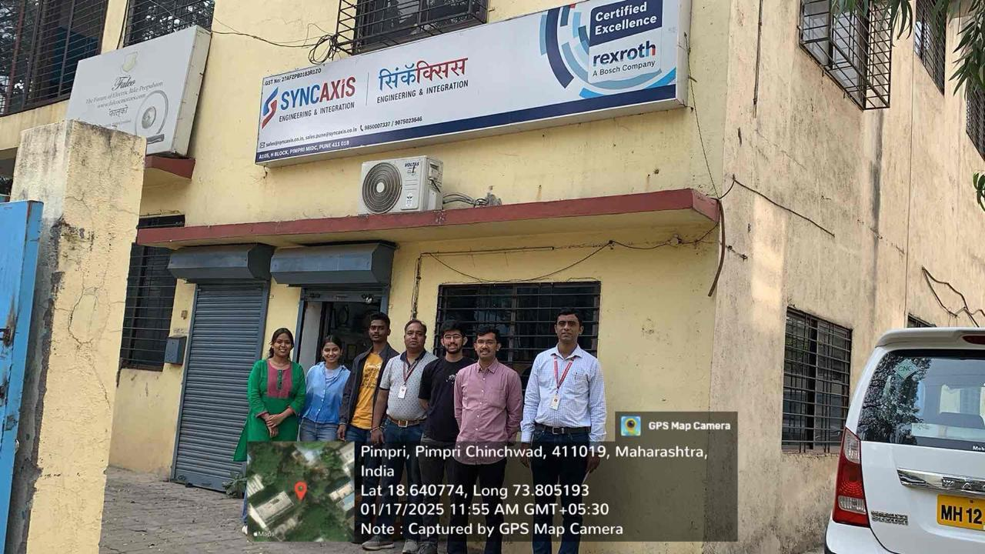
Visit to Pune Heat, Bhosari for TE internship student activity.
Visit to Syncaxis, Bhosari for TE internship student activity.

6. STUDENTS’ ACHIEVEMENTS

6.1 STUDENTS’ ACHIEVEMENT (Professional) (Individual Level) (Technical activities such as design competitions, paper presentations, technical quizzes, Product development, innovation, etc)
Term One
Name of Student |  | Details of Achievement (State/University/ National/International Level) | Remark  (Domain)
Term Two
Name of Student | Details of Achievement (State/University/ National/International Level) |  | Remark  (Domain)

6.2 STUDENTS’ ACHIEVEMENTS (other than Professional) (Individual Level) (Social activities, etc)
Term One
Name of Student | Details of Achievement (State/University/ National/International Level) | Remark  ((Domain)

Term Two
Name of Student | Details of Achievement (State/University/ National/International Level) | Remark  ((Domain)
Krishna Gadewar and Ganesh Pal | AISSMS College of Engineering's Triumphant Run at Techkriti 2025, IIT Kanpur: A Deep Dive into Innovation, Collaboration, and Engineering Excellence (Student Krishna Gadewar and Ganesh Pal) - Winners of the event. AISSMS College of Engineering students, in collaboration with Team Xenon and Quantumcube, achieved significant success at Techkriti 2025. | First Prize

6.3 CERTIFICATE / ONLINE COURSES COMPLETED BY STUDENTS (Certificate courses, value added courses, MOOC, etc)

Term One
S N | Name of Student | Title of the Course | Conducted By | Duration/ Dates
1
2
3
4
5
6
7
8
9
10
11
12
13
14
15
16
17
18
19
20
21
22

Term Two
S N | Name of Student | Title of the Course | Conducted By | Duration/ Dates

6.4 NUMBER OF STUDENTS PLACED
Term One
Sr No | Name of Student Placed | Name of Organization | Package
1
2

Lower Package Offered: Lakhs
Higher package Offered: Lakhs
Average Package Offered: Lakhs
6.5 NUMBER OF STUDENTS QUALIFIED IN THE EXAMINATIONS (GATE, GRE, UPSC, MPSC, CAT, TOEFL, any other examination)
Sr No | Name of Student | Examination | Examination / registration number
 | Nil

6.6 SPORTS / CULTURAL ACHIEVEMENTS OF STUDENTS (Individual Level) (Team level achievements to be mentioned in institute level sports/Cultural committee report)
Term One
Name of Student | Details of Achievement (State/University/ National/International Level) | Remark  (Domain)

Term Two
Name of Student | Details of Achievement (State/University/ National/International Level) | Remark  (Domain)

6.7 STUDENTS’ ACHIEVEMENTS (Team Level)
Term One
Name of Event | Name of Faculty Advisor | Details of Achievement (State/University/ National/International Level) | Remark  (Domain)

Term Two
Name of Event | Name of Faculty Advisor | Details of Achievement (State/University/ National/International Level) | Remark  (Domain)

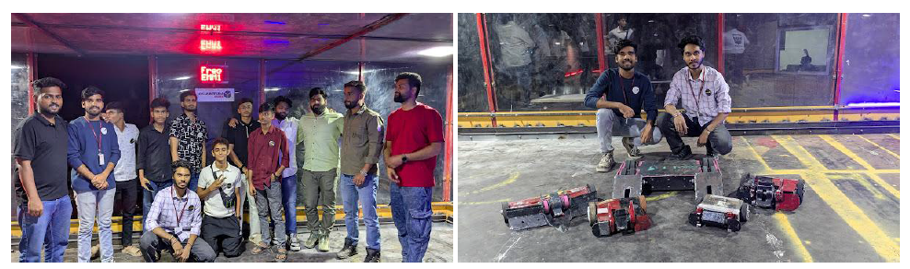
AISSMS College of Engineering's Triumphant Run at Techkriti 2025, IIT Kanpur: A Deep Dive into Innovation, Collaboration, and Engineering Excellence (Student Krishna Gadewar and Ganesh Pal) - Winners of the event. AISSMS College of Engineering students, in collaboration with Team Xenon and Quantumcube, achieved significant success at Techkriti 2025.

7. SUMMARY
AND
SWOC ANALYSIS

7.1 ANY OTHER NOTEWORTHY ACHIEVEMENT OF THE DEPARTMENT (Not mentioned above)
Sr No | Details
7.2 MISCELLANEOUS (SYLLABUS IMPLEMENTATION, MAJOR ADDITION IN INFRASTRUCTURE AND FACILITY, INNOVATIONS INTRODUCED, ETC)
FACULTY | ACTIVITY

7.3 FEEDBACK FROM STAKEHOLDERS

Sr No | Stake holder | Number of Feedbacks Received | Overall Feedback
1 | Alumni | 2 out of 7 | All POs are satisfied
2 | Parents | 2 out of 7 | All POs are satisfied
3 | Employers | 2 out of 7 | All POs are satisfied
4 | Students | 2 out of 7 | All POs are satisfied

7.4 TWO BEST PRACTICES FOLLOWED IN THE DEPARTMENT
Developing Teaching-Learning Materials: The department prioritizes the development of high-quality teaching-learning materials. This includes creating comprehensive course materials, presentations, and digital resources that are accessible to students. By investing in well-structured and up-to-date educational materials, the department enhances the teaching process, making it more engaging and effective for both faculty and students. Regularly updating these materials to align with the latest developments in the field ensures that students receive the most relevant and valuable education.

Industry-Embedded Projects and Internships: To establish and maintain strong connections with industry, the department encourages students to engage in industry-embedded projects and internships. These experiences provide students with practical exposure to real-world challenges and solutions, allowing them to apply their academic knowledge in a professional context. By collaborating with industry partners, the department ensures that its curriculum remains industry-relevant and that students are well-prepared for future employment. These connections often lead to better placement opportunities for students and foster ongoing collaboration between the department and industry stakeholders.

7.5 MAJOR GRIEVANCES OF STUDENTS (IF ANY) REDRESSED
Nil

7.6 SWOC ANALYSIS
Five major strengths, weaknesses, opportunities, and challenges (SWOC) of the department and future plans of the Department
Strengths:
1 | Liasoning With Industries: The department's strong relationships with industries provide valuable insights, resources, and potential collaboration opportunities, enhancing students' practical knowledge.
2 | Industry Exposure: Students benefit from exposure to real-world industry practices, which can better prepare them for the job market and foster a deeper understanding of their field.
3 | Experienced Faculty & Good Retention Ratio: Having experienced faculty members contributes to the quality of education. A high retention ratio indicates faculty satisfaction and stability, which is crucial for maintaining academic excellence.
4 | Specialized Facilities: Mention any state-of-the-art facilities or equipment the department has access to, which can further enhance teaching and learning capabilities.
5 | Strong Alumni Network: A strong alumni network can provide mentorship, job opportunities, and financial support to the department.

Weaknesses:
1 | Less Number of PhD Faculty: To enhance research and academic credibility, the department should focus on recruiting and retaining more PhD-qualified faculty members.
2 | Limited Consultancy and Research Grants: Insufficient funding for consultancy and research projects hampers innovation and collaboration with industries, hindering the department's growth.
3 | Few R&D Funded Projects: A low number of research and development funded projects limit opportunities for faculty and students to engage in cutting-edge research.
4 | Outdated Infrastructure: If there are any infrastructure limitations or outdated equipment, they should be addressed to stay competitive.
5 | Limited Publication Output: The department's faculty should aim to increase their research publication output, contributing to the academic prestige of the institution.

Opportunities:
1 | Utilization of Industrial Laboratories: The department can maximize the use of industrial laboratories for practical training and collaborative research during the students Industrial Inplant Training
2 | Partnerships Through MoUs: By entering into Memorandums of Understanding with industries, the department can expand opportunities for training programs, consultancy, and joint projects.
3 | Faculty Qualification and Up-Gradation: Supporting faculty in pursuing higher qualifications and professional development can enhance their teaching and research capabilities.
4 | Diversify Research Funding: Explore diverse sources of research funding, including government grants, private organizations, and international collaborations.
5 | Online and Hybrid Education: Leveraging online and hybrid teaching methods can help reach a broader student base and expand the department's influence.

Challenges
1 | Placement in Core Companies: Ensuring that students are placed in core companies related to their field of study can be challenging in a competitive job market.
2 | Improving Patents and Copyrights: Encouraging faculty and students to engage in innovative research and seek patents and copyrights can be a lengthy process and may require additional resources.
3 | Attracting Students for New Programs: Attracting students to Robotics and Automation programs may be challenging due to changing industry demands and competition from tech branches.
4 | Balancing Research and Teaching: Faculty may face difficulty in maintaining a balance between teaching and research, impacting the quality of both.
5 | Financial Sustainability: Securing long-term financial sustainability for the department to support its growth and development is an ongoing challenge. Future plans should address this concern through strategic initiatives and fundraising efforts.

7.7 FUTURE PLANS OF THE DEPARTMENT (For Next Academic Year)
1 | Enhance PhD Faculty Enrollment: The department aims to enroll a maximum number of faculty members for PhD programs to bolster research and academic excellence.
2 | Strengthen Industry Connections for Placement: The department will intensify efforts to strengthen its industry connections, facilitating increased placement opportunities for students.
3 | Expand Robotics and Automation Lab: There are plans to develop and expand the Robotics and Automation Lab, providing cutting-edge resources for research and hands-on learning in this rapidly evolving field.
4 | Implement Smart Classrooms: The department will implement smart classrooms to enhance the effectiveness of the teaching and learning process, leveraging technology for a more interactive and engaging educational experience.

7.8 INITIATIVES TAKEN BY THE DEPARTMENT AT DEPARTMENT AND INSTITUTE LEVEL TO IMPROVE AND ASSURE QUALITY IN THE FOLLOWING AREAS

Area | Initiatives
Academics and overall profile of Department | - To prepare course manual according to Blooms Taxonomy.  - To participate students’ projects in National Design Research Forum competition, paper presentation, BAJA, SUPRA, EFFICYCLE and GARUDSHWA competitions.  - Students are motivated to participate various sports and cultural activities.
Organization of different activities | - Alumni Interactive sessions for the students
Research and Innovation | - Faculty members are provided with financial assistance and research grants to conduct research.  - As part of a commitment to fostering academic excellence, the department is actively promoting faculty development through doctoral programs. Currently, four dedicated faculty members are pursuing their PhDs in their respective fields.
Industry institute Interaction | - Faculties are establishing contact with Industries, arranging guest lecture and students’ projects with industry. Students’ internship in Industry, industry visit and participation on advisory board.
Students’ Achievements | - Students are motivated to participate in various sports and cultural activities and for competitive examination.

SUMMARY SHEET (Annual)
 |  | Activity
S N | Activity/ Item | Term I | Term II | Total
 |  | Numbers
1 | Students in the department
FACULTY CONTRIBUTION
2 | e content development by faculty and available online
3 | Number of FDP/STTP attended by the department faculty
4 | Number of Seminars/ workshops/ webinars attended by the department faculty
5 | Number of Conferences/ symposiums attended by the department faculty
6 | Number of Online courses / certificate courses completed by department faculty
7 | Number of extension lectures / webinars (Lectures delivered on other than technical topics))
8 | Number of Faculty served as resource person, expert, chairperson
ACTIVITIES ORGANISED
9 | Number of FDP/STTP organized by the department
10 | Number of Seminars/ workshops/ webinars organized by the department (for faculty)
11 | Number of Conferences/ symposiums organized by the department (for faculty)
12 | Number of Extension activities conducted by the department (Social/ Quizzes at national/international level/any other activity)
13 | MOU signed with academic and professional organizations
14 | Number of Students’ chapters /clubs
15 | Number of Social activities organized
16 | Number of Parent meeting
17 | Number of Alumni meet
18 | Number of student counseling and career guidance at the department level
RESEARCH CONTRIBUTION
19 | Number of Funded research project
20 | Number of Testing and consultancy
21 | Number of Patents, copyright, trademark and other (IPR)
22 | Number of papers published/ presented in proceedings of conferences
23 | Number of Papers published in journals
24 | Number of Book/ article publications
25 | Total Research citations (Google Scholar)
26 | Number of ME awarded
27 | Number of PhD Awarded
INTERACTION WITH INDUSTRY
28 | Number of Industrial visits organized
29 | Number of Expert lectures delivered by industry experts
30 | Number of Industry –sponsored projects (UG/PG)
31 | Number of MOU signed with industry
32 | Number of Faculty members undergone industrial training
33 | Number of Students undergone in-plant training and (or) internship programme
34 | Number of students placed
35 | Number of students qualified in the competitive examinations
36 | Any other additional activities organized

Declaration by the Head of the Department

I am aware that the above information provided by the Department will be validated by the AAA committee during the visit

Name and Signature
Head of Department

