Below data is to be updated in Department of mechanical engineering tab under Student’s Achievements tab

Student of BE Mechanical bagged 3 prizes from Savitribai Phule Pune University being university topper

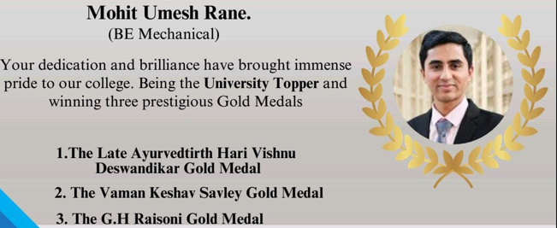

Mr Siddharth Jagtap from BE Mechanical won Silver medal Rank: -2 at State Archery Championship on 5th and 6th January in Senior Olympic style Recurve Category and selected for representing Maharashtra and Team Maharashtra at National Ranking Archery Championships held by NTPC at Jharkhand

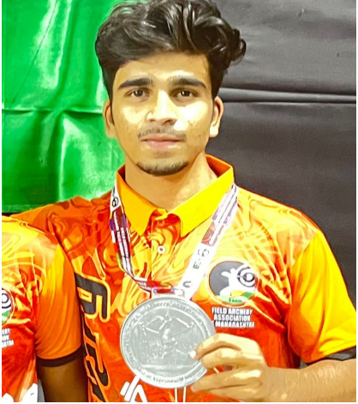

Mr. Ashish Anthony Overall General Secretary from BE Mechanical awarded with Rs 31,000/- Cash prize as best all-rounder student of the year. during Bank of Baroda achievers Award Ceremony on date 25.03.2025

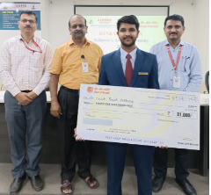

The 2025 season saw Team Resonance Racing India achieve remarkable success, securing top rankings in multiple categories at SAE mBAJA. 4.1 Event Results:

- AIR 1 - Sustainability (Best eco-friendly and efficient design implementation)
- AIR 2 - Manoeuvrability (Outstanding vehicle handling and agility)
- AIR 3 - Cost Evaluation (Efficient cost management without compromising performance)
- AIR 3 - Overall Dynamics (Superior suspension, stability, and handling)
- AIR 3 - CAE (Computer-Aided Engineering) (Advanced simulation and analysis techniques)
- Overall AIR 2 (Consistently among the best-performing teams)

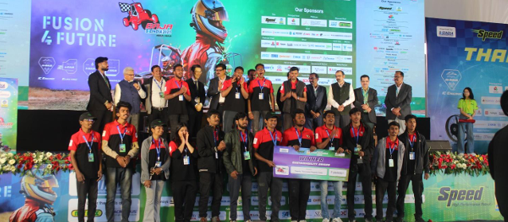
Students of TE Mechanical Engineering (Mr Samar Patil, Mr Aaryan Patil, Mr Omkar Tigote, Ms Tanaya Otari, Ms Mugdha Kirve, Mr Atharva Deshpande) participated in DIPEX 2025 and won the second prize in energy section.

