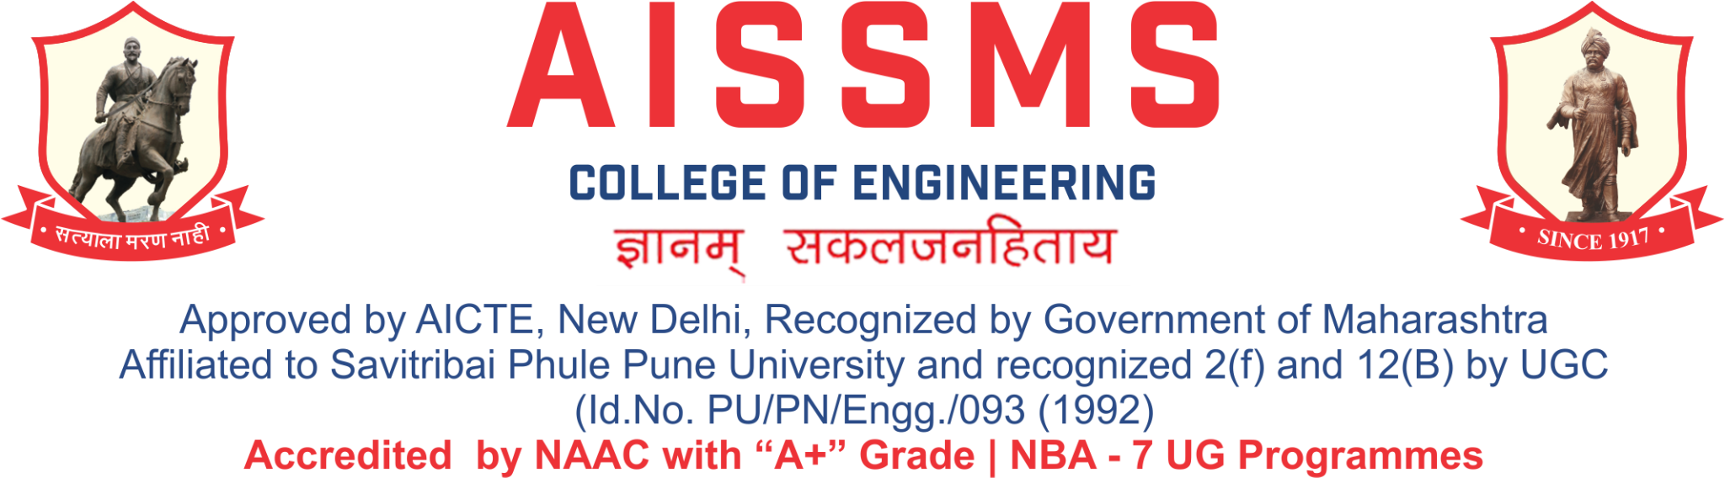
Internal Quality Assurance Cell

DEPARTMENT OF COMPUTER ENGINEERING
ANNUAL REPORT
(TERM ONE: 15 June to 30 November )
TERM TWO: 01 December to 14 June

Academic Year 2023 – 24
Guidelines:
Fill up this sheet for all the contributions /activities conducted at Department level only.
- In case data does not exist please mention it as ‘No Data’.
- Please add rows to the table below to suit your requirements
- Ensure that data does not differ from other official records and all the supporting documents are available.
- Use: Font Type: Times New Roman, Font Size: 12, Sentence case, Spacing: 1.15
- Use separate row for every details.
- For any queries, you may contact: Dr C S Choudhari, Coordinator, IQAC
- email: iqac@aissmscoe.com



CONTENTS
Sr No | Activity/ Item | Page No
- PROFILE OF DEPARTMENT
1.1 | Introduction | 6
1.2 | Laboratories in the Department | 6
1.3 | Software Available in the Department | 6
1.4 | Faculty in the Department | 7
1.5 | Details of Supporting Staff | 8
1.6 | Students’ Enrollment | 9
1.7 | Students–Faculty Feedback Details | 9
1.8 | Result Analysis | 11
1.9 | Class Result Analysis | 12
 | - FACULTY CONTRIBUTION
2.1 | Achievements of Faculty | 16
2.2 | Contribution of Faculty (Interaction With Outside World) | 17
2.3 | e content developed by faculty and available online | 18
2.4 | FDP/STTP attended by the department faculty | 21
2.5 | Seminars/ workshops/ webinars attended by the department faculty | 28
2.6 | Conferences/ symposiums attended by the department faculty | 29
2.7 | Online courses / certificate courses completed by department faculty | 30
2.8 | Extension lectures / webinars organized | 31
2.9 | Faculty served as resource person, expert, chairperson | 31
- ACTIVITIES ORGANISED
3.1 | FDP/STTP organized by the department | 34
3.2 | Seminars/ workshops/ webinars organized by the department (for faculty) | 34
3.3 | Conferences/ symposiums organized by the department | 35
3.4 | Extension activities conducted by the department | 36
3.5 | MOU signed with academic and professional organizations | 36
3.6 | Students’ chapters /clubs | 41
3.7 | Social activities organized | 42
3.8 | Parent meeting | 42
3.9 | Alumni meet | 43
3.10 | Support from Alumni | 43
3.11 | Interaction with Alumni | 43
3.12 | Student counseling and career guidance at the department level | 43
- RESEARCH CONTRIBUTION
4.1 | Funded research project | 45
4.2 | Testing and consultancy | 46
4.3 | Patents, copyright, trademark and other (IPR) | 47
4.4 | Papers published/ presented in proceedings of conferences | 48
4.5 | Papers published in journals | 48
4.6 | Book/ article publications | 54
4.7 | Total Research citations | 55
4.8 | ME awarded | 55
4.9 | PhD guide details | 55
4.10 | PhD AWARDED | 55
 | - INTERACTION WITH INDUSTRY
5.1 | Industrial visits organized | 58
5.2 | Expert lectures delivered by industry experts | 58
5.3 | Industry –sponsored projects (UG/PG) | 60
5.4 | MOU signed with industry | 62
5.5 | Faculty members undergone industrial training | 63
5.6 | Students undergone in-plant training and (or) internship programme | 63
5.7 | Support from Industry | 79
5.8 | Training to Industry personnel/ Activity Supporting industry | 79
5.9 | Any other activities to Promote Interaction With Industry | 79
5.10 | Students Undergone Sandwich Training | 80
- STUDENTS’ ACHIEVEMENT
6.1 | Students’ Achievement (Professional) (Individual Level) | 82
6.2 | Students’ Achievement (Other than Professional) (Individual Level) | 83
6.3 | Certificate / Online Courses Completed by Students | 88
6.4 | Number of Students Placed | 89
6.5 | Number of Students qualified in the competitive examinations | 90
6.6 | Sports / Cultural Achievements of Students (Individual Level) | 90
6.7 | Students’ Achievements (Team Level) | 92
 | - SUMMARY AND SWOC ANALYSIS
7.1 | Any other noteworthy achievement of the department | 93
7.2 | Miscellaneous (Syllabus Implementation, Major Addition In Infrastructure And Facility, Innovations Introduced, etc.) | 93
7.3 | Feedback from Stakeholders | 93
7.4 | Two Best Practices Followed in the Department | 93
7.5 | Major Grievances of Students (If Any) Redressed | 93
7.6 | SWOC Analysis | 93
7.7 | Future Plans of the Department | 94
7.8 | Initiatives Taken By The Department At Department And Institute Level To Improve And Assure Quality | 95
 | Summary Sheet (Annual) | 95

- PROFILE
OF
DEPARTMENT

1.1 INTRODUCTION
Year of Establishment | 10.09.1998
UG Programmes | 1
PG Programmes | 1
Number of Teaching Staff | 21
Number of Non-Teaching Staff | 11

1.2 LABORATORIES IN THE DEPARTMENT
Name of Laboratory
1.Linux Laboratory (115) | 2.Computer Network Laboratory (116)
3.Computer Design Laboratory (120) | 4.Computer software Laboratory(121)
5.Microprocessor Laboratory (101) | 6.Digital & Hardware Laboratory (102)
7.Multimedia Laboratory (119) | 8.Project Laboratory (227)

1.3 SOFTWARES AVAILABLE IN THE DEPARTMENT
Software Available
1. Rational Rose (30 users) | 2. Oracle 9i (5 users)
3. Vstudio.NET Pro 2002 Win32 ENG OLP NL AE (01 users) | 4. Borland C++ suite (02 users)
5. NetDruid Ver.9.0 | 6. MS Office XP 2003 (02 user)
7. Vstudio.NET Pro 2003 Win32 ENG OLP NL AE (25 users) | 8. Borland C++ suite (30 users)
9. ORACLE 10g Std. Edition one for 25 users with one media | 10. Office XP (01 user)
11. Microsoft Office Professional 2007(5 users) | 12. Auto Desk 3 CD’s max 8.0 with kit
13. Windows XP Pro.English UGP OLP NL AE with media(168 users) | 14. Internet developer suite ( Oracle D2K with media )
15. Xilinx 11.2 VLSI Design (25 User) | 16. Windows 2007 (50 User)
17. ETNL Language Lab (one teacher Cons | 18. Matlab 2 User
19. Microsoft Campus Agreement (Operating System)

1.4 FACULTY IN THE DEPARTMENT
Name of faculty | Designation
Dr S V Athawale | Associate Professor
Dr. M A Pradhan | Associate Professor
Dr D P Gaikwad | Associate Professor
Dr S F Sayyad | Associate Professor
N R Talhar | Assistant Professor
Dr. A J Kadam | Assistant Professor
S R Nalamwar | Assistant Professor
A S Deokar | Assistant Professor
V V Waykule | Assistant Professor
A M Jagtap | Assistant Professor
Dr D M Ujalambkar | Assistant Professor
S G Dhengre | Assistant Professor
S J Pachouly | Assistant Professor
M M Phadatare | Assistant Professor
S S Jadhav | Assistant Professor
M M Swami | Assistant Professor
Mrs. S. S. Kolte | Assistant Professor
Neha A Rai | Assistant Professor
V V Navale | Assistant Professor
V S Gunjal | Assistant Professor
Ms.A S Aphale | Assistant Professor
Mrs.V R Jorwekar | Assistant Professor

1.5 DETAILS OF SUPPORTING STAFF
Name of non-teaching staff | Designation
Mr.N.S.Sale | System Analyst
Mr. Jitendra Mohite | Laboratory Assistant
Mr. Prasad Mulay | Laboratory Assistant
Mr. Vinayak Unune | Laboratory Assistant
Mr Prasad Tikone | Laboratory Attendant
Mr A B Chavan | Laboratory Attendant
Mr Nitin Kale | Laboratory Attendant
Mr Omkar Nandu Magar | Laboratory Attendant

1.6 STUDENTS’ ENROLLMENT
Program | GEN |  | SC |  | ST |  | OBC |  | PWD |  | Others |  | Total
 | M | F | M | F | M | F | M | F | M | F | M | F | M | F
UG  (Comp) FE | 34 | 24 | 07 | 03 | 03 | 01 | 23 | 11 | 0 | 0 | 24 | 07 | 91 | 46
UG (Comp) SE | 41 | 18 | 07 | 04 | 03 | 01 | 32 | 09 | 00 | 00 | 22 | 08 | 105 | 40
UG (Comp) TE | 39 | 25 | 06 | 05 | 03 | 01 | 30 | 09 | 00 | 00 | 27 | 07 | 105 | 47
UG (Comp) BE | 44 | 18 | 08 | 05 | 02 | 01 | 26 | 09 | 00 | 00 | 27 | 08 | 107 | 41
PG ( AI &DS) FY | 00 | 04 | 01 | 01 | 00 | 00 | 01 | 00 | 00 | 00 | 01 | 00 | 03 | 05
PG ( AI &DS) SY | 00 | 02 | 00 | 01 | 00 | 00 | 02 | 00 | 00 | 00 | 00 | 00 | 02 | 03

1.7 STUDENTS–FACULTY FEEDBACK DETAILS
 | Term One
Sr. No. | Name of faculty | Class and Subject taught | Feedback (I) (%) | Feedback (II) (%) | Average  Feedback (%)
1 | Dr.S.V.Athawale | TE A CNS | 91 | 95 | 93
2 | Dr. M A Pradhan | EL-1 SPM | 89 | 90 | 89
3 | Dr D P Gaikwad | SE A OOP | 85 | 91 | 88
4 | Dr S F Sayyad | SE A CG | 90 | 94 | 92
5 | N R Talhar | BE A DAA | 89 | 88 | 88
6 | Dr. A J Kadam | BE OOMD | 79 | 85 | 82
7 | S R Nalamwar | ML SRN | 89 | 92 | 90
8 | A S Deokar | TE B SPM | 80 | 90 | 85
9 | A M Jagtap | SE B OOP  BE B OOMD | 85  93 | 88  92 | 86  92
10 | V V Waykule | TE A TOC | 92 | 93 | 92
11 | Dr D M Ujalambkar | BE B ML | 76 | 80 | 78
12 | S G Dhengre | SE A FDS  SE B FDS | 81  83 | 90  89 | 85  86
13 | S J Pachouly | TE B CNS | 90 | 91 | 90
14 | M M Phadatare | SE A DELD  TE B DBMS | 72  76 | 81  79 | 76  77
15 | Mrs. S. S. Kolte | TE A DBMS  BE STQA | 90  95 | 91  93 | 90  94
16 | S S Jadhav | SE B DELD  BE A SQTA | 87  86 | 90  92 | 88  89
17 | Neha A Rai | SE B DM | 81 | 87 | 84
18 | V V Navale | BE A BCT | 95 | 96 | 95
19 | V S Gunjal | TE A SPOS | 90 | 91 | 90
20 | Ms.A S Aphale | TE B SPOS | 79 | 64 | 71
21 | Mrs.V R Jorwekar | SE A DM | 91 | 93 | 92
 | Term Two
Sr. No. | Name of faculty | Class and Subject taught | Feedback (I) (%) | Feedback (II) (%) | Average  Feedback (%)
1 | Dr.S.V.Athawale | TE A DSBDA | 96 | 97 | 96
2 | Dr. M A Pradhan | SE A SE | 92 | 93 | 92
3 | Dr D P Gaikwad | TE A AI | 82 | 85 | 83
4 | Dr S F Sayyad | TEA WT | 90 | 92 | 91
5 | N R Talhar | TE A EL-II | 79 | 85 | 82
6 | Dr. A J Kadam | TE B DSBDA | 64 | 85 | 74
7 | S R Nalamwar | BE A DL | 94 | 95 | 94
8 | A S Deokar | SE A PPL | 97 | 96 | 96
9 | A M Jagtap | TE B WT | 92 | 94 | 93
10 | V V Waykule | SE A DSA | 95 | 96 | 95
11 | Dr D M Ujalambkar | BE B EL-VI | 96 | 94 | 95
12 | S G Dhengre | SE B DSA | 97 | 95 | 96
13 | S J Pachouly | BE A EL-VI | 93 | 95 | 94
14 | M M Phadatare | SE A MP | 88 | 90 | 89
15 | Mrs. S. S. Kolte | TE B EL-II | 89 | 91 | 90
16 | S S Jadhav | SE B SE | 96 | 94 | 95
17 | Neha A Rai | SE B PBL  BE A NLP  BE B NLP | 97  92  96 | 93  95  91 | 95  93  93
18 | V V Navale | SE B MP | 97 | 96 | 96
19 | V S Gunjal | SE B PPL  BE B DL | 96  97 | 97  95 | 96  96
20 | Ms.A S Aphale | TE B AI | 84 | 89 | 86
21 | Mrs.V R Jorwekar | SE A PBL  BE A HPC  BE B HPC | 92  98  98 | 93  97  96 | 92  97  97

1.8 RESULT ANALYSIS
Term One
Name of faculty | Class and Subject Taught | % passing | Name of faculty | Class and Subject Taught | % passing
Dr.S.V.Athawale | TE A CNS | 98.59 | S G Dhengre | SE A FDS  SE B FDS | 91.64  94.44
Dr. M A Pradhan | TE A SPM | 97.18 | S J Pachouly | TE B CNS | 98.61
Dr D P Gaikwad | SE A OOP | 88.89 | M M Phadatare | TE B DBMS  SE A DELD | 98.61  90.28
Dr S F Sayyad | SE A CG | 93.06 | Mrs. S. S. Kolte | TE A DBMS  BE B STQA | 100  98.59
N R Talhar | BE A DAA  BE B DAA | 95.95  98.59 | S S Jadhav | BE A STQA  SE B DELD | 97.30  97.30
Dr. A J Kadam | BE A OOMD | 97.30 | Neha A Rai | SE B DM | 94.44
S R Nalamwar | BE A ML | 97.30 | V V Navale | BE A BT  BE B BT | 98.65  98.59
A S Deokar | TE B SPM | 98.61 | V S Gunjal | TE A SPOS | 97.18
A M Jagtap | BE B OOMD  SE B OOP | 100  91.67 | Ms.A S Aphale | TE B SPOS  SE B CG | 98.61  94.44
V V Waykule | TE A TOC  TE B TOC | 92.96  93.06 | Mrs.V R Jorwekar | SE A DM | 81.94
Dr D M Ujalambkar | BE B ML | 98.59

Term Two
Name of faculty | Class and Subject Taught | % passing | Name of faculty | Class and Subject Taught | % passing
Dr.S.V.Athawale | TE A DSBDA | 96% | S G Dhengre | SE B DSA | 97%
Dr. M A Pradhan | SE A SE | 99% | S J Pachouly | BE A BI | 98.65%
Dr D P Gaikwad | TE A AI | 99% | M M Phadatare | SE A MP | 94%
Dr S F Sayyad | TE A WT | 100% | Mrs. S. S. Kolte | TE B CC | 99%
N R Talhar | TE A CC | 99% | S S Jadhav | SE B SE | 97%
Dr. A J Kadam | TE B DSBDA | 97% | Neha A Rai | BE A NPL  BE B NPL | 98.65%  100%
S R Nalamwar | BE A DL | 100% | V V Navale | SE B MP | 92%
A S Deokar | SE A POPL | 93% | V S Gunjal | BE B DL  SE B POPL | 100%  90%
A M Jagtap | TE B WT | 99% | Ms.A S Aphale | TE B AI | 99%
V V Waykule | SE A DSA | 93% | Mrs.V R Jorwekar | BE A HPC  BE B HPC | 98.65%  100%
Dr D M Ujalambkar | BE B BI | 100%

1.9 CLASS RESULT ANALYSIS (All Classes FE to BE)
Term One
SN | Class | Number of Students |  |  |  |  |  |  |  |  | Percentage of Passing
 |  | Appeared | Clear Passed | Outstanding  (O)  (9.1 -10) | Excellent  (A+)  (8.1 – 9) | Very Good (A)  (7.1 – 8) | Good (B+)  (6.1 – 7) | Above Average (B)  (5.1 – 6) | Average / pass class  (4 – 5 ) | Fail  (F)  0 – 3.99 | All Clear | With ATKT
1 | SE(A) | 72 | 56 | 11 | 21 | 13 | 6 | - | - | - | 77.8% | 100%
2 | SE(B) | 73 | 64 | 13 | 33 | 12 | 6 | - | - | - | 87.7% | 100%
3 | TE(A) | 71 | 66 | 10 | 32 | 14 | 10 | - | - | 05 | 93 | 99
4 | TE(B) | 72 | 67 | 10 | 33 | 17 | 07 | - | - | 05 | 93 | 99
5 | BE(A) | 74 | 71 | 06 | 38 | 21 | 06 | - | - | 03 | 95.90 | 100
6 | BE(B) | 71 | 68 | 08 | 40 | 17 | 03 | - | - | 03 | 95.80 | 100

Term Two
SN | Class | Number of Students |  |  |  |  |  |  |  |  |  | Percentage of Passing
 |  | Appeared | Clear Passed | Outstanding  (O)  (9.1 -10) | Excellent  (A+)  (8.1 – 9) | Very Good (A)  (7.1 – 8) | Good (B+)  (6.1 – 7) | Above Average (B)  (5.1 – 6) | Average / pass class  (4 – 5 ) | Fail  (F)  0 – 3.99 | All Clear |  | With ATKT
1 | SE(A) | 72 | 60 | 12 | 29 | 13 | 6 | - | - | - | 83% |  | 100%
2 | SE(B) | 73 | 63 | 17 | 32 | 13 | 1 | - | - | - | 86% |  | 100%
3 | TE(A) | 70 | 67 | 8 | 37 | 15 | 6 | - | - | 1 | 96% |  | 100%
4 | TE(B) | 72 | 69 | 10 | 39 | 17 | 3 | - | - | - | 96% |  | 100%
5 | BE(A) | 74 | 73 | 9 | 45 | 14 | 3 | - | - | 1 | 98.65% |  | 100%
6 | BE(B) | 71 | 71 | 11 | 43 | 16 | 1 | - | - | - | 100% |  | 100%

Term Two Final Result for BE Classes (Based on CGPA)
SN | Class | Number of Students |  |  |  |  |  |  |  |  | Percentage of Passing
 |  | Appeared | Clear Passed | Outstanding  (O)  (9.1 -10) | Excellent  (A+)  (8.1 – 9) | Very Good (A)  (7.1 – 8) | Good (B+)  (6.1 – 7) | Above Average (B)  (5.1 – 6) | Average / pass class  (4 – 5 ) | Fail  (F)  0 – 3.99 | All Clear | With ATKT
1 | BE(A) | 74 | 73 | 4 | 55 | 12 | - | - | - | 1 | 98.65% | 100%
2 | BE(B) | 71 | 71 | 8 | 52 | 11 | - | - | - | - | 100% | 100%

1.10 UNIVERSITY RANKERS (Consider last five academic years)
Academic Year 2023 - 24
Sr No | Name of the Ranker | Class | Rank
 | Nil

(start on new page) Few photographs of Labs, final year class group photos, faculty and staff group photos, photo of special facility available in the department, news published in the print media, any significant achievement of department
Size of photo 5 cm x 7 cm with captions
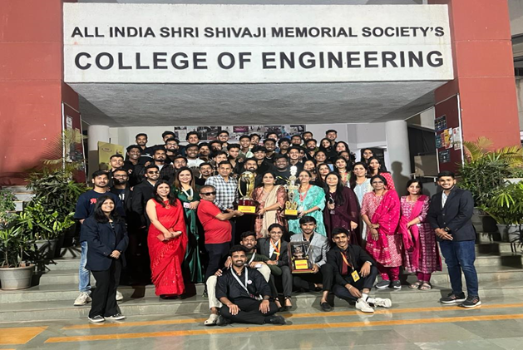 | 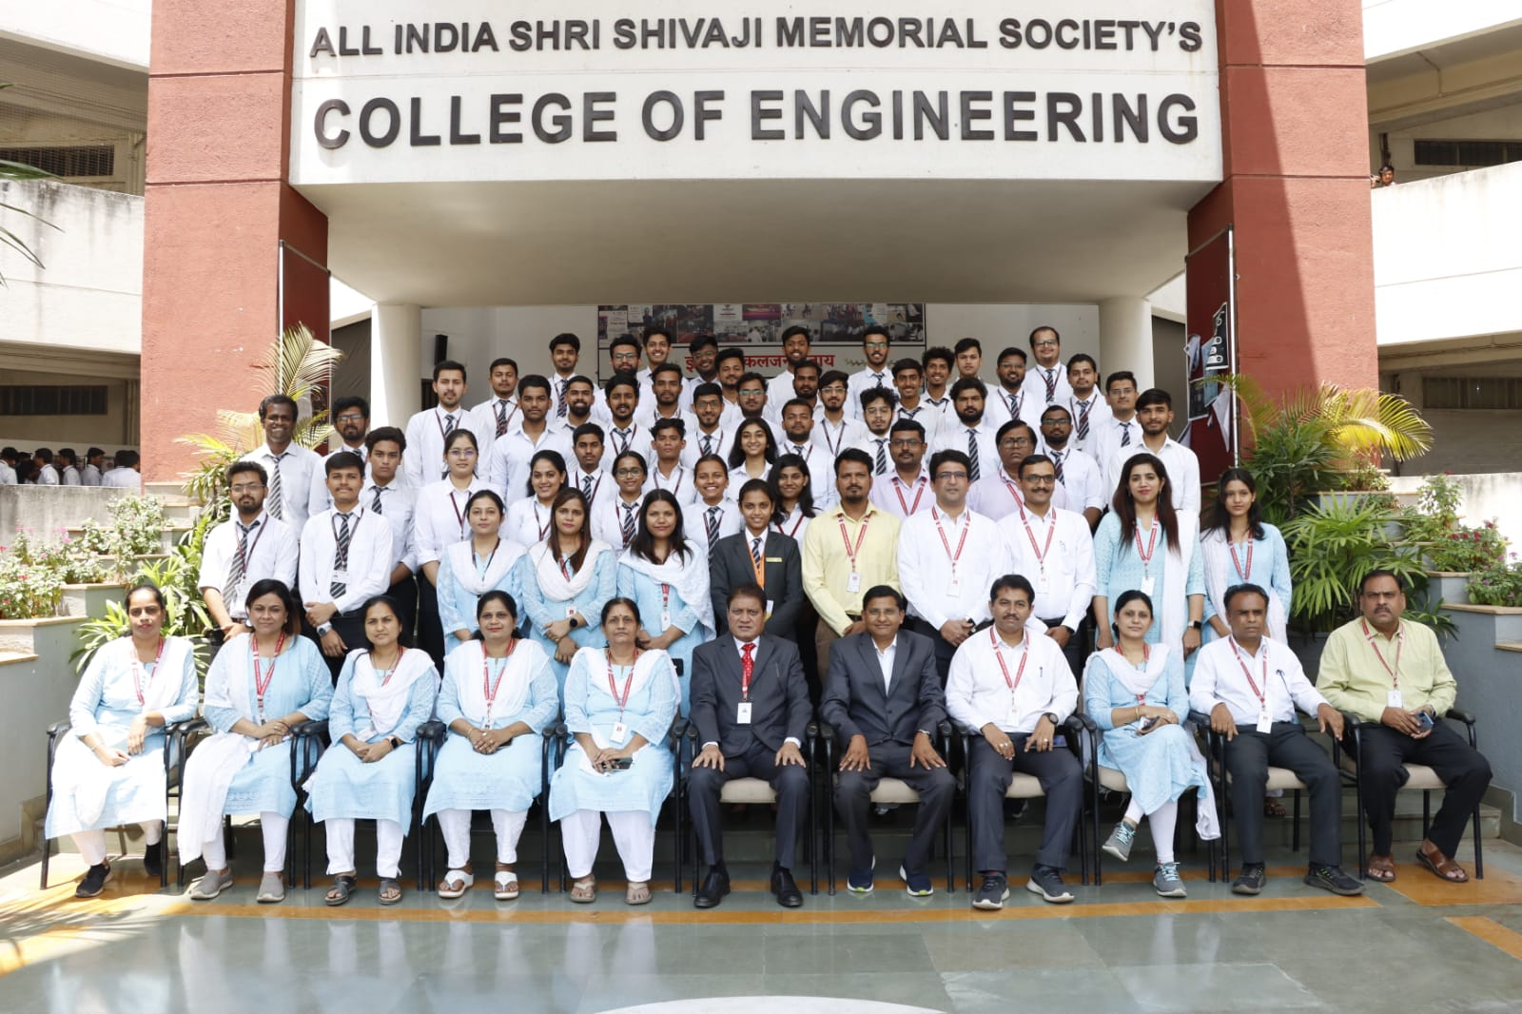
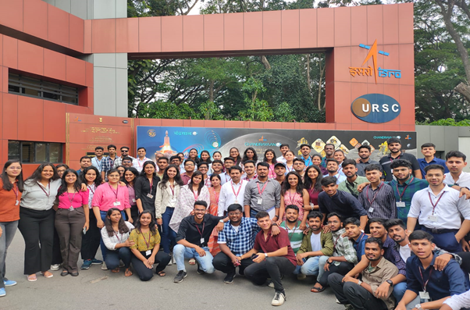 | 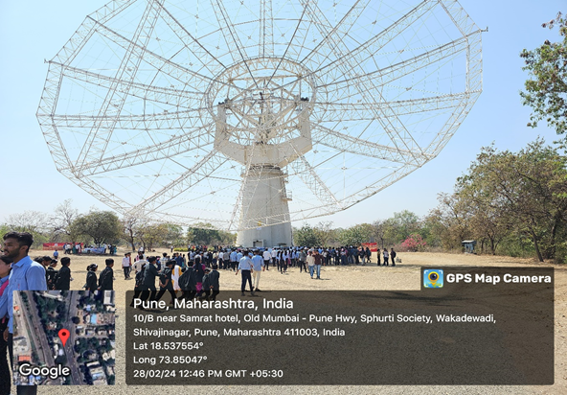
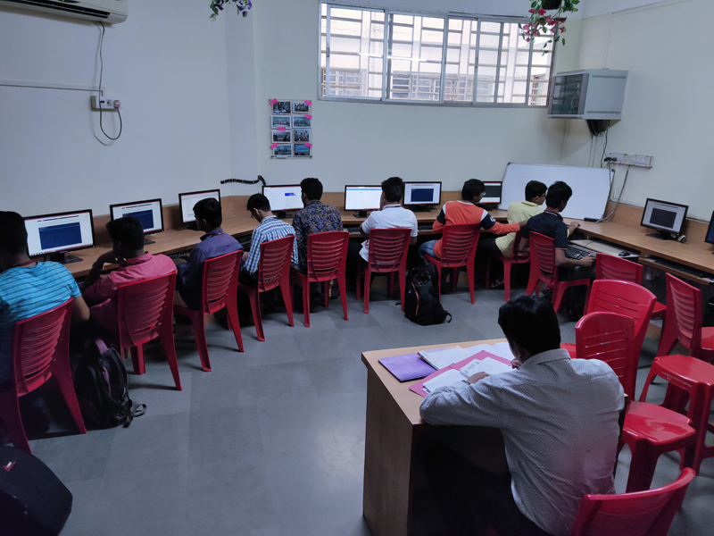 | 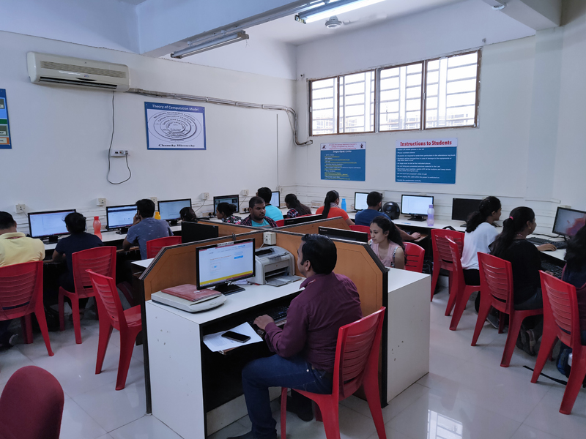
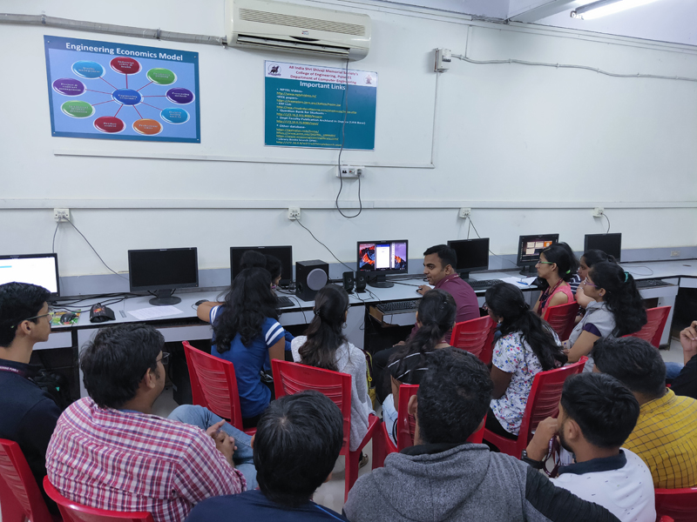 | 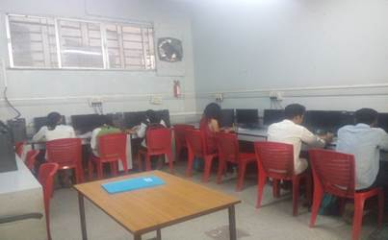

- FACULTY CONTRIBUTION

2.1 ACHIEVEMENTS OF FACULTY (AWARDS, RECOGNITION, PHD COMPLETION ETC.)
Term One
SN | Name of Faculty | Awards & Recognitions
1 | Dr S V Athawale | Young and Dynamic Researcher Award by PHOENIX
2 | Dr S F Sayyad | Awarded for As a College SPOC in ‘KAVACH-2023’,August 2023.
3 | Dr.D.M.Ujalambkar | Has Awarded in recognition of their works as Reviewer for the Hindawi Portfolio of Journals, 1 August 2023

Term Two
SN | Name of Faculty | Awards & Recognition
1 | NIL

2.2 CONTRIBUTION OF FACULTY (Interaction with outside world)
Term One
SN | Name of Faculty | Nature and details of contribution (Representation at University, State, National , International level, corporate world, Social Platforms, etc)
4 | Dr S F Sayyad | Chairman syllabus setting CG-SE
11 | Dr D M Ujalambkar | BOS member, syllabus setter - ME

Term Two
SN | Name of Faculty | Nature and details of contribution (Representation at University, State, National , International level, corporate world, Social Platforms, etc)
4 | Dr S F Sayyad | Chairman Deep learning(ME)
11 | Dr D M Ujalambkar | BOS Member, Syllabus setter -CS
18 | V V Navale | Session chair of International Conference on Advanced Technologies and Intelligent Automation (ICATIA-24)

2.3 eCONTENT DEVELOPED BY FACULTY AND AVAILABLE ONLINE
Term One
Sr No. | Name of Faculty | Title of e-content | e-content development facility/platform | link of the content
1 | Dr. M A Pradhan | SPM | Google ClassRoom | Class code  o7rfgu4
2 | Dr S F Sayyad | CG | Google classroom | Class code vgujf5c
3 | S R Nalamwar | LP-III Assisgnments | Github | https://github.com/sonalinalamwar/Deep-Learning
4 | A S Deokar | SPM | Google ClassRoom | Class code  tdc4tmy
5 | A M Jagtap | SE B OOP | Google Classroom | Class code  mvkhnch
6 | V V Waykule | TOC A  TOC B | Google Classroom | situohh  f4mtbmx
7 | Dr D M Ujalambkar | ML- B | Google classroom | https://classroom.google.com/u/1/c/NjE2MzczMjIzNDk0
8 | S J Pachouly | CNSL-TE B | Google classroom | https://classroom.google.com/c/NjE2NTYzNDUzNDYx?cjc=uotfaf5
9 | Mrs. S. S. Kolte | TE DBMSL  BE STQA | Google ClassRoom | https://classroom.google.com/c/NjE2NTU5MDYzNTAy?cjc=xv4gyu5
10 | Neha A Rai | SE B DM | Google ClassRoom | https://classroom.google.com/c/NTAxODA3OTk0MjQz?cjc=7zieg5s
11 | V V Navale | BE-A & BE-B BT | Google ClassRoom | https://classroom.google.com/u/1/c/NjE2MzI0NzI4MzE1  https://classroom.google.com/u/1/c/NTIzMTg4MTczNDUy
12 | V S Gunjal | TE SPOS  BE LP-IV | Google ClassRoom | https://classroom.google.com/c/NjE2MjU3ODMxOTgy?cjc=pcj2kge
13 | Mrs.V R Jorwekar | BE-HPC  SE-DM | Google Classroom | https://classroom.google.com/c/NjQ2ODI0ODg4NDIx  https://classroom.google.com/c/NjYyNTg0MzQ2MDY5

Term Two
Sr No. | Name of Faculty | Title of e-content | e-content development facility/platform | link of the content
1 | Dr. M A Pradhan | Software Engineering | Google Classroom | Class code  znoc5sz
2 | Dr S F Sayyad | Web Technology | Google Classroom | Class code xlg6fak
3 | S R Nalamwar | LP-V Practicals | Github | https://github.com/sonalinalamwar/Deep-Learning
4 | A S Deokar | SPM | Google ClassRoom | Class code  tdc4tmy
5 | A M Jagtap | TE B OOP | Google Classroom | Class code v2tllac
6 | V V Waykule | DSA | Google ClassRoom | situohh
7 | Dr D M Ujalambkar | BE-B BI | Google Classroom | https://classroom.google.com/u/1/c/NjUwNzY4NTA1NzU1
8 | S J Pachouly | BE-A BI | Google Classroom | https://classroom.google.com/c/NjUxMDI0NjgwNjg4?cjc=ewwh3h5
9 | Mrs. S. S. Kolte | Cloud Computing | Goolgle Classroom | https://classroom.google.com/c/NjQ3MDA2MTIyMzg2?cjc=7h3bqmw
10 | Neha A Rai | BE A NLP  BE B NLP | Google ClassRoom | https://classroom.google.com/c/NjY0MzI3NDU1MzQz?cjc=icnbcgz  https://classroom.google.com/c/NjQ2Nzc1Mjg2NDIy?cjc=4xbaz63
11 | V V Navale | SE B | Google ClassRoom | https://classroom.google.com/u/1/c/NjI4MDI3NTc2MzEw
12 | V S Gunjal | Deep Learning | Youtube Video Playlist | https://www.youtube.com/@TechVips
 |  | PPL | Youtube Video Playlist | https://www.youtube.com/@TechVips
13 | Mrs.V R Jorwekar | BE-HPC | Google Classroom | https://classroom.google.com/c/NjUzMzEzMTgxNzI4

2.4 FDP/STTP ATTENDED BY THE DEPARTMENT FACULTY
TERM ONE
Sr.  No | Name of Staff | Title | Organized by | Date
1 | Dr.S.V.Athawale | Faculty development program on cloud Infrastructure AWS | AICTE | 21-08-2023 to 25-08-2023
 |  | Advanced Excel for Data Analytics- Hands-on | PCET’s Pimpri Chinchwad College of Engineering & Research, Ravet, Pune | 07-08-2023 to 12-08-2023
 |  | National Intellectual Property Awareness Mission | Intellectual Property Office India | 30-08-2023
2 | Dr.M.A.Pradhan | Education 4.0 in Higher education | VIIT, Pune | 31-07-2023 to 04-08-2023
3 | Dr.S.F.Sayyad | Faculty development program on cloud Infrastructure AWS | Brain-O-Vision, AISSMSCOE and AICTE | 21-08-2023 to 25-08-2023
 |  | Education 4.0 in Higher education | VIIT, Pune | 31-07-2023 to 04-08-2023
 |  | Data Analyst | APSSDC | 19-06-2023 to 23-06-2023
 |  | Data Science using Machine Learning | Pravara Rural Engineering College | 02-01-2023 to 06-01-2023
 |  | .Energy Literacy Training | Energy Swaraj Foundation | 20-02-2023
 |  | National Intellectual Awareness | NATIONAL IP AWARENESS MISSION | 14-03-2023
 |  | Deep Learning Applications,Tools Process Design and Development | IIC-MESCOE Department of Computer | 20-03-2023 to 28-03-2023
5 | Mr.N.R.Talhar | Faculty Development Program on Cloud Infrastructure | Brain-O-Vision, AISSMSCOE and AICTE | 21-08-2023 to 25-08-2023
6 | Dr.A.J.Kadam | Education 4.0 in Higher  education | VIIT, Pune | 31-07-2023 to 04-08-2023
 |  | One-week National Level  FDP on Cloud  Infrastructure (AWS) | AISSMSCOE | 21-08-2023 to 25-08-2023
7 | Ms.S.R.Nalamwar | Innovative Teaching Methodology-A creative Pedagogy | Department of Artificial Intelligence & Data Science,Robotics & Automation, D Y Patil College of Engineering,Akurdi
 |  | Education 4.0 in Higher Education | VIIT,Pune
 |  | Data Science for Business | Dept. of AIDS VIIT,Pune | 04-09-2023 to 08-09-2023
 |  | Recent Trends in Heating, Ventilation, Air-Conditioning and Refrigeration | Department of Mechanical Engineering MMCOE in association with ISHRAE & ASHRAE Pune Chapter
 |  | AI in education : Adaptive Learning & Personalization | Dr.D Y Patil Institute of Engineering,Management and Research Akurdi
 |  | Exploring quality Research and its Societal Impact | Dr.D Y Patil Institute of Technology,pimpri,pune | 09-10-2023 to 13-10-2023
8 | Ms.A.S.Deokar | Education 4.0 in Higher Education | VIIT,Pune | 31-07-2023 to 04-08-2023
 |  | Cloud Infrastructure AWS | JNTUKCOE,Narasaraopet,Andhra Pradesh
9 | Mr.A.M.Jagtap | Advance Excel for Data Analytics - Hands on | PCET’s Pimpri Chinchwad College of Engineering & Research, Ravet Pune
 |  | Education 4.0 in Higher Education | VIIT,Pune | 31-07-2023 to 04-08-2023
 |  | National Intellectual Property Awareness Mission | AICTE
 |  | One-week National Level  FDP on Cloud  Infrastructure (AWS) | AISSMSCOE | 21-08-2023 to 25-08-2023
 |  | 24/7 Cyber Security | VIIT
10 | Mrs.V.V.Waykule | Lab Practice | BE Syllabus 2019 course Faculty Orientation Program | 03-08-2023
 |  | Innovations in Recent  Trends in Computing | JIS University | 1 week
11 | Dr.D.M.Ujalambkar | EDUCATION 4.0 IN HIGHER  EDUCATION | VIIT, Pune | 31-07-2023 to 04-08-2023
 |  | RECENT TRENDS IN AI TOOLS | D Y Patil College of Engineering, Akurdi. | 27-07-2023 to 28-07-2023
 |  | Cloud Infrastructure AWS | Brainovision Solutions India Pvt Ltd | 21-08-2023 to 25-08-2023
 |  | Energy Literacy Training | Energy Swaraj Foundation | 20-02-2023
12 | Mr.S.G.Dhengre | - | -
13 | Ms.S.J.Pachouly | Cloud Infrastructure (AWS) | Brain O Vision | 21-08-2023 to 25-08-2023
14 | Ms.M.M.Phadatare | “EDUCATION 4.0 IN HIGHER  EDUCATION” | Vishwakarma Institute of Information Technology, Pune | 31-07-2023 to 04-08-2023
 |  | Data Science for Business | VIIT,Pune | 04-09-2023 to 08-09-2023
15 | Ms.S.S.Kolte | .NATIONAL INTELLECTUAL PROPERTY AWARENESS MISSION | Intellectual Property Office, India | 30-08-2023
 |  | Data Science for Business | VIIT,Pune | 04-09-2023 to 08-09-2023
 |  | Cloud Infrastructure (AWS) | Dept. of CSE  JNTUK UCEN | 21-08-2023 to 25-08-2023
 |  | EDUCATION 4.0 | Dept. of Computer Engg. VIIT Pune | 31-07-2023 to 04-08-2023
16 | Mr.S.S.Jadhav | National Intellectual Property Awareness Mission | AICTE | 30-08-2023
17 | Ms.N.A.Rai | EDUCATION 4.0 IN HIGHER  EDUCATION | Vishwakarma Institute of Information Technology, Pune in association with Computer Society of India Pune Chapter | 31-07-2023 to 04-08-2023
 |  | Industrial Research and Consultancy | RESONANCE AUTOMATION(Madwkripa, Rajyog Society, Pune Satara Road, Pune 411009) | 15-12-2023 to 19-12-2023
 |  | Cloud Infrastructure (AWS) | AISSMS COE PUNE in Collaboration with Braino Vision | 21-08-2023 to 25-08-2023
18 | Mrs.V.V.Navale | Cloud Infrastructure(AWS) | AISSMS COLLEGE OF ENGINEERING, PUNE | 21-08-2023 to 25-08-2023
 |  | EDUCATION 4.0 IN HIGHER  EDUCATION | Vishwakarma Institute of  Information Technology, Pune | 31-07-2023 to 04-08-2023
19 | Mr.V.S.Gunjal | Business Analytics with Excel | Skillup | 28-08-2023
 |  | FDP on “EDUCATION 4.0 in Higher Education | Department of Computer Engg. VIIT | 31-07-2023 to 04-08-2023
 |  | Python Program and its application | SNJB’s SHH Polytechnic | 18-07-2023 to 19-07-2023
 |  | One Week Faculty Development Programme on “Fundamentals of Machine Learning and Deep Learning” | NITTTR Kolkata | 25-09-2023 to 29-09-2023
 |  | one-week online FDP on "Distributed LedgerTechnology" | Department of Artificial Intelligence & Data Science, Dr. D Y Patil Institute of Engineering and Management | 04-12-2023 to 11-12-2023
 |  | FDP on "Machine Learning", 10th to 14th July 2023. | Department of AIDS & Computer Engineering, Dr. D Y Patil Institute of  Engineering and Management Research, Akurdi. | 10-07-2023 to 14-07-2023
 |  | One Week National Level FDP on Cloud Infrastructure (AWS) | Organized By AISSMSCOE In Collaboration With Brainovision Solutions India Pvt Ltd & AICTE | 21-08-2023 to 25-08-2023
 |  | 30 Hours International Faculty Development Program on Deep Learning for NLP and Computer VisionExcelR (EDL) | Chaitanya Bharathi Institute of Technology (CBIT) in Collaboration with ExcelR | 10-07-2023 to 28-07-2023
 |  | International Faculty Development Program on Big Data Analytics | Department of Information Technology, VNR Vignana Jyothi Institute of Engineering and Technology, Hyderabad. | 04-12-2023 to 15-12-2023
 |  | One Week FDP on "Innovative Teaching Methodologies : A Creative Pedagogy" | Department of Robotics & Automation and AIDS, Dr. D Y Patil College of  Engineering Akurdi. | 31-07-2023 to 04-08-2023
 |  | 5 Days National STTP on "Data Science for Business" | Artificial Intelligence & Data Science Department VIIT,Pune | 04-09-2023 to 08-09-2023
20 | Ms. A S Aphale | FDP on “EDUCATION 4.0 in Higher Education | Department of Computer Engg. VIIT | 1week
 |  | One Week National Level FDP on Cloud Infrastructure (AWS) | Organized By AISSMSCOE In Collaboration With Brainovision Solutions India Pvt Ltd & AICTE | 31-07-2023 to 04-08-2023
21 | Mrs.V R Jorwekar | Exploring quality research and its societal impact | Dr. D Y Patil institute of technology | 1week
 |  | Education 4.0 in higher education | Vishwakarma Institute of technology, Pune | 21-08-2023 to 25-08-2023
 |  | Cloud Infrastructure (AWS) | AISSMS COE | 09-10-2023 to 13-10-2023
 |  | Applications of Business Analytics | EXCELR

Term Two
S N | Name of Faculty | Title of the FDP/STTP | Organized by | Duration/ Dates
1 | Dr.S.V.Athawale
2 | Dr. M A Pradhan | NFDP on "Business Analytics", 5th to 9th Feb2024. | Department of Computer Engineering,  AISSMS COE, Pune in collaboration with Excelr. | 05-02-2024 to 09-02-2024
4 | Dr S F Sayyad | Advances in material technology for next generation manufacturing | AICTE | 01-02-2024 to 05-02-2024
7 | S R Nalamwar | National FDP on “  Business Analytics | ExcelR Edtech Pvt.  Ltd | 05-02-2024 to 09-02-2024
 |  | One Week Online National Level FDP on “Latest trend and techniques in Software Engineering”
9 | A M Jagtap | One week FDp on Business Analytics | Excelr | 05-02-2024 to 09-02-2024
10 | V V Waykule | Artificial Intelligence and  Generative Models &quot | VIT | 15-01-2024 to 19-01-2024
 |  | National FDP on “  Business Analytics” | ExcelR Edtech Pvt.Ltd | 05-02-2024 to 09-02-2024
 |  | FDP on “Data Science  Application in Real World  Using Python” | Indiara COE and  Management 3 | 18-03-2024 to 22-03-2024
 |  | FDP on “Emerging  Technological Trends in  Industry” | VIT | 11-03-2024 to 15-03-2024
 |  | AWS Cloud Fundamental and Services
 |  | Simulation of Electrical Vehicle
11 | Dr D M Ujalambkar | Advances in material technology for next generation manufacturing | AICTE | 01-02-2024 to 05-02-2024
13 | S J Pachouly | 1. ChatGPT and Prompt Engineering | Bharati Vidyapeeth College of Engineering - Navi Mumbai in Collaboration with ExcelR Edtech Pvt. Ltd. | 18-12-2023 to 22-12-2023
 |  | 2. Business Analytics  organized | AISSMS College of Engineering | 05-02-2024 to 09-02-2024
15 | Mrs. S. S. Kolte | Business Analytics | Department of Computer Engineering,  AISSMS COE, Pune in collaboration with Excelr. | 05-02-2024 to 09-02-2024
 |  | AWS Cloud Fundamental  and Services | SIT | 27-03-2024 to 31-03-2024
 |  | Data science application in  real world using Python | Indira College of Engineering and Management | 18-03-2024 o 22-03-2024
17 | Neha A Rai | Business Analytics  organized | AISSMS College of Engineering | 05-02-2024 to 09-02-2024
 |  | Basics of Languages | NPTEL-AICTE | 01-2024 to 04-2024 (12 week)
 |  | ChatGPT and Prompt Engineering | Bharati Vidyapeeth College of Engineering - Navi Mumbai in Collaboration with ExcelR Edtech Pvt. Ltd. | 18-12-2023 to 22-12-2023
18 | V V Navale | Advancements in Artificial Intelligence | Vishwakarma Institute of Information Technology, Pune | 04-03-2024 to 08-03-2024
 |  | 10 Hours National Faculty Development Program on  Business Analytics | AISSMS College of Engineering, SJC Institute of Technology and  Matrusri Engineering College in Collaboration with ExcelR Edtech Pvt. Ltd | 05-02-2024 to 09-02-2024
 |  | One week FDP onRecent trends in Healthcare | Vishwakarma Institute of Information Technology, Pune | 18-12-2023 to 22-12-2023
19 | V S Gunjal | NFDP on "Business Analytics", 5th to 9th Feb2024. | Department of Computer Engineering,  AISSMS COE, Pune in collaboration with Excelr. | 05-02-2024 to 09-02-2024
 |  | Deep Learning and Artificial Intelligence | APSSDC in association with ExcelR | 26-02-2024 to 01-03-2024
 |  | Data Science Application real world using Python | Indira College of Engineering and Management | 18-03-2024 to 22-03-2024
 |  | Recent Advances & Future Trends in AI&NLP(GIST) | Dept. Computer science & Tech. GIST | 15-04-2024 to 19-04-2024
 |  | Generative  Artificial Intelligence and Machine Learning | Computer Engineering Department, Sandip  Institute of Engineering and Management, Nashik | 29-04-2024 to 03-05-2024
 |  | Multidisciplinary Education and Research | NITTTR, Bhopal | 21-05-2024 to 25-05-2024
21 | Mrs.V R Jorwekar | Multidisciplinary Education and Research | NITTTR, Bhopal | 10-06-2024 to 14-06-2024

2.5 SEMINARS/ WORKSHOPS/ WEBINARS ATTENDED BY THE DEPARTMENT FACULTY
Term One
S N | Name of Faculty | Title of the Seminar/Webinar | Organized By | Duration/ Dates
1 | Dr S F Sayyad | Strengthening the Future of Research and Education through Digital Transformation | Elsevier Connect at Pune | 11-10-2023
2 | Dr D M Ujalambkar | Strengthening the Future of Research and Education through Digital Transformation | Elsevier Connect at Pune | 11-10-2023

Term Two
S N | Name of Faculty | Title of the Seminar/Webinar | Organized By | Duration/ Dates
1 | Dr S F Sayyad | 1)Digital Marketing | IITM,skillcircle | 13-04-2024
 |  | 2) Understanding upcoming new changes,Binary accreditation and its methodology in NAAC | IQAC cluster india | 05-02-2024
2 | Dr D M Ujalambkar | Understanding upcoming new changes,Binary accreditation and its methodology in NAAC | IQAC cluster india | 05-02-2024
3 | V S Gunjal | Cut Through the Noise: Critical Thinking for Everyday Life | National HRD Network, Pune Chapter | 14-06-2024

2.6 CONFERENCES/ SYMPOSIUMS ATTENDED BY THE DEPARTMENT FACULTY
Term One
S N | Name of Faculty | Title of the Conference / Symposium | Organized By | Duration/ Dates
1 | Dr.S.F.Sayyad | An Analysis of ML based Intelligent IDS | 8th international conference on Micro electronics electromagnetic & telecommunications ICMEET 2023 | NIT Mizoram
 |  | Innovation in technology | 2023 3rd asian Conference | IEEE
2 | N R Talhar | Green Energy 2023 | SESI | 16-05-2023 to 17-05-2023
3 | Ms.S.R.Nalamwar | Develompent of Intelligent Skin Disease Classification system using Machine Learning | 5th International Conference on Inventive Research in Computing Applications | RVS College of Engineering and Technology, Coimbatore

Term Two
S N | Name of Faculty | Title of the Conference / Symposium | Organized By | Duration/ Dates
1 | Dr S F Sayyad | Insights into Age-Related Macular Degeneration Detection: A Comprehensive Review of OCT Image Analysis | CHRIST(Deemed to be University), Kangeri campus, Bangalore, sponsored by soft computing research  society and AICTE | 27-03-2024

2.7 ONLINE COURSES / CERTIFICATE COURSES COMPLETED BY DEPARTMENT FACULTY
Term One
S N | Name of Faculty | Title of the Course | Conducted By | Duration/ Dates
1 | Dr S F Sayyad | Design Thinking – A premier | NPTEL | 4 Weeks
2 | Dr D M Ujalambkar | Yoga and Positive Psychology for Managing Career and Life | NPTEL | 8 Weeks
3 | Dr D M Ujalambkar | Successful Negotiation: Essential Strategies and Skills | Coursera | self paced
4 | V S Gunjal | “Python For Data Science” | NPTEL | 4 Weeks
5 | V R Jorwekar | “Python For Data Science” | NPTEL | 4 Weeks
Term Two
S N | Name of Faculty | Title of the Course | Conducted By | Duration/ Dates
1 | Dr S F Sayyad | Managing Change In Organizations | NPTEL | 8 Weeks
2 | Dr D M Ujalambkar | Roadmap for Patent Creation | NPTEL | 8 Weeks
3 | Neha Rai | Basics of Language Science | NPTEL | 12 Weeks
4 | V S Gunjal | Programming In Java | NPTEL | 12 Weeks
5 | V V Navale | Programming Data structure and algorithm using Python | NPTEL | 12 Weeks

2.8 EXTENSION LECTURES / WEBINARS (Lectures organized on other than technical topics))
Term One
S N | Name of faculty coordinator | Topic | Name and contact details of guest | Date | Number of beneficiaries
1 | A S Deokar | Gender Equality (Health Care) | Mr. N K Lokhande, Pune | 29-08-2023 | 57

Term Two
S N | Name of faculty coordinator | Topic | Name and contact details of guest | Date | Number of beneficiaries
 | NIL

2.9 FACULTY SERVED AS RESOURCE PERSON, EXPERT, CHAIRPERSON
Term One
S N | Name of Faculty | Title of Activity | Organizing body | Date
1 | Dr S F Sayyad | Expert for Project Exhibition | IEEE | 05-10-2023
2 | Dr D M Ujalambkar | Expert lecture | Zeal COE, Pune | 14-10-2023
Term Two
S N | Name of Faculty | Title of Activity | Organizing body | Date
1 | Dr. M A Pradhan | Resource Person for MSBTE sponsored  FDTP on “ Artificial Intelligence: An Engineering Milestone” | AISSMS Polytechnic Pune | 30-01-2024
2 | Dr S F Sayyad | Session Chair in 5th International Conference of Emerging Technology (INCET 2024) during | IEEE, Bangalore | 24-05-2024 26-05-2024
 |  | Expert for COIL session on chatbot using NLP for Innovative business | Bharati Vidyapeeth,and LNU Sweden | 06-02-2024
3 | V V Navale | session Chair of International Conference on Advanced Technologies and Intelligent Automation (ICATIA-24) | Protean Tech Services | 18-05-2024

3.ACTIVITIES ORGANIZED

3.1 FDP/STTP ORGANIZED BY THE DEPARTMENT

Term One
S N | Name of faculty coordinator | Title of the FDP/STTP/WS/Seminar/Symposium | Duration/ Dates | No. of Participants | Funding Agency  (If any) and Amount (Rs.)
1 | Shikha Pachouly & Neha Rai | One week national level FDP on Cloud Infrastructure (AWS) | 21-08-2023 to 25-08-2023 (1 Week) | 120 | -

Term Two
S N | Name of faculty coordinator | Title of the FDP/STTP/WS/Seminar/Symposium | Duration/ Dates | No. of Participants | Funding Agency  (If any) and Amount (Rs.)
 | NIL

3.2 SEMINARS/ WORKSHOPS/ WEBINARS ORGANIZED BY THE DEPARTMENT

Term One
S N | Name of Coordinator/s | Title of the Seminar/Webinar/Workshop | Duration/ Dates | No. of Participants | Funding Agency  (If any) and Amount (Rs.)
1 | A S Deokar | Scrum Technology,Sayali Kapse , Accenture,Pune | 01-11-2023 | 60
 |  | Exploring job opportunities through Internship,Shikalgar,  Byteridge Pvt.Ltd.,Pune | 31-10-2023 | 72
2 | V V Waykule | Python Data Science Bootcamp | 28-11-2023 | 35
3 | Mrs. S. S. Kolte | Workshop on Soft Skills | 09-08-2023 | 45
4 | Neha A Rai | Training Workshop on Lecture Capture Solution | 28-07-2023 | 75
5 | Mrs.V R Jorwekar | Python Data Science Bootcamp | 28-11-2023 | 35

Term Two
S N | Name of Coordinator/s | Title of the Seminar/Webinar | Duration/ Dates | No. of Participants | Funding Agency  (If any) and Amount (Rs.)
1 | V. S. Gunjal | LIVE: Prime Minister Narendra Modi participates in ‘India’s Techade: Chips for Viksit Bharat' | 13-03-2024 | 22

3.3 CONFERENCES/ SYMPOSIUMS ORGANIZED BY THE DEPARTMENT
Term One
S N | Name of Coordinator/s | Title of the Conference / Symposium | Duration/ Dates | No. of Participants | Funding Agency  (If any) and Amount (Rs.)
1 | NIL

Term Two
S N | Name of Coordinator/s | Title of the Conference / Symposium | Duration/ Dates | No. of Participants | Funding Agency  (If any) and Amount (Rs.)
1 | NIL

3.4 EXTENSION ACTIVITIES CONDUCTED BY THE DEPARTMENT (Social activities / Quizzes at national/international level/any other activity)
Term One
S N | Name of Faculty Coordinator | Details of activity conducted | Date | Number of beneficiaries
1 | S. R. Nalamwar, V. R. Jorwekar | Social visit bal kalyan sanstha pune | 11-09-2023 | 24
2 | Dr D M Ujalambkar | YUVA UNSTOPPABLE NGO scholarship |  | 14

Term Two
S N | Name of Faculty Coordinator | Details of activity conducted | Date | Number of beneficiaries
1 | V. S. Gunjal | MSME Defence Expo | 25-02-2024 | 100+
3.5 MOU SIGNED WITH ACADEMIC AND PROFESSIONAL ORGANIZATIONS

Term One
Sr. No. | Faculty Coordinator | Name of Organisation | Date  of MoU Signed | Valid upto  00/00/0000
1 | Dr. D. S. Bormane | Automation Anywhere | 05-03-2023 | 05-02-2026
2 | Dr. S V Athawale | TATA STRIVE | 12-11-2023 | 10-12-2026
3 | Dr. S V Athawale | Reliance Entertainment Ltd | 19-12-2023 | 18-12-2030
4 | Dr. S V Athawale | Kasnet Technologies Pvt. Ltd., Pune | 12-05-2022 | 12-05-2029
5 | Dr. D P Gaikwad | Cloud technology consulting, Princeton, NJ, USA | 15-02-2023 | 14-02-2024
6 | Dr. DP Gaikwad | Codekul Pvt. Ltd | 30-11-2022 | 29/11/2025
7 | S F Sayyad | Audaz Pvt. Ltd., C2C-2/100, Janakpuri, New Delhi | 22-09-2021 | 21-09-2024

12 | V V Waykule | Elite Softwares, Pune | 10-10-2021 | 20-12-2024
13 | S J Pachouly,  V V Waykule | FinFit Education Pvt. Ltd., Pune | 03-07-2022 | 21-12-2025
14 | Dr. DM Ujalambkar | World Vision IT Infotech, Pune | 10-11-2021 | 10-10-2024
15 | S G Dhengre | ExcelR Solutions, Pune | 26-11-2022 | 26-11-2024
16 | S G Dhengre | Udemi IT and Learning Solutions, Pune. | 13-02-2023 | 02-12-2030
17 | M M Phadatare | Talentprotech Solution, Kharadi, Pune. | 16-11-2021 | 15-11-2024
18 | S S Kolte | AppyStack Pvt. ltd., Pune | 30-11-2022 | 29-11-2025
19 | S S Jadhav | Slogsite, Pune | 17-01-2022 | 16-01-2025
20 | N A Rai | Brilliance InfoTech, Wakad, Pune | 02-02-2022 | 02-02-2025
21 | N A Rai | VEDA EDU Consultants, Pune. | 23-01-2023 | 22-01-2028

Term Two
Sr. No. | Faculty Coordinator | Name of Organisation | Date  of MoU Signed | Valid upto  00/00/0000
1 | Dr. D. S. Bormane | Automation Anywhere | 05-03-2023 | 05-02-2026
2 | Dr. S V Athawale | TATA STRIVE | 12-11-2023 | 10-12-2026
3 | Dr. S V Athawale | Reliance Entertainment Ltd | 19-12-2023 | 18-12-2030
4 | S V Athawale | Kasnet Technologies Pvt. Ltd., Pune | 12-05-2022 | 12-05-2029
5 | Dr. D P Gaikwad | Cloud technology consulting, Princeton, NJ, USA | 15-02-2023 | 14-02-2024
6 | Dr. DP Gaikwad | Codekul Pvt. Ltd | 30-11-2022 | 29-11-2025
7 | S F Sayyad | Audaz Pvt. Ltd., C2C-2/100, Janakpuri, New Delhi | 22-09-2021 | 21-09-2024
8 | Dr. SF Sayyad | Cansulo Educare Pvt. Ltd., Pune | 15-09-2022 | 15-09-2023
9 | Dr. AJ Kadam | Asentir Solutions, Pune | 12-07-2021 | 12-06-2026
10 | S R Nalamwar | Sumago Infotech Pvt. Ltd, Nashik | 13-04-2022 | 13-04-2023
11 | A M Jagtap | Candent Technology Pvt. Ltd. Pune | 09-08-2022 | 09-08-2023
12 | V V Waykule | Elite Softwares, Pune | 10-10-2021 | 20-12-2024
13 | S J Pachouly,  V V Waykule | FinFit Education Pvt. Ltd., Pune | 03-07-2022 | 21-12-2025
14 | Dr. DM Ujalambkar | World Vision IT Infotech, Pune | 10-11-2021 | 10-10-2024
15 | S G Dhengre | ExcelR Solutions, Pune | 26-11-2022 | 26-11-2024
16 | S G Dhengre | Udemi IT and Learning Solutions, Pune. | 13-02-2023 | 02-12-2030
17 | S S Kolte | AppyStack Pvt. ltd., Pune | 30-11-2022 | 29-11-2025
18 | S S Jadhav | Slogsite, Pune | 17-01-2022 | 16-01-2025
19 | M M Phadatare | Talentprotech Solution, Kharadi, Pune. | 16-11-2021 | 15-11-2024
20 | N A Rai | Brilliance InfoTech, Wakad, Pune | 02-02-2022 | 02-02-2025
21 | N A Rai | VEDA EDU Consultants, Pune. | 23-01-2023 | 22-01-2028

Total Functional / Live MoU initiated by Department
Sr. No. | Faculty Coordinator | Name of Organisation | Date  of MoU Signed | Valid upto  00/00/0000
1 | Dr. D. S. Bormane | Automation Anywhere | 05-03-2023 | 05-02-2026
2 | S V Athawale | Kasnet Technologies Pvt. Ltd., Pune | 12-05-2022 | 12-05-2029
3 | Dr. D P Gaikwad | Cloud technology consulting, Princeton, NJ, USA | 15-02-2023 | 14-02-2024
4 | Dr. DP Gaikwad | Codekul Pvt. Ltd | 30-11-2022 | 29-11-2025
5 | S F Sayyad | Audaz Pvt. Ltd., C2C-2/100, Janakpuri, New Delhi | 22-09-2021 | 21-09-2024
6 | Dr. SF Sayyad | Cansulo Educare Pvt. Ltd., Pune | 15-09-2022 | 15-09-2023
7 | Dr. AJ Kadam | Asentir Solutions, Pune | 12-07-2021 | 12-06-2026
8 | S R Nalamwar | Sumago Infotech Pvt. Ltd, Nashik | 13-04-2022 | 13-04-2023
9 | A M Jagtap | Candent Technology Pvt. Ltd. Pune | 09-08-2022 | 09-08-2023
10 | V V Waykule | Elite Softwares, Pune | 10-10-2021 | 20-12-2024
11 | S J Pachouly,  V V Waykule | FinFit Education Pvt. Ltd., Pune | 03-07-2022 | 21-12-2025
12 | Dr. DM Ujalambkar | World Vision IT Infotech, Pune | 10-11-2021 | 10-10-2024
13 | S G Dhengre | Udemi IT and Learning Solutions, Pune. | 13-02-2023 | 02-12-2030
14 | S G Dhengre | ExcelR Solutions, Pune | 26-11-2022 | 26-11-2024
15 | S S Kolte | AppyStack Pvt. ltd., Pune | 30-11-2022 | 29-11-2025
16 | M M Phadatare | Talentprotech Solution, Kharadi, Pune. | 16-11-2021 | 15-11-2024
17 | S S Jadhav | Slogsite, Pune | 17-01-2022 | 16-01-2025
18 | N A Rai | VEDA EDU Consultants, Pune. | 23-01-2023 | 22-01-2028
19 | N A Rai | Brilliance InfoTech, Wakad, Pune | 02-02-2022 | 02-02-2025

3.6 STUDENTS’ CHAPTERS /CLUBS
Sr. No | Name of Students’ Chapter | Number of Student Members
1 | IUCEE | 147
2 | ISTE | 144
3 | CIPHER | 150

EVENTS ORGANISED (By Students’ Chapters / Clubs and others)
Name of Students’ Chapter:
Faculty Advisor:
Term One
SN | Event name and details of event | Name of chief guest, judges etc. | Duration and Dates | Number of beneficiaries
1. | NIL

Term Two
SN | Event name and details of event | Name of chief guest, judges etc. | Duration and Dates | Number of beneficiaries
1 | NIL

3.7 SOCIAL ACTIVITIES ORGANISED (NSS, Women empowerment, Awareness Programs, etc.)
Term One
Faculty coordinator | Name of Activity | Date, Duration | Number of students involved
Ms.S.R.Nalamwar  Mrs.V R Jorwekar | Bal Kalyan Sanstha | 11-09-2023

Term Two
Faculty coordinator | Name of Activity | Date, Duration | Number of students involved

3.8 PARENT MEETING
Faculty Coordinator | Day and Date | Details of Parent meetings organized | Number of Parents attended
V V Navale | 09-05-2024 | The Department of Computer Engineering has successfully organized a parents meet on Thursday, 09th May 2024. | 15

3.9 ALUMNI MEET
Faculty Coordinator | Day and Date | Details of Alumni meetings organized | Number of Alumni attended
S R Nalamwar | 09-05-2024 | Meet Alumni Report | 13

3.10 SUPPORT FROM ALUMNI
Term One
Sr No | Name of Alumni | Position and Organisation | Batch  (e.g. 2014 – 2018) | Details of Support | Date
 | Nill

Term Two
Sr No | Name of Alumni | Position and Organisation | Batch  (e.g. 2014 – 2018) | Details of Support | Date

3.11 INTERACTION WITH ALUMNI
Term One
S N | Name of Alumni and Activity coordinator | Details of Activity conducted | Date and duration | Total Number of beneficiaries
1 | Snehal Gore | Expert Lecture | 18-10-2023 | 50

Term Two
S N | Name of Alumni and Activity coordinator | Details of Activity conducted | Date and duration | Total Number of beneficiaries
1 | NIL

3.12 DETAILS OF STUDENT COUNSELING AND CAREER GUIDANCE AT THE DEPARTMENT LEVEL
Number of students referred for counseling
Number of Faculty referred for counseling | Nil

Faculty coordinator | CAREER GUIDANCE ACTIVITY DETAILS
 | Nil

(Start on new page) Few good photographs related to different activities organized
Size of photo 5 cm x 7 cm with captions

4.RESEARCH CONTRIBUTION

4.1 FUNDED RESEARCH PROJECT
Term One
S N | Principal Investigator | Title of the Project | Amount Received (Rs) | Funding Agency
1 | Nil
2

Term Two
S N | Principal Investigator | Title of the Project | Amount Received (Rs) | Funding Agency
1 | Nil
2

FUNDING RECEIVED FOR ANY OTHER ACTIVITY
Term One
S N | Faculty Coordinator | Title of the activity | Amount Received (Rs) | Funding Agency
1 | Nil

Term Two
S N | Faculty Coordinator | Title of the activity | Amount Received (Rs) | Funding Agency
1 | Nil

4.2 TESTING AND CONSULTANCY
Term One
Sr. No. | Faculty Coordinator | Details of Testing & Consultancy Conducted | Total Revenue Generated (Rs.)
 | Nil

Term Two
Sr. No. | Faculty Coordinator | Details of Testing & Consultancy Conducted | Total Revenue Generated (Rs.)
 | Nil

4.3 PATENTS, COPYRIGHT, TRADEMARK AND OTHER (IPR)
Sr.  No | Name of Staff | Title of the patent | Status: Published/ Granted as on date | Indian/  International | Present Status
1 | Dr.S.V.Athawale | smart plastic waste management device | 09-09-2023 | International | Granted
 |  | voice assistant device with AI | 05-05-2023 | International | Granted
2 | Dr.S.F.Sayyad | Weather reporting device | 27-12-2022 | Indian
3 | Mr.N.R.Talhar | voice assistant device with AI | 05-05-2023 | International | Granted
4 | Mr.A.M.Jagtap | smart plastic waste management device | 09-09-2023 | International | Granted
5 | Mr.S.G.Dhengre | voice assistant device with AI | 05-05-2023 | International | Granted
6 | Ms.M.M.Phadatare | Cloud based platform for crop recommendation for precision farming driven by AI | 09-01-2023 | Indian
7 | Mr.S.S.Jadhav | smart plastic waste management device | 09-09-2023 | International | Granted
8 | Mrs.V.V.Navale | Cyber Security risk assessment & management system using AI & ML for enterprise network | 29-09-2023 | Indian

Term Two
Sr No. | Name of Faculty | Name of the Patent | Patent Number and Date | Type (National/  International/Com  mercialized)
 | NIL

PUBLICATIONS
4.4 PAPERS PUBLISHED/ PRESENTED IN PROCEEDINGS OF CONFERENCES
Term One
S. No | Authors | Document Details | Year | Conference Details | ISBN | Organized  by
1 | S. G. Dhengre | An Analysis of ML-based Intelligent IDS for Wireless Sensor Network | 2023 | ICMEET 2023 |  | E&TC National Institute of Technology Mizoram India

Term Two
S. No | Authors | Document Details | Year | Conference Details | ISBN | Organized  by
1 | Dr S f Sayyad, Mr R S Nejkar | Insights into Age-Related Macular Degeneration Detection: A Comprehensive Review of OCT Image Analysis | March 2024 | CIS: Congress on Intelligent Systems | 2367-3389 | Springer

4.5 PAPERS PUBLISHED IN JOURNALS

Term One
S. No | Authors | Document Details | Year of Publication | Source Details | ISBN/  ISSN | Publisher
1 | Dr.S.V.Athawale | 1.Multi-Class Skin Diseases Classification Using Hybrid Deep Convolutional Neural Network | 2023-24 | https://ijisae.org/index.php/IJISAE/article/view/3230 | 2147-67992 | International Journal Of Intelligent Systems And Applications In  Engineering
2 |  | 2.Requirement Based Service Providing System | 2023-2024 | http://www.ijmra.us | 2249-0558
3 |  | 3.Securing Smartphone User Authentication using Teeth Pattern | 2023-2024 | www.tijer.org | 2349-9249
4 |  | 4.Strengths of Computational Systems of Techniques Using Artificial Intelligence in Machine  Learning | 2023-2024 | https://www.inderscienceonline.com/doi/abs/10.1504/IJSSE.2024.139420 | 1748-068X
5 |  | 5.Augmented and Virtual Reality | 2023-2024 |  | 978-93-5563-011-7
6 |  | 6.Artificial Neural networks Algorithm for diagnosis of human hair loss | 2023-2024 |  | 978-620-5-63291-8
7 |  | 7.Weakly Supervised Learning Model for Clustering and | 2023-2024
8 | Dr. M A Pradhan | 1.Decentralized Storage Rental System | 2023 | https://doi.org/10.22214/ijraset.2023.56790 | 2321-9653 | IJRASET
9 |  | 2.A survey on multi model image generation and its methodology | 2023-2024 |  |  | IETE
10 | Dr D P Gaikwad | 1.Dynamic cloud resource allocation efficient optimization strategies for enhanced performance | 2023-2024
11 |  | 2.Prediction of abrasive wear behavior of the polytetra floroethelene material using adaptive neoro fussy interface system | 2023-2024 |  | 2289-7232 | Jurnal tribologi
12 |  | 3.Application of rule lerner classifier for studying bio ethanol fuel spark ignition engine out emission and classification | 2023-2024 |  |  | Asean Journal
13 |  | 4.Microscope Analysis of Rolling contact bearing and its prediction using Deep learning | 2023-2024 |  |  | AEOTIT
14 |  | 5.Identification of cervical spine fracture using deep learning | 2023-2024 |  |  | Teller and Francis
15 | Dr S F Sayyad | 1.Blockchain Technology Application and Cryptocurrencies: Current Practice and Future Trends | 2023-2024 | www.pbr.co.in | 0974-438X(P) | pacific business review (PBR) International
16 |  | 2.Artificial Neural Networks Algorithm for Diagnosis of Human Hair Loss | 2023-2024 | LAMBERT Academic publishing | 2192-8029
17 |  | 3.Numerical analysis of uneven settlement of highway subgrade based on nonlinear algorithm | 2023-2024 |  |  | Nonlinear Engineering  Modeling and Application
18 |  | 4.Political Flower pollination Optimizer for age-related macular degeneration detection enabled deep Maxout network using OCT images | 2023-2024 |  | Volume 91,May 2024,105918 | Biomedical Signal Processing and Control
19 | N R Talhar | 1.Parkinson Disease Detection from Spiral and Wave Drawings using Machine Learning Algorithm | 2023-2024 | IJRASET | 2321-9653 | IJRASET
20 |  | 2.Dynamic Cloud Resource Allocation: Efficient Optimization Strategies for Enhanced Performance, Volume 46 l Special Issue l July 2023, page 366 | 2023-2024 |  | 0971-3034 | The Indian Journal of Technical Education
21 |  | 3.Immersive Pedagogy: Transforming Education through Augmented Reality Experiences. Volume 8, Issue 10 October 2023, page b111 | 2023-2024 |  | 2456-4184 | International Journal of Novel Research and Development
22 |  | 4.Revolutionizing Healthcare Delivery: A Comprehensive Review of Chatbot-enabled Systems Integrating Real-time Sensor Data and Cloud, Volume 8, Issue 10 October 2023, page b711 | 2023-2024 |  | 2456-4184 | International Journal of Novel Research and Development
23 | S R Nalamwar | Real time traffic control detection system | 2023-2024 |  | 2348-1269 | IJAR.ORG
24 | A S Deokar | 1.Fox Fables” an Adventure based  2D Game in Unity Game Engine | 2023-2024 |  | 2321-9653 | International Journal for Research in Applied Science & Engineering Technology (IJRASET)
25 |  | 2.Study of Heart  Disease Prediction Using Machine Learning and Data Mining | 2023-2024 |  | 2321-9653 | International Journal for Research in Applied Science & Engineering Technology (IJRASET)
26 |  | 3.Prediction of cardiovascular diseases using explainable A | 2023-2024 |  | 9781003393580 | Taylor and Francis
27 | Dr D M Ujalambkar | 1.Digitalization of Doctors Handwritten Prescription using optical character recognition OCR | 2023 | www.isteonline.in | vol. 46 | isteonline
28 |  | 2.Ship Detection at small ports using CNN | 2023 | www.isteonline.in | 2231-5381 | isteonline
29 |  | 3.Real-Time Dimension Detection using Customized Canny Edge Detection Algorithm | 2023-2024 | international journal of engineering trends and technology | 231–5381 | International Journal of Engineering Trends and Technology
30 |  | 4.Neurological Disorder Detection Using Computer Vision and Machine Learning Techniques | 2023-2024 |  | 9781003359456 | Applied Computer Vision and Soft Computing with Interpretable AI
31 | S G Dhengre | 1.The Proposed Intrusion Detection System using Support Vector Machine by IOT Enabled WSN | 2023 | IJRASET | 2321-9653 | IJRASET
32 |  | 2.Machine Learning Driven Anemia Identification and Classification: A Comprehensive Survey | 2023-2024 | IJRASET | 2321-9653 | IJRASET
33 | S J Pachouly | 1.Depression Detection of audio image and text using machine learning techniques | 2023 | IJSREM | 2582-3930 | IJSREM
34 | M M Phadatare | 1.Future Rainfall Forecasting for Water Supply Management in Agriculture | 2023 | iJRASET | 2321-9653 | iJRASET
35 | Mrs. S. S. Kolte | 1.Decentralized and Secure Voting System using Blockchain Technology | 2023 | www.isteonline.in | vol. 46 | isteonline
36 |  | 2.Overview on Efficient Resource Provisioning Approach Using Cloud Computing Environment | 2023 | www.ijraset.com | 2321-9653 | IJRASET
37 | Neha A Rai | 1Optimizing Precision: Brain Tumor Detection | 2023 | IJRASET | 2321-9653 | IJRASET
38 | V V Navale | 1.Stock Market Analyzing and prediction using machine learning techniques | 2023 | IJCRT | 2320-2882 | IJCRT
39 |  | 2.Music Recommendation System Based on your Facial Expression | 2023 | iJRASET | 2321-9653 | iJRASET
40 |  | 3.Superlative Classification Mode | 2023-2024 |  | 2321-9653 | International Journal for Research in Applied Science & Engineering Technology
41 | V S Gunjal | AI Enabled E-commerce Platform | 2023 | IJARIIE | Vol-9  23954396 | IJARIIE
42 | Ms.A S Aphale | 1.Automatic Microaneurysyms Detection using Deep Learning from Fundus Images | 2023-2024 |  | 979-8-3503-3575-0 | 2023 4th International Conference for Emerging Technology (INCET)  2023 4th
43 |  | 2.Robust Approach for Detecting Haemorrhage and Microaneurysyms from Fundus Images | 2023-2024 |  | 979-8-3503-3575- | International Conference for Emerging Technology (INCET)

Term Two
S. No | Authors | Document Details | Year of Publication | Source Details | ISBN/  ISSN | Publisher
1 | Dr. S V Athawale | Enhanced ubiquitous system architecture for securing healthcare IoT using efficient authentication and encryption | 2024 |  | 2364415X | International Journal of Data Science and Analytics Springer
2 |  | Blockchain-Based Lightweight Authentication Protocol for Next-Generation Trustworthy Internet of Vehicles Communication | 2024 |  | 1558-4127 | IEEE Transactions on Consumer Electronics.
3 |  | Securing Smartphone User Authentication Using Teeth Pattern | 2024 |  | 2633-4828 | International Journal of Applied Engineering & Technology
4 |  | Implementation of Requirement Based Service Providing System | 2024 |  | 2752-3829 | Stochastic Modelling and Computational Sciences
 |  | Anxiety Controlling Application using EEG  Neurofeedback System | 2024 |  | 2411-7145 | EAI Endorsed Transactions on Pervasive Health and Technology
5 | Dr S F Sayyad | Political Flower pollination Optimizer for age-related macular degeneration detection enabled deep Maxout network using OCT | 2024 | Biomedical Signal Processing and Control  Volume 91, May 2024, 105918 | https://doi.org/10.1016/j.bspc.2023.105918Get rights and content | Elsevier
6 | A S Deokar | 1.Impact of 5G on Internet of Things and its Challenges | February - 2024 |  | 2582-3930 | International Journal of Scientific Research in Engineering  and Management (IJSREM)
7 |  | 2.Advanced Machine And Deep Learning Techniques For Cardiovascular Disease Prediction |  |  | 2231-6329
8 |  | 3.“Flames of Redemption” Narrative-Driven 2D Platformer Game in Unity  Game Engine | May 2024 |  |  | ALOCHANA JOURNAL (ISSN NO:2231-6329) VOLUME 13 ISSUE 5 2024
9 | Dr D M Ujalambkar | Depression Detection using Facial, Text and HRV data | 2024 | Bulletin For Technology and History Journal | 0391-6715
10 |  | Automated Dental Cavity Detection System Using Deep Learning | 2024 | Journal of Technology | 10123407
11 | Mrs. S. S. Kolte | Efficient Resource Provisioning Approach Using Cloud Computing Environment | May 2024 | UGC | 2321-9653 | IJRASET
12 | Neha A Rai | DEEP LEARNING APPROACHES FOR BRAIN  TUMOR CLASSIFICATION | 2024 | TIJER | 2349-9249 | TIJER
13 | V V Navale | FeelFlow: Music Recommendation System Based on  Facial Expression | April 2024, Volume 11, Issue 4, | UGC Care | ,ISSN-2349-5162) | JETIR
14 |  | SUPERLATIVE CLASSIFICATION MODEL |  | VOLUME 12 ISSUE 3, 2024 | ISSN: 10123407
15 | V S Gunjal | Impact of 5G on Internet of Things and its Challenges | 2024 | UGC Care | 2582-3930 | International Journal of Scientific Research in Engineering and Management (IJSREM)
16 |  | AI ENABLED E-COMMERCE  PLATFORM | 2024 | UGC Care | 2231-6329 | ALOCHAN JOURNAL

4.6 BOOK / ARTICLE PUBLICATIONS
Term One
Author | Title of the Book | Published by | ISBN | Year
Dr S F Sayyad | “Introduction to Data Science” | LAP LAMBERT Academic Publishing | 6206784851 | September 2023.

Term Two
Author | Title of the Book | Published by | ISBN | Year
Dr. Hemantkumar B. Jadhav, Pragati B. Chandane, Jagruti R. Mahajan, Vipul S. Gunjal | DATA SCIENCE OPTIMIZATION TECHNIQUES | Nirali Prakashan | 9789361091452 | 2024

4.7 RESEARCH CITATIONS (Source of Data: Google scholar) (As on 30th May)
Name of faculty | Citations, h-index, i10 index | Name of faculty | Citations, h-index, i10 index
Dr.S V Athawale | 153,13,16 | A S Deokar | 10,2,0
Dr.M.A Pradhan | 200,7,5 | A M Jagtap | 3,1,0
Dr.D P Gaikwad | 546,10,11 | V V Waykule | 84,3,2
Dr.S.F.Sayyad | 78,5,2 | S G Dhengre | 50,2,2
N R Talhar | 151,5,3 | S J Pachouly | 12,3,0
Dr Anilkumar J Kadam | 138,5,4
Total Citations of Department: 1424
4.8 ME AWARDED
Sr No | Name of Supervisor | Title of Thesis | Name of Candidate
1 | Dr D M Ujalambkar | Smart Hire | Asmita Patil

4.9 PhD GUIDE DETAILS
Name of Faculty who are PhD Supervisor | Number of Scholars Registered
Dr. S V Athawale | 03
Dr.M.A.Pradhan | 03
Dr.D.P.Gaikwad | 03
Dr S F Sayyad | 03
Dr D M Ujalambkar | 00

4.10 PhD AWARDED (For departments having Ph.D research centers)
Sr No | Name of Supervisor | Title of Thesis | Name of Candidate
1 | NIL | NIL

Few good photographs related to different activities organized under research, innovation
Size of photo 5 cm x 7 cm with captions

5.INTERACTION WITH INDUSTRY

5.1 INDUSTRY VISITS ORGANIZED
Term One
Sr. No. | Faculty Coordinator | Class and Number of students attended | Industry Name and Address | Date of visit
1 | S R Nalamwar and V V Waykule | TE computer 55 students | Sumago Infotech Pune | 06-10-2023
2 | S F Sayyad and V R Jorwekar | SE (A) 68 students | BR Instrumentation and control Pune | 18-08-2023
3 | D M Ujalambkar | BE (B) 21 students | Proexcel Systems Pune | 18-08-2023
4 | N R Talhar, S G Dhengre, A M Jagtap, A J Kadam, S S Kolte, V V Navale | BE (Shift-1 and Shift-2) 91 students | U R Rao Satellite Centre (URSC) Bengaluru | 04-08-2023 to 08-08-2023
5 | N R Talhar, S G Dhengre | TE 45 students | Datamatica Pune | 03-03-2023

Term Two
Sr. No. | Faculty Coordinator | Class and Number of students attended | Industry Name and Address | Date of visit
1 | N R Talhar, S G Dhengre | 100 | GMRT | 29-02-2024

5.2 EXPERT LECTURES / WEBINARS DELIVERED BY INDUSTRY EXPERTS
Term One
Sr. No. | Faculty Coordinator | Class  (Number of students attended) | Name, Industry, designation and contact details of Expert | Topic | Date
1 | Dr.S.V.Athawale | 70 | Mrs Roshni Sundrani  Professor cum Freelancer | Advance Java-Jdbc Netbeans on Java Programming in industry perspective | 17-10-2023
2 | Dr. M A Pradhan | 57 | Mr. N K Lokhande Pune | Gender Equality Health Care  knowledge sharing about Health Care | 29-08-2023
3 | Dr D P Gaikwad | 56 | Mrs Shraddha Kapure | Cloud Computing and AI using Python | 24-04-2023
4 | Dr S F Sayyad | 76 | Mr. Shrenik kucheriya | Entrepreneurship a skill development | 16-10-2023
5 | N R Talhar | 51 | Rajarshi Banerjee Jamboree | Educational opportunities in Abroad | 24-08-2023
6 | S R Nalamwar | 55 | Ms Snehal Gore | Real-Time Application of Machine Learning in various Industries | 10-10-2023
7 | A S Deokar | 72 | Mr Murfahad Shikalgar Byteridge Pvt.Ltd.Pune | Exploring job opportunities through Internship | 31-10-2023
8 | A M Jagtap | 55 | Dr Sunita Dhotre Associate Professor | Introduction to IPR | 30-08-2023
9 | V V Waykule | 39 | Mr. Swami Panjala  Elites software Pvt.Ltd. Pune | Theory of Computation | 16-11-2023
10 | Dr D M Ujalambkar | 45 | Mr. Shrenik Kucheriya | Application on Machine Learning | 10-10-2023
11 | S G Dhengre | 60 | Mrs.Sayali Kapse  Accenture Pune | Scrum Technology | 11-01-2023
12 | S SJadhav | 53 | Rutuja Dudhagundi from IBM | IBM Selection Process and Interview | 28-11-2023
13 | Neha A Rai | 60 | Mr. Dhruv Shah Pune | Motivational Expert Talk and Guest Lecture | 04-11-2023
14 | V S Gunjal | 48 | Mr Nachiket Ethical Hacker | Cyber Security Awareness | 08-03-2023

Term Two
Sr. No. | Faculty Coordinator | Class  (Number of students attended) | Name, Industry, designation and contact details of Expert | Topic | Date
1 | Neha Rai | BE | Mr Amit JHA  Tata Consultancy Ltd,Pune | Recent Trends in Natural Language Processing | 16-04-2024

5.3 INDUSTRY – SPONSORED PROJECTS (UG) ((Excluding Sandwich Projects)
Sr. No. | Name of Project guide | Title of Industry Sponsored Project | Name of Sponsoring Industry
1 | Dr.S.V.Athawale | Requirements based service providing system. | Perssist Technology pvt ltd
 |  | Securing Smartphone User Authentication  using Teeth Pattern | Perssist Technology Pvt Ltd
2 | Dr. M A Pradhan | Decentralized Storage Marketplace | Elite Softwares
 |  | Stock trend prediction using high order information | Softtech Solution
3 | Dr D P Gaikwad | Decentralized E-Voting System using Blockchain  Technology | Elite Softwares
 |  | Iot based Network Attached Storage | Sparks Industries
4 | Dr S F Sayyad | Epileptic Seizure Detection using EEG | Elite Softwares
 |  | AutoML platform for comparative analysis of Machine Learning models | Elite Softwares
5 | N R Talhar | ARCADE: Augmented Reality for Collaborative And Dynamic Education | Elite Softwares
 |  | IoT-based-Healthcare-with AI Chatbot and AWS | Elite Softwares
6 | Dr. A J Kadam | Net Zero Carbon Emission | SANJAYREKHA AGGREGATOR PRIVATE LIMITED
 |  | Bridging Surplus and Scarcity For Sustainable Food Solutions | Brinkview
7 | S R Nalamwar | Classification of Skin Lesions Using Deep Learning Algorithms and GAN | Elite Softwares
 |  | Resume Evaluation Model and CAT Solution | Samarpak Management Solutions
 |  | Real Time Traffic Control Detection System | SamVinsan Engineering Pvt Ltd
 |  | Real Time Traffic Control Detection System | SamVinsan Engineering Pvt Ltd
8 | A S Deokar | Cardiovascular Disease Prediction using Machine Learning | Elite Softwares
 |  | "Fox Fables" an Adventure based 2D game in Unity Game engine | Elite Softwares
9 | A M Jagtap | Face Recognition Attendance Monitoring System | Elite Softwares
 |  | Sign language Translator | Whole New Level
10 | V V Waykule | Driver Drowsiness Detection System | Insource private limited
 |  | Image Classification Using Deep Learning(Apparel Recommendation System) | Ramani Creations
11 | Dr D M Ujalambker | Automated Dental Cavity Detection System using Deep Learning | Virtusky IT pvt Ltd
 |  | Depression Detection System | Elite Softwares
 |  | Depression Detection System | Elite Softwares
12 | S G Dhengre | Exchanging Digital Documents Using Blockchain Technology | Oasis Infobyte
 |  | Machine Learning Driven Anemia Identification and Classification | Naidu Hospital
13 | S J Pachouly | Blockchain based fund donation and splitter for open source projects | Lazarus Network
 |  | The Role of Explanability in AI-Driven Fashion Recommendation Model | Elite Softwares
14 | M M Phadatare | Rainfall prediction system for water supply management in agriculture | Elite Softwares
15 | Mrs. S. S. Kolte | Android offloading in cloud | Adsvook
16 | S S Jadhav | Smart Cart for Supermarkets | Hibiscus Marketing Private Limited
17 | Neha A Rai | Brain Tumor Detection | Elite Softwares
18 | V V Navale | Superlative Classification Model | Elite Softwares
 |  | FeelFlow:Music Recommendations based on Facial Expressions | Elite Softwares
19 | V S Gunjal | AI enabled E-commerce platform | Elite Softwares
20 | Ms.A S Aphale | Human Activity Monitoring : Yogasan | Elite Softwares

5.4 MOU SIGNED WITH INDUSTRY
Term One
Sr. No. | Faculty Coordinator | Name of Industry | Date  of MoU Signed | Valid upto  (00/00/0000)
1 | A M Jagtap | Candent Technologies Pvt Ltd | 08-09-2022 | 07-09-2023
2 | A S Deokar | The Code Culture | 23-10-2021 | 22-12-2022
3 | Dr D M Ujalambkar | World Vision Infotech Pvt Ltd | 11-10-2021 | 11-10-2024
4 | Dr D M Ujalambkar | Proxcel Systems | 05-09-2023 | 05-09-2026
5 | S.S.Kolte | Appystack Solution | 30-12-2021 | 29-12-2024

Term Two
Sr. No. | Faculty Coordinator | Name of Industry | Date  of MoU Signed | Valid upto  (00/00/0000)
1 | A M Jagtap | Candent Technologies Pvt Ltd | 08-09-2022 | 07-09-2023
2 | A S Deokar | The Code Culture | 23-10-2021 | 22-12-2022
3 | Dr D M Ujalambkar | World Vision Infotech Pvt Ltd | 11-10-2021 | 11-10-2024
4 | Dr D M Ujalambkar | Proxcel Systems | 05-09-2023 | 05-09-2026
5 | S.S.Kolte | Appystack Solution | 30-12-2021 | 29-12-2024

TOTAL FUNCTIONAL / LIVE MOU INITIATED BY THE DEPARTMENT
Sr. No. | Faculty Coordinator | Name of Industry | Date  of MoU Signed | Valid upto  (00/00/0000)
1 | Dr D M Ujalambkar | World Vision Infotech Pvt Ltd | 11-10-2021 | 11-10-2024
2 | Dr D M Ujalambkar | Proxcel Systems | 05-09-2023 | 05-09-2026

5.5 FACULTY MEMBERS UNDERGONE INDUSTRIAL TRAINING
Term One
Sr. No. | Name of Faculty | Name of Industry | Dates and Duration
 | NIL
Term Two
Sr. No. | Name of Faculty | Name of Industry | Dates and Duration
 | NIL
5.6 STUDENTS UNDERGONE IN-PLANT TRAINING AND (OR) INTERNSHIP PROGRAMME (Excluding Sandwich Training)
Term One
Sr. No. | Name of the Student | Name of the Industry | Class | Training duration
 |  |  |  | Start date | Last date | Duration (days)
01 | NIL

TERM TWO
Sr. No. | Name of the Student | Name of the Industry | Class | Training duration
 |  |  |  | Start date | Last date | Duration (days)
1 | Chavan Vishvesh Madhukar | Elite Softwares, 3rd Floor, Darpan Apartment, beside Unicorn Apple Store, Parihaar Chowk, Aundh, Pune - 411007 | TE | 25-11-2023
2 | Sounak Sanjay Ray | CDAC Innovation Park, Panchvati, Pashan | TE | 15-01-2024
3 | Gauri Santoshkumar Wagh | Growloc Pvt Ltd, Yerawada, Pune-411006 | TE | 11-12-2023
4 | Arindita Pa | Coding Raja Technologies | TE | 25-12-2023
5 | Aarya Rajkumar Kasbe | Prodigy infotech,Gandhi Nagar, Upper Worli, Mumbai- 400018 | TE | 15-12-2023
6 | Anurag Vijay Deshmukh | Elite Softwares Private limited aundh,pune | TE | 20-12-2023
7 | Yash pazade | TechnoHacks EduTech , 10, 2nd Floor, Devikrupa Apartment, Nashik, Maharashtra | TE | 26-04-2024
8 | Sounak Sanjay Ray | Centre for development of advance computing, CDAC Innovation Park, Panchavati Pashan | TE | 15-01-2024
9 | Prachi Dhanaji Patil | Cognifyz Technologies, nagpur,maharashtra. | TE | 26-12-2023
10 | Sanika Rahul Patil | Anvistar ITs Pvt Ltd Manaji nagar Narhe Pune | TE | 12-12-2023
11 | Harsh Vasant Karwande | Cognifyz technologies | TE | 02-01-2024
12 | Yash Gokul Mahajan | Anvistar ITS Pvt.Ltd. , Tarjum Apartment, Manaji Nagar, Narhe, Pune, Maharashtra 411041 | TE | 12-12-2023
13 | Chaitanya Neware | Anvistar ITS Pvt Ltd. Above Katraj Dairy, 2nd Floor, Behind Ganpati Temple, Manaji Nagar, Narhe , Pune. | TE | 12-12-2023
14 | Kulkarni Gayatri Mahesh | Cognifyz Technologies, Nagpur | TE | 22-12-2023
15 | Atharva M. Bhosale | Elite Softwares - Kothrud, pune | TE | 30-11-2023
16 | Siddhi Sangram Magdum | Orchestrator DevOps & Services | TE | 23-12-2023
17 | Sharvari Shivaji Pawar | Cognifyz Technologies. Nagpur,Maharashtra. | TE | 26-12-2023
18 | Harihar Vaishnavi  Vikas | CSM,Technologies | TE | 11-12-2023
19 | Janhavi Ravindra Patil | Sumago Infotech Pvt Ltd - Third Floor, Kakade Center Port, University Rd, near E-Square, Premnagar, Shivajinagar, Pune, Maharashtra 411016. | TE | 18-12-2023
20 | Pranali Hanmant Pukale | Cognifyz Technologies, Nagpur , Maharashtra. | TE | 25-12-2023
21 | Satyraj Harishchandra Madake | Sumago Infotech, Third Floor, Kakade Center Port, University Rd, near E-Square, Premnagar, Shivajinagar, Pune, Maharashtra 411016. | TE | 18-12-2023
22 | Swetanshu | Edunet Foundation , XJ3V+64P, IBM India Private Limited, Embassy Golf Links, Off Indira Nagar-Koramangala, Intermediate Ring Rd, Embassy Golf Links Business Park, Domlur, Bengaluru, Karnataka 560071 (Bangalore Office) | TE | 28-12-2023
23 | Tejas Ananda Pawar | Anvistar ITS Private Limited , Address: 2nd Floor, Above Katraj Dairy, Behind Ganpati Temple, Manaji Nagar, Narhe, Pune. | TE | 12-12-2023
24 | Suraj Vikas Pawar | Anvistar ITS Pvt. Ltd., Tarajum Building, Manaji Nagar, Narhe | TE | 12-12-2023
25 | Shaikh Shayan Aslam | TECHNOHACKS EDUTECH PVT.LTD,VIDYA VIKAS CIRCLE,GANGAPUR ROAD,NASHIK | TE | 23-12-2023
26 | Walunj Sujit Mahendra | Anvistar ITS Private limited 2nd Floor, Above Katraj Dairy, Behind Ganpati Temple, Manaji Nagar, Narhe, Pune-41 | TE | 12-12-2023
27 | Anurag Rathi | Mantra Consultancy, Karvenagar Pune-30 | TE | 15-12-2023
28 | Rapartiwar Aishwary Madhav | Tech_OCTANET SERVICES PRIVATE LTD. | TE | 01-02-2024
29 | Anurag Rathi | Mantra Consultancy, Karve Nagar, Pune-30 | TE | 15-12-2023
30 | Ria Rajesh Rao | Sumago infotech shivajinagar pune -16 | TE | 18-12-2023
31 | Ankita Vishwas Wagavekar | Amit Khojare.Anvistar ITS Pvt.Ltd. , Tarjuma Apartment, Manaji Nagar, Narhe, Pune, Maharashtra 411041 | TE | 10-12-2023
32 | Kopal Naramdeo | John Deere Magarpatta Pune | TE | 08-01-2024
33 | Pramod M Ahetti | Name: Internship Studio address:MVPM Spark, Lane NO 6,Ram Indu Park, Nr. Balewadi High St, Baner Pune- 411045, Maharashtra | TE | 20-12-2023
34 | Harshit Baldota | Cravita Technologies pune | TE | 18-12-2023
35 | Rushikesh Umesh pawar | Sanjayrekha aggregator pvt LTD [Ahen]-HBlock autocluster pimpri pune | TE | 20-11-2023
36 | Harshit Baldota | Cravita Technologies Pune | TE | 18-12-2023
37 | Shubham Kawatkar | SK Financial Solutions ADDRESS- Plot-31 Shivaji Housing Society, SB road, Pune | TE | 16-03-2024
38 | Pranav Maruti Powar | Internship Studio, MVPM Spark, Lane No 6, Ram Indu Park, Nr. Balewadi High St, Baner, Pune- 411045, Maharashtra. | TE | 20-12-2023
39 | Rushikesh Umesh pawar | Sanjayrekha aggregator pvt LTD [Ahen] | TE | 20-11-2023
40 | Suraj Vikas Pawar | Anvistar ITS Pvt. Ltd., Tarajum Building, Opp. to Urban Spice Family Kitchen, Manaji Nagar, Narhe | TE | 12-12-2023
41 | Rushikesh Umesh pawar | Sanjayrekha aggregator pvt ltd (ahen) | TE | 20-11-2023
42 | Harshal Tanaji Shelke | anAccord Web World Pvt.Ltd, Flat No.1 uttam Apartment Anandwan colony Canada corner Nashik 422003 | TE | 21-12-2023
43 | Abhinav Kame | COGNIFYZ TECHNOLOGIES, Nagpur, Maharashtra | TE | 01-01-2024
44 | Sonawane Onkar Santosh | Anvistar ITS Pvt. Ltd. Narhe,Pune-411041 | TE | 10-12-2023
45 | Atharva Vijay Kunde | Elite Softwares, 3rd Floor, Darpan Apartment, beside Unicorn Apple Store, Parihaar Chowk, Aundh, Pune — 411007 | TE | 11-12-2023
46 | Sakshi Jitendra Deore | eSmart Solutions Nashik | TE | 23-12-2023
47 | Nupoor Manish Kale | DigitalEdu It solutions Pvt Ltd..Ganga osian square Hinjewadi | TE | 16-12-2023
48 | Tushar Umesh Basugade | Elites softwares -kothrud ,pune | TE | 20-12-2023
49 | Harshada Madhukar Aher | Cognifyz technologies nagpur Maharashtra | TE | 02-01-2024
50 | Gaurangi Belamkar | Infinite Graphix Technologies Pvt. Ltd. Pune | TE | 15-12-2023
51 | Sudesh Pramod Hirave | Elite softwares 3rd floor darpan apartment, beside unicorn apple store Aundh , Pune 411007 | TE | 20-12-2023
52 | Vautre Manish Satish | PRODIGY INFOTECH,Gandhi Nagar, Upper Worli, Mumbai, Maharashtra 400018 | TE | 15-12-2023
53 | TAMBE ATHARVA VILAS | Prodigy Infotech, Gandhi Nagar, Worli, Mumbai-400018,Maharashtra. | TE | 15-12-2023
54 | Kunal Kiran Kamat | Anvistar ITS Pvt. Ltd. 2nd Floor, Tarjum Building Opp. to Urban Spice Family Kitchen , Manaji Nagar, Narhe, Pune-411041 | TE | 18-12-2023
55 | Harishkumar Rameshkumar Kumawat | Elite Softwares, 3rd floor, Darpan Apartment, beside unicorn apple store, parihaar chowk, Aundh, Pune-411007, Maharashtra | TE | 27-11-2023
56 | Pradnya Nalawade | Cognifyz Technologies, Nagpur, Maharashtra | TE | 24-12-2023
57 | Mayank Sachin Diwate | Elite Softwares at Kothrud, Pune | TE | 20-12-2023
58 | Mayank Sachin Diwate | Elite Softwares, kothrud, pune | TE | 20-12-2023
59 | Manas Sanjay Menge | Amit Khojare.TARJUM CONSUTRUCT SN 48/43 MANAJI NAGAR DHAYARI PUNE MH 411041 | TE | 10-12-2023
60 | Pranav zadge | Perssist technology pvt | TE | 12-11-2023
61 | Kaustubh Achyut Korpe | Anvistar ITS. Pvt. Ltd ,Second Floor, Tarjum Building, | TE | 18-12-2023
62 | Tejas Dilip Desai | Elite Softwares, Darpan Apartment, Parihar Chaowk, Aundh, Pune | TE | 11-12-2023
63 | DEOKAR MONIKA ANANDA | CSM digital technologies, chinchwad, Pune | TE | 11-12-2023
64 | DEOKAR MONIKA ANANDA | CSM digital technologies, chinchwad, Pune | TE | 11-12-2023
65 | Om Sunil Jadhav | Tech Amplifiers ,Pune | TE | 26-12-2023
66 | Parth Chetan Badgujar | Sumago Infotech Shivajinagar Pune | TE | 18-12-2023
67 | Shrutika Nandanwar | Perssist Technology pvt ltd,Pune | TE | 11-12-2023
68 | LONKAR GAURAV SANTOSH | Sumago Infotech Ltd. Third Floor, Kakade Center Port, University Rd, near E-Square, Premnagar, Shivajinagar, Pune, Maharashtra 411016. | TE | 18-12-2023
69 | Raut Atharva Sunil | Oxvsys Automation Technologies Private Limited, 2nd Floor, Samrudhi Building, Solapur - Pune Hwy, opp. to Alpha Petrol Pump, Kunjirwadi, Maharashtra 412201 | TE | 11-12-2023
70 | Akshay bedre | 1StopAI , Bangalore | TE | 01-10-2023
71 | Swami Mahesh Patil | NullClass Edtech private limited add-No.2/180, barur post krishnagiri tamil nadu india | TE | 03-01-2024
72 | Virendra tendolkar | Tevhnohacks pvt. Ltd. | TE | 14-12-2023
73 | Aniket Ashok Bidgar | Elite Softwares, 3rd Floor, Darpan Apartment, beside Unicom Apple Store, Parihaar Chowk, Aundh, Pune— 411007 | TE | 10-11-2023
74 | Pranav Shivaji Nirwane | Amit Khojare.Anvistar ITS Pvt.Ltd. , Tarjum Apartment, Manaji Nagar, Narhe, Pune, Maharashtra 411041 | TE | 10-12-2023
75 | Prajwal Nilesh Suryavanshi | Anaccord web world pvt. Ltd Shop no.4 kalal corner , near karwand nakka shirpur dist Dhule | TE | 21-12-2023
76 | Smita Fulari | Extion Infotech Pvt Ltd, Bangalore | TE | 17-11-2023
77 | Smita Fulari | Extion Infotech Pvt Ltd, Bangalore | TE | 17-11-2023
78 | PATIL SHRUTI DNYANESHWAR | Nullclass Edtech Private Limited. Add-Barur Post, krishnagiri, Tamilnadu, India, 635201 | TE | 06-01-2024
79 | Gaurav Gorakh Shirke | Anvistar ITS Pvt.Ltd. , Tarjum Apartment, Manaji Nagar, Narhe, Pune, Maharashtra 411041 | TE | 10-12-2023
80 | Vikas Lawand | Amit Khojare.Anvistar ITS Pvt.Ltd. , Tarjum Apartment, Manaji Nagar, Narhe, Pune, Maharashtra 411041 | TE | 10-12-2023
81 | Yashi Kamlesh Solanki | Edunet Foundation, Fairway Business Park, 7th Floor, EGL, Domlur, Bangalore 560071 | TE | 10-12-2023
82 | Raviraj Fulchand Shingate | ANVITSAR ITS Pvt. Ltd. 2nd Floor, Tarjuma Building Manaji Nagar, Narhe | TE | 10-12-2023
83 | Riddhi Deepak Khot | Elite softwares 3rd floor Darpan apartment beside unicorn Apple store Parihar chowk Aundh Pune Maharashtra | TE | 15-12-2023
84 | Wadekar Aakanksha Dattatray | Elite Softwares | TE | 15-12-2023
85 | Atharva Vijay Kunde | Elite Softwares, 3rd Floor, Darpan Apartment, beside Unicorn Apple Store, Parihaar Chowk, Aundh, Pune — 411007 | TE | 11-12-2023
86 | Priti Ananda Patil | 4Sumago Infotech Pvt. Ltd., 302, 3rd floor, Kakade Center Port, Near E-Square, University Road, Shivajinagar, Pune- 411016 | TE | 18-12-2023
87 | Khedkar Prajwal Ramdas | Elite Softwares, 3rd Floor, Darpan Apartment, beside Unicorn Apple Store, Parihaar Chowk, Aundh, Pune - 411007, Maharashtra. | TE | 27-11-2023
88 | Abhishek Kakasaheb Mule | Elite Softtware, 3th floor, Darpan Apartment, Parihaar Chowk, Aundh, Pune-411007 | TE | 11-12-2023
89 | Aniket Darade | Elite Softwares | TE | 27-11-2023
90 | Shantanu Choudhary | Jnana Prabhodhini , 510 Sadashiv peth pune | TE | 18-12-2023
91 | Sudhanshu Uike | anACCORD | TE | 21-12-2023
92 | Mohd Arman Rahim Mansuri | Gayatri koshi - karvenager | TE | 15-12-2023
93 | Saurav Lonkar | Sumago Infotech [3rd floor Kakade Centre University Road , Pune-411016] | TE | 18-12-2023
94 | Abhishek Kakasaheb Mule | Elite Softtware, 3th floor, Darpan Apartment, Parihaar Chowk, Aundh, Pune-411007 | TE | 11-12-2023
95 | Balasaheb Narayan Hinge | Elite Softwares, 3rd Floor, Darpan Apartment, beside Unicorn Apple Store, Parihaar Chowk, Aundh, Pune 411007. | TE | 27-11-2023
96 | Vare Kiran Anil | ANVISTAR ITS Pvt. Ltd | TE | 18-12-2023
97 | Shruti Deepak Waghmare | LetsGrowMore Prayagraj,UttarPradesh | TE | 01-01-2024
98 | Anisha Bhandare | Austere Systems Pvt Ltd , Pradhikaran , Nigdi , Pune | TE | 26-12-2023
99 | Akanksha Bhandare | Narhe, Pune | TE | 18-12-2023
100 | Sakshi Nilesh Amrutkar | BOOST STAR EXPERT, Chattisgarh | TE
101 | RUTURAJ TUKARAM TELE | Prodigy Infotech Mumbai 400018 | TE | 08-01-2024
102 | Vedant Devidas Yeole | Intership Studio Add:MVM spark, Ram Indu, Pune-41105 | TE | 15-12-2023
103 | UDAYAN DEEPAK KAKADE | Sumago Infotech Pvt Ltd 3 Rd floor Kakade Building near E Square Shivaji Nagar Pune | TE | 13-01-2024
104 | Rengade Sandesh Sunil | Anvistar ITs Pvt Ltd Second floor Tarjum Building Opp to urban Spice family restaurant Manaji Nagar Narhe Pune Maharashtra 411041 | TE | 18-12-2023
105 | Moksha Suryakant Mandape | Prodigy InfoTech Gandhinagar, Upper Worli, Worli, Mumbai, Maharashtra- 400018 | TE | 18-12-2023
106 | Shruti Vaibhav Bartakke | FIBERNETISP PVT LTD shaniwar peth karad | TE | 15-12-2023
107 | Rengade Sandesh Sunil | Anvistar ITs Pvt Ltd Second floor Tarjum Building Opp to urban Spice family restaurant Manaji Nagar Narhe Pune Maharashtra 411041 | TE | 04-12-2023
108 | Babalsure Krushnakant Balaji | Elite softwares,Dnyanvastal complex,karve road,kothrud,pune | TE | 18-12-2023
109 | Ojasvin Siddharth Borawke | Xpediolive Technologies Private Limited, S. N. 36/2/1/4,5,6 F. 308, City Spaces, 3rd Floor, Viman Nagar, Pune, Maharashtra, India, 411014 | TE | 11-12-2023
110 | Prayag Dnyaneshwar Patil | Sanjayrekha Aggregator Pvt. Ltd. (Ahen) H-Block, Autoclustor, Pimpri, Pune | TE | 01-02-2024
111 | Yuvraj Rachappa Kottalagi | TechnoHack EduTech | TE | 18-12-2023
112 | Tushar Chourse | Elite Softwares, 3rd Floor, Darpan Apartment, beside Unicorn Apple Store, Parihaar Chowk, Aundh Pune - 411007, Maharashtra | TE | 14-12-2023
113 | Bhagyesh Santosh Kale | Tilak Road Shukrawar Peth | TE | 30-11-2023
114 | Saurabh Asole | Elite Softwares | TE | 11-12-2023
115 | Bhavar Abhishek Kailas | Internship Studio, 12A Gopal Nivas, Kapileshwar Nagar, Ahmednagar | TE | 11-12-2023
116 | Dadali Sanket Chandrakant | Elite Softwares | TE | 23-12-2023
117 | ISHANI SACHIN BHONGALE | BOOSTSTAR EXPERTS, GPM, CHHATTISGARH | TE | 20-11-2023
118 | GADRE RITESH SUDIP | Elite Softwares, Darpan Apartment Parihar Chowk Aundh Pune. | TE | 10-01-2024
119 | Aryan Gaikwad | Elite Softwares , Darpan Apartment, Parihar Chowk , Aundh, Pune | TE | 11-12-2023
120 | Tushar Satyendra Chourse | Elite Softwares, 3rd Floor, Darpan Apartment, beside Unicorn Apple Store, Parihaar Chowk, Aundh,Pune - 411007, Maharashtra | TE | 20-11-2023
121 | Sanika Kendre | Boost Star, GPM, CHATTISGARH | TE | 30-11-2023
122 | Kashid Aniket Santosh | Anvistar PVT LTD narhe | TE | 10-01-2024
123 | Gaikwad Harshwardhan Nandkumar | Elite Softwares, Pune | TE | 12-12-2023
124 | Gite Navnath Ishwar | Elite softwares , kothrud pune | TE | 11-12-2023
125 | Atharva Mahadev Bhosale | ELITE Softwares - Kothrud, Pune-411038 | TE | 11-12-2023
126 | Titiksha Jawale | Chhatisgrah (Remote Internship) | TE | 30-12-2023
127 | AKSHADA NARENDRA KAKADE | Boost Star Experts | TE | 10-01-2024
128 | Rushikesh umesh pawar | SANJAYREKHA AGGREGATOR PRIVATE LIMITED[AHEN] | TE | 10-01-2024
129 | Pranav Maruti Powar | Balewadi High Street, Baner,Pune | TE | 20-11-2023
130 | Aditya Ganesh Mahale | Xpediolive Technologies Private Limited, S. N. 36/2/1/4,5,6 F. 308, City Spaces, 3rd Floor, Viman Nagar, Pune, Maharashtra, India, 411014 | TE | 20-12-2023
131 | Aryan Choudhary | Xpediolive Technologies Private Limited, S. N. 36/2/1/4,5,6 F. 308, City Spaces, 3rd Floor, Viman Nagar, Pune, Maharashtra, India, 411014 | TE | 01-02-2024
132 | Shreya Manish Bhavsar | XpedioLive Technologies Pvt. Ltd., F.308, City Spaces, Viman Nagar, Pune, Maharashtra, 411014 | TE | 01-02-2024
133 | Aniket Ashok Bidgar | Elite Softwares,3rd Floor, Darpan Apartment, beside Unicorn Apple Store, Parihaar Chowk, Aundh, Pune— 411007. | TE | 01-10-2023
134 | Bhosale Aniket Dhanaji | Elite Softwares 3rd Floor, Darpan Apartment Beside Unicorn Apple Store , Parihaar Chowk, Aundh, Pune-411041 | TE | 10-11-2023
135 | Shruti Vaibhav Bartakke | FIBERNETISP PVT LTD Shaniwar Peth Karad | TE | 20-11-2023
136 | Atharva Dattatray Khatavkar | Elite Softwares, 3rd Floor,Darpan Apartment, beside Unicorn,Apple Store, Parihaar Chowk, Aundh,Pune - 411007, Maharashtra. | TE | 04-12-2023
137 | Aditya Ganesh Mahale | Xpediolive Technologies Private Limited, S. N. 36/2/1/4,5,6 F. 308, City Spaces, 3rd Floor, Viman Nagar, Pune, Maharashtra, India, 411014 | TE | 20-11-2023
138 | Anurag Rathi | Mantra Consultancy, Karvenagar, Pune | TE | 01-02-2024
139 | Aryan Choudhary | Xpediolive Technologies Private Limited, S. N. 36/2/1/4,5,6 F. 308, City Spaces, 3rd Floor, Viman Nagar, Pune, Maharashtra, India, 411014 | TE | 15-12-2023
140 | Vare Kiran Anil | Anvistar ITS Pvt.Ltd. 2nd Floor, Above Katraj Dairy Behind Ganpati Temple, Manaji Nagar, Narhe, Pune-41. | TE | 01-02-2024
141 | Atharva Dattatray Khatavkar | Elite Softwares, 3rd Floor, Darpan Apartment, beside UnicornApple Store, Parihaar Chowk, Aundh,Pune - 411007, Maharashtra. | TE | 18-12-2023
142 | Bhosale Aniket Dhanaji | Elite Softwares 3rd Floor, Darpan Apartment Beside Unicorn Apple Store , Parihaar Chowk, Aundh, Pune-411041 | TE | 20-11-2023
143 | Shifa Khatri | 1stopai | TE | 20-11-2023
144 | Eeshaan Sawant | ONLYOFFICE Address: Ascensio Systems Inc 13355 Noel Rd Suite 1100 Dallas, TX, USA | TE | 01-10-2023
145 | Shruti Deepak Waghamare | LetsGrowMore | TE | 15-12-2023
146 | Vardhaman Jain | Webeasy Infotech & Education Private Limited, Nashik | TE | 01-01-2024
147 | Riddhi Deepak Khot | Elite softwares ,3rd floor Darpan apartment ,beside unicorn Apple store, Parihar chowk ,Aundh ,Pune 411007 | TE | 18-12-2023
148 | Gaurangi Belamkar | Infinite Graphix Technologies Pvt. Ltd. Jangali Maharaj road, 2nd floor, Above Bank of Baroda, Shivaji Nagar, Pune - 411005 | TE | 15-12-2023
149 | Tushar Satyendra Chourse | Elite Softwares, 3rd Floor, Darpan Apartment, beside Unicorn Apple Store, Parihaar Chowk, Aundh Pune - 411007, Maharashtra. | TE | 15-12-2023
150 | Ojasvin Siddharth Borawke | Xpediolive Technologies Private Limited, S. N. 36/2/1/4,5,6 F. 308, City Spaces, 3rd Floor, Viman Nagar, Pune, Maharashtra, India, 411014 | TE | 30-11-2023
151 | Bhavar Abhishek Kailas | Internship Studio, 12A Gopal Nivas, R No, 69/1 Kapileshwar Nagar, Maliwada, Ahmednagar | TE | 01-02-2024
152 | Ojasvin Siddharth Borawke | Xpediolive Technologies Private Limited, S. N. 36/2/1/4,5,6 F. 308, City Spaces, 3rd Floor, Viman Nagar, Pune, Maharashtra, India, 411014 | TE | 23-12-2023
153 | Shreya Bhavsar | Xpediolive Technologies Private Limited, S. N. 36/2/1/4,5,6 F. 308, City Spaces, 3rd Floor, Viman Nagar, Pune, Maharashtra, India, 411014 | TE | 01-02-2024
154 | Waghamare Shruti Deepak | LetsGrowMore Prayagrai Uttar Pradesh | TE | 01-10-2023
 |  |  |  | 01-01-2024

5.7 LIST OF INDUSTRIES SUPPORTED IN THE ORGANIZATION OF WORKSHOPS/SEMINARS/WEBINARS/CONFERENCES/COURSES AND ANY OTHER CONTRIBUTION OF INDUSTRY
Term One
Sr.  No. | Faculty Coordinators | Industry Representative and Name of Industry | Nature of Contribution
 | NIL
Term Two
Sr.  No. | Faculty Coordinators | Industry Representative and Name of Industry | Nature of Contribution
 | NIL

5.8 TRAINING TO INDUSTRY PERSONNEL/ ACTIVITY SUPPORTING TO INDUSTRY
Term One
Sr. No. | Faculty Coordinator | Technical Area in which Training Provided / Type of Support | Industry Name
 | NIL

Term Two
Sr. No. | Faculty Coordinator | Technical Area in which Training Provided / Type of Support | Industry Name
 | NIL

5.9 ANY OTHER ACTIVITIES TO PROMOTE INTERACTION WITH INDUSTRY
Term One
Sr. No. | Faculty coordinator | Name of Activity | Remark
1 | NIL

Term Two
Sr. No. | Faculty coordinator | Name of Activity | Remark
 | NIL

5.10 STUDENTS UNDERGONE SANDWICH TRAINING (For Mechanical & Production departments )
Term One
Sr No | Name of student | Industry | Sr No | Name of student | Industry
 | NIL

Term Two
Sr No | Name of student | Industry | Sr No | Name of student | Industry
 | Nil

Few good photographs related to different activities organized under Industry Institute Interaction
Size of photo 5 cm x 7 cm with captions

6.STUDENTS’ ACHIEVEMENTS

6.1 STUDENTS’ ACHIEVEMENT (Professional) (Individual Level) (Technical activities such as design competitions, paper presentation, technical quiz, Product development, innovation, etc.)
Term One
Name of Student | Details of Achievement (State/University/ National/International Level) | Remark  (Domain)
Sounak Ray  Yuvraj Kottalagi | Smart Irrigation System (AVISHKAR 2023) | 2nd
Snehal Borhade  Prajwal Karande | Active Prosthetic Ankle for Bike Riding( AVISHKAR 2023) | 3rd
Pranali Gole Atharva Kulkarni Shailesh Jadhav | Ideat and Implement the system to enhance the quality of education in rural areas (AVISHKAR 2023) | 3rd

Term Two
Name of Student | Details of Achievement (State/University/ National/International Level) | Remark  (Domain)

6.2 STUDENTS’ ACHIEVEMENTS (other than Professional) (Individual Level) (Social activities, etc.)
Term One
Name of Student | Details of Achievement (State/University/ National/International Level) | Remark  ((Domain)

Term Two
Name of Student | Details of Achievement (State/University/ National/International Level) | Remark  ((Domain)

6.3 CERTIFICATE / ONLINE COURSES COMPLETED BY STUDENTS (Certificate courses, value added courses, MOOC, etc.)

Term One
S  N | Name of Student | Title of the  Course | Conducted  By | Duration/ Dates
 |  |  |  | Start  Date | End  Date | Duration (Month/ Year)
1 | Abnave Pratik Mahadev | Core Java | Intershala | 07-03-2023 | 18-08-2023 | 6 Weeks
2 | Aditya Prashant Dayal | MS-Azure-900 | Microsoft | 20-05-2023 | 27-05-2023 | 6 hr 14 min
3 | Aglawe Satanshu Satish | Cloud Computing | Prepinsta | 07-01-2023 | 27-07-2023 | 1 month
4 | Ankur Surwase | html, css, Bootstrap | GDG | 06-01-2023 | 30-06-2023 | 1 month
5 | Anurag Jadhav | Javascript | Udemy | 18-04-2023 | 25-04-2023 | 6hrs
6 | Atharva Patil | IOS 16 Swift and SwiftUI | Udemy | 20-05-2023 | 10-12-2023 | 21 hours
7 | Atre Chinmayee Mahesh | Java | Udemy | 10-09-2023 | 20-09-2023 | 14 hours
8 | Bagal Gaurav Bhaskar | Java | Linkcode Technology | 06-05-2023 | 15-10-2023 | 4 months
9 | Banginwar Avanti Manoj | Oracle Foundation Associate | Oracle University | 26-08-2023 | 28-08-2023 | 6 hr 14 min
10 | Bava Nikhil | The complete python bootcamp | udemy | 01-01-2023 | 11-01-2023 | 22 hours
11 | Bhagwat Tanmay Santosh | Html, CSS , javascript course | udemy | 10-03-2023 | 25-10-2023 | 5hr 30min
12 | Bhirange Soham Jayant | Dart and Flutter: The Complete Flutter Development Course | Udemy | 23-10-2023 | 11-01-2023 | 19 hours
13 | Bhosale Anurag Baliram | Core Java | Internshala | 13-08-2023 | 27-09-2023 | 6 weeks
14 | Bodake Aditya Anil | Full stack python | Udemy | 21-08-2023 | 23-08-2023 | 9 hr 30 min
15 | Bodare Shubham Shivaji | oracle cloud infrastructure foundation | oracle University | 11-01-2023 | 11-02-2023 | 7 house
16 | Bokade Pranav Mahesh | Oracle Foundation Associate | Oracle University | 24-08-2023 | 26-08-2023 | 6 hr 14 min
17 | Bolli Vaishnavi Rajesh | Python Programming | GUVI Tech | 20-03-2023 | 25-04-2023 | 5 weeks
18 | Bomble Sarvesh Umesh | Android App Development | Udemy | 20-03-2023 | 25-04-2023 | 4.5weeke
19 | Changan Laukik Santosh | Oracle Cloud Infrastructure Foundation | Oracle University | 11-01-2023 | 11-02-2023 | 7 hours
20 | Chavhan Sayali Dilip | Javascript and PHP programming | Udemy | 27-10-2023 | 27-10-2023 | 5 hours
21 | Chinchole Suraj Pramod | Java Programming | Udemy | 07-03-2023 | 08-03-2023 | 4 weeks
22 | Dagade Om Sanjay | PHP and MySQL | Udemy | 04-02-2023 | 05-01-2023 | 1 month
23 | Deshpande Akanksha Chandrakant | We Development | Internshala | 20-06-2023 | 24-08-2023 | 8 weeks
24 | Dhopate Pranay Dipak | AI & ML Nano degree | prepinsta | 27-02-2023 | 14-03-2023 | 1 month
25 | Dhumal Yash Prakash | Full stack web development | Udemy | 20-01-2023 | 09-04-2023 | 63 hours
26 | Gadewar Sejal Pravin | Core Java | Internshala | 07-03-2023 | 18-08-2023 | 6 Weeks
27 | Gandhi Atharva Atul | C++ Course | Scaler | 15-09-2023 | 11-01-2023 | 6 weeks
28 | Gavali Sneha Rajendra | SQL | Great Learning | 08-04-2022 | 09-06-2023 | 4 weeks
29 | Gawali Rishikesh Bharat | Oracle SQL cocept | EDUCBA | 07-01-2023 | 26-07-2023 | 4 weeks
30 | Gokhare Atharva Nitin | Java Programming | IBM | 10-03-2023 | 11-03-2023 | 4 weeks
31 | Gore Gaurav Gopalrao | MySQL | Data science | 07-11-2023 | 15-08-2023 | 2weeks
32 | Gupta Shlok | Introduction to Quantam Computing | Udemy | 27-08-2023 | 27-10-2023 | 2 months
33 | Ilihas Shabuddin Patel | Intoduction to c++ programming | Udemy | 10-05-2023 | 10-05-2023 | 5 hours
34 | Jadhav Kunal Dhanaji | Java Programming | Great Learning | 09-01-2023 | 09-08-2025 | 1 week
35 | Jadhav Shailesh Shantilal | css, javascript, course | Udemy | 27-08-2023 | 27-10-2023 | 2 months
36 | Jadhav Sonal Satyawan | C++ Programming | Udemy | 14-07-2023 | 15-07-2023 | 10hours
37 | Jadhav Vaibhavi Sanjay | Advanced Python | Google launchpad | 06-01-2022 | 07-03-2022 | 1 month
38 | Jadhav Vaishnavi Pandurang | Oracle Certified Foundation Associate | Oracle | 09-01-2023 | 09-01-2023 | 8 hours
39 | Jagdale Sai Sachin | Python and Django Framework | Udemy | 07-01-2023 | 11-01-2023
40 | Jagtap Aniket Bhausaheb | python tkinter master class | udemy | 20-08-2023 | 20-09-2023 | 1 month
41 | Jahnavi Ajay Shejul | Data Analytics with Python | NPTEL |  |  | 3 months
42 | Jamdar Atharva Dilip | PHP with mySQL | Udemy | 09-05-2023 | 11-01-2023 | 2 months
43 | Janjire Tejas Appasaheb | CPP | SOLOLEARN | 01-07-2022 | 03-07-2022 | 2 months
44 | Jawanjal Sanika Amol | Python and Django framework | Udemy | 10-01-2023 | 11-01-2023
45 | Jaysheel Girish Dodia | Docker, DevOps and Kubernetes for Absolute Beginner [2022] | Udemy | 23-10-2023 | 23-11-2023 | 1 month
46 | Kadam Mangesh Shankarrao | Oracle Cloud Infrastructure | Oracle | 23-07-2023 | 23-08-2023 | 6hr
47 | Kadam Mrunal Pradip | Blockchain Basics | Great Learning | 23-11-2023 | 23-11-2023 | 1 hr
48 | Kadam Rohan Vilas | Blockchain Basics | Great Learning | 23-09-2023 | 23-09-2023 | 1 month
49 | Kadav Parth Chandrashekhar | AI Learning Bootcamp | Metvy | 09-01-2023 | 30-09-2023 | 1 month
50 | Kakde Rutvik Abhay | Google Data Analytics | Google | 01-11-2023 | 01-11-2023 | 1.5 hour
51 | Kale Purnendu Prasad | Intro to Machine Learning | Udemy | 01-09-2023 | 01-09-2023 | 1 hour
52 | Kamble Tanaya Madhukar | Blockchain Web Development on ethereum | Udemy | 23-10-2023 | 23-10-2023 | 3 hours
53 | Kanchan Aakash Dattatray | Basics of Blockchain Technology | Great Learning | 23-11-2023 | 23-11-2023 | 3 hours
54 | Khandekar Rohan Shivaji | C++ prog. | SHAPEAI | 01-11-2023 | 18-01-2023 | 1 week
55 | Kharat Atharva Rajaram | C++ Programming | Udemy | 13-07-2023 | 15-07-2023 | 10hrs
56 | Khodake Harsh Mangesh | BlockChain Basics | Great Learning | 25-10-2023 | 11-01-2023 | 1 week
57 | Kokane Rudraksha Ravindra | CyberSecurity Advance | Guvi | 23-08-2023 | 23-09-2023 | 1 month
58 | Koli Sumeet Sambhaji | Oracle Autonomous Database Cloud 2023 Certified Professional | Oracle University | 07-01-2023 | 26-07-2023 | 8 hours
59 | Kulkarni Atharv Dattatray | React with Redux | sololearn | 21-10-2023 | 21-10-2023 | 12 hrs
60 | Kumare Latika Vijay | Web Development Masterclass | Udemy | 27-07-2023 | 29-07-2023 | 26 hours
61 | Kunwar Shraddha Ashok | Android App development | udemy | 07-06-2023 | 08-06-2023 | 34 hours
62 | Lipne Sanket Ranjeet | C++ Programming | Udemy | 22-11-2023 | 22-11-2022 | 19.5 hour
63 | Mahagaonkar Shubham Mahadevappa | Html,Css,Bootstrap | GDG | 27-02-2023 | 14-03-2023 | 1 month
64 | Mahajan Jayesh Shantaram | data science | udemy | 23-07-2023 | 23-11-2023 | 25hour
65 | Malawe Devraj Makarand | Data visualization with python | Great Learning Academy | 11-01-2023 | 11-01-2023 | 2.5 hour
66 | Mannat Verma | Introduction to Machine Learning | Great Learning | 23-11-2023 | 23-11-2023 | 1hour
67 | Mansuri Saniya Sameer | DSA by Abdul bari sir | udemy | 21-07-2023 | 21-11-2023 | 6 weeks
68 | Mhetre Sushil Suresh | Deep Dive in C++ | Udemy | 04-09-2023 | 01-11-2023 | 6 Weeks

Term Two
S N | Name of Student | Title of the Course | Conducted By | Duration/ Dates
1 | NIL

6.4 NUMBER OF STUDENTS PLACED
Term One
Sr No | Name of Organization visited | Number of students Participated | Number of students Placed
1 | Hewlett Packard Enterprise | 10 | 1
2 | BMC Software | 12 | 1
3 | IBM | 12 | 3
4 | AAIS Global | 10 | 1
5 | Academor | 10 | 9
6 | Accenture | 20 | 15
7 | Amazon | 10 | 1
8 | Capgemini | 10 | 8
9 | Cognizant | 10 | 9
10 | Concentrix | 10 | 9
11 | DeltaX | 10 | 1
12 | Dentsu | 10 | 1
13 | Eumentis Informatics | 10 | 1
14 | ExcelR Edtech | 10 | 4
15 | Hexaware Technologies | 10 | 2

Term Two
Sr No | Name of Organization visited | Number of students Participated | Number of students Placed
1 | Jaro Education | 10 | 1
2 | Johnson Control | 10 | 2
3 | Lenze Software | 10 | 1
4 | OperForce AI | 10 | 1
5 | PyzaQl | 10 | 4
6 | Smart dings | 10 | 1
7 | Tech Mahindra | 10 | 4
8 | Tudip Technologies | 10 | 1
9 | Zeus Learning | 10 | 1
10 | Workday | 10 | 1

Lower Package Offered:4
Higher package Offered:14.5
Average Package Offered:5.8
6.5 NUMBER OF STUDENTS QUALIFIED IN THE EXAMINATIONS (GATE, GRE, UPSC, MPSC, CAT, TOEFL, any other examination)
Sr. No. | Name of Student | Examination | Examination / registration number
1 | Ananya Pandey | GATE
2 | Shivani Bhalsakle | TOFEL
3 | Suyash Pustake | TOFEL
4 | Atharva Thube | IELTS
5 | Yash Avinash Patil | IELTS
6 | Venkatesh Soni | GRE
7 | Jaysheel Dodiya | GRE
8 | Suyash Pustake | GRE

6.6 SPORTS / CULTURAL ACHIEVEMENTS OF STUDENTS (Individual Level) (Team level achievements to be mentioned in institute level sports/Cultural committee report)
Term One
Name of Student | Details of Achievement (State/University/ National/International Level) | Remark  (Domain)
Sanket Kewale | Best Outging Sportsperson | SPORTS
Vaishnavi Jadhav, Pranali Gole,Shifa Khatri,Sanjana Phand,Sakshi Divate,Monika Deokar,Srishti Yadav, Shreya Hande,Shrutika Nandanwar,Payal Ivare,Shruti Waghmar,Sidhhi Ranpise | Cricket Girls | 1st Position-Trophy
Atharva Gandhi,Tejas Abnave,Nishant Patil,Priyanshu Sarvaiyya | Table Tennis Boys | 1st Position-Trophy
Aditya Dayal,Atharva Gandhi,Tejas Abnave | Chess Boys | 1st Position-Trophy
Sanket Kewale,Dhananjay Rangat,Rohit Pawar,Bhushan Shinde,Ankur Surwase,Pranav Zadge Priyanshu Choudhari, Vishwajeet Phadtare,Prajyot Barsing,Pratik Lashkar,Atharv Mirajkar,Tejas Janjir | Volleyball Boys | 1st Position-Trophy
Atharva Khedkar,Ajay Bodkhe,Vedant Konde,Atharva Gokhare,Ankur Surwase,Nikhil Bawa,Aryan Pagar,Siddhesh Niknam,Pranav Patil,Aditya Agarwal,Punarv Pawade,Balaji Alli,Vedant Nerkar,Sareem Shaikh, Atharva Patil,Rajnish Kumar Singh | Football Men | 1st Position-Trophy
Pranali Gole,Payal Ivare,Shifa Khatri,Vaibhavi Nawale,Srishti Yadav,Shreya Hande,Siddhi Ranpise ,Snehal Kamale,Vishnavi Jadhav, Dnyaneshwari Shinde,Neha Kamlesh,Samruddhi Chordiya | FootballGirls- | 1st Position-Trophy

Term Two
Name of Student | Details of Achievement (State/University/ National/International Level) | Remark  (Domain)
NIL

6.7 STUDENTS’ ACHIEVEMENTS (Team Level)
Term One
Name of Event | Name of Faculty Advisor | Details of Achievement (State/University/ National/International Level) | Remark  (Domain)
Lakshyabhed- Treasure Hunt (Engineering Today) | V V Waykule  S S Jadhav | THE JAWANS-  SHARAYU RASAL | 1st
Battlefield Arena  (Engineering Today) | Ms Amruta Aphale  Mrs.Vaishali Jorwekar | Renegade Esports | 1st
Virtual Scape  (Engineering Today) | S.R.Nalamvar  M.M.Phadtare | Yash Patharkar | 1st

Term Two
Name of Event | Name of Faculty Advisor | Details of Achievement (State/University/ National/International Level) | Remark  (Domain)

Few good photographs related to students’ achievements
Size of photo 5 cm x 7 cm with captions
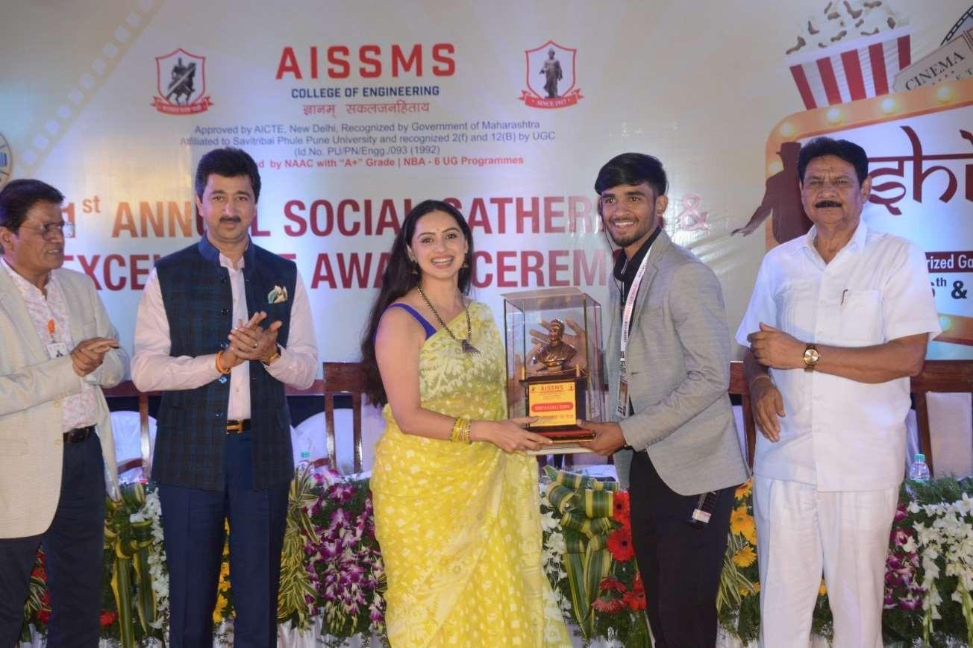 | 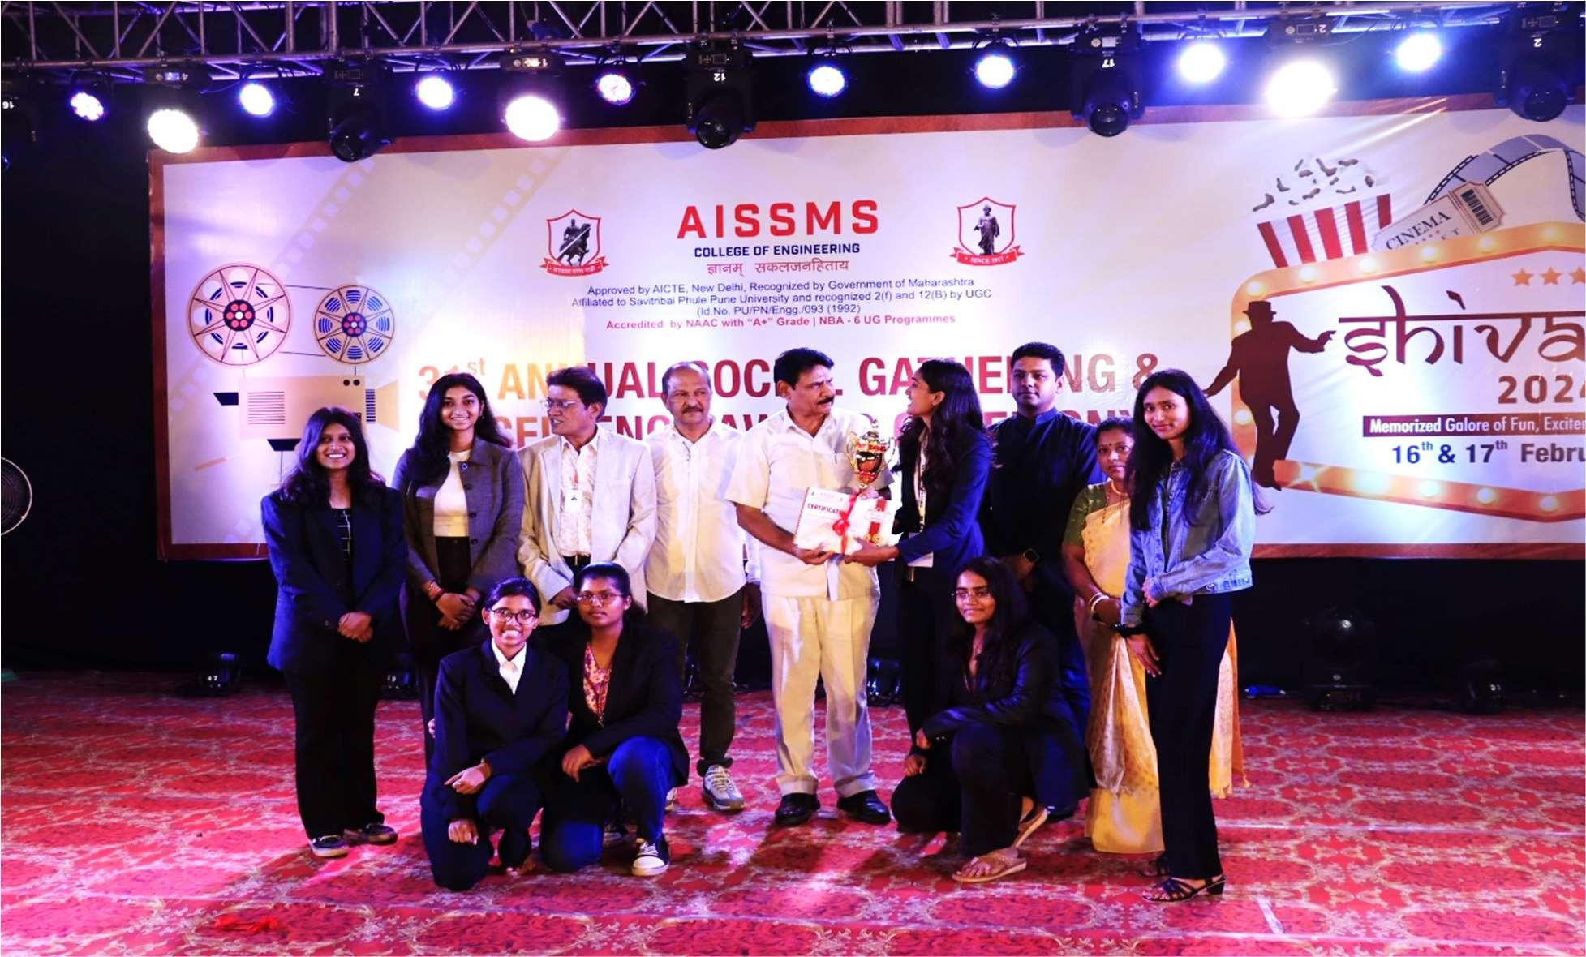
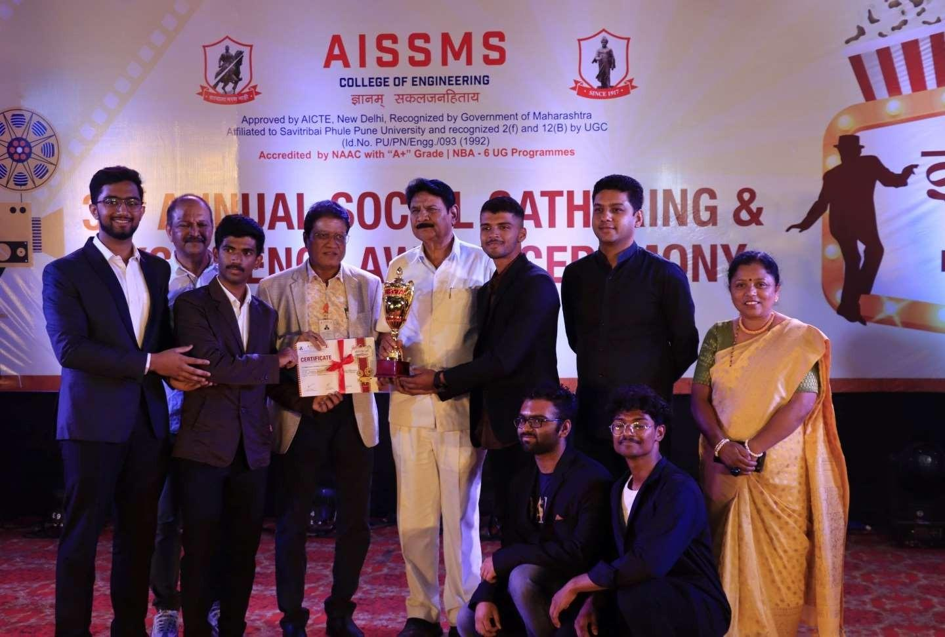 | 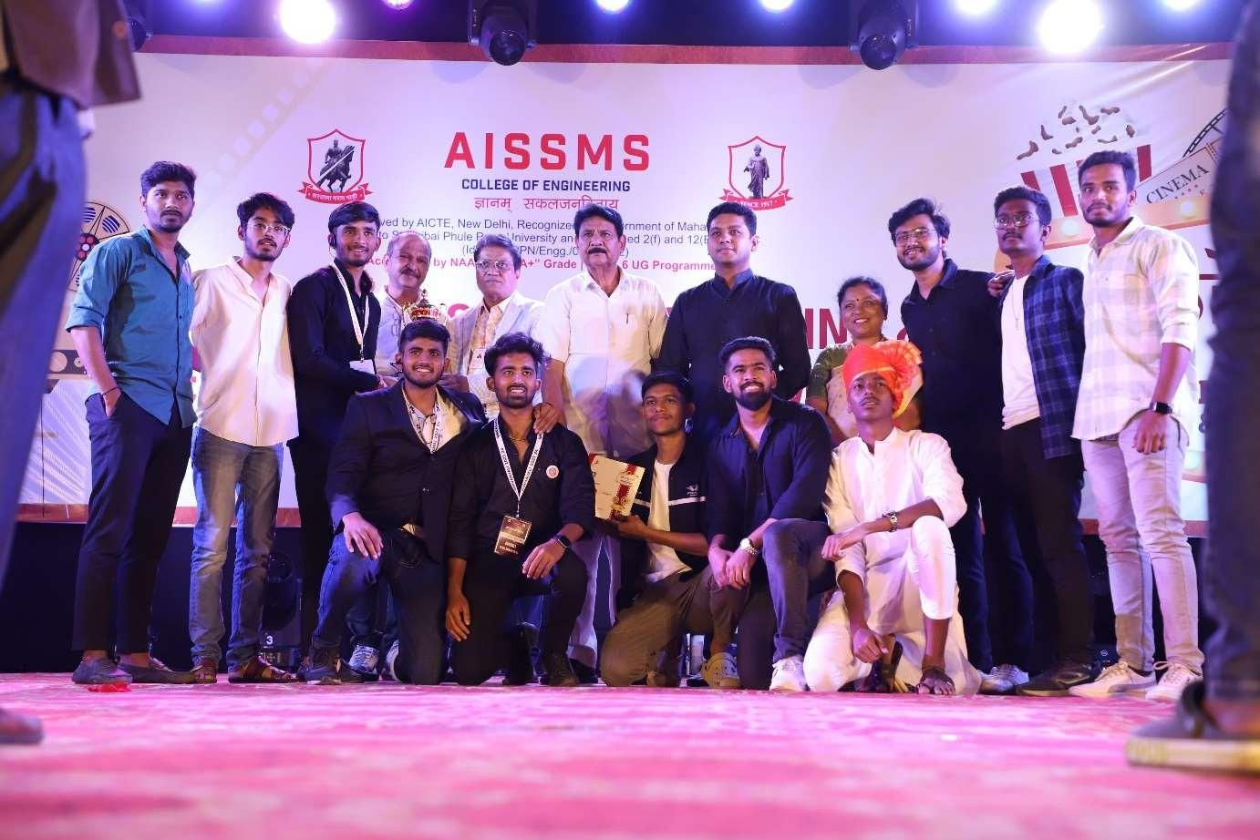
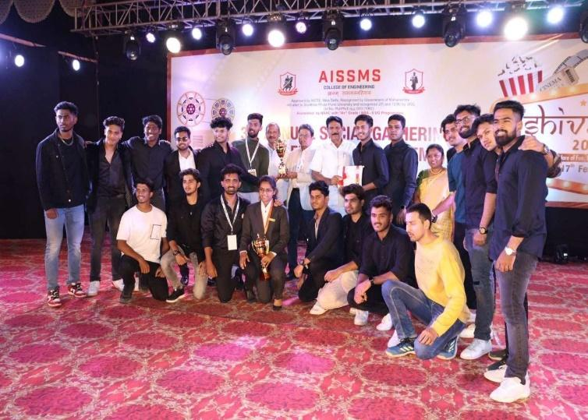 | 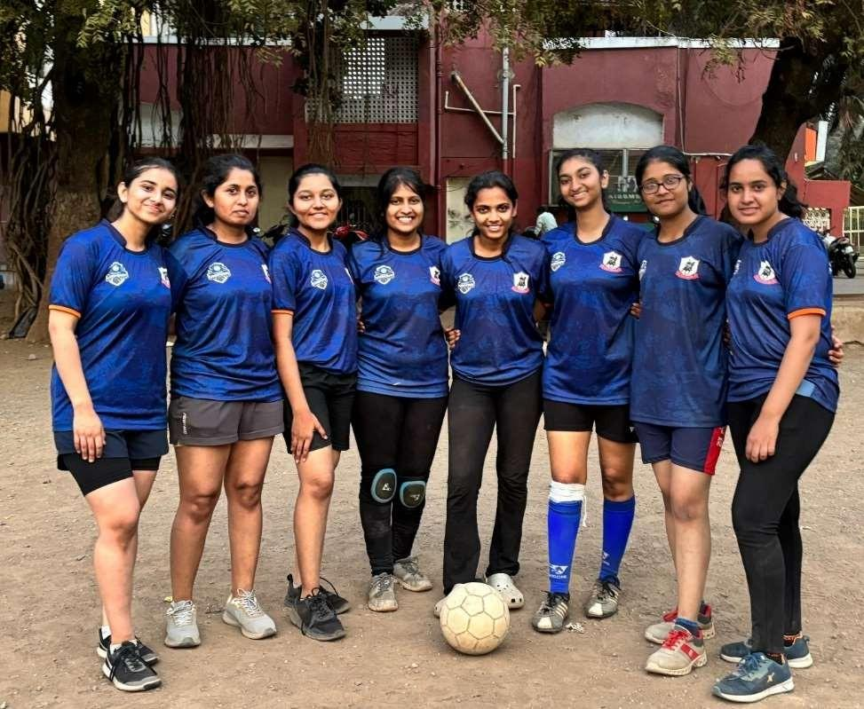

- SUMMARY
AND
SWOC ANALYSIS

7.1 ANY OTHER NOTEWORTHY ACHIEVEMENT OF THE DEPARTMENT (Not mentioned above)
Sr. No. | Details
1 | Research Center

7.2 MISCELLANEOUS (SYLLABUS IMPLEMENTATION, MAJOR ADDITION IN INFRASTRUCTURE AND FACILITY, INNOVATIONS INTRODUCED, ETC.)
FACULTY | ACTIVITY
Dr.S V Athawale | www.aissmscoe.tech (Website)

7.3 FEEDBACK FROM STAKEHOLDERS

Sr No | Stake holder | Number of Feedbacks Received | Overall Feedback
1 | Alumni | 12 | Good
2 | Parents | 9 | Good Response
3 | Employers | 20 | Good
4 | Students | 120 | Good

7.4 TWO BEST PRACTICES FOLLOWED IN THE DEPARTMENT
One faculty One Industry

Faculty presentation to update/transfer the knowledge

7.5 MAJOR GRIEVANCES OF STUDENTS (IF ANY) REDRESSED

7.6 SWOC ANALYSIS
Five major strengths, weaknesses, opportunities, and challenges (SWOC) of the department and future plans of the Department.
Strengths:
1 | Student and faculty publications.
2 | Placement of students in industries.
3 | Active Participation of students in Students Chapters and clubs
4 | Almost pursuing number of Ph.D
Weaknesses:
1 | Funded projects.
2 | Consultancy.
Opportunities:
1 | Undertake Artificial Intelligence and Deep learning related projects.
2 | Start Centre of Excellence and increase number of Research Oriented Projects.
3 | Increase internship and organize STTP programme for students.
4 | Establish collaborations with reputed Institutes.
5 | Research center

7.7 FUTURE PLANS OF THE DEPARTMENT (For Next Academic Year)
1 | To increase placement package of students in core companies
2 | To collaborate departments with different industries.

7.8 INITIATIVES TAKEN BY THE DEPARTMENT AT DEPARTMENT AND INSTITUTE LEVEL TO IMPROVE AND ASSURE QUALITY IN THE FOLLOWING AREAS

Area | Initiatives
Academics and overall profile of Department | Academic Monitoring
Organization of different activities | Organized Industry Visit, Expert Lecture, Seminar, Workshops, FDP,STTP, Webinar
Research and Innovation | Phd Assistance
Industry institute Interaction | I3 Meets has been conducted
Students’ Achievements | Different courses NPTEL,MOOC ,Swayam students have been participated

SUMMARY SHEET (Annual)
Sr No | Activity/ Item | Numbers
PROFILE OF DEPARTMENT
01 | Students in the department | 487
 | FACULTY CONTRIBUTION
02 | e content developed by faculty and available online | 33
03 | Number of FDP/STTP attended by the department faculty | 108
04 | Number of Seminars/ workshops/ webinars attended by the department faculty | 5
05 | Number of Conferences/ symposiums attended by the department faculty | 4
06 | Number of Online courses / certificate courses completed by department faculty | 10
07 | Number of extension lectures / webinars (Lectures delivered on other than technical topics)) | 1
08 | Number of Faculty served as resource person, expert, chairperson | 5
 | ACTIVITIES ORGANISED
09 | Number of FDP/STTP organized by the department | 1
10 | Number of Seminars/ workshops/ webinars organized by the department (for faculty) | 6
11 | Number of Conferences / symposiums organized by the department (for faculty) | -
12 | Number of Extension activities conducted by the department (Social/ Quizzes at national/international level/any other activity) | 3
13 | MOU signed with academic and professional organizations | 21
14 | Number of Students’ chapters /clubs | 3
15 | Number of Social activities organized | 1
16 | Number of Parent meeting | 1
17 | Number of Alumni meet | 1
18 | Number of student counseling and career guidance at the department level | -
 | RESEARCH CONTRIBUTION
19 | Number of Funded research project | -
20 | Number of Testing and consultancy | -
21 | Number of Patents, copyright, trademark and other (IPR) | 8
22 | Number of Papers published/ presented in proceedings of conferences | 2
23 | Number of Papers published in journals
24 | Number of Book/ article publications | 2
25 | Total Research citations | 704
26 | Number of ME awarded | 1
27 | Number of PhD AWARDED | -
 | INTERACTION WITH INDUSTRY
28 | Number of Industrial visits organized | 6
29 | Number of Expert lectures delivered by industry experts | 15
30 | Number of Industry –sponsored projects (UG/PG) | 36
31 | Number of MOU signed with industry | 10
32 | Number of Faculty members undergone industrial training | -
33 | Number of Students undergone in-plant training and (or) internship programme | 154
34 | Number of students placed | 64
35 | Number of students qualified in the examinations | 6

Declaration by the Head of the Department

I am aware that the above information provided by the Department will be validated by the AAA committee during the visit.

Name and Signature
Head of Department

