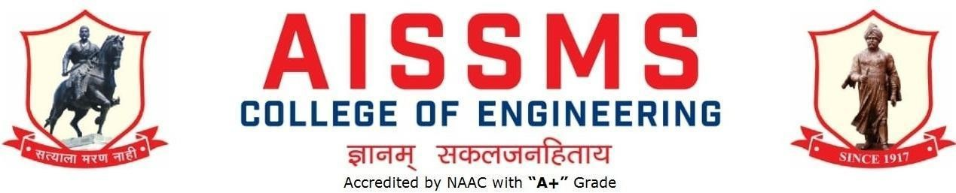

DEPARTMENT OF COMPUTER ENGINEERING
ANNUAL REPORT

(01 JUNE 2021 to 31 MAY 2022)
TERM ONE: 01 June to 30 November TERM TWO: 01 December to 31 May

Guidelines:
Academic Year 2021 – 2022

Fill up this sheet for all the contributions /activities conducted at Department level only.
- In case data does not exist please mention it as ‘No Data’.
- Please add rows to the table below to suit your requirements
- Ensure that data does not differ from other official records and all the supporting documents are available.
- Use: Font Type: Times New Roman, Font Size: 12, Sentence case, Spacing: 1.15
- Use separate row for every details.
- For any queries, you may contact: Dr C S Choudhari, Coordinator, IQAC
- email: iqac@aissmscoe.com

PROFILE
OF DEPARTMENT

INTRODUCTION

Year of Establishment | 1998-I Shift 2013-II Shift
UG Programmes | Shift I-60 ShiftII -60
PG Programmes | 18
Number of Teaching Staff | 21+03(First Year)
Number of Non-Teaching Staff | Lab Assistant-04 Lab attendant-03

LABORATORIES IN THE DEPARTMENT

Name of Laboratory | Name of Laboratory
Microprocessor Lab | Linux Lab
Digital Lab | Computer Network Lab
Multimedia Lab | Software Design Lab
Computer Software Lab | PG Lab
Fundamental and Programming Lab

SOFTWARES AVAILABLE IN THE DEPARTMENT

Software Available | Software Available
Windows 98(36 users) & (60 users) | Borland C++ suite (30 users)
Windows XP Pro. (50 users) | ORACLE 10g Std. Edition one for 25 users with one media
IBM Utilities, PC Doctor (60 users) | Office XP (01 user)
Lotus Smart Suit (60 users) | Microsoft Office Professional 2007(5 users)
Rational Rose (30 users) | Auto Desk 3 CD’s max 8.0 with kit
Oracle 9i (5 users) | Windows XP Pro.English UGP OLP NL AE with media(168 users)
Vstudio.NET Pro 2002 Win32 ENG OLP NL AE (01 users) | Internet developer suite ( Oracle D2K with media )

Borland C++ suite (02 users) | Xilinx 11.2 VLSI Design (25 User)
NetDruid Ver.9.0 | Windows 2007 (50 User)
MS Office XP 2003 (02 user) | ETNL Language Lab (one teacher Cons.

FACULTY IN THE DEPARTMENT

Name of faculty | Designation | Name of faculty | Designation
Dr. D P Gaikwad | Associate Professor | S G Dhengre | Assistant Professor
Dr M A Pradhan | Associate Professor | S J Pachouly | Assistant Professor
N R Talhar | Assistant Professor | S S Jadhav | Assistant Professor
A J Kadam | Assistant Professor | M M Swami | Assistant Professor
Dr.S F Sayyad | Associate Professor | S S Kolte | Assistant Professor
Dr.S V Athawale | Assistant Professor | M M Phadatare | Assistant Professor
A S Deokar | Assistant Professor | Neha Rai | Assistant Professor
S R Nalamwar | Assistant Professor | Savitri Chetan Pawar | Assistant Professor
V V Waykule | Assistant Professor | M. P. Deshmukh | Assistant Professor
A M Jagtap | Assistant Professor | Mrs. Ritu S. Dudhmal | Assistant Professor
Dr. D M  Ujlambkar | Assistant Professor

DETAILS OF SUPPORTING STAFF

Name of Non Teaching Staff | Designation | Name of Non Teaching Staff | Designation
Mr.J.B.Mohite | Lab.Asst | Mr.P.B.Tikone | Lab. Attendant
Mr.P.K.Mulay | Lab.Asst | Mr.A.B.Chavan | Lab. Attendant
Mr.N.S.Sale | System Analyst | Mr.N.A.Kale | Lab. Attendant
Mr.S.P.Mane | Lab.Asst | Mr Vinayak Unune | Lab.Asst

STUDENTS’ ENROLLMENT

Programm | GEN |  | SC |  | ST |  | OBC |  | PWD |  | Others |  | Total
 | M | F | M | F | M | F | M | F | M | F | M | F | M | F
UG  (Computer) | 41 | 16 | 5 | 4 | 3 | 2 | 28 | 6 | 0 | 0 | 26 | 6 | 103 | 34
PG
(Computer)

STUDENTS–FACULTY FEEDBACK DETAILS

Term One
Name of faculty | Class and Subject taught | Feedback  (I) (%) | Feedback  (II) (%) | Average Feedback (%)
Dr. D P Gaikwad | SE-I OOPs | 84 | 74 | 79
Dr M A Pradhan | TE-I(SPM) | 91 | 88 | 90
N R Talhar | BE-1:Distributed System | 84 | 78 | 81
A J Kadam | TE I _CNS | 89 | 86 | 88
Dr.S F Sayyad | CG(SE-I) and CG SE- II) | 87  82 | 85  83 | 86  83
Dr.S V Athawale | BE-I HPC | 83 | 77 | 80
A S Deokar | TE-I(SPM) | 65 | 89 | 77
S R Nalamwar | TE-I:DBMS | 94 | 91 | 43
V V Waykule | TE:TOC-I &TOC -II | 93  79 | 88  86 | 91  83
A M Jagtap | BE:DA-I | 85 | 81 | 83
Dr. D M Ujlambkar | DMW(BE-I) | 85 | 80 | 83
S G Dhengre | SE I FDS | 85 | 85 | 85

 | SE II FDS | 84 | 78 | 81
S J Pachouly | CN (TE II) | 85 | 91 | 88
S S Jadhav | SE:OOP-II BE:DMW-II | 79  80 | 80  80 | 80  80
M M Swami | DELD (SE-I) DELD (SE-II) | 90  83 | 83  85 | 87  84
S S Kolte | BE-I High Performance Computing | 86 | 80 | 83
M M Phadtare | BE-II Data Analytics TE-II DBMS | 76  81 | 88  81 | 82  81
Neha Rai | BE-I Artificial Intelligence and Robotics  BE-II Artificial Intelligence and Robotics | 85  82 | 82  83 | 84  83
Savitri Chetan Pawar | SE DM | 70 | 72 | 71
M. P. Deshmukh | TE -I System Programming and Operating Systems TE-II System Programming and Operating Systems | 89 | 85 | 87

Term Two
Name of faculty | Class and Subject taught | Feedback  (I) (%) | Feedback  (II) (%) | Average Feedback (%)
Dr. D P Gaikwad | TE-I Artificial Intelligence | 85 | 84.14 | 85
Dr M A Pradhan | BE-I( Machine Learning) | 85 | 86 | 86
N R Talhar | BE-1 Cloud Computing | 82 | 83 | 83

A J Kadam | TE-II Data Science and Big Data Analytics | 82 | 83 | 83
Dr.S F Sayyad | TE-I Web  Technology | 88 | 89 | 89
Dr.S V Athawale | TE-II Data Science and Big Data Analytics | 64 | 73 | 70
A S Deokar | SE-I  Principles of Programming Languages | 75 | 76 | 76
S R Nalamwar | BE-II : Machine Learning  ME : Artificial Inelligence | 89 | 87 | 88
V V Waykule | SE-I :Data Structures and Algorithm and | 81 | 81 | 81
A M Jagtap | TE-II Web  Technology | 60 | 73 | 67
Dr. D M Ujlambkar | BE-I Soft Computing and Optimization Algorithms  BE-II Soft Computing and Optimization Algorithms | 81  80 | 77  81 | 79  81
S G Dhengre | SE-II :Data Structures and Algorithm and | 83 | 89 | 86
S J Pachouly | BE-I :Information and cyber Security | 86 | 82 | 84
S S Jadhav | BE-II Information | 88 | 90 | 89

 | and Cyber Security
M M Swami | SE-I  Microprocessor | 84 | 87 | 86
S S Kolte | TE-I -II  Cloud Computing | 73 | 78 | 76
M M Phadtare | SE-II  Microprocessor | 81 | 85 | 83
Neha Rai | TE-II  Artificial Intelligence | 74 | 78 | 76
Savitri Chetan Pawar | BE-II Cloud Computing | 76 | 78 | 77
M. P. Deshmukh | SE Software Engineering | 87 | 86 | 87
Mrs. Ritu S. Dudhmal | SE-II Principle of Programming Languages  SE-II Principle of Programming Languages | 85  85 | 84  86 | 85  86

RESULT ANALYSIS (LAST TERM) (Academic Year: Term: I/II)

Term One
Name of faculty | Class and Subject Taught | %  passing | Name of faculty | Class and Subject Taught | %  passing
Dr. D P | OOP-SE-I | 100% | S G Dhengre | SE I | 100%
Gaikwad |  |  |  | FDS | 100%
 |  |  |  | SE II
 |  |  |  | FDS

Dr M A Pradhan | TE(Software Project Management) ME  (Operation Research) | 100 %  100% | S J Pachouly | TE-II CNS | 100%
N R Talhar | BE-1  Distributed Systems | 100% | S S Jadhav | SE-II- OOP BE-II- DMW | 100%  100%
A J Kadam | TE-I CNS | 100% | M M Swami | DELD SE-I SE-II | 100%  100%
Dr.S F Sayyad | CG SE-I CG-SE-II | 100%  100% | S S Kolte | BE-II HPC | 100%
Dr.S V  Athawale | HPC MANET | 100%  100% | M M Phadtare | BE-II DA TE-II DBMS | 100%
A S Deokar | TE-I SPM | 100% | Neha Rai | BE-I & BE-II  Artificia l Intellige nce and Robotics | 100%
S R Nalamwar | TE-I DBMS | 100% | Savitri Chetan Pawar | DM-I | 100%
V V Waykule | TOC I TOC II | 100% | M. P. Deshmukh | TE -I & TE-  IISystem Program ming | 100%
A M Jagtap | BE-I-DA | 100% | Mrs. Ritu S. Dudhmal | MC-BE | 100%

Dr. D M  Ujlambkar | BE-I DMW | 100%

Term Two
Name of faculty | Class and Subject Taught | %  passing | Name of faculty | Class and Subject Taught | %  passing
Dr. D P  Gaikwad | AI-TE-I | 97.56% | S G Dhengre | SE-II- DSA | 92.21%
Dr M A Pradhan | BE( Machine Learning) | 98.63% | S J Pachouly | BE-I ICS | 97.26%
N R Talhar | BE-1 Cloud Computing | 97.26% | S S Jadhav | BE-II- ICS | 100%
A J Kadam | TE-I  Data science & big data analytic | 100% | M M Swami | MP SE-I | 83%
Dr.S F Sayyad | TE-I Web  Technology | 100% | S S Kolte | TE-I-II  Cloud Computi ng | 100%  96%
Dr.S V  Athawale | TE-II  Data science & big data analytic | 88.61% | M M Phadtare | SE-II- MP | 85%
A S Deokar | PPL | 91% | Neha Rai | TE-II  Artificia l Intellige nce | 89.97%
S R Nalamwar | BE-II ML | 100% | Savitri Chetan Pawar | BE-II- CC | 100%
V V Waykule | SE I-Data Structures and | 94.94 | M. P. Deshmukh | SE-I-SE | 92%

 | Algorithms
A M Jagtap | TE-II-WT | 86.91% | Mrs. Ritu S. Dudhmal | SE-I PPL | 94%
Dr. D M  Ujlambkar | BE-I SCOA | 98.63%

CLASS RESULT ANALYSIS (LAST TERM) (Academic Year: Term: I/II)

Term One
S N | Class | No. Of Students |  |  |  |  |  |  |  |  |  | Percentage of Passing
 |  | Appe ared | Clear Passed | Outstanding (O)  (9 -10) | Excellent (A+) (8.5 –  8.99) | Very Good (A) (7.5 –  8.49) | Good (B+) (6.5 –  7.49) | Above Average (B)  (5.5 –  6.49) | Avera ge (4.25 – 5.49)  Class | Pass Class (4 –  4.24 | Fail (F)  0 – 3.99 | All Clea r | With ATK T
1 | BE I | 73 | 73 | 68 | 4 | 1 | 0 | 0 | 0 | 0 | 0 | 100 | 100
2 | BE II | 68 | 68 | 68 | 0 | 0 | 0 | 0 | 0 | 0 | 0 | 100 | 100
3 | TE I | 82 | 82 | 82 | 0 | 0 | 0 | 0 | 0 | 0 | 0 | 100 | 100
4 | TE II | 79 | 79 | 78 | 01 | 0 | 0 | 0 | 0 | 0 | 0 | 100 | 100
5 | SE I | 79 | 79 | 27 | 52 | 0 | 0 | 0 | 0 | 0 | 0 | 100 | 100
6 | SE II | 77 | 77 | 26 | 49 | 2 | 0 | 0 | 0 | 0 | 0 | 100 | 100

Term Two
S N | Class | No. Of Students | Percentage of Passing

 |  | Appe ared | Clear Passed | Outstanding (O)  (9 -10) | Excellent (A+) (8.5 –  8.99) | Very Good (A) (7.5 –  8.49) | Good (B+) (6.5 –  7.49) | Above Average (B)  (5.5 –  6.49) | Avera ge (4.25 – 5.49)  Class | Pass Class (4 –  4.24 | Fail (F)  0 – 3.99 | All Clea r | With ATK T
1 | BE I | 73 | 71 | 14 | 13 | 21 | 2 | 0 | 0 | 0 | 2 | 97.3  6 | 100
2 | BE II | 68 | 68 | 4 | 37 | 0 | 0 | 0 | 0 | 0 | 0 | 100 | 100
3 | TE I | 82 | 80 | 11 | 65 | 4 | 0 | 0 | 0 | 0 | 0 | 98 | 100
4 | TE II | 79 | 69 | 5 | 63 | 1 | 0 | 0 | 0 | 0 | 0 | 87.3 | 100
5 | SE I | 79 | 61 | 0 | 27 | 34 | 0 | 0 | 0 | 0 | 0 | 77 | 100
6 | SE II | 77 | 64 | 0 | 31 | 33 | 0 | 0 | 0 | 0 | 0 | 83.1 | 100

FACULTY CONTRIBUTION

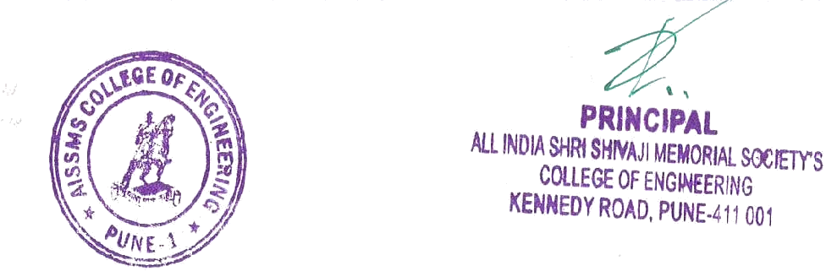

ACHIEVEMENTS OF FACULTY (AWARDS, RECOGNITION, PHD COMPLETION ETC.)

Term One
SN | Name of Faculty | Awards & Recognition
1 | Dr. D P Gaikwad | Received Award by GOAL as “Shksha Vibhuti” Delhi
3 | Dr S F Sayyad | Best Women Research Award- 2021
2 | D M Ujalambkar | Ph.D(Computer Science and Engineering)
4 | S J Pachouly | Felicitated and awarded by Jashn e Adab Delhi
5 | S S Kolte | Awarded as Super woman Multitalent Award by forever stat india

Term Two
SN | Name of Faculty | Awards & Recognition
1 | S J Pachouly | Felicitated and awarded by Deccan Literature Pune

Few photographs of related to faculty contribution (felicitation of faculty, photos of award function etc.
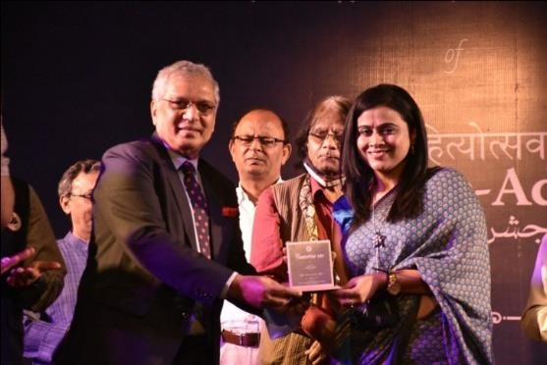 | 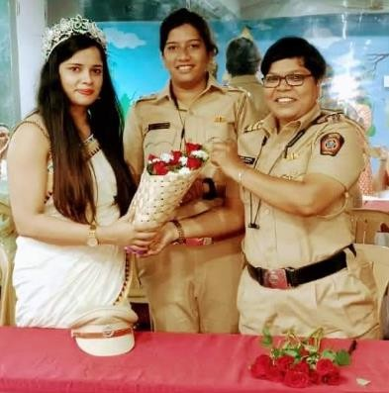
14

CONTRIBUTION OF FACULTY (Interaction with outside world)

Term One
SN | Name of Faculty | Nature and details of contribution (Representation at University, State, National , International level, corporate world, Social Platforms, etc)
1 | Dr. D P Gaikwad | - Board of Studies meeting of Cummins College  - One paper of IEI Springer reviewed  - One paper reviewed of international conference  4.1. Paper reviewed by International journal Currency and statistics An Intrusion Detection Approach using Ensemble Support Vector Machine based Chaos Game Optimization Algorithm in Big Data Platform.  - Paper reviewed on "Prediction performance comparison of risk management and control mode in regional sites based on decision tree and neural network" of Concurrency journal.  - Reviewed paper of Concurrency and Generation
2 | Dr M A Pradhan | - Board of Studies(BoS) member of Information technology, SPPU,  - Board of Studies(BoS) member of Computer Engineering VIIT, Pune  - Board of Studies(BoS) member of Computer Engineering Cummins College of Engineering, Pune  - Technical Committee member of SPPU  - Paper Setter (PG),Paper Setter (UG)
 | A J Kadam | - Paper Reviewer International Journal.  - Paper Setter (PG),Paper Setter (UG)  - ET core committee Member.  - Central Online Exam Coordinator.(TCS,ION)
3 | Dr.S F Sayyad | - Paper Setter and examiner computer Graphics(SE Computer Engineering, AI & DS)SPPU  Member of 8th International Conference on Signal, Image Processing and Embedded Systems (SIGEM 2022) November 19 ~ 20, 2022, Zurich, Switzerland  2 member
4 | Dr.S V Athawale | 1.Keynote speaker of International Conference on

innovations & Trends in Computing ICITC 2021
- 3 papers of IETF reviewed
- One paper reviewed of international conference
- My paper selected in MDPI (IF 3.5 )
- Board of Studies meeting of JSPM College
5 | Dr. D M Ujlambkar | Paper Setter (PG)
6 | S J Pachouly | - Performed and Felicitated at INSHAAD Sanstha Mumbai program for my contribution and Hindi poetry and literature on 12th 2021.  - Performed and Felicitated at Jashne adab Delhi at their 10th Foundation day program for my contribution and hindi poetry and literature on 24 Aug 2021.  - Performed and Organized Swarnim VIJAY Mashal Celebration at Roseland Residency Pune on 3rd October 2021 to celebrate 50 years of India’s glorious victory in into pak war of 1971 on date.  - Performed and Felicitated In a poetry event held by Deccan Lit committee at Pune on 12th March 2022

Term Two
SN | Name of Faculty | Nature and details of contribution (Representation at University, State, National , International level, corporate world, Social Platforms, etc)
1 | Dr M A Pradhan | - Board of Studies(BoS) member of Information technology, SPPU,  - Board of Studies(BoS) member of Computer Engineering VIIT, Pune  - Board of Studies(BoS) member of Computer Engineering Cummins College of Engineering, Pune  - Technical Committee member of SPPU  - Paper Setter (PG),Paper Setter (UG)
2 | Dr S F Sayyad | Speaker for “5 Days ISTE APPROVED STTP on "Machine Learning With IOT" organized by the Information Technology department from 14th March 2022 - 19th March 2022 ”

3 | M M Swami | 1) Faculty Mentor for the course “Artificial Intelligence for All” under IUCEE NEP Program

e CONTENT DEVELOPED BY FACULTY AND AVAILABLE ONLINE

Term One
Sr No. | Name of Faculty | Title of e- content | e-content development facility/platfo rm | link of the content
1 | Dr M A Pradhan | Lecture notes and assignment | Google classroom, google drive | https://drive.google.com/drive  /folders/12xufZMowv4wKP4 24mxgTeggq1ltextzf?usp=sha ring
2 | N R Talhar | Lecture Notes and Assessment Google Classroom | BE-1  Distributed System | https://classroom.google.com/ u/1/w/Mzc3MDE3OTUzOTI3  /tc/MzgwNzMyNzA0NDE4
3 | Dr.S F Sayyad | Lecture Notes and Assessment | Microsoft Teams | shorturl.at/hjIPT
4 | Dr.S V Athawale | Lecture Notes and Assessment Google Classroom | TE-2 Design and analysis of algorithms | lxcnrdd
5 | A S Deokar | Google Classroom | TE-I(Software Project Management) | https://classroom.google.com/ c/NDE3NjkyOTM4MTE5
6 | S R Nalamwar | Google ClassRoom | TE-I DBMS | https://classroom.google.com/ c/MTQzMTc0ODA1diJq

7 | V V Waykule | Google  ,Classroom | TE I (TOC) TE II (TOC) | Class Code: 4bnoyvh hgav5mv
8 | Dr. D M Ujlambkar | Google Classroom | BE-I Data Mining and Warehousing | https://classroom.google.com/ u/1/c/MzgxODg3ODE0NzAx
9 | S G Dhengre | Google Classroom | SE I FDS  SE II FDS | 2vs22ty omm4gmy
10 | S J Pachouly | Google Classroom | TE-II CNSL ME FTS | https://classroom.google.com/ c/Mzc0NzU0MTI0MTA1  https://classroom.google.com/ c/MTQzMTc0ODA1MjQw
11 | M M Swami | Google Classroom | SE I(DELD) SE II (DELD) | gyczz3e celgnof
12 | S S Kolte | Google Classroom | BE-II Cloud Computing | https://classroom.google.com/ c/MTE3NjQ4MTMyOTUy?cj c=k2buk6j
13 | M M Phadtare | Google Classroom | BE(DA) TE(DBMS) | 2fnd56h e3fdcyl
14 | Neha Rai | Google Classroom | BE I-AIR BE-II AIR | todar4g

kc46hn7

Term Two
Sr No. | Name of Faculty | Title of e- content | e-content development facility/platform | link of the content
1 | Dr M A Pradhan | Design of Predictive model Part 1  Design of Predictive model Part 2 | Youtube  Youtube | https://youtu.be/Qj 1xMlVLy-A  https://youtu.be/gZ FWQXGjjJ8
2 | Dr.S F Sayyad | TE-I  Web Technology | Google Classroom | https://classroom.g oogle.com/u/1/c/M jU4OTY1Njc0MT A1
3 | Dr.S V Athawale | BE-1 High performance computing | Google Classroom | rc5eyg3
4 | A S Deokar | Google Classroom | SE-I Principles of Programming Languages | https://classroom.g oogle.com/c/NDcw MTE3NzMxNzAz
5 | V V Waykule | Google Classroom | ME:MFDS SEI:DSA | Class Code:  ovxoznz class

 |  |  |  | Code:pbunxtv
6 | S J Pachouly | Google Classroom | BE-ICS | https://classroom.g oogle.com/c/MjY1 ODU0MjAwNTk5
7 | M M Swami | Google Classroom | SE I(MP) | gyczz3e
8 | S S Kolte | Google classroom | TE-I-II  Cloud Computing | vauaaxi 5obeh3y
9 | Neha Rai | Google Classroom | TE-II:AI | zelh2b6
10 | R. S. Dudhmal | Google Classroom | SE-II Principles of Programming Languages | https://classroom.g oogle.com/c/MzUz NjIzNzc5MzI4

FDP/STTP ATTENDED BY THE DEPARTMENT FACULTY

Term One
S N | Name of Faculty | Title of the FDP/STTP | Organized by | Duration/ Dates
1 | Dr D P Gaikwad | Webinar on “Discover Yourself”Organised by  AISSMSCOE | AISSMSCOE | 7 Dec 2021
2 | Dr M A Pradhan | One week FDP on"  Research Funding and  Patent Filing " | Department of  Information  Technology, | 25 Oct to 29  Oct 2021

Sinhgad
Institute of
Technology,
Lonavala
3 | Dr M A Pradhan | 2)One day FDP on “Software project  management “ | RMD Singhgad  college of  Engineering in  association  with SPPU | 11  August 2021
4 | Dr M A Pradhan | 3)Five days FDP on  Software based case studies  for development of  Multidisciplinary projects | Department of  Computer  Engineering in  association  with Faculty  development  cell , AISSMS  COE | 25 Nov to 29  Nov 2021
5 | N R Talhar | 1. Attended FDP on  TOC | Department of  Computer  Engineering in  association  with Faculty  development  cell , AISSMS  COE | 1 day  (03/08/2021)

6 | N R Talhar | Attended ATAL FDP  AICTE "Design Thinking:  Aspirations for  Innovations" | ATAL FDP  AICTE by  AISSMS COE  Comp Dept | 5 day  (29 Nov to  3rd Dec  2021)
7 | N R Talhar | 3. Attended FDP on  Software based case studies  for development of  multidisciplinary project | Department of  Computer  Engineering in  association  with Faculty  development  cell , AISSMS  COE | 5 days  (22 Nov to  26 Nov  2021)
8 | N R Talhar | 4. AICTE-ISTE sponsered  one week Refresher  program " Advances in  Engineering" | AICTE-ISTE  AISSMSCOE | 6 days  8/12/2021 to  14/12/2021

9 |  | Webinar on“Cloud Technolo |  | AISSMSCOE |  | 9/7/2021
10 |  | Webinar on “Discover Yours |  | AISSMSCOE |  | 7/12/2021
11 |  | ATAL FDP AICTE  Thinking: Aspirations  Innovations" |  | AISSMSCOE |  | 29-11-2021  to 3-12-2021
12 |  | DP on Software based case s |  | AISSMSCOE |  | 22-11-2021  to 26-11-  2021
 |  | development of | multidi
 |  | project

- A J Kadam
AICTE-ISTE sponsered o AISSMSCOE
Refresher program " Adv
Engineering
08-12-2021
to 14-12-
2021

- A J Kadam
Webinar on "Be Placement R AISSMSCOE
1/6/2021

- A J Kadam
Webinar on Intellectual Rights”
AISSMSCOE
05-06-2021

- A J Kadam
Webinar on Benefits and op of student chapters in pande
12-06-2021

Organised by
SSGMCOE

- A J Kadam
Webinar on
Communication in Crisis
Management – How ToDo
It Right?
organised by
Bharati
vidyapeeth
19-06-2021

18 | A J Kadam | Webinar on OBE-in p  academic excellent |  |  | organised by  Karpagam  university |  |  |  | 24-06-2021
19 | A J Kadam |  |  |  |  |  |  |  | 26-06-2021
 |  | Webinar on Research in Dig |  |  | Bharati
 |  | Problems and Opportunities |  |  | vidyapeeth
20 | A J Kadam | Webinar on Financial Literac |  |  | AISSMSCOE |  |  |  | 17-07-2021
21 | A J Kadam |  |  |  |  |  |  |  | 24-07-2021
 |  | Webinar on Quantum |  |  | Organised by
 |  | Classical | Cryptography |  | Bharati
 |  | PostQuantum Cryptography |  |  | Vidyapeeth
22 | A J Kadam | Webinar on Blockch |  |  | Organised by |  |  |  | 31-07-2021
 |  | GameChanger Tech in the |  |  | BVICAM
 |  | Post COVID World

23 | Dr.S F Sayyad | 1)NPTEL FDP“Introduction  to research 8 weeks (Aug to  Oct | AICTE NPTEL | 8 weeks  (Aug to Oct  2021
24 | Dr.S F Sayyad | One Week National  workshop On  Accreditation  Process Organized Under  PARAMASH Scheme of  UGC | UGC | 17/3/2021 to  23/3/2021
25 | Dr.S V Athawale | Attended 5 days FDP of  AICTE | AICTE | 12/3/21  18/3/21
26 | Dr.S V Athawale | Attended 5 days FDP of  AICTE | AICTE | 5//3/21  11/3/21
 | Dr.S V Athawale | Webinar on“Cloud Technology” | Aissmscoe | 9/7/2021
 | Dr.S V Athawale | Webinar on “Discover Yourself” | Aissmscoe | 7/12/2021
12 | A S Deokar | Attended webinar on“Cloud Technology” | Department of  Computer  Engineering,  AISSMS  College of  Engineering,  Pune | 1 day  (9th July, 2021)

13 | S R Nalamwar | Short Term Training  Programme (STTP)through ICT mode on ‘Advanced  Applications in Artificial  Intelligence and Machine Learning’ | Marathwada Mitra Mandal’s  Institutions  MMCOE and  MMIT
 |  |  |  |  | 2/08/21
 |  |  |  | 6/08/21
14 | S R Nalamwar | One Week Online  National Level FDP on | Computer Engg  & IT Dept Dr. | 5/07/2021  to
 |  | “Recent Advances in | Balasaheb | 9/07/2021
 |  | Computer Science and | Vikhe Patil
 |  | Allied Domains | Technology,
 |  | (RACSAD-2021)” | Nashik
15 | S R Nalamwar | 3. FDP on "MACHINE  LEARNING TO DEEP | Madhuben &  Bhanubhai | 13 /12/21  to 18/12/21
 |  | LEARNING: TRENDS | Patel Institute
 |  | AND CHALLENGES" | of Techn,New
 |  |  | Vallabh
 |  |  | Vidhyanagar

16 | S R Nalamwar | 4. STTP “Innovative &  Inventive Problem Solving” | Dept of  Production  Engineering,  AISSMS COE,  Pune | 13/07/21 to  18/07/21
17 | S R Nalamwar | 5.Two Days workshop on “  A Structured New Strategy  of Quality Enhancement in  Revised Accrediation for  all Higher Educational Institutions (HEI’S)” | Internal quality  Assurance Cell  ,Er Perumal  Manimekalai  College  ofEngineering  ,Hosur -  635117,Krishna  giri Tamilnadu | 22/09/21 to  23/09/21
 | A M Jagtap | Webinar on “Discover Yourself” | Organised by  AISSMSCOE | 7/12/2021
18 | V V Waykule | FDP on “OUTCOME  BASED CURRICULUM  AND EXAMINATION  REFORMS | B.V.V.S.Polyte  chnic(autonom  ous),Bagalkot  AISSMS COE | 2021-10-25  to  2021-10-21
19 | V V Waykule | STTP on "Innovative and  Inventive Problem Solving  (IIPS-2021) Phase IV | AISSMS COE | 2021-07-13  to  2021-07-18

20 | V V Waykule | FDP on "Design Thinking:  Aspirations for Innovations |  | Department of  Computer  Engineering,  Bharati  Vidyapeeth's  College Of  Engineering,  Lavale, Pune. |  |  |  | 29-11-2021
 |  |  |  |  |  |  |  |  | to 03-12-202
21 |  | participated & completed suc  AICTE Training And Learn  (ATAL) Academy Online  Elementary  FDP on "Design Thinking: |  | All India Shri Sh Memorial  Society's  College of  Engineering |  |  |  | 29/11/2021 to  03/12/2021
 |  | Aspirations for Innovations"
 |  | 29/11/2021 to
 |  | 03/12/2021 at All India Shri
 |  |  | Memorial Society's College
 |  | Engineering.
22 |  | 2. participated & completed |  | B.V.V.S.Polyt |  |  |  | 25/10/2021 to  29/10/2021
 |  | successfully AICTE Training |  | echnic(autono
 |  | And  (ATAL) Academy Online  Elementary  FDP on "OUTCOME  BASED  CURRICULUM AND  EXAMINATION  REFORMS" from  25/10/2021 to 29/10/2021 at |  | mous)  ,Bagalkot.
B.V.V.S.Polytechnic(autono
mous)
,Bagalkot
23 |  | participated & completed successfully AICTE |  | Dr. Harisingh |  |  |  | 27/12/2021

 |  | Training And Learning  (ATAL)  Academy Online  Elementary FDP on  "Data Sciences" from  27/12/2021 to  31/12/2021 at Dr. Harisingh  Gour Vishwavidyalaya  Sagar M.P | Gour  Vishwavidyalaya  Sagar M.P. |  | to  31/12/2021
24 |  | 4. participated in Faculty  Development Program on “Advanced Software  Engineering & Project Management” from  03/01/2022 to  07/01/2022. The program  was  organized by Dr. D. Y. Patil  Institute  of Engineering,  Management and  Research Akurdi Pune, in  association  with Indian Society for  Technical  Education (ISTE). | Dr. D. Y.  Patil Institute  of  Engineering,  Management  and  Research  Akurdi Pune |  | 03/01/2022  to  07/01/2022
25 |  | completed one-week  online Faculty Development Program on “Information  Security: Issues and  Challenges (ISIC-2021)”  sponsored by ISEA-II and  organized by Department of  Computer Science &  Engineering,  Motilal Nehru National  Institute of TechnologyAllahabad, | Motilal  Nehru  National |  | December  18 - 22, 2021.
 |  |  |  | Institute of Tech
Allahabad,
Prayagraj,
Uttar Pradesh,
India

Prayagraj,
Uttar Pradesh, India during
December
18 - 22, 2021.
26 |  | has Participated in Five  Days FDP  on “Software Based Case  Studies for Development of  Multidisciplinary Projects” Organized by  Department Of Computer  Engineering under Faculty  Development Cell, AISSMS  College  Of Engineering, Pune,  Maharashtra  From 22nd to 26th of  November | AISSMS  College  Of Engineering,  Pune | 22nd to 26th  of November
 | Dr D M  Ujalambkar | ATAL FDP on “Leading to  self Excellence | Organised by  AICTE | 15-10-21 to 19
 | Dr D M  Ujalambkar | AICTE FDP on “Enabling  Entrepreneurship and  startup mind set | Organised by  AICTE | 16-08-21 to 20
 | Dr D M  Ujalambkar | AICTE FDP on “Design  Thinking:Aspirations for innovations” | Organised by  AICTE | 29-11-21 to 3-
 | Dr D M  Ujalambkar | Refresher course on “3D  Interaction design using  AR-VR” | Organised by  PCCOE
 |  |  |  | 23-12-21 to 29
 | S G Dhengre | Webinar on “Discover Yourself” | AISSMSCOE | 7/12/2021
 | S J Pachouly | Webinar on Cloud  Technology | AISSMSCOE | 7/12/2021
 | S J Pachouly | ATAL Online Elementary  FDP on Design Thinking:  Aspirations for Innovations | AISSMSCOE | 9/7/2021

27 | M M Swami | pa​rticipated & completed  successfullyAICTE  Training And Learning  (ATAL) Academy Online  Elementary  FDP on "Design Thinking:  Aspirations for  Innovations" from  29/11/2021 to  03/12/2021 at All India  Shri Shivaji  Memorial Society's College  of  Engineering.  - webinar on“Cloud Technology”Organised by  AISSMSCOE | AISSMS COE  AISSMS COE | 29/11/2021  to  03/12/2021  9/7/2021
28 | S SKolte | pa​rticipated & completed  successfully  AICTE Training And  Learning  (ATAL) Academy Online  Elementary  FDP on "Design Thinking:  Aspirations for Innovations"  from 29/11/2021 to  03/12/2021 at All India Shri  Shivaji  Memorial Society's College  of  Engineering. | AISSMS COE  AISSMS COE | 29/11/2021  to  03/12/2021  7/12/2021  9/7/2021

1.
Webinar on “Discover Yourself”

AISSMS

2.
webinar on“Cloud Technology”Organis
d by AISSMSCOE

29 | M M Phadtare | participated & completed  successfully | AISSMS COE | 29/11/2021  to
 |  | AICTE Training And  Learning |  | 03/12/2021
(ATAL) Academy Online
Elementary
FDP on "Design Thinking:
Aspirations for Innovations"
from 29/11/2021 to
03/12/2021 at All India Shri
Shivaji
Memorial Society's College
of Engineering.
 |  | Webinar on “Discover Yourself” | AISSMSCOE | 7/12/2021

 | S S Jadhav | NPTEL FDP on systems usa  security |  | NPTEL
 |  |  |  |  |  |  |  | FEB-MARCH
30 | Neha Rai | participated & completed suc  AICTE Training And Learn  (ATAL) Academy Online  Elementary  FDP on "Design Thinking: |  | All India Shri Sh Memorial  Society's  College of  Engineering |  |  |  | 29/11/2021 to  03/12/2021
 |  | Aspirations for Innovations"
 |  | 29/11/2021 to
 |  | 03/12/2021 at All India Shri
 |  |  | Memorial Society's College
 |  | Engineering.

31 | Neha Rai | participated & completed | B.V.V.S.Polyt | 25/10/2021 to  29/10/2021
 |  | successfully AICTE Training | echnic(autono
 |  | And  (ATAL) Academy Online  Elementary  FDP on "OUTCOME  BASED  CURRICULUM AND  EXAMINATION  REFORMS" from  25/10/2021 to 29/10/2021 at | mous)  ,Bagalkot.
B.V.V.S.Polytechnic(autono
mous)
,Bagalkot
32 | Neha Rai | .participated & completed  successfully AICTE  Training And Learning  (ATAL)  Academy Online  Elementary FDP on  "Data Sciences" from  27/12/2021 to  31/12/2021 at Dr. Harisingh  Gour Vishwavidyalaya  Sagar M.P | Dr. Harisingh  Gour  Vishwavidyalaya  Sagar M.P. | 27/12/2021  to  31/12/2021

33 | Neha Rai | participated in Faculty  Development Program on “Advanced Software  Engineering & Project Management” from  03/01/2022 to  07/01/2022. The program  was  organized by Dr. D. Y. Patil  Institute  of Engineering,  Management and  Research Akurdi Pune, in  association  with Indian Society for  Technical  Education (ISTE). | Dr. D. Y.  Patil Institute  of  Engineering,  Management  and  Research  Akurdi Pune |  | 03/01/2022  to  07/01/2022
34 | Neha Rai | completed one-week  online Faculty Development Program on “Information  Security: Issues and  Challenges (ISIC-2021)”  sponsored by ISEA-II and  organized by Department of  Computer Science &  Engineering,  Motilal Nehru National  Institute of  TechnologyAllahabad,  Prayagraj,  Uttar Pradesh, India during  December  18 - 22, 2021. | Motilal  Nehru  National |  | December  18 - 22, 2021.
 |  |  |  | Institute of Tech
Allahabad,
Prayagraj,
Uttar Pradesh,
India

35 | Neha Rai | has Participated in Five  Days FDP  on “Software Based Case  Studies for Development of  Multidisciplinary Projects” Organized by  Department Of Computer  Engineering under Faculty  Development Cell, AISSMS  College  Of Engineering, Pune,  Maharashtra  From 22nd to 26th of  November | AISSMS  College | 22nd to 26th  of November
Of Engineering,
Pune
 | Neha Rai | 1. Webinar on “Discover | AISSMSCOE | 7/12/2021
 |  | Yourself
 |  | 2. Academy Online
 |  | Elementary FDP on "Data  Sciences" | AICTE | 27-12-2021 to  31-12-2021
36 | M. P. Deshmukh | Attended ATAL FDP on  "Design Thinking:  Aspirations for  Innovations"', organized by  AISSMS coe ,Pune | AISSMS COE  Pune | 29-11-2021  to 03-12-  2021

37 | M. P. Deshmukh | Attended ATAL FDP on  "Computer System  Design"', organized by IIT  Tirupati | IIT Tirupati | 03-01-2022  to 07-12-  2022
38 | M. P. Deshmukh | Attended Five days FDP on  IPR organized by KSRM  College of Engineering  Kadapa Andhrapradesh. | KSRM College  of Engineering  Kadapa  Andhrapradesh. | 26-10-2021  to 30-10-  2021
39 | Mrs. Ritu S.  Dudhmal | FDP on Intellectual  Property Rights | K.S.R.M.  College of  ngg., Kadapa. | 26th- 30th  Oct 2021
40 | Mrs. Ritu S.  Dudhmal | FDP on “Software  Based Case Studies for  Development of  Multidisciplinary Projects” | AISSMS-  COE, Pune | 22nd -26th  Nov 2021
41 | Mrs. Ritu S.  Dudhmal | FDP on “Design  Thinking:  Aspirations for Innovations” | AICTE -  ATAL | 29th Nov- 3rd  Dec 2021
42 | Mrs. Ritu S.  Dudhmal  Mrs. Ritu S.  Dudhmal | FDP on Advanced  SE&PM  FDP on “Quantum  Computing for Real | DYPIET,  Akurdi, Pune  AICTE,  ATAL | 3rd – 7th Jan  2022  17th- 22nd  Jan 2022

World Applications”

Term Two
S N | Name of Faculty | Title of the FDP/STTP |  | Organized by |  |  | Duration/ Dates
1 | Dr M A Pradhan | Current Research Trends in  Computer Engineering |  | D Y Patil  Institute of  Information  Technology,P  une |  |  | One week  28/3/2022 to  1/4/2022
 |  | ebinar Introduction to Lean Six  Sigma & its importance for  professional |  | AISSMSCOE |  |  | 3/5/2022
 | N R Talhar
2 | Dr.S F Sayyad | AICTE-ISTEOrientation  / Refresher Program on “Outcome |  | AICTE-ISTE
 |  |  | Based Pedagogic Principles Organize
 |  | by GMB polytechnic, Rajula,
 | A S Deokar |  |  |  |  |  | 2/2/2022
 |  | One day faculty orientation program |  | organised by
 |  | Computing and Laboratory Practice - |  | KBGTCOE
3 | Dr.S V Athawale | AICTE-ISTEOrientation  / Refresher Advances in engineering |  | AICTE-ISTE |  |  | 1 week
4 | V V Waykule | FDP on TE comp revised syllabus  Cloud Computing |  | Amrutvahini  College of  Sangamner |  |  | 11-02-2022

5 | V V Waykule | One Day Faculty Development  Program on "Data Science & Big Data Analytics” | IIIT,Pune | 08-02-2022
6 | V V Waykule | Refresher Course on AI and ML  Applications,Challenges and  Opportunities | PES’S  Modern  COE,Pune | 9-02-2022to  15-02-2022
7 | V V Waykule | Educator Training Certificate | Celonis,Edus  kills | 16-02-2022
8 | V V Waykule | CC and LP-II Faculty Orientation  Programme Cloud Computing | MVP’s KBT  COE,Nashik | 02-02-2022
9 | V V Waykule | STTP on PBL | AISSMS  COE  Pimpari | 21-02-2022 to  26-02-2022
10 | V V Waykule | FDP on Current Research Trends  in Computer Engg | DYP IOT | 28-03-2022 to  01-04-2022
11 | V V Waykule | 8)Introduction to Machine Learning | SIT,  Lonavla | 18-04-2022 to  22-04-2022
 | Dr D M  Ujalambkar | Faculty Orientation program on “Internet of Things” | organised by  KK wagh | 2/22/2022
12 | R. S. Dudhmal | 1) One week- ISTE approved  Online/SF-STTP/FDP Programme on “Project Based Learning (PBL)”. | AISSMS  COE, Pune. | 21.02.2022 to 26.02.2022

 |  | 2) Five days- ATAL FDP on  "Faculty Development  Program on "Data Science". | J C Bose  University of  Science &  Technology,  YMCA,  Faridabad | 21/02/2022  to 25/02/2022

SEMINARS/ WORKSHOPS/ WEBINARS ATTENDED BY THE DEPARTMENT FACULTY

Term One
S N | Name of Faculty | Title of the Seminar/Webinar | Organized By | Duration/ Dates
1 | Dr. D P  Gaikwad | Attended webinar on " Cloud  automation " | Computer  Dept.AISSMS  COE PUNE | 3rd June 2021
2 | Dr. D P  Gaikwad | Attended webinar  organized by IUCEE on 5G Network Slicing” | Dr.Vishalakshi  Prabhu, RV  College of  Engineering,dt,  AIT PUNE | Sept 14 at 4:30 pm  IST
3 | Dr. D P  Gaikwad | Attended webinar on "Real  time systems using cloud  heterogeneous system" | AISSMSCOE-  Computer dept  ISTE student  chapter | 7 Sept 2021

4 | Dr. D P  Gaikwad | Attended Webinar on  occasion of International  youth day on SEED- spirited  ethics for empowerment and  development. | Production  department  AISSMSCOE | 12Aug 2021.
5 | Dr. D P  Gaikwad | Attended session on  "Nuances of entrepreneurial  cycle" organized by | AISSMS COE | Dt:3rd June 21
6 | Dr. D P  Gaikwad | Attended and organized  webinar on " Cloud  automation " | AISSMS COE | Dt:1st June 21
7 | Dr. D P  Gaikwad | Attended and organized  webinar on " Be placement  ready " | AISSMS COE
8 | Dr M A  Pradhan | Introduction to Lean Six  Sigma & its importance  for professionals | IIC and TRIZ  CHAPTER,  AISSMS College of  Engineering, Pune | 5/3/2022
9 | Dr S V  Athawale | 1.Attended webinar on“Cloud Technology” | Department of  Computer  Engineering,  AISSMS College  of Engineering,  Pune | 1 day  (9th July, 2021)
10 | Dr S V  Athawale | 2. Attended Two Days workshop on “Discover Yourself” | Department of  Computer  Engineering,  AISSMS College  of Engineering,  Pune | 6-7 Dec 2021
11 | N R Talhar | Attended webinar on“Cloud | Department of  Computer Engineering, | 1 day

 |  | Technology” | AISSMS College  of Engineering,  Pune | (9th July, 2021)
12 | N R Talhar | 2. Attended Two Days workshop on “Discover Yourself” | Department of  Computer  Engineering,  AISSMS College  of Engineering,  Pune | 6-7 Dec 2021
13 | M M Swami | Attended webinar on“Cloud Technology” | Department of  Computer  Engineering,  AISSMS College  of Engineering,  Pune | 1 day  (9th July, 2021)
14 | M M Swami | Attended Two Days workshop on “Discover Yourself” | Department of  Computer  Engineering,  AISSMS College  of Engineering,  Pune | 6-7 Dec 2021
15 | S S Kolte | Attended webinar on“Cloud Technology” | Department of  Computer  Engineering,  AISSMS College  of Engineering,  Pune | 1 day  (9th July, 2021)

16 | S S Kolte | Attended Two Days workshop on “Discover Yourself” | Department of  Computer  Engineering,  AISSMS College  of Engineering,  Pune | 6-7 Dec 2021
17 | M M Phadtare | Attended webinar on“Cloud Technology” | Department of  Computer  Engineering,  AISSMS College  of Engineering,  Pune | 1 day  (9th July, 2021)
18 | S S Kolte | Attended Two Days workshop on “Discover Yourself” | Department of  Computer  Engineering,  AISSMS College  of Engineering,  Pune | 6-7 Dec 2021

19 | Mrs. Ritu S.  Dudhmal | 1) Webinar on “Higher  Education Overseas  Opportunities and Placement”. | Department Of  Computer  Engineering,  AISSMS- COE,  Pune | 1st Dec 2021
20 | Mrs. Ritu S.  Dudhmal | 2) National level webinar on “Symbol of Knowledge- My constitution My Pride” | AISSMS-COE,  Pune | 8th Dec 2021
21 | Mrs. Ritu S.  Dudhmal | 3) NPTEL E-Awareness  workshop. | NPTEL, IIT  Madras. | December 22, 2021
22 | Mrs. Ritu S.  Dudhmal | 4) Webinar on “Higher  Education Overseas  Opportunities and Placement”. | AISSMS- COE,  Pune | 1st Dec 2021.

Term Two
S N | Name of Faculty | Title of the Seminar/Webinar | Organized By | Duration/ Dates
1 | V V Waykule | National Intellectual Property  Awareness Mission | Intellectual  Property Office  ,India | 09-03-2022
2 | R. S.  Dudhmal | 1) Webinar on “Talk, Play  and Listen ! Co- Design  Practices of Simulation  Games | SHRI  VAISHNAV  VIDYAPEETH VISHWAVIDY | March 25, 2022

ALAYA, INDORE

ONLINE COURSES / CERTIFICATE COURSES COMPLETED BY DEPARTMENT FACULTY

Term One
S N | Name of Faculty | Title of the Course | Conducted By | Duration/ Dates
1 | Dr S F Sayyad | Introduction to Research 8 T | IIT Madras | 8weeks  (Aug to Oct 2021  )
2 | Dr S F Sayyad | One week STTP on  “predictive Analytics using AI” | AICTE NRI  Institute of Technology, AP | 4/1/2021 to  9/1/2021

Term Two
S N | Name of Faculty | Title of the Course | Conducted By | Duration/ Dates
1 | R. S. Dudhmal | Blue Prism Training- Foundation and Associate Developer | Blue Prism University | 5th- 15th April 2022
2 | Dr S F Sayyad | NPTEL FDP  “Data Science For Engineers” | IIT Madras | 8 weeks  (Jan to Mar 2022

EXTENSION LECTURES / WEBINARS (Lectures delivered on other than technical topics))

Term One
S N | Name of faculty coordinator | Topic | Name and contact details of guest | Date | Number of beneficiarie s
1 | S S Kolte  M M Swami  R. S. Dudhmal | 1) Webinar on “Introduction to IPR” | Dr. Shailaja Patil, Chair- IEEE WIE | 13th Oct 2021 | 100
 |  |  | Pune Section,
 |  |  | Dean R&D and
 |  |  | Professor,RSCOE
 |  |  | , Pune.

Term Two
S N | Name of faculty coordinator | Topic | Name and contact details of guest | Date | Number of beneficiarie s
1 | R. S. Dudhmal | 1) ‘WOMEN'S DAY PROGRAM | Dr. Sangita Gaikwad, | 8th March 2022 | 80
 |  |  | Director – Vedamrut Skylar Panchakarma Center, Pune.
2 |  | 2) Webinar on, | Mr. Saurabh | 11th April | 100
 |  | "STUDY | Navande, | 2022
 |  | ABROAD - | Regional
 |  | OPPORTUNITIES | Manager at
 |  | IN UK" | university of

Wales Trinity Saint David, London

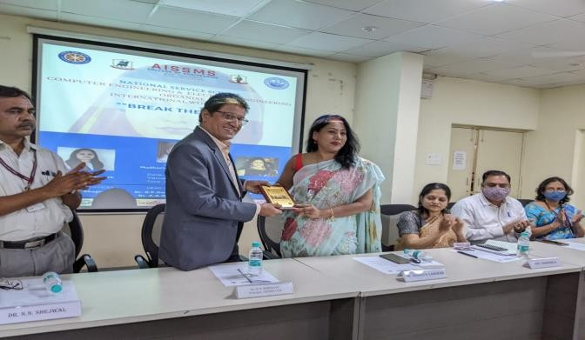 | 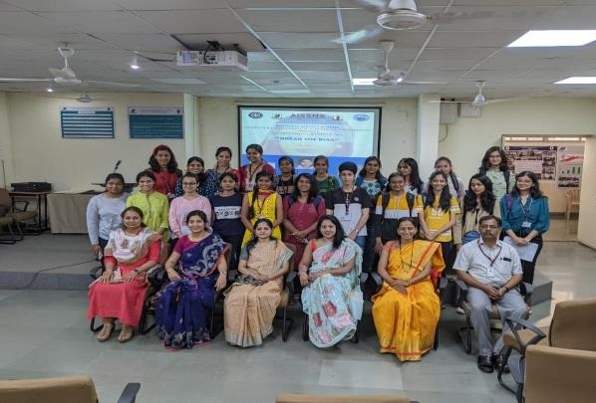

FACULTY SERVED AS RESOURCE PERSON, EXPERT, CHAIRPERSON

Term One
S N | Name of Faculty | Title of Activity | Organizing body | Date
1 | Dr. D P Gaikwad | 1. Speaker of One Day Faculty Development Program on"Theory Of Computation" | Organized by the Department of Computer Engineering, Bharati Vidyap eeth's College Of Engineering, Lavale, Pune. In Association with SPPU, Pune | 3rd August 2021.
2 | Dr. D P Gaikwad | 2.2.Delivered session in | AISSMS coe ,Pune | 26/11/21

 |  | FDP on 'Software based case studies for development of Multidisciplinary projects ', AISSMS coe ,Pune
3 | Dr Madhavi Pradhan | 1)Five days Faculty development program on “Software based  case studies for development of Multidisciplinary projects"  (Application of Machine Learning in Multidisciplinary Engineering Applications) | Department of Comp Engineering, Prof AISSMS  COE | 22/11/21
4 | Dr Madhavi Pradhan | 2)External panel member  PhD Annual Progress seminar | MIT ADT  University | 28 Sept 2021
5 | Dr Madhavi Pradhan | 3)Expert for Faculty interview | MIT ADT  University | 28 Sept 2021
6 | N R Talhar | Conducted FDP lecture for n teaching staff | Department of Comp Engineering in associ with Faculty develop cell , AISSMS COE | Two weeks 23 sep 2021  30 sep 2021
7 | S S Kolte | Conducted FDP lecture for n | Department of Comp | Two weeks

 |  | teaching staff | Engineering in associ with Faculty develop cell , AISSMS COE | 23 sep 2021  30 sep 2021
8 | Dr S V Athawale | As Session CHAIR & Keynote speaker | ICRTC 21 | 30 June 2021
9 | Dr S F Sayyad | Guest lecture at  Dr D Y Patil SCOE | Dr D Y  Patil SCOE | 14 Dec 21

Term Two
S N | Name of Faculty | Title of Activity | Organizing body | Date
1 | Dr M A Pradhan | External panel member PhD Annual  Progress seminar | MIT ADT  University | 3/3/2022

ACTIVITIES ORGANIZED

FDP/STTP ORGANIZED BY THE DEPARTMENT

Term One
S N | Name of Coordinator/s | Title of the FDP/STTP/WS/Semina r/Symposium | Duration  / Dates | No. of Participa nts | Funding Agency (If any) and Amount (Rs.)
1 | Dr. S F Sayyad | ATAL FDP on "Design Thinking: Aspirations for Innovations" from | 29/11/2021  to  03/12/202  1 | 96 | AICTE  (Rs 93,000)
2 | S.R.Nalamwar | FDP on “software Based Case Studies for development of | 22-11-2021  26-11-  2022 | 55 | AISSMS COE

multidisciplinary Projects

Term Two
S N | Name of Coordinator/s | Title of the FDP/STTP/WS/Seminar/ Symposium | Duration  / Dates | No. of Participa nts | Funding Agency (If any) and Amount (Rs.)
1 | Dr S F Sayyad | Kalam Program for IP  Literacy and awareness | 28.6.22 | 108 | AICTE KAPILA

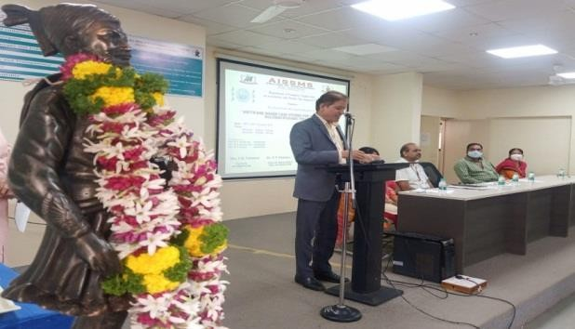 | 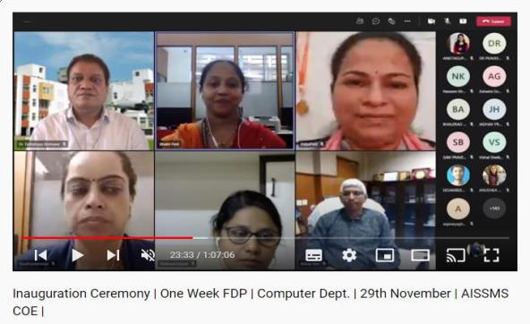

SEMINARS/ WORKSHOPS/ WEBINARS ORGANIZED BY THE DEPARTMENT
(For Faculty)

Term One
S N | Name of Coordinator/s | Title of the Seminar/Webinar | Duration  / Dates | No. of Participa nts | Funding Agency (If any) and Amount (Rs.)
1 | Dr. D P  Gaikwad | 2.Organized one webinar on "Internship in Industrial" | 20/08/20  21 | 90 | NA

2. | 1.S.S.kolte 2.M.M.Swami 3.M.M.Phadatar e | Webinar on  Cloud Automation Webinar on :”An Introduction to the Drone Ecosystem” |  | 90 | NA
3. | S. G. Dhengre | Webinar on Cloud Technology | Date: 09/07/20  21  Time: 3.00pm | 60 | NA
4. | Dr S V  Athawale | Webinar on :” How to write patent in software”
5 | 1 S.S.kolte 2.M.M.Swami  3. R. S.  Dudhmal | 1) Webnar on “Introduction to IPR” | 13th Oct 2021 | 100 | NA
6 | Waykule V V | Conducted webinar on Python DJango Developer | Date:18- 08-2021  Time:2:1 5PM | 85 | NA
7. | Waykule V V | 2.Web Development | 08-10-  2022 at 10:30AM | 72 | NA
8 | Dr S F Sayyad | Webinar on Entrepreneurship as Career Choice | 28/05/202  1 | 96 | NA

Term Two

S N | Name of Coordinator/s | Title of the Seminar/Webinar | Duration  / Dates | No. of Participa nts | Funding Agency (If any) and Amount (Rs.)
1. | R. S. Dudhmal | 1) Webinar on, "STUDY ABROAD - OPPORTUNITIES IN UK" | 11th April 2022 | 100 | NA
2. | S S Kolte | Session on Entrepreneurship Development Phases IIC and Codigo madrid club session on 12th March 2022 | 12th March 2022 | 101 | NA

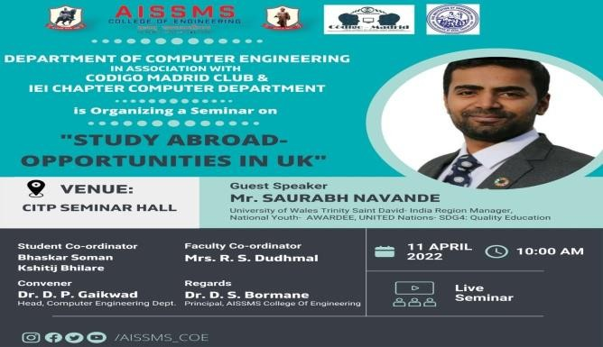 | 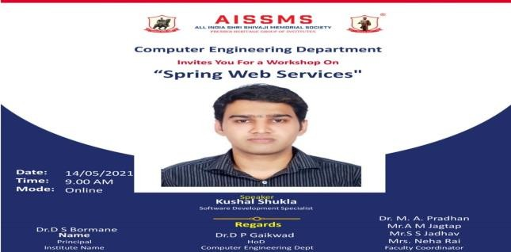

CONFERENCES/ SYMPOSIUMS ORGANIZED BY THE DEPARTMENT (For
Faculty)

Term One
S N | Name of Coordinator/s | Title of the Conference / Symposium | Duration  / Dates | No. of Participa nts | Funding Agency (If any) and Amount (Rs.)
 | - | - | - | - | -

Term Two
S N | Name of Coordinator/s | Title of the Conference / Symposium | Duration  / Dates | No. of Participa nts | Funding Agency (If any) and Amount (Rs.)
1 | D M  Ujlambkar | NCIET | 2Oth May | 60 | -

EXTENSION ACTIVITIES CONDUCTED BY THE DEPARTMENT (Social/ Quizzes
at national/international level/any other activity)

Term One
S N | Name of Faculty Coordinator | Details of activity conducted | Date | Number of beneficiarie s
Term Two
S N | Name of Faculty Coordinator | Details of activity conducted | Date | Number of beneficiarie s
1 | R. S. Dudhmal | 1) ‘WOMEN'S DAY PROGRAM | 8th March 2022 | 80
2 | S R Nalamwar | Social Visit to Balkalyan,Pune | 25 March  2022 | 50

MOU SIGNED WITH ACADEMIC AND PROFESSIONAL ORGANISATIONS

Term One
Sr.  No. | Faculty Coordinator | Name of Organisation | Date  of MoU Signed | Valid upto 00/00/0000
1 | Dr. D P Gaikwad | MeLayer | 26/12/21 | 26/12/21
2 | A J Kadam | Aceeture | 12/7/21 | 12/7/26
3 | Dr.S F Sayyad | Audaz Pvt Ltd | 22/9/21 | 21/9/24

4 | A S Deokar | The Code Culture | 28/12/21 | 27/12/21
5 | S R Nalamwar | Sumago Infotech Pvt Ltd, Nashik | 13/04/2022 | 13/04/2023
6 | V V Waykule | Elites Software | 20/12/2021 | 20/12/2024
7 | Dr. D M Ujlambkar | MOU Signed with “World Vision IT Infotech” | 9/10/2021 | 8/10/2024
8 | S J Pachouly | Elites Software | 20/12/2021 | 20/12/2024
9 | M M Swami | Paradise telecom pvt ltd | 7/04/22 | 7/04/25
10 | S S Kolte | MOU Signed with “Appystack Pvt Ltd ” | 30/12/2021 | 30/12/2024
11 | M M Phadatare | MOU signed with “Talent Pro Tech” | 3/10/2021 | 3/10/2024
12 | Mrs. Neha | MoU Signed with “Bag2Bag” | 21/12/21 | 21/12/22
13 | Mrs. Ritu S. Dudhmal | 1) MoU signed with “VEDA EDU  Consultant”, Pune | 24/11/2021 | 24/11/2022

Term Two
Sr.  No. | Faculty Coordinator | Name of Organisation | Date  of MoU Signed | Valid upto 00/00/0000
1. | Mrs. Ritu S. Dudhmal | 2) MoU Signed with “Brilliance Infotech” | 2/02/2022 | 2/02/2025

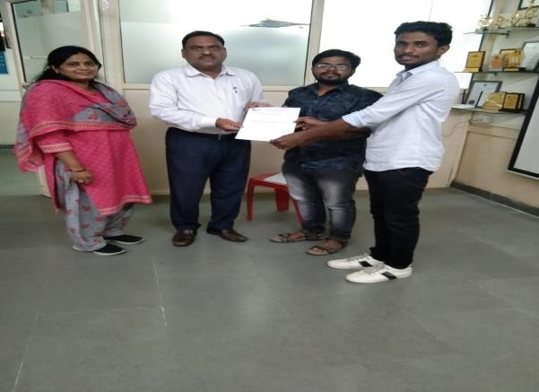
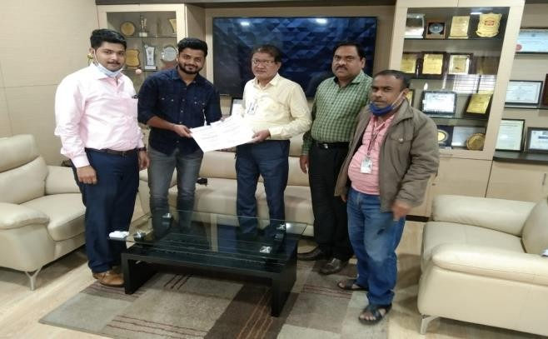
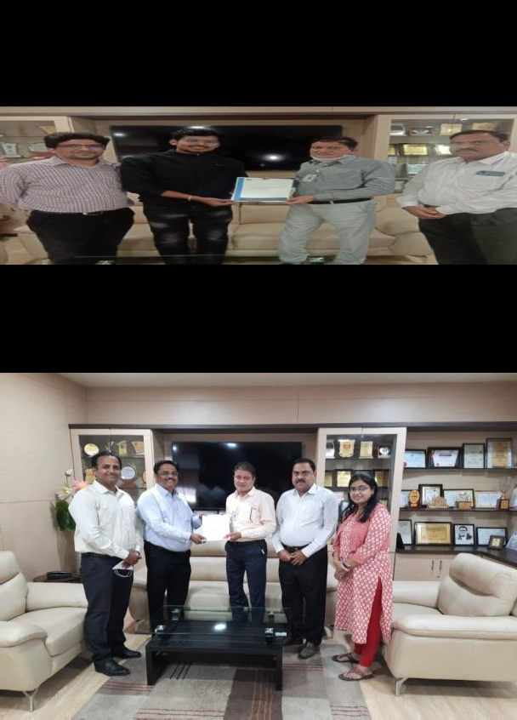
STUDENTS’ CHAPTERS /CLUBS

S.  No | Name of Students’ Chapter | Number of Student Members
1. | Código Madrid Club | 30

EVENTS ORGANISED (By Students’ Chapters / Clubs and others) Name of Students’ Chapter: Código Madrid Club

Term One
SN | Event name and details of event | Name of chief guest, judges etc. | Duration and Dates | Number of beneficiaries
1. | Código Madrid Club has conducted an online 4- day Hands-on workshop |  | 19th May – 22nd May,2021 at

 | on ‘CPP Programming’ for the First Year Engineering Department in collaboration with IEI Students’ Chapter from 19th May – 22nd May,2021 at 3:30pm. |  | 3:30pm

Term Two
SN | Event name and details of event | Name of chief guest, judges etc. | Duration and Dates | Number of beneficiaries
1 | Código Madrid Club successfully organised an online session on ‘Cyber Crime101’ in collaboration with the Developer Students’ Club and Anti Cyber Crime Society on 23rd January, 2021 at 4 pm. |  | 23rd January, 2021 at 4 pm.

SOCIAL ACTIVITIES ORGANISED (NSS, Women empowerment, Awareness Programms, etc.)

Term One
Faculty coordinator | Name of Activity | Date, Duration | Number of students involved
Mr. S. G. Dhengre | Shivaji Jayanti 2022 under NSS and UBA | 18th Feb 2021 | 25
S R Nalamwar | Social Visit to Balkalyan,Pune | 25 March 2022 | 50

Term Two
Faculty coordinator | Name of Activity | Date, Duration | Number of students involved

Mrs. Ritu S. Dudhmal | Women’s Day program | 8th March 2022 | 50

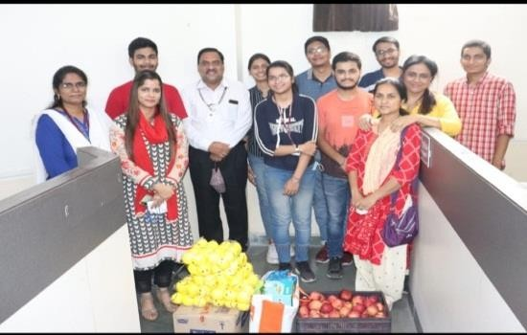 | 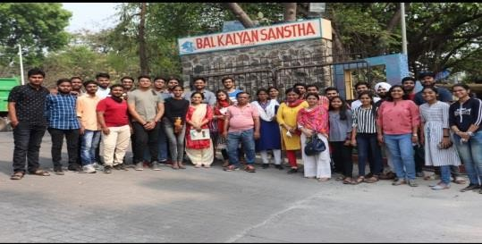

PARENT MEETING

Faculty Coordinator | Day and Date | Details of Parent meetings organised | Number of Parents attended
A S Deokar | 6/3/2022 | Online | 100
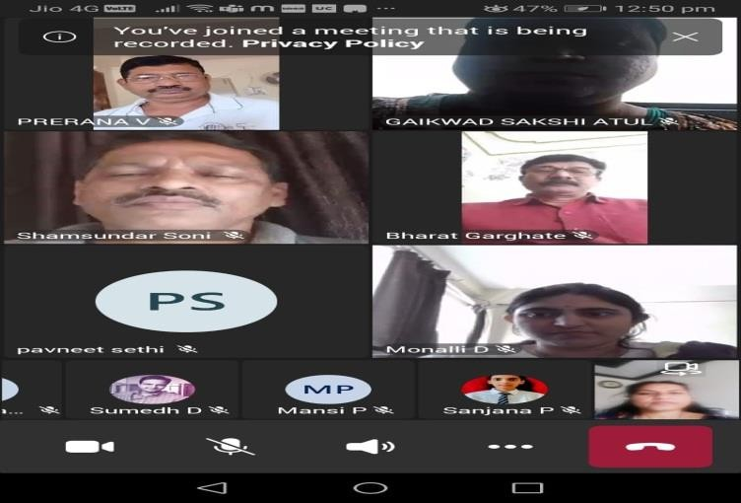

ALUMNI MEET

Faculty Coordinator | Day and Date | Details of Alumni meetings organised | Number of Alumni attended
A S Deokar | 6/3/2022 | Online | 20

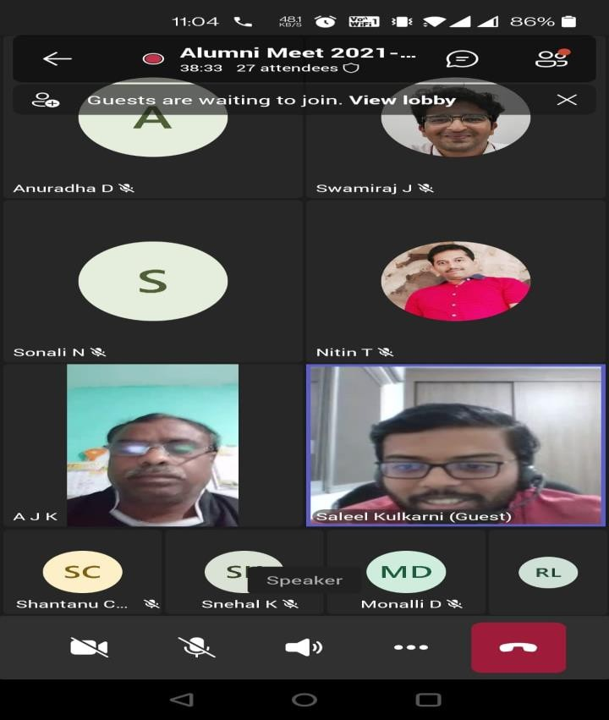 | 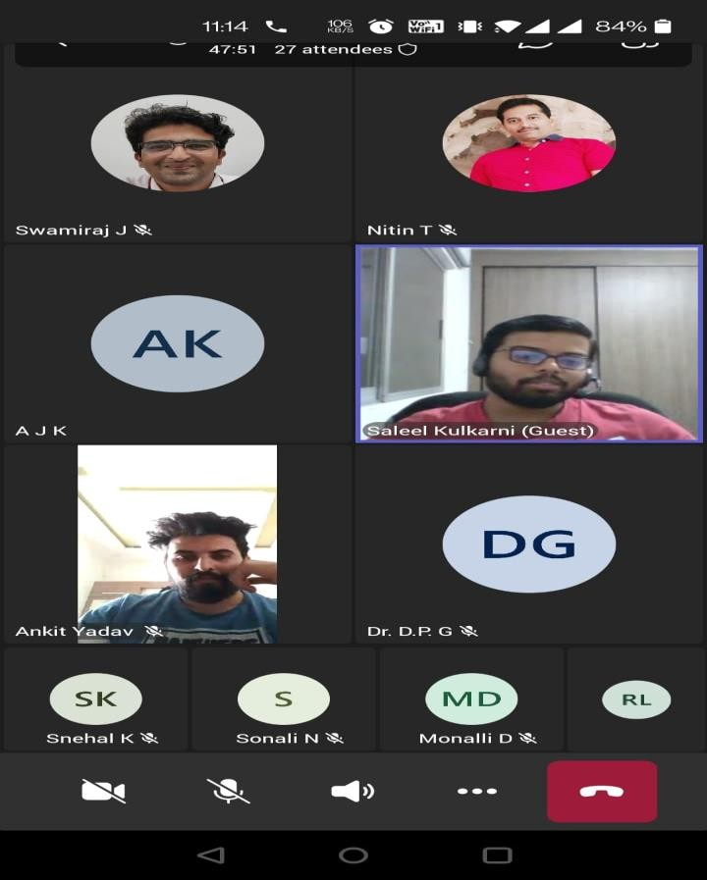

DETAILS OF STUDENT COUNSELING AND CAREER GUIDANCE AT THE DEPARTMENT LEVEL

Number of students referred for counseling | 458

RESEARCH CONTRIBUTION

FUNDED RESEARCH PROJECT

Term One
S N | Principal Investigator | Title of the Project | Amount Received (Rs) | Funding Agency
1 | NO DATA

Term Two
S N | Principal Investigator | Title of the Project | Amount Received (Rs) | Funding Agency
1 | NO DATA

TESTING AND CONSULTANCY

Term One
Sr. No. | Faculty Coordinator | Details of Testing & Consultancy Conducted | Total Revenue Generated (Rs.)

Term Two
Sr. No. | Faculty Coordinator | Details of Testing & Consultancy Conducted | Total Revenue Generated (Rs.)

PATENTS, COPYRIGHT, TRADEMARK AND OTHER (IPR)

Term One
Sr No. | Name of Faculty | Name Patent | of | the | Patent Number and Date | Type (National/ International/Com mercialized)
1 | Dr Shashikant V. | Robotics device for |  |  | 353914--001 | National
 | athawale | shortest path |  |  | 29/11/2021
 |  | identification in
 |  | hospital
2. | R. S. Dudhmal | Computer Vision and NLP based  intelligent Sign |  |  | 202121048154  A 22/10/2021 | National
 |  | Board detection
 |  | and Recognition
 |  | System.

Term Two
Sr No. | Name of Faculty | Name of the Patent | Patent Number and Date | Type (National/ International/Com mercialized)
1. | R. S. Dudhmal | System and method for Image Processing GMI | 29/12/2022 | National
2 | Dr S F Sayyad | A METHOD AND |  | International
 |  | SYSTEM FOR SAVING WATER  USING WATER | 2021106694  17 November
 |  | LEVEL INDICATOR | 2021,
 |  | AND SMART
 |  | LIMITER

PUBLICATIONS
PAPERS PUBLISHED/ PRESENTED IN PROCEEDINGS OF CONFERENCES

Term One
S. | Authors | Document Details | Year | Conference | ISBN | Organised

No |  |  |  | Details |  | by
1 | Dr. D P Gaikwad | 1.Parkinson Detection using Image Convolutional Neural Network and Transfer Learning. |  | Journal of network Security CN | e- ISSN:2 581-  639x
2 | Dr. D P Gaikwad | 2.User-Level Sentiment analysis technique in one go on social Network and E-Commerce |  | JETIR | ISSN- 2349-  5162
3 | Dr. D P Gaikwad | 3.Detection of Malaria in blood using Deep Learning. |  | Solid state Technolog y
4 | Dr M A Pradhan | 1.Prediction of Chronic Kidney Disease Using |  | TheInternatio journal of analytical an | IS  0886-  9367

 |  | Convolutional Neural Network  (1557-1563)  - Fact check using multinomial Naive Bayes  (813-823)  - Review Paper on Prediction of Chronic Kidney  Disease Using |  | experimental modal analysis  Smart Computing Techniques and Applications. Smart Innovation,  Systems and Technologies Springer  The Internatio journal of analytical | ISSN 2190-  3018  IS  08  86-9367

 |  | Convolutional Neural Net (1670-16742) |  | experimen modal  analysis
5 | S R Nalamwar | Deep Learning approach to Diagnosis of Covid- 19 through Pneumonia Prognosis |  | Deep Learning approach to Diagnosis of Covid-19 through Pneumonia Prognosis

Term Two
S.  No | Authors | Document Details | Year | Conference Details | ISBN | Organised by
1 | S.S.Kolte | Disk comparison to achieve a load- balanced solution in Azure cloud systems | 2022 | NCIET |  | AISSMSCO E
2 | M M Swami | 1. CONTRIBUTION OF MPLS | 2022 | NCIET |  | AISSMSCO E

 |  | TRAFFIC ENGINEERING IN THROUGHPUT  ENHANCEMENT  2. IMPLEMENTAT  ION -Surplus resources to Private | 2022 | IEEE  conferernce |  | IOIT

PAPERS PUBLISHED IN JOURNALS

Term One
S. No | Authors | Document Details | Year | Source Details | ISBN/ ISSN | Publisher
1 | Dr Madhavi Pradhan | Prediction ofChron  Disease Using Convolutional Neu | 2021 | UGC _ CARE  Approved | ISSN NO 0886-  9367

 |  | Network 1557-1563) |  | group II ISO 7021:2008  Certified  Journal
2 | S. G.  Dhengre | PERSONALITY PREDICTION BASED ON SOCIAL MEDIA USER BEHAVIOR | July 2021 | INTERNATIO NAL JOURNAL FOR RESEARCH  & DEVELOPME NT IN TECHNOLO GY | ISSN  (O) :- 2349-  3585 | IJRHDT
3 | Dr S V  Athawale | Support Vector  Regression for | Mrac  h | MDPI  Sensors | 1424-  8220 | MDPI  Sensors
 |  | Mobile Target | 2021
 |  | Localization in
 |  | Indoor
 |  | Environments
4 | V V | Plant Leaf Disease | 2021 | IJARSCT | 2581-
 | Wayukule | Detection using |  |  | 5425
 |  | Inception Resnet
 |  | V2 -CNN
5 | Dr S F | Study on Corrosion | 2021 | Design | 0011- | Scopus
 | Sayyad | Properties of |  | Engineering | 9342

Epoxy Polymer Composite Coating for Marine Application

Term Two
S.  No | Authors | Document Details | Year | Source Details | ISBN/ ISSN | Publisher
1 | Dr S F Sayyad | A Comparative Study of the Performance Appraisal Systems of India's Public and Private Sector Banks | Janu ary - Marc h, 2022 | Asian Journal of Organic & Medicinal Chemistry | Online  : 2456-  8937 | Asian Journal of Organic & Medicinal Chemistry
2 | M M Swami | 1.The Movie | May | IJARSCT, | 2581-
 |  | Recommendation | 2022 | VOLUME 2, | 9429
 |  | on System |  | ISSUE 2
 |  | using Content
 |  | Based Filtering
 |  | with TF-IDF-
 |  | Vectorization
 |  | and
 |  | Levenshtein
 |  | Distance

RESEARCH CITATIONS (Source of Data: Google scholar) (As on 30th June)

Name of faculty | Citations | Name of faculty | Citations
Dr. D P Gaikwad | 385 | Dr S V Athawale | 37
S. G. Dhengre | 25 | Waykule V V | 67

Total Citations of Department: 514

ME AWARDED

Sr No | Name of Supervisor | Title of Thesis | Name of Candidate
1 | Dr Madhavi Pradhan | Prediction of Chronic Kidney Disease Using Convolutional NeuralNetwork | Nishanthi K
2 | Dr S F Sayyad | Stock Exchange  Pattern Prediction  using Artificial Neural Networks | Pranav Dabhade

PhD GUIDE DETAILS

Name of Faculty who are PhD Supervisor | Number of Scholars Registered
Dr Madhavi Pradhan | 03
Dr Shabnam Sayyad | 03

INTERACTION WITH INDUSTRY

EXPERT LECTURES DELIVERED BY INDUSTRY EXPERTS

Term One
Sr.  No. | Faculty Coordinator | Class  (Number of students attended) | Name, Industry, designation and contact details of Expert | Topic | Date
- | - | - | - | - | -

Term Two
Sr.  No. | Faculty Coordinator | Class  (Number of students attended) | Name, Industry, designation and contact details of Expert | Topic | Date
1 | Dr S F  Sayyad | TE 64 | Shrenik Kucheriya | Latest Trends in Web Technology | 28/02/22

MOU SIGNED WITH INDUSTRY

Term One
Sr.  No. | Faculty Coordinator | Name of Industry | Date  of MoU Signed | Valid upto  (00/00/0000)
1 | Dr D M Ujalambkar | World Vision IT Infotech | 9/10/2021 | 8/10/2024

2 | S.S.kolte | APPYSYACK pvt ltd | 15/07/2021 | 15/07/2024
3 | Dr S F Sayyad | Audaz pvt ltd | 22/9/2021 | 21/9/2024
4 | Waykule V V | Elite Softwares | 20/12/2021 | 20/12/2024

Term Two
Sr.  No. | Faculty Coordinator | Name of Industry | Date  of MoU Signed | Valid upto  (00/00/0000)

FACULTY MEMBERS UNDERGONE INDUSTRIAL TRAINING

Term One
Sr.  No. | Name of Faculty | Name of Industry | Dates and Duration

Term Two
Sr.  No. | Name of Faculty | Name of Industry | Dates and Duration

STUDENTS UNDERGONE IN-PLANT TRAINING AND (OR) INTERNSHIP

Term One &Two
Sr.  No. | Name of the Student | Name of the Industry | Class | Training duration
 |  |  |  | Start date | Last date | Duration (days)
1 | Kothawade Rushikesh Kishor | Elite softwares | TE-I | 15/12/202  1 | 30/01/2022 | 45 Days
2 | Patil Krishnakant Sanjay | Elite softwares | TE-I | 15/12/202  1 | 30/01/2022 | 45 Days
3 | ADMUTHE MITALI MANISH | Elite softwares | TE-I | 15/12/202  1 | 30/01/2022 | 45 Days
4 | SUNNY ALEX | Elite softwares | TE-I | 15/12/202  1 | 30/01/2022 | 45 Days
5 | ARVIND SUDARSHAN | Elite softwares | TE-I | 15/12/202  1 | 30/01/2022 | 45 Days
6 | BHOSALE ATHARVA ABHAY | Elite softwares | TE-I | 15/12/202  1 | 30/01/2022 | 45 Days

7 | CHATANE SHREE ATUL | Elite softwares | TE-I | 15/12/202  1 | 30/01/2022 | 45 Days
8 | DABIR AISHWARYA SHARAD | Elite softwares | TE-I | 15/12/202  1 | 30/01/2022 | 45 Days
9 | DANDGE SHRIKANT ASHOK | Elite softwares | TE-I | 15/12/202  1 | 30/01/2022 | 45 Days
10 | DEOKAR HRISHIKESH MARUTI | Elite softwares | TE-I | 15/12/202  1 | 30/01/2022 | 45 Days
11 | DEVKATE KARAN KRISHNATH | Elite softwares | TE-I | 15/12/202  1 | 30/01/2022 | 45 Days
12 | DHOTE SAMIKSHA TILAKCHAND | Elite softwares | TE-I | 15/12/202  1 | 30/01/2022 | 45 Days
13 | DHUMAL PRAJAKTA DADABHAU | Elite softwares | TE-I | 15/12/202  1 | 30/01/2022 | 45 Days
14 | GADKARI GAURAV SUDHIR | Elite softwares | TE-I | 15/12/202  1 | 30/01/2022 | 45 Days

15 | GAIDHANI PRAJWAL ASHOK | Elite softwares | TE-I | 15/12/202  1 | 30/01/2022 | 45 Days
16 | GAIKWAD UDAY VIJAYSINH | Elite softwares | TE-I | 15/12/202  1 | 30/01/2022 | 45 Days
17 | GHADGE INDRAJEET SUBHASH | Elite softwares | TE-I | 15/12/202  1 | 30/01/2022 | 45 Days
18 | HATEKAR AISHWARYA TANAJI | Elite softwares | TE-I | 15/12/202  1 | 30/01/2022 | 45 Days
19 | JADHAV KIRTI PRADIP | Elite softwares | TE-I | 15/12/202  1 | 30/01/2022 | 45 Days
20 | JAGTAP HRUTVIK SHAHAJI | Elite softwares | TE-I | 15/12/202  1 | 30/01/2022 | 45 Days
21 | KALASKAR ROHAN RAJENDRA | Elite softwares | TE-I | 15/12/202  1 | 30/01/2022 | 45 Days
22 | KAWALE ANUSHKA ANIL | Elite softwares | TE-I | 15/12/202  1 | 30/01/2022 | 45 Days
23 | MEHER SWANAND GURUNATH | Elite softwares | TE-I | 15/12/202  1 | 30/01/2022 | 45 Days

24 | NIKAM RITESH SANJEEVAN | Elite softwares | TE-I | 15/12/202  1 | 30/01/2022 | 45 Days
25 | PAWAR ATHARVA SAMADHAN | Elite softwares | TE-I | 15/12/202  1 | 30/01/2022 | 45 Days
26 | PAWAR SHRUTI CHANDRAKANT | Elite softwares | TE-I | 15/12/202  1 | 30/01/2022 | 45 Days
27 | PRIYANSHU SHARMA | Elite softwares | TE-I | 15/12/202  1 | 30/01/2022 | 45 Days
28 | ROHAN DAYAL | Elite softwares | TE-I | 15/12/202  1 | 30/01/2022 | 45 Days
29 | SHAIKH ZAKI AHMED KHALID | Elite softwares | TE-I | 15/12/202  1 | 30/01/2022 | 45 Days
30 | SHARMA GUNJAN LAXMINARAYA N | Elite softwares | TE-I | 15/12/202  1 | 30/01/2022 | 45 Days
31 | VEDANT KISHOR SURYAWANSHI | Elite softwares | TE-I | 15/12/202  1 | 30/01/2022 | 45 Days
32 | TILEKAR VIRAJ VAIBHAV | Elite softwares | TE-I | 15/12/202  1 | 30/01/2022 | 45 Days
33 | WAGH MAHANT | Elite softwares | TE-I | 15/12/202 | 30/01/2022 | 45 Days

 | ISHWAR |  |  | 1
34 | YADNIK ABHILASH VIJAY | Elite softwares | TE-I | 15/12/202  1 | 30/01/2022 | 45 Days
35 | ZOPE SHUBHAM MOHAN | Elite softwares | TE-I | 15/12/202  1 | 30/01/2022 | 45 Days
36 | KHANDELWAL HARSH PRAMOD | Elite softwares | TE-I | 15/12/202  1 | 30/01/2022 | 45 Days
37 | KHEDKAR PRATIKSHA BALASAHEB | Elite softwares | TE-I | 15/12/202  1 | 30/01/2022 | 45 Days
38 | KAMBLE PRATIK MAHENDRA | Elite softwares | TE-I | 15/12/202  1 | 30/01/2022 | 45 Days
39 | CHAUHAN AMOGH | Lets grow more | TE-I | 1/2/22 | 28/2/22 | 1 month
40 | BADVE SHRIDHAN SANJAY | Vidharbha Infotech pvt Ltd | TE-I | 10/11/21 | 10/1/22 | 2 months
41 | SINGH BHANU PRATAP | EXposys data Labs | TE-I | 17/12/21 | 16 /1/22 | 1 month
42 | BHILARE KSHITIJ | Beyond Corporation | TE-I | 7/1/22 | 8/2/22 | 1 month

 | SHASHIKANT
43 | DESHPANDE SUDHANSHU SUBODH | Cosmic Skills | TE-I | 10/01/22 | 11/3/22 | 2 months
44 | AASHAY SACHIN BHUJBAL | Asiana Times | TE-I | 05/01/22 | 05/03/22 | 2 months
45 | TIWARI HARSH | Let's grow more | TE-I | 1/2/22 | 28/2/22 | 1 months
46 | EKSAMBEKAR YASH SAGAR | ADmyBRAND | TE-I | 05/01/22 | 5/4/2022 | 3 months
47 | GADGE SAHIL NIVRUTTI | Sparks Foundation | TE-I | 01/01/22 | 01/02/2022 | 1 month
48 | JAGTAP OMKAR DATTATRAY | Let's Grow More | TE-I | 1/3/22 | 1/4/22 | 1 Month
49 | JAGTAP PRATIK VINOD | Let's Grow More | TE-I | 1/2/22 | 1/3/22 | 1 month
50 | JAGTAP SHREYA ATUL | Let's Grow More | TE-I | 1/2/22 | 1/3/22 | 1 month
51 | JAMBHULKAR TUSHAR RAJU | Humans of Rural India | TE-I | 03/01/22 | 01/03/22 | 2 Months

52 | KARMAN SINGH SETHI | Davi Engineering Bhosari | TE-I | 28/12/202  1 | 29/2/2022 | 45 days
53 | KHADTARE ANURAG VIJAY | Let grow more VIP | TE-I | 1/2/2022 | 28/2/2022 | 28 days
54 | SARODE MOHIT SUNIL | Let grow more VIP | TE-I | 1/2/2022 | 28/2/2022 | 28 days
55 | PANCH LAXMI MUKUND | Let grow more VIP | TE-I | 1/2/2022 | 28/2/2022 | 28 days
56 | MULIK ABHISHEK SANJAY | Usd services | TE-I | 15/  11/21 | 20/01/22 | 2 month
57 | PINGALE PRATIK BAJIRAO | Convin | TE-I | 20/9/2021 | 20/3/2022 | 6 months
58 | RAUT ATHARVA HEMANT | SmartKnower Pvt Ltd | TE-I | 1/3/2022 | 1/7/2022 | 4 months

59 | SAGNIK ROY | Humans of Rural India | TE-I | 3/1/2022 | 3/4/2022 | 3 months
60 | SYED SABA MUSTAFA | Humans of Rural India | TE-I | 3/1/2022 | 3/4/2022 | 3 months
61 | AHIRE SEJAL KISHOR | Sparks Foundation | TE-II | 1 Feb 2022 | 28 Feb 2022 | 28 Days
62 | ANUSHKA ASHOK JOSHI | AZURE Skynet Solution pvt ltd | TE-II | 14th Jan 2022 | 13th March 2022 | 3 months
63 | ARYAN DINESH KHETARPAL | Exposys Data Lab | TE-II | 25 Dec 2021 | 25 Jan 2021 | 30 days
64 | BANGALI ADITYA PRASHANT (EWS) | Lets grow more | TE-II | 1st jan 2022 | 30 Jan 2022 | 30 days
65 | BHAGDE VAISHNAVI RAJESH | Lets grow more | TE-II | 1st jan 2022 | 30 Jan 2022 | 30 days
66 | BHALERAO ADITYA AVINASH | MESOTEK TECHNOLOGIES PVT LTD | TE-II | 10th Dec 2021 | 10 Jan 2022 | 1 months
67 | BHOSALE RUCHA SURESH | Trimurti Engineering works | TE-II | 15 Jan 2022 | 15 April  2022 | 3 months
68 | BIRAJDAR AMIT KASHINATH | Meal Arts | TE-II | 25 Dec 2021 | 30th Jan 2022 | 30 days
69 | CHAITANYA RAJENDRA SHIMPI | TCR Innovation | TE-II | 27.01.2022 | 27.3.2022 | 2 Months
70 | CHAKANKAR TEJAS VAIBHAV (EWS) | Beat the virus startup | TE-II | 5.9.2021 | 5.11.2021 | 2 months
71 | CHOUDHARY VEDANT MANOJ | Let's grow more | TE-II | 1.1.2022 | 30.1.2022 | 1 month

72 | DISHA RAJESH RATHOD | LETS GROW MORE | TE-II | 1.3.2021 | 30.4.2021 | 2months
73 | EDIGA LALIT KUMAR | STEP-NITK | TE-II | 22.11.2021 | 24.12.2021 | 1 month
74 | GADE CHHAYA NANDU | MRND Pvt.Ltd | TE-II | 4 oct.2021 | 10 Jan 2022 | 3months
75 | GANDHI SAHIL PRASHANT (EWS) | Elite softwares | TE-II | 20/08/201 | 15/10/2021 | 1 month
76 | GARGHATE NINAD BHARAT | Vidarbh Infotech Pvt.Ltd. | TE-II | 10 Nov 2021 | 10 Jan 2022 | 2 months
77 | GHODEKAR NETRA YASHWANT | TCR Innovation | TE-II | 5 Aug 2021 | 4 Oct | 1month
78 | GIDWANI SAGAR RAJESH | kasnet Technologies | TE-II | 22 Jan 2022 | 27 Feb 2022 | 1 mont
79 | GIRI SHIVAM NAVNATH | skillApp | TE-II | 23/10/2021 | 21/11/2021
80 | GUPTA TANUJ VIJAY | Sankalp Designers | TE-II | 3 July2021 | 29 sept. 2021 | 2 month
81 | Kundan khandare | MealArts | TE-II | 17-12-21 | 18-1-22 | 1 month
82 | JADHAV PRANAV HARI | EMVOKE TECHNOLOGIES PVT LTD | TE-II | 01/09/2021 | 28/02/2022 | 6 months
83 | JOSHI PARTH PRAVIN | Braincells Ltd. | TE-II | 03/01/2022 | 01/03/2022 | 2 months
84 | KADAM ADITYA RAJESH | YBIF | TE-II | 02/01/22 | 01/03/22 | 2 months
85 | KHAIRE GAURAV GOKUL | forage | TE-II | 17-12-21 | 18-1-22 | 1 month

86 | Abhinav Kulkarni | LGM | TE-II | 01/02/2022 | 28/02/2002 | 1 month
87 | Isha Agrawal | AIESEC | TE-II | 01/02/2022 | 3/2/2022 | 1 year
88 | Bhushan Mahajan | vidhyarthi mitra | TE-II | 01/09/21 | 29/2/2022 | 6 months
89 | sanket shinde | Always Sahi pvt Ltd | TE-II | 1/3/2021 | 28/2/2022 | 1 year
90 | LABADE SRUSHTI RAJESH | TCR Innovation Technical Coding Research | TE-II | 04/01/22 | 04/03/22 | 2 months
91 | LABADE SRUSHTI RAJESH | TCR Innovation Technical Coding Research | TE-II | 04/01/22 | 04/03/22 | 2 months
92 | Janhavi Pise | Link code Technologies Pvt Ltd | TE-II | 17/01/2021 | 17/02/2021 | 1 month
93 | Shruti Thorat | Let's grow More | TE-II | 01/02/2022 | 28/02/2022 | 1 month
94 | Shaikh Adil | The Entrepreneurship Network | TE-II | 15/8/2021 | 15/11/2021 | 3 months
95 | Akshay padwal | Nayantara Packaging Pvt Ltd | TE-II | 25/12/2021 | 25/01/2022 | 1 month
96 | MORE TANMAY ARVIND | LetsGrowMore | TE-II | 1/11/2021 | 1/12/2021 | 30 days
97 | ONKAR ANIL MIRAJKAR | Walrus Pay , LetsGrowMore | TE-II | 26 July 2021,  1 Nov 2021 | 25 Aug 2021,  01 Dec 2021 | 60 days
98 | OSWAL HARSH RAJESH | Go Informative, Tychas Infotech | TE-II | 07 July 2021,  15 Oct 2021 | 12 Oct 2021,  15 Dec 2021 | 180 days

99 | PATIL AISHWARYA ASHOK (EWS) | FirstEigen (Databuck) | TE-II | 27/12/2021 | 10/2/2022 | 45
100 | PINGALKAR VENKATESH SUNIL | Let's Grow More | TE-II | 1 Jan 2022 | 31st jan 2022 | 30
101 | PRATIK DADASAHEB NAWALE | The Entrepreneurship Network | TE-II | 15/07/21 | 15/10/21 | 90
102 | RATHOD PRANAV BANDU | Vidharbha Infotech | TE-II | 10 Nov 2021 | 10/1/2022 | 60
103 | SAMEEDHA MORE | Space ECE, Pune | TE-II | 1st Jan | 31st Jan 2022 | 31
104 | SANIYA BHALLA | Bristlecone Pune | TE-II | 10 Nov 2021 | 25th Jan 2022 | 76
105 | SARNAIK SAHIL MADHAV | LetsGrowMore | TE-II | 1 sept 2021 | 1 Oct 2021 | 30
106 | SAW PRAVEENKUMAR BHUVANESHWAR | The Spark Foundation(Singa pore) | TE-II | 01/12/2021 | 01/01/2022 | 31
105 | SHAH CHIRAG RAHUL | Hawkscode, Easy Shiksha | TE-II | 20/12/2021 | 18/01/2022 | 28
106 | SHAIKH SADIYA ABDUL RAJJAK | LetsGrowMore | TE-II | 1Feb 2022 | 4 March  2022 | 30
107 | SHASHANK VINOD ZANZAD | Fouses Business Solutions | TE-II | 28/10/2021 | 09/12/2021 | 42
108 | SHEGAR DIPTI SUNIL | Olcademy, new delhi, delhi | TE-II | 09/09/2021 | 09/12/2021 | 90
109 | SHINDE TEJAS SHIVAJI | Silicon Insiights Solution, Coimbatore, Tamil Nadu, India | TE-II | 23/08/2021 | 22/10/2021 | 60

110 | SHINKAR TEJAS NITIN | LetsGrowMore | TE-II | 01/01/22 | 30/01/22 | 30
111 | SOMAN BHASKAR DHAVAL | MealArts, LetsGrowMore | TE-II | 1 Nov ,. 25  dec | 31 Nov | 30
112 | SONAWANE SAMRUDDHI RAMDAS | Elite softwares | TE-II | 20/08/201 | 15/10/2021 | 30
113 | SURYAWANSHI RUSHIKESH BHATU | LetsGrowMore | TE-II | 01/11/21 | 1/12/21 | 30
114 | TANDULWADKAR ADITYA SUNIL | LetsGrowMore | TE-II | 28/01/22 |  | 30
115 | TELTUMBADE SHRUTI RAMESH | LetsGrowMore | TE-II | 01/01/22 |  | 30
116 | WADKAR DEVANSHI PANKAJ (EWS) | VERZEO | TE-II | 01/08/21 | 30/9/21 | 30
117 | WAGHADHARE SHREYASH PRASAD | Elite softwares | TE-II | 20/08/201 | 15/10/2021 | 30
118 | ZIMAL SUDARSHAN ANANDA | Hawkscode Easyshiksha | TE-II | 15th Dec | 13th Jan | 30

119 | WAICHAL SRUSHTI NIRANJAN | P K Technoworld | TE-II | 27/1/2022 | 28/2/2022 | 30
120 | SHAH DIPESH | Let's GrowMore | TE-II | 1st September | 1st October | 30
121 | AKASH CHAUDHARY | Elite Techno Groups | TE-II | 18th August | 29th September | 45
122 | AWAIT SAIFALI | TCR Innovation | TE-II | 27/1/2022 | 27/03/2022 | 60
123 | BHAGADE SWAROOPA DHANANJAY | TCR Innovation | TE-II | 27/1/2022 | 27/03/2022 | 60
124 | BHOSALE AADARSH AVINASH | TCR Innovation | TE-II | 27/1/2022 | 27/03/2022 | 60
125 | LIGADE POOJA SAHAJI | TCR Innovation | TE-II | 27/1/2022 | 27/03/2022 | 60

STUDENTS ACHIEVEMENTS

STUDENTS’ ACHIEVMENT (Professional) (Individual Level) (Technical activities such as design competitions, paper presentation, technical quiz, Product development, innovation, etc.)

Term One
Name of Student | Details of Achievement (State/University/ National/International Level) | Remark  (Domain)
Faizan Riyaz Mulla (BE COMPUTER B) | INTERNATION AL LEVEL | IEEE  Research Paper Presentatio n at 10th Internationa l ICCET CONFEREN CE

Term Two
Name of Student | Details of Achievement (State/University/ National/International Level) | Remark  (Domain)
Shivani | INTERNATIONAL LEVEL | IEEE
Bhalsakle |  | Research
 |  | Paper
 |  | Presentatio
 |  | n at 4th
 |  | IEEE ESCI-
 |  | 2022; Paper
 |  | published
 |  | in IEEE
 |  | Xplore

NUMBER OF STUDENTS PLACED

Term One And Two
Sr No | Name of Organization visited | Number of students Placed
1 | Tata Consultancy Services | 12

2 | Jio Platform | 13
3 | Datamatica Solutions | 10
4 | Blazclaim | 05
5 | L&T Infotech | `11
6 | Hexaware Technologies | 05
7 | Capgemini | 13
8 | Winjit Technologies | 01
9 | Hitachi Vantara | 01
10 | Acty System Pvt. Ltd. | 01
11 | Zensar | 10
12 | Birlasoft | 3
13 | Tech Mahindra | 01
14 | Wipro | 01

Total : 87
Lower Package Offered:
Higher package Offered: 45LPA Average Package Offered:
NUMBER OF STUDENTS QUALIFIED IN THE EXAMINATIONS

GATE | GRE | UPSC | MPSC | Any other reputed examination for Higher studies (TOFEL, etc.)
3 | 4 | - | - | 4

STUDENTS’ ACHIEVEMENTS (Team Level)

First Half
Name of Event | Name of Faculty Advisor | Details of Achievement (State/University/ National/International Level) | Remark  (Domain)

‘How to deploy web application s’ |  | Codigo Madrid Club conducted an online 2-day Hands-on workshop on ‘How to deploy web applications’ for the students of the Computer Department on 21stAugust and 22nd August, 2021 at 2pm.
‘Cyber Crime101’ |  | Código Madrid Club successfully organised an online session on ‘Cyber Crime101’ in collaboration with the Developer Students’ Club and Anti Cyber Crime Society on 23rd January, 2021 at 4 pm.

Term Two
Name of Event | Name of Faculty Advisor | Details of Achievement (State/University/ National/International Level) | Remark  (Domain)

SUMMARY AND
SWOC ANALYSIS

ANY OTHER NOTEWORTHY ACHIEVEMENT OF THE DEPARTMENT (Not
mentioned above)

Sr.  No. | Details
1. | RESEARCH CENTER

MISCELLANEOUS (SYLLABUS IMPLEMENTATION, MAJOR ADDITION IN INFRASTRUCTURE AND FACILITY, INNOVATIONS INTRODUCED, ETC.)

FACULTY | ACTIVITY

FEEDBACK FROM STAKEHOLDERS

Sr No | Stake holder | Number of Feedbacks Received | Overall Feedback
1 | Alumni | 6 | Good
2 | Parents | 60 | Good

TWO BEST PRACTICES FOLLOWED IN THE DEPARTMENT
One faculty One Industry
Faculty presentation to update/transfer the knowledge

SWOC ANALYSIS
Detail five major strengths, weaknesses, opportunities, and challenges (SWOC) of the department and future plans of the Departments
Strengths | 1 | Student and faculty publications.
 | 2 | Placement of students in industries.
 | 3 | Active Participation of students in Students Chapters and clubs
 | 4 | Almost pursuing number of Ph.D

Weaknesses | 1 | Funded projects.
 | 2 | Consultancy.

Opportunitie s | 1 | Undertake Artificial Intelligence and Deep learning related projects.

 | 2 | Start Centre of Excellence and increase number of Research Oriented Projects.
 | 3 | Increase internship and organize STTP programme for students.
 | 4 | Establish collaborations with reputed Institutes.
 | 5 | Research center

Challenges | 1 | Funds from different Government and Non-Government agencies.
 | 2 | Increase the number of consultancies.
 | 3 | Increase the number of complete patents.

FUTURE PLANS OF THE DEPARTMENT (For Next Academic Year)

1 | To get a six year accreditation from NBA.
2 | To increase placement package of students in core companies
3 | To collaborate departments with different industries.

SUMMARY SHEET (Annual)

Sr No | Activity/ Item | Numbers
PROFILE OF DEPARTMENT
01 | Students in the department | 458
 | FACULTY CONTRIBUTION
02 | e content developed by faculty and available online | 24
03 | Number of FDP/STTP attended by the department faculty | 60
04 | Number of Seminars/ workshops/ webinars attended by the department faculty | 24
05 | Number of Conferences/ symposiums attended by the department faculty | -
06 | Number of Online courses / certificate courses completed by department faculty | 4
07 | Number of extension lectures / webinars (Lectures delivered on other than technical topics)) | 3
08 | Number of Faculty served as resource person, expert, chairperson | 10
 | ACTIVITIES ORGANISED
09 | Number of FDP/STTP organized by the department | 3
10 | Number of Seminars/ workshops/ webinars organized by the department (for faculty) | 10
11 | Number of Conferences/ symposiums organized by the department (for faculty) | 1

12 | Number of Extension activities conducted by the department (Social/ Quizzes at national/international level/any other activity) | 2
13 | MOU signed with academic and professional organizations | 02
14 | Number of Students’ chapters /clubs | 5
15 | Number of Social activities organized | 3
16 | Number of Parent meeting | 1
17 | Number of Alumni meet | 1
18 | Number of student counseling and career guidance at the department level | 458
 | RESEARCH CONTRIBUTION
19 | Number of Funded research project | -
20 | Number of Testing and consultancy | -
21 | Number of Patents, copyright, trademark and other (IPR) | 4
22 | Number of Papers published/ presented in proceedings of conferences | 7
23 | Number of Papers published in journals | 7
24 | Number of Book/ article publications | -
25 | Total Research citations | 514
26 | Number of ME awarded | 4
27 | Number of PhD AWARDED | -
 | INTERACTION WITH INDUSTRY

28 | Number of Industrial visits organised | -
29 | Number of Expert lectures delivered by industry experts | 1
30 | Number of Industry –sponsored projects (UG/PG) | -
31 | Number of MOU signed with industry | 13
32 | Number of Faculty members undergone industrial training | -
33 | Number of Students undergone in-plant training and (or) internship programme | 125
34 | Number of students placed | 87
35 | Number of students qualified in the examinations | 11

Declaration by the Head of the Department
I am aware that the above information provided by the Department will be validated by the AAA committee during the visit.

Name and Signature Head of Department

