ANNUAL REPORT 2018-19
Name of Department: Computer Department
HOD: Dr. D. P. Gaikwad
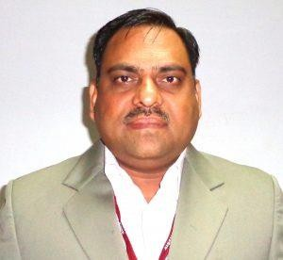
Intake: shift I-60, Shift II-60. Starting Year: 1992 Introduction of Department:
The Computer Engineering Department of AISSMS College of Engineering was started in the year 1998. The goal of the Department is to prepare students for successful careers in software and hardware industry that meets the needs of Indian and multinational companies or to excel in higher studies. The Department has experienced and dedicated faculty members with strong commitment to the engineering education and professional ethics.
Computer Engineering is the field which deals with analyzing and designing hardware, software, and operating systems for a computer system. Our students are trained in software design and the integration of hardware and software. The Department has well equipped laboratories with a good number of personal computers, servers and latest licensed software’s like Oracle, Rational Rose, MatLab, .NET, 3D-Max etc. The Central Computing facility and internet centre with 10 Mbps lease line are managed by the Department. The Department also has a library.
Various workshops, seminars, guest lectures, webinars and training programs based on current technologies are organized for the development of faculty and students. Industrial visits are arranged to expose the students to real world applications. The research work is carried out by the faculty along with students in the areas like Artificial Intelligence, Bigdata, IOT.
The annual technical event Bits-n-Bytes is conducted under the aegis of AISSMS Engineering Today. It is the mega event in which students from all over India and SAARC countries participate. Students are encouraged and guided for participating in various technical events organized by industries and reputed institutes.
As a result of sincere efforts of faculty & state of art facilities provided by the Department, our students are excelling in IT as well as other related industries.

Areas research studies:
The following forefront areas have been identified to carry out the research studies.
  - Cyber Security
  - Big Data Mining
  - Artificial intelligence
  - Wireless Sensor Networks
  - Cloud Computing
  - Soft Computing

Facilities:
- ERP System
- WIFI Facility for Student.
- Lab
- Moodle
- Service Bus
- Smart Board
- Virtual Lab
- Swayam- Mooc
- Library

Performance of this year:
  - Academic Result: May 2018

Sr. No | Class | No. Of Students |  |  |  |  |  |  |  | Percentage of Passing
 |  | Appear ed | Clear Passe d | SG PA  >9.  5 | 8.5 to  9.5 | 7.5  to 8.5 | 6.5 to  7.5 | SGPA< 6.5 | Fail | All Clear | With ATKT
1 | SE- I  CE(A) | 75 | 42 | 0 | 6 | 22 | 13 | 1 | 0 | 56 % | 100 %
2 | SE- II  CE(B) | 68 | 34 | 0 | 1 | 16 | 14 | 3 | 0 | 50 % | 100%
3 | TE- I CE(A) | 75 | 61 | 1 | 3 | 28 | 21 | 7 | 14 | 81.30 % | 100%
4 | TE –II  CE(B) | 68 | 54 | 0 | 7 | 29 | 12 | 6 | 14 | 79.40% | 100%
5 | BE-I  CE(A) | 66 | 65 | 46 | 15 | 4 | 0 | 0 | 1 | 98.48% | 100%
6 | BE-II  CE(B) | 66 | 66 | 42 | 23 | 1 | 0 | 0 | 0 | 100 % | 100%

  - Topper’s List: May 2018

Sr. no | Class | Name | Percentage
1 | SE – I | CHAUDHARI ANJALI MILIND | 9
 |  | TAMBOLI NUSARAT KASAMBHAI | 8.98
 |  | POOJA SHANTARAM NANGUDE | 8.8
 | SE-II | BHAINGADE PIYUSH TANAJI | 8.78
 |  | VISHAL | 8.44
 |  | KRISHNAN NANDANI BIPIN UPADYAY | 8.3
2 | TE –I | GHORPADE TAPASYA SUNIL | 9.13
 |  | RAUT AMRUTA HANUMANT | 8.78
 |  | BOROLE YOGITA GOVIND | 8.56
 | TE –II | MANKAR SHRIDHAR RAJENDRA | 9.07
 |  | NANGRE NANDKISHORE PRAKASHRAO | 8.91
 |  | SONI ROHAN SURENDRA | 8.74
3 | BE-I | JANGID YASHWANT RAJENDRA | 79.93%
 |  | PATIL HIMALI DAYARAM | 78.20%
 |  | GOSAVI RAJKUMAR ASHOK | 77.73%
 | BE-II | SARAP SHWETA RAMDAS | 78.00%
 |  | SHIVAM KUMAR SINGH | 77.80%
 |  | KADAM SAYALI SANJAY | 77.33%

Activities: (Activities carried in academic year 2018 are only to be mentioned) Example:
1. Workshops / Seminars/ Guest lecturers arranged by Department for students
1) Seminar on Project Opportunities and Guidance on 29 June 2018 under IE Students’ Chapter
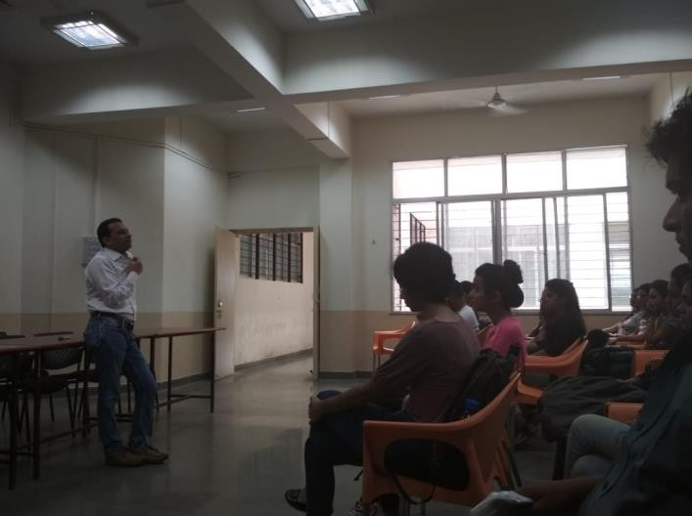
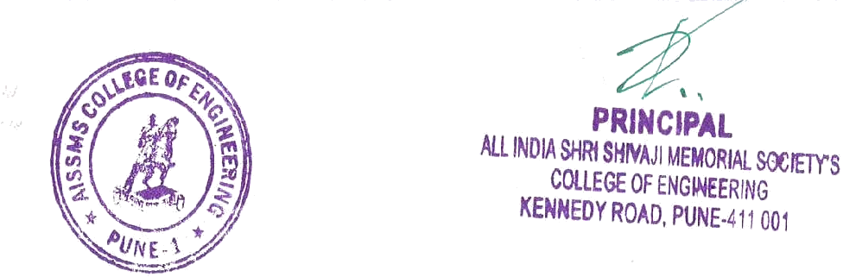
Information about Seminar: Mr. Pranav Sharma is currently working in Netflix as a Data Scientist. Computer Engineering Department organized Expert Lecture on Artificial Intelligence, on 29th June 2018 to bridge the curriculum gap of Artificial Intelligence subject. 95 students actively participated in this lecture.

Mr. Pranav Sharma from Netflix interacting with students

Achievements of this year (2018-19): -
- Faculty – 13 NPTEL Certification
- Dr. D P Gaikwad, “Hyper Parameters Tuning of N-Gram evaluation based Machine Learning Model for Sentiment Analysis ,” IJRAR, Vol. 5, Issue.04, December 2018, ISSN No. 2348-1269. PP.428-436
- Minal M Swami “Review of Different Schemes of Image Enlargement” IJRASET, Vol.07,Issue.01,Jan 2019,ISSN No.2321-9653
- C K Vasvani and S S Kolte, “Secure sharing Hospital Data using Visual Cryptography,” International Journal of Innovative Research in Computer and Communication Engg, Vol. 6, Issue.11, November 2018, ISSN No. 2320-9801.

FDP/Workshops Attended:

Year | Name of the  participant |  | Designation | Title of the FDP /  professional  development /  administrative training  program
Dr D P  Gaikwad | Assistant  Professor |  | Workshop on Artificial Intelligence and  Deep Learning organised by Greater  Noida | 06-10-2018 to 8-10-2018
Dr M A  Pradhan | Associate  Professor |  | Participating Knowledge of knowledge  sharing program Developing student  teacher connect organised by IBS | 10-08-2018
N R Talhar | Assistant  Professor |  | FDP for Laboratory Practice IV organised  by D.Y.Patil ,akurdi | 1/7/2019
A J Kadam | Assistant  Professor |  | One Week orientation program on  “Modern pedagogy and Recent  Technological development" organised  by AISSMSCOE | 10-12-2018 to 14-12-  2018
Dr.S F  Sayed | Assistant  Professor |  | FDP NPTEL Introduction to Internet of  Things | Jul-Oct 2018(12 weeks)
S V  Athawale | Assistant  Professor |  | FDP on Cyber Secuirty organized by  Shivaji university | 11-02-2019 to 17-02-  2019
A S Deokar | Assistant  Professor |  | FDP on Cyber Secuirty organized by  Shivaji university | 11-02-2019 to 17-02-  2019
V V  Waykule | Assistant  Professor |  | FDP on LP 2 organized by TCS | 16-07-2018
D M  Ujalambkar | Assistant Professor |  | One Week orientation program on  “Modern pedagogy and Recent  Technological development"AISSMSCOE | 10-12-2018 to 14-12-  2018
A Gupta | Assistant  Professor |  | FDP on Laboratory Practice -I organised  by MIT | 10-07-2018 to 12-07-  2018
M M  Phadtare | Assistant  Professor |  | One Week orientation program on  “Modern pedagogy and Recent  Technological development"AISSMSCOE | 10-12-2018 to 14-12-  2018
O P  Kasarlewar | Assistant  Professor |  | FDP on Laboratory Practice -I organised  by MIT | 10-07-2018 to 12-07-  2018
N S  Devekar | Assistant |  | FDP on Softwear Engineering organised
 | Professor |  | by AICTE | Jul-Oct 2018(12 weeks)
S S Jadhav | Assistant |  | One week STTP on Software testing using | 06-06-2018 to 10-06-
 | Professor |  | Open Source Tools organized by D Y Patil | 2018

 |  | Akurdi
M M  Swami | Assistant  Professor | One Week orientation program on  “Modern pedagogy and Recent  Technological development"organised by  AISSMSCOE | 10-12-2018 to 14-12-  2018
S S  Deshmukh | Assistant Professor | Workshop on Machine learning and  python organised by Cummins college of  Engineering | 21-12-2018 to 22-12-  2018
S S Kolte | Assistant  Professor | One Week orientation program on  “Modern pedagogy and Recent  Technological development"organised by  AISSMSCOE | 10-12-2018 to 14-12-  2018
C K  Vaswani | Assistant  Professor | One Week orientation program on  “Modern pedagogy and Recent  Technological development"organised by  AISSMSCOE | 10-12-2018 to 14-12-  2018

Students Achievements –
  - Department: Our students brought sponsorship in ET with amount of Rs. 38000 and coupons worth 15000
  - ​
  - TE student Shweta Chousalkar got best side actress award in Purroshotam Karandak 2018

Sports Achievements of student

Sr.No. | Name of the Student  /Team | Prize | Discription
1 | VaibhavNarde | Best Batsman | AISSMSCOE Cricket Team
2 | Animesh Kumar
3 | Football(M) | Winner | Computer
4 | Manjiri Thombre Footbal  (W) | Winner | Computer
5 | VivekTodmal | Chess(Winner) | Runner Up at “Infinity”, intercollegiate Chess  competition
6 | Ashish Bhingardive | FirodiyaKarandak-  2nd prize Contemporary  Dance | Trophy + Certificates
7 | Shreya Vashikar | Vinodottamkarandak – Best Supporting Actress Dajikaka gadgil Karandak-  Consolation Prize for supporting role Bharat Karandak- Best actress in Supporting role
 | Abhishek Limkar | Best Player –  Basketball

NAAC Visit
  - The NAAC peer team visited the College on 7th September 2018. As per schedule one of the member of the NAAC peer team,
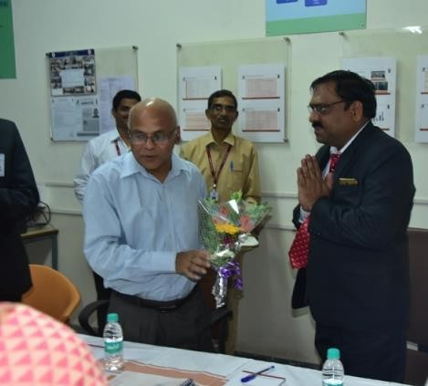
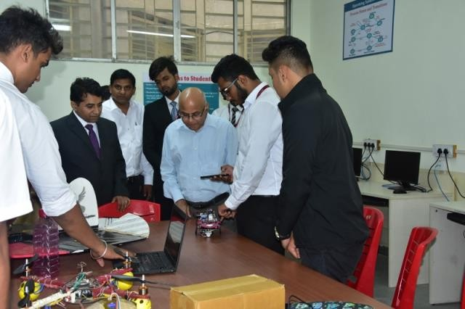
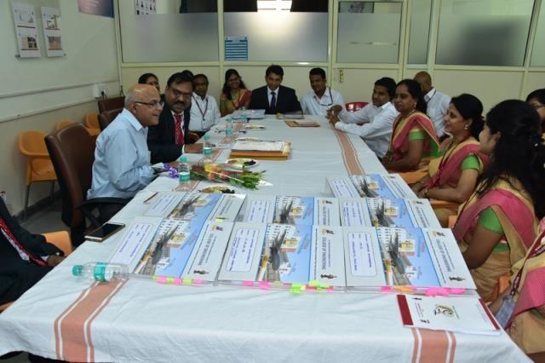

Dr Anil Kumar Tripathi Professor at IIT(BHU) visited Computer Engineering Department at 2:00 pm . He was welcomed by the Head of Computer Engineering Department, Dr D P Gaikwad with a bouquet. He interacted with every faculty of the department. All faculties were very keen to introduce themselves

Engineering Today
Department of Computer Engineering arranged various events in “Engineering Today” on 10th and 11th September 2018. Under the event “Bits N Bytes” various technical events were conducted as follows:
- For the event “Quizzlers”, we invited Mr. Mallikarjun V. Swami, senior manager voda idea ltd, Pune. Software for quizzlers was developed by the Computer Engineering Students. Around 60 students participated in this event.

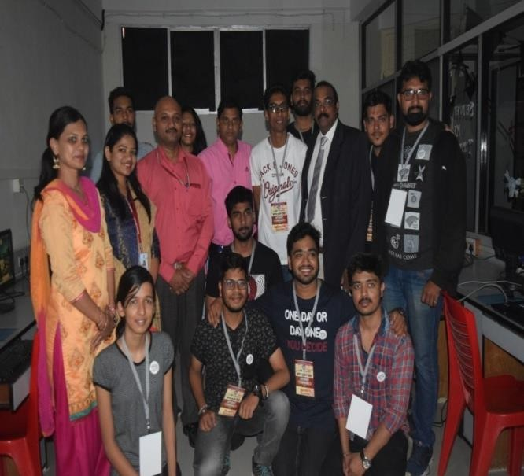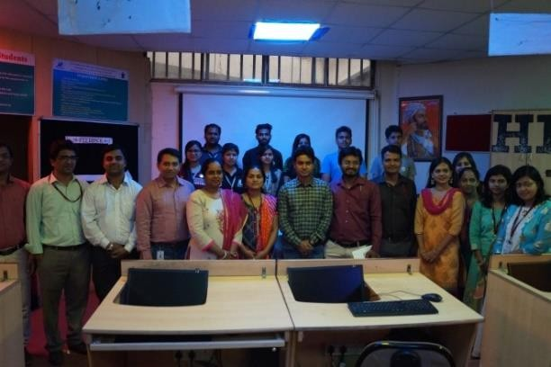
- For the event “Technical Paper Presentation”, we invited Prof. Vijay Kotkar from Rajshri College of Engineering, Pune as judge, in which 22 students participated.
- Department also arranged a fun filled event “Internet Treasure Hunt”on 10th & 11th September 2018 for which
Mr. Amol Aher, Kastech Sol Pvt. Ltd Pune Founder and CEO acted as a judge. Around 72 students participated
in this event.
For the event “Hide N C’K”, we invited Mr. Amit Shah, Vodafone Pvt.Ltd Pune, as a judge on 10th & 11th Sept. 2016. Around 46 students participated in this event.
- In the event “Code Blooded” we invited Mr.Sandipkumar Patil from Cognizant as a judge.
Department organized “Science Exhibition” on 12th Sept 2018 in which 20 projects were presented by students.

IE Students’ Chapter Events:
Our department organized around 22 different activities under IE Students’ Chapter.
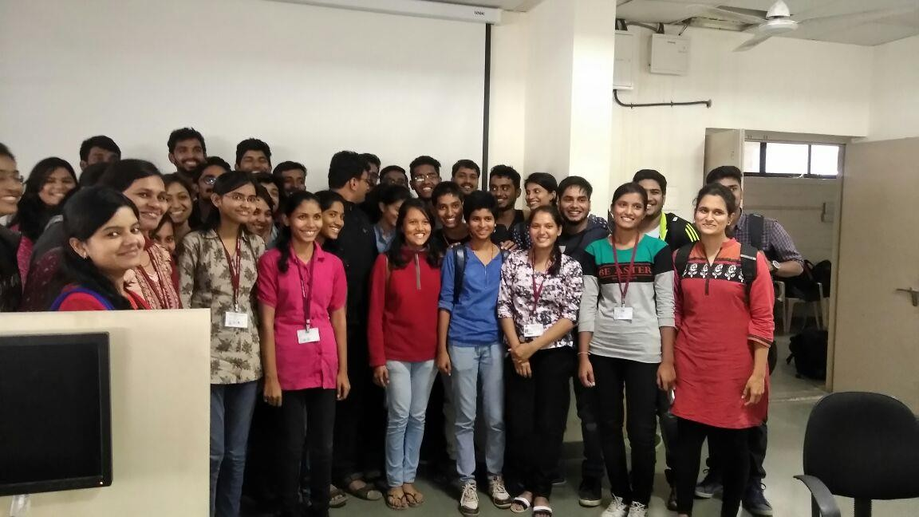
Student members with Industry Expert Machine Learning Workshop

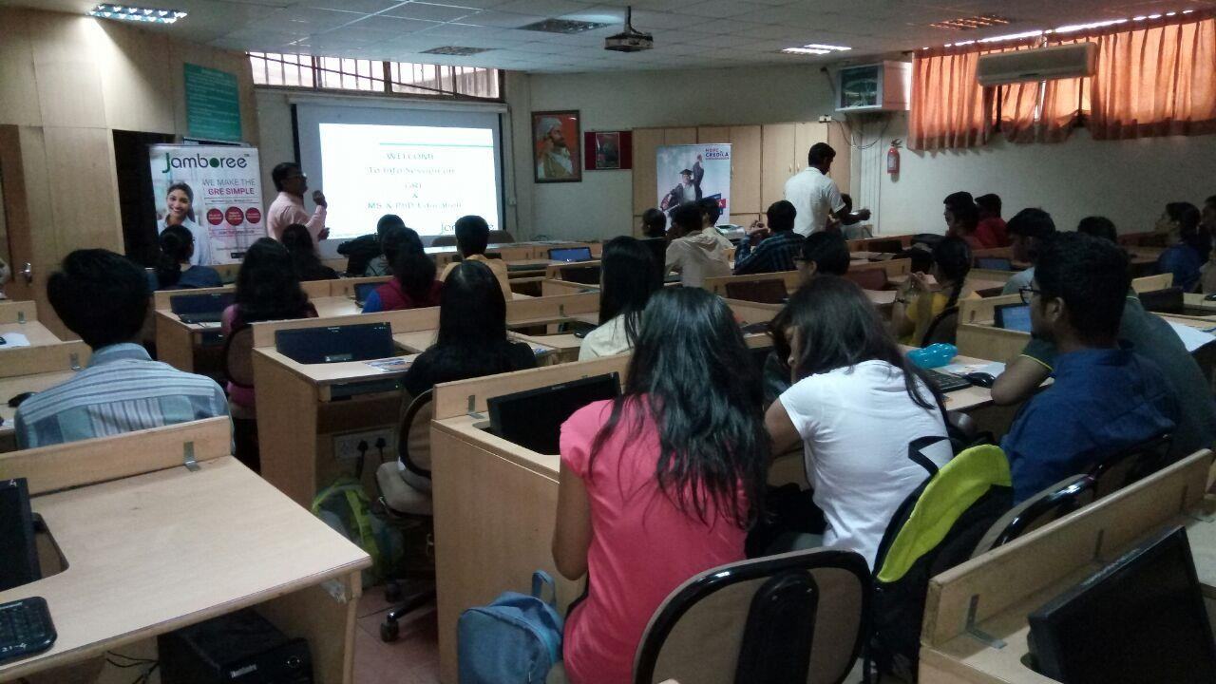
Event: SEMINAR ON “ EDUCATIONAL OPPORTUNITIES IN ABROAD

Students Club : Codigo Madrid
Our students started a club named Codigo Madrid in which students teach other students their expertise.
