Department of E&TC Enginnering

ESDC- Electronics for You Skill Development Centre
The Electronics for You Skill Development Centre Lab is an integral part of our college’s commitment to excellence in the field of Electronics and Telecommunication engineering. This state-of-the-art facility is designed to provide students with hands-on experiences and real-world applications of theoretical concepts learned in the classroom. Also its vision is to encourage students to study and apply innovative ideas through magazines. This lab was introduced to the department in academic year 2020-2021.
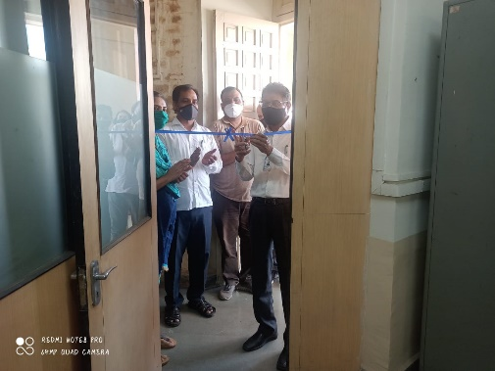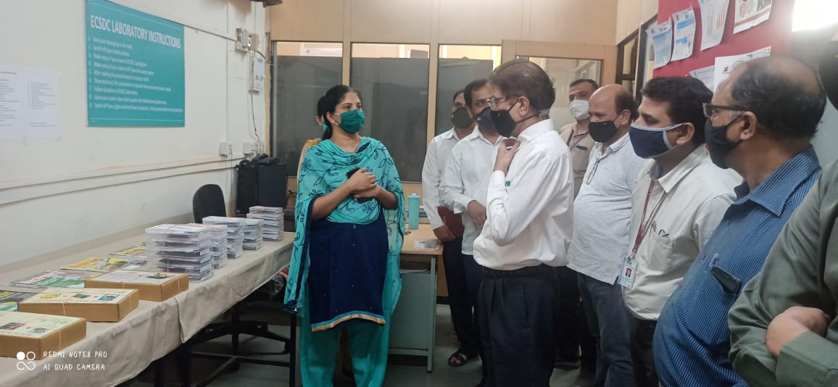

Objectives:
- Enhancing Practical skills:To augment the theoretical knowledge of students with practical hands-on experiments and projects that foster a deeper understanding of electronic and communication systems.
- Innovation and Creativity: To encourage students to innovate and develop new electronic solutions and applications, fostering a spirit of research and development.
- Industry Preparedness: To prepare students for professional careers in the electronics industry by familiarizing them with the latest tools, technologies, and industry practices.
Facilities and Resources:
- 50 magazines each month.
- DIY kits, self-learning kits, development boards, electronics component.
- Links to access magazine online.
- Links of courses.
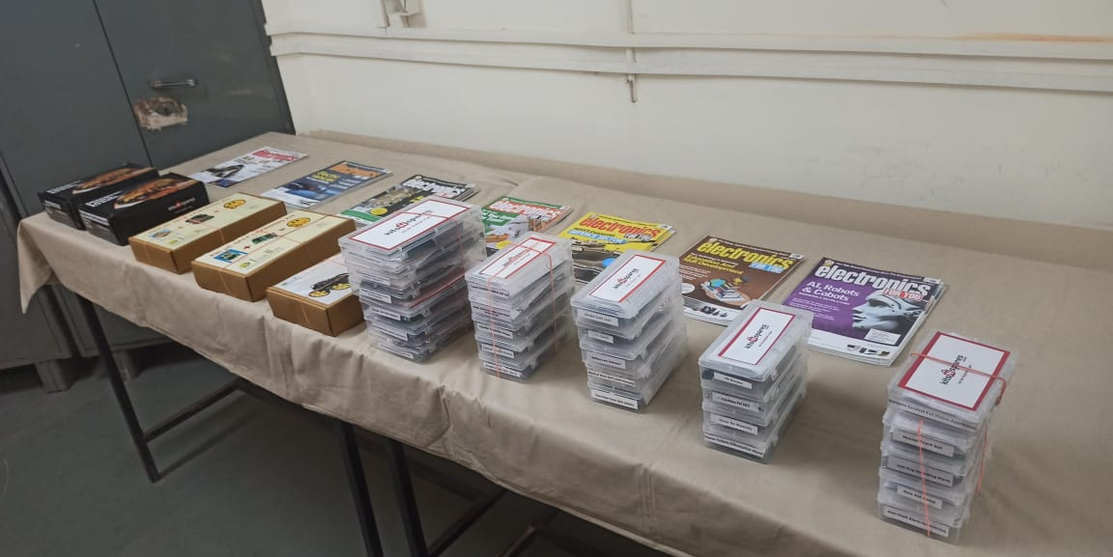

Activities:
- Distribution of online Courses.
- Distribution of online magazine link to students.
- Issuing of DIY Kits to students.
- Issuing of EFY magazine to students.
- Conduction of DIY kits workshop for SE E&TC students.
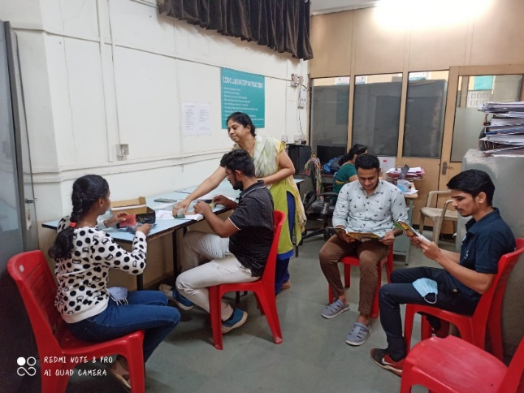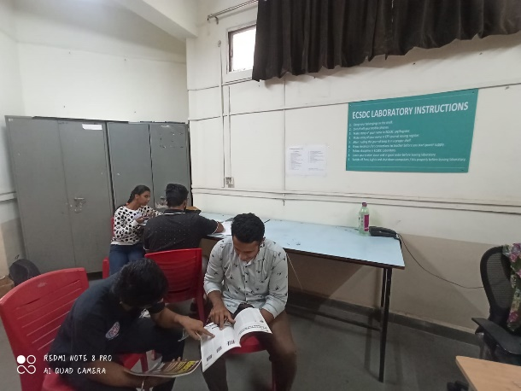

Future outlook:
Looking forward, the EFY Lab aims to expand its facilities, continue enhancing its curriculum to include more projects that meet the evolving demands of technology and society. We are excited about the future and believe our students will be at the forefront of technological innovation.
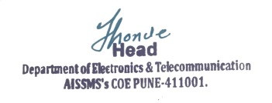

Dr. Prachi P. Vast Dr. S. B. Dhonde
Faculty Co-ordinator HOD of E&Tc Dept

