All India Shri Shivaji Memorial Society’s College of Engineering Pune-1
MECHANICAL ENGINEERING DEPARTMENT
Achievements AY 2018-2019

INTRODUCTION:
Teaching Staff: 36 (32 in the Department and 04 to FE), Non-Teaching Staff: 9
Start of the Department: 1992
UG Programmes: 2; Mechanical and Mechanical Engineering (Sandwich pattern)
PG Programmes: 2; Automotive and Design specialization
Laboratories: 18, Drawing Hall:1 and Seminar Hall: 2
Softwares: MATLAB, MasterCAM, ANSYS , Pro-E,AutoCAD, MSc ADAMS, Altair Hyperworks
Unique Equipments: Chassis Dynamometer, FFT Analyser

AWARDS AND RECOGNITION

SN | Name | Awards and Recognition
1 | Prof.(Dr.) A V Waghmare | VC Nominee as a Member, Board of Studies, Mechanical Engineering, SPPU, Pune
 |  | Member of Engineering Education Board and Faculty Development Committee, SAE INDIA
2 | Prof.(Dr.) B D Bachchhav | VC Nominee as a Member, Board of Studies, Mechanical and Materials Technology, Dept. of Technology, SPPU, Pune
3 | Prof.(Dr.) P S Gajjal | Outstanding Women in Engineering
 |  | IARDO award for excellence
4 | Dr. M.R.Phate | Best Teacher Award (Rank1), AISSMS Excellence Award 2019
Copyright Reg (ROC-L-82418/2019) :-
Analysis of 6-DOF Human Biodynamic Model for Seated Human Posture Using Artificial Neural Network

 |  | Copyright Reg(Roc:L-81672/2019)Critical Analysis of novel fabricated Al/SiC/B4C Metal Matrix Composites Machining Performance
 |  | Copyright Reg : (ROC:L-80752/2019)-Formulation of Experimental Data Based Model for the Machining Process using Dimensional Analysis Approach.

MEMORANDUM OF UNDERSTANDINGS:

SN | Name of organization | Date of MOUs | Period of validity
1 | Seinumero Nirman Pvt. Ltd. Pune | 07/07/2017 | 07/07/2020
2 | Vishwadeep Enterprises, Pune | 13/07/2017 | 13/07/2022
3 | e-Addict Mobility solutions Pvt.Ltd.Pune | 21/08/2017 | 21/08/2022
4 | Engineering Cluster, Chinchwad | 28/02/2018 | 28/02/2022
5 | Suntech Landriani M/c tools Pvt. Ltd | 08/08/2018 | 07/08/2021
6 | Nemade Engineering Pvt Ltd | 08/08/2018 | 07/08/2021
7 | Indi-Tech valves Pvt. Ltd. Pune | 31/08/2016 | 31/08/2018
8 | Meher Techno Consultants Pvt. Ltd. Pune | 16/09/2016 | 16/09/2019
9 | Kakade Laser, Pune | 06/09/2016 | 06/09/2019
10 | Plazma Technologies Pvt. Ltd. Pune | 01/01/2017 | 01/01/2020
11 | S M Auto Engineering Pvt. Ltd, Pune | 08/12/2016 | 08/12/2020

Doctor of Philosophy (PhD)

Prof.(Dr.) S J NAVLE
Title of Research: Investigations on performance of S.I.Engine fueled with hydrogen gas as an alternate fuel in comparison with pure gasoline
Name of the Guide: Dr R.R.Kulkarni (Guide), Dr S.S.Thipse (Co-Guide)
Research Center: VIT, Pune
University: Savitribai Phule Pune University,Pune
Prof.(Dr.) C S CHOUDHARI
Title of Research: Design, development and performance evaluation of a refrigeration system for a new environment friendly refrigerant.
Name of the Guide: Dr S N Sapali
Research Center: COEP, Pune
University: Savitribai Phule Pune University,Pune
FUNDED RESEARCH PROJECT

S N | Title of the Project | Principal Investigator | Amount received (Rs) | Funding Agency
1 | Tribological Performance Evaluation of Non-asbestos organic Brake Pad Materials | Prof.(Dr.) B D Bachchhav | 25,000 | Institution of Engineers R&D Cell

STUDENTS’ CHAPTERS/CLUBS
1.Society of Automotive Engineers (I) (SAEINDIA)
2.Indian Society for Heating Refrigeration and Air-conditioning Engineers (ISHRAE) 3.Institution of Engineers (I) (IEI)
4.Institution of Mechanical Engineers (UK) (IMechE)
5.Mechanical Engineering Students Association (MESA)

Funded FDP/STTP/WS/Seminar/Symposium Organised by the Department:

S N | Title of the FDP/STTP/WS/Seminar/Symposium | Duration | Co-ordinator | Funding Agency  (If any) and Amount (Rs.)
1 | One day Syllabus Implementation Program on, “Systems in Mechanical  Engineering” | 01 Day | Dr A V Waghmare | Planning and Development, SPPU  (Rs. 10,000/-)
2 | Fourth Mechanical Engineering Post Graduate Student’s Conference | 02 Days 13, 14 June2018 | Dr D Y Dhande  Mr S R Patil | BOS, SPPU

EVENTS ORGANISED:

SN | Event name | Event type | Funding source | Event status type | From date | To date
1 | Basics of Altair Hypermesh | Workshop | -- | Inter Collegiate level | 07/09/18 | 08/09/18
2 | A-Quest HVAC Quiz -2019 | QUIZ | ISHRAE | National Level | 05/01/19 | 05/01/19
3 | Aero design workshop 2018 | Workshop | SAEINDIA | Pune | 16/09/18 | 17/09/18
4 | MECHPULSE 2018 | Technical Symposium | AISSMS COE | National Level | 10/09/18 | 13/09/18
5 | Current Trends in Vehicle Power Train | Workshop | IEI | Inter Department Level | 03/01/19 | 03/01/19
6 | Technical Quiz : RAC | Quiz | IEI | Inter Department Level | 27/9/2018 | 27/9/2018
7 | Poster presentation competition | General | IEI | Inter Department Level | 27/8/2018 | 27/8/2018
8 | BE Project Competition 2019 | Exhibition | Department Alumni | Inter Department Level | 29/3/2019 | 29/03/2019
9 | Technical quiz Competition : BME | Technical | IEI | For First Year Students | 28/3/2019 | 29/3/2019
10 | Two days workshop on “Basics of Hypermesh” | Workshop | AISSMS COE | Inter Departmental | 7/8/2018 | 8/8/2018
11 | Two days workshop on “Basics of Hypermesh” | Workshop | AISSMS COE | Inter Departmental | 6/2/2019 | 7/2/2019
12 | Branding & Souvenir printing | ET-2018 | Aissms COE | Central committee | 10/09/2018 | 12/09/2018
13 | One Day Training Program on Smart Data Analysis by using Minitab | One Day Training Program | AISSMS COE | Department Level | 19/03/2019 | 19/03/2019
14 | One day Workshop on “Geometric Dimensioning and Tolerancing (GD&T)” | Workshop | AISSMS COE | Department level under Industry Institute Interaction | 26/03/2019 | 26/03/2019
15 | One day Teacher’s Training Workshop | Workshop | Knorr-Bremse Technology Centre, Pune | Department level under Industry Institute Interaction | 22/04/2019 | 22/04/2019
16 | Technical Quiz on Thermal and fluid Engineering | Technical Quiz | IEI | Interdepartmental | 28th September 2018 | 28th September 2018
17 | One day workshop on “Fault Diagnosis in Refrigeration systems” | Workshop | ISHRAE Students’ Chapter | Department level under Industry Institute Interaction | 27th March 2019 | 27th March 2019

PUBLICATIONS:

Title of paper | Author | Name of journal | ISBN /ISSN
Critical Property Assessment of Novel Brake pad Materials by AHP | Prof.(Dr.) B D Bachchhav | Journal of Manufacturing Engineering | 0973-6867
Challenges in formatting vegetable based metalworking lubricants - A Review | Prof.(Dr.) B D Bachchhav | International Conference on tribology TRIBO-India 2018
Screening of organic breakpad materials using MADM technique | Prof.(Dr.) B D Bachchhav | AEOTIT 2018 (Conference)
Numerical analysis of three lobe hydrodynamic journal bearing using CFD–FSI technique based on response surface evaluation | Prof.(Dr.) D Y Dhande | Journal of Brazilian Society of Mechanical Sciences and Engineering (Springer), August 2018, 40:393 | 1678-5878
Implementation of CFD–FSI Technique Coupled with Response Surface Optimization method for Analysis of Three-Lobe Hydrodynamic Journal Bearing | Prof.(Dr.) D Y Dhande | Journal of The Institution of Engineers (India): Series C (Springer), October 2018, pp 1–12 | Print ISSN:  2250-0545 Online ISSN: 2250-0553
Multiphase flow analysis of hydrodynamic journal bearing using CFD coupled Fluid Structure Interaction considering cavitation | Prof.(Dr.) D Y Dhande | Journal of King Saud University-Engineering Sciences,Volume 30, Issue 4, October 2018, Pages 345-354 (Elsevier) | 1018-3639
Exploring Biodynamic Response (Apparent Masses) of a Seated Human Body Exposed To External Excitation in Vertical Direction | Prof.(Dr.) M R. Phate | International Journal of Industrial Engineering & Production Research, Volume 29, Issue 4 (12-2018) | 2008-4889
Modeling and prediction of WEDM performance parameters for Al/SiCp MMC using Dimensional analysis and artificial neural network. | Prof.(Dr.) M R Phate | Engineering Science and Technology, an International Journal (Elsevier) | 2008-4889
Analysis of Machining Parameters in WEDM of Al/SiCp20 MMC Using Taguchi based Grey-fuzzy Approach | Prof.(Dr.) M R Phate | Modeling and Simulation in Engineering (In press and Accepted for publication), (Hindawi)
Taguchi Technique for Dry Sliding Wear Behavior of PEEK Composite Materials | Prof.(Dr.) P S Gajjal | Materials Today: Proceedings Elsevier,  5 (2018), 950–957 | ISSN: 2214-7853
Effect of Volute Tongue Clearance Variation on Performance of Centrifugal Blower by Numerical and Experimental Analysis | Prof. S R Patil  Prof. S S Vadgeri | Materials Today: Proceedings 5 (2018) 3883–3894 (Elsevier) | ISSN: 2214-7853
Static and Fatigue Analysis of Lathe spindle for Maximum Cutting Force | Prof. S S Vadgeri  Prof. S R Patil | Materials Today: Proceedings 5 (2018) 4438–4444 (Elsevier) | ISSN:  2214-7853
Testing of environment friendly refrigerant R290 for water cooler application | Prof.(Dr.) C S Choudhari | International Journal of Engineering, Transactions A: Basic | ISSN : 10252495
Synthesis and characterisation of cashew nut shell liquid matrix composite for composite application | Prof. A R Takalkar | Biopolymer & Biomaterials | ISSN-978-1-315-1698-3
Experimental identification of non-hysteresis algebraic force model of automotive hydraulic damper | Prof.(Dr.) C S Dharankar | International Journal of Vehicle Performance (IJVP), Interscience Publisher | ISSN Online : 1745-3208  ISSN Print: 1745-3194
Electricity Generation by Using High Velocity wind produced due to motion of vehicle | Prof.V S Wagare | Proceedings of Indian Science Congress
A Review on Optimum Tool Geometry Design to Minimize Cutting Forces for Turning of Hardened Steel | Prof. S S Vadgeri | ICIIST Proceedings | March 2019
Next generation Automotive seat Cover to improve Thermal comfort Using Thermoelectric Effect | Prof. S.V.Chaitanya | Journal Of Manufacturing Engineering | Dec 2018
Performance Analysis of Cool air ventilated seat cover | Prof. S.V.Chaitanya | International Journal of Science Technology and Engineering | July 2018  ISSN 2349-784X
Design and Development of eco friendly road cleaner. | Prof. M.P.Bauskar | MAT JOURNAL | December 2018
Insights on Supply Chain Needs and Issues in Indian SMEs | Prof. G B Narkhede | Industrial Engineering Journal | ISSN: 2581-4915
Performance Characterization & Multi Objective Optimization of Laser Beam cutting process on Steel | Prof. N.N.Gotkhindikar | International Journal for Research in applied science and Engineering Technology | ISSN: 2321-9653
Tribological Parametric Influence of Dry Sintered Iron Bearings | Dr (Mrs) P S Gajjal | Journal of Emerging Technologies and Innovative Research | ISSN 2349-5162
Wear Model of Dry Sintered Bearing Material by Dimensional Analysis | Dr (Mrs) P S Gajjal | Journal of Emerging Technologies and Innovative Research | ISSN 2349-5162
Function and Behaviour analysis of a Nanoparticle  based bio-Lubricant used in hydrodynamic  Bush Bearing | P V Deshmukh | Journal of Applied Science and Computations, Volume VI, Issue V, May/2019 | 1076-5131
Experimental Transmissibility Investigation of Shock Absorber and  Comparison with MATLAB results for Two Wheeler | P V Deshmukh | International Research Journal of Engineering and Technology, Volume: 06 Issue: 05 | May 2019 | 2395-0056
CFD analysis of diffuser augmented wind turbine | P V Deshmukh | International Journal of Advance Research, Ideas and Innovations in Technology, Volume 5, Issue 3 | 2454-132X

BOOK PUBLICATIONS:

Title of Book | Author | Name of Publisher | ISBN /ISSN
Experimental Investigation of Maximum Cutting Force Condition in Lathe | Prof. S S Vadgeri &  Prof. S R Patil | LAMBERT Publication, Germany | ISBN: 978-613-9-45019-0
Springer book series - AEOTIT 2018 | Prof.(Dr.) B D Bachchhav | Springer | ISBN - 978-9981-13-8196-6
Fabrication of temperature control solar dryer | Prof.(Dr.) M. S. Deshmukh & Prof.(Dr.) M R Phate | LAMBERT Publication, Germany | ISBN : 978-613-999230-0
WEDm performance analysis of AL/GR mmc using response surface method | Prof.(Dr.) M R Phate | LAMBERT Publication, Germany | ISBN : 978-613-999228-7
Operation Research | Prof.(Dr.) M R Phate | Sharp / Success | ISBN : 978-93-24457-08-2
Tribo-Behaviour of Dry Sintered Material | Prof.(Dr.) P S Gajjal | LAMBERT Publication, Germany | ISBN: 978-613-9-44952-1
Study of WCO Biofueled VCR CI Engine performance testing with DPF | Prof.(Dr.) M. S. Deshmukh | LAMBERT Publication, Germany | ISBN 978-613-9-47099-0
Tribo Behaviour of Dry Sintered Bearing Material | Dr (Mrs) Priya Gajjal | Lambert Publication Germany | 978-613-9-44952-1

INDUSTRIAL VISITS

S N | Subject | Place | Faculty involved | Date
1 | RAC: Central AC system | Bal Gandharva Rang Mandir Pune | Prof.(Dr.) C S Choudhari  Prof. S S Patil  Prof. D S Mane | 28-29th Jan 2019
2 | Speciality Sintered India Pvt Ltd, Shirwal, Pune. | Shirwal, Pune. | Prof.S.R.Patil  Prof. G.B.Narkhede | 01st Oct, 2018
3 | 512 ARMY BASE WORKSHOP | Kirkee, Pune | Prof.(Dr.) D Y Dhande  Prof. M P Bauskar | 24th Sep 2018
4 | Shree system Pvt Ltd | Pirangut,Pune | Prof. A R Takalkar &  Prof. S S Vadgeri | 04th Feb 2019
4 | Kalyani Maxion Wheels Pvt Ltd | Chakan | Prof.(Dr.) D Y Dhande  Prof. V.S.Wagare | 20 Sept 2018
5 | Mahindra CIE, Chakan-Ambhetan Road , Tal: Khed, Pune, 410 501 | Chakan | Prof. M.P.Bauskar | 4th Sep 2018
6 | Manufacturing of Heat Exchangers/ Boilers at Thermax | Pune | Prof.(Dr.) C S Choudhari | 11th Oct 2018
7 | Shreenath Mhasoba Sugar Factory | A/P. Patethan, Tal. Daund., Dist. Pune | Prof.(Dr.) M.S. Deshmukh  Prof. P.V.Amte  Prof. K.L.Kumbhar | 7th Feb 2019
8 | Kalyani Maxion Wheels Pvt Ltd, Chakan, Pune (30) | Gat No. 635, At Post - Kuruli Chakan, Taluka - Khed, Pune, Maharashtra 410501 | Prof. (Dr.) M M Sayyad  Prof. M P Bauskar | 23rd Feb 2019
9 | Solar Thermal Power Plant, Shive, Tal. Khed | A/P.Shive, | Prof.(Dr.) M.S. Deshmukh  Prof. P.V.Amte  Prof. K.L.Kumbhar | 27th Mar 2019
10 | Water Pump plant | Nigdi, Pune | Prof. P V Amate
11 | Siddheshwar Industries Pvt.Ltd, | Chinchwad | Prof.(Dr.) D Y Dhande  Prof. A T Thombare | 20,22 March 2019
11 | Bemcho Hydraulics Pvt Ltd | Belgaum | Prof. A R Takalkar | 22th March 2019
12 | Ujani Hydroelectric power Plant | Ujani, Solapur | Prof. M.U.Gan  Prof. K.L.Kumbhar
13 | Applied Thermodynamics and Engineering Metallurgy | Diesel Locomotive, Ghorpadi Pune. | Prof. M. S. Swami  Prof. M. R. Dahake  Prof.(Dr.) S. J. Navale | 30th March 2019

EXPERT LECTURES

S N | Title of expert lecture | Resource person | Date
1 | Product Design and Development : Industry Insides | Mr Sagar B Mane | 4th Feb 2019
2 | Applications of CFD in Heat transfer analysis | Mr Anil Samale, Technical Leader – Aero-Thermo Group, Dresser Rand | 25th Sep 2018
3 | Importance of CAD, CAM and CAE in Manufacturing Industry | Mr Swapnil Panke, 9960941196 | 27th Sep 2018
4 | Application of PERT- CPM in Industry | Prof B B Bite, Institute of Management, AISSMS Society, Pune 411001 | 4th Oct 2018
5 | Heat Transfer in IC Engine | Mr Sagar E Patil, Sr Manager, ERC , Tata Motors Pune. | 11th Oct 2018
6 | Industry 4.0 and Design Thinking | Dr. Krishnaswami Srihari , Dean of The Thomas J. Watson School of engineering and Applied Science Binhamton University, New York | 5th Oct 2018
7 | “Orientation on Project & Operation Management” | Mr Atul Inamdar, Centre head, Synergy School of Buisness Skills, 8308838828, mh.bundgarden@synergysbs.com | 04th October 4, 2018
8 | Career opportunities in Designing | Mr Sunder, DQ Labs (9637322555) | 27th February 2019
9 | Refrigeration for cold storages | Mr. Sharad patil Senior consultant,Coolexpert, Cold Chain | 27th March 2019
10 | Expert talk on BIM software | Expert from Building Information Modelling industry | 29th February 2019

PROGRAMS FDP/STTP/WEBINAR/WORKSHOP etc. ATTENDED BY STAFF

S. No. | Name of the participant | Designation | Title of the FDP / professional development / administrative training program | Dates (from-to) (DD-MM-YYYY)
Term-I
1 | Chandrakishor S Choudhary | Associate Professor | Short term course on "Efficient energy conversion in Harmony with environment" | 29-10-2018 - 03-11-2018
2 | Omprakash More | Assistant Professor | Short term course on "Machining Dynamics" | 15-10-2018 - 19-10-2018
3 | Narkhede Ganesh | Assistant Professor | AICTE Sponsored QIP-short term course on "Supply chain management-2018" | 08-10-2018 - 13-10-2018
Term-II
S. No. | Name of the participant | Designation | Title of the FDP / professional development / administrative training program | Dates (from-to) (DD-MM-YYYY)
1 | Dr. P. S Gajjal | Associate Professor | Five day faculty development program on "Automotive product development & best manufacturing practices" | 06-02-2019 - 10-02-2019
2 | Dr. P. S Gajjal | Associate Professor | National workshop on "Solar thermal and electrical appliances" | 14-12-2018 - 15-12-2018
3 | Dr. P. S Gajjal | Associate Professor | One week orientation program on "Modern pedagogy and recent technological development | 10-12-2018 - 14-12-2018
4 | Ashwini T.Thombare | Assistant Professor | Five day faculty development program on "Automotive product development & best manufacturing practices" | 06-02-2019 - 10-02-2019
5 | Manoj Dahake | Assistant Professor | Five day faculty development program on "Automotive product development & best manufacturing practices" | 06-02-2019 - 10-02-2019
6 | M.P.Bauskar | Assistant Professor | One week orientation program on "Modern pedagogy and recent technological development | 10-12-2018 - 14-12-2018
7 | Nitin Gotkhindikar | Assistant Professor | Faculty development program in "Cyber security and data science " | 11-02-2019 - 17-02-2019

AISSMS ENGINEERING TODAY-MECH-PULSE

S N | Name of Event | Name of Faculty
1 | Model Making | Prof. D.S.Mane  Prof.(Dr.) Mannan Sayyed
2 | Robo Race | Prof. O.A.More  Prof. M.U. Gan  Prof N.N. Gotkhindikar
3 | Paper Presentation | Prof.(Dr.) M.R. Phate  Prof.(Dr.) C.S.Dharankar  Prof.(Dr.) S.J. Navale
4 | Shuttle Bug  Treasure Hunt | Prof.Y.B.Karandikar  Prof.V.S.Wagare | 11th Sept 2018 | 35 Participants
5. | Rocket Launcher | Prof. M.R. Dahake  Prof. S.S Vadgeri | 11 & 12 th Sept. 2018
6 | CAD-War | Prof P.S.Aglawe  Prof. M.P. Shah | 10 th Sept. 2018 | 60 Teams
7 | Science Exhibition | Prof.(Dr.) P.S.Gajjal  Prof G.B. Narkhede
8 | Decoration | Prof. V.R.Patil  Prof. S.S. Patil
9 | Campaigning | Prof. K.L.Kumbhar  Prof. A.R. Takalkar
10 | Registration | Prof. A.T.,Thombare
11 | Publicity | Prof M S Swami
12 | Printing | Prof.(Dr.) D Y Dhande  Prof A R Takalkar

GLIMPSES:

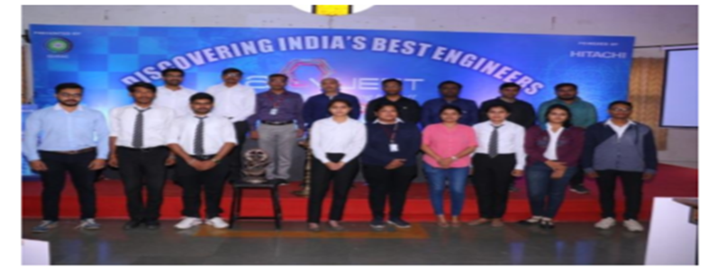 | A-Quest HVAC Quiz -2019 Quarter final powered by HITACHI was held at “AISSMS COLLEGE OF ENGINEERING, PUNE on 5th January 2019 for East zone ISHRAE chapters
Two days’ workshop on Basics of Altair Hypermesh by Mr. Iqbal Hussain (Teccam solution, Pune) | 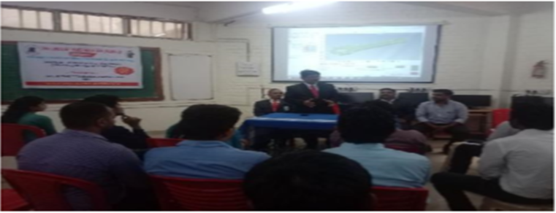
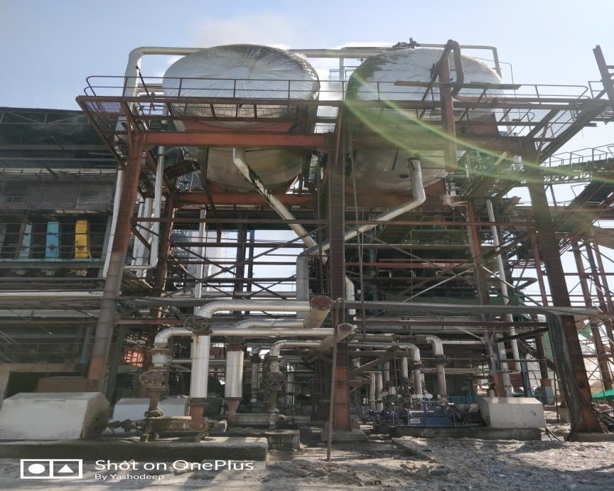 | Industrial visit at “Sheenath Mhaskoba Sugar Factory”
Industrial Visit at “Thermax Solar Thermal Power Plant, A/P. Shive” | 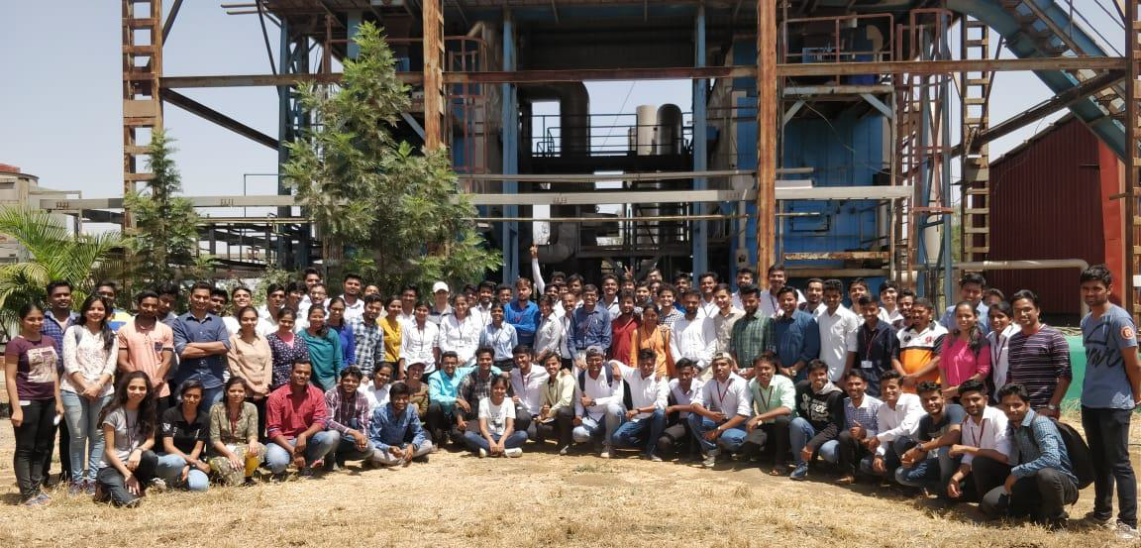
BE Project Competition [Exhibition]- 2019 | 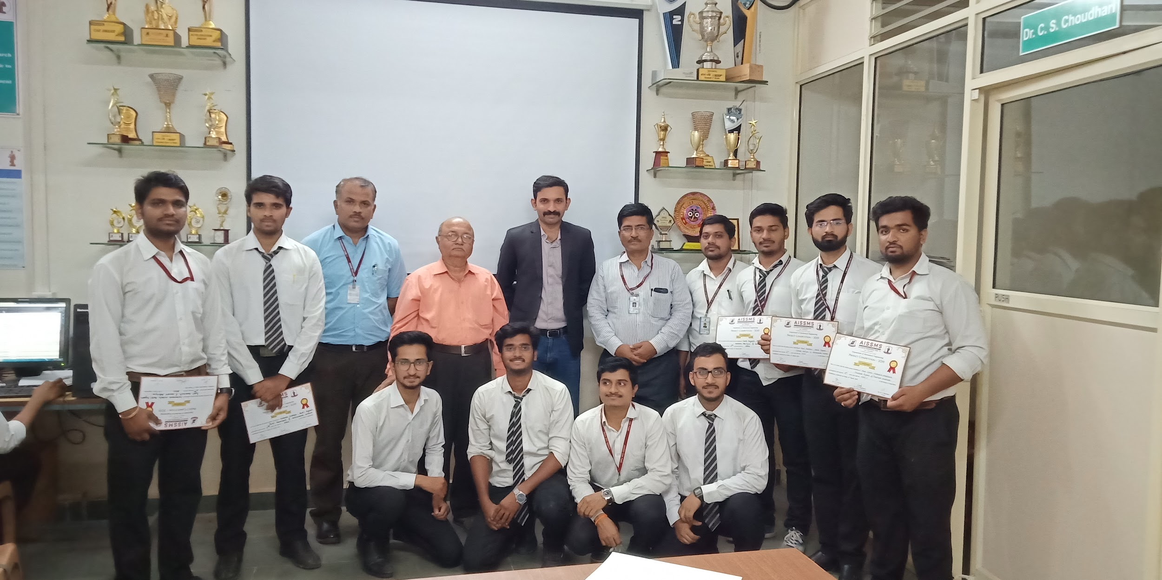
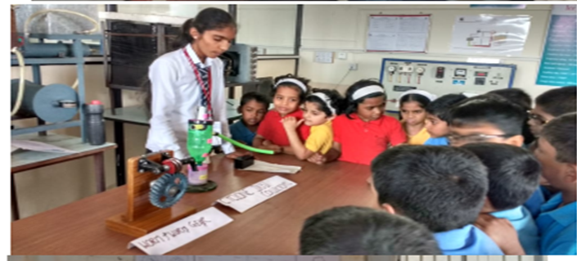 | Science Exhibition, MECHPULSE 2018
Inauguration of Aero design One day Workshop 2018, Organised by Team Garudashwa | 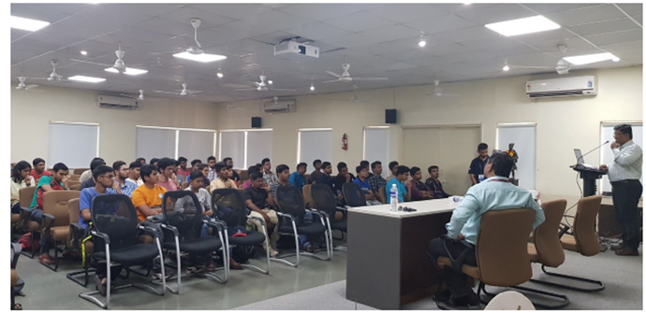
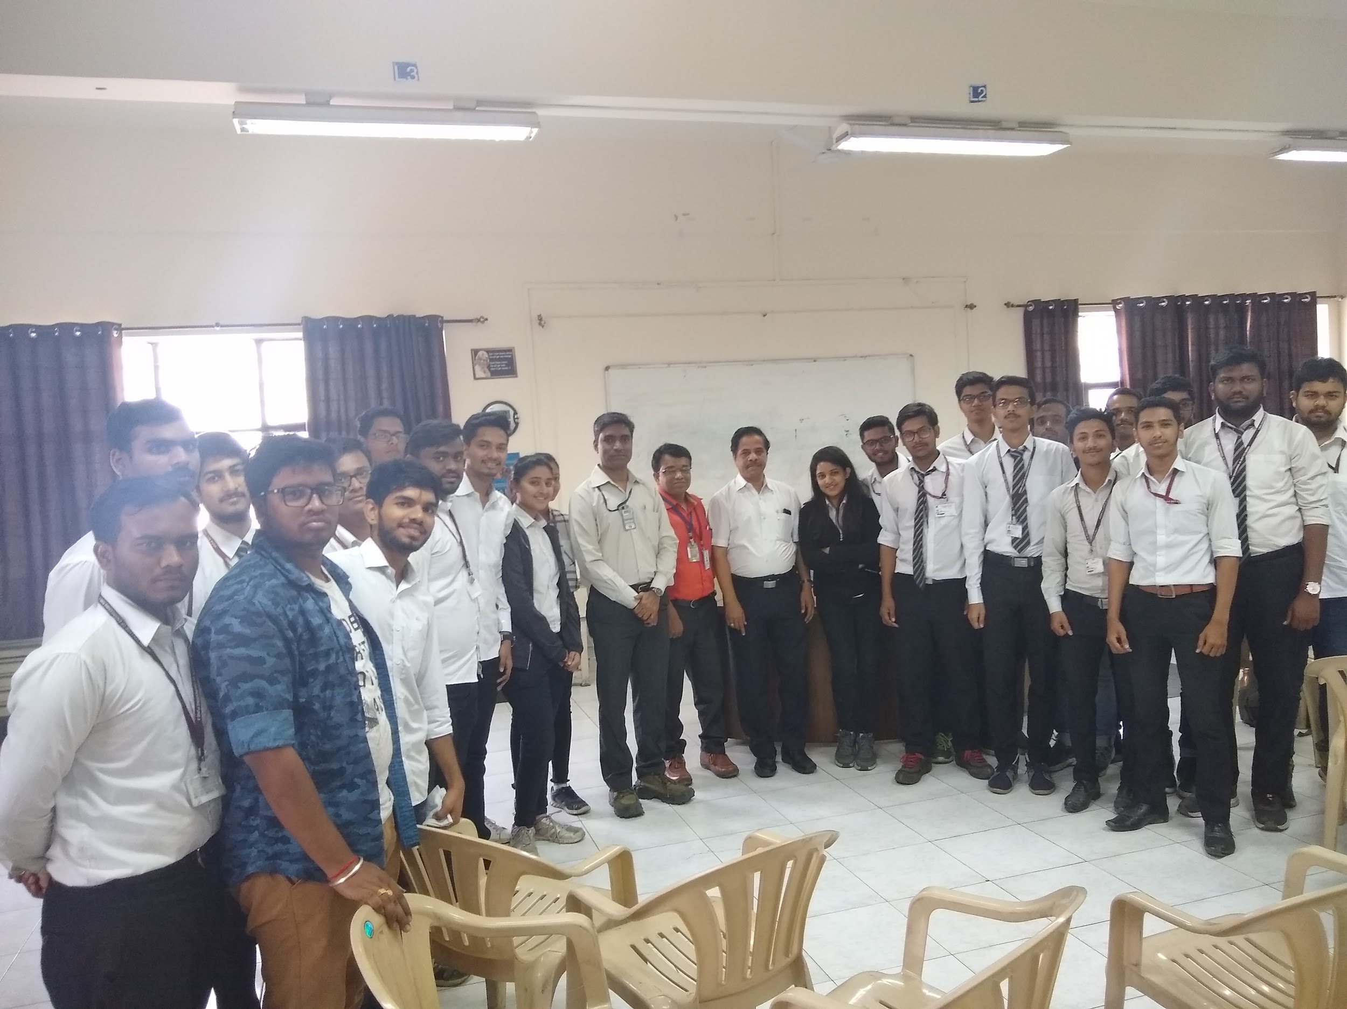 | With Shri. Sunil Bhatambrekar, Head- Product Engineering at Kalyani Maxion Wheels, Pune
Industrial Visit at “ Siddheshwar Industries Pvt.Ltd.”, Chinchwad | 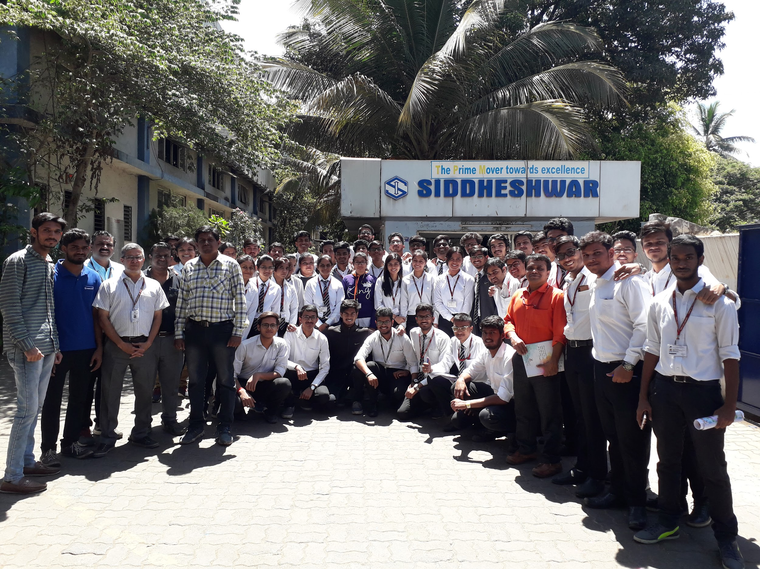
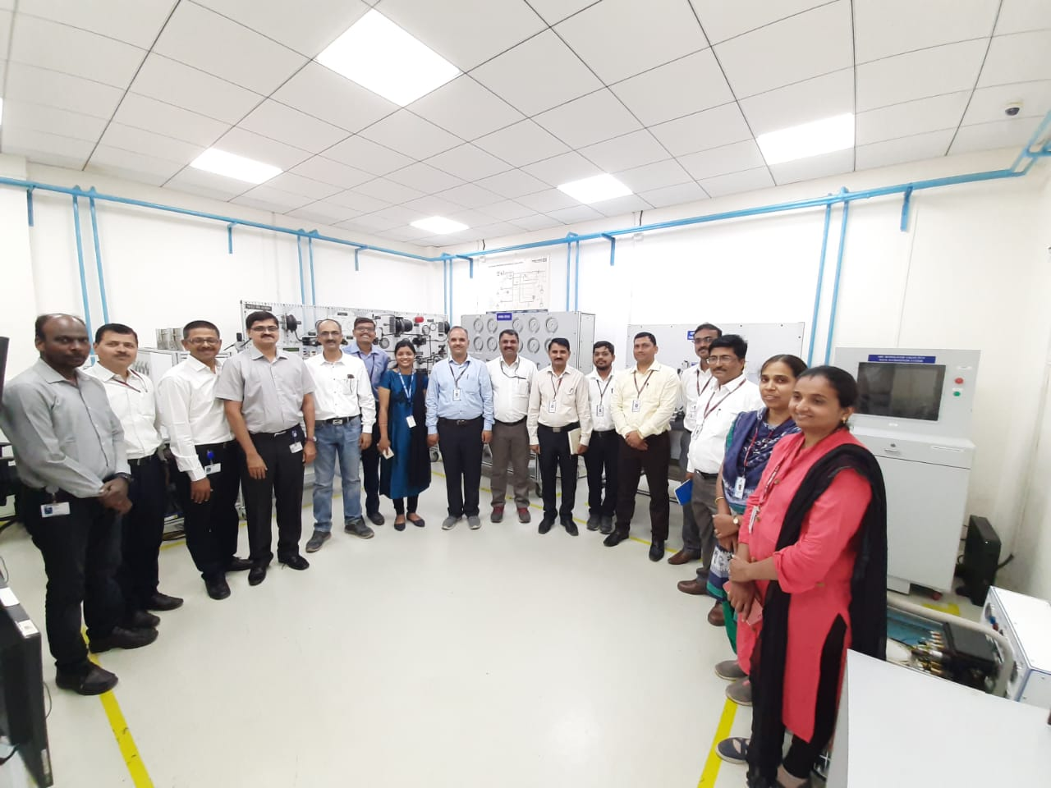 | One day Teachers Training Workshop at “Knorr-Bremse Technology Centre, Hinjewadi, Pune”
One day workshop on “GD & T” | 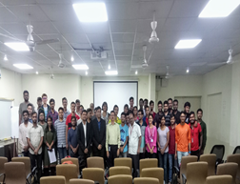
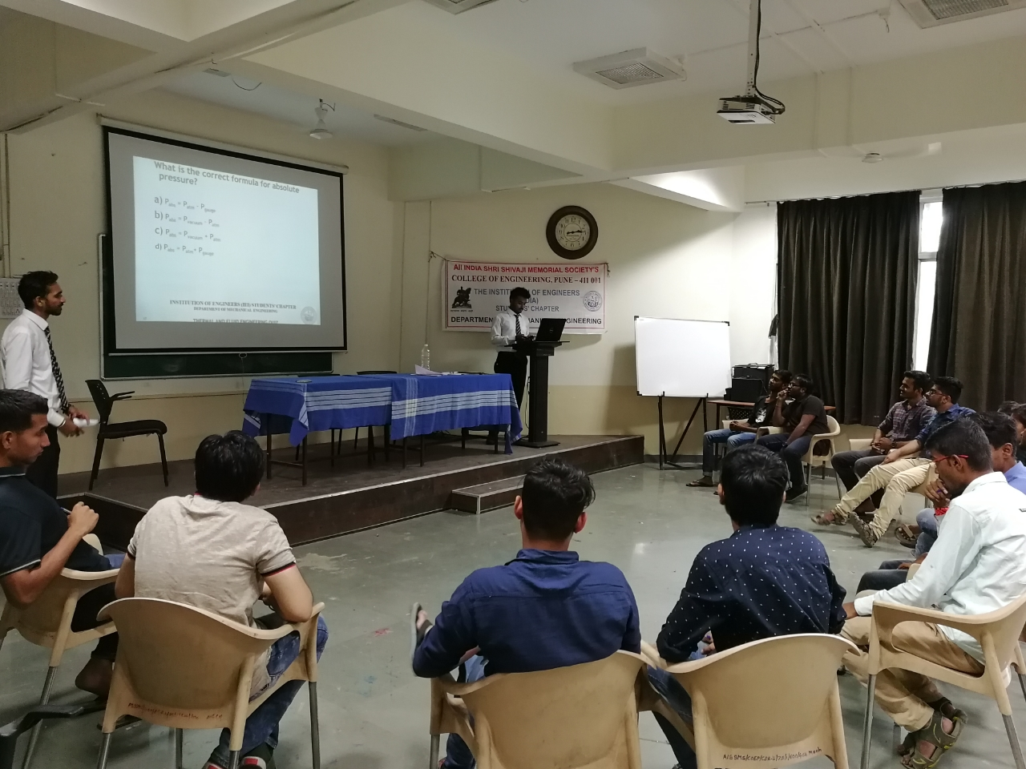 | Technical Quiz on “Thermal and fluid Engineering “ organised by IEI students’ chapter
Industrial visit to Thermax | 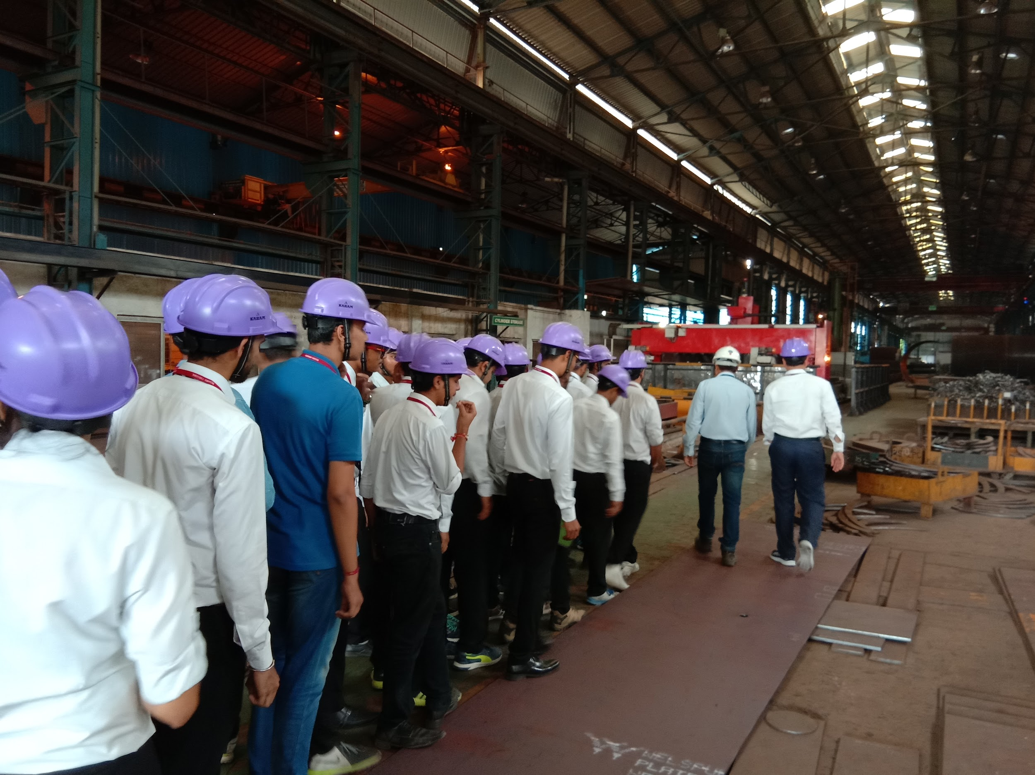
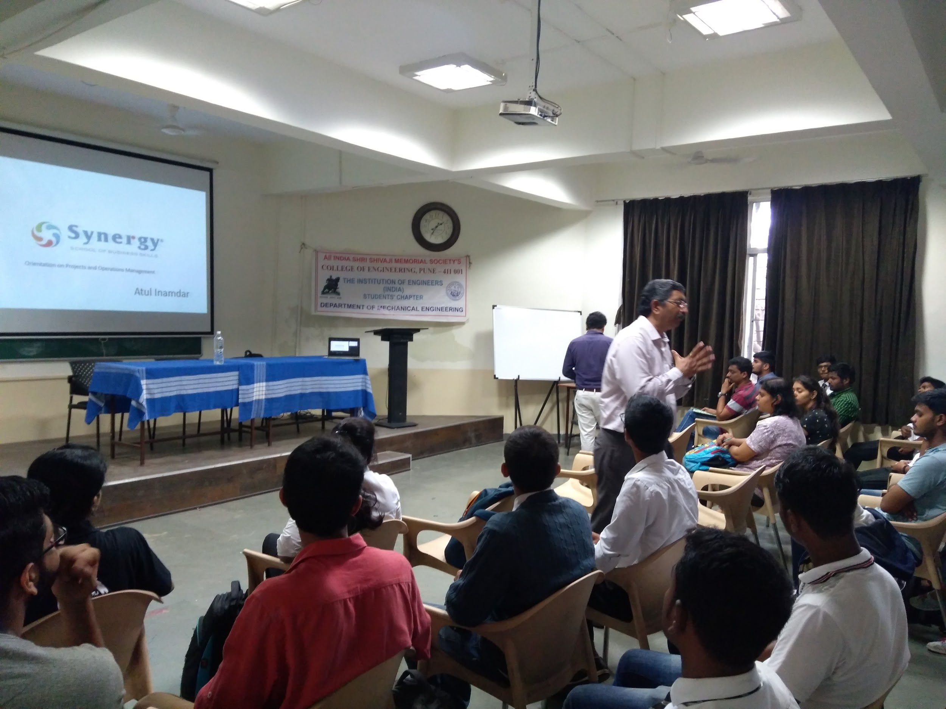 | Expert talk on “Design Thinking”
Expert talk on Applications of CAD CAM in Manufacturing | 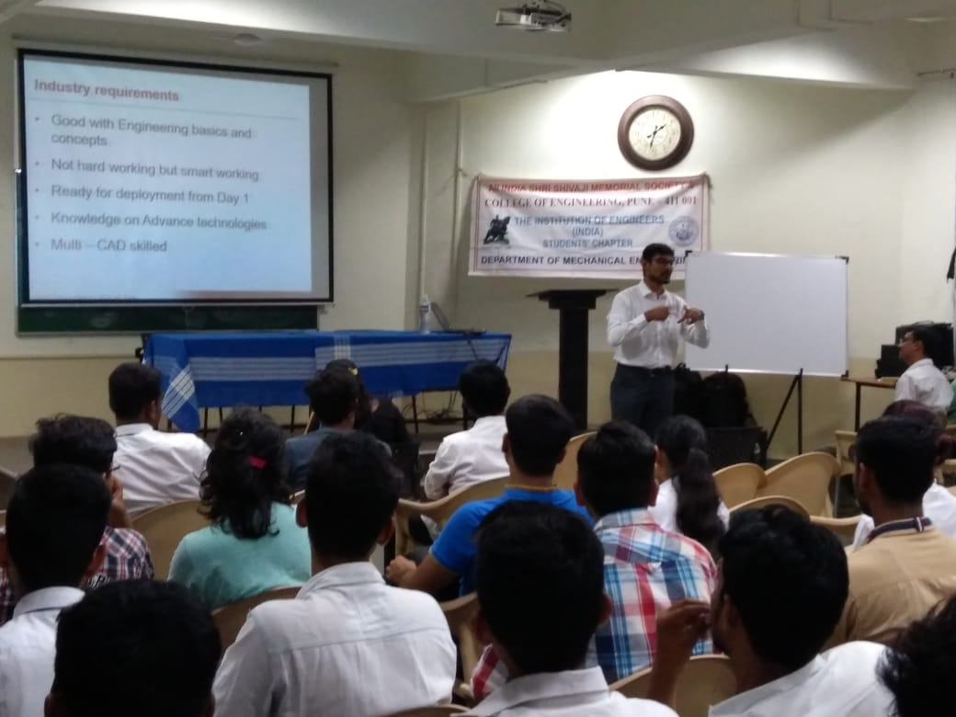
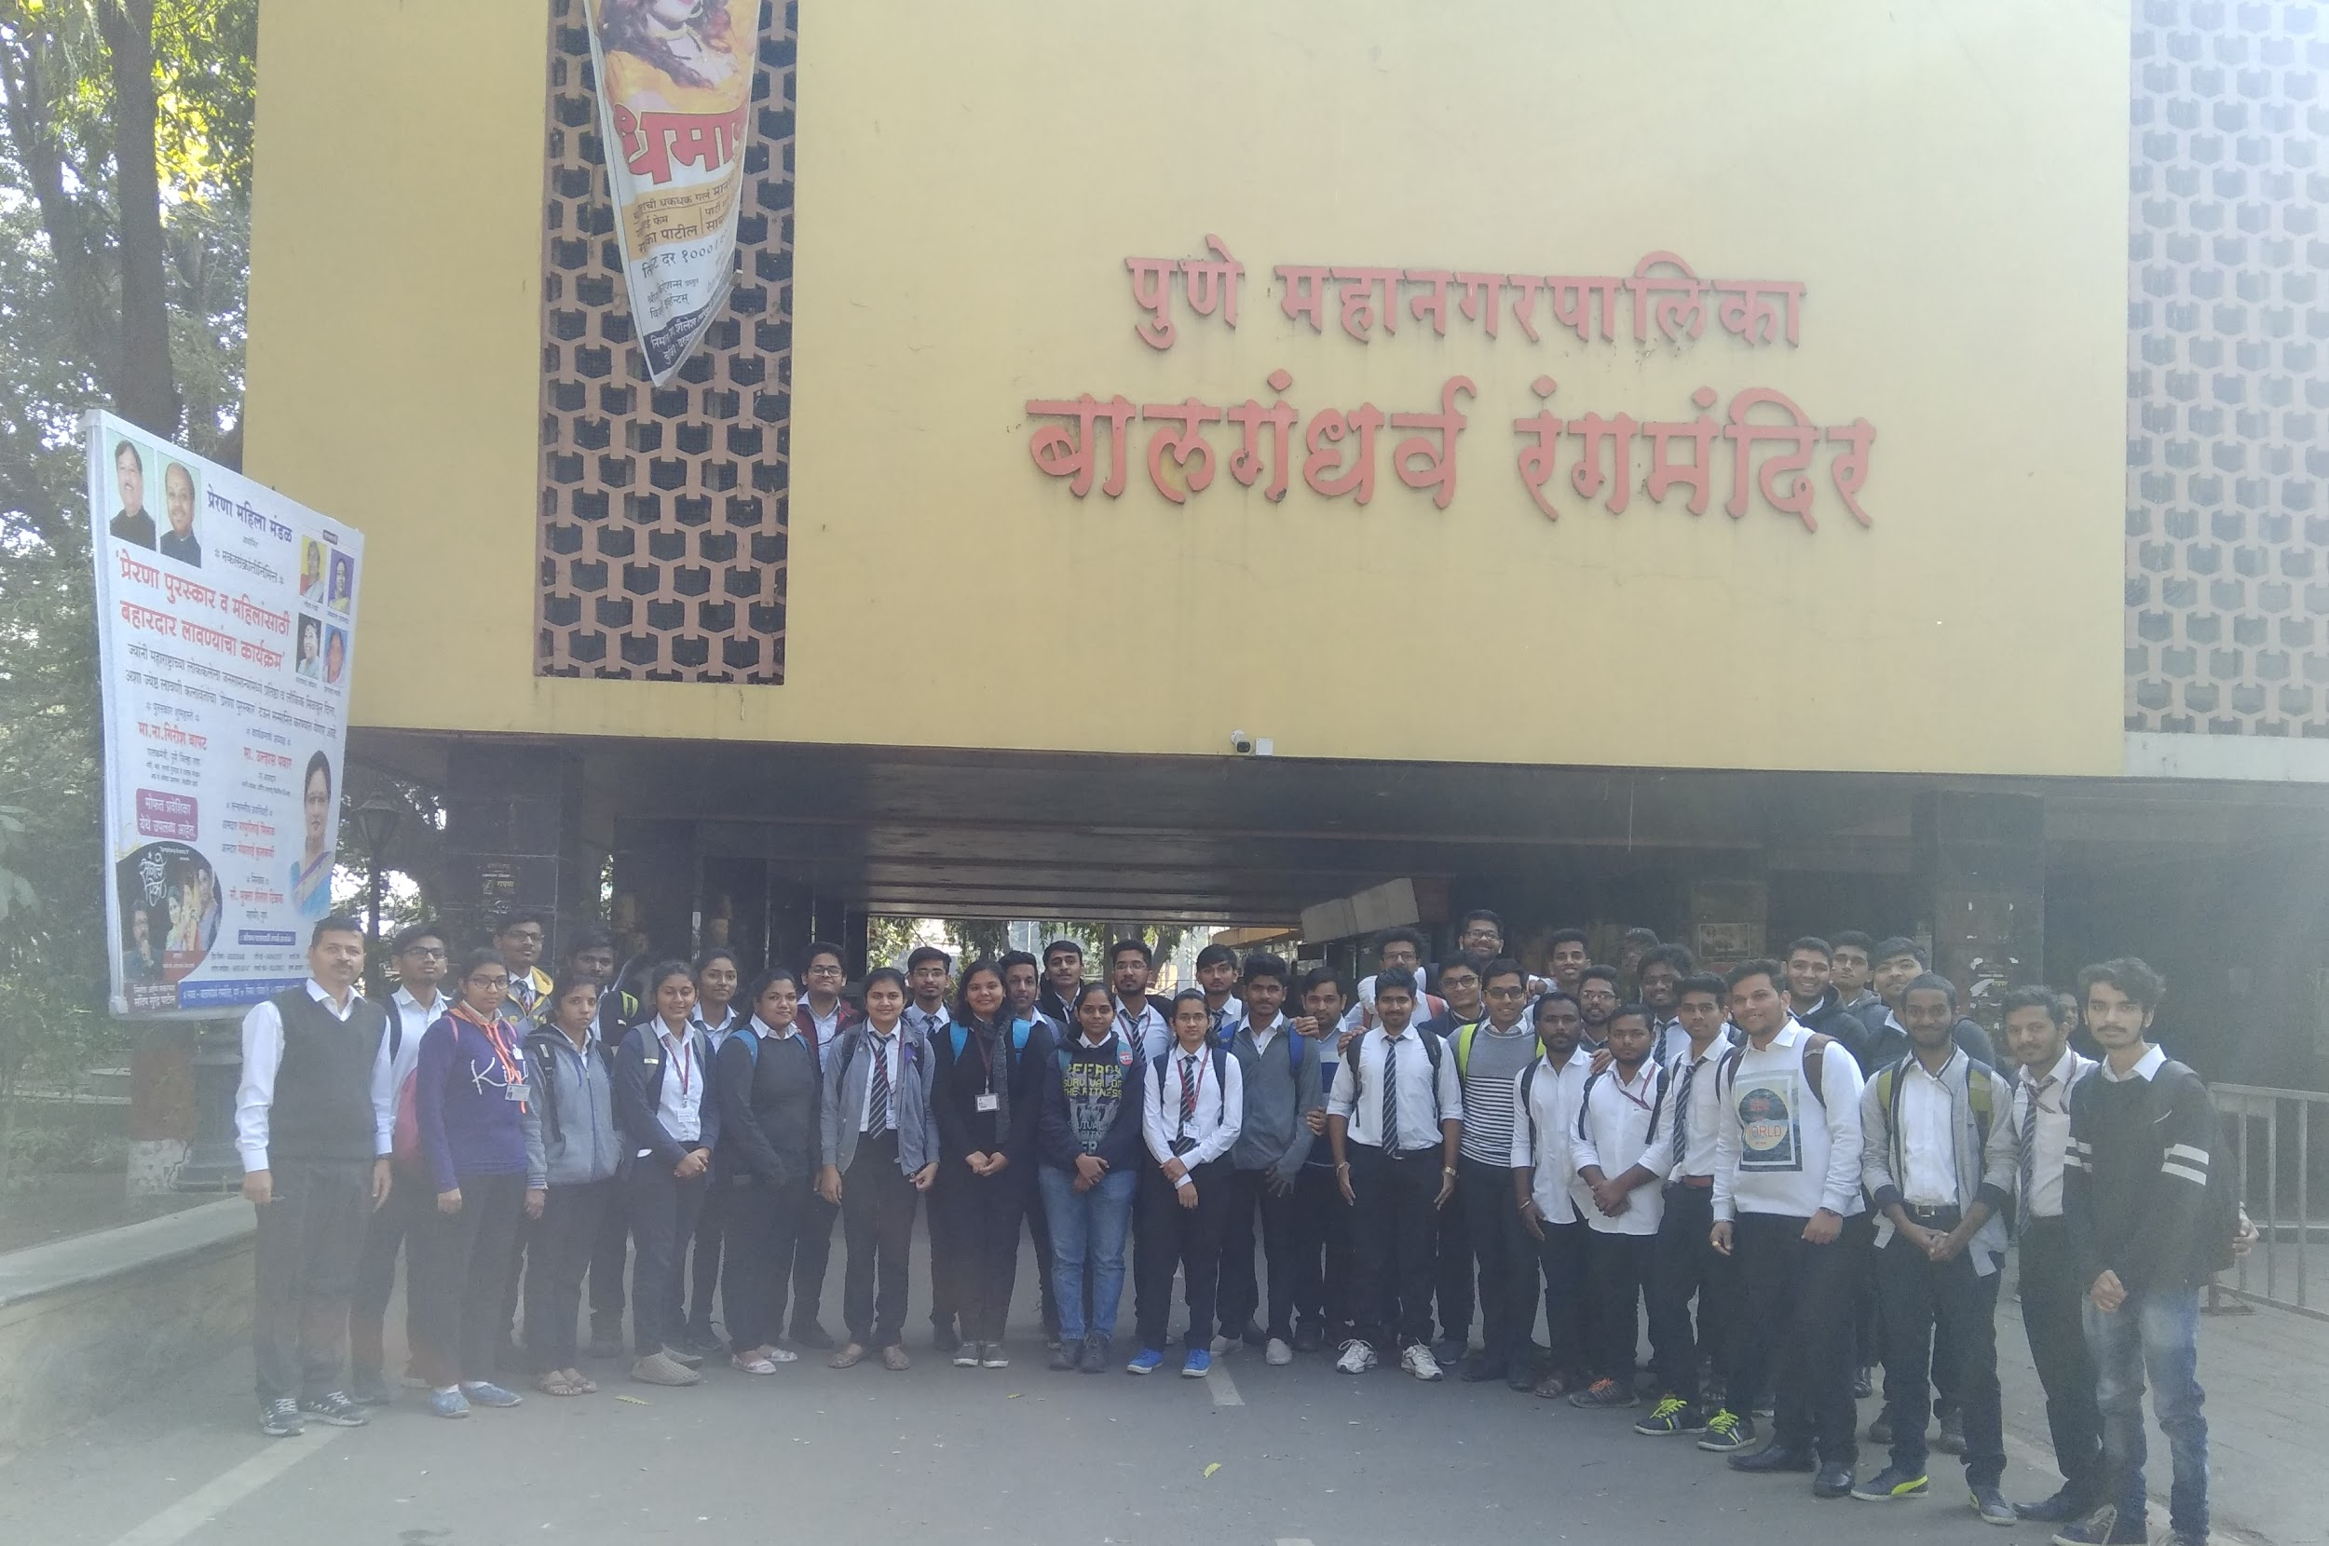 | Visit to Balgandhrav Rangmandir, Pune for observing Central Air Conditioning Plant

