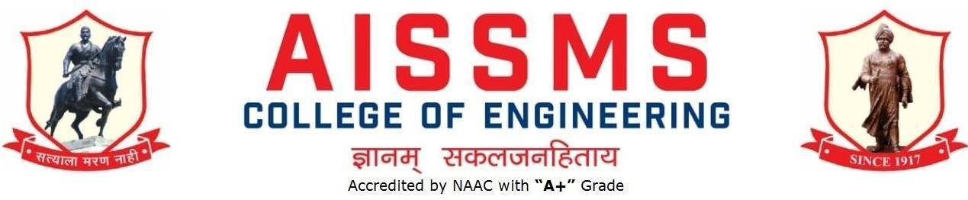
Internal Quality Assurance Cell

DEPARTMENT OF Electronics and Telecommunication ENGINEERING
ANNUAL REPORT
(15June 2022 to 14 June 2023)
TERM ONE: 15 June to 30 November
TERM TWO: 01 December to 14 June

Academic Year 2022 – 23
Guidelines:
Fill up this sheet for all the contributions /activities conducted at Department level only.
- In case data does not exist please mention it as ‘No Data’.
- Please add rows to the table below to suit your requirements
- Ensure that data does not differ from other official records and all the supporting documents are available.
- Use: Font Type: Times New Roman, Font Size: 12, Sentence case, Spacing: 1.15
- Use separate row for every details.
- For any queries, you may contact: Dr C S Choudhari, Coordinator, IQAC
- email: iqac@aissmscoe.com

CONTENTS

Sr No | Activity/ Item | Page No
- PROFILE OF DEPARTMENT
1.1 | Introduction | 6
1.2 | Laboratories in the Department | 6
1.3 | Software Available in the Department | 6
1.4 | Faculty in the Department | 6
1.5 | Details of Supporting Staff | 7
1.6 | Students’ Enrollment | 7
1.7 | Students–Faculty Feedback Details | 7
1.8 | Result Analysis | 9
1.9 | Class Result Analysis | 11
 | - FACULTY CONTRIBUTION
2.1 | Achievements of Faculty | 14
2.2 | Contribution of Faculty (Interaction With Outside World) | 15
2.3 | e content developed by faculty and available online | 18
2.4 | FDP/STTP attended by the department faculty | 27
2.5 | Seminars/ workshops/ webinars attended by the department faculty | 36
2.6 | Conferences/ symposiums attended by the department faculty | 39
2.7 | Online courses / certificate courses completed by department faculty | 39
2.8 | Extension lectures / webinars organized | 41
2.9 | Faculty served as resource person, expert, chairperson | 43
- ACTIVITIES ORGANISED
3.1 | FDP/STTP organized by the department | 46
3.2 | Seminars/ workshops/ webinars organized by the department (for faculty) | 47
3.3 | Conferences/ symposiums organized by the department | 52
3.4 | Extension activities conducted by the department | 53
3.5 | MOU signed with academic and professional organizations | 53
3.6 | Students’ chapters /clubs | 54
3.7 | Social activities organized | 59
3.8 | Parent meeting | 59
3.9 | Alumni meet | 59
3.10 | Support from Alumni | 60
3.11 | Interaction with Alumni | 60
3.12 | Student counseling and career guidance at the department level | 60
- RESEARCH CONTRIBUTION
4.1 | Funded research project | 64
4.2 | Testing and consultancy | 64
4.3 | Patents, copyright, trademark and other (IPR) | 65
4.4 | Papers published/ presented in proceedings of conferences | 66
4.5 | Papers published in journals | 69
4.6 | Book/ article publications | 71
4.7 | Total Research citations | 71
4.8 | ME awarded | 72
4.9 | PhD guide details | 72
4.10 | PhD AWARDED | 72
 | - INTERACTION WITH INDUSTRY
5.1 | Industrial visits organised | 74
5.2 | Expert lectures delivered by industry experts | 74
5.3 | Industry –sponsored projects (UG/PG) | 76
5.4 | MOU signed with industry | 76
5.5 | Faculty members undergone industrial training | 77
5.6 | Students undergone in-plant training and (or) internship programme | 78
5.7 | Support from Industry | 83
5.8 | Training to Industry personnel/ Activity Supporting industry | 84
5.9 | Any other activities to Promote Interaction With Industry | 85
5.10 | Students Undergone Sandwich Training (only for Mechanical and Production Sandwich) | 85
- STUDENTS’ ACHIEVMENT
6.1 | Students’ Achievement (Professional) (Individual Level) | 88
6.2 | Students’ Achievement (Other than Professional) (Individual Level) | 88
6.3 | Certificate / Online Courses Completed by Students | 88
6.4 | Number of Students Placed | 89
6.5 | Number of Students qualified in the competitive examinations | 89
6.6 | Sports / Cultural Achievements of Students (Individual Level) | 89
6.7 | Students’ Achievements (Team Level) | 90
 | - SUMMARY AND SWOC ANALYSIS
7.1 | Any other noteworthy achievement of the department | 95
7.2 | Miscellaneous (Syllabus Implementation, Major Addition In Infrastructure And Facility, Innovations Introduced, etc.) | 95
7.3 | Feedback from Stakeholders | 95
7.4 | Two Best Practices Followed in the Department | 95
7.5 | Major Grievances of Students (If Any) Redressed | 95
7.6 | SWOC Analysis | 96
7.7 | Future plans of the department | 96
7.8 | Future Plans of the Department | 97
7.9 | Initiatives Taken By The Department At Department And Institute Level To Improve And Assure Quality | 97
7.10 | Summary Sheet (Annual) | 98

- PROFILE
OF
DEPARTMENT

1.1 INTRODUCTION
Year of Establishment | 1992
UG Programmes (E&TC) | 1992
PG Programmes | 2010
Number of Teaching Staff | 14
Number of Non-Teaching Staff | 7

1.2 LABORATORIES IN THE DEPARTMENT
Name of Laboratory
Data Analytics Laboratory | Communication Engineering Laboratory
Basic Electronics Laboratory | VLSI Laboratory
Project and Skill Development Laboratory | Signal Processing & Embedded Laboratory
Circuit & Simulation Laboratory | AI and IOT Laboratory
Power Electronics and Digital Circuit Laboratory

1.3 SOFTWARES AVAILABLE IN THE DEPARTMENT
Software Available
1. Xilinx | 2.Multisim
3.Microwind | 4.Octave
5.Proteus | 6.Dev C++
7.eClipse | 8.Side 51, Side Arm, Side Terminal
9.Code Composer Studio

1.4 FACULTY IN THE DEPARTMENT
Name of faculty | Designation
Dr. D S Bormane | Principal
Dr..S B Dhonde | Professor - HOD
Dr. K.B.Chaudhari | Assistant Professor
Mr. S.B.Dhekale | Assistant Professor
Mr. N.P.Mawale | Assistant Professor
Dr. P.P.Vast | Assistant Professor
Ms. V.D.Nagrale | Assistant Professor
Dr. V.V.Deshmukh | Assistant Professor
Mrs. V.S.Navale | Assistant Professor
Mrs. Y.P.Lad | Assistant Professor
Mr. V.B.Gawai | Assistant Professor
Dr. R.R.Itkarkar | Assistant Professor
Mrs. S.A.Takalkar | Assistant Professor
Mrs. P P Tayade | Assistant Professor

1.5 DETAILS OF SUPPORTING STAFF
Name of non-teaching staff | Designation
1. Mr. A.D.Paygude | Technical Assistant
2. Mr. S.M.Dhiwar | Technical Assistant
3.Mr. S.T.Gajar | Laboratory Assistant
4. Mrs. K Zhambre | Laboratory Assistant
5. Mrs. S S Bodke | Laboratory Assistant
6.Mr. G.P.Pimple | Attendant
7.Mr. S.P.Gaikwad | Attendant
8.Mr. S.S.Kale | Attendant

1.6 STUDENTS’ ENROLLMENT
Program | GEN |  | SC |  | ST |  | OBC |  | PWD |  | Others |  | Total
 | M | F | M | F | M | F | M | F | M | F | M | F | M | F
UG (SE &TC) | 21 | 15 | 4 | 1 | 0 | 0 | 9 | 11 | 0 | 0 | 12 | 4 | 46 | 31
UG (TE E&TC) | 28 | 10 | 4 | 1 | 0 | 0 | 11 | 6 | 0 | 0 | 16 | 2 | 59 | 19
UG(BE E&TC) | 22 | 15 | 3 | 3 | 0 | 0 | 10 | 7 | 0 | 0 | 11 | 7 | 46 | 32
PG (IoT and Sensor) | No Admission

1.7 STUDENTS–FACULTY FEEDBACK DETAILS
 | Term One
Sr. No. | Name of faculty | Class and Subject taught | Feedback (I) (%) | Feedback (II) (%) | Average  Feedback (%)
1 | Dr..S B Dhonde | BE: RMT | TH:80, PR:82 | TH:85, PR:85 | 83.00%
2 | Prof. K.B.Chaudhari | SE: DS | TH:75,  PR:76 | TH:76,  PR:77 | 76.00%
 |  | BE:DL | TH:92 | TH:91 | 91.50%
3 | Prof. A.Y.Kazi
4 | Prof. S.B.Dhekale | TE:FJP | TH: 88,  PR:89 | TH:93,  PR:94 | 91.00%
 |  | BE:AJP | TH:87,  PR:88 | TH:87,  PR:90 | 88.00%
5 | Prof. N.P.Mawale | TE:SD | PR:77 | PR:80 | 78.5%
 |  | BE:VLSI | TH:86,  PR:87 | TH:85,  PR:87 | 86.25%
6 | Dr. P.P.Vast | TE: Microcon | TH:86,  PR:87 | TH:88,  PR:88 | 87.00%
 |  | TE:SD | PR:85 | PR:88 | 86.50%
7 | Prof. V.D.Nagrale | SE:ESD | PR:67 | PR:68 | 67.50%
 |  | TE:DBMS | TH:90  PR:92 | TH:92,  PR:91 | 91.25%
8 | Prof. V.V.Deshmukh | SE:DC | TH:61,  PR:67 | TH:75,  PR:79 | 70.50%
 |  | TE:CN | TH:92,  PR:91 | TH:100,  PR:99 | 95.5%
9 | Prof. V.S.Navale | SE:Elect C | TH:72,  PR:75 | TH:70,  PR:71 | 72.00%
10 | Prof. Y.P.Lad | TE:DC | TH:87,  PR:87 | TH:91,  PR:90 | 89.00%
 |  | BE:EPD | TH:90, |  | 90.00%
11 | Prof. V.B.Gawai | SE:EC | TH:79,  PR:79 | TH:77,  PR:76 | 78.00%
 |  | TE:ESD | PR:79 | PR:78 | 78.50%
12 | Prof. R.R.Itkarkar | TE:EWP | TH:90,  PR:91 | TH:91,  PR:91 | 91.00%%
 |  | BE:MIOT | TH:88,  PR:84 |  | 86.00%
13 | Prof P P Tayade | SE:DS | PR:67 | PR:75 | 71.00%
 |  | BE:CC | TH:92,  PR:91 | TH:92;  PR:91 | 91.50%

 | Term Two
Sr. No. | Name of faculty | Class and Subject taught | Feedback (I) (%) | Feedback (II) (%) | Average  Feedback (%)
1 | Dr..S B Dhonde | TE:NS | TH:72  PR:75 | TH:88 PR:89 | 81%
2 | Prof. K.B.Chaudhari | SE:DAL  BE:DM | PR:76  TH:93 | PR:74 TH:92 | 83.75%
3 | Prof. A.Y.Kazi
4 | Prof. S.B.Dhekale | SE:OOP | TH:67  PR:67 | TH:76 PR:76 | 71.5%
5 | Prof. N.P.Mawale | TE:PDC  BE:IE | TH:83  PR:81  TUT:83 | TH:83 PR:84 TUT:86 | 83.33%
6 | Dr. P.P.Vast | TE:CN | TH:84  PR:84 | TH:87 PR:86 | 85.25%
7 | Prof. V.D.Nagrale | SE:ESD  TE:PM | TH:74  PR:75  TH:89 | TH:80 PR:78 TH:88 | 80.66%
8 | Prof. V.V.Deshmukh | SE:S&S | TH:82  TUT:81  PR:82 | TH:90 TUT:89 PR:89 | 85.5%
9 | Prof. V.S.Navale | SE:PCS | TH:73  PR:75 | TH:69 PR:71 | 72%
10 | Prof. Y.P.Lad | BE:FO | TH:92  PR:91 | TH:90 PR:89 | 90.5%
11 | Prof. V.B.Gawai | SE: CS  BE:IE | TH:85  PR:83  TUT:93 | TH:90 PR:89 TUT:92 | 88.66%
12 | Prof. R.R.Itkarkar | BE:MC  BE:IE | TH:89  PR:90  TUT:89 | TH:90 PR:87 TUT:91 | 89.33%
13 | Prof. S.A.Takalkar
14 | Prof P P Tayade | TE:AJP  BE:DBM | TH:91  PR:93  TUT:91 | TH:79 PR:77 TUT:92 | 87.16%

1.8 RESULT ANALYSIS
Term One
Name of faculty | Class and Subject Taught | % passing | Name of faculty | Class and Subject Taught | % passing
SE(E&TC)
Mr. V.B.Gawai | Electronic Circuits | 60.00% | Dr. K.B.Chaudhari | Data Structures | 86.84%
Ms. V.V.Deshmukh | Digital Circuits | 74.67% | Mr. S.T.Surase | Eng. Mathematics III | 61.84%
Mrs. V.S.Navale | Electrical Circuits | 77.33%
TE(E&TC)
Mrs.Y.P.Lad | Digital Communication | 85.52 | Ms.V.D.Nagrale | Database Management | 88.15
Dr.R.R.Itkarkar | Electromagnetic Field | 76.31 | Mr.S.B.Dhekale | Fun Java Pro | 79.48
Dr.P.P.Vast | Microcontroller | 63.15 | Dr.V.V.Deshmukh | Com.Network | 89.18
BE (E&TC)
Dr.S.B.Dhonde | Radiation & microwave theory | 92.30 | Dr.R.R.Itkarkar | Modernized IoT | 89.58
Mr.N.P.Mawale | VLSI design and technology | 82.05 | Mr.S.B.Dhekale | Java script | 100
Mrs.P.P.Tayade | Cloud computing | 94.87 | Mrs.Y.P.Lad | Electronic product dev | 88.88
Dr.K.B.Chaudhari | Deep learning | 100

Term Two
Name of faculty | Class and Subject Taught |  | % passing |  | Name of faculty |  |  | Class and Subject Taught | % passing
SE(E&TC)
Dr. V.V.Deshmukh | Signal & Systems |  | 76% |  | Prof. S.B.Dhekale |  |  | Object Oriented Programming | 77.03%
Prof. V.B.Gawai | Control Systems |  | 74.67%
Prof. V.S.Navale | Principles of Comm. Systems |  | 68.92%
TE(E&TC)
Dr.P.P.Vast | Cellular Networks |  | 82.43 |  | Mr.S.B.Dhekale |  |  | Advanced Java  Programming | 100
Ms.V.D.Nagrale | Project management |  | 95.94 |  | Dr.S.B.Dhonde |  |  | Network Security | 79.54
Mr.N.P.Mawale | Power device and circuit |  | 81.08
BE (E&TC)
Mrs.Y.P.Lad |  | Fiber Optic  Communication |  | 97.44 |  | Mobile Computing | Dr.R.R.Itkarkar |  | 98.72
Dr.K.B.Chaudhari |  | Digital Marketing |  | 98.72

1.9 CLASS RESULT ANALYSIS (Classes SE to BE)
Term Two
SN | Class | Number of Students |  |  |  |  |  |  |  |  |  | Percentage of Passing
 |  | Appeared | Clear Passed | Outstanding  (O)  (9.1 -10) | Excellent  (A+)  (8.1 – 9) | Very Good (A)  (7.1 – 8) | Good (B+)  (6.1 – 7) | Above Average (B)  (5.1 – 6) | Average / pass class  (4 – 5 ) |  | Fail  (F)  0 – 3.99 | All Clear | With ATKT
1 | SE  (E&TC) | 75 | 39 | 1 | 10 | 10 | 15 | 0 |  |  | 8 | 52.00% | 89.33%
2 | TE  (E&Tc ) | 78 | 48 | 3 | 18 | 21 | 6 | 0 | 0 | 0 | 4 | 64.86 | 94.59%
3 | BE  (E&Tc) | 78 | 70 | 15 | 49 | 6 |  |  |  |  | 8 | 89.74

1.10 UNIVERSITY RANKERS (Consider last five academic years)
Academic Year 2021 - 22
Sr No | Name of the Ranker | Class | Rank
 | No Data

Photographs of Labs, final year class group photos, faculty and staff group photos, any significant achievement of department
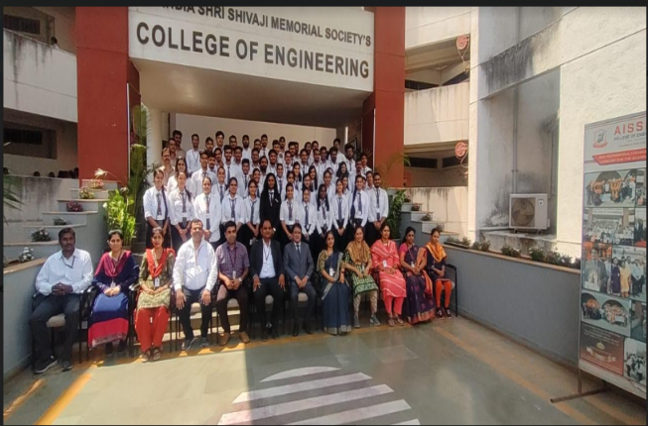  E&TC Department Faculty member and BE Students. | 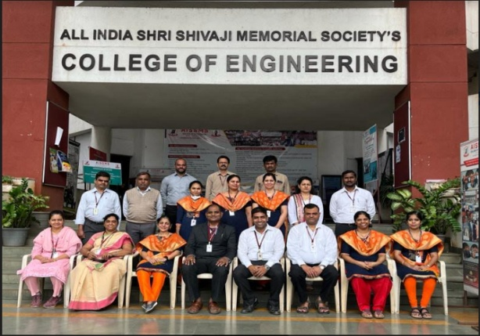  E&TC Department Faculty members
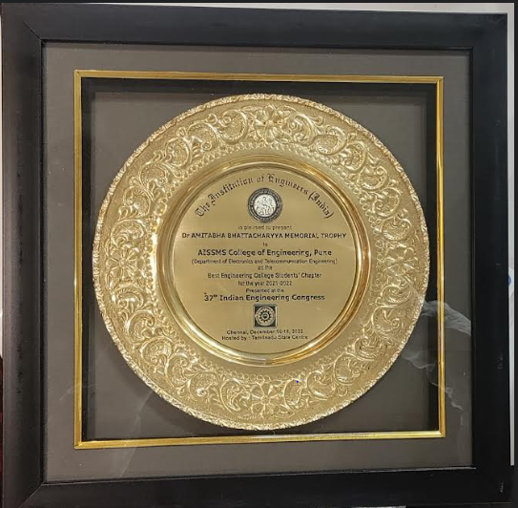  Dr. Amitabh Bhattacharyya Memorial Trophy to AISSMSCOE, E&TC Department as Best Student Chapter Award for AY 2021-22 | 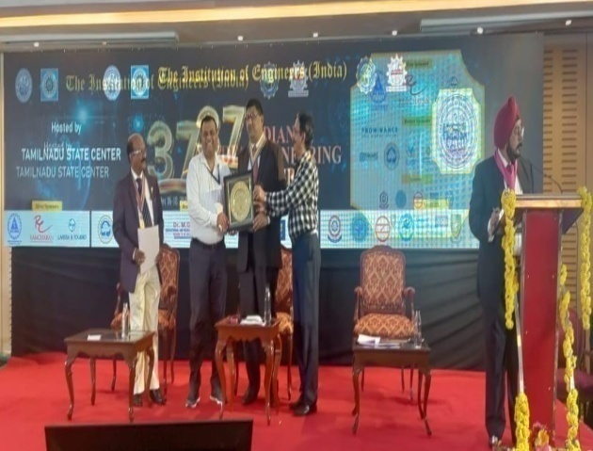  Dr. Amitabh Bhattacharyya Memorial Trophy to AISSMSCOE, E&TC Department as Best Student Chapter Award for AY 2021-22 received by Mr. N P Mawale
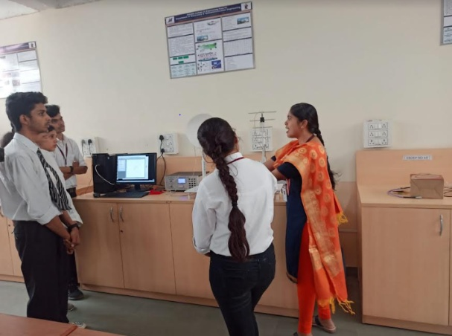  Communication Laboratory | 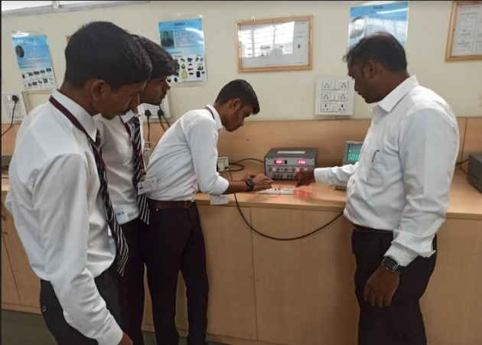  Circuit and Simulation Laboratory
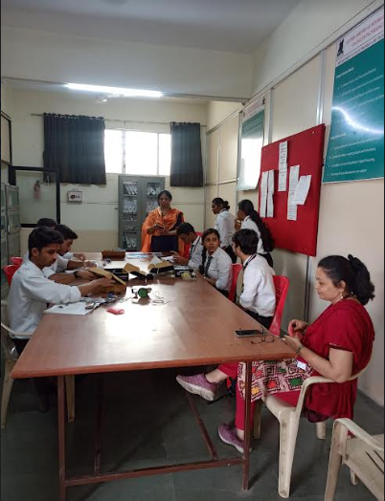  Electronics for You Skill Center | 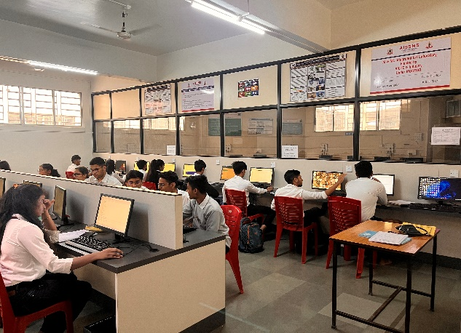  AI & ML Integrated IoT Laboratory

- FACULTY CONTRIBUTION

2.1 ACHIEVEMENTS OF FACULTY (AWARDS, RECOGNITION, PHD COMPLETION ETC.)
Term One
SN | Name of Faculty | Awards & Recognitions
1 | Dr. D S Bormane | 1. Elected as Vice President IETE, New Delhi. 24/9/2022
2 | Dr. R R Itkarkar | 2. Awarded with Ph. D ,VTU Belgum, 3/12/2022
3 | Mr. N P Mawale | 1. Best Sponsorship Award in ET-2022 ,AISSMSCOE.  2. Elected as Faculty Adviser Representative on National Level  All India Students Committee (AISC) of The Institution of  Engineers (India), Kolkata.  3. National Level Best Engineering College Students’ Chapter  Award from HQ The Institution of Engineers (India) for the  Year 2021-22. Award Distribution event held at Chennai on  17.12.2022.  4. Elected as Hon. Secretary, Western Regional Chapter of Solar  Energy Society of India at AISSMS College of Engineering,  Pune.  5. Elected as Hon. Secretary, ISTE Chapter at AISSMS College of  Engineering, Pune
4 | Dr. V V Deshmukh | 1. Best Department ET Coordinator in ET- 2022, AISSMSCOE

Term Two
SN | Name of Faculty | Awards & Recognition
1 | Dr.V V Deshmukh | 1. Awarded with Ph.D ,SPPU, 17/03/2023
2 | Mr. V B Gawai | 1. AISSMS COE Team Won AISSMS Credit Society Cricket Tournament 2023. (Mr. V B Gawai- Member of Team)
3 | Dr. V V Deshmukh | 1. Winner of Panel Discussion in AISSMS DIVA 2022-23  2.1st Runner up position in AISSMS DIVA 2022-23
4 | Ms. Payal P. Tayade | 1. AISSMS COE secured 1st Runner Up position in AISSMS DIVA 2022-23 (Team Members: Dr. Vidya Deshmukh & Ms. Payal P. Tayade)

2.2 CONTRIBUTION OF FACULTY (Interaction with outside world)
Term One
SN | Name of Faculty | Nature and details of contribution (Representation at University, State, National , International level, corporate world, Social Platforms, etc)
1 | Dr. S B Dhonde | 1. International conference session chair at DYPIET,  Pune  2. Subject Chairman of Computer network, Network  security, Electronic in Agriculture at university level
2 | Dr. P P Vast | 1.Dr .Prachi Vast Worked as a Resource Person in Faculty  Orientation Workshop on BE(E&TC) revised syllabus  2019 Course) under aegis of Board of Studies (E&TC),  Savitribai Pune University, organized by Dept of E&TC,  Engineering, STES Sinhgad Institute of Technology,  Lonavala,Pune from 14/07/2022 to 16/07 /2022.  2. Dr Prachi Vast worked as a judge for Paper Presentation  Competition organized by AISSMS Polytechnic, Pune.
3 | Dr. R R Itkarkar | 1.Worked as reviewer for the Second International Conference on Signal and Information Processing- 2022,IEEE IConSIP-II-202 organized by Electronics & Telecommunication Engineering Department, COEP Technological University Pune during 26nd - 27th August 2022.  2.Providing technical consultancy to Kone crane on  Implementation of Image detection methodology for visual inspection of crane parts” Students: Vignesh Iyer and Vijay  Amble  3.Worked as Mentor for SIH Mentor at Coimbatore from  24/08/20222 to 30/08/2022.Meeting with Mr. Kishore Bapat  Ekalipi Pvt Ltd, on 1st December 2022 regarding Internship.  ( 2 students were offered Internship).
4 | Ms.P P Tayade | 1.Had a meeting with “Sinhgad Industry Association” Mrs.  Pallavi Jadhav & Mrs. Supriya Jagdale ma’am toCreate  internship opportunities and project assistance for students  dated on 21st September 2022 at 2 pm  2.Had a meeting with “Technoscript” Gaus Patel to create internship opportunities and project assistance for students dated on 6th July 2022 at 3 pm
5 | Dr. V V Deshmukh | 1.Attended EX SARVATRA PRAHAR COMBAT ENGINEER DEMONSTRATION-2023 at College of Military Engineering, Pune on 10/1/2023
6 | Mrs. V S Navale | 1.Attended EX SARVATRA PRAHAR COMBAT ENGINEER DEMONSTRATION-2023 at College of Military Engineering, Pune on 10/1/2023
7 | Ms. Y P Lad | 1.Attended EX SARVATRA PRAHAR COMBAT ENGINEER DEMONSTRATION-2023 at College of Military Engineering, Pune on 10/1/2023
8 | Ms.V D Nagarale | 1.Attended EX SARVATRA PRAHAR COMBAT ENGINEER DEMONSTRATION-2023 at College of Military Engineering, Pune on 10/1/2023
9 | Mr. N P Mawale | - Worked at National Level All India Students Committee of The Institution of Engineers (India), Kolkata as Faculty Adviser Representative from Engineering Colleges for AY: 2022-23  - Worked as Hon. Secretary, Western Regional Chapter of Solar Energy Society of India at AISSMS College of Engineering, Pune.  - Worked as Hon. Secretary, ISTE Chapter at AISSMS College of Engineering, Pune  - Invitee Member at Pune Local Center, The Institution of Engineers (India).  - Invitee Member of Program Committee at Maharashtra State Center, The Institution of Engineers (India).  - Attended “The Smarter E India 2022 (International Solar Industries Exhibition) from 7-9 December-2022 at Gandhinagar (Gujrat).  - Attended 37th National Congress at Chennai of The Institution of Engineers (India) from 16-18 December-2022.  - Working for Institutional Member of TRIZ Association of India.  - Worked as Resource Person for Expert Lecture on IEI Students’ Chapter at Dr. D Y Patil Institute of Technology, Pimpri, Pune on 25.11.2022) Worked as Resource Person for Guest Lecture on VLSI and Embedded System on 3.12.2022 at Pratibha College of Commerce & Computer Studies, Pune
10 | Mr. S B Dhekale | 1.Conducted Comprehensive Viva Voce Oral & PR examination @VIT Pune Autonomous Intitule on Advanced Data Structures &OS  2.Visited ENCON Yashada Industrial Complex  3.Subject Theory and Practical Chairman of SPPU Pune  4. Conducted Expert Talk on Fundamentals of Java at DIT Pimpri.  5.Completed Consultancy work with Wish Energy Pvt. Ltd Pune with Rs. 15000/-

Term Two
SN | Name of Faculty | Nature and details of contribution (Representation at University, State, National , International level, corporate world, Social Platforms, etc)
1 | Dr V V Deshmukh | 1. Dr V V Deshmukh was invited as session chair for ACCET National Conference on 28/4/2023, conducted by Wadia College of Engineering .
2 | Mr. S B Dhekale | 1.Worked as judge for BE E&TC project completion at AISSMSIOIT on 28.03.2023
3 | Dr R R Itkarkar | 1.Contribution as Mentor for Avishkar 2023, at state level inter university research convention under Medicine and Pharmacy category held at SPPU -12th to 15th Jan 2023.  2.Resource Person in Faculty Orientation Workshop on Mobile computing BE(E&TC) revised syllabus (2019) under the aegis of Board of Studies (E&TC/Elex.), Savitribai Phule Pune University, organized by, Dept. of E&TC Engineering, STES, Sinhgad Institute of Technology and Science,Narhe,Pune-41, from 30/01/2023 to 1/02/2023.  3.Providing technical consultancy to Kone crane on Since March 2022 May 2023) “Implementation of Image detection methodology for visual inspection of crane parts” Students: Vignesh Iyer and Vijay Amble.  4.Resource person in Faculty Orientation Workshop on “Recent Trends in Mobile Computing with real time Approach” organized by BSIOTR, Pune from 27th March to 1st April 2023 in online mode in association with IETE Pune section and IEEE Communication society Pune Chapter on topic Mobile System

2.3 e CONTENT DEVELOPED BY FACULTY AND AVAILABLE ONLINE
Term One
Sr No. | Name of Faculty | Title of e-content | e-content development facility/platform | link of the content
1 | Dr..S B Dhonde | Subject: Digital Electronics | Youtube Video | https://www.youtube.com/watch?v=onZsMhAXcLk
 |  | Subject: Digital Electronics | Youtube Video | https://www.youtube.com/watch?v=7rEKXWhzB34
 |  | Subject: Digital Electronics( MOD 6 Counter ) | Youtube Video | https://www.youtube.com/watch?v=ce8vV7dYpQk
 |  | Subject: Digital Electronics( MOD 8 Counter ) | Youtube Video | https://www.youtube.com/watch?v=D9vBiuxRPR8
2 | Dr. K.B.Chaudhari | BE ETC  Deep Learning | Google classroom | https://classroom.google.com/u/1/c/NDk3MjcyNTEwNzEy
 |  | SE ETC  Data Structures | Google classroom | https://classroom.google.com/u/1/c/NDk3OTAyNTcyNDA4
3 | Mr. S. B. Dhekale | TE E&TC  BE E&TC | Google classroom | https://classroom.google.com/c/MTQwMzcxNDM5MDA5
4 | Mr. N. P. Mawale | BE E&TC  VLSI & Design Technology | Google classroom | https://classroom.google.com/u/0/c/NTM4MDQ0NDQ1MTI5
 |  | TE E&TC  Skill Development | Google classroom | https://classroom.google.com/u/0/c/NTczMzA3OTIwNDc4
5 | Dr. P. P. Vast | TE E&TC Microcontroller | Google classroom | https://classroom.google.com/u/1/c/NTM5NDIwMjI2Mzk0
6 | Ms. V. D. Nagrale | TE E&TC  for DBM | Google classroom | https://classroom.google.com/c/NTI2NDM5NjQ3Njgy
7 | Dr. V.V.Deshmukh | SE E&TC  Digital Circuits | Google Classroom | https://classroom.google.com/c/NDk4MjI3MTE1NTcx?cjc=ruvdzky
 |  | TE E&TC  Computer Networks | Google Classroom | https://classroom.google.com/c/NTQ4NzIzNjAxOTA0?cjc=ktfnbpl
8 | Mrs. V.S.Navale | SE E&TC 2022-23 Sem-I Electrical Circuits | Google Classroom | https://classroom.google.com/c/NTI2NTY4MzkyODY0
 |  | Electrical Circuits | Youtube Video | https://youtu.be/GCMw89RV2gA  https://youtu.be/5Ciz04e3ncc
9 | Mrs. Y.P.Lad | BE E&Tc 2022-23 Sem-I Electronics Product Development | Google Classroom | https://classroom.google.com/c/NTM3NzE3ODQyNTI5
 |  | TE E&Tc 2022-23 Sem-I  Digital Communication | Google Classroom | https://classroom.google.com/c/NTM3NTczNDI0ODcy
10 | Mr. V.B.Gawai | SE E&TC Sem I  Electronic Circuits Practicals | You Tube and Google class room | https://youtu.be/xq7Tu_2yl1U  2.https://youtu.be/V5JG3_1yPGo  3.https://youtu.be/B9wgK-bRZFU  4.https://youtu.be/krUPiLDylFA  5.https://youtu.be/zA3w2UZPF04  6.https://youtu.be/bxpWxjVgNKs  7.https://youtu.be/BnTYVhwLTEs  8.https://youtu.be/MW4iNusAj88  9.https://youtu.be/bxpWxjVgNKs  Google class Room Link: https://meet.google.com/gzx-gwkr-ehz
11 | Dr. R.R.Itkarkar |  |  | https://www.youtube.com/watch?v=nrUuNRB54fM  https://www.youtube.com/watch?v=Zj239ekgl6g  https://www.youtube.com/watch?v=73PdCbpTQLE  https://www.youtube.com/watch?v=i0Xm_FxCtCU  https://www.youtube.com/watch?v=CLwBkcwJjX8  https://www.youtube.com/watch?v=I7NNig5g-fc  https://www.youtube.com/watch?v=oSecmBu1p-w  https://www.youtube.com/watch?v=9w0xb5Eo3_Q  https://www.youtube.com/watch?v=KdBS5WYaJs8  https://www.youtube.com/watch?v=MfQ01h2mpyM  https://www.youtube.com/watch?v=tOELlMBt-1Y  https://classroom.google.com/c/NTAxODA5MzUyMjU4  https://classroom.google.com/c/NTM5MDM0MDU5MDcz
12 | Ms. P P Tayade | BE E&TC Term I, Subject: Cloud Computing | Google classroom | https://classroom.google.com/c/NDk3MTgwNTUyMDMw

Term Two
Sr No. | Name of Faculty | Title of e-content | e-content development facility/platform | link of the content
1 | Dr. S B Dhonde | Subject: WSN | Youtube Video | https://www.youtube.com/watch?v=ekK6OVDtV7o
 |  | Subject: WSN | Youtube Video | https://www.youtube.com/watch?v=yXX-RK9mWbU
 |  | Subject: WSN | Youtube Video | https://www.youtube.com/watch?v=ArGgF27xHCo
 |  | Subject: WSN | Youtube Video | https://www.youtube.com/watch?v=mjw0KPu18lQ
 |  | Subject: WSN | Youtube Video | https://www.youtube.com/watch?v=6sV84k1bL6s
 |  | Subject: WSN | Youtube Video | https://www.youtube.com/watch?v=zIq7-R8Eotk
 |  | Subject: WSN | Youtube Video | https://www.youtube.com/watch?v=P-wK5K8Tscg
 |  | Subject: WSN | Youtube Video | https://www.youtube.com/watch?v=ELnJc_NchTs
 |  | Subject: WSN | Youtube Video | https://www.youtube.com/watch?v=ekK6OVDtV7o
 |  | Subject: WSN | Youtube Video | https://www.youtube.com/watch?v=ArGgF27xHCo
2 | Dr. K.B. Chaudhari | BE ETC  Digital Marketing | Google Classroom | https://classroom.google.com/u/1/w/NTE2MTY5MTgzMjky/t/all
 |  | SE ETC  Data Analytics | Google Classroom | https://classroom.google.com/u/1/c/NTE3MzM2NjYyODc5
3 | Mr. S.B.Dhekale |  | OOP Google Classroom https://classroom.goo | gle.com/c/NTE5NTE
4 | Mr. N.P.Mawale | TE E&TC  Power Devices and Circuits | Google Classroom | https://classroom.google.com/u/0/c/NTkzOTQwNDcwODM5
5 | Dr. P.P.Vast | TE E&TC Cellular Network | Google classroom | https://classroom.google.com/u/1/c/NTE3NDMyMTI0NzE5
6 | Ms. V.D.Nagrale | TE E&TC  for PM | Google classroom | https://classroom.google.com/c/NTI2NDM5NjQ3Njgy
7 | Dr. V.V.Deshmukh | SE E&TC  2022-23 Sem II  Signals & Systems | Google classroom | https://classroom.google.com/c/NjAwOTY1NzIwNjE2?cjc=lqa3sbk
8 | Mrs. V.S.Navale | SE E&TC 2022-23 Sem-II Principles of Communication Systems | Google Classroom | https://classroom.google.com/c/NjAwOTY1OTg1Njkx
9 | Mrs. Y.P.Lad | BE E&TC  2022-23 Sem-II  Fiber Optics Communication | Google Classroom | https://classroom.google.com/c/NTkyNzk5ODI0ODgw
10 | Mr. V.B.Gawai | SE E&TC Control systems | Google Classroom | https://meet.google.com/gzx-gwkr-ehz
11 | Dr. R.R.Itkarkar | BE E&TC | Mobile Communication | https://www.youtube.com/watch?v=nrUuNRB54fM  https://www.youtube.com/watch?v=Zj239ekgl6g  https://www.youtube.com/watch?v=73PdCbpTQLE  https://www.youtube.com/watch?v=i0Xm_FxCtCU  https://www.youtube.com/watch?v=CLwBkcwJjX8  https://www.youtube.com/watch?v=I7NNig5g-fc  https://www.youtube.com/watch?v=oSecmBu1p-w  https://www.youtube.com/watch?v=9w0xb5Eo3_Q  https://www.youtube.com/watch?v=KdBS5WYaJs8  https://www.youtube.com/watch?v=MfQ01h2mpyM  https://www.youtube.com/watch?v=tOELlMBt-1Y  https://www.youtube.com/watch?v=s6gq7WlETt4  https://classroom.google.com/c/NTk5MDY1MzM3NzM4  https://classroom.google.com/c/NTE5MTIyMjA1NTIw
12 | Ms. P P Tayade | TE E&TC Term II Subject: Advance Java Programming | Google classroom | https://classroom.google.com/c/NTkzMjk4NjMxMzMx

2.4 FDP/STTP ATTENDED BY THE DEPARTMENT FACULTY
Term One
S N | Name of Faculty | Title of the FDP/STTP | Organized by | Duration/ Dates
1 | Dr. S B Dhonde | Data Science using machine learning | PREC Loni. | 2/8/2022 to 6/8/ 2022
 |  | Data Science and Python | College of Engineering and Technology, Akola. | 16/1/23 to 28/1/2023
 |  | Recent Trends in Mobile computing with real time approach | Bhivrabai Sawant Institute of Technology and Research, Wagholi, Pune | 27/3/2023 to 1/4/2023
2 | Dr K B Chaudhari | STTP on “Data Science” | ISTE and department of computer engineering, K J College of Engineering and Management Research, Pune | 1 Week  11/07/2022 to 15/07/2022.
 |  | FDP on “Machine Learning and Deep Learning Using Python” | organized by MET Institute of Computer Science, Mumbai | One Week  02/08/2022 - 06/08/2022
 |  | FDP on “AWS (Amazon Web Services)” | Brainovision Solutions India Pvt Ltd and AICTE | One Week  22/08/2022 to 26/08/2022
 |  | STTP on “Cloud Computing using GCP and AWS” | Department of E&TC Engineering, K J College of Engineering and Management Research Pune | One Week 19/09/2022 to 23/09/2022
 |  | ATAL FDP on “Stress management, Art of living and Communication” | Sardar Patel College of Engineering, Andheri. | Two Weeks  14/11/2022 to 25/11/2022
3 | Mr.S B Dhekale | Machine Learning | SIT Lonawala | 07/12/2022 To  11/12/2022
4 | Mr. N P Mawale | The Smarter E India 2022  (Solar Industries International Exhibition and Conference) | Intersolar, Mumbai  (Helipad Exhibition Center, Gandhinagar, Gujarat) | 03 Days  07/12/2022 to 09/12/2022
 |  | 37th Indian Congress at Chennai (Theme: Conference on Role of Engineers for Creating A Sustainable & Self Reliant India | The Institution of Engineers (India), Kolkata,  (At Hotel Le Royal Meridian, Chennai) | 03 Days  16/12/2022 to 18/12/2022
5 | Dr.P P Vast | One week Faculty Development Program  on "Amazon Web Services" | Organized by Department of Computer Engineering,  AISSMS COLLEGE OF ENGINEERING, PUNE in collaboration with BRAINOVISION SOLUTIONS INDIA PVT.LTD &  ALL INDIA COUNCIL FOR TECHNICAL EDUCATION - AICTE | 22/8/2022 to 27/8/2022
6 | Dr. V V Deshmukh | One week Faculty Development Program  on "Amazon Web Services" | Organized by Department of Computer Engineering,  AISSMS COLLEGE OF ENGINEERING, PUNE in collaboration with BRAINOVISION SOLUTIONS INDIA PVT.LTD &  ALL INDIA COUNCIL FOR TECHNICAL EDUCATION - AICTE | 22/8/2022 to 27/8/2022
 |  | one-week online FDP on “Machine Learning”, from | organized by Dept. of IT, SIT, Lonavala, Pune | 7/12/2022 to 11/12/2022
 |  | ISTE approved Online/SF-STTP/FDP Programme on “Cloud Computing  Using-Amazon Web Services & Google Cloud Platform” | organized by KJ College of Engineering and Management  Research, Pune, Maharashtra | 19/09/2022  to 23/09/2022
 |  | ISTE approved Online/SF-STTP/FDP Programme on “Data Analysis &  Machine Learning for Engineering Research using Python & MATLAB” | organized by KJ College of Engineering and  Management Research, Pune, Maharash | 08/08/2022 to 12/08/2022
7 | Ms Vismita Nagrale | STTP on “Data Science” | ISTE and department of computer engineering, K J College of Engineering and Management Research, Pune | 1 Week  11/07/2022 to 15/07/2022.
 |  | FDP on “AWS (Amazon Web Services)” | Brainovision Solutions India Pvt Ltd and AICTE | One Week  22/08/2022 to 26/08/2022
8 | Mrs. V S Navale | FDP on “AWS (Amazon Web Services)” | Brainovision Solutions India Pvt Ltd and AICTE | One Week  22/08/2022 to 26/08/2022
 |  | One week Faculty Development Program  on "Machine Learning" | Sinhgad Institute of Technology, Lonavala | 7/12/2022 to 12/12/2022
 |  | 5 Day's Live International Level Faculty Development Program on Data Science using Machine Learning | Pravara Rural Engineering College in Collaboration with ExcelR | 2/1/2023 to 6/1/ 2023
9 | Mrs. Yogita Pradip Lad | Training Program on “National Intellectual Property Awareness Mission” | Organized by Department of Computer Engineering,  AISSMS COLLEGE OF ENGINEERING, PUNE in collaboration with BRAINOVISION SOLUTIONS INDIA PVT.LTD &  ALL INDIA COUNCIL FOR TECHNICAL EDUCATION - AICTE | 22/8/2022 to 27/8/2022
 |  | one-week online FDP on “Machine Learning”, from | organized by Dept. of IT, SIT, Lonavala, Pune | 7/12/2022 to 12/12/2022
 |  | ISTE approved Online/SF-STTP/FDP Programme on “Cloud Computing  Using-Amazon Web Services & Google Cloud Platform” | organized by KJ College of Engineering and Management  Research, Pune, Maharashtra | 19/09/2022  to 23/09/2022
 |  | ISTE approved Online/SF-STTP/FDP Programme on “Data Analysis &  Machine Learning for Engineering Research using Python & MATLAB” | organized by KJ College of Engineering and  Management Research, Pune, Maharash | 08/08/2022 to 12/08/2022
10 | Mr.V.B.Gawai | Entrepreneurship and IP strategy | 8 week FDP by NPTEL AICTE | July- sept 2022
11 | Mrs. R R Itkarkar | - Five days FDP on Data science: Tools and Research | Organized By Dept. of AI & DS VIIT Pune with society of a data science | 01/11/2022 to 5/11/2022
12 | Ms. Payal P. Tayade | FDP on “ Cloud Computing” conducted by SPPU | Savitribai Phule Pune University, Pune | 14/7/ 2022 to 16/7/ 2022
 |  | Iron Lady Workshop by Rajesh Bhat, Founder and CEO of Iron Lady | Iron lady Institute | 1/6/2022 to 3/6/ 2022
 |  | Online one week ISTE Financed STTP on PBL | ISTE. All India Shri Shivaji Memorial Society, College of Engineering, Pune | 21/6/2022 to 26/6/2022
 |  | STTP on Cloud Computing using Amazon Web Server (AWS) and Google cloud Platform (GCP) | ISTE, KJ’s College of Engineering and Management Research, Pune | 19/9/2022 to 23/9/2022
 |  | One week workshop on “Cloud Computing Lab Sessions” | Pune Institute of Computer Technology | 26/9/2022 to 4/10/2022
 |  | FDP on “Research Methodology and IPR” | 22nd to 24th August 2022  KJ”s College of Engineering and Management Research, Pune | 22/8/2022 to 24/8/2022
13 | Mrs. S A Takalkar | Training Program on “National Intellectual Property Awareness Mission” | Organized by Department of Computer Engineering,  AISSMS COLLEGE OF ENGINEERING, PUNE in collaboration with BRAINOVISION SOLUTIONS INDIA PVT.LTD &  ALL INDIA COUNCIL FOR TECHNICAL EDUCATION - AICTE | 22/8/2022 to 27/8/2022
 |  | Online one week ISTE Financed STTP on Project Based Learning | ISTE Sponsored , All India Shri Shivaji Memorial Society, College of Engineering, Pune | 21/6/ 2022 to 26/6/2022

Term Two
S N | Name of Faculty | Title of the FDP/STTP | Organized by | Duration/ Dates
1 | Dr. S B Dhonde | Data Science and Python | College of Engineering  and Technology, Akola, Maharashtra  (Sponsored by ISTE) | 16/01/2023 to 28/01/2023
 |  | Recent Trends in Mobile Computing with Real Time Approach” | BSIOTR, Wagholi, Pune  (Supported by IEEE & IETE) | 27/03/2023 to 01/04/2023
2 | Dr K B Chaudhari | International FDP on "Research Innovations and Emerging Advances in Electrical Engineering" | Department of Electrical and Electronics Engineering of Easwari Engineering College | One Week  05/01/2023 to 12/01/2023
 |  | ISTE approved one week STTP on Recent Advances in Deep Learning and Its Multidisciplinary Approach, organized by from | ISTE and Sinhgad of E & TC Engineering, Pune | One Week  23/01/2023 to 28/01/2023
 |  | FDP on "Business Intelligence in Data Science" | Department of E & TC Engineering, Ajinkya D Y Patil School of Engineering, Lohegaon, Pune | One Week  30/01/2023 to 03/02/2023
3 | Mr. S.B.Dhekale | One week FDP on “Recent Trends on Machine Learning” under the aegis of IETE Student Forum and Professional Activity Centre of IETE,New Delhi . | organized by Department of E&TC, AISSMS College of Engineering, Pune | 13/3/2023 to 17/3/ 2023
 |  | Out Based Education | AISSMSIOIT | 21/01/2023
4 | Prof. Mr.N.P.Mawale | One week FDP on “Recent Trends on Machine Learning” under the aegis of IETE Student Forum and Professional Activity Centre of IETE,New Delhi . | organized by Department of E&TC, AISSMS College of Engineering, Pune | 13/3/2023 to 17/3/ 2023
5 | Dr. P.P.Vast | One week FDP on “Recent Trends on Machine Learning” under the aegis of IETE Student Forum and Professional Activity Centre of IETE,New Delhi . | organized by Department of E&TC, AISSMS College of Engineering, Pune | 13/3/2023 to 17/3/ 2023
 |  | One week Online International Level Faculty Development Program on Data Science using Machine Learning | organized by Pravara Rural Engineering College in Collaboration with ExcelR | 2nd January 2023 to 6th January 2023
6 | Ms. V.D.Nagrale | One week FDP on “Recent Trends on Machine Learning” under the aegis of IETE Student Forum and Professional Activity Centre of IETE,New Delhi . | organized by Department of E&TC, AISSMS College of Engineering, Pune | 13/3/2023 to 17/3/ 2023
7 | Dr. V.V.Deshmukh | One week FDP on “Recent Trends on Machine Learning” under the aegis of IETE Student Forum and Professional Activity Centre of IETE,New Delhi . | organized by Department of E&TC, AISSMS College of Engineering, Pune | 13/3/2023 to 17/3/ 2023
 |  | One week FDP on Advanced Network Simulation and Protocol Analysis using NS2 and NS3 | organized by Department of E&TC, VIIT, Pune | 4/4/2023 to 8/4/2023.
 |  | One week Online International Level Faculty Development Program on Data Science using Machine Learning | organized by Pravara Rural Engineering College in Collaboration with ExcelR | 2/1/ 2023 to 6/1/2023
8 | Mrs. V.S.Navale | One week FDP on “Recent Trends on Machine Learning” under the aegis of IETE Student Forum and Professional Activity Centre of IETE,New Delhi . | organized by Department of E&TC, AISSMS College of Engineering, Pune | 13/3/2023 to 17/3/ 2023
 |  | 5 Day’s Online International Level Faculty Development Program on  Data Science using Machine Learning | organized by Pravara Rural Engineering College in Collaboration with ExcelR | 2/1/2023 to 6/1/2023
 |  | One week FDP on Advanced Network Simulation and Protocal Analysis using NS2 and NS3 | VIIT,Pune | 4/4/2023 to 8/4/2023
9 | Mrs. Y.P.Lad | One week FDP on “Recent Trends on Machine Learning” under the aegis of IETE Student Forum and Professional Activity Centre of IETE,New Delhi . | organized by Department of E&TC, AISSMS College of Engineering, Pune | 13/3/2023 to 17/3/ 2023
 |  | One week online FDP on Solar PV and its applications | Annat Gyan Knowledge and Skills Pvt. Ltd. | 27/3/2023 to 1/4/2023
 |  | One week online FDP on Advanced network simulation and Protocol Analysis using NS2 and NS3 | VIIT, Pune | 4/4/2023 to 8/4/2023
10 | Mr. V.B.Gawai | One week FDP on “Recent Trends on Machine Learning” under the aegis of IETE Student Forum and Professional Activity Centre of IETE,New Delhi . | organized by Department of E&TC, AISSMS College of Engineering, Pune | 13/3/2023 to 17/3/ 2023
11 | Dr. R.R.Itkarkar | ISTE approved Online/SF-STTP/FDP Programme on “FOG-EDGE Computing and Data Science”  One week FDP on “Recent Trends on Machine Learning” under the aegis of IETE Student Forum and Professional Activity Centre of IETE,New Delhi . | organized by Dr. D. Y. Patil Institute of Technology, Pimpri, Pune, Maharashtra.  organized by Department of E&TC, AISSMS College of Engineering, Pune | 17/01/2023 to 21/01/2023  13/3/2023 to 17/3/ 2023
12 | Mrs. S.A.Takalkar | One week FDP on “Recent Trends on Machine Learning” under the aegis of IETE Student Forum and Professional Activity Centre of IETE,New Delhi . | organized by Department of E&TC, AISSMS College of Engineering, Pune | 13/3/2023 to 17/3/ 2023
13 | Ms. P P Tayade | One week FDP on “Recent Trends on Machine Learning” under the aegis of IETE Student Forum and Professional Activity Centre of IETE,New Delhi . | organized by Department of E&TC, AISSMS College of Engineering, Pune | 13/3/2023 to 17/3/ 2023

2.5 SEMINARS/ WORKSHOPS/ WEBINARS ATTENDED BY THE DEPARTMENT FACULTY
Term One
S N | Name of Faculty | Title of the Seminar/Webinar | Organized By | Duration/ Dates
1 | Dr K B Chaudhari | Faculty Orientation Workshop on BE (E&TC) Revised Syllabus 2019 Course on subject “Deep Learning” | SPPU and Department of Electronics & Telecommunication of Dr D Y Patil Institute of Engineering Management and Research Akurdi | 3 days  14/07/2022 to 16/07/2022
2 |  | webinar on “AI Techniques for Signal Processing” | Designtech Solutions Pvt Ltd | 23/07/2022
3 |  | Workshop on “Designing and Modeling of IoT, AI & ML Systems” | Arm Community group sponsored by AICTE, STMicroelectronics, and Microsoft | 5 Days  1/08/2022 to 05/08/2022
4 |  | Webinar on “GAN for image classification” | Signal Processing And Computational imagE formation (SPACE) of IEEE Computational imaging committee | 06/09/2022
5 |  | Webinar on “Learning Activation Functions in Deep (Spline) Neural Networks” delivered by Mr Michelle Demydenko | IEEE SPS Society | 07/11/2022
6 |  | Webinar on “Neural Spectrospatial Filter”, delivered by Dr DeLiang Wang, Professor Ohio University | IEEE SPS Society | 09/11/2022
7 |  | Webinar on “Audio-visual Speech Enhancement and Separation Based on Deep Learning” delivered by Daniel Michelsanti | IEEE SPS Society | 17/11/2022
8 | Mr. N P Mawale | Faculty Orientation Workshop on BE(E&TC) revised syllabus 2019 Course) under aegis of Board of Studies Studies (E&TC), Savitribai Pune University  (Subject: VLSI Design Technology) | Dept. of E&TC SCOE, Pune | 14 /07 /2022 to 16 /07 /2022
9 | Dr. P P Vast | Faculty Orientation Workshop on BE(E&TC) revised syllabus 2019 Course) under aegis of Board of Studies Studies (E&TC), Savitribai Pune University | Dept .of E&TC,Engineering,STES Sinhgad Institute of Technology, Lonavala,Pune from | 14 /07 /2022 to 16 /07 /2022
10 | Mr. V B Gawai | Faculty Orientation Workshop on BE(E&TC) revised syllabus 2019 Course) under aegis of Board of Studies Studies (E&TC), Savitribai Pune University  (Subject:PLC and Automation) | Imperial College of Engineering wagholi | 14 /07 /2022 to 16 /07 /2022
11 | Ms. P P Tayade | Iron Lady Workshop by Rajesh Bhat, Founder and CEO of Iron Lady | Iron lady Institute | 1/6/2022 to 3/6/2022
12 |  | Workshop on “CC Practical Platform” | Pune Institute of Technology, Pune | 26/09/2022 to 4/10/22

Term Two
S N | Name of Faculty | Title of the Seminar/Webinar | Organized By | Duration/ Dates
1 | Dr. S.B.Dhonde | Faculty Development Workshop on BE (E&TC) Revised Syllabus 2019 Course for the elective subject “Digital Business Management” | SPPU & AISSMS COE | 3 days  30/01/2023 - 01/02/2023
2 | Dr K B Chaudhari | Faculty Development Workshop on BE (E&TC) Revised Syllabus 2019 Course for the elective subject “Digital Marketing” | SPPU and Zeal College of Engineering | 3 days  30/01/2023 - 01/02/2023
 |  | Webinar on State of Data Mesh delivered by Dr Zhamak | Data science group of IEEE | 07/03/2023
3 | Mrs. Y. P. Lad | Half Day webinar on 5G Course and establishment of use case Labs in Engineering Institutions | organized by P&AP Bureau in association with Skill Development Unit, Department of Telecommunication New Delhi | 19/04/2023
 |  | Three days Faculty Orientation Workshop for BE E&Tc, Fiber Optics Communication Course under the agies of BoS, SPPU Pune | Organized by Dept. of E&TC  Engineering at PVG’s COET &GKPIOM, Pune | 30/1/2023 to 1/2/2023
4 | Mr.V.B.Gawai | Entrepreneurship awareness camp. organized Entrepreneurship and skill development cell AISSMS COE sponsored by Department of science and Technology GOVT of India | organized Entrepreneurship and skill development cell AISSMS COE sponsored by Department of science and Technology GOVT of India | 26/4/2023 to 28/4/2023
 |  | FAculty Orientation Workshop on BE revised syllabus course 2019 ubder the aegis of BoS E&TC SPPU Pune | D.Y.Patil college of Engineering Pimpri Pune | 30/1/2023 to 31/1/2023

2.6 CONFERENCES/ SYMPOSIUMS ATTENDED BY THE DEPARTMENT FACULTY
Term One
S N | Name of Faculty | Title of the Conference / Symposium | Organized By | Duration/ Dates
1 | Dr. S.B.Dhonde | 2nd International Conference on Intelligent Systems (ICIS-2022) | DYPIET, Pimpri | 23/9/2022 and 24/9/2022
2 | Dr. K B Chaudhari | International Region 10 Tensymp2022 | IEEE | 02/07/2022 and 03/07/2022.
 |  | International online conference GTC, a developers conference for the era of AI | nvidia | 19/9/ 2022 to 22/9/2022
3 | Mr. N P Mawale | The Smart E India 2022 (Solar Industries) International Conference & Exhibition | InterSolar | 06/12/2022 to 10.12.2022
 |  | 37th Indian Congress at Chennai | The Institution of Engineers (India), Kolkata | 16/12/2022 to 18/12/2022

Term Two
S N | Name of Faculty | Title of the Conference / Symposium | Organized By | Duration/ Dates
1) | Mr. S B Dhekale | IEEE conference by IEEE Mumbai Brach | IEEE | 31/03/2023 TO01/03/2023
 |  | Nasscom Organised Conference @Pune | Nasscom | 23/03/2023

2.7 ONLINE COURSES / CERTIFICATE COURSES COMPLETED BY DEPARTMENT FACULTY
Term One
S N | Name of Faculty | Title of the Course | Conducted By | Duration/ Dates
1 | Dr K B Chaudhari | Deep Learning | NPTEL course conducted by IITM and Ropar | 12 Weeks  26/07/2022 to 30/10/2022
2 | Mr.V.B.Gawai | Entrepreneurship and IP strategy | NPTEL course conducted by IIT Kharagpur | Jul-Sept 2022
3 | Dr R R Itkarkar | Self-Assessment in Parkh | AICTE- Parakh | 30/09/2022
4 | Dr R R Itkarkar | Innovation Ambassador training Advance level (15/10/2022) | MoE’s Innovation Cell and AICTE | 15 Sessions 30 Contact hours

Term Two
S N | Name of Faculty | Title of the Course | Conducted By | Duration/ Dates
1 | Dr K B Chaudhari | Energy Literacy Training | Energy Swaraj Foundation, Mumbai | 3 hours
2 | Dr R R Itkarkar | Energy Literacy Training (04/03/2023) | Energy Swaraj Foundation, Mumbai New Delhi | 3 hours
3 | Dr R R Itkarkar | SESI-Senior Green Ambassador Program (17/01/2023) | Solar Energy Society of India, New Delhi | 10 hours
4 | Mr. N P Mawale | Energy Literacy Training | Energy Swaraj Foundation, Mumbai | 3 hours
5 | Ms. V D Nagrale | Energy Literacy Training | Energy Swaraj Foundation, Mumbai | 3 hours
6 | Ms. S A Takalkar | Energy Literacy Training | Energy Swaraj Foundation, Mumbai | 3 hours

2.8 EXTENSION LECTURES / WEBINARS (Lectures organized on other than technical topics)
Term One
S N | Name of faculty coordinator | Topic | Name and contact details of guest | Date | Number of beneficiaries
1 | Dr. S B Dhonde | Project problem  statement | Ms Namita  Pachaling | 10/11/2022 | 60 BE  Students
2 | Dr. S B Dhonde | Technical paper  writing | Supriya Lohar | 09/11/2022 | 55 BE  students
3 | Dr. S B Dhonde | How to write  Research paper | Shashikant Thite | 10/11/2022 | 56 BE  Students
4 | Mr. N P Mawale | Expert Talk on “ Getting to Know Software Industry Practices” | Mrs. Priti Munshi,  Principle Global Services, Pune | 11/11/2022
5 | Mr.V.B.Gawai | Guest lecture on IPR | Dr. Kishor Wagh | 13/10/2022 | 60 SE students
6 | Dr. R R Itkarkar | Role of IEEE in Engineering Education in association with AISSMS COE Library | Gaurav Dat -Training Manager, EBSCO | 8/9/2022 | 152

Term Two
S N | Name of faculty coordinator | Topic | Name and contact details of guest | Date | Number of beneficiaries
1 | Dr. R R Itkarkar | Career Opportunities in Electronics and Telecommunication | S Manimohan Trinath ACE Academy Pune | 24/01/2023 | 55
2 | Dr. R R Itkarkar | How to write Research Paper  Speaker | : Dr. V V Deshmukh - AISSMS COE Pune | 15/2/2023 | 60
3 | Dr. R R Itkarkar | How to prepare for placement on | Piyush Chaudhari - Technical, HR interview and GD.  ·Vignesh Iyer - Aptitude preparation and coding rounds.  ·Deepali Dalvi - Core company interview cracking.  Vedant Dere - Coding, Profile building and showcasing on GitHub | 14/03/2023 | 60
4 | Dr. R R Itkarkar | Career Guidance in Management | Speaker: Mr. Anuj Khanna - TIME, Deccan Pune | 17/4/2023 | 75
5 | Dr. R R Itkarkar | How to Plan Startup(legal and ethical steps) | Speaker: Mr. Swacchand Gokhale- Partner at Gokhale Bhave Associates Pune | 18/4/2023 | 106
6 | Dr. R R Itkarkar | Career Guidance for How to Prepare for CAT Exam | Vishal Nandargi, TIME Deccan Pune | 26/4/2023 | 110
7 | Dr. R R Itkarkar | Career Guidance for How to Prepare for GATE Exam | Vangal Aditya Shrinivas, ACE Academy Pune | 24/04/2023 | 54

2.9 FACULTY SERVED AS RESOURCE PERSON, EXPERT, CHAIRPERSON
Term One
S N | Name of Faculty | Title of Activity | Organizing body | Date
1 | Dr. S.B.Dhonde | 2nd International Conference on Intelligent Systems (ICIS-2022) | DYPIET, Pimpri | 23rd & 24th Sept. 2022
2 | Dr .Prachi Vast | Dr .Prachi Vast Worked as a Resource Person in Faculty Orientation Workshop on BE(E&TC) revised syllabus 2019 Course) under aegis of Board of Studies Studies (E&TC), Savitribai Pune University. | Dept .of E&TC,Engineering,STES Sinhgad Institute of Technology, Lonavala,Pune | 14 /07 /2022 to 16 /07 /2022
3 | Mr. N P Mawale | Worked as Resource Person for Guest Lecture on “VLSI and Embedded System” | Pratibha College of Commerce & Computer Studies | 03.12.2022
4 | Mr. S B Dhekale | Worked as Resource Person for Guest Lecture on “Fundamentals of JAva Programming | DIT Pimpri | 09/12/2022

Term Two
S N | Name of Faculty | Title of Activity | Organizing body | Date
1 | Dr. R R Itkarkar | Resource Person for FDP on Resource Person in Faculty Orientation Workshop on Mobile computing BE(E&TC) revised syllabus (2019) | under the aegis of Board of Studies (E&TC/Elex.), Savitribai Phule Pune University, organized by, Dept. of E&TC Engineering, STES, Sinhgad Institute of Technology and Science,Narhe,Pune-41, | 30/01/2023 to 1/02/2023.
2 | Dr. R R Itkarkar | Resource person in Faculty Orientation Workshop on Recent Trends in Mobile Computing with real time Approach | organized by BSIOTR, Pune in online mode in association with IETE Pune section and IEEE Communication society Pune Chapter on topic Mobile System | 27/3/2023 to 1/4/2023

Few photographs of related to faculty contribution (felicitation of faculty, photos of award function etc.
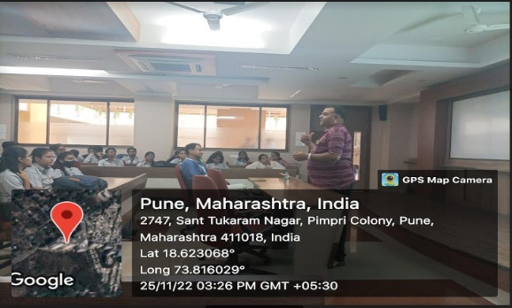 | 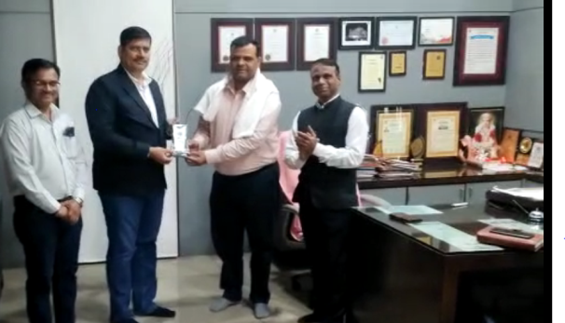
Mr. N P Mawale Worked as Resource Person for Session on IE(I),D Y Patil, Pimpri | Mr. N P Mawale Worked as Resource Person for Guest Lecture on “VLSI and Embedded System” ”Pratibha College of Commerce & Computer Studies
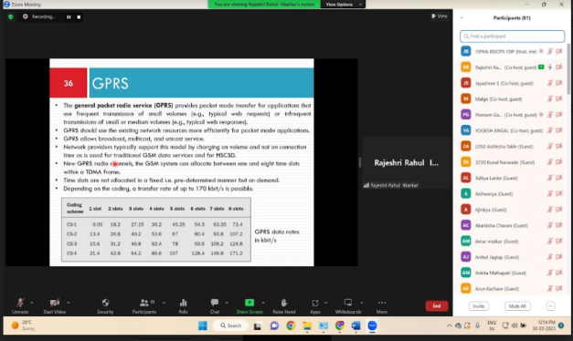  Dr. R R Itkarkar Worked as Resource Person for Guest Lecture on in Faculty Orientation Workshop on Recent Trends in Mobile Computing with real time Approach | 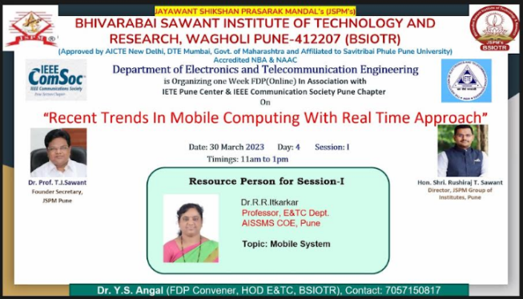  Dr. R R Itkarkar Worked as Resource Person for Guest Lecture on in Faculty Orientation Workshop on Recent Trends in Mobile Computing with real time Approach

3. ACTIVITIES ORGANIZED

3.1 FDP/STTP ORGANIZED BY THE DEPARTMENT
Term One
S N | Name of faculty coordinator | Title of the FDP/STTP/WS/Seminar/Symposium | Duration/ Dates | No. of Participants | Funding Agency  (If any) and Amount (Rs.)
 | No Data

Term Two
S N | Name of faculty coordinator | Title of the FDP/STTP/WS/Seminar/Symposium | Duration/ Dates | No. of Participants | Funding Agency  (If any) and Amount (Rs.)
1 | Dr. S B Dhonde  Mr. S B Dhekale  Mr.V B Gawai | One week FDP on “Recent Trends on Machine Learning” under the aegis of IETE Student Forum and Professional Activity Centre of IETE,New Delhi organized by Department of E&TC, AISSMS College of Engineering, Pune  Speaker: Dr. Swati Shinde (Dean R&D PCCOE,Pune)  Dr. Maneesh Kokare ( Professor, Dean of Academics SGGS Institute of Engineering and Technology)  Dr. S N Talbar (Professor, SGGS Institute of Engineering and Technology)  Dr. U B Chavan (Assistant Professor,Department of Information and Technology, Walchand College of Engineering, Sangli) | 13th  March 2023 to 17th March 2023 | 300+ | -

3.2 SEMINARS/ WORKSHOPS/ WEBINARS ORGANIZED BY THE DEPARTMENT
Term One
S N | Name of Coordinator/s | Title of the Seminar/Workshop/Webinar | Duration/ Dates |  | No. of Participants | Funding Agency  (If any) and Amount (Rs.)
1 | Mr. N P Mawale | Induction Program and Selection of Students for Avio-to-Virtue Club | 17/9/2022 |  | 50 | -
2 | Dr. P P Vast  Mrs. P P Tayade | Mini Project C  Competition for  TE (E&TC) Students | 05/05/2022 |  | 82  82 | AISSMSCOE  E&TC  Department,  ISTE Students Chapter
3 | Mr. V B Gawai | Induction Program for SE E&TC Students | 22/8/2022 |  | 45 | -
4 | Mrs. R R Itkarkar | Seminar on AVISHKAR Guidance  Speaker: Dr. Vidya Patil | 23/9/2022 |  | 45 | -
5 | Mr. S B Dhekale | Inauguration function of Professional Activity Center IETE.  Speaker: Prof. (Wg. Cdr) Pradeep Prabhakar. | 16/9/2022 |  | 150 | -
6 | Mr. N P Mawale | Institute Level AVISHKAR-2022 Competition (Poster Competition) | 15/9/2022 |  | 180 | ISTE Students Chapter  (Rs.6000/-)
7 | Dr.R R Itkarkar | Role of IEEE in Engineering Education in association with AISSMS COE Library by Gaurav Dat -Training Manager, EBSCO | 8/9/2022 |  | 152
8 | Dr. R R Itkarkar | IEEE Membership drive by  Mr. Piyush Chaudhari, Chairperson, AISSMSCOE, IEEE Student Branch(2021-22)  Mr. Devang Pingale  Co-SSR IEEE Pune Section, Social Media Coordinator IEEE India Council | 8/9/2022 |  | 152
9 | Dr. V V Deshmukh | ET-2022, SILICON FUSION | 18/10/2022,19/10/2022 and 20/10/2022
10 | Mrs. V S Navale | Expert Talk on “Electric Vehicle”  Speaker: Mr. Hemant Padhye, Pro Business Innovations (OPC), pvt. Ltd. | 9/11/2022 | 117
11 | Ms V D Nagrale | Expert lecture on Career guidance on Red Hat Linux  Speaker: Mrs. Bhagyashree Bhat  CEO,  Bhagyashree IT Solutions,Pune | 6/9/2022 | 40
12 | Mr. N P Mawale | Expert Talk on “ Getting to Know Software Industry Practices”  Speaker: Mrs. Priti Munshi,  Principle Global Services, Pune | 11/11/2022 | 70
13 | R R Itkarkar | Celebration of IEEE Day by E & TC Engineering department on 17th October 2022 | 17/10/2022 | 40 |  | AISSMS COE IEEE Student Branch

Term Two
S N | Name of Coordinator/s | Title of the Seminar/Webinar | Duration/ Dates | No. of Participants | Funding Agency  (If any) and Amount (Rs.)
1 | Mr.V B Gawai | Workshop on “Python Programming” | 1 month | 35
2 | Dr. R R Itkarkar | Career Guidance in Management  Speaker: Mr. Anuj Khanna - TIME, Deccan Pune | 17/4/2023 | 75
3 | Dr. R R Itkarka | How to Plan Startup(legal and ethical steps)  Speaker: Mr. Swacchand Gokhale- Partner at Gokhale Bhave Associates Pune | 18/4/2023 | 106
4 | Dr. R R Itkarkar | Career Guidance for How to Prepare for CAT Exam Vishal Nandargi, TIME Deccan Pune | 26/4/2023 | 110
5 | Dr. R R Itkarkar | Career Guidance for How to Prepare for GATE Exam Vangal Aditya Shrinivas, ACE Academy Pune | 24/04/2023 | 54
6 | Mr. N P Mawale | Study MS Abroad and Opportunities  Speaker: Ms. SaritaSinha, General Manager,IMF,Pune | 6/2/2023 | 150+
7 | Dr. K B Chaudhari  Mr. N P MAwale | “Digital Marketing”  Ms Spurti Sushil  Icfaian Business School, Pune | 14/2/2023
8 | Dr. R R Itkarkar | How to write Research Paper  Speaker: Dr. V V Deshmukh - AISSMS COE Pune | 15/2/2023 | 60
9 | Mr. N P Mawale | Technical Demonstration | 15.02.2023 | 78
10 | Mr. N P Mawale | Global Edufest-2023  Speaker from:IMFS, Pune | 08.02.2023 | 1000+
11 | Mr. N P Mawale | Online Training Program  Energy Literacy Training  Energy Swaraj Foundation, Mumbai  (Dr. Chetan Singh Solanki) | Jan 2023 to May 2023 | 4500+
12 | Mr. N P Mawale | Workshop on Fabrication of Climate Clock  Swaraj Foundation, Mumbai  (Dr. Chetan Singh Solanki) | 22.04.2023 | 100+
13 | Ms. V D Nagrale | Seminar on Career in red hat linux with certification  Mrs. Bhagyashree Bhat  CEO,  Bhagyashree IT Solutions,Pune | 25/4/2023
14 | Dr. S B Dhonde  Dr. R R Itkarkar | Faculty Orientation Workshop on Digital Business Management | 3 days  30/01/2023 - 01/02/2023 | 60+ | SPPU & AISSMS Society  Rs. 16000/-
15 | Dr. R R Itkarkar | Project Competition for BE E&TC students  Dr. A A Apte  Dr. L S Godse  Dr. D P Gaikwad | 1 day
16 | Mrs. V S Navale  Mr. N P Mawale | Project Based Learning Competiton for SEE&TC students under ISTE Stdent Chapter  Judges: Mr. M P Gajare  Mr. Itole  Dr. Shobha Nikam  Mrs. A A Randive  Mrs. S. Lohar  Mr. A Y Kazi | 1 day  12/5/2022 | 70
17 | Dr. P P Vast  Mrs. V S Navale | Mini-Project Competition for TE E&TC students  Judges: Mr. Gaurav Powar, Vice President, Digilence Tech, Pune  Mr. Harshal Bhavsar, Vice President, Digilence Tech, Pune  Mr. D Itole,  Mrs. A A Randive,  Mr. S Jagtap  Mr. S Kale  Dr. L S Godse  Mrs. V Tarange | 1 day  18/5/2023 | 78

3.3 CONFERENCES/ SYMPOSIUMS ORGANIZED BY THE DEPARTMENT
Term One
S N | Name of Coordinator/s | Title of the Conference / Symposium | Duration/ Dates | No. of Participants | Funding Agency  (If any) and Amount (Rs.)
 | No Data

Term Two
S N | Name of Coordinator/s | Title of the Conference / Symposium | Duration/ Dates | No. of Participants | Funding Agency  (If any) and Amount (Rs.)
1 | Mr. N P Mawale | International Conference on Green Energy (ICOGE-2023) | 02 Days  (16-17 May-2023 | 100+ | IMFS, Pune  (1.20 Lakhs)  IEI, Kolkata  (25000/-)
2 | Dr. R R Itkarkar | National Conference on Innovation in Engineering Technology - 2023 | 31st May 2023 | 100+

3.4 EXTENSION ACTIVITIES CONDUCTED BY THE DEPARTMENT (Social activities / Quizzes at national/international level/any other activity)
Term One
S N | Name of Faculty Coordinator | Details of activity conducted | Date | Number of beneficiaries
1 | R R Itkarkar  Mr. N P Mawale | Social Visit to Balkalyan Sanstha, Pune | 29/7/2022 | 50+

Term Two
S N | Name of Faculty Coordinator | Details of activity conducted | Date | Number of beneficiaries
 | No Data

3.5 MOU SIGNED WITH ACADEMIC AND PROFESSIONAL ORGANISATIONS
Term One
Sr. No. | Faculty Coordinator | Name of Organisation | Date  of MoU Signed | Valid upto  00/00/0000
1 | No Data

Term Two
Sr. No. | Faculty Coordinator | Name of Organisation | Date  of MoU Signed | Valid upto  00/00/0000
1 | Ms V D Nagrale  Dr K B Chaudhari  Ms V V Deshmukh | NEXUS infosec Texas USA | 08/02/2023 | 07/02/2027

Total Functional / Live MoU initiated by Department
Sr. No. | Faculty Coordinator | Name of Organisation | Date  of MoU Signed | Valid upto  00/00/0000
1 | Dr.D.G.Bhalke | Firenest Reality Pvt Ltd | 2021-22 | 2027
2 | Ms.P.P.Tayade | Startech Enginneers, Mumbai | 2021-22 | 2025
3 | Ms.S.A.Takalkar | Automate Engineering | 2021-22 | 2023
4 | Mr.V.B.Gawai | Elon Power | 2021-22 | 2027
5 | Dr.P.P.Vast | PMP Automation Pvt Ltd | 2021-22 | 2025
6 | Ms.P.P.Tayade | CMS Digital Automation Pune | 2021-22 | 2025
7 | Mr.S.B.Dhekale | Wish Energy | 2021-22 | 2025
8 | Mr.N.P.Mawale | Softcon Pvt Ltd | 2021-22 | 2027
9 | Mr.V.B.Gawai | MICROCON Power Electronics Pune | 2021-22 | 2025
10 | Dr.K.B.Chaudhari | IndEyes Infotech Pvt | 2019-20 | 2025
11. | Dr V V Deshmukh | Sunshine Powertronics. Pune | 2021-22 | 2026
12 | Ms V D Nagrale  Dr K B Chaudhari  Ms V V Deshmukh | NEXUS infosec Texas USA | 2022-23 | 2027

3.6 STUDENTS’ CHAPTERS /CLUBS
Sr. No | Name of Students’ Chapter | Number of Student Members
1 | Daexus Data Science Club | 35
2 | IETE Students Forum | 47
3 | The Institution of Engineers (India), Students’ Chapter | 121
4 | IEEE Student Branch | 35
5 | ISTE Student Branch | 52
6 | Electronics for You Skill Center | 30
7 | Drone and Robo Club | 40
EVENTS ORGANISED (By Students’ Chapters / Clubs and others)
Name of Students’ Chapter: Institution of Engineers (India), Students’ Chapter ____
Faculty Advisor: Mr. N P Mawale

Term One
SN | Event name and details of event | Name of chief guest, judges etc. | Duration and Dates | Number of beneficiaries
1 | 11.11.2022 | Expert Talk on “ Getting to Know Software Industry Practices” | Mrs. Priti Munshi,  Principle Global Services, Pune | 70
2 | 15.09.2022 | Institute Level AVISHKAR-2022 Poster Competition | – | 105

Term Two
SN | Event name and details of event | Name of chief guest, judges etc. | Duration and Dates | Number of beneficiaries
1 | Technical Demonstration | – | 15.02.2023 | 78
2 | Seminar on How to Write Research Paper | – | 15.02.2023 | 78
3 | Globle Edufest-2023 | IMFS, Pune | 08.02.2023 | 1000+
4 | Seminar on Digital Marketing | IBS, Pune | 14.02.2023 | 100+
5 | Online Training Program  Energy Literacy Training | Energy Swaraj Foundation, Mumbai  (Dr. Chetan Singh Solanki) |  | 4500+
6 | Workshop on Fabrication of Climate Clock | Energy Swaraj Foundation, Mumbai  (Dr. Chetan Singh Solanki) | 22.04.2023 | 100+

Name of Students’ Chapter: __ IETE
Faculty Advisor: Mr. S B Dhekale

Term One
SN | Event name and details of event | Name of chief guest, judges etc. | Duration and Dates | Number of beneficiaries
1 | nauguration function of Professional Activity Center IETE. | Speaker: Prof. (Wg. Cdr) Pradeep Prabhakar. | 1 Day | 160+

Term Two
SN | Event name and details of event | Name of chief guest, judges etc. | Duration and Dates | Number of beneficiaries
1 | FDP on Recent Trends in ML | Dr. Manesh B Kokare  Dr. U B Chavan | One Week | 150+

Name of Students’ Chapter: __ ISTE
Faculty Advisor: Mrs. V S Navale

Term One
SN | Event name and details of event | Name of chief guest, judges etc. | Duration and Dates | Number of beneficiaries
1 | Expert Talk on “Electric Vehicle” | Faculty Coordinator: Mrs. V S Navale  Speaker: Mr. Hemant Padhye  Director Programs and Technology (Automotive),  Pro Business Innovations (OPC) Pvt. Ltd. | 9/11/2022  2 hours | 117

Term Two
SN | Event name and details of event | Name of chief guest, judges etc. | Duration and Dates | Number of beneficiaries
1 | Project Based Learning Competition  Mrs. V S Navale  Mr. N P Mawale | Project Based Learning Competiton for SEE&TC students under ISTE Stdent Chapter  Judges: Mr. M P Gajare  Mr. Itole  Dr. Shobha Nikam  Mrs. A A Randive  Mrs. S. Lohar  Mr. A Y Kazi | 1 day  12/5/2022 | 70
2 | Mini-Project Competition  Dr. P P Vast  Mrs. V S Navale | Mini-Project Competition for TE E&TC students  Judges: Mr. Gaurav Powar, Vice President, Digilence Tech, Pune  Mr. Harshal Bhavsar, Vice President, Digilence Tech, Pune  Mr. D Itole,  Mrs. A A Randive,  Mr. S Jagtap  Mr. S Kale  Dr. L S Godse  Mrs. V Tarange | 1 day  18/5/2023 | 78

Name of Students’ Chapter: __ IEEE
Faculty Advisor: Dr. R R Itkarkar
Term One
SN | Event name and details of event | Name of chief guest, judges etc. | Duration and Dates | Number of beneficiaries
1 | Role of IEEE in Engineering Education in association with AISSMS COE Library | Gaurav Dat -Training Manager, EBSCO | 8/9/2022 | 152
2 | IEEE Membership drive by | Mr. Piyush Chaudhari, Chairperson, AISSMSCOE, IEEE Student Branch(2021-22)  Mr. Devang Pingale  Co-SSR IEEE Pune Section, Social Media Coordinator IEEE India Council | 8/9/2022 | 152
3 | Industrial Visit to Dankeltech Pune | Dankeltech Pune | 07/11/2022 | 85
4 | Social Visit to Balkalyan Pune | Balkalyan Pune | 29/07/2022 | 100
5 | IEEE day Celebration |  | 17/10/2022 | 50

Term Two
SN | Event name and details of event | Name of chief guest, judges etc. | Duration and Dates | Number of beneficiaries
1 | Career Opportunities in Electronics and Telecommunication | S Manimohan Trinath ACE Academy Pune | 24/01/2023 | 55
2 | How to write Research Paper  Speaker | : Dr. V V Deshmukh - AISSMS COE Pune | 15/2/2023 | 60
3 | How to prepare for placement on | Piyush Chaudhari - Technical, HR interview and GD.  ·Vignesh Iyer - Aptitude preparation and coding rounds.  ·Deepali Dalvi - Core company interview cracking.  Vedant Dere - Coding, Profile building and showcasing on GitHub | 14/03/2023 | 60
4 | Career Guidance in Management | Speaker: Mr. Anuj Khanna - TIME, Deccan Pune | 17/4/2023 | 75
5 | How to Plan Startup(legal and ethical steps) | Speaker: Mr. Swacchand Gokhale- Partner at Gokhale Bhave Associates Pune | 18/4/2023 | 106
6 | Career Guidance for How to Prepare for CAT Exam | Vishal Nandargi, TIME Deccan Pune | 26/4/2023 | 110
7 | Career Guidance for How to Prepare for GATE Exam | Vangal Aditya Shrinivas, ACE Academy Pune | 24/04/2023 | 54

3.7 SOCIAL ACTIVITIES ORGANISED (NSS, Women empowerment, Awareness Programs, etc.)
Term One
Faculty coordinator | Name of Activity | Date, Duration | Number of students involved
R R Itkarkar  Mr. N P Mawale | Social Visit to Balkalyan Sanstha, Pune | 29th July 2022 | 50+

Term Two
Faculty coordinator | Name of Activity | Date, Duration | Number of students involved
Dr. N N Shejwal (Coordinator)  Mr. S B Dhekale ( for 2 days)  Mrs. V S Navale ( for 2 days)  Mrs. P P Tayade ( for 2 days) | NSS Camp at Kalyan Village | 6/2/2023 to 12/2/2023 | 09

3.8 PARENT MEETING
Faculty Coordinator | Day and Date | Details of Parent meetings organized | Number of Parents attended
Dr. V V Deshmukh | 20/5/2023,Saturday | SE,TE and BE Students parent meeting | 20

3.9 ALUMNI MEET
Faculty Coordinator | Day and Date | Details of Alumni meetings organized | Number of Alumni attended
Ms. V D Nagrale | Saturday 25/02/2023 | Organized at College Level | 32

3.10 SUPPORT FROM ALUMNI
Term One
Sr No | Name of Alumni | Position and Organisation | Batch | Details of Support | Date
1 | Mrs Bhagyashree Bhat | Owner at Bhagyashree IT solutions | 1992-1996 | Conducted webinar lecture on Career in red hat linux with certification | 6/9/2022

Term Two
Sr No | Name of Alumni | Position and Organisation | Batch  (e.g. 2014 – 2018) | Details of Support | Date
1 | Mrs Bhagyashree Bhat | Owner at Bhagyashree IT solutions | 1992-1996 | Conducted lecture on Career in red hat linux with certification | 25/4/2023

3.11 INTERACTION WITH ALUMNI
Term One
S N | Name of Alumni and Activity coordinator | Details of Activity conducted | Date and duration | Total Number of beneficiaries
 | No Data

Term Two
S N | Name of Alumni and Activity coordinator | Details of Activity conducted | Date and duration | Total Number of beneficiaries
1 | Mr Sagar Sadigale  Dr V V Deshmukh | DAB Meeting | 03/04/2023 | Staff

3.12 DETAILS OF STUDENT COUNSELING AND CAREER GUIDANCE AT THE DEPARTMENT LEVEL
Number of students referred for counseling | Nil
Number of Faculty referred for counseling | Nil

Faculty coordinator | CAREER GUIDANCE ACTIVITY DETAILS
Mr. N P Mawale | Expert Talk on “ Getting to Know Software Industry Practices”  Speaker: Mrs. Priti Munshi,Principle Global Services, Pune  Participants: 70
Mr. N P Mawale | Global Edufest,  IMFS, Pune, 8/2/2023  Participants:1000+
Dr. R R Itkarkar | Career Opportunities in Electronics and Telecommunication  S Manimohan Trinath ACE Academy Pune, 24/1/2023  Participants:55
Dr. R R Itkarkar | Career Guidance in Management  Speaker: Mr. Anuj Khanna - TIME, Deccan Pune,17/4/2023  Participants:75
Dr. R R Itkarkar | How to Plan Startup(legal and ethical steps)  Speaker: Mr. Swacchand Gokhale- Partner at Gokhale Bhave Associates Pune, 18/4/2023  Participants:106
Dr. R R Itkarkar | Career Guidance for How to Prepare for CAT Exam  Speaker: Vishal Nandargi, TIME Deccan Pune, 26/4/2023  Participants:110
Dr. R R Itkarkar | Career Guidance for How to Prepare for GATE Exam  Speaker:Vangal Aditya Shrinivas, ACE Academy Pune,24/4/2023  Participants: 54

Photographs related to different activities organized
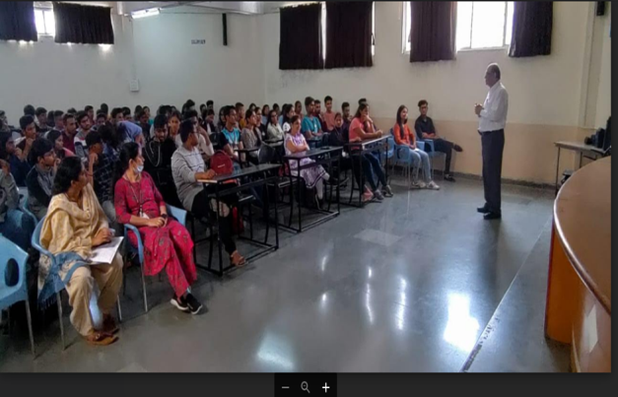  Expert talk by Mr. Hemant Padhye on “Electric Vehicle”on 9/11/2022 | 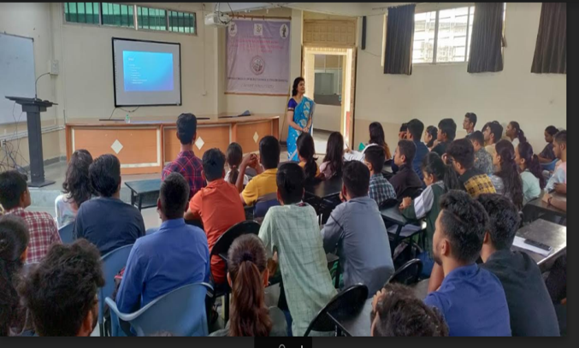  Expert Talk on “Getting to Know Software Industry Practices”
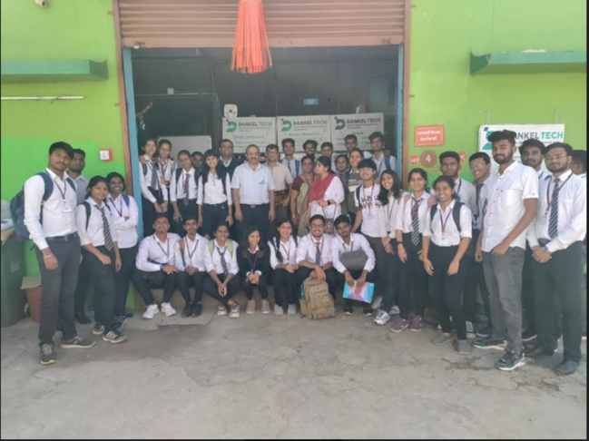  Industry visit of TE(E&TC) and IEEE student branch students to Dankel Tech Pvt. Ltd.,Pune | 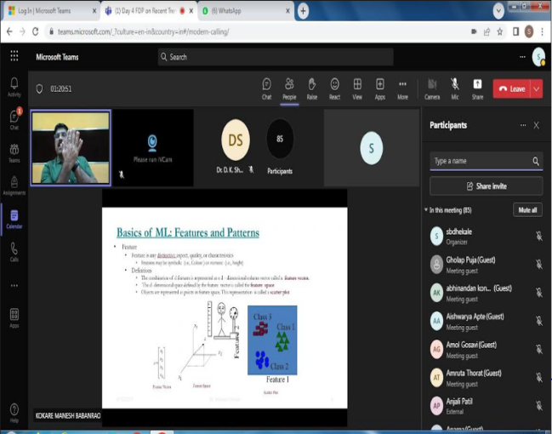  FDP on Recent Trends in MACHINE LEARNING
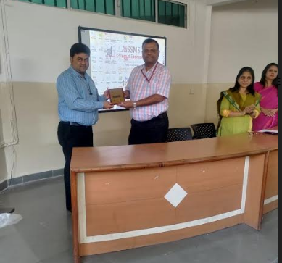  Felicitation of Expert Talk on Digital Marketing | 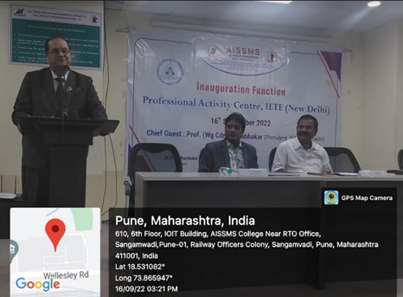  Inauguration of IETE Student Forum

- RESEARCH CONTRIBUTION

4.1 FUNDED RESEARCH PROJECT
Term One
S N | Principal Investigator | Title of the Project | Amount Received (Rs) | Funding Agency
1 | Dr. S B Dhonde | MODROB | 14,74,730/- | AICTE & Netalla Innovation Pvt. Ltd.

Term Two
S N | Principal Investigator | Title of the Project | Amount Received (Rs) | Funding Agency
1 | No Data
2

FUNDING RECEIVED FOR ANY OTHER ACTIVITY
Term One
S N | Faculty Coordinator | Title of the activity | Amount Received (Rs) | Funding Agency
1 | No Data
2

Term Two
S N | Faculty Coordinator | Title of the activity | Amount Received (Rs) | Funding Agency
1 | No Data

4.2 TESTING AND CONSULTANCY
Term One
Sr. No. | Faculty Coordinator | Details of Testing & Consultancy Conducted | Total Revenue Generated (Rs.)
1 | Mr. S B Dhekale | Structural Audit, Wish Energy Ltd. Pune | 15000/-

Term Two
Sr. No. | Faculty Coordinator | Details of Testing & Consultancy Conducted | Total Revenue Generated (Rs.)
 | No Data

4.3 PATENTS, COPYRIGHT, TRADEMARK AND OTHER (IPR)
Term One
Sr No. | Name of Faculty | Name of the Patent | Patent Number and Date | Type (National/  International/Com  mercialized)
1 | Dr. R R Itkarkar | Development of a Screening tool for Sleep Apnea for experts in clinical setups: setups | 2021103840 & 14/04/2022 | International (Australian)  Patent Granted

Term Two
Sr No. | Name of Faculty | Name of the Patent | Patent Number and Date | Type (National/  International/  Commercialized)
1 | Mr.V.B.Gawai | Design Patent e “IOT BASED SOLAR POWERED AGRICULTURE ROBOT” | 381449-001 14/3/2023 | National

PUBLICATIONS
4.4 PAPERS PUBLISHED/ PRESENTED IN PROCEEDINGS OF CONFERENCES
Term Two
S. No | Authors | Document Details | Year | Conference Details | ISBN | Organized  by
1 | Dr. S B Dhonde  Sapna Chaudhary | Underwatercommunication using li-fitechnology | 2023 | National Conference on Innovation in Engineering and Technology |  | AISSMSCOE
2 | V. D.Nagrale[1], Ms,Janhavi Dabhade[2],Ms. Shruti Gadhave[3], Ms. Saumya[4] | Digital SignageMobile Van | 2023 | National Conference on Innovation in Engineering and Technology |  | AISSMSCOE
3 | Y. P. Lad,Rutuja Raut,Minal Pandey,Sanika Wadake,Himalay Khachane | Multi-Banking AtmSystem ServicesUsing Biometrics. | 2023 | National Conference on Innovation in Engineering and Technology |  | AISSMSCOE
4 | Deepali R Dalvi1, PrachiKshirsagar2,Satyam Walekar3, DrR. R. Itkarkar4 | Autonomous Medical AssistiveRobot | 2023 | National Conference on Innovation in Engineering and Technology |  | AISSMSCOE
5 | Vijay Amble,Vignesh Iyer,Amol Rathod, Mayuri Desai and KirtimaliniChaudh | Custom object distance & size analysisusing computervision | 2023 | National Conference on Innovation in Engineering and Technology |  | AISSMSCOE
6 | Dr. S B. Dhonde,Shweta S. Jagdale, Sumedha S. Chaudhari,Tanvi P. Gavhane | Elevator control using voice command | 2023 | National Conference on Innovation in Engineering and Technology |  | AISSMSCOE
7 | Yogita Lad, Samruddhi Jadhav, Prathamesh Vishwas, DiyaVora | IoT basedsanitary napkin vendingmachine (SNVM) | 2023 | National Conference on Innovation in Engineering and Technology |  | AISSMSCOE
8 | Mr. Vipin Gawai,Mr. PiyushChaudhari, neeraj mahajan, Nikita Patil | Crop Monitoringand Analysis Robotusing IoT | 2023 | National Conference on Innovation in Engineering and Technology |  | AISSMSCOE
9 | Shivam Kalane,GaneshKadam , AdityaKumkar,NitinMawale | Smart CylinderTrolley for Homesafety | 2023 | National Conference on Innovation in Engineering and Technology |  | AISSMSCOE
10 | Dr. P.P.Vast1 , Siddhi Nasare2 , IshikaChankeshwara3 , Harsh Shah4 | Design andDevelopment OfMicrostrip AntennaFor Non-InvasiveGlucose Testing | 2023 | National Conference on Innovation in Engineering and Technology |  | AISSMSCOE
11 | Vaishnavi Navale, AmanSagar, Arjun Singh, Shreyash Parkhe | Text-To-Image AI Model Using DeepLearning | 2023 | National Conference on Innovation in Engineering and Technology |  | AISSMSCOE
12 | Kirtimalini Chaudhari,Diksha Khade,Abhishek  Khande, RamPatil | Smart and integrated homeautomation system using javascript | 2023 | National Conference on Innovation in Engineering and Technology |  | AISSMSCOE
13 | Vidya Deshmukh, Kiran SunilZure Akshay Gautam Jadhav Pravin KailasKunte Nisha Balwant Nelge | Smart Chef: Automated Cooking System withRobotic Arm | 2023 | National Conference on Innovation in Engineering and Technology |  | AISSMSCOE
14 | Dr. PrachiPrashant Vast | IOT Based System to Avoid Wastageof Fruits | 2023 | National Conference on Innovation in Engineering and Technology |  | AISSMSCOE
15 | VidyaDeshmukh Ayush ShettyGaurav Singh,Rajesh Parale | Breaking Language Barriers: Transformer Based Sentence Translation | 2023 | National Conference on Innovation in Engineering and Technology |  | AISSMSCOE

4.5 PAPERS PUBLISHED IN JOURNALS
Term One
S. No | Authors | Document Details | Year | Source Details | ISBN/  ISSN | Publisher
1 | Dr. S B Dhonde | Rapid Manufacturing Ventilator | 2022 | https://www.proquest.com/openview/d9fb7c19f8dc17c441133f44485b491f/1?pq-origsite=gscholar&cbl=5314840 | 25813048 | IRJIET
2 | Dr. Prachi Vast | Network  Security in  Cloud and Big  Data Computing  using AI | 2022-23 | Scopus | 1006-5911 | Computer  Integrated  Manufacturing Systems
3 | Dr. Prachi Vast | Observation of  an Uncertainty  Estimation in  Deep Learning | 2022-23 | Scopus | 1303-5150 | Neuro Quantology
4 | Dr. Prachi Vast | SMART MINING SAFETY SYSTEM | 2022-23 | UGC | 0975-1386 | Wesleyan Journal of Research
5 | Dr. Prachi Vast | POTHOLE DETECTION USING IMAGE PROCESSING | 2022-23 | UGC | 0975-1386 | Wesleyan Journal of Research
6 | Mr.V.B.Gawai | Survey Paper on Extraction of 3D image Data for Detecting Chest Diseases | 2022-23 | Scopus | ISSN:1005-0086 | JOURNAL OF OPTOELECTRONICS LASER
7 | Mr.V.B.Gawai | Evaluation of Success Factors in Professional Business Incubation | 2022-23 | Scopus | ISSN: 1005-0086 | JOURNAL OF OPTOELECTRONICS LASER
8 | R R Itkarkar | Early Diagnosis of Obstructive Airway Disease Using EMG Technique | 2022 | UGC | Print ISSN : 2229-7111 Online ISSN : 2454-5767 | SAMRIDDHI Volume 14, Special Issue 3, 2022  SAMRIDDHI : A Journal of Physical Sciences, Engineering and Technology

Term Two
S. No | Authors | Document Details | Year | Source Details | ISBN/  ISSN | Publisher
1 | R R Itkarkar | DETECTION AND DIAGNOSIS OF COVID-19 USING PNEUMONIA | 2022 | UGC | Print ISSN : 2229-7111 Online ISSN : 2454-5767 | SAMRIDDHI Volume 14, Special Issue 3, 2022  SAMRIDDHI : A Journal of Physical Sciences, Engineering and Technology

4.6 BOOK / ARTICLE PUBLICATIONS
Term One
Author | Title of the Book | Published by | ISBN | Year
Dr. S B Dhonde | Digital Circuits | Technical Publications | 978-93-332-2152-8 | 2022

Term Two
Author | Title of the Book | Published by | ISBN | Year
 | No Data

4.7 RESEARCH CITATIONS (Source of Data: Google scholar) (As on 30th May)
Name of faculty | Citations, h-index, i10 index | Name of faculty | Citations, h-index, i10 index
Dr. S B Dhonde | Citations : 157  h index: 7  i10 index: 6
Dr V V Deshmukh | Citations : 123  h index: 9  i10 index:7 | Dr R R Itkarkar | Citations : 68  h index: 5  i10 index:3
Ms V D Nagrale | Citations : 13  h index: 2  i10 index:0 | Ms P P Tayade | Citations : 69  h index: 2  i10 index:0
Mr.V.B.Gawai | Citations : 5  h index: 1  i10 index:0 | Ms S A Takalkar | Citations : 22  h index: 3  i10 index:0
Total Citations of Department:457

4.8 ME AWARDED
Sr No | Name of Supervisor | Title of Thesis | Name of Candidate
 | No Data

4.9 PhD GUIDE DETAILS
Name of Faculty who are PhD Supervisor | Number of Scholars Registered
Dr. S B Dhonde | 4
4.10 PhD AWARDED (For departments having Ph.D research centers)

Sr No | Name of Supervisor | Title of Thesis | Name of Candidate
 | No Data

- INTERACTION WITH INDUSTRY

5.1 INDUSTRY VISITS ORGANISED
Term One
Sr. No. | Faculty Coordinator | Class and Number of students attended | Industry Name and Address | Date of visit
1 | Dr. R R Itkarkar | TE(E&TC)  86 | DankelTech.,Pune | 7/11/2022

Term Two
Sr. No. | Faculty Coordinator | Class and Number of students attended | Industry Name and Address | Date of visit
1 | Mr. S B Dhekale  Mr. N P Mawale  Mrs. Y P Lad | TE & BE E&TC  (50) | GMRT, Khodad  (Narayangaon) | 27.01.2023

5.2 EXPERT LECTURES / WEBINARS DELIVERED BY INDUSTRY EXPERTS
Term One
Sr. No. | Faculty Coordinator | Class  (Number of students attended) | Name, Industry, designation and contact details of Expert | Topic | Date
1 | Dr. S B Dhonde | BE E&TC | Namita Pachaling  Vishwadeep Enterprises, Bhosari, Pune | Identify project statement | 10/11/2022
2 | Mrs. V S Navale | SE and TE E&TC  Number of students attended:117 | Mr. Hemant Padhye  Pro Business Innovations | Expert Talk on “Electric Vehicle”  Participants:117 | 9/11/2022
3 | Ms V D Nagrale | TEE&TC  Number of students attended:40 | Mrs. Bhagyashree Bhatt  Bhagyashree IT Solutions CEO, partner of Red Hat Linux | xpert lecture on Career guidance on Red Hat Linux  Participants:40 | 6/9/2022
4 | Mr. N P Mawale | SE,TE and BE (E&TC)  Number of students attended:80 | Ms. Priti Munshi  Program Manager, Global Principal Services,Pune | Expert Talk on “ Getting to Know Software Industry Practices” | 11/11/2022

Term Two
Sr. No. | Faculty Coordinator | Class  (Number of students attended) | Name, Industry, designation and contact details of Expert | Topic | Date
1 | Dr K B Chaudhari  Mr. N P Mawale | BE E & TC Students: 51 | Ms Spurti Sushil  Icfaian Business School, Pune | Search Engine Optimization | 14/02/2023

5.3 INDUSTRY – SPONSORED PROJECTS (UG/PG) ((Excluding Sandwich Projects) (All Faculties)
Sr. No. | Name of Project guide | Title of Industry Sponsored Project | Name of Sponsoring Industry
1 | Mr.V.B.Gawai | Solar panel cleaning system | Atomic Enterprises Pune

5.4 MOU SIGNED WITH INDUSTRY
Term One
Sr. No. | Faculty Coordinator | Name of Industry | Date  of MoU Signed | Valid upto  (00/00/0000)
 | No Data

Term Two
Sr. No. | Faculty Coordinator | Name of Industry | Date  of MoU Signed | Valid upto  (00/00/0000)
1 | Ms. V D Nagrale | NEXUS infosec Texas USA | 08/02/2023 | 07/02/2027

TOTAL FUNCTIONAL / LIVE MOU INITIATED BY THE DEPARTMENT
Sr. No. | Faculty Coordinator | Name of Industry | Date  of MoU Signed | Valid upto  (00/00/0000)
1 | Dr.D.G.Bhalke | Firenest Reality Pvt Ltd | 2021-22 | 2027
2 | Ms.P.P.Tayade | Startech Enginneers, Mumbai | 2021-22 | 2025
3 | Ms.S.A.Takalkar | Automate Engineering | 2021-22 | 2023
4 | Mr.V.B.Gawai | Elon Power | 2021-22 | 2027
5 | Dr.P.P.Vast | PMP Automation Pvt Ltd | 2021-22 | 2025
6 | Ms.P.P.Tayade | CMS Digital Automation Pune | 2021-22 | 2025
7 | Mr.S.B.Dhekale | Wish Energy | 2021-22 | 2025
8 | Mr.N.P.Mawale | Softcon Pvt Ltd | 2021-22 | 2027
9 | Mr.V.B.Gawai | MICROCON Power Electronics Pune | 2021-22 | 2025
10 | Dr.K.B.Chaudhari | IndEyes Infotech Pvt | 2019-20 | 2025
11. | Dr V V Deshmukh | Sunshine Powertronics, Pune | 2021-22 | 2026
12 | Ms V D Nagrale  Dr K B Chaudhari  Ms V V Deshmukh | NEXUS infosec Texas USA | 2022-23 | 2027

5.5 FACULTY MEMBERS UNDERGONE INDUSTRIAL TRAINING
Term One
Sr. No. | Name of Faculty | Name of Industry | Dates and Duration
1 | Dr. S B Dhonde | J.J. Precision Ltd, Bhosari, Pune | 16th to 18th June 2022

Term Two
Sr. No. | Name of Faculty | Name of Industry | Dates and Duration

5.6 STUDENTS UNDERGONE IN-PLANT TRAINING AND (OR) INTERNSHIP PROGRAMME (Excluding Sandwich Training)
Term One
Sr. No. | Name of the Student | Name of the Industry | Class | Training duration
 |  |  |  | Start date | Last date | Duration (days)
1 | Vignesh Iyer | Suma Soft | BE | 1/7/22 | 3/10/22 | 48 days (Per day 5 hours)
2 | Vijay Amble | Suma Soft | BE | 1/7/22 | 3/10/22 | 48 days (Per day 5 hours)
3 | Neeraj Mahajan | Suma Soft | BE | 1/7/22 | 3/10/22 | 48 days (Per day 5 hours)
4 | Shruti Gadhave | Suma Soft | BE | 1/7/22 | 3/10/22 | 48 days (Per day 5 hours)
5 | Amol Rathode | Suma Soft | BE | 1/7/22 | 3/10/22 | 48 days (Per day 5 hours)
6 | Mayuri Desai | Suma Soft | BE | 1/7/22 | 3/10/22 | 48 days (Per day 5 hours)
7 | Saumya | DRDO (Robotics) | BE | 10/1/22 | 31/5/22 | 48 days (Per day 5 hours)
8 | Saumya | Knorr Bremse Technology Centre India |  | 11/7/22 | 3/1/23 | 48 days (Per day 5 hours)

Term Two
Sr. No. | Name of the Student | Name of the Industry | Class | Training duration
 |  |  |  | Start date | Last date | Duration (days)
1 | Atharv Hapse | Automate Engineering | TE | 14th December 2023 | 14th January 2023 | 1 month
2 | Priti Ankush Sagar | Twin tech Control System Pvt Ltd | TE | 6th December | 25th December
3 | Omkar Vitthal Tanpure | Automate Engineering | TE | 14th December 2022 | 14th January 2023 | 1 month
4 | Yogesh Vinod Devkate | OASIS Infobyte | TE | 1 February 2023 | 1 March 2023 | 1 Month
5 | Sakshi Surendra Shinde | Ekalipi Technology Pvt Ltd | TE | 5th December2022 and 21st January 2023 | 24th December 2022 and 10th Februar 2023 | App 1 month
6 | Vaishnavi Dalave | Elite Software | TE | 5th December 2022 | 3rd February 2023 | 2 month
7 | Pramila Gangaram Sherkhane | Elite Software | TE | 2nd January 2023 | 10th February 2023 | 1 month
8 | Anjali Manik Jagtap | Automate Engineering | TE | 14th December 2022 | 14th January 2023 | 1 month
9 | Omkar Godase | VCB Electronics Pvt Ltd | TE | 1st January 2023 | 16th February 2023 | App 1 month
10 | Pradnya Sarjerao Bhoskar | Automate Engineering | TE | 14th December 2022 | 14th January 2023 | 1 month
11 | Gaurav Santosh Londhe | OASIS Infobyte | TE | 1 February 2023 | 1 March 2023 | 1 Month
12 | Vedant Dhopate | Anveshk TEchnology and Knowledge Solution | TE | 2nd January 2023 | 10th February 2023 | 1 Month
13 | Hirave Akshay Dattatray | OASIS Infobyte | TE | 1 February 2023 | 1 March 2023 | 1 Month
14 | Yashraj Yuvaraj Shelar | OASIS Infobyte | TE | 1 February 2023 | 1 March 2023 | 1 Month
15 | Mohd Aqib | VOLTAS TATA Enterprise | TE | 12 December 2022 | 20 January 2023 | 1 Month
16 | Vedant Bandarkar | Automate Engineering | TE | 14th December 2022 | 14th January 2023 | 1 month
17 | More Deepraj Balasaheb | VCB Electronics Pvt Ltd | TE | 1st January 2023 | 16th February 2023 | App 1 month
18 | Praveen choudhary | CSM Digital Technology | TE | 2nd December 2022 | 30th December 2023 | App 1 month
19 | Maithili Gujar | Automate Engineering | TE | 14th December 2022 | 14th January 2023 | 1 month
20 | Virakshi Birajdar | CODE RED Softwares | TE | 3rd December 2022 | 10th January 2023 | 1 Month
21 | Nupur Chandane | Suven Consultant Technology and Pvt Ltd | TE | 10th December 2022 | 31st January 2023 | 1.5 month
22 | Priti Tukaram Kadam | Avant Garde | TE | 6th December 2022 | 7th February 2023 | 2 month
23 | Devang Kishor Angre | Suven Consultant Technology and Pvt Ltd | TE | 10th December 2022 | 31st January 2023 | 1.5 month
24 | Vishwaja Manish Kadu | Elite Software | TE | 2nd January 2023 | 10th February 2023 | 1 month
25 | Ruthvik Kamble | Automate Engineering | TE | 14th December 2022 | 14th January 2023 | 1 month
26 | Shubham Ganesh Bodhe | Suven Consultant Technology and Pvt Ltd | TE | 10th December 2022 | 31st January 2023 | 1.5 month
27 | Atharva Vyawahare | Suviraj Services Pvt Ltd | TE | Not Mentioned | Not Mentioned | 1 month
28 | Siddhant Suresh Chougale | Suviraj Services Pvt Ltd | TE | Not Mentioned | Not Mentioned | 1 month
29 | Desai Pranav Sanjay | Suven Consultant Technology and Pvt Ltd | TE | 10th December 2022 | 31st January 2023 | 1.5 month
30 | abhay pawar | Suven Consultant Technology and Pvt Ltd | TE | 10th December 2022 | 31st January 2023 | 1.5 month
31 | Yash Ravangave | Sunshine Power electronics Pvt Ltd | TE | Not Mentioned | Not Mentioned | 1 month
32 | Aditya Gujar | Wish | TE | 5th December 2022 | 3rd February 2023 | 2 month
33 | Priyanka Shahaji Redekar | Twintech Control System Pvt Ltd | TE | 6th December 2022 | 25th December 2022 | 1 month
34 | Soham Borawake | YBI Foundation | TE | 16 January 2023 | 14th February 2023 | 1 month
36 | Ketaki Subhash Nanaware | Cyber Alert Solution Pvt Ltd | TE | 20th January 2023 | 21 February 2023 | 1 month
37 | Shivam Rajendra Zinjurde | Suven Consultant Technology and Pvt Ltd | TE | 10th December 2022 | 31st January 2023 | 1.5 month
38 | Rishi Gandhi | Wish | TE | 5th December 2022 | 3rd February 2023 | 2 month
39 | Krishna Balaji Mare | Sunshine Power electronics Pvt Ltd | TE | Not Mentioned | Not Mentioned | 1 month
40 | Atharva Shelke | Sunshine Power electronics Pvt Ltd | TE | Not Mentioned | Not Mentioned | 1 month
42 | Anish Sanjay Jadhav | OASIS Infobyte | TE | 1 February 2023 | 1 March 2023 | 1 Month
43 | Vishweshwar Subhash Patil | Elite Software | TE | 2nd January 2023 | 10th February 2023 | 1 month
44 | Niraj Sunil Patil | Elite Software | TE | 2nd January 2023 | 10th February 2023 | 1 month
45 | Anvekar Atul Rameshwar | Atomic Industries | TE | 12th December 2022 | 4 February 2023 | 1.5 month
46 | Niranjan Nivrutti Devale | Saimhalkar Electra | TE | 5th December 2022 | 25 January 2023 | 1 month
47 | Prathamesh Yogesh Shahapure | Smit Solutions | TE | 24th January 2023 | 24th February 2023 | 1 month
48 | SURAJ SANAJY METE | Brainovision | TE | 20 February 2023 | 23 March 2023 | 1 Month
49 | Shristi Singh | Elite Software | TE | 2nd January 2023 | 10th February 2023 | 1 month
50 | SUDHANSH DONGARE | Brainovision | TE | 20 February 2023 | 23 March 2023 | 1 Month
51 | Sonar jotsna pramod | Suven Consultant Technology and Pvt Ltd | TE | 10th December 2022 | 31st January 2023 | 1.5 month
52 | More Dhiraj Shashikant | Smit Solutions | TE | 24th January 2023 | 24th February 2023 | 1 month
53 | Aniruddha Raghwendra Goswami | AP Software Solution | TE | 25 December 2022 | 25 January 2023 | 1 Month
54 | Janhvi Shendre | BITS | TE | 2nd January 2023 | 17 February 2023 | 1 month
55 | Aditya Satyawan Pawar | Ekalipi Technology Pvt Ltd | TE | 5th December2022 and 21st January 2023 | 24th December 2022 and 10th Februar 2023 | App 1 month
56 | Manali Gopal Jadhav | OASIS Infobyte | TE | 1 February 2023 | 1 March 2023 | 1 Month
57 | Aniket Daddi | Board Gravity Industries Pvt Ltd | TE | 22 December 2022 | 21 January 2023 | 1 Month
58 | Abhishek Walke | Brainovision | TE | 20 February 2023 | 23 March 2023 | 1 Month
59 | siddhesh vishwasrao badgujar | Lets Grow More | TE | 1 January 2023 | 1 February 2023 | 1 month
60 | ATHARVA KADAM | Automate Engineering | TE | 14th December 2022 | 14th January 2023 | 1 month
61 | Aishwarya Sanjay Shinde | S R Engineering | TE | 5th December 2022 | 3rd January 2023 | 1 month
62 | Saifoddin Kazi | Elite Software | TE | 2nd January 2023 | 10th February 2023 | 1 month
63 | Arnav Kawale | Hawkscode | TE | 24 January 2023 | 14 February 2023 | 1 Month
64 | Ajay Atkire | Suven Consultant Technology and Pvt Ltd | TE | 10th December 2022 | 31st January 2023 | 1.5 month
65 | Omkar Mahajan | Automate Engineering | TE | 14th December 2022 | 14th January 2023 | 1 month
66 | Tandale Nitin Annasaheb | Sunshine Power electronics Pvt Ltd | TE | Not Mentioned | Not Mentioned | 1 month
67 | Samruddhi Rupesh Shivarkar | Automate Engineering | TE | 14th December 2022 | 14th January 2023 | 1 month
68 | Mohit sanjay mane | Surya Electronics | TE | 2nd Jan 2023 | 18th February 2023 | 1 month
69 | Rajwee Wable | JIJA Enterprise | TE | 1 December 2022 | 7 January 2023 | 1 month

5.7 LIST OF INDUSTRIES SUPPORTED IN THE ORGANISATION OF WORKSHOPS/SEMINARS/WEBINARS/CONFERENCES/COURSES AND ANY OTHER CONTRIBUTION OF INDUSTRY
Term One
Sr.  No. | Faculty Coordinators | Industry Representative and Name of Industry | Nature of Contribution
1 | Mrs. V S Navale | Mr. Hemant Padhye  Pro-Business Consultant | Expert Talk  9/11/2022
2 | Mr. N P Mawale | Mrs. Priti Munshi  Program Manager  Global Services | Expert Talk  11/11/2022
3 | Ms. V D Nagrale | Bhagyashree IT Solutions CEO, partner of Red Hat Linux | Expert Talk  6/9/2022
Term Two
Sr.  No. | Faculty Coordinators | Industry Representative and Name of Industry | Nature of Contribution
 | No Data

5.8 TRAINING TO INDUSTRY PERSONNEL/ ACTIVITY SUPPORTING TO INDUSTRY
Term One
Sr. No. | Faculty Coordinator | Technical Area in which Training Provided / Type of Support | Industry Name
1 | Mr. N P Mawale | Energy Literacy Training (ELT) | Energy Swaraj Foundation, Mumbai

Term Two
Sr. No. | Faculty Coordinator | Technical Area in which Training Provided / Type of Support | Industry Name
1 | Mr. N P Mawale | Energy Literacy Training (ELT) | Energy Swaraj Foundation, Mumbai

5.9 ANY OTHER ACTIVITIES TO PROMOTE INTERACTION WITH INDUSTRY
Term One
Sr. No. | Faculty coordinator | Name of Activity | Remark
 | No Data

Term Two
Sr. No. | Faculty coordinator | Name of Activity | Remark
1 | Mr. N P Mawale | Global Edufest-2023  (08.02.2023) | IMFS, Pune  (50 + Foreign Universities Participated & 1000+ Participants)

5.10 STUDENTS UNDERGONE SANDWICH TRAINING (For Mechanical & Production department )
Term One
Sr No | Name of student | Industry | Sr No | Name of student | Industry
 | ----

Term Two
Sr No | Name of student | Industry | Sr No | Name of student | Industry
 | ----

Photographs related to different activities organized under Industry Institute Interaction
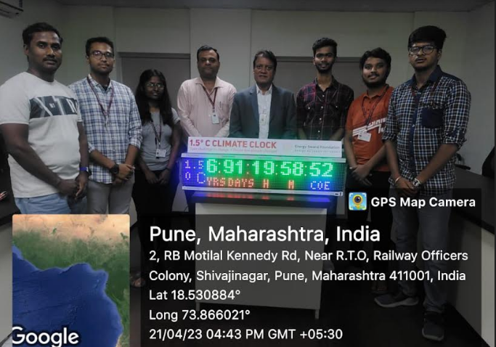 | 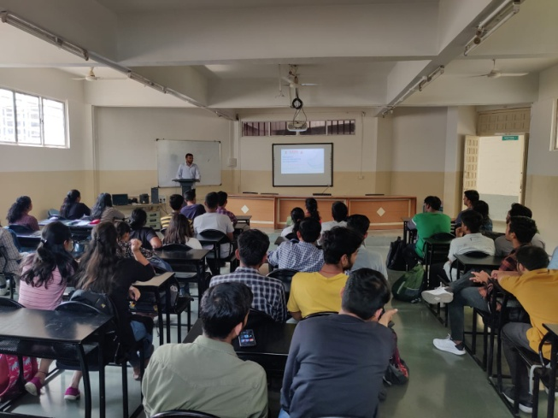
Winner of Digital Clock,Energy Literacy Training | How to prepare for Placement 14/03/2023 under IEEE
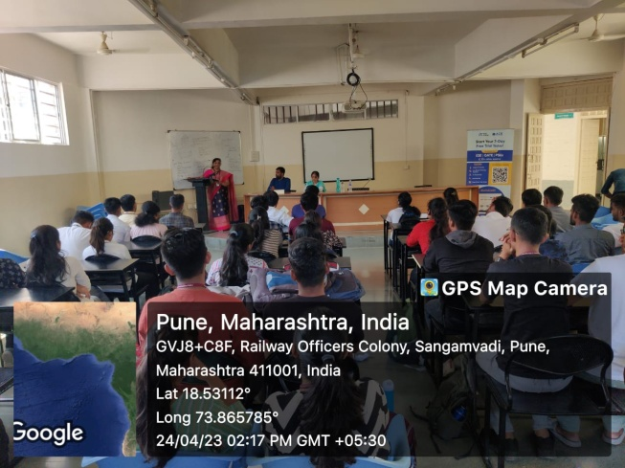 | 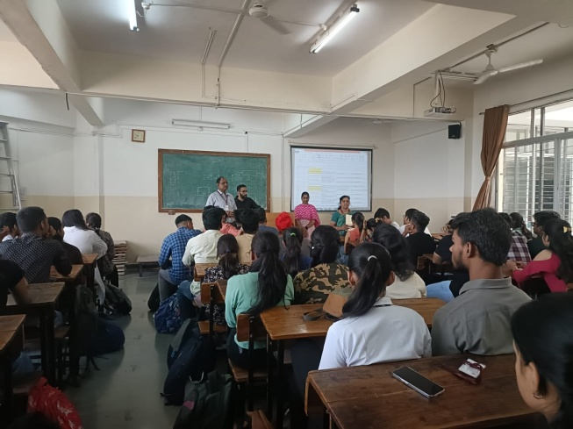
Seminar on “How to prepare for GATE” 24/04/2023 under IEEE | Seminar on How to Prepare for CAT 26/04/2023 under IEEE
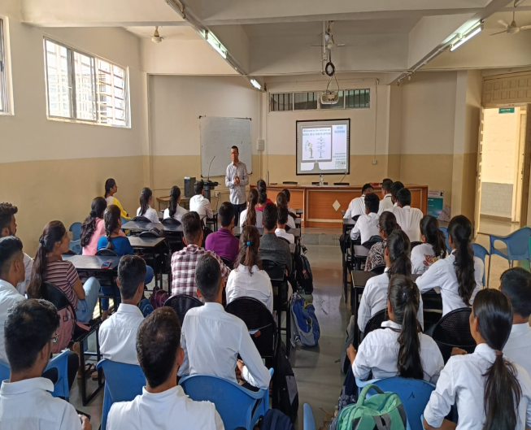
Career Guidance in Management 17/04/2023

- STUDENTS’ ACHIEVEMENTS

6.1 STUDENTS’ ACHIEVEMENT (Professional) (Individual Level) (Technical activities such as design competitions, paper presentation, technical quiz, Product development, innovation, etc.)
Term One
Name of Student | Details of Achievement (State/University/ National/International Level) | Remark  (Domain)
 | No Data

Term Two
Name of Student | Details of Achievement (State/University/ National/International Level) | Remark  (Domain)
Mr. Neeraj Mahjan | IEEE Pune Section’s Student Volunteer of the Year 2022 Award

6.2 STUDENTS’ ACHIEVEMENTS (other than Professional) (Individual Level) (Social activities, etc.)
Term One
Name of Student | Details of Achievement (State/University/ National/International Level) | Remark  ((Domain)
 | No Data

Term Two
Name of Student | Details of Achievement (State/University/ National/International Level) | Remark  ((Domain)
 | No Data

6.3 CERTIFICATE / ONLINE COURSES COMPLETED BY STUDENTS (Certificate courses, value added courses, MOOC, etc.)

Term One
S N | Name of Student | Title of the Course | Conducted By | Duration/ Dates
 | No Data

Term Two
S N | Name of Student | Title of the Course | Conducted By | Duration/ Dates
1 | SE, TE and BE E&TC Students | Energy Literacy Training Course  Total Students:193 | Energy Swaraj Foundation | From Jan 2023 to 2/5/2023

6.4 NUMBER OF STUDENTS PLACED
Term One
Sr No | Name of Organization visited | Number of students Participated | Number of students Placed
1 | TCS , Cognizant, TCL,Bristlecone,LTI | 78 | 17

Term Two
Sr No | Name of Organization visited | Number of students Participated | Number of students Placed
1 | Vodafone, Academor | 78 | 05

Lower Package Offered:
Higher package Offered:
Average Package Offered:
6.5 NUMBER OF STUDENTS QUALIFIED IN THE EXAMINATIONS (GATE, GRE, UPSC, MPSC, CAT, TOEFL, any other examination)
Sr. No. | Name of Student | Examination | Examination / registration number
 | No Data

6.6 SPORTS / CULTURAL ACHIEVEMENTS OF STUDENTS (Individual Level) (Team level achievements to be mentioned in institute level sports/Cultural committee report)
Term One
Name of Student | Details of Achievement (State/University/ National/International Level) | Remark  (Domain)
Ashutosh Waghavkar | Mr. Ashutosh Waghavkar won silver medal in the state level taekwondo championship held on 2nd Oct 2022 at Nashik | won silver medal
Sushil Dhanje | Finalist of India’s Top Model 2022 season 4.0 | Finalist
Ms. Shaista Mujawar | Selected for Parade as Presenter from SPPU at University and Sate level organized by University of Mumbai and Government of Maharashtra | Represented SPPU

Term Two
Name of Student | Details of Achievement (State/University/ National/International Level) | Remark  (Domain)
Devanshi Agarkar | Runner Up trophy in Table Tennis at G H Raisoni College 24/2/2023 | Runner Up
Devanshi Agarkar | Runner Up in Table Tennis at Ajeenkya, D Y Patil UniversityTech 2022-23 | Runner Up
Devanshi Agarkaar | Table Tennis winner in ICE event organised bySymbiosis college of Libersl Arts 2022-23’ 30/4/2023 | Winner

6.7 STUDENTS’ ACHIEVEMENTS (Team Level)
Term One
Name of Event | Name of Faculty Advisor | Details of Achievement (State/University/ National/International Level) | Remark  (Domain)
Technical Consultancy | Mrs. R R Itkarkar | Vijay Amble  Vighnesh Iyer  Piyush Chaudhari  Working with KONECRANES for consultancy Projects 19/9/2022. | Provided technical consultancy
Smart India Hackathon Competition | Dr. R R Itkarkar | Students: Deepali Dalvi, Neeraj Sable, Prachi Kshirsagar,Shirish Nandkar  Team AUDAX is a real product innovator. Team got special appreciation and sponsorship for product development.Project: Automatic Wheelchair Helping Handicapped Person  (Smart India Hackathon Competition) 28/8/2022. | Team got special appreciation and sponsorship for product development
Robo Soccer Competetion | Mr. N P Mawale | Avit-O-Virtue Robotics Club Won first Prize in Robo Soccer at IIT Hyderabad 18/2/2023 | Won first Prize in Robo Soccer
AVISHKAR competition | Dr.. R R Itkarkar  Mr. N P Mawale | Students: Deepali Dalvi, Neeraj Sable, Prachi Kshirsagar,Shirish Nandkar | Selected for State level in AVISHKAR competition (20/12/2022)
AVISHKAR competition | Mr. V B Gawai | Sunayna, Likhita,Snehal Borhade,Arya Dombre | Selected for University Level in AVISHKAR competition (8/12/2022)
Robo Racing | Mr. N P Mawale | Rajwee Wable,Deevanshi Agarkar,Atif Shikalgar | 2ndprize at Bits Pilani.
Robo War | Mr. N P Mawale | Students:Ketaki Nanaware,Vaishnavi Sawale, Zheeshan Shaikh,Rajwee Wable,Atharva HApse, Anand MAratha, Pranav Birade,Shashiraj Sahani,Atif Shikalgar | 3rd prize at Bits Pilani.  27/3/2023

Few good photographs related to students’ achievements
Size of photo 5 cm x 7 cm with captions
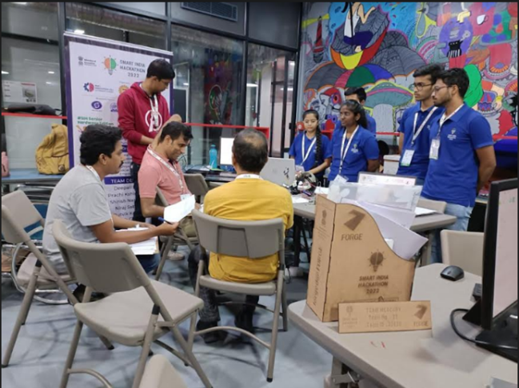  Student Participation inSmart India Hackathon | 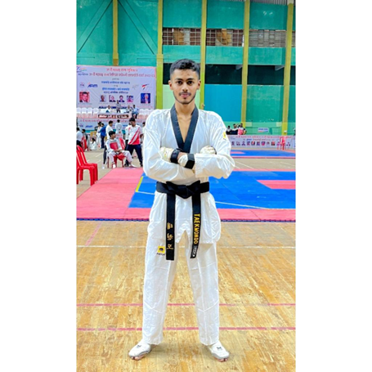  Mr. Ashutosh Waghavkwr won Silver MEdal in Taekwondo competition
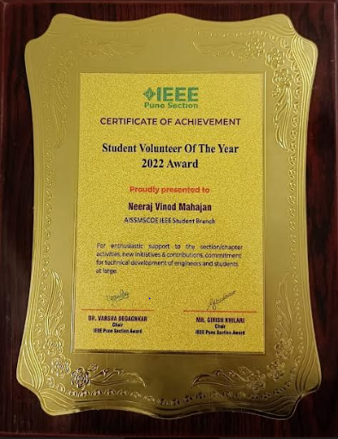  Mr. Neeraj Mahajan won IEEE Pune Section’s Student Volunteer of the Year 2022 Award | 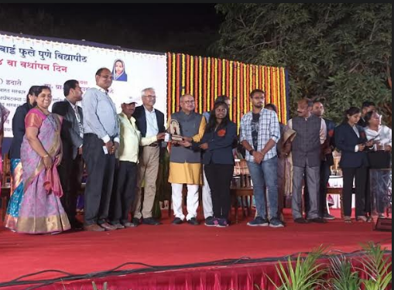  Deepali Dalvi Prachi Kshirsagar and Neeraj Sable won State Level Avishkar Competition
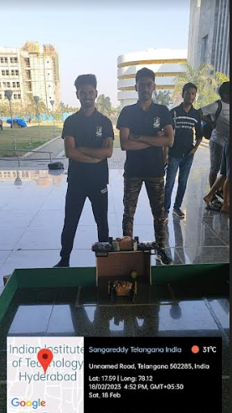  Avit-O-Virtue Club won First Prize at IIT Hyderabad 18/2/2023 | 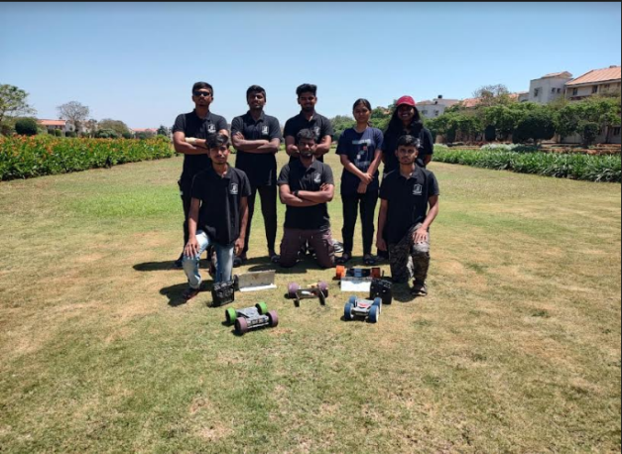  Avit-O-Virtue Club won 3rd prize at Bits Pilani.

- SUMMARY
AND
SWOC ANALYSIS

7.1 ANY OTHER NOTEWORTHY ACHIEVEMENT OF THE DEPARTMENT(Not mentioned above)
Sr. No. | Details
1 | Dr. Amitabh Bhattacharyya Memorial Trophy to AISSMS College of Engineering, Pune Department of Electronics and Telecommunication Engineering for AY 2021-22
2 | Best Overall Performing Department Award: 17th AISSMS Engineering Today-2022

7.2 MISCELLANEOUS (SYLLABUS IMPLEMENTATION, MAJOR ADDITION IN INFRASTRUCTURE AND FACILITY, INNOVATIONS INTRODUCED, ETC.)
FACULTY | ACTIVITY

7.3 FEEDBACK FROM STAKEHOLDERS

Sr No | Stake holder | Number of Feedbacks Received | Overall Feedback
1 | Alumni | -
2 | Parents | -
3 | Employers | -
4 | Students | -

7.4 TWO BEST PRACTICES FOLLOWED IN THE DEPARTMENT
One faculty One Industry

Active Student Chapter/Clubs

7.5 MAJOR GRIEVANCES OF STUDENTS (IF ANY) REDRESSED
---

7.6 SWOC ANALYSIS
Five major strengths, weaknesses, opportunities, and challenges (SWOC) of the department and future plans of the Department.
Strengths:
1 | Experienced Faculty
2 | Effective Teaching Learning Process
3 | Industry Institute Interaction
4 | Center of Excellence
5 | Active Student Chapter/Clubs

Weaknesses:
1 | Consultancy
2 | Research Grants
3 | Less number of Industry sponsored laboratories

Opportunities:
1 | To Increase Research and Development.
2 | To increase the number of Training Programs
3 | To increase the number of Consultancies and funded Projects.
4 | To increase number of Ph.D. faculties
5 | To increase Research publications of faculties and Students

Challenges
1 | To cope up with Dynamic changes in technology
2 | To improve number of Patents and Copyrights
3 | To increase Placement in core Industries

7.7 FUTURE PLANS OF THE DEPARTMENT (For Next Academic Year)
1 | To be NBA Accredited
2 | To increase Industry sponsored Laboratories
3 | To Launch certificate courses
4 | To Strengthen Industry Institute Interaction
7.8 INITIATIVES TAKEN BY THE DEPARTMENT AT DEPARTMENT AND INSTITUTE LEVEL TO IMPROVE AND ASSURE QUALITY IN THE FOLLOWING AREAS

Area | Initiatives
Academics and overall profile of Department | Conducted Webinars and Expert Talk organized on Technical Topic
Organization of different activities | Motivated Students to Participate in Various Sports and Cultural activities
Research and Innovation | Motivated students to participate in NSS and various Social Programs
Industry institute Interaction | Strengthened Departmental Student Clubs/Chapters
Students’ Achievements | Organized Faculty Development Program on “Project Based Learning

SUMMARY SHEET (Annual)
Sr No | Activity/ Item | Numbers
PROFILE OF DEPARTMENT
01 | Students in the department | 233
 | FACULTY CONTRIBUTION
02 | e content developed by faculty and available online | 68
03 | Number of FDP/STTP attended by the department faculty | 58
04 | Number of Seminars/ workshops/ webinars attended by the department faculty | 19
05 | Number of Conferences/ symposiums attended by the department faculty | 07
06 | Number of Online courses / certificate courses completed by department faculty | 10
07 | Number of extension lectures / webinars (Lectures delivered on other than technical topics)) | 13
08 | Number of Faculty served as resource person, expert, chairperson | 05
 | ACTIVITIES ORGANISED
09 | Number of FDP/STTP organized by the department | 01
10 | Number of Seminars/ workshops/ webinars organized by the department (for faculty) | 01
11 | Number of Conferences/ symposiums organized by the department (for faculty) | 02
12 | Number of Extension activities conducted by the department (Social/ Quizzes at national/international level/any other activity) | 01
13 | MOU signed with academic and professional organizations | 12
14 | Number of Students’ chapters /clubs | 07
15 | Number of Social activities organized | 01
16 | Number of Parent meeting | 01
17 | Number of Alumni meet | 01
18 | Number of student counseling and career guidance at the department level | 07
 | RESEARCH CONTRIBUTION
19 | Number of Funded research project | 01
20 | Number of Testing and consultancy | 01
21 | Number of Patents, copyright, trademark and other (IPR) | 02
22 | Number of Papers published/ presented in proceedings of conferences | 16
23 | Number of Papers published in journals | 09
24 | Number of Book/ article publications | 01
25 | Total Research citations | 457
26 | Number of ME awarded | 00
27 | Number of PhD AWARDED | 00
 | INTERACTION WITH INDUSTRY
28 | Number of Industrial visits organised | 02
29 | Number of Expert lectures delivered by industry experts | 05
30 | Number of Industry –sponsored projects (UG/PG) | 01
31 | Number of MOU signed with industry | 12
32 | Number of Faculty members underg  one industrial training | 01
33 | Number of Students undergone in-plant training and (or) internship programme | 77
34 | Number of students placed | 22
35 | Number of students qualified in the examinations | 00

Declaration by the Head of the Department

I am aware that the above information provided by the Department will be validated by the AAA committee during the visit.

Name and Signature
Head of Department

