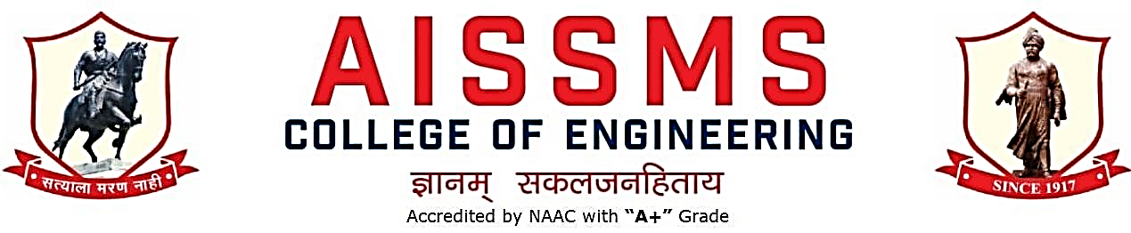
Internal Quality Assurance Cell

DEPARTMENT OF MECHANICAL ENGINEERING
ANNUAL REPORT
(15 JUNE 2021 to 14 June 2022)
TERM ONE: 15 June to 30 November
TERM TWO: 01 December to 14 June

Academic Year 2021 – 22
Guidelines:
Fill up this sheet for all the contributions /activities conducted at Department level only.
- In case data does not exist please mention it as ‘No Data’.
- Please add rows to the table below to suit your requirements
- Ensure that data does not differ from other official records and all the supporting documents are available.
- Use: Font Type: Times New Roman, Font Size: 12, Sentence case, Spacing: 1.15
- Use separate row for every details.
- For any queries, you may contact: Dr C S Choudhari, Coordinator, IQAC
- email: iqac@aissmscoe.com

CONTENTS
Sr No | Activity/ Item | Page No
- PROFILE OF DEPARTMENT
1.1 | Introduction
1.2 | Laboratories in the Department
1.3 | Software Available in the Department
1.4 | Faculty in the Department
1.5 | Details of Supporting Staff
1.6 | Students’ Enrollment
1.7 | Students–Faculty Feedback Details
1.8 | Result Analysis
1.9 | Class Result Analysis
 | - FACULTY CONTRIBUTION
2.1 | Achievements of Faculty
2.2 | Contribution of Faculty (Interaction With Outside World)
2.3 | e content developed by faculty and available online
2.4 | FDP/STTP attended by the department faculty
2.5 | Seminars/ workshops/ webinars attended by the department faculty
2.6 | Conferences/ symposiums attended by the department faculty
2.7 | Online courses / certificate courses completed by department faculty
2.8 | Extension lectures / webinars organized
2.9 | Faculty served as resource person, expert, chairperson
- ACTIVITIES ORGANISED
3.1 | FDP/STTP organized by the department
3.2 | Seminars/ workshops/ webinars organised by the department (for faculty)
3.3 | Conferences/ symposiums organised by the department
3.4 | Extension activities conducted by the department
3.5 | MOU signed with academic and professional organisations
3.6 | Students’ chapters /clubs
3.7 | Social activities organised
3.8 | Parent meeting
3.9 | Alumni meet
3.10 | Support from Alumni
3.11 | Interaction with Alumni
3.12 | Student counseling and career guidance at the department level
- RESEARCH CONTRIBUTION
4.1 | Funded research project
4.2 | Testing and consultancy
4.3 | Patents, copyright, trademark and other (IPR)
4.4 | Papers published/ presented in proceedings of conferences
4.5 | Papers published in journals
4.6 | Book/ article publications
4.7 | Total Research citations
4.8 | ME awarded
4.9 | PhD guide details
4.10 | PhD AWARDED
 | - INTERACTION WITH INDUSTRY
5.1 | Industrial visits organised
5.2 | Expert lectures delivered by industry experts
5.3 | Industry –sponsored projects (UG/PG)
5.4 | MOU signed with industry
5.5 | Faculty members undergone industrial training
5.6 | Students undergone in-plant training and (or) internship programme
5.7 | Support from Industry
5.8 | Training to Industry personnel/ Activity Supporting industry
5.9 | Any other activities to Promote Interaction With Industry
5.10 | Students Undergone Sandwich Training
- STUDENTS’ ACHIEVEMENT
6.1 | Students’ Achievement (Professional) (Individual Level)
6.2 | Students’ Achievement (Other than Professional) (Individual Level)
6.3 | Certificate / Online Courses Completed by Students
6.4 | Number of Students Placed
6.5 | Number of Students qualified in the competitive examinations
6.6 | Sports / Cultural Achievements of Students (Individual Level)
6.7 | Students’ Achievements (Team Level)
 | - SUMMARY AND SWOC ANALYSIS
7.1 | Any other noteworthy achievement of the department
7.2 | Miscellaneous (Syllabus Implementation, Major Addition In Infrastructure And Facility, Innovations Introduced, etc.)
7.3 | Feedback from Stakeholders
7.4 | Two Best Practices Followed in the Department
7.5 | Major Grievances of Students (If Any) Redressed
7.6 | SWOC Analysis
7.8 | Future Plans of the Department
7.9 | Initiatives Taken By The Department At Department And Institute Level To Improve And Assure Quality
7.10 | Summary Sheet (Annual)

- PROFILE
OF
DEPARTMENT

1.1 INTRODUCTION
Year of Establishment | 1992 Mechanical, 1996 Mechanical (Sandwich Pattern)
UG Programmes | Mechanical & Mechanical SW
PG Programmes | Automotive , Design Engineering
Number of Teaching Staff | 30
Number of Non-Teaching Staff | 3+6=9

1.2 LABORATORIES IN THE DEPARTMENT
Name of Laboratory
Heat Engine Lab | Automotive System Lab
Metallurgy Lab | Automotive Chassis lab
Heat Transfer Lab | PG Software Lab Auto
Theory of Machine Lab | PG Lab Design
Dynamics of Machinery Lab | BME Lab
Drawing Hall | Central Facility
Fluid Machinery Lab | Mechatronics
Fluid Power Lab | Computer Graphics Lab
Refrigeration & Air conditioning Lab | Computer Center
Metrology Lab | Inhouse Project
Computer Aided Design Lab | Computer Aided Engineering Lab

1.3 SOFTWARES AVAILABLE IN THE DEPARTMENT
Software Available
AutoCAD 2009 | Master CAM X9
Pro/Engineer WildFire 5.0 | ANSYS 16
Altair Hyperworks R11 | MSC Adams
MATLab

1.4 FACULTY IN THE DEPARTMENT
S N | Name of faculty | Designation
1 | Dr B D Bachchhav | Professor
2 | Dr M R Phate | Professor
3 | Dr Mrs P S Gajjal | Associate Professor
4 | Dr M S Deshmukh | Associate Professor
5 | Dr A V Waghmare | Associate Professor
6 | Dr D Y Dhande | Associate Professor
7 | Dr S H Wankhade | Associate Professor
8 | Dr C S Choudhari | Associate Professor
9 | Dr S V Chaitanya | Assistant Professor
10 | Dr S R Patil | Assistant Professor
11 | Mr P V Deshmukh | Assistant Professor
12 | Mr R A Marne | Assistant Professor
13 | Dr C S Dharankar | Assistant Professor
14 | Dr S J Navale | Assistant Professor
15 | Mr M U Gan | Assistant Professor
16 | Mr P S Aglawe | Assistant Professor
17 | Mr O A More | Assistant Professor
18 | Mrs A A Tonde | Assistant Professor
19 | Mr M S Swami | Assistant Professor
20 | Mr G P Lohar | Assistant Professor
21 | Mrs M P Shah | Assistant Professor
22 | Dr M R Dahake | Assistant Professor
23 | Mr M P Bauskar | Assistant Professor
24 | Mrs S S Patil | Assistant Professor
25 | Mr N N Gotkhindikar | Assistant Professor
26 | Dr M M Sayyad | Assistant Professor
27 | Dr A M Ramteke | Assistant Professor
28 | Dr. D S Malwad | Assistant Professor
29 | Mr Shahid Ali Ansari | Assistant Professor

1.5 DETAILS OF SUPPORTING STAFF
Name of non-teaching staff | Designation | Name of non-teaching staff | Designation
J N Khiratkar | Tech Asstt | G B Mate | Attendant
S K Jogdand | Lab Asstt | R D Nalawade | Attendant
A A Jachak | Lab Asstt | P D Mahajan | Attendant
 |  | P R Pharande | Attendant
 |  | S M Waghmare | Attendant
 |  | R S Amolik | Attendant

1.6 STUDENTS’ ENROLLMENT
Program | GEN |  | SC |  |  | ST |  |  | OBC |  |  | PWD |  |  | Others |  |  | Total
 | M | F | M | F | M |  | F | M |  | F | M |  | F | M |  | F | M |  | F
UG (Mech) Division I | 151 | 26 | 50 | 19 | 8 |  | 1 | 103 |  | 21 | 0 |  | 0 | 169 |  | 33 | 482 |  | 100
UG (Mech) Division II
UG (Mech SW) | 74 | 6 | 24 | 6 | 1 |  | 0 | 44 |  | 10 | 0 |  | 0 | 74 |  | 11 | 217 |  | 33
PG ( Auto) | 1 | 0 | 0 | 0 | 0 |  | 0 | 0 |  | 0 | 0 |  | 0 | 0 |  | 0 | 1 |  | 0
PG (Design)

1.7 STUDENTS–FACULTY FEEDBACK DETAILS
 | Term One
Sr. No. | Name of faculty | Class and Subject taught | Feedback (I) (%) | Feedback (II) (%) | Average  Feedback (%)
1 | Dr B D Bachchhav | TE A AFJP | 83 | 81 | 82
2 | Dr B D Bachchhav | TE B AFJP | 85 | 100 | 92.5
3 | Dr M R Phate | BE A OR | 76 | 73 | 75
4 | Dr M R Phate | BE B OR | 82 | 82 | 82
5 | Dr P S Gajjal | SE A SM | 84 | 84 | 84
6 | Dr P S Gajjal | SE MS SM | 90 | 89 | 89.5
7 | Dr M S Deshmukh | SEA ET | 74 | 79 | 76.5
8 | Dr M S Deshmukh | BE A HVAC | 99 | 100 | 99.5
9 | Dr M S Deshmukh | BE B HVAC | 89 | 87 | 88
10 | Dr A V Waghmare | BE A HP | 80 | 83 | 81.5
11 | Dr A V Waghmare | BE B HP | 78 | 81 | 79.5
12 | Dr D Y Dhande | TE MS ACAE | 81 | 82 | 81.5
13 | Dr S H Wankhade | BE MS MTX | 86 | 85 | 85.5
14 | Dr C S Choudhari | TE A HMT | 81 | 83 | 82
15 | Dr S V Chaitanya | BE A AE | 84 | 88 | 86
16 | Dr S V Chaitanya | BE B AE | 79 | 83 | 81
17 | Prof S R Patil | TE A DME | 81 | 81 | 81
18 | Prof P V Deshmukh | SE A SMD | 73 | 77 | 75
19 | Prof P V Deshmukh | BE A CCA | 78 | 83 | 80.5
20 | Prof R A Marne | TE B DME | 78 | 84 | 81
21 | Dr C S Dharankar | BE A DOM | 83 | 86 | 84.5
22 | Dr C S Dharankar | BE B DOM | 79 | 81 | 80
23 | Dr S J Navale | TE A NSM | 81 | 84 | 82.5
24 | Dr S J Navale | TE MS HMT | 79 | 82 | 80.5
25 | Prof M U Gan | SE B ET | 85 | 84 | 84.5
26 | Prof P S Aglawe | TE MS NSM | 74 | 81 | 77.5
27 | Prof P S Aglawe | BE B CCA | 79 | 81 | 80
28 | Prof O A More | TE A MTX | 78 | 82 | 80
29 | Prof O A More | TE B MTX | 74 | 81 | 77.5
30 | Prof A T Thombare | TE MS DME | 77 | 83 | 80
31 | Prof M S Swami | SE A EMM | 75 | 79 | 77
32 | Prof M S Swami | SE MS SMD | 89 | 92 | 90.5
33 | Prof G P Lohar | SE MS ET | 84 | 88 | 86
34 | Prof M P Shah | BE A FEA | 85 | 87 | 86
35 | Prof M R Dahake | TE B HMT | 78 | 84 | 81
36 | Prof M P Bauskar | TE A MST | 83 | 83 | 83
37 | Prof M P Bauskar | TE B MST | 100 | 100 | 100
38 | DR. M M Sayyad | SE B SM | 91 | 89 | 90
39 | DR. M M Sayyad | TE B NSM | 78 | 83 | 80.5
40 | Prof K L Kumbhar | BE A EAM | 81 | 83 | 82
41 | Prof K L Kumbhar | BE B EAM | 76 | 77 | 76.5
42 | Prof N N Gotkhindikar | SE MS EMM | 86 | 89 | 87.5
43 | Dr D S Malwad | SE B SMD | 91 | 88 | 89.5
44 | Dr D S Malwad | BE B FEA | 79 | 81 | 80
45 | Dr A M Ramteke | TE B MST | 75 | 79 | 77

 | Term TwoTerm Two
Sr. No. | Name of faculty | Class and Subject taught | Feedback (I) (%) | Feedback (II) (%) | Average  Feedback (%)
1 | Dr B D Bachchhav | SE MS ME  BE A AMP  BE B AMP | 83  96  100 | 84  96  100 | 83.5  96  100
2 | Dr M R Phate | BE A MSD BE MS OR | 79  74 | 85  68 | 82  71
3 | Dr Mrs P S Gajjal | BE MS MSD  BE B MSD | 88  86 | 90  93 | 89  89.5
4 | Dr M S Deshmukh | BE MS EA&M  BE B EE | 88  88 | 92  93 | 90  90.5
5 | Dr A V Waghmare | BE MS HP | 86 | 90 | 88
6 | Dr D Y Dhande | TE B CAE | 88 | 88 | 88
7 | Dr S H Wankhade | BE A PDD  BE B IE | 84  85 | 83  80 | 83.5  82.5
8 | Dr C S Choudhari | BE A EE | 87 | 86 | 86.5
9 | Dr S V Chaitanya | BE A IE | 86 | 85 | 85.5
10 | Dr S R Patil | SE B KOM  SE MS KOM | 82  69 | 84  78 | 83  73.5
11 | Mr P V Deshmukh | TE A CAE | 77 | 79 | 78
12 | Mr R A Marne | TE A DTS  TE B DTS | 81  84 | 84  86 | 82.5  85
13 | Dr C S Dharankar | BE MS MV | 87 | 92 | 89.5
14 | Dr S J Navale | SE B AT  BE MS EE | 84  87 | 86  91 | 85  89
15 | Mr M U Gan | SE A FM  SE B FM | 81  85 | 80  87 | 80.5  86
16 | Mr P S Aglawe | TE B AIML  BE A Robo  BE B Robo | 84  70  70 | 85  69  100 | 84.5  69.5  85
17 | Mr O A More | TE A SE | 75 | 79 | 77
18 | Mrs A A Tonde | SE A KOM | 76 | 83 | 79.5
19 | Mr M S Swami | TE B SE | 83 | 85 | 84
20 | Mr G P Lohar | SE MS TE | 70 | 79 | 74.5
21 | Mrs M P Shah | BE MS FEA  BE MS CCA | 90  93 | 99  84 | 94.5  88.5
22 | Dr M R Dahake | SE A AT | 81 | 77 | 79
23 | Mr M P Bauskar | SE B MP | 85 | 90 | 87.5
24 | Mrs S S Patil
25 | Mr N N Gotkhindikar | SE A MP | 89 | 90 | 89.5
26 | Dr M M Sayyad | TE A CM  TE B CM | 87  86 | 85  90 | 86  88
27 | Dr Mrs A M Ramteke | BE B PDD | 78 | 85 | 81.5
28 | Dr D S Malwad | TE A AIML  BE A SWE  BE B SWE | 80  93  85 | 84  99  94 | 82  96  89.5
29 | Mr Shahid Ali | SE MS FMM | 85 | 85 | 85
30 | Mr S T Surase | SE A EM III SE B EM III  SE MS EM III | 91  91  83 | 89  92  83 | 90  91.5  83

1.8 RESULT ANALYSIS
Term One
Name of faculty | Class and Subject Taught | % passing
Dr B D Bachchhav | TE Mech (A) Advanced Forming & Joining Processes | 100
Dr M R Phate | BE Mech (A&B) Operation Research | 100
Dr Mrs P S Gajjal | SE Mech (A) Solid Mechanics | 98.68
 | SE Mech Sand Solid Mechanics | 98.72
Dr M S Deshmukh | SE Mech (A) Engineering Thermodynamics  BE Mech (A&B) Heating Ventilation & Air Conditioning | 100  100
Dr A V Waghmare | BE Mech (A&B) Hydraulics & Pneumatics | 100
Dr D Y Dhande | TE Mech Sand Fundamental of Computer Aided Engineering | 100
Dr S H Wankhade | TE Mech Sand Mechatronics | 100
Dr C S Choudhari | TE Mech (A) Heat & Mass Transfer | 100
Dr S V Chaitanya | BE Mech (A&B) Automobile | 100
Mr S R Patil | TE Mech (A) Design of Machine Elements | 100
Mr P V Deshmukh | SE Mech (A) Solid Modeling & Drafting  BE Mech (A) CAD CAM Automation | 98.68  100
Mr R A Marne | TE Mech (B) Design of Machine Elements | 100
Dr C S Dharankar | BE Mech (A&B) Dynamics of Machinery | 100
Dr S J Navale | TE Mech (A) Numerical Statistical & Methods  TE Mech Sand Heat & Mass Transfer | 98.83  100
Mr M U Gan | SE Mech (B) Engineering Thermodynamics | 100
Mr P S Aglawe | TE Mech Snad Numerical Statistical & Methods | 100
Mr O A More | TE Mech (A&B) Mechatronics | 100
Mrs A A Tonde | TE Mech Sand Design of Machine Elements | 100
Mr M S Swami | SE Mech (A) Engg. Materials & Metallurgy | 100
 | SE Mech Sand Solid Modeling & Drafting | 100
Mr G P Lohar | SE Mech Sand Engineering Thermodynamics | 100
Mrs M P Shah | BE Mech (A&B) Finite Elements Analysis | 100
Mr M R Dahake | TE Mech (B) Heat & Mass Transfer | 100
Mr M P Bauskar | TE Mech (A&B) Machining Science & Technology | 100
Mr K L Kumbhar | BE Mech (A&B) Energy & Audit & Management | 100
Mr D S Mane | SE Mech (B) Engg. Materials & Metallurgy | 100
Mrs S S Patil
Mr N N Gotkhindikar | SE Mech Sand Engg. Materials & Metallurgy | 100
Dr M M Sayyad | TE Mech (B) Numerical Statistical & Methods | 100
 | SE Mech (B) Solid Mechanics | 100
Dr Mrs A M Ramteke | TE Mech (B) Advanced Forming & Joining Processes | 100
Dr D S Malwad | SE Mech (B) Solid Modeling & Drafting | 100
Self Study | BE Mech Sand Automobile Engineering | 100
Self Study | BE Mech Sand Power Plant Engineering | 100
Miss S S Mujawar | SE Mech (A&B) Electrical & Electronics Engineering | 100
Mr R S Shinde | SE Mech sand Electrical & Electronics Engineering | 100

Term Two
Name of faculty | Class and Subject Taught | % passing
Dr B D Bachchhav | SE Mech Sand Manufacturing Engineering  BE Mech A & B Advance Mfg Process | 73  100 & 100
Dr M R Phate | BE Mech Sand Operation Research  BE Mech A Mechanical System Design | 100  94.52
Dr Mrs P S Gajjal | BE Mech B Mechanical System Design  BE Mech Sand Mechanical System Design | 94.87  94.87
Dr M S Deshmukh | BE Mech Sand Energy Audit & Mgt  BE Mech B Energy Engineering | 91.38
Dr A V Waghmare | BE Mech Sand Hyd & Pneumatics | 91.38
Dr D Y Dhande | TE Mech B Computer Aided Engineering | 86.9
Dr S H Wankhade | BE Mech A Product Dsg & Develop | 95.38
Dr C S Choudhari | BE Mech A Energy Engineering | 97.26
Dr S V Chaitanya | BE Mech A Industrial Engineering | 97.2
Mr S R Patil | SE Mech B Kinematics of Machinery  SE Mech Sand Kinematics of Machinery | 79.2  62
Mr P V Deshmukh | TE Mech A Computer Aided Engineering | 81.4
Mr R A Marne | TE Mech A & B Design of Transmission System | 79.07 & 76.19
Dr C S Dharankar | BE Mech Sand Mechanical Vibration | 97.44
Dr S J Navale | SE Mech B Applied Thermodynamics  BE Mech Sand Energy Engineering | 72.73  96.15
Mr M U Gan | SE Mech A & B Fluid Mechanics | 76.32 & 58.44
Mr P S Aglawe | TE Mech B Artificial Intelligence & Machine learning  BE Mech A Robotics | 89.29  100
Mr O A More | TE Mech A Surface Engineering | 76.6
Mrs A A Tonde | SE Mech A Kinematics of Machinery | 78.9
Mr M S Swami | TE Mech BSurface Engineering | 81.43
Mr G P Lohar | SE Mech Sand Thermal Engineering | 69
Mrs M P Shah | 1.BE Mech Sand CAD/CAM  2.BE Mech Sand Finite Elements Analysis | 100  71.43
Dr M R Dahake | SE Mech A Applied Thermodynamics | 77.6
Mr M P Bauskar | SE Mech B Manufacturing Process | 83.12
Mrs S S Patil
Mr N N Gotkhindikar | SE Mech A Manufacturing Process | 86.84
Dr M M Sayyad | TE Mech A & B Composite Materials | 87.18 & 100
Dr Mrs A M Ramteke | BE Mech B Product Dsg & Develop | 100
Dr D S Malwad | TE Mech A Artificial Intelligence & Machine Learning  BE Mech A & B Solar & Wind Energy | 93.02  100 & 100
Mr Shahid Ali | SE Mech Sand Fluid Mechanics & Machinery | 54
Mr S T Surase | SE Mech A & B Engineering Maths -III SE Mech Sand Engineering Maths -III | 76.32 & 63.64  44

1.9 CLASS RESULT ANALYSIS (All Classes FE to BE)
Term One
SN | Class | Number of Students |  |  |  |  |  |  |  |  |  | Percentage of Passing
 |  | Appeared | Clear Passed | Outstanding  (O)  (9.1 -10) | Excellent  (A+)  (8.1 – 9) | Very Good (A)  (7.1 – 8) | Good (B+)  (6.1 – 7) | Above Average (B)  (5.1 – 6) | Average / pass class  (4 – 5 ) | Fail  (F)  0 – 3.99 | All Clear |  | With ATKT
1 | SE Mech (A) | 76 | 75 | 33 | 37 | 5 | - | - | - | 1 | 98.68 |  | 100
2 | SE Mech (B) | 77 | 77 | 23 | 46 | 8 | - | - | - | 0 | 100 |  | 100
3 | TE Mech (A) | 86 | 84 | 79 | 5 | -- | - | - | - | 2 | 98 |  | 100
4 | TE Mech (B) | 84 | 84 | 79 |  | 5 | - | - | - | 0 | 100 |  | 100
5 | BE Mech (A) | 70 | 69 | 68 | 1 | - | - | - | - | 1 | 98.57 |  | 100
6 | BE Mech (B) | 78 | 78 | 78 | - | - | - | - | - | 0 | 100 |  | 100
7 | SE Mech Sand | 78 | 72 | 23 | 45 | 4 | - | - | - | 6 | 92.31 |  | 100
8 | TE Mech Sand | 80 | 80 | 76 | 4 | - | - | - | - | 0 | 100 |  | 100
9 | BE Mech Sand | 78 | 77 | 76 | 1 | - | - | - | - | 1 | 98.72 |  | 100

Term Two
SN | Class | Number of Students |  |  |  |  |  |  |  |  |  | Percentage of Passing
 |  | Appeared | Clear Passed | Outstanding  (O)  (9.1 -10) | Excellent  (A+)  (8.1 – 9) | Very Good (A)  (7.1 – 8) | Good (B+)  (6.1 – 7) | Above Average (B)  (5.1 – 6) | Average / pass class  (4 – 5 ) |  | Fail  (F)  0 – 3.99 | All Clear | With ATKT
1 | SE Mech (A) | 76 | 49 | 3 | 27 |  |  |  |  |  | 27 | 64 | 100
2 | SE Mech (B) | 77 | 41 | 1 | 19 | 20 |  |  |  |  | 36 | 53 | 100
3 | TE Mech (A) | 86 | 58 | 14 | 37 | 7 |  |  |  |  | 28 | 67.44 | 100
4 | TE Mech (B) | 84 | 61 | 31 | 24 | 6 |  |  |  |  | 23 | 72.62 | 100
5 | BE Mech (A) | 73 | 67 | 64 | 3 |  |  |  |  |  | 6 | 91.78 | –
6 | BE Mech (B) | 78 | 74 | 71 | 3 |  |  |  |  |  | 4 | 94.87 | –
7 | SE Mech Sand | 78 | 28 | 0 | 6 | 19 | 3 |  |  |  | 50 | 36 | 100
8 | TE Mech Sand | 80 | 69 | 57 | 12 |  |  |  |  |  | 11 | 86 | 100
9 | BE Mech Sand | 78 | 65 | 63 | 2 |  |  |  |  |  | 13 | 83.33 | –

Term Two Final Result for BE Classes (Based on CGPA)
SN | Class | Number of Students |  |  |  |  |  |  |  |  | Percentage of Passing
 |  | Appeared | Clear Passed | Outstanding  (O)  (9.1 -10) | Excellent  (A+)  (8.1 – 9) | Very Good (A)  (7.1 – 8) | Good (B+)  (6.1 – 7) | Above Average (B)  (5.1 – 6) | Average / pass class  (4 – 5 ) | Fail  (F)  0 – 3.99 | All Clear | With ATKT
1 | BE Mech (A) | 73 | 67 | 64 | 3 |  |  |  |  |  | 6 | 91.78 | –
2 | BE Mech (B) | 78 | 74 | 71 | 3 |  |  |  |  |  | 4 | 94.87 | –
3 | BE Mech Sand | 78 | 65 | 63 | 2 |  |  |  |  |  | 13 | 83.33 | –

1.10 UNIVERSITY RANKERS (Consider last five academic years)
Academic Year 2017 - 18
Sr No | Name of the Ranker | Class | Rank
1 | Satpute Anurag Ajit | TE Mech S/W | 3
2 | Kriplani Mayur Suresh | TE Mech S/W | 9
3 | Jagtap Akshay Rajendra | BE Mech S/W | 1
4 | Kulkarni Prathmesh Ravikant | BE Mech S/W | 1
5 | Ketkali Sammed Ajit | BE Mech S/W | 3
6 | Chappidi Sreenivasulu Subaiya | BE Mech S/W | 4
7 | Sawant Abhishek Satish | BE Mech S/W | 5
8 | Mandlik Sunil Krishnat | BE Mech S/W | 7
9 | Shenvi Mohit Nitin | BE Mech S/W | 9

Academic Year 2018 - 19
Sr No | Name of the Ranker | Class | Rank
1 | Bhandare Ankur Nitin | SE Mech S/W | 1
2 | Sarkar Omkar Vilas | SE Mech S/W | 2
3 | Jadhav Hrishikesh Sanjay | SE Mech S/W | 3
4 | Joshi Atharv Shekhar | SE Mech S/W | 4
5 | Gandhi Sarthak Sriraj | SE Mech S/W | 5
6 | Vaishnavi Prabhu | SE Mech S/W | 6
7 | Chaitanya Omkar Shrikant | SE Mech S/W | 7
8 | Kulkarni Bhagyesh Govind | SE Mech S/W | 8
9 | Shirsathe Gaurav Rakesh | SE Mech S/W | 9
10 | Choudhari Prathmesh Satish | SE Mech S/W | 10
11 | Shinde Divya Prakash | BE Mech | 1
12 | Desai Shiwani Chandrahasya | BE Mech | 2
13 | Done Sudarshan Balwant | BE Mech | 3
14 | Patil Kamlesh Mohan | BE Mech | 4
15 | Sawant Swapnil Uday | BE Mech | 5
16 | Satpute Anurag Ajit | BE Mech S/W | 1
17 | Mutha Pratik Rajkumar | BE Mech S/W | 2
18 | Dalvi Sanit Jagdish | BE Mech S/W | 3
19 | Mahale Akash | BE Mech S/W | 4

Academic Year 2019 - 20
Sr No | Name of the Ranker | Class | Rank
1 | Jaurat Saurabh Vishwanath | SE Mech | 7
2 | Khedkar Sudarshan Rajendra | SE Mech S/W | 1
3 | Ghanwat Tejas Balasaheb | SE Mech S/W | 2
4 | Zende Vidita Vijay | SE Mech S/W | 3
5 | Momin Urooj Ahmed Ansari a Ahmed | SE Mech S/W | 4
6 | Gawade maithili Sashikant | SE Mech S/W | 5
7 | Dabholkar Aniruddh Rajendra | SE Mech S/W | 6
8 | Kichloo Anmol | SE Mech S/W | 7
9 | Bhasme Rushikesh Sanjay | SE Mech S/W | 7
10 | Hiremath Vivek Vijaymahantesh | SE Mech S/W | 8
11 | Mohite Vaishnavi Vijay | SE Mech S/W | 9
12 | Musai Sarvesh Sanjay | SE Mech S/W | 10
13 | Giri Menika Rakesh | TE Mech | 10
14 | Bhandare Ankur Nitin | TE Mech S/W | 1
15 | Gandhi Sarthak Shriraj | TE Mech S/W | 2
16 | Jadhav Rushikesh Sanjay | TE Mech S/W | 3
17 | Kaudare Gaurav Bharat | TE Mech S/W | 3
18 | Vaishnavi Prabhu | TE Mech S/W | 4
19 | Babar Manshi Bhalchandra | TE Mech S/W | 5
20 | Kulkarni Chaitanya Bhalchandra | TE Mech S/W | 5
21 | Chaitanya Omkar Shrikant | TE Mech S/W | 6
22 | Raut Shraddha Dipak | TE Mech S/W | 7
23 | Shirsathe Gaurav Rakesh | TE Mech S/W | 8
24 | Sarkar Omkar Vilas | TE Mech S/W | 9
25 | Jadhav Kamlesh Shivajirao | TE Mech S/W | 10

(start on new page) Few photographs of Labs, final year class group photos, faculty and staff group photos, photo of special facility available in the department, news published in the print media, any significant achievement of department
Size of photo 5 cm x 7 cm with captions
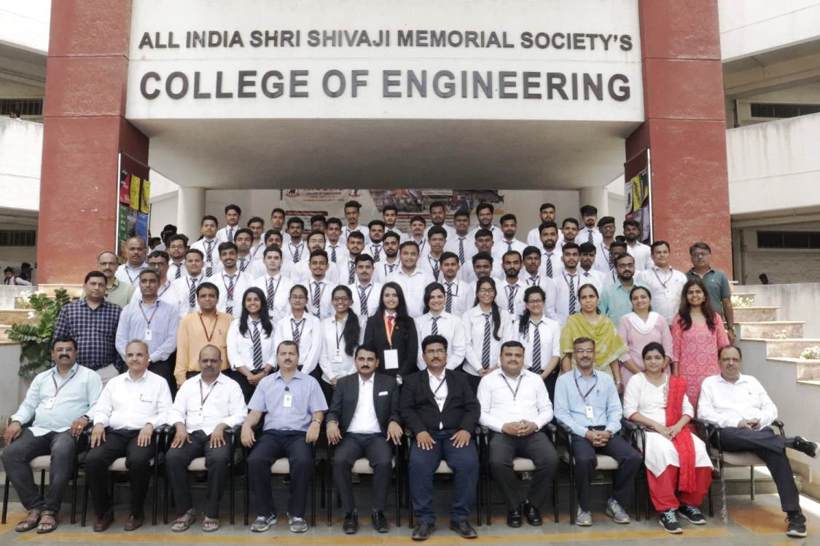

BE Mechanical A 2021- 22 Batch

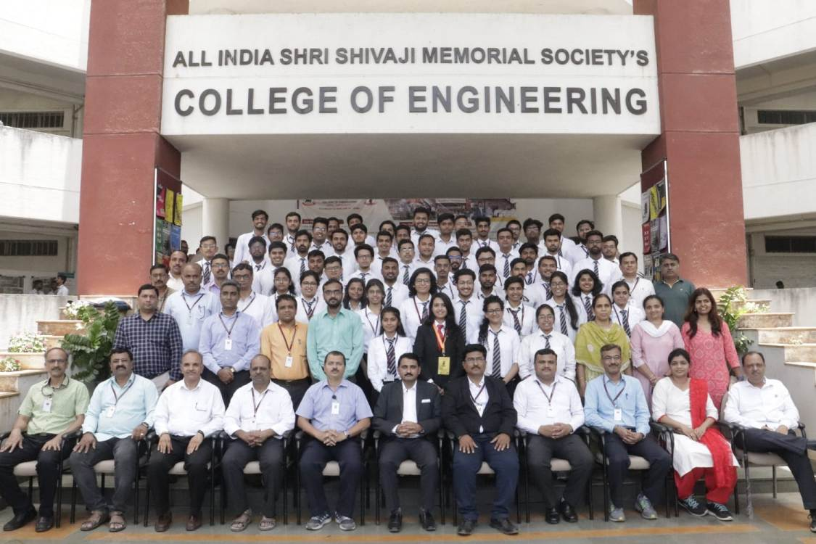
BE Mechanical B 2021- 22 Batch
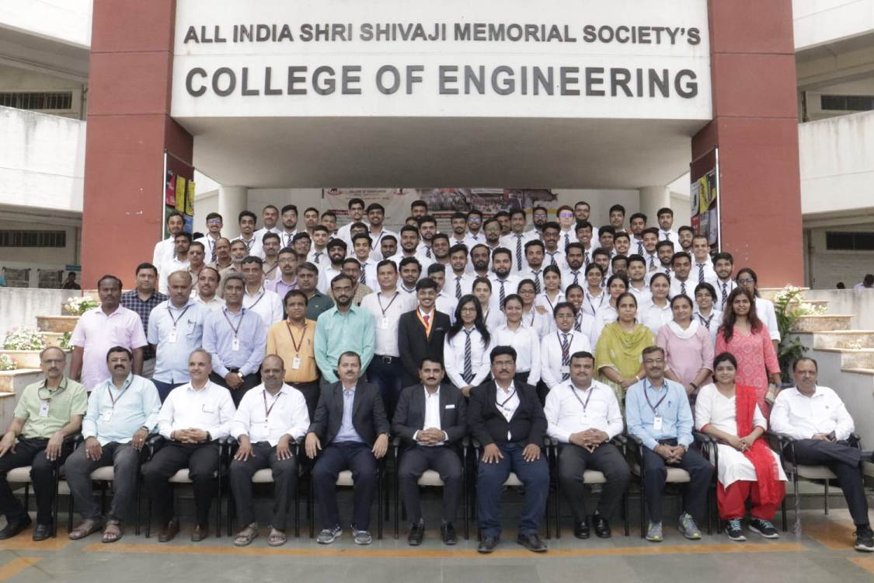
BE MechanicalSandwich AY 2021- 22 Batch

- FACULTY CONTRIBUTION

2.1 ACHIEVEMENTS OF FACULTY (AWARDS, RECOGNITION, PHD COMPLETION ETC.)
Term One
SN | Name of Faculty | Awards & Recognitions
1 | Dr A V Waghmare | Member-Awards and Recognition SAEINDIA
2 | Dr A V Waghmare | Member-Board of Studies, Savitribai Phule Pune University

Term Two
SN | Name of Faculty | Awards & Recognition
1 | Dr S R Patil | Completed Ph.D. in Mech.Engg. from SPPU, Pune
 | Dr C S Choudhari | Received recognition as a PhD research guide of SPPU Pune on 01/04/2022
3 | Dr M R Dahake | Completed Ph.D. in Mech.Engg. from SPPU, Pune in May 2022
4 | Dr C S Dharankar | Received recognition as a PhD research guide of SPPU Pune in 21-22
5 | Dr D Y Dhande | Received recognition as a PhD research guide of SPPU Pune in 21-22
6 | Dr A V Waghmare | Received recognition as a PhD research guide of SPPU Pune in 21-22
2.2 CONTRIBUTION OF FACULTY (Interaction with outside world)
Term One
SN | Name of Faculty | Nature and details of contribution (Representation at University, State, National , International level, corporate world, Social Platforms, etc)
1 | Dr P S Gajjal | - Subject Chairman for DoTS TE 2019 Course  - Subject Member for TE - Electric Vehicle Honors Course in Framing syllabus
2 | Dr C S Choudhari | - Subject Chairman for the subject Refrigeration and Air conditioning”  - Panel member for Energy management Honors Courses
3 | Dr. M. S. Deshmukh | - Subject Chairman Exam- B.E.(2015 PAT.) (MECHANICAL) (7041566) Paper-Heating Ventilation & Air Conditioning(402044C)
4 | Dr.S.R.Patil | - Academic Advisor on Research Project of Defence Research Development Organisation, Pune
5. | Dr D Y Dhande | - Subject Chairman for the subjects Fundamentals of Computer Aided Engg (TE Mech SW); REsearch Methodology (ME- Mechanical Engg)  - Project Leader in Research project entitled “ DEvelopment of Environment friendly corrosion fouling inhibitors for marine applications” in association with UTM, UKM Mylasia and River Dale University, Nigeria as a part of Research Collaboration.

Term Two
SN | Name of Faculty | Nature and details of contribution (Representation at University, State, National , International level, corporate world, Social Platforms, etc)
01 | Dr. Mangesh R. Phate | Session Chair inInternational conference on “Recent Advances in Materials, Manufacturing and Machine Learning(RAMMML-2022)” organised by YCCE Nagpur
02 | Dr. Mangesh R. Phate | Expert Session on“NBA Attributes for the students”  @ Zeal College of Engineering & Research, Pune on on 21/03/2022
03 | Dr P S Gajjal | - Subject Member for TE - Electric Vehicle Honors Course in Framing syllabus  - Subject Member for BE- Process Equipment design in framing Syllabus  - Panel Member for BE Elec I Electric and Hybrid Vehicle

2.3 e CONTENT DEVELOPED BY FACULTY AND AVAILABLE ONLINE
Term One
Sr No. | Name of Faculty | Title of e-content | e-content development facility/platform | link of the content

Term Two
Sr No. | Name of Faculty | Title of e-content | e-content development facility/platform | link of the content
1. | P V Deshmukh | Videos | Video Lecturers for SMD, CCA | https://www.youtube.com/watch?v=iBaclKzMf40  https://www.youtube.com/watch?v=Xwwanvsv7q8&t=30s

2.4 FDP/STTP ATTENDED BY THE DEPARTMENT FACULTY
Term One
S. No. | Name of the participant | Designation | Title of the FDP / professional development / administrative training program | Dates (from-to) (DD-MM-YYYY)
1 | A.V.Waghmare | Associate Professor | ISTE approved online /SF-STTP/FDP Programme on "Advances and applications of artificial intelligence and machine learning" | 22-11-2012 - 02 -12 -2021
2 | A.V.Waghmare | Associate Professor | FDP on electric mobility as a future | 25-10-2021 - 29-10-2021
3 | A.V.Waghmare | Associate Professor | FDP on fundamentals of electric vehicles | 25-10-2021-29-10-2021
4 | A.V.Waghmare | Associate Professor | Workshop on "structure and syllabus detailing of honors course in energy management in utility system" | 9/11/2021
5 | Dr D Y Dhande | Associate Professor | FDP on "computational fluid dynamics -A potential engineering design tool" | 26-07-2021-30-7-2021
6 | Dr D Y Dhande | Associate Professor | FDP on alternative fuels :biofuels | 04-10-2021 - 08-10-2021
7 | Dr D Y Dhande | Associate Professor | FDP On NANOFLUIDS: THEORY, EXPERIMENTATION. COMPUTATION AND APPLICATIONS | 13-09-2021 - 15-09-2021
8 | Dr M S Deshmukh | Associate Professor | FDP on recent advances in solar energy research and applications | 25-10- 2021 - 29-10-2021
9 | Dr M S Deshmukh | Associate Professor | Syllabus implementation workshop on subject "Design of transmission system'
10 | Dr SV Chaitanya | Associate Professor | FDP on quality attributes for the strategic improvement of faculty productivity | 03-08-2021 - 07-08-2021
11 | Dr SV Chaitanya | Associate Professor | FDP on design thinking | 21-06-2021 - 25-06-2021
12 | Dr SV Chaitanya | Associate Professor | Webinar on role of professional students chapter in enhancing engineering students career growth and increasing opportunities | 26-06-2021
13 | Mr P V Deshmukh | Assistant Professor | FDP on product design and prototype development | 12-7-2021 - 16-7-2021
14 | Mr P V Deshmukh | Assistant Professor | FDP on elements of FEM | 26-07-2021 - 30 -7 -2021
15 | Mr P V Deshmukh | Assistant Professor | FDP on revolution and advances in e vehicles | 30-08-2021 - 03-09-2021
16 | Dr C S Dharankar | Assistant Professor | 4 week induction / orientation program for faculty in universities/colleges / institutes of higher education | 19-11-2021 - 18-12-2021
17 | Dr S J Navale | Assistant Professor | 4 week induction / orientation program for faculty in universities/colleges / institutes of higher education | 19 -11-2021 - 18-12-2021
18 | Dr S J Navale | Assistant Professor | 4 week induction / orientation program for faculty in universities/colleges / institutes of higher education | 19-11-2021 - 18-12-2021
19 | Dr S J Navale | Assistant Professor | Impact lecture series 2021 on IPR with reference patent drafting and filling in Indian context | 14-10-2021
20 | Dr S J Navale | Assistant Professor | Webinar on automotive industry trends and challenges | 10-07 2021
21 | Mr M U Gan | Assistant Professor | 4 week induction / orientation program for faculty in universities/colleges / institutes of higher education | 19 -11-2021 - 18-12- 2021
22 | Mr M U Gan | Assistant Professor | Webinar on innovation , entrepreneurship and startup week | 10/11/2021
23 | Mr M U Gan | Assistant Professor | Webinar on automotive industry trends and challenges | 7/10/2021
24 | Mr M U Gan | Assistant Professor | Webinar on innovation in technology adoption and development of high precision slipring : A Case study | 18-07-2021
25 | Mrs A T Thombare | Assistant Professor | FDP on recent advances in mechanical engineering design | 20 -07 -2021 - 24-7-2021
26 | Mrs A T Thombare | Assistant Professor | Short term training program on innovative and inventive problem solving | 13-07-2021 - 18-07-2021
27 | Mrs A T Thombare | Assistant Professor | Syllabus implementation workshop for the course name of design of machine elements | 27-07-2021
28 | Mr MS Swami | Assistant Professor | Innovation ambassador training ( advance level ) | 30-06-2021 - 30-07-2021
29 | Mrs M P Shah | Assistant Professor | Short term training program on innovative and inventive problem solving | 13-07-2021 - 18-07-2021
30 | Mrs M P Shah | Assistant Professor | FDP on "Additive manufacturing: current trends and prospects towards developing AM research" | 22 -08 -2021- 26-08-2021
31 | Mrs M P Shah | Assistant Professor | FDP on 3D printing and design | 25 -10 -2021 - 29-10-2021
32 | Mrs M P Shah | Assistant Professor | FDP on 3D printing and design | 19 -10 -2021 - 23-10-2021
33 | Mrs M P Shah | Assistant Professor | Workshop on outcome based education (OBE ) | 20 -08-2021- 21 -08-2021
34 | Mrs M P Shah | Assistant Professor | Workshop on 3D printing solutions for medical innovation | 17-07-2021 - 18-07-2021
35 | Dr M R Dahake | Assistant Professor | One week FDP on electric mobility as a future | 25-10-2021- 29-10-2021
36 | Dr M R Dahake | Assistant Professor | Syllabus implementation workshop for the course name of heat and mass transfer | 27-07- 2021
37 | Dr M R Dahake | Assistant Professor | Syllabus implementation workshop on skill development and audit course 5 and 6. | 27-07-2021
38 | Mr M P Bauskar | Assistant Professor | One week online short term training program on innovative and inventive problem solving | 22-06-2021-27-06-2021
39 | Mr M P Bauskar | Assistant Professor | One week FDP on role of honours courses in engineering education and research | 25-10-2021- 29-10-2021
40 | Mr M P Bauskar | Assistant Professor | Webinar on innovation entrepreneurship and startup Week | 10/11/2021
41 | Mr M P Bauskar | Assistant Professor | Webinar developing the culture of innovation | 9/15/2021
42 | Mr OA More | Assistant Professor | FDP on "Classical optimisation techniques in manufacturing systems" | 05-07-2021 - 09-07-2021
43 | Dr. Mrs P S Gajjal | Associate Professor | FDP on electric mobility as a future | 25-10-2021- 29-10-2021
44 | Dr. S H Wankhade | Assiociate Professor | Short term training program on "Innovations and challenges in industry 4.0 automation and smart manufacturing" | 09-08-2021- 14-08-2021
45 | Dr. S H Wankhade | Assiociate Professor | FDP on software based case studies for development of multi disciplinary projects | 22-11-2021 - 26-11-2021
46 | Dr. S H Wankhade | Assiociate Professor | foundation to electric vehicle subsistence and technology | 10/24/2021
47 | Dr. C S Choudhari | Associate Professor | FDP on achieving leadership excellence for teachers of higher education institution | 27-09-2021 - 01-10-2021
48 | Dr. C S Choudhari | Associate Professor | FDP on guidance, counselling and mentoring | 20-09-2021-24-09-2021
49 | Mr R A Marne | Assistant Professor | Short term training program on innovative and inventive problem solving | 29 -06-2021 -04 -07-2021
50 | Mr R A Marne | Assistant Professor | Induction / orientation program for faculty University / colleges / institutes of higher education | 19-11-2021-18-12-2021
51 | Mr R A Marne | Assistant Professor | Webinar on innovation in technology adoption and development of high precision slipring : A case study | 18-07-2021
52 | Dr. M M Sayyad | Assistant Professor | FDP on design synthesis and characterization of novel materials | 25/10/2021 - 29/10/2021
53 | Dr. M M Sayyad | Assistant Professor | Innovation ambassador training ( foundation level ) | 30-06-2021-30-07-2021
54 | Dr. M M Sayyad | Assistant Professor | Webinar on smart clean and green electrical energy for the sustainable future | 10/5/2021
55 | Dr. M M Sayyad | Assistant Professor | Webinar on innovation entrepreneurship and startup week | 10/11/2021
56 | Dr. M M Sayyad | Assistant Professor | Webinar on developing a culture of innovation | 9/15/2021
57 | Dr. M M Sayyad | Assistant Professor | Impact lecture series on developing entrepreneurship personalities | 10/4/2021
58 | Dr. M M Sayyad | Assistant Professor | Expert talk on engineering for healthy planet | 9/15/2021
59 | Dr. M M Sayyad | Assistant Professor | Impact lecture series on IPR with reference patent drafting and filing in Indian context | 14-10-2021
60 | Mr N N Gotkhindikar | Assistant Professor | Short term training program on innovative and inventive problem solving | 13-07-2021 - 18-07-2021
61 | Mr N N Gotkhindikar | Assistant Professor | Syllabus implementation workshop for the course name of mechatronics | 27-07-2021
62 | Mr N N Gotkhindikar | Assistant Professor | Webinar on role of professional students chapter in announcing engineering students career growth and increasing opportunities | 26-06-2021
63 | Mr N N Gotkhindikar | Assistant Professor | Webinar on current scenario of India under symbol of knowledge
64 | Mr N N Gotkhindikar | Assistant Professor | Webinar on OBE : in pursuit of academic excellence - II | 6/24/2021
65 | Mr N N Gotkhindikar | Assistant Professor | Webinar on innovation in technology adoption and development of high precision slipring : A case study | 18-07-2021
66 | Mr N N Gotkhindikar | Assistant Professor | Webinar on automotive industry trends and challenges | 7/10/2021
67 | Dr. D S Malwad | Assistant Professor | FDP on research areas in mechanical engineering | 18 -10-2021 - 23-10-2021
68 | Dr. D S Malwad | Assistant Professor | FDP on recent advance size in solar energy research and applications | 25-10-2021 - 29-10-2021
69 | Dr. D S Malwad | Assistant Professor | FDP on IOT applications in renewable energy | 22 -11 -2021- 26-11-2021
70 | Mr. Shahid Ali | Assistant Professor | FDP on recent advancement in sustainable energy storage and conversion | 25-10-2021-29-10-2021
71 | Mr. Shahid Ali | Assistant Professor | One week short term training program on "Advancement in refrigeration and air conditioning" | 25-10-2021- 29-10-2021
72 | Mr. Shahid Ali | Assistant Professor | NPTEL E-awareness workshop | 25-11-2021
73 | Mr. Shahid Ali | Assistant Professor | Syllabus implementation workshop on modelling and simulation of EHV | 24-09-2022

Term Two
S. No. | Name of the participant | Designation | Title of the FDP / professional development / administrative training program | Dates (from-to) (DD-MM-YYYY)
1 | Dr B D Bachchhav | Professor | FDP on product design development and manufacturing through a boot camp | 10-01-2022 – 14 – 01-2022
2 | Dr B D Bachchhav | Professor | AICTE/ISTE approved orientation /refresher programme on "Nanotechnology applications in mechanical engineering | 10-12-2021 - 16 -12 -2021
3 | Dr M R Phate | Professor | One week AICTE-ISTE sponsored one week induction/refresher programme on "Advances in engineering" | 08-12-2021 - 14 - 12 -2021
4 | Dr M R Phate | Professor | IP awareness / training program under National intellectual property awareness mission | 1/29/2022
5 | A.V.Waghmare | Associate Professor | Online workshop on "Artificial intelligence and machine learning" | 26-12-2021
6 | A.V.Waghmare | Associate Professor | Coursera using google forms for student success | 12/24/2021
7 | Dr D Y Dhande | Associate Professor | Orientation/refresher programme on "Additive manufacturing in medical and emerging application" | 27-01-2022 - 02-02-2020
8 | Dr M S Deshmukh | Associate Professor | STTP on conservation of energy water and environment- present and future | 07-03-2022 - 11-03-2022
9 | Mr P V Deshmukh | Assistant Professor | One week online STTP/refresher program on project based learning | 21 - 2 -2022 - 26-02-2022
10 | Mr P V Deshmukh | Assistant Professor | One week online FDP on FEM and its applications in recent material technology | 10-03 2022 - 14-03-2022
11 | Mr P V Deshmukh | Assistant Professor | Orientation / Refresher programme on "Advances in engineering" | 8 -12 -2021 - 14 -12 -2021
12 | Dr C S Dharankar | Assistant Professor | FDP on recent advances in noise vibration and harshness | 07-04-2022 - 09-04 2022
13 | Dr C S Dharankar | Assistant Professor | Orientation / Refresher programme on "Advances in engineering" | 8 -12 -2021 - 14 -12 -2021
14 | Dr S J Navale | Assistant Professor | Orientation / Refresher programme on "Advances in engineering" | 8 -12 -2021 - 14 -12 -2021
15 | Mr M U Gan | Assistant Professor | Orientation / Refresher programme on "Advances in engineering" | 8 -12 -2021 - 14 -12 -2021
16 | Mr P S Aglawe | Assistant Professor | Orientation / Refresher programme on "Advances in engineering" | 8 -12 -2021 - 14 -12 -2021
17 | Mrs A T Thombare | Assistant Professor | STTP through ICT Mode on refresher course on MATLAB and LABVIEW applications in engineering | 21-02-2022 - 25-02-2022
18 | Mrs A T Thombare | Assistant Professor | Short term training program through ICT Mode on MATLAB in mechanical engineering application | 21-03-2022 - 25-03-2022
19 | Mrs A T Thombare | Assistant Professor | Online syllabus implementation workshop on kinematics of machinery 2019 course | 2/18/2021
20 | Mrs A T Thombare | Assistant Professor | Orientation / Refresher programme on "Advances in engineering" | 8-12-2021 - 14 -12 -2021
21 | Mr MS Swami | Assistant Professor | FDP on biomass to fuels, chemicals and value added products for sustainable energy and environmental future | 20 -12 -2021- 24-12-2021
22 | Mrs M P Shah | Assistant Professor | STTP through ICT Mode on refresher course on matlab and labview applications in engineering | 21-02-2022 - 25-02-2022
23 | Mrs M P Shah | Assistant Professor | One week short term course on additive manufacturing and characterization | 21-02-2022 - 25-02-2022
24 | Mrs M P Shah | Assistant Professor | STTP through ICT Mode on refresher course on MATLAB and LABVIEW applications in engineering | 21-02-2022 - 25-02-2022
25 | Mrs M P Shah | Assistant Professor | Workshop on "Additive manufacturing : materials and applications | 2/7/2022
26 | Mrs M P Shah | Assistant Professor | Orientation / Refresher programme on "Advances in engineering" | 08-12-2021 - 14 -12 -2021
27 | Dr M R Dahake | Assistant Professor | Orientation / Refresher programme on "Advances in engineering" | 08-12-2021 - 14 -12 -2021
28 | Mr M P Bauskar | Assistant Professor | One week AICTE-ISTE Sponsored one week induction/refresher programme on "Advances in Engineering " | 08-12-2021 - 14-12-2021
29 | Mr M P Bauskar | Assistant Professor | One week FDP on "modern trends in engineering systems' | 07-02-2022 - 11 -02-2022
30 | Mr OA More | Assistant Professor | Short term course on"Mechatronics integrated technology for intelligent machines | 14 -03-2022 - 19-03-2022
31 | Mr OA More | Assistant Professor | One week AICTE-ISTE Sponsored one week induction/refresher programme on "Advances in Engineering " | 08-12-2021 - 14-12-2021
32 | Mr OA More | Assistant Professor | FDP on recent advancement in manufacturing processing | 27-12-2021-31-12-2021
33 | Mr G P Lohar | Assistant Professor | One week online AICTE-ISTE Sponsored refresher program on "Recent development in advanced materials" | 03-05-2021 -08-05-2021
34 | Dr. Mrs P S Gajjal | Associate Professor | workshop on intellectual property rights and IP man management for startups | 27-04-2021 - 28-04-2021
35 | Dr. Mrs P S Gajjal | Associate Professor | One week AICTE-ISTE Sponsored one week induction/refresher programme on "Advances in Engineering " | 08-12-2021 - 14-12-2021
36 | Mr R A Marne | Assistant Professor | Workshop for a subject design of transmission system | 2/15/2022
37 | Mr R A Marne | Assistant Professor | One week AICTE-ISTE Sponsored one week induction/refresher programme on "Advances in Engineering " | 08-12-2021-14-12-2021
38 | Dr. M M Sayyad | Assistant Professor | FDP on shape memory alloy modelling its applications to wearable devices and smart structure | 03-01-2022-07-01-2022
39 | Dr. M M Sayyad | Assistant Professor | Short term training program on numerical simulation application using commercial simulation software | 21-02-2022 - 26 -02-2022
40 | Dr. M M Sayyad | Assistant Professor | One week AICTE-ISTE Sponsored one week induction/refresher programme on "Advances in Engineering " | 08-12-2021 - 14-12-2021
41 | Mr N N Gotkhindikar | Assistant Professor | FDP on modern trends in energy systems | 07-02-2022 - 11-02-2022
42 | Dr. D S Malwad | Assistant Professor | FDP on exploring the research in mechanical engineering | 23-02-2022 to 27-02-2022
43 | Dr. D S Malwad | Assistant Professor | Coursera "Crash course on python" | 21-04-2022
44 | Dr. D S Malwad | Assistant Professor | participation and presentation of the paper entitled A Review on the recent development in solar dryer | 20 -05-2022
45 | Dr. D S Malwad | Assistant Professor | Short term training program on NBA accrediation and SAR preparation | 03-01-2022 - 07-01-2022
46 | Dr. D S Malwad | Assistant Professor | One week AICTE-ISTE Sponsored one week induction/refresher programme on "Advances in Engineering " | 08-12-2021 - 14-12-2021
47 | Mr. Shahid Ali | Assistant Professor | International workshop on solar thermal energy storage | 13-12-2021-14-12-2021

2.5 SEMINARS/ WORKSHOPS/ WEBINARS ATTENDED BY THE DEPARTMENT FACULTY
Term One
S N | Name of Faculty | Title of the Seminar/Webinar | Organised By | Duration/ Dates
1 | Dr S V Chaitanya | Role of Professional students chapter in enhancing engineering student career growth and increasing opportunities | AISSMS COE ISTE Students Chapter | 26-June 2021
2 | Dr S V Chaitanya | Design of Experiments | LD college of Engineering SAE India Gujarat Division | 18-sept-2021
3 | Dr S V Chaitanya | Electric Mobility As Future | Dr D Y Patil Pratishthan’s  Dr. D.Y. Patil Institute of Engineering, Management  and Research, Akurdi, Pune | 25-29 Oct-2021
4 | Dr. M. M. Sayyad | Innovation and Entrepreneurship | Maharashtra Institute of Technology, Aurangabad | 08 Nov 2021
5 | Dr. M. M. Sayyad | Life Skills and Mental Health | MGM’s College of Engineering and Technology | 01 Oct 2021
6 | Dr. M. M. Sayyad | “IPR with reference patent drafting and filing in Indian context” | Institution’s Innovation Council AISSMS COE & Sponsored by | 14 Oct 2021
7 | Dr. M. M. Sayyad | Mazi Vasundhara Mitra | Govt. of Maharashtra | 09 Oct 2021
8 | Dr. M. M. Sayyad | “Innovation, Entrepreneurship & Startup Week” | AISSMS's College of Engineering | 11 Oct 2021
9 | Dr. Mannan Sayyad | Smart, Clean and Green Electrical Energy for Sustainable Future | IEEE, AISSMS COE | 05 Oct 2021
10 | Dr. Mannan Sayyad | “DEVELOPING ENTREPRENEURSHIP PERSONALITIES” | Institution’s Innovation Council AISSMS COE Innovation Cell | 04 Oct 2021
11 | Dr. Mannan Sayyad | “Developing a Culture of Innovation” | ASSIM COE TRIZ chapter | 15 Sept 2021
12 | Dr. Mannan Sayyad | Engineering for Healthy panet” | Indian Water Works | 15 Sept 2021
13 | Dr. Mannan Sayyad | “Essential Tips for Publishing in High Impact Journals” | Researcher Academy On Campus | 08 Sept 2021
14 | Dr B D Bachchhav | Mazi Vasundhara Mitra | Govt. of Maharashtra | 09 Oct 2021
15 | Dr B D Bachchhav | Syllabus implementation workshop, TE _Mechanical Elective COurse | Amrutvahini College of Engineering, Sangamner | 28 July 2021
16 | Dr C S Choudhari | “Present and Future Energy Scenario in India” | Ganpat University - U.V. Patel College of Engineering | 23th October 2021
17 | Mr M R Dahake | Stress Management for Working Professional | BVCOE, Navi Mumbai | 24th July 2021
18 | Mr M R Dahake | Role of Professional Chapters in Enhancin Engineering Students Career Growth and Increasing Opportunities | AISSMSCOE Pune | 26th June 2021
19 | Mr M R Dahake | OBE in Pursuit of Academic Excellence-II | Karpagam Academy of Higher Education Coimbatore | 24th June 2021
20 | Mr M P Bauskar | “Automotive Industry Trends and Challenges (webinar) | AISSMS COE | 10th July 2021
21 | Mr M P Bauskar | “Developing a Culture of Innovation”(webinar) | AISSMS COE | 15th Sept 2021
22 | Mr M P Bauskar | “Developing Entrepreneurship Personalities”(lecture series) | AISSMS COE | 04th Oct 2021
23 | Mr M P Bauskar | “Innovation,Entrepreneurship & Startup Week” (Webinar) | AISSMS COE | 11th Oct 2021
24 | N N Gotkhindikar | Quiz on India at olympics | AISSMS COE | 27.07.2021
25 | N N Gotkhindikar | Two Days Hands-on Workshop on Machine Learning | AISSMS COE | 31.08.2021-01.09.2021
26 | N N Gotkhindikar | Webinar on Current scenario in India | AISSMS COE | 05/10/2021
27 | N N Gotkhindikar | Webinar on AUTOMOTIVE INDUSTRY TRENDS AND CHALLENGES | AISSMS COE | 10/07/2021
28 | N N Gotkhindikar | Webinar on Innovation in Technology Adoption and Development of High Precision  Slipring: A Case Study | AISSMS COE | 18/07/2021
29 | N N Gotkhindikar | Webinar on OBE in pursuit of academic excellence | Karpagam university | 24/06/2021
30 | N N Gotkhindikar | Syllabus implementation workshop Mechatronics | MMIT Pune | 27/06/2021
31 | Dr Mrs P S Gajjal | Stress Management for Working Professional | BVCOE, Navi Mumbai | 24th July 2021
32 | Dr Mrs P S Gajjal | Role of Professional Chapters in Enhancin Engineering Students Career Growth and Increasing Opportunities | AISSMSCOE Pune | 26th June 2021
33 | Dr Mrs P S Gajjal | OBE in Pursuit of Academic Excellence-II | Karpagam Academy of Higher Education Coimbatore | 24th June 2021
34 | Shahid Ali | NPTEL E –Awareness Workshop | IIT Madras | November 25, 2021
35 | Shahid Ali | Workshop on Automation Studio Simulation Software” | MESCOE Pune | 16 Dec 2021
36 | Shahid Ali | “e-Symposium on Building Innovation and Entrepreneurial Ecosystem | AICTE | 11 12 Dec 2021
37 | Shahid Ali | NPTEL E –Awareness Workshop | IIT Madras | 17 Nov 2021
38 | G.P.Lohar | “Electric Vehicle-Future Scope and Challenges” | Dr. D. Y. Patil Institute of Technology  Pimpri, Pune-18 | 14th to 18th September 2021.
39 | Dr. M. S. Deshmukh | “Developing a Culture of Innovation”(webinar) | AISSMS COE | 15th Sept 2021
40

Term Two
S N | Name of Faculty | Title of the Seminar/Webinar | Organised By | Duration/ Dates
1 | Dr P S Gajjal | IP awareness/Training program under National Intellectual Property Awareness Mission | Intellectual Property Office and MoE's Innovation Cell, India | June 28, 2022
2 | Mrs. M P Shah | Indo-USA SPARC  Workshop on "Additive manufacturing: Materials and application" | Indus University | Feb 7,2022
3 | Mrs. M P Shah | Hands on  Workshop on  “Introduction to  Additive  Manufacturing from  ANSYS " | ANSYS | April 2, 2022

2.6 CONFERENCES/ SYMPOSIUMS ATTENDED BY THE DEPARTMENT FACULTY
Term One
S N | Name of Faculty | Title of the Conference / Symposium | Organized By | Duration/ Dates
1 | Dr C S Choudhari | 11th International conference on Sustainable Waste Management and Circular Economy & IPLA Global Forum 2021 | International Society of Waste Management, Air and Water | December 01-04 , 2021
2 | Appurva Kale, Dr P S Gajjal | Paper on wind load estimation and truss optimization of parabolic radio dish antenna | NECITME-2021  SIT Lonavala, | July, 6th, 2021

Term Two
S N | Name of Faculty | Title of the Conference / Symposium | Organized By | Duration/ Dates
1 | Dr B D Bachchhav | International Conference on Materials Engineering and Manufacturing Systems | Mattest Research Academy, Chennai, Tamil Nadu, India, | 28-29-30 January 2022.
2 | M P Bauskar | Published Research Paper in Conference NCIET ON Experimental Analysis of E glass & Carbon | AISSMSCOE PUNE | 20 May 2022
3 | Dr. D S Malwad | Presented two papers in National Conference on Innovation in Engineering and Technology 2022 | AISSMSCOE PUNE | 20 May 2022

2.7 ONLINE COURSES / CERTIFICATE COURSES COMPLETED BY DEPARTMENT FACULTY
Term One
S N | Name of Faculty | Title of the Course | Conducted By | Duration/ Dates
1 | Dr S V Chaitanya | Mazi Vasundhara Mitra | Govt of Maharashtra Environment and Climate Change Department | 09-Oct-2021
2 | Dr. M. M. Sayyad | ATAL FDP on "Design, Synthesis and Characterization of Novel Materials | INDIAN INSTITUTE OF INFORMATION TECHNOLOGY TIRUCHIRAPPALLI. | 25/10 to 29/10/2021
3 | Dr S H Wankhade | 5 weeks Professional Certificate Course through Coursera on “Foundations: Data, Data, Everywhere” | Google Data Analytics, Coursera | 09/08/21- 13/09/21
4 | Dr S H Wankhade | 1 week Certificate course on “Foundation to Electric Vehicle Subsystems” | Decibels Labs Pvt. Ltd., Bangalore | 11/10/21- 18/10/21
5 | N N Gotkhindikar | 12 week NPTEL Course on Manufacturing Processes I & II | Swayam | 12 weeks
6 | Dr P S Gajjal | AICTE ATAL  Electric Vehicle | AICTE ATAL | 4th October 2021 to 8th October 2021
7 | Shahid Ali | One week ATAL FDP on "Recent advancements in sustainable energy storage and conversion | Manipal Institute of Technology | 25/10/2021 to 29/10/2021
8 | Dr S H Wankhade | 12 weeks Certificate Course on ‘Product Design and Manufacturing’, secured Elite + Silver medal. | NPTEL | Jan - Apr 2022

Term Two
S N | Name of Faculty | Title of the Course | Conducted By | Duration/ Dates
 | Dr P S Gajjal | 14th summer School in Tribology | IIPM Gurgaon | 14-18 june 22
2 | Mrs M P Shah | Attended one week online Short Term course on “Refresher course on  MATLAB and LABVIEW  Applications in Engineering” | NITTTRK | 21/2/22 -25/2/22
3 | Mrs M P Shah | AICTE-ISTE  approved  Refresher course on  Advances in Engineering | AISSMS COE | 8/12/21 to  14/12/21
2.8 EXTENSION LECTURES / WEBINARS (Lectures organised on other than technical topics))
Term One
S N | Name of faculty coordinator | Topic | Name and contact details of guest | Date | Number of beneficiaries

Term Two
S N | Name of faculty coordinator | Topic | Name and contact details of guest | Date | Number of beneficiaries
1 | Dr P S Gajjal  Dr M R Dahake | Presentation Skills and Motivational Thoughts | Dr Rakesh Himte  Motivational  speaker | 17 March 2022 | 92

2.9 FACULTY SERVED AS RESOURCE PERSON, EXPERT, CHAIRPERSON
Term One
S N | Name of Faculty | Title of Activity | Organizing body | Date
1 | Dr C S Choudhari | Resource person for Induction Program | Arvind Gavali COE Satara | 10/12/2021
2 | Dr C S Choudhari | Expert for External Audit | AISSMS College of Pharmacy, Pune | 21, 22 & 25 October 2021
3 | Dr C S Choudhari | Expert for External Audit | Kirloskar Institute of management and Advanced studies, Pune | 01/12/2021
4 | Dr Mangesh Phate | Expert Session on “Research Scope for Engineering Students” | Zeal College of Engineering & Research,Pune | 11/09/2021
5 | Dr Mangesh Phate | Expert Session in Five Days Faculty Development Program on  Experimental Data “Based Model(EDBM):-(An Effective Research Approach) ”  Under AISSMSCOE’s Faculty Development Cell | AISSMSCOE, PUNE | 26/11/2021
 | Dr S H Wankhade | “Creative Pedagogy - TRIZ way”  at One week online self finance AICTE - ISTE approved STTP on "Creative and Innovative Approaches for Teaching and Learning" | Dr. Rajendra Gode Institute of Technology and Research Amravati, Department of Applied Science and Humanities | 05/10/2021
7 | Dr S H Wankhade | “TRIZ - Theory of Inventive Problem Solving”, during Expert Lecture series | IIT Guwahati | 23/09/2021
8 | Dr S H Wankhade | “Innovation and Creativity” at Series of impact lectures for creating awareness amongst students  about Innovation & Entrepreneurship. | “Institutions’ Innovation Council” WIT Solapur | 29/09/2021
9 | Dr S H Wankhade | “Creative Pedagogy - TRIZ way” at AICTE - ISTE approved STTP on "Creative and Innovative Approaches for Teaching and Learning" | Dr. Rajendra Gode Institute of Technology and Research Amravati, Department of Applied Science and Humanities | 05/10/2021
10 | Dr S H Wankhade | Introduction to TRIZ (Inventive Problem Solving) at Mentor Session for POPBL batches | Indo Universal Collaboration of Engineering Education (IUCEE) | 07/10/2021  & 14/10/2021.
11 | Dr S H Wankhade | Moderated the TRIZ for X Conference | TRIZ Association of Asia & AISSMSCOE | 15 to 19/11/ 2021
12 | Dr S H Wankhade | TRIZ based guidance on Innovation to top 100 teams of Sparkle competition | KPIT Sparkle 2022, KPIT Technologies. | 26/11/2021  &  29/11/2021
13 | Dr D Y Dhande | Resource Person for One week ISTE-AICTE Induction/Refresher Program on “Advances in Engineering” | AISSMSCOE, Pune | 09/12/2021

Term Two
S N | Name of Faculty | Title of Activity | Organizing body | Date
1 | Dr Mangesh Phate | Expert Session on “Scope of the Design of Machine Elements with Real time Applications and Opportunities in the Industry | Zeal College of Engineering & Research,Pune | 22/01/2022
2 | Dr Mangesh Phate | Expert Session on “NBA Attributes for the students | Zeal College of Engineering & Research,Pune | 21/03/2022
3 | Dr C S Choudhari | ISTE approved inter disciplinary one week online STTP on “ Low cost automation in view of Industry 4.0” | Shri Shivaji Education Society’s COE and Technology, Akola | 03/02/2022
4 | Dr S H Wankhade | One day TRIZ based Session on Problem Solving and Ideation Workshop | IIC, G H Raisoni Institute of Engineering and Business Management, Jalgaon | 18/02/2022
5 | Dr S H Wankhade | “TRIZ Introduction, application and case study in Digital Manufacturing" at STC on "Digital Manufacturing" | Punjab Engineering College, Chandigarh | 26/02/2022 6
6 | Dr S H Wankhade | Systematic Innovation | Tech Summit, KPIT Cummins at COEP | 08/07/2022

Few photographs related to faculty contribution (felicitation of faculty, photos of award function etc.
Size of photo 5 cm x 7 cm with captions
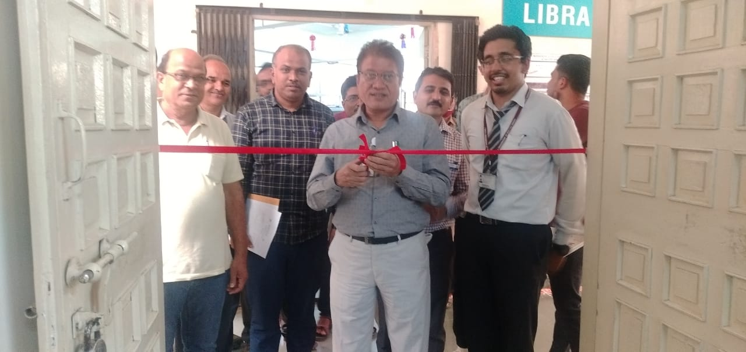BE PROJECT COMPETITION (EXHIBITION)

Glimpses of the Project Competition [Exhibition]

3. ACTIVITIES ORGANIZED

3.1 FDP/STTP ORGANIZED BY THE DEPARTMENT
Term One
S N | Name of faculty coordinator | Title of the FDP/STTP/WS/Seminar/Symposium | Duration/ Dates | No. of Participants | Funding Agency  (If any) and Amount (Rs.)
01 | Dr Mangesh R Phate | AICTE-ISTE Sponsored One week (6 days) online Induction/Refresher Program on ‘Advances in Engineering’@ Institute Level | 08/12/2021 to 14/12/2021 | 100 | ISTE (93,000/-)  Reference No ISTE/AICTE-ISTE Induction Refresher program/2021-22/28/2021 Dated 28.11.2021

Term Two
S N | Name of faculty coordinator | Title of the FDP/STTP/WS/Seminar/Symposium | Duration/ Dates | No. of Participants | Funding Agency  (If any) and Amount (Rs.)
3.2 SEMINARS/ WORKSHOPS/ WEBINARS ORGANIZED BY THE DEPARTMENT
Term One
S N | Name of Coordinator/s | Title of the Seminar/Webinar | Duration/ Dates | No. of Participants | Funding Agency  (If any) and Amount (Rs.)
01 | Dr S H Wankhade | Conducted Webinar on “Developing a culture of Innovation '' on the occasion of Engineer’s Day Celebration by Mr Ramana Ramanathan, Sr Vice President, TCS; First Mission Director, Atal Innovation Mission (AIM) and Additional Secy Niti Aayog. | 15/09/2021 | 150 | AISSMSCOE
02 | Dr S H Wankhade | National Level Event on ‘India in 2040-CD/Soap Art’ | 13/10/2021 - 21/10/2021 | 20 | AISSMSCOE
03 | Dr S H Wankhade | Conducted a webinar on “Challenge based Higher Education at LUT University, Finland” | 30/11/2021 | 50 | IIC and TRIZ Chapter.
04 | N N Gotkhindikar | Career opportunities after BE Mech and Gate 2022 | 02/12/2021 | 64 | NA
05 | N N Gotkhindikar | First Regional Conclave of Students’ Chapter of The Institution of Engineers (India) for Western Region for the year 2021-22 , Paper presentation | 09-10 December | 78 | IEEE, AISSMS COE
06 | Dr (Mrs) P S Gajjal | Expert Talk  Analysis of Beams by CREO software, | 25th Dec 2021 | 112

Term Two
S N | Name of Coordinator/s | Title of the Seminar/Webinar | Duration/ Dates | No. of Participants | Funding Agency  (If any) and Amount (Rs.)
01 | Dr M R Phate | Identifying Intellectual property right component ar the early stage of Innovation | 09 March 2022 | 65 | IPR office Government of India
02 | Dr S H Wankhade, M P Bauskar | Introduction to Lean Six Sigma and its Importance to Professionals | 05/03/2022 | 85 | IIC, AIQM India, TRIZ Association of Asia & AISSMSCOE
03 | Dr S H Wankhade | TRIZ based Innovation | 10/03/2022 | 82 | IIC, TRIZ Association of Asia, AISSMSCOE
04 | N N Gotkhindikar | Importance of Aptitude for campusing | 24/03/2022 | 68 | IMech E ,AISSMS COE
05 | Dr C S Choudhari | Expert talk on “ Design Thinking and Value Engineering” | 12 may 2022 | 65 | AISSMS COE
06 | Dr P S Gajjal | Expert talk on Industrial Large Assembly Management Systems for Better Product Development | 1st April 2022 | 82 | AISSMS COE
07 | Dr P S Gajjal | Presentation Skills and Motivational Thoughts” | 17/03/22 | 93 | AISSMS COE
08 | Dr S H Wankhade | Expert lecture on “Structured approach towards productivity improvement in manufacturing industries” | 17/05/2022 | 63 | AISSMS COE
09 | Dr D Y Dhande  Prof P V Deshmukh | Injection Molding of Plastics | 28/05/22 | 55 | AISSMSCOE

3.3 CONFERENCES/ SYMPOSIUMS ORGANIZED BY THE DEPARTMENT
Term One
S N | Name of Coordinator/s | Title of the Conference / Symposium | Duration/ Dates | No. of Participants | Funding Agency  (If any) and Amount (Rs.)

Term Two
S N | Name of Coordinator/s | Title of the Conference / Symposium | Duration/ Dates | No. of Participants | Funding Agency  (If any) and Amount (Rs.)
3.4 EXTENSION ACTIVITIES CONDUCTED BY THE DEPARTMENT (Social activities / Quizzes at national/international level/any other activity)
Term One
S N | Name of Faculty Coordinator | Details of activity conducted | Date | Number of beneficiaries
1 | Dr A V Waghmare, Dr C S Choudhari | Campus Engagement Program - Knorr Bremse Technology (I) Pvt Ltd. Pune | 24 August 2021 | 245
2 | Dr C S Choudhari | GK Quiz “ India at Olympics” | 24th July to 08 August 2021 | 254
3 | Dr C S Choudhari  Dr D Y Dhande | National Level Quiz on “Innovation and start Up” | 11 October to 16 October 2021 | 329
4

Term Two
S N | Name of Faculty Coordinator | Details of activity conducted | Date | Number of beneficiaries
1

3.5 MOU SIGNED WITH ACADEMIC AND PROFESSIONAL ORGANIZATIONS
Term One
Sr. No. | Faculty Coordinator | Name of Organization | Date  of MoU Signed | Valid upto  dd/mm/yyyy
1. | Dr D Y Dhande | University Therengganu, Malysia | 01/07/2021 | 30/06/2023

Term Two
Sr. No. | Faculty Coordinator | Name of Organization | Date  of MoU Signed | Valid upto  dd/mm/yyyy
01 | Dr B D Bachchhav | Institute of Systems | 04/04/2022 | 03/04/2025
02 | Dr B D Bachchhav  Dr S V Chaitanya | SSIG Manufacturing Advancements Pvt. Ltd., Pune | April 2022 | April 2025
03 | Dr S H Wankhade | U B Cryogenic Solutions LLP, Pune | March 2022 | April 2027

Total Functional / Live MoU initiated by Department
Sr. No. | Faculty Coordinator | Name of Organisation | Date  of MoU Signed | Valid upto  dd/mm/yyyy
1 | M P Bauskar | Mettechnik, MIDC Bhosari Pune 411026 | 10/10/2019 | 09/10/2024

3.6 STUDENTS’ CHAPTERS /CLUBS
Sr. No | Name of Students’ Chapter | Number of Student Members
1 | SAEINDIA Collegiate Club | 120
2 | Team m-BAJA | 30
3 | Team Formula student | 22
4 | Team Garudashwa | 21
5 | Team Go-kart | 28
6 | Team Reev | 25
7 | ISHRAE | –
8 | SAE SUPRA | 25
9 | Solar Energy Society of India (SESI) | 20
10 | Institution of Engineers India IE (I) | --
11 | Indian Society of technical education ISTE | 120
12 | IMechE | 87

EVENTS ORGANISED (By Students’ Chapters / Clubs and others)
Name of Students’ Chapter: SAEINDIA Collegiate Club
Faculty Advisor: Dr A V Waghmare and Dr C S Dharankar
Term One
SN | Event name and details of event | Name of chief guest, judges etc. | Duration and Dates | Number of beneficiaries

Term Two
SN | Event name and details of event | Name of chief guest, judges etc. | Duration and Dates | Number of beneficiaries

Name of Students’ Chapter: Institution of Engineers India IE(I)
Faculty Advisor: Mr. M U GAN

Term One
SN | Event name and details of event | Name of chief guest, judges etc. | Duration and Dates | Number of beneficiaries
1 | Expert lecture on “Introduction to CREO & ANSYS” | Mr Apoorv Bapat | 7 September 2021,10.00 am to 12.00pm | 110

Term Two
SN | Event name and details of event | Name of chief guest, judges etc. | Duration and Dates | Number of beneficiaries
1 | Name of the Activity: Expert Talk  Objectives of the activity: Enhancement of presentation skills and a thought of motivation in the students for upgrading themselves. | Dr Rakesh Himte | 17th March 2022 @ 09:00 am | 92

3.7 SOCIAL ACTIVITIES ORGANISED (NSS, Women empowerment, Awareness Programs, etc.)
Term One
Faculty coordinator | Name of Activity | Date, Duration | Number of students involved

Term Two
Faculty coordinator | Name of Activity | Date, Duration | Number of students involved

3.8 PARENT MEETING
Faculty Coordinator | Day and Date | Details of Parent meetings organized | Number of Parents attended
A T Thombare | SE Mech A and B and SE MS  05/03/22  (Saturday )  TE Mech A and B  12/03/22  (Saturday ) | Parents meet for Mechanical Engineering department was scheduled in March 2022.The meet was arranged on Microsoft Teams platform. Number of points related to department, academics, Training and placement, sandwich training ,examination etc. were discussed by respective class GFM, HOD, sandwich coordinator, CITP head and Examination coordinator.  Suggestions from parents were collected during meeting as well as feedback link is shared with parents | 155

3.9 ALUMNI MEET
Faculty Coordinator | Day and Date | Details of Alumni meetings organized | Number of Alumni attended
Dr.A.V. Waghmare  Dr.S.R.Patil | Saturday, 27/11/2021 | All alumni interacted with faculties of the department. | 93

3.10 SUPPORT FROM ALUMNI
Term One
Sr No | Name of Alumni | Position and Organisation | Batch  (e.g. 2014 – 2018) | Details of Support | Date

Term Two
Sr No | Name of Alumni | Position and Organisation | Batch  (e.g. 2014 – 2018) | Details of Support | Date

3.11 INTERACTION WITH ALUMNI
Term One
S N | Name of Alumni and Activity coordinator | Details of Activity conducted | Date and duration | Total Number of beneficiaries
1 | 1.Mr.Nainish Tikoo  2.Mr.Supreet Upadhyay  3.Mr.Munaf Abdul Tisekar  Coordinator- Prof. M.M. Kondhare,Media Team and Prof.S.R.Patil | All three alumni interacted with students and faculties of the department in the prog.of “Coffee and Conversation with Alumni”. | Saturday  14/08/2021. | 78

Term Two
S N | Name of Alumni and Activity coordinator | Details of Activity conducted | Date and duration | Total Number of beneficiaries

3.12 DETAILS OF STUDENT COUNSELLING AND CAREER GUIDANCE AT THE DEPARTMENT LEVEL
Number of students referred for counselling
Number of Faculty referred for counselling

Faculty coordinator | CAREER GUIDANCE ACTIVITY DETAILS
N N Gotkhindikar | Career opportunities after BE Mech and Gate 2022

(Start on new page) Few good photographs related to different activities organized
Size of photo 5 cm x 7 cm with captions
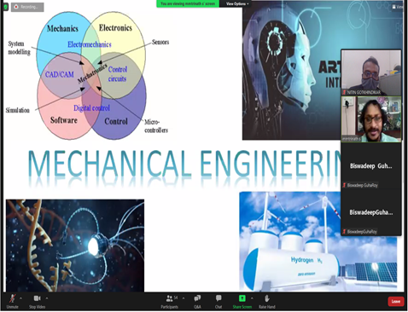  Mode Online for Career Guidance | 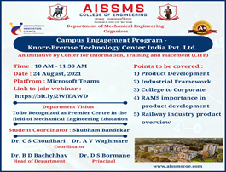
 | Campus Engagement Program by Knorr Bremse Pune
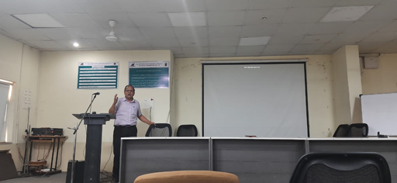 | 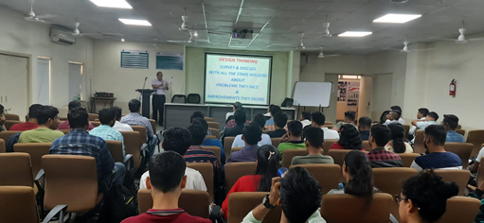
Expert talk by Mr Kiran Nawathe, Engineering Cluster Pune on Design Thinking and value Engineering (12/05/2022)
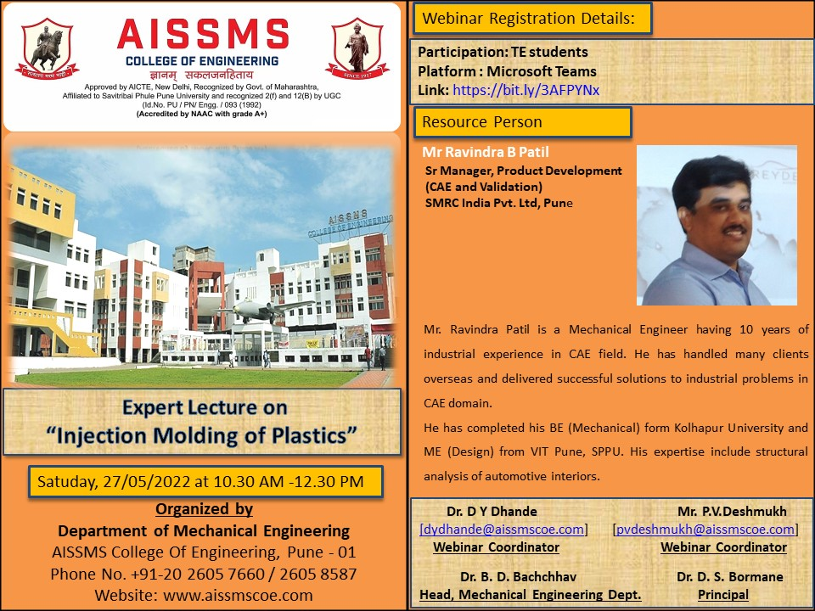
Expert Lecture on “Injection Moulding of Plastics” on 27/05/2022
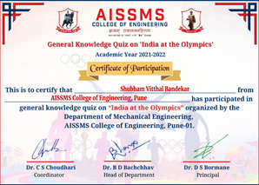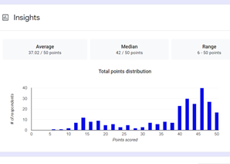
National level online quiz on “ India at Olympics” during 24 July 2021 - 08 August 2021

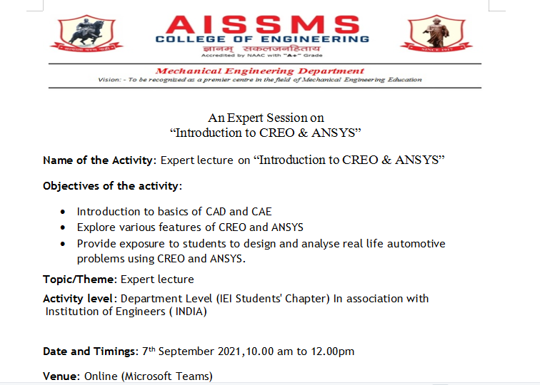
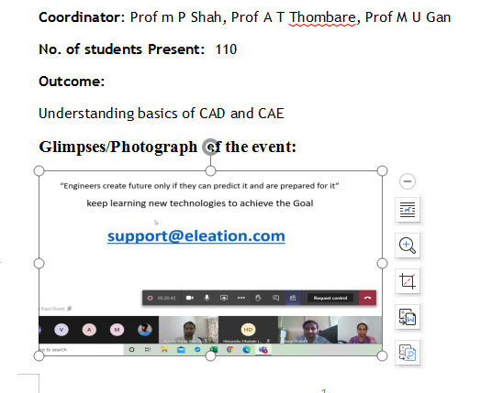

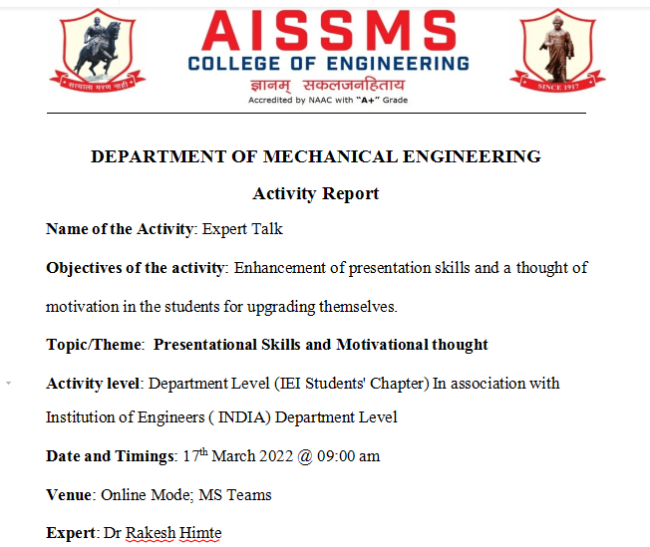
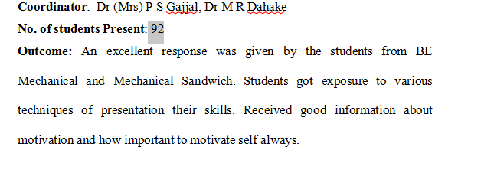

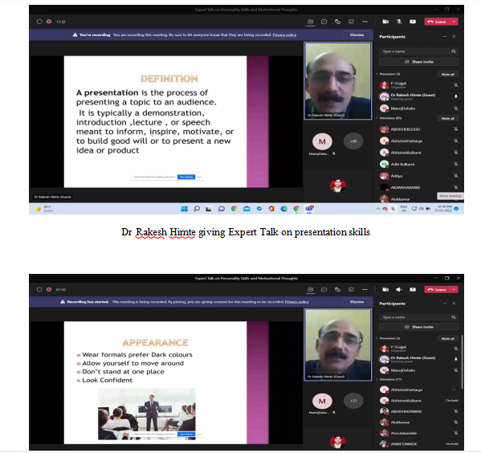

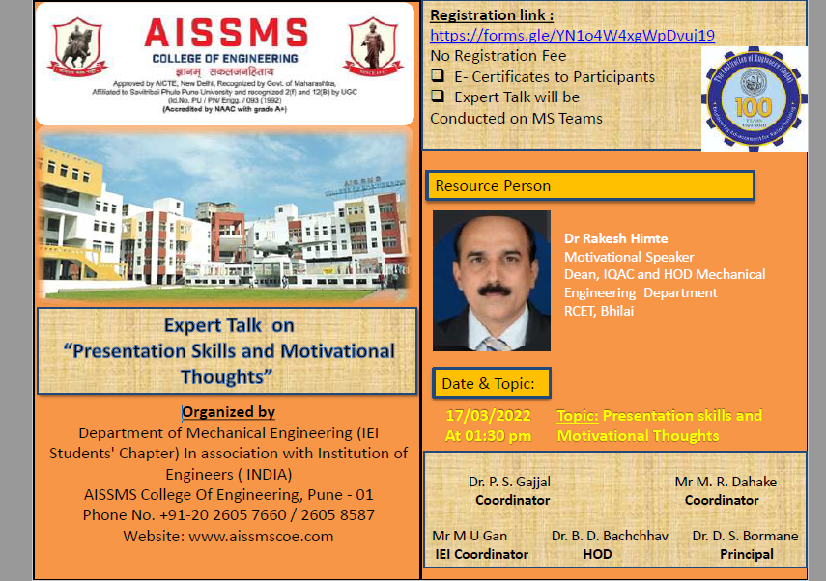

- RESEARCH CONTRIBUTION

4.1 FUNDED RESEARCH PROJECT
Term One
S N | Principal Investigator | Title of the Project | Amount Received (Rs) | Funding Agency

Term Two
S N | Principal Investigator | Title of the Project | Amount Received (Rs) | Funding Agency
1 | Dr B D Bachchhav  Dr D Y Dhande | AICTE- Grant-in-aid under the scheme  MODROB-ASP for the Project entitled:  “Modernisation of Tribology Laboratory for  Performance Evaluation of Nano/Bio  Lubricants” | 17,18,500/- | AICTE

FUNDING RECEIVED FOR ANY OTHER ACTIVITY
Term One
S N | Faculty Coordinator | Title of the activity | Amount Received (Rs) | Funding Agency
1 | Dr C S Dharankar/ Mr S A Ansari | M - BAJA | 515000.00 | AISSMS Society Pune
2 | Dr A A Apte | E - BAJA | 80000.00 | AISSMS Society Pune
3 | Dr S H Wankhade | SUPRA | 300000.00 | AISSMS Society Pune
4 | Dr M R Phate | Gokart and Reev | 300000.00 | AISSMS Society Pune
5 | Dr D Y Dhande | Aerodesign (Garudashwa | 484000.00 | AISSMS Society Pune
6 | Mr M S Swami/Dr M R Dahake | Eifi Cycle | 52074.00 | AISSMS Society Pune

Term Two
S N | Faculty Coordinator | Title of the activity | Amount Received (Rs) | Funding Agency
1 | Dr C S Dharankar/ Mr S A Ansari | M - BAJA | 515000.00 | AISSMS Society Pune
2 | Dr A A Apte | E - BAJA | 80000.00 | AISSMS Society Pune
3 | Dr S H Wankhade | SUPRA | 300000.00 | AISSMS Society Pune
4 | Dr M R Phate | Gokart and Reev | 300000.00 | AISSMS Society Pune
5 | Dr D Y Dhande | Aerodesign (Garudashwa | 484000.00 | AISSMS Society Pune
6 | Mr M S Swami/Dr M R Dahake | Eifi Cycle | 52074.00 | AISSMS Society Pune

4.2 TESTING AND CONSULTANCY
Term One
Sr. No. | Faculty Coordinator | Details of Testing & Consultancy Conducted | Total Revenue Generated (Rs.)
01 | Dr Mangesh R Phate | X Int Katraj Pune (testing) in process | 3000/-

Term Two
Sr. No. | Faculty Coordinator | Details of Testing & Consultancy Conducted | Total Revenue Generated (Rs.)
1. | Dr D Y Dhande  Dr C S Dharankar  Mr M S Swami | Bearing Life Testing  (Work in process, PO confirmation received, PO yet to be received) | 7.50 Lacs
2 | Dr D G Bhalke  Dr C S Choudhari | Consultancy to NAAC accreditation institute “Prathibha College of Arts, Commerce and computer studies, Pune” | 1,00,000/-

4.3 PATENTS, COPYRIGHT, TRADEMARK AND OTHER (IPR)
Term One
Sr No. | Name of Faculty | Name of the Patent | Patent Number and Date | Type (National/  International/Com  mercialized)
1

Term Two
Sr No. | Name of Faculty | Name of the Patent | Patent Number and Date | Type (National/  International/Com  mercialized)

PUBLICATIONS
4.4 PAPERS PUBLISHED/ PRESENTED IN PROCEEDINGS OF CONFERENCES
Term One
S. No | Authors | Document Details | Year | Conference Details | ISBN | Organized  by
01 | Jitendra Singh Pal,  C S Choudhari, S N Sapali, T R Anil | Energy  analysis of  waste  incineration  plant used  in marine  vessels | 2021 | 11th International conference on Sustainable Waste Management and Circular Economy & IPLA Global Forum 2021 during December 01-04 , 2021 |  | International Society of Waste Management, Air and Water

Term Two
S. No | Authors | Document Details | Year | Conference Details | ISBN | Organized  by
1 | M P Bauskar | Published Research Paper in Conference ON Experimental Analysis of E glass & Carbon Fibre Composite | 2022 | NCIET |  | AISSMSCOE PUNE
2 | Mrs. M P Shah, Dr Sarang Pande, Dr D R Patel | Additive manufacturing integrated Casting- A review.  Volume 62, Part 13,  Pages 6913-7340 (2022) | 2022 | International Conference on Additive Manufacturing and Advanced Materials (AM2) | 22147853 | PDDU

4.5 PAPERS PUBLISHED IN JOURNALS
Term One
S. No | Authors | Document Details | Year | Source Details | ISBN/  ISSN | Publisher
1 | C S Choudhari, D Y Dhande | Smart Technologies to mitigate and manage the pandemic: Today and tomorrow | 2021 | SAMRIDDHI Vo. 13, Issue 2, 2021 | 2229-7111 | SAMRIDDHI: A journal of Physical sciences, Engineering and Technology
2 | P S Gajjal, S Y Gajjal | Wear behaviour of  Sintered bearings using  additives in dry  sliding | 2021 | Materials  Today  Proceedings | Doi.org/10.116/j.matpr.2021.01.413 | Elsevier
3 | P S Gajjal, S Y Gajjal | Wear of Dry Sintered  Iron Bearings with  Molybdenum  Disulphide and  Zinc Stearte | 2021 | IUP Journal of Mechanical Engineering | ISSN: 0974-6536 | IUP
4 | P S Gajjal, Yadnik Kude | Design of Planetary Gear Train for Geared Rotary Actuator | 2021 | IOP: Material science and Engineering | doi:10.1088/1757-899X/1170/1/012005 | IOP Science
5 | P S Gajjal | Paper on wind load estimation and truss optimization of parabolic radio dish antenna | 2021 | IJSER | 2229-5518
6. | Dr D Y Dhande, | Extraction of bioethanol from waste pomegranate fruits as a  potential feedstock and its  blending effects on a  performance of a single  cylinder SI engine | 2021 | Renewable and Sustainable Energy Reviews | ISSN : 13640321 | Elseveir BV
7. | Dr D Y Dhande | Experimental Investigation of Spark Ignition Engine Performance Fuelled with various Pomegranate Ethanol-Gasoline Mixtures | 2021 | Journal of The Institution of Engineers (India): Series C | · Print ISSN :2250-0545  · Online ISSN:2250-0553 | Springer
8 | Dr. M.R.Phate Mr. Prateek Gaikwad,  Shraddha Toney | Analysis of Seat to Head Transmissibility of the Seated Human Body using Artificial Neural Network | 2021 | Journal of The Institution of Engineers (India): Series C | · Print ISSN :2250-0545  · Online ISSN:2250-0553 | Springer
9 |  |  | 2022

Term Two
S. No | Authors | Document Details | Year | Source Details | ISBN/  ISSN | Publisher
1 | Dinesh Y. Dhande, Chandrakishore S. Choudhari, Dwarkoba P. Gaikwad,  Nazaruddin Sinaga & Kiran B. Dahe | Prediction of spark ignition engine performance  with bioethanol-gasoline mixes using a multilayer  perception model | 2022 | Vol 40, issue 2, 2022 | Print (ISSN) 1091-6466  Online (ISSN) 1532-2459 | Petroleum Science and technology, Taylor & Francis
2 | Mangesh R Phate | Analysis of Seat to Head Transmissibility of the Seated Human Body using Artificial Neural Network | 2022 | Published | [2250-0545] | Springer. Institution of Engineers, India Series C
3 | Mangesh R Phate | Multi-response Optimization and Analysis of Al/B4Cp MMC EDM using Grey Relational Analysis | 2022 | 19(1) Jan 2022  PP: 39-55 | [1823-5514] | Journal of mechanical Engineering
4 | Mangesh R Phate | Evaluation of Human Seated Posture Exposes to Low Frequency Vibrations using Biodynamic Model.  to the journal | 2022 | Accepted |  | Inderscience , International Journal of Vehicle Safety
5 | P S Gajjal, G S Lathkar | Fault diagnosis in an optimized rolling bearing using an intelligent approach | 2022 | https://doi.org/10.1007/s00419-022-02134-0 |  | Archive of Applied Mechanics
6 | P S Gajjal S Y Gajjal | A Novel Tuned Antlion-Grey Relational Dry Sintered Bearing for Bore Application | 2022 | Accepted |  | Journal of the Brazilian Society of Mechanical Sciences and Engineering.
7 | P S Gajjal, Yadnik Kude | Mathematical Model of Planetary Gear Train for Geared Rotary Actuator International | 2022 | Vol. 7 No. 4 April, 2022, Pp 619 – 624, ISSN: 0974-5823 | International Journal of Mechanical Engineering,  Vol. 7 No. 4 April, 2022, Pp 619 – 624, ISSN: 0974-5823 | International Journal of Mechanical Engineering
8 | Bachchhav, B.D. and Kathamore, P.S. | Wear behavior of environment friendly trimethylolpropane trioleate-based lubricant", Industrial Lubrication and Tribology | 2022 | Published | https://doi.org/10.1108/ILT-12-2021-0469 | Industrial Lubrication and Tribology, Vol. 74 No. 5,
9 | Bachchhav, B.D. and Kathamore, P.S. | Tribological investigations of trimethylolpropane trioleate bio-based lubricants | 2022 | Published | https://doi.org/10.1108/ILT-05-2021-0157 | Industrial Lubrication and Tribology, Vol. 73 No. 7, pp. 1074-1083
10 | Ashishkumar Gavande  S.R.Patil | Manufacturing and Testing of an Infinitely Variable Transmission (IVT) Test Rig | 2022 | Vol.XV &  Issue No.06 | Print,  ISSN 0970-2555 | Industrial Engineering Journal
11 | M P Bauskar | Published Research Paper on “Design And Development of Ultrasonic Plastic Welding Machine” | 2022 | Published | ISSN2582-7421 | International Journal of Research Publication and Reviews
12 | Dr D Y Dhande  DR C S Choudhari  DR D P Gaikwad | Development of Artificial Neural Network to predict the performance of Spark Ignition Engine fueled with waste pomegranate ethanol blends | 2022 | Information Processing in Agriculture | 2214-3173 | Elseveir BV
13 | Dr D P Gaikwad  Dr D Y Dhande | Video Summarization Using Deep Learning for Cricket Highlights Generation. | 2022 | Journal of Scientific Research, 14(2), 533–544. | 2070-0237
14 | Dr S V Chaitanya  Dr D Y Dhande | Complex assembly Analysis for Geometric and Dimensional Tolerance to obtain selective assembly from partitioned bins using a multi-objective approach to control clearance variation of IC Engine | 2022 | Journal of The Institution of Engineers (India): Series C | Print ISSN :2250-0545  Online ISSN:2250-0553 | Springer
15 | Dr D Y Dhande  Dr C S Choudhari  Dr D P Gaikwad | Evaluation of Emission Characteristics and Performance of Pomegranate Ethanol Blended S. I. Engine using Artificial Neural Network and Rule Learner Classifier | 2022 | Journal of The Institution of Engineers (India): Series A (2022) | Electronic ISSN  2250-2157  Print ISSN  2250-2149 | Springer
16 | N N Gotkhindikar et.al | A Novel FDM Based Additive Manufacturing of PLA  Components Using Optimized Deep Learning Strategy | 2022 | Published | 2321-9653 | International Journal for Research in Applied Science & Engineering Technology
17 | Sourabh Hole, C S Choudhari | Design and development of hot air engine | 2022 | International Journal of advance research in science, communication and technology, Vol. 2, Issue 5, May 22  doi: 10.48175/IJARSCT-4125 | ISSN: 2581-9429 | IJARSCT
18 | S.R.Patil,  Ashishkumar Gavande | Manufacturing and Testing of an Infinitely Variable Transmission (IVT) Test Rig | 2022 | Industrial Engineering Journal  Vol.XV  Issue No.06 | ISSN 0970-2555 | Indian Institute of Industrial Engineering

4.6 BOOK / ARTICLE PUBLICATIONS
Term One
Author | Title of the Book | Published by | ISBN | Year
P S Gajjal, S Y Gajjal, G S Lathkar | Investigations of wear behaviour of Journal Bearing Materials | LNME Springer | 978-981-16-3135-1_15 | 2021

Term Two
Author | Title of the Book | Published by | ISBN | Year

4.7 RESEARCH CITATIONS (Source of Data: Google scholar) (As on 30th May)
Name of faculty | Citations, h-index, i10 index | Name of faculty | Citations, h-index, i10 index
Dr B D Bachchhav | 90,5,1
Dr M R Phate | 336,10,10
Dr Mrs P S Gajjal | 77,5,3
Dr M S Deshmukh | 13,2,0
Dr A V Waghmare | 168,3,2
Dr D Y Dhande | 183,6,5
Dr S H Wankhade | 7,1,0
Dr C S Choudhari | 132, 4, 1
Dr S V Chaitanya | 11,2,0
Mr S R Patil | 41,3,1
Mr P V Deshmukh | 10,2,0
Dr C S Dharankar | 30,3,1
Dr S J Navale | 32,2,1
Mr P S Aglawe | 2,1,0
Dr M R Dahake | 50, 3, 2
Mr M P Bauskar | 11,2,0
Mr N N Gotkhindikar | 05,1,0
Dr M M Sayyad | 88, 3, 3
Dr D S Malwad | 71, 2, 2
Mr Shahid Ali | 35,2,1
4.8 ME AWARDED
Sr No | Name of Supervisor | Title of Thesis | Name of Candidate
01 | Dr Mangesh Phate | Design and Development Lower Limb Exoskeleton for Rehibition | Suyog B. Bhale
02 | Dr B D Bachchhav | Tribological Behavior of Al6061-SiC Hybrid MMC | Viraj Prabhu
03 | DR D Y Dhande | “Design and Development of Harmonic Gear Drive Using Additive Manufacturing” | Utkarsh Rathod
04

4.9 PhD GUIDE DETAILS
Name of Faculty who are PhD Supervisor | Number of Scholars Registered
Dr S V Chaitanya | 02
Dr D Y Dhande | 03
Dr C S Choudhari | 02
Dr A V Waghmare | 02
Dr S H Wankhade | 02
Dr C S Dharankar | 02
Dr B D Bachchhav | 02
4.10 PhD AWARDED (For departments having Ph.D research centers)
Sr No | Name of Supervisor | Title of Thesis | Name of Candidate

Few good photographs related to different activities organized under research, innovation
Size of photo 5 cm x 7 cm with captions

- INTERACTION WITH INDUSTRY

5.1 INDUSTRY VISITS ORGANISED
Term One
Sr. No. | Faculty Coordinator | Class and Number of students attended | Industry Name and Address | Date of visit
1 | NIL Due to pandemic

Term Two
Sr. No. | Faculty Coordinator | Class and Number of students attended | Industry Name and Address | Date of visit
1 | Dr. M R Dahake Dr S J Navale Mr G P Lohar | SE M A SE M B  SE M/S | Diesel Locomotive Shed Pune | 24th, 25th and 26th March 2022
2 | Dr. M R Dahake Mr G P Lolhar | TE M B | Vertex Infracore Solutions Pune | 04/05/2022
3 | Dr P S Gajjal Dr M R Dahake Mr M S swami | Electric Vehicle Honour Course Students | Pune Alternate Fuel Conclave | 05/04/2022

5.2 EXPERT LECTURES / WEBINARS DELIVERED BY INDUSTRY EXPERTS
Term One
Sr. No. | Faculty Coordinator | Class  (Number of students attended) | Name, Industry, designation and contact details of Expert | Topic | Date
1 | Dr B D Bachchhav | SE MS | Mr Yashwant Mahankal
2 | Dr Mrs P S Gajjal | 109 | Mr. Shrishant Patil  PTC Softcell Pune | Digital solutions for real world mechanical engineering design challenges | 25/12/2021
3 | Dr S V Chaitanya | 26 | Mr Sagar Kenjale  Asst Manager, Burckhardt Compression India Ltd. Pune | Excel for freshers | 25/10/2021
4 | Mrs A A Tonde/ Mrs M P Shah | 300 | Mr. Apoorv Bapat  CEO, Eleation Pune | Introduction to CREO and ANSYS | 07/09/2021
5 | Dr D S Malwad | 150 | Mr. Suraj Ghante  technical Lead, TTL Pune | Role of CAD in Design of Automotive Systems | 19/11/2021

Term Two
Sr. No. | Faculty Coordinator | Class  (Number of students attended) | Name, Industry, designation and contact details of Expert | Topic | Date
1 | Dr B D Bachchhav | SE MS  (56) | Principal Consultant  Institute of Systems  Pune | Lean manufacturing and quality systems | 04/04/2022
2 | Dr Mrs P S Gajjal | 98 | Dr Rakesh Himte  Motivational Speaker  Nagpur | Presentation Skills and Motivational Thoughts | 17/3/22
3 | Dr D Y Dhande | 55 | Mr Ravi Patil  Sr Manager (CAE & Validation), SMRC India Pvt LTD, Pune | Injection moulding of Plastics | 28/05/2022
4 | Dr C S Choudhari | 65 | Mr Kiran Nawathe  Project Leader, Engineering Cluster Pune | Design Thinking and value Engineering | 12/05/2022

5.3 INDUSTRY – SPONSORED PROJECTS (UG/PG) ((Excluding Sandwich Projects)
Sr. No. | Name of Project guide | Title of Industry Sponsored Project | Name of Sponsoring Industry
1 | Dr. M. M. Sayyad | New Safety ideas for Overhead Crane | Konecranes
2 | Dr. M. M. Sayyad | EOT Cranes in 2030 | Konecranes
3 | Dr C S Choudhari | “Analytically Design of Hot Air Engine and manufacturing of Components and assembly” | Engineering Cluster, Pune
4 | Dr. M. M. Sayyad | Optimizing the Crane parts design –Using Generative design Methodology | Konecranes
5 | Mr M P Bauskar | Design and Development of Ultrasonic welding Machine for Joining Thermoplastics | Sanitek Plasto Weld Pvt Ltd
6 | N N Gotkhindikar | Design and optimized new bins & large containers for waste collection | TCS
7 | Dr.S.R.Patil | Machining Cycle Time Optimization of CNC-Regulator Body | Yawalkar Industries, Pune
8 | Dr S.J.Navale | Analysis of hydro jet pump used in Propulsion System of Combat Vehicle | VRDE,Ahmednagar
9 | M.S.Swami | Design, Modelling and Analysis of Airboat | DRDO
10 | Dr M.R.Phate | Design and fabrication of an automated conveyor system and actuator system through cloud | Manisha Industries
11 | S.S.Patil | Ground variator pulley vibration at high RPM | New Holland
12 | S.T.Gadhe | Optimization of turning parameters of AISI – 1016 using TAGUCHI method | SAMVINSAN ENGINEERING Pvt Ltd

5.4 MOU SIGNED WITH INDUSTRY
Term One
Sr. No. | Faculty Coordinator | Name of Industry | Date  of MoU Signed | Valid upto  c
01 | Dr C S Choudhari, Dr A V Waghmare | Vimal Nourishment Technologies Pvt. Ltd. Pune | 04/08/2021 | 04/08/2024
02 | Dr A V Waghmare | Ameya Industries Pune | 31/08/2021 | Till it is discontinued by both parties.

Term Two
Sr. No. | Faculty Coordinator | Name of Industry | Date  of MoU Signed | Valid upto  (dd/mm/yyyy)
1 | Dr. B. D. Bachhav  Dr. C. S. Chaudhari  Dr. P. S. Gajjal | Setco Spindles India (Pvt) Ltd Pune | 18/02/2022 | 17/02/2025
2 | Dr. B. D. Bachhav | Stead Solve Design and Manufacturing Solutions LLP Pune | 23/02/2022 | 22/02/2025
3 | Dr. S H Wankhade | UB Cryogenic Solutions LLP, Pune | 04/03/2022 | 03/03/2025
4 | Dr. B. D. Bachchhav | Institute of Systems Pune. | 04/04/2022 | 03/04/2025
5 | Dr. B. D Bachchhav  Dr S V Chaitanya | SSIG Manufacturing Advancements Pvt Ltd. Pune | 27/04/2022 | 26/04/2025
6 | Mr M S Swami | Pranita Engineering Works Ltd Pune | 08/03/2022 | 07/03/2023

TOTAL FUNCTIONAL / LIVE MOU INITIATED BY THE DEPARTMENT
Sr. No. | Faculty Coordinator | Name of Industry | Date  of MoU Signed | Valid upto  (dd/mm/yyyy)
01 | Dr C S Choudhari, Dr A V Waghmare | Vimal Nourishment Technologies Pvt. Ltd. Pune | 04/08/2021 | 04/08/2024
02 | Dr A V Waghmare | Ameya Industries Pune | 31/08/2021 | Till it is discontinued by both parties.
03 | Dr. B. D. Bachhav  Dr. C. S. Chaudhari  Dr. P. S. Gajjal | Setco Spindles India (Pvt) Ltd Pune | 18/02/2022 | 17/02/2025
04 | Dr. B. D. Bachhav | Stead Solve Design and Manufacturing Solutions LLP Pune | 23/02/2022 | 22/02/2025
05 | Dr. S H Wankhade | UB Cryogenic Solutions LLP, Pune | 04/03/2022 | 03/03/2025
06 | Dr. B. D. Bachchhav | Institute of Systems Pune. | 04/04/2022 | 03/04/2025
07 | Dr. B. D Bachchhav  Dr S V Chaitanya | SSIG Manufacturing Advancements Pvt Ltd. Pune | 27/04/2022 | 26/04/2025
08 | Mr M S Swami | Pranita Engineering Works Ltd Pune | 08/03/2022 | 07/03/2023
09 | Dr D Y Dhande | University of Therengganu Malaysia | 01/07/2021 | 30/06/2023
10 | Mr. M S Swami | Firodiya & Naik Consulting GBR, Berlin Germany | 05/01/2021 | 04/01/2022
11 | Dr. S V Chaitanya | Seinumero Nirman Pvt Ltd Pune | 01/01/2021 | 31/12/2023
12 | Mr. M P Bauskar | Mettchnik Pvt Ltd Pune | 31/12/2019 | 31/12/2020
13 | Mr P S Aglawe | eAddict Mobility Solutions Pvt Ltd Pune | 21/08/2017 | 20/08/2022
14 | Dr S V Chaitanya | Vishwadeep Enterprises | 13/07/2017 | 12/07/2022

5.5 FACULTY MEMBERS UNDERGONE INDUSTRIAL TRAINING
Term One
Sr. No. | Name of Faculty | Name of Industry | Dates and Duration
01 | Dr C S Choudhari | Vimal Nourishment Technologies Pvt. Ltd. Pune | Two Weeks (14/07/2021 to 27/07/2021)
02 | Dr A V Waghmare | Vimal Nourishment Technologies Pvt. Ltd. Pune | Two Weeks (14/07/2021 to 27/07/2021)

Term Two
Sr. No. | Name of Faculty | Name of Industry | Dates and Duration

5.6 STUDENTS UNDERGONE IN-PLANT TRAINING AND (OR) INTERNSHIP PROGRAMME (Excluding Sandwich Training)
Sr. No. | Name of Student | Name of Industry | Class | Start Date | End Date | Duration (No. of Days)
1 | Aniruddha Kulkarni | CricStox Pvt Ltd | TE A | 24/12/2021 | 31/01/2022 | 48
2 | Aniket Rajendra Kadam | Simira Healthcare Private Limited | TE A | 01/01/2022 | 31/01/2022 | 31
3 | Rutuja Kank | Rieter India Private Limited | TE A | 05/01/2022 | 05/02/2022 | 30
4 | Vedant Chavan | Wipro PARI | TE A | 03/01/2022 | 04/02/2022 | 31
5 | Sayali Santosh Koli | Shri Jagadamba Engineering Works Karad. | TE B | 20/12/2021 | 20/1/2022 | 30
6 | Darshan Dayanand Gawas | Fabchair | TE A | 15/12/2021 | 30/01/2022 | 45
7 | Shivam Nitin Deshmukh | Shree Motors (Maruti Suzuki Arena) | TE A | 11/1/2022 | 11/2/2022 | 28
8 | Om Bayas | SAJ Test Plant. | TE A | 15/12/2021 | 13/01/2022 | 30
9 | Balraj Waghmare | ARAI CHAKAN | TE A | 27/12/2021 | 27/01/2022 | 31
10 | Rutuja Jadhav | ARAI, Chakan | TE A | 27/12/21 | 27/01/22 | 31
11 | Shubham sahebrao borade | Shaurya motors pvt .Ltd nashik | TE A | 1/1/2022 | 31/1/2022 | 30
12 | Nitesh umesh pampattiwar | Sai auto (Toyota pro service) | TE B | 3/1/2022 | 4/2/2022 | 31
13 | Vijay Dattatraya Takmoge | Shree Ramkrishna dies and tooling | TE B | 24/12/21 | 24/1/22 | 30
14 | RAHUL MURLIDHAR KOKANE | Ammunition factory khadki, Pune | TE A | 10/01/2022 | 09/02/2022 | 30
15 | Vedant Aher | Brose India Pvt Ltd | TE A | 13/12/2021 | 28/01/2022 | 46
16 | GANESH KHANDALKAR | YBI FOUNDATION | TE A | 03/01/2022 | 28/02/2022 | 56
17 | Omkar Bamble | Ammuniton Factory khadki | TE A | 10-01-2022 | 9-02-2022 | 30
18 | Rohan Chaure | High-Way Automobiles Tata motors authorised service station | TE A | 09/01/2022 | 05/02/2022 | 28
19 | Mane Sangram Bhau | Meritech | TE B | 27/12/2021 | 24/01/2022 | 29
20 | Ranade Saket Ramchandra | DYEGLO PVT. LTD. | TE B | 16/12/2021 | 16/01/2022 | 32
21 | Shree Rajaram Khopade | Nilesh Fabricators | TE A | 01/01/2022 | 31/01/2022 | 31
22 | Nikhil Santosh Bundele | Nikhil Santosh Bundele | TE A | 03/01/2022 | 05/02/2022 | 33
23 | Pratik Kailas Mahajan | MARUTI SUZUKI ARENA (Manraj Motors Pvt. Ltd. Jalgaon) | TE B | 13/01/2022 | 12/02/2022 | 31
24 | SHAMBHURAJ YASHVANT CHAVAN | TRISHUL SERVICE STATION PVT LTD | TE A | 26/12/2021 | 31/01/2022 | 37
25 | RANE MOHIT UMESH | OM ENGINEERING WORKS | TE B | 01/01/2022 | 31/01/2022 | 31
26 | Neha Jitendra Kuchekar | Manufacturing industry | TE A | 05/01/2022 | 05/02/2022 | 30
27 | Parag Rajendra Dhamne | Snehal Industries, Nashik | TE A | 31/12/2021 | 31/01/2022 | 30
28 | Pratik Khagesh Jadhav | Kiran Engeenering Works | TE A | 17/12/2021 | 23/01/2022 | 38
29 | Palange Sejal Devraj | Avi Enterprises | TE B | 13/01/22 | 14/02/22 | 33
30 | Prachi Baban Pandhare | PUSALKAR SU–RAK–SHA COMPONENTS PRIVATE LIMITED | TE B | 02/02/2022 | 07/03/2022 | 35
31 | Ameya Gandhi | Apex Imprints | TE A | 27/12/2021 | 25/01/2022 | 30
32 | MANE VRUNDA PARMESHWAR | Shri Ramkrishna Dies and Tooling | TE B | 24/12/2021 | 24/01/2022 | 30
33 | KSHITIJ MODHE | NSK FABS AND WELDS | TE A | 22-12-2021 | 23-01-2022 | 28
34 | Rawool Sanyogita Sandeep | Mapsons India Private Limited | TE B | 24/12/2021 | 22/01/2022 | 30
35 | Aashish Shashikant Mahale | Hexagon Nutrition Limited | TE B | 4/1/2022 | 4/2/2022 | 31
36 | Gourav Sharma | Shivpratap Engineering Works | TE A | 30/01/22 | 28/02/22 | 30
37 | Rohit Vijay Honwadajkar | VARSHA FORGINGS LIMITED | TE A | 24/01/2022 | 28/02/2022 | 36
38 | Joshi Dnyanesh Vilas | Wingstair Elevators Pvt.Ltd, Pune | TE A | 25th December 2021 | 25th January 2022 | 30
39 | Patil Sarvesh Dinkar | SHREE MOTORS | TE B | 03/01/2022 | 03/02/2022 | 30
40 | Sanskar sunil fursule | Ridewell Motors Nanded | TE A | 03/02/2022 | 03/03/2022 | 30
41 | Durgesh Rajendra Nankar | KSB Ltd., Pimpri. | TE B | 10/01/2022 | 09/02/2022 | 31
42 | Gaurav Singh | Pratyin infotech consulting Pvt. Ltd. | TE B | 31/12/2021 | 31/01/2022 | 31
43 | Omkar Pralhad Landge | SEVA ENGINEERING WORKS PVT LTD | TE B | 03/01/2022 | 02/02/2022 | 30
44 | LAKSHMI BAKSHI | 512 ARMY BASE WORKSHOP | TE A | 5 JAN 2022 | 12 FEB 2022 | 24
45 | Siddharth Shitole | pakshimitra poultry technologies | TE B | 23-12-2021 | 03-02-2022 | 43
46 | Pathan Aman Mainoddin | Shriram automobile,sangola | TE B | 31/12/2021 | 31/01/2022 | 31
47 | Sharvil Sanjay Suradkar | Padmavati Industries Pvt Ltd | TE B | 27/12/2021 | 22/01/2022 | 28
48 | Yash Sanjay Gulhane | Shri Gurukrupa Enterprise (Mundada Fastener) | TE A | 24/12/2021 | 23/01/2022 | 31
49 | Ranjit Baban Kharat | Eleation Institute Pune | TE A | 15/12/2021 | 29/01/2022 | 45
50 | Siddiqui Faizan Babaruddin Siddiqui | RS Engineering Industries | TE B | 03/01/2022 | 04/02/2022 | 30
51 | LANDAGE SHUBHAM PANDURANG | RIETER INDIA PVT. LTD. | TE A | 05/01/2022 | 05/02/2022 | 32
52 | Dhobe Manthan Bhausaheb | High-Way Automobile (Tata Authorised Service Center) | TE A | 09/01/2022 | 09/02/2022 | 30
53 | Dighe Harshad Laxman | Oriental Machine care | TE A | 03-01-2022 | 28--01-2-2022 | 25
54 | Tanvi Gavhane | Kohler power India private limited | TE A | 10/01/2022 | 10 /02/2022 | 32
55 | Urjit Mehta | Meritech.Pvt.Ltd | TE B | 27/12/2021 | 24/1/2022 | 30
56 | Raj Ramdas Nishandat | Salasar Mahindra Autocraft pvt. ltd | TE B | 01/01/2022 | 31/01/2022 | 31
57 | Sunayana Khandu Mohite | Pusalkar SU-RAK-SHA components pvt.ltd | TE B | 03/01/2022 | 03/02/2022 | 32
58 | TAKSAL PRITAM KAILAS | Shilpi Engineering PVT, LTD,Nagothane, Raigad. | TE B | 16/12/2021 | 31/01/2022 | 45
59 | Soham Raghunath Ingale | Ultra Marc Industries | TE A | 20/12/2021 | 22/01/2022 | 27
60 | Rohit Sobale | Yash Plastic and Engineering Works | TE B | 27/12/2021 | 30/01/2022 | 25
61 | Kundan shankar ghorpade | Garaware fulflex india pvt ltd | TE A | 05/02/2022 | 05/03/2022 | 28
62 | Ashwathi Maniyath | Ameya industries | TE B | 15/12/2021 | 31/01/2022 | 45
63 | Sahil Nisar Jahagirdar | Mahabal Metals PVT.LTD | TE A | 28/12/2021 | 28/01/2022 | 31
64 | Kokare Guruprasad Dattaram | Durga Fibres | TE A | 05/01/2022 | 06/02/2022 | 33
65 | Vedant Rameshrao Godbole | Endurance Technology Pvt. Ltd. | TE A | 07/01/2022 | 05/02/2022 | 28
66 | Rajwardhan wagh | PRMOLC INDUSTRIES | TE B | 17/1/2022 | 15/2/2022 | 28
67 | Sandesh Rajaram Deshmukh | Sandesh Fabricators And Glass Centre | TE A | 01/01/2022 | 31/01/2022 | 31
68 | Atharva Prashant Deokar | TRISHUL SERVICE STATION PVT. LTD. | TE A | 26/12/2021 | 31/01/2022 | 31
69 | Nikhil Durgam | ELEATION | TE A | 24/12/2021 | 24/1/2022 | 31
70 | Prajwal Rathod | Leanpro Manufacturing | TE B | 12/01/2022 | 12/02/20122 | 30
71 | NITESH VERMA | MARUTI SUZUKI JAMKASH VECHICLEADES PVT LTD | TE B | 17 Jan 2022 | 17 Feb 2022 | 23
72 | Akash Didbhai | Trisons Engineering | TE A | 01/01/2022 | 31/01/2022 | 31
73 | Atharva Shankar Thube | ALFA LAVAL INDIA PRIVATE LIMITED | TE A | 03-01-2022 | 02-02-2022 | 30
74 | Siddhant Warule | Sandesh fabrications and glass centre | TE B | 15/12/2021 | 15/01/2022 | 30
75 | Sumit Ramesh Shirtode | Tube products of India, Shirwal | TE B | 01/01/22 | 31/01/22 | 28
76 | DHIRAJ RAJESH SHINDE | ARKA ENGINEERING WORKS | TE B | 27/12/2021 | 31/01/2022 | 36
77 | NAWDE YOGESH DINESH | Kirloskar Pneumatic Co. Limited | TE B | 15/12/2021 | 31/01/2022 | 45
78 | Tanishq Badegar | InfinityX Tech Systems pvt Ltd | TE A | 14/01/2022 | 14/02/2022 | 30
79 | SAMARJEET AHERRAO | ORACLE PRESSCOMPS AND ENGINEERING PVT. LTD. SATARA | TE A | 19/12/2021 | 20/01/2022 | 30
80 | Sahil Sunil Mate | Alpha Dies & Pattern (I) Pvt.Ltd | TE B | 05/01/2022 | 05/02/2022 | 26
81 | Sourav Parimal Bhowmick | Dhananjay Bendre Foods and Beverages PVT. LTD | TE A | 02/01/2022 | 31/01/2022 | 30
82 | Sanyogini Sanjay Mohite | Vanaz Engineers Limited | TE B | 01/01/2022 | 30/01/2022 | 30
83 | Raju Ganpati Mali | KSB limited Pune | TE B | 10/01/2022 | 09/02/2022 | 31
84 | Atharv Shrirang Jadhav | KAIVALYA ELECTRICALS PVT. LTD. | TE A | 05/01/2022 | 05/02/2022 | 30
85 | Avanti Narendra Waghmare | Kartik Industries | TE B | 01/01/2022 | 31/01/2022 | 31
86 | Atharva pravin pakhode | Spirotech heat exchangers pvt. Ltd | TE B | 27/12/2021 | 23/01/2022 | 29
87 | Sreyesh Chandrashekhar Dharne | Shree Ganesh Engineering Works | TE B | 14th Jan 2022 | 14th Feb 2022 | 28
88 | Abhishek Manjarekar | Thermo Touch | TE B | 30/12/2021 | 31/01/2022 | 33
89 | Kamble Girish Jagannath | Proton Metalcrafts Pvt. Ltd. | TE A | 27/12/2021 | 30/01/2022 | 29
90 | Sharang Purwant | Global Corporate Council India | TE B | 02/01/2022 | 31/01/2022 | 30
91 | Divya Mahendra Dhamal | Bhavani Industries | TE A | 31/12/2021 | 31/01/2022 | 30
92 | Parth Jivaraj Khedekar | 512,Army base workshop Kirkee | TE A | 05/01/2022 | 06/02/2022 | 24
93 | Utkarsh Anil Ekatpure | S.K. Engineers | TE A | 15/12/2021 | 28/01/2022 | 45
94 | Paithankar Jyoti Prasad | Shree Ramkrishna Dies And Tooling | TE B | 24/12/2021 | 24/01/2022 | 30
95 | Tanaya Jagtap | ALFA LAVAL, DAPODI | TE A | 28/12/2021 | 28/01/2022 | 31
96 | Yash Bendre | Pioneer Pvt Ltd | TE A | 02/01/2022 | 31/01/2022 | 30
97 | VIKKY MUKUND KALE | Shiv enterprises | TE B | 01/01/2022 | 30/01/2022 | 30
98 | Waghole Nikita Vitthal | ELEATION | TE B | 24/12/2021 | 31/1/2022 | 30
99 | WADJE VILAS HARI | PADMAVATI INDUSTRIES | TE B | 27/12/2021 | 22/01/2022 | 28
100 | Atish Machindra Saste | Padmavati Industries,Dhayari | TE B | 27/12/2021 | 22/01/2022 | 24
101 | ANIKET RAMESH AMBULE | ALKYL AMIENS | TE A | 07/012020 | 05/02/2020 | 25
102 | Vaishnavi Shailesh Shisode | ELEATION | TE B | 24/12/2021 | 24/01/2022 | 32
103 | Madhura Gulavani | Technovision Auto components pvt ltd | TE A | 24/12/2021 | 23/01/2022 | 31
104 | Suvidha Sanjay Bhosale | Sharv polyplast pvt ltd. | TE A | 09/01/2022 | 10/02/2022 | 30
105 | Lalikar Tejas Tukaram | Shivraj Heavy Engineering pvt. Ltd. Dehu- Yelwadi Road, Yelwadi Tq:khed, Dist:pune | TE A | 01/01/2022 | 31/01/2022 | 31
106 | Harshal Anil Gaikwad | Patri Engineers | TE A | 31/12/2021 | 31/01/2022 | 31
107 | Saurabh Maskade | RM ENGINEERING AND CONSULTANCY | TE B | 24/12/2021 | 23/01/2022 | 30
108 | Srushti Sunil Shinde | Yash Plastic & Engineering Works | TE B | 27/12/2021 | 27/01/2022 | 32
109 | Vishvajeet Vivek Ghatage | MSL Driveline System Limited | TE A | 17/12/2021 | 18/01/2022 | 33
110 | Heramb Siddheshwar Khandve | 512 Army Base Workshop, Kirkee, Pune 03 | TE A | 05/01/2022 | 05/02/2022 | 24
111 | Rohan Mane | Resonance Racing | TE B | 10/01/2022 | 10/02/2022 | 30
112 | Sahil Mangesh Pawar | TEJASWI ENGINEERING WORKS | TE B | 03/01/202w | 02/02/2022 | 30
113 | Khagesh Sanjay Patil | MASTERLINE LUBRICANTS PVT LTD | TE B | 08/12/2021 | 07/01/2022 | 30
114 | jaswantsingh patil | Jain pipes systems | TE B | 1/01/2022 | 31/01/2022 | 30
115 | Aryan Rahul Deshpande | Inypco Macmold Industries | TE A | 1.1.22 | 31.1.22 | 31
116 | Suyash Satish Pawar | Innovative Automation Products | TE B | 24/12/2021 | 23/01/2022 | 31
117 | Vinaya Arun Gholap | Force Motors, Akurdi | TE A | 04-01-2022 | 03-03-2022 | 59
118 | Swapnil Tole | Team Garudashwa, AISSMS CoE | TE B | 16/12/2022 | 31/01/2022 | 45
119 | DESHMUKH RAJESHWARI SATISHRAO | SANGAMNER TALUKA SAHAKARI DUDH SAHGH LTD(RAJHANSE MILK) | TE A | 15/02/2022 | 15/03/2022 | 30
120 | Sakshi Vijay Jagdhane | Rieter India pvt Ltd | TE A | 05-01-2022 | 05-02-2022 | 30
121 | Aniket Ramdas Londhe | Rathod metal rolling mill | TE A | 27/12/2021 | 27/01/2022 | 28
122 | Akshata Sachin Patil | Team Garudashwa, AISSMS COE | TE B | 16/12/21 | 31/01/22 | 45
123 | Nikita anil bhamare | Om engineering nashik | TE A | 8/1/2022 | 8/2/2022 | 30
124 | Shruti Puntambekar | AISSMSCOE, Team Garudashwa | TE B | 16/12/21 | 31/1/22 | 45
125 | BHOSALE OMKAR SANJEEV | APEX IMPRINTS , MIDC BHOSARI | TE A | 27/12/2021 | 25/01/2022 | 30
126 | Neeraj Shashikant Maddel | Yash Automobiles (Yash Honda) | TE B | 14/01/2022 | 14/02/2022 | 25
127 | Sagar Navnath Ghalme | PROTO-D ENGINEERING PVT LTD CHAKAN | TE A | 01/02/2022 | 05/03/2022 | 31
128 | Ghadge Jalindar Radhakisan | PROTO-D,PVT ENGINEERING LTD,CHAKAN | TE A | 1/2/2022 | 5/3/2022 | 33

Term Two
Sr. No. | Name of the Student | Name of the Industry | Class | Training duration
 |  |  |  | Start date | Last date | Duration (days)
01
02

5.7 LIST OF INDUSTRIES SUPPORTED IN THE ORGANIZATION OF WORKSHOPS/SEMINARS/WEBINARS/CONFERENCES/COURSES AND ANY OTHER CONTRIBUTION OF INDUSTRY
Term One
Sr.  No. | Faculty Coordinators | Industry Representative and Name of Industry | Nature of Contribution
01 | Dr C S Choudhari | Mr Kiran nawathe, Engineering Cluster Pune | Expert talk, Contribution in curriculum development, sponsored one UG project
02 | Dr D Y Dhande | Mr. Pravin Dhole, KNorr Bremse Technological Centre, Hinjewadi | TE Mech SW training, Placements, Expert talks, FDP

Term Two
Sr.  No. | Faculty Coordinators | Industry Representative and Name of Industry | Nature of Contribution
01 | DR D Y Dhande  DR C S Dharankar  Mr. M S Swami | Mr. Pravin Sawant  Mr. Rahjesh Nehete  KoneCranes India Pvt Ltd | Consultancy Project work
02 | DR D Y Dhande  DR C S Dharankar | Mr Padwal,  Om Engineering Pvt Ltd, Katraj | Development of bearing life test setup
5.8 TRAINING TO INDUSTRY PERSONNEL/ ACTIVITY SUPPORTING TO INDUSTRY
Term One
Sr. No. | Faculty Coordinator | Technical Area in which Training Provided / Type of Support | Industry Name

Term Two
Sr. No. | Faculty Coordinator | Technical Area in which Training Provided / Type of Support | Industry Name

5.9 ANY OTHER ACTIVITIES TO PROMOTE INTERACTION WITH INDUSTRY
Term One
Sr. No. | Faculty coordinator | Name of Activity | Remark

Term Two
Sr. No. | Faculty coordinator | Name of Activity | Remark

5.10 STUDENTS UNDERGONE SANDWICH TRAINING (For Mechanical departments)
Term One BE Mechanical sw
Sr No | Name of student | Industry | Sr No | Name of student | Industry
1 | AGAWANE KUNAL RAJENDRA | TATA MOTORS (PVBU) | 42 | KHAN SHAHID NASEEM | Yantra Winone Product Technologies
2 | ALHAT OMKAR BHANUDAS | Sandvik Mining and Rock Technology, Pune | 43 | KHANDAGALE HARSHAD SHIVAJI | Suhas Enterprises
3 | ANMOL KITCHLOO (J & K) | Tata Motors (PVBU) | 44 | KHANDELWAL SURAJ NANDKISHOR | Knorr-bremse technology center India pvt.ltd.
4 | ANUJ SUNIL MISAR | Tata Motors ERC, Pune | 45 | KHEDKAR SUDARSHAN RAJENDRA | Burckhardt Compression Pvt Ltd
5 | BARKE AKANSHA SANDIP | Bharat Forge Ltd | 46 | KHOT PRANAV SUDIP (TFWS)
6 | BENDALE RAGINI KAILAS | Mettechnik | 47 | LAVHE RACHNA BAPURAO | S. S. Heavy Equipments. Pvt. Ltd
7 | BHALERAO PRIYANKA ANIL | Siddhi Vinayak Engineering | 48 | LODH VIHANG UDAY | WinOne product technologies pvt. Ltd.
8 | BHAMBAL MONALISA ALEX | Transfilter Services | 49 | LONDHE NEHA SATISH | siddhakala Engineers
9 | BHASME RUSHIKESH SANJAY | Farmking Agro Industry | 50 | MOGHE ATHRVA SHASHANK | Wika Instruments India Pvt. Ltd.
10 | BHATI PRATIK VASANT | PMG POLYMERS | 51 | MOHITE VAISHNAVI VIJAY | Alfa Laval limited India
11 | BHOSALE MAYUR KISAN | Burckhardt Compression (India) Pvt. Ltd | 52 | MOMIN UROOJ AHMED ANSARI ASHFAQUE AHMED | Knorr Bremse TCI
12 | BHUTEKAR MAHESH GANESH | Kranti Industries Ltd. Pune | 53 | MORE SIDDHANT KAKASAHEB | Suhas Enterprises
13 | BODHE ATHARVA RHISHIKESH | Knorr-Bremse TCI | 54 | MRUGENDRA MATEKAR | Thermotech systems limited
14 | BOGAWAT CHIRAG TUSHAR | Sarita Industry | 55 | MUSAI SARVESH SANJAY | Knorr Bremse TCI
15 | BOGAWAT KARAN ATUL (TFWS) | Sarita Industry | 56 | NAGARALE ASHUTOSH RAJENDRA | Suntech Landriani Machine Tools
16 | BORSE SIDDHESH MAHENDRA | Tata Motors Limited | 57 | NANAWARE NEEMESH MAHESH | Tara Tools
17 | CHANDAN PRAMOD YADAV | R & DE(E) | 58 | NIKAM RUSHIKESH BABASAHEB | Fouress Engineering India Pvt Ltd
18 | CHAUDHARI NEHA MANOHAR | Knorr-Bremse TCI | 59 | NIRANJAN NITIN POLEKAR | Nikhtish Engineering Pvt. Ltd.
19 | CHAUDHARI YASH DINESH | TATA Motors PVBU | 60 | PAHADE YASH RAHUL | Namo Industries
20 | DABHADE SHUBHAM ULHAS | Uno Minda | 61 | PANCHAL PREET SANJAY | J.K. Hydraulics
21 | DABHOLKAR ANIRUDDH RAJENDRA | WinOne Product Technologies pvt. ltd | 62 | PANPATIL SUMEDH BAPURAO | Suntech Landriani Machine Tools
22 | DESAI VISHVAJEET LALASAHEB | Sanmati Components Pvt Ltd | 63 | PARAKH RASIK AJAY | Sarita Industry
23 | DESHMUKH CHAITANYA GOVINDRAO | Ubique Systems Pvt Ltd | 64 | PATIL ROHIT VIJAY | Vimalsonics Pvt.ltd
24 | GAIKWAD ASHUTOSH YESHWANT | Sandvik Mining and Rock Technology | 65 | PAWAR ARYADIT ANIL | Patil Automobiles
25 | GAIKWAD HARSHAL ARVIND | Sandvik Mining and Rock Technology | 66 | RATHOD GAURAV PRAKASH | Jhurbi metrology and consultants
26 | GAIKWAD SHUBHAM BHARAT | virtual simutech Pvt.ltd. | 67 | RAUL POOSHAN VIJAY | Attaquant Enterprises Pvt Ltd.
27 | GAURAV JOSHI | Tata Motors, Pune | 68 | SANDHIYA ANBAZHAGAN | Precision Pressing Manufacturers
28 | GAWADE MAITHILI SHASHIKANT | Knorr-Bremse TCI | 69 | SAWANT SAIRAJ MANGESH | Suhas enterprises
29 | GAWADE PRADHYUMN PRASHANT | Autodisir Performance | 70 | SHINDE KAUSTUBH RAJESH | KION INDIA Pvt Ltd
30 | GHANWAT TEJAS BALASAHEB | TATA MOTORS PUNE (PVBU) | 71 | SHRIVAS NAYAN UDAY | Neel Metal Products ltd
31 | GITE SANJANA SANJAY | Mettechnik | 72 | SURYAWANSHI DEVENDRA SHARAD | KNORR-BREMSE Systems for Commercial vehicles india
32 | GOSAVI VISHAL VIJAY | M.G. Industries | 73 | TANTAK SAKSHI RAJESH | Precision Pressing Manufacturers
33 | GURRAM SHUBHAM SHRINIVAS | Nemade Engineers Pvt Ltd | 74 | TAWARE PRATHAMESH MOHAN | mayuresh enterprises
34 | HAWALDAR SIDDHARTH SUNIL | HOG ENGINEERING PVT LTD | 75 | UGALE VAISHNAVI SANTOSH | Warade PackTech Private Limited
35 | HIREMATH VIVEK VIJAYMAHANTESH | TCL | 76 | VANBHANE TEJAS BALU | WillPro Technologies
36 | JIWADE ANIKET CHANDRAKANT | FORCE MTU ROLLS ROYCE | 77 | VARUN PRAMOD MORE | TATA motors (PVBU)
37 | JUTLA GANESH PUNDLIK | nemade engineers Pvt Ltd | 78 | WAJE SOHAM MUKUND | Stella industries
38 | KABADE GAURAV GHANSHYAM |  | 79 | ZENDE VIDITA VIJAY | Emerson Automation Solutions
39 | KAMANI DARSHAK VINOD | castell dies and tools
40 | KAMBLE KIRAN DATTA | Yantra Winone Product Technologies
41 | KHAIRNAR HARSHKUMAR ISHWAR | Sandvik Mining and Rock Technology, Pune

Term Two
Sr No | Name of student | Industry | Sr No | Name of student | Industry
 |  | TE MECH SW TERM II
1 | KULKARNI SHRUNGAL SURENDRA | Mahindra CIE | 42 | AMBLE SANKET SACHIN | TATA Motors Limited
2 | SHENDGE ABHISHEK BALASAHEB | IGW India technologies Pvt ltd | 43 | THUSE VARAD AMOD | Atlas Copco (India) Ltd.
3 | JADIYE HITESH HARISH | Mahindra CIE Chakan | 44 | GUJAR PARSHWAL PRASHANT | Mahle Anand Thermal Systems
4 | ARPIT SIMON ZILKAR | Western Coalfield ltd | 45 | DAHAGAONKAR ABHIJIT BHIMRAO | Burckhardt compression INDIA Pvt.ltd
5 | TAYADE ANKIT SANTOSH | Manas Automotive system.LTD | 46 | KHAROSEKAR PRANAV PRASHANT (EWS) | Burckhardt compression INDIA Pvt.ltd
6 | GAWALI SANKET UMAKANT | GESTAMP AUTOMOTIVE INDIA PVT LTD. | 47 | PILLAY YUVRAJ VIJAY | The kothari wheels
7 | BHANGALE AMULYA RAJENDRA | Hitachi Astemo Brake Systems India Private Limited. | 48 | PRAJAPATI GIRISH LAXMAN | The kothari wheels
8 | KHARADE YASH UTTAM | Setco Spindles India pvt. limited | 49 | AHER ADINATH SUBHASH | Burckhardt compression INDIA Pvt.ltd.
9 | SHELAR SNEHA RAMCHANDRA | Stead Solve | 50 | SHINDE PRASAD CHANDRAKANT | Pioneer Technology and Product Development Center
10 | SHAIKH RAMEEZ ABDULRAUF (EWS) | Stead solve | 51 | PARATANE HEMANSHU LALCHAND | Perfect engineer's
11 | JADHAV DNYANESHWAR MAHARUDRA | manas automotive pvt LTD | 52 | ATHARVA CHANDRAKANT KHAIRE | GKN Driveline (India) LTD
12 | ANANT VARSHNEY. | manas automotive pvt LTD | 53 | BHARANE ATHARVA RATIKANT | GKN Driveline (India) LTD
13 | PAWAR VISHWAJIT JANBA (EWS) | Manas Automotive Pvt Ltd | 54 | DEDE GANESH SADASHIV | GKN Driveline (India) LTD
14 | HOLE AKSHAT NANDU | Tata Motors Limited | 55 | UPADHYE MRUNAL SHEETAL | Kalyani Powertrain Limited
15 | ROTE SUSHANT YUVARAJ | TATA Motors Limited | 56 | PAWAR ANIRUDDHA JITENDRA | Devise Electronics
16 | THORAT PRATHAMESH SATISH | TATA Motors Limited | 57 | SHINDE AKANKSHA DHARMRAJ (EWS) | Hodeck Engine Ptv Ltd(A. K engineers)
17 | KARANDE ATHARAV ABHIJEET | Tata Motors Limited, Pune | 58 | CHAUDHARI JAYESH SANJAY | IAC International Automotive India Pvt Ltd
18 | KAWADE PRITESH RAJENDRA | Tata Motors Limited, Pune | 59 | KHALATE KARAN MANOJ | Mubea Automotive India Private Ltd
19 | PATIL NIKHIL ABHAY | bhagyalaxmi enterprisees,pune | 60 | PATIL SAURABH SARJERAO | Shriram Foundry Pvt.Ltd.
20 | PAWAR AMISHA RAJKUMAR | Ravi industries | 61 | GAIKWAD ROHIT RAHUL | Precision Pressing Manufacturers
21 | BHADANE JAGRUT RAVINDRA | Knorr-Bremse TCI | 62 | SHAIKH ADIL ANWAR | Precision Pressing Manufacturers
22 | CHAVAN ABHISHEK SANTOSH | Knorr-Bremse TCI | 63 | LUNGARE TEJAS SIDDHESHWAR | R.K. ENTERPRISES
23 | JADHAV SIDDHID SUHAS | Knorr-Bremse TCI | 64 | NAIR VISHNU HARIDAS | BHARAT FORGE LTD
24 | MAHAJAN ADWAIT HIMANSHU | Knorr-Bremse TCI | 65 | TADWALKAR SHIVAM SUBHASH (TFWS) | Fligen Systens Pvt Ltd
25 | WAGH DIGVIJAY SUDAMRAO | Knorr-Bremse TCI | 66 | JAIN MOHIT RAJESH | Raj Fasteners
26 | KOLATE ROSHAN SUNIL | Knorr-Bremse CVS | 67 | YADAV SAURABH RAKESH | Sagar Defence Engineering
27 | MAGAR HIMANSHU DINESH | Knorr-Bremse TCI | 68 | PAWLE ABDULLAH SAAD (EWS) | Samarth Aircon Pvt ltd
28 | BHOLE ANURAG AJAY | Manas Automotive Systems.LTD | 69 | TALWALKAR SHRAVAN BHOOSHAN | Mahindra CIE Automotive Pvt Ltd
29 | HELWADE ISHAAN ANIRUDDHA | MARS Packaging Private Limited | 70 | MAHAVARKAR PRATHAMESH DHANANJAY | Wartsila India Pvt. Ltd.
30 | SAROWARE PRATHAM RAVIKANT | Nikash CNC Engineers Pvt. Ltd. | 71 | PATIL ANIL PANKAJ | Mahabal Metals Pvt Ltd
31 | SURWASE PRASHANT VAIJNATH (EWS | Cpc Precipart Pvt Ltd | 72 | POKALE RUJAL MANISH | Nikhtish Engineering Pvt. Ltd
32 | TELPANDE SARTHAK NITIN | Cpc Precipart Pvt Ltd | 73 | KARANDIKAR SHREYA SHAILESH | PJ valves MFG. PVT.LTD
33 | BHOITE SANJEEWANI SANJAY | ELIXIR INDUSTRIES UNIT - II | 74 | KALE CHAITANYA PRASAD | Thermax LTD
34 | BHAGAT KARTIK JITENDRA | Aera Gad Control System Private Limited | 75 | KHANSE ADITYA SANTOSH | Thermax LTD
35 | RAUT SAAJ PRASHANT | Aera gas Control Systems Pvt Ltd.  Pune | 76 | KULKARNI RUGVED RAVIKIRAN (TFWS) | Thermax LTD
36 | DAGADE OM CHANDRAKANT | FORCE MOTORS Ltd. | 77 | NAIK GHANSHYAM PRADIP | Thermax LTD
37 | SHINDE SHUBHAM SURESH | Ultra Enterprises | 78 | PATTANSHETTI SIDDHARTH SHEETAL | Thermax LTD
38 | VEDANT CHITTE | TATA Ficosa Automotive Pvt. Ltd. | 79 | DATIR PRANAV VITTHAL (TFWS) | Sandvik Asia Private Limited, Pune
39 | ABHINAV SATISH MENON | Tata motors | 80 | BARHATE DEVASHRI DIPAK | VDL Pinnacle Engineering Pune
40 | CHOUDHARI ATHARVA DINESH | Tata Motors
41 | DORAGE KUNAL RAMBHAU | Tata Motors

Few good photographs related to different activities organized under Industry Institute Interaction
Size of photo 5 cm x 7 cm with captions

6.STUDENTS’ ACHIEVEMENTS

6.1 STUDENTS’ ACHIEVEMENT (Professional) (Individual Level) (Technical activities such as design competitions, paper presentation, technical quiz, Product development, innovation, etc.)
Term One
Name of Student | Details of Achievement (State/University/ National/International Level) | Remark  (Domain)
Omkar Khot SE (Mechanical) | Unleash-ORF India hackathon 2021 Winner. Theme of “Air Pollution” | United Nations Sustainable Development Goals; selected for grand finale
Divya Dhamal, Tejas Lot, Vinaya Gholap, Pratip Kenche | Won 1st consolation Award(Rs15000+ Certificates) | Grand Finale of TCS Sustainathon Pune 2021
Abhishek Chavan | Domain Scholar certificate form NPTEL in Product Design | -
Monali Patil | New safety enhancing ideas for overhead cranes. | Konecranes
Sudip Dongre
Ashish Karande
Aashutoshsingh Pardeshi
Abhishek Chavan | EOT cranes in 2030-Generative Design for EOT cranes | Konecranes
Ameya Gandhi
Omkar Khot | Vista 2021 at IIM Bangalore | Participation

Term Two
Name of Student | Details of Achievement (State/University/ National/International Level) | Remark  (Domain)
Ashish karande | Techo-Genesis 2022 (International Level Project Exhibition Cum Competition") at MIT ADT University during 18-23 April 2022 | MIT ADT University
Sudip Dongare
Saurabh Jaurat
Titiksha Jagtap
Omkar Khot | Hack for Earth | Won $10000 prize

6.2 STUDENTS’ ACHIEVEMENTS (other than Professional) (Individual Level) (Social activities, etc.)
Term One
Name of Student | Details of Achievement (State/University/ National/International Level) | Remark  ((Domain)
Vivek Singh BE (Mechanical) | Selected to represent the INDIAN NCC DELEGATION in Dhaka, Bangladesh. on Occasion of Victory Day Celebration, under the Youth Exchange Program (YEP) | BDB

Term Two
Name of Student | Details of Achievement (State/University/ National/International Level) | Remark  ((Domain)
Sayali Koli  (BE Mech-B) | AVHAN maharashtra State Inter University Disaster Preparedness Training Programme
Umesh Nikumbh  (BE Mech -A) | Member of NCC Cadet Welfare Society
Atharv Jadhav (BE Mech-A) | Attended interview in front of SSB (AIR FORCE)

6.3 CERTIFICATE / ONLINE COURSES COMPLETED BY STUDENTS (Certificate courses, value added courses, MOOC, etc.)
Term One
S N | Name of Student | Title of the Course | Conducted By | Duration/ Dates
1 | Abhishek Santosh Chavan | Ergonomics Workplace Analysis - online | NPTEL | July 2021
2 | Abhishek Santosh Chava | Design Practice II - online | NPTEL | July 2021
3 | GAURAV DATTAPRASAD DESHPANDE | Production Technology Theory and Practice - online | NPTEL | July 2021
4 | Yash Amol Chaudhari | Developing Soft Skills and Personality - online | NPTEL | July 2021
5 | Abhishek Santosh Chavan | Production Technology Theory and Practice - online | NPTEL | July 2021

Term Two
S N | Name of Student | Title of the Course | Conducted By | Duration/ Dates
1 | Yogesh Dinesh Nawde | Manufacturing Guidelines for Product Design | NPTEL | Jan 2022
2 | Abhishek Santosh Chavan | Manufacturing Guidelines for Product Design | NPTEL | Jan 2022
3 | Mrunmayee Ravindra Pednekar | German - I | NPTEL | Jan 2022
4 | Adwait Mahajan | Design, Technology and Innovation | NPTEL | Jan 2022

6.4 NUMBER OF STUDENTS PLACED
Term One Mechanical Sandwich
Sr No | Name of Organization visited | Number of students Participated | Number of students Placed
1 | Cognizant | 12 | 07
2 | Bristlecone | 03 | 01
3 | CCTECH | 05 | 01
4 | Ford Motors | 03 | 01

Term One Mechanical
Sr No | Name of Organization visited | Number of students Participated | Number of students Placed
1 | TCS | 08 | 04
2 | Cognizant | 25 | 19
3 | Wipro Pari | 10 | 03
4 | Fleetguard | 05 | 02
5 | Bristlecone India Ltd | 05 | 02
6 | Infosys Ltd | 05 | 02
7 | Thermax Ltd. | 03 | 01
8 | Alten India pvt.Ltd | 02 | 01
9 | Bosch Chassis System India Pvt.Ltd | 02 | 01

Term Two Mechanical Sandwich
Sr No | Name of Organization visited | Number of students Participated | Number of students Placed
1 | Applus IDIADA | 04 | 02
2 | Valeo India Pvt Ltd | 02 | 01
3 | Swift PLM | 02 | 01
4 | Thermax | 03 | 01
5 | Winone Product Technologies Pvt Ltd | 03 | 01
6 | Minda | 02 | 01
7 | Mahindra & Mahindra | 06 | 02

Term Two Mechanical
Sr No | Name of Organization visited | Number of students Participated | Number of students Placed
1 | Capgemini | 10 | 04
2 | Godrej & Boyce | 05 | 03
3 | KPIT | 08 | 03
4 | Lorel India | 05 | 01
5 | Mahindra & Mahindra Ltd | 03 | 01
6 | Minda Corporation Ltd. | 03 | 01
7 | Reliance India Ltd | 02 | 01
8 | Kohler Power India Ltd | 02 | 01
9 | Integrated Design & Analysis Consultant | 01 | 01

For Mech Sw Lower Package Offered: 180000/-
Higher package Offered:574410//-
Average Package Offered:374000/-
For Mech Lower Package Offered: 144000/-
Higher package Offered:549456//-
Average Package Offered:401988/
6.5 NUMBER OF STUDENTS QUALIFIED IN THE EXAMINATIONS (GATE, GRE, UPSC, MPSC, CAT, TOEFL, any other examination)
Sr. No. | Name of Student | Examination | Examination / registration number
1 | Pushkar Pandit | GATE | ME21S82083128
2 | Sumit Bendale | IELTS | 308445
3 | Neemesh Nanaware | IELTS | 0087672
4 | Noopur Kaulgi | IELTS | 331946
5 | Yugmini Deshmukh | IELTS, GRE | 005008, 6031235
6 | Omkar Shinde | IELTS | 249518
7 | Vidya Salunke | IELTS | 121269

6.6 SPORTS / CULTURAL ACHIEVEMENTS OF STUDENTS (Individual Level) (Team level achievements to be mentioned in institute level sports/Cultural committee report)
Term One
Name of Student | Details of Achievement (State/University/ National/International Level) | Remark  (Domain)
Yash Dakila | MIT Summit-Football(Boys) | SPPU
Aditya Mandale | MIT Summit-Basketball (Boys)
Urooj Momin

Term Two
Name of Student | Details of Achievement (State/University/ National/International Level) | Remark  (Domain)
Niranjan Polekar | INTER INSTITUTION EVENT | Basketball
Atharva Bodhe
Yash Pahade
Pratik Bhati
Siddharth More
Aryesh Uttekar
Shaunak Limkar
Gaurang Gujrathi

6.7 STUDENTS’ ACHIEVEMENTS (Team Level)
Term One
Name of Event | Name of Faculty Advisor | Details of Achievement (State/University/ National/International Level) | Remark  (Domain)
Effi Cycle | Dr C S Choudhari | Award certificate for BEST PROJECT PLAN & DESIGN VALIDATION PLAN at SAEINDIA Northern Section EFFI-CYCLE 2021 held on 5th December 2021 and received cash prize of Rs 5000/- | Technical

Term Two
Name of Event | Name of Faculty Advisor | Details of Achievement (State/University/ National/International Level) | Remark  (Domain)
Resonance Racing | Dr A V Waghmare | 4th Rank in Technical Presentations Globally  Advanced design: score 42.2180  Technical presentation: score 41.8833 | Technical
 | Dr A V Waghmare | stood first in Technical Presentation, m-Baja Static event | Technical
 | Dr A V Waghmare | 2nd runner up - Manufacturing Award, International Aerodesign competition | Technical
 | Dr A V Waghmare | 1st runner up, REEV Virtuals 2022 | Technical
Team Garudashwa | Dr D Y Dhande | Overall- Globally 2nd in SAE International Advanced Class | Technical
Team Garudashwa | Dr D Y Dhande | Design Report- Globally 1st in SAE International Advanced Class | Technical
Team Garudashwa | Dr D Y Dhande | Technical Presentation- Globally 4th in SAE International Advanced Class | Technical

Few good photographs related to students’ achievements
Size of photo 5 cm x 7 cm with captions
Garudashwa Team Participated in international Advance Class
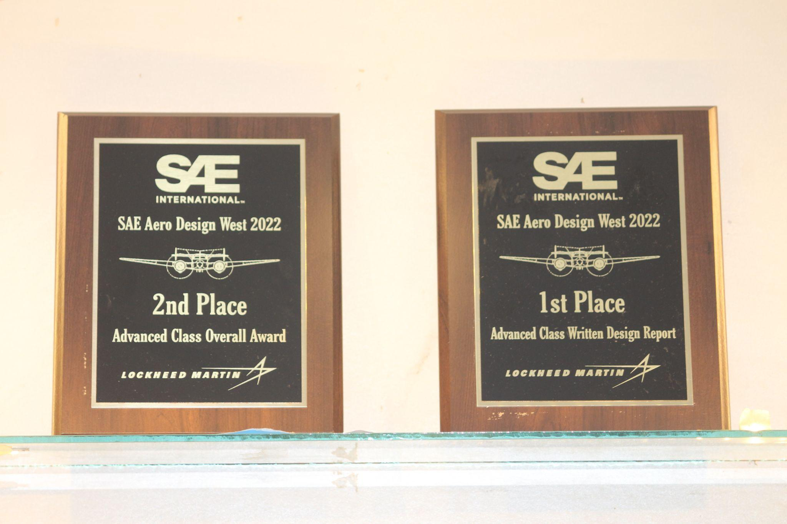
Awards Received by Team Garudashwa in SAE International Competition

- SUMMARY
AND
SWOC ANALYSIS

7.1 ANY OTHER NOTEWORTHY ACHIEVEMENT OF THE DEPARTMENT (Not mentioned above)
Sr. No. | Details
1 | Initiated Collaboration with foreign university by Dr D Y Dahnde
2 | Initiated consultancy with KoneCranes, Germany
3 | 2 faculty members got recognition as PhD Guide from SPPU

7.2 MISCELLANEOUS (SYLLABUS IMPLEMENTATION, MAJOR ADDITION IN INFRASTRUCTURE AND FACILITY, INNOVATIONS INTRODUCED, ETC.)
FACULTY | ACTIVITY

7.3 FEEDBACK FROM STAKEHOLDERS

Sr No | Stakeholder | Number of Feedbacks Received | Overall Feedback
1 | Alumni | 18 | Satisfactory ,suggested some courses to be incorporated.
2 | Parents | 63 | Satisfied with teaching faculties and infrastructure in the department.
3 | Employers | 28 | Satisfied with infrastructure,Suggested improvement in curriculum,Some facilities are required.
4 | Students | 322 | Satisfied with facilities in college.

7.4 TWO BEST PRACTICES FOLLOWED IN THE DEPARTMENT
Real life exposure to the student’s through Chapter activities
Active SAE India Collegiate club Motor sports activities.

7.5 MAJOR GRIEVANCES OF STUDENTS (IF ANY) REDRESSED
Nil

7.6 SWOC ANALYSIS
Five major strengths, weaknesses, opportunities, and challenges (SWOC) of the department and future plans of the Department.
Strengths:
1 | 15 Faculty members with PhD Qualification. Another 6 are pursuing PhD
2 | Average experience of faculty is more than 15 Years
3 | Faculty Retention ratio is good
4 | SFR is reasonable
5 | PhD research centre (Six internal faculty are having PhD guide recognition of SPPU)
6 | Good number of research publications and copyrights
Weaknesses:
1 | Consultancy work to be improved
2 | High end research facility is lagging
3 | Modernization of laboratories
4 | Need to fetch more research funds
5 | National/International Industry/Academia collaboration is required
Opportunities:
1 | To develop Research Laboratory
2 | To develop Industry support Laboratory
3 | To establish centre of excellence in the department
4 | Get more number of research students
5 | International Research Collaborations
6 | Multidisciplinary Projects and Research within the institute
Challenges
1 | To improve admission scenario
2 | Updation of laboratories as per present need of Industry
3 | To improve Placement scenario
4 | To encourage students to become entrepreneur

7.7 FUTURE PLANS OF THE DEPARTMENT (For Next Academic Year)
1 | NBA accreditation
2 | MoU with international academic institutes
3 | Enhanced interaction with Industry 1. Knorr Bremse, 2. Kone cranes
4 | Strengthen Research Centre

7.8 INITIATIVES TAKEN BY THE DEPARTMENT AT DEPARTMENT AND INSTITUTE LEVEL TO IMPROVE AND ASSURE QUALITY IN THE FOLLOWING AREAS

Area | Initiatives
Academics and overall profile of Department | - Three faculty members got PhD recognition from SPPU in AY 21-22  - Effective online teaching Learning process
Organization of different activities | Organised following activities during AY 2021-22 and beneficiaries  Webinars  Faculty development program  4 day online training program  Quiz  Alumni Interaction  Expert talk
Research and Innovation | Journal Papers  Conference Papers  Books  FDP  Webinar/Seminar  Consultancy testing
Industry institute Interaction | Increased number of MoU.  Increased Industry Visits.
Students’ Achievements | Participation in National and International events

SUMMARY SHEET (Annual)
Sr No | Activity/ Item | Numbers
PROFILE OF DEPARTMENT
01 | Students in the department | 833
 | FACULTY CONTRIBUTION
02 | e content developed by faculty and available online | 1
03 | Number of FDP/STTP attended by the department faculty | 77
04 | Number of Seminars/ workshops/ webinars attended by the department faculty | 41
05 | Number of Conferences/ symposiums attended by the department faculty | 5
06 | Number of Online courses / certificate courses completed by department faculty | 11
07 | Number of extension lectures / webinars (Lectures delivered on other than technical topics)) | 2
08 | Number of Faculty served as resource person, expert, chairperson | 13
 | ACTIVITIES ORGANISED
09 | Number of FDP/STTP organized by the department | 1
10 | Number of Seminars/ workshops/ webinars organized by the department (for faculty) | 14
11 | Number of Conferences/ symposiums organized by the department (for faculty) | –
12 | Number of Extension activities conducted by the department (Social/ Quizzes at national/international level/any other activity) | 3
13 | MOU signed with academic and professional organizations | 4
14 | Number of Students’ chapters /clubs | 9
15 | Number of Social activities organized
16 | Number of Parent meeting | 2
17 | Number of Alumni meet | 1
18 | Number of student counselling and career guidance at the department level
 | RESEARCH CONTRIBUTION
19 | Number of Funded research project | 2
20 | Number of Testing and consultancy | 3
21 | Number of Patents, copyright, trademark and other (IPR) | –
22 | Number of Papers published/ presented in proceedings of conferences | 5
23 | Number of Papers published in journals | 25
24 | Number of Book/ article publications | 1
25 | Total Research citations | 1392
26 | Number of ME awarded | 2
27 | Number of PhD AWARDED | –
 | INTERACTION WITH INDUSTRY
28 | Number of Industrial visits organised | 03
29 | Number of Expert lectures delivered by industry experts | 9
30 | Number of Industry –sponsored projects (UG/PG) | 7
31 | Number of MOU signed with industry | 9
32 | Number of Faculty members undergone industrial training | 2
33 | Number of Students undergone in-plant training and (or) internship programme | 128+82
34 | Number of students placed | 14+49
35 | Number of students qualified in the examinations | 7

Declaration by the Head of the Department

I am aware that the above information provided by the Department will be validated by the AAA committee during the visit.

