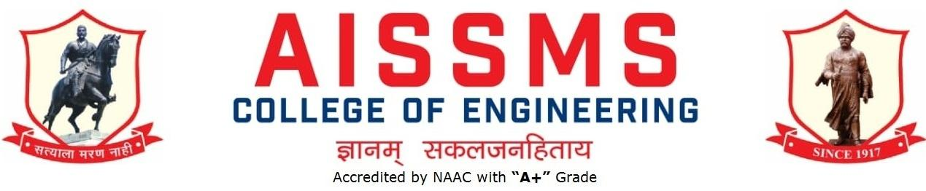
DEPARTMENT OF MECHANICAL ENGINEERING
ANNUAL REPORT
01 July 2019 to 31 December 2019
First Half: 01 July 2019 to 31 December 2019
Second Half: 01 January 2020 to 30 June 2020

INTRODUCTION
Year of Establishment | 1992
UG Programmes | Mechanical – 1992, Mechanical SW - 1994
PG Programmes | ME (Automotive)- 2010 , ME (Design ) - 2014
Number of Teaching Staff | 31
Number of Non-Teaching Staff | 09

LABORATORIES IN THE DEPARTMENT
Sr.No. | Name of the Laboratory | Sr.No. | Name of the Laboratory
1 | Heat Engines Lab | 12 | CAD Lab
2 | Metallurgy Lab | 13 | CAE Lab
3 | Heat Transfer Lab | 14 | Computer Graphics Lab
4 | TOM Lab | 15 | Computer Centre
5 | DOM Lab | 16 | BME Lab
6 | Drawing Hall | 17 | Central Facility
7 | Fluid Machinery Lab | 18 | Mechatronics
8 | Fluid Power Lab | 19 | Automotive System Lab
9 | RAC Lab | 20 | Automotive Chassis Lab
10 | MQC Lab | 21 | PG Software Lab Auto
11 | In-house Project | 22 | PG Design Lab
SOFTWARES AVAILABLE IN THE DEPARTMENT
S N | Softwares Available | S N | Softwares Available
¹ | PRO/E WILDFIRE 4.0 | 7 | Master CAM X 9
² | MatLab 7.0 Common | 8 | Auto Desk Product AutoCAD 2009
³ | MATLab 10 Common | 9 | Altair Hyper Works 125 Hyper
⁴ | ANSYS Software 13.0 | 10 | MSC ADAMS software 5 users
⁵ | Matlab 16 B Academic version | 11 | MATLAB R2014a
⁶ | ANSYS Software 16.02

FACULTY IN THE DEPARTMENT
Sr No | Name of the staff | Designation | Sr No | Name of the staff | Designation
1 | Dr B D Bachchhav | Professor | 17 | Mr O A More | Asstt Prof
2 | Dr A V Waghmare | Asso Prof | 18 | Mrs A T Thombare | Asstt Prof
3 | Dr D Y Dhande | Asso Prof | 19 | Mr M S Swami | Asstt Prof
4 | Dr M R Phate | Asso Prof | 20 | Mr G P Lohar | Asstt Prof
5 | Dr Mrs Dr. P S Gajjal | Asso Prof | 21 | Mrs M P Shah | Asstt Prof
6 | Dr M S Deshmukh | Asso Prof | 22 | Mr M R Dahake | Asstt Prof
7 | Dr S V Chaitanya | Asstt Prof | 23 | Mr M P Bauskar | Asstt Prof
8 | Mr S R Patil | Asstt Prof | 24 | Mr V S Wagare | Asstt Prof
9 | Mr P V Deshmukh | Asstt Prof | 25 | Mr K L Kumbhar | Asstt Prof
10 | Dr C S Choudhari | Asstt Prof | 26 | Mr S S Vadgeri | Asstt Prof
11 | Mr A P Desale | Asstt Prof | 27 | Mr D S Mane | Asstt Prof
12 | Mr R A Marne | Asstt Prof | 28 | Miss S S Patil | Asstt Prof
13 | Dr C S Dharankar | Asstt Prof | 29 | Mr N N Gotkhindikar | Asstt Prof
14 | Dr S J Navale | Asstt Prof | 30 | Mr A R Takalkar | Asstt Prof
15 | Mr M U Gan | Asstt Prof | 31 | Mr K S Kolambe | Asstt Prof
16 | Mr P S Aglawe | Asstt Prof

DETAILS OF SUPPORTING STAFF
Sr No | Name of the Technical staff | Designation
1 | Mr.D.S.Kulkarni | Tech Asstt
2 | Mr.S.K.Jogdand | Lab Asstt
3 | Mr.A.A.Jachak | Lab Asstt

Sr No | Name of the Non-teaching staff | Designation
1 | Mr.G.B.Mate | Attendent
2 | Mr.R.D.Nalavade | Attendent
3 | Mr.P.D.Mahajan | Attendent
4 | Mr Pramod Pharande | Attendent
5 | Mr Sachin Waghmare | Attendent
6 | Mr Rajesh Amolik | Attendent

STUDENTS’ ENROLLMENT
Programm | GEN |  | SC |  | ST |  | OBC |  | PWD |  | Others |  | Total
 | M | F | M | F | M | F | M | F | M | F | M | F | M | F
UG (Mech) Division I | 28 | 04 | 11 | 01 | 00 | 00 | 28 | 05 |  |  | 25 | 5 | 92 | 15
UG (Mech) Division II | Above data includes DivI & II
UG (Mech SW) | 20 | 2 | 6 | 0 | 0 | 0 | 10 | 1 |  |  | 13 | 0 | 49 | 3
PG ( Auto) | 4 | 0
PG (Design)

Students–Faculty Feedback Details (*) (Not to be included in annual report)
Sr No. | Name of faculty | Class and Subject taught | Feedback (I) (%) | Feedback (II) (%) | Average  Feedback (%)
1 | Dr B D Bachchhav | Metrology & QC (TE M A) | 80 | 85 | 82.5
2 | Dr A V Waghmare | BE Mech (A)  Hydraulics & Pneumatics | 81 | 85 | 83
 | Dr A V Waghmare | BE Mech (B)  Hydraulics & Pneumatics | 76 | 79 | 77.5
3 | Dr D Y Dhande | Applied Computer Aided Engineering (TE Mech SW) | 93 | 93 | 93
4 | Dr M R Phate | BE (Mech B) Operation Research | 96 | 97 | 96.5
5 | Dr Mrs Dr. P S Gajjal | Strength of Materials | 79 | 88 | 83.5
6 | Dr M S Deshmukh | ET  EAM  RAC TE B | 89  88  87 | 92  93 | 91  91  87
7 | Dr S V Chaitanya | Operations Research | 82 | 83 | 82.5
8 | Mr S R Patil | Design of Machine Elements I  TE Mech.B | 82 | 91 | 86.5
9 | Mr P V Deshmukh | BE Mech (B) CAD/CAM and Automation | 78 | 79 | 78.5
10 | Dr C S Choudhari | Refrigeration and Air Conditioning Div SW | 88 | 90 | 89
11 | Mr A P Desale
12 | Mr R A Marne | Machine Design  TE Mech Sand | 92 | 95 | 94.5
13 | Dr C S Dharankar | BE Mech (A)  Dynamics of Machinery | 87 | 88 | 87.5
14 | Dr S J Navale | Heat Transfer TE Mech | 79 | 85 | 82
15 | Mr M U Gan | T E AND B MECH A Turbo Machines | 88 | 87 | 87.5
16 | Mr P S Aglawe | BE Mech (A) CAD/CAM & Automation | 89 | 88 | 88.5
17 | Mr O A More | T.E.MS Mechatronics | 87 | 88 | 87.5
18 | Mrs A T Thombare | TOM II TE A | 83 | 86 | 84
 | Mrs A T Thombare | TOM II TE B | 78 | 82 | 80
19 | Mr M S Swami
20 | Mr G P Lohar | TE SE MECHSAND | 82 | 80 | 81
21 | Mrs M P Shah | FEA | 85 | 82 | 83.5
22 | Mr M R Dahake | Heat Transfer TE M B | 82 | 86 | 84
23 | Mr M P Bauskar | TE Mechanical B  MQC | 83 | 88 | 84
24 | Mr V S Wagare | TE MS NMO | 87 | 90 | 88.5
25 | Mr K L Kumbhar | SE Mech S/W Fluid Mechanics & Machinery | 81 | 87 | 84
26 | Mr S S Vadgeri | BE Mech (B)  Dynamics of Machinery | 87 | 88 | 87.5
27 | Mr D S Mane | Manufacturing Processes I | 82  77 | 82  80 | 82  78.5
28 | Miss S S Patil | Design of machine elements | 82 | 81 | 81.5
29 | Mr N N Gotkhindikar | SE Mech S/W Material Science and Metallurgy | 88 | 91 | 89.5
30 | Mr A R Takalkar
31 | Mr K S Kolambe | SE Mech (S/W) Strength of Materials | 77 | 83 | 80

RESULT ANALYSIS (LAST TERM)
Sr No. | Name of faculty | Class and Subject Taught | % passing | Sr No. | Name of faculty | Class and Subject Taught | % passing
1 | Dr B D Bachchhav | TE Mech (A)  MQC | 93.75 | 17 | Mr O A More | TE Mech(A)- Mechatronics | 98.48
 |  |  |  |  |  | TE Mech (B)-  Mechatronics | 98.51
2 | Dr A V Waghmare | BE Mech (A)  Hydraulics & Pneumatics | 90.1 | 18 | Mrs A T Thombare | TE A TOM II | 93.75
 |  | BE Mech (B)  Hydraulics & Pneumatics | 97.1 |  |  | TE B TOM II | 80.6
3 | Dr D Y Dhande | DME II | 90.28 | 19 | Mr M S Swami | SE MECH A  MS  SE MECH B  MS | 84  86
4 | Dr M R Phate | Operation Research (BE B) |  | 20 | Mr G P Lohar | SE Mechsand | 87
5 | Dr Mrs Dr. P S Gajjal | Strength of Material SE A | 67 | 21 | Mrs M P Shah | BEM A  EL-1-Finite Element Analysis  BEM B  EL-1-Finite Element Analysis | 80.3  84.1
6 | Dr M S Deshmukh | ET  EAM  RAC | 95.31  97.14  98.55 | 22 | Mr M R Dahake | HT TE M B | 78
7 | Dr S V Chaitanya | Operations Research | 94.11 | 23 | Mr M P Bauskar | MQC TEMB | 88
8 | Mr S R Patil | Design of Machine Elements I  TE Mech.B |  | 24 | Mr V S Wagare | TE Mech SW-NMO | 90.48
9 | Mr P V Deshmukh | BE Mech (B)  CAD/CAM and  Automation | 98.6 | 25 | Mr K L Kumbhar | SE Mech S/W Fluid Mechanics & Machinery
10 | Dr C S Choudhari | Heat Transfer | 77.78 | 26 | Mr S S Vadgeri | BE Mech (B)  Dynamics of Machinery | 87
11 | Mr A P Desale |  |  | 27 | Mr D S Mane | Manufacturing Processes I
12 | Mr R A Marne | Machine Design  TE Mech Sand | 80 | 28 | Miss S S Patil
13 | Dr C S Dharankar | BE Mech (A)  Dynamics of Machinery | 92 | 29 | Mr N N Gotkhindikar | SE M/S  Material Science and Metallurgy
14 | Dr S J Navale | Heat Transfer TE Mech A | 81.25 | 30 | Mr A R Takalkar
15 | Mr M U Gan | Turbo machines (T E A)  Turbo machines (T E B) | 77  79.1 |  | Mr K S Kolambe | SE M/S  Strength of Materials
16 | Mr P S Aglawe | Cad Cam & Automation  BE Mech B | 98.6

Class Result Analysis (LAST TERM) May 2019
SN | Class | No. Of Students |  |  |  |  |  |  |  |  |  | Percentage of Passing
 |  | Appeared | Clear Passed | Outstanding  (O)  (9 -10) | Excellent  (A+)  (8.5 – 8.99) | Very Good (A)  (7.5 – 8.49) | Good (B+)  (6.5 – 7.49) | Above Average (B)  (5.5 – 6.49) | Average (4.25 – 5.49)Class | Pass Class  (4 – 4.24 | Fail  (F)  0 – 3.99 | All Clear | With ATKT
1 | SE (M) A | 74 | 41 | 1 | 1 | 7 | 22 | 3 | 7 |  | 5 | 47.22 | 91.67
2 | SE(M) B | 80 | 40 | 1 | 3 | 15 | 21 |  |  |  | 7 | 62.12 | 93.94
3 | TE(M) A | 72 | 41 | 1 | 5 | 18 | 13 | 4 |  |  |  | 56.94 | 95.83
4 | TE(M) B | 73 | 48 | 1 | 7 | 20 | 15 | 5 |  |  |  | 65.75 | 97.26
5 | BE(M) A | 66 | 65 | 1 | 7 | 31 | 19 | 2 | 5 |  | 1 | 98.48
6 | BE(M) B | 56 | 55 | 1 | 13 | 23 | 17 | 1 |  |  | 1 | 98.21
7 | SE (MS) | 66 | 35 | 1 | 2 | 11 | 17 | 4 |  |  | 31 | 53.03 | 100
8 | TE (MS) | 61 | 43 | 0 | 13 | 28 | 2 |  |  |  |  | 70.49 | 93.44
9 | BE (MS) | 69 | 67 | 4 | 7 | 31 | 19 | 6 |  |  |  | 97.10

UNIVERSITY RANKERS (LAST ACADEMIC YEAR)
Sr No | Name of the Ranker | Class | Rank
ACHIEVEMENTS OF FACULTY (AWARDS, RECOGNITION, PHD COMPLETION ETC.)
SN | Name of Faculty | Awards & Recognition
1 | Dr S V Chaitanya | PhD Completed
CONTRIBUTION OF FACULTY (Interaction with the outside world)
SN | Name of Faculty | Nature and details of contribution (Representation at University, State, National , International level)
1 | Dr A V Waghmare | Member, Board of Studies, Automobile and Mechanical Engineering, SPPU, Pune
2 | Dr A V Waghmare | Member, Engineering Education Board, SAEINDIA
3 | Dr A V Waghmare | Convener, Student Convention, SAEINDIA WS
4 | Dr A V Waghmare | Worked as a committee member at various levels of SPPU
5 | Dr B D Bachchhav | Member, Board of Studies, Mechanical and Materials Technology, SPPU, Pune.
6 | Dr D Y Dhande | Editorial Board Member, Nanoscience and Nanotechnology, Whioce Publications, Singapore
7 | M P SHAH | Subject Chairman
FUNDED RESEARCH PROJECT
S N | Principal Investigator | Title of the Project | Amount Received (Rs) | Funding Agency
1 | Dr B D Bachchhav | Tribological Performance Evaluation of Non-asbestos organic Brake Pad Materials | 25000/- | IE(I) R&D Cell
2 | P V Deshmukh | Wind Analysis of Canopy, Pitch-roof and Square Tall Building with Different Shape Using Wind Tunnel and CFD | 20000 | IEI R&D Cell  Technical Department  The Institution of Engineers (India)

FDP/STTP/SEMINARS/CONFERENCES/WORKSHOPS/ SYMPOSIUMS ORGANIZED BY THE DEPARTMENT (For Faculty)
S N | Name of Coordinator/s | Title of the FDP/STTP/WS/Seminar/Symposium | Duration/ Dates | No. of Participants | Funding Agency  (If any) and Amount (Rs.)
1 | Dr A V Waghmare | Baja SAEINDIA 2020  “Design Mega Workshop” | Sept. 14-15, 2019 | 76 | SAEINDIA
2 | Dr B D Bachchhav  Dr A V Waghmare | Syllabus implementation workshop on “Systems in Mechanical Engineering | July 8, 2019 | 110 | SPPU, Pune
3 | Dr A V Waghmare | ‘Speak for India’ a debate competition. District level. | August 10 and 19, 2019 | 130 and 80 | Times Group
4 | Dr Dr. P S Gajjal and Dr A V Waghmare | AICTE sponsored one week STTP on, “Advances in Tribology” | 4-9 Nov. 2019. | 61 | AICTE
5 | Dr A V Waghmare and Prof A R Takalkar | Installation of ‘Fluid Power Chapter’ | Sept 30, 2019 | 57 | Fluid Power Society of India
5 | Dr. M S Deshmukh, Dr. D. Y. Dhande, Dr. M. R. Phate | International Conference on Mechanical Engineering for Sustainable development- ICMESD-2020 | 17-18 Feb 2020 | 67 | QIP SPPU

FDP/STTP/SEMINARS/CONFERENCES/WORKSHOPS/ SYMPOSIUMS ATTENDED BY THE DEPARTMENT FACULTY
S N | Name of Faculty | Title of the FDP/STTP/WS/Seminar/Symposium | Organized by | Duration and Date

Term ONE
S N | Name of Faculty | Designation | Title of the Seminar/Webinar and Organised By | Duration/ Dates
1 | Dr. A V Waghmare | Associate Professor | One week online faculty deveopment program on "funding opportunities for engineering teachers & technical paper writing" | 15-06-2020 - 19-06-2020
2 | Dr. A V Waghmare | Associate Professor | Webinar on "Best practices in autonomy-automation of academic & examination department processes and end to end" | 6/29/2020
3 | Dr. M R Phate | Professor | NPTEL-AICTE FDP on " Mathematical modeling of manufacturing processes " | July-Oct.2019 (12 week course)
4 | Dr. D.Y.Dhande | Professor | Short term course on "Fundamentals of tribology" | 07-10-2019 - 11-10-2019
5 | Dr. D.Y.Dhande | Professor | AICTE sponsored one week short term training programme on "Advances in Tribology" | 04-11-2019 - 09-11-2019
6 | Dr. S V Chaitanya | Associate Professor | Faculty development program on data science | 17-06-2019 - 22-06-2019
7 | Dr. S V Chaitanya | Associate Professor | AICTE sponsored One week short term training programme on "Advances in tribology | 04-11-2019 - 09-11-2019
8 | P V Deshmukh | Assistant Professor | coursera digital manufacturing and design | 9/6/2020
9 | C S Dharankar | Assistant Professor | One day faculty development programme on health awareness at workplace | 10/11/2019
10 | C S Dharankar | Assistant Professor | Two days national level workshop on advances in measurement and analysis of vibration and noise | 09-01-2020 - 10-01-2020
11 | M U Gan | Assistant Professor | One week online faculty deveopment program on "future materials: nanocomposites" | 15-06-2020 - 21-06-2020
12 | M U Gan | Assistant Professor | Faculty development program on solar energy & its applications, economical implications in Indians scenario after covid-19 | 15-06-2020 - 19-06-2020
13 | P S Aglawe | Assistant Professor | faculty development program on data science | 17-06-2019 - 22-06-2019
14 | Mrs A T Thombare | Assistant Professor | One week short term training programme on advances in tribology | 04-11-2019 - 09-11-2019
15 | M S Swami | Assistant Professor | National cohort of the Boeing university innovation leadership development program | 23-06-2019 - 26-06-2019
16 | M R Dahake | Assistant Professor | Faculty development program on " Innovations in ICT Enabled teaching learning - a step towards digital India | 25-11-2019 - 06-12-2019
17 | M R Dahake | Assistant Professor | NPTEL-Heat transfer | Sep-Dec 2020
18 | M P Bauskar | Assistant Professor | AICTE sponsored one week short term training programme on " advances in Tribology | 04-11-2019 - 09-11-2019
19 | O A More | Assistant Professor | NPTEL -Innovation by Design | Aug-Sep 2019
20 | Dr. P S Gajjal | Associate Professor | Faculty development program on " Innovations in ICT Enabled teaching learning - a step towards digital India | 25-11-2019 - 06-12-2019
21 | R A Marne | Assistant Professor | One day faculty development programme on health awareness at workplace | 10/11/2019
22 | M M Sayyad | Assistant Professor | NPTEL strength of materials | July-Oct.2019 (12 week course)
23 | N N Gotkhindikar | Assistant Professor | Faculty development program Data Science | 17-06-2019 - 22-06-2019
24 | N N Gotkhindikar | Assistant Professor | AICTE sponsored one week short term training programme on " advances in Tribology | 04-11-2019 - 09-11-2019
25 | N N Gotkhindikar | Assistant Professor | FDP on Rubrics | 6/21/2019
26 | Shivraj Vadgeri | Assistant Professor | FDP "recent trends in Mechanical Engineering | 17-08-2020 - 21-08-2020
27 | Shivraj Vadgeri | Assistant Professor | Syllabus implementation workshop for the course of " Engineering materials & metallurgy | 6/19/2020
28 | Dhananjay S Mane | Assistant Professor | A Syllabus implementation workshop on " Systems in Mechanical Engineering" | 7/8/2019

EXTENSION LECTURES (LECTURES DELIVERED BY VISITING GUESTS)
S N | Name of faculty coordinator | Topic | Name and contact details of guest | Date
1 | S S Vadgeri | Orientation and Appreciation Session on “Sandwich Industrial Training” | Mrs. Tanuja Indi, Managing Director, INDITECH VALVES Pvt. Ltd. Pune. | 7th January, 2020
2 | Dr A V Waghmare | Hydraulic System | Mr. Prasanna Umarani, Slimline Hydrotek, Pune | 30 Sept 2019
3 | M P Bauskar | Lecture on Lean Six sigma White Belt | Mr Michael Testani | 29 January 2020

FACULTY SERVED AS a RESOURCE PERSON, EXPERT OR CHAIRPERSON
S N | Name of Faculty | Title of Activity | Organizing body | Date
1 | Dr B D Bachchhav | Expert Talk in AICTE sponsored One week STTP on Advances in Tribology | AISSMS COE | 7/11/2019
2 | Dr A V Waghmare | Resource person at ‘Two Week AICTE-FDP on OBE’ on Alumni Engagements | DYP, Akurdi | 6/11/2019
EXTENSION ACTIVITIES CONDUCTED BY THE DEPARTMENT
S N | Name of Faculty Coordinator | Details of activity conducted | Date
01 | Dr C S Choudhari | Interdepartmental quiz on “Robotics and Automation | 04/10/2019

MOU SIGNED WITH ACADEMIC AND PROFESSIONAL ORGANISATIONS
Sr. No. | Faculty Coordinator | Name of Organisation | Date  of MoU Signed | Valid upto  00/00/0000
1 | M P Bauskar | Mettchnik Pvt Ltd | 10/10/2019 | 10/10/2024
2 | Dr S.J.Navale | Avishkar Engineers Pvt.Ltd | 31/12/2019 | 31/12/2020
3 | D S Mane | Suntech Landriani Machine Tools Pvt Ltd | 08/08/2018 | 07/08/2021
4 | P.S.Aglawe | eAdicct Mobility Solution Pvt Ltd | 21/08/2017 | 21/08/20
5 | D S Mane | Nemade Engineers Pvt Ltd | 08/08/2018 | 07/08/2021
6 | M P SHAH(CHOKSHI) | Raviraj Hitech Pvt. Ltd | 06/10/2017 | 06/10/2020
STUDENTS’ CHAPTERS /CLUBS
S. No | Name of Students’ Chapter | Number of Student Members
1 | SAEINDIA | 64
2 | FPSI | 54
3 | IMechE | 80
4 | IE | 18
5 | ISHRAE | 11

EVENTS ORGANISED (By Students’ Chapters / Clubs and others)
Name of Students’ Chapter: SAEINDIA
Faculty Advisor: Dr A V Waghmare and Dr C S Dharankar

SN | Event name and details of event | Details of faculty and students involvement, Name of chief guest, judges etc. | Duration and Dates
1. | BAJA-Competition Participation | 1.Participated in Virtual BAJA at Chitkara University, Chandigad  2.Participate in M-BAJA at NATRAX Facility, Pithampur, MP  3.Participated in International Virtual BAJA and secured a $500 prize. | 11-13 July 2019  Jan 2020  June 2020
2. | SUPRA-Competition Participation | Participated in SUPRA Competition at Buddh International Circuit,Greater Noida. | 15-20 July 2019
3. | Efficycle-Competition Participation | -Team participated in SAE EFFI-CYCLE 2019 at Lovely Professional University, Punjab  -Team secured 4th rank in Advanced Format | 1st october to 5th october, 2019
4. | Aero Design-Competition Participation at National and International | International: Team participated in Van Nuys, California  • 5 th in technical presentation in SAE INTERNATIONAL advanced class 2019.  • 13th amongst the 75 International teams in Advanced Class 2019. | 5 -7 April 2019.
 |  | National:  Team Garudashwa participated in the 4th Annual SAE ISS Aero Design Challenge in both Regular and the Micro Class Categories.  Micro class :  Overall result – 2𝑛in India.  Regular class :  4th in report 5th in presentation | 19th-21st July 2019
5. | TIFAN-Competition Participation | Competition postponed due to COVID | 18 March 2020
6. | Organised: BAJA Workshop | Organised ATV Room for students of other institutions.
Name of Students’ Chapter: INSTITUTE OF ENGINEERING
Faculty Advisor: __M U GAN

SN | Event Name And Details Of Event | Details Of Faculty | Students Involvement | Name Of Chief Guest, Judges Etc. | Duration and Dates
1 | One Minute Talk (BE- B) | S S Vadgeri | 39 | M P Shah And Pv Deshmukh | 11-09-2019
2 | One Minute Talk--TE- A | A T Thombare | 8 | G P Lohar And A T Thombare | 11-09-2019
3 | One Minute Talk --TE B | S R Patil | 18 | M U Gan, S S Patil | 11-09-2019
4 | One Minute Talk --SE A | M S Swami | 31 | Dr.Dr. P S Gajjal | 12-09-2019
5 | One Minute Talk --SE B | Dr.Ms Deshmukh | 48 | M U Gan, Dr.Ms Deshmukh | 11-09-2019
6 | One Minute Talk --TE M/Sw | V S Wagare | 32 | Dr. C S Choudhari And Dr. D.Y. Dhande | 09-09-2019
7 | One Minute Talk --Pahse Ii | M U Gan | 24 | Dr. M R Phate And P V Deshmukh | 16-09-2019
8 | One Minute Talk-SE M/S | N N Gotkhindikar | 39 | G P Lohar, P V Deshmukh | 09.09.2019

PAPERS PUBLISHED IN PROCEEDINGS OF CONFERENCES
S N | Authors | Title of paper | Details of Conference  (Name of conference, dates and duration, Organising body details, ISBN)
1 | Nayan H Dhanvij,  Dr Dr. P S Gajjal | Tribological performance evaluation of friction and wear of EN24 for PGT of CNC Bending Machine | ICIAER -2019, Rajuri 18-19 Oct 2019, Shayari Valley College of Engg and Tech,Rajuri

PAPERS PUBLISHED IN REFEREED JOURNALS
S N | Authors | Paper Details (Paper title, Publication year, Volume no., issue no., Page no.s, Doi, ISSN)
1 | P V Deshmukh | “Experimental and Finite Element Analysis On the Steel Fiber Reinforced Concrete (SFRC) Beam Under Pure Torsion”, International Journal of Research and Analytical Reviews, E-ISSN 2348-1269, P- ISSN 2349-5138, Volume 6, Issue 2, June 2019
2 | Dr B D Bachchhav | Kishor N. Hendre, Bhanudas D. Bachchhav., “Friction and Wear Characteristics of Rubber Resin-Bonded Metallic Brake Pad Materials”, International Journal of Engineering and Advanced Technology (IJEAT), Vol: 8, Issue: 6, (August 2019), pp. 1312-1316.
3 | R A Marne | Ajinkya Mali, Rahul Marne,”Finite element analysis comparison of spur gears between standard tooth profile and modified profile”,International Research Journal of Engineering and Technology,(IRJET)e-ISSN:2395-0056,p-ISSN-2395-OO72,volume 6 ,Issue 9, Sept 2019
4 | Vadgeri S. S., Patil S. R. | Stress Analysis of Carbon Fiber Reinforced Composite Laminate with Different Centrally Located Cutouts, Materials Today: Proceedings (Elsevier), ISSN 2214-7853, 2019
5 | Bauskar M .P., Dhande, D.Y., Vadgeri S. S., Patil, S.R. | Study of aerodynamic drag of sports utility vehicle by experimental and numerical method, Materials Today: Proceedings (Elsevier), ISSN 2214-7853,2019
6 | Dr Dr. P S Gajjal | “Tribological Parametric Influence of Dry Sintered Iron Bearings”Journal of Emerging Technologies and Innovative Research, ISSN-2349-5162
7 | Dr Dr. P S Gajjal | Wear Model of Dry Sintered Bearing Material by Dimensional Analysis, Journal of Emerging Technologies and Innovative Research, ISSN-2349-5162
8 | Dr D Y Dhande, Langewar G H & Pande D W . | Implementation of CFD–FSI Technique Coupled with Response Surface Optimization method for Analysis of Three-Lobe Hydrodynamic Journal Bearing, Journal of The Institution of Engineers (India): Series C
9 | Kishor N. Hendre, Bhanudas D. Bachchhav, Harijan H. Bagchi., | “Frictional Characteristics of Brake Pad Materials Alternate to Asbestos”, International Journal of Engineering and Advanced Technology (IJEAT), Vol: 9, Issue: 2, (December 2019), pp. 694-698.
10 | Kathmore P. S; Bachchhav B. D | “Bio-based Lubricant Selection for Metal Cutting Operations Using MADM Technique”, International Journal of Mechanical and Production Engineering Research and Development (IJMPERD), ISSN(P): 2249–6890; ISSN(E): 2249–8001, Vol. 9, Issue 6, Dec 2019, 845–858.

PATENTS, COPYRIGHT, TRADEMARK AND OTHER (IPR)
Sr No. | Name of Faculty | Name of the Patent | Patent Number and Date | Type (National/  International/Com  mercialized)
01 | Dr. Mangesh R. Phate | Fabrication of Garbage Disposal Unit FER submission : 23/07/2019 | (2879/MUM/2014)10/09/2014 | National

RESEARCH CITATIONS (Source of Data: Google scholar)
S N | Name of faculty | Citations |  | Name of faculty | Citations
1 | Dr. Mangesh R. Phate | 106 | 6 | Dr C S Choudhari | 52
2 | Dr A V Waghmare | 133 | 7 | Dr Dr. P S Gajjal | 48
3 | S R Patil | 08 | 8 | Dr B D Bachchhav | 16
4 | S S Vadgeri | 08 | 9 | Dr S J Navale | 21
5 | K L Kumbhar | 04
Total citations: 364
NUMBER OF STUDENTS PLACED
Sr No | Name of Organization visited | Number of students Participated | Number of students Placed
1 | Tata Consultancy Services |  | 1
2 | I Research Services |  | 2
3 | Godrej & Boyce |  | 3
4 | Infosys |  | 3
5 | Square Yard |  | 2
6 | A Raymond Fasteners India Pvt. Ltd. |  | 3
Lower Package Offered:
Higher package Offered:
Average Package Offered:

NUMBER OF STUDENTS QUALIFIED IN THE EXAMINATION
GATE | GRE | UPSC | MPSC | Any other reputed examination for Higher studies (TOFEL, etc.)
 |  |  |  | 01 qualified in CAT 2019

ME AWARDED
Sr No | Name of Supervisor | Title of Thesis | Name of Candidate
1 | Dr B D Bachchhav | Tribological Characterization of Brake pad Materials | Mr K N Hendre
2 | Dr Dr. P S Gajjal | Tribological Performance Evaluation of Gear Material for Planetary Gear Transmission of CNC Bending Machine | Mr N H Dhanvij
3 | S.R.Patil | Experimental and Numerical Analysis of Asymmetric Spur Gear | Mr A S Banate
4 | S.R.Patil | Design and Analysis of Infinitely Variable Transmission Test Rig | Mr A D Gawande

PhD GUIDE DETAILS (AISSMSCOE Research centre)
S N | Name of Faculty who are PhD Supervisor | Number of Scholars Registered
01 | Dr. V. N. Raibhole  MES College of Engineering, Pune | 01
02 | Dr. Abhay A. Pawar  Principal, DyPatil COE Ambi Pune | -
03 | Dr. B. D. Bachchhav  AISSMSCOE, Pune | 02
04 | Dr. M. S. Deshmukh  AISSMSCOE, Pune | 01

PhD AWARDED
Sr No | Name of Supervisor | Title of Thesis | Name of Candidate
INDUSTRIAL VISITS ORGANISED
Sr. No. | Faculty Coordinator | Class and (Number of students attended) | Industry Name and Address | Date of visit
1 | P V Deshmukh | BE (Mech- B) 67 Students | IMTMA, Pimpri-Chinchwad, 411019 | 3 Oct 2019
2 | N N Gotkhindikar  S R Patil | SE (Mech S/W) 62 Students | SPECIALITY SINTERED PRODUCTS PVT. LTD. Chakan, Pune 410501 | 11th Oct 2019
3 | M.U.Gan  K.L.Kumbhar | TE (Mech A & B)118 | Ujani Hydroelectric Power Plant, Bhimanagar, Pune | 23rd Sept. 2019
4 | M P Bauskar | TE Mech A ( 68) | Whirlpool India ltd | 23/07/2019
5 | M P Bauskar  S R Patil | TE Mech B ( 69) | Fiat India Ltd | 24/07/2019
6 | A V Waghmare  A R Takalkar  S S Vadgeri | BE Mech A & B (118) | Stauff India Pvt Ltd | 10/10/2019
7 | P.S.Aglawe  Dr. C.S.Dharankar | BE Mechanical (A)  (68) | INDIAN MACHINE TOOL MANUFACTURERS’ ASSOCIATION | 04/10/2019
8 | Dr C S Choudhari | TE Mechanical B | Thermax Ltd Pune | 26/09/2019

EXPERT LECTURES DELIVERED BY INDUSTRY EXPERTS
Sr. No. | Faculty Coordinator | Class  (Number of students attended) | Name, Industry, designation and contact details of Expert | Topic | Date
1 | Dr B D Bachchhav | 61 | Mr. Avinash Khare, IMTMA, Chinchwad | Additive Mfg. | 8/8/2019
2 | P V Deshmukh | 67 | Gautam Doshi, Advisor, Indian Machine Tool Manufacturers' Association (IMTMA) | Role and Effect on Industries of Robotics and Automation in coming years | 3/10/2019
3 | D S Mane | SE Mech A & B (82) | Mr. Sagar Naikade, Valmont India, Quality Engineer, | Welding Technology | 08/07/2019
4 | M P Bauskar | TE Mech B | Mr S A Mandhare | MSA system | 26/07/2019
5 | M R Dahake | TE Mech B | Mr S S Tikar | ARAI Pune | 05/10/2019
6 | Dr. C S Dharankar & S S Vadgeri | BE Mech A & B (120) | Mr. Nitin Badhe, Sr. Technical Specialist- Global NVH, ALTAIR INDIA Pvt Ltd, Pune | Fundamentals of Dynamic Analysis | 15/10/2019
7 | K.L.Kumbhar | TE Mech (A & B) | Mr. Ajit Deshpande (Advanced Analytics, FinTech) | How to Enter in Artificial Intelligence | 01/10/2019
8 | Dr C S Choudhari | TE Mechanical SW | Dr Vivek Vitankar | Applications of CFD in Heat transfer Analysis | 24/09/2019
8 | Dr C S Choudhari | TE Mechanical SW | Mr Quayam Akhatar | Robotics Process Automation | 25/09/2019
9 | Dr C S Choudhari | TE Mechanical SW | Dr Prasad Khandagale, R & D Head, Henkel, Pune  9822683341 | Energy and Environment | 04/10/2019

INDUSTRY –SPONSORED PROJECTS (UG/PG)
Sr. No. | Name of Project guide | Year | Title of Industry Sponsored Project | Name of Sponsoring Industry
1 | P V Deshmukh | 2019 - 20 | Design and Development of Overhead Crane with Rotating Jib Arm | G A Enterprises
2 | D S Mane | 2019-20 | Design, Analysis and Development of Connecting Rod For V12 IC Engine | MechaTol Engineering Solutions
3 | S S Vadgeri | 2019-20 | Design and Development of Biogas Engine for Power Generation | Kirloskar Oil Engines Ltd, Pune
4 | Dr C S Choudhari | 2019 - 20 | Design and development of solar powered sterling engine for electricity generation | Engineering Cluster Pune

MOU SIGNED WITH INDUSTRY
Sr. No. | Faculty Coordinator | Name of Industry | Date  of MoU Signed | Valid upto  (00/00/0000)
1 | Dr S.J.Navale | Avishkar Engineers Pvt.Ltd | 31/12/2019 | 31/12/2020
2 | D S Mane | Suntech Landriani Machine Tools Pvt Ltd | 08/08/2018 | 07/08/2021
3 | D S Mane | Nemade Engineers Pvt Ltd | 08/08/2018 | 07/08/2021
4 | P.S.Aglawe | eAdicct Mobility Solution Pvt Ltd | 21/08/2017 | 21/08/2022
5 | M P Bauskar | Mettchnik Pvt Ltd | 10/10/2019 | 10/10/2024

FACULTY MEMBERS UNDERGONE INDUSTRIAL TRAINING
Sr. No. | Name of Faculty | Name of Industry | Dates and Duration

STUDENTS UNDERGONE IN-PLANT TRAINING AND (OR) INTERNSHIP PROGRAMME
Sr. No. | Name of the Student | Name of the Industry | Class | Training duration
 |  |  |  | Start date | Last date | Duration (days)
01 | Isabel Edison | Thermax Pvt Ltd |  | 6/13/2019 | 6/28/2019 | 15 days
02 | Kunal Gaikwad | Ameya Industries |  | 6/13/2019 | 6/28/2019 | 15 days
03 | Pushkaraj Deshmukh | Marvelour Metals Pvt Ltd |  | 6/15/2019 | 6/30/2019 | 15 days
04 | Vijayalaxmi Kodoli | Hero Pvt Ltd |  | 6/01/20119 | 6/30/2019 | 30 days
05 | Kedar Ashtikar | Milman Thinfilm systems |  | 6/02/20119 | 7/02/2019 | 30 days
06 | Aditya Chougule | Milman Thinfilm systems |  | 6/02/20119 | 7/02/2019 | 30 days
07 | Yadnya Khadake | Cummins India Ltd |  | 6/03/20119 | 7/03/2019 | 30 days
08 | Hrushikesh Banger | Hrushi Insustries |  | 6/05/20119 | 6/30/2019 | 25 days
09 | Pratik Dond | Bosch Ltd Nashik |  | 6/01/20119 | 6/28/2019 | 28 days
10 | Suraj Gadgade | DCE Refrigeration |  | 6/16/20119 | 7/01/2019 | 15 days
11 | Abhishek Dyade | Enggineering Cluster Pvt Ltd |  | 6/07/20119 | 7/06/2019 | 30 days
12 | Tejas Borkar | Enggineering Cluster Pvt Ltd |  | 6/05/20119 | 7/04/2019 | 30 days
13 | Abhishek Pisal | Ratna Gears Pvt Ltd |  | 6/01/2019 | 6/30/2019 | 30 days
14 | Rohan Soni | S. M. Engineers and Distributors |  | 11/01/2019 | 11/15/2019 | 15 days
15 | Himanshu Jaiswal | Engineering Cluster |  | 6/05/2019 | 7/04/2019 | 30 days
16 | Shrungal Kulkarni | CASIO |  | 8/01/2019 | 9/30/2019 | 60 days
17 | Aditya Ghode | Sundaram Fasteners |  | 6/10/2019 | 6/21/2019 | 10 days

WORKSHOPS/SEMINARS/CONFERENCES/COURSES CONDUCTED WITH INDUSTRY SUPPORT/COLLABORATION (FOR STUDENTS)
Sr.  No. | Faculty Coordinators | Title of the Programme | Name of Industry | Type of Support/ Name & Designation of Expert

TRAINING TO INDUSTRY PERSONNEL/ ACTIVITY SUPPORTING TO INDUSTRY
Sr. No. | Faculty coordinator | Technical Area in which Training Provided / Type of Support | Industry Name
1 | Dr S V Chaitanya | Visit of students of National Safety Organization NSO to workshop and laboratories for safety measures during conduction of practicals. date of the visit 16 August 2019 | National Safety Organization,
TESTING AND CONSULTANCY
Sr. No. | Faculty Coordinator | Type of Testing & Consultancy Conducted | Total Revenue Generated (Rs.)

ANY OTHER ACTIVITIES TO PROMOTE INTERACTION WITH INDUSTRY
Sr. No. | Faculty coordinator | Name of Activity | Remark

SUPPORT FROM ALUMNI
Sr No | Name of Alumni | Position and Organisation | Batch  (e.g. 2014 – 2018) | Details of Support | Date

STUDENTS’ ACHIEVEMENT (Individual Level)
S N | Name of Student | Details of Achievement (State/University/ National/International Level)
1 | Parth Bhosale | Successfully completed training class and demonstrated through examination on 22 September 2019. LEAN SIGMA GREENBELT)
2 | A) Shriram Kalhapure (Rs 25000)  B) Kamlesh Sarode (Rs 18000)  C) Shubham Anbhule (Rs 8000) | Awarded:17 December 2019.  IndiTech Valves Pvt.Ltd  Excellence in Project During his Internship
3 | Akshay Warghade | Participated :17 December 2019.  Participated in Cluster Level i-2-e Competition  organized by the CENTRE FOR INNOVATION ,INCUBATION & ENTERPRISE (SPPU)
4 | Kishor Hendre | 3rd prize winner of ASM India 2019- Masters Award on 19t October 2019
5 | Himanshu Jaiswal | Publication of research paper in Eduindex Journals (ISSN 0474-9030)

STUDENTS’ ACHIEVEMENT (Team Level)
S N | Name of Event | Name of Faculty Advisor | Details of Achievement (State/University/ National/International Level)
01 | Effi-cycle | Dr. C. S. Choudhari | National
02 | Krushak | Prof. M. R Dahake | National
03 | Garudashwa | Dr. D Y Dhande | National

SPORTS / CULTURAL ACHIEVEMENTS OF STUDENTS (Individual Level) (Team level achievements to be mentioned in institute level sports/Cultural committee report)
S N | Name of Student | Details of Achievement (State/University/ National/International Level)
1 | Aniket Pawar | Secured Gold medal in State Level Mallakhamb organized by MAHARASTRA AMETURE MALLAKHAMB ASSOCIATION Held at Pune, from -9TH November 2019 to 10th November 2019.
2 | Rutuja Badade | Silver medal 62nd National Pistol Shooting
3 | Abhishek Amin | Football :  1Runner up Inter Colligate University organized by SPPU  2. MIT Summit organized by MIT-WPU  3. ZEST organized by COEP  4. IMED Basketball Tournament organized by IMED College
4 | Sahil Vyas
5 | Prajwal More
6 | Nihal Mujawar
7 | Tanishq Badegar
8 | Vivek Singh
9 | Mahesh Wagaskar | Cricket:  1.MIT Summit organized by MIT-WPU  2. Inter Colligate organized by SPPU  3. Engineers Cup Cricket League organized by AISSMS IOIT  4. ZEST organized by COEP  5. Engineers Cup organized by Sandeep Foundation, Nashik  6. Chhatrapati Shivaji Trophy organized by AISSMS COE
10 | Tejas Athare
11 | Nihal Mujawar
12 | Akash Kakade
13 | Mahesh Mahajan

SOCIAL ACTIVITIES ORGANISED (NSS, Women empowerment etc.)
S N | Faculty coordinator | Name of Activity | Date, Duration | Number of students involved
1 | HOD | Donation to flood victims total Rs/-13950 and 156 Kg of cereals and groceries for rehabilitation of flood affected people. | 1st week of | 30

PARENT MEETING
S N | Faculty Coordinator | Day and Date | Details of Parent meetings organised

ALUMNI MEET
S N | Faculty Coordinator | Day and Date | Details of Alumni meetings organised

DETAILS OF STUDENT COUNSELING AND CAREER GUIDANCE AT THE DEPARTMENT LEVEL
Number of students referred for counseling | 4(Mechanical) + 1 (Mechanical SW)=5
Number of Faculty referred for counseling | Nil

S N | Faculty coordinator | CAREER GUIDANCE ACTIVITY DETAILS
1 | K.L.Kumbhar | Career Guidance at C.T. Bora Jr. College, Shirur (No. of Students- 52)
2 | K.L.Kumbhar | Career Guidance at (No. of Students- 142)
3 | D S Mane | Career Guidance at Kisan Veer Mahavidyalaya, Wai (No of students 50)
4 | Dr. M S Deshmukh | Career Guidance at Kisan Veer Mahavidyalaya, Wai (No of students 50)
5 | A R Takalkar | Career Guidance at Maharashtra Jr College, Kolhapur (No of students 60)
6 | Dr B D Bachchhav | Rashtriya Vidyalaya and Junior College Chalisgaon (510 Students data submitted)
5 | S S Vadgeri | Career Guidance at Maharashtra Main Rajaram College Kolhapur and Jr College, Kolhapur (No of students 80)
8 | N N Gotkhindikar | Career Guidance at Bhojane Coaching Institute, Kolhapur (No of students 116)
9 | K S Kolambe | Career Guidance at Khadse Academy, Bhusawal  & Ambai Classes, Bhusawal. (No of students 100+)

MAJOR GRIEVANCES OF STUDENTS (IF ANY) REDRESSED (*) (Not to be included in annual report)
MISCELLANEOUS (SYLLABUS IMPLEMENTATION, MAJOR ADDITION IN INFRASTRUCTURE AND FACILITY, INNOVATIONS INTRODUCED, DEVELOPMENT OF E – CONTENT ETC.)
S N | FACULTY | ACTIVITY
1 | HOD | LCD repair and maintenance f all classrooms were done.
2 | B D Bachchhav | Purchased 3D Printing machine and Torsion testing machine to existing laboratory facility.

FEEDBACK FROM STAKEHOLDERS

Sr No | Stakeholder | Number of Feedbacks Received | Overall Feedback
1 | Alumni
2 | Parents
3 | Employers
4 | Students | 540

ANY OTHER NOTEWORTHY ACHIEVEMENT OF THE DEPARTMENT (Not mentioned above)
Sr. No. | Details
1 | AISSMSCOE, mechanical engineering department as a research centre, As per letter No PGS/4514 dated-14/12/2019 received from S P Pune university

Student Chapter IE Faculty Advisor-Mr M U GAN
SN | Event name and details of event | Details of faculty | students involvement, | Name of chief guest, judges etc. | Duration and Dates
1 | One Minute Talk (BE- B) | S S Vadgeri | 39 | M P Shah And P V Deshmukh | 11-09-2019
2 | One Minute Talk--TE- A | A T Thombare | 8 | G P Lohar And A T Thombare | 11-09-2019
3 | One Minute Talk --TE B | S R Patil | 18 | M U Gan, S S Patil | 11-09-2019
4 | One Minute Talk --SE A | M S Swami | 31 | Dr.Dr. P S Gajjal | 12-09-2019
5 | One Minute Talk --SE B | Dr.Ms Deshmukh | 48 | M U Gan, Dr.Ms Deshmukh | 11-09-2019
6 | One Minute Talk --TE M/Sw | V S Wagare | 32 | Dr. C S Choudhari And Dr. D.Y. Dhande | 09-09-2019
7 | One Minute Talk --Pahse Ii | M U Gan | 24 | Dr. M R Phate And P V Deshmukh | 16-09-2019
8 | One Minute Talk-SE M/S | N N Gotkhindikar | 39 | G P Lohar, P V Deshmukh | 09.09.2019

TWO BEST PRACTICES FOLLOWED IN THE DEPARTMENT
Faculty Knowledge Sharing Program (FKSP) every wednesday 03.15 to 04:15 pm

Project Exhibition held every year in the month of March

SWOC ANALYSIS
Detail five major strengths, weaknesses, opportunities, and challenges (SWOC) of the department and future plans of the Departments
Strengths | 1 | Healthy environment in the department
 | 2 | Students involvement in Co-curricular and Extracurricular activities

Weaknesses | 1 | Industry training programs to staff and students
 | 2 | More activities related to professional body need to be conducted.

Opportunities | 1 | Joining hands with industry for Research and Projects
 | 2 | Funds generation through conduction of training programs
 | 3 | Jointly organizing programs with nearby institutions

Challenges | 1 | Develop Industry supported/Sponsored lab.
FUTURE PLANS OF THE DEPARTMENT (For Next Academic Year)
1 | Applying for NBA

INITIATIVES TAKEN BY THE DEPARTMENT AT DEPARTMENT AND INSTITUTE LEVEL TO IMPROVE AND ASSURE QUALITY IN THE AREA OF

Area | Initiatives
Academics | Faculty knowledge sharing program
Co curricular | Motivate student to participate in Paper presentations at various National and International conferences
Extra curricular | Motivated students to work for extra-curricular activity.
Social | Donation to flood victims total Rs/-13950 and 156 Kg of cereals and groceries for rehabilitation of flood affected people.
Infrastructure and facility | 1. LCD repair and maintenance f all classrooms were done.  2. Purchased 3D Printing machine and Torsion testing machine to existing laboratory facility.
Faculty Development | Organised AICTE sponsored one week Faculty Development Program on “Advances in Tribology”
Student welfare | Students are working under Earn and learn scheme

SUMMARY SHEET
Sr No | Activity/ Item | Numbers
01 | Students in the department (Enrolled in AY 2019-20) | 159
02 | FDP/STTP/Seminars/Conferences/Workshops/ Symposiums organized by the department | 02
03 | FDP/STTP/Seminars/Conferences/Workshops/ Symposiums attended by the department faculty | 62
04 | Extension lectures (lectures delivered by visiting guests) | 03
05 | Faculty served as resource person, expert or chairperson | 02
06 | Extension activities conducted by the department | 03
07 | MOU signed with academic and professional organizations | 05
08 | Students’ chapter /clubs | 05
09 | Student events organized | 08
10 | Papers published in proceedings of conferences | 01
11 | Papers published in refereed journals | 10
12 | Book/ Article publications | 00
13 | Patents and other IPR | 01
14 | Students placed | 14
15 | Students qualified in the examination | NA
16 | ME Awarded | 04
17 | PhD guides | --
18 | PhD awarded | 01
19 | Industrial visits conducted | 08
20 | Expert lectures delivered by industry experts | 09
21 | Industry –sponsored projects (UG/PG) | 04
22 | MOU signed with industry | 05
23 | Faculty members undergone industrial training | 00
24 | Students undergone in-plant training and (or) internship programme | 12
25 | Workshops/seminars/conferences/courses conducted with industry support/collaboration (for students) | 03
26 | Training to industry personnel/ activity supporting to industry | 01
27 | Testing and consultancy for industry | 00
28 | Any other activities to promote interaction with industry | 00
29 | Support from alumni | 00
30 | Sports / cultural achievements of students (Individual level) | 03
31 | Social activities organized | --
32 | Parent meetings organized | --
33 | Alumni meet organized | 00
34 | Number of student counseling and career guidance sessions organised | 09

GLIMPSES
ACHIEVEMENTS OF FACULTY (AWARDS, RECOGNITION, PHD COMPLETION ETC.)
Photo Size 5” x 7”
FDP/STTP/SEMINARS/CONFERENCES/WORKSHOPS/ SYMPOSIUMS ORGANIZED BY THE DEPARTMENT
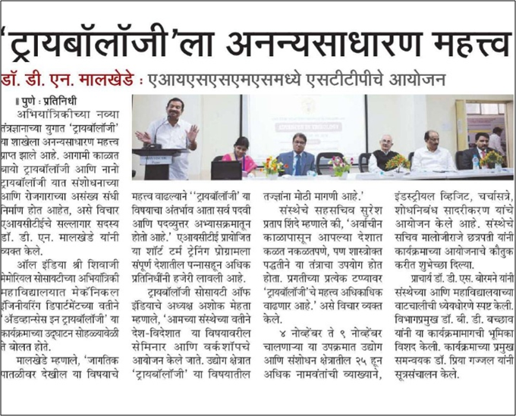 | 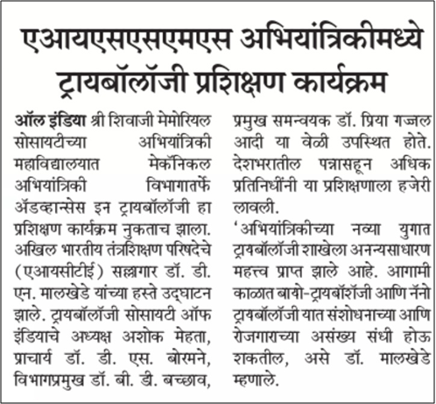
EXTENSION LECTURES (LECTURES DELIVERED BY VISITING GUESTS)
MOU SIGNED
EVENTS ORGANISED
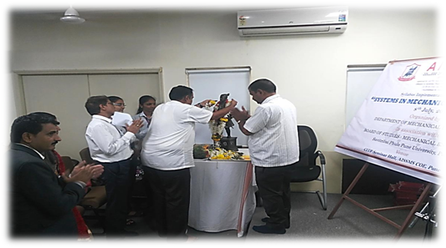 | 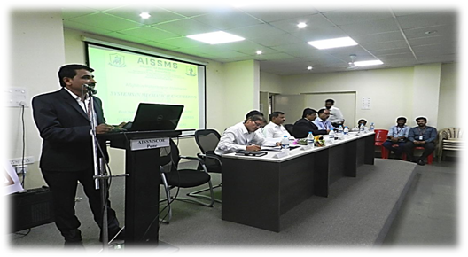
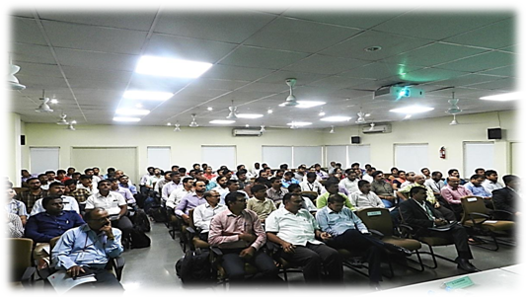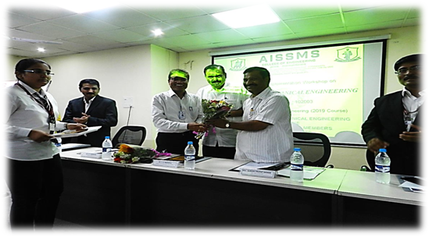
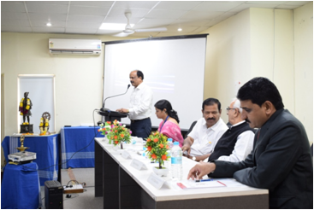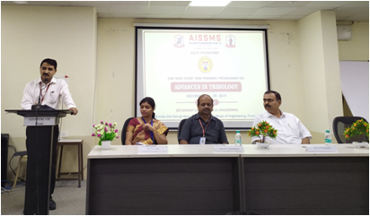
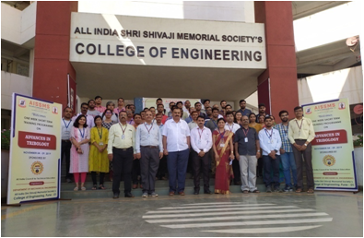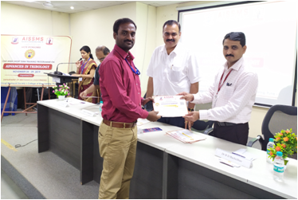
One week AICTE sponsored STTP on “Advances in Tribology”
conducted on November 4-9, 2019

INDUSTRIAL VISITS
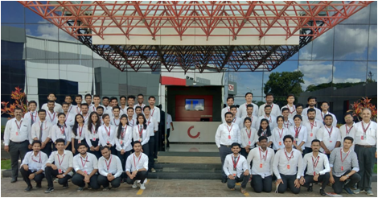 | 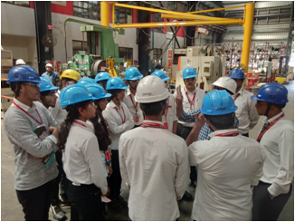
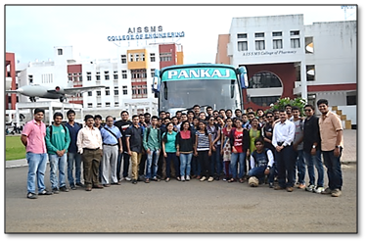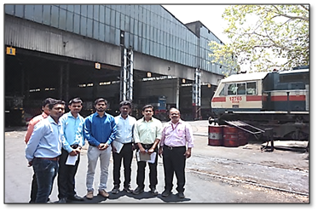
EXPERT LECTURES DELIVERED BY INDUSTRY EXPERTS
SPORTS / CULTURAL ACHIEVEMENTS
SOCIAL ACTIVITIES
AISSMS ENGINEERING TODAY
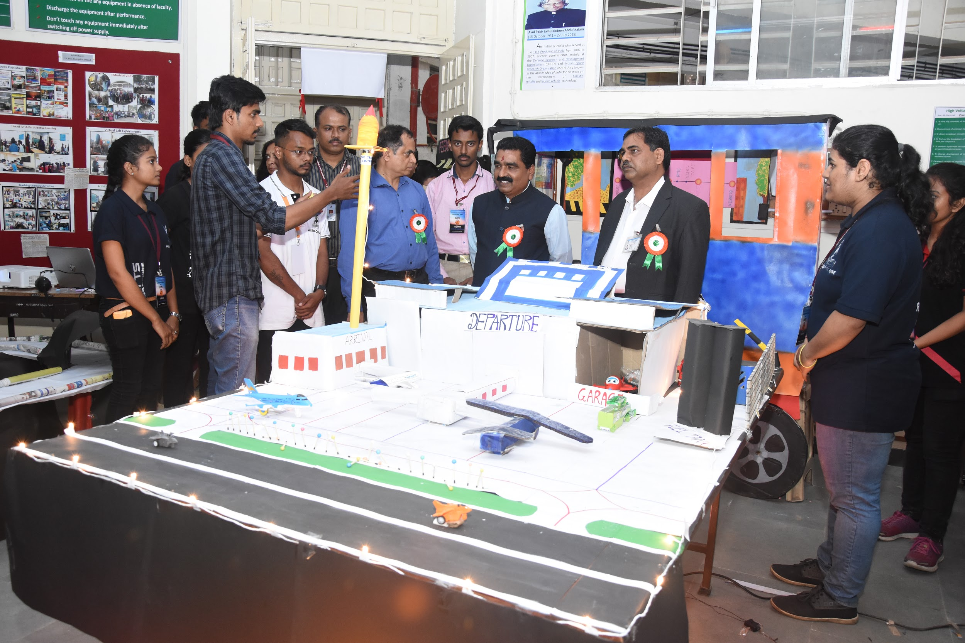 | 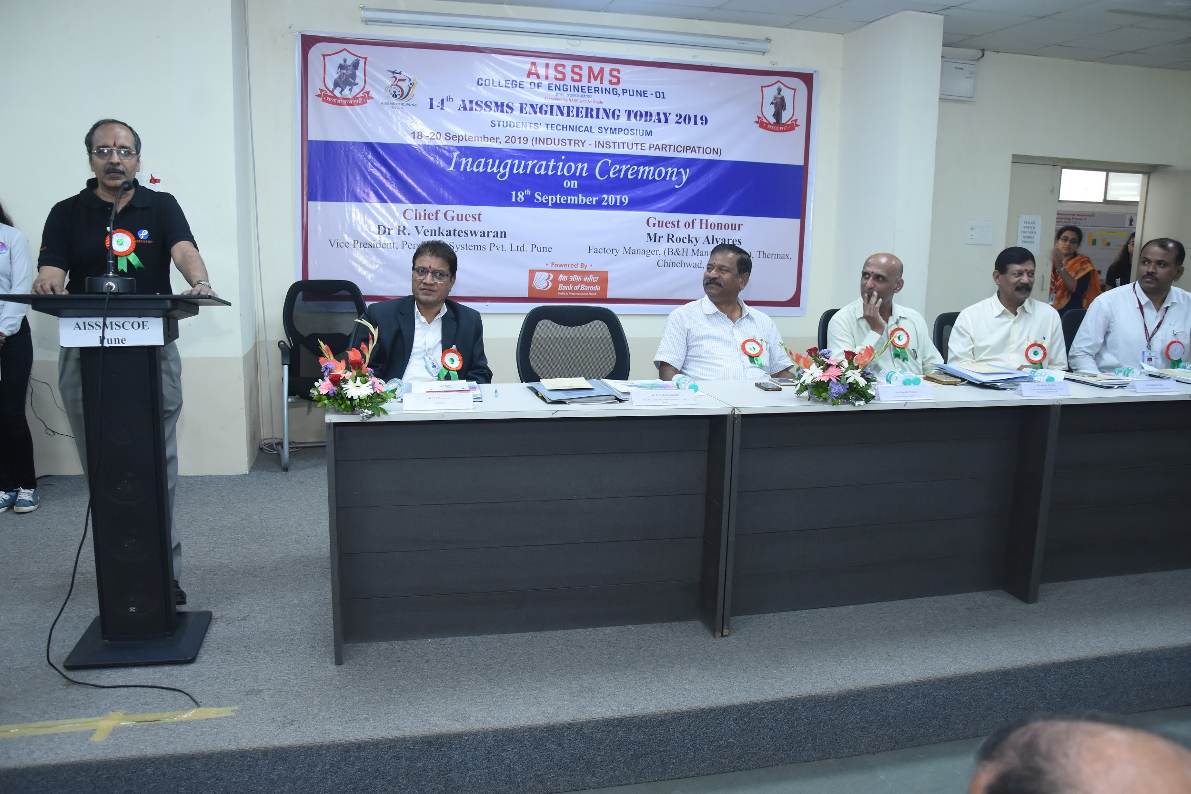
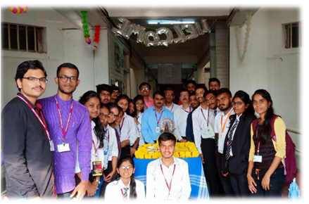 | 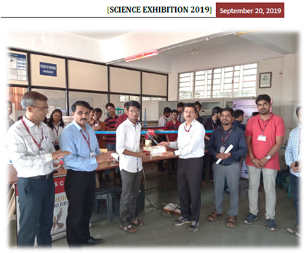

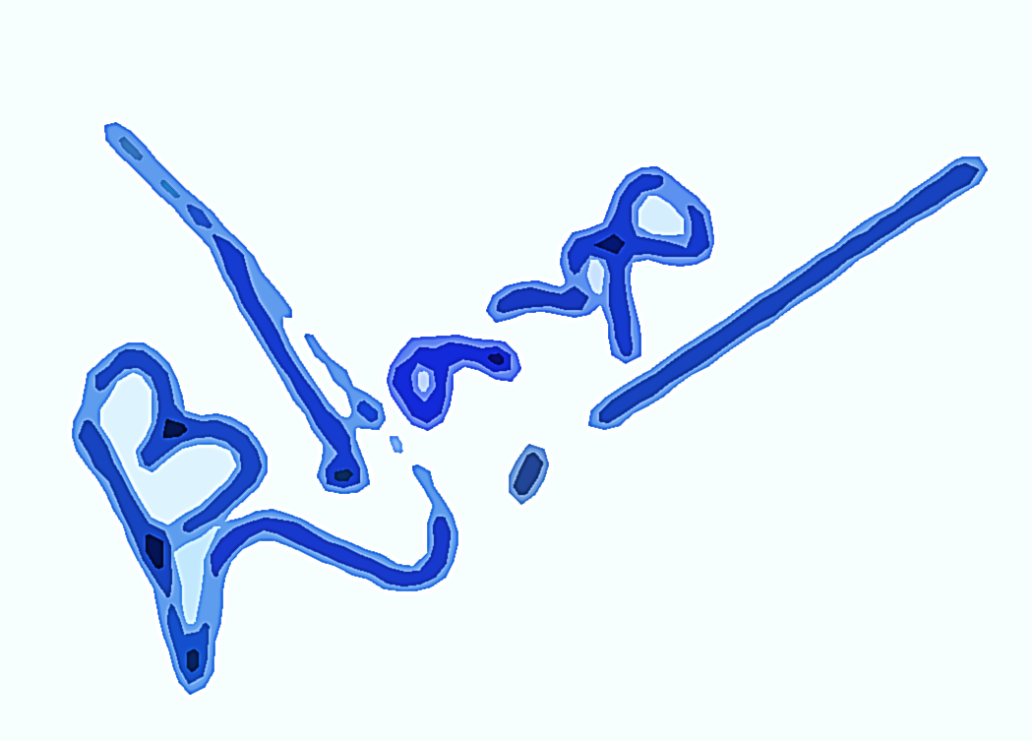
Dr B D Bachchhav
(Name and Signature)
Head of Department
Mechanical Engineering

