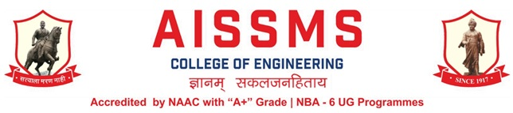
Internal Quality Assurance Cell

DEPARTMENT OF PRODUCTION ENGINEERING
ANNUAL REPORT
(15 JUNE 2022 to 14 June 2023)
TERM ONE: 15 June 2022 to 30 November 2022
TERM TWO: 01 December 2022 to 14 June 2023

Academic Year 2022 – 23
Guidelines:
Fill up this sheet for all the contributions /activities conducted at Department level only.
- In case data does not exist please mention it as ‘No Data’.
- Please add rows to the table below to suit your requirements
- Ensure that data does not differ from other official records and all the supporting documents are available.
- Use: Font Type: Times New Roman, Font Size: 12, Sentence case, Spacing: 1.15
- Use a separate row for every detail.
- For any queries, you may contact: Dr C S Choudhari, Coordinator, IQAC
- email: iqac@aissmscoe.com

CONTENTS
Sr No | Activity/ Item | Page No
- PROFILE OF DEPARTMENT
1.1 | Introduction
1.2 | Laboratories in the Department
1.3 | Software Available in the Department
1.4 | Faculty in the Department
1.5 | Details of Supporting Staff
1.6 | Students’ Enrollment
1.7 | Students–Faculty Feedback Details
1.8 | Result Analysis
1.9 | Class Result Analysis
 | - FACULTY CONTRIBUTION
2.1 | Achievements of Faculty
2.2 | Contribution of Faculty (Interaction With Outside World)
2.3 | e content developed by faculty and available online
2.4 | FDP/STTP attended by the department faculty
2.5 | Seminars/ workshops/ webinars attended by the department faculty
2.6 | Conferences/ symposiums attended by the department faculty
2.7 | Online courses / certificate courses completed by department faculty
2.8 | Extension lectures / webinars organized
2.9 | Faculty served as resource person, expert, chairperson
- ACTIVITIES ORGANISED
3.1 | FDP/STTP organized by the department
3.2 | Seminars/ workshops/ webinars organized by the department (for faculty)
3.3 | Conferences/ symposiums organized by the department
3.4 | Extension activities conducted by the department
3.5 | MOU signed with academic and professional organizations
3.6 | Students’ chapters /clubs
3.7 | Social activities organized
3.8 | Parent meeting
3.9 | Alumni meet
3.10 | Support from Alumni
3.11 | Interaction with Alumni
3.12 | Student counseling and career guidance at the department level
- RESEARCH CONTRIBUTION
4.1 | Funded research project
4.2 | Testing and consultancy
4.3 | Patents, copyright, trademark and other (IPR)
4.4 | Papers published/ presented in proceedings of conferences
4.5 | Papers published in journals
4.6 | Book/ article publications
4.7 | Total Research citations
4.8 | ME awarded
4.9 | PhD guide details
4.10 | PhD AWARDED
 | - INTERACTION WITH INDUSTRY
5.1 | Industrial visits organised
5.2 | Expert lectures delivered by industry experts
5.3 | Industry –sponsored projects (UG/PG)
5.4 | MOU signed with industry
5.5 | Faculty members undergone industrial training
5.6 | Students undergone in-plant training and (or) internship programme
5.7 | Support from Industry
5.8 | Training to Industry personnel/ Activity Supporting industry
5.9 | Any other activities to Promote Interaction With Industry
5.10 | Students Undergone Sandwich Training
- STUDENTS’ ACHIEVEMENT
6.1 | Students’ Achievement (Professional) (Individual Level)
6.2 | Students’ Achievement (Other than Professional) (Individual Level)
6.3 | Certificate / Online Courses Completed by Students
6.4 | Number of Students Placed
6.5 | Number of Students qualified in the competitive examinations
6.6 | Sports / Cultural Achievements of Students (Individual Level)
6.7 | Students’ Achievements (Team Level)
 | - SUMMARY AND SWOC ANALYSIS
7.1 | Any other noteworthy achievement of the department
7.2 | Miscellaneous (Syllabus Implementation, Major Addition In Infrastructure And Facility, Innovations Introduced, etc.)
7.3 | Feedback from Stakeholders
7.4 | Two Best Practices Followed in the Department
7.5 | Major Grievances of Students (If Any) Redressed
7.6 | SWOC Analysis
7.8 | Future Plans of the Department
7.9 | Initiatives Taken By The Department At Department And Institute Level To Improve And Assure Quality
7.10 | Summary Sheet (Annual)

- PROFILE OF DEPARTMENT
1.1 INTRODUCTION

Year of Establishment | 1994
UG Programmes | PRODUCTION ENGINEERING
PG Programmes | NA
Number of Teaching Staff | 09
Number of Non-Teaching Staff | 12 (Production + Workshop)

1.2 LABORATORIES IN THE DEPARTMENT

Name of Laboratory |  | Name of Laboratory
1 | CAD/CAM Laboratory | 5 | NonTraditional Machine Laboratory
2 | Robot & Automation Laboratory | 6 | Advanced Production Technology
3 | Production Management Laboratory | 7 | Department Central Facility
4 | Tool Engineering Laboratory

1.3 SOFTWARES AVAILABLE IN THE DEPARTMENT

Software Available |  | Software Available
1 | Unigraphics Mfg. Bundle 10 nos. and (FEMAP +NASTRAN) 5 nos. and FACTORY CAD-2 nos. and  FACTORY FLOW-02 Nos.and eMplant- 02 Nos. | 5 | ANSYS Academic Teaching + CFD Version 16.2 for (25 user)
2 | Computer Software Autodesk Inventor Professional Edu. License (03) | 6 | JASP- Version 2 (Janatics Animation Software & Pneumatics) (01)
3 | Solid Edge Bundle (Drafting Solid Modeling and Sheet Metal) for 25 user | 7 | Systat Statistical Software -Version 12 (01)
4 | Unigrahics 8.0 Cam Express  (Simulation, Modeling, Tool Path Generation) 20 user

1.4 FACULTY IN THE DEPARTMENT
Name of faculty | Designation
Dr N G Shekapure | Head & Assistant Professor
Mr V Y Sonawane | Assistant Professor
Mr V D Dholle | Workshop Superintendent
Mr M A Kelkar | Asst Workshop Superintendent
Mr S S Kallurkar | Assistant Professor
Mr S N Chiwande | Assistant Professor
Mr S K Bidgar | Assistant Professor
Mr M L Chanpur | Assistant Professor
Ms Y K Funde | Assistant Professor

1.5 DETAILS OF SUPPORTING STAFF
Name of non-teaching staff | Designation
Mr Rahul S Gangawane | Technical Assistant
Mr A Chopane | Store Keeper
Mr N V Walke | Instructor
Mr V N Hire | Instructor
Mr R M Khedekar | Instructor
Mr Sanjay M K | Instructor
Mr P D Pawar | Electrician
Mr B H Gade | Attendant
Mr Y G Patil | Attendant
Mr N V Adhav | Attendant
Mr A U Dhame | Attendant

1.6 STUDENTS’ ENROLLMENT
Program | GEN |  | SC |  | ST |  | OBC |  | PWD |  | Others |  | Total
 | M | F | M | F | M | F | M | F | M | F | M | F | M | F
UG (FE) (Prod/Sw) | - | - | - | - | - | - | 1 | - | - | - | - | - | 1 | -

1.7 STUDENTS–FACULTY FEEDBACK DETAILS
Term One
Sr. No. | Name of faculty | Class and Subject taught | Feedback (I) (%) | Feedback (II) (%) | Average  Feedback (%)
1 | Dr N G Shekapure | BE Prod SW, Creative Product Design | 87 | 93 | 90
2 | Mr V Y Sonawane | BE Prod SW, Manufacturing Automation | 68 | 81 | 74.50
3 | Mr V D Dholle | BE Prod SW,  Operation Research | 78 | 91 | 84.5
4 | Mr M A Kelkar | SE Prod SW,  MP I | 90 | 90 | 90
5 | Mr M A Kelkar | BE Prod SW, Mini Project | 95 | 95 | 95
6 | Mr S S Kallurkar | SE Prod SW, H&FE | 100 | 100 | 100
7 | Mr S S Kallurkar | BE Prod SW, Mini Project | 86 | 90 | 88
8 | Mr S N Chiwande | BE Prod SW,  Industrial Robotics | 80 | 91 | 86
9 | Mr S K Bidgar | SE Prod SW, Material Science & Metallurgy | 100 | 100 | 100
10 | Mr M L Chanpur | SE Prod SW, Strength of Materials | 100 | 100 | 100
11 | Ms Y K Funde | TE Electrical, Industrial & Technology Management | 79 | 79 | 79
12 | Ms Y K Funde | /BE PSW Mini Project | 79 | 96 | 87.50

Term Two
Sr. No. | Name of faculty | Class and Subject taught | Feedback (I) (%) | Feedback (II) (%) | Average  Feedback (%)
1 | Dr N G Shekapure | SE Prod SW, Industrial Engineering & Management | 100 | 96 | 98
2 | Mr V Y Sonawane | TE Prod SW, Metal Forming and Mold Design | 89 | 87 | 88
3 | Mr V D Dholle | TE Prod SW,  Kinematics and Design of Machines | 89 | 81 | 85
4 | Mr M A Kelkar | TE Prod SW,  Metrology & Quality Control | 90 | 90 | 90
5 | Mr S S Kallurkar | TE Prod SW,  Statistics and Numerical Optimization methods | 89 | 79 | 84
6 | Mr S N Chiwande | SE Prod SW,  Theory of Machines | 100 | 88 | 94
7 | Mr S K Bidgar | SE Prod SW, Manufacturing Process - II | 100 | 100 | 100
9 | Mr M L Chanpur | SE Prod SW, Design of Machine Elements | 99 | 83 | 91
10 | Mr M L Chanpur | SE Prod SW, Soft Skills | 100 | 84 | 92
11 | Ms Y K Funde | TE Prod SW,  World Class Manufacturing | 92 | 86 | 89
12 | Ms Y K Funde | SE Prod SW, Programming in C  Language Lab | 100 | 98 | 99

1.8 RESULT ANALYSIS
Term One (Nov/Dec 2021)
Name of faculty | Class and Subject Taught | % Passing | Name of faculty | Class and Subject Taught | % Passing
SE
Mr K B Kshirsagar | MIII | 96.29 | Mr M A Kelkar | MP I | 100
Mr S S Kallurkar | H & FE | 100 | Mr S K Bidgar | M S & M | 100
Mr M L Chanpur | SOM | 100
TE
Dr N G Shekapure & Staff | IIT (TW) | 100 | Dr N G Shekapure  & Staff | Seminar (OR) | 100
Dr N G Shekapure & Staff | IIT (OR) | 100 | Mr V D Dholle | MT (PP) | 100
Dr N G Shekapure  & Staff | Seminar (TW) | 100 | Mr V D Dholle | MT (TW) | 100
BE
Mr V D Dholle | OR | 100 | Mr S N Chiwande | AE | 100
Ms Y K Funde | M & R | 100 | Dr N G Shekapur | MML | 100
Mr V Y Sonawane | APT | 100 | Mr M A Kelkar | E&HFE | 100

Term Two (May/June 2022)
Name of faculty | Class and Subject Taught | % Passing | Name of faculty | Class and Subject Taught | % Passing
SE
Dr L S Godse | EIE | 86 | Dr N G Shekapure | IE& M | 71
Mr S N Chiwande | TOM | 75 | Mr S K Bidgar | MP II | 61
Mr M L Chanpur | DME | 61
TE
Mr V D Dholle | KDM | 85 | Mr M A Kelkar | MQC | 90
Mr S S Kallurkar | S&NOM | 90 | Mr V Y Sonawane | MF& MD | 87
Ms Y K Funde | WC MFG | 80
BE
Dr N G Shekapure & Staff | IIT(TW) | 100 | Dr N G Shekapure & Staff | TPP (TW) | 100
Dr N G Shekapure & Staff | IIT(OR) | 100 | Dr N G Shekapure & Staff | TPP (OR) | 100
Dr N G Shekapure  & Staff | Project (TW) | 100 | Mr M A Kelkar | SCM(PP) | 100
Dr N G Shekapure  & Staff | Project(OR) | 100 | Mr M A Kelkar | SCM(TW) | 100

1.9 CLASS RESULT ANALYSIS (All Classes FE to BE)
Term One
SN | Class | Number of Students = 154 |  |  |  |  |  |  |  |  | Percentage of Passing
 |  | Appeared | Clear Passed | Outstanding  (O)  (9.1 -10) | Excellent  (A+)  (8.1 – 9) | Very Good (A)  (7.1 – 8) | Good (B+)  (6.1 – 7) | Above Average (B)  (5.1 – 6) | Average / pass class  (4 – 5) | Fail (F)  0 – 3.99 | All Clear | With ATKT
1 | SE | 27 | 26 | — | 19 | 7 | — | — | — | — | 96.3 | 100
2 | TE | 53 | 52 | 52 | — | — | — | — | — | — | 98.12 | 100
3 | BE | 73 | 73 | 72 | 1 | — | — | — | — | — | 100 | —

Term Two
SN | Class | Number of Students = 155 |  |  |  |  |  |  |  |  | Percentage of Passing
 |  | Appeared | Clear Passed | Outstanding  (O)  (9.1 -10) | Excellent  (A+)  (8.1 – 9) | Very Good (A)  (7.1 – 8) | Good (B+)  (6.1 – 7) | Above Average (B)  (5.1 – 6) | Average / pass class  (4 – 5 ) | Fail  (F)  0 – 3.99 | All Clear | With ATKT
1 | SE | 28 | 13 | — | 2 | 10 | 1 | — | — | — | 43 | 100
2 | TE | 54 | 39 | 12 | 23 | 4 | — | — | — | — | 72.22 | 100
3 | BE | 73 | 73 | 69 | 4 | — | — | — | — | 100 | — | —

Term Two Final Result for BE Classes (Based on CGPA)
SN | Class | Number of Students |  |  |  |  |  |  |  |  | Percentage of Passing
 |  | Appeared | Clear Passed | Outstanding  (O)  (9.1 -10) | Excellent  (A+)  (8.1 – 9) | Very Good (A)  (7.1 – 8) | Good (B+)  (6.1 – 7) | Above Average (B)  (5.1 – 6) | Average / pass class  (4 – 5) | Fail (F)  0 – 3.99 | All Clear | With ATKT
1 | BE | 73 | 73 | 69 | 4 | — | — | — | — | — | 100 | —

1.10 UNIVERSITY RANKERS (Consider last five academic years)
Year 2021 - 22 (Oct 21) Academic Term I
Sr No | Name of the Ranker | Class | Rank
1 | DHAKE PURVESH PRAVIN | SE | 1st
2 | DESHMUKH SHRIGANESH PRAVINCHANDRA | SE | 2nd
3 | YASH JAGDISH TADAS | SE | 3rd
4 | MANDHARE ATHARVA RAVINDRA | SE | 4th
5 | PATIL ADITYA KAILAS | SE | 4th
1 | THAKARE JANHAVI CHANDRASHEKHAR | TE | 1st
2 | PAWAR SHANKAR GANESH | TE | 2nd
3 | SONAR PRATIK DATTATRAY | TE | 2nd
4 | CHAWARE KARTIKI SHANKAR | TE | 3rd
5 | JAJU KESHAV MATHURADAS | TE | 4th
1 | SHINDE RAJVEER VEERENDRA | BE | 1st
2 | SHINDE ANURAG AVADHUT | BE | 1st
3 | MARKANDE KALYANI MILIND | BE | 1st
4 | SARODE OMKAR SANJAY | BE | 2nd
5 | PAWAR PRATHAMESH JIJABHAU | BE | 3rd

Year 2021 - 22 (May 22) Academic Term II
Sr No | Name of the Ranker | Class | Rank
1 | DESHMUKH SHRIGANESH P | SE | 1st
2 | GHAROTE SAISHNU SANJAY | SE | 2nd
3 | PATIL ADITYA KAILAS | SE | 3rd
4 | THAKUR EKTA SHANMUKH | SE | 4th
5 | MANDHARE ATHARVA RAVINDRA | SE | 5th
1 | MANE HRUSHIKESH GORAKH | TE | 1st
2 | WAGH RUTUJA SURESH | TE | 2nd
3 | CHAWARE KARTIKI SHANKAR | TE | 3rd
4 | KADAM RUTUJA UDAY | TE | 3rd
5 | AMRUTKAR RUSHIKESH LAXMAN | TE | 4th
1 | SHREYASH DNYANDEO ASANE | BE | 1st
2 | SOMOSHI AKSHAY RAKHMAJI | BE | 2nd
3 | KAKADE PRATIKSHA ANANT | BE | 3rd
4 | KACHI OMKAR BIPIN | BE | 4th
5 | RANE TEJAS ATUL | BE | 4th

- FACULTY CONTRIBUTION

2.1 ACHIEVEMENTS OF FACULTY
(AWARDS, RECOGNITION, PHD COMPLETION ETC.) (ALL FACULTIES)
SN | Name of Faculty | Awards & Recognitions
1 | Dr N G Shekapure | Elected as a BOS Member (Production & Industrial Engineering) at SPPU, Pune
2 | Mr V Y Sonawane | Eminent Jury member National convention, Indian Institution of Industrial engineering Pune chapter 16th and 17th December 2022 theme paper contest

2.2 CONTRIBUTION OF FACULTY (Interaction with outside world)
Term One
SN | Name of Faculty | Nature and details of contribution (Representation at University, State, National, International level, corporate world, Social Platforms, etc)
1 | Dr N G Shekapure | Delivered a Expert lecture on topic “Ensuring Students Engagement during Online teaching”, at FabTech College of Engineering on 25/08/2022
2 | Mr S K Bidgar | Published an International Patent on “Hybrid Technology for Facilitating Parking for Vehicles in Congested Areas” on 03/08/2022.

Term Two
SN | Name of Faculty | Nature and details of contribution (Representation at University, State, National, International level, corporate world, Social Platforms, etc)
1 | Mr V Y Sonawane | Resource person for One Week Short Term Training Program (STTP) on “EMERGING TRENDS IN MECHANICAL ENGINEERING” at Dr. V. B. Kolte College of Engineering, Malkapur Dist-Buldana, In association with ISTE Local Chapter
2 | S S Kallurkar | Published and Presented paper at International Conference on Material Characterization at GHIRET Hyderabad titled “Identifying User Experience Issues For Computer Aided Design  (CAD) Software: A Survey and Exploratory Factor Analysis To  Identify The Issues To Implement Artificial Intelligence For  Improving User Experience.”

2.3 E-CONTENT DEVELOPED BY FACULTY AND AVAILABLE ONLINE
Term One
Sr No. | Name of Faculty | Title of e-content | e-content development facility/platform | Link of the content
1 | Ms Y K Funde | PPT/ Video | Mail/ Whatsapp
2 | Mr M L Chanpur | Lecture Notes | Google Drive and ERP
3 | Dr N G Shekapure | PPT / Lecture Notes / Question Bank | Google Drive
4 | Mr V Y Sonawane | PPT / Lecture Notes / Question Bank | Mail/ Whatsapp Google Drive
5 | Mr Veejhay Dholle | PPT / Lecture Notes / Question Bank | Google Drive
6 | Mr S K Bidgar | PPT / Lecture Notes / Question Bank | Google Drive and Whatsapp Group

Term Two
Sr No. | Name of Faculty | Title of e-content | e-content development facility/platform | link of the content
1 | Ms Y K Funde | PPT/ Video | Mail/ Whatsapp
2 | Mr V Y Sonawane | PPT / Lecture Notes / Question Bank | Google Drive
3 | Mr M L Chanpur | Lecture Notes | Google Drive and ERP
4 | Mr S K Bidgar | PPT / Lecture Notes / Question Bank | Google Drive and Whatsapp Group

2.4 FDP/STTP ATTENDED BY THE DEPARTMENT FACULTY
Term One
S N | Name of Faculty | Title of the FDP/STTP | Organized by | Duration/ Dates
1 | Mr S N Chiwande | Developing Soft Skills & Personality | NPTEL MoE GoI & IITK | 08 Week Course
2 | Mr M L Chanpur | Trends and Challenges in Development of Electric Vehicles and Hybrid Electric Vehicles | Lendi Institute of Engineering and Technology, Kakinada | 01 Week
3 | Dr N G Shekapure | E-Learning Authoring Tools | NITTTR, Chennai | 01 Week
4 | Dr N G Shekapure | Entrepreneurship Development and Start-ups | NITTTR, Chennai | 01 Week
5 | S S Kallurkar | E-Learning Authoring Tools | NITTTR, Chennai | 01 Week
6 | S S Kallurkar | Entrepreneurship Development and Start-ups | NITTTR, Chennai | 01 Week
7 | Mr V Y Sonawane | FDP on One Week Faculty Development Program on “Machine Learning” | Sinhgad Institute of Technology, Lonavala | 01 Week
8 | Mr V Y Sonawane | FDP on Trends and challenges in the development of Electrical vehicles and Hybrid electrical vehicles (Series 1) | Lendi Institute of Engineering and Technology Vizianagaram, Andhra Pradesh | 01 Week
9 | Mr V Y Sonawane | FDP on One Week Faculty Development Programme (Online) on “Industry 4.0 & Smart Manufacturing” | Padm. Dr. V. B. Kolte College of Engineering | 01 Week
10 | Mr V Y Sonawane | FDP on 14th Summer School in Tribology | Indian Oil Institute of Petroleum Management (IiPM), Gurugram | 01 Week
11 | Mr Veejhay Dholle | Laser Based Manufacturing | NPTEL MoE GoI & IIT Guwahati | 08 Week Course
12 | Mr S K Bidgar | LaTeX and Desktop Publishing | NITTTR, Chennai | 01 Week
13 | Mr S K Bidgar | E-Learning Authoring Tools | NITTTR, Chennai | 01 Week

Term Two
S N | Name of Faculty | Title of the FDP/STTP | Organized by | Duration/ Dates
01 | Mr S N Chiwande | IoT based Predictive Analytics using Artificial Intelligent | ATAL FDP | 13/02/2023 to  24/02/2023
02 | Mr V Y Sonawane | One Week Short Term Training Program (STTP) on “EMERGING TRENDS IN MECHANICAL ENGINEERING”  Dr. V. B. Kolte College of Engineering, Malkapur Dist-Buldana, | ISTE | 13th March 2023 to 17th March 2023
03 | Mr S K Bidgar | One Week National Level Faculty Development Program on “Recent Advancement in Material, Micro-Manufacturing and Characterization (RAMMC-23) | ISTE | 13 - 17 March 2023

2.5 SEMINARS/ WORKSHOPS/ WEBINARS ATTENDED BY THE DEPARTMENT FACULTY
Term One
S N | Name of Faculty | Title of the Seminar/Webinar | Organized By | Duration/ Dates
1 | Mr S N Chiwande | Energy Literacy Training | Energy Swaraj Foundation | 27/02/2023
2 | Ms Y K Funde | Lean six Sigma yellow belt certification program | Binghamton University, USA | 15/10/2022 to 18/10/2022
3 | Ms Y K Funde | Energy Literacy Training | Energy Swaraj Foundation | 23/02/2023
4 | Dr N G Shekapure | PARAKH AICTE Self learning Assessment Test | AICTE | 04/10/20227
5 | Mr V D Dholle | PARAKH AICTE Self learning Assessment Test | AICTE | 17/10/2022
6 | Mr M L Chanpur | Triz Talk Chapter 7 | Triz Asia | 29/07/2022
7 | Mr S N Chiwande | A one-day workshop on industrial robotics | Autofina Robotics. | 30/07/2022
8 | Mr S N Chiwande | “What do you mean by Prakriti, How disease is formed? Solution is Agnihotra Healing.” | AISSMS COE & NSS | 26/08/2022.
9 | Mr S N Chiwande | “Rejuvenate with Yoga” | NSS and FE Department | 05/09/2022
10 | Mr S N Chiwande | "Awareness in Industrial Automation & PLC-SCADA '' delivered by Sofcon India Pvt Ltd on | Department of Production Engineering | 15/09/2022.
11 | Mr S N Chiwande | Attended PCSIC Startup Conclave | PCSIC, Pune | 22/12/2022
12 | Mr V Y Sonawane | Attended Webinar  Augmented Reality in  Learning Environment  Resource Person Dr.  Syed Ali Fathima | Kumaraguru  College of  Technology  Coimbatore | 25/07/2022
13 | Mr V Y Sonawane | Attended a Seminar by Ayurvedacharya, an event coordinated with NSS on the topic “What do you mean by  Prakriti, how disease is  formed? Solution is  Agnihotra Healing.” | AISSMS COE | 26/08/2022
14 | Mr V Y Sonawane | Attended a guest lecture  on “Rejuvenate with  Yoga”, which was organized by the NSS and FE  Department | AISSMS COE | 05/09/2022
15 | Mr V Y Sonawane | Attended online Inauguration Ceremony of SPPU Pavilion Building,  Synthetic Track and  Indoor Hall | Savitribai Phule Pune University | 07/07/2022
16 | Mr V Y Sonawane | Attended Unnat Bharat  Abhiyan, | MHRD Govt. of  India program at AISSMS COE | 07/07/2022.
17 | Mr V Y Sonawane | Attended “YUVAWANI-Author's meet”, an initiative of  Shivdarpan Magazine  Committee, | AISSMS COE | 29/08/2022
18 | Mr M A Kelkar | Energy Literacy Training | Energy Swaraj Foundation | 27/02/2023

Term Two
S N | Name of Faculty | Title of the Seminar/Webinar | Organized By | Duration/ Dates
1 | Dr N G Shekapure | Energy Literacy Training | Energy Swaraj Foundation | 20/02/2023
2 | Mr S N Chiwande | Energy Literacy Training | Energy Swaraj Foundation | 27/02/2023
3 | Mr V Y Sonawane | Energy Literacy Training | Energy Swaraj Foundation | 27/02/2023
4 | Mr M L Chanpur | Energy Literacy Training | Energy Swaraj Foundation | 27/02/2023
5 | Mr V Dholle | Energy Literacy Training | Energy Swaraj Foundation | 27/02/2023
6 | Mr S N Chiwande | Symbol of Knowledge | AISSMS COE NSS | 13/04/2023
7 | Dr N G Shekapure | Symbol of Knowledge | AISSMS COE NSS | 13/04/2023
8 | Mr S K Bidgar | Symbol of Knowledge | AISSMS COE NSS | 13/04/2023
9 | Mr S N Chiwande | Intellectual Property Rights: An overview for Innovation & Growth” | Production Engineering Department AISSMS COE | 14/03/2023
10 | Mr V Y Sonawane | Intellectual Property Rights: An overview for Innovation & Growth” | Production Engineering Department AISSMS COE | 14/03/2023
11 | Mr S K Bidgar | Intellectual Property Rights: An overview for Innovation & Growth” | Production Engineering Department AISSMS COE | 14/03/2023
12 | Dr N G Shekapure | Intellectual Property Rights: An overview for Innovation & Growth” | Production Engineering Department AISSMS COE, Pune on | 14/03/2023
13 | Mr M A Kelkar | Intellectual Property Rights: An overview for Innovation & Growth” | Production Engineering Department AISSMS COE, Pune | 14/03/2023
14 | Mr S N Chiwande | NASSCOM SME Confluence 2023, Pune | NASSCOM | 23/03/2023
15 | Ms Y K Funde | “Symbol of Knowledge” | AISSMS COE NSS | 13/04/2023
16 | Mr S K Bidgar | Energy Literacy Training | Energy Swaraj Foundation | 27/02/2023

2.6 CONFERENCES/ SYMPOSIUMS ATTENDED BY THE DEPARTMENT FACULTY
Term One
S N | Name of Faculty | Title of the Conference / Symposium | Organized By | Duration/ Dates
1

Term Two
S N | Name of Faculty | Title of the Conference / Symposium | Organized By | Duration/ Dates
1 | Mr S S Kallurkar | International Conference on Material Characterization 2023 (ICMPC 2023). | GRIET Hyderabad | 24/03/2023 to 26/03/2023

2.7 ONLINE COURSES / CERTIFICATE COURSES COMPLETED BY DEPARTMENT FACULTY
Term One
S N | Name of Faculty | Title of the Course | Conducted By | Duration/ Dates
1 | Mr M L Chanpur | Matlab Modelling of Physical Systems | Inspire Infotech Solutions | 26/11/2022 to 28/11/2022
2 | Mr V D Dholle | Laser Based Manufacturing- NPTEL Course | IIT- Guwahati | 8 Weeks  (22 August -14 Oct 2022)

Term Two
S N | Name of Faculty | Title of the Course | Conducted By | Duration/ Dates
01

2.8 EXTENSION LECTURES / WEBINARS (Lectures organized on other than technical topics))
Term One
S N | Name of faculty coordinator | Topic | Name and contact details of guest | Date | Number of beneficiaries
1 | Dr N G Shekapure | “'Opportunities for higher education in Germany after an Undergraduate Degree’ | Miss Aishwarya Bhosale | 21/09/2022 | 26
2 | Mr V Y Sonawane | Organized  Engineers Day  with production  Students and  Faculty | AISSMS COE Pune  Production Department | 15/09/2022 | 35

Term Two
S N | Name of faculty coordinator | Topic | Name and contact details of guest | Date | Number of beneficiaries
1

2.9 FACULTY SERVED AS RESOURCE PERSON, EXPERT, CHAIRPERSON
Term One
S N | Name of Faculty | Title of Activity | Organizing body | Date
1 | Dr N G Shekapure | Ensuring Students Engagement during Online teaching | FabTech College of Engineering | 25/08/2022
2 | Dr N G Shekapure | Judge for Avishkar Competition 2022-23 | AISSMS COE, Pune | 15/09/2022
3 | Mr S N Chiwande | FE Induction on Entrepreneurship Awareness | FE Department, AISSMS COE, Pune | 21/11/2022 to  24/11/2022
4 | Mr V Y Sonawane | Judge for Avishkar Competition 2022-23 | AISSMS COE, Pune | 15/09/2022

Term Two
S N | Name of Faculty | Title of Activity | Organizing body | Date
1 | Mr S N Chiwande | Appointed as judge for FTC-Asia Pacific Robotic Competition 2022–23 at Shree Shiv Chhatrapati Sports Complex, Pune | FTC-Asia Pacific Robotic | 10/03/2023 to 12/03/2023
2 | Mr S N Chiwande | Delivered the lecture in Entrepreneurship Awareness Camp sponsored by DST GoI, under E&SD-Cell | AISSMS E&SD Cell in association with DST GoI | 08/02/2023

3. ACTIVITIES ORGANIZED

3.1 FDP/STTP ORGANIZED BY THE DEPARTMENT

Term One
S N | Name of faculty coordinator | Title of the FDP/STTP/WS/Seminar/Symposium | Duration/ Dates | No. of Participants | Funding Agency  (If any) and Amount (Rs.)

Term Two
S N | Name of faculty coordinator | Title of the FDP/STTP/WS/Seminar/Symposium | Duration/ Dates | No. of Participants | Funding Agency  (If any) and Amount (Rs.)

3.2 SEMINARS/ WORKSHOPS/ WEBINARS ORGANIZED BY THE DEPARTMENT
Term One
S N | Name of Coordinator/s | Title of the Seminar/Webinar | Duration/ Dates | No. of Participants | Funding Agency  (If any) and Amount (Rs.)
1 | Mr S N Chiwande | AISSMS CoE, ESD-cell organized a two-day training on the “Entrepreneur Awareness Program” in collaboration with BYST, Pune | 29/08/2022  to 30/08/2022 | 20 | BYST, Pune
2 | Mr S N Chiwande | Entrepreneurship Pune Summit in association with IIT-B & AISSMS COE Pune | 24/11/2022 to 26/11/2022 | 200 | AISSMS COE, Pune  Rs 29000/-
3 | Mr V Y Sonawane | Organised one day  workshop PLC /SCADA  awareness for Industrial  Automation with Sofcon  India Pvt Lid Pune | 11/09/2022 | 48 | AISSMS COE Pune, Production  Department  collaboration with Sofcon  India Pvt Lid Pune
 | Mr V Y Sonawane | Industrial visit at  Automation EXPO 2022  Bombay Exhibition  Center at Goregaon  Mumbai | 15/09/2022 | 48 | Bombay Exhibition  Center at Goregaon  Mumbai

Term Two
S N | Name of Coordinator/s | Title of the Seminar/Webinar | Duration/ Dates | No. of Participants | Funding Agency  (If any) and Amount (Rs.)
 | Mr V Y Sonawane | Event Name: “Intellectual Property Rights: An Overview for Innovation and Growth.”  Guest Name: Mr ARPIT JAIN  Topic : Examiner of Patents and Designs & NIPAM officer Patent office, Mumbai DPIIT, Ministry of commerce and industry, Govt. of India | 14/03/2023 | 109 | NIPAM office Patent office, Mumbai DPIIT, Ministry of commerce and industry, Govt. of India

3.3 CONFERENCES/ SYMPOSIUMS ORGANIZED BY THE DEPARTMENT
Term One
S N | Name of Coordinator/s | Title of the Conference / Symposium | Duration/ Dates | No. of Participants | Funding Agency  (If any) and Amount (Rs.)

Term Two
S N | Name of Coordinator/s | Title of the Conference / Symposium | Duration/ Dates | No. of Participants | Funding Agency  (If any) and Amount (Rs.)

3.4 EXTENSION ACTIVITIES CONDUCTED BY THE DEPARTMENT
(Social activities / Quizzes at national/international level/any other activity)
Term One
S N | Name of Faculty Coordinator | Details of activity conducted | Date | Number of beneficiaries
1

Term Two
S N | Name of Faculty Coordinator | Details of activity conducted | Date | Number of beneficiaries
1

3.5 MOU SIGNED WITH ACADEMIC AND PROFESSIONAL ORGANIZATIONS
Term One
Sr. No. | Faculty Coordinator | Name of Organisation | Date  of MoU Signed | Valid upto  00/00/0000
1 | Mr S N Chiwande | BYST, Pune | 04/12/2020 | 04/12/2025
2 | Mr S N Chiwande | Pune Management Association, Pune | 20/09/2021

Term Two
Sr. No. | Faculty Coordinator | Name of Organisation | Date  of MoU Signed | Valid upto  00/00/0000
01 | Mr S N Chiwande | B&R Industrial Automation, Pune | 01/03/2023 | 01/03/2025

Total Functional / Live MoU initiated by Department
Sr. No. | Faculty Coordinator | Name of Organisation | Date  of MoU Signed | Valid upto 00/00/0000
01 | Dr N G Shekapure | Elon Power Pvt. Ltd | 22/02/2022 | 21/02/2027
02 | Ms Y K Funde | Univision Automation Pune | 08/01/2021 | 20/01/2026
03 | Ms Y K Funde | Sofcon PvT Ltd Pune | 18/10/2017 | 17/10/2022
04 | Mr M L Chanpur | Aarohi Industries | 18/01/2021 | 20/01/2026
05 | Mr S K Bidgar | UB Cryogenic Solutions LLP Pune | 04/03/2022 | 03/03/2022
06 | Mr S N Chiwande | BYST, Pune | 04/12/2020 | 04/12/2025
07 | Mr S N Chiwande | Pune Management Association, Pune | 20/09/2021
08 | Mr S N Chiwande | B&R Industrial Automation, Pune | 01/03/2023 | 01/03/2025

3.6 STUDENTS’ CHAPTERS/CLUBS
Sr. No | Name of Students’ Chapter | Number of Student Members
1 | IE(I) Production Engineering Students Chapter | Nil

EVENTS ORGANISED (By Students’ Chapters / Clubs and others)
Name of Students’ Chapter: IE(I) Production Engineering Students Chapter
Faculty Advisor: Mr Veejhay Dholle

Term One
SN | Event name and details of event | Name of chief guest, judges etc. | Duration and Dates | Number of beneficiaries
1 | Seminar by Ayurvedacharya, an event coordinated with NSS on the topic “What do you mean by Prakriti, How disease is formed? Solution is Agnihotra Healing.” | Dr. Girija Rajimwale | 26/08/2022. | 60
2 | One day Seminar- Awareness of Industrial Automation for PLC - SCADA along with Sofcon India Pvt. Ltd Pune | Sofcon India Ltd., | 15/09/2022 | 42
3 | Organized Engineers Day with production Students and Faculty | 1.Mr. Shubham Sharma 2.Ms. Priya Morgaonkar  Sofcon India Pvt. Ltd., | 15/09/2022 | 42
4 | Expert talk on “Opportunities for Higher Studies in Germany” | Ms Aishwarya Bhosale | 21/09/2022 | 19
5 | Industrial Visit of BE PSW Students at Automation 2022, Mumbai | Mr S S Kallurkar | 18/08/2022

Term Two
SN | Event name and details of event | Name of chief guest, judges etc. | Duration and Dates | Number of beneficiaries

3.7 SOCIAL ACTIVITIES ORGANISED (NSS, Women empowerment, Awareness Programms, etc.)
Term One
Faculty coordinator | Name of Activity | Date, Duration | Number of students involved

Term Two
Faculty coordinator | Name of Activity | Date, Duration | Number of students involved

3.8 PARENT MEETING
Faculty Coordinator | Day and Date | Details of Parent meetings organized | Number of Parents attended

3.9 ALUMNI MEET
Faculty Coordinator | Day and Date | Details of Alumni meetings organized | Number of Alumni attended
Mr M A Kelkar | Saturday, 25/02/2023 | as per report | 45

3.10 SUPPORT FROM ALUMNI:
Term One
Sr No | Name of Alumni | Position and Organization | Batch  (e.g. 2014 – 2018) | Details of Support | Date
1 | Miss Aishwarya Bhosale | MS Student at University of Hof, Germany | 2018-2021 | Delivered a Expert lecture on topic “'Opportunities for higher education in Germany after an Undergraduate Degree’ | 21/09/2022

Term Two
Sr No | Name of Alumni | Position and Organization | Batch  (e.g. 2014 – 2018) | Details of Support | Date

3.11 INTERACTION WITH ALUMNI
Term One
S N | Name of Alumni and Activity coordinator | Details of Activity conducted | Date and duration | Total Number of beneficiaries
01 | Miss Aishwarya Bhosale | Expert lecture | 21/09/2022 | 32

Term Two
S N | Name of Alumni and Activity coordinator | Details of Activity conducted | Date and duration | Total Number of beneficiaries

3.12 DETAILS OF STUDENT COUNSELING AND CAREER GUIDANCE AT THE DEPARTMENT LEVEL
Number of students referred for counseling
Number of Faculty referred for counseling | 9

Faculty coordinator | CAREER GUIDANCE ACTIVITY DETAILS

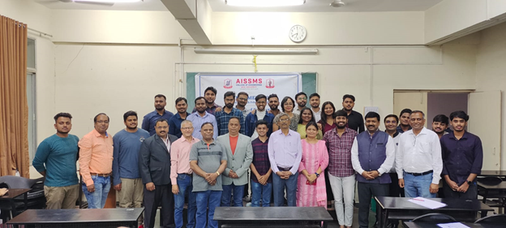
Glimpses of the Alumni Meet on 25/02/2023
Department of Production Engineering
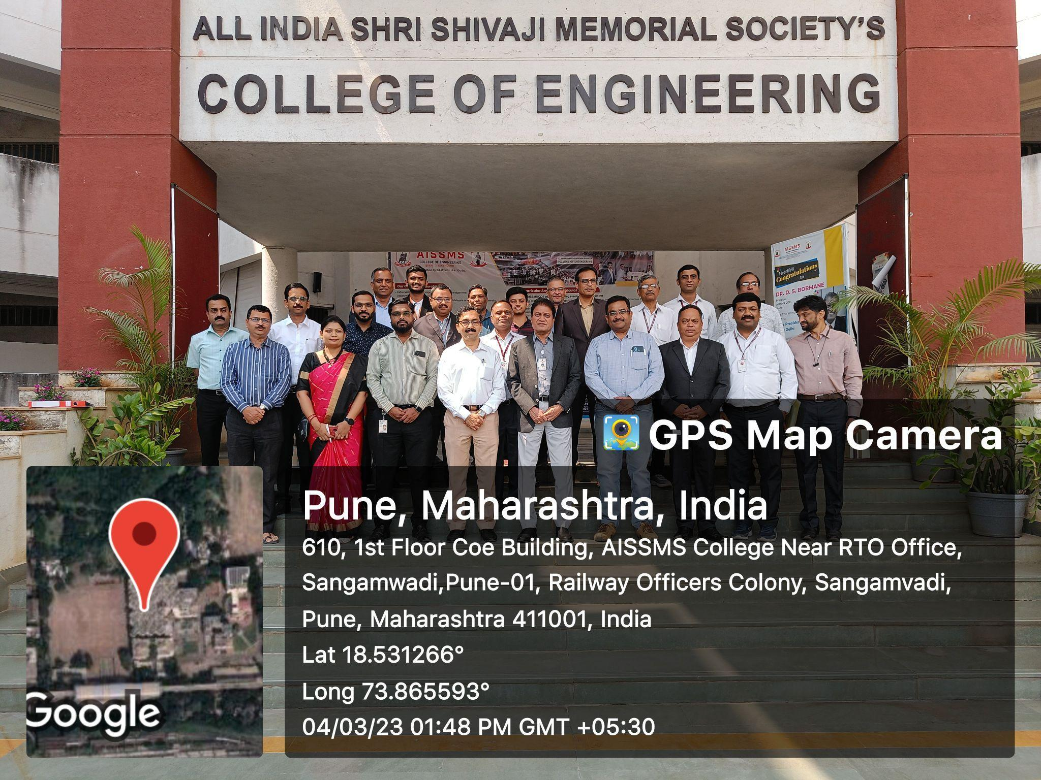
Department Advisory Board Meeting on 04/03/2023
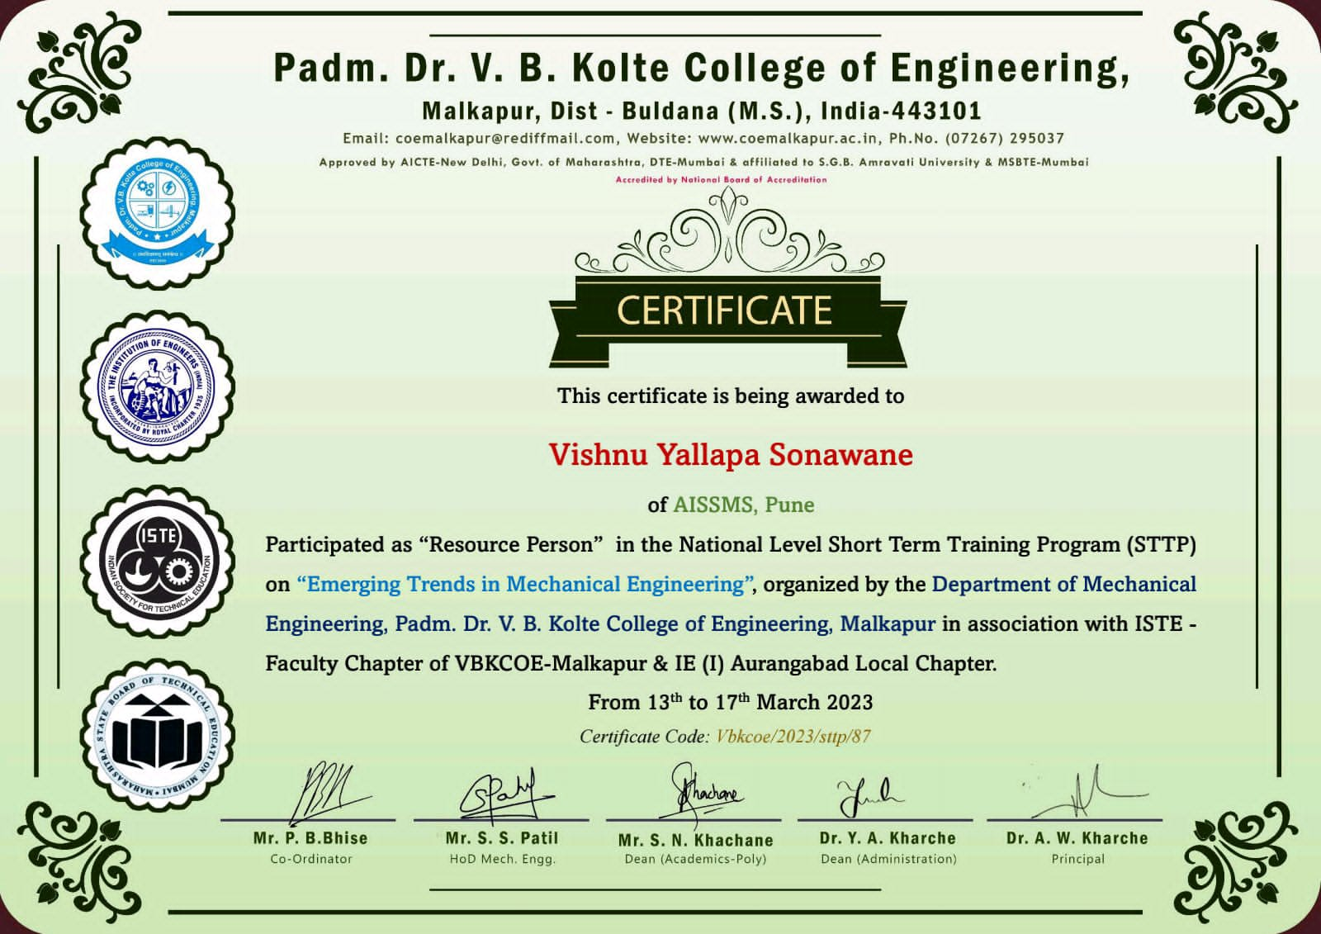
Mr V Y Sonawane as a resource person
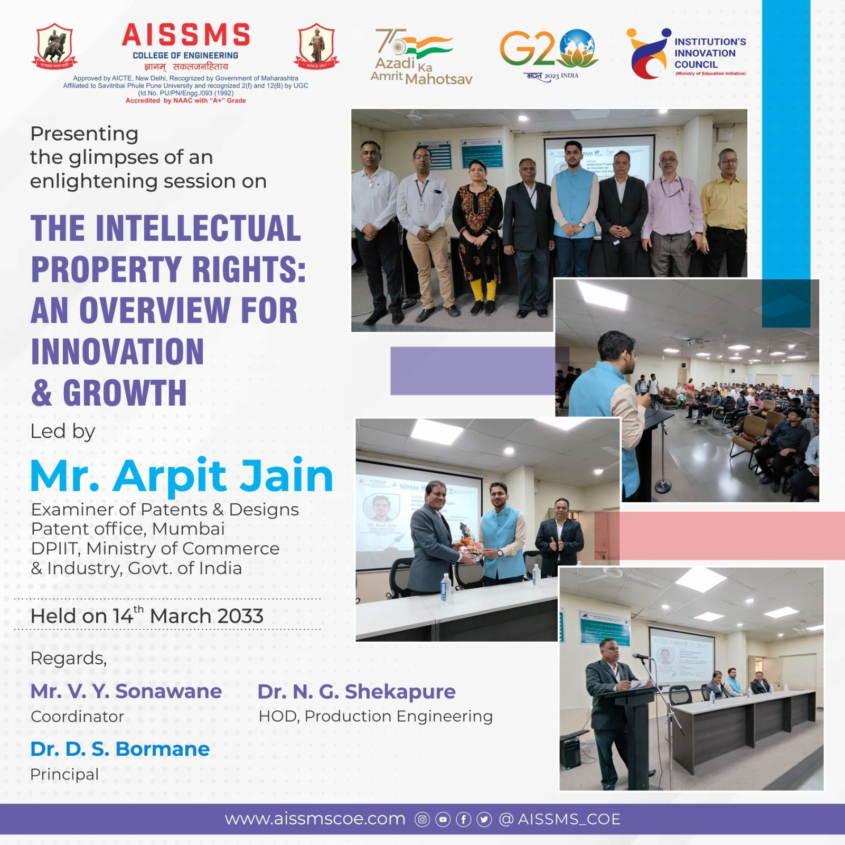
Glimpses of the Event organized by Department of Production Engineering
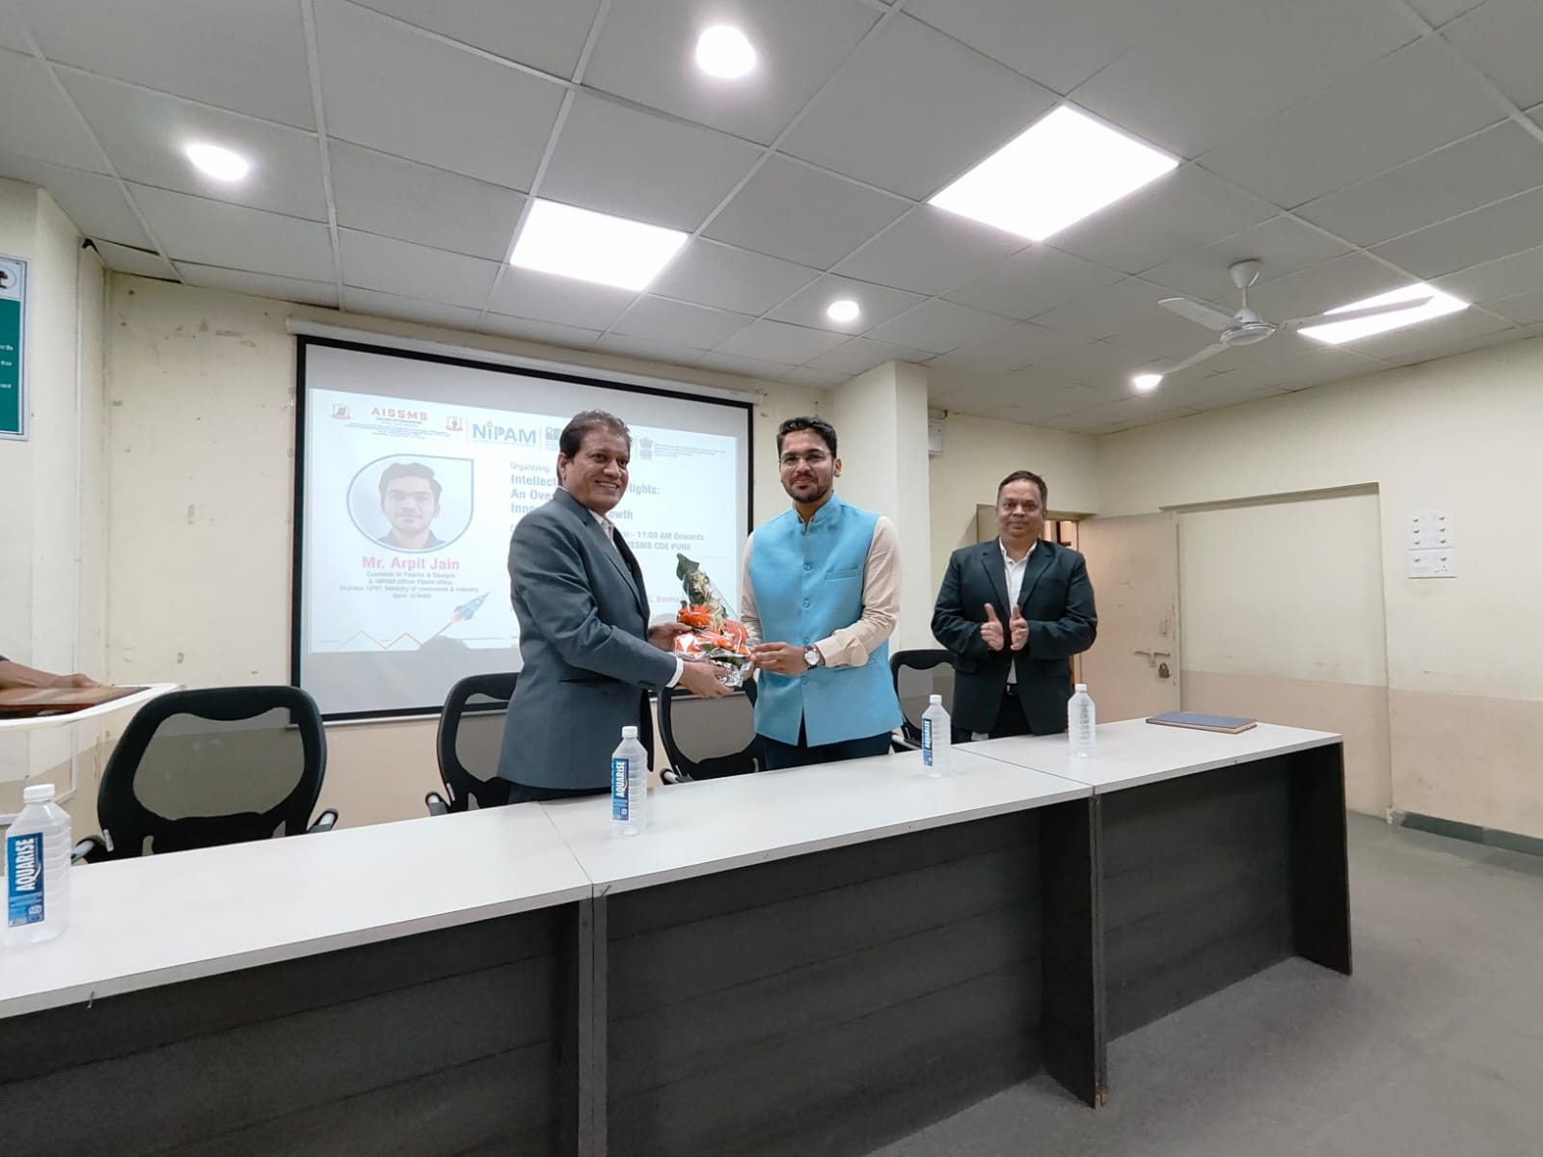
Dr D S Brormane, Principal AISSMS, COE facilitated the guest Mr Arpit Jain on 14/03/2023

- RESEARCH CONTRIBUTION

4.1 FUNDED RESEARCH PROJECT
Term One
S N | Principal Investigator | Title of the Project | Amount Received (Rs) | Funding Agency

Term Two
S N | Principal Investigator | Title of the Project | Amount Received (Rs) | Funding Agency

FUNDING RECEIVED FOR ANY OTHER ACTIVITY

Term One
S N | Faculty Coordinator | Title of the activity | Amount Received (Rs) | Funding Agency
1

Term Two
S N | Faculty Coordinator | Title of the activity | Amount Received (Rs) | Funding Agency
1

4.2 TESTING AND CONSULTANCY
Term One
Sr. No. | Faculty Coordinator | Details of Testing & Consultancy Conducted | Total Revenue Generated (Rs.)

Term Two
Sr. No. | Faculty Coordinator | Details of Testing & Consultancy Conducted | Total Revenue Generated (Rs.)

4.3 PATENTS, COPYRIGHT, TRADEMARK AND OTHER (IPR)
Term One
Sr No. | Name of Faculty | Name of the Patent | Patent Number and Date | Type (National/  International/Com  mercialized)

Term Two
Sr No. | Name of Faculty | Name of the Patent | Patent Number and Date | Type (National/  International/Com  mercialized)
1 | Dr N G Shekapure | IOT BASED SOLAR POWERED AGRICULTURE ROBOT | 381449-001  Date: 14/03/2023 | National

PUBLICATIONS
4.4 PAPERS PUBLISHED/ PRESENTED IN PROCEEDINGS OF CONFERENCES
Term One
S. No | Authors | Document Details | Year | Conference Details | ISBN | Organized  by

Term Two
S. No | Authors | Document Details | Year | Conference Details | ISBN | Organized  by

4.5 PAPERS PUBLISHED IN JOURNALS
Term One
S. No |  | Authors |  | Document Details |  | Year |  | Source Details |  | ISBN/  ISSN |  | Publisher
1 |  | Dr N G Shekapure |  | Evaluation of Success Factors in Professional Business Incubation, pg no. 202-210 |  | 2022 |  | Journal Of Optoelectronics Laser  Volume 41 Issue 8 |  | 1005-0086 |  | Journal Of Optoelectronics Laser
2 | Dr N G Shekapure |  | Survey Paper on Extraction of 3D image Data for Detecting Chest Diseases, pg no. 249-253 |  | 2022 |  | Journal of Optoelectronics Laser  Volume 41 Issue 8 |  | 1005-0086 |  | Journal of Optoelectronics Laser
3 | Dr N G Shekapure |  | Cognitive Analysis of Employer for Identifying Incubation Success Factors, pg no. 6139-6147 |  | 2022 |  | Journal of NeuroQuantology Volume 20 | Issue 6 |  | 1303-5150 |  | Journal of NeuroQuantology
4 | Dr N G Shekapure |  | Cognitive Analysis of User for Suggesting Learning Objects, pg no. 6130-6138 |  | 2022 |  | Journal of NeuroQuantology Volume 20 | Issue 6 |  | 1303-5150 |  | Journal of NeuroQuantology
5 | Dr N G Shekapure |  | Clinical Data Analysis of Patient and Recommendation, pg no. 6148-6155 |  | 2022 |  | Journal of NeuroQuantology Volume 20 | Issue 6 |  | 1303-5150 |  | Journal of NeuroQuantology

Term Two
S. No | Authors | Document Details | Year | Source Details | ISBN/  ISSN | Publisher
1 | Dr N G Shekapure, Mr S S Kallurkar | Improving Productivity by Using RULA: A Case Study | 2023 | Scandinavian Journal of Information Systems, Vol 35 No 1, Pg No 219-225 | 0905-0167 | Scandinavian Journal of Information Systems

4.6 BOOK/ ARTICLE PUBLICATIONS
Term One
Author | Title of the Book | Published by | ISBN | Year
Dr N G Shekapure | Data Analysis for Technical Business Incubation Performance Improvement, pg no. 195 to 211 | Data Science: Techniques and Intelligent Application | 9781003283249 | 2022

Term Two
Author | Title of the Book | Published by | ISBN | Year

4.7 RESEARCH CITATIONS (Source of Data: Google scholar) (As on 30thMay)

Name of faculty | Citations, h-index, i10 index | Name of faculty | Citations, h-index, i10 index
Dr N G Shekapure
Total Citations of Department:

4.8 ME AWARDED (NA)
Sr No | Name of Supervisor | Title of Thesis | Name of Candidate

4.9 PhD GUIDE DETAILS (NA)

Name of Faculty who are PhD Supervisor | Number of Scholars Registered

4.10 PhD AWARDED (For departments having Ph.D research centers) (NA)

Sr No | Name of Supervisor | Title of Thesis | Name of Candidate

INTERACTION WITH INDUSTRY

5.1 INDUSTRY VISITS ORGANIZED
Term One
Sr. No. | Faculty Coordinator | Class and Number of students attended | Industry Name and Address | Date of visit
1 | Mr V Y Sonawane | BE Prod SW 48 | Industrial visit at  Automation EXPO 2022  Bombay Exhibition  Center at Goregaon  Mumbai | 18 th August,  Thursday , 2022

Term Two
Sr. No. | Faculty Coordinator | Class and Number of students attended | Industry Name and Address | Date of visit

5.2 EXPERT LECTURES / WEBINARS DELIVERED BY INDUSTRY EXPERTS
Term One
Sr. No. | Faculty Coordinator | Class  (Number of students attended) | Name, Industry, designation and contact details of Expert | Topic | Date

Term Two
Sr. No. | Faculty Coordinator | Class  (Number of students attended) | Name, Industry, designation and contact details of Expert | Topic | Date

5.3 INDUSTRY –SPONSORED PROJECTS (UG/PG) ((Excluding Sandwich Projects)
Sr. No. | Name of Project guide | Title of Industry Sponsored Project | Name of Sponsoring Industry

5.4 MOU SIGNED WITH INDUSTRY
Term One
Sr. No. | Faculty Coordinator | Name of Industry | Date  of MoU Signed | Valid upto  (00/00/0000)

Term Two
Sr. No. | Faculty Coordinator | Name of Industry | Date of MoU Signed | Valid up to  (00/00/0000)
1 | Mr S N Chiwande | B&R Automation, Pune | 01/03/2023 | 01/03/2025
2 | Ms Y K Funde | Univision Automation Pune | 08/01/2021 | 20/01/2026
3 | Dr N G Shekapure | Elon Power Pvt. Ltd | 22/02/2022 | 21/02/2027
4 | Mr S K Bidgar | UB Cryogenic Solutions LLP Pune | 04/03/2022 | 03/03/2022

TOTAL FUNCTIONAL / LIVE MOU INITIATED BY THE DEPARTMENT
Sr. No. | Faculty Coordinator | Name of Industry | Date  of MoU Signed | Valid upto  (00/00/0000)
1 | Mr M L Chanpur | Aarohi Industries | 18/01/2021 | 20/01/2026
2 | Ms Y K Funde | Univision Automation Pune | 08/01/2021 | 20/01/2026
3 | Mr S N Chiwande | B&R Automation | 01/03/2023 | 01/03/2025
4 | Mr V Y Sonawane | X-Cubator | 18/03/2021 | 18/03/2024
5 | Dr N G Shekapure | Elon Power Pvt Ltd | 22/02/2022 | 21/02/2027

5.5 FACULTY MEMBERS UNDERGO INDUSTRIAL TRAINING
Term One
Sr. No. | Name of Faculty | Name of Industry | Dates and Duration
01 | Mr M L Chanpur | Cluster Engineering, Chinchwad | 12/12/2022 to 23/02/2023, (11 week)

Term Two
Sr. No. | Name of Faculty | Name of Industry | Dates and Duration

5.6 STUDENTS UNDERGONE IN-PLANT TRAINING AND (OR) INTERNSHIP PROGRAMME (Excluding Sandwich Training)

5.7 LIST OF INDUSTRIES SUPPORTED IN THE ORGANIZATION OF WORKSHOPS/SEMINARS/WEBINARS/CONFERENCES/COURSES AND ANY OTHER CONTRIBUTION OF INDUSTRY
Term One
Sr.  No. | Faculty Coordinators | Industry Representative and Name of Industry | Nature of Contribution
01 | Mr M L Chanpur | Mr Rahul Mali, ARaymond Fasteners Pvt Ltd | Industry Institute Interaction and Alumni Interaction at Company on 19/08/2022

Term Two
Sr.  No. | Faculty Coordinators | Industry Representative and Name of Industry | Nature of Contribution

5.8 TRAINING TO INDUSTRY PERSONNEL/ ACTIVITY SUPPORTING TO INDUSTRY

Term One
Sr. No. | Faculty Coordinator | Technical Area in which Training Provided / Type of Support | Industry Name

Term Two
Sr. No. | Faculty Coordinator | Technical Area in which Training Provided / Type of Support | Industry Name

5.9 ANY OTHER ACTIVITIES TO PROMOTE INTERACTION WITH INDUSTRY

Term One
Sr. No. | Faculty coordinator | Name of Activity | Remark
01 | Mr M L Chanpur | MCCIA Edu Fest 2022 in Maharashtra Chambers of Commerce Senapati Bapat Road on 26/11/2023 | Interacting with Industry HR and Director for identifying their expectation from the colleges
02 | Mr M L Chanpur | Faculty visit to SAJ Test Plant Pvt Ltd, Mundhwa and Jaw Industries | For Placement, IIT and Consultancy.
03 | Dr N G Shekapure | Faculty Visit to Autofina Robotics | Interaction on future prospect in Robotics and Automation
04 | Mr S K Bidgar | Schneider Electric India Pvt. Ltd. A-9/10, MIDC, Ahmednagar | for TE PSW Student visit Reading students Industrial Inplant Training and Project Activity
05 | Mr V Dholle | SAJ Test Plant Pvt Ltd, Mundhwa , Pune | for TE PSW Student visit Reading students Industrial Inplant Training and Project Activity

Term Two
Sr. No. | Faculty coordinator | Name of Activity | Remark
1 | Ms Y K Funde | DAB | Syllabus / Lab development/ CO-PO Framing & mapping
2 | Mr V Y Sonawane | Visit to ALPHA LAVAL Industry PUNE | For Placement, IIT
03 | Mr M L Chanpur | Soudamini Instruments, Pune | For IIT and Placement
04 | Ms Y K Funde | Visit to ElectroFab Pvt Ltd, Pune | BE PSW Student Reading students project activity
05 | Mr S K Bidgar | Harish Trading Company, MIDC, Ahmednagar & Schneider Electric India Pvt. Ltd. A-9/10, MIDC, Ahmednagar | for BE PSW Student visit Reading students Industrial Inplant Training and Project Activity
06 | Mr V Dholle | ATS Conveyors Pvt Ltd., Chakan, Pune | for BE PSW Student visit regarding students Industrial Inplant Training and Project Activity

5.10 STUDENTS UNDERGONE SANDWICH TRAINING (For Mechanical & Production departments)

Term One
Sr. No. | Name of the Student | Name of the Industry | Class | Training duration
 |  |  |  | Start date | Last date | Duration (days)
1 | KALE PRANAV PRATAP | FIAT India Automobile Private limited | TE | 7/12/2022 | 1/4/2023 | 177
2 | PARNERKAR ATHARVA UMESH | Thermax Limited | TE | 8/5/2022 | 2/5/2023 | 185
3 | TAKUR EKTA SHANMUKH(EWS) | Vanaz Engineers Ltd | TE | 7/5/2022 | 1/4/2023 | 183
4 | GHAROTE SAISHNU SANJAY | Thermax LTD | TE | 8/5/2022 | 2/5/2023 | 185
5 | KHAN MUHAMMED JAWWAD | Sharada Industries | TE | 7/18/2022 | 1/4/2023 | 171
6 | PATIL ADITYA KAILAS | Cu-built Engineers PVT LTD | TE | 7/5/2022 | 1/5/2023 | 184
7 | GAIKWAD PRATIK TRUSHANT | Sharada Industries | TE | 7/18/2022 | 1/4/2023 | 171
8 | TADAS YASH JAGDISH | SKF | TE | 7/18/2022 | 1/11/2023 | 178
9 | BHOSALE SAHIL MANOJ | Thermax Ltd | TE | 8/5/2022 | 2/5/2023 | 185
10 | DESHMUKH SHRIGANESH PRAVINCHANDRA | THERMX LTD, Bhosari, Pune. | TE | 8/5/2022 | 2/5/2023 | 185
11 | DESHMUKH SATYAJEET GOPALKRUSHNA | SKF India Pvt | TE | 7/4/2022 | 1/4/2023 | 184
12 | DHAKE PURVESH PRAVIN | Victory Precision Pvt.Ltd | TE | 7/15/2022 | 1/15/2023 | 185
13 | KACHI ADITYA GIRISH | SAJ TEST PLANT PUNE | TE | 7/11/2022 | 1/10/2023 | 184

(Guide of TE Sem I (ALL))

Term Two
Sr. No. | Name of the Student | Name of the Industry | Class | Training duration
 |  |  |  | Start date | Last date | Duration (days)
01 | PAWAR SWEJAL RAJENDRA | ADVIK HI-TECH PVT. LTD | BE | 23/12/2023 |  | 180
02 | MANE HRUSHIKESH GORAKH | ALFA LAVAL INDIA PVT. LTD | BE | 15/01/2023 |  | 180
03 | MACHE RADHIKA SANJAY | ATHARVA GROUP OF INDUSTRIES PVT LTD | BE | 16/01/2023 |  | 180
04 | SIDDHANT DEVIDAS PASALKAR | ATLAS COPCO INDIA LIMITED | BE | 16/01/2023 |  | 180
05 | JAWALKAR ABHISHEK SHEKHAR | ATLAS COPCO INDIA LIMITED | BE | 16/01/2023 |  | 180
06 | CHAWARE KARTIKI SHANKAR | ATLAS COPCO INDIA LIMITED | BE | 16/01/23 |  | 180
07 | PATIL AAYUSH SHRINIWAS | ATLAS COPCO INDIA LIMITED | BE | 16/01/2023 |  | 180
08 | SHIVALIKAR SACHHIDANAND SANJAY | ATLAS COPCO INDIA LIMITED | BE | 17/01/2023 |  | 180
09 | RITE AKASH SATISH | ATLAS COPCO INDIA LIMITED | BE | 17/1/2023 |  | 180
10 | THAKARE JANHAVI CHANDRASHEKHAR | ATS CONVEYORS PTV LTD. | BE | 13/ 01/ 2023 |  | 180
11 | GHARDE NOVIL PRAMOD | CEAT TYRES LTD | BE | 09/01/2023 |  | 180
12 | DALVI PRAJAKTA HEMANT | CRANE PROCESS FLOW TECHNOLOGY | BE | 1/02/2023 |  | 180
13 | ABHIJEET PANDEY | GIRNAR ISUZU CARS PVT. LTD | BE | 23/01/2023 |  | 180
14 | GUJARATI PALASH | HARISH TRADING CO | BE | 01/01/2023 |  | 180
15 | PATIL DNYANESH MUKUNDA | INTEVA PRODUCTS INDIA AUTOMOTIVE PVT LTD | BE | 15/01/2023 |  | 180
16 | MULAY KAIWALYA SANDIP | K.K.NAG PVT. LTD | BE | 13/02/2023 |  | 180
17 | PATIL PRASHANT GOKUL | KAIVALYA ELECTRICALS | BE | 15/01/2023 |  | 180
18 | JAJU KESHAV MATHURADAS | KNEST ALUFORMS | BE | 27/01/ 2023 |  | 180
19 | DODAL KALPESH KISHOR | KNEST MANUFACTURERS LLP | BE | 13-01-2023 |  | 180
20 | THORAT VAIBHAV NANDKISHOR | L. E. TRANSFORMATION | BE | 23/01/2023 |  | 180
21 | GAIKWAD SUSHANT SHESHRAO | L.E TRANSFORMATION | BE | 23/01/2023 |  | 180
22 | PATIL AKASH RANGNATH | L.E TRANSFORMATION CONSULTANT FIRM. | BE | 23/01/2023 |  | 180
23 | KOLEKAR MEHUL BALKRISHNA | L.E. TRANSFORMATION | BE | 23/01/2023 |  | 180
24 | EKSHINGE PRASAD PANDHARINATH | L.E. TRANSFORMATION | BE | 23/01/2023 |  | 180
25 | PAWAR SHANKAR GANESH | LE TRANSFORMATION | BE | 23/01/2023 |  | 180
26 | PATIL LOKESH RAJIV | LEAR CORPORATION | BE | 16/01/2023 |  | 180
27 | LOHANDE SAHIL ASHOK | MAGNUM FORGE & MACHINE WORKS PVT LTD | BE | 15/01/2023 |  | 180
28 | ABHISHEK UTTAM AMBUPE | MAURYA GROUP OF INDUSTRIES | BE | 05/02/2023 |  | 180
29 | MORE ROHIT RAJENDRA | MAURYA INDUSTRIES | BE | 24/01/2023 |  | 180
30 | SAID SIDDHANT VISHWAS | METACOAT INDUSTRIES UNIT 2 | BE | 24/01/2023 |  | 180
31 | GAIKWAD SAKSHI MOHAN | METAMORPHIC HEAT TREATMENT | BE | 15/01/2023 |  | 180
32 | HONKARPE ABHIJEET BALASAHEB | NOQS DIGITAL PVT. LTD | BE | 13/01/2023 |  | 180
33 | SIDDIQUI ZAIN FARHATEJAJ | SAARLOHA ADVANCE PVT LTD | BE | 12/12/2023 |  | 180
34 | VINAYKUMAR SRINIVASULU JALAGAM | SANJAY INDUSTRY | BE | 23/01/2023 |  | 180
35 | KACHAVE NARAYAN BHAGWAN | SAUDAMINI INSTRUMENT KOTHRUD PUNE | BE | 01/02/2023 |  | 180
36 | JADHAV SHREYAS VIJAY | SERUM INSTITUTE OF INDIAN PVT.LTD | BE | 10/01/2023 |  | 180
37 | BHAKRE SHIVAM DILIP | SHREE KAMDHENU AGRO INDUSTRIES | BE | 06/02/2023 |  | 180
38 | SUROSHE KRUSHNA SHRIRAM | SHRI DAMODAR GINNING AND PRESSING INDUSTRIES | BE | 05/02/2023 |  | 180
39 | BANDGAR SHUBHAM KISHOR | SOUDAMINI INSTRUMENT | BE | 20/02/2023 |  | 180
40 | PAWAR GAURAV SUNIL | SPARKLE KITCHEN PVT LTD | BE | 20/01/2023 |  | 180
41 | PATIL DHANARAJ SUMANT | STAR ENGINEER'S PVT,LTD. | BE | 03/02/2023 |  | 180
42 | LATE SHREYAS JITENDRA | STAR MECH CONTROLS PVT. LTD | BE | 01/02/2023 |  | 180
43 | MULANI ARMAN DADABHAI | STARS ENGINEERS INDIA PVT LTD | BE | 06/02/23 |  | 180
44 | PHAD PRANAV BALIRAM | SWIFT TOOLS AND MACHINES | BE | 07/03/2023 |  | 180
45 | CHAVAN SARANG SUNIL | TALENTCORP SOLUTIONS PVT LTD | BE | 28/01/2023 |  | 180
46 | BHOSALE GAURAV RAJENDRA | TATA CUMMINS PVT LTD | BE | 17/02/2022 |  | 180
47 | ZAREKAR PRANAV SANTOSH | TATA MOTORS LTD | BE | 21/02/2023 |  | 180
48 | SONAR PRATIK DATTATRAY | UDYOG ENGINEERING | BE | 10/02/2023 |  | 180
49 | BHAGWAT KUANL VIJAY | UDYOG ENGINEERING | BE | 10/02/2023 |  | 180
50 | PAROLEKAR SUNNY YATIN | UDYOG ENGINEERING | BE | 10/02/2023 |  | 180
51 | KADAM RUTUJA UDAY | VANAZ ENGINEERS LIMITED | BE | 01/02-/2023 |  | 180
52 | AMRUTKAR RUSHIKESH LAXMAN | VANAZ ENGINEERS LIMITED | BE | 16/01/2023 |  | 180
53 | WAGH RUTUJA SURESH | VANAZ ENGINEERS LIMITED | BE | 16/01/2023 |  | 180
54 | SONWANE GANESH ASHOK | YEDESHWARI AGRO PRODUCTS LIMITED | BE | 01/02/2023 |  | 180

6.STUDENTS’ ACHIEVEMENTS

6.1 STUDENTS’ ACHIEVEMENT(Professional) (Individual Level) (Technical activities such as design competitions, paper presentation, technical quiz, Product development, innovation, etc.)

Term One
Name of Student | Details of Achievement (State/University/ National/International Level) | Remark  (Domain)

Term Two
Name of Student | Details of Achievement (State/University/ National/International Level) | Remark  (Domain)

6.2 STUDENTS’ ACHIEVMENTS (other than Professional) (Individual Level) (Social activities, etc.)

Term One
Name of Student | Details of Achievement (State/University/ National/International Level) | Remark  ((Domain)

Term Two
Name of Student | Details of Achievement (State/University/ National/International Level) | Remark  ((Domain)

6.3 CERTIFICATE / ONLINE COURSES COMPLETED BY STUDENTS
(Certificate courses, value added courses, MOOC, etc.)
Term One
S N | Name of Student | Title of the Course | Conducted By | Duration/ Dates
1 | Panday Abhijeet | Developing Soft Skills & Personality | NPTEL | 08 Weeks
2 | S D Pasalkar | Developing Soft Skills & Personality | NPTEL | 08 Weeks
3 | Prajakta H Dalvi | Developing Soft Skills & Personality | NPTEL | 08 Weeks
4 | Zarekar Pranav S | Developing Soft Skills & Personality | NPTEL | 08 Weeks
5 | Pratik G Mohire | Developing Soft Skills & Personality | NPTEL | 08 Weeks
6 | Mache Radhika S | Developing Soft Skills & Personality | NPTEL | 08 Weeks
7 | Rohit R More | Developing Soft Skills & Personality | NPTEL | 08 Weeks
8 | Amrutkar R L | Developing Soft Skills & Personality | NPTEL | 08 Weeks
9 | Rutuja S Wagh | Developing Soft Skills & Personality | NPTEL | 08 Weeks
10 | S Shivalikar | Developing Soft Skills & Personality | NPTEL | 08 Weeks
11 | Sahil A lokhande | Developing Soft Skills & Personality | NPTEL | 08 Weeks
12 | S M Gaikwad | Developing Soft Skills & Personality | NPTEL | 08 Weeks
13 | Chavan Sarang S | Developing Soft Skills & Personality | NPTEL | 08 Weeks
14 | Shivam D Bhakre | Developing Soft Skills & Personality | NPTEL | 08 Weeks
15 | Siddhant V Said | Developing Soft Skills & Personality | NPTEL | 08 Weeks
16 | Shankar G Pawar | Developing Soft Skills & Personality | NPTEL | 08 Weeks
17 | S Y PAROLEKAR | Developing Soft Skills & Personality | NPTEL | 08 Weeks
18 | Rutuja U Kadam | Developing Soft Skills & Personality | NPTEL | 08 Weeks
19 | V S JALAGAM | Developing Soft Skills & Personality | NPTEL | 08 Weeks
20 | K S Mulay | Developing Soft Skills & Personality | NPTEL | 08 Weeks
21 | AAYUSH PATIL | Developing Soft Skills & Personality | NPTEL | 08 Weeks
22 | A S Jawalkar | Developing Soft Skills & Personality | NPTEL | 08 Weeks
23 | Akash R Patil | Developing Soft Skills & Personality | NPTEL | 08 Weeks
24 | Akash Rite | Developing Soft Skills & Personality | NPTEL | 08 Weeks
25 | Dhanaraj S Patil | Developing Soft Skills & Personality | NPTEL | 08 Weeks
26 | P D SONAR | Developing Soft Skills & Personality | NPTEL | 08 Weeks
27 | D M Patil | Developing Soft Skills & Personality | NPTEL | 08 Weeks
28 | G A Sonwane | Developing Soft Skills & Personality | NPTEL | 08 Weeks
29 | G R Bhosale | Developing Soft Skills & Personality | NPTEL | 08 Weeks
30 | Janhavi Thakare | Developing Soft Skills & Personality | NPTEL | 08 Weeks
31 | K S Chaware | Developing Soft Skills & Personality | NPTEL | 08 Weeks
32 | DODAL K K | Developing Soft Skills & Personality | NPTEL | 08 Weeks
33 | H G MANE | Developing Soft Skills & Personality | NPTEL | 08 Weeks
34 | Mehul B Kolekar | Developing Soft Skills & Personality | NPTEL | 08 Weeks
35 | KACHAVE N B | Developing Soft Skills & Personality | NPTEL | 08 Weeks
36 | Lokesh Patil | Developing Soft Skills & Personality | NPTEL | 08 Weeks
37 | Prashant G Patil | Developing Soft Skills & Personality | NPTEL | 08 Weeks
38 | Swejal R Pawar | Developing Soft Skills & Personality | NPTEL | 08 Weeks
39 | Thorat Vaibhav N | Developing Soft Skills & Personality | NPTEL | 08 Weeks
40 | A U Ambupe | Developing Soft Skills & Personality | NPTEL | 08 Weeks
41 | Honkarpe A B | Developing Soft Skills & Personality | NPTEL | 08 Weeks
42 | Arman Mulani | Developing Soft Skills & Personality | NPTEL | 08 Weeks
43 | Kunal Bhagwat | Developing Soft Skills & Personality | NPTEL | 08 Weeks
44 | Keshav M Jaju | Developing Soft Skills & Personality | NPTEL | 08 Weeks

Term Two
S N | Name of Student | Title of the Course | Conducted By | Duration/ Dates

6.4 NUMBER OF STUDENTS PLACED
Term One
Sr No | Name of Organization visited | Number of students Participated | Number of students Placed
1 | Fleetguard Filters |  | 1
2 | Inspira Enterprises |  | 1
3 | Knest Manufacturers LLP |  | 1

Term Two
Sr No | Name of Organization visited | Number of students Participated | Number of students Placed

Lower Package Offered: 3.00 Lakh
Higher package Offered: 4.00 Lakh
Average Package Offered: 3.5 Lakh
6.5 NUMBER OF STUDENTS QUALIFIED IN THE EXAMINATIONS (GATE, GRE, UPSC, MPSC, CAT, TOEFL, any other examination)

Sr. No. | Name of Student | Examination | Examination / registration number

6.6 SPORTS / CULTURAL ACHIEVEMENTS OF STUDENTS (Individual Level) (Team level achievements to be mentioned in institute level sports/Cultural committee report)
Term One
Name of Student | Details of Achievement (State/University/ National/International Level) | Remark  (Domain)

Term Two
Name of Student | Details of Achievement (State/University/ National/International Level) | Remark  (Domain)

6.7 STUDENTS’ ACHIEVEMENTS (Team Level)
Term One
Name of Event | Name of Faculty Advisor | Details of Achievement (State/University/ National/International Level) | Remark  (Domain)

Term Two
Name of Event | Name of Faculty Advisor | Details of Achievement (State/University/ National/International Level) | Remark  (Domain)

- SUMMARY
AND
SWOC ANALYSIS

7.1 ANY OTHER NOTEWORTHY ACHIEVEMENT OF THE DEPARTMENT (Not mentioned above) (HOD & ALL FACULTIES)
Sr. No. | Details

7.2 MISCELLANEOUS (SYLLABUS IMPLEMENTATION, MAJOR ADDITION IN INFRASTRUCTURE AND FACILITY, INNOVATIONS INTRODUCED, ETC.)
FACULTY | ACTIVITY

7.3 FEEDBACK FROM STAKEHOLDERS

Sr No | Stakeholder | Number of Feedbacks Received | Overall Feedback
1 | Alumni
2 | Parents
3 | Employers
4 | Students

7.4 TWO BEST PRACTICES FOLLOWED IN THE DEPARTMENT

Developing Teaching-Learning Materials: The department prioritizes the development of high-quality teaching-learning materials. This includes creating comprehensive course materials, presentations, and digital resources that are accessible to students. By investing in well-structured and up-to-date educational materials, the department enhances the teaching process, making it more engaging and effective for both faculty and students. Regularly updating these materials to align with the latest developments in the field ensures that students receive the most relevant and valuable education.

Industry-Embedded Projects and Internships: To establish and maintain strong connections with industry, the department encourages students to engage in industry-embedded projects and internships. These experiences provide students with practical exposure to real-world challenges and solutions, allowing them to apply their academic knowledge in a professional context. By collaborating with industry partners, the department ensures that its curriculum remains industry-relevant and that students are well-prepared for future employment. These connections often lead to better placement opportunities for students and foster ongoing collaboration between the department and industry stakeholders.

7.5 MAJOR GRIEVANCES OF STUDENTS (IF ANY) REDRESSED
Nil

7.6 SWOC ANALYSIS
Five major strengths, weaknesses, opportunities, and challenges (SWOC) of the department and future plans of the Department.
Strengths:
1 | Liasoning With Industries: The department's strong relationships with industries provide valuable insights, resources, and potential collaboration opportunities, enhancing students' practical knowledge.
2 | Industry Exposure: Students benefit from exposure to real-world industry practices, which can better prepare them for the job market and foster a deeper understanding of their field.
3 | Experienced Faculty & Good Retention Ratio: Having experienced faculty members contributes to the quality of education. A high retention ratio indicates faculty satisfaction and stability, which is crucial for maintaining academic excellence.
4 | Specialized Facilities: Mention any state-of-the-art facilities or equipment the department has access to, which can further enhance teaching and research capabilities.
5 | Strong Alumni Network: A strong alumni network can provide mentorship, job opportunities, and financial support to the department.

Weaknesses:
1 | Less Number of PhD Faculty: To enhance research and academic credibility, the department should focus on recruiting and retaining more PhD-qualified faculty members.
2 | Limited Consultancy and Research Grants: Insufficient funding for consultancy and research projects hampers innovation and collaboration with industries, hindering the department's growth.
3 | Few R&D Funded Projects: A low number of research and development funded projects limit opportunities for faculty and students to engage in cutting-edge research.
4 | Outdated Infrastructure: If there are any infrastructure limitations or outdated equipment, they should be addressed to stay competitive.
5 | Limited Publication Output: The department's faculty should aim to increase their research publication output, contributing to the academic prestige of the institution.

Opportunities:
1 | Utilization of Industrial Laboratories: The department can maximize the use of industrial laboratories for practical training and collaborative research during the students Industrial Inplant Training
2 | Partnerships Through MoUs: By entering into Memorandums of Understanding with industries, the department can expand opportunities for training programs, consultancy, and joint projects.
3 | Faculty Qualification and Up-Gradation: Supporting faculty in pursuing higher qualifications and professional development can enhance their teaching and research capabilities.
4 | Diversify Research Funding: Explore diverse sources of research funding, including government grants, private organizations, and international collaborations.
5 | Online and Hybrid Education: Leveraging online and hybrid teaching methods can help reach a broader student base and expand the department's influence.

Challenges
1 | Placement in Core Companies: Ensuring that students are placed in core companies related to their field of study can be challenging in a competitive job market.
2 | Improving Patents and Copyrights: Encouraging faculty and students to engage in innovative research and seek patents and copyrights can be a lengthy process and may require additional resources.
3 | Attracting Students for Production Programs: Attracting students to production programs may be challenging due to changing industry demands and competition from other departments or institutions.
4 | Balancing Research and Teaching: Faculty may face difficulty in maintaining a balance between teaching and research, impacting the quality of both.
5 | Financial Sustainability: Securing long-term financial sustainability for the department to support its growth and development is an ongoing challenge. Future plans should address this concern through strategic initiatives and fundraising efforts.

7.7 FUTURE PLANS OF THE DEPARTMENT (For Next Academic Year)
1 | Enhance PhD Faculty Enrollment: The department aims to enroll a maximum number of faculty members for PhD programs to bolster research and academic excellence.
2 | Strengthen Industry Connections for Placement: The department will intensify efforts to strengthen its industry connections, facilitating increased placement opportunities for students.
3 | Expand Robotics and Automation Lab: There are plans to develop and expand the Robotics and Automation Lab, providing cutting-edge resources for research and hands-on learning in this rapidly evolving field.
4 | Implement Smart Classrooms: The department will implement smart classrooms to enhance the effectiveness of the teaching and learning process, leveraging technology for a more interactive and engaging educational experience.

7.8 INITIATIVES TAKEN BY THE DEPARTMENT AT DEPARTMENT AND INSTITUTE LEVEL TO IMPROVE AND ASSURE QUALITY IN THE FOLLOWING AREAS

Area | Initiatives
Academics and overall profile of Department | To prepare course manual according to Blooms Taxonomy.  To participate students’ projects in National Design Research Forum competition, paper presentation, BAJA, SUPRA, EFFICYCLE and GARUDSHWA competitions.  Students are motivated to participate various sports and cultural activities.
Organization of different activities
Research and Innovation | Faculty members are provided with financial assistance and research grants to conduct research.  As part of a commitment to fostering academic excellence, the department is actively promoting faculty development through doctoral programs. Currently, four dedicated faculty members are pursuing their PhDs in their respective fields.
Industry institute Interaction | Faculties are establishing contact with Industries, arranging guest lecture and students’ projects with industry. Students’ internship in Industry, industry visit and participation on advisory board.
Students’ Achievements | Students are motivated to participate in various sports and cultural activities and for competitive examination.

SUMMARY SHEET (Annual)

 |  | Activity
S N | Activity/ Item | Term I | Term II | Total
 |  | Numbers
1 | Students in the department | 93
FACULTY CONTRIBUTION
2 | e content development by faculty and available online | 06 | 04 | 10
3 | Number of FDP/STTP attended by the department faculty | 13 | 03 | 16
4 | Number of Seminars/ workshops/ webinars attended by the department faculty | 18 | 16 | 34
5 | Number of Conferences/ symposiums attended by the department faculty | - | 01 | 01
6 | Number of Online courses / certificate courses completed by department faculty | 02 | - | 02
7 | Number of extension lectures / webinars (Lectures delivered on other than technical topics)) | 02 | - | 02
8 | Number of Faculty served as resource person, expert, chairperson | 04 | 02 | 06
ACTIVITIES ORGANISED
9 | Number of FDP/STTP organized by the department | - | - | -
10 | Number of Seminars/ workshops/ webinars organized by the department (for faculty) | 04 | 01 | 05
11 | Number of Conferences/ symposiums organized by the department (for faculty) | - | - | -
12 | Number of Extension activities conducted by the department (Social/ Quizzes at national/international level/any other activity) | - | - | -
13 | MOU signed with academic and professional organizations | 02 | 01 | 03
14 | Number of Students’ chapters /clubs | 01 | - | 01
15 | Number of Social activities organized | - | - | -
16 | Number of Parent meeting | - | 01 | 01
17 | Number of Alumni meet | - | 01 | 01
18 | Number of student counseling and career guidance at the department level | - | 19 | 19
RESEARCH CONTRIBUTION
19 | Number of Funded research project | - | - | -
20 | Number of Testing and consultancy | - | - | -
21 | Number of Patents, copyright, trademark and other (IPR) | - | 01 | 01
22 | Number of papers published/ presented in proceedings of conferences | - | - | -
23 | Number of Papers published in journals | 05 | 01 | 06
24 | Number of Book/ article publications | 01 | - | 01
25 | Total Research citations (Google Scholar) | 01 | 0 | 01
26 | Number of ME awarded | - | - | -
27 | Number of PhD Awarded | - | - | -
INTERACTION WITH INDUSTRY
28 | Number of Industrial visits organized | 01 | - | 01
29 | Number of Expert lectures delivered by industry experts | - | - | -
30 | Number of Industry –sponsored projects (UG/PG) | - | - | -
31 | Number of MOU signed with industry | - | 04 | 04
32 | Number of Faculty members undergone industrial training | 01 | - | 01
33 | Number of Students undergone in-plant training and (or) internship programme | - | - | -
34 | Number of students placed | - | 07 | 07
35 | Number of students qualified in the competitive examinations | - | - | -
36 | Any other additional activities organized | 05 | 06 | 11

Declaration by the Head of the Department

I am aware that the above information provided by the Department will be validated by the AAA committee during the visit.

Dr N G Shekapure
Head of Department

Name and Signature of External Member | ___________________________________
Name and Signature of External Member | ___________________________________
Name and Signature of External Member | ___________________________________

