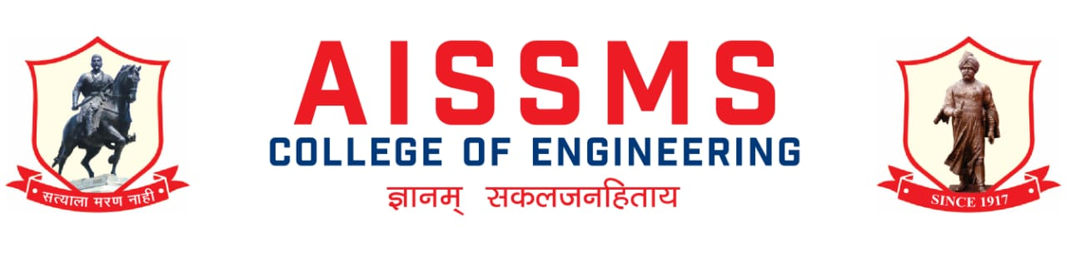
Department of Electronics and Telecommunication Engineering
2021-22, Sem-I
e-NEWSLETTER

July 2021to Dec 2021 Month of release: Dec 2021

Principal: Dr. D S Bormane Head of Department: Dr. D G Bhalke

Advisory Committee Chief Editor
Dr. D. S. Bormane Dr. D G Bhalke
Prof. K B Chaudhari
Prof. N P Mawale Editor
Dr. P P Vast Prof. V S Navale
Prof. Y P Lad

AISSM Society, Pune :Our Inspiration

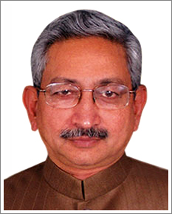 | 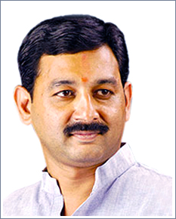 | 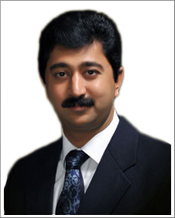
ShriShahuChhatrapatiMaharaj  President, AISSM Society | ShriSambhajirajeChhatrapati  Vice President, AISSM Society | ShriMalojirajeChhatrapati  Honorary Secretary, AISSM Society

Principal Message
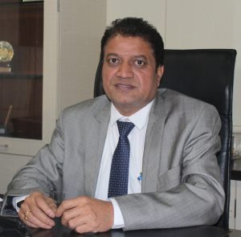 | Dr.D.S.Bormane  Principal  AlSSMS College of Engineering, Pune
AISSMS COE as an outcome of academic excellence achieved is consistently producing University gold medalists and top rankers in different branches of engineering. Faculty is actively involved in research and development. College has number of very high-end analytical, computational and experimental facilities for students. We have inclined our focus towards Research field to concentrate more upon the Engineering Research activities for overall development of students. College is accredited by NAAC A+ grade and received Best Professional College Award by Savitribai Phule Pune University.
.

HOD Message
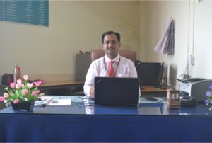 | Dr. D. G. Bhalke  Professor & Head, Department of Electronics and Telecommunication Engineering  Office: +91-20-26058587  E-mail: entc.hod@aissmscoe.com
Department of Electronics&Telecommunication Engineeringis supported by 13 faculty members and 06 non- teaching staff. Electronics and E&TC Engineers produced by this Department have contributed to industrial development at national and international level. Department has a good liaison with the industry.Department has well equipped laboratories and excellent computational facilities. Software like MATLAB, Simulink, Multisim, Psim, CadFeko, Xilinx, Microwind, etc. are available in the Department to work on top-of-the line projects in various areas of Electronics and Telecommunication Engineering. Faculty members and students are actively engaged in research.
For overall development of the students, Guest Lectures from eminent persons in the field are arranged; Industrial Tours, Technical Workshops, Soft Skill training programs are arranged on regular basis. IE Student Chapter, ISTE, IETE and IEEE student branch helps students to arrange the various programs in the Department. It leads to develop the leadership and managerial qualities of the students. Institution of Engineers, India (IEI) Students’ chapter is very active in the Department and won Best Student Chapter Award at National Level for consistently seven years. Every year students organize a Technical Event ‘SILICON FUSION’ under the aegis of ‘AISSMS ENGINEERING TODAY’. The Prizes are sponsored by various industries. Students from all over India, in engineering field, are participating in this event.
Students are encouraged to pursue higher education like ME/M.Tech and MS. All eligible students are placed in various industries. Consistently, the result of BE (Electronics) and BE(E&TC) class is Excellent. Department has a track record of University Rankers.

VISION of Department
Society Growth and Welfare through Competent Electronics and Communication Engineering Graduates

MISSION of Department
To impart quality education in the field of E & TC engineering to solve societal and industrial problems with focus on transdisciplinary approach
To provide stimulating learning environment with modern tools & technologies
To produce dynamic graduates with ethics and moral values.

PROGRAM SPECIFIC OUTCOMES
PSO1 | Analyze Design and test Analog and Digital circuits and systems for given application.
PSO2 | Implements technical blocks of hardware – software co-design for Embedded & Robotics automation application.
PSO3 | Apply knowledge of E & TC system for social and environmental problems as a individual member or leader of diverse team in multidisciplinary settings

PROGRAM EDUCATIONAL OBJECTIVES(PEOs)
PEO1 | To build strong fundamental knowledge among graduates required to pursue their higher education and continue professional development
PEO2 | To enable graduates to identify, analyze and solve Electronics and communication engineering problems by applying basic principles and modern techniques.
PEO3 | To enable graduates to innovate, design and develop hardware & software components and groom their ability to succeed in multidisciplinary &diverse field.
PEO4 | To imbibe professional attitude, effective communicational skills, teamwork skills for becoming a responsible, cultured human being

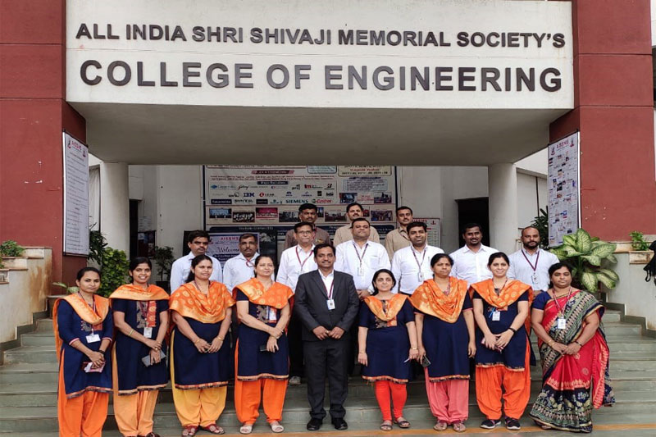
Department Faculty member and Non-teaching Staff

FACULTY ACHIEVEMENTS:

SN | Name of Faculty | Awards & Recognition
1 | Dr. D S Bormane | - State level Best Principal of the Year Awward by ISTE Maharashtra and Goa Section.  - Appointed as President at Pune City Zonal Sports Committee, SPPU Pune for AY 2021-22  - Elected as IETE Governing Council ,member,New Delhi, 01/07/2021
2 | Dr. D G Bhalke | - Appreciation from NAMO Group Foundation for Outstanding Dedication and Service to nAtion and Fight against Novel Corona (Covid-19) in Lockdown Period. 28/7/2021  - Recognition as a Teacher of the Year for 2021 from Campus Mall  - Elected on Institution of Engineers (India) at Pune local Center from E&TC Division, October 2021.  - Working as member BoS(E&TC) at Solapur University and D.Y. Patil University, Ambi.
3 | Mr. N P Mawale | - Awarded with “World Teachers Day Award 2021” byIMRF Institute of Higher Education and Research”
 | Total Faculty Achievements: 8

CONTRIBUTION OF FACULTY (Interaction with outside world)
SN | Name of Faculty | Nature and details of contribution (Representation at University, State, National , International level)
1 | Dr D S Bormane | - Chairman ,BOS E&TC Engg, SPPU
2 | Dr D G Bhalke | - Delivered Webinar on “National Education Policy 2020” at P K International School,Kadachiwadi, Chakan, Pune on 24/7/2021.  - Dr D G Bhalke Worked as resource person for faculty orientation workshop on TE(E&TC) revised syllabus for the subject “Skill Development” on 31st July 2021 organized by NMIT Talegaon under the agies of BOS(E&TC) SPPU Pune.  - Dr D G Bhalke is Invited as resource person for webinar on “ Quality Education, Accreditation and Teacher development” at COE Osmanabad on 06th August 2021
3 | Mr N P Mawale | - Invited as Resourse Person for Webinar on OBE-In Pursuit of Academic Excellence-II organized by Karpagam Academy of Higher Education, Coimbatore, Tamil Nadu Date: 24.06.2021
- Delivered Expert session on Institution of Engineers (I), Opening of Student Chapter by Mechanical Engineering Dept, SSGMCE, Shegaon
Date:28.08.2021
 |  | - Invited as Resource Person for Institution of Engineers (India) Membership Benefits at AISSMS’s IOIT, Pune . Date: 07.09.2021
 |  | - Invited as Guest of Honor for Inaguration Ceremony of IEI Students’ Chapter (Mechanical Engineering) at SSGMCE, Shegaon. Date: 30.10.2021
 |  | - Invited as Resourse Person for Institution of Engineers (India) Membership Benefits at BVCOE for Women, Pune on Date: 17.12.2021
 |  | - Invited as Resourse Person for Students’ Chapter Activities at FE Induction Program 27.12.2021
4 | Dr. P P Vast | - Industry visit to PMP Automation Pvt.Ltd
5 | Ms V D Nagrale | - Resource person at 5 days FDP on “Software Based Case Studies for Development of Multidisciplinary Projects ”. organised by Department of Computer Engineering in Association with Faculty Development Cell, AISSMS College of Engineering, Pune, Maharashtra,
6 | Ms V S Navale | - Industry visit to PMP Automation Pvt.Ltd
7 | Mr V B Gawai | - Industry Visit at CMS Technologies Chinchavad Pune about Students Internships.  - Industry Visit to Automate Engnieers ,Narhe ,Pune  - Industry Visit at DankaltechPvt Ltd , Nanded City Pune
8 | Mrs. R RItkarkar | - Delivered Expert Session on unit 5 -”Information Theoretic Approach to Communication System” for Digital communication subject at the Faculty orientation workshop for TE(E & TC) revised syllabus 2019, organized by AIT under the aegis of BoS E & TC, SPPU Pune on 24/07/2021.
9 | Mrs. P PTayade | - Industry Visit at CMS Technologies Chinchavad Pune about Students Internships.  - Industry Visit to Automate Engnieers ,Narhe ,Pune
Total Faulties Interacted with Outside world: 9

FDP/STTP/SEMINARS/ WORKSHOPS/ WEBINARS/QUIZ ORGANIZED BY THE DEPARTMENT

S N | Name of Coordinator/s | Title of the FDP/STTP/WS/Seminar/Symposium | Duration/ Dates | No. of Participants | Funding Agency  (If any) and Amount (Rs.)
1 | Mr. S B Dhekale  Mrs. V S Navale | Faculty Orientation Workshop on “Fundamentals of JAVA Programming” | 26/7/2021 to 28/7/2021 | 56 | SPPU
2 | R RItkarkar | Awareness Session on 'IEEE Membership Benefits'  Ms. Shreya Bhonsle, PR Team Member, IEEE Pune Section Mr. Piyush Chaudhari, Chair, AISSMSCOE IEEE Student Branch | 13/08/2021 | 250 | AISSMSCOE
3 | Mr. S B Dhekale  Mrs. V S Navale | 5 Days Induction Program | 23/8/20221 to 27/8/2021 | 176 | AISSMSCOE
5 | Mr. S B Dhekale | Opportunities and Preparation for Campus Placement. Speaker:Mr. S P Raoborde,TPO, JSPM | 23/8/2021 | 122 | AISSMSCOE
6 | Mrs. V S Navale  Dr. P P Vast | Being Interview Ready and Cultivating Emotional Intelligence for Work Ready.Speaker: Ms. Monika Nehe, Assistant Manager,US West TCS | 23/8/2021 | 137 | AISSMSCOE
7 | Mr. S B Dhekale | Panel Discussion : BE E&TC 2020-21 Batch Students. | 24/8/2021 | 100 | AISSMSCOE
8 | Mr. N P Mawale | Key to Stress and Time Management. Speaker: Dr. R. Jalnekar, Director, VIT | 24/8/2021 | 171 | AISSMSCOE
9 | Mrs. K B Chaudhari  Ms. V D Nagrale | Internship and Innovation as a Career Opportunity.Speaker: Mr. SuryakantDodmise,SIBIC Business Incubator,Founder and Chief Executive Officer | 25/8/2021 | 90 | AISSMSCOE
10 | Mrs. R RItkarkar | Problem Based Learning. Speaker: Dr. Gayatri M Phade, Professor, Sandip Foundation Nashik | 25/8/2021 | 112 | AISSMSCOE
11 | Dr. D G Bhalke | Outcome Based Learning. Speaker: Dr. D G Bhalke | 24/8/2021 | 50 | AISSMSCOE
12 | Ms. V VDeshmukh | Students Internship. Speaker: Mr. Rajesh Vartak | 26/8/2021 | 100+ | AISSMSCOE
13 | Mr. V B Gawai | Counselling Session for Personal and Professional Growth. Speaker: Mr. TouheedMujawar, CEO and Founder Center of Carrier Development and Placement | 26/8/2021 | 150 | AISSMSCOE
14 | Mr. V B Gawai | Career Scope in IT Sector. Speaker: Mr. AvinashChauhan, Software Developer,FIS Global | 27/8/2021 | 70 | AISSMSCOE
15 | Mrs. R RItkarkar | Project Based Learning. Speaker: Dr. ShripadBhatlawande, HoD E&TC VIT Pune | 27/8/2021 |  | AISSMSCOE
16 | Mr. N P Mawale | Benefits of Student Chapter | 31/8/2021 | 56 | AISSMSCOE
17 | Mr. N P Mawale | Teachers Day Celebration | 5/9/2021 | 67 | AISSMSCOE
18 | Mr. V  B Gawai | 1 month workshop on “Python for Data Science” under Daeux Students Club | 7/9/2021 | 58 | AISSMSCOE
19 | Mr. N P Mawale | 1 week Students development Program on “Drone Operations Development”in Association with RGB Buds Group | 6/9/2021 to 10/9/2021 | 64 | AISSMSCOE
20 | Mrs. R RItkarkar | 16th AISSMS Engineering Today 2021 – Silicon Fusion's Ideathon: National Level Idea Presentation Competition.  Guest Jury - Mr. SuryakantDodmise, Founder & CEO of SIBIC Business Incubator | 30/09/2021 | 74 | AISSMSCOE
21 | S A Takalkar | Webinar on Career Opportunities in Artificial Intelligence and Machine Learning  Mr. AkhileshDeo, Director, Automate Engineering Pvt. Ltd. Pune Ms. ShwetaChaudhari, Senior Software Developer, Harbinger Systems | 04/10/2021 | 80 | AISSMSCOE
22 | Mrs. R RItkarkar  Dr. D G Bhalke | International Webinar on ‘Smart, Clean and Green Electrical Energy for the Sustainable Future’ on the occasion of IEEE Day 2021 Celebration  Dr. Deepak Waikar, Chair, IEEE Education Society, Singapore Chapter | 05/10/2021 | 100 | AISSMSCOE
23 | R RItkarkar | Organization of ‘IEEE Xtreme 15.0 Programming Competition’  Proctor – Dr. M.H.Dhend, IEEE Senior Member (No. 93243765), AISSMS COE Pune | 23/10/2021 | 15 | AISSMSCOE
24 | Dr. D G Bhalke  Mrs. R RItkarkar | International Conference on Smart Gen Computing, Communication and Networking SMARTGENCON-2021  Technically Co-Sponsored by IEEE Pune Section  Keynote Speakers: Dr. Deepak Waikar, Chair, IEEE Education Society, Singapore Chapter Dr. Alexandros-Apostolos A. Boulogeorgos, Research Assistant/Project Engineer, University of Piraeus, Greece  RaneenKango, Software Engineer, Amaan, Jordan Dr. GwoGiun Chris Lee, Professor, National Cheng Kung University, Taiwan | 29/10/2021 to 30/10/2021 | 157 | AISSMSCOE
25 | R RItkarkar | Expert Talk on Battery Management and Designing – A Practical Approach  Mr. RushabShingi, Design Engineer, AX Design Pune | 13/11/2021 | 100 | AISSMSCOE
26 | Mrs. R RItkarkar  Dr D G Bhalke | Webinar Series on Research Methodology  Speaker: Dr.MausmiMunot (PICT Pune)  Dr. NileshUke (Principal,Trinity Academy of Engineering,Pune)  Dr. S M Gulhane (Principal, Pravara Rural COE,Pune)  Dr. Parikshit N  Mahale( VIIT,Pune)  Dr. Piyush Kumar (Professor at East West COE,Bengaluru)  Dr. D G Bhalke (AISSMSCOE, Pune) | 15/11/2021 to 18/11/2021 and 22/11/2021 to 23/11/2021 | 91 | AISSMSCOE
27 | Mr. V B Gawai | Webinar on “Everything You Should Know About Incubation  Mr. Jagdish A PAtel  (Incubator Manager, SANDIP ™ Incubator Association) | 13/10/2021 | 88 | AISSMSCOE
28 | Mr. N P Mawale | Webinar on “Learning and Upskilling during Global Crisis”  Ms. ManishaSachdev, Head Student ,  learning Vertical, ITM Group Mumbai | 9/10/2021 | 88 | AISSMSCOE
29 | Mr. N P Mawale | Webinar on “ How Graduates can manage their career amid CORONAVIRUS  Ms. KhushbooVarma, Soft Skills Trainer at ITM Business School,Mumbai. | 8/10/2021 | 66 | AISSMSCOE
30 | Mrs. S A Takalkar | Webinar on “Career Opportunities in Artificial Intelligence and Machine Learning  Mr. AkhileshDeo, Director at Automate Engineering Pvt. Ltd,Pune  Ms. ShwetaChaudhari, Senior Software Developer in AI ML, HArbinger Systems Pvt. Ltd. | 4/10/2021 |  | AISSMSCOE
31 | Mrs. V S Navale | Webinar on “ Defence Services in India”  Mr. PramodVaidya(HR/Administration/IR Professional) | 3/10/2021 | 102 | AISSMSCOE
32 | Mr. V B Gawai &  Mr. N P Mawale | Two Days hands on Workshop “Machine Learning”  Mr. Arunjit Choudhary, CEO,EBTS  Keynote address by Mr. Bharat Patel | 31/8/2021 to 1/9/2021 | 87 | AISSMSCOE
33 | Ms V D Nagrale | Webinar on Career path in RED HAT LINUX | 18th nov 2021 | 73 | AISSMSCOE
34 | Mr. N P Mawale | Inauguration ceremony of Indian Society for Technical Education (ISTE) Students’ Chapter | 26.06.2021 | 150+ | AISSMSCOE
35 | Mr. N P Mawale | Webinar on Entrepreneurship and Atmanirbhar Bharat for Start UP India | 07.07.2021 | 2700+ | AISSMSCOE
36 | Mr. N P Mawale | Webinar on Innovation in Technology Adoption and Development of High Precision Slipring: A Case Study | 18.07.2021 | 150+ | AISSMSCOE
37 | Mr. N P Mawale | Inauguration Ceremony of Solar Energy Society of India (SESI) AISSMSCOE Students’ Chapter | 26.08.2021 | 200+ | AISSMSCOE
38 | Mr. N P Mawale | Student Development Program (SDP) on Drone Operation Management | 06.09.2021 to 10.09.2021 | 50+ | AISSMSCOE
39 | Mr. S B Dhekale | IETE Student Forum(ISF), AISSMS COE Pune organized an inaugural ceremony of IETE st  udent Forum(ISF).....!!  Topic : Research and Technologies Driving 5G Advanced & Leading Towards 6G  Chief Guest: Dr. M H Kori  Vice president IETE | 22/12/2021 | 150+ | AISSMSCOE
40 | Dr. D G Bhalke  Mrs. K B Chaudhari  Mr. S B Dhekale  Mr. N P Mawale  Ms. V D Nagrale  Dr. P P Vast  Mrs. V V Deshmukh  Mrs. V S Navale  Mrs. Y P Lad  Mr. V B Gawai  Mrs. R R Itkarkar  Mrs. S A Takalkar  Ms. P P Tayade | “16th AISSMS Engineering Today-2021-Silicon Fusion”  - Digimania (Quiz Competition)  - Ideathon (Poster Presentation)  - Code Chronicles (Coding Competition)  Date:29/9/2021,30/9/2021 and 1/10/2021 | 29/9/2021,30/9/2021 and 1/10/2021 | 1300 | AISSMSCOE
41 | Dr. D G Bhalke  Mrs. K B Chaudhari  Mr. S B Dhekale  Mr. N P Mawale  Ms. V D Nagrale  Dr. P P Vast  Mrs. V V Deshmukh  Mrs. V S Navale  Mrs. Y P Lad  Mr. V B Gawai  Mrs. R R Itkarkar  Mrs. S A Takalkar  Ms. P P Tayade | “Western Region Conclave” E&TC Department  - Drone Competition  - Robo Competition  - Digimania Competition  8/12/2021,9/12/2021 and 10/12/2021 | 8/12/2021,9/12/2021 and 10/12/2021 | 600 | AISSMSCOE
42 | Mrs. R R Itkarkar | Industry Visit of SE and TE Students to ‘Bharat Electronics Limited, Pune on 21/12/21 | 21/12/21 | 15 students | BEL, Pune
43 | Ms. V D Nagrale | Alumni Meet conducted for AY 2021-22 | 11/12/2021 | 32 | AISSMSCOE
Total Activities Conducted by Department |  |  |  |  | 43

FDP/STTP/SEMINARS/CONFERENCES/WORKSHOPS/ SYMPOSIUMS ATTENDED BY THE DEPARTMENT FACULTY
S N | Name of Faculty | Title of the FDP/STTP/WS/Seminar/Symposium | Organized by | Duration and Date
1 | Dr. D G Bhalke | Completed one month online training on “ Innovation Ambassador training” (Foundation level) | MOEs Innovation cell & AICTE | 30th June 2021 to 30th July 2021.
2 | Mrs K B Chadhari | STTP on "Innovative and Inventive Problem Solving (IIPS-2021)”, Sponsored by AICTE, New Delhi, India | Production S/W department, AISSMS COE, | One week  29 June - 04 July 2021
 |  | ATAL FDP on “Machine Learning and Optimization Techniques: Applications to Financial Markets” | School of Basic Science, IIT Mandi | One week  12July -16 July 2021
 |  | ATAL FDP on “Business Analytics for Food and agriculture sector” | Indian Institute of Plantation Management, Bengaluru | One week  26 July - 30 July, 2021
3 | Mr. S B Dhekale | FOW on Fundamentals of JAVA | SPPU, AISSMSCOE | 26/7/2021 to 28/7/2021
4 | Mr. N P Mawale | Regional Research Symposium on PBL (RRSPBL-2021) | IUCEE &AlborgeUniversity | 18-19 June 2021
 | Mr. N P Mawale | ISTE Sponsored STTP/FDP Program on Augmented Reality and Virtual Reality | ISTE New Delhi | One Week  21-25 June 2021
 | Mr. N P Mawale | STTP on “Innovative and Inventive Problem Solving” | Production Department, AISSMSCOE | 13/07/2021 to 18/07/2021
 | Mr. N P Mawale | International Conference on Smart Generation Computing, Communication and Networking (SMART GENCON-2021) | IEEE Pune Section & E&TC Department, AISSMS COE, Pune | 29-30 October, 2021
5 | Ms V D Nagrale | STTP on "Innovative and Inventive Problem Solving (IIPS-2021)”, Sponsored by AICTE, New Delhi, India | Production S/W department, AISSMS COE, | One week  29 June - 04 July 2021
6 | Ms V VDeshmukh | Faculty Orientation Workshop on TE E&TC revised syllabus 2019 for the subject Computer Network | Board of Studies E&TC, SavitribaiPhule Pune University, Pune organized by Dept. of E&TC, AISSMS Institute of Information Technology, Pune | 26/07/2021 to 28/07/2021.
 |  | One Week FDP on Augmented  Reality & Virtual  Reality | Department of Electronics and Telecommunication Engineering in association with Buds Engineering Academy Pune, Under IEEE Students Branch, Institution of Engineers(India), Kolkata and ISTE, New Delhi | 21/6/2021 to 25/6/2021
 |  | AICTE & ISTE approved one week Refresher Program on “ 3D Interaction using AR VR” | PCCOE Nigadi | 23/12/2021-29/12/2021
 |  | ATAL FDP on "Cyber Security & Digital Forensics" | Indian Institute of Information Technology Pune. | 06/12/2021 to 10/12/2021
 |  | STTP on “Innovative and Inventive Problem Solving” | Production Department, AISSMSCOE | 29/6/2021 to 4/7/2021
7 | Mrs. V S Navale | FOW on Fundamentals of JAVA | SPPU, AISSMSCOE | 26/7/2021 to 28/7/2021
 |  | STTP on “Innovative and Inventive Problem Solving” | Production Department, AISSMSCOE | 29/6/2021 to  4/7/2021
8 | Mrs. Y P Lad | AICTE & ISTE sponsored one week Refresher course on 3 D Interaction Design using AR VR | PCCOE, Nigadi | 23.12.2021 to 29.12.2021
 |  | TE E&Tc Faculty Orientation Workshop on Digital Communication | AIT, Pune | 22.7.2021 to 24.7.2021
 |  | Faculty Orientation workshop on Skill Development | Hosted by NMIET pune, under the aegis of BoS -E & TC SPPU Pune | 30/07/21 to 31/07/2021
 |  | Online one week STTP on “Internet of Things (IOT)” in collaboration with IETE | SBGI, Miraj | 27/09/2021 to  1/10/2021
9 | Mr. V B Gawai | FOW on Fundamentals of JAVA | SPPU, AISSMSCOE | 26/7/2021 to 28/7/2021
 |  | ISTE approved Online/SF-STTP/FDP Programme on “Augmented Reality and Virtual Reality” held during | AISSMS COE Pune | 21.06.2021 to 25.06.2021
10 | R RItkarkar | Faculty Development Program on Python | E & ICT Academy, IIT Kanpur | 5th July 2021 to 10th July 2021 (1 week)
 |  | AICTE Quality Improvement Scheme (AQIS) sponsored one week online Short Term Training Program on “Innovative & Inventive Problem Solving | AISSMS COE Pune | 13th July to 18th July 2021.
 |  | ISTE approved Online/SF-STTP/FDP Programme on “Augmented Reality and Virtual Reality” held during | AISSMS COE Pune | 21.06.2021 to 25.06.2021
 |  | Faculty Orientation workshop on Electromagnetic Field Theory | Hosted by PICT pune, under the aegis of BoS -E & TC SPPU Pune | 22/07/21 to 24/07/2021
 |  | Faculty Orientation workshop on Skill Development | Hosted by NMIET pune, under the aegis of BoS -E & TC SPPU Pune | 30/07/21 to 31/07/2021
 |  | 5G Colloquium | Organized by VIIT, Pune | 26/07/21 to 31/07/21
 |  | Completed one month online training on “ Innovation Ambassador training” (Foundation level) | MOEs Innovation cell & AICTE | 30th June 2021 to 30th July 2021.
11 | Mrs. S A Takalkar | FOW on Fundamentals of JAVA | SPPU, AISSMSCOE | 26/7/2021 to 28/7/2021
 |  | ISTE Sponsored STTP/FDP Program on Augmented Reality and Virtual Reality | ISTE New Delhi | One Week  21-25 June 2021
 |  | STTP on “Innovative and Inventive Problem Solving” | Production Department, AISSMSCOE | 13/07/2021 to 18/07/2021
 |  | Total FDP Attended by Faculty : 32

EXTENSION LECTURES (LECTURES DELIVERED BY VISITING GUESTS)
S N | Name of faculty coordinator | Topic | Name and contact details of guest | Date
1 | Mr.V.B.Gawai | New Technologies in Software, Career perspective in software domain | Mr.IrfanMomin | 4/12/2021

FACULTY SERVED AS RESOURCE PERSON, EXPERT OR CHAIRPERSON
S N | Name of Faculty |  | Title of Activity |  | Organizing body |  | Date
1 | Dr. D G Bhalke |  | - Delivered Webinar on “National Education Policy 2020”  - Dr D G Bhalke as resource person for faculty orientation workshop on TE(E&TC) revised syllabus for the subject “Skill Development”  - Dr D G Bhalke Invited as resource person for webinar on “ Quality Education, Accreditation and Teacher development” at COE Osmanabad on 06th August 2021  - Dr D G Bhalke Invited as resource person for webinar on “ How to do Literature Survey” at SPCOE Otur on 07th Sep 2021  - Dr D G Bhalke Invited as resource person for webinar on “ Industrial Requirement from Professional Colleges and Engineering Graduates” organised under ISF of M H Sabooiddik COE, Mumbai on 06th Sep 2021 |  | P K International School,Kadachiwadi, Chakan, Pune  NMIT Talegaon, BoS, Pune  COE Osmanabad  SPCOE, Otur, Pune  ISF of M H Sabooiddik COE, Mumbai |  | 24/7/2021  31st July 2021  06th August 2021  07th Sep 2021  06th Sep 2021
2 | R RItkarkar |  | Expert session on Unit-5 in Digital communication |  | AIT, Pune , under the aegis of BoS -E & TC SPPU Pune |  | 24/07/2021
3 | Mr. N P Mawale |  |  | - Expert session on Institution of Engineers (I), Opening of Student Chapter  - Delivered Session on “Benefits and Opportunities of Professional Students Chapter”  - Invited as Chief Guest on Teacher’s Day | Mechanical Engineering Deptt. SSGMCE, Shegaon  AISSMS IOIT  AISSMS Polytechnic | 28/8/2020  7/9/2021  6/9/2021
4 | Ms. V D Nagrale |  |  | Resource person at 5 days FDP on “Software Based Case Studies for Development of Multidisciplinary Projects ”. | organised by Department of Computer Engineering in Association with Faculty Development Cell,  AISSMS College of Engineering, Pune, Maharashtra, | 22nd to 26th Nov 2021
5 | Mr.V.B.Gawai |  |  | Resource person at 4 days FDP on “Software Based Case Studies for Development of Multidisciplinary Projects ”. | Organized by Department of Computer Engineering in Association with Faculty Development Cell,  AISSMS College of Engineering, Pune, Maharashtra, | 22nd to 26th Nov 2021
 |  | Total Number of Faculty Served as Resource Person |  |  |  |  | 05

CONFERENCES/ SYMPOSIUMS ATTENDED BY THE DEPARTMENT FACULTY
S N | Name of Faculty | Title of the Conference / Symposium | Organized By | Duration/ Dates
1 | Dr. D G Bhalke | Keynote Speakers: Dr. Deepak Waikar, Chair, IEEE Education Society, Singapore Chapter  Dr. Alexandros-Apostolos A. Boulogeorgos, Research Assistant/Project Engineer, University of Piraeus, Greece  RaneenKango, Software Engineer, Amaan, Jordan  Dr. GwoGiun Chris Lee, Professor, National Cheng Kung University, Taiwan | Technically Cosponsored by IEEE Pune Section and AISSMSCOE,E&TC Department | 29/10/2021 & 30/10/2021  157 IEEE: 55 Guests: 102
2 | Mr. A Y Kazi | Keynote Speakers: Dr. Deepak Waikar, Chair, IEEE Education Society, Singapore Chapter  Dr. Alexandros-Apostolos A. Boulogeorgos, Research Assistant/Project Engineer, University of Piraeus, Greece  RaneenKango, Software Engineer, Amaan, Jordan  Dr. GwoGiun Chris Lee, Professor, National Cheng Kung University, Taiwan | Technically Cosponsored by IEEE Pune Section and AISSMSCOE,E&TC Department | 29/10/2021 & 30/10/2021  157 IEEE: 55 Guests: 102
3 | Mrs. K B chaudhari | Keynote Speakers: Dr. Deepak Waikar, Chair, IEEE Education Society, Singapore Chapter  Dr. Alexandros-Apostolos A. Boulogeorgos, Research Assistant/Project Engineer, University of Piraeus, Greece  RaneenKango, Software Engineer, Amaan, Jordan  Dr. GwoGiun Chris Lee, Professor, National Cheng Kung University, Taiwan | Technically Cosponsored by IEEE Pune Section and AISSMSCOE,E&TC Department | 29/10/2021 & 30/10/2021  157 IEEE: 55 Guests: 102
4 | Mr. S B Dhekale | Keynote Speakers: Dr. Deepak Waikar, Chair, IEEE Education Society, Singapore Chapter  Dr. Alexandros-Apostolos A. Boulogeorgos, Research Assistant/Project Engineer, University of Piraeus, Greece  RaneenKango, Software Engineer, Amaan, Jordan  Dr. GwoGiun Chris Lee, Professor, National Cheng Kung University, Taiwan | Technically Cosponsored by IEEE Pune Section and AISSMSCOE,E&TC Department | 29/10/2021 & 30/10/2021  157 IEEE: 55 Guests: 102
5 | Mr. N P Mawale | Keynote Speakers: Dr. Deepak Waikar, Chair, IEEE Education Society, Singapore Chapter  Dr. Alexandros-Apostolos A. Boulogeorgos, Research Assistant/Project Engineer, University of Piraeus, Greece  RaneenKango, Software Engineer, Amaan, Jordan  Dr. GwoGiun Chris Lee, Professor, National Cheng Kung University, Taiwan | Technically Cosponsored by IEEE Pune Section and AISSMSCOE,E&TC Department | 29/10/2021 & 30/10/2021  157 IEEE: 55 Guests: 102
6 | Dr. P P Vast | Keynote Speakers: Dr. Deepak Waikar, Chair, IEEE Education Society, Singapore Chapter  Dr. Alexandros-Apostolos A. Boulogeorgos, Research Assistant/Project Engineer, University of Piraeus, Greece  RaneenKango, Software Engineer, Amaan, Jordan  Dr. GwoGiun Chris Lee, Professor, National Cheng Kung University, Taiwan | Technically Cosponsored by IEEE Pune Section and AISSMSCOE,E&TC Department | 29/10/2021 & 30/10/2021  157 IEEE: 55 Guests: 102
7 | Ms. V D Nagrale | Keynote Speakers: Dr. Deepak Waikar, Chair, IEEE Education Society, Singapore Chapter  Dr. Alexandros-Apostolos A. Boulogeorgos, Research Assistant/Project Engineer, University of Piraeus, Greece  RaneenKango, Software Engineer, Amaan, Jordan  Dr. GwoGiun Chris Lee, Professor, National Cheng Kung University, Taiwan | Technically Cosponsored by IEEE Pune Section and AISSMSCOE,E&TC Department | 29/10/2021 & 30/10/2021  157 IEEE: 55 Guests: 102
8 | Ms. V VDeshmukh | Keynote Speakers: Dr. Deepak Waikar, Chair, IEEE Education Society, Singapore Chapter  Dr. Alexandros-Apostolos A. Boulogeorgos, Research Assistant/Project Engineer, University of Piraeus, Greece  RaneenKango, Software Engineer, Amaan, Jordan  Dr. GwoGiun Chris Lee, Professor, National Cheng Kung University, Taiwan | Technically Cosponsored by IEEE Pune Section and AISSMSCOE,E&TC Department | 29/10/2021 & 30/10/2021  157 IEEE: 55 Guests: 102
9 | Mrs. V S Navale | Keynote Speakers: Dr. Deepak Waikar, Chair, IEEE Education Society, Singapore Chapter  Dr. Alexandros-Apostolos A. Boulogeorgos, Research Assistant/Project Engineer, University of Piraeus, Greece  RaneenKango, Software Engineer, Amaan, Jordan  Dr. GwoGiun Chris Lee, Professor, National Cheng Kung University, Taiwan | Technically Cosponsored by IEEE Pune Section and AISSMSCOE,E&TC Department | 29/10/2021 & 30/10/2021  157 IEEE: 55 Guests: 102
10 | Mrs. Y P Lad | Keynote Speakers: Dr. Deepak Waikar, Chair, IEEE Education Society, Singapore Chapter  Dr. Alexandros-Apostolos A. Boulogeorgos, Research Assistant/Project Engineer, University of Piraeus, Greece  RaneenKango, Software Engineer, Amaan, Jordan  Dr. GwoGiun Chris Lee, Professor, National Cheng Kung University, Taiwan | Technically Cosponsored by IEEE Pune Section and AISSMSCOE,E&TC Department | 29/10/2021 & 30/10/2021  157 IEEE: 55 Guests: 102
11 | Mr. V B Gawai | Keynote Speakers: Dr. Deepak Waikar, Chair, IEEE Education Society, Singapore Chapter  Dr. Alexandros-Apostolos A. Boulogeorgos, Research Assistant/Project Engineer, University of Piraeus, Greece  RaneenKango, Software Engineer, Amaan, Jordan  Dr. GwoGiun Chris Lee, Professor, National Cheng Kung University, Taiwan | Technically Cosponsored by IEEE Pune Section and AISSMSCOE,E&TC Department | 29/10/2021 & 30/10/2021  157 IEEE: 55 Guests: 102
12 | Mrs. R RItkarkar | Keynote Speakers: Dr. Deepak Waikar, Chair, IEEE Education Society, Singapore Chapter  Dr. Alexandros-Apostolos A. Boulogeorgos, Research Assistant/Project Engineer, University of Piraeus, Greece  RaneenKango, Software Engineer, Amaan, Jordan  Dr. GwoGiun Chris Lee, Professor, National Cheng Kung University, Taiwan | Technically Cosponsored by IEEE Pune Section and AISSMSCOE,E&TC Department | 29/10/2021 & 30/10/2021  157 IEEE: 55 Guests: 102
13 | Mrs. S A Takalkar | Keynote Speakers: Dr. Deepak Waikar, Chair, IEEE Education Society, Singapore Chapter  Dr. Alexandros-Apostolos A. Boulogeorgos, Research Assistant/Project Engineer, University of Piraeus, Greece  RaneenKango, Software Engineer, Amaan, Jordan  Dr. GwoGiun Chris Lee, Professor, National Cheng Kung University, Taiwan | Technically Cosponsored by IEEE Pune Section and AISSMSCOE,E&TC Department | 29/10/2021 & 30/10/2021  157 IEEE: 55 Guests: 102
14 | Mrs. P P Tayade | Keynote Speakers: Dr. Deepak Waikar, Chair, IEEE Education Society, Singapore Chapter  Dr. Alexandros-Apostolos A. Boulogeorgos, Research Assistant/Project Engineer, University of Piraeus, Greece  RaneenKango, Software Engineer, Amaan, Jordan  Dr. GwoGiun Chris Lee, Professor, National Cheng Kung University, Taiwan | Technically Co Sponsored by IEEE Pune Section and AISSMSCOE,E&TC Department | 29/10/2021 & 30/10/2021  157 IEEE: 55 Guests: 102
Total number of Faculty Attended Conference:14

BOOK/ ARTICLE PUBLICATIONS
Author | Title of the Book | Published by | ISBN | Year
Dr. D G Bhalke | A text book for Digital Communication TE (E&TC) 2019 ISBN 978-93-90770-62-5 | Technical Publication | ISBN 978-93-90770-62-5 | 2021
Total Books Published:01

PATENTS, COPYRIGHT, TRADEMARK AND OTHER (IPR)
Sr No. | Name of Faculty | Name of the Patent | Patent Number and Date | Type (National/  International/Com  mercialized)
1. | R RItkarkar | Development of a screening tool for sleep apnea for experts in clinical setups | 202141022036  filling date 17/05/2021 | International(Australian Govt)
2. | R RItkarkar | Writing Board with arrangement of Projector and camera | Design no. 350663-001  Granted on  24/11/2021 | National- Indian Patent
3 | Dr D G Bhalke | A Novel IOT based agriculture soil and irrigation drainage machine | Application no. 350165-001  Date: 26/09/2021 | National
TOTAL PATENTS, COPYRIGHT, TRADEMARK AND OTHER (IPR) :03

STUDENTS UNDERGONE IN-PLANT TRAINING AND (OR) INTERNSHIP PROGRAMME :

Sr No. | Name of the Student | Name of the Industry | Class | Training Duration
 |  |  |  | Start Date | Last Date | Duration
1 | Pranav Patil | Tata Sons Ltd | TE | 20/12/21 | 20/03/2022 | 3 months
2 | Aman Sagar | Tata Sons Ltd | TE | 20/12/22 | 20/03/2022 | 3 months
3 | Vedant Dere | Bubble AI | TE | 17/12/21 | 31/01/2022 | 1.5 month
4 | Holkarvaibhav Rameshwar | Healthcare Dignostic Ltd | TE | 13/12/21 | 31/01/2022 | 1.5 month
5 | Khachane Himalay Madan | eMomey solution | TE | 21/12/2021 | 19/01/2022 | App 1 month
6 | Mayuri Desai | CSM Digital Technologies | TE | 22/12/21 | 13/02/22 | App 1.5 month
7 | Amol Vilas Rathod | CSM Digital Technologies | TE | 22/12/22 | 13/02/22 | App 1.5 month
8 | Wadake Sanika Atul | Kalpataru | TE | 25/1/2022 | 25/02/22 | 1 month
9 | Rakh Abhijit Ramdas | Automate Engineer's Ltd | TE | 31/01/22 | 28/02/22 | App 1 month
10 | Rautrutujanitin | KalpataruPlasts | TE | 25/1/22 | 25/02/22 | 1 month
11 | Shinde Abhishek Bharat | Linkcode | TE | 16/1/22 | 16/2/22 | 1 month
12 | Deepak Pathak | CSM Digital Technologies | TE | 22/12/21 | 23/01/2022 | 1 month
13 | Shruti Gadve | Automate Engineer's Pvt Ltd | TE | 27/12/21 | 13/02/2022 | App 1.5 month
14 | Warule Sahil Dipak | Automate Engineer's Pvt Ltd | TE | 31/1/22 | 28/02/22 | App 1 month
15 | Parkhe Shreyash Eknath | Sunshine Power Electronics | TE | 3/1/2022 | 15/02/2022 | App 1.5 month
16 | Bakare Yash Sanjay | Automic Engineers Pvt Ltd | TE | 10/1/2022 | 28/01/2022 | 18 days
17 | Pravin Kailas Kunte | ENCON | TE | 22/12/21 | 05/02/22 | App 1.5 month
18 | Rutamuday khati | Dankel Tech | TE | 22/12/21 | 31/01/22 | App 1.5 month
19 | Chauhan Deepesh Anand | Automate Engineer's Pvt Ltd | TE | 31/01/22 | 28/02/22 | App 1 month
20 | Chothe Mrunmayee Tushar | FirstEigen | TE | 26/12/21 | 31/01/22 | App 1 month
21 | Dabhade Janhavi Gajanan | BoLTs IOT | TE | 27/12/21 | 05/02/2022 | App 1.5 month
22 | Piyush Dinesh Chaudhari | Automate Engineer's Ltd | TE | 27/12/21 | 13/02/2022 | App 1.5 month
23 | Siddheshshivajimaskare | CSM Digital Technologies | TE | 22/12/21 | 13/02/2022 | App 1.5 month
24 | Jangam Abhishek Rajesh | Sunshine Power Electronics | TE | 3/1/2022 | 03/02/2022 | App 1 month
25 | Dhapse Aditya Subhash | Schnell Technologies | TE | 3/2/2022 | 15/02/2022 | 12 days
26 | Gaikwad Vrushali Sadashiv | Diligence Tech | TE | 3/1/2022 | 11/02/2022 | App 1.5 month
27 | Honkalse Yash Utkarsh | eptune Enterprises | TE | 3/1/2022 | 10/02/2022 | App 1 month
28 | Deepali Rajendra Dalvi | CSM Digital Tech | TE | 22/12/21 | 22/01/2022 | App 1 month
29 | Sabalenirajnamdev | CSM Digital Technologies | TE | 22/12/21 | 22/01/2022 | App 1 month
30 | Vishwas Prathamesh Devidas | Teknik Engineers | TE | 27/12/21 | 24/01/2022 | App 1 month
31 | Kadam Ganesh Rajesh | Kalika Steel Private Ltd., Jalna | TE | 27/12/21 | 04/02/2022 | App 1.5 month
32 | Khande Abhishek Mahesh | Shiksha | TE | 3/1/2022 | 17/02/22 | App 1.5 month
33 | Kumkar Aditya Bhausheb | Chaitanya | TE | 3/2/2022 | 28/02/22 | 25 days
34 | Nandkar Shirishtul Shiram | CSM Digital Technologies | TE | 22/12/21 | 22/1/2022 | App 1 month
35 | Shweta Sharad Jagdale | Dankel Tech | TE | 1/1/2021 | 31/1/2022 | App 1 month
36 | Tanvi Parmeshwar Gavhane | CSM Digital Technologies | TE | 22/12/23 | 22/1/2022 | App 1 month
37 | Sumedha Shekhar Chaudhari | CSM Digital Technologies | TE | 22/12/24 | 22/1/2022 | App 1 month
38 | Deshmukh Shraddha Avinash | Aviator Automation India | TE | 27/12/21 | 27/1/2022 | App 1 month
39 | There Rohit Shalikrao | Dankel Tech, Sunshine Power Electronics | TE | 3/1/2022 | 15/02/22 | App 1.5 month
40 | Bundhe Rushikesh Ashok | Dankel Tech, Sunshine Power Electronics | TE | 3/1/2022 | 15/02/22 | App 1.5 month
41 | Saumya | DRDO Pune | TE | 15/1/2022 | 20/2/2022 | App 1 month 5 days
42 | Vignesh Sridhar Iyer | CSM Digital Tech | TE | 22/12/21 | 22/01/22 | App 1 month
43 | Ballal Ashwini Charuhas | Diligence Tech | TE | 3/1/2022 | 11/2/2022 | App 1 month 7 days
44 | Sapna | Society for Space Education Research & Development | TE | 10/1/2022 | 21/2/2022 | App 1.5 month
45 | Rathod Chetana Kush | Dankel Tech | TE | 1/1/2022 | 31/1/2022 | App 1 month
46 | Sutar Divya Vishnu | Diligence Tech | TE | 10/1/2022 | 11/2/2022 | App 1 month
47 | Kunal Patilba Kadnor | CSM Digital Technologies | TE | 22/12/21 | 13/02/22 | App 1.5 month
48 | Ashutosh Naresh Pardeshi | CSM Digital Technologies | TE | 22/12/21 | 13/02/22 | App 1.5 month
49 | Pratiksha Pradip Kavthale | CSM DIgital Technologies /ENCON | TE | 05/01/22 | 05/02/22 | App 1 month
50 | Vora Diya Nischal | Shiksha | TE | 3/1/2022 | 31/01/22 | App 1 month
51 | Yeole Amisha Milind | Diligence Tech | TE | 3/1/2022 | 11/02/22 | App 1 month 7 days
52 | Patil Ram Dnyandeo | Shiksha | TE | 3/1/2022 | 31/01/22 | App 1 month
53 | Dupargude Pooja Babasaheb | Automate Engineer's Pvt Ltd | TE | 31/1/22 | 28/02/22 | App 1 month
54 | Kiran Zure | Microcon | TE | 21/12/21 | 31/1/2022 | App 1 month 10 days
55 | Satyam Walekar | Microcon | TE | 21/12/21 | 31/1/2022 | App 1 month 10 days
56 | Harsh Shah | CSM Digital Technologies | TE | 22/12/21 | 13/2/2022 | App 1.5 month
57 | Gaikwad Vishakha Vinod | Aviator Automation India | TE | 27/12/21 | 31/1/2022 | App 1 month
58 | Mujawar Shaista Jakir | Elon | TE | 27/12/21 | 12/2/2022 | App 1.5 month
59 | Nelge Nisha Balawant | Elon | TE | 27/12/21 | 12/2/2022 | App 1.5 month
60 | Nikam Sayali Sadashiv | NETTOYER AUTOMOTIVE | TE | 19/1/22 | 14/2/2022 | App 3 week
61 | Nikita Ajitsinh Patil | CSM Digital Technologies | TE | 22/12/21 | 31/01/2022 | App 1 month 7 days
62 | Samruddhi Nagesh Jadhav | CSM Digital Technologies | TE | 22/12/21 | 31/01/2022 | App 1 month 10 days
63 | Pandey Minal Suresh | Shiksha | TE | 3/1/2022 | 31/01/2022 | App 1 month
64 | Patil Shruti Sunil | Dankel Tech | TE | 01/01/2022 | 31/01/2022 | App 1 month
65 | Parale Rajesh Yashwant | Data Tech Labs | TE | 22/12/2021 | 31/01/2022 | App 1 month 7 days
66 | Munde Pritam Nathrao | Dankel Tech | TE | 27/12/21 | 31/01/2022 | App 1 month 7 days
67 | Palash Dhande | Automate Engineer's Pvt Ltd | TE | 27/12/21 | 13/02/22 | App 1.5 month
68 | Neeraj Mahajan | Automate Engineer's Pvt Ltd | TE | 27/12/22 | 13/02/22 | App 1.5 month
69 | Shivam Kalane | Automate Engineer's Pvt Ltd | TE | 27/12/23 | 13/02/22 | App 1.5 month
70 | Diksha Khade | Automate Engineer's Pvt Ltd &Shiksha | TE | 27/12/24 | 03/02/22 | App 1.5 month
71 | Prachi Kshirsagar | Automate Engineer's Pvt Ltd | TE | 27/12/25 | 13/02/22 | App 1.5 month
72 | Lole Pratima | Automate Engineer's Pvt Ltd | TE | 27/12/26 | 13/02/22 | App 1.5 month
73 | Mubin Inamdar | Automate Engineer's Pvt Ltd | TE | 27/12/27 | 13/02/22 | App 1.5 month
74 | Ayush Shetty | Tata Technologies | TE | 3/01/22 | 1/4/22 | App 3 month
75 | Amble Vijay Dattatray | CSM Digital Technologies | TE | 22/12/21 | 13/02/22 | App 1.5 month
76 | Chankeshwar Ishika Amit | CSM Digital Technologies | TE | 22/12/21 | 13/02/22 | App 1.5 month
77 | Siddhi Devendra Nasare | CSM Digital Technologies | TE | 22/12/21 | 13/02/22 | App 1.5 month
78 | Akshay Jadhav | Microcon&Encon | TE | 05/01/22 | 20/02/22 | App 1.5 month
79 | Gaurav Singh | CSM Digital Technologies | TE | 22/12/21 | 13/02/22 | App 1.5 month
80 | Arjun Singh | Picshort Private Limited | TE | 04/12/21 | 06/02/21 | App 2 month
 | Total Students |  |  |  |  | 80

STUDENTS’ ACHIEVEMENT

Name of Student | Details of Achievement (State/University/ National/International Level)
Saumya Thakur | Achieved 2nd place in “Extempore Competition” organized by IUCEE student Chapter,AISSMS COE on 4th January 2021.
Saumya Thakur | Coordinated successful execution of “Innovative Material Handling Ideas and Concepts”withKonecranes.
VigneshIyer | Coordinated successful execution of “Innovative Material Handling Ideas and Concepts”withKonecranes.
Satyam Walekar | Coordinated successful execution of “Innovative Material Handling Ideas and Concepts”withKonecranes.
Vijay Amble | Coordinated successful execution of “Innovative Material Handling Ideas and Concepts”withKonecranes.
Piyush Chaudhari | Coordinated successful execution of “Innovative Material Handling Ideas and Concepts”withKonecranes.
Piyush Chaudhari | Outstanding Student Branch Chair 2021 by IEEE Pune Section Awards 2021, Second Prize in extempore competition by IUCEE, Outstanding Student Branch Chair 2021
Piyush Chaudhari | Student member volunteer of the year by IEEE Pune section Awards 2021, Student member volunteer of the year
Piyush Chaudhari | Dare to Dream Innovation Contest 2.0 organized by DRDO, Participation
Piyush Chaudhari | Internet of things using Arduino through Tinkercad, Participation
Satyam Walekar | Swayamsiddh Hackathon, Participation
Total Student Achievements = 11

ACHIEVEMENTS OF THE DEPARTMENT

Sr. No. | Details
1 | Department started IETE student forum (ISF).
2 | Department Received grant for MOROB proposal of Rs 20 lacs from AICTE. Principal Investigator: Dr. D.G. Bhalke
3 | Third year went for internship: 80, No of Companies identified: 20, Paid internship: 05
4 | No of MoUs signed in year 2021-22: 05
5 | Department has organized IEEE sponsored International conference on SMARTGENCON 2021 on oct 29-30, 2021.

GLIMPSES of EVENT CONDUCTED:

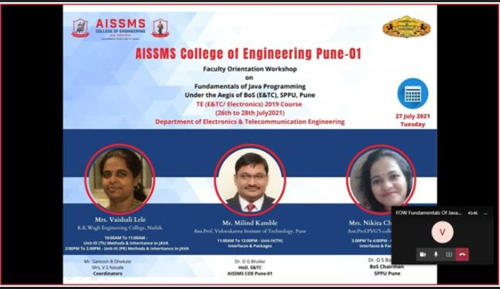  Faculty Orientation Workshop for TE Revised Syllabus.26/7/2021 to 28/7/2021 | 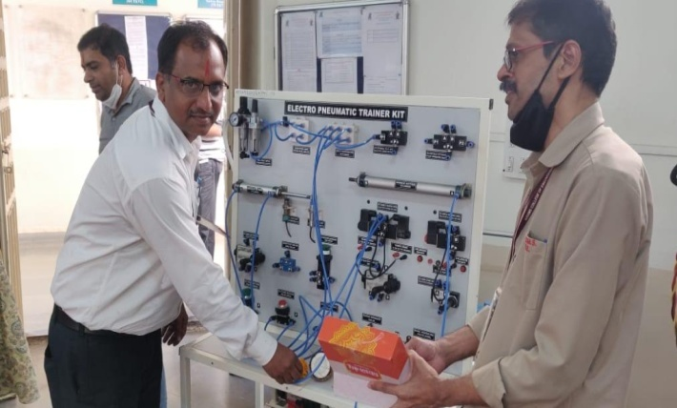  Khandenavmi Pooja in Department on 14/10/2021
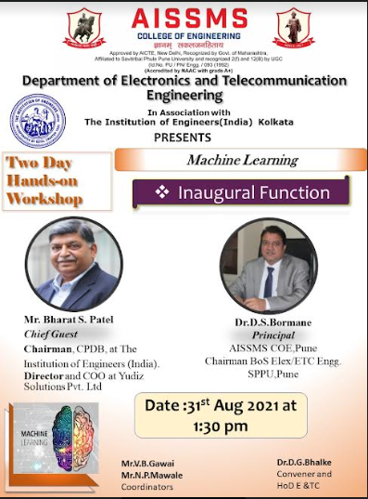  Two days hands-on workshop in Machine Learning on 31/8/2021 | 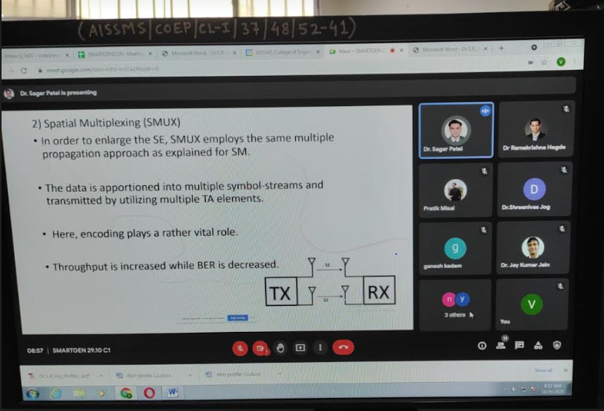  SMARTGENCON 2021 organized by IEEE and AISSMSCOE, 29/10/2021, 30/10/2021
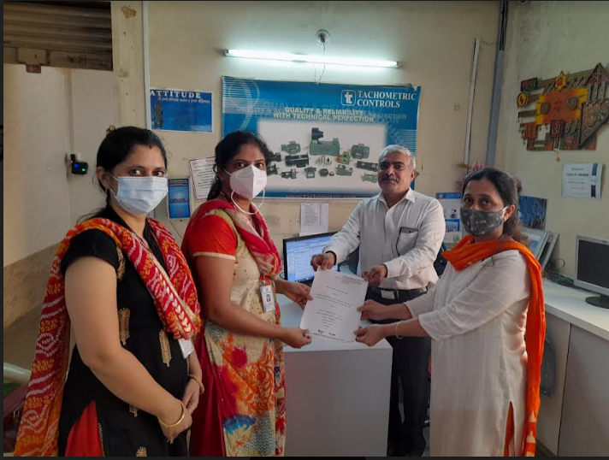  MoU signed with PMP Automation Pvt, Ltd. 16/9/2021 | 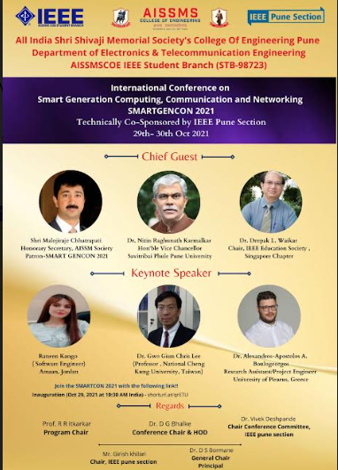  SMARTGENCON 2021 organized by IEEE and AISSMSCOE, 29/10/2021, 30/10/2021
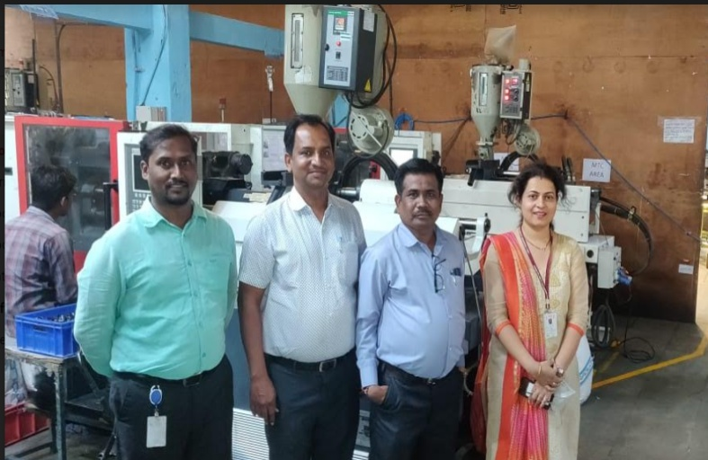  Faculty Visit to Dankel Solutions Pvt. Ltd. | 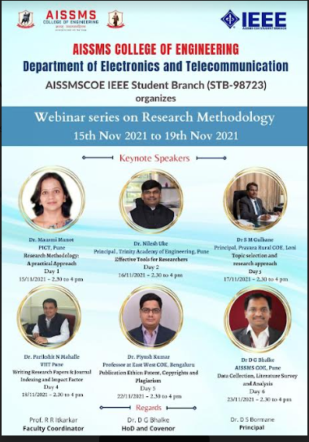  Webinar Series on Research Methodology, 15/11/2021 to 22/11/2021
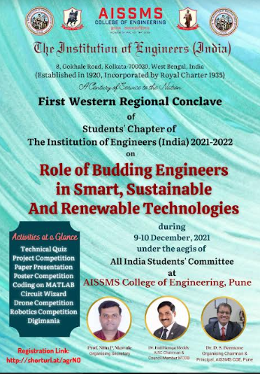  First Western Regional Conclave 8/12/2021,9/12/2021 and 10/12/20 | 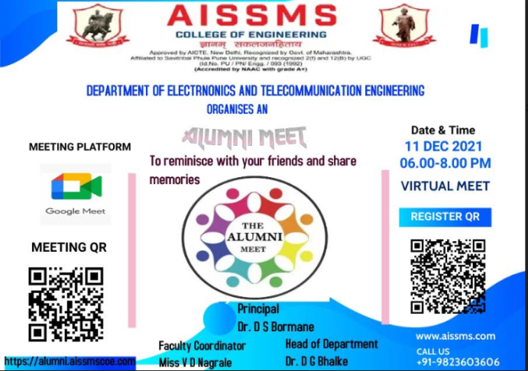  Alumni Meet conducted on 11/12/2021
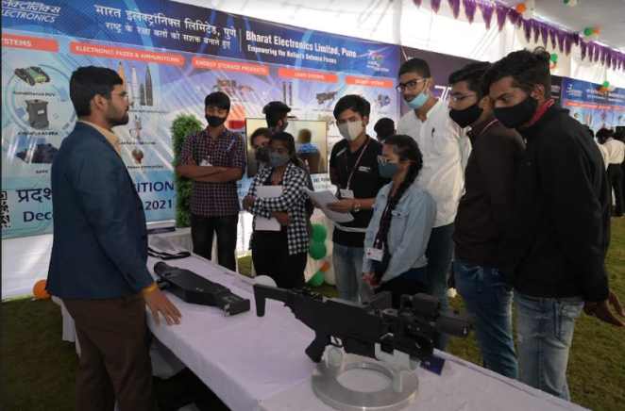  Student Visit to Bharat Electronics Limited, Pune ,17/12/2021 | 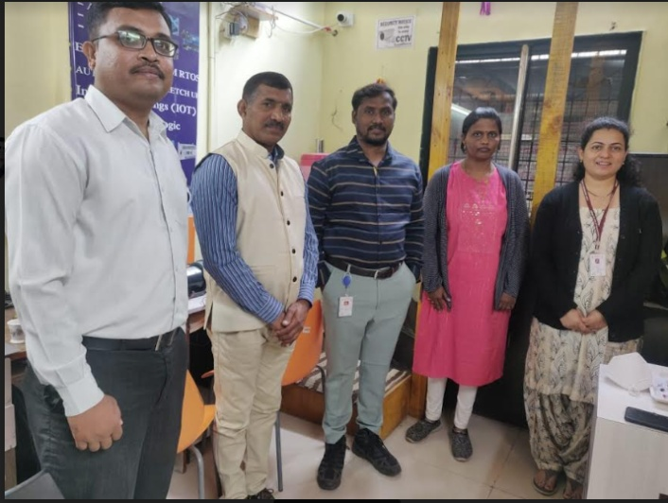  Faculty Visit to CSM Technology,21/12/2021
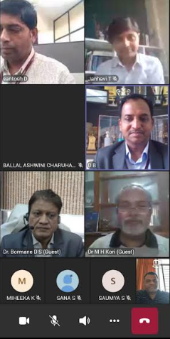
Inauguration of ISF forum ,22/12/2021

HoD

