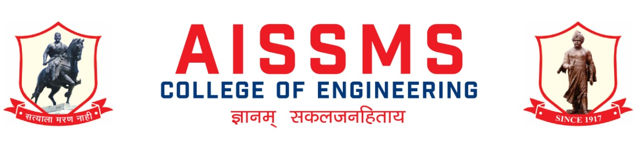
Department of Electronics and Telecommunication Engineering
2020-21, Sem-I
e-NEWS LETTER

July 2020to Dec 2020 Month of release: Jan 2021

Principal: Dr. D S Bormane Head of Department: Dr. D G Bhalke

Advisory Committee Chief Editor
Dr. D. S. Bormane Dr. D G Bhalke
Prof. K B Chaudhari
Prof. N P Mawale Editor
Dr. P P Vast Prof. V S Navale
Prof. Y P Lad

AISSM Society, Pune : Our Inspiration

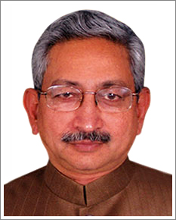 | 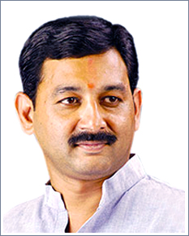 | 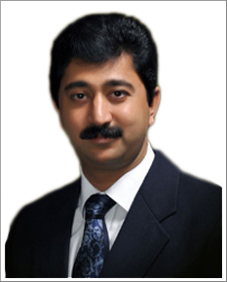
Shri Shahu Chhatrapati Maharaj  President, AISSM Society | Shri Sambhajiraje Chhatrapati  Vice President, AISSM Society | Shri Malojiraje Chhatrapati  Honorary Secretary, AISSM Society

Principal Message
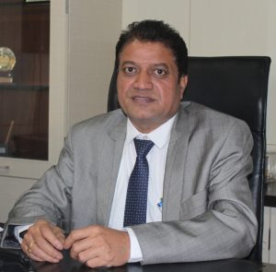 | Dr.D.S.Bormane  Principal  AlSSMS College of Engineering, Pune
AISSMS COE as an outcome of academic excellence achieved is consistently producing University gold medalists and top rankers in different branches of engineering. Faculty is actively involved in research and development. College has number of very high-end analytical, computational and experimental facilities for students. We have inclined our focus towards Research field to concentrate more upon the Engineering Research activities for overall development of students. College is accredited by NAAC A+ grade and received Best Professional College Award by Savitribai Phule Pune University.

HOD Message
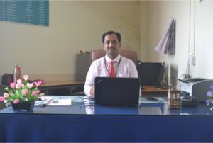 | Dr. D. G. Bhalke  Professor & Head, Department of Electronics and Telecommunication Engineering  Office: +91-20-26058587  E-mail: entc.hod@aissmscoe.com
Department of Electronics &Telecommunication Engineering is supported by 14 faculty members and 06 non- teaching staff. Electronics and E&TC Engineers produced by this Department have contributed to industrial development at national and international level. Department has a good liaison with the industry. Department has well equipped laboratories and excellent computational facilities. Software like MATLAB, Simulink, Multisim, Psim, CadFeko, Xilinx, Microwind, etc. are available in the Department to work on top-of-the line projects in various areas of Electronics and Telecommunication Engineering. Faculty members and students are actively engaged in research.
For overall development of the students, Guest Lectures from eminent persons in the field are arranged; Industrial Tours, Technical Workshops, Soft Skill training programs are arranged on regular basis. IE Student Chapter, ISTE, IETE and IEEE student branch helps students to arrange the various programs in the Department. It leads to develop the leadership and managerial qualities of the students. Institution of Engineers, India (IEI) Students’ chapter is very active in the Department and won Best Student Chapter Award at National Level for consistently seven years
. Every year students organize a Technical Event ‘SILICON FUSION’ under the aegis of ‘AISSMS ENGINEERING TODAY’. The Prizes are sponsored by various industries. Students from all over India, in engineering field, are participating in this event.
Students are encouraged to pursue higher education like ME/M.Tech and MS. All eligible students are placed in various industries. Consistently, the result of BE (Electronics) and BE(E&TC) class is Excellent. Department has a track record of University Rankers.

VISION of Department
Society Growth and Welfare Through Competent Electronics and Communication Engineering Graduates

MISSION of Department
To impart quality education in the field of E & TC engineering to solve societal and industrial problems with focus on transdisciplinary approach
To provide stimulating learning environment with modern tools & technologies
To produce dynamic graduates with ethics and moral values.

PROGRAM SPECIFIC OUTCOMES
PSO1 | Analyze Design and test Analog and Digital circuits and systems for given application.
PSO2 | Implements technical blocks of hardware – software co-design for Embedded & Robotics automation application.
PSO3 | Apply knowledge of E & TC system for social and environmental problems as a individual member or leader of diverse team in multidisciplinary settings

PROGRAM EDUCATIONAL OBJECTIVES(PEOs)
PEO1 | To build strong fundamental knowledge among graduates required to pursue their higher education and continue professional development
PEO2 | To enable graduates to identify, analyze and solve Electronics and communication engineering problems by applying basic principles and modern techniques.
PEO3 | To enable graduates to innovate, design and develop hardware & software components and groom their ability to succeed in multidisciplinary &diverse field.
PEO4 | To imbibe professional attitude, effective communicational skills, teamwork skills for becoming a responsible, cultured human being

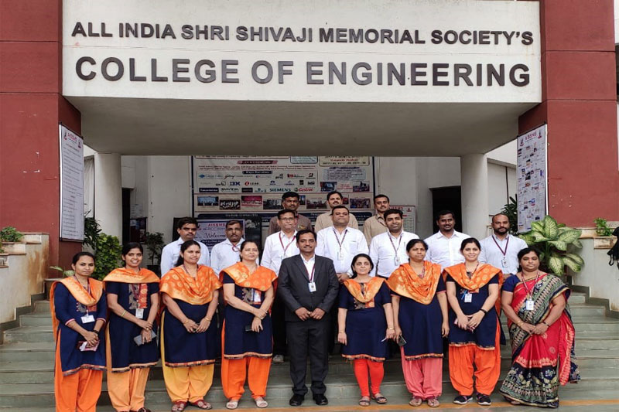
Department Faculty member and Non-teaching Staff

DEPARTMENT ACHIEVEMENT:

FACULTY ACHIEVEMENTS:

SN | Name of Faculty | Nature and details of contribution (Representation at University, State, National , International level, corporate world, Social Platforms, etc)
1 | Dr. D G Bhalke | Organized and delivered talk in VLAB Outreach workshop at SKNCOE Pune Pune on 7thOctomber 2021. ( 76 Participants)
 |  | Organized and delivered talk VLAB Outreach workshop all engineering college under SPPU, Pune on 18th July 2020. ( 696 Participants)
 |  | Organized and delivered talk VLAB Outreach workshop at Parikrama GOI, Kasti Pune on 18th August 2020. (73 Participants)
2 | Mrs. R R Itkarkar | Demonstration of Vlab Experiments at  a.MES COE, Pune on 12th August 2020  b.Parikrama COE, Kashti on 18th August 2020  c. SKN COE Pune on 7th October 2020
 |  | Guest Lecture at S B Patil COE Indapur for TE( E & TC) on Digital Communication subject on 5th October 2020
 |  | Faculty Mentor and Grader for IUCEE Course on “AI for All” Sep to Nov 2020
3 | Mr. S B Dhekale | S E (2019 course) Object Oriented Programming Syllabus framing and presented to BoS E&TC SPPU Pune
 |  | Conducted session for faculty members of SPPU on Operator overloading in Object Oriented Programming FOW organized by BoS E&TC SPPU Pune
 |  | Delivered talk on ARM university program for free online resources to SPPU faculties
 |  | Participated in Syllabus framing workshop of TE (E&TC) 2019 pattern
4 | Dr. P P Vast | Faculty Mentor and Grader for IUCEE Course on “Entrepreneurship” Sep to Dec 2020
5 | Mrs. V S Navale | Faculty Mentor and Grader for IUCEE Course on “Entrepreneurship” Sep to Dec 2020

SEMINAR/WORKSHOP/WEBINAR ORGANISED BY DEPARTMENT:

Sr. No. | Name of Coordinator/s | Title of thr Seminar/Webinar/Workshop | Duration /Dates | No. of Participants | Funding Agency (If any) and Amount (Rs.)
1 | Dr. D G Bhalke | Webinar on organized with speaker Dr D G Bhalke on enhancing quality culture in technical institutes through online teaching for Outcome based Education | 5/7/2020 | 90 International Participants from 28 Countries and 1500+ registered and 2000+ YouTube Views. | AISSMSCOE
2 | Dr. D G Bhalke  Mr. N P Mawale  Mrs. R R Itkarkar | Virtual Labs Hands on workshop for faculty of all Engineering Disciplines  Speaker: Dr Santosh Naronha, Hon Pushpdeep Mishra, dr D S Bormane, Prof Rajendra Kaduskar, Dr K J Kulkarni,PVG & AISSMS COE Vlab nodal centre in coordination with SPPU & IIT Bombay | 18/7/2020 | 7243 | AISSMSCOE
3 | Mrs R R Itkarkar  Mr N P Mawale | Webinar on Design, Development and implementation of project methodologies  Speaker: Mr Satyashil Adnaik (Scrum Master/ IT project manager) atJet2.com, Leeds,UK | 11/7/2020 | 100 | AISSMSCOE
4 | Mr. N P Mawale | Webinar on NAAC Process, Review & Reformation organized by AISSMSCOE , Pune in association with Terana Public Trust COE, Osmanabad and IE, Kolkata  Speaker: Dr. D S Bormane,  Dr. D G Bhalke | 12/7/2020 | 4100+ | AISSMSCOE
5 | Mr. S B Dhekale | opportunities and career perspective of E& TC Engineering  Speaker: Dr. D G Bhalke | 6/7/2020 | 200 | AISSMSCOE
6 | Mr. N PMawale | Health & Happiness Workshop  Speaker: Mr. Arvind Goel | 6/7/2020 | 200 | AISSMSCOE
7 | Mr. N PMawale | Virtual Internship  Mr Swarup Gandewar (Founder & CEO, GTGP Nagpur) | 6/7/2020 | 200 | AISSMSCOE
8 | Mr. V B Gawai | Physical Fitness  Dr M M Kondhare (Gymkhana Head), Ms K Sant (Cultural Coordinator), Mrs Shikha J Pachouly | 6/7/2020 | 200 | AISSMSCOE
9 | Mrs. V D Nagrale | CITP Support for Students  Dr A V Waghmare (CITP coordinator) | 6/7/2020 | 200 | AISSMSCOE
10 | Mr. S B Dhekale | Importance of project from placement point of view  speaker:Mr Rajesh Vartak , Director & Chief mentor , Texceed Technologies | 7/7/2020 | 200 | AISSMSCOE
11 | Mr. S B Dhekale | How to kick start your campus preparation  Speaker: Dr. Madhav Raul | 7/7/2020 | 200 | AISSMSCOE
12 | Mr. N P Mawale | Role of professional student chapter  Speaker:Dr S M Ali, Director membership, IEI Kolkata | 7/7/2020 | 200 | AISSMSCOE
13 | Mr. N P Mawale | Opportunities & challenges for research & Development  Speaker:Dr Nilanjan Sengupta (Director Technical, IEI, Kolkatta | 7/7/2020 | 200 | AISSMSCOE
14 | Mr. N P Mawale | Lifelong learning skills (Meditation , Yoga)  Mr. Akshay Seshadri | 8/7/2020 | 200 | AISSMSCOE
15 | Mrs. V S Navale | Being interview ready  Speaker:Mrs. Monika Nehe (Lead Business Group HR, BFSI-US west, TCS) | 8/7/2020 | 200 | AISSMSCOE
16 | Mrs. K B Chaudhari | Resume building  Speaker: Mr. Kedar Chaudhari | 8/7/2020 | 200 | AISSMSCOE
17 | Mr. V B Gawai | Hackathon preperation  Speaker: Mr. Shubham Badhe | 8/7/2020 | 200 | AISSMSCOE
18 | Ms. V V Deshmukh | Life learning skills( Financial Management)  Speaker: Mr. Siddharth Shah  Speaker: Mr. Siddharth Shah | 8/7/2020 | 200 | AISSMSCOE
19 | Dr. D G Bhalke | Opportunities & preparation for campus placement  Speaker: Mr. S P Rao Borde | 9/7/2020 | 200 | AISSMSCOE
20 | Mr. S B Dhekale | Stress management  Speaker: Dr C A Halingale | 9/7/2020 | 200 | AISSMSCOE
21 | Mr. S B Dhekale | online certification  Speaker: Mr Lalit Bhalerao, Senior Consultant, Price water House Coopers Pvt Ltd | 9/7/2020 | 200 | AISSMSCOE
22 | Dr. P P Vast | Why, how & what entrepreneur  Speaker:Mr. Ishan Kute | 9/7/2020 | 200 | AISSMSCOE
23 | Mr. N P Mawale | Industry 4.0  Dr Enti Rangga Reddy , Diector member IEI Kolkota | 10/7/2020 | 200 | AISSMSCOE
24 | Mr. N P Mawale | Higher education opportunities  Speaker: Ms. Nikita Gaikwad | 10/7/2020 | 200 | AISSMSCOE
25 | Ms. V V Deshmukh | Alumni panel discussion  Nr Nadeem Athani, mr Gaurav Powar, Mr Gunjan Naik | 10/7/2020 | 200 | AISSMSCOE
26 | Dr. D G Bhalke | Opportunities in RPA  Speaker: Mr. Sagar Kothe | 10/7/2020 | 200 | AISSMSCOE
27 | Mr. N P Mawale  Mrs. V S Navale | Gender equality ,lets rise from shadows  Speaker:Mrs Alka Joshi ( Founder member of Abhivyakti group, Pune & leading activist) faculty coordinator Dr M A Pradhan, Mr N P Mawale, Ms V S Navale | 15/7/2020 | 2600 | AISSMSCOE
28 | Mr. S B Dhekale | Internship & Project Opportunities in IOT  Speaker: Abhigyanam, training head at Ind Eyes Infotech Pvt Ltd faculty coordinator Mr S B Dhekale | 19/8/2020 | 100 | AISSMSCOE
29 | Dr. P P Vast | IEEE sponsored webinar on Embedded System & RTOS Mr Dnyanesh Joshi Senior Software Engineer , Magic Leap, San Jose, California Coordinator Dr P P Vast  Speaker:Mr Dnyanesh Joshi | 30/9/2020 | 100 | AISSMSCOE
30 | Mr. N P Mawale | Role of Youth in Attending Atmanirbhar bharat in Energy  Speaker:AISSMS COE in association with Energy Swaraj Foundation Dr Anil Kakodkar, Mrs Ela Gandhi, Prof Subhasis Chaudhari, Chetan singh Solanki coordinator Mr N P Mawale | 2/10/2020 | 100 | AISSMSCOE
31 | Mr. N P Mawale | Career Opportunities in Civil Services for Engineers  Pratik V Thube , IPS, Assam Meghalaya Cadre coordinator Mr N P Mawale & Mrs V S Navale | 15/9/2020 | 100 | AISSMSCOE
32 | Dr. D G Bhalke  R R Itkarkar | Create your success story with growth Mindset  Speaker:Dr Rupali Pawar , CEO TechieMindz coordinator R R Itkarkar & Dr D G Bhalke | 25/9/2020 | 100 | AISSMSCOE
33 | Mrs. R R Itkarkar | Inauguration of AISSMS COE IEEE Student Branch, Chief Guest Mr. Girish Khilare, Chair -IEEE Pune section. Coordinator R R Itkarkar  Webinar on Engineering Graduates- A Road Map by Dr. Shankar Nawale -Principal NBN Sinhgad COE , Solapur Coordinated by R R Itkarkar | 03/10/2020 | 110 | AISSMSCOE
34 | Mrs. R R Itkarkar | Evolution of Telecom Network landline to 5 G  Mr Avinash Kumar, Head RNOP MAN/PLGEtisalat (Emirates Telecommunications) Dubai coordinator R R Itkarkar | 6/10/2020 | 100 | AISSMSCOE
35 | Mr S B Dhekale | Resume Preparation  Dr Madhav Raul Head T&P, SVMP's COE, Malegaon Baramati coordinator | 28/10/2020 | 100 | AISSMSCOE
36 | Dr D G Bhalke  R R Itkarkar | Journey to Brain  Dr Prabhat Ranjan VC , D Y patil International University Pune Dr D G Bhalke, R R Itkarkar, coordinator | 31/10/2020 | 100 | AISSMSCOE
37 | Mr V B Gawai | Bridge the gap between Industry & Academics  Ms Patil. Expert from Deloitte coordinator Mr V B Gawai | 31/10/2020 | 100 | AISSMSCOE
38 | Dr P P Vast | EMI/EMC set up demonstration  coordinator Dr P P Vast | 3/11/2020 | 13 | AISSMSCOE
39 | Mr. N P Mawale | Introduction to Industrial IOT & its Prospects  Mr Sandeep Shroff , CEO, founder Autointell Services coordinator Mr N P Mawale & Mr S B Dhekale | 6/11/2020 | 100 | AISSMSCOE
40 | Mrs. R R Itkarkar | How to write research paper  Dr Parikshit Mahalle coordinator R R Itkarkar | 10/11/2020 | 100 | AISSMSCOE
41 | Dr. D G Bhalke | Interaction of Principal with Department Students  Dr. D S Bormane, Principal, AISSMSCOE Dr. D G Bhalke , HOD E&TC Department | 14/12/2020 | 100 | AISSMSCOE
42 | Mr. S B Dhekale | Organized webinar on “Introduction to industrial IoT and its prospect” by Mr. Sandeep Shroff | 06/11/2020 | 100+ | AISSMSCOE
TOTALSEMINAR/WORKSHOP/WEBINAR ORGANISED BY DEPARTMENT:42

FDP/STTP/WORKSHOP ATTENDED BY DEPARTMENT FACULTY:

S N | Name of Faculty | Title of the FDP/STTP | Organized by | Duration/ Dates
1 | Dr.D G Bhalke | One week ATAL FDP on ROAD - Response Effectiveness, Organising Self, Attitudinal Shift, Decision Making” | Manipal University Jaypur | 23rd to 27th November, 2020
 |  | ATAL FDP on Internet of Things” | IIT Goa | 14-11-2020 to 18-11-2020
 |  | AICTE sponsored One week STTP on, “ Advances in Biomedical Signal Processing Hands on” | ccoew pUNE | 5-10 oCT 2020
 |  | AICTE sponsored one week STTP on, “Challenges and Opportunities in Smart City Implementation in IOT Era”, | RSCOE Pune | 19-24 Oct 2020.
 |  | One week AICTE Sponsored STTP on, “ Digital Skill development for professionals” | BSIOTR Pune | 7 Dec to 12 Dec 2020
 |  | AICTE sponsored one week STTP on, ” “Emerging application of geographic information system (EAGIS-2020)” | AISSMSCOE Pune | 30 Nov -5 Dec 2020
 |  | IETE sponsored one week FDP on, “Computational Intelligence for Cyber security”, | AISSMSIOIT Pune | 26 Oct to 2ndNov 2020.
 |  | ATAL Online FDP on “internet of things (IOT) from 14/11/2020 to 18/11/2020 at Indian institute of technology (IIT Goa) | Indian institute of technology (IIT Goa) | 14/11/2020 to 18/11/2020
 |  | . ATAL Online FDP on “Road- Response Effectiveness Organising Self, attitudinal shift ,decision  making” from 23/11/2020 to 27/11/2020 at Manipal University Jaipur | Manipal University Jaipur | 19-24 Oct 2020.
 |  | One week ATAL FDP on “ Internet of Things” from 14-11-2020 to 18-11-2020 organized by IIT Goa | IIT Goa | 19-24 Oct 2020.
 |  | AICTE sponsored One week STTP on, “ Advances in Biomedical Signal Processing Hands on” organized by CCOEW Pune during 5-10 Oct 2020. | CCOEW Pune | 19-24 Oct 2020.
 |  | AICTE sponsored one week STTP on, “Challenges and Opportunities in Smart City Implementation in IOT Era”, organized by JSPMs RSCOE Pune during 19-24 Oct 2020. | JSPMs RSCOE Pune | 19-24 Oct 2020.
 |  | One week AICTE Sponsored STTP on, “ Digital Skill development for professionals” organized by BSIOTR, Wagholi, Pune during 07/12/2020 to 12/12/2020. | BSIOTR, Wagholi, | 07/12/2020 to 12/12/2020
 |  | AICTE sponsored one week STTP on, ” “Emerging application of geographic information system (EAGIS-2020)” during 30 Nov -5 Dec 2020 organized by AISSMSCOE Pune | AISSMSCOE Pune | 30 Nov -5 Dec 2020
 |  | One week FDP on, “ Research and Quality Publications: practices and Tools”, Jointly organized by Central Library, COEP Pune and Manipal Technical University, Imphal under TEQIP-III during 20-12-2020 to 24-12-2020. | Central Library, COEP Pune and Manipal Technical University, Imphal | 20-12-2020 to 24-12-2020
 |  | One week national level one week faculty development program on “ computational intelligence for cyber security” organized by E & TC engineering of AISSMS IOIT pune from 26th oct to 2nd Nov 2020 | E & TC engineering of AISSMS IOIT pune | 26th oct to 2nd Nov 2020
 |  | One week FDP on, “ Research and Quality Publications: practices and Tools”, | Jointly organized by Central Library, COEP Pune and Manipal Technical University, Imphal under TEQIP-III. | 20-12-2020 to 24-12-2020
 |  | Hands-On Workshop on Virtual Lab | AISSMS COE in association with PVGs COET, Pune, IIT Bombay and SPPU BoS E&TC | 18 July 2020
Total FDP/STTP/Workshop attended by Dr. D G Bhalke |  |  |  | 17
2 | Mrs. K B Chaudhari | ATAL FDP “Electric Hybrid Vehicle HESS Technology” | Electrical Department, AISSMS COE, Pune | 5th - 9th Oct 2020
 |  | ATAL FDP “Biomedical Engineering Systems and Technology” | Sardar Patel Institute of Technology, Mumbai | 23rdNov - 27th Nov 2020
 |  | FDP on “Higher Education 2020: Requirements and Expectations”. | Organized by Internal Quality Assurance Cell, TPCT’s College, of Engineering, Osmanabad | 8th July to 12th July, 2020
 |  | FDP on “Algorithms and Techniques for Signal Processing” | College of Engineering, Pune and Manipur Technical University (MTU), Imphal, Sponsored by TEQIP-III (CoE S&IP) | 14 July 2020 to 18 July 2020
 |  | FDP on “Recent Trends in Mechatronics and Automation” | Jointly Organized by  the Department of Mechanical Engineering and Electronics & Telecommunication Engineering,  NBN Sinhgad School of Engineering, Ambegaon (Bk) Pune | 30th June to 04th July, 2020
 |  | FDP on “Research Methodology and Techniques” | Sandeep Foundations Sandip Institute of Engineering and Management, Nasik | 4th July -06th July 2020
 |  | STTP on “Machine Learning: Algorithms and Applications in Data Science” | Department of Electronics Engineering  BRACT’s Vishwakarma Institute of Technology | 1 Week  7th Sept. 2020 to 12th Sept. 2020
 |  | STTP on “Computer Networking-Network security” | Department of Electronics & Communication, Bharati Vidyapeeth (Deemed to be University) College of Engineering, Pune | 21st to 26th September 2020
 |  | STTP on “Advances in Biomedical Signal Processing with Hands-on” | MKSS Cummins College of Engineering | One-Week  02 -07 November 2020
 |  | STTP on “Digital Skill Development for Professionals” | BSIOTR, Wagholi | 07 Dec to 12 Dec2020
 |  | Hands-On Workshop on Virtual Lab | AISSMS COE in association with PVGs COET, Pune, IIT Bombay and SPPU BoS E&TC | 18 July 2020
Total FDP/STTP/Workshop attended by Mrs. K B Chaudhari |  |  |  | 11
3 | Mr. A Y Kazi | “Enhancing Quality Culture in Technical Institutes  through Online Teaching for Outcome Based Teaching | All India Shri Shivaji Memorial Society's College of Engineering,Pune in association with The Institution of Engineers (India),Kolkata | 05th July 2020
 |  | “Internet of Thing for Agriculture” | Gajanan Maharaj College of Engg. Shegaon | 5/10/2020 to 9/10/2020
 |  | Hands-On Workshop on Virtual Lab | AISSMS COE in association with PVGs COET, Pune, IIT Bombay and SPPU BoS E&TC | 18 July 2020
Total FDP/STTP/Workshop attended by Mr. A Y Kazi |  |  |  | 03
5 | Mr. N P Mawale | “Internet of Thing for Agriculture” | Gajanan Maharaj College of Engg. Shegaon | 5/10/2020 to 9/10/2020
 |  | Hands-On Workshop on Virtual Lab | AISSMS COE in association with PVGs COET, Pune, IIT Bombay and SPPU BoS E&TC | 18 July 2020
Total FDP/STTP/Workshop attended by Mr. N P Mawale |  |  |  | 02
6 | Ms. V D Nagrale | AICTE Training  And Learning (ATAL) Academy  Online FDP on  "Computer  Science &  Biology | Government Engineering College, Hassan | 2020-10-12  to 2020-10-16
 |  | NITTTR,  BHOPAL  Accreditation  12 Webinar series | NITTTR,  BHOPAL | 14th July to 27th  Aug 2020
 |  | One Week Online Faculty Development Program on  “Linux” | Spoken Tutorial Project, IIT Bombay, funded by  NMEICT,  MHRD, Govt. of India | 25th May 2020 to 29th May 2020
 |  | AICTE Sponsored One Week STTP  on  “VLSI Design Using Cadence Tools:  Digital CMOS Design and Verification”  series of 3 | SPIT, Mumbai | 12th oct 2020  to 5th dec  2020
 |  | AICTE Sponsored Two Week FDPon“Insights into Intelligent Automation, Machine Learningand Data Science :Foundation of Data Science”series of 3 | SPIT, Mumbai | 19th oct to  19th Dec 2020
 |  | Hands-On Workshop on Virtual Lab | AISSMS COE in association with PVGs COET, Pune, IIT Bombay and SPPU BoS E&TC | 18 July 2020
Total FDP/STTP/Workshop attended by Ms. V D Nagrale |  |  |  | 06
7 | Dr. P P Vast | "Sensors Technology" | NIT Jamshedpur. | 1/10/2020 to 5/10/2020
 |  | "Micro-electromechanical Systems" | SARDAR PATEL COLLEGE OF ENGINEERING | 23/11/2020 to 27/11/2020
 |  | Hands-On Workshop on Virtual Lab | AISSMS COE in association with PVGs COET, Pune, IIT Bombay and SPPU BoS E&TC | 18 July 2020
Total FDP/STTP/ Workshop attended by Dr. P P Vast |  |  |  | 03
8 | Ms V V Deshmukh | FDP on  "Control Systems & Sensors  Technology | Gayatri Vidya  Parishad College for Degree and  PG courses (A).  ATAL FDP | 2/11/2020 to  6/11/2020
 |  | STTP on “ Practical Approach Towards Engineering for Technical Persons Technovators 2020 | PCCOE, Pune  Department of  E&TC  Engineering | 7/7/2020 to  13/7/2020
 |  | STTP on “Recent Trends in Data Science & Information Security” | RAIT, Navi Mumbai.  Department of Computer Engineering | 22/6/2020 to  26/6/2020
 |  | Hands-On Workshop on Virtual Lab | AISSMS COE in association with PVGs COET, Pune, IIT Bombay and SPPU BoS E&TC | 18 July 2020
 |  | FDP on “ Computational ntelligence for Cyber Security” | AISSMS IOIT  Department of  E&TC  Engineering | 26/10/2020 to  2/11/2020
Total FDP/STTP/Workshop attended by Ms. V V Deshmukh |  |  |  | 05
9 | Mrs. V S Navale | “Internet of Thing for Agriculture” | Gajanan Maharaj College of Engg. Shegaon | 5/10/2020 to 9/10/2020
 |  | “Augmented Reality Virtual Reality” | Rajeev Gandhi Memorial College of Engg.and Technology | 12/10/2020 to 16/10/2020
 |  | STTP on Digitally Controlled Power Converters for Industrial and Renewable Application | SSBT’s College of Engineering and Technology, Bhambori, Jalgaon | 26/10/2020 to 31/10/2020
 |  | Hands-On Workshop on Virtual Lab | AISSMS COE in association with PVGs COET, Pune, IIT Bombay and SPPU BoS E&TC | 18 July 2020
Total FDP/STTP/Workshop attended by Mrs. V S Navale |  |  |  | 04
10 | Mrs. Y P Lad | ATAL FDP on “Mechatronics” | GCIET. | 19/10/2020 to 23/10/2020
 |  | ATAL FDP on Advanced Communication Engineering | Bharati Vidyapeeth College of Engineering, Navi Mumbai | 07/12/2020 to 11/12/2020
 |  | Online STTP on Data Science organized by RAIT, Navi Mumbai | RAIT, Navi Mumbai | 22/06/2020 to 26/06/2020.
 |  | STTP on Computer Networking | Bharati Vidyapeeth College of Engineering. Pune | 26/10/2020 to 31/10/2020
 |  | Hands-On Workshop on Virtual Lab | AISSMS COE in association with PVGs COET, Pune, IIT Bombay and SPPU BoS E&TC | 18 July 2020
Total FDP/STTP/Workshop attended by Mrs. Y P lad |  |  |  | 05
11 | Mr V B Gawai | “Internet of Thing for Agriculture” | Gajanan Maharaj College of Engg. Shegaon | 5/10/2020 to 9/10/2020
 |  | “Enhancing Quality Culture in Technical Institutes  through Online Teaching for Outcome Based Teaching | All India Shri Shivaji Memorial Society's College of Engineering,Pune in association with The Institution of Engineers (India),Kolkata | 05th July 2020
 |  | Faculty Orientation workshop on SE 2019 Course organized by SPPU | BoS SPPU,Pune | 22-26 June 2021
 |  | Hands-On Workshop on Virtual Lab | AISSMS COE in association with PVGs COET, Pune, IIT Bombay and SPPU BoS E&TC | 18 July 2020
Total FDP/STTP/Workshop attended by Mr. V B Gawai |  |  |  | 04
12 | Mrs. R R Itkarkar | FDP on Pedagogical techniques in electronics and electrical engineering | Walchand COE Sangli under TEQIP-III | 10-14 August 2020
 |  | ATAL Academy online FDP on Cyber security | Gandhi Institute of technology and management Bengaluru | 14th Dec 2020 to 18th Dec 2020
 |  | AICTE funded STTP on Digital Skill Development for Professionals | JSPM’s BSIOTR, Pune | 6 days – 07th Dec 2020 to 12th Dec 2020
 |  | Hands-On Workshop on Virtual Lab | AISSMS COE in association with PVGs COET, Pune, IIT Bombay and SPPU BoS E&TC | 18 July 2020
Total FDP/STTP/Workshop attended by Mrs. R R Itkarkar |  |  |  | 04
13 | Mrs. S A Takalkar | STTP on “Computer Networking-Network security” | Department of Electronics & Communication, Bharati Vidyapeeth (Deemed to be University) College of Engineering, Pune | 21st to 26th September 2020
 |  | “Enhancing Quality Culture in Technical Institutes  through Online Teaching for Outcome Based Teaching | All India Shri Shivaji Memorial Society's College of Engineering,Pune in association with The Institution of Engineers (India),Kolkata | 05th July 2020
 |  | Internet of Things (IoT) | ATAL-AICTE  Training and  Learning Academy | 5th Oct to  9th Oct 2020
 |  | Recent Trends in IoTs and Cloud Computing | ATAL-AICTE  Training and  Learning Academy | 12th Oct to  16th Oct 2020
 |  | Global Navigation Satellite System (GNSS) | ATAL-AICTE  Training and  Learning Academy | 18th Dec to  22nd Dec 2020
 |  | Hands-On Workshop on Virtual Lab | AISSMS COE in association with PVGs COET, Pune, IIT Bombay and SPPU BoS E&TC | 18 July 2020
Total FDP/STTP/Workshop attended by Mrs. S A Takalkar |  |  |  | 06
Total FDP/STTP/Workshop attended by Faculty |  |  |  | 70
FDP/STTP/WORKSHOP ORGANISED BY DEPARTMENT:

Sr.No | Details
1. | Virtual Labs Hands on workshop for faculty of all Engineering Disciplines by PVG& AISSMS COE Vlab nodal centre in coordination with SPPU & IIT Bombay.Speaker: DrSantosh Naronha,IIT, Bombay, Hon Pushpdeep Mishra, Dr D S Bormane, Prof RajendraKaduskar, Dr K J Kulkarni.

CONFERENCES/ SYMPOSIUMS ATTENDED BY THE DEPARTMENT FACULTY :
S N | Name of Faculty | Title of the Conference / Symposium | Organized By | Duration/ Dates
1 | Ms K B Chaudhari | Milti-Media Signal Processing MMSP 2020 | IEEE SP Society held in TAMPERE, Finland | 21-24 September 2020

ONLINE COURSES / CERTIFICATE COURSES COMPLETED BY DEPARTMENT FACULTY:
S N | Name of Faculty | Title of the Course | Conducted By | Duration/ Dates
1 | Dr D G Bhalke | Nptel Course on NBA | IIT Mumbai | Jan 2021  (12 weeks)
2 | Mr N P Mawale | Introduction to Problem Based Learning | Online Mooc Course of Albourge University, Denmark | 2 Weeks
3 | Dr P P Vast | Introduction to Embedded Systems | NPTEL | 12 weeks
4 | Ms V D Nagrale | Data Analysis using Python -Pandasandearned his/her Kaggle Certificate | Suven consultants  Technology, Mumbai | One week
 |  | Coding a Deep learning Neural Network for classifying Clothing & Accessories using Tensorflow-Keras | Suven consultants and technology,mumbai | One week
5 | Ms V S Navale | Introduction to Embedded Systems | NPTEL | 12 weeks
6 | Ms Y P Lad | Three Months Online Course on IUCEE Online Teaching | IUCEE | July 2020 to September 2020
7 | Mr. A D Paygude  (Lab Assistant) | Introduction to Programming with MATLAB | Coursera and  Vanderblit University | 9 Weeks course completed on 31 October 2020
TOTAL ONLINE COURSES / CERTIFICATE COURSES COMPLETED BY DEPARTMENT FACULTY: 07

FACULTY SERVED AS RESOURCE PERSON, EXPERT, CHAIRPERSON :
S N | Name of Faculty | Title of Activity | Organizing body | Date
1 | Dr. D G Bhalke | Delivered talk on, “ Research Methodology: Literature Survey” at One week AICTE sponsored STTP on, “ Data analytics and Research methodology”, organized by JSPM’s RSCOE Pune during 7-12th December 2020 | JSPM’s RSCOE | 7-12 Dec 2020
 |  | Delivered talk as resource Person for online short term, Faculty Development Training Programme on ‘Institutional Quality Enhancement through NAAC Perspective’ for the Teaching and Non Teaching” at Pratibha College of Commerce and Computer Studies, Pune during 9-11 Dec 2020. | Pratibha College of Commerce and Computer Studies, Pune | 9-11 Dec 2020
 |  | Resource Person for webinar on, “ Recent trends in Audio Signal Processing” on 17/07/2020 at NMIT Talegaon. | NMIT Talegaon. | 17 July 2020
 |  | Delivered talk for National webinar on “Outcome Based Education” organized by AISSMS COE on 23rd Sept 2020. | AISSMS COE | 23rd sep 2020
 |  | Worked as resource person for webinar on “ opportunities and challenges in Electronics engineering” at DY Patil University Ambi on 05/08 | DY Patil University Ambi | 5/8/2020
 |  | Worked as resource person for one week online FDP on Engineering 2020: Expectation and requirements at TPCTs COE Osmanabad on 12/07/2020 | TPCTs COE Osmanabad | 12 July 2020
 |  | worked as resource person for webinar on Recent trends in Audio signal processing at NMIT on 15/07/2020 | NMIT,Pune | 15th July 2020
 |  | Delivered talk on a webinar on “ Why E&TC Engineering” at NMIT Pune on 25th June 2020 | NMIT, Pune | 25th June 2020
 |  | Delivered talk on a webinar on “ Effective use of ICT tools for OBE” on 26th June 2020 | NMIT, Pune | 26th June 2020
 |  | Delivered talk on “ opportunities and challenges in E&TC engineering” on 15th Sept 2020 for E&TC students | NMIT, Pune | 15th Sep 2020
Total (Dr. D G Bhalke) |  |  |  | 10
2 | Mrs K B Chaudhari | Hands-on workshop on Matlab | Government College of Engineering, Aurangabad. | 23-25 October 2020
 |  | Subject expert and reviewed the syllabus of subjects ‘Digital Signal Processing’ and ‘Advanced Signal Processing’ proposed under autonomy | K K Wagh Institute of Engineering Education & Research, Nasik | 6-8 November 2020
Total (Mrs. K B Chaudhari) |  |  |  | 02
3 | Mr N P Mawale | Delivered a talk on Students Chapter Activities | AISSMSCOE, Chemical Department | 29/7/2020
 |  | Delivered a talk on Membership Benefits of Institution of Engineers (India) | Mr. N P Mawale  ( At PVG’s COET, Pune) | 31.10.2020
Total (Mr. N P Mawale) |  |  |  | 02
4 | R R Itkarkar | Demonstration of Vlab Experiments at  Guest Lecture at S B Patil COE Indapur for TE( E & TC) on Digital Communication subject on 5th October 2020 | MES COE, Pune on 12th August 2020  Parikrama COE, Kashti on 18th August 2020  SKN COE Pune on 7th October 2020  S B Patil COE Indapur | 12th August 2020  18th August 2020  7th October 2020
Total (Mrs. R R Itkarkar) |  |  |  | 04
Total Events Faculty served as Resource Person/Expert/Chair Person |  |  |  | 18

EXTENSION ACTIVITIES CONDUCTED BY THE DEPARTMENT:
S N | Name of Faculty Coordinator | Details of activity conducted | Date | Number of beneficiaries
1 | Mr. N P Mawale  Mr. V B Gawai | Robo Quiz Competition | 24/9/2020 to 27/9/2020 | 500+
2 | Mr. N P Mawale  Mr. V B Gawai | Drone Quiz Competition | 24/9/2020 to 27/9/2020 | 500+
3 | Dr. D G Bhalke  Mrs. R R Itkarkar | Mask Distribution at Kalyan Village | Nov 2020 | 100
4 | S B Dhekale | Covid Madat Kaksh Founder MemberA/P-Wakhari Tal-Phaltan Dist-Satara | Dec 2020 | 50+
5 | Dr D G Bhalke  R R Itkarkar | Awareness campaign to celebrate Diwali Safe & Eco-Friendly and Promote ‘Vocal for Local’ mission | 13th – 18th November 2020 | 500
TOTAL EXTENSION ACTIVITIES CONDUCTED BY THE DEPARTMENT |  |  |  | 05

MOU SIGNED WITH ACADEMIC AND PROFESSIONAL ORGANISATIONS
Sr. No. | Faculty Coordinator | Name of Organisation | Date  of MoU Signed | Valid upto  00/00/0000
1 | Mr.V.B.Gawai | Microcon Power Pvt Ltd | 13/7/2020 | 12/7/23
TOTAL |  |  |  | 01

PAPERS PUBLISHED IN JOURNALS
Authors | Paper Details (Paper title, Publication year, Volume no., issue no., Page no.s, Doi, ISSN) | Indexing
Vidya Deshmukh1, Mahesh Ghate, Akanksha Sukre, Pramila Shinde2 | “Accident Detection and Monitoring using Black Box”,  SAMRIDDHI Volume 12, Special Issue 2, 2020 Print ISSN: 2229-7111,Online ISSN: 2454–5767 | UGC Care I
Vidya Deshmukh,  Suvarna Chorage | “Non-invasive determination of blood glucose level using narrowband microwave sensor” Journal of Ambient Intelligence and Humanized Computing, Springer Nature, DOI:  https://link.springer.com/article/10.1007/s12652-021-03105-z | SCIE,  Scopus,  UGC Care II (India)
Rajeshri R. Itkarkar, Omkar H. Darekar, Sahil U. Vora, Prachi K. Gorate, Nividita V. Ketkar, Dattataray Bormane, Anilkumar Nandi | Voice Conversion System for Indian Sign Language using Raspberry Pi, SAMRIDDHI : A Journal of Physical Sciences, Engineering & Technology, ISSN : 2229 - 7111 (Print) ISSN : 2454 - 5767 (Online), Vol. 12, Special Issue 2 (2020) | UGC
Ajinkya P. Gaddime, Dhananjay P. Mane, Ruchita K. Vehale, Vaishnavi S. Khawale, D. G. Bhalke, R. R. Itkarkar | Text to Speech Synthesis in Celebrity’s VoiceSAMRIDDHI : A Journal of Physical Sciences, Engineering & Technology, ISSN : 2229 - 7111 (Print) ISSN : 2454 - 5767 (Online), Vol. 12, Special Issue 2 (2020) | UGC
Kirtimalini Chaudhari, Prafulla Ingale, Prathamesh Aswale, Prajyot Aksapure | “Distressed Positioning System based on Long Range Module (LoRa)”SAMRIDDHI : A Journal of Physical Sciences, Engineering & Technology, ISSN : 2229 - 7111 (Print) ISSN : 2454 - 5767 (Online), Vol. 12, Special Issue 2 (2020) | UGC
Vinay S. Sidawadkar, Rohini Ahire, Shankaranand Lohare, Dipak Gavhale, Prachi P. Vast | Internet of Things-Based Onion Preservation System  SAMRIDDHI : A Journal of Physical Sciences, Engineering & Technology, ISSN : 2229 - 7111 (Print) ISSN : 2454 - 5767 (Online), Vol. 12, Special Issue 2 (2020) | UGC
Arya A. Pisharody, Jayanti S. Pote, Pranali N.R. Jadhav, Santosh B. Dhekale | Internet of Things-Based Monitoring and Mapping of Absentee Visualization on the ShopFloor  SAMRIDDHI : A Journal of Physical Sciences, Engineering & Technology, ISSN : 2229 - 7111 (Print) ISSN : 2454 - 5767 (Online), Vol. 12, Special Issue 2 (2020)  SAMRIDDHI : A Journal of Physical Sciences, Engineering & Technology, ISSN : 2229 - 7111 (Print) ISSN : 2454 - 5767 (Online), Vol. 12, Special Issue 2 (2020) | UGC
Pranita S. Patil, Poorwa D. Kapgate, Shambhavi B. Rathour, Nitin P. Mawale, Rajendra G. Khope | Water Level Monitoring and Leakage Detection System using Long Range Module (LoRa)SAMRIDDHI : A Journal of Physical Sciences, Engineering & Technology, ISSN : 2229 - 7111 (Print) ISSN : 2454 - 5767 (Online), Vol. 12, Special Issue 2 (2020) | UGC
Rupali B. Kale, Ruchika K. Balwade, Vipin B. Gawai | Online Food Ordering System for College CanteenSAMRIDDHI : A Journal of Physical Sciences, Engineering & Technology, ISSN : 2229 - 7111 (Print) ISSN : 2454 - 5767 (Online), Vol. 12, Special Issue 2 (2020) | UGC
Varsha K. Harihar, D. G. Bhalke | Student Placement Prediction System using Machine LearningSAMRIDDHI : A Journal of Physical Sciences, Engineering & Technology, ISSN : 2229 - 7111 (Print) ISSN : 2454 - 5767 (Online), Vol. 12, Special Issue 2 (2020) | UGC
TOTAL PAPER PUBLISHED IN JOURNAL |  | 10

BOOK/ ARTICLE PUBLICATIONS:
Author | Title of the Book | Published by | ISBN | Year
S B Dhekale | Data Structures SE (2019 Course) | Technical Publications | 978-93-90641-36-7 | 2020
TOTAL |  |  |  | 01

PATENTS, COPYRIGHT, TRADEMARK AND OTHER (IPR) :
Sr No. | Name of Faculty | Name of the Patent/Copyright | Patent Number and Date | Type (National/  International/Com  mercialized)
1 | Itkarkar Rajeshri R, Anil Kumar V. Nandi, Vaishali B. Mungurwadi, Apurva Itkarkar | CNN based hand gesture recognition for Indian Sign  Language | Copyright Diary Number 6203/2020-CO/L. 19/10/2020 | National
TOTAL |  |  |  | 01

STUDENT PLACEMENT:

Sr No | Name of Organization visited | Number of students Participated | Number of students Placed
1 | Birlasoft | 05 | 01
2 | L&T | 03 | 01
3 | TCS | 32 | 05
TOTAL |  |  | 07
STUDENTS UNDERGONE IN-PLANT TRAINING AND (OR) INTERNSHIP PROGRAMME:
Sr. No. | Name of the Student | Name of the Industry | Class | Training duration/ implant training
 |  |  |  | Start date | Last date | Duration (days)
01 | Aashutosh Jodh | IndEyes | B E Elex | 01/11/20 | 21/11/20 | Three weeks
02 | Akib Raut | IndEyes | B E Elex | 01/11/20 | 21/11/20 | Three weeks
03 | Ankansha sukre | IndEyes | B E Elex | 01/11/20 | 21/11/20 | Three weeks
04 | Amol Dhole | IndEyes | B E Elex | 01/11/20 | 21/11/20 | Three weeks
05 | Monisha Patil | IndEyes | B E Elex | 01/11/20 | 21/11/20 | Three weeks
06 | Bhushan Dhangar | IndEyes | B E Elex | 01/11/20 | 21/11/20 | Three weeks
07 | Piyush Patil | IndEyes | B E Elex | 01/11/20 | 21/11/20 | Three weeks
08 | Vishal Patil | IndEyes | B E Elex | 01/11/20 | 21/11/20 | Three weeks
09 | Shreyas Lohakare | IndEyes | B E Elex | 01/11/20 | 21/11/20 | Three weeks
10 | Prashant Dodke | IndEyes | B E Elex | 01/11/20 | 21/11/20 | Three weeks
11 | Pranav kadam | IndEyes | B E Elex | 01/11/20 | 21/11/20 | Three weeks
12 | Priyanka Rudrawar | IndEyes | B E Elex | 01/11/20 | 21/11/20 | Three weeks
13 | Rushikesh kale | IndEyes | B E Elex | 01/11/20 | 21/11/20 | Three weeks
14 | Sanket bansode | IndEyes | B E Elex | 01/11/20 | 21/11/20 | Three weeks
15 | Shrutika chavan | IndEyes | B E Elex | 01/11/20 | 21/11/20 | Three weeks
16 | Shivani Dere | IndEyes | B E Elex | 01/11/20 | 21/11/20 | Three weeks
17 | Sumeet Supe | IndEyes | B E Elex | 01/11/20 | 21/11/20 | Three weeks
18 | Sahil Sethi | IndEyes | B E Elex | 01/11/20 | 21/11/20 | Three weeks
19 | Omkar Kshirsagar | IndEyes | B E Elex | 01/11/20 | 21/11/20 | Three weeks
20 | Ganesh Patil | IndEyes | B E Elex | 01/11/20 | 21/11/20 | Three weeks
21 | Ashwin Joshi | IndEyes | B E Elex | 01/11/20 | 21/11/20 | Three weeks
22 | Datta More | IndEyes | B E Elex | 01/11/20 | 21/11/20 | Three weeks
23 | Kiran Tondchore | IndEyes | B E Elex | 01/11/20 | 21/11/20 | Three weeks
24 | Shivam Ramdas Deshmukh | The Sparks Foundation | BE E&TC |  |  | more than 2 weeks
25 | Priyanka sawant | PIE INFOCOMM | BE |  |  | more than 2 weeks
26 | Swar Malu | M & S Trainings | BE E&TC |  |  | more than 2 weeks
27 | Chaitali Pramod Mahajan | Edgate University programming | BE(E&TC) |  |  | one week
28 | Aishwarya Kadu | Renu Electronics Pvt Ltd Pune | TE E&TC |  |  | more than 2 weeks
29 | Astha Sharma | VI Solutions | BE |  |  | more than 2 weeks
30 | Shreya Sidramappa Usturage | Pie Infocomm Private limited | B.E. ( E&TC) |  |  | more than 2 weeks
31 | Shivani Singh | VI solutions | BE ENTC |  |  | more than 2 weeks
32 | Prathmesh Pardeshi | VI Solutions | BE |  |  | more than 2 weeks
33 | Abhishek Khedkar | THUSE ELEKTRONICS P. LTD. | TE E&tc |  |  | more than 2 weeks
34 | Kedar Pawar | AISSMS COE | Third Year E&Tc |  |  | two week35
35 | Diksha Mahendra Ingle | Pie Infocomm Pvt Ltd | BE |  |  | more than 2 weeks
36 | Vedant Sandeep Kasat | Macbell Infotech | BE E&TC |  |  | more than 2 weeks
37 | Pragna Chatla | Microcon Power Electronics | BE E&TC |  |  | more than 2 weeks
38 | Samiksha Metha | Microcon Power Electronics | BE E&TC |  |  | more than 2 weeks
39 | Taushif Ahmed | EdGate Technologies Pvt Ltd | B.E |  |  | two week
40 | Akshay Gautam Jadhav | Curiosity Automation Pvt Ltd, Baramati | SE |  |  | more than 2 weeks
41 | Rutam Uday Khati | SNG packaging pvt.ltd | 2nd year [Dsy] |  |  | more than 2 weeks
42 | Shruti Sunil Patil | Microspectra software technologies | 2nd Year (Dsy) |  |  | more than 2 weeks
43 | Swapnali katke | Pie infocomm | BE (E&TC) |  |  | more than 2 weeks
TOTAL STUDENTS UNDERGONE IN-PLANT TRAINING AND (OR)INTERNSHIP PROGRAMME: |  |  |  |  |  | 43

STUDENTS’ ACHIEVEMENTS:

Name of Student | Details of Achievement (State/University/ National/International Level) | Remark  (Domain)
Neeraj V. Mahajan | Best out of Waste/Organised by AISSMSCOE NSS team | 2nd rank and Silver Certificate
Saumya  Sapna  Siddhi Nasare | Efficycle 2020 back team member, Second Prize in extempore competition by IUCEE | Second Prize in extempore competition by IUCEE
TOTAL |  | 02

CERTIFICATE / ONLINE COURSES COMPLETED BY STUDENTS:

S N | Name of Student | Conducted By | Title of the Course | Duration | Dates
1 | Amol Rathod | Great Learning | Data Structure | 10 Days | Oct 2020
2 | Amol Rathod | Great Learning | AWS for Beginners | 10 days | Oct 2020
3 | Amol Rathod | AISSMS COE | "Learn to Design your own Solar Home System". | 1 Day | 8th Aug 2020
4 | Piyush Dinesh Chaudhari | AISSMS COE | "Learn to Design your own Solar Home System". | 1 Day | 8th Aug 2020
5 | Vignesh Iyer | AISSMS COE | "Learn to Design your own Solar Home System". | 1 Day | 8th Aug 2020
6 | Sapna | AISSMS COE | "Learn to Design your own Solar Home System". | 1 Day | 8th Aug 2020
7 | Harsh Shah | AISSMS COE | "Learn to Design your own Solar Home System". | 1 Day | 8th Aug 2020
8 | Siddhi Nasare | AISSMS COE | "Learn to Design your own Solar Home System". | 1 Day | 8th Aug 2020
9 | Prathmesh Vishwas | AISSMS COE | "Learn to Design your own Solar Home System". | 1 Day | 8th Aug 2020
10 | Pratima Lole | AISSMS COE | "Learn to Design your own Solar Home System". | 1 Day | 8th Aug 2020
11 | Aashutosh Anant Jodh | AISSMS COE | "Learn to Design your own Solar Home System". | 1 Day | 8th Aug 2020
12 | Neeraj Mahajan | Sololearn | C Tutorial | 15 days | Aug 2020
13 | Piyush Dinesh Chaudhari | Coursera | Introduction HTML -5 | 10 day | 14th Aug 2020
14 | Piyush Dinesh Chaudhari | Coursera | Programming for Everybody (Getting Started with  Python) | 10 Day | 16th Aug 2020
15 | Mubin Inamdar | Coursera | Programming for Everybody (Getting Started with  Python) | 10 Day | 16th Aug 2020
16 | Mubin Inamdar | Coursera | Python Data Structure | 10 Days | 8th Aug 2020
17 | Vignesh Iyer | Coursera | Programming for Everybody (Getting Started with  Python) | 10 Day | 16th Aug 2020
18 | Prachi Kshirsagar | Coursera | Programming for Everybody (Getting Started with  Python) | 10 Day | 16th Aug 2020
19 | Prachi Kshirsagar | Coursera | Python Data Structure | 10 Days | 8th Aug 2020
20 | Neeraj Mahajan | Coursera | Programming for Everybody (Getting Started with  Python) | 10 Day | 16th Aug 2020
21 | Neeraj Mahajan | Coursera | Google Cloud | 15 days | Sep 2020
22 | Shirish Nandkar | Coursera | Programming for Everybody (Getting Started with  Python) | 10 Day | 16th Aug 2020
23 | Shirish Nandkar | Coursera | Python Data Structure | 10 Days | 8th Aug 2020
24 | Shirish Nandkar | Coursera | Speak English | 10 days | July 2020
25 | Pranav patil | Coursera | Programming for Everybody (Getting Started with  Python) | 10 Day | 16th Aug 2020
26 | Pranav patil | Coursera | Python Data Structure | 10 Days | 8th Aug 2020
27 | Pranav patil | Coursera | Speak English | 10 days | July 2020
28 | Sapna | Coursera | Learning How To Learn for Youth | 25 days | 30 July 2020
29 | Sapna | Coursera | Data Structure | 15 days | 16th oct 2020
30 | Saumya | Coursera | Learning How To Learn for Youth | 25 days | 30 July 2020
31 | Saumya | Coursera | Data Structure | 15 days | 16th oct 2020
32 | Saumya | Coursera | AI for Everyone | 15 days | Nov 2020
33 | Saumya | Coursera | Advanced Manufacturing | 10 days | 04 July 2020
34 | Saumya | Coursera | Cyber security management | 25 days | 22nd July 2020
35 | Saumya | Coursera | Design of online course printable using CANVA | 3 weeks | 28th Dec 2020
36 | Saumya | Coursera | Digital marketing | 3 weeks | 13th July 2020
37 | Partima Lole | Coursera | AI for Everyone | 15 days | 14th July 2020
38 | Akansha arun shirbhate | Coursera | Industrial IoT on Google Cloud Platform | 10 days | 29TH July 2020
39 | Akansha arun shirbhate | Coursera | Programming Foundations with JavaScript, HTML  and CSS | 25days | 23th Aug 2020
40 | Akib Rashid Raut | Coursera | Programming for Everybody (Getting Started with  Python) | 15days | 25th July 2020
41 | Aashutosh Jodh | Coursera | Emotion AI: Facial Key-points Detection | 10 days | 18th July 2020
42 | Aashutosh Jodh | Coursera | Programming for Everybody (Getting Started with  Python) | 15 days | 16th July 2020
43 | Prashant Sanjay Dodke | Coursera | Python Data Structures | 15 days | 18th July 2020
44 | Shrutika Dattatray Chavan | Coursera | The Arduino Platform and C Programming | 10 days | 8th July 2020
45 | Sumeet Supe | Udemy | Python Developer in 2020: Zero to Mastery | 20 days | 3rd Sep 2020
46 | Sanket Manohar Bansode | IOT | Industrial Training | 3 Weeks | 1st Nov to 21st Nov 2020
47 | Prashant Sanjay Dodke | IOT | Industrial Training | 3 Weeks | 1st Nov to 21st Nov 2020
48 | Sahil Sethi | IOT | Industrial Training | 3 Weeks | 1st Nov to 21st Nov 2020
49 | Shreyash Lohakare | IOT | Industrial Training | 3 Weeks | 1st Nov to 21st Nov 2020
50 | Shrutika Dattatray Chavan | IOT | Industrial Training | 3 Weeks | 1st Nov to 21st Nov 2020
51 | Prathmesh Vishwas | Automation Anywhere | Advanced RPA Professional |  | Aug 2020
52 | Piyush Dinesh Chaudhari | Automation Anywhere | Advanced RPA Professional | 1 | Aug 2020
53 | Deepali Dalvi | Automation Anywhere | Advanced RPA Professional | 1 | Aug 2020
54 | Prachi Kshirsagar | Automation Anywhere | Advanced RPA Professional | 1 | Aug 2020
55 | Aashutosh Jodh | Automation Anywhere | Advanced RPA Professional | 1 | Aug 2020
56 | Sapna | IUCEE | IUCEE for AI | 90 days | Sep to Nov 2020
57 | Siddhi nasare | IUCEE | IUCEE for AI | 90 days | Sep to Nov 2020
58 | Piyush Dinesh Chaudhari | NIIT Chennai | Robotics control using Arduino | 4 Weeks | 15th Jun to 19th July 2020
57 | Vignesh Iyer | NPTEL | German-I | 12 Weeks | Sep-Oct 2020
58 | Sapna | NPTEL | Human Behavior | 12 Weeks | Jan Mar 2020
59 | Daideep Bhingarde | NPTEL | Introduction to Embedded System design | 12 Weeks | Sep-Oct 2020
60 | Piyush Dinesh Chaudhari | NIT surathkal Workshop | Raspberry Pi and Applications | 2 Days | 12/13th Dec 2020
61 | Piyush Dinesh Chaudhari | NASSCOM | AI | 1 Day | 2nd Sep 2020
62 | Deepali Dalvi | NASSCOM | AI | 1 Day | 13th July 2020
63 | Piyush Dinesh Chaudhari | NASSCOM | Adobe UX Design | 1 Day | 8th Dec 2020
TOTAL CERTIFICATE / ONLINE COURSES COMPLETED BY STUDENTS: |  |  |  |  | 63

SOCIAL ACTIVITIES ORGANISED:

Faculty coordinator | Name of Activity | Date, Duration | Number of students involved
R R Itkarkar  Dr, D G Bhalke | Awareness campaign to celebrate Diwali Safe & Eco-Friendly and Promote ‘Vocal for Local’ mission | 13th – 18th November 2020 | 500

DEPARTMENT ACHIEVEMENT:

Sr. No. | Details
1 | The Department of E&TC received, Best National Level Institution of Engineers Student Chapter Award for AY 2019-20
2 | Best Emerging IEEE Student Branch Award 2020 under Pune IEEE Student Section

Glimpses of Event Conducted:

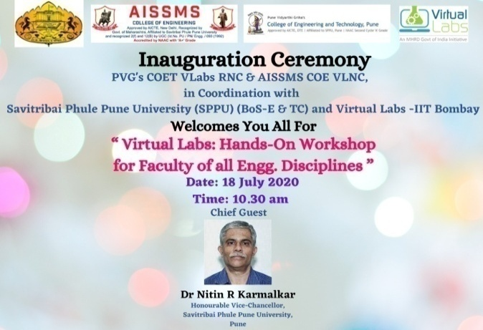
Virtual Lab Workshop (Date:18/7/2020)

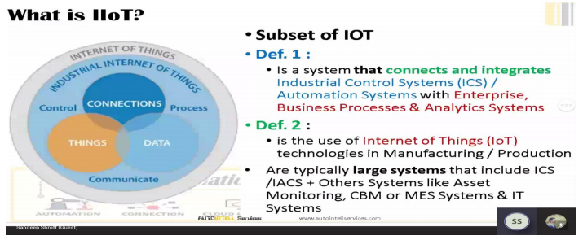

Webinar on ‘Introduction to Industrial IoT and Its Prospects’ (Date:06/11/2020 )

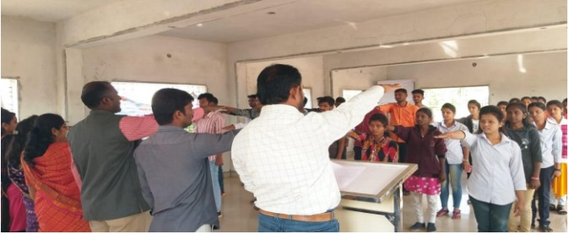Awareness campaign to celebrate Diwali Safe & Eco-Friendly and Promote ‘Vocal for Local’ mission (Date: 13/11/2020 )

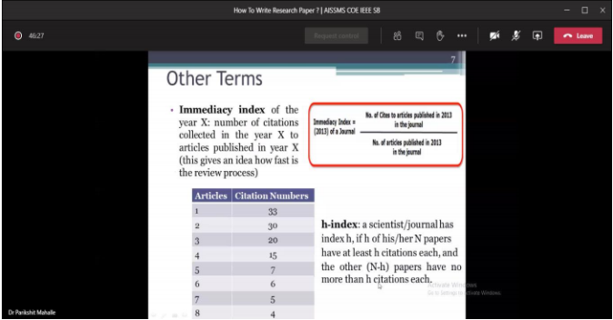

Webinar on ‘How to write Research Papers?(Date: 10/11/2020 )

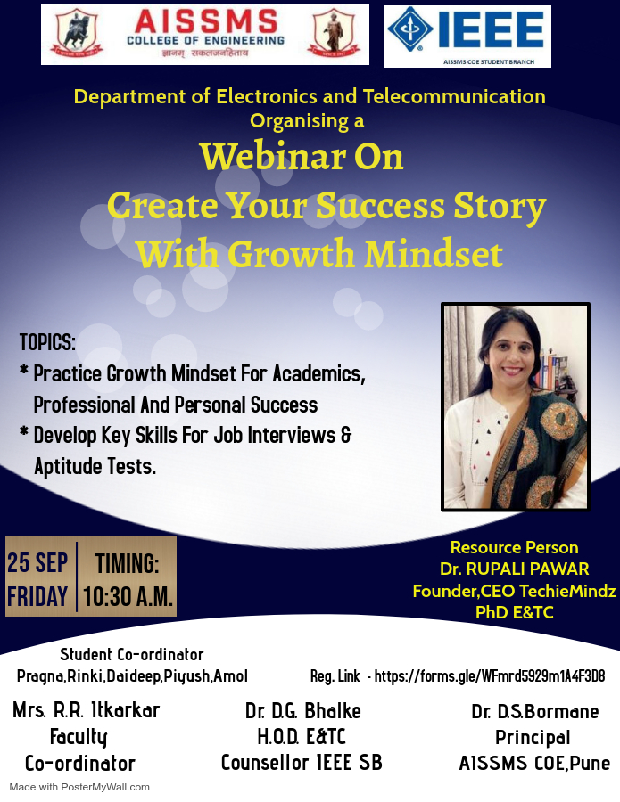
Webinar on “Create your Success Story with Growth Mindset”(Date:25/9/2020 )

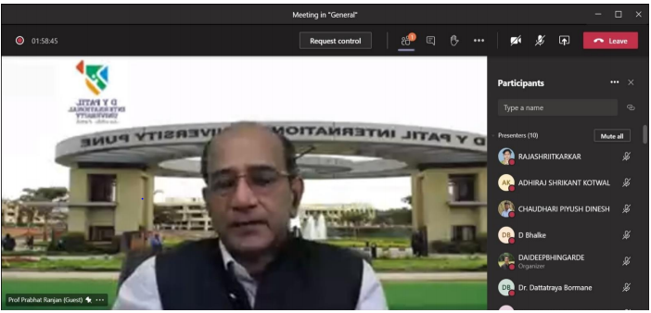
Webinar on “My Journey to Brain”(Date:31/10/2020 )

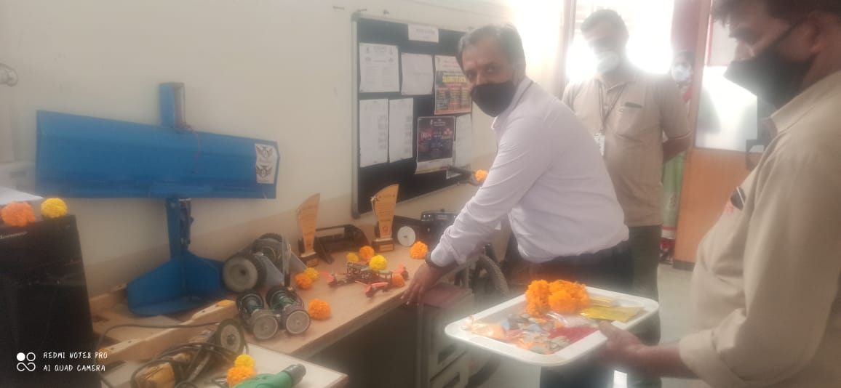Khandenavmi Pooja(Date:24/10/2020 )

Teachers’s Day Celebration (Date:5/9/2020)

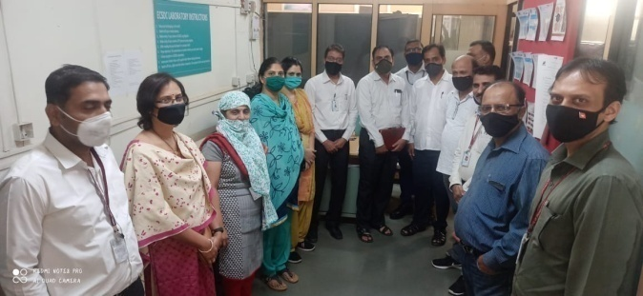
EFY Skill Center Inauguration (Date: 29/10/2020 )

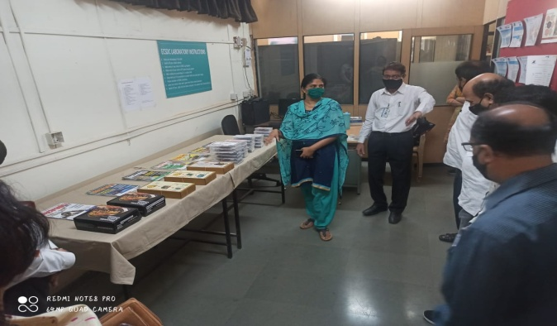
EFY Skill Center Inauguration (29/10/2020)

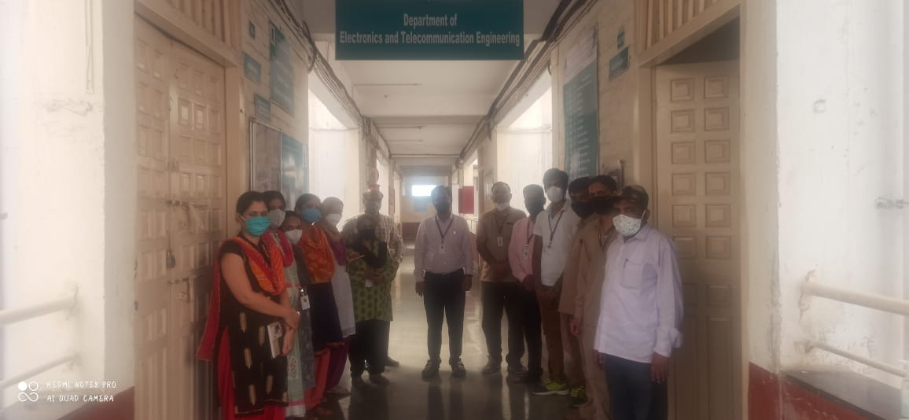
Khandenavmi Pooja (Date:24/10/2020 )

SUMMARY:

Sr.No. | Details | Total
1 | Faculty Achievements | 05
2 | Seminar/workshop/webinar Organized by Department | 42
3 | FDP/STTP/Workshop Attended by Faculty | 70
4 | FDP/STTP/Workshop Organized | 01
5 | Conference/ Symposium Attended by Department Faculty | 01
6 | Online Courses / Certificate courses completed by department faculty | 07
7 | Faculty served as Resource Person/Expert/Chair Person | 18
8 | Extension Activities Conducted by Department | 05
9 | MoU signed with Academic and professional Organizations | 01
10 | Paper Published in Journal | 10
11 | Book/ Article Publications | 01
12 | Patents, Copyright, trademark and other (IPR) | 01
13 | Student Placement | 7
14 | Students undergone in-plant training and (or)internship | 43
15 | Student Achievements | 02
16 | Online courses completed by students | 63
17 | Social Activity organized | 1
18 | Department Achievements | 2

