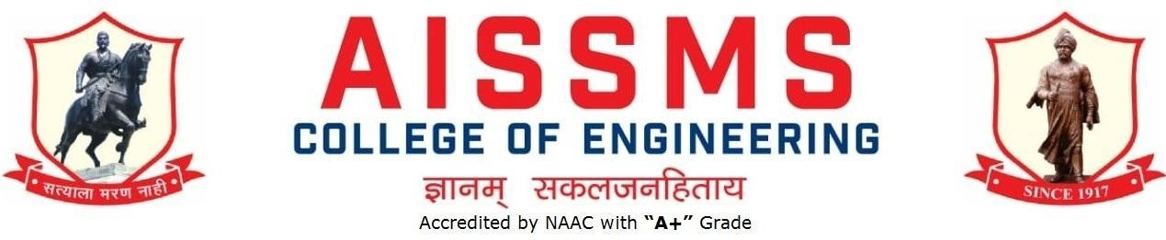
Internal Quality Assurance Cell

DEPARTMENT OF PRODUCTION ENGINEERING
ANNUAL REPORT

(15JUNE 2021 to 14June 2022)

CONTENTS

Sr No | Activity/ Item | Page No
 | 1. PROFILE OF DEPARTMENT
1.1 | Introduction
1.2 | Laboratories in the Department
1.3 | Software Available in the Department
1.4 | Faculty in the Department
1.5 | Details of Supporting Staff
1.6 | Students’ Enrollment
1.7 | Students–Faculty Feedback Details
1.8 | Result Analysis
1.9 | Class Result Analysis
 | 2. FACULTY CONTRIBUTION
2.1 | Achievements of Faculty
2.2 | Contribution of Faculty (Interaction With Outside World)
2.3 | e content developed by faculty and available online
2.4 | FDP/STTP attended by the department faculty
2.5 | Seminars/ workshops/ webinars attended by the department faculty
2.6 | Conferences/ symposiums attended by the department faculty
2.7 | Online courses / certificate courses completed by department faculty
2.8 | Extension lectures / webinars organized
2.9 | Faculty served as resource person, expert, chairperson
3. ACTIVITIES ORGANISED
3.1 | FDP/STTP organized by the department
3.2 | Seminars/ workshops/ webinars organized by the department (for faculty)
3.3 | Conferences/ symposiums organized by the department

3.4 | Extension activities conducted by the department
3.5 | MOU signed with academic and professional organizations
3.6 | Students’ chapters /clubs
3.7 | Social activities organized
3.8 | Parent meeting
3.9 | Alumni meet
3.10 | Support from Alumni
3.11 | Interaction with Alumni
3.12 | Student counseling and career guidance at the department level
4. RESEARCH CONTRIBUTION
4.1 | Funded research project
4.2 | Testing and consultancy
4.3 | Patents, copyright, trademark and other (IPR)
4.4 | Papers published/ presented in proceedings of conferences
4.5 | Papers published in journals
4.6 | Book/ article publications
4.7 | Total Research citations
4.8 | ME awarded
4.9 | PhD guide details
4.10 | PhD AWARDED
 | 5. INTERACTION WITH INDUSTRY
5.1 | Industrial visits organised
5.2 | Expert lectures delivered by industry experts
5.3 | Industry –sponsored projects (UG/PG)
5.4 | MOU signed with industry
5.5 | Faculty members undergone industrial training

5.6 | Students undergone in-plant training and (or) internship  programme
5.7 | Support from Industry
5.8 | Training to Industry personnel/ Activity Supporting industry
5.9 | Any other activities to Promote Interaction With Industry
5.10 | Students Undergone Sandwich Training
6. STUDENTS’ ACHIEVMENT
6.1 | Students’ Achievement (Professional) (Individual Level)
6.2 | Students’ Achievement (Other than Professional) (Individual Level)
6.3 | Certificate / Online Courses Completed by Students
6.4 | Number of Students Placed
6.5 | Number of Students qualified in the competitive examinations
6.6 | Sports / Cultural Achievements of Students (Individual Level)
6.7 | Students’ Achievements (Team Level)
 | 7. SUMMARY AND SWOC ANALYSIS
7.1 | Any other noteworthy achievement of the department
7.2 | Miscellaneous (Syllabus Implementation, Major Addition In Infrastructure And Facility, Innovations Introduced, etc.)
7.3 | Feedback from Stakeholders
7.4 | Two Best Practices Followed in the Department
7.5 | Major Grievances of Students (If Any) Redressed
7.6 | SWOC Analysis
7.8 | Future Plans of the Department
7.9 | Initiatives Taken By The Department At Department And Institute Level To Improve And Assure Quality
7.10 | Summary Sheet (Annual)

PROFILE OF
DEPARTMENT
INTRODUCTION

Year of Establishment | 1994
UG Programmes | PRODUCTION ENGINEERING
PG Programmes | NA
Number of Teaching Staff | 09
Number of Non-Teaching Staff | 12 (Production + Workshop)

LABORATORIES IN THE DEPARTMENT

Name of Laboratory |  | Name of Laboratory
1 | CAD/CAM Laboratory | 5 | NonTraditional Machine Laboratory
2 | Robot & Automation Laboratory | 6 | Advanced Production Technology
3 | Production Management Laboratory | 7 | Department Central Facility
4 | Tool Engineering Laboratory

SOFTWARES AVAILABLE IN THE DEPARTMENT
Software Available |  | Software Available
1 | Unigraphics Mfg. Bundle 10 nos. and (FEMAP +NASTRAN) 5  nos.and FACTORY CAD-2 nos. and  FACTORY FLOW-02  Nos.and eMplant- 02 Nos. | 5 | ANSYS Academic Teaching + CFD Version 16.2 for(25 user)
2 | Computer Software Autodesk Inventor Professional Edu. License (03) | 6 | JASP- Version 2 (Janatics Animation Software & Pneumatics) ( 01)
3 | Solid Edge Bundle (Drafting Solid Modeling and Sheet Metal) for 25 user | 7 | Systat Statistical Software -Version 12 ( 01)
4 | Unigrahics 8.0 Cam Express (Simulation, Modeling, Tool Path Generation) 20 user

FACULTY IN THE DEPARTMENT

Name of faculty | Designation
1.Prof.V.D.Dholle | Head/WS ,Asst. Prof
2.Prof.V.Y.Sonawane | Asst. Prof
3.Prof.M.A.Kelakr | AWS
4.Dr.N.G.Shekapure | Asst. Prof

5.Prof.S.S.Kallurkar | Asst. Prof
6.Prof.S.N.Chiwande | Asst. Prof
7.Prof.S.K.Bidgar | Asst. Prof
8.Prof.M.L.Chanpur | Asst. Prof
9.Prof.Ms. Y.K.Funde | Asst. Prof

DETAILS OF SUPPORTING STAFF

Name of non-teaching staff | Designation
1.Mr.Rahul S Gangawane | Lab Assistant
2.Mr A.Chopane | Store Keeper
3.Mr N V Walke | Instructor
4.Mr V N Hire | Instructor
5.Mr G M Kadam | Instructor
6.Mr Sanjay M K | Instructor
7.Mr P D Pawar | Electrician
8.Mr.B.H.Gade | Attendant
9.Mr.Y.G.Patil | Attendant
10.Mr R M Khedekar | Attendant
11.Mr N V Adhav | Attendant
12.Mr A U Dhame | Attendant

FACULTY CONTRIBUTION
ACHIEVEMENTS OF FACULTY

(AWARDS, RECOGNITION, PHD COMPLETION ETC.)

Term One
SN | Name of Faculty | Awards & Recognitions
1 | Mr VY Sonawane | NPTEL DOMAIN STAR
2 | Mr VY Sonawane | NPTEL BELIEVER
3 | Mr VY Sonawane | National best Teacher award Sarvepalli Radhakrishnan best  teacher award
4 | Mr VY Sonawane | NPTEL Motivated learner
5 | Mr VY Sonawane | 3rd IJMST EXCELLENCE AWARD international journal for  modern trends in Science and Technology
6 | Mr S K Bidgar | Nil

Term Two
SN | Name of Faculty | Awards & Recognition
1 | Mr VY Sonawane | 3rd IJMST EXCELLENCE AWARD international journal for  modern trends in Science and Technology
2 | Mr VY Sonawane | Indo Asian teaching excellence award International  multidisciplinary Research Foundation 2021
3 | Dr N G Shekapure | Award of degree of Doctor of Philosophy (Ph.D.) in the subject  of Mechanical Engineering
4 | Mr S K Bidgar | Nil
CONTRIBUTION OF FACULTY (Interaction with outside world) (ALL FACULTIES)

Term One
SN | Name of Faculty | Nature and details of contribution (Representation at University,  State, National , International level, corporate world, Social Platforms, etc)
1 | S S Kallurkar | Delivered session in FDP on Software Based Case Studies for  Development of Multidisciplinary Projects

e CONTENT DEVELOPED BY FACULTY AND AVAILABLE ONLINE
Term One
Sr No. | Name of Faculty | Title of e- content | e-content development  facility/platform | link of the content

 | Mr V Y Sonawane | APT MFMD | Video, PDF TEAMS , ERP | https://web.microsofts tream.com/studio/vide os  https://drive.google.co m/drive/search?q=700 1
2 | Dr N G Shekapure | e - Book on Material Management and Logistics | Soft Copy in PDF format | https://drive.google.co m/file/d/18p_ONH- dZY6IQsuJN9MMgis vcW3tNstA/view?usp  =sharing
3 | Mr M L Chanpur | E-Notes on Strength of Materials | Soft Copy in PDF format | https://drive.google.co m/drive/folders/1yaJb dsXaYz- leMnGPFiafx1AzEjH LF39?usp=sharing
4 | Ms Y K Funde | E-Notes on Mechatronics & Robotics | Soft Copy in PDF format
5 | Mr S K Bidgar | E-Notes on Material Science & Metallurgy | Soft Copy in PDF format, Video, TEAM, ERP | https://drive.google.co m/drive/folders/1yaJb dsXaYz- leMnGPFiafx1AzEjH LF39?usp=sharing

Term Two
Sr No. | Name of Faculty | Title of e- content | e-content  development facility/platform | link of the content

1 | Mr V Y Sonawane | APT MFMD | Video, PDF TEAMS , ERP | https://web.microsofts tream.com/studio/vide os  https://drive.google.co m/drive/search?q=700 1
2 | Dr N G Shekapure | e - Book on Industrial Engineering and Management | Soft Copy in PDF format | https://drive.google.co m/file/d/1Om- bOwHqMCBTHl_Ckl QW6QfexgZcDOS0/v iew?usp=sharing
3 | Mr M L Chanpur | E-Notes on Strength of Materials | Soft Copy in PDF format | https://drive.google.co m/drive/folders/108B 7NaLNr2GLf7Y-  dd26ToTzxBl0vHkZ? usp=sharing
4 | Mr S S Kallurkar | E Notes on Heat and Fluid Engineering | Soft Copy in PDF format | https://drive.goog  le.com/drive/folders/1 9hxKf2fin9r3l7kYXC EIQBOCeh7k-  ugb?usp=sharing
5 | Ms Y K Funde | E-Notes on World Class Manufacturing | Soft Copy in PDF format | Video, PDF TEAMS ,
6 | Mr S K Bidgar | E-Notes on Manufacturing Process - II | Soft Copy in PDF format, Video, TEAM, ERP | https://drive.google.co m/drive/folders/1yaJb dsXaYz- leMnGPFiafx1AzEjH LF39?usp=sharing

FDP/STTP ATTENDED BY THE DEPARTMENT FACULTY
Term One
S N | Name of Faculty | Title of the FDP/STTP | Organized by | Duration/ Dates

1 | Mr V Y  Sonawane | NPTEL Theory of Production Processes | NPTEL MHRDC, GOI | Sep-Dec 2021
2 | Mr VY  Sonawane | NPTEL Manufacturing system Technology I and II | NPTEL MHRDC, GOI | Sep-Dec 2021
3 | Mr V Y  Sonawane | NPTEL Introduction to Robotics | NPTEL MHRDC, GOI | Sep-Dec 2021
4 | Mr V Y  Sonawane | ATAL FDP Advancements in Computational Fluid Dynamics using FLUIDYN Computational Fluid Dynamics Engineering | AICTE ATAL  The Department of Aerospace Engineering, Alliance University | 02/06/2021  To 06/06/2021
5 | Mr V Y  Sonawane | ATAL FDP Research Methodology: Design and Technology Design and Technology Design & Media | AICTE ATAL  Nelson Mandela Marg, Vasant Kunj, New  Delhi – 110 070 | 07/06/2021  To 11/06/2021
6 | Mr VY  Sonawane | Training on “Salesforce Technology - Admin” | Nagpur Institute Of  Technology, Nagpur 441501 | 04/09/2021  To 11/09/2021
7 | Mr VY  Sonawane | Attended FDP on AICTE-Workshop on Examination Reforms | ICT 250 NIITTR,  Kolkata | 10/01/2022  To 12/01/2022
8 | Mr V Y  Sonawane | Attended FDP on Fusion Welding Processes | ICT 250 NIITTR,  Kolkata | 10/01/2022  To 14/01/2022
9 | Mr V Y  Sonawane | Attended Faculty Development Program on "Trends and Innovations in Healthcare | Vishwakarma Institute of Information Technology, Pune 411 048 | 25/10/2021  To 29/10/2021
10 | Mr V Y  Sonawane | Attended Industrial Visit: International Exhibition on automation | Goregaon Bombay Exhibition | 22/092021  To 25/09/2021

15

 |  |  | Centre
11 | Mr V Y  Sonawane | Attended FDP One Week Virtual Training on "Sales  force Technology-Admin" as an Internal Quality Assurance  Cell (IQAC) | NIT, Nagpur | 04/09/2021  To 11/09/2021
12 | Mr V Y  Sonawane | Attended FDP 13th Summer School in Tribology | Indian Oil Corporation Ltd and Tribology Society of India | 31/08/2021  To 04/069/2021
13 | Mr V Y  Sonawane | Attended FDP Advances in Fluid, Heat and Mass Transfer | Pravara SVIT Nashik | 05/07/21  To 09/06/2021
14 | Mr V Y  Sonawane | Attended FPTS 2021 | Fluid Power Society  of India (FPSI) | 18/06/2021  To 19/06/2021
15 | Dr N G  Shekapure | FDP on “Software Based Case Studies for Development of Multidisciplinary Projects” | AISSMS  College Of Engineering, Pune | 22/11/2021  to 26/11/2021
16 | Ms Y K  Funde | FDP on Application of Internet of the Things in Environmental, Medical Science and Human Life | Shri Shankaracharya Group of Institutions, SSTC.  (ATAL) | 04/10/2021  TO 8/10/2021
17 | Mr S N  Chiwande | (ATAL) Academy Online Elementary FDP on "EMINENCE OF ELECTRIC VEHICLES AND ROBOTICS IN AGRONOMY" | DHANALAKS HMI SRINIVASAN ENGINEERIN G COLLEGE | 21/06/2021  to 25/06/2021
18 | Mr S N  Chiwande | Short Term Training Program on “Innovative & Inventive Problem Solving” | Department of Production Engineering, AISSMS COE,  Pune | 13/07/2021  to 18/07/2021
19 | Mr S N  Chiwande | (ATAL) Academy Online Elementary FDP on "PATENT LAW FOR | PRATHYUSH A | 26/07/2021  to

16

 |  | ENGINEERS AND RESEARCHERS" | ENGINEERIN G COLLEGE | 30/07/2021
20 | Mr S N  Chiwande | (ATAL) Academy Online Elementary FDP on "Faculty Development Program on Sensor Technology" | ATAL &  University Institute of Engineering & Technology, Kurukshetra University, Kurukshetra. | 06/09/2021  to 10/09/2021
21 | Mr M L  Chanpur | Finite Element Method (with applications to solid mechanics, heat transfer and fluid mechanics) | AICTE Training and Learning (ATAL)  Academy Online FDP | 17/08/2021-  21/08/2021
22 | Mr M L  Chanpur | Research Methodology | AICTE Training and Learning (ATAL)  Academy Online FDP | 23/08/2021 –  27/08/2021
23 | Mr M L  Chanpur | Software Based Case Studies for Development of Multidisciplinary Projects | AISSMS COE, FDC | 22/11/2021-  26/11/2021
24 | Mr S S  Kallurkar | ATAL FDP on Design Thinking: Aspirations for Innovations | AISSMS COE, AICTE | 29-11-2021  to 03-12-  2021
25 | Mr S K Bidgar | Completed ISTE approved one week FDP on “Augmented Reality and Virtual Reality” | AISSMS College of Engineering, Pune | 21 /06/2021  to 25/06/2021

17

26 | Mr S K Bidgar | Completed AICTE Quality Improvement (AQIS)  Sponsoredone week online Short Term Training Program On“Innovative & Inventive Problem Solving” | Department of Production Engineering, AISSMS COE,  Pune | 22 /06/2021  to 27/06/2021
27 | Mr S K Bidgar | Attended one week online FDP on “Foundations of Data Science” | MIT Academy of Engineering, Alandi | 26 /07/2021  to 30/07/2021
28 | Mr S K Bidgar | National Level Workshop on “Recent Trends in Mechatronics and Automation” | Karmaveer Adv.  BaburaoGanpat raoThakareCOE  , Nashik | 24 /09/2021  to 25/09/2021
29 | Mr S K Bidgar | Completed the AICTE-ISTE approved One Week FDP on “Electric Mobility as a Future” | Dr. D.Y.Patil IOEM&R  Akurdi Pune in association  with SAE India | 25/10/2021  to 29/10/2021
30 | Mr S K Bidgar | Participated in Five Days FDP on “Software Based Case Studies for Development Of Multidisciplinary Projects” | Department of Computer Engineering, AISSMS COE,  Pune | 22/11/2021  to 26/11/2021
31 | Mr S K Bidgar | Completed the AICTE-ISTE approved Orientation/ Refresher Programme on “Nanotechnology | MuffakhamJah COE&T,  Hyderabad | 10/12/2021  to 16/12/2021

18

Application in Mechanical Engineering

Term Two
S N | Name of Faculty | Title of the FDP/STTP | Organized by | Duration/ Dates
01 | Mr V Y  Sonawane
02 | Dr N G  Shekapure | STTP/Refresher Program on “Project Based Learning” | AISSMS  College Of Engineering, Pune | 21/02/2022 to  16/02/2022
03 | Ms Y K  Funde | Orientation /Refresher Program “Nanotechnology Application In Mechanical Engineering”. | MUFFAKHA M JAH COLLEGE OF ENGINEERI NG AND TECHNOLO GY | 10/12/2021 to  16/12/2021
04 | Mr S N  Chiwande | AICTE-ISTE sponsored refresher program on "Nanotechnology Applications in Mechanical Engineering" | MUFFAKHA M JAH COLLEGE OF ENGINEERI NG AND TECHNOLO GY | 10/12/2021 to  16/12/2021
05 | Mr S N  Chiwande | Faculty Development Program on “INDUSTRY 4.0 with EMPHASIS on ROBOTICS AND AUTOMATION”  from 21st February  to 25th February 2022 | in Association with ISTE and IQAC Cell, DYPCOE,  Akurdi. | 21/03/2022 to  25/03/2022
06 | Mr S K  Bidgar | Faculty Development Program on “INDUSTRY 4.0 with EMPHASIS on ROBOTICS AND AUTOMATION”  from 21st February | in Association with ISTE and IQAC | 21/03/2022 to  25/03/2022

19

 |  | to 25th February 2022 | Cell, DYPCOE,  Akurdi.
07 | Mr S S  Kallurkar | Faculty Development Program on “INDUSTRY 4.0 with EMPHASIS on ROBOTICS AND AUTOMATION”  from 21st February  to 25th February 2022 | in Association with ISTE and IQAC Cell, DYPCOE,  Akurdi. | 21/03/2022 to  25/03/2022
08 | Mr M L  Chanpur | Intellectual Property Rights | Cummins COE | 07/03/2022 to  12/03/2022
09 | Mr M A  Kelkar | FDP on “Software Based Case Studies for Development of Multidisciplinary Projects” | AISSMS  College Of Engineering, Pune | 22/11/2021 to  26/11/2021
10 | Mr S K  Bidgar | Online FDP on “Industry 4.0 with Emphasis on Robotics and Automation” | DYPCOE  Akurdi, Pune | 21/02/2022  to 25/02/2022
11 | Mr S N  Chiwande | National Level Faculty Development Program on “INDUSTRY 4.0 & SMART MANUFACTURING”, | Dr. V. B.  Kolte CoE Malkapur | 31/05/2022  to 04/06/2022

SEMINARS/ WORKSHOPS/ WEBINARS ATTENDED BY THE DEPARTMENT FACULTY
Term One
S N | Name of Faculty | Title of the Seminar/Webinar | Organized By | Duration/ Dates
1 | Mr V Y  Sonawane | Attended Webinar on National education Policy | AICTE | 16/12/2021

2 | Mr V Y  Sonawane | Attended Webinar "Symbol of Knowledge" program on the occasion of “Constitution Day" | AISSMS COE  Pune | 08/12/2021
3 | Mr VY  Sonawane | Web seminar: Session 5 – Green rating system and Smart Cities | ASSOCHAM INDIA | 02/12/2021
 | Mr VY  Sonawane | Attended Webinar orientation program for 12th pass out students | AISSMS COE  Pune | 18/11/2021
4 | Mr VY  Sonawane | Attended Webinar on Commvault Connections 21 APJ | Commvault | 11/11/2021
5 | Mr VY  Sonawane | Attended Webinar Moldex 3D E-learning | Moldex  3D E-learning | 11/11/2021
6 | Mr V Y  Sonawane | Attended Webinar Inauguration Ceremony Event of 16th AISSMS Engineering | AISSMS COE  Pune | 29/09/2021
7 | Mr V Y  Sonawane | Attended National Workshop on Digital Disruption | ASSOCHAM,  New Delhi | 17/09/2021  To 18/09/2021
8 | Mr V Y  Sonawane | One faculty one Industry OFOI done During International Exhibition | SHRIDHAN  Automation Pvt. Ltd Bangalore | 23/09/2021
9 | Mr VY  Sonawane | Attended WINGS OF NSS Chief Guest Savita Kulkarni Nodal Officer NSS SPPU | NSS, AISSMSCOE | 23/09/2021
10 | Mr VY  Sonawane | Attended National Workshop for Educators on Integration of  Building Heat Transfer in Engineering Curriculum | IIT Bhilai | 28/08/2021  To 29/08/2021
11 | Mr V Y  Sonawane | Attended Webinar Inauguration Ceremony of AISSMS COE | AISSMS COE  Pune | 26/08/2021

SESI Institutional Member and AISSMS COE SESI
Students'
12 | Mr VY  Sonawane | Attended Webinar on AISSMS COE ISTE  Students' Chapter, AISSMS COE IEEE Student Branch, IEI Students' Chapter & IETE Students Forum (ISF) | Dr. Rajesh Jalnekar, Director VIT Pune | 24/08/2021
13 | Mr V Y  Sonawane | Attended Webinar and Quiz Industrial Automation and Control AISSMS (I) Connect under ISTE Chapter Mr.  Shivaji  Suryawanshi Director Mr. Sanket and Aero circle Automation Pvt limited Pune | AISSMS COE  Pune | 17/07/2021
14 | Mr VY  Sonawane | Attended Parent Meet for BE Production Sandwich | Production Engineering Department | 24/07/2021
15 | Mr VY  Sonawane | Attended Expert Session on “Enhancement of Energy Dissipation using Combination of Solid Roller Bucket & Type II  Stilling Basin for Ogee Stepped Spillway” | Indian Water Works Association, Pune Centre in association with AISSMS  College of Engineering, Pune | 24/07/2021
16 | Mr V Y  Sonawane | Attended webinar on "Ask Me Anything about Data Science and Analytics" | Great Learning | 28/07/2021
17 | Mr V Y  Sonawane | Attended webinar on “Importance of Material & Supply Chain Management in Near Future” | ASSOCHAM INDIA | 24/07/2021

18 | Mr V Y  Sonawane | Attended Webinar on Expert Talk on Financial Literacy AISSMSCOE ISTE Students' | AISSMS COE  Pune | 17/07/2021
19 | Mr V Y  Sonawane | Attended Webinar on ESG (Environmental, Social and Governance) in FMCG Sector’ | ASSOCHAM INDIA | 22/07/2021
20 | Mr V Y  Sonawane | Attended Webinar on AISSMS I - Connect Program (An Industry Institute Interaction Program) on "Automotive Industry Trends and Challenges" | Mr. Parvin Dhole, Sr. Manager, R & D, Truck Division Knorr- Bremse Technological Centre, Hinjewadi, Pune | 10/07/2021
21 | Mr V Y  Sonawane | Attended Webinar on AISSMS I - Connect Program Do’s and Don’ts for Career Aspirants | Aspirants Mr. Raghu  Nair, Head Steam Engineering Centre,  Forbes Marshall, Pune | 09/07/2021
22 | Mr V Y  Sonawane | Attended Webinar on IEEE Publications: Technical Writing and Enhancing Your Research | IEEE  Publications | 14/07/2021
23 | Mr V Y  Sonawane | Attended Webinar on “Anyone Can Automate” Automation Anywhere | Automation | 08/07/2021
24 | Mr V Y  Sonawane | Attended Webinar AISSMS I-CONNECT brings you an expert Lecture on *“Career Opportunities for Engineering Students.” | AISSMS COE  Pune | 06/07/2021

25 | Mr V Y  Sonawane | Attended Webinar on "Innovative Way for Successful Entrepreneurship” | AISSMS COE  Pune | 07/07/2021
26 | Mr V Y  Sonawane | Attended ISTE Students Chapter Inauguration Ceremony and Keynote Address | ISTE Students | 26/06/2021
27 | Mr V Y  Sonawane | Attended International Certified Career Coach Foundation Program | International Certified Career Coach Foundation Program Delhi | 25/06/2021  To 25/07/2021 26/06/2021
31 | Mr V Y  Sonawane | Attended "Webinar on OBE  – IN PURSUIT OF ACADEMIC EXCELLENCE - II |  | 26/06/2021
28 | Mr V Y  Sonawane | Attended International Exhibition KROHNE Germany | KROHNE  Germany | 21/06/2021
29 | Mr V Y Sonaw | Attended AISSMS I- CONNE Industry- Institute-Interaction Programmed | Mr. Bhushan Pati (Senior VP Tech Mahindra) | 26/06/2021
30 | Mr V Y Sonaw | Attended Webinar on “Cycles way for Innovation & Entrepreneurship” | AISSMS COE Pu | 22/07/2021
21 | Mr V Y Sonaw | Attended AISSMS College of Engineering Pune-01, National Service Scheme, Unnat Bharat Abhiyan and GYMKHANA celebrating 7th International Yoga Day in association with Savitribai Phule Pune University,  Pune-0 | AISSMS COE Pu | 21/06/2021
32 | Mr V Y Sonaw | Attended FPTS 2021 | Fluid Power Socie India (FPSI) | 18/06/2021  To 19/06/2021

33 | Mr V Y Sonaw | Attended Savitribai Phule Pune University Board Sports Physical Education in collabor | Pune City, Pune Ahmednagar Dist Nashik District | 21/06/2021
34 | Mr V Y Sonaw | Attended Webinar on AICTE Initiatives | AICTE | 18/06/2021
35 | Mr V Y Sonaw | Attended Savitribai Phule Pune University, Pune and Department of Higher Education, Maharashtra | Savitribai Phule Pune University, and Department Higher Education Maharashtra | 21/06/2021
36 | Mr V Y Sonaw | Attended Webinar on OBE – I PURSUIT OF ACADEMIC EXCELLANCE – II | Great Learning | 24/06/2021
37 | Mr V Y Sonaw | Attended Webinar, webinar with Automation Anywhere & CNBC TV18 together present Future Ready India | TV18 CNBC | 15/06/2021
38 | Mr V Y Sonaw | Attended Two Days workshop 2021 | Fluid Power Socie of India (FPSI) | 17/06/2021  To 18/06/2021
39 | Mr V Y Sonaw | Attended Shri Sant Gajanan Maharaj College of Engineeri Shegaon Department of Ele And Tele Engg An Webinar o Benefits and Opportunities of Professional Students' Chapter Pandemic." | Shri Sant Gajanan Maharaj College Engineering, She | 11/06/2021
40 | Mr V Y Sonaw | Attended the Webinar on "Symbol of Knowledge". | AISSMS COE Pu
41 | Mr V Y Sonaw | Attended “Effective Online Teaching using Bodhi Tree” | IIT Bombay
42 | Mr V Y Sonaw | Attended National level Quiz Environment Day | AISSMS COE Pu
43 | Mr V Y Sonaw | Attended Webinar shivswrajya Din | AISSMS COE Pu
44 | Dr N G | Webinar on | Department of | 07/07/2021
D
o

 | Shekapure | “Innovative way for Successful Entrepreneurship” | Production Engineering and Institution’s Innovation Council, AISSMS COE,  Pune
45 | Dr N G  Shekapure | Webinar on  “Innovation in Technology Adoption and Development of High Precision  Slipring: A Case Study” | Department of Production Engineering and Institution of Engineers (India), Kolkata Students’ Chapter, AISSMS COE,  Pune  in association with TRIZ Association of Asia | 18/07/2021
46 | Dr N G  Shekapure | Webinar on  “Importance of Material & Supply Chain Management in Near Future" | Department of Production Engineering, AISSMS COE,  Pune | 24/07/2021
47 | Ms Y K  Funde | Disha Pragatichi | AISSMS COE | 18/09/2021
48 | Ms Y K  Funde | Current Scenario of India | AISSMS COE | 02/10/2021
49 | Ms Y K  Funde | “IPR with reference patent drafting and filing in Indian context” | Institution’s Innovation Council AISSMS COE | 14/10/2021
50 | Mr S N  Chiwande | Webinar on “Cycle - Proven way for Innovation & Entrepreneurship” | Department of Production Engineering, AISSMS COE PUNE SOURCE : ZOOM | 01/07/2021

51 | Mr S N  Chiwande | Webinar on AICTE - Envisioning the reforms in Higher Education in the context of National Education Policy 2020 on 08th July 2021 at 15:00 Hrs | AICTE -  Envisioning the reforms in Higher Education | 08/07/2021
52 | Mr S N  Chiwande | Expert session on “Enhancement of Energy Dissipation using Combination of Solid Roller Bucket & Type II Stilling Basin for Ogee Stepped Spillway ” | Organized by Indian Water Works Association, Pune Center in association with AISSMS CoE,  Pune | 24/07/2021
53 | Mr S N  Chiwande | Webinar on “Importance of Material & Supply Chain Management in Near Future" By Mr. Gaurav Joshi | Organised by Department of Production Engineering, AISSMS COE,  Pune on 24 July 2021. | 24/07/2021
54 | Mr S N  Chiwande | National Webinar on ‘Industry Automation and Control’ and  passing the quiz | Organised by AISSMS COE  ISTE Students' Chapter | 17/08/2021
55 | Mr S N  Chiwande | ttending World Entrepreneurship Day, “Powering Yuvoudhyamis" on Saturday 21st August from 10:10am to 1:00pm. With this virtual event, focus on building collaborations and partnerships to fuel youth entrepreneurship as a viable and aspirational career path. | IUCEE Partner GAME on | 21/08/2021

56 | Mr S N  Chiwande | Webinar on the Topic: Internship & innovation as a career opportunities | Department of E&TC, AISSMS COE, PUNE  Platform: Microsoft Teams | 25/08/2021
57 | Mr S N  Chiwande | Participated in a Webinar on 'Problem Based Learning' Guest Speaker: Dr. Gayatri M Phade, Professor, Sandip Foundation Nashik | Department of Electronics & Telecommunicat ion Engineering, AISSMS  College of Engineering, Pune in association with AISSMS COE  IEEE Student Branch, IE(I) & ISTE Student Chapter and ISTE Student Forum (ISF) | 25/08/2021
58 | Mr S N  Chiwande | Webinar on Inauguration Ceremony_Solar Energy Society of India (SESI) Institutional Membership and SESI Students' Chapter | Solar Energy Society of India (SESI)  Institutional Membership and SESI Students' Chapter at 2.00 pm | 26/08/2021
59 | Mr S N  Chiwande | Webinar on EduSkills & ISTE "Industry Center of Excellence" | AISSMS  College of Engineering, Pune | 07/09/2021
60 | Mr S N  Chiwande | Webinar on "Global Trends and Challenges in NanoTechnology" | AISSMS  College of Engineering, Pune is inviting you for | 30/09/2021

 |  |  | Inauguration Ceremony SCITECH- IDEATHON
61 | Mr S N  Chiwande | Webinar on "Key to Start-Up" by Mr Shrirang Gokhale & Mr Biman Gandhi, mentor and Guide from BYST & PMA Pune | Organised by Department of Production Engineering , AISSMS COE PUNE | 12/10/2021
62 | Mr M L  Chanpur | Automotive Sensor System | AISSMS COE,  Prod Engg Dept | 04/10/2021
63 | Mr M L  Chanpur | Developing a Culture of Innovation | AISSMS COE,  Mech and Prod Engg Dept | 15/09/2021
64 | Mr M L  Chanpur | NPTEL E-Awareness workshop | NPTEL | 22/12/2021
65 | Mr M L  Chanpur | Role of IPR In Start-up | Institution’s Innovation Council AISSMS COE | 14/10/2021
66 | Mr M L  Chanpur | CII Mystic South - Global Linkages Summit | CII | 23/09/2021 –  24/09/2021
67 | Mr M L  Chanpur | NEP | NAAC | 16/12/2021
68 | Mr M L  Chanpur | IPR with reference patent drafting and filing in Indian context | Institution’s Innovation Council AISSMS COE | 14/10/2021

69 | Mr M L  Chanpur | How to carry out Research? Tips for Research Scholars | Dr. Vithalrao Vikhe Patil college of Engineering, Ahmednagar | 15/09/2021
70 | Mr S S  Kallurkar | Webinar on Inauguration Ceremony_Solar Energy Society of India (SESI) Institutional Membership and SESI Students' Chapter | Solar Energy Society of India (SESI)  Institutional Membership and SESI Students' Chapter at 2.00 pm | 26/08/2021
71 | Mr S S  Kallurkar | National Webinar on ‘Industry Automation and Control | AISSMS COE | 17/08/2021
72 | Mr S S  Kallurkar | National Webinar on MATERIAL FORMING | AISSMS COE | 17/08/2021
73 | Mr S K  Bidgar | webinar on  “Awareness program of Manthan Hackathon” | AISSMS COE | 08/10/2021
74 | Mr S K  Bidgar | “IPR with reference patent drafting and filing in Indian context” | AISSMS COE | 14/10/2021
75 | Mr S K  Bidgar | “Innovation in Technology Adoption and Development of High Precision Slipring: A | AISSMS COE | 18/07/2021

 |  | Case Study”
76 | Mr S K  Bidgar | webinar on “Developing a Culture of Innovation” | AISSMS COE | 15/09/2021
76 | Mr S K  Bidgar | Online National Level Workshop on ‘Recent Trends in Mechatronics and Automation’ | Karmaveer Adv. Baburao Ganpatrao Thakare College of Engineering, Nashik | 24/09/2021  to 25/09/2021

Term Two
S N | Name of Faculty | Title of the Seminar/Webinar | Organized By | Duration/ Dates
1 | Mr M L  Chanpur | Advanced Materials Characterisation Techniques | COE AVK Nagar, Kanyakumari Dist | 01/03/2022 -  03/03/2022
2 | Mr M L  Chanpur | IP Awareness/Training program | Govt of India | 10/03/2022
3 | Mr M L  Chanpur | Design Thinking, Critical Thinking and Innovation Design | Moradabad Institute of Technology | 24/03/2022

4 | Mr M L  Chanpur | IP Awareness/Training program | Govt of India | 25/03/2022
5 | Mr S K  Bidgar | Pledge of “NATIONAL VOTERS DAY” | AISSMS COE | 25/01/2022
6 | Mr S K  Bidgar | Online workshop on “Advanced Materials Characterisation Techniques " | Annai Vailankanni COE, Chennai | 01/03/2022  to 01/03/2022

CONFERENCES/ SYMPOSIUMS ATTENDED BY THE DEPARTMENT FACULTY

Term One
S N | Name of Faculty | Title of the Conference / Symposium | Organized By | Duration/ Dates
1 | S S Kallurkar | AICTE Sponsored International E Conference on Mechanical and Material Science Engineering:  Innovation and Research | SITRC Nashik | 17/09/2021-  18/09/2021
2 | Mr S K  Bidgar | Nil

Term Two
S N | Name of Faculty | Title of the Conference / Symposium | Organized By | Duration/ Dates
1 | Mr S N  Chiwande | International Conference on Intelligent Technologies  (ICIT- 2021 | (ICIT – 2021) –  Singapore | 17/12/2021  TO 19/12/2021
2 | Mr S K  Bidgar | Nil

ONLINE COURSES / CERTIFICATE COURSES COMPLETED BY DEPARTMENT FACULTY (ALL FACULTIES)

Term One
S N | Name of Faculty | Title of the Course | Conducted By | Duration/ Dates
1 | Mr V Y  Sonawane | NPTEL Theory of Production Processes | NPTEL MHRDC, GOI | Sep-Dec 2021
2 | Mr VY  Sonawane | NPTEL Manufacturing system Technology I and II | NPTEL MHRDC, GOI | Sep-Dec 2021
3 | Mr V Y  Sonawane | NPTEL Introduction to Robotics | NPTEL MHRDC, GOI | Sep-Dec 2021
4 | Mr V Y  Sonawane | ATAL FDP Advancements in Computational Fluid Dynamics using FLUIDYN Computational Fluid Dynamics Engineering | AICTE ATAL  The Department of Aerospace Engineering, Alliance University | 02/06/2021  To 06/06/2021
5 | Mr V Y  Sonawane | ATAL FDP Research Methodology: Design and Technology Design and Technology Design & Media | AICTE ATAL  Nelson Mandela Marg,  Vasant Kunj, New Delhi – 110 070 | 07/06/2021  To 11/06/2021
6 | Mr VY  Sonawane | Training on “Salesforce Technology - Admin” | Nagpur Institute Of  Technology, | 04/09/2021  To 11/09/2021

 |  |  | Nagpur 441501
7 | Mr VY  Sonawane | Attended FDP on AICTE- Workshop on Examination Reforms | ICT 250 NIITTR,  Kolkata | 10/01/2022  To 12/01/2022
8 | Mr V Y  Sonawane | Attended FDP on Fusion Welding Processes | ICT 250 NIITTR,  Kolkata | 10/01/2022  To 14/01/2022
9 | Mr V Y  Sonawane | Attended Faculty Development Program on "Trends and Innovations in Healthcare | Vishwakarma Institute of Information Technology, Pune 411 048 | 25/10/2021 To  29/10/2021
10 | Dr N G  Shekapure | Coursera Course on “Ask Questions to Make Data-Driven Decisions” | Google | 20/08/2021 to  10/09/2021
11 | Dr N G  Shekapure | Coursera Course on “Foundations: Data, Data, Everywhere” | Google | 15/08/2021 to  08/09/2021
12 | Dr N G  Shekapure | Coursera Course on “Prepare Data for Exploration” | Google | 25/08/2021 to  12/09/2021
13 | Dr N G  Shekapure | Coursera Course on “Process Data from Dirty to Clean” | Google | 28/08/2021 to  19/09/2021
14 | Mr S S  Kallurkar | ATAL FDP on Design Thinking: Aspirations for Innovations | AISSMS COE, AICTE | 29-11-2021 to  03-12-2021
15 | Mr S K Bidgar | Completed ISTE approved one week FDP on “Augmented Reality and Virtual Reality” | AISSMS College of Engineering, Pune | 21 /06/2021  to 25/06/2021

16 | Mr S K Bidgar | Completed AICTE Quality Improv Scheme (AQIS)  Sponsoredone week online Short Term Training Program On“Innovative & Inventive Problem Solving” | Department of Production Engineering, AISSMS COE, Pune | 22 /06/2021  to 27/06/2021
17 | Mr S K Bidgar | Attended one week online FDP on “Foundations of Data Science” | MIT Academy of Engineering, Alandi | 26 /07/2021  to 30/07/2021
18 | Mr S K Bidgar | National Level Workshop on “Recent Trends in Mechatronics and Automation” | Karmaveer Adv. BaburaoGanpatra oThakareCOE, Nashik | 24 /09/2021  to 25/09/2021
19 | Mr S K Bidgar | Completed the AICTE-ISTE approved One Week FDP on “Electric Mobility as a Future” | Dr. D.Y.Patil IOEM&R  Akurdi Pune in association  with SAE India | 25/10/2021  to 29/10/2021
20 | Mr S K Bidgar | Participated in Five Days FDP on “Software Based Case Studies for Development Of Multidisciplinary Projects” | Department of Computer Engineering, AISSMS COE, Pune | 22/11/2021  to 26/11/2021
21 | Mr S K Bidgar | Completed the AICTE-ISTE approved Orientation/ Refresher Programme on “Nanotechnology | MuffakhamJah COE&T, Hyderabad | 10/12/2021  to 16/12/2021

Application in Mechanical Engin

Term Two
S N | Name of Faculty | Title of the Course | Conducted By | Duration/ Dates
01 | Mr S K  Bidgar | Online FDP on “Industry 4.0 with Emphasis on Robotics and Automation” | DYPCOE  Akurdi, Pune | 21/02/2022  to 25/02/2022

EXTENSION LECTURES / WEBINARS (Lectures organized on other than technical topics)) (ALL FACULTIES)

Term One
S N | Name of faculty coordinator | Topic | Name and contact details of  guest | Date | Number of beneficiarie  s
1 | Mr V Y Sonawane | National level Quiz on World  Environment Day |  | 05/06/2021 | 89
2 | Ms Y K Funde2 | Industrial  Automation | Ms Nital Sarap | 15/11/2021 | 50
3 | Mr V Y Sonawane | Social program and National Quiz on World's Conservation  day | Dr Suhas Gore,  Assistant General Manager  Mailhem Ikos Enviro Pvt.  Ltd. Pune | 28/07/2021 | 105
4 | Mr V Y Sonawane | National Quiz on Industrial Automati | Mr. Shivaji Suryawa Director and Joint | 17/07/2021
o

 |  | Control AISSMS (I) under ISTE  Chapter | partner Mr. Sanket Palkar of Aero circle Automation Pvt limited Pune
5 | Mr V Y Sonawane | National webinar on Industrial Automatio Control AISSMS (I) under ISTE Chapter | Mr. Shivaji Suryawa Director and Joint partner Mr. Sanket P Aero circle Automati limited Pune | 17/07/2021
6 | Mr V Y Sonawane | National webinar on Worlds Conservation Day | Dr Suhas Gore,  Assistant General Manager  Mailhem Ikos Enviro Pvt.  Ltd. Pune | 28/07/2021
7 | Mr S K Bidgar | Online Webinar on “Career Opportunities After Engineering” | Mr B V Reddy Mobile No. - 8208525714 | 13/01/2022 | 48

Term Two
S N | Name of faculty coordinator | Topic | Name and contact details of  guest | Date | Number of beneficiarie  s
1 | Mr S K Bidgar | “Importance of General Aptitude for Jobs” | Mr Kusumanchi Rajesh  Mobile No. -  9007322356 | 24/03/2022 | 78

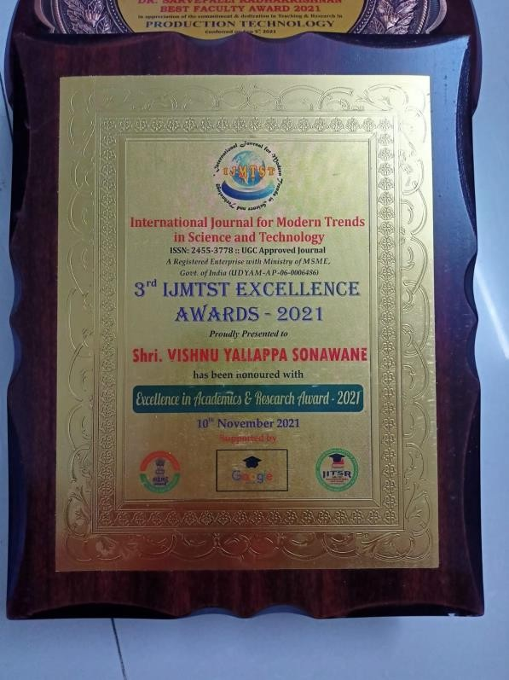 | 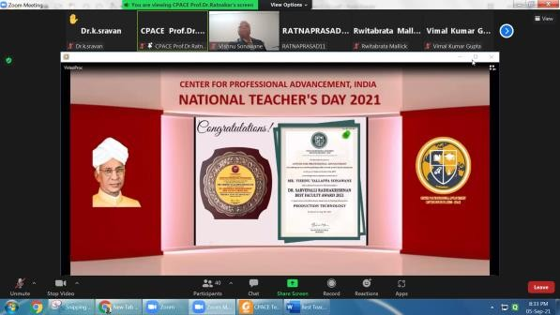
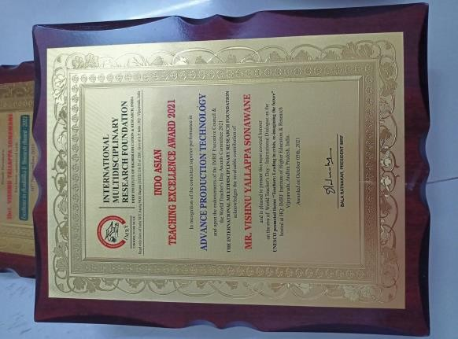 | 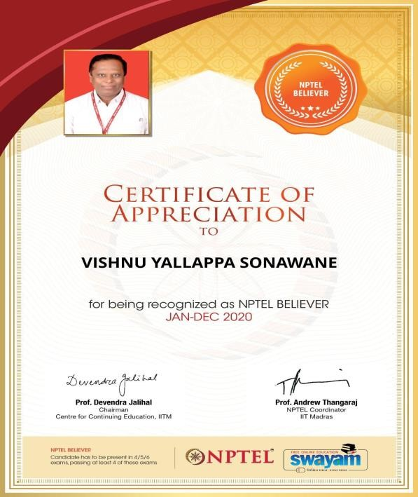

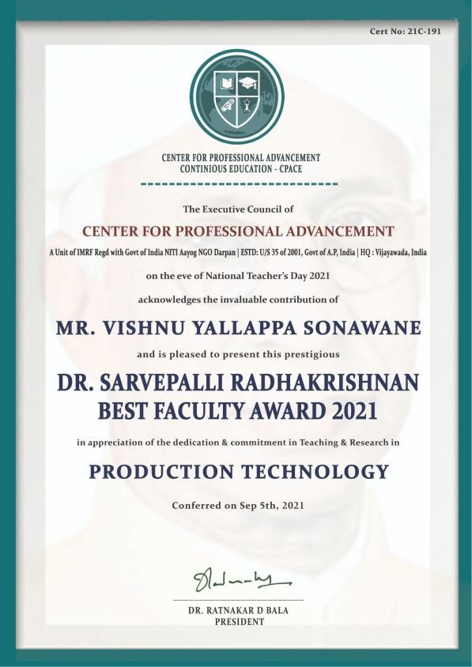 | 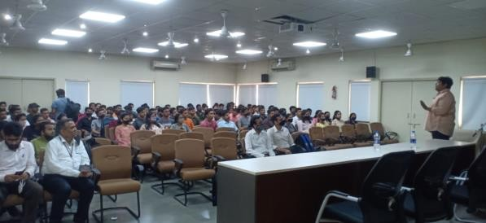  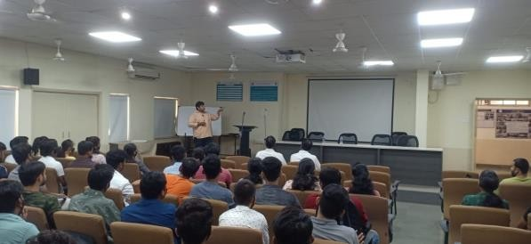  Webinar on “Importance of General Aptitude for Jobs” on 24/03/2022, Organized by Mr S K Bidgar
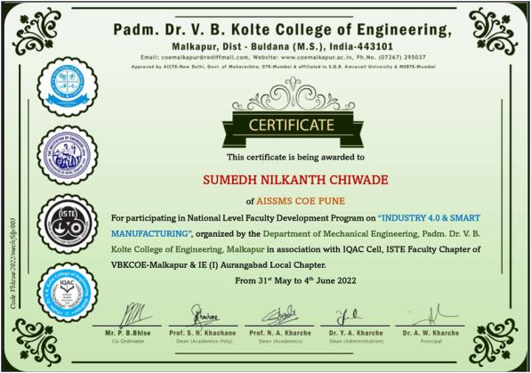
FDP attended by S N Chiwande on 31/05/2022 to 04/06/2022

ACTIVITIES ORGANIZED

FDP/STTP ORGANIZED BY THE DEPARTMENT

Term One
S | Name of faculty | Title of the | Duration/ | No. of | Funding
N | coordinator | FDP/STTP/WS/ | Dates | Participants | Agency
 |  | Seminar/Sympo |  |  | (If any) and
 |  | Sium |  |  | Amount (Rs.)

01 | Dr S H Wankhade | Conducted One | Phase I: | Phase I: 70 | AICTE,
 | Dr N G Shekapure Mr S S Kallurkar | Week Online STTP sponsored  by AICTE | 22/06/2021 to  27/06/2021  PhaseII: 29/06/2021 to | PhaseII: 194 | 3,92208/-
 |  | Quality | 24/07/2021
 |  | Improvement Scheme “Innovative and  Inventive | Phase III: 06/07/2021 to  11/07/2021  Phase IV:  13/07/2021 to | Phase III: 125  Phase IV: 396
 |  | Problem Solving | 17/07/2021
 |  | (IIPS-2021)” in
 |  | 4 Phases
02 | Mr S K Bidgar | Nil

SEMINARS/ WORKSHOPS/ WEBINARS ORGANIZED BY THE DEPARTMENT

Term One
S N | Name of Coordinator/  s | Title of the Seminar/Webinar | Duration  / Dates | No. of Participa  nts | Funding Agency (If any) and  Amount (Rs.)
01 | Mr S N | Webinar on "Key to Start- | 12/10/20 | 112 | NIL
 | Chiwande | Up" by Mr Shrirang | 21
 |  | Gokhale & Mr Biman
 |  | Gandhi, mentor and Guide
 |  | from BYST & PMA

02 | Mr M L  Chanpur | First Regional Conclave of Students’ Chapter of The Institution of Engineers (India) for Western Region for the year 2021-22 : Poster Competition | 09/12/20  21 –  10/12/20  21 | 103 | IE in association with AISSMS COE, Production Engineering Department
3 | Mr V Y  Sonawane | National Quiz on Industrial Automation and  Control AISSMS (I) Connect under ISTE Chapter Mr.  Shivaji Suryawanshi  Director and Joint partner Mr. Sanket  Palkar of Aero circle Automat limited Pune | 17/07/202  1 | 110 | NIL
4 | Mr S K  Bidgar | Online Webinar on “Career Opportunities After Engineering” | 13/01/20  22 | 48 | –

Term Two
S N | Name of Coordinator/  s | Title of the Seminar/Webinar | Duration  / Dates | No. of Participa  nts | Funding Agency (If any) and  Amount (Rs.)
01 | Dr N G | Webinar on “Introduction | 05/03/20 | 68 | -
 | Shekapure | to Lean Six Sigma & Its  importance for | 22
 |  | Professionals”
02 | Mr S K | Webinar on “ Importance | 24/03/20 | 78 | –
 | Bidgar | of General Aptitude for | 22
 |  | Jobs”

Term Two
S  N | Name of Faculty  Coordinator | Details of activity conducted | Date | Number of  beneficiarie

 |  |  |  | s
1 | Mr S K Bidgar | Industrial Visit Organized in Vanaz Engineers Ltd., Kothrud, Pune for SE Production S/W Engineering  Students | 08/04/2022 | 17

MOU SIGNED WITH ACADEMIC AND PROFESSIONAL ORGANISATIONS

erm One
Sr.  No. | Faculty Coordinator | Name of Organisation | Date  of MoU Signed | Valid upto  00/00/0000
1 | Ms Y K Funde | Univision Automation Pune | 08/01/2021 | 20/01/2026
2 | Ms Y K Funde | Sofcon PvT Ltd Pune | 18/10/2017 | 17/10/2022
3 | Mr S N Chiwande | Pune Management Association, Pune | 20/09/2021
4 | Mr M L Chanpur | Aarohi Industries | 18/01/2021 | 20/01/2026
5 | Mr V Y  Sonawane | X-Cubator | 18/03/2021 | 18/03/2024
6 | Mr S K Bidgar | Nil

Term Two
Sr.  No. | Faculty Coordinator | Name of Organisation | Date  of MoU Signed | Valid upto  00/00/0000
01 | Dr N G Shekapure | Elon Power Pvt. Ltd | 22/02/2022 | 21/02/2027
02 | Ms Y K Funde | Univision Automation Pune | 08/01/2021 | 20/01/2026
03 | Ms Y K Funde | Sofcon PvT Ltd Pune | 18/10/2017 | 17/10/2022

04 | Mr S K Bidgar | UB Cryogenic Solutions LLP Pune | 04/03/2022 | 03/03/2022

Total Functional / Live MoUinitiated by Department
Sr.  No. | Faculty Coordinator | Name of Organisation | Date  of MoU Signed | Valid upto 00/00/0000
01 | Dr N G Shekapure | Elon Power Pvt. Ltd | 22/02/2022 | 21/02/2027
2 | Ms Y K Funde | Univision Automation Pune | 08/01/2021 | 20/01/2026
3 | Ms Y K Funde | Sofcon PvT Ltd Pune | 18/10/2017 | 17/10/2022
04 | Mr M L Chanpur | Aarohi Industries | 18/01/2021 | 20/01/2026
05 | Mr S K Bidgar | UB Cryogenic Solutions LLP Pune | 04/03/2022 | 03/03/2022

RESEARCH CONTRIBUTION
FUNDED RESEARCH PROJECT
Term One
S N | Principal Investigator | Title of the Project | Amount Received  (Rs) | Funding Agency
1 | Mr S K Bidgar | Development of Cryogenic Treatment Setup & Testing for Enhancing and Measurement of Tool  Life | InProcess | ASPIRE 2020 SPPU  Pune

Term Two
S N | Principal Investigator | Title of the Project | Amount  Received (Rs) | Funding Agency
1 | Mr S K Bidgar | Development of Cryogenic Treatment  Setup & Testing for | InProcess | ASPIRE 2020

 |  | Enhancing and Measurement of Tool  Life |  | SPPU  Pune
PATENTS, COPYRIGHT, TRADEMARK AND OTHER (IPR)
Term One
Sr No. | Name of Faculty | Name of the Patent | Patent Number and Date | Type (National/ International/Com mercialized)
01 | Dr N G Shekapure | Copyrights on | L-109933/2021, | National
 |  | “Excel Sheet to  Compile and | 29/12/2021
 |  | Extract Attendance
 |  | from Microsoft
 |  | Teams Attendee”

Term One
S.  No | Authors | Document Details | Year | Source  Details | ISBN/  ISSN | Publisher
 | Mr S S | Enhancing User | 2021 | http://www. thedesigneng ineering.com  /index.php/D E/article/vie w/7276 | ISSN: | Design
 | Kallurkar | Experience for | -22 |  | 0011- | Engineeri
 | Dr P R  Baviskar Dr S H  Wankhade | Computer Aided Design packages through Artificial Intelligence |  |  | 9342 |  Year 2021 |  Issue:  9 | | ng
 |  |  |  |  | Pages:
 |  |  |  |  | 2973-
 |  |  |  |  | 2982
BOOK/ ARTICLE PUBLICATIONS
Term One
Author | Title of the Book | Published by | ISBN | Year
Dr N G | Data Science - Techniques | Taylor & Francis Group, | 978103 | 2021
Shekapure | and Intelligent | LLC, USA | 225449
 | (Chapter No 13- |  | 4
 | Applications
 | Data Analysis for
 | Technical Business
 | Incubation Performance
INTERACTION WITH INDUSTRY
Term Two
Sr. No. | Faculty Coordinator | Class and Number of students attended | Industry Name and Address | Date of visit
01 | Mr S K  Bidgar | SE Production S/W | Vanaz Engineers Ltd Kothrud | 08/04/20  22
EXPERT LECTURES / WEBINARS DELIVERED BY INDUSTRY EXPERTS
Term One
Sr.  No. | Faculty Coordinator | Class  (Number of students attended) | Name, Industry, designation and contact details of Expert | Topic | Date
 | Dr N G  Shekapure | SE, TE, BE  Production SW (168) | Mr Gaurav Joshi  Global Project Manager (Atlas Copco India Limited) | Expert Talk on “IMPORTA NCE OF SUPPLY CHAIN MANAGE MENT IN NEAR FUTURE” | 24/07/2  021
MOU SIGNED WITH INDUSTRY
Term One
Sr.  No. | Faculty Coordinator | Name of Industry | Date  of MoU Signed | Valid upto
01 | Mr M L Chanpur | Aarohi Industries | 18/01/2021 | 20/01/2026
02 | Ms Y K Funde | Univision Automation | 08/01/2021 | 07/01/2026

Term Two
Sr.  No. | Faculty Coordinator | Name of Industry | Date  of MoU Signed | Valid upto
1 | Ms Y K Funde | Univision Automation | 08/01/2021 | 07/01/2026

2 | Mr S K Bidgar | UB Cryogenic Solutions LLP Pune | 04/03/2022 | 03/03/2022

TOTAL FUNCTIONAL / LIVE MOU INITIATED BY THE DEPARTMENT
Sr.  No. | Faculty Coordinator | Name of Industry | Date  of MoU Signed | Valid upto  (00/00/0000)
01 | Mr S K Bidgar | UB Cryogenic Solutions LLP Pune | 04/03/2022 | 03/03/2022

Term Two
Sr.  No. | Faculty Coordinator | Technical Area in which Training Provided / Type of Support | Industry Name
01 | Mr M L  Chanpur | Testing of Measuring Gauge | Jaws Industries, Pune

2 | Mr M L  Chanpur | Designing of Furnace Oil chamber | Unity DesignTech Pvt Ltd

