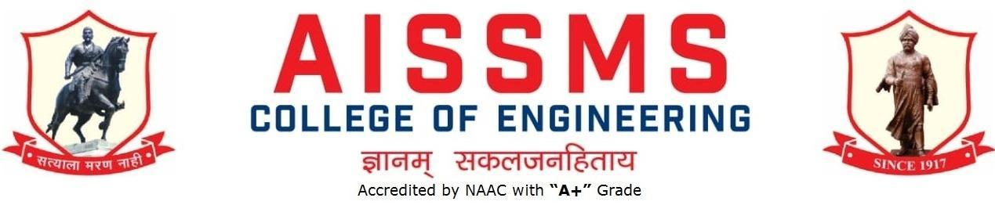

DEPARTMENT OF PRODUCTION ENGINEERING
ANNUAL REPORT
JULY 2019 to JUNE 2020
Second Half: 01 January 2020 to 30 June 2020

INTRODUCTION
Year of Establishment | 1994
UG Programmes | Production Engineering (Sandwich Pattern)
Number of Teaching Staff | 11
Number of Non-Teaching Staff | 12 (Production + Workshop)

SOFTWARES AVAILABLE IN THE DEPARTMENT
SN | Software Available | SN | Software Available
1 | Unigraphics Mfg. Bundle 10 nos. and (FEMAP +NASTRAN) 5 nos.and FACTORY CAD-2 nos. and FACTORY FLOW-02 Nos.and eMplant- 02 Nos. | 5 | ANSYS Academic Teaching + CFD Version 16.2 for(25 user)
2 | Computer Software Autodesk Inventor Professional Edu. License (03) | 6 | JASP- Version 2 (Janatics Animation Software & Pneumatics) ( 01)
3 | Solid Edge Bundle (Drafting Solid Modeling and Sheet Metal) for 25 user | 7 | Systat Statistical Software -Version 12 (01)
4 | Unigrahics 8.0 Cam Express (Simulation, Modeling, Tool Path Generation) 20 user

RESULT ANALYSIS (LAST TERM) (Academic Year: Term: II)
Name of faculty | Class and Subject Taught | % passing | Name of faculty | Class and Subject Taught | % passing
Mr V Y Sonawane | TE Production SW MFMD | 97 | Mr D H Joshi | SEPIM-I | 100
Mr M A Kelkar | TEPM (T) | 90 | Mr V D Dholle | TEKDM | 90
Mr N G Shekapure | TEPIM II | 95.8 | Mr L S Godse | SE ET | 100
Mr S S Kallurkar | TENTDS(T) | 90 | Mr S K Bidgar | SEMEMP (T) | 100
Mr S N Chiwande | SETheory of Machine | 100 | Mr M L Chanpur | SE  CG- Lab II (PR)  DME (T) | 100  100

Class Result Analysis (LAST TERM) (Academic Year: (19-20) May 20 Term: I/II)
SN | Class | No. of Students |  |  |  |  |  |  |  |  |  | Percentage of Passing
 |  | Appeared | Clear Passed | Outstanding  (O)  (9 -10) | Excellent  (A+)  (8.5 – 8.99) | Very Good (A)  (7.5 – 8.49) | Good (B+)  (6.5 – 7.49) | Above Average (B)  (5.5 – 6.49) | Average (4.25 – 5.49)Class | Pass Class  (4 – 4.24 | Fail  (F)  0 – 3.99 | All Clear | With ATKT
1 | SE | 62 | 28 | 3 | 7 | 14 | 4 | - | - | - | 1 | 45.2 | 98.4
2 | TE | 72 | 58 | 26 | 14 | 14 | 4 | - | - | - | 2 | 80.6 | 97.2

UNIVERSITY RANKERS (LAST ACADEMIC YEAR) (Academic Year: 19-20 (May 20 )

Sr No | Name of the Ranker | Class(SGPA) | Rank
SE PSW
1 | KAKADE PRATIKSHA | 9.38(I*) | 1
2 | SHINDE ANURAG | 9.1(I*) | 2
3 | GAVHANE ROHAN SANJAY | 8.98(I*) | 3
4 | MOGHE ATHARVA VIVEK | 8.78(I*) | 4
5 | RANE TEJAS ATUL | 8.72(I*) | 5
TE PSW
1 | VISPUTE PREM SUNIL | 9.8(I*) | 1
2 | PATIL NIKITA SANJAY | 9.76(I*) | 2
3 | TAMBOLI AMANULLAH JUNAID | 9.74(*) | 3
4 | KATPHALKAR SHABDALI SURESH | 9.59(I*) | 4
5 | BIDWE SAHISHNUTA NAGNATH | 9.57(I*) | 5
6 | JADHAV HARSHVARDHAN SHAILESH | 9.57(I*) | 6

CONTRIBUTION OF FACULTY (Interaction with outside world)
SN | Name of Faculty | Nature and details of contribution  (Representation at University, State, National , International level, corporate world,Social Platforms, etc)
1 | Dr S H Wankhade | Research on Efficacy of TRIZ tools on enhancement of creativity of an individual sponsored by TRIZ Asia – GEN TRIZ, Boston, US

E CONTENT DEVELOPED BY FACULTY AND AVAILABLE ONLINE
(During Academic Year 2019-20)
Sr No. | Name of Faculty | Title of e-content and | e-content development facility/paltform | link of the content
1 | Mr V D Dholle | E Book pdf, Notes, Lecture PPTs, Question Bank, Quiz for Kinematics Design of Machines | E Book,pdf,Notes  Question Banks  MCQ  Assignment | www.aissmcoe.ackronsystems.com
2 | Mr N G Shekapure | Notes, Lecture PPTs, Question Bank, Quiz for Production & Industrial Management | Notes  Lecture wise Notes  Question Banks  Quiz  Assignment | College ERP  www.aissmcoe.ackronsystems.com
3 | Mr S S Kallurkar | PPT for Unit 4 & 5 Sub: Numerical Techniques and Databases |  | ERP
4 | Mr M A Kelkar | Subject : Production Metallurgy ( TE - P/SW )  PDF notes  PDF practical write-ups PDF question bank  Subject : Supply Chain Management ( BE - P/SW )  PDF Journal | PM - Unit wise notes, Question bank, Tests.  Journal  ERP  Whatsapp group | College ERP  www.aissmcoe.ackronsystems.com
5 | Mr S N Chiwande | E BOOK, NOTES,  PPT ETC  Whatapp group  student mail | Notes  Lecture wise Notes  Question Banks | College ERP  www.aissmcoe.ackronsystems.com
6 | Mr V Y Sonawane | E Book pdf, Notes, Lecture PPTs, Question Bank, Quiz for for Metal forming and Mould Design TEPSW PDF TERMWORK write-ups uploaded on Whatsapp group and student mail | E Book,pdf,Notes  Question Banks  MCQ  Assignment  on  ERP Whatsapp group development platform | College ERP  www.aissmcoe.ackronsystems.com
7 | Mr S K Bidgar | Notes, Lecture PPTs, Question Bank, Assignment for Manufacturing Engineering & Metrology Practices | Notes  Lecture wise Notes  Question Banks  Assignment | College ERP  www.aissmcoe.ackronsystems.com

FDP/STTP ORGANIZED BY THE DEPARTMENT (Total No. 01)
S N | Name of Coordinator/s | Title of the FDP/STTP/WS/Seminar/Symposium | Duration/ Dates | No. of Participants | Funding Agency  (If any) and Amount (Rs.)
01 | Mr M L Chanpur | Five Days FDP on “ LATEX ” | 28th April 2020 - 02nd May 2020 | 157 | In association with Spoken Tutorial IIT Bombay

SEMINARS/ WORKSHOPS/ WEBINARS ORGANIZED BY THE DEPARTMENT (For Faculty) (Total No. 02 )
S N | Name of Coordinator/s | Title of the Seminar/Webinar | Duration/ Dates | No. of Participants | Funding Agency  (If any) and Amount (Rs.)
1 | MrN G Shekapure | Conducted International Webinar on “Genius Code – Science of PEAK Performance”  Speaker: Tejas Toro, Peak Performance Coach & Master Practitioner (NFNLP USA) | 26/05/2020 | 1301 | --
2 | Mr M L Chanpur | National level Webinar on – Industry Connect | 30/05/2020 | 89 | --

FDP/STTP ATTENDED BY THE DEPARTMENT FACULTY (Total No. 47)
S N | Name of Faculty | Title of the FDP/STTP | Organized by | Duration/ Dates
1 | Mr V D Dholle | One-week online Faculty Development Program on “OUTCOME BASED EDUCATION: A STEP TOWARDS EXCELLENCE” under Margdarshan Scheme of AICTE, New Delhi. | Government College of Engineering, Karad, Dist.-Satara Maharashtra, PIN- 415 124. | 11/05/2020 to  15/05/2020
2 | Mr V D Dholle | Online Faculty Development Program on “Renewable Energy Sources: A Way Ahead” | Cummins College of Engineering for Women, Nagpur | 15/05/2020 to  21/05/2020
3 | Mr V D Dholle | One week online Faculty Development Program on “Innovation, Entrepreneurship and its Relevance in Industry 4.0 Practices in the Post Covid-19 Situation” | Terna Engineering College, Nerul ,Navi Mumbai | 25/05/2020 to 29/05/2020
4 | Mr V D Dholle | One Week National Level Faculty Development Program on “Futuristic Technologies in Mechanical Industries” | Dr. D Y Patil Institute of Engineering, Management & Research, Akurdi | 05/06/2020 to 09/06/2020
5 | Mr V D Dholle | STTP on “DIGITAL TRANSFORMATION” | Organized by Department of Computer Engineering ,AISSMS College of Engineering, Pune-01 | 11/06/2020 to  13/06/2020
6 | Mr V D Dholle | National Level One Week Online Faculty Development Programme on “Introduction to Outcome Based Education and Enhancing Quality of Teaching Learning Process” | INTERNAL QUALITY ASSURANCE CELL Govindrao Wanjari College of Engineering & Technology, Nagpur | 15/06/2020 to 19/06/2020
7 | Mr V D Dholle | ISTE & IEI Approved National Level One Week Online FDP on “Advanced Teaching Tools, Techniques and Methodologies for Outcome Based Education” | Center of Excellence in Teaching & Learning, AISSMS College of Engineering,Pune | 01/06/2020 to 05/06/2020
8 | Mr N G Shekapure | Advanced Pedagogy for empowering Teachers | AISMS COE, Pune-01 | (3 Days)  11/03/2020 to 13/03/2020
9 | MrN G Shekapure | Faculty Awareness Programme on Outcome Based Education (OBE) and NBA Accreditation | Sinhgad Institute of Technology & Science, Nare | 08/05/2020
10 | MrN G Shekapure | Faculty Awareness Program on NAAC Accreditation | Shri Chhatrapati Shivajiraje College of Engineering | (5 Days)  10/05/2020 to 15/05/2020
11 | MrN G Shekapure | Introduction of Accreditation Mechanism & NBA Process | Padm. Dr. V. B. Kolte College of Engineering | 11/05/2020 to 15/05/2020
12 | MrN G Shekapure | Technical Teachers Training | Vidyavardhini Institute of Technology, Pal | 22/05/2020 to 27/05/2020
13 | MrV Y Sonawane | Two Weeks Faculty Development Programme on  “MANAGING ONLINE CLASSES And CO-CREATING MOOCS:2.0” | Pandit Madan Mohan Malaviya  National Mission On Teachers And Teaching  (Pmmmnmtt)  Teaching Learning Centre  Ramanujan College  (University Of Delhi) | 18/05/2020 to 03/06/2020
14 | MrV Y Sonawane | Faculty Development Program  Cpp Test Organized At  Padmabhooshan Vasantraodada Patil Institute Of Technology, BudhgaonWith Course Material Provided By The Spoken Tutorial Project, IIT Bombay | Spoken  Tutorial Project, IIT Bombay, Funded By National Mission On Education Through ICT, MHRD,  Govt., Of India. | 02/05/2020
15 | MrV Y Sonawane | One Week Online Faculty Development Program On Latex | Spoken Tutorial Project, IIT Bombay, Funded By National Mission On Education Through ICT, MHRD, Govt., Of India.  P.V.P.I.T. Sangli (Budhgaon) In Association With IIT-Bombay Spoken Tutorial Project | 26/04/2020 to 02/05/2020
16 | MrV Y Sonawane | One Week Online Faculty Development Program On “Promoting Quality Culture In Technical Institutions” | AISSMSCOEP  Internal Quality Assurance Cell Under ‘UGC Paramarsh Scheme’. | 25/05/2020 to 29/05/2020
17 | MrV Y Sonawane | International Faculty Development Program Two WeeksVideo Creation Activities In”Environment And Sustainability [OE4BW]”  And Commitment To Ethical Completion Of Course | Open Education For A Better World UNESCO With DYPCOE | 01/05/2020 to 31/05/2020
18 | MrV Y Sonawane | Online Faculty Development On Renewable Energy Sources: A Way Head | Cummins College Of Engineering For Woman Nagpur In Association With ASM International Chapters And ISHRAE Nagpur Chapter | 15/05/2020 to 21/05/2020
19 | MrV Y Sonawane | Bodhi Tree IIT Bombay  1 ONLINE TEACHING: A HANDS-ON WORKSHOP (PRIVATE) | IIT Bombay | 01/05/2020 to 30/05/2020
20 | MrV Y Sonawane | Bodhi Tree IIT Bombay  2 EFFECTIVE AND EFFICIENT ONLINE TEACHING | IIT Bombay | 12/05/2020 to 18/05/2020
21 | MrV Y Sonawane | Bodhi Tree IIT Bombay  3 BODHITREE AND SAFE TOOLS (PRIVATE) | IIT Bombay | 12/06/2020 to 18/06/2020
22 | MrV Y Sonawane | One Week Online Faculty Development Program On C & CPP | P.V.P.I.T. Sangli (Budhgaon) In Association With IIT-Bombay Spoken Tutorial Project | 26/04/2020 to 02/05/2020
23 | MrV Y Sonawane | Faculty Development Program On Outcome-Based Education | Inpods Ed Tech | 29/04/2020
24 | MrV Y Sonawane | Online Faculty Development On Renewable Energy Sources: A Way Head | Cummins College Of Engineering For Woman Nagpur In Association With ASM International Chapters And ISHRAE Nagpur Chapter | 15/05/2020 to 21/05/2020
25 | MrV Y Sonawane | FDP On Future Automotive Industry And Challenges AUTOMOTIVE | Dr Rangarajan Dr Sankunthla Enginee Inpods Ed Tech Ring College | 27/05/2020
26 | MrV Y Sonawane | Online Short Term  Training Programing On ‘Patenting For Innovations’ | Department of  Mechanical Engineering of Sanjivani College ofEngineering Kopargaon | 25/05/2020 to 29/05/2020
27 | MrS N Chiwande | FDP on 'LaTex' in Association with Spoken Tutorial IITB & AISSMS COE, Pune" | in Association with Spoken Tutorial IITB & AISSMS COE, Pune" | 28/04/2020 to 04/05/2020  01 WEEK
28 | MrS S Kallurkar | One Week National Level Faculty Development Program on “Futuristic Technologies in Mechanical Industries” | Dr. D Y Patil Institute of Engineering, Management & Research, Akurdi | 05/06/2020 to 09/06/2020
29 | MrM A Kelkar | AISSMSCOE Yoga day | AISSMSCOE, Pune-01 | 21/06/2020
30 | MrM A Kelkar | Webinar on Genius Code – Webinar | AISSMSCOE, Pune-01 | 26/05/2020
31 | MrM A Kelkar | Webinar on ‘Robotics and Process Automation’ | SU, Kolhapur | 03/05/2020
32 | Mr M L Chanpur | One Week, National level online FDP on Moodle | Spoken tutorial IIT Bombay and AISSMS College of Engineering | 28/04/2020 to 04/05/2020
33 | Mr M L Chanpur | One Week, National level online FDP on Introduction to Forensic Science and Digital & Cyber Security | NIT, Nagpur | 15/05/2020 to 19/05/2020
34 | Mr M L Chanpur | One Week, National level online FDP on Faculty Awareness Program on NAAC Accreditation | Shri Chhatrapati Shivajiraje College of Engineering, Pune | 10/05/2020 to 15/05/2020
35 | MrS K Bidgar | Attended National Level One Week Online Faculty Development Program on “LaTeX” | Production Engineering Department, AISSMS College of Engineering, Pune in association with Spoken Tutorial, IIT Bombay | 28/04/2020 to 04/05/2020
36 | MrS K Bidgar | Attended One Week Online Faculty Development Program entitled “DRUPAL” | Department of Information Technology, Sinhgad Technical Education Society’s,  Sinhgad Institute of Technology and Science, Narhe, Pune in association with Spoken Tutorial, IIT Bombay | 04/05/2020 to 09/05/2020
37 | MrS K Bidgar | Attended One Week Online FDP on “Faculty Awareness Program on NAAC Accreditation” | Rajgad Dnyanpeeth’s Shri Chhatrapati Shivajiraje College of Engineering, Dhangawadi, Pune | 10/05/2020 to 15/05/2020
38 | MrS K Bidgar | Attended One Week Online Faculty Development Program on “Outcome Based Education: A Step Towards Excellence” | Government College of Engineering, Karad | 11/05/2020 to 15/05/2020
39 | MrS K Bidgar | Attended Online One Week Faculty Development Program on “Introduction to Forensic Science and Digital & Cyber Forensics” | Department of Information Technology, Nagpur Institute of Technology, Nagpur | 15/05/2020 to 19/05/2020
40 | MrS K Bidgar | Attended Online Faculty Development Program on “Renewable Energy Sources: A Way Ahead” | Department of Mechanical Engineering, MKSSS Cummins College of Engineering for Women, Nagpur | 15/05/2020 to 21/05/2020
41 | MrS K Bidgar | Attended Online One Week Faculty Development Program on “Spoken Tutorial Technology” | Sinhgad Technical Education Society’s, Department of Mechanical Engineering, SKN College of Engineering, 42Vadgaon,Pune | 18/05/2020 to 22/05/2020
42 | MrS K Bidgar | Attended Online Two Weeks International Faculty Development Program On “Emerging Trends in Industry 4.0” | Department of Computer Engineering, JSPM’s Rajarshi Shahu College of Engineering, Pune | 18/05/2020 to 29/05/2020
43 | MrS K Bidgar | Attended One Week National Level FDP on ICT Tools in Education Using MOODLE | Dept. of Computer Science and Engineering, PACE Institute of Technology and Sciences, Ongole | 22/05/2020 to 26/05/2020
44 | MrS K Bidgar | Attended Online FDP on “TECHNICAL TEACHER’S TRAINING” | Shri Vidyavardhini Educational Academy’s, Vidyavardhini Institute Of Technology, Pal | 22/05/2020 to 27/05/2020
45 | MrS K Bidgar | Attended One Week Online FDP on “Promoting Quality Culture in Technical Institutions” | AISSMS College of Engineering, Pune | 25/05/2020 to 29/05/2020
46 | MrS K Bidgar | Attended Online One Week National Level Faculty Development Program on “Futuristic Technologies in Mechanical Industries” | Department of Mechanical Engineering Dr. D Y Patil Pratishthan’s, Dr. D Y Patil Institute of Engineering, Management & Research, Akurdi,Pune-44 in Association with Indian Society for Technical Education (ISTE) & Indian Welding Society (IWS) | 05/06/2020 to 09/06/2020
47 | MrY K Funde | Attained one week online FED on“ Renewable Energy Source: A way ahead” | Department of Mechanical Engineering , CUMMINES College of Engineering Woman Nagpur | 15/05/2020 to 21/05/2020

SEMINARS/ WORKSHOPS/ WEBINARS ATTENDED BY THE DEPARTMENT FACULTY (Total No. of Seminars/webinars: 103 )
S N | Name of Faculty | Title of the Seminar/Webinar | Organized By | Duration/ Dates
1 | MrV D Dholle | Webinar on “NAAC: Systematic Data Organization and Presentation" | IQAC, Vidyalankar Institute of Technology, Mumbai. | 16/05/2020
2 | MrV D Dholle | National Webinar for teaching faculty on the topic “INNOVATION AND ENTREPRENEURSHIP ECOSYSTEM IN EDUCATIONAL INSTITUTES” | SIES College of Arts , Science and Commerce (Autonomous) , Sion (West) , Mumbai-400022 | 10/05/2020
3 | MrV D Dholle | Webinar on “Employbility Enhancement in various countries and best practices world wide” | Edukerron International in association with MaTPO | 28/05/2020
4 | MrV D Dholle | Webinar on “Faculty Awareness Programme on Outcome Based Education (OBE) and NBA Accreditation“ | Sinhgad Institute of Technology and Science, Narhe,Pune | 08/05/2020
5 | MrV D Dholle | Online Training Program on “How to Balance Academics and Administrative Work” | Skill Slate and Powered by Zovy Studios, Pune | 25/05/2020
6 | MrV D Dholle | webinar on “ Digital Disruptions Leading to Innovation in Business Models ” | Institutional Innovation Cell (IIC), AISSMS College of Engineering, Pune | 31/05/2020
7 | MrV D Dholle | National Level Online Webinar on “Supply Chain Management “ | Department of Mechanical Engineering, AISSMS College of Engineering, Pune | 31/05/2020
8 | MrV D Dholle | Webinar on “SELECTION OF START- UP ” on | Institutional Innovation Cell (IIC), AISSMS College of Engineering, Pune | 30/05/2020
9 | MrV D Dholle | Webinar on: Impact of COVID-19 on jobs, career and skills required to survive in the new normal (Session 21) | MaTPO | 10/05/2020
10 | MrV D Dholle | Webinar on: Career Opportunities in Design, Automotive & Heavy Industries. Speaker: Mr Kevin Kutto, Director | Design Grads Pune | 10/05/2020
11 | MrV D Dholle | Webinar on: “How can niche skills in ERP and Industry 4.0 help boost careers in these challenging times” | Hon. Sachin Sharangpani, Business Head-Training Services Group, Industry 4.0 Solutions, Atos, India | 11/05/2020
12 | MrV D Dholle | Webinar on “Entrepreneurship and Industry 4.0 after Covid 19” | Mr Sunil Jadhav, Ex. Vice Precident (Institutional Clients) at City Bank USA | 12/05/2020
13 | MrV D Dholle | Webinar on: “Make Education Win- During Covid 19 & Beyond!” | Abhay Jere , Chief Innovation Officer (CIO), Ministry of HRD, Govt. of India | 13/05/2020
14 | MrV D Dholle | Webinar on: “Post COVID Placements Scenario” | Speaker Sanjay Dhaygude, Dean Industry Institute Interaction and Alumni Affairs, Training and Placement Officer, Walchand College of Engineering, Sangli Organised by AISSMS COE (Elex Dept) Pune | 13/05/2020
15 | MrV D Dholle | Webinar on: Robotics Process Automation (RPA) | AISSMS COE (Elex Dept) Pune. Speaker: Mr Krishna Raju [ Manager, Buisiness Development, Automation Anywhere] & Mr Arjun Meda [ Sr Developer, Automation Anywhere | 14/05/2020
16 | MrV D Dholle | Webinar on “Native cloud AWS-Amazon Web Services” | Department Of Computer Engineering, AISSMS College Of Engineering, Pune, Maharashtra. | 16/05/2020
17 | MrV D Dholle | National Level Webinar on “Growth in Challenges” | Department of Mechanical Engineering, AISSMS College of Engineering, Pune In association with (IEI Students’ Chapter)Institution of Engineers (INDIA) | 30/05/2020
18 | MrV D Dholle | National Level Webinar on “Cyber Security” | Department Of Computer Engineering, AISSMS College Of Engineering, Pune, Maharashtra | 31/05/2020
19 | MrV D Dholle | One day webinar on “Intellectual Property Right‘ | Department of Electronics and Telecommunication, AISSMS College of Engineering, Pune -01 | 24/05/2020
20 | MrV D Dholle | Webinar on “MATLAB for Deep Learning” | Department of Electronics and Telecommunication, AISSMS COE, Pune | 30/05/2020
21 | MrV D Dholle | Webinar on “Study Opportunities in USA post Covid-19” | All India Shri Shivaji Memorial Society's College of Engineering, Pune in association with The Institution of Engineers (India) and Oregon State University and IMFS | 03/06/2020
22 | MrV D Dholle | Webinar on: “Electric Mobility Supply Chain: Focus on Batteries, Motors & Power Electronics” | Auto Tech Review | 22/05/2020
23 | MrV D Dholle | Webinar on: “ Preparing Mind set of the Students for the Industry Scenario Post COVID 19” | Resourse Person: Hon. Vishwesh Kulkarni, National President -NIPM (MaTPO) | 22/05/2020
24 | MrV D Dholle | Webinar on: "Sports– A key to Health and Fitness" | Speaker Mr Diptanshu Pardeshi (MBA in Sport Management from Melbourne Australia) Organiser Pratk Copper. | 23/05/2020
25 | MrV D Dholle | Webinar on: “INTRODUCTION TO TRIZ METHODOLOGY AND CHAPTER “ | Alex Lyubomirskiy, TRIZ Master, Member of The Expert Council of the International TRIZ Association (MATRIZ) | 23/05/2020
26 | MrV D Dholle | Webinar on: “Digital Transformation in Plant Engineering” | AVEVA Global | 24/05/2020
27 | Mr VD Dholle | Webinar on “Genius Code- Science of PEAK Performance”. | Speaker Tejas Toro , Department of Production Engineering , AISSMS COE,PUNE | 26/05/2020
28 | MrN G Shekapure | Attended 3 days’ workshop on “Education 4.0” Season I | Atharva College of Engineering, Mumbai | 28/05/2020 to 30/05/2020
29 | MrN G Shekapure | Participated in COVID-19 Awareness Program | Shivaji University, Kolhapur | 28/04/2020
30 | MrN G Shekapure | Attended “MaTPO COVID-19 Awareness Program” | Rajarambapu Institute of Technology | 28/04/2020
31 | MrN G Shekapure | Attended Webinar on “Robotics and Automation” | AISSMS College of Engineering | 14/05/2020
32 | MrN G Shekapure | Attended Webinar on “Awareness Program on Intellectual Property Rights” | Shri Chhatrapati Shivajiraje College of Engineering | 19/05/2020
33 | MrN G Shekapure | Attended 2 days webinar on "Startup Lifecycle and Patent Registration" | Atharva College of Engineering, Mumbai | 18/05/2020 to 19/05/2020
34 | MrN G Shekapure | Attended webinar “Technical Failures of START- UPS” | AISSMS College of Engineering, | 29/05/2020
35 | MrN G Shekapure | Attended 3 days’ workshop on “Education 4.0” Season II | Atharva College of Engineering, Mumbai | 28/05/2020 to 30/05/2020
36 | MrN G Shekapure | Attended Webinar on “Digital Marketing and Growth Hacking” | Guru Nanak Institute of Technology, Nagpur | 29/05/2020
37 | MrN G Shekapure | Attended Webinar on “IoT Application” | AISSMS College of Engineering | 31/05/2020
38 | MrV Y Sonawane | Webinar “A Systematic Software Based Approach To Implement Outcome Based Educationto Achieve Academic Excellence Leading To Accreditation Readiness Through Ioncudos” | ION Ideas | 23/04/2020
39 | MrV Y Sonawane | Webinar onHow To Publish A High Quality Technical Journal Paper | IEEE India Operations | 20/04/2020
40 | MrV Y Sonawane | Webinar: Introduction To Intellectual Property | British Library And Business IP Center | 04/05/2020
41 | MrV Y Sonawane | “Online Workshop on Concept, Methodology & Implementation Of Problem Based Learning (PBL)” | Sinhgad Technical Education Society’s, Smt. Kashibai Navale College Of Pharmacy Pune | 05/05/2020
42 | MrV Y Sonawane | “Faculty Awareness Programme On  Outcome Based Education (OBE) And NBA Accreditation “ | Sinhgad Institute Of Technology And Science,  Narhe , Pune | 8-5-2020
43 | MrV Y Sonawane | Webinar On “Native Cloud AWS-Amazon Web Services” | Department Of Computer Engineering, AISSMS College Of Engineering, Pune, Maharashtra. | 16/05/2020
44 | MrV Y Sonawane | Webinar: Introduction To Intellectual Property | British Library And Business IP Center | 18/05/2020
45 | MrV Y Sonawane | National Level Webinar On "Genius Code- Science Of PEAK Performance”. | Department of Production Engineering, AISSMS College of Engineering, Pune | 26/05/2020
46 | MrV Y Sonawane | Webinar on Online Teaching -Learning And Online Assessment Platform | Inpods Ed Tech | 28/05/2020
47 | MrV Y Sonawane | Research Methodology Including Experimental Approach | Department of  Mechanical Engineering of AISSMS College of Engineering Pune . | 31/05/2020
48 | MrV Y Sonawane | Faculty  Awareness Program on NAAC Accreditation | RD’s Shri Chhatrapati Shivajiraje College of Engineering, Dhangawadi, Pune-412206 | 10/05/2020 To 15/05/2020
49 | MrV Y Sonawane | International Panel Discussions On Research, Innovation & Entrepreneurship Opportunities In COVID-19 Scenario | Pandit Dindayal Petroleum University & PDPU Innovation &Incubation Center | 15/05/2020
50 | MrV Y Sonawane | Webinar On “ Application of Statistical Tools  And Energy Engineering” | Mechanical Engineering,  SLRTCOE, Mira Road, Thane | 20/05/2020 to 21/05/2020
51 | MrV Y Sonawane | Five Day Webathon On Future Topics In Mechanical Engineering Webinars On “Lean Six Sigma”, “Dimensions Of Quality For  Manufacturing And Service Sector”, “Application Of MCDM Tools”, “Lean Manufacturing In Industries” | Department of Mechanical Engineering, Ramco Institute Of Technology, Rajapalayam-626117 | 18/05/2020 to 22/05/2020
52 | MrV Y Sonawane | National Level Webinar Energy Conservation Tips For Engineers | Department of Mechanical Engineering, AISSMS College of Engineering, Pune | 23/05/2020
53 | MrV Y Sonawane | Webinar on “Opprtunities Innovation in Renewable Energy and Sustainability” | Department of Mechanical Engineering, AISSMS College of Engineering, Pune | 25/05/2020
54 | MrV Y Sonawane | NAAC Accreditation Management System For Health Sciences Institutions | Inpods Ed Tech | 28/05/2020
55 | MrV Y Sonawane | Webinar On “Advanced Digital Content Creation Tools And Techniques For Education” | Department of Electronics And  Telecommunication, AISSMS COE, Pune In Association With The Institute of  Engineers (India) And Iocare,Pune | 31/05/2020
56 | MrV Y Sonawane | Webinar On “Industry 4.0 [AI And AR/VR]”, | Department of Mechanical Engineering, Ramco Institute Of Technology, Rajapalayam 626117 | 25/05/2020
57 | MrV Y Sonawane | National Webinar “INNOVATION AND ENTREPRENEURSHIP ECOSYSTEM IN EDUCATIONAL INSTITUTES | Desai Sethi School of Entrepreneurship (IIT BOMBAY)  And Enactus India And Hosted By The SIES College of Arts , Science And  Commerce (Autonomous) , Sion (West) Mumbai-400022 | 10/05/2020
58 | MrV Y Sonawane | Online Workshop on Intellectual Property Rights | EVENBRITE SOLUTION | 11/04/2020
59 | MrV Y Sonawane | Webinar: How To Publish A High Quality Technical Journal Paper | IEEE India Operations | 20/04/2020
60 | Mr S N Chiwande | Webinar on “Employability : A Startup Pespective” organised | by NPTEL | 08/05/2020  One day
61 | Mr S N Chiwande | Webinar on “Innovation and Entrepreneurship Workshop” | an initiative by IIT Bombay’s DS School of Entrepreneurship | 06/05/2020
62 | Mr S N Chiwande | Attended Webinar on “Understanding Role & Application of Marketing Research at Idea to Startup Stage” | Organised by MHRD Innovation Cell | 14/05/2020  One day
63 | MrS N Chiwande | Webinar on “What is Depression and how to Manage Stress” | NPTEL Live streeming | 01/07/2020  One day
64 | MrS S Kallurkar | Attended 3 days’ workshop on “Education 4.0” Season I | Atharva COE, Malad | 28/4/2020-30/4/2020
65 | MrS S Kallurkar | Expert Talk on Facing the VUCA world - a Students' Perspective By: Mr. Ashutosh Thatte (AGM- Business Head Special Services, Xpressbees) | Dept of Production, AISSMS COE | 05/05/2020
66 | MrS S Kallurkar | “Faculty Awareness Programme on  Outcome Based Education (OBE) and NBA Accreditation“ | SCOE, Narhe | 09/05/2020
67 | MrS S Kallurkar | Webinar on RPA conducted by Automation Anywhere and AISSMS COE | AISSMSCOE | 14/05/2020
68 | MrS S Kallurkar | Webinar on Startup Lifecycle and Patent Registration | iCell Atharva COE Malad Mumbai | 18/05/2020 to 19/05/2020
69 | MrS S Kallurkar | Webinar on “Genius Code- Science of PEAK Performance” Speaker Tejas Toro | Production Engineering Department.  AISSMSCOE Pune | 26/05/2020
70 | MrS S Kallurkar | Attended 3 days’ workshop on “Education 4.0” Season II | Atharva College of Engineering, Mumbai | 28/05/2020 to 30/05/2020
71 | MrS S Kallurkar | Webinar on Native Cloud AWS Amazon Web Service | AISSMSCOE | 16/05/2020
72 | MrM A Kelkar | Attended 3 days’ workshop on “Education 4.0” Season I | Atharva COE, Malad | 28/4/2020 to 30/4/2020
73 | Mr M L Chanpur | National level online Webinar on Cyber crimes and safety. | NIT, Nagpur | 16/03/2020
74 | Mr M L Chanpur | National level online Webinar on Robotic Process Automation. | AISSMS College of Engineering, Pune and Automation Anywhere | 14/03/2020
75 | Mr M L Chanpur | National level online webinar on Simulation Driven Innovation for e-Mobility | Altair India | 10/06/2020
76 | MrS K Bidgar | Attended Online “An International Webinar on Research Methodology” | AISSMS College of Hotel Management and Catering Technology Pune | 21/04/2020 to 24/04/2020
77 | MrS K Bidgar | Expert Talk on Facing the VUCA world - a Students' Perspective By: Mr. Ashutosh Thatte (AGM- Business Head Special Services, Xpressbees) | Production Engineering Department.  AISSMSCOE Pune | 05/05/2020
78 | MrS K Bidgar | Attended the National Webinar for teaching faculty on the topic “INNOVATION AND ENTREPRENEURSHIP ECOSYSTEM IN EDUCATIONAL INSTITUTES” | Desai Sethi School of Entrepreneurship (IIT BOMBAY) and Enactus India and hosted by the SIES College of Arts, Science and Commerce (Autonomous), Sion (West), Mumbai | 10/05/2020
79 | MrS K Bidgar | Attended Online Webinar on “How Mechanical and Mechatronics Engineering will benefits the Post COVID-19 World” | MIT-ADT University Pune | 10/05/2020
80 | MrS K Bidgar | Attended the Online Webinar on “UG Project Management (A PBL Approach)” | Department of Information Technology, JSPM’s Rajarshi Shahu College of Engineering, Pune | 11/05/2020
81 | MrS K Bidgar | Attended Online Webinar on "SAP Analytics Cloud (SAC)" | SANDIP FOUNDATION’S, Department of Computer Engineering, Sandip Institute of  Engineering and Management, Nashik | 12/05/2020
82 | MrS K Bidgar | Attended Online Webinar on “Robotic Process Automation'' conducted by AISSMS COE | Automation Anywhere and AISSMS College of Engineering, Pune | 14/05/2020
83 | MrS K Bidgar | Attended Online Webinar on “Data Science : Reinforcement Learning” | Sinhgad Technical Education Society’s, Department of Computer Engg., RMDSSOE, Pune | 15/05/2020
84 | MrSK Bidgar | Attended Online Webinar on “Data Science : Reinforcement Learning” | Sinhgad Technical Education Society’s, Department of Computer Engg., RMDSSOE, Pune | 15/05/2020
85 | MrS K Bidgar | Attended Online Webinar on “Native Cloud AWS Amazon Web Service” | Computer Engineering Department,  AISSMS College of Engineering, Pune | 16/05/2020
86 | MrS K Bidgar | Attended Online Webinar on “Lung Disease Classification System” | Sinhgad Technical Education Society’s, Department of Computer Engineering, SKN College of Engineering, Vadgaon,Pune | 18/05/2020
87 | MrS K Bidgar | Attended Online A National Webinar on “Electric Vehicle Technology” | Mechanical Engineering Department, AISSMS College of Engineering, Pune | 22/05/2020
88 | MrS K Bidgar | Attended Online Webinar on “Aspects of Industry 4.0 – Manufacturing Execution System (MES) & Supply Chain Management (SCM) | Mechanical Engineering Department, AISSMS College of Engineering, Pune | 23/05/2020
89 | MrS K Bidgar | Attended Online Webinar on “Genius Code- Science of PEAK Performance” Speaker Tejas Toro | Production Engineering Department.  AISSMS College of Engineering, Pune | 26/05/2020
90 | MrS K Bidgar | Attended Online Webinar on “How to Write a Book - Become a Published Author” | Dattakala Group of Institutions, Faculty of Engineering, Bhigwan, Daund, Pune | 28/05/2020
91 | MrS K Bidgar | Attended National Level Webinar on “Right choice - Motivational Talk” | Computer Engineering Department, AISSMS College of Engineering, Pune | 30/05/2020
92 | MrS K Bidgar | Attended National Level Online Webinar on “Supply Chain Management” | Mechanical Engineering Department, AISSMS College of Engineering, Pune | 31/05/2020
93 | MrS K Bidgar | Attended Online Webinar on "Advanced Digital Content Creation Tools and Techniques for Education" | Department of Electronics and  Telecommunication, AISSMS COE, Pune in association with The Institution of  Engineers (India) and ioCare, Pune | 31/05/2020
94 | MrS K Bidgar | Attended Online Webinar on “Industry Trends Using Machine Learning With Matlab” | Pimpri Chinchwad College of Engineering, Pune in Collaboration with Mathworks | 03/06/2020
95 | MrS K Bidgar | Attended Online Webinar on “Study  Opportunities in USA post Covid-19” | AISSMS College of Engineering, Pune, in association with The Institution of Engineers (India) and Oregon  State University and IMFS | 03/06/2020
96 | MrS K Bidgar | Attended Online International Webinar on “Re-Engineering The Supply Chain: Imperatives for Post Pandemic Scenario” | Department Of Electronics And  Telecommunication (IEI Student’s Chapter), AISSMS College of Engineering Pune, In Association With Institution Of Engineers (INDIA) Kolkata | 07/06/2020
97 | MrS K Bidgar | Attended Online International Webinar on “Employability Skills 2020-Post Covid-19 | Department of E&TC & Computer Engineering Department, AISSMS College of Engineering, Pune | 14/06/2020
98 | MrS K Bidgar | Attended Online webinar on “Employability In Current Situation" | Department of E&TC & First Year Engineering, AISSMS College of Engineering, Pune | 18/06/2020
99 | MrS K Bidgar | Attended Online Orientation session on “TRIZ & Design for Patentability” | TRIZ Association of Asia | 18/06/2020
100 | MrS K Bidgar | Attended Online Webinar on “TRIZ Tool for Disruptive Cost Reduction” | TRIZ Association of Asia | 25/06/2020
101 | Ms Y K Funde | Attended online webinar on “ Transform your ideas into reality by using 3D printing Technology.” | Department of Production Engineering Sinhgad College of Engineering Pune. | 15/05/2020
102 | Ms Y K Funde | Attended online webinar on : “Robotic Process Automation” | Center of Excellence in RPA in association with AUTOMATION ANYWHERE,  AISSMS College of Engineering, Pune | 14/05/2020
103 | Ms Y K Funde | Attended online webinar on “IEEE Explore Digital Library Bosting Every Aspect of Your Carreer.” | Central Library & IEEE AISSMS College of Engineering, Pune | 04/05/2020

CONFERENCES/ SYMPOSIUMS ATTENDED BY THE DEPARTMENT FACULTY (Total No. of faculty who attended Conferences: 01)
S N | Name of Faculty | Title of the Conference / Symposium | Organized By | Duration/ Dates
1 | MrN G Shekapure | IEEE International Conference on Convergence to Digital World (UCCDW) | Atharva College of Engineering, Mumbai | 19/02/2020 to 20/02/2020
2 | MrS S Kallurkar | IEEE International Conference on Convergence to Digital World (UCCDW) | Atharva College of Engineering, Mumbai | 19/02/2020 to 20/02/2020

ONLINE COURSES / CERTIFICATE COURSES COMPLETED BY DEPARTMENT FACULTY (Total No. of faculty who completed Online Courses: 36)
S N | Name of Faculty | Title of the Course | Conducted By | Duration/ Dates
1 | Mr V D Dholle | “Digital Manufacturing & Design” Coursera Course | The State University of New York | 29/05/2020 (4 Week)
2 | Mr V D Dholle | “Ferrous Technology-I” Coursera Course | Pohang University of Science & Technology | 02/06/2020 (4 Week)
3 | Mr V D Dholle | Completed NPTEL Course on “NBA Accreditation and Teaching-Learning in Engineering (NATE)” | NPTEL | 22/04/2020 (12 Weeks)
 | Mr N G Shekapure | “Foundations of Business Strategy” Coursera Course | University of Virginia | 18/05/2020 (4 Weeks)
5 | Mr N G Shekapure | “Six Sigma Principles” Coursera Course | University System of Georgia | 18/05/2020 (4 Weeks)
6 | Mr N G Shekapure | “Digital Manufacturing & Design” Coursera Course | University at Buffalo and The State Univ of New York | 18/05/2020 (2 Weeks)
7 | Mr N G Shekapure | “Digital Product Management: Modern Fundamentals” Coursera Course | University of Virginia | 22/05/2020 (4 Weeks)
8 | Mr N G Shekapure | “Introduction to Big Data” Coursera Course | University of California San Diego | 25/05/2020  (3 Weeks)
9 | Mr N G Shekapure | “Creative Thinking: Techniques and Tools for Success” Coursera Course | Imperial College London | 02/06/2020  (7 Weeks)
10 | Mr N G Shekapure | “Six Sigma Principles” Coursera Course | University System of Georgia | 18/05/2020  (4 Weeks)
11 | Mr N G Shekapure | “Digital Manufacturing & Design” Coursera Course | University at Buffalo and The 9State University of New York | 18/05/2020  (2 Weeks)
12 | Mr N G Shekapure | “Initiating and Planning Projects” Coursera Course | University of California, Irvine | 07/06/2020  (6 Weeks)
13 | Mr N G Shekapure | “Innovation Management” Coursera Course | Erasmus University Rotterdam | 10/06/2020  (9 Weeks)
14 | Mr N G Shekapure | “Agile Meets Design Thinking” Coursera Course | University of Virginia | 10/06/2020  (4 Weeks)
15 | Mr N G Shekapure | “Learning to Teach Online” Coursera Course | UNSW Sydney (The University of New South Wales) | 23/06/2020  (5 Weeks)
16 | Mr N G Shekapure | Completed NPTEL Course on “NBA Accreditation and Teaching-Learning in Engineering (NATE)” | NPTEL | 22/04/2020  (12 Weeks)
17 | Mr N G Shekapure | Completed NPTEL Course on “Applied Ergonomics” | NPTEL | 22/04/2020  (12 Weeks)
18 | Mr V Y Sonawane | Six Sigma | Swayam NPTEL | 27/01/2020 to 26/04/2020
19 | Mr V Y Sonawane | Quality Design And Control | Swayam NPTEL | 27/01/2020 to 26/04/2020
20 | Mr V Y Sonawane | Inspection And Quality Control | Swayam NPTEL | 24/02/2020 to 27/04/2020
21 | Mr S N Chiwande | Successfully completed “Work Smarter, Not Harder: Time Management for Personal & Professional Productivity” Coursera Course by University of California, | Coursera Course by University of California, | (Date:03/07/2020)  04WEEK
22 | Mr S N Chiwande | Successfully completed “Meditation : A way to achieve your goals in yourLife” Coursera Course by Korea Advanced Institute of Science and Technology California, | Coursera Course by Korea Advanced Institute of Science and Technology California | (Date:03/07/2020)  06 WEEK
23 | Mr S N Chiwande | Successfully completed “Collaborative Robot Safety : Design & Deployment” Coursera Course by University at Buffalo & State University of New York | Course by University at Buffalo & State University of New York | 02/07/2020  04 WEEK
24 | Mr M A Kelkar | Essentials of entrepreneurship: Thinking & action | Coursera Course | 24/06/2020
25 | Mr M A Kelkar | Work Smarter, Not Harder: Time Management for Personal & Professional Productivity | Coursera Course | 04/05/2020
26 | Mr M A Kelkar | Improving business performance with Google forms | Coursera Course | 21/06/2020
27 | Mr M A Kelkar | Digital manufacturing & Design | Coursera Course | 02/06/2020
28 | Mr M A Kelkar | Six sigma principles | Coursera Course | 02/06/2020
29 | Mr M A Kelkar | Cybersecurity & Internet of Things | Coursera Course | 02/06/2020
30 | Mr M A Kelkar | Introduction to big data | Coursera Course | 03/06/2020
31 | Mr M A Kelkar | Improving business performance with Google forms | Coursera Course | 21/06/2020
32 | Mr M A Kelkar | Essentials of entrepreneurship: Thinking & action | Coursera Course | 24/06/2020
33 | Mr M A Kelkar | Work Smarter, Not Harder: Time Management for Personal & Professional Productivity | Coursera Course | /05/202004
34 | Mr M L Chanpur | NPTEL Course on Innovation by Design | NPTEL, IIT Bombay | 04 Week,  Feb - March 2020
35 | Mr S K Bidgar | NPTEL Course on  Manufacturing Process Technology I  and II | NPTEL, IIT Kanpur | Jan 2020 to  April 2020  (12 Week)
36 | Mr S K Bidgar | NPTEL Course on  Introduction to Industry 4.0 and  Industrial IOT | NPTEL, IIT  Kharagpur | Jan 2020 to  April 2020  (12 Week)

EXTENSION LECTURES / WEBINARS (Lectures delivered on other than technical topics) (Total No. of Extension lectures - 02)
S N | Name of faculty coordinator | Topic | Name and contact details of guest | Date | Number of beneficiaries
1 | MrN G Shekapure | Conducted International Webinar on “Genius Code – Science of PEAK Performance” | Tejas Toro, Peak Performance Coach & Master Practitioner (NFNLP USA) | 26/05/2020 | 1301
2 | MrN G Shekapure | Expert Talk on Facing the VUCA world - a Students' | Mr. Ashutosh Thatte (AGM- Business Head Special Services, Xpressbees) | 05/05/2020 | 68

FACULTY SERVED AS RESOURCE PERSON, EXPERT, CHAIRPERSON (Total No. Faculty Served as Resource Person: 01)
S N | Name of Faculty | Title of Activity | Organizing body | Date
1 | MrN G Shekapure | Conducted Session on “Gagne’s suggested 9 events of instruction” | International Level FDP conducted by AISMS COE | 04/06/2020

EXTENSION ACTIVITIES CONDUCTED BY THE DEPARTMENT
(Social/ Quizzes at national/international level/any other activity) (Total No. of activities: 03)
S N | Name of Faculty Coordinator | Details of activity conducted | Date | Number of beneficiaries
1 | MrN G Shekapure | Conducted National Level Online Quiz on "Quality Management" | 16/05/2020 | 1534
2 | Mr M L Chanpur | National level Quiz on – Mechanics of Materials | 24/05/2020 to 26/05/2020 | 151
3 | Mr M L Chanpur | National level Quiz on – Design of Machine | 25/05/2020 to 27/05/2020 | 159

STUDENTS’ CHAPTERS /CLUBS(Total No.)
S. No | Name of Students’ Chapter | Number of Student Members
01 | IEI Production Engineers Students Chapter | 90

EVENTS ORGANISED (By Students’ Chapters / Clubs and others)
Name of Students’ Chapter: IEI Production Engineers Students Chapter
Faculty Advisor: Mr Veejhay Dholle
SN | Event Name and details of event | Name of chief guest, judges etc.  Organization of visits | Duration and Dates | Number of beneficiaries
1 | Industrial Visit | Katraj Dairy, Katraj, Pune | 26/02/2020 | 62
2 | Exhibition Visit  TE Prod SW | MahaTech-2020 Exhibition, Agriculture Ground, Pune | 7/02/2020 | 30
3 | Exhibition Visit  SE Prod SW | MahaTech-2020 Exhibition, Agriculture Ground, Pune | 7/02/2020 | 40
4 | National level Quiz | National level Quiz on – Mechanics of Materials | 24/05/2020 to 26/05/2020 | 151
5 | National level | National level Quiz on – Design of Machine | 25/05/2020 to 27/05/2020 | 159
6 | Expert Lecture on Facing the VUCA world - a Students' Perspective | Mr. Ashutosh Thatte (AGM- Business Head Special Services, Xpressbees) | 05/05/2020 | 40
7 | Expert Lecture on Automation | Mr Vazarkar, System Engineer,,Siemens Ltd | 6/1/2020 | 50

PUBLICATIONS
PAPERS PUBLISHED IN PROCEEDINGS OF CONFERENCES (Total Number of Papers Published/ Presented:02)
Authors | Title of paper | Details of Conference  (Name of conference, dates and duration, Organizing body details, ISBN)
Mr N G Shekapure | Significance of Business Incubation in Practice | IEEE International Conference on Convergence to Digital World (UCCDW)
Mr S K Bidgar | Online Assessment of Set Pressure of Safety Valves | International Conference on “Future Intelligence in Science and Technology” held on 31 May 2020 at Sinhgad Institute of Technology and Science, Pune

RESEARCH CITATIONS (Source of Data: Google scholar) (As on 30th June)
Name of faculty | Citations
Dr S H Wankhade | 6

NUMBER OF STUDENTS PLACED
Sr No | Name of Organization visited | Number of students Participated | Number of students Placed
1 | Topper Technology | 12 | 02
2 | I Research Technology | 15 | 02
3 | Godrej & Boyes | 10 | 01
4 | Amazon Development Centre | 22 | 02
5 | Concentrix | 13 | 02

Lower Package Offered: 1.5L
Higher package Offered: 3.5L
Average Package Offered: 2.5L

INDUSTRIAL VISITS ORGANISED (Total no. of Industrial Visits: 03 )
Sr. No. | Faculty Coordinator | Class and Number of students attended | Industry Name and Address | Date of visit
1 | MrN G Shekapure | TE Production  No. of Students 30 | MahaTech-2020 Exhibition, Agriculture Ground, Pune | 7/02/2020
2 | MrN G Shekapure | TE Production  No. of Students 62 | Katraj Dairy, Katraj, Pune | 25/02/2020
3 | MrM L Chanpur | SE Production  40 | MahaTech-2020 Exhibition, Agriculture Ground, Pune | 07/02/2020

EXPERT LECTURES DELIVERED BY INDUSTRY EXPERTS (Total no. of Expert Talks:02)
Sr. No. | Faculty Coordinator | Class (Number of students attended) | Name, Industry, designation and contact details of Expert | Topic | Date
1 | MrN G Shekapure | TE Production SW (40) | Mr. Ashutosh Thatte (AGM- Business Head Special Services, Xpressbees) | Facing the VUCA world - a Students' Perspective | 05/05/2020
2 | MrV Y Sonawane | BE Production SW(50) | Mr Vazarkar, System Engineer,,Siemens Ltd | Automation | 6/1/2020

STUDENTS UNDERGONE SANDWICH TRAINING (TERM II) 65 Nos (For Mech & Prod. )
Sr No | Name of student | Industry | Sr No | Name of student | Industry
1 | Devendra Patil | Forbes Marshall | 21 | Hinge Sumit Sandip | Thermo Touch India Pvt Ltd, Pune 411046
2 | Shinde Omkar | Forbes Marshall | 22 | Mulani Mohammadshoyaib | Forbes Marshall
3 | Dheeraj Nikam | Sandvik, Kasarwadi | 23 | Rishabh Kumar Mishra | Forbes Marshall
4 | Dhumal Omkar | Sandvik, Kasarwadi | 24 | Datir Mayur | Forbes Marshall
5 | Bhondave Ajit Shivaji | Sandvik, Kasarwadi | 25 | Gaigole | Forbes Marshall
6 | Chakkarwar Pritesh Mahesh | Sandvik, Kasarwadi | 26 | Sonawane Bhushan | Forbes Marshall
7 | Chhindam Ritesh | Forbes Marshall | 27 | Pitale Niraj Nitin | Forbes Marshall
8 | Nayak Jyoti | ARaymond, Chakan | 28 | Patil Rohan | L & T Ahmednagar
9 | Chaudhari Arti | ARaymond, Chakan | 29 | Vaidya Ravi | Siemens, Mumbai
10 | Sagar Gathe | Bosch, Chakan | 30 | Choudhari Vishal Raosaheb | Siemens, Mumbai
11 | Lokhande P Vijay | Subu Chem Pvt Ltd, Moshi | 31 | Jadhav Kiran | Siemens, Mumbai
12 | Pradhyumna Alone | Forbes Marshall | 32 | Gaikwad Vinayak | L&T Ahmednagar
13 | Shende Shantanu | CNHI, Chakan | 33 | Gaikwad Sanket | L&T Ahmednagar
14 | Shibani Kannan | CNHI, Chakan | 34 | Thakur Ashish | CNHI, Chakan
15 | Sayyad Mohsin | Forbes Marshall | 35 | Potdar Shailesh | CNHI, Chakan
16 | Niprul Aishwarya Deepak | Forbes Marshall | 36 | Shinde Abhijit | CNHI, Chakan
17 | Devi Sayali | Forbes Marshall | 37 | Kamble Dhammpal | Minda Stoneridge Instruments Ltd
18 | Khandelwal Tushar | Suraj Engineering Works, Pune | 38 | Bhintade Aniruddha | Sandvik, Kasarwadi
19 | Pardeshi Abhishek | Pioneer Enterprises Pvt Ltd | 39 | Sonwane Swapnil | R C Pasto Tanks & Pipes Pvt. Ltd., Nagpur
20 | Parbat Kshitij V | Tata Motors Ltd | 40 | Ahiwale V Waman | A 1 Fence, Mumbai
41 | Gagandeep Singh Muchal | Endress Hauser, Aurangabad | 54 | Mohite Sudhanshu Mahendra | CNHI, Chakan
42 | Nimbone Roshan | Forbes Marshall | 55 | Dhepe Tanvi | CNHI, Chakan
43 | Maidkar Omakr | Forbes Marshall | 56 | Chavan Sachin | Tata Autocomp, Chinchwad
44 | Yadav Harshad | Forbes Marshall | 57 | Khairnar Yash | Thermax, Chinchwad
45 | Bhamare Saurabh Prashant | Dipesh Engg. Works, Ambernath &Thermax Ltd | 58 | Vaibhav Dhole | Thermax, Chinchwad
46 | Shiravanekar Rohan | CNHI, Chakan | 59 | Viram Parakh | Vanaz, Kothrud
47 | Suryawanshi Pradip | CNHI, Chakan | 60 | Pawale Jui | Vanaz, Kothrud
48 | Zanwar Nikhil | S R Precision , Bhosari | 61 | Kothari Mitesh | Nav Fibro Plastics, Nanded Phata
49 | Prafull Gangawane | Spark Engineering Company Pvt. Ltd., Hadapsar | 62 | Bharadia Ronak | Nav Fibro Plastics, Nanded Phata
50 | Sanket Kalekar | Techavo gauges & tools pvt. Ltd. | 63 | Dorle Abarish | Siemens, Mumbai
51 | Karande Onkar | Spark Engineering Company Pvt. Ltd., Hadapsar | 64 | Vivek S Fegade | Siemens, Mumbai
52 | Shedge Dhiraj Ganesh | Spark Engineering Company Pvt. Ltd., Hadapsar | 65 | Patole Kamlesh | Siemens, Mumbai
53 | Shinde Roshan | CNHI, Chakan

SUPPORT FROM ALUMNI
Sr No | Name of Alumni | Position and Organisation | Batch  (2014 – 2018) | Details of Support | Date
1 | Mr. Ashutosh Thatte | (AGM- Business Head Special Services, Xpressbees) | 1996-2000 | Expert Talk on “Facing the VUCA world - a Students' Perspective” | 05/05/2020
2 | Mr Tejas Toro | Peak Performance Coach & Master Practitioner (NFNLP USA) | 2004-2008 | Conducted International Webinar on “Genius Code – Science of PEAK Performance” | 26/05/2020
3 | Mr Vazarkar | System Engineer | 1994-1998 | Expert Lecture on Automation 4.0 | 06/01/2020
4 | Mr Gaganpreet Singh | EngineerTata Technologies | 2012-2016 | Interaction on present status of alumni and current situation. | 30/05/2020

INTERACTION WITH ALUMNI (Total no. of Activities: 04)
S N | Name of Alumni and Activity coordinator Coordinator | Details of Activity conducted | Date and duration | Total Number of beneficiaries
1 | Mr. Ashutosh Thatte  & Activity Coordinator  Mr N G Shekapure | Expert Talk on “Facing the VUCA world - a Students' Perspective” | 05/05/2020 | 68
2 | Mr Tejas Toro  & Activity Coordinator  Mr N G Shekapure | Conducted International Webinar on “Genius Code – Science of PEAK Performance” | 26/05/2020 | 1301
3 | Mr Vazarkar  & Activity Coordinator  Mr V Y Sonawane | Expert Lecture | 06/01/2020 | 50
4 | Mr Gaganpreet Singh  & Activity Coordinator  Mr M L Chanpur | Interaction on present status of alumni and current situation. | 30/05/2020, 30 mins | Department Students and staff

STUDENTS’ ACHIEVMENT (Professional) (Individual Level)
(Technical activities such as design competitions, paper presentation,technical quiz, Product development, innovation, etc.)
Name of Student | Details of Achievement  (State/University/ National/International Level) | Remark  (Domain)
Rohan Gavhane | 1)IKC Kolhapur AIR-1st overall  2)Zeal drag 3.0 best design | paper presentation
Roshan Shinde | 1)Winner of state level paper presentation prodzine by SCOE | paper presentation

STUDENTS’ ACHIEVEMENTS (other than Professional) (Individual Level) (Social activities, etc.)
Name of Student | Details of Achievement (State/University/ National/International Level) | Remark  (Domain)
Dheeraj Shegde | Helping with food to needy and people and police staff | Socialactivity
Roshan Shinde | Helping to needy people with Groceries at Sinner Dist.Nashik | Socialactivity
Rehan Khan Pathan | Providing food and groceries to needy people | Socialactivity

CERTIFICATE / ONLINE COURSES COMPLETED BY STUDENTS (Total No. of students who completed Courses :)(Certificate courses, value added courses, MOOC, etc)

S N | Name of Student | Title of the Course | Conducted By | Duration/ Dates
1 | Pawar Manali Vilasrao | Six Sigma Tools for Define and Measure | Kennesaw state University | 12 Weeks
2 | Pawar Manali Vilasrao | Genius Code- Science of PEAK Performance | AISSMS COE | 1Day
3 | Pawar Manali Vilasrao | Leadarship Development in Women | AISSMS COE | 1Day
4 | Pawar Manali Vilasrao | TRIZ for Business Management and Service | TRIZ Association of Asia | 1Day
5 | Pawar Manali Vilasrao | Creative Thinking : Techniques and Tools For Success | Imperial College London | 7 Week
6 | Pawar Manali Vilasrao | Stress Management and Emotional Intallagent - During and Post COVID-19 | Cusrow wadia Institute of Technology pune -01 | 1 Day
7 | Pawar Manali Vilasrao | Quiz on Chhatrapati Rajarshi shahu maharaj | AISSMS COE | 1 Day
8 | Pawar Manali Vilasrao | Leadership Development in Women Professional Entrants | AISSMS COE | 1 Day
9 | Pawar Manali Vilasrao | Quiz on Quality Management | AISSMS COE | 1 Day
10 | Laxmikant Yashwantrao Lahankar | Gemba Kaizen | LinkedIn Learning | 1 Day
11 | Laxmikant Yashwantrao Lahankar | "VMS Applications - Right Solutions" by Forbes Marshall | Forbes Marshall | 1 Day
12 | Laxmikant Yashwantrao Lahankar | "Systematic Invention through TRIZ" by Dr. S H wankhade | TRIZ Asia | 1 Day
13 | Laxmikant Yashwantrao Lahankar | Introduction to TRIZ Methodology & Chapter' by Mr. Alex Lyubomirsky | TRIZ Asia | 1 Day
14 | Laxmikant Yashwantrao Lahankar | Devlopment of Passenger Vehicle | AISSMS COE | 1 Day
15 | Shardul Vijay Lekurwale | Project Manegment : The Basics for Success | University Of California, Irvine | 4 Weeks
16 | Shardul Vijay Lekurwale | Six Sigma Principles | Kennesaw State University | 4 Weeks
17 | Shardul Vijay Lekurwale | Supply Chain Logistics | RUTGERS University | 4 Weeks

SPORTS / CULTURAL ACHIEVEMENTS OF STUDENTS (Individual Level) (Team level achievements to be mentioned in institute level sports/Cultural committee report)
Name of Student | Details of Achievement  (State/University/ National/International Level) | Remark  (Domain)
Omkar Shinde | Sandeep foundation trophy winner | cricket
Omkar Buchade | Zest cricket trophy winner | cricket
Kshitij Parbat | MIT cricket trophy winner | cricket
Varun Gandhi | AISSMS IOIT Cricket Cup winner | cricket

STUDENTS’ ACHIEVEMENTS (Team Level)
Name of Event | Name of Faculty Advisor | Details of Achievement (State/University/ National/International Level) | Remark  (Domain)
Kabaddi | Mr M A Kelkar | Won Inter Department Kabaddi Match | Kabaddi
Garudashwa | Mr M A Kelkar | 9th Rank in International Aerodynamic Design Competetion(USA) | Aeromodel

SOCIAL ACTIVITIES ORGANISED (NSS, Women empowerment, Awareness Programms, etc.)
Faculty coordinator | Name of Activity | Date, Duration | Number of students involved
MrV V Sonawane  AISSMS COE, PUNE  Ms Pawar  Pratibhatai Pawar Vidyamandir, Kothrud Pune | Safety Awareness of Road And Safety, Pratibhatai Pawar Vidyamandir, Kothrud Pune | 20/02/2020  One Day | 20 – Institute Students  100- participant

PARENT MEETING
Faculty Coordinator | Day and Date | Details of Parent meetings organised | Number of Parents attended
MrD H Joshi | Thursday  13/02/2020 | Parent meet of TE Prod sw students parents | 23

Faculty coordinator | CAREER GUIDANCE ACTIVITY DETAILS
MrD H Joshi | GATE, GRE, Higher studies

MISCELLANEOUS (SYLLABUS IMPLEMENTATION, MAJOR ADDITION IN INFRASTRUCTURE AND FACILITY, INNOVATIONS INTRODUCED, ETC.)
FACULTY | ACTIVITY
Mr Veejhay Dholle | Attended syllabus implementation meeting of SE Prod SW on 23/06/2020 for Manufacturing Processes-I
Mr S S Kallurkar | Attended syllabus implementation meeting of SE Prod SW on 23/06/2020 for Heat &Fluid Engineering
Mr S K Bidgar | Attended syllabus implementation meeting of SE Prod SW on 23/06/2020 for Material Science & Metallurgy
Mr M L Chanpur | Attended syllabus implementation meeting of SE Prod SW on 23/06/2020 for Strength of Materials
Ms S Jadhav | Attended syllabus implementation meeting of SE Prod SW on 23/06/2020 for Engineering Mathematic III
Mr D H Joshi | Attended syllabus implementation meeting of SE Prod SW on 23/06/2020 for Production & Industrial Management-I

FEEDBACK FROM STAKEHOLDERS
Sr No | Stake holder | No. of Feedbacks Received | Overall Feedback
1 | Alumni | 79 | Conclusions on the summarized opinion  1.Most of the Alumni agree that they gained fundamental knowledge during their graduation which indicates that the curriculum the university and its implementation are satisfying is one of the program outcomes. ( PO1)  2. Most of the alumni feel that the practical exposure that they get during graduation is insufficient and not helping to cope with the industry environment.  3. Most of them accept that Inputs given to them helped to improve their soft skills and personality development.  4.Motivation to lifelong learning seems to very much satisfactory  5.Mostly all accept that they developed abilities and attitude to serve the society during their stay at AISSMS.
2 | Parents | 68 | · Maximum parents are satisfied about what is offered by the college  . Communication with parents found comparatively poor. This was discussed in the Department meeting and later in the ADC meeting.  Following actions were taken  1. Actually, students’ progress is displayed on notice boards and the same is sent to parents through SMS via the ERP system. It is found that most of the parents are from rural back-ground who might not understand English. But Class GFMs and mentors , in that case, asked to call them on the phone and convey the students’ progress.  2. It was decided to increase the Frequency of displaying defaulter students and messaging
3 | Employers | 05
4 | Students | 70 | Student’s Feedback Analysis BE PSW 2019-20  1. Almost all students are agree on following points  a. Syllabus covers all courses required for higher studies  b. Computational component required is covered sufficiently in the syllabus  c. Practical component required is covered sufficiently  d. Courses covered in the syllabus forms the basis of fundamental knowledge of professional engineering

FUTURE PLANS OF THE DEPARTMENT (For Next Academic Year)
1 | To enroll maximum faculty for PhD
2 | To increase the liaisoning with industry for placement.

INITIATIVES TAKEN BY THE DEPARTMENT AT DEPARTMENT AND INSTITUTE LEVEL TO IMPROVE AND ASSURE QUALITY IN THE AREA OF
Area | Initiatives
Academics | To prepare course manual according to Blooms Taxonomy.
Co curricular | To motivate and guide students to participate in students’ project competitions viz. National Design Research Forum (Institute of Engineers), Technical paper presentation, BAJA, SUPRA, EFFICYCLE and GARUDSHWA competitions.
Extra curricular | Students are motivated to participate in various sports and cultural activities.
Social | To arrange Techno social activities at industries.
Infrastructure and facility | Update the lab facilities
Faculty Development | Participation of maximum number of NPTEL courses to faculty and facilitating them to attend various FDPs at reputed institutes and organization.

GLIMPSES (Photographs) (Photo Size 5” x 7”)
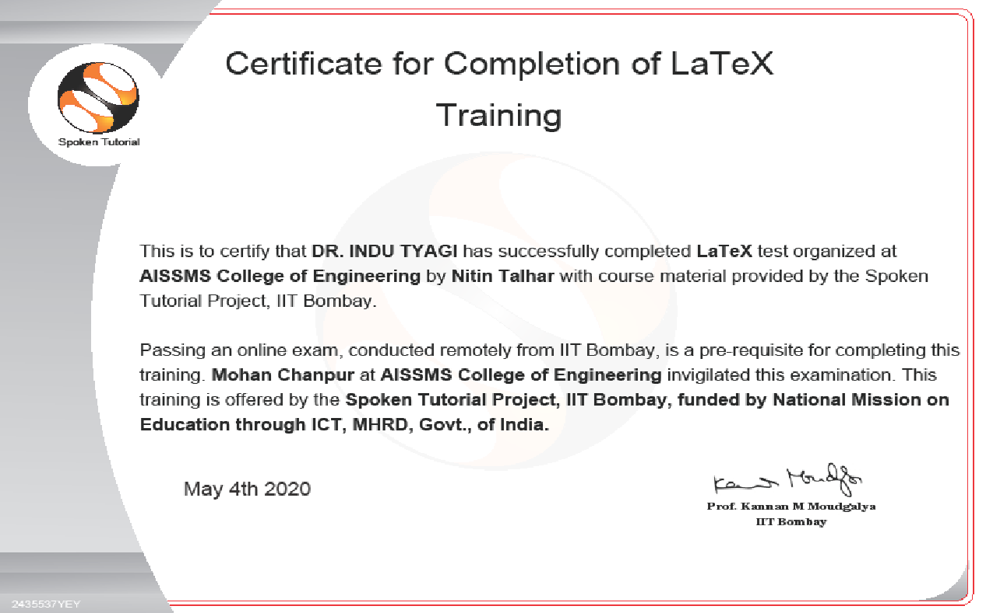  FDP Certificate | 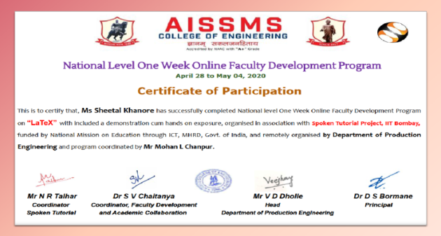  FDP Certificate
EXTENSION LECTURES (LECTURES DELIVERED BY VISITING GUESTS)
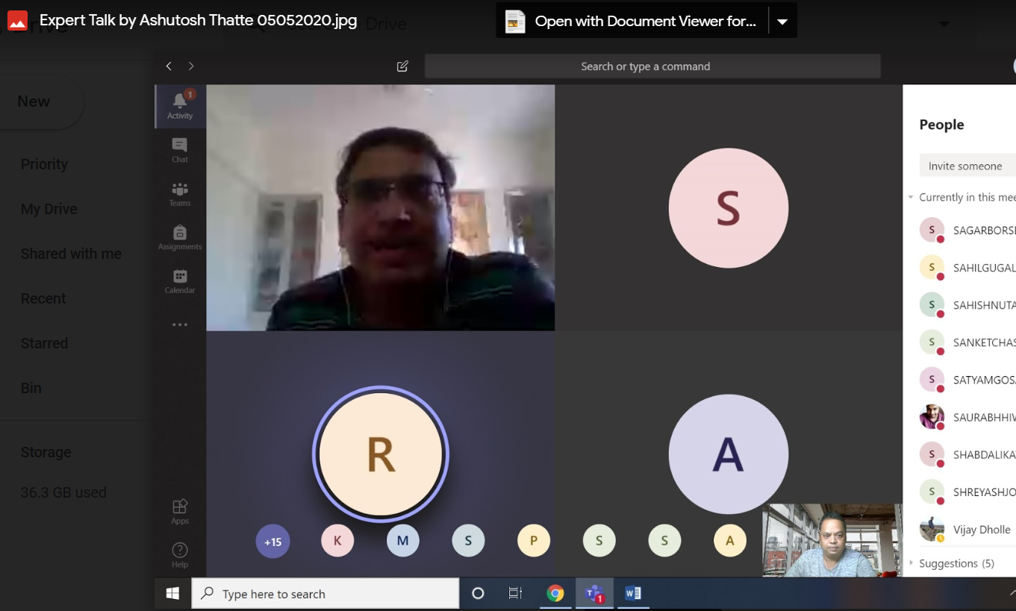
Mr Ashutosh Thatte delivering Lecture on “Facing the VUCA world - a Students' Perspective” 05/05/2020
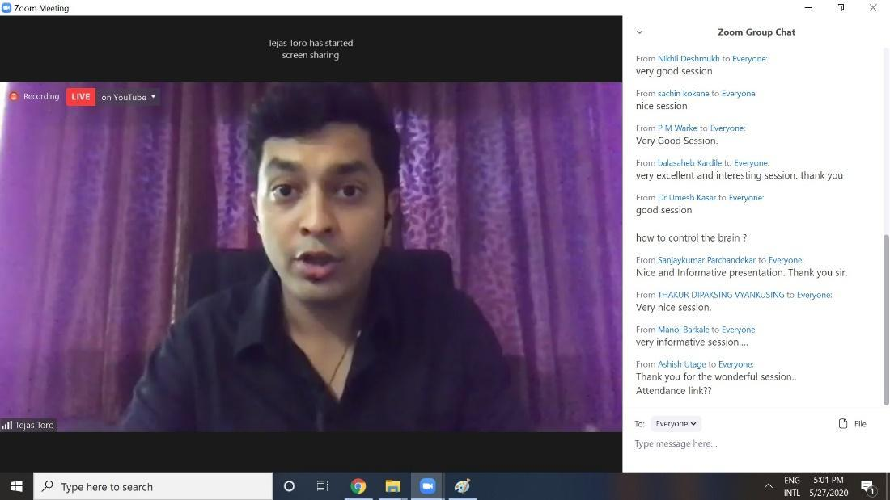
Mr Tejas Toro delivering Lecture on “Genius Code – Science of PEAK Performance” 26/05/2020
PARENT MEET
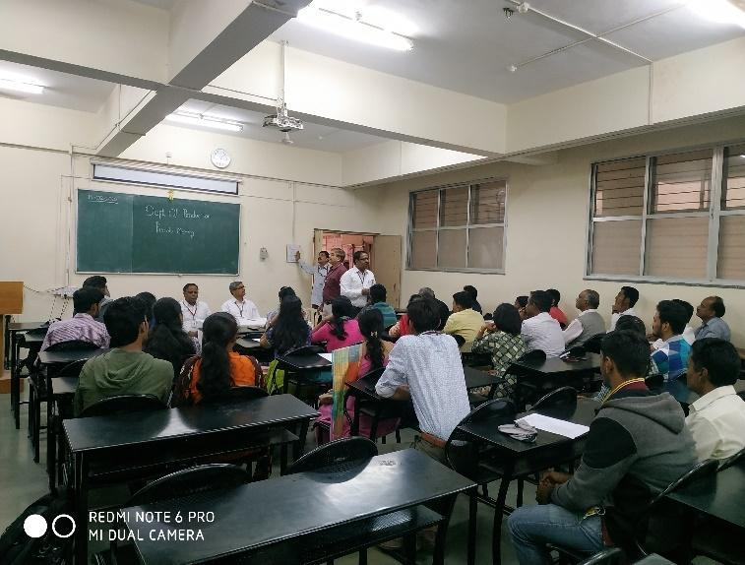  Faculty interacting with Parents | 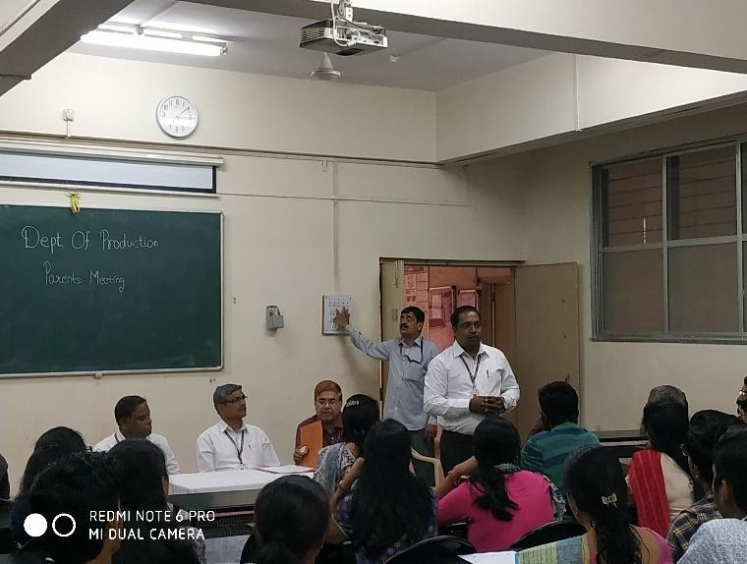  Prof M L Chanpur answering the queries of Parents
INDUSTRIAL VISITS
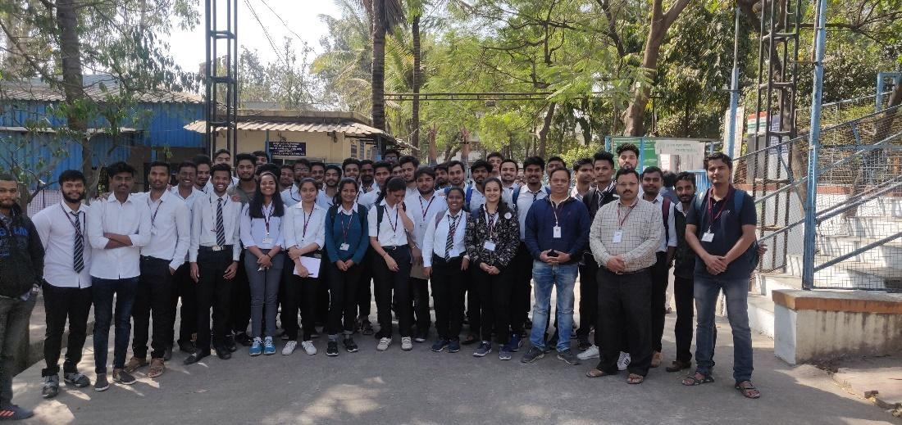
Industrial Visit of TE Prod SW Students to Katraj Dairy, Katraj, Pune on 26/02/2020 organised by Prof N G Shekapure & Prof S S Kallurkar
SOCIAL ACTIVITIES
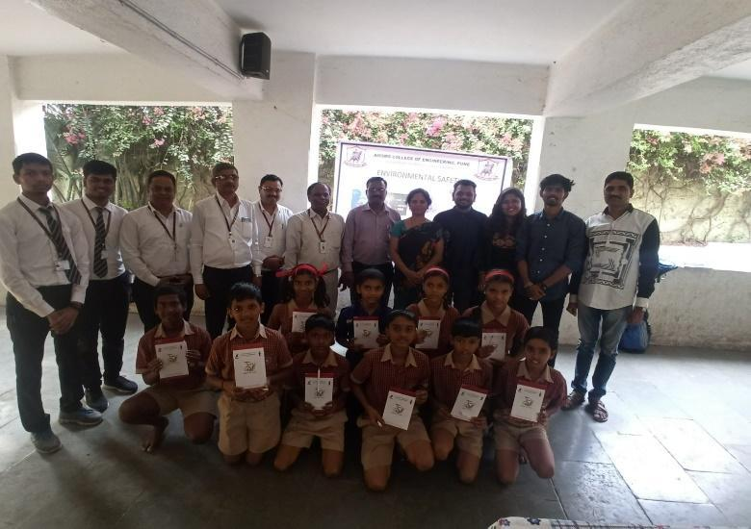  Social Activity by Production Engineering Students | 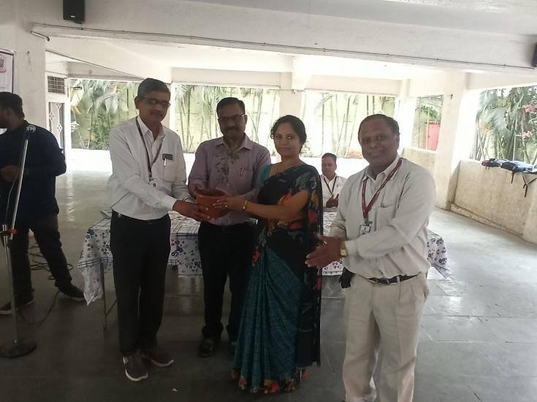  Social Activity at Pratibha Pawar Vidylaya, Pune
ALUMNI INTERACTION
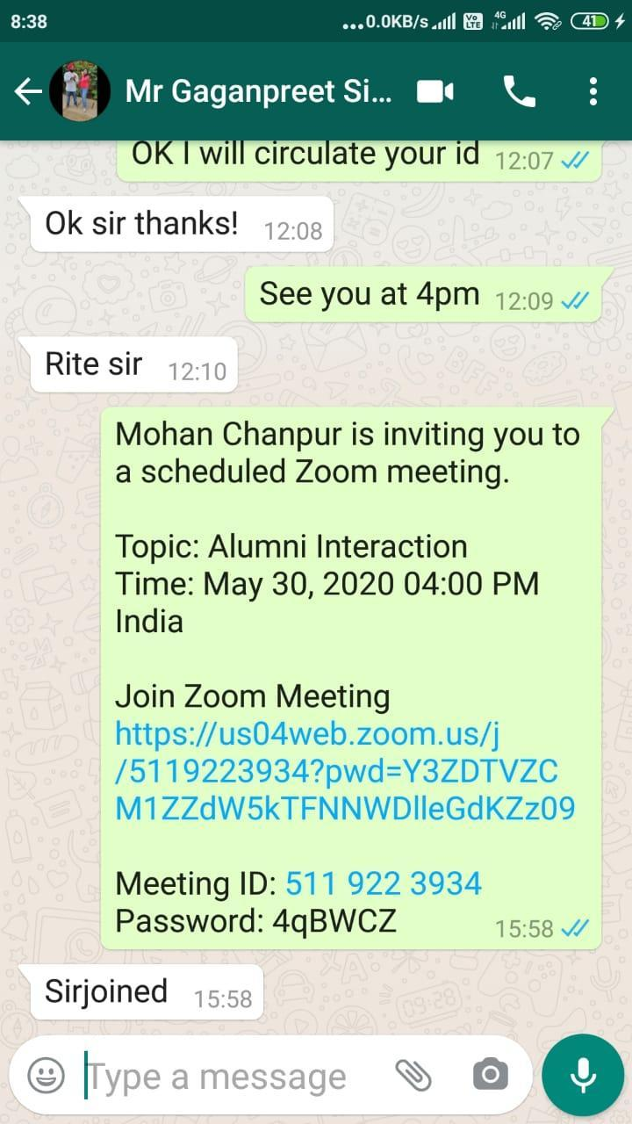 | 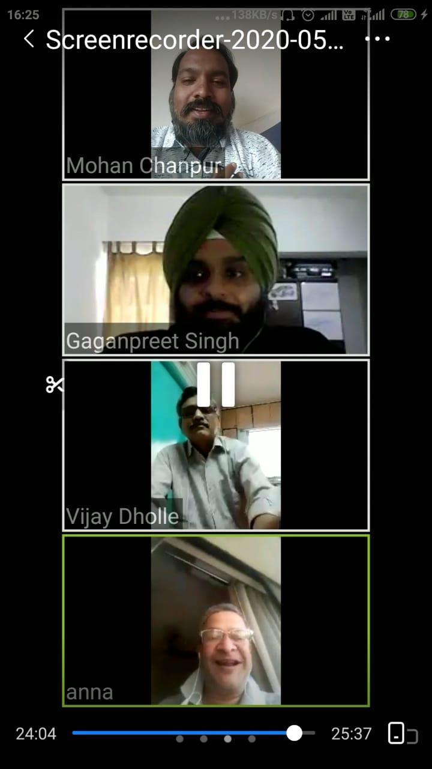  Mr Gaganpreet singh interacting with production Staff
INDUSTRY CONNECT
