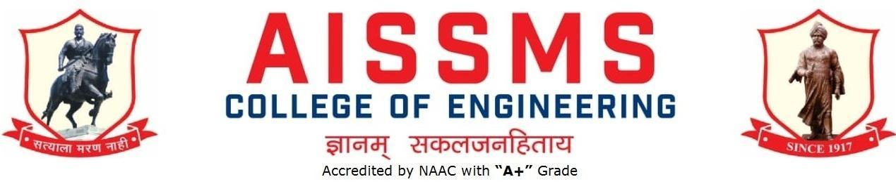

DEPARTMENT OF PRODUCTION ENGINEERING
ANNUAL REPORT
JULY 2019 to JUNE 2020
First Half: 01 July 2019 to 31 December 2019

INTRODUCTION
Year of Establishment | 1994
UG Programmes | Production Engineering (Sandwich Pattern)
Number of Teaching Staff | 11
Number of Non-Teaching Staff | 12 (Production + Workshop)

LABORATORIES IN THE DEPARTMENT
S N | Name of Laboratory | S N | Name of Laboratory
1 | CAD/CAM Laboratory | 5 | Non Traditional Machine Laboratory
2 | Robot & Automation Laboratory | 6 | Advanced Production Technology
3 | Production Management Laboratory | 7 | Department Computer Lab
4 | Tool Engineering Laboratory | 8 | Workshop

SOFTWARES AVAILABLE IN THE DEPARTMENT
S N | Softwares Available | S N | Softwares Available
1 | Unigraphics Mfg. Bundle 10 nos. and (FEMAP +NASTRAN) 5 nos.and FACTORY CAD-2 nos. and FACTORY FLOW-02 Nos. and eMplant- 02 Nos. | 5 | ANSYS Academic Teaching + CFD Version 16.2 (25 user)
2 | Computer Software Autodesk Inventor Professional Edu. License (03) | 6 | JASP- Version 2 (Janatics Animation Software & Pneumatics) ( 01)
3 | Solid Edge Bundle (Drafting Solid Modeling and Sheet Metal) for 25 user | 7 | Systat Statistical Software -Version 12 ( 01)
4 | Unigrahics 8.0 Cam Express (Simulation,Modeling,Tool Path Generation) 20 user

FACULTY IN THE DEPARTMENT
S N | Name of faculty | Designation | S N | Name of faculty | Designation
1 | Dr. S.H.Wankhade | HOD & Associate Prof | 7 | Mr.S.S.Kallurkar | Asst. Prof
2 | Mr. D.H.Joshi | Asst. Prof | 8 | Mr.S.N.Chiwande | Asst. Prof
3 | Mr. V.Y.Sonawane | Asst. Prof | 9 | Mr.S.K.Bidgar | Asst. Prof
4 | Mr.V.D.Dholle | WS | 10 | Mr.M.L.Chanpur | Asst. Prof
5 | Mr.M.A.Kelkar | AWS | 11 | Ms.Y.K.Funde | Asst. Prof
6 | Mr.N.G.Shekapure | Asst. Prof

DETAILS OF SUPPORTING STAFF
S N | Name of Non teaching | Designation | S N | Name of Non teaching | Designation
1 | Mr. R.S.Gangawane | Laboratory Assistant | 3 | Mr.B.H.Gade | Attendant
2 | Mr. Babu Krishnan | LDC | 4 | Mr.Bhira Kagada | Attendant

STUDENTS’ ENROLLMENT
Programme | GEN |  | SC |  | ST |  | OBC |  | PWD |  | Others |  | Total
 | M | F | M | F | M | F | M | F | M | F | M | F | M | F
UG (Prod s/w) SE | 43 | 3 | 3 | 0 | 0 | 0 | 12 | 1 | - | - | - | - | 58 | 4
UG (Prod s/w) TE | 42 | 7 | 5 | 1 | 0 | 0 | 20 | 1 | - | - | - | - | 67 | 9
UG (Prod s/w) BE | 35 | 6 | 10 | 1 | 0 | 0 | 13 | 0 | - | - | - | - | 58 | 7
UG (Prod s/w) | 120 | 16 | 18 | 02 | 0 | 0 | 45 | 02 | - | - | - | - | 183 | 20

CLASS RESULT ANALYSIS (LAST TERM) MAY 19
SN | Class | No. of Students |  |  |  |  |  |  |  |  |  | Percentage of Passing
 |  | Appeared | Clear Passed | Outstanding  (O)  (9 -10) | Excellent  (A+)  (8.5 – 8.99) | Very Good (A)  (7.5 – 8.49) | Good (B+)  (6.5 – 7.49) | Above Average (B)  (5.5 – 6.49) | Average (4.25 – 5.49) Class | Pass Class  (4 – 4.24 | Fail  (F)  0 – 3.99 | All Clear | With ATKT
1 | S.E. | 65 | 25 | - | 1 | 11 | 12 | 1 | - | - | 2 | 38.46 | 96.92
2 | T.E. | 61 | 46 | 10 | 14 | 21 | 1 | - | - | - | - | 75.4 | 24.59
3 | B.E. | 70 | 66 | 6 | 12 | 37 | 11 | - | - | - | 4 | 94.28 | --

UNIVERSITY RANKERS (LAST ACADEMIC YEAR) Departmental Rank
Sr No | Name of the Ranker | Class | Rank
1 | VISPUTE PREM SUNIL | SE Prod s/w | I
2 | PATIL NIKITA SANJAY | SE Prod s/w | II
3 | TAMBOLI AMANULLAH JUNAID | SE Prod s/w | III
4 | BHANGALE LOKESH GOPAL | SE Prod s/w | IV
5 | PAWAR MANALI VILASRAO | SE Prod s/w | V
6 | SHINDE ROSHAN VASANT | TE Prod s/w | I
7 | KARANDE ONKAR SHIVAJI | TE Prod s/w | II
8 | BHARADIA RONAK DEELIP | TE Prod s/w | III
9 | GAIKWAD VINAYAK VILAS | TE Prod s/w | IV
10 | THAKUR ASHISH LEKHPAL | TE Prod s/w | V
11 | CHAVHAN KUNAL TUKARAM | BE Prods/w | I
12 | JAGTAP SACHIN ANIL | BE Prods/w | II
13 | BADAKH ROHAN JALINDARNATH | BE Prods/w | III
14 | SHIRKE MIHIR JAYPRAKASH | BE Prods/w | IV
15 | GHANAWAT DATTATRAY H | BE Prods/w | V

FDP/STTP/SEMINARS/CONFERENCES/WORKSHOPS/ SYMPOSIUMS ATTENDED BY THE DEPARTMENT FACULTY
S N | Name of Faculty | Title of the FDP/STTP/WS/Seminar/Symposium | Organized by | Duration and Date
1 | Mr. V Y Sonawane | NPTEL FDP on Engineering Metrology | MHRDC ,GOI | 12 week
2 | Mr V Dholle | NPTEL FDP on Welding Metallurgy | MHRDC ,GOI | 12 week
3 | Mr S N Chiwande | NPTEL FDP on Engineering Metrology | MHRDC ,GOI | 12 week
4 | Mr M A Kelkar | NPTEL FDP on Workplace Ergonomics | MHRDC ,GOI | 04 week
5 | Mr S K Bidgar | 8-week NPTEL FDP on An Introduction to materials – Nature and Properties | MHRDC ,GOI | 08 week
6 | Mr S K Bidgar | NPTEL FDP on Computer Numerical Control of Machine Tools & Processes | MHRDC ,GOI | 04 week
7 | Mr S K Bidgar | FDP on imparting outcome based education (OBE) in professional education: Objectives, Best practices and measurement of outcomes on Nov 4-15, 2019 | AICTE | 02 week
8 | Mr M L Chanpur | NPTEL FDP on Workplace Ergonomics | MHRDC ,GOI | 04 week
9 | Mr M L Chanpur | NPTEL Online course on Workplace Ergonomics | MHRDC ,GOI | 04 week
10 | Mr M L Chanpur | NPTEL Online course on Strength of Materials | MHRDC ,GOI | 12 week
11 | Mr M L Chanpur | FDP on imparting outcome based education (OBE) in professional education: Objectives, Best practices and measurement of outcomes on Nov 4-15, 2019 | AICTE | 02 week

EXTENSION LECTURES (LECTURES DELIVERED BY VISITING GUESTS)
S N | Name of faculty coordinator | Topic | Name and contact details of guest | Date
1 | Mr.S.K.Bidgar | Powder Metallurgy, its applications with advantages and disadvantages | Mr. Sudarshan Palwe  Speciality Sintered Products Pvt Ltd, Shirwal MIDC | 03/10/2019
2 | Mr.S.N.Chiwande | Sensors in Automobiles | Mr Ajay Pradhan | 09/08/2019
3 | Mr.V.Y.Sonawane | Plastic Injection Molding | Mr Abhishek Tiwari & Mr Pratik Kurne  Mouldex 3 D Moulding innovation Taiwan | 03/09/2019
4 | Mr .M. L.Chanpur | Application of Principal Stresses and strain in FEA | Ms Vijaya Nitnaware FEA Analyst, Engineering Design, Pune | 16/10/ 2019

MOU SIGNED WITH ACADEMIC AND PROFESSIONAL ORGANISATIONS
Sr. No. | Faculty Coordinator | Name of Organisation | Date  of MoU Signed | Valid upto  00/00/0000
1 | Ms Y K Funde | Sofcon India Pvt Ltd Pune,61/B, Building-B,Ground Floor Pune, Shree Chambers, Mumbai Highway, Pune, Maharashtra 411005 http://www.sofcontraining.com/ | 12/10/2017 | 12/10/2022

STUDENTS’ CHAPTERS /CLUBS
S. No | Name of Students’ Chapter | Number of Student Members
1 | Institution of Engineers Production Engineering Students Chapter | 90

EVENTS ORGANISED (By Students’ Chapters / Clubs and others)
Name of Students’ Chapter: Institution of Engineers (I) Production Engineering
Students’ Chapter
Faculty Advisor: Mr. Veejhay Dholle
SN | Event name and details of event | Details of faculty and students involvement, Name of chief guest, judges etc. | Duration and Dates
1 | Expert Lecture | Expert : Mr. Sudarshan Palwe  Specialty Sintered Products Pvt Ltd, Shirwal MIDC  Topic: Powder Metallurgy, its applications with advantages and disadvantages  Organizer: Mr.S.K.Bidgar | 03/10/2019
2 | Expert Lecture | Expert: Mr Ajay Pradhan  Topic: Sensors in Automobiles  Organizer: Mr.S.N.Chiwande | 09/08/2019
3 | Expert Lecture | Expert: Mr Abhishek Tiwari & Mr Pratik Kurne  Mouldex 3 D Moulding innovation Taiwan  Topic: Plastic Injection Molding  Organizer: Mr.V.Y.Sonawane | 03/09/2019
4 | Expert Lecture | Expert: Ms Vijaya Nitnaware FEA Analyst, Engineering Design, Pune  Topic: Application of Principal Stresses and strain in FEA  Organizer: Mr M L Chanpur | 16/10/ 2019
5 | Industry Visit | Industry: Speciality Sintered Products Pvt Ltd, Chakan MIDC  Class: SE Prod s/w | 12/10/19
6 | Industry Visit | Industry: Vindhyachal Hydropower Pvt Ltd Rajgurunagar  Class: SE Prod s/w | 12/10/19

Name of Students’ Chapter: Institution of Engineers (I) Production Engineering
Faculty Advisor: V D DHOLLE
SN | Event name and details of event | Details of faculty and students involvement, Name of chief guest, judges etc. | Duration and Dates
1 | Powder Metallurgy, its applications | Mr. Sudarshan Palwe,  Speciality SinteredProducts Pvt Ltd, Shirwal MIDC | 03/10/2019
2 | Sensors in Automobiles | Mr Ajay Pradhan | 09/08/2019
3 | Plastic Injection Molding | Mr Abhishek Tiwari & Mr Pratik Kurne, Mouldex 3 D Moulding innovation Taiwan | 03/09/2019

RESEARCH CITATIONS (Source of Data: Google scholar)
S N | Name of faculty | Citations | Name of faculty | Citations
1 | S H Wankhade | 06 | -
Total citations:06
NUMBER OF STUDENTS PLACED
Sr No | Name of Organization visited | Number of students Participated | Number of students Placed
1 | Topper Technologies | 30 | 1
2 | I Research Services | 39 | 1
4 | Godrej & Boyce | 40 | 1
Lowest Package Offered: 3 Lacs, Highest package Offered: 3 Lacs, Average Package Offered:

INDUSTRIAL VISITS ORGANISED:
Sr. No. | Faculty Coordinator | Class and (Number of students attended) | Industry Name and Address | Date of visit
1 | Mr S. K. Bidgar | SE (P/sw) -55 | Speciality Sintered Products Pvt Ltd, Chakan MIDC | 12/10/2019
2 | Mr S. K. Bidgar | SE (P/sw) -55 | Vindhyachal Hydropower Pvt Ltd Rajgurunagar | 12/10/2019
3 | Mr V. Y. Sonawane  Mr S. N. Chiwande | BE (P/sw)  54 | Automation 2019  International Exhibition at NSE  Goregaon, Mumbai | 28/09/2019

EXPERT LECTURES DELIVERED BY INDUSTRY EXPERTS
Sr. No. | Faculty Coordinator | Class  (Number of students attended) | Name, Industry, designation and contact details of Expert | Topic | Date
1 | Mr S.K.Bidgar | SE (P/Sw)-50 | Mr. Sudarshan Palwe  Speciality Sintered Products Pvt Ltd, Shirwal MIDC | Powder Metallurgy, its applications with advantages and disadvantages | 03/10/2019
2 | Mr S.N. Chiwande | BE / SE 75 | Mr Ajay Pradhan | Sensors in Automobiles | 09/08/2019
3 | Mr V. Y. Sonawane | BE / SE  69 | Mr Abhishek Tiwari &  Mr Pratik Kurne  Name of Company: Mouldex 3 D Moulding innovation Taiwan | Plastic Injection Molding | 03/09/2019

MOU SIGNED WITH INDUSTRY
Sr. No. | Faculty Coordinator | Name of Industry | Date  of MoU Signed | Valid upto
1 | Mr M. L. Chanpur | Maharajashree Industrial Solution (MIS),  Plot No-210, J block, Near Gawalimata Chock, Bhosari, Pune | 14/10/2017 | 14/10/2022
STUDENTS UNDERGONE IN-PLANT TRAINING AND (OR) INTERNSHIP PROGRAMME
Sr. No. | Name of the Student |  | Name of the Industry |  | Class |  | Training Duration
 |  |  |  |  |  |  | Start Date |  | Last Date |  | Duration (Days)
01 | Hajare Akshay Arun |  | Jems Machines And Systems |  | TE |  | 15/06/2019 |  | 15/12/2019 |  | 180
02 | Katphalkar Shabdali Suresh |  | Godrej & Boyce Mfg. Pvt. Ltd. |  | TE |  | 15/06/2019 |  | 15/12/2019 |  | 180
02 | Raskar Kaustubh Shekhar |  | Godrej & Boyce Mfg. Pvt. Ltd. |  | TE |  | 15/06/2019 |  | 15/12/2019 |  | 180
03 | Tamboli Amanullah Juniad |  | Godrej & Boyce Mfg. Pvt. Ltd. |  | TE |  | 15/06/2019 |  | 15/12/2019 |  | 180
04 | Vispute Prem Sunil |  | Godrej & Boyce Mfg. Pvt. Ltd. |  | TE |  | 15/06/2019 |  | 15/12/2019 |  | 180
05 | Shikalgar Mainuddin Salim |  | Tata Motors Ltd. |  | TE |  | 15/06/2019 |  | 15/12/2019 |  | 180
06 | Muttamshetty Chandrashekhar |  | Forbes Marshall |  | TE |  | 15/06/2019 |  | 15/12/2019 |  | 180
07 | Kadam Siddhant Sunil |  | Forbes Marshall Pvt. Ltd. |  | TE |  | 15/06/2019 |  | 15/12/2019 |  | 180
08 | Pawar Rohan Ajay |  | Forbes Marshall Pvt. Ltd. |  | TE |  | 15/06/2019 |  | 15/12/2019 |  | 180
09 | Aditya Date |  | Sany Heavy Industry |  | TE |  | 15/06/2019 |  | 15/12/2019 |  | 180
10 | Borate Rishikesh Dhanaji (Tfws) |  | Vanaz Engineers Ltd. |  | TE |  | 15/06/2019 |  | 15/12/2019 |  | 180
11 | Pawar Manali Vilasrao |  | Vanaz Engineers Ltd. |  | TE |  | 15/06/2019 |  | 15/12/2019 |  | 180
12 | Pharakate Vijay R |  | Aditya Enterprises Gokul Shirgaon,Kolhapur |  | TE |  | 15/06/2019 |  | 15/12/2019 |  | 180
13 | Radhakrishnan Divya |  | Suzlon Energy Ltd |  | TE |  | 15/06/2019 |  | 15/12/2019 |  | 180
14 | Wagh Bhavesh Rajendra |  | Larsen And Toubro, Mahape |  | TE |  | 15/06/2019 |  | 15/12/2019 |  | 180
15 | Pranav B Mandge |  | L&T Defence, Talegaon |  | TE |  | 15/06/2019 |  | 15/12/2019 |  | 180
16 | Jadhav Harshvardhan Shailesh |  | Alfa Laval Pvt Ltd |  | TE |  | 15/06/2019 |  | 15/12/2019 |  | 180
17 | Mare Sadanand Ganpati |  | Forbes Marshall |  | TE |  | 15/06/2019 |  | 15/12/2019 |  | 180
18 | Bhagat Alankar Sunil |  | Forbes Marshall Pvt. Ltd. |  | TE |  | 15/06/2019 |  | 15/12/2019 |  | 180
19 | Kalaskar Tejashree Rajendra |  | Forbes Marshall Pvt.Ltd |  | TE |  | 15/06/2019 |  | 15/12/2019 |  | 180
20 | Shivam Bhan |  | Forbes Marshall Pvt. Ltd. |  | TE |  | 15/06/2019 |  | 15/12/2019 |  | 180
21 | Pillay Yash Shivkumar |  | Tata Motors Ltd |  | TE |  | 15/06/2019 |  | 15/12/2019 |  | 180
22 | Rajput Vishal Bharatsing |  | Suhas Enterprises Pvt Ltd (Training Completed) |  | TE |  | 15/06/2019 |  | 15/12/2019 |  | 180
23 | Gawali Rupesh Rajendra |  | Case New Holland Industrial Chakan |  | TE |  | 15/06/2019 |  | 15/12/2019 |  | 180
24 | Panchal Abhishek Shankar |  | General Motors, Talegon |  | TE |  | 15/06/2019 |  | 15/12/2019 |  | 180
25 | Pawar Prathamesh Jijabhau |  | Case New Holland Industrial Chakan |  | TE |  | 15/06/2019 |  | 15/12/2019 |  | 180
26 | Kuwar Abhishek Dasharath |  | Case New Holland Industrial Chakan |  | TE |  | 15/06/2019 |  | 15/12/2019 |  | 180
27 | Rathi Saurabh Sanjeev |  | Godrej & Boyce Mfg. Pvt. Ltd. |  | TE |  | 15/06/2019 |  | 15/12/2019 |  | 180
28 | Shirsath Saurabh Sunil |  | Case New Holland Industrial Chakan |  | TE |  | 15/06/2019 |  | 15/12/2019 |  | 180
29 | Auti Himanshu Shashikant |  | Saakshi Machine And Tools Pvt. Ltd. |  | TE |  | 15/06/2019 |  | 15/12/2019 |  | 180
30 | Hiwrale Saurabh Kadu |  | Araymond Fastners Pvt, Chakan Ltd,Pune |  | TE |  | 15/06/2019 |  | 15/12/2019 |  | 180
31 | Vaidya Hrishikesh S |  | Saakshi Machine And Tools Pvt. Ltd. |  | TE |  | 15/06/2019 |  | 15/12/2019 |  | 180
32 | Hansora Darshan Ratilal |  | Dura Auto Components |  | TE |  | 15/06/2019 |  | 15/12/2019 |  | 180
33 | Sonawane Piyush Anil |  | Dura Auto Components |  | TE |  | 15/06/2019 |  | 15/12/2019 |  | 180
34 | Danekar Rishikesh Vijay |  | Endress + Hauser Pvt Ltd,Aurangabad |  | TE |  | 15/06/2019 |  | 15/12/2019 |  | 180
35 | Kamble Tejas Jitendra |  | Bharat Forge Ltd |  | TE |  | 15/06/2019 |  | 15/12/2019 |  | 180
36 | Shashwat R Sangewadikar |  | Bharat Forge Ltd |  | TE |  | 15/06/2019 |  | 15/12/2019 |  | 180
37 | Waghmare Nimish Rajesh |  | Bharat Forge Ltd |  | TE |  | 15/06/2019 |  | 15/12/2019 |  | 180
38 | Bhosale Aishwarya Anil |  | Fiat India Automobiles Ltd. Ranjangaon |  | TE |  | 15/06/2019 |  | 15/12/2019 |  | 180
39 | Patil Nikita Sanjay |  | Fiat India Automobiles Ltd. Ranjangaon |  | TE |  | 15/06/2019 |  | 15/12/2019 |  | 180
40 | Jaiwal Raj Deepak |  | Fiat India Automobiles Ltd. Ranjangaon |  | TE |  | 15/06/2019 |  | 15/12/2019 |  | 180
41 | Bhise Hrishikesh Ganesh |  | Viktek |  | TE |  | 15/06/2019 |  | 15/12/2019 |  | 180
42 | Gandhi Hritik Jinesh |  | Kimaya Enterprises |  | TE |  | 15/06/2019 |  | 15/12/2019 |  | 180
43 | Bhat Kshitija Prakash |  | Case New Holland Industrial Chakan |  | TE |  | 15/06/2019 |  | 15/12/2019 |  | 180
44 | Bidwe Sahishnuta Nagnath |  | Case New Holland Industrial Chakan |  | TE |  | 15/06/2019 |  | 15/12/2019 |  | 180
45 | Chinchwade Krishna Shivraj |  | Case New Holland Industrial Chakan |  | TE |  | 15/06/2019 |  | 15/12/2019 |  | 180
46 | Kulkarni Amey Prashant |  | Araymond Fastners Pvt Ltd,Pune |  | TE |  | 15/06/2019 |  | 15/12/2019 |  | 180
47 | Deshpande Harish Deelip |  | Sany Heavy Industry |  | TE |  | 15/06/2019 |  | 15/12/2019 |  | 180
48 | Gosavi Satyam Sunil | Jaws Mfg.Co. |  | TE |  | 15/06/2019 |  | 15/12/2019 |  | 180
49 | Lonkar Aditya Vitthal | Jaws Mfg. Co. |  | TE |  | 15/06/2019 |  | 15/12/2019 |  | 180
50 | Patil Urvesh Kailash | Sany Heavy Industry |  | TE |  | 15/06/2019 |  | 15/12/2019 |  | 180
51 | Tupe Kshitij Pandurang (Tfws) | Jaws Mfg. Co. |  | TE |  | 15/06/2019 |  | 15/12/2019 |  | 180
52 | Chaudhari Durgesh Dinkar | Tata Motors Ltd. Pimpri |  | TE |  | 15/06/2019 |  | 15/12/2019 |  | 180
53 | Bam Atharv Satish | Godrej & Boyce Mfg. Pvt. Ltd. |  | TE |  | 15/06/2019 |  | 15/12/2019 |  | 180
54 | Borse Sagar Mohan | Ekveera Industry |  | TE |  | 15/06/2019 |  | 15/12/2019 |  | 180
55 | Saurabh Chavhan | L&T Ahmednagar |  | TE |  | 15/06/2019 |  | 15/12/2019 |  | 180
56 | Jadhav Mahesh Sayaji | L&T Ahmednagar |  | TE |  | 15/06/2019 |  | 15/12/2019 |  | 180
57 | Wandhekar Mayur Shivaji | L&T Ahmednagar |  | TE |  | 15/06/2019 |  | 15/12/2019 |  | 180
58 | Deshmukh Ajay Suresh | Godrej & Boyce Mfg. Pvt. Ltd. |  | TE |  | 15/06/2019 |  | 15/12/2019 |  | 180
59 | Joshi Shreyash Uddhav | Godrej & Boyce Mfg. Pvt. Ltd. |  | TE |  | 15/06/2019 |  | 15/12/2019 |  | 180
60 | More Sushant Bapusaheb | L&T Ahmednagar |  | TE |  | 15/06/2019 |  | 15/12/2019 |  | 180
61 | Bhangale Lokesh Gopal | A-Raymond Fasteners Pvt Ltd, Pune |  | TE |  | 15/06/2019 |  | 15/12/2019 |  | 180
62 | Chetan Jatkar | J.V.Steel And Engineering Works |  | TE |  | 15/06/2019 |  | 15/12/2019 |  | 180
63 | Gugale Sahil Santosh | Hyundai India Ltd |  | TE |  | 15/06/2019 |  | 15/12/2019 |  | 180

SUPPORT FROM ALUMNI
Sr No | Name of Alumni | Position and Organisation | Batch | Details of Support | Date
1 | Mr Vinodkumar Bachkar | Associate Manager,  Thermax Ltd, Pune | 2002-2006 | External Examiner for Industrial Inplant Training Oral | 02/01/20
2 | Mr Shekhar Joglekar | Senior Manager, Assembly Process  Tower International, Technical Centre, Hyderabad | 2005-2009 | External Examiner for Industrial Inplant Training Oral | 03/01/20
3 | Mr Manoj Vazarkar | Senior Manager,  Teamcenter Development at Siemens Digital Industries Software, Pune | 1994-1998 | External Examiner for Industrial Inplant Training Oral | 02/01/20

STUDENTS’ ACHIEVEMENT (Individual Level)
S N | Name of Student | Details of Achievement (State/University/ National/International Level)
1 | Mr. Vishal Sangve  (BE P/Sw) | Bagged prestigious Gold medal respectively at “ 50th National Design and Research Forum” (NDRF), Bangalore 2019
2 | Mr.Roshan Shinde  (TE P/Sw) | Bagged prestigious Silver medal respectively at “ 50th National Design and Research Forum” (NDRF), Bangalore 2019
3 | Mr. Nagesh Kokare  (BE P/Sw) | Bagged prestigious Bronze medal respectively at “ 50th National Design and Research Forum” (NDRF), Bangalore 2019

SPORTS / CULTURAL ACHIEVEMENTS OF STUDENTS (Individual Level) (Team level achievements to be mentioned in institute level sports/Cultural committee report)
S N | Name of Student | Details of Achievement  (State/University/ National/International Level)
1 | Rohan Gavhane | 1)Go Kart  2)IKC Kolhapur AIR 1st overall  3)Zeal Drag 3.0 best in design
2 | Roshan Shinde | 1)Winner of State level paper presentation Prodzine by SCOE  2)Bagged prestigious Silver medal respectively at “ 50th National Design and Research Forum” (NDRF), Bangalore 2019
3 | Ashish Thakur | 1) Go Kart
4 | Shubham Vaidya | 1) 3rd Prize for Group Dance (Vendant 2019)  2)Won Vinodattam Karandak 2019
5 | Omkar Shinde | 1)Sandeep foundation trophy winner  2)Zest COEP Cricket winner  3) MIT Cricket Trophy winner
6 | Omkar Buchade
7 | Kshitij Parbat
8 | Parth Bafna | 1)MIT Summit Participation  2)University Trophy  3)IOIT Cricket Cup winner
9 | Varun Gandhi
10 | Alankar Bhagat | Certificate of appreciation in 5s activity in QCfi-JUSE audit
11 | Ajay Deshmukh | NPTEL: TE (Course :CNC Processes)
12 | Aditya Lonkar
13 | Aman Tamboli
14 | Prem Vispute

MISCELLANEOUS
FEEDBACK FROM STAKEHOLDERS
Sr No | Stake holder | Number of Feedbacks Received
1 | Alumni | 03
2 | Parents | 73
3 | Employers | 00
4 | Students | 73

ANY OTHER NOTEWORTHY ACHIEVEMENT OF THE DEPARTMENT
(Not mentioned above): Nil

TWO BEST PRACTICES FOLLOWED IN THE DEPARTMENT
1 | Involve maximum number of students in NDRF competition.
2 | Extension of Techno-social activities

SWOC ANALYSIS
Detail five major strengths, weaknesses, opportunities, and challenges (SWOC) of the department and future plans of the Departments
Strengths | 1 | Provisionally Accredited
 | 2 | Liasoning With Industries
 | 3 | Industry Exposure
 | 4 | Experience faculty & good Retention Ratio
Weaknesses | 1 | Less Number of PhD Faculty
 | 2 | Less Consultancy, Research Grand
 | 3 | Less No. of R&D Funded Projects
Opportunities | 1 | Utilization of Industrial Laboratories
 | 2 | Through MoU, Training Program, Consultancy and Project in Association With Industries
 | 3 | Qualification And Up-Gradation of All Faculties
Challenges | 1 | Placement In Core Companies
 | 2 | Improve No. of Patents & Copyright
 | 3 | To attract students for Production Programme

FUTURE PLANS OF THE DEPARTMENT (For Next Academic Year)
1 | To enroll maximum faculty for PhD
2 | To increase the liasoning with industry for placement.

INITIATIVES TAKEN BY THE DEPARTMENT AND INSTITUTE LEVEL TO IMPROVE AND ASSURE QUALITY IN THE AREA OF
Area | Initiatives
Academics | To prepare course manual according to Blooms Taxonomy.
Co curricular | To participate students’ projects in National Design Research Forum competition, paper presentation, BAJA, SUPRA, EFFICYCLE and GARUDSHWA competitions.
Extra curricular | Students are motivated to participate various sports and cultural activities.
Social | To arrange Techno social activities at industries.

SUMMARY SHEET
Sr No | Activity/ Item | Numbers
 | Students in the department | 203
 | FDP/STTP/Seminars/Conferences/Workshops/ Symposiums attended by the Faculty | 09
 | Extension lectures (lectures delivered by visiting guests) | 04
 | MOU signed with academic and professional organizations | 01
 | Students’ chapter /clubs | 01
 | Student events organized | 06
 | Students placed | 03
 | Industrial visits conducted | 02
 | Expert lectures delivered by industry experts | 04
 | MOU signed with industry | 01
 | Students undergone in-plant training and (or) internship programme | 63
 | Support from alumni | 03
 | Sports / cultural achievements of students (Individual level) | 14
 | Social activities organized (Techno Social) | 01

GLIMPSES (Photographs)
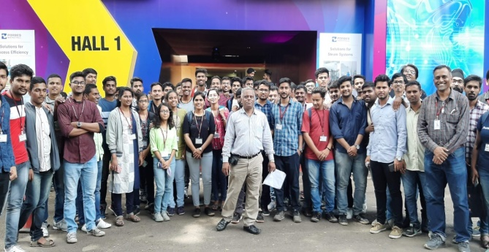  Bombay Exhibition Center NSE Goregaon Mumbai | 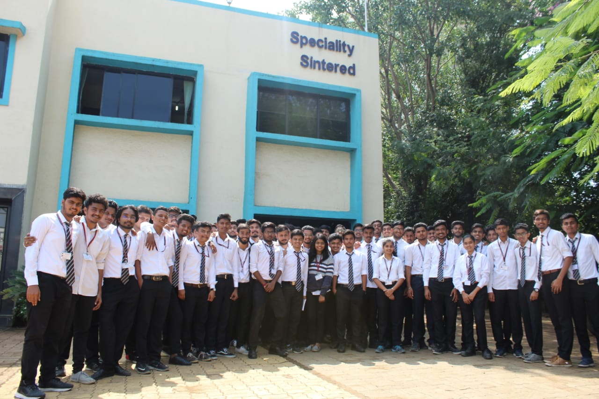  Specialty Sintered Products Pvt Ltd, Chakan MIDC
EXPERT LECTURES DELIVERED BY INDUSTRY EXPERTS
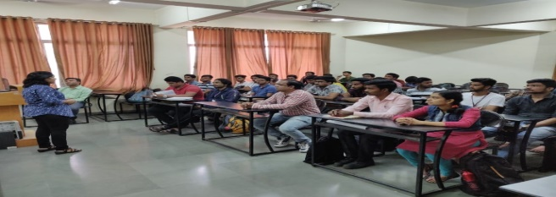  “Application of Principal Stresses and strain in FEA” by  Ms V. Nitnaware FEA Analyst, Engg Design, Pune 16/10/2019 | 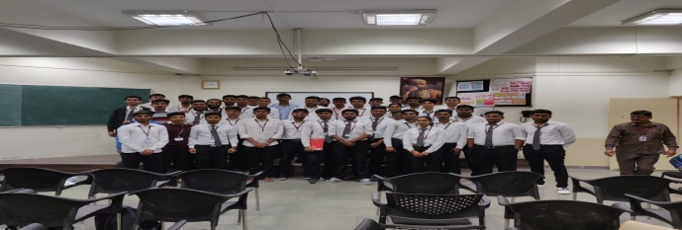  “Sensors in Automobiles” by Mr Ajay Pradhan, Freelancer and Ex-Manager, Tata Motors, Pune 09/08/2019

