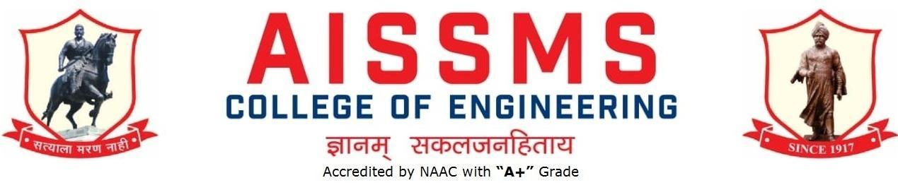

DEPARTMENT OF ELECTRICAL ENGINEERING
ANNUAL REPORT
(01 JULY 2019 to 30 JUNE 2020)
First Half: 01 July 2019 to 31 December 2019
Second Half: 01 January 2020 to 30 June 2020

Academic Year 2019 –20
First Half: 01 July 2019 to 30 December 2019
Guidelines:
Fill up this sheet for all the contributions /activities conducted at Department level only.
- In case data does not exist please mention it as ‘No Data’.
- Please add rows to the table below to suit your requirements
- Ensure that data does not differ from other official records and all the supporting documents are available.
- Use: Font Type: Times New Roman, Font Size: 12, Sentence case, Spacing: 1.15
- For any queries, you may contact: Dr C S Choudhari, Coordinator, IQAC
- email: iqac@aissmscoe.com

INTRODUCTION
Year of Establishment | 1992
UG Programmes | 01
PG Programmes | 01
Number of Teaching Staff | 12
Number of Non-Teaching Staff | 07

SOFTWARES AVAILABLE IN THE DEPARTMENT
Software Available | Software Available
MATLAB
ETAP
Turbo C

RESULT ANALYSIS (LAST TERM) (Academic Year: 2019-20 Term: I)
Name of faculty | Class and Subject Taught | % passing | Name of faculty | Class and Subject Taught | % passing
Dr A A Godbole | BE  CS II | 86.15 | Mrs P Sankala | TE  PE | 78.46%
Dr M H Dhend | NA  Study leave | NA  Study leave | Mrs V N Tarange | SE-ADE  BE-RE | 80.8  87.5
Mr S K Biradar | BE  EHV | 96.82 | Mr C D Kulkarni | BE  PLC & SCADA | 100
Dr A A Apte | TE  AMA | 92.06 | Mrs Sree Rekha Vadi | SE  MS | 89.04
Mr L S Godse | BE  PQ | 94.54 | Ms S S Mujawar
Ms S R Lengade | SE  EMI | 91.78 | Mr R S Shinde | TE-EM/C II  SE-PGT | 84.37  82.19
Mr V S Ponkshe | BE  PSOC | 84.12 | Dr D Srivastava | TE  EIMT | 95.38

Class Result Analysis (LAST TERM) (Academic Year: 2019-20 Term: I)
SN | Class | No. Of Students |  |  |  |  |  |  |  |  |  | Percentage of Passing
 |  | Appeared | Clear Passed | Outstanding  (O)  (9 -10) | Excellent  (A+)  (8.5 – 8.99) | Very Good (A)  (7.5 – 8.49) | Good (B+)  (6.5 – 7.49) | Above Average (B)  (5.5 – 6.49) | Average (4.25 – 5.49)Class | Pass Class  (4 – 4.24 | Fail  (F)  0 – 3.99 | All Clear | With ATKT
1 | SE | 73 | 31 | 03 | 05 | 03 | 09 | 09 | 02 | 00 | 42 | 42.47 | 57.53
2 | TE | 65 | 39 | 03 | 10 | 15 | 10 | 01 | - | - | 26 | 60 | 40
3 | BE | 66 | 51 | - | 26 | 16 | 04 | 02 | - | - | 15 | 77.27 | 22.72

UNIVERSITY RANKERS (LAST ACADEMIC YEAR) (Academic Year:2017-18 )
Sr No | Name of the Ranker | Class | Rank
1 | Sanjay Sinh Hazare | BE | 2
2 | Vishruti Choudhary | BE | 5

ACHIEVEMENTS OF FACULTY (AWARDS, RECOGNITION, PHD COMPLETION ETC.)
SN | Name of Faculty | Awards & Recognition
1 | Dr A A Godbole | 1. Reviewer of Indicon 2019 conference  2. Examiner MTech examination in Embedded control systems in COEP
2 | Dr. Mrs. Mangal Dhend | 1)Received 12,575/- $ (Around 9.42 lac) Scholarship from East West Center, USA  2) Received Leadership Fellow award of East West Center, USA · for leading the leaders for developing peace, understanding and growth among Indo-USA and Asia Pacific regions, December 2019  3) Received recognition as a certified professional and peer coacher EWC, USA, 2019  4)Received AISSMS 2nd Rank Excellence Award cash of Rs. 25,000/- on 5th Sept. 2019  5) Received “Bharat Excellence 2019”, National award 28th July 2019 at International center, Delhi

CONTRIBUTION OF FACULTY (Interaction with outside world)
SN | Name of Faculty | Nature and details of contribution (Representation at University, State, National , International level, corporate world, Social Platforms, etc)
1 | Dr A A Godbole | Worked as reviewer for IEEE transaction Control system technology, IEEE transaction on industrial electronics, Indicon 2019.
2 | Dr. Mrs. Mangal Dhend | International:  1)Worked as a member of scientific committee for IEEE PES, circuit and systems’ society’s International conference on Electric Vehicles to be held on 3-4 October 2019 in Romania  2)Technical Programme Committee in the 2nd International Conference on Renewable Energy and Environment Engineering, August 19-22, 2019, Munich, Germany  4)Technical Programme Committee in IEEE PES, PEL’s 9th International Conference on Power and Energy Systems (ICPES), 10-12 December 2019, Perth, AuStralia  5)Working as a senior member of IEEE  9) Doing social work for improving qualities of institute and faculties
3 | Dr A A Apte | 1) PhD completed  2) Worked as reviewer for IEEE transaction on Power Electronics,IEEE transaction on industrial applications  3) Worked as Paper setter for MPSC.

E CONTENT DEVELOPED BY FACULTY AND AVAILABLE ONLINE (During Academic Term 2019-20)
Sr No. | Name of Faculty | Title of e-content | e-content development facility/platform | link of the content
1 | Dr. Mrs. Mangal Dhend | 1)Programme curriculum |  | https://www.youtube.com/watch?v=bf-Hz5vKe-k
 |  | 2)PEO PSO PO CO mapping |  | https://www.youtube.com/watch?v=uEnxoZG7PrA

FUNDED RESEARCH PROJECT (Total Funding Received: In INR 5 Lac )
S N | Principal Investigator | Title of the Project | Amount Received (Rs) | Funding Agency
1 | Dr Mangal Dhend | 10 days Faculty development programme on Advanced Pedagogy for Empowering Teachers | about 5 lac | UGC-HRDC  under  PMMMNMTT

FDP/STTP/Quiz ORGANIZED BY THE DEPARTMENT (Total No. )
S N | Name of Coordinator/s | Title of the FDP/STTP/WS/Seminar/Quiz/Symposium | Duration/ Dates | No. of Participants | Funding Agency  (If any) and Amount (Rs.)
NIL

SEMINARS/ WORKSHOPS/ WEBINARS ORGANIZED BY THE DEPARTMENT (For Faculty) (Total No.01 )
S N | Name of Coordinator/s | Title of the Seminar/Webinar | Duration/ Dates | No. of Participants | Funding Agency  (If any) and Amount (Rs.)
1 | V V Kulkarni  Dr A A Godbole | Syllabus orientation workshop of Basic Electrical Engineering | 08/8/2019 | 78

CONFERENCES/ SYMPOSIUMS ORGANIZED BY THE DEPARTMENT (For Faculty) (Total No. )
S N | Name of Coordinator/s | Title of the Conference / Symposium | Duration/ Dates | No. of Participants | Funding Agency  (If any) and Amount (Rs.)
NIL

FDP/STTP ATTENDED BY THE DEPARTMENT FACULTY (Total No. )
S N | Name of Faculty | Title of the FDP/STTP | Organized by | Duration/ Dates
1 | Dr.A.A.Godbole | 1.FDP on “ Vision-Mission-PEO-PEO-PO-CO:Framing Mapping, Assessment and Attainment.” | AISSMS COE | 10/06/2019-  15/06/2019
2 | Dr. Mrs. Mangal Dhend | 1. cyber security and data sciences  2. Asia Pacific professional Leadership Development Programme | Shivaji university and AISSMS COE  East-West center, USA5 | 17/06/2019-22/06/2019  August -DEcember 2019
3 | S K Biradar | 1.FDP on “ Vision-Misson-PEO-PSO-PO-CO:Framing Mapping, Assessment and Attainment. | AISSMS COE | 10/06/2019-  15/06/2019
4 | Dr.A.A.Apte | 1.FDP on “ Vision-Mission-PEO-PEO-PO-CO:Framing Mapping, Assessment and Attainment. | AISSMS COE | 10/06/2019-  15/06/2019
5 | L S Godese | 1.FDP on “ Vision-Mission-PEO-PEO-PO-CO:Framing Mapping, Assessment and Attainment. | AISSMS COE | 10/06/2019-  15/06/2019
6 | S R Lengade | 1.FDP on “ Vision-Mission-PEO-PEO-PO-CO:Framing Mapping, Assessment and Attainment. | AISSMS COE | 10/06/2019-  15/06/2019
7 | V N Tarange | 1.FDP on “ Vision-Mission-PEO-PEO-PO-CO:Framing Mapping, Assessment and Attainment. | AISSMS COE | 10/06/2019-  15/06/2019
8 | V.S. Ponkshe | 1.FDP on “ Vision-Mission-PEO-PEO-PO-CO:Framing Mapping, Assessment and Attainment. | AISSMS COE | 10/06/2019-  15/06/2019
9 | P.Sankala | 1.FDP on “ Vision-Mission-PEO-PEO-PO-CO:Framing Mapping, Assessment and Attainment. | AISSMS COE | 10/06/2019-  15/06/2019
10 | Dr Deepika Srivastava | 1.STTP on “ICT Mode on Problem Based Learning.”  2.FDP on “ Vission-Misson-PEO-PSO-PO-CO:Framing Mapping, Assessment and Attainment.” | AISSMS IOIT  AISSMS COE | 20/05/2019-31/5/2019  10/06/2019-  15/06/2019
11 | R.S.Shinde | 1.FDP on “ Vision-Mission-PEO-PEO-PO-CO:Framing Mapping, Assessment and Attainment. | AISSMS COE | 10/06/2019-  15/06/2019
12 | Sreerekha Vadi | 1)FDP on “Awareness on open source platform for online learning,research and self study  3)STTP on “ICT Mode on Problem Based Learning.” | AISSMS COE  AISSMS IOIT | 04/10/2019  20/05/2019-31/05/2019
13 | C. D. Kulkarni | “Machine learning and Data analytics” | VIT,Pune | 9/12/2019-20/12/2019

SEMINARS/ WORKSHOPS/ WEBINARS ATTENDED BY THE DEPARTMENT FACULTY (Total No. of Seminars/webinars: 03 )
S N | Name of Faculty | Title of the Seminar/Webinar | Organized By | Duration/ Dates
1 | Dr Deepika Srivastava | Workshop on “revised curriculum of Basic Electrical Engineering.” | AISSMS COE | 08/08/2019
2 | R.S.Shinde | Workshop on “revised curriculum of Basic Electrical Engineering.” | AISSMS COE | 08/08/2019
3 | Sreerekha Vadi | Workshop on “revised curriculum of Basic Electrical Engineering.” | AISSMS COE | 08/08/2019

CONFERENCES/ SYMPOSIUMS ATTENDED BY THE DEPARTMENT FACULTY (Total No. of faculty who attended Conferences: )
S N | Name of Faculty | Title of the Conference / Symposium | Organized By | Duration/ Dates
NIL

ONLINE COURSES / CERTIFICATE COURSES COMPLETED BY DEPARTMENT FACULTY (Total No. of faculty who completed Online Courses: 09 )
S N | Name of Faculty | Title of the Course | Conducted By | Duration/ Dates
1 | V.S.Ponkshe | Power System Analysis | NPTEL | 12 Week
2 | S.Vadi | Technical English for Engineers | NPTEL | 8 Week
3 | P. Sankala | Fundamentals of Electric Drives | NPTEL | 8 Week
4 | S.k.Biradar | Accreditation and outcome based learning | NPTEL | 8 Week
5 | R.S.Shinde | Fundamentals of Electrical Engg. | NPTEL | 12 Week
6 | P. Sankala | Power Electronics | NPTEL | 12 Week
7 | Dr A.A.Godbole | Linear System theory | NPTEL | 12 Week
8 | V.N.Tarange | Solar Photovoltaics Fundamentals ,Tech and application | NPTEL | 8 Week
9 | C D Kulkarni | Programming for Everybody | Cousera

EXTENSION LECTURES / WEBINARS (Lectures delivered on other than technical topics) (Total No. of Extension lectures: )
S N | Name of faculty coordinator | Topic | Name and contact details of guest | Date | Number of beneficiaries
NIL

FACULTY SERVED AS RESOURCE PERSON, EXPERT, CHAIRPERSON (Total No. Faculty Served as Resource Person: 01 )
S N | Name of Faculty | Title of Activity | Organizing body | Date
1 | Dr M.H.Dhend | Worked as a member of scientific committee for circuit and systems’ society’s International conference on Electric Vehicles | IEEE PES | 3-4 October 2019
2 | Dr M.H.Dhend | Indian & US Power System | Natural Energy Institute, University of Hawaii, USA, | Nov 2019
3 | Dr M.H.Dhend | Material science, | RSCOE, Pune | 28/09/2019
4 | Dr M.H.Dhend | Coaching for manifesting goals | RSCOE, Pune | 28/09/2019

EXTENSION ACTIVITIES CONDUCTED BY THE DEPARTMENT (Social/ Quizzes at national/international level/any other activity) (Total No. of activities: )
S N | Name of Faculty Coordinator | Details of activity conducted | Date | Number of beneficiaries
NIL

MOU SIGNED WITH ACADEMIC AND PROFESSIONAL ORGANISATIONS (Total No. of academic MoU: 01 )
Sr. No. | Faculty Coordinator | Name of Organisation | Date  of MoU Signed | Valid upto  00/00/0000
1 | C D Kulkarni | Alka Technologies | 15/07/2019 | For three years

STUDENTS’ CHAPTERS /CLUBS (Total No. 02 )
S. No | Name of Students’ Chapter | Number of Student Members
1 | INSTITUTE OF ENGINEERS(I) | 90
2 | ENERGY AUDIT CLUB | 66

EVENTS ORGANISED (By Students’ Chapters / Clubs and others)
Name of Students’ Chapter: INSTITUTE OF ENGINEERS(I)
Faculty Advisor: Mrs P Sankala

SN | Event name and details of event | Name of chief guest, judges etc. | Duration and Dates | Number of beneficiaries
1 | Licence To Kill: Laser War |  | ET 2019 | 30
2 | PIRATES OF WIZARD |  | ET 2019 | 45
3 | TECHNICAL CROSSWORD |  | ET 2019 | 38
4 | AVIATED FALL |  | ET 2019 | 78
5 | Science Exhibition |  | ET 2019 | 78

Name of Students’ Chapter:IE
Faculty Advisor: Mrs P Sankala

SN | Event name and details of event | Name of chief guest, judges etc. | Duration and Dates | Number of beneficiaries

PUBLICATIONS
PAPERS PUBLISHED IN PROCEEDINGS OF CONFERENCES (Total Number of Papers Published/ Presented: 01)
Authors | Title of paper | Details of Conference  (Name of conference, dates and duration, Organising body details, ISBN)

PAPERS PUBLISHED IN JOURNALS (UGC Listed) (Total Number of Papers: 07)
Authors | Paper Details (Paper title, Publication year, Volume no., issue no., Page no.s, Doi, ISSN) | Indexing
Dr.A.A.Godbole | Fuzzy Smc based speed control of BLDC Motor | ISSN:2278-0181  Vol 8 Issue 12 December 2019
Dr. Mrs. Mangal Dhend | “Hybrid Neural Network with Bat Approach for Smart Grid Fault Location”,  International Journal of, “Reasoning based intelligent systems.” (IJRS)1755-0556E- vol.11, no.3, 2019, pp.242-249, InderScience Publisher, Switzerland, | ISSN:1755-0564
Mr S K Biradar | Design and analysis of  enhancement of solar PV  efficiency with aluminum  sheet reflection | IJSDR, Vol 4, Issue 7, July 2019
Dr A A Apte | Direct torque control of PMSM using SVPWM  Disturbance Observer based Sensorless Control of PMSM using Integral State Feedback Controller | IRJET Vol.6 Issue 11, November 2019  IEEE Transaction on Power Electronics available as early access paper
Mr V S Ponkshe | Adaptive approach for reducing  the total harmonic distortion of  boost converter using PWM  Switching | IRJET, Volume 6,Issue 7 ,July 2019
P Sankala | Comparison of single phase 21 level cascaded H bridge MLI with reduced switches and sources for renewable energy applications | IRJET, Volume 6, 11 September 2019

PAPERS PUBLISHED IN JOURNALS (Other than in UGC Listed Journals) (Total Number of Papers: _____)
Authors | Paper Details (Paper title, Publication year, Volume no., issue no., Page no.s, Doi, ISSN) | Indexing
NIL

BOOK/ ARTICLE PUBLICATIONS (Total No. of books/articles published: )
Author | Title of the Book | Published by | ISBN | Year
NIL

PATENTS, COPYRIGHT, TRADEMARK AND OTHER (IPR) (Total No. of Patents: )
Sr No. | Name of Faculty | Name of the Patent | Patent Number and Date | Type (National/  International/Com  mercialized)
NIL

RESEARCH CITATIONS (Source of Data: Google scholar) (As on 30th June)
Name of faculty | Citations | Name of faculty | Citations
Dr A A Godbole | Google Citations: 298  h index- 5  i-10 index -4
Dr. Mrs. Mangal Dhend | Google citations- 134  h index-4  i10-1
Dr.A.A.Apte | Google Citations: 75  h index- 5  i-10 index -3
Mr S K Biradar | Google Citations: 21  h index- 1  i-10 index -1
Total Citations of Department: 528

NUMBER OF STUDENTS PLACED
Sr No | Name of Organization visited | Number of students Participated | Number of students Placed
1 | Neilsoft | 35 | 01, Pranjali Pattanshetti
2 | Mahindra and Mahindra | 35 | 01, Rushikesh Sambare
3 | TCS | 35 | 01,Omkar chavan
4 | Amazon | 35 | 01, Siddhi Patil
Lower Package Offered:1.5 Lac
Higher package Offered:3.5 Lac
Average Package Offered:

NUMBER OF STUDENTS QUALIFIED IN THE EXAMINATIONS
GATE | GRE | UPSC | MPSC | Any other reputed examination for Higher studies (TOFEL, etc.)
05 | 02

ME AWARDED (Total No. )
Sr No | Name of Supervisor | Title of Thesis | Name of Candidate
NIL

INDUSTRIAL VISITS ORGANISED (Total no. of Industrial Visits: 06 )
Sr. No. | Faculty Coordinator | Class and Number of students attended | Industry Name and Address | Date of visit
1 | V.S.Ponkshe | BE (Electrical)  65 | SLDC Substation Kalwa | 12/10/2019
2 | Dr Deepika Srivastav | TE(Electrical)  48 | 400KV Lonikand Substation MSETCL | 30/08/2019
3 | R.S.Shinde | TE(Electrical)  51 | Hydro Power Plant Ghatghar | 02/08/2019
4 | S.Vadi | SE(Electrical)  55 | Madhav Capacitors Pvt Ltd, Bhosari | 11/09/2019
5 | Dr A A Apte | BE(Electrical)  35 | PARI Automation | 29/8/2019
6 | S.Vadi | SE(Electrical)  55 | Science Park, Pimpri Chinchwad | 11/09/2019

EXPERT LECTURES DELIVERED BY INDUSTRY EXPERTS (Total no. of Expert Talks: 05 )
Sr. No. | Faculty Coordinator | Class  (Number of students attended) | Name, Industry, designation and contact details of Expert | Topic | Date
1 | S.R.Lengade | SE Electrical  42 | Mr Aditya AKole | Audit course session II | 12/07/2019
2 | S.R.Lengade | TE Electrical  61 | Mr Pramod Daspute | Energy Audit and Conservation, BEE and case studies | 28/08/2019
3 | Dr A.A.Godbole | BE Electrical  60 | Mr Jaywant Kolhe  Sc ‘D’  R & D Engineers,  DRDO | Applications of Control Systems in Defence | 15/10/2019
4 | C.D.Kulkarni | BE Electrical  50 | Ms Nital Sarap,  Technocrat | Role of PLC in Automation | 23/09/19
5 | Dr A A Apte | 42 | Mr Amar Salunke | Career in Management studies | 24/07/2019
6 | Dr A A Apte | 25 | Ajit Jha | Project area selection and project management | 02/08/2020

INDUSTRY –SPONSORED PROJECTS (UG/PG) (Total number of Industry Sponsored Projects: ) (Excluding Sandwich Projects)
Sr. No. | Name of Project guide | Title of Industry Sponsored Project | Name of Sponsoring Industry
 |  | NIL

MOU SIGNED WITH INDUSTRY (Total No. of MoU Signed with Industry: )
Sr. No. | Faculty Coordinator | Name of Industry | Date  of MoU Signed | Valid upto  (00/00/0000)
 |  | NIL

FACULTY MEMBERS UNDERGONE INDUSTRIAL TRAINING (Total No. )
Sr. No. | Name of Faculty | Name of Industry | Dates and Duration
NIL

STUDENTS UNDERGONE IN-PLANT TRAINING AND (OR) INTERNSHIP PROGRAMME (Total number: 24 ) (Excluding Sandwich Training)
Sr. No. | Name of the Student | Name of the Industry | Class | Training duration
 |  |  |  | Start date | Last date | Duration (days)
1 | Bhagat Aishwarya | MSETCL,HVDC Padghe |  | 18/06/2019 | 28/06/2019 | 5
2 | Patil Tejaswini | MSETCL,HVDC Padghe |  | 18/06/2019 | 28/06/2019
3 | Rathod Dipali | MSETCL,HVDC Padghe |  | 18/06/2019 | 28/06/2019
4 | Ahire Pranav | MSETCL,HVDC Padghe |  | 18/06/2019 | 28/06/2019
5 | Pande Abhishek | MSETCL,HVDC Padghe |  | 18/06/2019 | 28/06/2019
6 | Sable Rushikesh | MSETCL,HVDC Padghe |  | 18/06/2019 | 28/06/2019
7 | Kachare Pratik | MSETCL,HVDC Padghe |  | 18/06/2019 | 28/06/2019
8 | Sarode Rahul | MSETCL, Manmad (132 KV) |  | 20/06/2019 | 27/06/2019 | 7
9 | Kasat Sudarshan | VL Engineers Sangli |  | 07/06/2019 | 26/06/2019 | 30
10 | Kaveri Neha | WCL Wani |  | 20/06/2019 | 20/06/2019 | 21
11 | Ganorkar Vaibhav | Vishwas Power Engineering Services, Nagpur |  | 12/06/2019 | 05/07/2019
12 | Savadekar Mayur | Mak Tech LLP Pvt Ltd, A'bad |  | 15/06/2019 | 27/06/2019
13 | Thorat Mrunal | Mak Tech LLP Pvt Ltd, A'bad |  | 15/06/2019 | 27/06/2019
14 | Nikam Sampada | Co-generation Plant, Sugar Mill Satara |  | 01/06/2019 | 15/06/2019
15 | Chavan Omkar | Emerson Climet Technology, Atit |  | 17/06/2019 | 02/06/2019 | 15
16 | Solankar Darshan | Electric Vehical at MIT ADT |  | 08/06/2019 | 22/06/2019 | 15
17 | Kaul Kaushki | Baglihar Hydro Power Plant J & K |  | 04/06/2019 | 02/07/2019 | 30
18 | Pawar Krishna | Rucha Engineers Aurangabad |  | 01/06/2019 | 25/06/2019 | 15
19 | Nagargoje Shrikant | Anshuman Technology Pvt Ltd |  | 11/06/2019 | 28/06/2019 | 15
20 | Mali Snehal |  |  | 11/06/2019 | 28/06/2019
21 | Bansi Atmaram | Transmission line installation, Pusad |  | 20/06/2019 | 05/07/2019
22 | Geetanjali Upadhaya | DRDO (R & D) Dighi |  | 04/06/2019 | 03/082019
23 | Shah Jayesh | Igatpuri Municipal Council |  | 21/06/2019 | 02/07/2019 | 15
24 | Raut Pranoti | Hrushi Industries |  | 01/06/2019 | 30/06/2019 | 30

LIST OF INDUSTRIES SUPPORTED IN THE ORGANISATION OF WORKSHOPS/SEMINARS/WEBINARS/CONFERENCES/COURSES AND ANY OTHER CONTRIBUTION OF INDUSTRY
Sr.  No. | Faculty Coordinators | Industry Representative and Name of Industry | Nature of Contribution
 |  | NIL

TRAINING TO INDUSTRY PERSONNEL/ ACTIVITY SUPPORTING TO INDUSTRY
Sr. No. | Faculty Coordinator | Technical Area in which Training Provided / Type of Support | Industry Name
NIL

TESTING AND CONSULTANCY (Total Revenue Generated (In INR) __________)
Sr. No. | Faculty Coordinator | Details of Testing & Consultancy Conducted | Total Revenue Generated (Rs.)
NIL

ANY OTHER ACTIVITIES TO PROMOTE INTERACTION WITH INDUSTRY
Sr. No. | Faculty coordinator | Name of Activity | Remark
NIL

STUDENTS UNDERGONE SANDWICH TRAINING (TERM I/II) (For Mech & Prod. )
Sr No | Name of student | Industry | Sr No | Name of student | Industry
NIL

SUPPORT FROM ALUMNI
Sr No | Name of Alumni | Position and Organisation | Batch  (e.g. 2014 – 2018) | Details of Support | Date
 | Mr Amar Salunke | Sr Manager,  UAE | 2007 | Expert Lecture | 24/07/2019
2 | Ajit Jha | Proprietor | 2007 | Expert Lecture | 02/08/2020

INTERACTION WITH ALUMNI (Total no. of Activities: 01)
S N | Name of Alumni and Activity coordinator | Details of Activity conducted | Date and duration | Total Number of beneficiaries
1. | Dr M.H.Dhend | MSEDCL | 2018-19 | Berojgar Abhiyanta Melawa | 28/06/2019

STUDENTS’ ACHIEVEMENT (Professional) (Individual Level) (Technical activities such as design competitions, paper presentation, technical quiz, Product development, innovation, etc.)
Name of Student | Details of Achievement (State/University/ National/International Level) | Remark  (Domain)
Anurag Lambhor | 2nd Prize SPPU -I-2-E, organized by SPPU Incubation Centre, Pune
 | 1st Prize at startup-Anveshan organized by GOI
 | 1st Prize at Young aspiring Entrepreneurs, Bizz Hour by VIIT, Pune
Onkar Dahiwal | Runner up at SPPU -I-2-E, organized by SPPU Incubation Centre, Pune
Aditya Bhople | Runner up at Game of Circuits organized by AISSMS IOIT, Pune

STUDENTS’ ACHIEVEMENTS (other than Professional) (Individual Level) (Social activities, etc.)
Name of Student | Details of Achievement (State/University/ National/International Level) | Remark  ((Domain)
 | NIL

CERTIFICATE / ONLINE COURSES COMPLETED BY STUDENTS (Total No. of students who completed Courses: 08 ) (Certificate courses, value added courses, MOOC, etc.)
S N | Name of Student | Title of the Course | Conducted By | Duration/ Dates
1 | Arbaaz Ibrahim K | Advanced Linear Continuous Control Systems: Applications with MATLAB Programming and Simulink | NPTEL | 8 weeks
2 | Tejal Kadam |  | NPTEL | 8 weeks
3 | Aishwarya Gorakh Bhagat |  | NPTEL | 8 weeks
4 | Ganorkar Vaibhav P | Power System Analysis | NPTEL | 8 weeks
5 | Patil Pranil b |  | NPTEL | 8 weeks
6 | Bhirud Gaurav K |  | NPTEL | 8 weeks
7 | Koshti vinay N |  | NPTEL | 8 weeks
8 | Kubhar Pooja A | German-I | NPTEL | 8 weeks

SPORTS / CULTURAL ACHIEVEMENTS OF STUDENTS (Individual Level) (Team level achievements to be mentioned in institute level sports/Cultural committee report)
Name of Student | Details of Achievement (State/University/ National/International Level) | Remark  (Domain)
NIL

STUDENTS’ ACHIEVEMENTS (Team Level)
Name of Student | Name of Faculty Advisor | Details of Achievement (State/University/ National/International Level) | Remark  (Domain)
Omkar Dahiwal |  | Top 9 Position in state level theatre play competition,”Firodiya Karandak” | Theatre Play
 |  | Top 3 Position in state level theatre play competition,”Bharat Karandak” | Theatre Play
 |  | Top 1 Position in state level theatre play competition,”Vinodattam Karandak” | Theatre Play
 |  | Top 1 Position in state level theatre play competition,”Vinodattam Karandak” | Theatre Play

SOCIAL ACTIVITIES ORGANISED (NSS, Women empowerment, Awareness Programs, etc.)
Faculty coordinator | Name of Activity | Date, Duration | Number of students involved
Our students participated in NSS camp. 04 faculty members also joined them

PARENT MEETING
Faculty Coordinator | Day and Date | Details of Parent meetings organised | Number of Parents attended
Dr A A Godbole | 16/10/2020 | SE,TE,BE Meeting organised | 35(Many parents called on phone)

ALUMNI MEET
Faculty Coordinator | Day and Date | Details of Alumni meetings organised | Number of Alumni attended
NIL

DETAILS OF STUDENT COUNSELING AND CAREER GUIDANCE AT THE DEPARTMENT LEVEL
Number of students referred for counseling | 14
Number of Faculty referred for counseling | 01

Faculty coordinator | CAREER GUIDANCE ACTIVITY DETAILS
Dr A A Apte | Career in Management Studies
Dr A A Godbole | Career opportunities in DRDO

MAJOR GRIEVANCES OF STUDENTS (IF ANY) REDRESSED

MISCELLANEOUS (SYLLABUS IMPLEMENTATION, MAJOR ADDITION IN INFRASTRUCTURE AND FACILITY, INNOVATIONS INTRODUCED, ETC.)
FACULTY | ACTIVITY

FEEDBACK FROM STAKEHOLDERS

Sr No | Stake holder | Number of Feedbacks Received | Overall Feedback
1 | Alumni | 30
2 | Parents | 35 | Parents have expressed satisfaction over their wards progress
3 | Employers
4 | Students | 60 | Students have written about difficulty in coping up with analytical subjects and programming skills

ANY OTHER NOTEWORTHY ACHIEVEMENT OF THE DEPARTMENT (Not mentioned above)
Sr. No. | Details

FUTURE PLANS OF THE DEPARTMENT (For Next Academic Year)
1 | To prepare for NBA
2 | To increase the MOUs signed with industry
3 | To fetch consultancy from industry
4
5

INITIATIVES TAKEN BY THE DEPARTMENT AT DEPARTMENT AND INSTITUTE LEVEL TO IMPROVE AND ASSURE QUALITY IN THE AREA OF

Area | Initiatives
Academics | The faculty members are instructed to follow the academic schedule of tests and assignments.They encourage the students to participate in intercollegiate technical activities like paper presentation, poster competition and quizzes.Students are encouraged to go for industrial implant training and get industry sponsored projects.
Co curricular | Students are encouraged to enrol for various certification courses like NPTEL, Coursera, Udemy.  Our students also work in Efficycle, BAHA team
Extra curricular | Our students take part in various sports and cultural activities like Firodiya, street play at intercollege level. Department supports such activities.
Social | Participation in NSS and other social activities like blood donation camp, tree plantation, visit to orphanages is done by students and faculty supports the same.
Infrastructure and facility | Purchase of some equipments is done for conduction of practicals
Faculty Development | Faculty members are advised to attend the FDPs in their area of interest to increase their subject know-how and OD leaves are granted for the same.
Student welfare | Student counselling is done through mentors and support is provided to them. Any issue which needs attention is referred to a professional counselor. Thus the students overall progress: technical and personal is monitored by the department through the mentors.

GLIMPSES
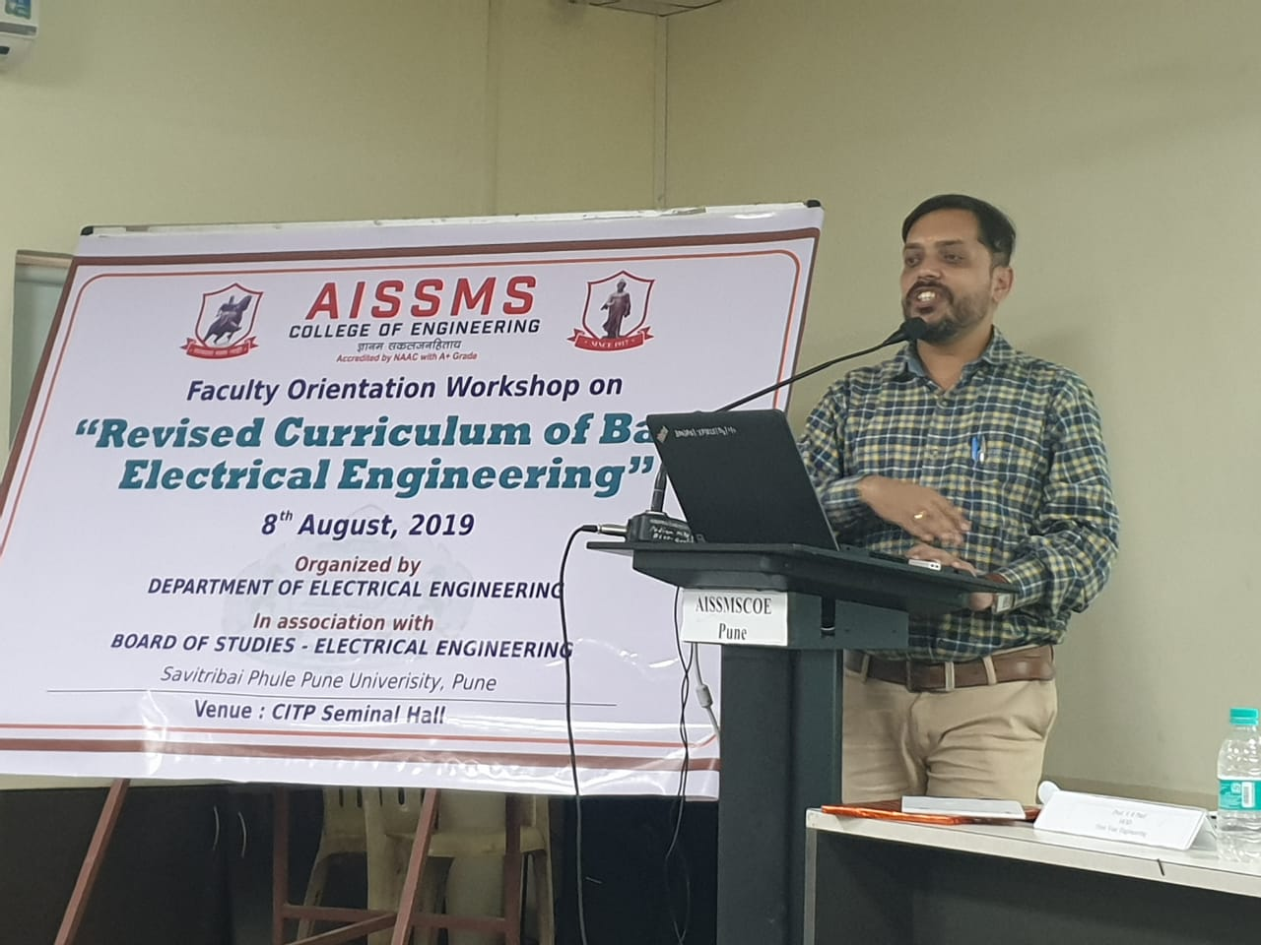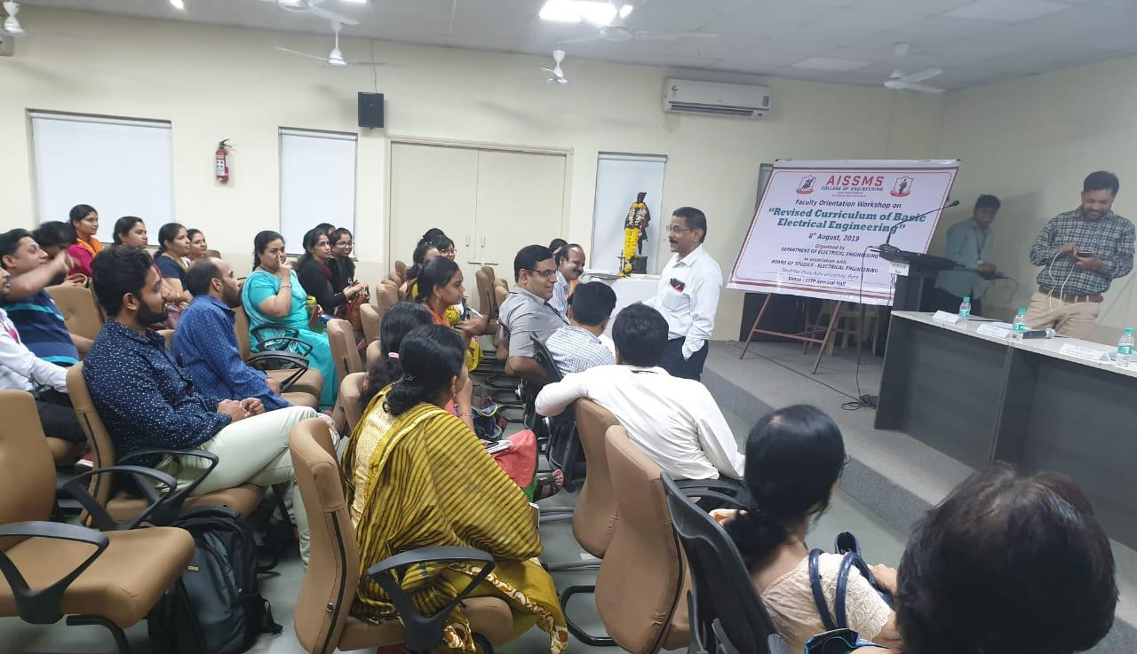
Revised curriculum of BEE workshop, on 8th August 2019
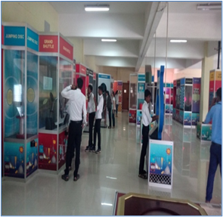
Cultural activity winner at Vinodattam Karandak. S.E. Electrical students to Science Park, Pimpri, on 11th September, 2019

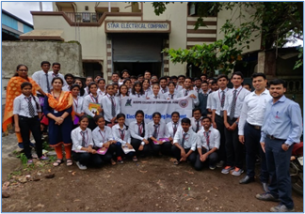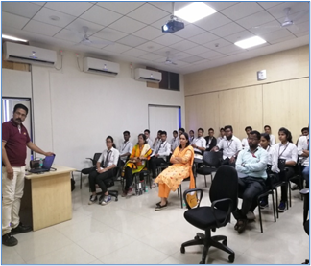
Industrial visit to S.E Electrical students to Star Electricals on 25/7/2019 and PARI robotics Shirwal 31/08/2019.

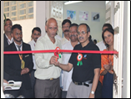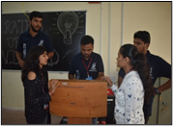
Engineering Today- Watts 2019 activities Laser War, Pirates Wizard

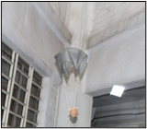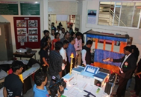
Engineering Today- Watts 2019 activities Aviated Fall and Science Exhibition

Name and Signature
Head of Department

