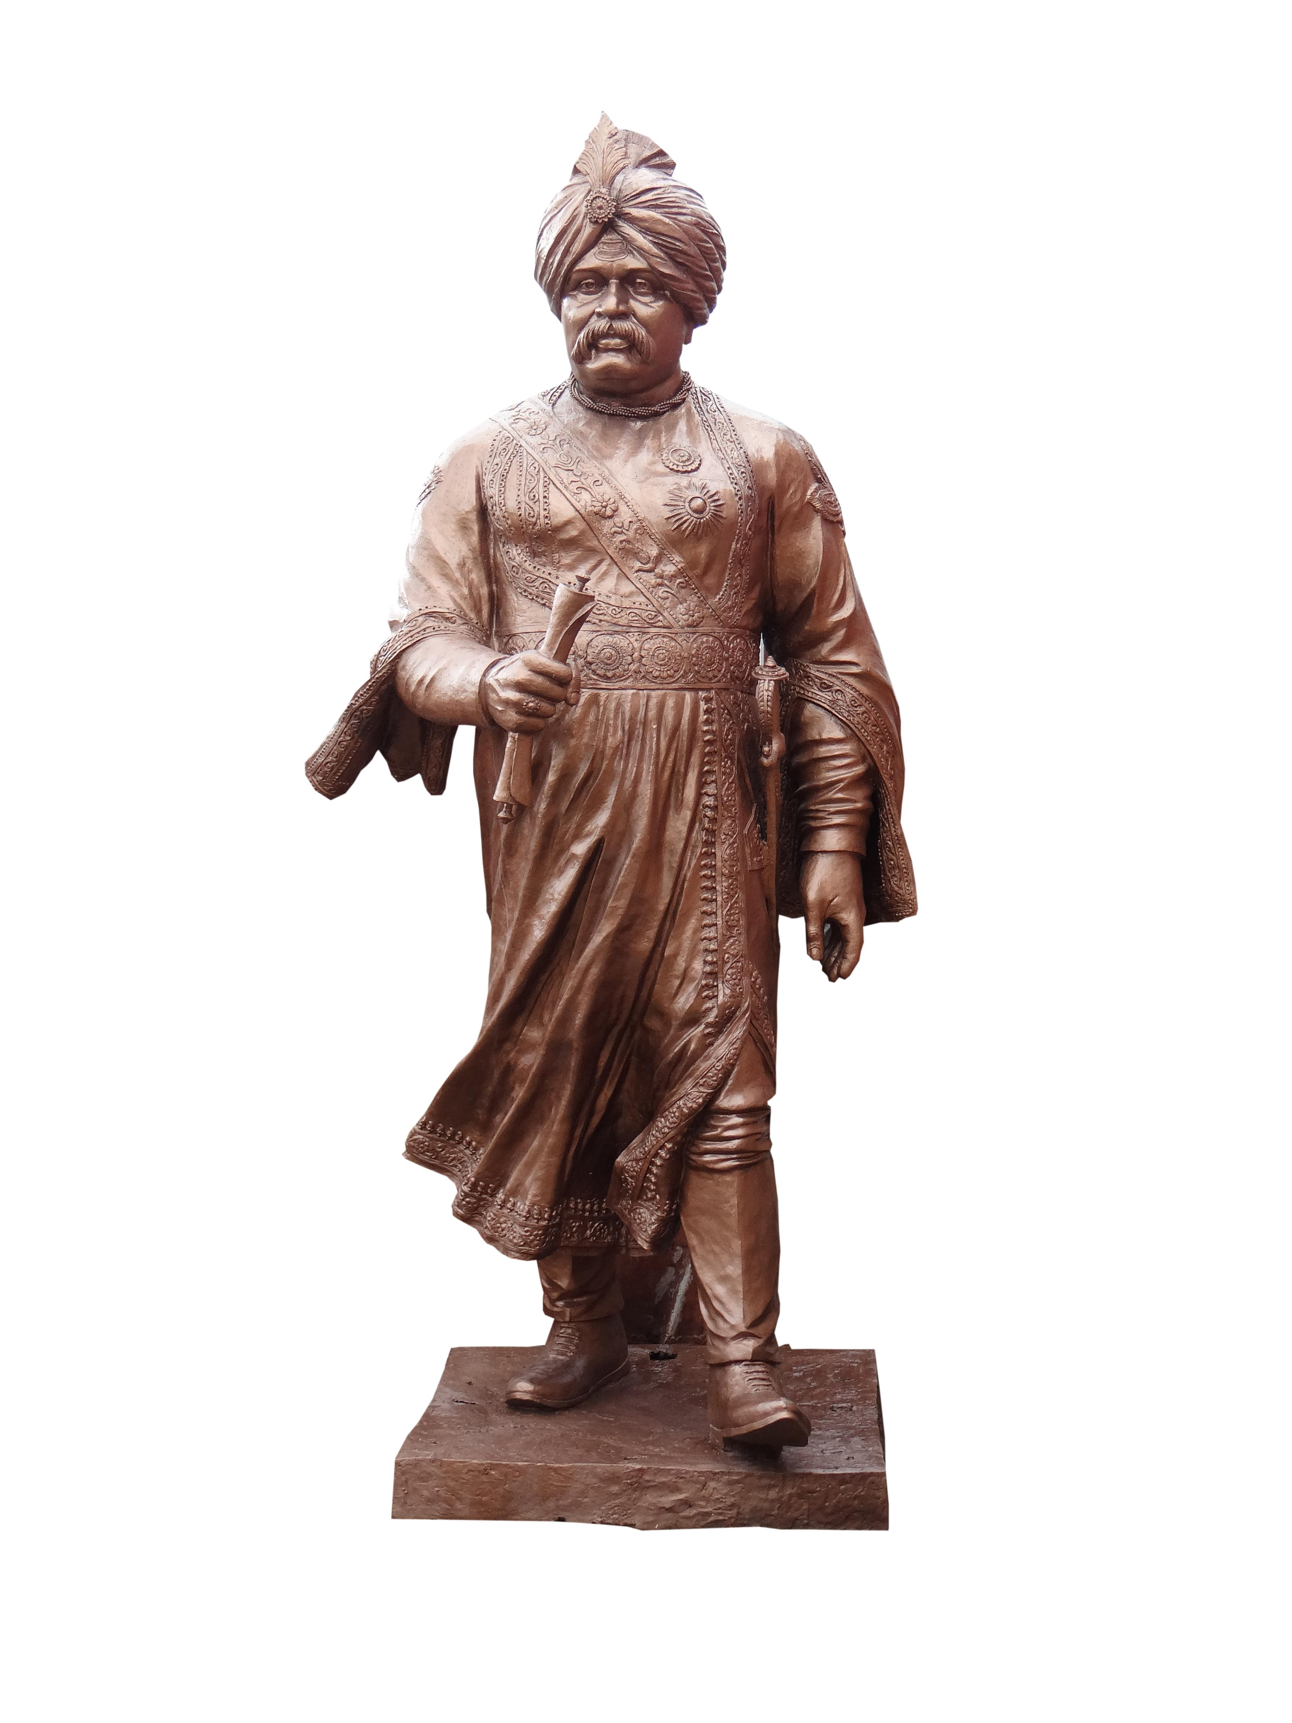

All India Shri Shivaji Memorial Society
55-56, Shivajinagar, Pune : 411005

(Established in 1917)

Tel : 020-26058342, 26058587 (COE)
020-26058877, 26057636 (IOIT)

E-mail : career@aissmscoe.com

Visit : www.aissmscoe.com
www.aissmsioit.org

Form No.:
[Latest Passport size Color Photograph]

APPLICATION FORM

With reference to the advertisement dated ____________ published in _______________
I, wish to apply for the post of _______________________________________________
in the discipline (Branch) of __________________________ in COE □ /IOIT □ (give preference as 1/2).
=============================================================================

1) Full Name : ___________________________________________________________
(Surname) (First name) (Middle name)
Address _______________________________________________
(for correspondence)
___________________________________________________________

Pin :____________________ Phone :_____________________________

Mobile No. _________________ E-mail ___________________________

2) * Date of Birth : _______/______/_________ (DD/MM/YY)

3) Nationality : ________________________

4) * Caste Category : Open / Reserved (SC, ST, DTNT, OBC, etc.) Specify _______________

5) Mother Tongue : ____________________________________________________

6) Languages known
Language | Speak | Read | Write

7) * Academic Qualifications (Starting from S.S.C.)
Sr.No. | Exam.Passed | Passing Year | Board/University | Main Subject | Class, % Marks, No.of Attempts | Remarks  (Rank etc.if any)

...2/-
:: 2 ::
8) * Experience
Sr.No. | Name of Establishment | Post Held | Period |  | Last Pay | Nature of Work
 |  |  | From | To

Total Experience = (Teaching = & Industrial = )

9)*For Professor/Associate Professor post, : _______________________________________________
if you are ME / M Tech First Class & from industry/
profession, please enclose proof justifying that your
experience is significant & equivalent to Ph.D.

10) * Membership of Professional bodies : ______________________________________________

11) * Achievements (Awards, medals, etc.) : ______________________________________________

12) * Paper Published/Presented : ______________________________________________
(Enclose copies)

13) * Book Published, if any : ______________________________________________

14) Areas of Interest : ______________________________________________

15) * Research Experience : ______________________________________________

______________________________________________

16) * Minimum salary expected : ______________________________________________

17) Notice period required to join the post, : ______________________________________________
if selected.

18) Other information, if any : ______________________________________________

19) Please specify four areas of your
probable contribution to College 1._____________________________________________

2 .____________________________________________

3._____________________________________________

4._____________________________________________

I hereby certify that the above information given is true and correct.

( Signature of Candidate )
----------------------------------------------------------------------------------------------------------------------------------
* Self Attested photo copies of the necessary certificates etc. to be enclosed. Use separate sheet(s) wherever necessary. (Ӽ) Strike out whichever is not applicable.

List of required documents enclosed for application :

- B.E./ B.Tech /B.Sc Marksheet with University Certificate
- NET / SET Qualified letter
- M.E./M.Tech/M Phil/M.Sc Marksheet with University Certificate
- Ph.D Awarded Certificate (For Professor, Associate Professor and other)
- Caste Certificate
- Caste Validity Certificate
- Non-Creamylayaer (if applicable)
- Previous University Approval letter
- Previous University Approval to Recognition as a PG Teacher
- Previous University Approval to Recognition as a Ph.D. Guide
- Experience Certificate
- Proof justifying document about your experience paper presented etc.
(as applicable under point no. 09,10,11,12,14 & 15)
- Marriage / Name Changed Certificate (if applicable)
- Relieving Certificate / Discharge Certificate for previous employer
- Last salary certificate
- Latest Passport Sized Photographs in colour
- Character Certificate
- PAN Card
- Adhar Card

=*=*=*=*=*=*=*=*=*=*=

