AERO DESIGN WORKSHOP
-Conducted by TEAM GARUDASHWA
Team Garudashwa is an Aero Modeling Collegiate Club from AISSMS College of Engineering which competes in National as well as International Aero Modeling competitions, representing our college & country in a budding technical sport.
The main agenda of workshop was to impart knowledge about the field of aviation and design parameters of RC planes.
The preparation for this workshop started a month before the day of the workshop. We decided to conduct this workshop with the aim of spreading knowledge about aero designing. As soon as the necessary formalities were done the whole team started planning and dividing work amongst ourselves with regard to the workshop.

SCHEDULE:
28/08/2017 | We started campaigning in our college and drafted out the posters and the messages were sent by our team members to each of their respective classes and branches.
04/09/2017 | We assembled our previous year airplanes and displayed them in the college hoping to attract more students for our workshop.
11/09/2017 | End of campaigning for the workshop and started working on the content and working on power point presentations for the workshop
18/09/2017 | We started practicing our speeches which we were going to deliver in our workshop.
23/09/2017 | THE DAY OF THE WORKSHOP!

THE WORKSHOP CONTENT
The workshop content included -the first one hour of the workshop included introduction of our team and our honorable chief guest Mr. S P Shinde (Hon Joint Secretary of our society) and delegates from our college, our principal sir Dr. D.S Bormane, our Administrative Officer A.B Bhonsle, and our faculty advisor Prof. A V Waghmare.
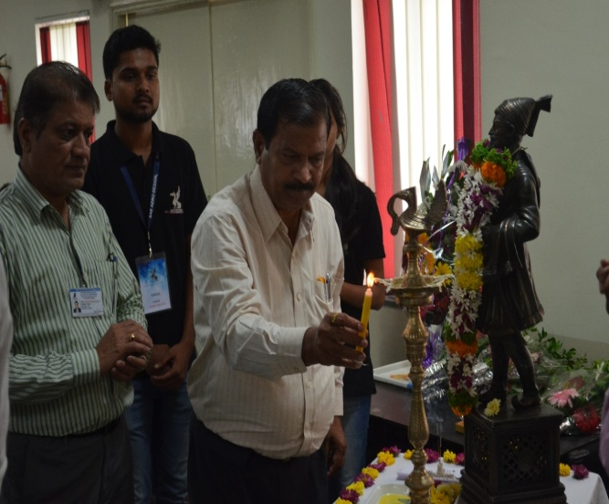 | 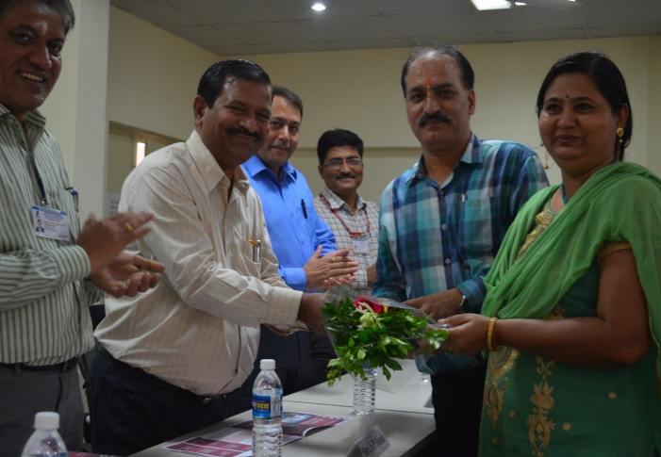
Inaugurated by Mr Suresh Shinde | Faliciation of Sponsors
This was followed by a session on the evolution of aero planes overtime delivered by Sumit Dhage.
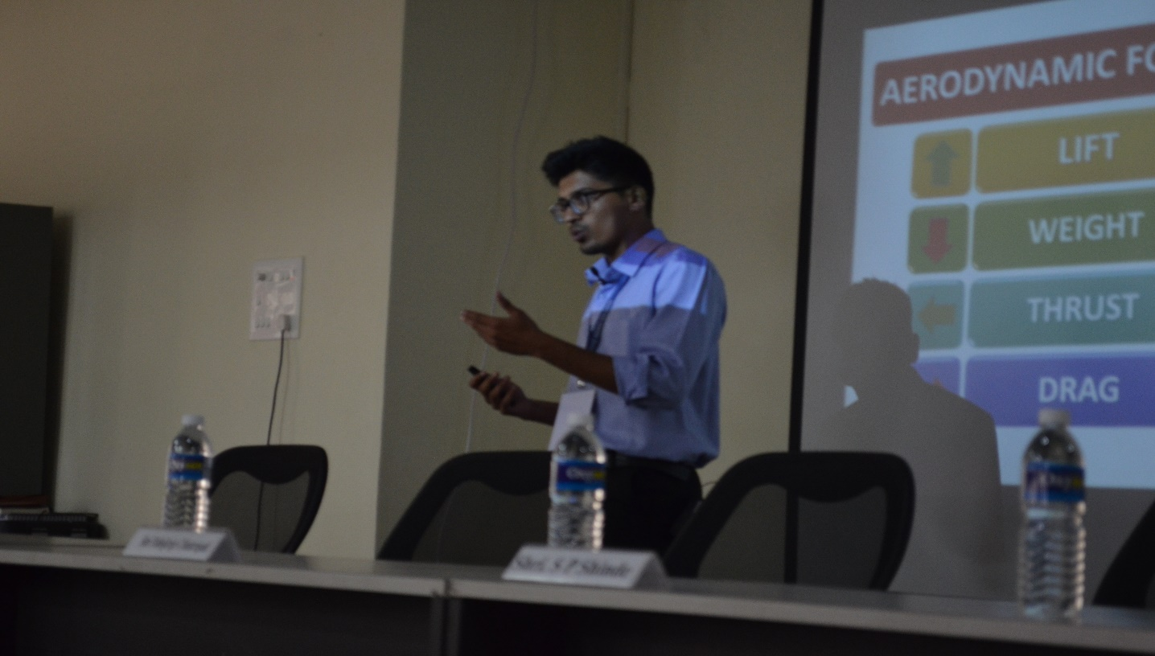
The next session was conducted by Bhavesh Shingvi based on design configurations of an aero plane.
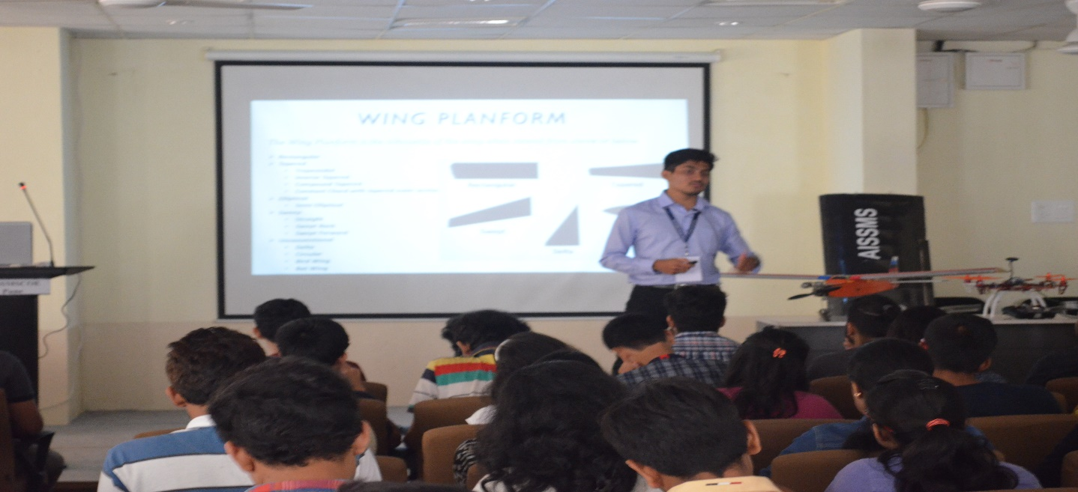
This was followed by a short break in which we distributed Red Bull and a Samosa to each of the participants.
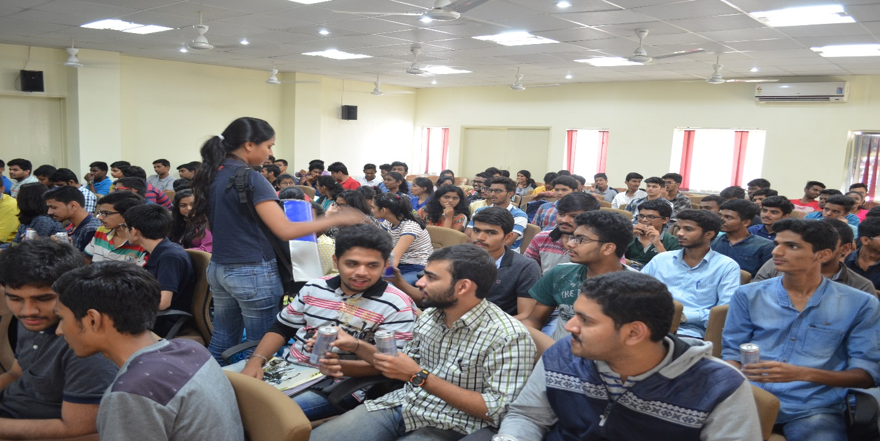
After the break we had a session on plane avionics delivered by Dipankar Munshi.
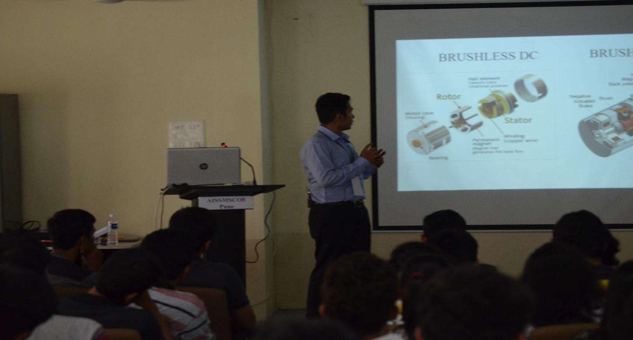
The next session was conducted by Harshal Suryawanshi on drone avionics.
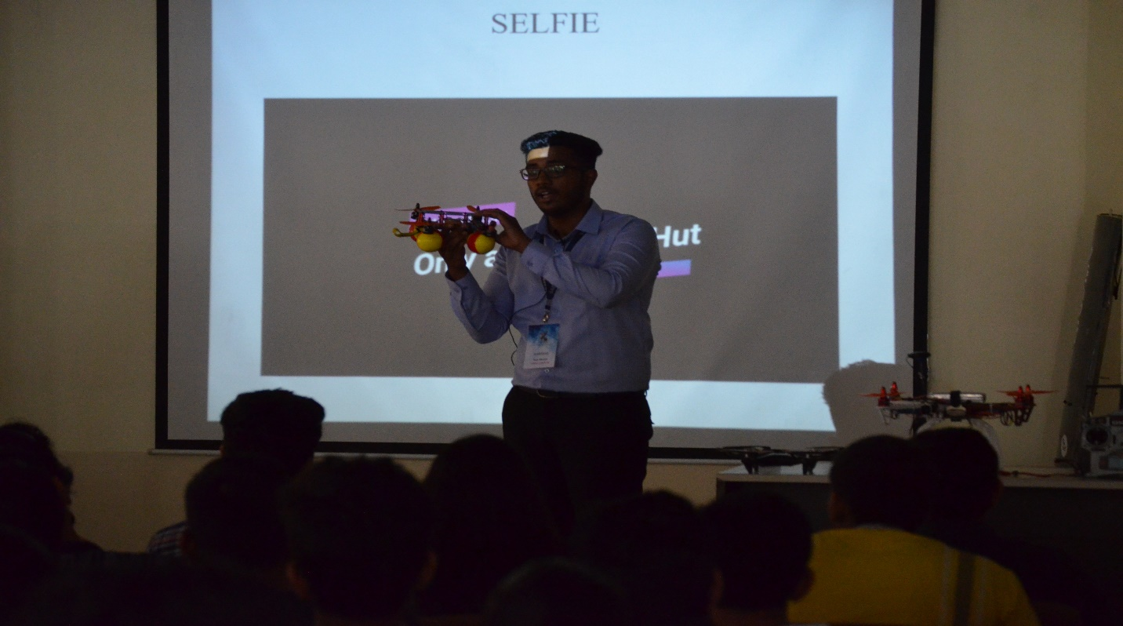
After this there was a demonstration on glider assembly by Gaurav Kasar.
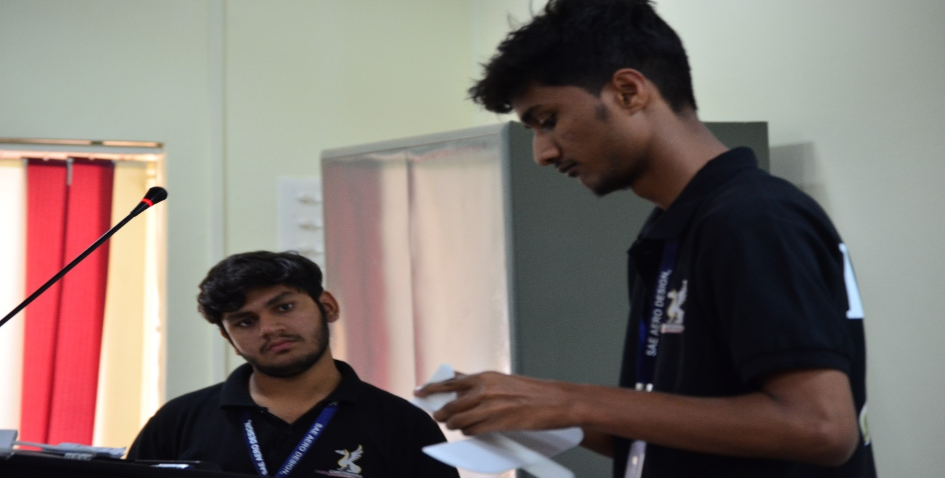
Certificates were distributed along with the glider kits.
This was immediately followed by flight and drone demonstration on our college ground followed with a group photo sessions.
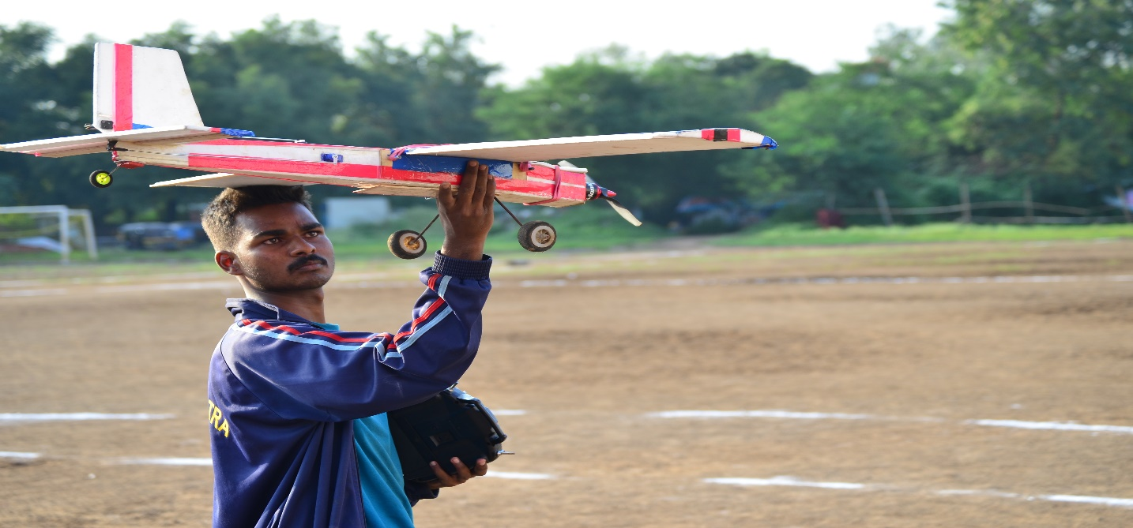
We thank our college and our sponsors for their undying support towards our team. We thank our college and our sponsors for their undying support towards our team

