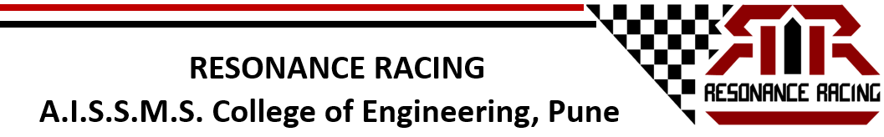
ATV Room (2017)
Resonance Racing BAJA from A.I.S.S.M.S College Of Engineering, conducted a workshop, ATV ROOM, on 17th September, 2017. Organised under the SAE collegiate club chapter of A.I.S.S.M.S College Of Engineering, Pune, the workshop aimed at delivering insights on the SAE BAJA event and mainly focused on providing basic automobile knowledge. The workshop was host to more than 120 undergraduate engineering students from various colleges across Maharashtra. The workshop sessions were conducted by the acclaimed alumni members of the team, having an abundance of experience and knowledge. All the basic components required to produce a vehicle, right from design to manufacturing were covered in the workshop. Redbull was the official hospitality sponsor of the event.
The event was embarked upon by distinguished dignitaries, Respected Principal Dr D.S.Bormane and Faculty Advisor Prof A.V. Waghmare. At the very onset of the workshop the alumni members were welcomed and felicitated by respected Principal Dr D.S.Bormane and by Professor A.V. Waghmare. Shortly after the felicitation ceremony the event was by the valuable presence of the chief guest for the day Mr Anand Iyer, Head Of Marketing, FCA India and the founder of team ‘Resonance Racing’. Mr Iyer founded the team in the year 2009 and gave birth to the Resonance Racing BAJA legacy. The event was further addressed by Principal Dr.D.S.Bormane, who gave motivation and guidance to all the students present through his views and moulded the young minds.
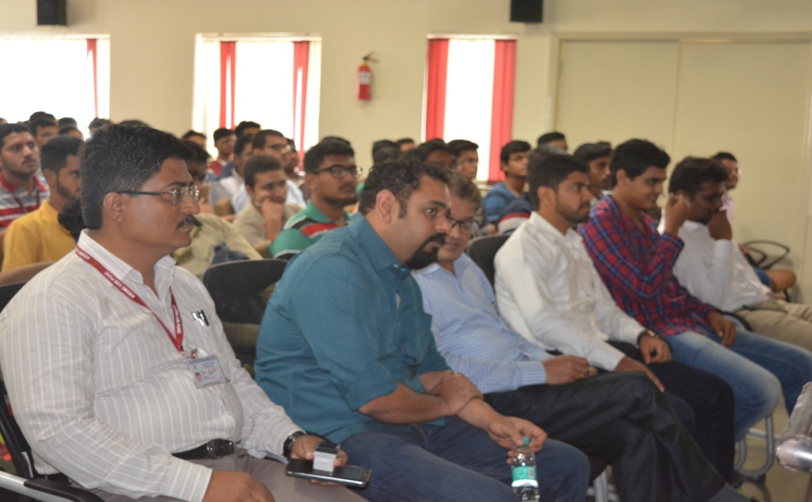
Mr Atharva Ulangwar, former Team Captain and alumni member of the team presented an overview on the BAJA SAE competition and explained the various competition avenues to the students. Mr Atharva is presently working as Technical associate with Air Products India. The students were filled with excitement and enthusiasm after getting an overview about the competition. Followed by the overview was a brief presentation on the history of Resonance Racing and introduction about the team. Mr Anand Iyer shared his valuable views and past experiences in Resonance Racing with the students and left them motivated and awe inspired.
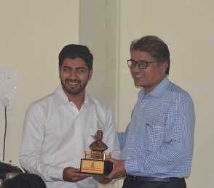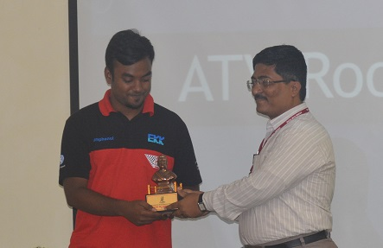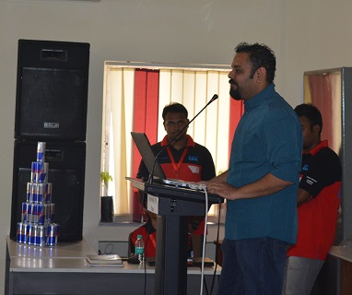
Then began the technical phase of the workshop. The technical phase was divided into subcategories namely Design,Analysis, Suspension, Steering, Brakes, DAQ, Powertrain and Manufacturing. Mr Gaurav Parmar , alumni member, Senior Marketing Manager , ELEATION explained the designing and analysis of automobile to the students. The next session was followed by Mr Dharmesh Seth, alumni member, former Technical and Vehicle dynamics Head, presently working as Senior Engineer, Supply chain in Eaton India. Mr Seth explained to the students about suspension and steering of the vehicle and made all the complicated concepts easier and more understandable. Next, the brakes overview was carried out by alumni member and former Brakes Head Mr Rishikesh Kulkarni. The brakes in the vehicle were covered in an unique and interesting manner. In between the sessions, students were asked questions and given a Redbull can to encourage active participation. All the doubts regarding the technical aspects were also actively resolved by the alumni members.
Followed by a refreshing break, the next session was on Powertrain. Mr Rugved Ainapure, Powertrain Head explained the students about the powertrain of a vehicle. Yash Lodha, Driver and Vice Captain also provided information on powertrain and shared his onfield experiences with the students. Lastly moving on to the manufacturing of an automobile, the session was conducted by Mr Ashutosh Gawade, Chief Marketing Officer, Eaddict Mobility Solutions and former team manager and manufacturing head. The students profoundly enjoyed this session.
To make sure that the students have learnt attentively and to test their understanding, a short test was conducted at the end. A cash prize of Rs.1000 AND Rs.750 were awarded to the first and second ranks, in the test. Apart from this, the top 10 students of A.I.S.S.M.S College Of Engineering, were shortlisted for recruitment into the team. The students were also provided with study material and reference books softcopies to boost their knowledge.
The student members of the team ‘Resonance Racing’ under the humble guidance of respectable Faculty Advisor Prof A.V.Waghmare, marked a successful event in the history of the team.
