HEAT TRANSFER LABORATORY

Lab In-charge | Prof M R Dahake
Lab Area | 58 m²
Location | Second Floor, Room No.219
Utilization | Under Graduate Programme
Investment | Rs 2.20 Lacs

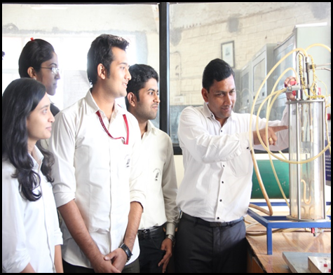 | 