METROLOGY AND QUALITY CONTROL LABORATORY

Lab Area | 58 Sq mtr
Location | Second Floor, Room No.232
Utilization | Under Graduate Course
Equipments | Vernier Caliper, Surface Roughness Tester, Vernier Bevel Protector, Gear Tooth Vernier Caliper, Depth Micrometer, Indicating Micrometer, Profile Projector , Auto Collimator, Monochromatic Light Unit, Tool Maker’s Microscope
Investment | 5.93 Lacs

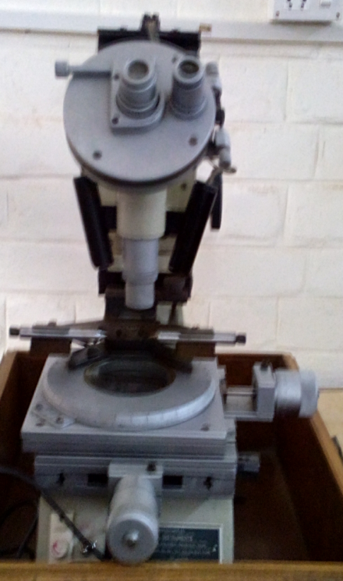
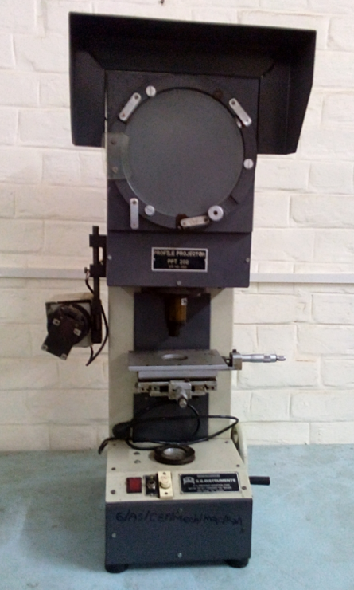

Toolmakers microscope Profile Projector
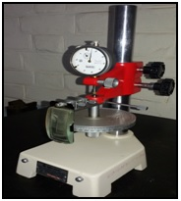
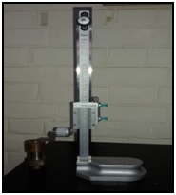

Dial Calibration Tester Vernier Height Gauge

