HEAT ENGINE LABORATORY

Lab Area | 165 Sq mtr
Location | Ground Floor, Room No.015
Utilization | Under Graduate Course, PG Automotive Engg.
Equipments | Ice Plant Test rig, Vapour compression test rig, Vapour absorption test rig, Vortex tube Refrigeration test rig  Air Conditioning Test rig
Investment | Rs 10.74 Lacs

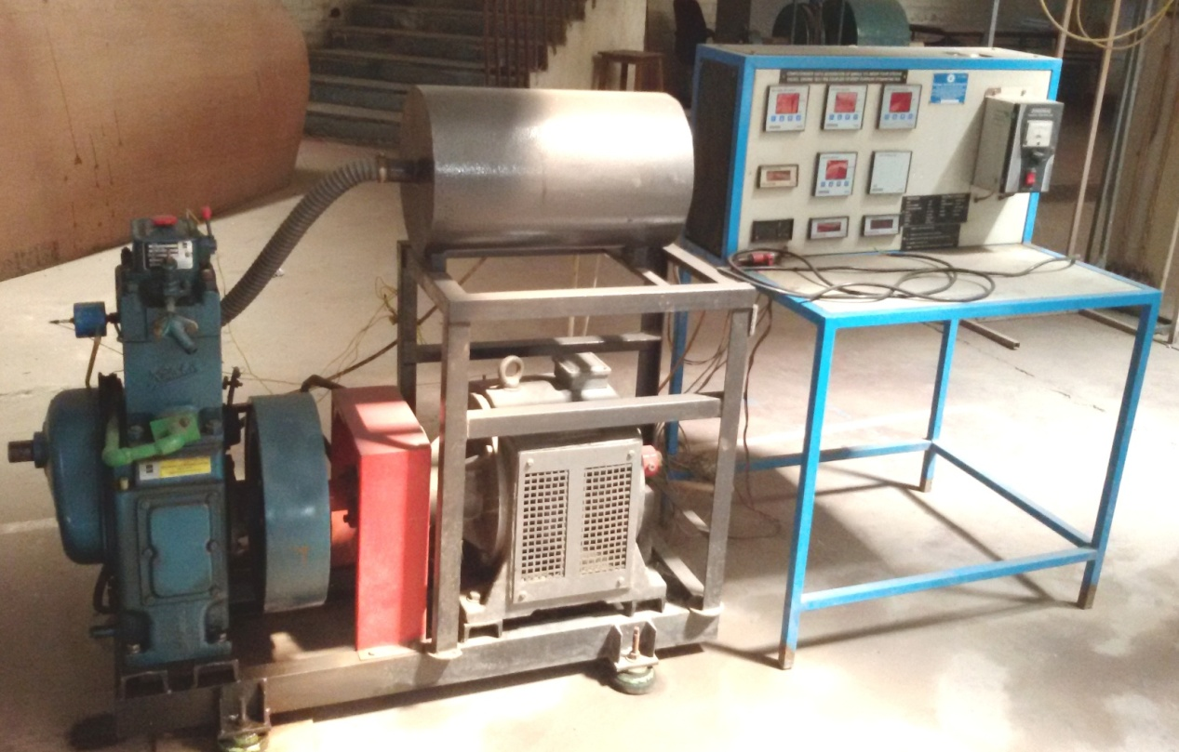

COMPUTERIZED SINGLE CYLINDER DIESEL ENGINE TEST RIG

